Value Chain Tool Description

In this document we will explain how to use the Value Chain Tool and interpret the results. The value chain is discussed in several places in the WIPO publication *Using Inventions in the Public Domain: A Guide for Inventors and Entrepreneurs* (2020), in particular in section 2.3 of Module III “Value chain analysis in an assessment of a firm’s competitive environment”.

In this NPD Toolkit, we recommend using the Value Chain Tool during the Screening stage as depicted in Figure 1, below, before entering the Design stage.

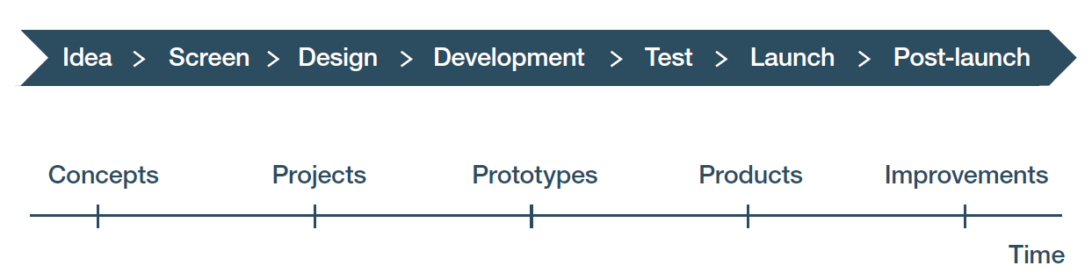

Figure 1: The green and red arrows depict the beginning and end of the tool (respectively) being used before entering the Design stage. Value Chain analysis is critical for a concurrent engineering approach to design. It takes into account the ability of the organization or company to actually complete NPD and make, sell, and support the product or service once it is launched.

## What is the Value Chain?

The value chain is a concept from Michael Porter and refers to the set of activities needed to get a product or service to market and then make money off it. It is called the value chain because, when done well, each activity in the value chain creates value. The so-called **primary activities** are those needed to make, sell, and support the product or service in the market. The **support activities** are those that enable performing the primary activities. The goal of value chain analysis is to make sure the product or service can be developed, made, sold, and supported profitably. Each activity is examined to make sure the company, organization, or agency has the capabilities and capacities to perform the activity effectively and efficiently. (An activity can be performed by an employee, a contractor, a consultant, or an external partner.) Analyzing the value chain is critical for reducing execution risk.

The value chain depicted in Figure 2 below, is reproduced from the WIPO publication *Using Inventions in the Public Domain: A Guide for Inventors and Entrepreneurs* (2020).

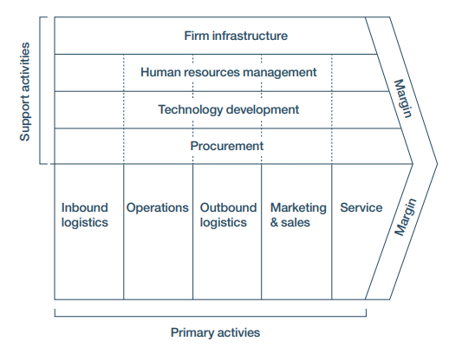

Figure 2: Porter’s generic value chain[1]

Value chain analysis focuses on the primary activities in the value chain, which are categorized in this model as inbound logistics, operations, outbound logistics, marketing and sales, and service. Value chain analysis involves identifying levels of potential risk associated with each of these activities in the value chain. This analysis will require you to break down these activities in two ways that will give you a detailed picture of the value chain for your NPD project.

* First, you break down an activity into the specific items that are required for that activity, such as all the essential components and human resources you will need to build a product as part of your inbound logistics and operations activities, or all the outputs you will generate as part of your outbound logistics, marketing and sales, and service activities.
* Second, you need to identify and list issues that are specific to each activity, which could have an impact on the items that are required for that activity. These issues can be a list of design requirements or specifications, or a list of production methods and facilities/equipment/human resources that will be needed, or a list of issues related to inventory, shipping, and handling.

This two-factor analysis creates a matrix that facilitates identifying aspects of the value chain where risks may lie. Then you can evaluate each intersection and make an estimate of the risk level for that cell. You can now focus on how to reduce the risks you have identified.

Value chain analysis is an important tool for addressing execution risk, which refers to the ability of your organization or company to actually produce, sell, and support the product or service. Execution risk can be reduced by identifying and trying to solve potential downstream problems early in the NPD process by designing and making more easily produced, sold, and supported goods. Value chain analysis provides one method for finding potential problems in the value chain, which provides an opportunity to address execution risk by trying to solve those problems.

Note that after you make this detailed analysis of each cell and its associated risks, you will be able to generate higher-level estimates of risk, such as an average estimated level of risk for each item required for an activity across all the issues listed, and an average estimated level of risk for the activity as a whole. These higher-level estimates have two uses. First, they allow you to prioritize your risk reduction activities in order to have the best possible impact. To illustrate this using the Biofuels Example, you may find a high level of risk associated with reliably procuring sensors with consistently high quality, but you find that you have a low risk related to procuring consistently high-quality vats and piping. These results suggest that you should focus risk reduction activities on the sensor problem before addressing procuring vats and piping. As another example, you may find that a single activity has consistently high estimated risk levels for every item you listed, which indicates you may want to redesign that activity before proceeding further with the NPD process.

The second use of higher-level risk estimates is when generating discount rates for net present values for a product or service. How to do that is discussed in the Net Present Value Tool Description.

## How do you enter data in the Value Chain Tool?

The Value Chain Tool focuses on the primary activities in the value chain. The workbook for the Value Chain Tool uses a matrix-based approach for capturing information and analyzing each of these primary activities. It is easy to copy the blank tabs and adapt them if you also wish to make tabs and enter data for support activities.

The Value Chain Tool is based on an input-output model of flows though the primary activities, that is, what comes into a primary activity (e.g. parts and components being inventoried for later use in production) and what goes out (e.g. the product and the final product and its add-ons). On each sheet you enter what is requested in the rows and columns. What is requested is specified in the titles in white in the dark blue cells above the rows and columns. Inputs and outputs when entered on one spreadsheet are carried forward, as appropriate, to the next one. Sometimes instead of a new input or output, you are asked to enter concerns associated with an activity in the rows. The heading specifies what information should be entered.

As will be explained next, in the intersections of the matrix, you will make estimates of the risk associated with that intersection of an input or output and the specified aspect of that activity of the value chain. The spreadsheet will then automatically calculate the average risk for a row and for the activity. How to use these calculations is explained below.

The workbook is built around inputs to value chain activities, outputs from them, and risks that may occur either obtaining inputs or creating outputs. Each tab is a specific value chain activity.

On each of the tabs, for that value chain activity you have the inputs (e.g., parts, components, subsystems, etc. on the first tab “Inbound logistics”) that you need to conduct the activity. These items are entered in the far-left column (column A). When appropriate, the items in that column are carried forward to column A on the next tab “Operations”, automatically. The kinds of items to be entered by the user in row 3 are specified in the label in row 2 of that tab. Where row 3 consists of outputs, when those outputs are inputs to the next value chain activity, they appear in the far-left column on the next tab as inputs to that next value activity. Figures 3, 4, and 5 below illustrate this by showing completed matrices from the Inbound logistics, Operations, and Outbound logistics tabs of the Value Chain Tool workbook for the Biofuels Example.



Figure 3: On the Inbound logistics tab of the Value Chain Tool workbook, you enter parts, components, etc. in the far-left column (column A) and design requirements/specifications concerns in the third row, as shown in the workbook for the Biofuels Example.



Figure 4: Note how the items entered in the parts, components, etc. column on the first tab, Inbound logistics, are automatically carried forward to the next tab, Operations, as shown in the Value Chain Tool workbook for the Biofuels Example.



Figure 5: On the Outbound logistics tab of the Value Chain Tool workbook, the Outputs/product systems/major components from the right-hand table on the Operations tab have been carried forward as shown in the workbook for the Biofuels Example. These Outputs/product systems/major components are then carried forward to the next two tabs – Marketing and sales and Service and support.

Unfortunately, there is no way to pre-determine the risk for any cell. Risk is the fear of failure, so what you are estimating is how large the risk of failure is for that specific aspect of the value chain. The best advice we can give is to ask the people responsible for performing the activity. These people may be employees of the company or organization conducting new product development; at vendors or subcontractors; consultants, or at partnering organizations.

Describe the product you are planning on developing. Give them information concerning what the design parameters are likely to be. Next, ask these people how confident they are, in light of the information you have provided, that they can do the activities in the value chain you expect them to without any problems. Ask them to be honest with you about where they have concerns and capture those concerns in the columns of the relevant activity spreadsheet. Sometimes you will be asking for concerns associated with the process and methods for conducting the activity. Other times you will be asking for concerns associated with being able to obtain an input or produce an output. Again, each activities page in the workbook guides you on the data to seek as it is specified in the white titles on dark blue background for the rows and columns.

The less confident the people you talk with are, the higher the risk associated with that item. Be sure to make it clear to the people you talk with that there is no right or wrong answer. What you need is realistic assessments so that as you design the product or service during the next stage of NPD, you can do it in a way that makes it possible for them to be successful at what they do. Once you have captured their concerns, next ask them to estimate the level of concern they have (that is, their perception of the risk). The rankings go from 1 (low risk) to 3 (high risk). Capture that in the intersection cell. The spreadsheet will automatically generate an estimated average risk for that row.

You may wish to improve your estimates by seeking the advice of outside consultants who are experts in the relevant activities for your kind of product or service and who have good knowledge concerning best practices before speaking with in-house people. Ask these outside consultants to set the risk rankings for you based on using best practices and provide an explanation for them that includes a description of the best practices. These rankings and the explanations can be offered as a “strawman” to the people responsible for performing the activity. A strawman is a draft prepared solely for the purposes of providing a starting point for discussions. The reason for creating a strawman is that people often find it easier to make estimates if they are reacting to a strawman when confronted by a new product or service they have not dealt with before.

To illustrate this, look at the results of such conversations with the people responsible for the activity of Inbound logistics. The results of these hypothetical conversations have been captured on the Inbound logistics tab of the Biofuels Example workbook. The rows are the items to be procured and inventoried. The columns reflect design requirements or specifications for the product or service being produced. We have also captured hypothetical estimates of risk in the intersection cells. For the part identified as “Vats” in row 4 on that tab, an estimated level of risk was entered for each of the following aspects of inbound logistics: Vats – Availability at affordable price (cell C4); Vats – Efficiency/efficacy (cell D4); Vats – Storage of inventory (cell E4); Vats- Payment terms (cell F4); Vats – Environmentally friendly (cell G4); Vats – On-time delivery (cell H4); and Vats – Quality (cell I4). An embedded formula then automatically calculated the average risk level for Inbound logistics involved with the vats that are needed for building mini-refineries (cell B4). At the bottom of column B, an embedded formula calculates the average risk for all of the listed Inbound logistics activities in the value chain for this product, based on the average estimated risk for each item in column A. The results show that logistics involved with acquiring the vats has a low estimated risk level (cell B4). In contrast, the logistics involved with acquiring sensors for the mini-refineries (see row 6) have a high average level of risk (cell B6), with the highest risk levels associated with availability at an affordable price (cell C6), on-time delivery (cell H6) and quality (cell I6), and low risk associated with storage of inventory (cell E6) and being environmentally friendly (cell G6).

The most accurate risk estimates will come from the people who work and manage that part of the value chain. Ask them to set the rankings for you. If they find it difficult to make estimates of risk, offer them a strawman. As described above, a strawman is a draft prepared solely for the purposes of providing a starting point for discussions. In this approach, using your best guesses as to the riskiness, you complete a tab to make a strawman. Then you show that strawman to the people responsible for completing that part of the value chain and ask them to modify the rankings as they see fit and explain to you why they are coming up with ranking they are entering.

Now that you have your risk rankings, begin with the activities with the highest risk. Within them, go to the items (the columns) with the highest risk. Ask the people responsible for the activity to help you disaggregate their rankings into two dimensions: how significant for their activity the risk is, and how likely it is to occur. Next, use the following table to help you determine how to address the risk.

|  |  |  |
| --- | --- | --- |
| **Likelihood of occurring:** | **High** | **Low** |
| **Significance: High** | **Avoid** | **Mitigate**  (contingency plans and control consequences |
| **Significance: Low** | **Mitigate**  (contingency plans and control consequences) | **Accept** (muddle through, unless you have the time and resources to mitigate) |

Figure 6: Risk ranking and how to address the risks after examining their significance and likelihood of occurring.

Where the table says “Avoid” because a risk is significant and likely to occur, it probably means you have to reconsider that design requirement for the product or service. Where the table says “Mitigate”, in consultation with the people responsible for performing the activity, first determine if you can adopt a new way of performing the relevant tasking (a best practice) in order to mitigate or avoid it. If not, consider other mitigation strategies with the people responsible – including redesigning or changing the requirements for the product or service. If you cannot, then ask yourself the question whether this a risk you are willing to bear. Depending on the time you want to spend on risk reduction, address the low risks last. Your risk solutions should be entered on the Solutions tab of the workbook (see figure 8 below).

To make your strawman, examine your Action Plan (see figure 7 below). Ask yourself the following question: if this Action Plan is successfully executed (this would be a so-called support activity under “Technology Development” in the upper portion of Porter’s generic value chain model as per figure 2 above), how confident are you that the various primary activities you enter on the tabs of the Value Chain Tool workbook can be successfully completed? If you are very confident, that means there is little risk, so you enter 1. If you are not confident at all, that means high risk so you enter a 3. If you are not sure, do you lean more towards confident (a 1) or not confident (a 3). When making estimates with little certainty, just use a binary ranking scale of 1 or 3.



Figure 7: Your Action Plan can be used as a starting point for estimating the riskiness of your value chain, as shown here by the Action Plan workbook for the Biofuels Example.

Note that each tab will give you an average risk for each row, and for the table, and in some cases, for the entire tab. We recommend developing mitigation strategies for the higher risks first, beginning with the tab with the highest risk. For each average risk value of 2 or 3, develop a risk avoidance or mitigation solution. To do so, consult with the people who are responsible for the activity. If appropriate or necessary, seek outside support from consultants, vendors, partners, or other experts.

The solutions for risks are recorded on the Solutions tab. List the risks you identified and record the solutions you developed on the spreadsheet, as shown in figure 8 below from the Biofuels Example workbook. On the Solutions tab you are asked to estimate both the feasibility and the anticipated effectiveness of each solution. Obviously, where either or both of these seem low, the solution should only be adopted if nothing else can be proposed or thought of.



Figure 8: A clip from the Solutions tab of the Value Chain Tool workbook for the Biofuels Example

After developing your solutions, go back and redo the risk rankings. Iterate the process until you feel the riskiness of the value chain is acceptable.

## How do you interpret the data in the Value Chain Tool and use it in your NPD process?

The purpose of the Value Chain Tool is to ensure that you have the capabilities and capacities to successfully make, sell, and support the product or service you are designing and developing. Where there is risk, the likelihood of success decreases. How much risk you are willing to bear will vary by entity, but each company, institution, or agency has a risk threshold. This Value Chain Tool helps you to see what and where your risks are, think about how much risk you can bear, and decide whether you have exceeded your risk threshold.

After completing the Value Chain Tool, go back and review your Action Plan.



Figure 9: Your Action Plan should be reviewed after examining the riskiness of your value chain and developing ways of reducing risk. Shown here is a part of the Action Plan from the Biofuels Example workbook.

Ask yourself the following questions: What revisions should I make to the Action Plan based on the Value Chain analysis? Once you have made these revisions, ask yourself: can this Action Plan likely be successfully executed? If the answer is no, there is a problem. It means the NPD project has an unacceptable level of risk. It is then a management decision whether to bear that risk and proceed, or to terminate the NPD project.

1. Source: Competitive Advantage: Creating and Sustaining Superior Performance by Michael E. Porter. Copyright 1985 Michael E. Porter. Reprinted with the permission of The Free Press, a Division of Simon & Schuster, Inc. All rights reserved.