SWOT (Strengths, Weaknesses, Opportunities, Threats) Analysis Tool Description

In this document we will explain how to use the SWOT (strengths, weaknesses, opportunities, threats) Analysis Tool and interpret the results.

SWOT Analysis is discussed in several places in the WIPO publication *Using Inventions in the Public Domain: A Guide for Inventors and Entrepreneurs* (2020), in particular in section 8.8 of Module III “Strengths, weaknesses, opportunities, threats (SWOT) analysis”, which states that a SWOT analysis is “useful for evaluating the options and making more informed decisions during NPD.”

In this Toolkit, we use the SWOT Analysis Tool mainly before entering the Design stage to enhance the likelihood that your design will result in a successful product or service once introduced. The SWOT Analysis Tool examines if the proposed product or service and the design requirements emerging from the Screening stage will likely lead to a product or service that can be successfully marketed, or whether market entry and sales expansion concerns suggest the design requirements may need to be revised.

It is recommended to use the SWOT Analysis Tool early in NPD, as the further into the Design stage you go, the more rapidly cash outlays (expenses) rise. Therefore, ensuring that the risk of NPD failure can be minimized is important. This combination of risk and rising cost is called the Valley of Death, as additional funding often must be released or found to continue NPD.

The SWOT Analysis Tool should also be checked again and revised as necessary before entering the Launch stage (see figure 1 below).

V

V

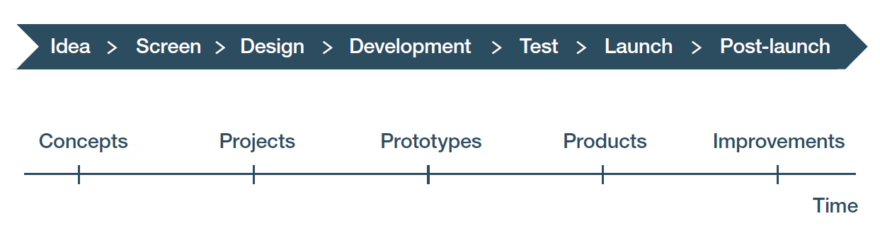

Figure 1: The arrows show that the SWOT Analysis Tool can be used before entering the Design Stage as a concurrent engineering exercise to validate that the requirements that will drive the design are reasonable for the downstream market success. It should be checked again and revised as necessary before entering the Launch stage. SWOTs are a generic tool that can be useful throughout the NPD process when focusing on a relevant strategic question.

The use of a SWOT analysis here examines critical internal and external factors that could influence your market entry and expansion strategy and that strategy itself in order to make sure any necessary revisions to the design to enable the product or service to succeed are made during the final design process. Both good (positive) and bad (negative) factors are included as shown in figure 2 below. There are various ways to make a SWOT Analysis matrix. Figure 2 reproduced from the WIPO publication *Using Inventions in the Public Domain: A Guide* *for Inventors and Entrepreneurs* (2020) presents the SWOT Analysis matrix used for this tool.

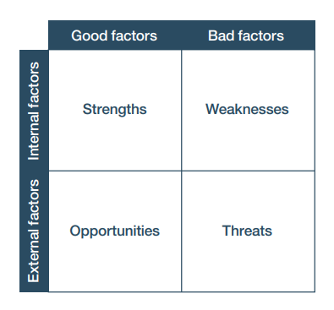

Figure 2: The SWOT Analysis matrix

## What is a SWOT Analysis?

The SWOT Analysis Tool is designed to be a tool to help you gather and arrange information in a way that will help you develop a market entry strategy based on key considerations that apply to your type of product or service.

A SWOT analysis looks at both internal and external factors, as well as good (positive) and bad (negative) factors. Internal factors are under your control, such as your product concept, your NPD team, your value chain, and your IP position. External factors are outside your control, such as customer and end-user requirements, market forces and barriers, enforceable IP owned by others, and competition. Good or positive factors are those factors that support your successful completion of NPD and market entry. Conversely, bad or negative factors are those factors that hinder or prevent your successful completion of NPD and market entry.

In this Toolkit, the SWOT Analysis Tool is a heuristic tool that provides techniques for gathering and evaluating information, and then brainstorming to discover new insights in ways that help you develop a viable market entry strategy or “marketing mix” for your product or service.

The SWOT Analysis Tool uses the results of a SWOT analysis in a 4Ps marketing mix model, where the 4Ps are Product, Price, Place, and Promotion. Figure 3 below explains each of the 4Ps found in a marketing mix, using excerpts from the descriptions on page 61 of the WIPO publication *Using Inventions in the Public Domain: A Guide for Inventors and Entrepreneurs* (2020).

|  |  |  |
| --- | --- | --- |
| **Category** | **Description** | **Examples** |
| Product | “The product is what will be sold. It is not just the core item being developed; it also includes ancillary tangible benefits (such as packaging, brand, quality, warranties, etc.) – in other words, everything needed to meet the user’s need.” | - Product tangible features and features providing performance and ease of use.  Product intangible features making it easier to buy the product. |
| Price | “The price is what the product is sold at. The price needs to cover expenses and produce an acceptable profit, while being attractive to buyers and within the limits the targeted customer segments are prepared to pay (to avoid “sticker shock” – an unexpectedly high price that does not reflect the customers’ expectations of the product or service delivered).” | The cost of the product in currency.  The life cycle costs of using the product is sometimes considered part of the price, that includes any costs of disposal, cost of utilities required, cost of any special equipment or facilities needed to use the good etc. |
| Place | “Place is how the products are delivered to customers. It can be at a building that is the point of sale, via mail after ordering on an online platform, or a download, as is the case with software generally. Place depends on the complexity of the product, with complex products and services often needing personalized delivery and training, while simpler products can be drop-shipped.” | Pick-up at store  Delivered to customer  Pick-up at a warehouse  Download from the web  Use by logging in to a site on the web  Delivered via an app |
| Promotion | “Promotion is how customers become aware of the product and its net benefits. It includes the communication channels used to reach them and the content, format and length of the messages that they will read, hear or view. How a product is promoted depends on how it is positioned in the market in relation to competitors and customers (for this reason, many marketing professionals use “position” as an alternative for this particular P).” | Advertising  Articles in trade publications  Press releases  Websites  Blogs  Social media  Presentations and papers at trade shows and professional meetings  Beta testing and free samples |

Figure 3: The 4 Ps

Sometimes, a marketing mix model refers to the five Ps. The fifth P, People, is described on page 61 of the WIPO guide as follows: “People are those who market, sell and deliver the product. They may work for the company (staff) or be distributors, direct customers (in the case of an original equipment manufacturer (OEM) product) or sales representatives. They are the ones downstream in the supply chain that reaches from the firm to the consumer or other buyer. They must have the requisite capabilities to execute a marketing strategy and ensure success in the market; therefore, most companies will use a mix of internal staff and outside contractors.”

Our approach to using a SWOT analysis to develop a market entry strategy uses the 4Ps model. Using the 4Ps makes it easier to leverage the matrix structure of the SWOT for brainstorming the marketing mix. People are discussed elsewhere as a strength or a weakness, so the fifth P, People, is not included in this analysis.

This tool uses a two-step method that can be repeated over and over as you gain insight and refine your ideas. First, you populate a SWOT analysis matrix as provided at tab 1 of the SWOT Analysis Tool workbook entitled “Factors”. Next, you look at the intersections of the external and internal good (positive) and bad (negative) factors at tab 2 of the SWOT Analysis workbook, entitled “Analysis of intersections”. In each cell of the intersection, you brainstorm what the factors for that intersection would mean for one of the 4Ps in a successful market entry. You use good factors to mitigate or circumvent bad factors. As you work through the SWOT intersections, you iterate the process as new insights are gained.

An important function of a SWOT analysis is to gain insights that can be used in addressing adoption risk, which refers to the risk of whether the intended customers will buy a product or service, and whether end-users will deploy it. A SWOT analysis helps you focus on how each of the 4Ps of a market entry strategy would apply to the product or service you want to develop, and how they should work together in the market mix. In addition, insights from SWOT analyses can be used to support the process of backward chaining to address execution risk related to the ability of your organization or company to actually conduct an NPD initiative that includes successful market entry. Backward chaining begins with the desired end-state (a successful market entry) and works backward to the current state (the current design or project plan) to determine if, at each step of the chain, you have what you need to create the desired end-state. If your SWOT analysis indicates that the current design does not support a successful market entry strategy, then the design needs to be rethought.

We emphasize that the SWOT Analysis Tool can be used to help explore options in any stage of NPD or any part of business operations. SWOT analyses are a very useful heuristic tool.

## How do you enter data in the SWOT Analysis Tool?

In general, very little new research is needed to use the SWOT Analysis Tool to do a SWOT analysis. Rather, you are reviewing what you have done before in connection with other tools. To use the SWOT Analysis Tool, you take information and observations you have already generated, and look at them in a different way that lets you gain new insights. That said, it is useful to also do web searching on market forces and barriers which may apply to your product or service, and update your Freedom to Operate and Competitive Advantage workbooks if you learn new information.

An example of how to use your prior work to discover factors is shown in the next three figures. Figure 4 displays the Factors tab of the SWOT Analysis Tool workbook for the Biofuels Example.



Figure 4: The Factors tab of the SWOT Analysis Tool workbook for the Biofuels Example

Note that the second strength identified here is the core technical staff and team. This strength comes from examining the “Team members” section of the Project Charter (figure 5, below, from the Biofuels Example) and the Operations tab of the Value Chain Tool (figure 6, below, from the Biofuels Example). If there were significant risks to Operations for which solutions were not found, then you would most likely not enter the technical team as a strength.



Figure 5: The Team members section of the Project Charter Tool workbook of the Biofuels Example



Figure 6: Operations tab of the Value Chain Tool workbook of the Biofuels Example

Now look at the fifth factor listed in the Opportunities quadrant, which addresses expansion of cell coverage into remote, isolated locations where the mini-refinery product might be used. Clearly this is an external market force that you cannot control. One way to identify if this really is an opportunity is to do web research to find coverage maps for countries of interest from several years ago and then compare these with recent coverage maps to see how coverage is expanding. Another way to evaluate this factor is to find a site with market research or a government report discussing trends in cell and internet coverage in those countries. An example of an internet penetration map is at <https://www.internetadvisor.com/key-internet-statistics#post-navigation-14>.

Once you have identified the factors you think are important and you have entered them into one of the quadrants of the SWOT matrix (Opportunities, Strengths, Threats, Weaknesses), next go to the “Analysis of intersections” tab. An embedded function in the spreadsheet automatically places the factors from the previous tab in the correct place. Now pick any one of the 4Ps, look at an intersection between factors in separate quadrants, and start brainstorming about what those intersections suggest about that part of the marketing mix. Continue until you have used all cells and addressed product, price, place, and promote. Review your work to see if you should iterate and revise what you have proposed. When iterating, it is acceptable to move the Ps into different cells.

Figure 7 below shows the completed analysis of the “Analysis of intersections” tab from the SWOT Analysis Tool workbook for the Biofuels Example.



Figure 7: The Analysis of intersections tab from the SWOT Analysis Tool workbook for the Biofuels Example

## How do you interpret the data from the SWOT Analysis Tool and use it in your NPD process?

Once you have completed a SWOT analysis that you think is comprehensive and provides useful guidance, you then examine the current design of your product or service for its compatibility with the SWOT analysis you have developed.

The term “design” can include design of the product or service, as well as the project design for developing, training, and supporting the product or service. Use backward chaining to make this determination, starting from a SWOT analysis that suggests a design for a successful future market entry, and working back to the current design. If the SWOT analysis and design do not cohere well, either the SWOT analysis or the design should be revised. That, in turn, may require revising the NPD Project Charter and Action Plan, which may trigger another set of questions and tasks. If the current design cannot be brought into coherence with the design from the SWOT analysis, or if necessary modifications to the Project Charter or Action Plan are significant, then the NPD initiative should be put on hold until solutions are found or a decision to terminate the NPD project is made.