Portfolio Construction Tool Description

The Portfolio Construction Tool provides a way to brainstorm and evaluate product and service ideas that are related to the product or service currently under development that could be members of a product or service line or a product or service family. A line is a set of products or services that do the same thing, as a line of monitors for air quality. The goods in a line are used for similar purposes. A family is a set of products or services that do related but different things, such as a family of air and water monitors. This tool enables viewing the current product or service within the context of a larger New Product Development (NPD) portfolio.

There are a variety of different ways to develop and assess an NPD portfolio. When you use the Portfolio Construction Tool, you build a portfolio by brainstorming synergistic products and services for targeted customer segments. You also look for spin-off applications in new customer segments, or in the technologies to be incorporated into the product or service. You then make a rough estimate of the potential likelihood of successful market entry. This process enables deciding which products and services should be included in the NPD portfolio. This tool focuses on which products or services portfolio might be presented to management. The managerial decision concerning whether to pursue a specific product or service, and when to do so, is not part of this tool.

## What is the Portfolio Construction Tool?

Products and services have life spans. The life span of any particular product or service depends on a variety of factors, such as the stability of customer and end-user needs, the rate of product or service change, the varieties of a product or service type offered in the market, time to market saturation, replacement rates for products or renewal rates for services, the rate of relevant technological change, macro- and micro-economic conditions, and so forth. For this reason, NPD is an on-going process in successful companies. The Portfolio Construction Tool examines how the product or service currently being developed fits within the larger NPD portfolio of a company or organization.

Product or service life spans are often described in terms of four phases: introduction, growth, maturity, and decline. During introduction, the goal is to obtain market traction or take-off. Break-even is typically more important than profitability in this phase. Growth is a period of relatively rapid sales expansion and greater profitability. Maturity is when the product or service is well established, and often is accompanied by maximum profitability as economies of scale and scope, network economies, and learning curve benefits come into play. At some point, market saturation is reached, and sales and profits begin to decline. In the decline phase, the goal is to maximize the life span of the product or service in order to take full advantage of it until the product or service is no longer profitable.

An objective in NPD portfolio management is to have one or more new products or services ready for introduction before the ones currently being sold or under development hit the latter half of the maturity phase. The reason is decline can occur earlier than anticipated due to market saturation or swamping, i.e. the interruption of the product or service life span. Like a small boat swamped by a large wave can sink, a product or service can be overcome by a wave of change in buyer needs, availability of superior product or service technology, or other factors. When swamped, the product or service experiences a rapid drop in sales. Swamping is usually caused by another product or service being introduced by a competitor. However, a company may intentionally swamp its own product or service, as when it is trying to counter the anticipated introduction of competing products or services with new and superior technology. Figure 1, below, illustrates swamping.

Figure 1: Product or service being swamped by a newly introduced substitute which better provides the core benefits and tangible features desired by customers and end-users. Figure courtesy of Foresight Science & Technology.

In developing an NPD portfolio, it is necessary to think about the role of this product or service in the overall strategy of your entity. Is it a stand-alone product or service, or is it part of a product or service line or family? Expanding on what was said above, a product or service line is an array of products or services providing the same core benefits and having similar tangible features that are sold to the same customer segments under the same brand name. A product or service family is a suite of complementary (and often synergistic) products or services that may, but need not, have the same core benefits or even related tangible features, that are marketed under the same brand name.

The reason for developing an NPD portfolio (or refining an existing one) as soon as possible after a Technology Forecasting is completed, is to determine if future product or service considerations should influence the design of the product or service being developed. It may be possible to simplify and reduce the expenses of future NPD by making prudent design decisions for the product or service currently undergoing NPD. Again, which products or services should be retained in the portfolio is a question for management, because this decision is influenced by a range of business positioning and strategy factors. These include product/market strategy (e.g. focused, differentiated, price leadership, etc.), technology and innovation strategy (e.g. innovator, fast follower, adaptive imitator, etc.), access to capital, and so on. Management’s decision should be made shortly after the tool is used, so the results can inform the rest of the design process.

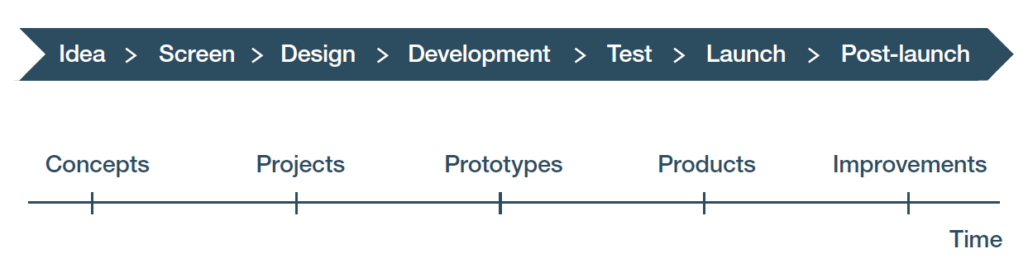

Figure 2: Stages and gates. The green arrow depicts where the Portfolio Construction Tool is being used early in the Design stage. The red arrow depicts completing the analysis during the Design stage so that decisions based on the results can inform the rest of the design process. In larger or multiproduct companies, the tool could also be used already during the previous screening stage. Results from using the Portfolio Construction Tool should also be reviewed at the gate between the Design and Development stages.

In brainstorming products and services, it is useful to think in terms of at least three generations: this generation, the next generation, and the generation after next. For well-established companies, a fourth generation, often called “blue sky”, can be added.

The Portfolio Construction Tool workbook has a single spreadsheet provided at the “Portfolio construction” tab, with an additional tab for recording any “Notes and references”. As products or services are thought of during brainstorming, they are entered into the tool’s spreadsheet where they are assessed for potential inclusion in the company’s or organization’s NPD portfolio. You then evaluate these products or services using three criteria: technical feasibility; market demand; and anticipated annual revenues once established in the market. Technical feasibility is determined by the maturity of the technology that will be used in the product or service, and the absorptive capacity of your company or organization to work with that technology. Market demand is determined by the anticipated demand for the product or service *at the time of market introduction*. This demand is estimated through normal market research techniques. Anticipated annual revenues per year once established (at least in the growth phase) is an estimate based on normal market research techniques.

The Portfolio Construction Tool addresses all three types of risk associated with NPD: execution risk; co-innovation risk; and adoption risk. Execution and co-innovation risks are addressed through the evaluation of the technical feasibility of each potential product or service. Adoption risks are addressed by assessing the market demand for each potential product or service.

In general, the risk associated with a potential product or service can be evaluated by using the matrix in Figure 3 below. The rows are associated with the confidence in the ratings for technical feasibility in the tool, and the columns are associated with confidence in the ratings for market demand and estimated sales revenues. The more the risk, the more important it is to have high-quality data for decision-making.

|  |  |  |  |
| --- | --- | --- | --- |
|  | Product to be sold into current customer segments | Product to be sold into new, but related, customer segments | Product to be sold into unrelated customer segments |
| Technology currently used by your company or organization | Low risk | Moderate risk | High risk |
| Technology in use by others but new to you | Moderate risk | High risk | Very high risk |
| Technology exists but not yet in use | High risk | Very high risk | Very high risk |
| Technology still in research and development phase | Very high risk | Very high risk | Very high risk |

Figure 3: Risk matrix for confidence in ratings and revenue estimates for including in NPD portfolio

The Portfolio Construction Tool is associated with Module II “Finding opportunities to leverage inventions and public domain knowledge” of the WIPO publication *Using Inventions in the Public Domain: A Guide for Inventors and Entrepreneurs* (2020).The discussion in this module will enable you to better understand how to use the patent literature and other sources of information to develop your NPD portfolio.

## How do you enter data in the Portfolio Construction Tool?

The primary challenge in collecting data for this tool is in brainstorming what products or services to include. There are a variety of methods that can be used to brainstorm ideas for products and services. After you have entered results from your research and brainstorming, you will carry out an assessment of the data you entered.

### Looking for ideas, brainstorming, identifying new possibilities

Begin by entering the product or service you are developing in the tool’s workbook. Figure 4 below, from the Biofuels Example, presents the first entry in the Portfolio Construction Tool workbook, which is a description of the product or service currently being developed (cell A3). Again, the first entry should always be the product or service you are currently developing, as that provides an anchor for your brainstorming.



Figure 4: The first entry in the tool is always the product you are currently developing, as demonstrated on the NPD Portfolio tab of the Portfolio Construction Tool workbook for the Biofuels Example.

In Figure 4, note that by defining the “Product or service family” as “Biofuel” (see first column, third row) and the “Product or service line” as “Mini-refineries” (second column, third row), the attention is directed towards what else may fit within this product line and towards what other product lines or product families may be relevant. At this point the objective is to brainstorm freely. To do that, the focus is on generating ideas into columns A to F, reproduced in Figure 5 below.



Figure 5: Columns A to F in the Portfolio Construction Tool workbook are the initial foci for brainstorming product ideas.

Using this entry as your starting point, ask: what related products or services do people in your customer segments also use or want, or what products or services might they use or desire? Pay particular attention to products or services that use variants of your current design or its specific systems, subsystems, or components. Once that is done, look at related customer segments and ask what products or services they might use or desire that would use variants of your existing design or specific systems, subsystems, or components they incorporate.

An example of how this is done is seen in the new offerings from the American motorcycle company Harley-Davidson. They have focused on low to moderate risk products in their recently introduced new products. First, they introduced what was then a next generation product, an electric motorcycle. Then they introduced what was a generation after next product: an e-bike. At first glance, electric bicycles might seem a stretch for Harley-Davidson. But consider that they are already selling electric motorcycles and there is significant overlap between the technology used in motorcycles and bicycles. So the technology currently used by Harley-Davidson has applications in electric bicycles, which should reduce execution risk. Further, their suppliers for these parts for electric motorcycles can also make parts for electric bicycles, which should reduce co-innovation risk. As for the customer segments, as part of their customer base ages for motorcycles, they still could ride a bike, making e-bikes a low adoption risk product idea. Finally, since demand is soaring for e-bikes in general the old adage “in a rising tide many boats float” applies.

If you are stuck or want to expand on the ideas you have come up with, then review interviews in the Voice of the Customer Tool to see if there are suggestions to build upon in them. You could decide to conduct additional interviews for the Voice of the Customer Tool, with new questions. Also, look at the product offerings of competitors or others using technologies you are incorporating in your product or service. That is particularly useful when you are open to contracting with them as an Original Equipment Manufacturer (OEM) for your product or service.

Another method for collecting information is searching the citation clouds of patents related to your product or service, or the technology you intend to deploy. Figure 6 below is from the WIPO publication *Using Patents in the Public Domain: A Guide for Inventors and Entrepreneurs* (2020), which provides details of how to search for forward and backward citations, and how to interpret results*.* In addition, look at the “Background of the Invention” section of any patent document you found to be of interest, to see if it suggests other products you can include in your NPD portfolio.

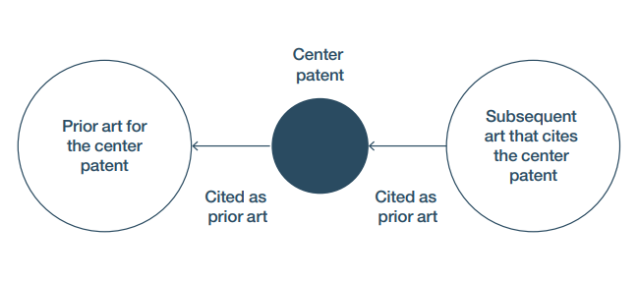

Figure 6: Presentation of the citation cloud of a center patent, reproduced from the WIPO publication Using Patents in the Public Domain: A Guide for Inventors and Entrepreneurs (2020).

The obvious path to finding other products or services to be developed is to explore additional products within the current product or service line. Figure 7 below, shows the “Product or service being developed” cell from the Project Charter Tool workbook for the Biofuels Example.



Figure 7: Extract from the Project Charter Tool workbook for the Biofuels Example, where biodiesel, ethanol and hydrogen are suggested as possibilities for additional products.

In the Biofuels Example, biodiesel, ethanol, and hydrogen were considered in the original Project Charter and thus should be considered here. Accordingly, both biodiesel and biohydrogen were entered in the Portfolio Construction Tool workbook shown in Figure 8 below.



Figure 8: Biohydrogen expands the mini-refinery product line in the Portfolio Construction Tool workbook for the Biofuels Example.

To generate additional product ideas, you can also look at your functional decomposition from the Technology Forecasting Tool workbook. This examination of the previous functional decomposition of your product or service may suggest opportunities for other products and services.

In the Biofuels Example, if the company is thought of as having a focus on green energy for smaller scale applications, then expanding this idea can lead to discovering a potential new product family, on-site electricity, with incinerators as a possible first product (see Figure 9).



Figure 9: Expanding out from heat recapture on incinerators adds an on-site electric power product family, as shown in the Portfolio Construction Tool workbook for the Biofuels Example. Some columns and rows have been hidden for better readability.

The use of thermo-electric was also mentioned as a possibility in the functional decomposition found in the Technology Forecasting Tool workbook for the Biofuels Example. Searching for other relevant applications on the web and in the patent and research and development (R&D) literature will suggest additional products in on-site electricity that might be developed in the future. All you are doing is leveraging the technology and expertise needed to develop the current product or service. In the Biofuels Example, as highlighted in Figure 9 above, incorporating “Thermo-electric generators” in the “Incinerators” component of the product currently under development opens a door to new product and market opportunities.

As discussed, searching patent citation clouds can yield additional useful information. As patents turn up, examine them. As noted, pay special attention to the “background of the invention” section in the patent description as it usually holds clues to earlier product applications. When used with the search term “thermo-electric”, this approach revealed a granted US patent for a “Thermoelectric generator battery charger and power supply” as shown in Figure 10 below, where the WIPO PATENTSCOPE database retrieved this document that lists published US patent application US20130167892 in the document title and shows the application was granted as US Patent No. 8,779,275. While the practical application discussed for this patent is for charging cell phones in the wilderness, the approach could be adapted to draw off the heat from a vehicle engine, which would be relevant for the customer segments targeted by the mini-refinery because the mini-refineries generate heat during their operation.

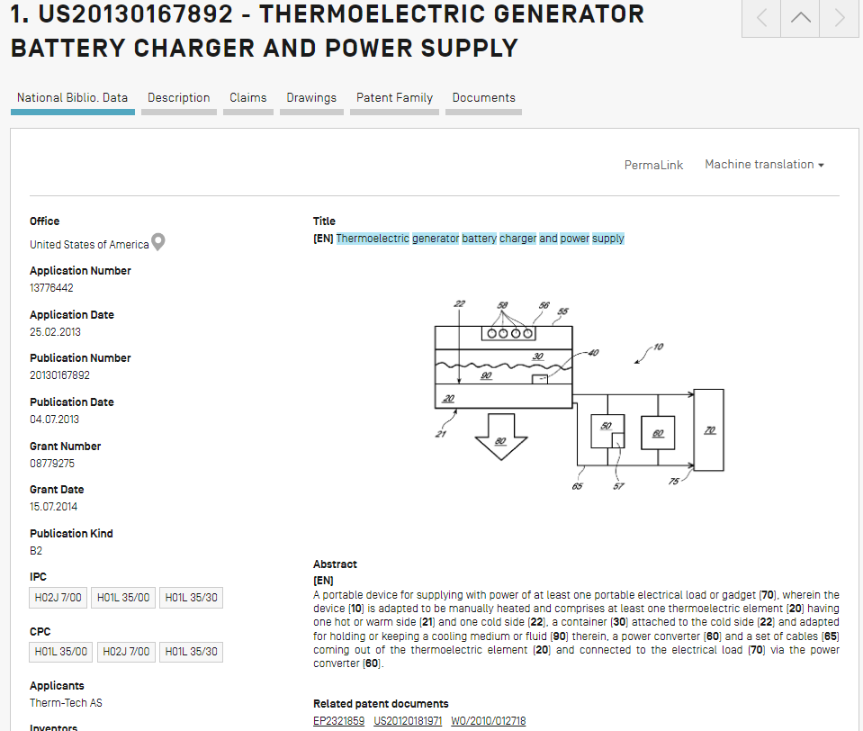

Figure 4: US patent discovered by searching the citation cloud for a thermo-electric heat exchanger on WIPO’s PATENTSCOPE database.

Figure 11 below from the Biofuels Example workbook shows how ideas from this patent were adapted as potential new products or product lines. As shown in that Figure, “Thermo-electric generators” was added as a new product or service for the “On-site electricity” product family (cell C9). The idea for a vehicle battery charger suggested the possibility of a new product line, so “vehicle battery chargers” was entered as a product line within the “On-site electricity” product family (cell B10). Note that similar products could also be added, in which case the product line would become battery chargers and the vehicle charger would be one product within it.



Figure 5: Thermo-electric electricity generation suggests vehicle battery chargers as a new product line within the “On-site electricity” product family in the Portfolio Construction Tool workbook for the Biofuels Example. Some columns and rows have been hidden for better readability.

Because the company is basically integrating components made by others, that suggests other integration opportunities for related products may exist, particularly where the sun’s direct or indirect heat (as ambient hot weather) is being captured. This kind of solar energy/thermo-electric energy has not been widely applied yet.

Figure 12 below demonstrates how this technique is used in the Biofuels Example, where a potential new solar product line (cell B11) was added, and new products are listed that could be thermo-electric generators (cells C11, C12) or solar collectors (cell C13). Figure 12 also shows that further brainstorming led to ideas for new product lines that use wind (cell B14) or hydroelectric force (cell B15) that could be part of the on-site electricity generation product family.



Figure 6: Addition of solar, wind, and hydroelectric power generation product lines and products in the Portfolio Construction Tool workbook for the Biofuels Example.

In addition, you will enter the results of your brainstorming by completing your descriptions of each current or proposed product or service line (column B), or product or service (column C). You should enter descriptions in the column entitled “Customer segments”, i.e. who it is being sold or offered to (column D), in the column entitled “Core benefits sought”, i.e. what customers and end-users desire as core benefits (column E), and add comments on anticipated tangible and augmented features (column F) entitled “Proposed design concept”.

### Assessing ideas

Once you have brainstormed ideas, the next step is to assess them. The Portfolio Construction Tool workbook has three categories for assessment: “Technical feasibility” (column G), “Market demand” (column H), and “Anticipated annual revenues once established in market” (column K).

Technical feasibility and market demand are each assessed on an ordinal scale of 1 to 3 entered into the cell corresponding to each product or service from column C, where a value of 1 is low and 3 is high. The last category is assessed in currency and applies only to the markets in which it will be sold (i.e. the countries and customer segments of interest).

In order to assess “Technical feasibility” (column G), first look at the maturity of the technology. An easy way to determine that is to look at its technology readiness level (TRL). The TRL scale in Figure 13 is from a Wikipedia article on TRLs.[1]

Figure 7: Technology Readiness Levels

Assuming sufficient absorptive capacity in the entity developing the product or service, technical feasibility can be based on the TRL of the technologies used for the product or service.

Absorptive capacity refers to a person’s or entity’s ability to understand, work with, and adapt the technology as needed. It is a measure that combines knowledge, skill, know-how, and experience. If there is not sufficient absorptive capacity, adjust the TRL-based Technical Feasibility downward.

The European Union definitions to determine technology feasibility will be used here:

* Anything below TRL level 5 “technology validated in relevant environment (industrially relevant environment in the case of key enabling technologies)”[2] is high risk and would be given a score of 1 in the technical feasibility assessment for the Portfolio Construction Tool.
* TRL level 6 “technology demonstrated in relevant environment (industrially relevant environment in the case of key enabling technologies)”[3] and TRL level 7 “system prototype demonstration in operational environment”[4] are moderate risk and would be given a score of 2 in the technical feasibility assessment for the Portfolio Construction Tool.
* TRL level 8 “system complete and qualified”[5] and TRL level 9 “actual system proven in operational environment (competitive manufacturing in the case of key enabling technologies; or in space)”[6] is low risk and would be given a score of 3 in the technical feasibility assessment for the Portfolio Construction Tool.

“Market demand” (column H) is determined through market research. You can use the Voice of the Customer Tool results and web searching for this research.

* If the core benefits and tangible features offered by the product and its anticipated price range have been expressly stated as desirable by customers and end-users, and if web searching confirms that perspective, then market demand is high and would be a 3 in the market demand assessment for the Portfolio Construction Tool.
* If the core benefits, tangible features, and anticipated price range can be inferred to be desirable based on explicit statements and web research confirms that perspective, then market demand is moderate and would be a 2 in the market demand assessment for the Portfolio Construction Tool.
* If both sources of information do not indicate a need for the core benefits and tangible features, or the anticipated price range appears to be unrealistic, then market demand is low and would be a 1 in the market demand assessment for the Portfolio Construction Tool.

“Overall ranking” (column I) is automatically calculated by an embedded formula as the product of the ranking for “technical feasibility” (value in column G) and the ranking for “market demand” (value in column H). A value for the overall ranking is calculated for each product or service listed in column C, and displayed in the corresponding cell in column I.

The column entitled “Anticipated annual revenues once established in market” (column K) can be estimated using either of two ways: either you estimate units sold or you estimate market share.

Sometimes you can find market reports that give units. Realistically, this rarely occurs because the market reports are often at too high a level of aggregation. For example, in the Biofuels Example you may be able find the number of farms in a country by size, but not the consumption of diesel by size of farm.

One solution is to seek information about units from industry or trade associations, government agencies, relevant non-profit organizations, or experts. Another solution is to conduct sufficient interviews to feel confident you can make a rough estimate as to farm consumption of diesel by size of farm. For example, you could call a number of large farm, mid-sized farm, and small farm managers and ask them to estimate how much diesel they use in a year and what it costs them. If you multiply the number of farms by size, by their average consumption per farm of that size, and then multiply by the average cost of diesel for that farm size, you have a consumption basis that would allow you to make a rough estimate of how many units you can sell into that size category of farm.

Other times you have to estimate market share. Suppose you know the anticipated global consumption of biodiesel. Suppose also that you can find diesel consumption by country. For rough estimating purposes, you decide to assume that the share of biodiesel consumed will be somewhat equivalent to the share of diesel per se. However, if you see data suggesting that is not the case, such as data showing North America has two times the diesel consumption of lesser developed countries, then you should adjust your assumptions.

You can also ask experts for their estimate of how much of that diesel will be bought by farms (or the agriculture sector in general) for a country of interest. If other experts can give an estimate as to how much of that consumption will be by farms of various size categories, you can estimate units for the customer segments in farming.

Figure 14 shows the rankings for the biodiesel and biohydrogen mini-refineries listed in the Portfolio Construction Tool workbook for the Biofuels Example (as highlighted in the Figure). It shows the values for “Technical feasibility” (column G) and “Market demand” (column H) entered into the spreadsheet, and the “Overall ranking” (column I) calculated for each potential new product.

In this example, it was possible to estimate anticipated annual revenues for some products (see cells K4 and K5) but to be determined (“TBD”) was entered for other new products. This example also shows how to use the “Comments” column (column L) to store thoughts or tasks important for deciding whether the product should be considered for inclusion in an NPD portfolio.

Further, you can select in what time frame this new product should be developed (column J). The time frame options are: this generation (T); in the next generation (N); in the generation after next (AN); and sometime in the future (F). The example in Figure 14 shows different time frames selected for different products (see column J), with the biodiesel mini-refinery product selected for this generation (cell J4) and other new products selected for generation after next (AN) or future (F).



Figure 8: The Portfolio Construction Tool workbook for the Biofuels Example showing assessment of products. Some columns and rows have been hidden for better readability.

## How do you interpret data from the Portfolio Construction Tool and use it in your NPD process?

The data gained from using the Portfolio Construction Tool enables you to consider how the NPD initiative for this product or service can be leveraged to increase the overall value of the company in the short term, the mid-term, and the long term. Deciding just what products or services should be included in an NPD portfolio is a task for management. Upper management is responsible for balancing expenditures for near-term NPD with expenditures for products in the future. That said, to the extent consistent with maintaining a competitive advantage for the product or service being developed, it makes sense to leverage the current design to facilitate and cut the costs of future generations of this product or service, and the development of other products or services in this product or service line, related product or service lines, and other product or service families.

Management’s decisions may affect how design proceeds. In the Biofuels Example, if thermo-electrics is seen as a desirable technology path for the future, then it may make sense to incorporate that technology into the current mini-refinery product’s design even if it is necessary to develop absorptive capacity to do so. If relevant absorptive capacity is not present and thermo-electrics is not a path of interest, then it does not make sense to incorporate that technology into the current design. Such decisions provide useful guidance and constraints for the Design stage.

Results from using the Portfolio Construction Tool should be reviewed at the gate between the Design and Development stages for two reasons. First, depending on the length of time the design project has taken, some of the overall rankings or anticipated revenues from future products and services may have changed since the tool was used earlier in the Design stage. For example, market demand for online video conferencing and training software soared as the COVID-19 pandemic occurred and many countries went into lockdown. Such changes may need to be addressed in the design. Finally, the design emerging from this stage may affect the recommended time framework for a product or service in the portfolio. For example, adopting thermo-electric power generation as an add-on for a Harley-Davidson motorcycle would enable accelerating development and introduction of thermo-electric as a power source for charging the battery in a next generation motorcycle or e-bike.

1. Wikipedia, “Technology readiness level”, available at https://en.wikipedia.org/wiki/Technology_readiness_level, accessed September 22, 2021.
2. Technology readiness levels (TRL), European Commission, document available at: <https://ec.europa.eu/research/participants/data/ref/h2020/other/wp/2018-2020/annexes/h2020-wp1820-annex-g-trl_en.pdf>. Last accessed on December 12, 2023.
3. Ibid.
4. Ibid.
5. Technology readiness levels (TRL), European Commission, document available at: <https://ec.europa.eu/research/participants/data/ref/h2020/other/wp/2018-2020/annexes/h2020-wp1820-annex-g-trl_en.pdf>. Last accessed on December 12, 2023.
6. Ibid.