Competitive Advantage Tool Description

In this document we will explain how to use the Competitive Advantage Tool and how to interpret the results. Competitive Advantage is discussed in the WIPO publication *Using Inventions in the Public Domain: A Guide for Inventors and Entrepreneurs* (2020) in section 2.3 “Value chain analysis in an assessment of a firm’s competitive environment” and in section 8.4 “Assessing competitive advantage through competitive intelligence”. It is also mentioned in the discussion of market research, intellectual property, and SWOT Analysis.

In this Toolkit, we use the Competitive Advantage Tool during the Screening stage as depicted in Figure 1, below, as well as during the Design stage before entering the Development stage.

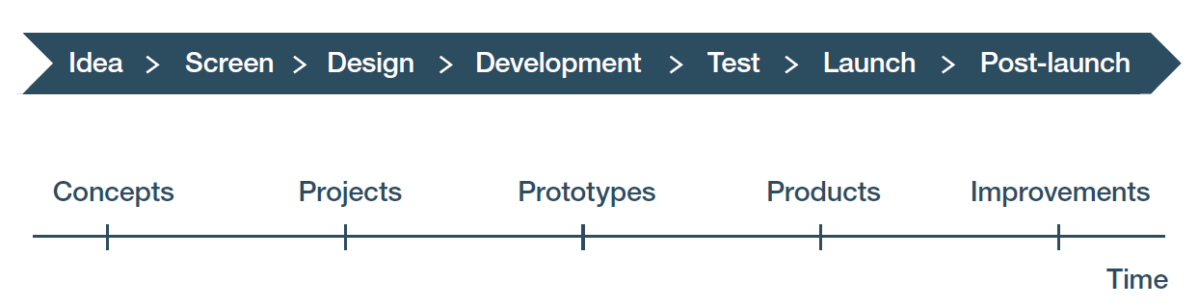

Figure 1: The Competitive Advantage tool is used early during the Screening stage, prior to entering the Design stage. The green and red arrows indicate the beginning and end of the period in which the tool should be used. This allows for early eliminating of concepts which are unlikely to have market traction. The competitive advantage of the final design is checked before entering the Development stage.

## What is Competitive Advantage?

Competitive Advantage means your product of service meets customer and end-user needs and requirements better than any other substitute. Because your product or service meets their needs and requirements better than the substitutes, if the customers and end-users are rational, they will be more likely to buy your product or service over the competition. Identifying and measuring the competitive advantage(s) of your product or service should provide you with information you can use to address adoption risk associated with your NPD initiative. On the other hand, if your product or service lacks a competitive advantage over other substitutable goods, your adoption risk may be high enough to make you reconsider your NPD initiative in its present form.

Three points are important here:

First, competitive advantage is not simply a matter of tangible features. Augmented features may also be important. Identifying which features are important is a question for market research. The Voice of the Customer Tool is one way to address this question. So is web research, visits to potential customers and end-users, surveys, and a variety of other methods.

Second, competitive advantage is often dependent on a combination of factors that can include technical features, design features, ease of use, the way the product or service is marketed, customer expectations, customer perceptions, etc. Further, buying behavior is not always rational, especially when it comes to adoption of innovations. Classic examples which failed due to factors such as bad marketing, customer indifference, displacement by new rivals or just customer tastes include the Ford Edsel, New Coke, and the Sony Betamax video cassette.

Third, markets are dynamic. The needs and requirements of your target customers and end-users can change over time. The products and services that are available for purchase and use can also change over time. Having a competitive advantage at time *t* does not mean you will have it at time *t+1.*

It helps to use a metaphor to think about gaining competitive advantage: imagine being a football (soccer) player heading the ball. You must take actions that will put you in a position to intercept the moving ball. You do that by figuring out the trajectory of the ball and then positioning yourself at a point some distance along that trajectory. In the NPD process, market forces (drivers) and barriers are what affect the trajectory.

Forces (drivers) are factors that can be statistically described, such as aging population, inflation, climate change, immigration, rate of technology development, etc. These forces can shape customer needs, wants, requirements, or preferences, which in turn shape what customers will buy and end-users deploy. Forces may also affect availability of raw materials, supplies, and other factors of production, which in turn can affect what is – or will be – available in the market.

Barriers are different. A barrier stops an identifiable group of people from buying and/or using a product or service. Barriers can be short-term or long-term. Temporary component shortages which disrupt supply chains are likely short-term barriers. The absence of sufficient manufacturing capacity for computer chips due to the COVID-19 pandemic, and the shortage of shipping containers to move chips around the globe, are examples as they prevented customers from buying those goods that require these chips no matter how much they were willing to pay. The automotive industry also suffered from this short-term chip availability barrier. Lack of regulatory approvals are often longer-term barriers. For example, prescription drugs cannot be sold without regulatory approval from the appropriate government authority, and approval to use a product is typically given only for certain diseases and treatments and then after a process that includes successful in vitro testing, phase I and II clinical trials. The US Food and Drug Administration estimates that, on average, it takes eight-and-a-half years to study and test a new drug before the agency can approve it for the general public. That includes early laboratory and animal testing, as well as later clinical trials using human subjects.

Electric cars can be used to illustrate the difference between forces and barriers. If gas prices soar exponentially and the price of electric cars drops exponentially, market forces are at play. But if a government mandates that a certain percentage of an automotive manufacturer’s products must be electric, that mandate is a market barrier to the expansion of gas vehicle sales.

Figure 2 below illustrates how forces and barriers work.

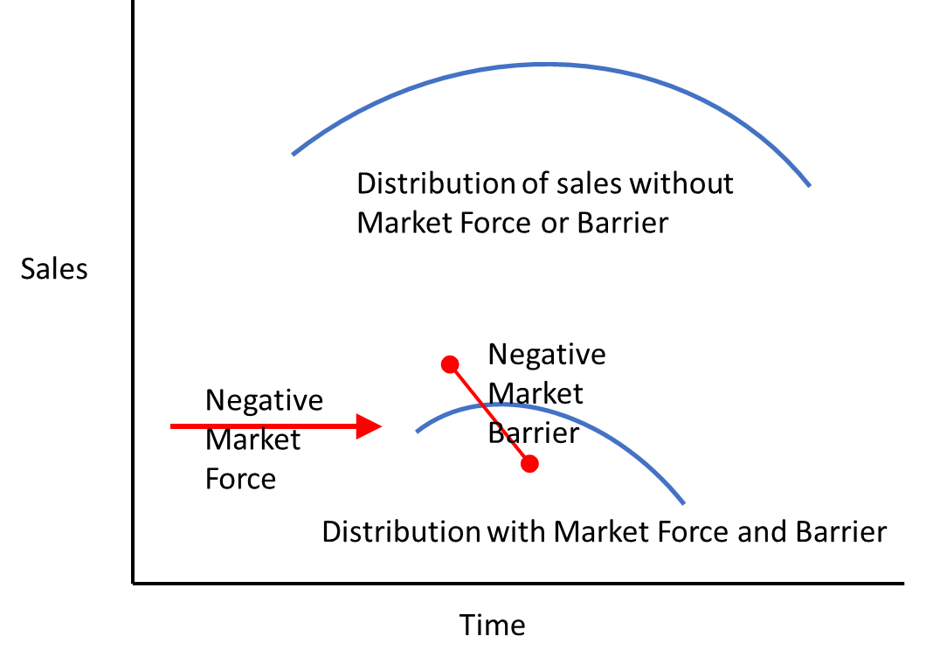

Figure 2: Market forces and barriers. The red arrow indicates that sales are deferred and reduced by a negative market force but can continue over time. The red blocking line indicates that the rest of any potential sales could be cut off when a negative market barrier goes into effect. An example where this occurs where a product fails to achieve regulatory approval and can only be used for research purposes. Figure courtesy of Foresight Science & Technology.

Because competitive advantage is so critical for market success, let us review it using an example. Suppose you want to buy a bicycle helmet. Your first concern is safety, but comfort and visibility are also important. So is price. As you compare helmets online, you find one helmet with a higher safety rating but without an LED light, and another with a slightly lower safety rating that is adequate for your needs, has a light, and a lower price. Since the second helmet meets more of your criteria, in this case the second helmet has the competitive advantage, so you buy it.

It is not enough to have a product or service that meets your customers’ and end-users’ needs. If there are substitutes available to choose instead of what you are offering, then your product or service must be more attractive than the competition. Meeting customer and end-user requirements better than any competitor is called having a competitive advantage.

## How do you find data to use in the Competitive Advantage Tool?

The data for this tool comes primarily from comparing your product or service with substitutes. These substitutes may have been mentioned in the Voice of the Customer interviews or in discussions with people in your company, organization, or agency, web searching, or other means. Web searching should involve searching for both potential or actual substitutes. Potential substitutes can be found by searching related products offered for sale for other purposes, disclosures in published patent documents, and descriptions of research and development (R&D) on relevant topics and products. You can consider asking for follow-on interviews, if necessary, to clarify the quantitative performance (expressed as interval or cardinal rankings) on specifications and prices, and qualitative performance (ordinal rankings) related to other anticipated design requirements. For example, you may want to carry out research concerning the attractiveness of a warranty for your product or service.

When searching for goods on the market today, focus on searching trade and business publication sites, websites of likely competitors, and catalogs offering relevant goods. Look for information about specific products and services as well as annual reviews of what is going on in the industries or economic sectors of interest. The list of exhibitors at relevant trade shows is also helpful because this list allows you to identify companies whose offerings you should review.

The product/service data tells you what potential substitutes might offer a competitive advantage threat today. Patent documents give you both today’s situation and a glimpse into the future. Free patent databases such as WIPO’s PATENTSCOPE database and those offered by national and regional patent offices provide access to millions of patent documents. Begin with a search for granted patents and published patent applications that disclose information that is relevant to the product or service you want to develop in this NPD project. Then focus on the granted patents and published patent applications that give important insights into what potential substitutes are emerging.

When you read a patent document, always remember you are trying to figure out if the invention is a potential substitute for your product or service, and if so, how much of a threat it is. Focus on the abstract, the description of the invention, the claims (especially the first claim), and review the drawings. The background of the invention may also be helpful for identifying what is already known and what might be unique. The title of the patent and abstract is usually only a starting point and, on rare occasions, may even be misleading. For more on how to read and use patent information, you can refer to the WIPO publication *WIPO Guide to Using Patent Information* (2022).

Patent documents also include a list of prior art references that were considered by the patent office that examined this patent document, which is helpful to look at should you decide the patent poses any potential threat. A patent document may also have subsequent citations, that is, later patent applications which cite this patent or patent application. So if you find a relevant patent document, check the references to see if features of interest to you were previously disclosed in patents that are now expired. Also check the subsequent citations to see if a newer patented invention represents an even greater competitive advantage threat. Finally, note the patent classification symbols mentioned in the patent document. All patents have patent classification symbols associated with the invention that designate the areas of technology related to the invention. By skimming though the patents in relevant classes, especially using the International Patent Classification (IPC), you may find additional patent documents that disclose additional potential substitutes.

Finally, search for reports of relevant research, which can give you an idea of what might emerge as competition in the future. There are three sets of literature to review when searching.

* The first set includes refereed publications published in refereed journals, and research papers posted on pre-publication repositories. There are a range of websites you can use to search for these reports, including Google Scholar, Science Direct, PubMed, GreyB, Evolve, arXiv, and many others. While the patent databases mentioned above are free, as are most trade and industry sites, private sector repositories of research reports usually charge fees for access.
* The second set is databases of research awards. Most government agencies, foundations, and NGOs making R&D awards will have sites where you can search for information of the awards they have made. Such databases include the European Union’s CORDIS site and the United States SBIR.gov site, and similar websites exist for award programs in other countries. The information in these databases can include what the project is, who was awarded the grant, and who performed the research. These databases may also provide technical reports, or links to reports, that describe the details and outcomes of the funded research.
* The third set is sites containing information about technologies available for licensing. Almost every research university, research institute, hospital, or laboratory will have a site listing technology it is licensing. Many government agencies also list technology that is available for licensing, and sometimes list patents they have put into the public domain. Look for entities that have on-going research relevant to the product or service you are developing. Then look for their technology transfer, commercialization, knowledge sharing page. For a wider search, the Association of University Technology Managers (AUTM) has a database called AIM (AUTM Innovation Marketplace). Likewise, WIPO GREEN is an online platform for technology exchange. If you find something relevant, then search the website of the university or institution that posted the technology as there may be other technologies on their site.

For follow-on interviews, think about who is likely to have the information you are seeking. If the product is sold through wholesalers, distributors, or sales representatives, these people can be helpful as they often represent several different products and thus can clarify the differences. People who write annual industry reviews in trade journals have similar cross-cutting knowledge. People who track economic sectors which will use your products or services or who are in test laboratories may also be useful. If you asked your respondents if you could recontact them when doing your Voice of the Customer research, then these individuals may be helpful here. Even if they do not know, they may have ideas of where you can find the data you seek.

Because the market is always changing, you must constantly repeat and update your competitive advantage analysis as you approach subsequent gates in NPD. Never rely on old data. Always check what you find with your team to get their read on actual or potential threats.

An honest assessment of the competition may force you to reevaluate the core benefits and features of your product or service. That has consequences for whether or not you continue the NPD initiative on the one hand, and what modifications must be made to the Project Charter and Action Plan on the other hand should you decide to move forward. A strong competitive advantage at the time of launch helps to protect the project investment.

## How do you enter data in the Competitive Advantage Tool?

The first three tabs of the Competitive Advantage Tool are where you enter the results of your searching for potentially substitutable products or services (see Figure 3, below, from the Biofuels Example).

Note that for each item you found, you must specify why it is relevant. For patent documents, you need to know the priority date as it may affect Freedom to Operate (FTO). FTO is the focus of another tool. If you found a published patent application in your search, try to determine whether or not a patent was ever granted for that application, as that may also affect FTO. You do not need to enter a website for a patent or patent application as you can easily find it again by searching for the patent number or patent application number.







Figure 3: Clips from the first three tabs of the Competitive Advantage Tool workbook showing where you enter the potential substitutes you have located; from the workbook for the Biofuels Example.

On the next tab – Inputs –, you assess how much of a threat these substitutes might be. To do that, you may need supplemental web searching or interviews. You are assessing these substitutes against the customer requirements (i.e., the desired benefits and features) identified in the Voice of the Customer Tool or obtained through other market research. Only use criteria that you are confident are important to buyers and end-users.

Rank each substitute on a scale of 1 (low) to 10 (high) on how well they meet the customer requirement. Be aware this will be a judgement call no matter how much or what kind of market research you do. The only way to know how competitive a product or service is, will be to see what sells in the marketplace when they compete against each other. So for this tool, just make your best estimate, given the data you have time and budget to gather.

Figure 4 below presents the rankings found in the Biofuels Example using this tool.



Figure 4: Rankings on the Inputs tab of the Competitive Advantage Tool workbook for the Biofuels Example.

Note that in this figure the names of some competitors have been abbreviated, so that the “Results” tables on the next tab are more readable. If you abbreviate names, use the last tab of the workbook, labelled Key for Inputs tab, to document what the abbreviations stand for.

Figure 5 presents the two charts on the Results tab. These charts are automatically generated by formulas embedded in the spreadsheet, using data you entered in the Inputs tab.



Figure 5: Charts on the Results tab of the Competitive Advantage workbook for the Biofuels Example.

The left-hand chart should be examined first. It displays the ranking of each competitor on each customer requirement. It is easy to compare the competitors to your product or service, as the rankings for your product or service are connected by the green line.

As in this example, it is unusual for a product or service to outperform all substitutes on every requirement. That is because there are usually trade-offs that must be made between the requirements. A high ranking on one requirement may lead to a lower ranking on another. In the bicycle helmet example above, we saw that in the trade-off between safety rating and price. In general, the goal is to rank highest on those requirements that are most important to buyers and end-users, and if trade-offs need to be made, then make them so you stay in the acceptable range for requirements that are less important.

One way to evaluate the Results tab is to weight the requirements. In the Biofuels Example, suppose the ability to use multiple types of waste and affordability are the most important criteria, and being environmentally friendly is less important so long as all applicable standards and regulations are met. You could multiply the ranking for most important requirements by some number (i.e., 1.5, 2, etc.) to reflect that greater importance. Alternatively, you could multiply by a number from 0.1 to 0.9 to lower the ranking of less important requirements. If you do use weighting, be sure to weight the rankings for all competitors the same way. Should you do that, record what you have done on the Notes and references tab.

## How do you interpret the data in the Competitive Advantage Tool and use it in your NPD process?

The right-hand chart on the Results tab entitled “Overall competitive advantage” averages all the rankings to give an overview of which product or service is likely to be most competitive.

See Figure 5 above for an illustration from the Biofuels Example. If your product or service does not have the highest average ranking, then re-examine your design requirements to determine how you can increase your overall competitive advantage. Do not simply revise the rankings entered. If your product or service does not have the highest average ranking, then you have a substantive problem that must be addressed. That said, if you are sure that some requirements are more important that others, or some are less important than others, you can weigh the entries on the Input table and the tool will automatically recalculate the overall competitive advantage using those weighted values.

It makes no sense to move forward with NPD on a product or service that does not have a competitive advantage. If you cannot figure out how to give your product or service a competitive advantage in the relevant market, then you may need to halt NPD and reconsider.

Be aware that even if you have determined that your product or service has a competitive advantage, that is no guarantee of market success. As we shall see in later modules, lack of freedom to operate, a poor value chain, or a poor market entry strategy can derail a product or service which appears to have a solid competitive advantage.