Action Plan Tool Description

In this document we will explain how to develop an Action Plan. Together with the Project Charter, the Action Plan is used to formally initiate a New Product Development (NPD) project.

## What is the Action Plan?

As the name suggests, the Action Plan is a description of the tasks you will accomplish in order to achieve specific milestones within the schedule indicated and with the people and budget indicated. The Action Plan identifies: 1) what are the key stages of development; 2) what are the key tasks for each stage; 3) who is responsible for each task; 4) what milestones must be met to continue development; and 5) what are the resources and budget available for completion. You likely do not know everything you have to do in detail, nor everyone and everything you will need to complete all the tasks. When that happens, your Action Plan identifies how you intend to figure it out.

If we continue using the metaphor of NPD as a voyage of scientific discovery, then the Action Plan can be seen as a plot of the anticipated course for that voyage. This initial Action Plan would be like a plot on a chart. The plot indicates where you are going and how you intend to get there. It is not the same as the course that actually will be steered because factors such as weather, uncharted obstacles, or equipment malfunction, solar winds, and gravitational pull will affect the actual course steered. Some of these factors can only be identified once you have embarked on the voyage – or in the case of NPD, once you have begun working on developing the product or service.

From the perspective of risk management, the Action Plan focuses on managing execution risk. Execution risk refers to the ability of your organization or company to actually conduct NPD. An Action Plan addresses this risk by listing the specific tangible features and/or design requirements that are necessary to realize the core benefits being sought, and then developing a framework that identifies the tasks and resources that would be needed for each feature or design requirement at each stage of the NPD process. Because the Action Plan identifies specific tasks that must be completed, and predicts the resources and timelines for completing them, it presents a more detailed understanding of what will be required to successfully execute the NPD project.

The more detailed tasking and assignment of resources is based on the “Preliminary project plan” section of the Project Charter (see Figure 1 below). Because the Project Charter and Action Plan must align, the process of developing the Action Plan may reveal that it is necessary to revise sections in your Project Charter in order to make it more realistic and persuasive. Pay particular attention to the preliminary project plan, scope, budget, spending authority, and team members in your Project Charter. Because the Project Charter and Action Plan must align and are both necessary to get a realistic overview on what an NPD initiative involves, the Action Plan is prepared prior to the formal initiation of NPD and submitted for approval together with the Project Charter.



Figure 1: Preliminary project plan section from the Project Charter workbook for the Biofuels Example

Like the Project Charter, the Action Plan is used at the gate for entering the Idea stage of NPD.

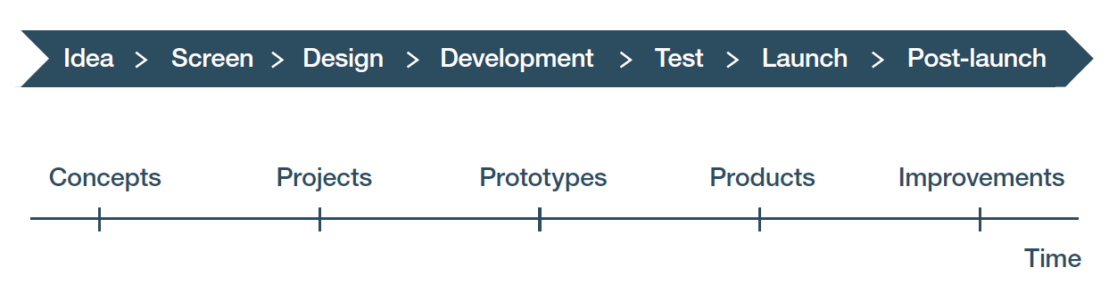

Figure 2: The Action Plan is developed prior to beginning NPD and is approved alongside the Project Charter. The red arrow indicates it must be done in time to be used at the gate for entry into the Idea stage.

It is important to review the Project Charter before starting the Action Plan, as that document defines the objectives which the Action Plan must realize and thus, is the starting point for developing the Action Plan. The entries for the Action Plan come from the project team, discussions with people throughout the company or organization’s value chain, external experts and consultants, potential vendors, and web searching.

We emphasize it is not necessary to have every sub-task pinned down before the formal beginning of the NPD project. What is essential for preparing an effective Action Plan is to know what the major tasks and sub-tasks will be, their milestones and how they will be accomplished, and to be able to indicate when and how you will figure out the sub-tasking and actions that will be required, so they can be included in the Action Plan in a timely manner. Once the NPD initiative is approved, you can develop more detailed tasking and scheduling using a GANTT chart or other project management tools, for example project management software suitable for your technology area and type of product or service.

In this Action Plan Tool, the focus is on scoping out what must be done in order to keep NPD on track to meet the goals and objectives in the Project Charter.

## How do you enter data in the Action Plan Tool?

Begin by considering what product or service is being developed. That is described in the first section of your Project Charter, entitled “Product or service being developed.” What is the core benefit or benefits the product or service will provide? In Figure 3 below, taken from the Project Charter Tool of the Biofuels Example, you can see the product or service being developed is a mobile mini-refinery and the core benefit is the on-site production of biofuels such as biodiesel or ethanol out of organic waste materials. This description may also indicate some important features, such as the ability to link multiple units and provide on-board diagnostics.



Figure 3: Core benefit(s) can be determined by reviewing the Product or service being developed section of the Project Charter Tool workbook, as shown in that section from the Biofuels Example.

Next, consider what features your targeted customers and end-users will want the product or service to have. The core benefits are realized through the tangible and augmented features of the product or service, as indicated in Figure 4 below. Tangible features are related to the physical performance of the product or service, its ease of use, its purchase price, and the cost of using it. Augmented features relate to factors that make it more attractive to purchase, bring into operation, and reduce or spread out costs over time, thereby reducing costs in any given time period.

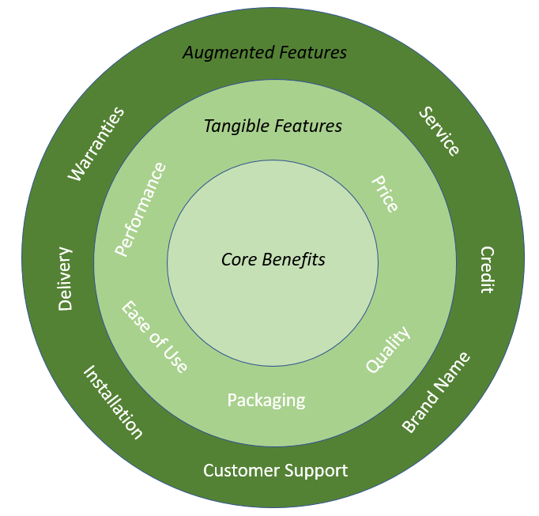

Figure 4: Tangible and augmented Features. Figure courtesy of Foresight Science & Technology.

The core benefits are the primary reason customers and end-users will buy and use the product or service being developed. The core benefits you intend to provide are found in the “Targeted customer segments and why they will use it” section of your Project Charter. See Figure 5 below, taken from the Project Charter workbook of the Biofuels Example.



Figure 5: Core benefits are found in the Targeted customer segments and why they will use it section of the Project Charter, as shown in that section from the Project Charter Tool workbook for the Biofuels Example

The key tangible feature in this example is the ability to make biodiesel on site. Another tangible feature is the reduction in cash flow drain. This second feature is also seen in the project’s “Success metrics” section, which in the Biofuels Example includes a two-year payback period for customers as shown in Figure 6 below, taken from the Project Charter for the Biofuels Example.



Figure 6: The Success metrics section of the Project Charter Tool workbook for the Biofuels Example

Note that augmented features are not discussed in either section of the Biofuels Example Project Charter. However, you can infer some augmented features associated with these two sections. For example, to reduce the time to payback, installation and training may be required. Financing may also help meet that objective.

## The Action Plan Tool workbook

The Action Plan Tool is a workbook with two tabs for entering information, and a third tab for your notes and references. As noted above, the Action Plan being developed with the aid of this tool is focused on what is necessary to provide the benefit(s) driving product development. For that reason, the Capabilities and capacities tab (tab 1) begins by considering what are the critical tangible and augmented features for your buyers and end-users. As shown in Figure 7 below, a description of each of these features is entered into a cell in row 2 of the spreadsheet, entitled “Tangible features OR design requirements to realize core benefits sought.”



Figure 7: A portion of the Capabilities and capacities tab of the Action Plan Tool workbook for the Biofuels Example

The ability to determine what features to enter assumes some familiarity with the market. Even if you are in a company selling similar or related goods, it helps to visit some current or potential customers to discuss their requirements and preferences for a good like the one you intend to develop. A bit of market research on the web is also recommended. If you are not currently in the market selling related goods, more extensive market research is called for. You can use the Voice of the Customer Tool for that. A separate module focuses on that tool, so please refer to it if you would like to use that tool to collect data for this part of the Action Plan.

Note that this approach begins with consulting relevant sections of the Project Charter and then determining the tasking and resources necessary to provide the core benefit(s) the Project Charter calls for providing. The Capabilities and capacities tab of the Action Plan Tool provides a structured approach that probes for information relevant to each feature. To illustrate this, for the feature listed in column A, rows 3-11 ask you to enter specific types of information about that feature. This approach helps to ensure the two documents are aligned. It is permissible to go back and revise the Project Charter based on insights gained while creating the Action Plan.

The second tab is labelled “Action plan framework.” The spreadsheet on this tab guides you through the development of your tasking and milestones for each feature, and then asks you to identify who is responsible for completing key tasks at each stage. This data can then be used to develop a GANTT chart or other project scheduling chart which will also include who is responsible for the tasking, the budget, and the schedule dates.

The Action plan framework tab has two sections with different but related functions. The section on the left-hand side entitled “Steps involved and percentage of anticipated progress toward completion” builds on the features and design requirements developed using the spreadsheet on the Capabilities and capacities, tab. These features and requirements are reviewed by the NPD team. After reflecting on them, go to the section on the right-hand side of the Action plan framework tab entitled “How it will be accomplished and how you will know it is done” that focuses on developing high-level tasking. Here you create a list of features or design requirements that are specific, concrete, and addressable in column A. In columns B through H then determine the stage of NPD when work on creating each tangible feature or design requirement should be done, and how much of the total effort is expected to be expended at each stage.



Figure 8: The left-hand side of the Action plan framework tab of the Action Plan Tool workbook for the Biofuels Example

Data is entered in columns under the heading “Steps involved and percentage of anticipated progress toward completion” only after conferring with the people who will be responsible for doing that tasking. This way of developing the Action Plan is called concurrent engineering. Concurrent engineering involves people from throughout the value chain in developing the tasking and detailed design requirements. (The value chain is the set of activities needed to create, make, market, sell, deliver, and support the product or service.) The key tasking (high level description of the tasking) is developed using the entries on the right-hand side of this tab, the entries on the “Capabilities and capacities” tab, and the Project Charter as the starting point.

In the example above from the Biofuels Example, note that the previous tab (“Capabilities and capacities”) listed complex, high-level tangible features and/or design requirements including “make biofuel”, “ease of use sensor and software”, “delivery”, “biomass for testing”, and others. However, on the Action plan framework tab, in column A labelled “Tangible features OR design requirements”, you enter more specific information on the features and requirements desired, such as “cutting and mulching waste equipment”, “brewing vats and capture tanks”, “cleanable filters”, “piping and valves”, “conveyers” etc., so that an action plan to create them can be formulated. It is very important to break down the project into specific, manageable, addressable features for this tab of analysis. The features and requirements here must be “SMART”, meaning specific, measurable, achievable, relevant, and time bound.

The data in the columns under the header “Steps involved and percentage of anticipated progress toward completion” are “guesstimates” based on the Project Charter, as seen in Figure 9 below. You should anticipate that these percentages will change as the critical tasking is developed using concurrent engineering. Indeed, the “Tangible features OR design requirements” entries may also change as key tasking is developed. That means you must be prepared to revise the Capabilities and capacities tab of this workbook as well as the Project Charter to ensure the two documents remain internally aligned and aligned with each other. Be aware that you may have to revise the team members in the Project Charter if additional capabilities and capacities are critical to include.



Figure 9: The Preliminary project plan and Target date sections from the Project Charter Tool workbook for the Biofuels Example.

One way to check the realism of your milestones is to look at similar projects your company or organization has done. If it has not done any, you can examine government awards to entities doing similar work and/or consult experts. The European Union’s CORDIS site presents projects and their results, together with project duration and budget. The United States SBIR.gov site allows you to search for information on projects, award size, and duration for the Small Business Innovation Research and Small Business Technology Transfer programs. Similar websites exist for award programs in other countries. Note that these sites also provide insight into the budget and durations for your Action Plan.

As an aside, another aspect of being realistic when you develop the actual Action Plan is to allow for time and budget to recover from unforeseen problems. NPD is called “new” product development because what is being done is to make something new. By definition, that means it has not been done before. That, in turn, means something is likely to go wrong somewhere along the line. By including a cushion, something that goes wrong will not derail the entire NPD initiative. Just how big the cushion needs to be will depend on how similar this initiative is to ones which your team and your company or organization have done previously. For example, the James Webb Space Telescope was originally estimated to cost NASA $4.96 billion and launch in 2014. Instead, NASA spent $8.8 billion on spacecraft development between 2003 and 2021. The more you boldly go into the unknown, the greater the cushion needed.

Next, turn to the section on the right-hand side of the spreadsheet on the Action plan framework tab, entitled “How it will be accomplished and how you will know it is done”. This section requires a different approach that involves thinking about what should be the relevant milestones and the progress that should be obtained by the end of each step in your NPD. This section then requires you to determine the tasking that needs to be done, the budget, and the schedule in light of the tangible features or design requirements found on that tab. This section of the Action Plan Framework tab for the Biofuels Example is shown in Figure 10 below.



Figure 10: The right-hand side of the Action plan framework tab of the Action Plan Tool workbook for the Biofuels Example.

Perhaps the most important element to understand about the Action Plan Tool is that its preparation is an iterative process. As people are pulled into concurrent engineering, new insights are gained and the data changes. Each time new data is entered, the rest of the entries in this workbook and in the workbook for the Project Charter must be re-examined for consistency. There is a back-and-forth process which seeks to combine the goals and objectives of the Project Charter with the practical realities of attaining those goals and objectives, as captured in the Action Plan. Only at the end of this iterative process can a project schedule be prepared with the aid of a GANTT chart or other project scheduling software.

## How do you interpret the data in the Action Plan Tool and use it in your NPD process?

Remember that the Action Plan is a plot for the anticipated course for an NPD initiative. Although the Action Plan is developed prior to the formal initiation of NPD and is an estimate of the tasks, time, and resources that will be needed, realism is critical to developing this estimate. When both the Project Charter and the Action Plan align and seem reasonable, that is a good sign you are on the right path. When all the key players for completing NPD, product launch, and market expansion have participated in the development of the Action Plan and are supportive of the plan, then you are ready to go. If realism, alignment, or support are missing, it is wise to reconsider the NPD initiative.