December 2, 2004
DRAFT
“ENLARGED” CONCEPT OF NOVELTY: INITIAL STudy concerning novelty
and the prior art effect of CERTAIN applications
under Draft Article 8(2) of the SPLT
prepared by the International Bureau

I. SUMMARY

1 The present initial study is submitted upon request of the Standing Committee on the Law of Patents (SCP) at its tenth session, held in Geneva from May 10 to 14, 2004, in order to provide a basis for discussion concerning a possible new novelty concept applicable to the prior art effect of unpublished earlier applications under Article 8(2) of the draft Substantive Patent Law Treaty (SPLT). The study aims at providing broad background information and at facilitating further substantive discussion in the SCP, and thus addresses not only national and regional laws and practices regarding the prior art effect of earlier applications, but also the policy objectives underlying these different practices.

2 The divergences among national laws and practices in respect of the prior art effect of unpublished earlier applications seem to reflect different principles and objectives underlying the prevention of double patenting. Examining a number of national and regional laws and practices, it appears that those different practices correspond mainly to one or more of the following three models:

(i) Strict novelty: if a claimed invention is explicitly or inherently disclosed in an earlier application, the earlier application defeats the patentability of the claimed invention;

(ii) Broader novelty: even if the claimed invention is not fully disclosed (explicitly or inherently) in the earlier application, the earlier application defeats the patentability of the claimed invention if the differences between the two are minor (for example, a replacement with a well-known equivalent element);

(iii) Novelty and inventive step (non-obviousness): the earlier application defeats the patentability of the claimed invention if the latter lacks either novelty or inventive step (non-obviousness) compared to the earlier application.

The present initial study describes the characteristics of the different models in detail and further outlines possible legal and practical consequences of applying those models.

3 Further, since each model inherently provides certain advantages and disadvantages, many national and regional laws provide additional mechanisms in order to meet the underlying policy objectives, for example, provisions that avoid self-collision (earlier unpublished applications do not constitute prior art in respect of applications filed later by the same inventor or applicant) or a mechanism to subject the patent term of the later patent to that of the earlier patent (terminal disclaimer). The study examines the effects and the applicability of those mechanisms when combined with the different models. Since the adjustment of the term of protection per se is neither a matter of prior art nor of novelty, it is suggested that this matter does not need to be discussed in conjunction with the determination of the prior art effect of earlier applications.

4 In accordance with the request of the SCP, the initial study also considers the implications of extending a broader novelty concept to the issue of novelty in general. It seems that applying a broader novelty standard to publicly available prior art or imposing a strict novelty standard to such prior art does not lead to significant practical problems. In the former case, certain claimed inventions may be refused on the ground of lack of novelty, and in the latter case, they may be refused on the ground of lack of inventive step. Further, although a strict novelty standard can be applied to other cases involving a determination of the same invention, such as the validity of a priority right, divisional applications or amendments, the objectives underlying the novelty requirement and these other cases are different. A broader novelty standard may not easily be applied to, or appropriate for, those other cases in respect of which the preservation of the original contents of the application is decisive.

5 The initial study reveals that the different approaches in respect of the prior art effect of earlier applications reflect different patent cultures and societal objectives as well as different ways of balancing the interests of the parties involved under each legal framework. Therefore, each of the various systems constitutes a delicate balance of social, economic and legal factors. The main objective of harmonizing the prior art effect of earlier applications is to achieve a uniform prior art basis at the international level, thus contributing to more legal certainty and facilitating mutual work sharing among Patent Offices. In order to achieve this goal, a common standard on this issue at the international level would at least need to aim at achieving simplicity, clarity, legal certainty and predictability.

ii. INTRODUCTION

6 At its tenth session, held in Geneva from May 10 to 14, 2004, the Standing Committee on the Law of Patents (SCP) requested the International Bureau to prepare a study on a new novelty concept applicable to the prior art effect of earlier applications under Article 8(2) of the draft Substantive Patent Law Treaty (SPLT). The SCP further agreed that the study would focus initially on draft SPLT Article 8(2), but would also consider the implications of extending such a concept to novelty in general (see paragraph 94 of the draft Report of the tenth session of the SCP (document SCP/10/11 Prov.2)).

7 The background of this document is provided by the discussions of the SCP concerning the prior art effect of earlier applications. Earlier applications are applications the filing or priority date of which is earlier than the filing date (or priority date) of the application under consideration, and which are published on or after the filing date (or priority date) of that latter application. Although at the time of filing, the applicant of the later application would not, in general, know that an earlier application had been filed (since the earlier application would not yet be available to the public), such an earlier application forms part of the prior art in respect of the later application in many jurisdictions.

8 Since the very beginning of the discussions on the draft SPLT in May 2001, the draft texts submitted to the SCP have included provisions on the prior art effect of earlier applications. In addition to other issues discussed in the Committee, such as the question of the prior art effect of unpublished earlier filed international applications under the Patent Cooperation Treaty (PCT), the issue of the extent of the prior art effect of earlier applications (namely whether such effect should extend to novelty only or to both novelty and inventive step/non-obviousness) has been on the table since the beginning of the relevant discussions. The report of the fifth session of the SCP reflects the split of opinions among delegations on this matter which first appeared at an early stage of the discussions on the draft SPLT.

9 While the text relating to the prior art effect of earlier applications contained in the draft SPLT has evolved over several sessions of the SCP, the main question of the extent of such a prior art effect as mentioned above has not yet been solved due to fundamental differences in approach among delegations. Although the latest versions of the draft SPLT apply the prior art effect of earlier applications to novelty only, the debate on whether such prior art effect should also apply to inventive step/non-obviousness is still going on.

10 At the eighth session of the SCP held in November 2002, some delegations pointed out that the question of the difference in practice between applying the prior art effect of earlier applications to novelty only and applying it to both novelty and obviousness would depend on the criteria for determining novelty. Similar arguments were put forward at the ninth session of the SCP held in May 2003. At the tenth session of the SCP in May 2004, a number of delegations suggested that, instead of extending the prior art effect of earlier applications to inventive step/non-obviousness, a concept of “enlarged novelty” could be considered as a compromise. In response to a request for clarification by one delegation, the Chair explained that a concept of “enlarged novelty” could include inherent disclosures and equivalents in addition to a strictly “photographic” concept of novelty. Following that suggestion, the SCP agreed to a proposal by the Chair that the International Bureau should prepare a study on this subject, focussing initially on the prior art effect of earlier applications, but also considering the implications of extending the concept of “enlarged novelty” to novelty in general. The present document addresses a number of issues related to this question, and further gives some consideration to the application of such a concept to novelty in general.

11 Pursuant to the mandate of the SCP, the International Bureau requested, through the SCP Electronic Forum, members and observers of the SCP to provide information concerning the “novelty” criterion and the prior art effect of earlier filed, but later published applications under draft Article 8(2) of the SPLT as applied under national laws and practices. The information received by the members of the SCP was taken into account in preparing this study.

12 Against this background, this document constitutes an initial response to the request by the SCP, aiming at providing broad background information and at facilitating further substantive discussion in the SCP. Thus, it addresses not only national and regional laws and practices regarding the prior art effect of earlier applications, but also the policy objectives underlying these different practices. The document first describes the general rules governing novelty and inventive step and then addresses the prior art effect of earlier applications as well as the policy objectives behind such rules (Chapters III and IV). Chapter V portrays various national/regional laws and practices regarding the prior art effect of earlier applications with an emphasis on the applicable notion of “novelty”, and Chapter VI outlines the concept of “enlarged novelty” described by Samson Helfgott, Director of Patents, KMZ Rosenman, New York, Heinz Bardehle, European Patent Attorney, Bardehle Pagenberg Dost Altenberg Geissler, Munich and John Hornickel, Intellectual Property Counsel, PolyOne Corp., Avon Lake, Ohio. Chapter VII provides the concept of novelty applied to earlier applications under the SPLT. Chapter VIII portrays a range of various concepts, including the feasibility of broadening the concept of “novelty”, and provides an analysis of the commonalities and differences characterizing them. Chapter IX considers a number of implications to other novelty-related issues. Chapter X draws some provisional conclusions from the previous chapters.

IiI. GENERAL CONSIDERATIONS REGARDING NOVELTY AND INVENTIVE STEP

(a) Novelty

13 The patent system confers on a patentee the exclusive right to prevent others from commercially using the patented invention in return for the public disclosure of the invention in order to enrich the existing body of technical knowledge in the world. It is a fundamental objective of the patent system that nothing be alienated from society which already belongs to it. Indeed, granting a patent on an invention already known would impose constraints on society in respect of the use of known information without offering any return or benefit. The line between what belongs to society and what can be withheld from it is, to a large extent, drawn by the notion of novelty. Accordingly, the novelty requirement is one of the most important internationally recognized principles provided under patent law.

14 The term “novelty” does not necessarily coincide with its recognized understanding in the general usage of the language. In general, patent law requires an invention to be new in the sense that it does not form part of the prior art, prior art being defined as information that, in some form, has been made available to the public (although the same form(s) are not necessarily recognized as relevant in all jurisdictions). Since the determination of novelty involves the factual question of whether the same invention has already been made available to the public before the filing or the priority date, in considering novelty, it is not permissible to combine separate items of prior art. Two questions arise in this context: Firstly, what constitutes “prior art”? Secondly, what does the expression “form part of the prior art” mean?

15 The first question is twofold. In many national/regional patent systems, the prior art in connection with the novelty criterion consists of any information made available to the public in any form (by written or oral disclosure, by use, etc.) anywhere in the world before the filing date (or the priority date), while in a number of other systems, non-written public disclosures in foreign countries are not considered as prior art. Further, in many countries/regions, earlier applications which have an earlier filing date (or priority date) than the filing date (or the priority date) of the claimed invention, but which are published after that latter date, also form part of the prior art. As stated above, the prior art effect of such earlier applications will be examined in more detail in the following chapters. The second question concerns the comparison between the claimed invention and the prior art. It addresses one of the key issue of this study, that is, the determination of the extent of public disclosure through publication, oral disclosure, by use or in any other way, which is needed to trigger anticipation of the claimed invention.

(b) Inventive step (non-obviousness)

16 In addition to the novelty requirement, the inventive step (non-obviousness) requirement is another internationally recognized requirement of patentability under patent law. Human beings constantly create new inventions. Some of those may be truly innovative. Many, however, differ from known art only in minor details and could easily have been conceived by other inventors without any inventive activity. Thus, the objective of the inventive step (non-obviousness) requirement is to prevent inventions involving only trivial accomplishments from obtaining a patent that confers rights to exclude others from exploiting the patented invention. In other words, only truly inventive achievements over the existing art, and not developments that a person with ordinary skill could easily deduce from what already exists, should be rewarded with an exclusive right.

17 In general, an invention is considered to involve an inventive step (be non-obvious) if, having regard to the prior art, that invention is not obvious to a person skilled in the art on the filing date (or the priority date). In the context of this study, the question of the definition of the term “prior art” for the purpose of the determination of inventive step (non-obviousness) may arise. As will be developed in more detail below, one of the major differences among national/regional laws is that, in some systems, earlier, unpublished applications are also considered as part of the prior art for the determination of inventive-step (non-obviousness), while in other systems, applications that have not been made available to the public before the filing date (priority date) of the application under consideration are not taken into account for the determination of inventive step (non-obviousness).

Iv. PRIOR ART EFFECT OF EARLIER APPLICATIONS

(a) General aspects

18 The above general considerations on prior art apply to situations where the prior art was published before the filing or priority date of the application under examination. A more complex situation occurs where different applications covering the same subject matter (in full or in part) are filed at relatively short time intervals, but the earlier application has not yet been published at the time of filing of the later application. Since Patent Offices generally do not publish applications on the day on which they are received, there are inevitably a number of earlier applications the filing (or priority) date of which is earlier than the filing (or priority) date of the claimed invention, but the publication of which occurs later than the filing (or priority) date of the claimed invention. The general rules in respect of prior art, according to which the body of knowledge made available to the public before the filing (or priority) date constitutes the prior art, do not address this specific issue. Without special provisions, earlier applications would not have priority over later-filed applications, because the earlier applications were not available to the public before the filing (or priority) date of the later-filed application. Such a situation could lead to unsatisfactory results, in particular, in a first-to-file system. This situation requires the legislator to make certain choices. These choices may relate to a number of different criteria, which are not necessarily compatible at first sight. For example, the interests of the inventors need to be safeguarded, while at the same time, those of third parties and the public, as well as legal certainty, need to be taken into account. Furthermore, the possibility of delays in the granting procedure need to be considered as well. Consideration also needs to be given to one of the important principles of patent law, that is, the prevention of granting more than one patent in respect of the same invention (so-called ban on double patenting).

19 In order to avoid double patenting in respect of identical inventions, strictly speaking, it is sufficient if the later application is not granted a patent on the same invention that is claimed in the patented earlier application (so-called prior-claim approach). This approach, however, has several drawbacks such as: (i) the later application cannot be processed (that is, a patent cannot be granted) until the final wording of the claims of the earlier application is determined; (ii) where the invention claimed in the later application was contained only in the description of the earlier application, in view of the objectives of the patent system, it may not be appropriate to grant a patent to the later application because the publication of the later application does not enrich the public knowledge through a new technical contribution; (iii) it may encourage defensive subsequent applications since third parties may file later applications which claim the invention that was contained only in the description of the earlier application. For these reasons, under many patent laws, the prior art effect of earlier applications is determined taking into account the whole contents of these applications (so-called “whole contents” approach).

20 The whole contents approach is based on the assumption that the earlier application as a whole (that is, with its complete disclosure) forms part of the prior art. The whole contents approach has the advantage that the matter contained in an earlier application which is taken into account for a later filed application remains unchanged, that is the disclosure of the earlier application as of its filing or priority date is considered. Thus, the work to be carried out for determining the relevance of an earlier application under the whole-contents approach is, in principle, identical to determining the relevance of any other prior art document.

21 In order to avoid potential double patenting, it is essential that the later application is not granted a patent if it claims the same subject matter that is contained in the earlier application. The emphasis here is on balancing the rights of the applicant of the earlier application with those of the applicant of the later application. Yet, this is perhaps not the only issue to bear in mind: the rights of the applicant of the later application and the rights of the public require consideration as well.

22 Where the claimed invention in the later application is not the same as the invention contained in the earlier application, but is an obvious variant of the invention contained in the earlier application, there is no risk of double patenting stricto sensu by virtue of the grant of a patent in respect of the later application. However, some argue that according an exclusive right to the applicant of the later application for merely an obvious variant of what has been invented by the applicant of the earlier application disrupts the delicate balance between the interests of the applicant of the earlier application and those of the applicant of the later application and of the public. In other words, granting a patent to such a later application could result in preventing non-value-added subject matter from entering the public domain. Following this line of thinking, some conclude that the later application claiming different, but (in respect of an earlier application) obvious, subject matter should not be patentable vis-à-vis that earlier application.

(b) Main approaches in detail

Prior art effect applied to novelty only

23 As described above, the rationale for applying the novelty-only approach to the prior art effect of earlier applications is mainly to avoid granting two or more patents for the same invention, a governing principle which is common to many patent systems. If that is the main objective, the novelty-only approach is sufficient to address the issue. It allows, in particular, to avoid that more than one patent is granted in respect of the same subject matter. Some argue that, with respect to the prior art available to the public, the later applicant’s invention must involve an inventive step in order to justify an exclusive right. However, as regards the non-published earlier applications already pending, the later applicant does not have to make an inventive contribution over the first invention in order to prevent double patenting. In addition, the ban on double patenting seeks to ensure that no unjustified extension of the exclusive right is obtained for the same invention. The effect of applying the novelty only approach is that, without any additional rule, both the applicant of the invention contained in the earlier application and third parties who have developed improvements or variants of the invention contained in the earlier application can obtain a patent for those developments, even if they are considered obvious.

24 This approach offers the possibility of patenting new, but obvious developments during a limited time period, that is, between the filing date of the earlier application and its publication. It is therefore rather favorable to the granting of rights to further developments of earlier inventions, even if such developments are obvious, minor technical achievements. On the other hand, it may result in the granting of a number of patents in respect of subject mater that are, although not identical, nevertheless obvious. Such a thicket of overlapping patent claims may lead to complexity in terms of the number of co-existing rights, and also with regard to the relationship of those rights among themselves, in particular, where they are owned by different persons. Consequently, the exploitation of those rights may become more complex. Further, it may be more complicated for third parties to obtain licenses from the various patentees. In addition, a patent granted in respect of a later invention containing only a minor variation compared to the earlier invention might, in effect, extend the term of patent protection with respect to the earlier invention.

Prior art effect applied to novelty and inventive step

25 The main objective of applying the prior art effect of earlier applications to both novelty and inventive step is, in addition to avoiding strict double patenting, to prevent a proliferation of patents in respect of new, but nevertheless similar inventions. One additional argument sometimes put forward is that there is no reason for treating the novelty and the inventive step/non-obviousness aspects differently, since, once an earlier applicant has filed an application before the Office, he has taken the necessary step to communicate his invention to the public. Therefore, he should be able to rely on the filing of the earlier application to prevent any later applicant from obtaining a patent for a later invention which is obvious in respect of the invention he had disclosed (even though it may not yet have been published).

26 This second approach aims to prevent the patenting of developments which are new and obvious vis-à-vis an earlier application, even if the applicant of the later application could not know that an earlier application was pending at the time of his later filing. It is further intended to prevent the extension of the patent term by prohibiting claims in a second patent that are not inventive over claims in the first patent. This approach also raises some issues: one of them relates to the fact that, in practice, inventors often file a first application and later improve the invention contained in that first application. Where such improvements are obvious in respect of the invention contained in the earlier filed application, there is no possibility for the inventor himself to obtain a patent for his own developments.

27 One of the counter-arguments to the above conclusion that later obvious inventions should not obtain a patent in view of patentable earlier applications is based on the ground that, at the time of filing of the later application, the earlier application was not available to the public, that is, that the applicant of the later application arrived at the obvious variant independently without knowledge of the subject matter contained in the earlier application. Focusing on the individual and independent achievement by the applicant of the later application, it is thus sometimes argued that his achievement should be reviewed against the published state of the art which was available at the time of filing, but not against information of which the applicant could not have been aware of.

28 In sum, this approach bars the possibility to patent obvious improvements/developments of an invention contained in an earlier application, even if they were made independently and are not derived from that first invention.

Measures to adjust the system

29 The above two main approaches inherently contain some practical issues which may not be in line with some of the underlying policy objectives. The first issue relates to the fact that it is the whole contents of an earlier application that eventually became part of the prior art. It may happen that, shortly after filing an earlier application, the applicant realizes that subject matter disclosed, but not claimed, in his earlier application is worth obtaining patent protection. Under the whole contents approach, however, where the applicant disclosed subject matter in the description of an earlier application, but did not claim such subject matter, the same applicant can no longer claim that same subject matter in a later application (so-called “self-collision”). In this case, although the applicant may file a divisional application on the basis of his earlier application or claim internal priority from the earlier application, he must comply with the procedural and substantive requirements under the applicable law in order to enjoy the benefits of divisional applications or of claiming internal priority. Further, since inventive activities are often carried out in a corporation by a group of inventors working together, the corporation may file more than one application containing the same disclosure of a particular subject matter, but each of which claims a different invention by different inventor(s). In particular, where the prior art effect of earlier applications applies to both novelty and inventive step, if one inventor of the group made an obvious development to the invention contained in the earlier application which had been made by colleagues in the same company, the corporation could not obtain a patent on the later invention. Some patent systems therefore provide remedies for these cases, such as provisions that avoid the self-collision (so called “anti-self-collision”), providing that earlier unpublished applications do not constitute prior art in respect of applications filed later by the same inventor or applicant.

30 A second issue relates to the concerns about extending the term of patent protection through the issuance of a second patent claiming a variation or obvious development of the first patent. Some patent systems thus require that the term of the second patent may not go beyond the term of protection of the first patent, and that both patents have to remain in the hands of the same owner (or at least related owners). Combined with the anti-self-collision rule, this aims to ensure that the inventor (or the assignee) of the first patent does not effectively extend the term of his exclusive rights via the second patent.

A possible way forward

31 The two approaches as well as measures to respond to certain concerns outlined above reflect, at least in part, conflicting underlying policy objectives. Should the patent system encourage later applications containing minor or obvious variants, thereby accepting a potential proliferation of patents related to at least similar subject matter, or should it rather aim to limit the number of such patents and primarily reward the contribution to the art by the first inventor (the applicant of the earlier application)? The divergence in the discussions in the SCP have shown that this issue is deeply rooted in the different patent cultures of the various countries.

32 As rightly pointed out by some delegations in the SCP (see paragraph 10 above), the issue depends also on the definition of the notion of “novelty” vis-à-vis unpublished earlier applications. One possible avenue to explore might thus consist in the further elaboration of that concept. Does “novelty” mean that a claimed invention shall be strictly identical to what was explicitly disclosed in the earlier application? Is subject matter that is inherently or implicitly disclosed in the earlier application also considered “disclosed” in the earlier application? If the difference between the claimed invention and what is disclosed in the earlier application is a mere replacement by a well-known equivalent element, is the claimed invention anticipated by the contents of the earlier application? The following chapter provides information concerning different national/regional practices as regards the prior art effect of earlier applications, emphasizing the notion of applicable “novelty”.

V. EXAMPLES OF National/regional laws and practices CONCERNING the PRIOR ART EFFECT OF EARLIER APPLICATIONS

33 This chapter is based essentially on the submissions to the SCP Electronic Forum by the SCP members concerning the “novelty” criterion and the prior art effect of earlier applications (see paragraph 11). All of the submissions received from members of the SCP can be found on the SCP Electronic Forum’s website.

(a) Bulgaria

34 According to Article 8 of the Bulgarian Patent Law 1993, for the purpose of determining novelty, applications the filing date (or the priority date) of which is earlier than the filing date (or priority date) of the application under examination, but which are published after the filing date (or priority date) of that latter application, also form part of prior art. Such earlier applications include earlier national, European and international applications designating the Republic of Bulgaria. The examination practice of the Bulgarian Patent Office is that a conclusion of lack of novelty may be made only when full coincidence exists between the claimed invention and the subject matter of the prior art. In addition to features expressly mentioned in the prior art, features which are implicit to a person skilled in the art are also taken into account.

(b) France

35 The concept of novelty is laid down in Article L.611-11 of the Intellectual Property Code (Code de la propriété intellectuelle (CPI)). Paragraph (1) of that Article provides that an invention shall be considered novel if it does not form part of the prior art. The prior art is defined in paragraph (2) as everything accessible to the public before the filing date of the application in writing, by oral disclosure, through use or in any other form. Paragraph (3) provides that, for the purpose of determining novelty, prior art also consists of certain earlier applications (national applications as well as European applications and international applications under the PCT designating France) the filing dates (priority dates) of which are earlier, but the publication dates of which are later, than the filing (priority) date of the application under consideration.

36 As regards the practice by the National Industrial Property Institute (INPI), according to the Directives concerning the examination of patent applications, Title I, Section C, Chapter VIII, p.25 and 26, lack of novelty can be determined in case where “there is identity between the claimed invention and the item of prior art, that is, when they are exact copies, the effect of the prior art being flagrant and indisputable. The disclosure of specific technical means in the prior art destroys the novelty of general means”. On the other hand, there is no manifest lack of novelty where “the claimed invention, although it is not an exact copy of the item of prior art, only differs from that item in details, forming part of a whole which is more complex, or where there is a doubt concerning the identity of the two. In that case, a patent is granted with a search report citing that item of prior art”.

37 As regards court decisions concerning novelty determination in France, the courts apply novelty in a strict sense. An item of prior art can destroy novelty only where it is one single piece that is, it is found entirely in the patent (TGI Toulouse, October 31, 1996, PIBD 1997 III, p.92). In principle, in order to form part of the prior art, an item of prior art shall contain all the elements of the claimed invention, with definite character, with the elements which constitute the same form, the same arrangement and the same function in view of the same technical result; the item of prior art destroys novelty only where the essential characteristics are represented (Cour de cassation, March 12, 1996, PIBD 1996 611 III p.273; CA Paris February 28, 1991, PIBD 1991 506 III p.497). Consequently, it is not sufficient for the characterization of lack of novelty that the patent recapture a major part of the item of prior art (TGI Paris March 19, 2002). On the contrary, an invention is considered novel because of the only fact that, for example, it claims a function different from that of the item of prior art, even if its structure, its form and its arrangement are identical (Cour d’appel de Paris, February 9, 2001, PIBD 2001 725 III p.389).

38 With respect to the effect of equivalent means, the French Law of 1844 took into account the equivalents for the determination of novelty. Thus, a patent was revoked due to lack of novelty if the claimed invention was found equivalent to the state of the art. This practice was abandoned by the Law of January 2, 1968 which applies a stricter novelty due to the integration of the requirement of inventive step in addition to novelty and industrial applicability. According to the decision of December 1, 1993, the Appeal Court of Paris considered that an equivalent means should not be considered for the determination of novelty (Cour d’appel de Paris, December 1, 1993, PIBD 562 III p.139). In the same sense, in a decision of March 19, 2002, the Paris High Court rejected the argument that a patent should be revoked on the basis of a lack of novelty because one part of the patent was found equivalent to the prior art. The Court considered that “the prior art should present all the technical characteristics of the claimed invention. Since the novelty of the claimed invention should be considered strictly, the equivalents invoked by the plaintiff cannot be taken into account for the determination of novelty” (TGI Paris, March 19, 2002). Such practice, therefore, seems to be well-established under the French law, although there are certain isolated cases that still apply the principles that were valid before 1968 (for example, TGI Lyon, September 29, 1986, PIBD 1986 405 III p.52 and Cour d’appel de Lyon, September 10, 1998, PIBD 1999 669 III p.42).

(c) Germany

39 Section 3(2) of the German Patent Law provides that, for the purpose of the determination of novelty, the contents of applications which have earlier priority and which were published only on or after the date relevant for the priority of the later application, shall also be considered to form part of the prior art. According to the submission by the Delegation of Germany, essentially, this provision aims at preventing double patenting. This is in the interest of the public, and of the earlier applicant who should be able to trust that the inventions that he has disclosed will not be protected by another person. The restriction to the novelty examination also contributes to safeguarding the interests of the later applicant: the contents of the earlier application, which is published only after the priority date of the later application, as a rule, cannot be known to the later applicant. Therefore, he is not able to incorporate the contents of the earlier application into his considerations when further developing the known state of the art.

40 As regards the interpretation of the term “novelty”, according to German case law, the content of disclosure of a written citation is not limited to its wording (so-called “photographic novelty”). Rather, the relevant criterion for understanding the invention is the general expert knowledge of a person skilled in the art who considers the citation. The prior art of a citation comprises everything - even if not expressly mentioned - which the skilled person, in the light of his general expert knowledge, deems to be obvious or nearly indispensable from the whole contents of the single item of prior art for executing the teaching. Likewise, it also includes evident variations that are obvious from the general context of the document, that is variations which the skilled person will automatically realise and take as read, if he studies the documents carefully and focuses on the discernible meaning rather than on the wording. The Federal Court of Justice has expressly confirmed that these principles apply as well to novelty evaluation in relation to documents made available to the public under Section 3(2) of the German Patent Law.

(d) Japan

41 Under the Japanese Patent Law, the general novelty requirement and the prior art effect of the earlier applications are regulated separately. Section 29(1) deals with the novelty requirement with respect to publicly available prior art. The prior art effect of earlier applications is described in Section 29bis, which regulates, together with Section 39, the priority over two or more competing applications. Section 29bis provides, in essence, that where an invention claimed in a patent application is identical with an invention disclosed in the specification or drawings originally attached to the request of another patent or utility model application the filing date (priority date) of which was prior to the filing date (priority date) of the patent application and which was laid open to the public after the filing date (priority date) of the patent application, a patent shall not be granted for that invention.

42 Where the inventor or the applicant of the earlier application and the application under examination are the same, Section 29bis does not apply. In other words, the so-called anti-self-collision rule is applicable. Therefore, where an invention claimed in the second application is disclosed, but not claimed, in the earlier application and the inventor or the applicant of both applications are the same, the claimed invention is patentable, provided the other requirements for patentability are also complied with.

43 According to the Examination Guidelines, the expression “an invention […] disclosed in […] another application” in Section 29bis means an invention identified by the “matters described” or “matters essentially described, though not literally” in the other application on the filing date. It is explained that the expression “matters essentially described, though not literally” means those matters that are directly derivable from the matters described, taking into consideration the common general knowledge at the time of the filing of the other application. The term “common general knowledge” means technologies generally known to a person skilled in the art or matters clear from empirical rules. The common general knowledge includes “well-known art”, which is generally known technologies in the relevant technical field, such as the existence of many prior art documents describing those technologies, technologies widely known throughout the industry, or well-known technologies which are not necessary to be explained in details. It also includes “commonly used art” which means well-known and widely used art. In sum, the scope of the disclosure in the other application is determined by the subject matter which a person skilled in the art can identify on the basis of the explicit disclosure as well as the implicit disclosure that can be directly derivable from the matters described in the other application taking into account the common general knowledge of a person skilled in the art.

44 Where the other application describes a specific concept, it necessarily implies or suggests a generic concept that involves the same genus or common characteristics. On the other hand, where the other application describes a generic concept, it neither implies nor suggests any subject matter in a specific manner (except where such specific concept can be directly derived from such a generic concept, taking into consideration the common general knowledge).

45 The Examination Guidelines further clarify that, for the purpose of determining the identity of a claimed invention and an invention disclosed in the earlier application, where there is no difference between the claimed invention and the invention disclosed in the earlier application, the claimed invention and the invention disclosed in the earlier application are identical. In addition, even where there is a difference between the two inventions, the difference is considered as a very minor difference if it consists in an addition, deletion or replacement of well-known or commonly used art which generates no new effects in embodied means to solve a problem (that is, substantially identical). This is a major difference compared to the determination of “identity” between the claimed invention and subject matter described in a publicly available prior art publication. For the purpose of determining novelty vis-à-vis publications made available to the public, if there is a difference between the claimed invention and subject matter disclosed in the publication, the claimed invention is novel.

46 Where a claimed invention is defined in the alternative, if one of the alternatives is identical with the invention disclosed in the earlier application, the claimed invention is deemed to be identical with the invention disclosed in that earlier application.

(e) Netherlands

47 In the Netherlands, the prior art extends to applications that are filed before and published after the filing date (or priority date) of the application under examination for the purpose of determining novelty. This extension is an exception to the general rule that the prior art information had to be made available to the public. The reason for this exception is to prevent one invention from being double-patented.

48 The practice in the Netherlands show that not only the literal text of the earlier application is taken into account, but also everything a person skilled in the art understands immediately from the text while reading it. Further, if the claimed invention is nothing more than a normal use of the invention from the earlier application for the person skilled in the art, then the claimed invention is not considered novel. In other cases, it was decided that if the differences between the claimed invention and subject matter disclosed in the earlier application only concerned well-known equivalents to a person skilled in the art, the claimed invention lacked novelty.

49 Whether both applications are from the same person or not is irrelevant to the determination of the prior art effect of earlier applications. Similarly, assignment or transfer of rights of the earlier application to a third party does not affect the prior art effect of that earlier application.

50 According to the submission to the SCP Forum by the Netherlands Industrial Property Office, however, under the current Dutch approach, double patenting is still not prevented at 100%. Although the second patent may be new with respect to the first patent due to equivalent embodiments of the inventions, the scope of both patents may still overlap.

(f) Russian Federation

51 Article 4 of the Patent Law of the Russian Federation contains the novelty requirement. When establishing the novelty of an invention, the prior art includes, provided that they have an earlier priority, all the applications filed in the Russian Federation by other persons for inventions and utility models, the materials of which any person may familiarize himself or herself with.

52 In accordance with paragraph 19.5.2 of the Rules issued by the Office on the Compilation, Filing and Examination of an Application for the Grant of a Patent, an invention shall be recognized as anticipated by the prior art and not meeting the requirement of novelty, if the prior art inherently discloses a means with features identical to all the features contained in the claims of an application, including the characterization of the purpose of an invention.

53 When establishing the novelty of an invention, the prior art also includes inventions and utility models patented in the Russian Federation, provided that they have an earlier priority. Since this rule addresses the prohibition of double patenting, prior patents owned by the same applicant of an application under examination also become part of the prior art and only the information contained in the claims of the corresponding patent is taken into account.

(g) Spain

54 Article 6 of the Spanish Law on Patents (Law 11/1986, of March 20, 1986) governs the requirement of novelty, according to which an invention shall be considered novel where it is not included in the prior art. In addition to the prior art made available to the public (Article 6.2), the prior art shall also include the contents of Spanish patent or utility model applications, as they have originally been filed, the filing date (or priority date) of which is prior to the filing date (or priority date) of the patent application under examination and which have been published on the latter date or on a subsequent date.

55 As regards the practice followed by the Spanish Patents and Trademarks Office (OEPM) in examining the novelty of an invention which is the subject of a patent application, the following aspects are taken into account:

- the novelty of the invention as it is claimed is examined, not the different embodiments;

- an invention is not novel where the prior art (one single document) has all the technical features of the application and is suitable for solving the same problem as the invention being examined.

56 To sum up, Spanish legislation and practice provide for the requirement of novelty as an absolute requirement:

- at the global level;

- in terms of identity: if a previous document contains the same features as the claimed invention, be it explicitly or implicitly, it destroys the novelty. Minimal differences in the technical features between both documents imply that the claimed invention is considered novel, apart from where such minimal technical differences are irrelevant, obvious or matters of detail;

- a particular embodiment annuls the novelty of the general concept, but not vice versa, mainly in the case of ranges or parameters.

The OEPM indicated that, in any case, it followed the practice and guidelines of the European Patent Office, mainly in order to achieve harmonization in Europe.

(h) United Kingdom

57 Under the patent law of the United Kingdom (UK), the requirement for novelty is defined by Section 2 of the Patents Act 1977 which corresponds closely with Article 54 of the European Patent Convention (EPC). Section 130(7) of the Act states that this section is amongst those which are framed to have, as nearly as practicable, the same effects in the UK as the corresponding provision of the EPC. The policy considerations underlying this Article and the jurisprudence of the Boards of Appeal at the European Patent Office (EPO) are therefore also of relevance to the application of the novelty requirement under UK law.

58 Section 2(3) of the Act defines the state of the art as also including matter contained in an application for another patent having a priority date earlier than the application in suit, but which was published on or after the priority date of the application in suit. In order to form part of the state of the art under Section 2(3), the matter must be contained in the application for that other patent both as filed and as published, and the priority date of that matter must be earlier than that of the invention of the application in suit.

59 Details of the practice followed under the Patents Act 1977 to assess novelty of a patent application are described in paragraphs 2.01 to 2.56 of the Manual of Patent Practice. When considering whether a patent claim lacks novelty, in addition to information that is explicitly disclosed, the teaching that is implicit in the prior publication may be taken into account. In other words, the skilled person may use his common general knowledge to deduce that certain standard features of a system, product, method, etc. must be a necessary part of the disclosure and are thus implicitly present. The concept of novelty therefore has a broader extent than “photographic novelty”. However, the skilled person may not go so far as to assume that certain common but non-universal features are present; this would be a matter for obviousness instead. This distinction is emphasized in General Tire v Firestone [1972] RPC 457, which sets out the generally-held principle in UK patent law that a disclosure which would infringe a claim in a patent application if the application was granted demonstrates a lack of novelty in the same claim before grant (the “post-infringement” or “right to work” test). In this judgment, on pages 485 to 486, it is stated: “If the prior inventor’s publication contains a clear description of, or clear instructions to do or make, something that would infringe the patentee’s claim if carried out after the grant of the patentee’s patent, the patentee’s claim will have been shown to lack the necessary novelty, that is to say, it will have been anticipated. The prior inventor, however, and the patentee may have approached the same device from different starting points… but if carrying out the directions contained in the prior inventor’s publication will inevitably result in something being made or done which, if the patentee’s patent were valid, would constitute an infringement of the patentee’s claim, this circumstance demonstrates that the patentee’s claim has in fact been anticipated. If, on the other hand, the prior publication contains a direction which is capable of being carried out in a manner which would infringe the patentee’s claim, but would be at least as likely to be carried out in a way which would not do so, the patentee’s claim will not have been anticipated, although it may fail on the grounds of obviousness”.

60 The General Tire judgment continues: “To anticipate the patentee’s claim, a prior publication must contain clear and unmistakable directions to what the patentee claims to have invented… A signpost, however clear, upon the road to the patentee’s invention will not suffice. The prior inventor must be clearly shown to have planted his flag at the precise destination before the patentee”. This requirement was applied in Asahi’s Application [1991] RPC 485, where it was held that a prior disclosure had to have an enabling character in order to anticipate an invention. An invention was not made available to the public merely by a published statement of its existence, unless the method of working is so self-evident as to require no explanation.

61 The test to determine whether matter in a patent application unpublished at the priority date of the application in suit forms part of the state of the art under section 2(3) of the Act is the same as the test for whether matter in a prior publication made available to the public forms part of the state of the art under section 2(2) of the Act, as held in the Asahi judgment. In both cases, the matter has to be enabling. Furthermore, when considering novelty, matter which forms part of the state of the art under section 2(3) is considered in exactly the same way as matter that is part of the state of the art under section 2(2), as was confirmed in SmithKline Beecham’s Patent [2003] RPC 6.

(i) United States of America

62 In the United States of America, novelty and non-obviousness are determined in accordance with 35 U.S.C. §102 and 35 U.S.C. §103, respectively. Further, guidance on novelty and non-obviousness practice concerning prosecution of patent applications before the United States Patent and Trademark Office (USPTO) is found in Chapters 700 and 2100 of the USPTO Manual of Patent Examining Procedure (MPEP).

63 The prior art effect of prior-filed but later-published applications is determined in accordance with 35 U.S.C. §102(e), which reads as follows:

“A person shall be entitled to a patent unless –

[…]

(e) the invention was in — (1) an application for patent, published under section 122(b), by another filed in the United States before the invention by the applicant for patent or (2) a patent granted on an application for patent by another filed in the United States before the invention by the applicant for patent, except that an international application filed under the treaty defined in section 351(a) shall have the effects for the purposes of this subsection of an application filed in the United States only if the international application designated the United States and was published under Article 21(2) of such treaty in the English language; or

[…]”

According to MPEP 2136.04, the term “another” means persons other than the applicant (In re Land, 368 F.2d 866, 151 USPQ 621 (CCPA 1966)), in other words, a different inventive entity. The inventive entity is different if not all inventors are the same.

64 In accordance with 35 U.S.C. §103(a), in order to determine whether a claimed invention is obvious from the prior art, all subject matter that is prior art under U.S.C. §102 can be used. Thus, the prior art effect of prior-filed but later-published applications is applicable to the determination of both novelty and non-obviousness. However, 35 U.S.C. §103(c) provides that subject matter developed by another person, which qualifies as prior art under section 102(e), (f) or (g), shall not be considered when determining whether an invention sought to be patented is obvious under 35 U.S.C. §103, provided the subject matter and the claimed invention were, at the time the invention was made, owned by the same person or subject to an obligation of assignment to the same person. The subject matter and the claimed invention were owned by the same person if the subject matter, which would otherwise be prior art in respect of the claimed invention, and the claimed invention are entirely or wholly owned by the same person(s) or organization(s)/business entity(ies) at the time the claimed invention was made. Therefore, for example, if employees A and B work for a company C, each with knowledge of the other’s work, and with obligation to assign inventions to C while employed, a so called “earlier application” under 35 U.S.C. §102(e), the applicant of which is A, would not be considered when examining the obviousness of the subsequent claimed invention made by applicant B.

65 Even if the claimed invention complies with the conditions laid down in 35 U.S.C. §102(e) and §103(a) and (c) and thus the claimed invention is considered novel and non-obvious vis-à-vis earlier applications and patents, the question as to whether the doctrine of double patenting applies is examined. The doctrine of double patenting seeks to prevent the unjustified extension of patent exclusivity beyond the term of the patent. The public policy behind this doctrine is that the public should be able to act on the assumption that upon the expiration of the patent it will be free to use not only the invention claimed in the patent but also modifications or variants which would have been obvious to those of ordinary skill in the art at the time the invention was made, taking into account the skill in the art and prior art other than the invention claimed in the issued patent. Before consideration can be given to the issue of double patenting, there must be some common relationship of inventorship and/or ownership of two or more patents or applications. Since the doctrine of double patenting seeks to avoid unjustly extending patent rights at the expense of the public, the focus of any double patenting analysis is on the claims in the multiple patents or patent applications involved in the analysis.

66 There are generally two types of double patenting rejection. One is the “same invention” type of double patenting rejection based on 35 U.S.C. §101. Where the claims of an application are subsequently the same as those of a first patent, they are barred under 35 U.S.C. §101 – the statutory basis for a double patenting rejection. The term “same invention” in this context means an invention drawn to identical subject matter. A reliable test for double patenting under 35 U.S.C. §101 is whether a claim in the application could be literally infringed without literally infringing a corresponding claim in the patent.

67 The second is the “non-statutory-type” double patenting rejection based on a judicially created doctrine grounded in public policy and which is primarily intended to prevent prolongation of the patent term by prohibiting claims in a second patent not patentably distinct from claims in a first patent. In determining whether a non-statutory basis exists for a double patenting rejection, the first question to be asked is – does any claim in the application define an invention that is merely an obvious variation of an invention claimed in the patent? If the answer is yes, then an “obvious-type” non-statutory double patenting rejection may be appropriate. A double patenting rejection of the obvious-type is analogous to a failure to meet the non-obviousness requirement of 35 U.S.C. §103, except that the patent principally underlying the double patenting rejection is not considered prior art. In addition to the “obvious-type” rejection, there are some unique circumstances where it has been recognized that another type of non-statutory double patenting rejection is applicable even where the inventions claimed in two or more applications/patents are considered non-obvious over each other.

68 A rejection based on a non-statutory type of double patenting can be avoided by filing a terminal disclaimer in the application or proceeding in which the rejection is made. A terminal disclaimer is a statement filed by an owner of a patent or a patent to be granted that disclaims the terminal portion of the term of the later patent and includes in the disclaimer a provision that the patent shall be enforceable only for and during the period the patent is commonly owned with the application or patent which formed the basis of the double patent rejection, thereby eliminating the problem of extending patent life. For example, if employees A and B work for a company C, each with knowledge of the other’s work and with obligation to assign inventions to C while employed, in accordance with 35 U.S.C. §103(c), a so called “earlier application” under 35 U.S.C. §102(e) filed by applicant A claiming invention X would not be considered for the determination of non-obviousness regarding a subsequent claimed invention X⁺, which is obvious from invention X, invented by applicant B. However, the claimed invention X⁺ may be rejected on the basis of a non-statutory type of double patenting. Such a rejection can be avoided by filing a terminal disclaimer. MPEP 804.02 explains that the use of a terminal disclaimer in overcoming a non-statutory double patenting rejection is in the public interest because it encourages the disclosure of additional developments, the earlier filing of applications and the earlier expiration of patents whereby the inventions covered become freely available to the public.

(j) European Patent Convention (EPC)

69 Article 54(3) of the EPC provides that the content of European patent applications as filed, of which the filing dates (priority dates) are prior to the filing date (priority date) of the application under examination and which were published on or after the latter date, shall be considered as comprised in the state of the art. In accordance with Article 56, such European patent applications are not to be considered in deciding whether a claimed invention involves inventive step. They form part of the state of the art only for the purpose of determining novelty. Details concerning the novelty practice in the EPO is provided in the “Guidelines for Examination in the European Patent Office”, in particular in sections C-III.4, C-IV.5 to 7 and D-V.3. The relevant case law is summarized in section I-C of “Case Law of the Boards of Appeal of the European Patent Office”. According to the submission by the EPO, the most important aspect of the EPO practice concerning novelty is that the EPO practice aims to provide an absolute standard for novelty which is unambiguously distinguishable from the relative standard of inventive step.

70 The first step in deciding whether an invention is new is to define the prior art, the relevant part of that art, and the content of that relevant art. The next step is to compare the claimed invention with the prior art thus defined, and to assess whether the invention differs from such prior art. If it does, the invention is novel [Case Law of the Boards of Appeal, I.C].

71 The case law provides that for an invention to lack novelty, its subject matter must be clearly and directly derivable from the prior art (T 465/92, OJ 1996, 32; T 511/92) and all its features – not just the essential ones – must be known from the prior art. The content of a prior art document is not to be considered to be limited to what it explicitly discloses, but it includes also the implicit disclosure of the document, as interpreted by the skilled person reading the document (see T 677/91, T 465/92 (OJ 1996, 32) and T 511/92). Such implicit disclosure comprises subject matter which is “derivable directly and unambiguously” from the prior art document. This can be in the form of features which the skilled person would recognize as necessarily part of what is disclosed in the document, even if they are not explicitly mentioned. For example, in T 6/80 (OJ 1981, 434) the board found that where a further functional attribute of an element of a device disclosed in a document was immediately apparent to a person skilled in the art reading the document, such attribute formed part of the state of the art with regard to that device. Further, in T 71/93, it was held that a feature not explicitly mentioned in a prior art document, even though generally known to help overcome a drawback usual in the same technical field, could not be considered implicitly disclosed if it were not directly derivable from the prior art document that the drawback was considered unacceptable and/or if other solutions were proposed for overcoming the drawback.

72 Alternatively, in particular in the case of properties or parameters, there can be features which can be seen to be present automatically if the teaching of the prior art is put into practice. This interpretation also has the consequence that a specific disclosure can take away the novelty of a generic claim embracing that specific disclosure (e.g. a disclosed value takes away the novelty of a range including that value), but that the converse is not the case (see T 651/91 and T 508/91).

73 Moreover, well-known equivalents of features which are explicitly or implicitly disclosed in the prior art document are not considered to be “derivable directly and unambiguously” from the prior art document, and are therefore to be taken into account only for the assessment of inventive step (see T 517/90). This narrow concept of novelty, which excludes equivalents, is of particular importance for the application of Article 54(3) EPC. In T 167/84 (OJ 1987, 369) the board commented that conflicting applications within the meaning of Article 54(3) EPC were included in the state of the art solely from the point of view of novelty, but were considered in the light of their “whole contents”. In order to mitigate the harsh effects of the “whole contents approach”, its application was confined to novelty (see Article 56 EPC, second sentence). Further, in order to reduce the risk of “self-collision”, it had always been considered justified to adopt a strict approach to novelty. Accordingly, the board held that the “whole contents” of an earlier document did not also comprise features which were equivalents of features in the later document (see also T 928/93).

VI. PROPOSAL CONCERNING “ENLARGED NOVELTY” APPLIED TO EARLIER APPLICATIONS BY HELFGOTT, BARDEHLE AND HORNICKEL

74 In view of the different laws and practices at the national/regional level described above and the divergent views expressed on this matter in the SCP, Helfgott, Bardehle, and Hornickel, published an article outlining a concept of “enlarged novelty” which could be applied to the determination of patentability vis-à-vis prior filed, but subsequently published conflicting earlier applications in the international context, so as to overcome existing differences. The following paragraphs provide a summary of the article, is reproduced in its entirety in Annex III.

75 According to that proposal, conceptually, the concept of enlarged novelty is located somewhere between “photographic novelty” (no difference whatsoever between the earlier application and the claimed invention) and obviousness. The concept of enlarged novelty covers not only the subject matter explicitly disclosed in the earlier application but also all that one skilled in the art usually understands when reading the earlier application. Further, where the difference between the claimed invention and the contents of the earlier application consists of a substitution with equivalent means which is well known to a person skilled in the art reading the original disclosure, the claimed invention should also be precluded from obtaining a patent. Similarly, if a generic invention is disclosed in the secret prior art, it should preclude a subsequent application from covering a species not particularly identified within the generic disclosure (unless the “species” is in the nature of a “selection” which could give rise to patentability). To the extent that the second applicant can show that his particular species, equivalent, substitute, etc., would not have been within the original “enlarged” disclosure, because it provides unexpected benefits, unusual results or the like, he may present arguments to overcome the rejection. Also, as the earlier application can only be used for (enlarged) novelty defeating purposes, it cannot be combined with any other references or any other material to provide an obviousness type rejection.

76 This approach of applying an enlarged novelty to the prior art effect of earlier applications aims to give the full benefit of the invention to the applicant who is the first to file. Although the first applicant may have only described his invention and given some examples, someone else should not be able to come up with another equivalent or well known substitute and get a separate patent for such modified invention. The first applicant should be given protection for the full breadth of his invention and be able to prevent others from getting patents on anything falling within the scope of his invention. The first applicant, however, should not be able to hinder others from making use of his invention if combined with other independent ideas. Thus, earlier applications should not be used for the determination of non-obviousness.

77 In accordance with the above principle that the first applicant should be given protection for the full breadth of his invention, the paper proposes that the applicant should be able to claim anything disclosed in his first application from an “enlarged” viewpoint. In other words, where the applicants of both the earlier application and the application under examination are the same, the earlier application does not take away the patentability of the claimed invention contained in the latter application even if the claimed invention is not novel (in the enlarged sense) vis-à-vis the contents of the earlier application. It makes no difference whether two applications are filed by a common inventor or by a common applicant (the inventors of each application are not the same but they had an obligation to assign their inventions to the same applicant). However, with a view to achieve fairness in respect of the public, in cases where a common applicant files both applications, it is proposed that the second application be subject to a terminal disclaimer. Such a terminal disclaimer, however, should be limited to the “enlarged novelty” of the invention. If a claimed invention in the second application complies with the enlarged novelty requirement, but is obvious from the contents of the earlier application, the common inventor/applicant would be entitled to the full term of protection as regards the second application, provided that no other grounds of refusal apply.

VII. Concept of novelty applied to earlier applications under the SPLT

78 Before further exploring possible concepts of “novelty”, “enlarged novelty” and “inventive step” applied to earlier applications, it is first necessary to examine in detail how the SPLT applies the “novelty” standard to earlier applications.

79 As reproduced in Annex I, Article 8(2) and Rule 9 provide for the prior art effect of certain applications which are filed before, but published after, the filing date (or priority date) of the application under examination. According to Article 8(2)(a), earlier applications form part of the prior art for the purpose of determining novelty, but not of determining inventive step. Rule 9(1)(a) regulates the principle of the “whole contents” approach, and Rule 9(3), which provides the principle of anti-self-collision, is included within square brackets in the draft SPLT.

80 The requirement of novelty is provided in Article 12(2) and Rule 14, as reproduced in Annex II. Article 12(2) provides for the principle that the novelty requirement is complied with where the invention does not form part of the prior art. According to paragraph 157 of the draft Practice Guidelines (as contained in document SCP/11/4), the following three steps shall be applied to the assessment of novelty:

(i) determination of the [scope][elements] of the claimed invention;

(ii) determination of the [disclosure in][elements of] the relevant item of prior art;

(iii) assessment of whether every and each element or step of the claimed invention is found in the scope of the item of prior art.

81 Rule 14 provides more detailed rules concerning the determination of the relevant item of prior art when assessing novelty. In particular, Rule 14(1)(b) states that a “mosaic” approach to assessing novelty, whereby a plurality of items in the prior art are combined to defeat the novelty of an invention, may not be applied. Further, Rule 14(2) provides that the scope of the item of prior art shall be determined by what was explicitly or inherently disclosed to a person skilled in the art.

82 The following explanations regarding the inherent disclosure in the item of prior art are given in paragraph 156 of the draft Practice Guidelines:

“As regards the words “inherently disclosed”, even if a certain characteristic is not disclosed explicitly in the item of prior art, such characteristic is inherent, where it could be recognized by a person skilled in the art that, taking into account his/her general knowledge, the characteristic is necessarily contained in the disclosure. Inherency requires that the extrinsic evidence should make it clear that the missing descriptive matter is necessarily present in the information described in the item of prior art, and that it would be so recognized by a person skilled in the art. Inherency, however, may not be established by probabilities or possibilities. The mere fact that a certain thing may result from a given set of circumstances is not sufficient”.

83 In sum, according to the SPLT provisions, the scope of the disclosure of an earlier application under Article 8(2) for the purpose of the assessment of novelty is not limited to what is explicitly disclosed, but also includes subject matter inherently disclosed in the earlier application when a person skilled in the art reads the earlier application.

84 In addition to the scope of the disclosure, currently, divergent practices apply in national/regional systems with regard to the relevant date for determining the scope of the disclosure of earlier applications under Article 8(2). In some systems, the filing date (or priority date) of the earlier application is the relevant date for determining what the earlier application discloses and whether the disclosure is enabling. In other systems, the relevant date is the filing date (or priority date) of the claimed subject matter. Under the SPLT, these two positions are reflected as alternatives under Rule 14(2). This issue may also be addressed in the context of the discussions on harmonization.

85 Paragraphs 158 and 159 of the draft Practice Guidelines deal with the novelty assessment in respect of generic vs. specific disclosures. They provides that:

“An item of prior art that discloses a genus does not always anticipate a claim to a species within the genus. In other words, where a claim contains a specific disclosure, for the determination of novelty, a generic disclosure in the item of prior art does not always anticipate the claim to a specific example falling within that generic disclosure. However, where the specific example is identified with sufficient specificity in the scope of the item of prior art, the species claim is anticipated no matter how many other species are additionally described in the item of prior art.

“On the other hand, where a claim contains generic disclosure, for the determination of novelty, the disclosure of a specific example in the item of prior art falling within a claimed generic disclosure anticipates that generic disclosure. For example, the disclosure of “copper” in the item of prior art defeats the novelty of a claim comprising “metal” as a generic concept. Similarly, where a claim defines the genus of specific species in the alternatives, for example, Markush claims (P1, P2, P3 … Pn), and if at least one of the alternatives (P1) is described in the item of prior art, the whole claim would be rejected unless the applicant delete the alternative P1 from the scope of that claim”.

Therefore, in connection with the prior art effect of earlier applications, the SPLT provides that a claim containing generic disclosure lacks novelty where an earlier application discloses a specific example falling within the claimed generic disclosure. On the other hand, where an earlier application contains a generic disclosure, a claim under examination with a specific disclosure is not always anticipated by the earlier application (for example, such a species may be a so-called “selection invention” which could be patentable).

86 In addition, the novelty assessment regarding the disclosure of a claimed range is provided for in paragraph 160 of the draft Practice Guidelines, which reads as follows:

“A specific example in the item of prior art which is within a claimed range anticipates the range claimed. Therefore, where, as by a recitation of ranges or otherwise, a claim covers several compositions, the claim is anticipated if one of them is described in the item of prior art. For example, a claim to titanium (Ti) alloy with 0.6 to 0.7% nickel (Ni) and 0.2 to 0.4% Molybdenum (Mo) would be anticipated by an item of prior art that describes a Ti alloy containing 0.65% Ni and 0.3% Mo. Where an item of prior art discloses a range which touches, overlaps or is within the claimed range, but no specific examples falling within the claimed range was disclosed, a case-by-case determination must be made as to the novelty of the claim. In order to anticipate the claims, the claimed subject matter should be disclosed with sufficient specificity in the item of prior art. If the claims are directed to a narrow range and the item of prior art discloses a broad range, and if the selected narrow range is not merely one way of carrying out the teaching of the item of prior art (for example, there is evidence that the effect of the selection (e.g., unexpected results) occurred in all probability only within the claimed narrow range), depending on the other facts of the case, it may be reasonable to conclude that the narrow range is not disclosed with sufficient specificity in the item of prior art in order to anticipate the claims (a selection invention). The unexpected results may also render the claims unobvious”.

Applying the above assessment to the prior art effect of earlier applications, a claimed invention lacks novelty where the earlier application provides a specific example which is within a claimed range. On the other hand, where an earlier application discloses a range which touches, overlaps or is within the claimed range, the novelty of the claim should be assessed on a case-by-case basis.

87 In sum, according to the provisions under the draft SPLT and to its Practice Guidelines, the novelty requirement under the draft SPLT does not require a photographic identity between the relevant item of prior art and the claimed invention. Not only the explicit disclosure in the item of prior art, but also the disclosure inherent to a person skilled in the art, should be considered when assessing novelty. Taking into account the draft Practice Guidelines, the draft SPLT also provides guiding principles when assessing the novelty of special types of claims, such as claims formulated in generic/specific terms and claims defining ranges. Those general rules concerning novelty are also applicable for the prior art effect of earlier applications under Article 8(2).

VIII. possible Concepts of “novelty”, “enlarged novelty” and “inventive step” applied to earlier applications and their effects

(a) Objectives: commonalties and differences

88 Many patent systems provide that, in addition to the publicly available prior art, so-called earlier applications should form part of the prior art in order to avoid “double patenting”. The divergences among national laws and practices, as described above, do not contradict with this standpoint. Rather, the different practices seem to reflect different principles and objectives underlying the prevention of double patenting. It appears that one of the key policy questions is: where there is a granted patent, to what extent should the said patent prevent the issuance of later patents which cover the same or at least similar subject matter? Since a patent grants an exclusive right to carry out the claimed invention for a certain period of time, granting two or more patents for the same invention would reward later applicants with the same exclusive right as well, and would allow an unfair extension of the patent term with respect to the same invention. Beyond this general concept, however, the question arises as to the definition of the term “same invention” covered by more than one patent, and whether a somewhat “different” invention filed later, for example, a later invention which is obvious from the earlier patented invention, should be precluded from also obtaining an exclusive right.

89 Clearly, the issue of “double patenting” as such concerns the relationship between two claimed inventions, and it is not, strictly speaking, a matter of prior art. However, as described in Chapters IV and V, the raison d’être of the prior art effect of earlier applications cannot be considered in isolation, that is, without understanding the different principles underlying the double patenting bar. Each of those principles mirrors a certain social and cultural environment, but they all attempt, in their own way, to strike a balance among the first applicant, later applicants and the general public, and to guarantee a sound, reliable and predictable legal system.

(b) Different notions of novelty and inventive step applied to the prior art effect of earlier

applications

90 Examining the concept of novelty under the draft SPLT as well as various national/regional laws and practices as described in Chapter V, it appears that the prior art effect of earlier applications under the SPLT is in line with the laws and practices of many national/regional systems. However, there are other systems that adopt different criteria for such a determination. Generally speaking, those different practices correspond mainly to one or other of the following three models:

(i) The first model (Model A) suggests that, if a claimed invention is explicitly or inherently disclosed in an earlier application, the earlier application defeats the patentability of the claimed invention. This assessment is in line with the draft SPLT and corresponds to the practices which apply in, for example, France and the Russian Federation and under the EPC.

(ii) The second model (Model B) is located somewhere between the first model and the third model (below). An earlier application defeats the patentability of a claimed invention even if the claimed invention is not entirely disclosed (explicitly or inherently) in the earlier application. However, it is not permissible to combine the earlier application with another item of prior art. The difference between the claimed invention and the disclosure in the earlier application should be minor in the sense that it could be envisaged either by employing the general common knowledge in the relevant field of the art or by a person skilled in the art reading the earlier application with his general knowledge and ordinary skill in the relevant field of the art. Such a concept can be found in the practices of, for example, Germany, Japan and the Netherlands. The “enlarged novelty” proposal made by Helfgott, Bardehle and Hornickel can be considered to form part of this category.

(iii) The third model (Model C) provides that, if a claimed invention also lacks inventive step (non-obviousness) in respect of the disclosure in an earlier application, the earlier application defeats the patentability of the claimed invention. This practice is applied in the United States of America, in particular.

91 The above models may be illustrated as follows:

 | Prior Art Effect of Earlier Applications
Model A | Broader Novelty:  Explicit or inherent disclosure in earlier applications.  No combination of earlier applications and other items of prior art.
Model B | Broader Novelty:  Explicit or inherent disclosure in earlier applications + general common knowledge in the relevant field (for example, replacing with a well-known equivalent element).  No combination of earlier applications and other items of prior art.  -------------------------------------------------------------------------------  Broader Novelty:  Explicit or inherent disclosure in earlier applications + what a person skilled in the art can understand and envisage from the disclosure (for example, evident modifications such as a mere optimization of a size or a mere re-arrangement of elements).  No combination of earlier applications and other items of prior art.
Model C | Novelty and Inventive Step:  Combination of earlier applications and other items of prior art.

92 Comparing the above three models, Model A offers the possibility of patenting a later invention that goes beyond the explicit or inherent disclosure in the earlier application. It therefore avoids the potential risk of granting a patent to a later invention which is identical to subject matter disclosed in the earlier application. On the other hand, it allows later patents to be granted in respect of subject matter that is, although not “disclosed” in the earlier application, nevertheless apparent to a person skilled in the art applying the general common knowledge in the relevant field of art. It will encourage the patenting of further developments of earlier inventions, even if such developments are minor, thereby offering the opportunity to later inventors (including the applicant of the earlier invention himself) to obtain patents in respect of later inventions. At the same time, this model increases the risk of a thicket of overlapping patents.

93 Model B is characterized by the fact that certain matters that go beyond the explicit or inherent disclosure in the earlier application can be taken into account when determining lack of novelty. However, it does not go so far as to allow the combination of the earlier application with any other piece of prior art which would render the claimed invention obvious. Under this model, different degrees of other “matters that go beyond explicit or inherent disclosure in the earlier applications” can be explored. The first variation can be described in a way that if a person skilled in the art, having read the earlier application, can arrive at the claimed invention by applying his/her general common knowledge, the earlier application destroys the novelty of the claimed invention. The person skilled in the art can only refer to the general common knowledge in the relevant field, such as the addition/deletion of, or the replacement with, well-known or conventionally and widely used art which does not generate any substantial effect. In other words, if the difference between the claimed invention and the disclosure in the earlier application provides unexpected benefits or unusual results, the claimed invention is indeed a separate invention as in the case of so-called selection inventions, and would thus not be anticipated by the earlier application. A typical situation where a person skilled in the art would take into account the general common knowledge may be replacing an element disclosed in the earlier application with a well-known or common equivalent element which does not generate any substantial difference in effect.

94 The second variation under Model B can be described in a way that, based on the teaching of the earlier application, everything that can be understood by a person skilled in the art could be taken into account. In other words, the scope of the earlier application is extended to what a person skilled in the art with his general knowledge and ordinary skill might understand and envisage from the teaching of the earlier application. The difference between the claimed invention and the disclosure in the earlier application should be able to be, in some way, filled by a person skilled in the art when he reads the earlier application. In order to fill such a difference, the person skilled in the art can utilize his full capacity, not just the general common knowledge. For example, evident modifications to the prior art, such as the mere optimization of a size or a shape or the mere re-arrangement of elements, could evidently be made by the person skilled in the art when he reads and understands the teaching of the earlier application. However, unlike Model C, the prior art effect of earlier applications is limited to what a person skilled in the art can derive from such earlier applications, and the difference between the claimed invention and the earlier application should not be so wide that it could only by filled by combining the earlier application with other items of prior art.

95 The consequence of Model B is that the earlier application prevents later minor developments from being patented, but allows patent protection for later developments which are new but obvious. Therefore, in addition to avoiding strict double patenting, it prevents a proliferation of later patents claiming inventions providing only minor technical improvements, such as a mere substitution with well-known equivalent means with no substantial effects. In the absence of an anti-self-collision provision, this means that no one, including the applicant of the earlier application himself, may obtain a patent in respect of subject matter going beyond the disclosure in the earlier application but having a similar scope. Consequently, that subject matter either falls into the public domain or, depending on how broad the doctrine of equivalents is applied under the applicable law, is considered as infringing the earlier patent. At the same time, it leaves room for later applicants to obtain patents in respect of later inventions that are not just minor variants, but are obvious developments from earlier inventions. It allows the co-existence of later patents which do not comply with the inventive step requirement and which are not making a sufficient contribution to the state of the art.

96 If Model B was considered to be the best practice, it would need further elaboration as to the extent to which other “matters” can be taken into account in addition to the disclosure in the earlier application. Without a clear definition in this respect, it will be difficult to ensure legal certainty and predictability at the international level.

97 Model C completely bars the possibility of patenting obvious improvements or developments of an invention contained in the earlier application, even if they were made independently and are not derived from the first invention. In effect, the earlier application prevents any person, including the applicant of the earlier application himself, from obtaining a later patent which claims obvious developments, unless there is a special rule avoiding self-collision. Consequently, such obvious improvements or developments fall into the public domain. Theoretically, different variations can be considered under this model. One variation could be that, in order to deny the patentability of the claimed invention, an earlier application could be combined with other items of prior art only where they were made available to the public before the filing (priority) date. In effect, it would not be possible to combine two or more earlier applications to render the claimed invention obvious. However, such a distinction between the combination of earlier applications and the combination between an earlier application and publicly available prior art may be an artificial one, since it appears that there is no substantial reason to treat earlier applications and publicly available prior art differently in this context.

98 The above three models require different degrees of identity or similarity between the subject matter disclosed in the earlier application and a later invention in order for the later invention not to be patentable. They also clearly reflect different underlying policy choices. At the one end of the spectrum, later applications including only minor or obvious variants are rather encouraged. At the other end, certain systems prevent, in principle, issuing patents to any later developments that do not fulfil the novelty and inventive step (non-obviousness) requirements. In between, a number of patent systems found some form of a balance that they considered appropriate.

99 As regards Model B, a clarification should be made with respect to the time as at which the general common knowledge must be assessed. Should a person skilled in the art apply the general common knowledge as of the filing date (or priority date) of the later application, or should the relevant date be the filing date (or priority date) of the earlier application? Under those systems which publish applications 18 months after their filing date (or priority date), the difference between the two relevant dates will not exceed 18 months. Nevertheless, in areas of quickly advancing technologies, the evolution of the general common knowledge might be fast, and the choice of the relevant date might have serious implications. It appears, though, that such a date determining the general common knowledge should be the same as the relevant date for the determination of the scope of the earlier application (see paragraph 84).

(c) Anti-self-collision

100 As described in Chapter V, some patent systems apply anti-self-collision in conjunction with determining the prior art effect of earlier applications. At first sight, the provision of anti-self-collision does not depend on the three different models above. For each model, there is at least one country that provides anti-self-collision.

101 Anti-self-collision provides that, if the inventor or the applicant of the earlier application and the application under examination are the same, such an earlier application does not become part of the prior art. Combined with Model A, anti-self-collision would allow the same inventor or applicant to later claim an invention that was originally disclosed (either explicitly or inherently) in the earlier application. As described in paragraph 29, the applicant may achieve a similar result by way of filing a divisional application or claiming internal priority, or simply amending the claims of the earlier application, if the applicable law so permits. Therefore, anti-self-collision may provide an additional safety net for inventors/applicants who wish to seek a patent in respect of subject matter that they inadvertently disclosed in the earlier application. However, as correctly pointed out by the Boards of Appeal of the EPO, a strict approach to novelty essentially reduces the risk of “self-collision” (see paragraph 73). Therefore, it appears that anti-self-collision may not be a critical factor for the operation of Model A.

102 On the other hand, under Model B, a patent may not be granted to a later application claiming subject matter that is not disclosed in the earlier application, but is a minor modification (such as well-known equivalents). Combined with an anti-self-collision clause, Model B would operate in such a way as to allow the inventor or the applicant of the earlier application, but not third parties, to obtain a patent on such a later invention with minor modifications compared to his own earlier invention. The underlying consideration seems to be that, particularly under a first-to-file system where an early filing date plays a crucial role for obtaining a patent, an applicant may first file an application with certain claims and embodiments, and later seek patent protection for another embodiment, which was not disclosed in his earlier application, but is nothing more than, for example, a substitution with well-known equivalents. In effect, anti-self-collision provides a certain safeguard for the inventor/applicant who first made a contribution to the art, while leaving room for third parties, who do not know the contents of the earlier application at the time they file a later application, to obtain a patent on a later invention developed independently even if that invention is obvious in respect of the earlier invention.

103 As regards Model C, its strict application leads to the situation that, even if the earlier applications are not published, they defeat the patentability of later inventions which are not novel or obvious from the subject matter disclosed in the earlier applications. Combined with anti-self-collision, this model provides the possibility for the inventor/applicant of the earlier application to obtain a patent in respect of subject matter that is not novel or obvious vis-à-vis the earlier application, provided that double patenting rejection does not apply. The underlying consideration of combining anti-self-collision with Model C appears to be similar to the reasoning in respect of Model B. In the case of Model C, however, a mechanism without anti-self-collision provision may give rise to greater concerns, since anyone, including the inventor/applicant of the earlier application himself, would be prevented from obtaining a patent in respect of later new, but obvious improvements. On the other hand, anti-self-collision, when combined with Model C, may put the inventor/applicant of the earlier application in a relatively strong position, since, once an earlier application is filed, third parties will not be able to obtain a patent in respect of subject matter similar or obvious from the earlier invention.

(d) Adjustment of the term of protection

104 The practice in at least one country, namely the United States of America, addresses the issue of effectively extending the term of patent protection by granting patents for similar or obvious variations. The American Intellectual Property Law Association (AIPLA) expressed its concerns on this matter in its submission to the International Bureau as follows:

“The issuance of patents for obvious variations of what is, in actuality, a single invention, would subject consumers to extended patent terms for potentially every invention. This can result in an improper burden on the public at large, bringing discredit on patent systems for placing the interests of patent applicants and patentees first, and failing to take the public’s interest into account”.
Accordingly, as described in paragraph 68, so-called terminal disclaimers play a key role in the United States of America in view of eliminating public concerns about the potential risk of extending the term of a patent. However, the International Bureau is not aware of any other countries raising such concern or providing specific mechanisms to respond to such concerns in their submissions.

105 It may be noted that the above concern is raised by the United States of America, which applies to Model C, while no concerns in this respect have been expressed by any other countries that belong to Model A or C. From a purely theoretical point of view, comparing Models A to C without anti-self-collision, the probability of granting multiple patents covering similar subject matter is the highest in the case of Model A and the lowest in the case of Model C, since only what is explicitly or inherently disclosed in earlier applications becomes part of the prior art under Model A. If that is the case, theoretically, the above concerns should be higher under Models A and B than under Model C. However, if these models apply anti-self-collision, as described in paragraph 103, Model C strengthens the relative position of the inventor/applicant of the earlier application by way of retaining his possibility of obtaining a patent in respect of obvious improvements in respect of his earlier invention, while third parties would be excluded from such possibility. On the other hand, under Models A and B, the inventor/applicant of the earlier application could obtain marginal advantage over third parties through anti-self-collision, since any person may obtain a patent in respect of obvious improvements compared to the earlier application. Therefore, it may be said that terminal disclaimers are applied under Model C together with the anti-self-collision system in order to balance the relatively strong position of the earlier inventor/applicant with a limitation of the term of protection.

106 In any case, the adjustment of the term of protection per se or terminal disclaimers as such are neither a matter of the definition of prior art nor of the definition of novelty. Although public concerns about extended patent terms may merit further examination, discussions on terminal disclaimers or any other mechanism for the adjustment of the term of protection should be isolated from the determination of the prior art effect of earlier applications.

IX. SHOULD THE SAME NOVELTY STANDARD BE APPLIED THROUGHOUT THE PATENT SYSTEM?

107 In connection with reviewing the novelty standard applicable to the prior art effect of earlier applications, one related issue that remains to be examined is whether the novelty standard applicable to the prior art effect of earlier applications should necessarily be the same as the novelty standard applicable to publicly available prior art as well as to a number of other situations occurring in the patent system. As described in Chapter V, different countries take different approaches in this respect: some apply the same novelty standard to both publicly available prior art and prior art consisting of earlier applications; others apply a strict novelty standard to publicly available prior art and a broader novelty concept to prior art consisting of earlier applications.

108 A question which arises is whether a “broader” novelty standard, if accepted, should necessarily apply to all types of prior art. In this regard, a comparison of two possible scenarios provide a clearer picture of the consequences of applying the same or different novelty standards to different types of prior art: the first scenario would apply the same broader novelty standard to publicly available prior art, and the second scenario would apply, a much stricter novelty concept to the publicly available prior art. It would seem that, in practice, the difference between the two scenarios has no significant consequences on the result of substantive examination because, as far as publicly available prior art is concerned, not only lack of novelty, but also lack of inventive step is examined. If a claimed invention under examination is not explicitly or inherently disclosed in the publicly available prior art, but the difference between the two consists in, for example, a substitution by well-known equivalents, such a claimed invention would not be patentable on the grounds of lack of novelty vis-à-vis the publicly available prior art under the first scenario. Under the second scenario, although the novelty requirement would be complied with, since the claimed invention would be considered obvious for a person skilled in the art through combining the publicly available prior art and well-known equivalent means, it would not be patentable on the grounds of lack of inventive step. Therefore, under both scenarios, the claimed invention would not be patentable.

109 The adoption of different approaches, therefore, may result only in theoretical differences leading to the same end, since there is no contradiction in respect of the fate of the application between the two. In this respect, the historical development of national laws as described in the French submission (see paragraph 38) is suggestive. It may well be that one of the reasons for applying a strict novelty standard is a consequence of introducing the concept of inventive step in the 20th century.

110 Among those that apply a strict novelty standard, the EPC, for example, applies that same novelty test to other matters, such as determining whether the “same invention” is contained in a previous application the priority of which is claimed, examining whether a divisional application is permissible or the assessment of the admissibility of amendments. Since the strict novelty standard requires an identity with the explicit or inherent disclosure in the document concerned, obviously, the same test could be extended to the above matters where it is indispensable to preserve the contents of the original application, be it a previous application the priority of which is claimed or a parent application in the case of divisional applications.

111 It would seem, however, that the objectives underlying the novelty requirement and those relating to the validity of a priority right, divisional applications or amendments are different. The objective relating to the novelty requirement is to avoid the grant of an exclusive right to what already belongs to the public domain. Granting a patent to an invention already known is not justified. The key issue is, therefore, to define the boundary between existing prior art which belongs to society and subject matter that can be subject to an exclusive right. What constitutes the “existing prior art” in the context of novelty determination should be considered against this backdrop. On the other hand, the validity of a priority right, divisional applications, and amendments are based on the principle that an applicant should not obtain patent protection in respect of subject matter which he did not disclose in the application on the filing date (priority date). An exclusive right cannot be extended to subject matter that the applicant had not invented before filing an application, and which he had not described in the application as filed. On the basis of this assumption, the key issue in these cases is the determination of the scope of the original disclosure (disclosure in the application the priority of which is claimed, the parent application for divisional application or the application as filed in the case of amendments), and no priority claim, division or amendment that goes beyond the original disclosure should be allowed. Therefore, in those systems that apply a novelty standard that is broader than a concept covering solely the explicit or inherent disclosure in the earlier application, such a standard may not easily be applied to those other matters in respect of which the preservation of the contents is important.

112 In sum, in connection with the prior art effect of earlier applications, where a novelty standard goes beyond the explicit or inherent disclosure contained in the earlier applications, whether applying the same novelty standard to publicly available prior art or imposing a stricter novelty standard to such prior art does not seem to lead to significant practical problems. In certain cases, the same invention may be refused on the grounds of lack of novelty in one system, and on the grounds of lack of inventive step in another. In any case, however, the outcome regarding the patentability of the same invention remains the same. If the novelty standard with respect to earlier applications is determined by the explicit or inherent disclosure in the earlier application, it might be convenient to apply the same standard for other type of determination, such as claiming priority, divisional applications and amendments. The different underlying objectives between novelty and other types of determination, however, should be borne in mind.

X. CONCLUSION

113 The different patent systems have opted for different approaches in respect of the prior art effect of earlier applications. These approaches are not randomly chosen alternatives, but reflect different patent cultures and societal objectives, including the relevant environments in which innovation is promoted and exploited. Another relevant factor is the way in which the interests of the parties involved are balanced against each other under the different legal frameworks. Therefore, each of the various systems described in this document constitutes a delicate balance of social, economic and legal factors.

114 The main objective of harmonizing the prior art effect of earlier applications is to achieve a uniform prior art basis at the international level, thus contributing to more legal certainty and facilitating mutual exploitation of search and examination results among Offices. In order to achieve this goal, Member States would have to agree on a common best practice to be implemented in an international instrument. While it has been shown that precisely the term “best practice” differs due to differences in respect of the underlying objectives, it would seem that such a best practice at the international level, if any, would at least need to aim to achieve more simplicity, clarity, legal certainty and predictability. Whether such a common basis can be found in view of the existing divergences remains to be discussed. One question which will have to be addressed in the course of that discussion relates to the consequences of not harmonizing this particular issue, if no agreement among Member States was reached, and whether a meaningful harmonization of the broader notion of prior art can be achieved despite leaving aside earlier unpublished prior art.

115 In terms of structuring the debate, based on the preliminary information contained in the present document, the following steps might be considered:

- Identification of the main models currently applied to the prior art effect of earlier applications;
- Identification of the main objectives underlying each of those systems;
- Analysis of (a) the extent to which common ground in respect of these objectives exists or may be developed, and (b) whether the identified common ground could form the basis for the development of a common approach;
- If the analysis referred to in the previous items was able to generate some form of common standard, consideration should be given to whether such a standard should apply to earlier unpublished applications only, or whether it could also be applied to (a) novelty in general, and (b) to certain situations where an identity test similar or equal to the novelty test is applied (e.g. admissibility of amendments or the assessment of the identity of the inventions when comparing a claimed invention with a invention contained in a priority document). The two following situations would then appear to be the main alternatives: in the first case, the common standard would apply to earlier applications only, and a different standard (e.g. the existing novelty standard) would apply to the novelty test for published prior art as well as for other situations. In the second case, the common standard would apply to both published prior art and earlier applications, and another test could apply to other situations.
- Finally, consideration might be given to limiting the discussion to those elements that appear to be necessary to achieve a common prior art basis, while leaving aside those elements that, while applied in certain systems in the context of the prior art effect of earlier applications, do not seem to relate directly to prior art (such as, for example, terminal disclaimers).

116 The Committee is invited to note the contents of, and to consider possible approaches to address the issues raised in, this document.

[Annexes follow]

ANNEX I

ARTICLE 8(2) AND RULE 9 OF THE
DRAFT SUBSTANTIVE PATENT LAW TREATY (SPLT)

Article 8
Prior Art

…

(2) [Prior Art Effect of Certain Applications] (a) The following subject matter in another application (“the other application”) shall also form part of the prior art for the purpose of Article 12(2), provided that the other application or the specification of the patent granted thereon is made available to the public on or after the priority date of the claimed invention by the Office[, as prescribed in the Regulations]:

(i) if the filing date of the other application is prior to the priority date of the claimed invention, the whole contents of the other application;

(ii) if the other application has a filing date that is the same as, or later than, the priority date of the claimed invention, but claims, in accordance with the applicable law, the priority of a previous application having a filing date that is earlier than the priority date of the claimed invention, subject matter that is contained in both the other application and that previous application.

(b) For the purpose of this provision, “the other application” means:

[Alternative A]

(i) where the Contracting Party is a State, an application referred to in Article 3(1)(i) and (iii) and, if that Contracting Party is a member of a regional patent organization, [subject to the applicable law,] a regional application filed with or for the Office of that regional patent organization through which patent protection in the said Contracting Party is sought and an international application the processing and examination of which has started before the Office of that regional patent organization in its capacity as a designated Office under the PCT;

(ii) where the Contracting Party is a regional patent organization, an application referred to in Article 3(1)(ii) and (iii).

[End of Alternative A]

[Alternative B]

(i) where the Contracting Party is a State, an application referred to in Article 3(1)(i) and an international application which designates the said Contracting Party and, if that Contracting Party is a member of a regional patent organization, [subject to the applicable law,] a regional application filed with or for the Office of that regional patent organization through which patent protection in the said Contracting Party is sought and an international application which designates the Office of that regional patent organization;

(ii) where the Contracting Party is a regional patent organization, an application referred to in Article 3(1)(ii) or an international application which designates the said Contracting Party.

[End of Alternative B]

Rule 9
Prior Art Effect of Certain Applications Under Article 8(2)

(1) [Principle of “Whole Contents”] (a) The whole contents of another application referred to in Article 8(2) shall consist of the description, claims and drawings as of the filing date.

(b) The other application referred to in subparagraph (a) shall also include an application for a utility model or any other title protecting an invention under the applicable law, except where the applicable law allows for a patent and another such title to be validly granted with effect for a Contracting Party for the same claimed invention.

(2) [Applications That Should Not Have Been Made Available] Where the other application has been made available to the public in accordance with Article 8(2) in spite of the fact that it should not have been made available to the public under the applicable law, it shall not be considered as prior art for the purposes of Article 8(2).

[(3) [Anti-Self-Collision] Article 8(2) and paragraph (1) shall not apply when the applicant in respect of, or the inventor identified in, the other application and the applicant in respect of, or the inventor identified in, the application under examination, are, at the filing date of the application under examination, one and the same person, provided that only one patent may be validly granted with effect for a Contracting Party for the same claimed invention.]

[Annex II follows]

ANNEX II

ARTICLE 12(2) AND RULE 14 OF THE
DRAFT SUBSTANTIVE PATENT LAW TREATY (SPLT)

Article 12
Conditions of Patentability

…

(2) [Novelty] A claimed invention shall be novel. It shall be considered novel if it does not form part of the prior art[, as prescribed in the Regulations].

…

Rule 14
Items of Prior Art Under Article 12(2)

(1) [Item of Prior Art] (a) An item shall qualify as an item of prior art only if it enables a person skilled in the art to carry out the claimed invention.

(b) Any item of prior art relevant to the determination of lack of novelty may only be taken into account individually and may not be combined with other items of prior art.
(c) An item of prior art incorporated by explicit reference in another item of prior art shall be considered to form part of the latter item of prior art.

(2) [Scope of the Item of Prior Art]

[Alternative A]

The scope of the item of prior art shall be determined by what was explicitly or inherently disclosed on the date on which the item of prior art was made available to the public to a person skilled in the art as of that date.

(3) [Other Application as Item of Prior Art] Where the item of prior art is another application referred to in Article 8(2), the reference to the date on which the primary item of prior art was made available to the public in paragraph (2) shall be considered as a reference to the filing date of the other application or, where applicable under Article 8(2)(b), the filing date of the previous application.

[End of Alternative A]

[Alternative B]

The scope of the item of prior art shall be determined by what was explicitly or inherently disclosed to a person skilled in the art as of the priority date of the claimed invention.

[End of Alternative B]

[Annex III follows]

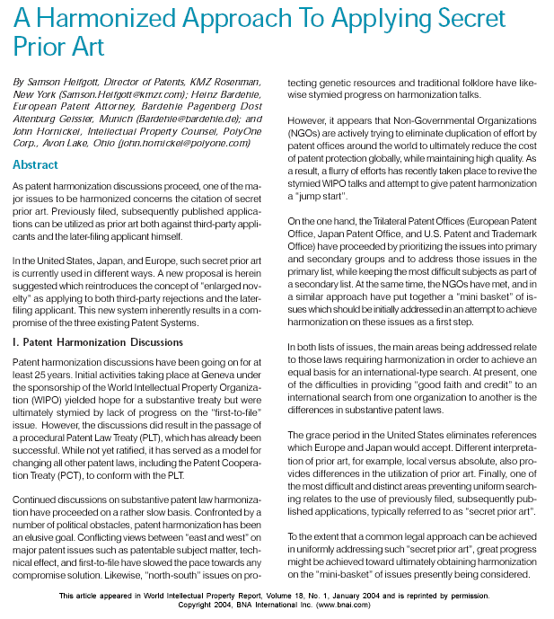
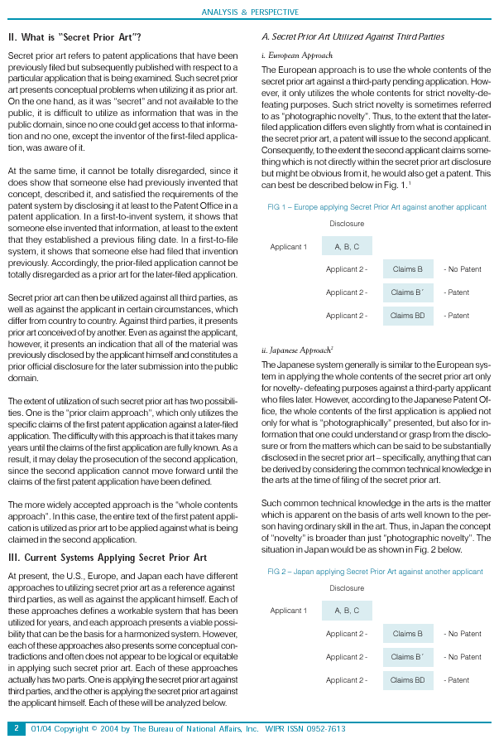
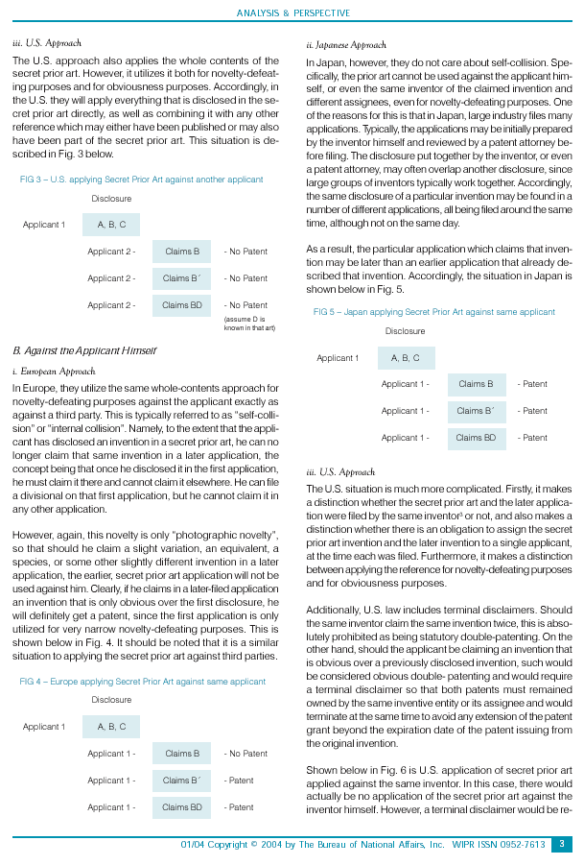
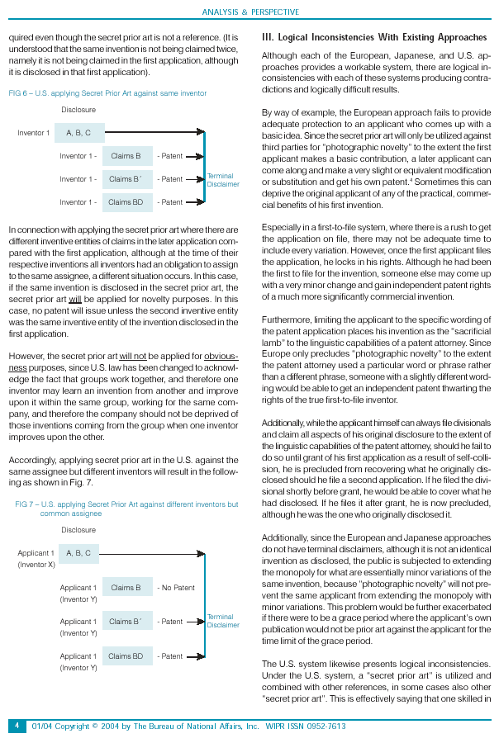
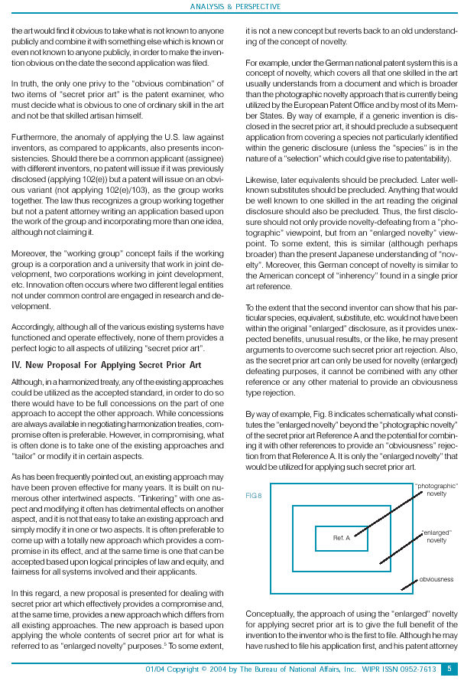
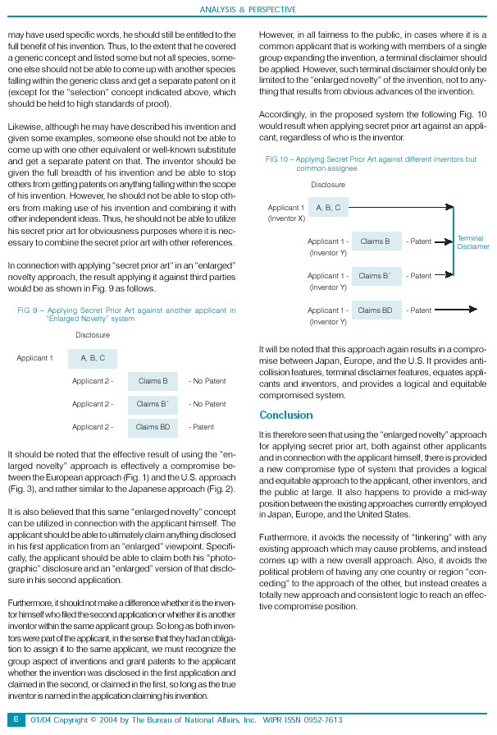
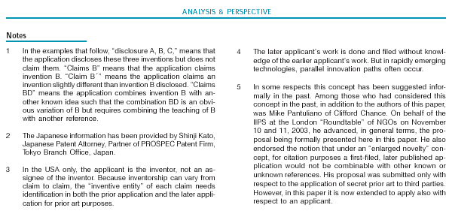

[End of Annex III and of document]

See for example the first draft of the SPLT, Article 9 of document SCP/5/2 and Rule 7 of document SCP/5/3.
See, in particular, paragraph 88 of document SCP/5/6.
The texts of relevant draft SPLT provisions are reproduced in Annexes I and II.
See for example paragraphs 136 and 137 of document SCP/6/9; paragraph 74 ff. of document SCP/7/8; paragraphs 173 to 175 of document SCP/8/9; paragraph 173 of document SCP/9/8; paragraph 88 of document SCP/10/11 Prov.2.
See paragraphs 173 and 174 of document SCP/8/9.
See paragraph 173 of document SCP/9/8.
See paragraph 89 of document SCP/10/11 Prov.2. See also Chapter VI.
See Annex III.
Unless stated otherwise, in this document, the term “double patenting” is used in the context of patenting the same subject matter. It has to be borne in mind, however, that some patent systems use this term in relation to inventions that are different, but still obvious, vis-à-vis one another.
In the United States of America, since the applicant has to be the inventor, the right to the patent has to be assigned to the corporation from each inventor.
The INPI rejects a patent application on the basis of a lack of novelty, but not of a lack of inventive step.
Examination Guidelines, Chapter II-3, 2.3.
Examination Guidelines, Chapter II-3, 2.4(3).
Examination Guidelines, Chapter II-3, 2.4 and 3.4.
http://www.fips.ru/ruptoen2/law/patent_law.htm.
Article 21(6) of the Patent Law provides for the publication of the particulars of applications by the Patent Office upon expiry of a period of 18 months from the filing date or earlier (where the applicant makes an appropriate request) and for the right of any person to familiarize him or herself with the application following such publication. Information on an application is not published, if before the expiry of 12 months from the application filing date, the application is withdrawn or a patent is granted for it. The second part of Article 25 provides for the publication of information on the grant of a patent and the right of any person to familiarize him or herself with an application following such publication. Publication includes basic bibliographical data and claims.
http://www.fips.ru/npdoc/VEDOM/PR_is00.HTM.
The characterization of the purpose of an invention may be missing only from claims relating to a chemical compound.
http://www.patent.gov.uk/patent/reference/mpp/index.htm.
http://www.uspto.gov/web/offices/pac/mpep/consolidates_laws.pdf.
http://www.uspto.gov/web/offices/pac/mpep/index.html.
MPEP 706.02(l)(2). It is explained that the requirement for common ownership at the time the claimed invention was made is intended to preclude obtaining ownership of subject matter after the claimed invention was made in order to disqualify that subject matter as prior art against the claimed invention.
MPEP 804 provides the details concerning prohibition of double patenting.
For example, In re Schneller, 397 F.2d 350, 158 USPQ 210 (CCPA 1968) and In re Kaplan, 789 F.2d 1574, 229 USPQ 678 (Fed. Cir. 1986).
See Chapter VI and Annex III.
In certain countries, the same novelty test applies to both publicly disclosed prior art and earlier applications. In other countries, the “identity” of the claimed invention and the disclosure in the prior art is not considered in the same manner between the publicly available prior art and earlier applications. This issue will be discussed in Chapter IX.
Even in this case, in general, the ban of double patenting applies to the claimed invention in the earlier application and the claimed invention in the later application.
In fact, filing a divisional application or claiming internal priority would preserve the benefit of filing date/priority date of the earlier application, which is more advantageous than filing a separate later application.
It should be noted that neither double patenting nor the term of protection are covered by the current draft SPLT.

