**IPC Publication Help**

**IPCPUB Version 9.0**

# Introduction

## Information access

The various notions of the IPC and related information in authentic language versions (i.e. English and French) are accessible through horizontal tabs in the main frame:

* IPC Scheme with current and previous versions of the IPC indicated in the “Version” box on the left side of the screen;  The scheme includes definitions, structural chemical formulae and graphic illustrations explaining classification places in more details;
* RCL (Revision Concordance List) between subsequent versions of the IPC;
* Compilation with a list of all amendments between two consecutive versions of the IPC;
* Catchwords index, with references to the IPC;
* Search to retrieve various IPC related information.

Links to the “[IPC home page](https://www.wipo.int/classifications/ipc/en/)” and the “[IT Support & Download Area](https://www.wipo.int/classifications/ipc/en/ITsupport/Version20190101/)” (depending on selected IPC version), respectively IPC HOME | DOWNLOAD, are located at the top of the left part of the page.

Additional support can be found in the HELP menu located on the right part of the page header:

* [Guide to the IPC](http://www.wipo.int/export/sites/www/classifications/ipc/en/guide/guide_ipc.pdf) on how the Classification should be used for the purpose of classifying or retrieving patent documents;
* IPCPUB Support (this document).

## Meaning and layout of the IPC

Information about the meaning and the layout of the IPC is available in the [Guide to the IPC](http://www.wipo.int/export/sites/www/classifications/ipc/en/guide/guide_ipc.pdf).

## Search functions

The text field  and the “Search”, “Reset” and “IPC Symbol Keypad” buttons  respectively displayed on the top left part of the screen are provided for searching IPC Symbolsto display directly a specified place in the IPC Scheme or Compilation.

The “Search” tab is provided for searching by making use of:

* Terms: to search for terms in the IPC Scheme, Catchwords and Definitions.
* Cross-references: to search for places in the IPC Scheme, Catchword s and Definitions referring to a specified IPC symbol or its subgroups.
* STATS: The highest number of IPC occurrences in patent documents of PATENTSCOPE.
* [Text categorization (IPCCAT)](#_Categorization_(IPCCAT)): Automatic text categorization and classification assistance in the IPC.
* The “Reset” button allows for clearing both search field and results.

Note: these keyboard shortcuts can be used in any editable text field or area:

* [Ctrl] [a] to select the entire text
* [Ctrl] [x] to cut the selected text
* [Ctrl] [v] to paste the clipboard content

**Important notice:**

There are two search modes available in the publication. The “Smart Search” for general users as a default search option with the default processing of the search term(s) as described below and the “Advanced Search” for advanced and professional users with various search options as described in a separate section of this help.

Search tab also displays search results with links to the IPC and related information, where the searched terms or symbols are highlighted. The highlighting of the terms depends on the selected view and search options, i.e. in some cases only a part of the searched term is highlighted.

**Symbol search**

If a valid IPC Symbol in the selected IPC version is a subject of the search, a corresponding IPC entry is displayed in the Scheme tab in the context of the default view or corresponding to the user selected view options. Accepted input formats of the IPC symbols in the “Search” text field: **A, A01, A01B, A01B 1/00, A01B1/00, A 01 B 1/00, A01B1/00** or **A01B0001000000.**

Symbols may also be typed using a dedicated keypad displayed by clicking on “IPC Symbol Keypad” button, the feature primarily developed for viewing of the IPC on small screens like tablets or smartphones.

A pop-up window is displayed to alert the user in case an invalid IPC Symbol in the selected IPC version is a subject of the search.

## Smart Search

The “Smart Search” can be performed if “Advanced Search” option is unticked (by default) in the left menu when the “Search” tab on the top is active, making all the options disabled and using the following query interpretation:

1. If a query consists of at least 10 words, the search operation is performed only as the **IPCCAT** assistance.
2. If a query consists of words and logic operators and consists of less than 10 words, the following search will be performed:
   1. **Terms** in Scheme (excluding references),
   2. If no results above: **Terms** in Catchwords,
   3. If no results above: **STATS** (in Groups under the most relevant Subclass only),
   4. If no results above: **IPCCAT** at subgroup level,
   5. If no results above: **Terms** in Definitions.

Search results are displayed below the “Search” and “Reset” buttons by a list of IPC symbols that are most relevant to the search query, ordered by their relevance and linked to the appropriate view/tab.

## URL based access and web services

It is possible to use hyperlinks to various notions and views of the IPC publication through URL parameters.

Examples:

https://www.wipo.int/classifications/ipc/ipcpub/?notion=scheme&**viewmode=m**

opens the IPC in “Maingroup view”

https://www.wipo.int/classifications/ipc/ipcpub/?notion=scheme&**viewmode=p**

opens the IPC in “Path view”

<https://www.wipo.int/classifications/ipc/ipcpub/?notion=scheme&version=20200101&menulang=en&lang=en&viewmode=m&showdeleted=yes&indexes=yes&headings=yes&notes=yes>

opens IPCPUB with English user interface and displays the English version of the scheme for IPC 2020.01 with “Maingroup view”, “Deleted items”, “Subclass Indexes”, “Guidance Headings” and “Notes”.

IT systems can also directly communicate with IPCPUB through the Application Programming Interface (API) documented under [IPC internet publication URL and Web Services specification](http://www.wipo.int/ipc/itos4ipc/ITSupport_and_download_area/Documentation/IPC_Internet_URL_Web_Services_specification) **.**

## Browser compatibility

Browser compatibility has been considered for Edge 44, Internet Explorer 11, Google Chrome 76 and Mozilla Firefox 68, the publication has been optimized for Google Chrome. Enabling of JavaScript and cookies is required for a good functioning of publication.

# IPC Scheme Viewer

## IPC navigation

The following scenarios are available for navigating through the IPC:

1. A symbol to be viewed can be entered in the symbol field followed by a click on the “Search” button or by pressing Enter on the keyboard; this will display the selected entry of the IPC and its context according to the selected view and search options. Change of view options when an entry is displayed makes the view of the displayed entry automatically refreshed.
2. All IPC symbols in the viewer are hyperlinked; thus, the corresponding entry in the IPC will be displayed upon click on a symbol.

The Scheme options on the left side of the screen are the following:

|  |  |  |
| --- | --- | --- |
| **Version** | | Selection of the IPC version to be browsed. By default, the current version in force is pre-selected (see also paragraph 10 in the [Guide to the IPC](http://www.wipo.int/export/sites/www/classifications/ipc/en/guide/guide_ipc.pdf)). |
| **“Go to current Symbol” button** | | Shows the current symbol displayed in the scheme, RCL or compilation in the context according to the selected view options. By default, “**None**” is displayed before any search is performed or if “Index” button is clicked.  The current symbol changes when a symbol is clicked in the search results or in the Scheme, RCL, Compilation or Catchwords tab.  This function also provides access to information on a specific symbol which was deleted in the selected IPC version, e.g. about its transfer. |
|  | | The Index of the scheme displays the list of IPC sections. |
|  | Click on this button to open the Class, Section or Subclass in a PDF document which contains the current symbol.  The PDF document is opened in a new browser tab / window. | |
| **“Bridge” button** | Provides access to other language versions of the IPC (as established by some national authorities), other patent classification systems and to patent databases; clicking this button will open a pop-up window according to the current symbol; clicking on one of the offered choices in the pop-up window either displays the closest corresponding symbol in the selected language version or initiates a search in the selected database with the respective IPC symbol as a parameter. | |
| **Language** | | Select the language version to be used. Select English/French, to display the two authentic language versions side by side. |
| **View mode** | | Select the context of the current symbol to be displayed.  In all view modes, the button **+**  next to a symbol expands the symbol to display the subdivisions of the symbol in the next hierarchical level and also indicates if such level(s) exist(s). This action can be reversed by clicking the button **‒**  which collapses the symbol to hide its subdivisions.  **Path**: Displays the current symbol, its hierarchically higher entries, and all subdivisions of the current symbol in the next hierarchical level.  **Full** (default): For groups and subclasses, this view mode displays all groups of the corresponding subclass. For class and section symbols this view mode is equivalent to the path mode.  **Hierarchic**: Displays the current symbol, its hierarchically higher entries, and all neighbour entries on the same hierarchical level as the current symbol.  **Maingroup**: This view shows the scheme in the **Full** view with the main groups collapsed. This view allows for faster browsing in most situations. |
| **Tree view** | | Select to display guiding lines between hierarchical subdivisions of groups instead of dots next to subgroups. |
| **Deleted entries** | | Select to display entries valid in previous IPC version which are not valid since the displayed IPC version. |
| **Subclass index** | | Select to display subclass indexes, where exist, to see an overview of the content of the whole subclass. Some subclasses do not have the index. |
| **Guidance headings** | | Select to display guidance headings, where exist. When a plurality of successive main groups within a scheme relate to common subject matter, a “guidance heading” before the first of such main groups may be provided. |
| **Notes** | | Select to display notes in IPC scheme, where exist. |
| **IPCPUB vX.Y** | | Version of the IPCPUB application by which the IPC publication is presented. |
| **Last modified:** | | Date of the last change in IPCPUB. |

## IPC presentation details

|  |  |
| --- | --- |
| **Definitions**  **D**  . | Clicking this icon will display/hide the corresponding Definition entirely unfolded below the IPC entry title and notes.  **Folding / unfolding definition sections**  1. Click on the **‒**  icon folds the corresponding section of the Definition.  2. Click on the **+**  icon unfolds the corresponding section of the Definition.  **Linked symbols and terms**   1. All symbols in Definitions are hyperlinked and clicking on them will display the corresponding entry in the IPC Viewer. 2. Terms contained in the Glossary and terms defined in the Glossary of the Guide are hyperlinked; when activated, they open a pop-up window with the terminology of the particular term. |
| **Indexing symbol l** | Indexing symbols are marked by a frame, e.g. . |
| **Warnings** | The Warning icons are present to the left of symbols where a specific situation needs to be mentioned, e.g. errors found after the technical preparation of this publication or incomplete reclassification, etc.  Click on this icon to display the explanatory text associated with this warning.  **Note**: these warnings only refer to IPC data and never to software application warning or error messages. |
| **Background colour** | The following colour marking is applied to backgrounds of IPC entries:   1. Classes are presented on a **dark red background**. 2. Subclasses are presented on a pale red background. 3. Main groups are presented on a light pale red background. 4. Definition titles are presented on a **dark green background**. 5. Definitions are presented on a light pale green background. 6. Guidance headings are presented on a white background, **red characters**. 7. All other entries, e.g. subgroups or indexes or notes, are presented on a white background; 8. Occurrences of searched terms and cross-references in the displayed view are highlighted with a green background. |
| **Format of the version indicator** | The version indicator in the scheme is either [**1], [2], [3], [4], [5], [6], [7]** before or **[YYYY.MM]** after the IPC reform of 2006.01.  If only one version is indicated next to the scheme entry, the version indicator is rendered as black and bold text.  If more than one version is indicated, the version indicator is rendered as a link and only the most recent version indicator is displayed. When clicking on it, all version indicators pertaining to that entry are displayed in a pull down window. |
| **Linked symbols and terms** | All symbols are hyperlinked and by clicking on any of them the corresponding entry in the IPC Scheme Viewer will be displayed. In case a term appears in the IPC Guide Glossary or in subclasses where the Definition of this subclass contains a Glossary, such term is displayed in the scheme as hyperlinked to show its explanation with the following precedence by decreasing order:   * group Definition Glossary * subclass Definition Glossary * IPC Guide Glossary. |

# RCL: Revision Concordance List

The RCL tab displays the relation between entries of two consecutive versions in the following cases:

1. for each scope-changed and deleted entry of the older version, all entries of the newer version, where subject matter is now classified, can be displayed, and
2. for each entry of the newer version, any entries of the older version, where subject matter was formerly classified, can be displayed.

The RCL options shown on the left side of the screen are the following:

|  |  |
| --- | --- |
| **Version** | Select the Version of the IPC to be browsed. |
| **Direction** | Select the direction as:   1. **Old-to-new:** the left column of the RCL table contains symbols valid in the older version and the right column contains for each such symbol at least one symbol valid in the newer version (see case (a) above); 2. **New-to-old:** the left column of the RCL table contains symbols valid in the newer version and the right column contains for each such symbol at least one symbol of the older version (see case (b) above). |
|  | The Index of the RCL displays the classes and subclasses concerned by the revision of this IPC version.  All subclass symbols are hyperlinked, click on them to open the above mentioned table for the concerned subclass. |
|  | Click on this button to open the all-in-one RCL PDF file.  The PDF document is opened in a new browser tab / window. |
| **Presentation** | |  |  | | --- | --- | | **Red and light pale red background** | Entries in the older version | | **Green and light pale green background** | Entries in the newer version | | ***Green, Italics*** | New entries | | **Red** | Deleted entries | | Blue | Symbol with change in scope | | Black | Not modified but used as a source or target of reclassification | |

All symbols are hyperlinked. Clicking a symbol allows to view the respective entry in the corresponding version of the IPC, i.e. clicking on a symbol in the column of the previous version will display this entry according to this version.

# Catchwords

When opening the Catchword tab for the first time, an index page is presented for direct navigation - by clicking on any term - to an appropriate range of the alphabetically ordered Catchwords.

Ranges may also be folded / unfolded using **‒**  / **+**  buttons respectively.

The Catchwords options shown on the left side of the screen are the following:

|  |  |
| --- | --- |
| **Version** | Select the Version of the IPC to be browsed. |
| **Language** | Select the language version to be used. |
|  | Press the **Index** button to return to the Index in the selected language. Click on any of the entries to open the alphabetically closest list of catchword entries. |

# Compilation of amendments to the IPC

The Compilation tab shows a list of all amendments between two consecutive versions of the IPC.

The Compilation options shown on the left side of the screen are the following:

|  |  |
| --- | --- |
| **Version** | Select the Version of the IPC to be browsed. |
|  | Press the **Index** button to collapse all expanded subclasses. |
|  | Click on this button to open the all-in-one Compilation PDF file.  The PDF document is opened in a new browser tab / window. |
| **Language** | Select the language version to be used. |

## Items of the IPC compilation

The compilation follows the order of the IPC scheme.

When opening the Compilation tab for the first time all subclasses for which, or for one of its sub-entries, there is an amendment are displayed folded.  
Section and class amended notes are also displayed by default.

Sections, classes and subclasses can be folded / unfolded using **‒**  / **+**  buttons respectively.

## Entries within the IPC compilation

Each amended entry is displayed with the following markings:

1. Type of the amendment:
   * + **N**: the entry is a **new** in the displayed IPC version
     + **C**: thefile scopeof the entry was  **modified,** being source of reclassification
     + **T**: thefile s**c**opeof the entry was  **modified,** being target of reclassification
     + **M**: the title or other part of the entry was **modified**, but not its file scope
     + **D**: the entry was **deleted**
     + **U**: the entry was **unchanged**, but is displayed to improve the readability of the compilation
     + **L**: the entry was **unchanged** only in one of the two authentic languages of the IPC while the other authentic language is modified and marked as “M”.
2. Location in the IPC Scheme (i.e. the symbol of the entry)
3. Modifications of the previous IPC Version:
   * + For new entries: the text of the new entry
     + For modified entries (**C** or **M** modification): the actual modifications to be made on the text (see **Presentation rules** below)
     + For deleted structured entries (e.g. groups): the transfer notes
     + For removed non-structured entries (e.g. notes, guidance headings): no text

For example:

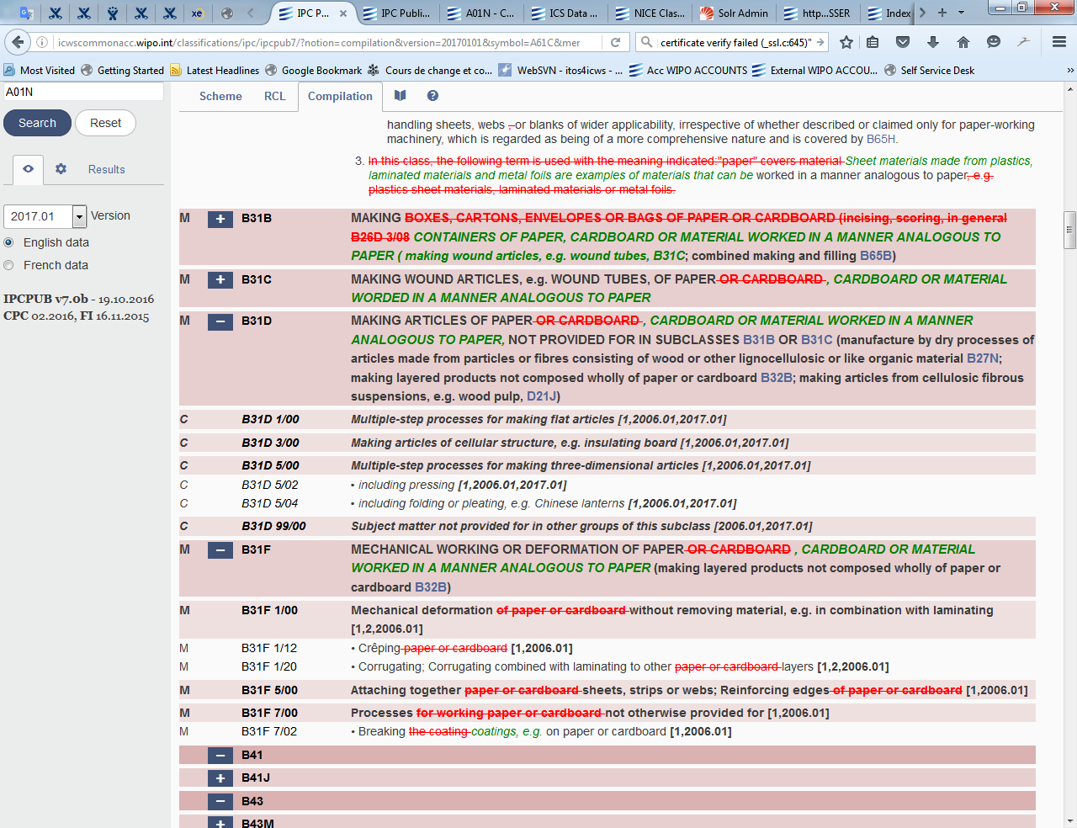

## Presentation rules

For the background colour of entries, the same rules apply as for the IPC scheme.

The dots of the subgroups are displayed according to the following convention:

* dots inserted in the entries existing in the previous version: green background
* dots deleted from the entries existing in the previous version: red background

The text of the entries and their amendments is displayed according to the following convention:

* new entries: ***text in italics***
* text inserted in the entries existing in the previous version: ***green text in italics***
* text deleted from the entries existing in the previous version: **~~red strikethrough text~~**
* non-modified text: black characters

For example

The modified text of the scheme displayed in the compilation:

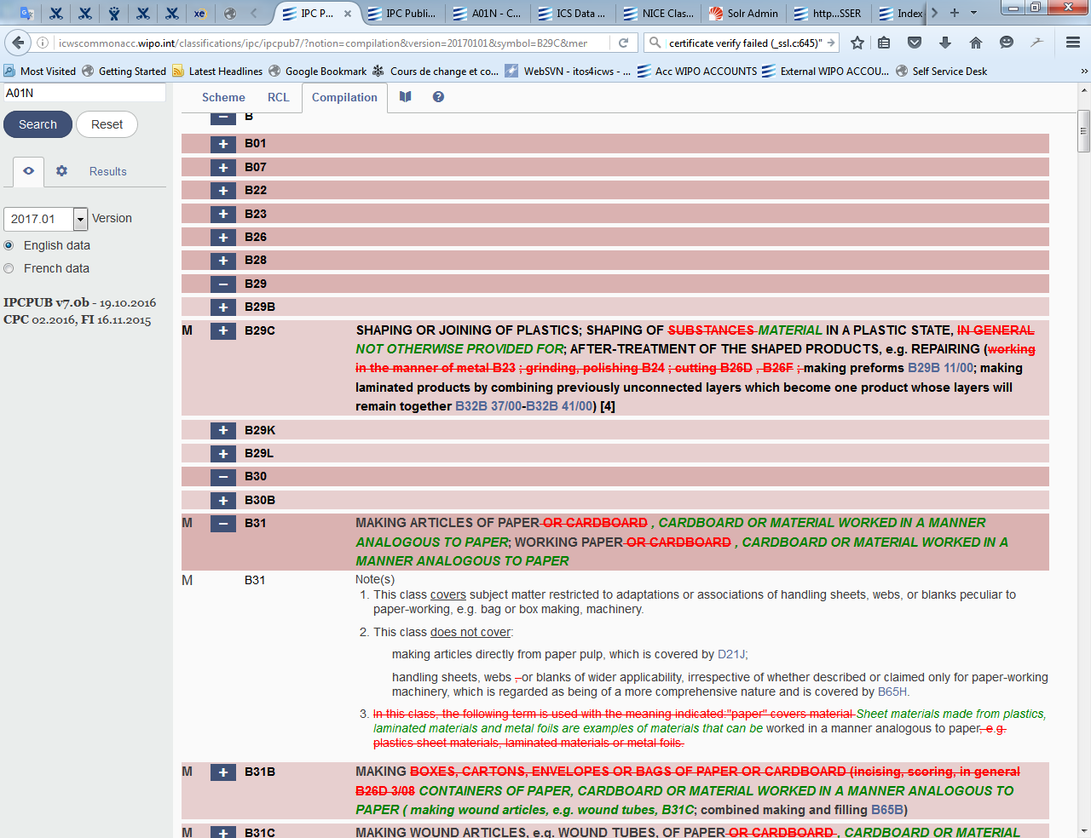

The final text in the scheme looks like:

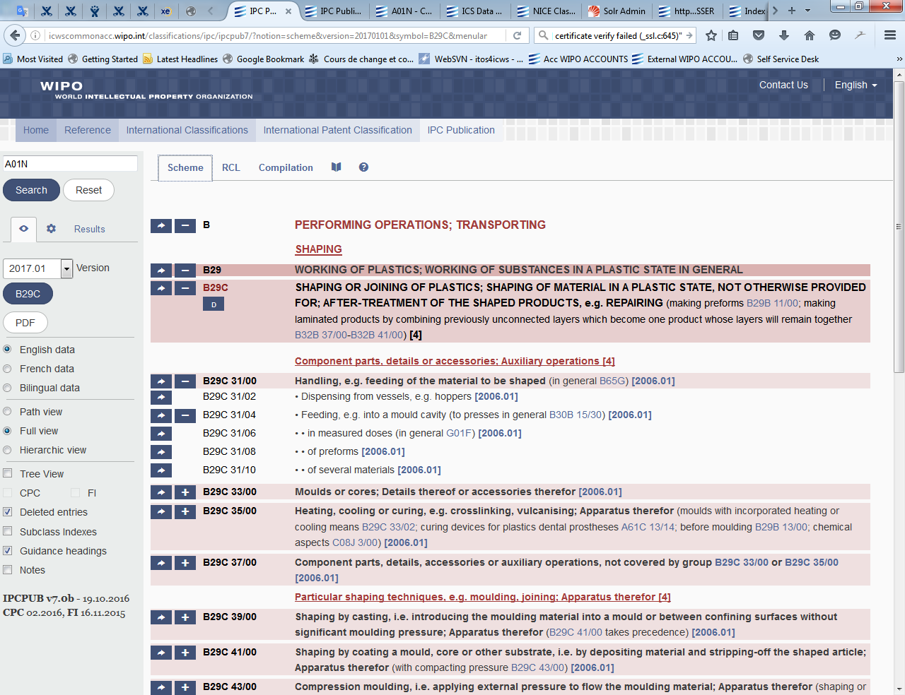

# Advanced Search

The “Advanced Search” can be performed if “Advanced Search” option is ticked in the search options shown on the left part of the screen when the “Search” tab is active, making all the options enabled.

The text “Search” field and the “Search” button displayed on the top right part of the screen are provided for searching different kinds of IPC information in different areas. The search is performed in the language selected in the search options.

The search is performed according to options defined on the left part of the screen.

All the search results are displayed and linked to the language selected before the search even if another language is selected after displaying of the results.

The options and results displayed are the ones related to the set of search options that is selected in the menu shown on the left, e.g. if STATS is selected:

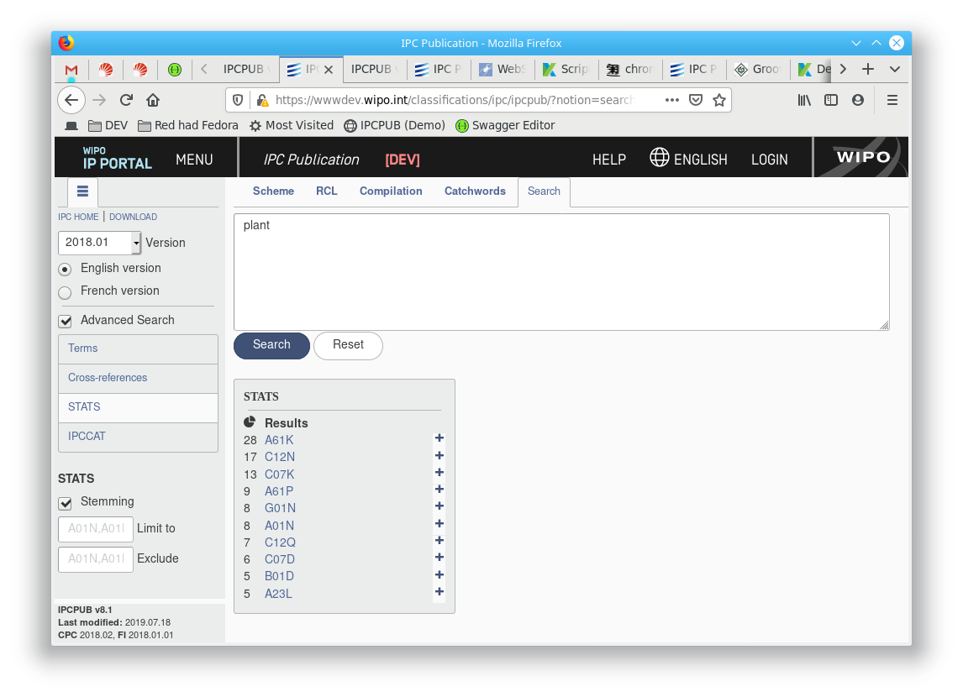

**Clipboard feature**: if search results is a list of IPC Symbols, the “Prepare copy” button allow for copying the full list of results in order to paste it into another tool, e.g. Excel:

1. Perform a Terms or Cross-References search in the Scheme or Definitions
2. Click the “Prepare Copy” button shown below the result list
3. Click the “Clipboard” button that appears after the “Prepare copy” is clicked
4. Select a cell in Excel and Paste (or Ctrl V)

Note: The clipboard capacity is limited to 10000 symbols.

The search query syntax, options and results for each area are described below.

## Term

Term search in the IPC is possible for simple terms (sequence of alphanumerical characters) or multi-term input (combination of simple terms separated by space characters) to be searched in the textual parts of the Scheme, Catchword Index and Definitions of the IPC.

Term search options are accessible under “Terms” menu item on the left part of the screen when the “Search” tab is active:

|  |  |
| --- | --- |
| **QUERY SYNTAX** | For search, characters in terms are considered as case and accent insensitive.  Some special characters (e.g. % ( ) { } [ ] ! & | ^ , :) and stop words (e.g. “an”, “and”, “not”, “such”) are ignored (i.e. typing them or not returns the same search result)  The order in which terms are indicated in the query is not significant for the order in which terms are looked up, i.e. results are the same if user looks for [plant biocides] or for [biocides plant]), except for terms searched as a phrase, where results are not the same if user looks for [“plant biocides”] or for [“biocides plant”]). |
|  | Special characters acting as operators: **?**  In the term search, query string “**?**” stands for any single character present (e.g., without “Stemming”, [plant?] stands for “**plant**s” but not “plant”).   One or more occurrence of the “?” wildcard character can be used.  **\***  In the term search, query string “**\***” stands for no or any number of any characters (e.g., without “Stemming”, [plant*] stands for “**plant**”, “**plant**s”, “**plant**ation”, “**plant**ing”...) One or more occurrence of the “*” wildcard character can be used.  **""**  Use **quotes** to search for an expression as phrase (e.g. [**“**electric car**”**] searches for “electric” followed by “car”. Note that terms found can be separated by one or more special characters and/or stop words in the text of the hit)  **~**  Use **tilde "~" and a number** at the end of an expression to perform a Proximity Search within a specific distance. For example, to search for an "electric" and a "car" within 10 words of each other use: ["electric car"~10]. (See Fuzzy Search below)  **+** Use "**+**" to mean that the immediately following term must be in the text of the hit list (e.g. [plant biocide +repellent]).  **-** Use "**-**"to mean that the immediately following term must not be included in the text of the hit list (e.g. [plant biocide -repellent]).  Note that if they do not start the query, + and – must be preceded with **a blank space** to be interpreted as operator. |
|  | Boolean operators: Boolean operators allow terms and phrases to be combined through logic operators.  The following operators are supported and must be used in ALL CAPS:  The **AND** operator is the default conjunction operator. This means that if there is no Boolean operator between two terms, the AND operator is used. This operator matches entries where both terms exist anywhere in the text of a single place.  The **OR** operator links two terms and finds a matching place if either of the terms exist in this place.  The **NOT** operator excludes places that contain the term after NOT.  **Warning:**  **All operators except the ones used for fuzzy and wildcard search are ignored when searching Scheme terms with Path option.**  **The AND and OR operators must not start or end the query string.**  **The NOT operator must not end the query string.**  **A Boolean operator must not precede or follow another one, except when using OR NOT or AND NOT.** |
|  | Fuzzy search: The system supports fuzzy searches based on the Levenshtein Distance, or Edit Distance algorithm. To do a fuzzy search use the **tilde "~"** character at the end of a Single word Term. For example to search for a term similar in spelling to "roam" use the fuzzy search:  [roam~]  This search will find terms like foam and roams.  An optional value can be put after the tilde to change the expected degree of similarity. This value must be from 0 to 1 (excluded) and by default is 0.5. For example:  [roam~0.8]  Boolean, fuzzy operators and special characters “?”, and “*” are ignored when part of a phrase. |
| **Stemming** (Software  installation option) | If the “Stemming” optional feature is installed, a “Stemming” option is visible under the Term Search.  If “Stemming” is selected, words that come from the same stem of the word specified in the query are also searched (e.g. searching for “medicinal” will also match “medicine”).  If “Stemming” is not selected, the search is performed according to the above mentioned definition of words, special characters and operators. |
| **Limit to** | The content of the “Limit to” box specifies the places of the IPC and their subgroups to be searched by using a comma-separated list of IPC symbols.  If “Limit to” is empty, the full contents of what is defined by “IPC notions” (i.e. Any combination of the following: “scheme”, “definitions”, “catchword”) is considered. |
| **Exclude** | The content of the “Exclude” box specifies the places of the IPC and their subgroups to be excluded from the search by using a comma-separated list of IPC symbols. |
| **Path** | The use of this option doesn't have any effect for single term search. In case of multi-term search, paths are considered in the IPC tree structure and defined as follows:  All paths starting from the subclass symbol in which the first occurrence of one of the specified terms is found, all hierarchically lower symbols where any specified term occurs, and ending at the hierarchically lowest symbols where one of the specified terms occurs.  If the “Path” option is selected, Term Search returns the list of symbols where all of the specified terms occur within the list of above defined path. The contents of “Guidance Headings” and “Subclass Indexes” are excluded from the search.  Boolean, phrase and proximity operators are **ignored** if the “Path” option is selected. |
| **Scope options** | These tick boxes are used to select the list of IPC-related notions where the search should be performed. i.e., within **Scheme titles, Scheme references, Definitions** and/or **Catchwords**. |
| **RESULTS** | The list of search results is displayed as a list of hyperlinks to the relevant notion. If the “Path” option is ticked, the view mode is automatically updated to “Path”. Otherwise the view mode is set to “Full”. Each occurrence of a searched term (or resulting from interpretation of the search query) is highlighted in the corresponding view. |

## Cross-References

A type of search for places referring to a specified IPC symbol and its subgroups (the latter as an option). Only one IPC symbol can be searched. The search results display all relevant places grouped by IPC notion (scheme, definition and catchword).  For scheme and definition, the search results are grouped in a list of IPC symbols sorted in IPC order. For Catchword index, the search results are grouped in a list of catchword entries in alphabetical order. Found references are highlighted in he displayed places.

In case a reference is found in a place covering an interval (e.g. note or guidance heading), the first symbol of this interval is returned.

IPC Compilation presentation

Cross-references search options are accessible under “Cross-references” menu item on the left part of the screen when the “Search” tab is active:

|  |  |
| --- | --- |
| **QUERY SYNTAX** | An IPC symbol of a place referred to in other places of the IPC. |
| **Include subgroups** | If selected, the cross reference search returns all places of the IPC referring to this symbol (e.g. A01N) or referring to its subgroups (A01N 1/00, A01N 1/02). This option is not suitable for IPC referenced symbol above subclass (i.e. section, subsection, class). If not selected, the cross reference search returns the places of the IPC referring only to this symbol. |
| **Scope options** | These tick boxes are used to select the list of IPC notions in which the search should be performed. i.e., within **Scheme**, **Catchwords** and/or **Definitions** |
| **RESULTS** | The list of search results is displayed as a list of hyperlinks to the relevant notion. The view mode is automatically set to “Full”. Each occurrence of a searched symbol is highlighted in the corresponding view. |

## STATS

This function identifies IPC places most frequently referenced in the PATENTSCOPE database when searched for particular terms. Statistical presentation of the search results is performed according to IPC subclass and group. It is possible to search for simple terms (sequence of alphanumerical characters) and multi-term input (combination of simple terms separated by space characters) in all patent collections of the PATENTSCOPE.

STATS search options are accessible under “STATS” menu item on the left part of the screen when the “Search” tab is active:

|  |  |
| --- | --- |
| **QUERY SYNTAX** | During STATS search, the query is broken up into terms. A term is a single word such as "car" or "engine".  Some special characters (e.g. % ( ) { } [ ] ! & | ^ , :) and stop words (e.g. “an”, “and”, “not”, “such”) are ignored (i.e. typing them or not returns the same search result)  The search engine is trying to find all the specified terms in a text neighbourhood which corresponds more or less to the size of a Patent document paragraph.  Note: that the PATENTSCOPE query string selects the Stemmer according to the one set under the “Language” button. For example if English is selected, the term "electrical" will be stemmed to "electric", "electricity" and so on.  So it is important to choose a language option from the left menu. |
| **Stemming** | English: Standard Lucene implementation of the Porter Stemming Algorithm, a normalization process that removes common endings from words.  Example: "riding", "rides", "horses" ==> "ride", "ride", "hors".  Other languages: specific Stemming Algorithms are also used |
| **Limit to** | The content of the “Limit to” box specifies the places of the IPC and their subgroups to be searched and to be used as filter for returned places. It is a comma-separated list of IPC symbols. |
| **Exclude** | The content of the “Exclude” box specifies the places of the IPC and their subgroups to be excluded from the search and from returned places. It is a comma-separated list of IPC symbols. |
| **RESULTS** | The search results are displayed as a list of hyperlinks to the relevant IPC subclasses (maximum 10 subclasses), based on an analysed summary of the main IPC in PATENTSCOPE, with a numerical indication of “Relevance” level between 1 and 100 for each subclass under the sign. The Refine icon  next to each subclass displays subgroup level results (maximum 5 subgroups) within the specified subclass, with a numerical indication of “Relevance” level between 1 and 100 for each subgroup. |

## Categorization (IPCCAT-neural or IPCCAT)

The classification is made with the myClass module of the Olanto foundation (<https://olanto.org>).

The IPCCAT (IPC Computer-Assisted Categorization) services were primarily designed for small and medium sized patent offices to assist them in classifying applications according to the International Patent Classification (IPC). On the basis of a given input text (typically the abstract of a patent document), IPCCAT offers predictions of most likely corresponding IPC symbols at Class, Sub-Class, Main Group or Sub-Group levels.

IPCCAT-neural services are provided through several thousands of neural networks which are activated on the basis of selected options.

IPCCAT was designed with the concept of full phrases describing the technical subject matter and should be understood as classification assistant, not as a keyword search tool.

While the function attempts to perform its task even with a limited number of keywords as an input, the results should be taken cautiously (see Limitations).

For better precision, it is recommended to perform cascaded categorization i.e. to start with a categorization at subclass level, and then to use “Refine” within the subclass selected as the most appropriate among predicted ones (see “Refine” below).

### Supported Languages

### IPCCAT is natively trained with the English collection of WIPO-delta data set (see below IPC Coverage and precision) and therefore primarily support English language. However, it can also offer cross-lingual text categorization through automatic translation performed by WIPO Translate service in the following languages (ordered by their ISO-639-1 code):

* ar: Arabic,
* de: German,
* es: Spanish,
* fr: French (other authentic language of the IPC),
* ko: Korean,
* ja: Japanese,
* pt: Portuguese,
* ru: Russian,
* zh: Chinese.

Categorization search options are accessible under “IPCCAT” menu item on the left part of the screen when the “Search” tab is active:

|  |  |
| --- | --- |
| **QUERY SYNTAX** | The text for which categorization in the IPC is expected.  The text length is limited to 1500 characters. |
| **Number of predictions** | The maximum number of IPC Symbols to be returned: 3 or 5  The predictions initially displayed are the IPC places predicted by IPCCAT as best matching the input text (given the selected classification level).  Predictions are based on previous training of the system using WIPO-delta collection of patent documents classified in either the CPC or the IPC or both.  As a default setting, predictions are initially delivered at the subclass level. |
| **Classification level** | The hierarchic level at which IPCCAT is requested to operate within the IPC tree structure: it can be either the **Class**, **Subclass**, **Main** **Group** or **Subgroup level**  **Important:** this feature is different from the "Refine" one available in the search results. By selecting “Maingroup” from the "Classification Level" dropdown menu the user asks IPCCAT to categorize directly at main group level, i.e. to predict 3 or 5 among all covered IPC main groups, as if it had not made any previous prediction at any other level before. The user may also first ask for predictions at a higher hierarchical levels by selecting “Class” or “SubClass” levels form the dropdown menu and then select one of the IPC symbols predicted by IPCCAT for a “refine” action i.e. to ask IPCCAT to perform a new categorization at deeper hierarchical level, using the neural network associated to this selected IPC prediction. |
| **Input language** | The language in which the prediction should be made (see “Supported languages” above). |
| **Start From** | The place of the IPC delimiting the search scope: an IPC symbol |
| **RESULTS** | The search results are displayed as a list of 2 values:   * Under the ★ sign, a number (from 0 to 5) indicates the categorization confidence that IPCCAT has in the corresponding IPC prediction (through a number of stars proportional to this level of confidence).   From time to time IPCCAT is re-trained with highly controlled data to ensure that it makes use of new vocabulary and recent reclassification of patent documents in the IPC. This ensures that the confidence indicator remains meaningful.   * The initial prediction. i.e. a symbol linked to the relevant place in the IPC scheme.   **Refine:**  The user may wish for a more detailed level in the IPC, i.e. for the tool to be yet more specific within each of its prediction(s). In this case the user may click the  **‒**  /  **+**  buttons on the IPC prediction line so that the tool shows the higher / lower level predictions.  **Note:** The number of lower level predictions is determined by the expected number of predictions set on the tab with search options for IPCCAT.  It is also possible for the user to select hierarchically higher IPC level and see initial IPC symbol predictions, before refining them within one of these specific symbols.  Alternatively, if after reading a set of predictions the user thinks that the prediction is wrong and that the patent application should be classified under a particular place of the IPC (for instance the A01B subclass), he/she can force the categorizer to make predictions under this place. To do so, the user types the required place code (in our example, A01B) in the "Start From" field located at the bottom of the IPCCAT options tab. |

### IPC Coverage and precision

The corpus of patent documents used for training is a collection prepared from the 2020 WIPO-delta collections including patent documents reclassified in IPC 2020.01.

The WIPO-delta collections are available on demand at <https://www.wipo.int/classifications/ipc/en/ITsupport/Categorization/dataset/>.

An IPC category is considered as covered by IPCCAT if it contains at least one document.

Nevertheless, the statistics below take into consideration only categories including at least 1 document. They show that for certain Main Groups IPCCAT's predictions are not as reliable as those of an IPC specialist.

Assessment of IPCCAT predictions precision:

2% of the WIPO-delta collection are randomly extracted (and their IPC symbols removed) for the purpose of assessing the precision of the categorizer trained with the other 98%.

Then, 100% of the collection are used to retrain the version of IPCCAT used in production.

IPCCAT precision is assessed using 3-guess evaluation method i.e. success if one the top 3 IPC symbol predictions appears among IPC symbols of the corresponding test document.

|  |  |
| --- | --- |
|  | **English Set** |
| Data Source | 2020 WIPO-delta |
| Number of Patent Documents Used for Training | 36’184’946 |
| Number of Patent Documents Used for Testing | 738’468 |
| Total Number of Example Patents | 36’923’414 |
| Total Number of Classes | 131 |
| Number of Trained Classes | 131 |
| Coverage at Class Level | **100.0%** |
| **Precision of Classification at Class Level ("Three Guesses")** | **96.2%** |
| Total Number of Sub-Classes | 646 |
| Number of Trained Sub-Classes | 645 |
| Coverage at Sub-Class Level | **99.8%** |
| **Precision of Classification at Sub-Class Level ("Three Guesses")** | **94.0%** |
| Total Number of Main Groups | 7’518 |
| Number of Trained Main Groups | 7’484 |
| Coverage at Main Group Level | **99.5%** |
| **Precision of Classification at Main Group Level ("Three Guesses")** | **89.4%** |
| Total Number of Sub Groups | 75’548 |
| Number of Trained Sub Groups | 74’762 |
| Coverage at Sub Group Level | **99.0%** |
| **Precision of Classification at Sub Group Level ("Three Guesses")** | **82.0%** |

|  |  |  |  |  |  |  |  |  |
| --- | --- | --- | --- | --- | --- | --- | --- | --- |
| **English at main group** | **2011** | **2013** | **2014** | **2016** | **2017** | **2018** | **2019** | **2020** |
| Total Number of Main Groups Found by IPCCAT | 7'392 | 7'400 | 7'136 | 7'434 | 7’420 | 7’461 | 7’483 | 7’518 |
| Number of Trained Main Groups | 6'660 | 6'731 | 6'777 | 6'920 | 7'374 | 7’413 | 7’438 | 7’484 |
| Coverage at Main Group Level | 90% | 91% | 95% | 93% | 99% | 99% | 99.4% | **99.5%** |
| **Precision of Classification at Main Group Level ("Three Guesses")** | 79% | 80% | 81% | 81% | 89% | 89% | 88.9% | **89.4%** |
| **Precision of Classification at Sub Group Level ("Three Guesses")** | N/A | N/A | N/A | N/A | 82.5% | 81.9% | 83.7% | **82.0%** |

### Limitations of IPCCAT

It is useful to underline the training task was initially performed using the patent's title and abstract. Therefore if the user does not want to use the full text of the patent application, it is suggested that the abstract be used (as a minimum), and not a random selection of text from the description.

**Categorization results consistency**: Because of the big number of main groups and even bigger number of subgroups in the IPC, it is difficult to find a large number of good training examples for each of them.

More generally, users should be aware that all categories of the IPC are not documented in an even way, and that inconsistencies are also present in legacy patent classifications used to train IPCCAT. Therefore some of IPCCAT predictions (i.e. attempts to replicate legacy classification practices) are less reliable than others.

With this in mind it is perhaps understandable that for certain Main Group or Sub Group areas the IPCCAT's predictions may not be as accurate as a human classification. However, it is also understandable that several iterations of IPCCAT on the basis of the same input text would always lead to the same set of IPC predictions, thus offering to some level of consistency in this way to classify in the IPC.

[Further information on WIPO Computer-Assisted Categorization of Patent Documents in the IPC](http://www.wipo.int/classifications/ipc/en/ITsupport/Documentation/categorization.html)

# CPC/FI parallel view

**CPC**: Cooperative Patent Classification,

see <http://www.cooperativepatentclassification.org/index.html>

**FI** (File Index): The Japanese Patent classification based on the IPC,

see <http://www.jpo.go.jp/torikumi_e/searchportal_e/classification.htm>

“CPC” and “FI” options are located in the selection menu and are enabled only for the **current IPC Version in force**. If these options are visible, it means that this optional feature was enabled during IPCPUB software package installation.

When selected, these options allow for displaying CPC and/or FI subdivisions of the IPC place indicated in the “CPC to IPC” respectively “FI to IPC” concordance tables of the corresponding CPC respectively FI versions. These versions are indicated at the bottom left part of the screen.

Selecting “CPC” and/or “FI” option displays a C, F or C/F indication next to each concerned IPC entry symbol:

* C: CPC subdivision is available
* F: FI subdivision is available
* C/F: Both CPC and FI subdivisions are available

Clicking on a **+**  button (for which there is also a C, F or C/F indication) displays:

* with an orange background all CPC subdivisions in the left part of the page, immediately below the IPC symbol indicated in the above mentioned concordance table.
* with a yellow background all FI subdivisions in the right part of the page, immediately below the IPC symbol indicated in the above mentioned concordance table.

**Links within CPC or FI subdivisions**

A link to a CPC or FI symbol that appears within a subdivision is always related to the nearest IPC parent of the symbol targeted by this link. Clicking on this link will set this IPC parent symbol as the “**Current symbol**”.

The icon 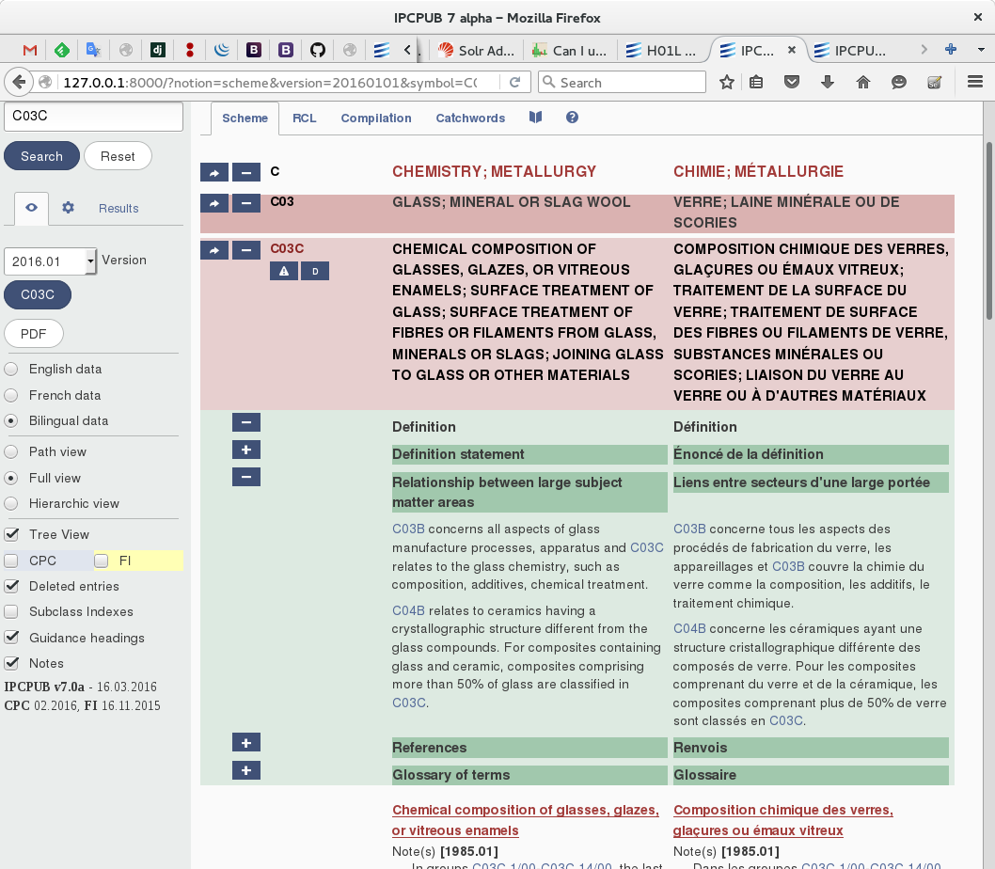 is used to indicate a problematic entry in the XML input file (CPC or FI).

**Notes**:

* CPC or FI symbols cannot be reached by performing a search operation (which refers to the IPC).
* “Tree View” option cannot be selected if both “CPC” and “FI” options are selected.

# URL and Web Services for IPC Internet Publication

[URL and Web Services for IPC Internet Publication](http://www.wipo.int/ipc/itos4ipc/ITSupport_and_download_area/Documentation/IPC_Internet_URL_Web_Services_specification/IPC_Internet_Publication_URLs_and_Services.pdf)