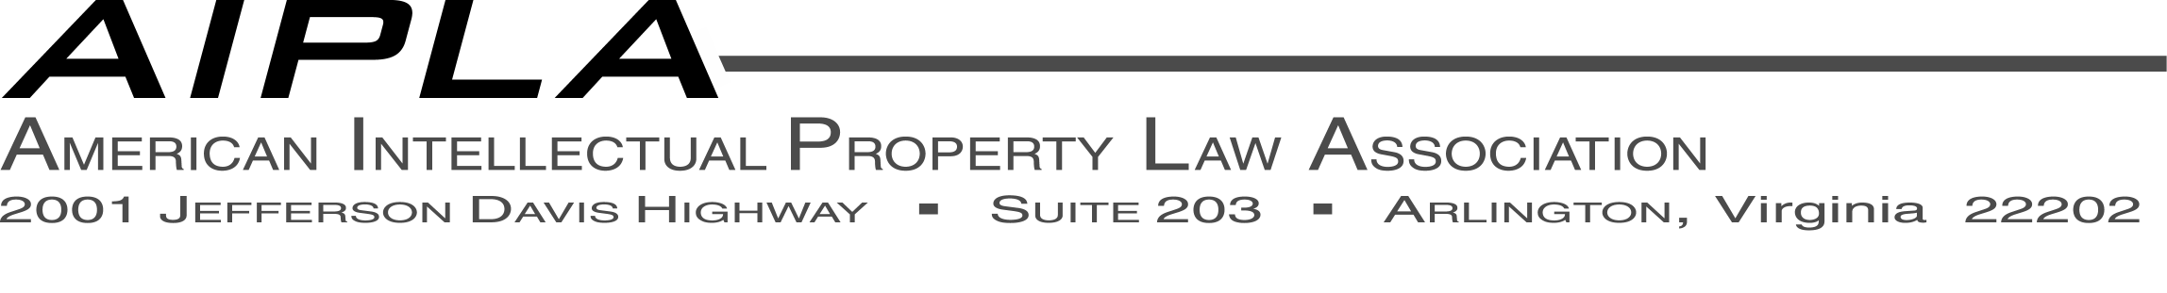
July 29, 2004
Mr. Philippe Baechtold
Head, Patent Law Section
Patent Law Department
World Intellectual Property Organization
Geneva, Switzerland

Subject: Request for Information Concerning Novelty
SCP Forum Notice Posted June 30, 2004
Dear Philippe:
The American Intellectual Property Law Association (AIPLA) has long supported the goals and processes for patent law harmonization at WIPO. We welcome the opportunity to present our views on the concept of “enlarged novelty” in response to your June 30, 2004 request for information.
The concept of enlarged novelty has been suggested as a compromise for the consideration of pending unpublished applications as prior art. While it may have some superficial attraction in the spirit of compromise among divergent views, we view the approach to be counterproductive to efforts to achieve a harmonized patent system that would be simple, clear, predictable, and productive of desirable results.
The consideration of the “enlarged novelty” of pending, unpublished patent applications rather than the non-obviousness/inventive step of such applications during the period from filing to publication would be a step in the wrong direction. AIPLA favors defining prior art to require that patents and published patent applications have a prior art effect from their effective filing date for purposes of both novelty and non-obviousness/inventive step. Effective filing date means that the prior art effect date includes the priority date for whatever subject matter is also disclosed in the priority application.
There are sound reasons why the whole contents of an earlier filed application should be available to assess whether an invention in a later application satisfies both the novelty and non-obviousness/inventive step criteria. To fail to use an earlier application to prevent the issuance of claims in a later application which are obvious in view of the whole contents of the earlier application is unfair to the earlier applicant, to competitors, and to the public.
Once an applicant has filed an application, that applicant has done all it should have to do to disclose the invention to the public. The applicant should be able to rely on the disclosure of the earlier application to prevent any later applicant from obtaining a claim for an invention that is different in only obvious ways from the invention the applicant has disclosed. The earlier applicant should be able to both enjoy the exclusive rights identified by his claims and also to prevent a late-comer from encroaching on those exclusive rights.
If obvious variations of the invention disclosed in an earlier application were permitted to be patented, competitors could face a thicket of overlapping patent claims, restricting their freedom of action short of seeking licenses from the owner of each obvious variant for which a patent was obtained.
Similarly, the issuance of patents for obvious variations of what is, in actuality, a single invention, would subject consumers to extended patent terms for potentially every invention. This can result in an improper burden on the public at large, bringing discredit on patent systems for placing the interests of patent applicants and patentees first, and failing to take the public’s interest into account.
Any treatment of pending, unpublished patent applications as prior art that falls short of non-obviousness/inventive step would be a step backward. Quite apart from the uncertainties that would be introduced by an as yet undefined enlarged novelty concept, we do not believe the results that would necessarily follow are in the best interests of the public or the business community.
We appreciate the opportunity to offer our views on enlarged novelty in the hope that future efforts will be directed to concepts that are more likely to lead to substantial agreement.

Sincerely,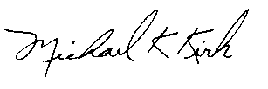
Michael K. Kirk
Executive Director
AIPLA

