XML4IP
Examples of harmonized markup for all three industrial property types
Address Type

<xsd:complexType name="AddressType">
<xsd:sequence>
<xsd:element ref="AddressLine" minOccurs="0" maxOccurs="unbounded"/>
<xsd:element ref="City" minOccurs="0"/>
<xsd:element ref="GeographicRegion" minOccurs="0"/>
<xsd:element ref="PostalCode" minOccurs="0"/>
<xsd:element ref="Country" minOccurs="0"/>
</xsd:sequence>
<xsd:attribute name="languageCode" type="ISOLanguageCodeType" default="en"/>
<xsd:attribute name="addressCategory" type="AddressCategoryType"/>
</xsd:complexType>

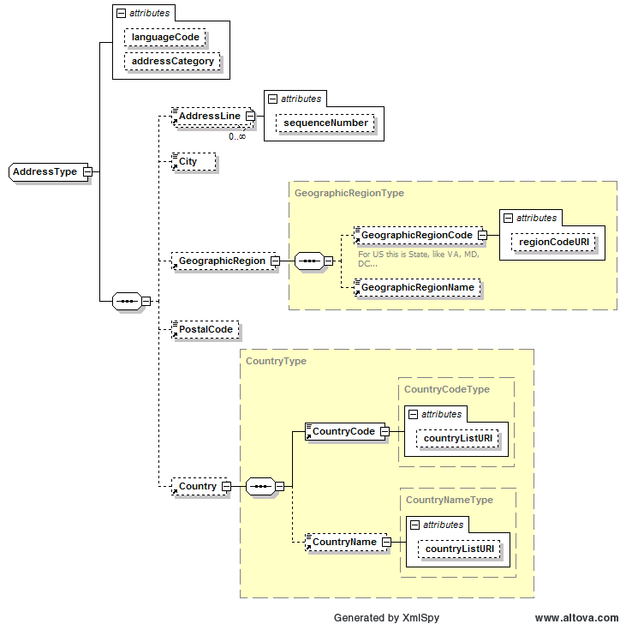

Person Name Type

<xsd:complexType name="PersonNameType">
<xsd:choice>
<xsd:sequence>
<xsd:element ref="Prefix" minOccurs="0"/>
<xsd:element ref="FirstName"/>
<xsd:element ref="PreferredFirstName" minOccurs="0"/>
<xsd:element ref="MiddleName" minOccurs="0"/>
<xsd:element ref="LastName"/>
<xsd:element ref="SecondLastName" minOccurs="0"/>
<xsd:element ref="Suffix" minOccurs="0"/>
<xsd:element ref="Initials" minOccurs="0"/>
<xsd:element ref="IndividualFullName" minOccurs="0">
<xsd:annotation>
<xsd:documentation>Freeform string describing Full Personal name</xsd:documentation>
</xsd:annotation>
</xsd:element>
</xsd:sequence>
<xsd:element ref="IndividualFullName">
<xsd:annotation>
<xsd:documentation>Freeform string describing Full Personal name</xsd:documentation>
</xsd:annotation>
</xsd:element>
</xsd:choice>
<xsd:attribute name="languageCode" type="ISOLanguageCodeType" default="en"/>
</xsd:complexType>

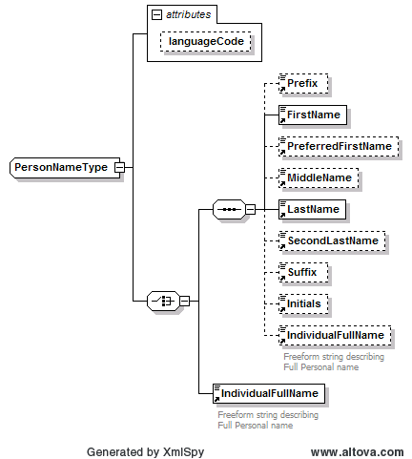

Organization Name Type

<xsd:complexType name="OrganizationNameType">
<xsd:sequence>
<xsd:element ref="OrganizationFullName"/>
<xsd:element ref="OrganizationShortName" minOccurs="0" maxOccurs="unbounded"/>
</xsd:sequence>
<xsd:attribute name="languageCode" type="ISOLanguageCodeType" default="en"/>
</xsd:complexType>

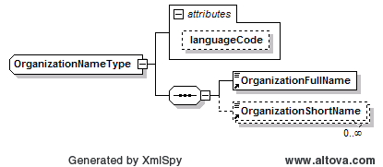

Inventor

<xsd:element name="Inventor">
<xsd:complexType>
<xsd:sequence>
<xsd:choice>
<xsd:element ref="PersonName"/>
<xsd:element ref="OrganizationName"/>
<xsd:element ref="RegisteredNumber"/>
</xsd:choice>
<xsd:element ref="Address" maxOccurs="unbounded"/>
<xsd:element ref="DesignatedStates" minOccurs="0"/>
</xsd:sequence>
<xsd:attribute name="sequenceNumber" type="xsd:positiveInteger" use="required"/>
</xsd:complexType>
</xsd:element>

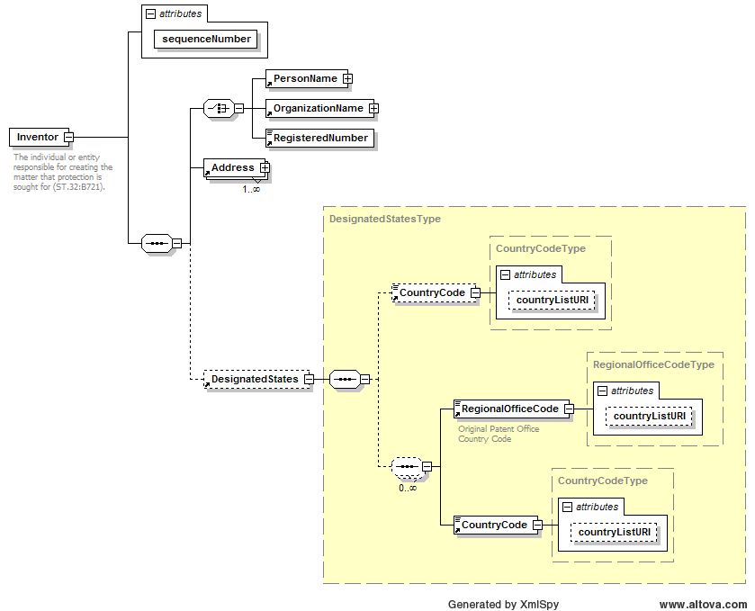

Alternatives for Industrial Property Codes

Country Code List Intersections
2007-10-24
USPTO
241 code
ISO 3166
246 codes
WIPO ST3
226 codes
AS - AMERICAN SAMOA
BL - SAINT BARTHALEMY
GU - GUAM
MF - SAINT MARTIN
PR - PUERTO RICO
UM - UNITED STATES MINOR OUTLYING ISLANDS
VI - VIRGIN ISLANDS, U.S.
QP - PARACEL ISLANDS
XP - NOT PROVIDED
ZZ - STATELESS
AP-ARIPO
BX-BBDM
EA-EAPO
EM-OHIM
EP-EPO
GC-GCC
IB-WIPO
OA-OAPI
QZ-CPVO
WO-WIPO
XN - NPI
AQ - ANTARCTICA
AX - ALAND ISLANDS
CC - COCOS (KEELING) ISLANDS
CX - CHRISTMAS ISLAND
FM - MICRONESIA, FEDERATED STATES OF
GF - FRENCH GUIANA
GP - GUADELOUPE
HM - HEARD ISLAND AND MCDONALD ISLANDS
IO - BRITISH INDIAN OCEAN TERRITORY
MH - MARSHALL ISLANDS
MQ - MARTINIQUE
NC - NEW CALEDONIA
NF - NORFOLK ISLAND
NU - NIUE
PF - FRENCH POLYNESIA
PM - SAINT PIERRE AND MIQUELON
PN - PITCAIRN
PS - PALESTINIAN TERRITORY, OCCUPIED
RE - REUNION
SJ - SVALBARD AND JAN MAYEN
TF - FRENCH SOUTHERN TERRITORIES
TK - TOKELAU
WF - WALLIS AND FUTUNA
YT - MAYOTTE
MP - NORTHERN MARIANA ISLANDS
214 Common Codes
http://www.iso.org/iso/iso_3166-1_list_en.zip
http://www.wipo.int/export/sites/www/scit/en/standards/pdf/03-03-01.pdf
http://etc-ais-60-es.etc.uspto.gov/ICT2/services/ICT/wsdl/ICT.wsdl

- Separate lists for ISO 3166, ST.3, and national augemtations
- A new combined list that exceeds ST.3 and ISO 3166
- Status quo, that is, ST.3 only

Alternatives for Country Code content model
- Define ContryCode as either enumerated lists (referenced as countryListURI in the attribute); or
- as two-character upper-case string.

CountryCodeType

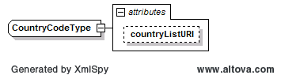

<xsd:complexType name="CountryCodeType">
<xsd:simpleContent>
<xsd:extension base="USPTOCountryCodeType">
<xsd:attribute name="countryListURI" type="xsd:anyURI" default="http://www.uspto.gov/xml/cv/USPTOCountryCodeType-v1-2007-07-18.xsd"/>
</xsd:extension>
</xsd:simpleContent>
</xsd:complexType>

CountryCodeType

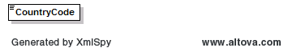

<xsd:element name="CountryCode">
<xsd:simpleType>
<xsd:restriction base="xsd:NMTOKEN">
<xsd:pattern value="[A_Z][A_Z]"/>
</xsd:restriction>
</xsd:simpleType>
</xsd:element>

ST.36 paragraph content model as implemented in US Red Book:

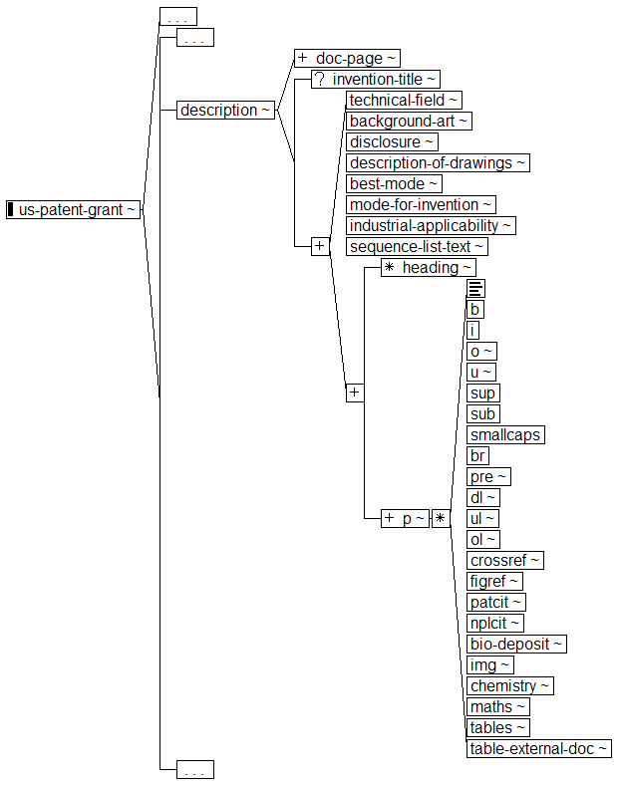

JPO proposal introducing block-level markup (layout unit):

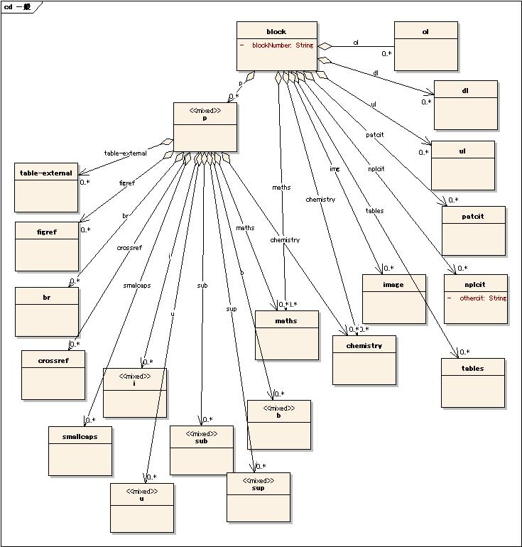
Revised ST.36 DTD based on US interpretation of JPO proposal:
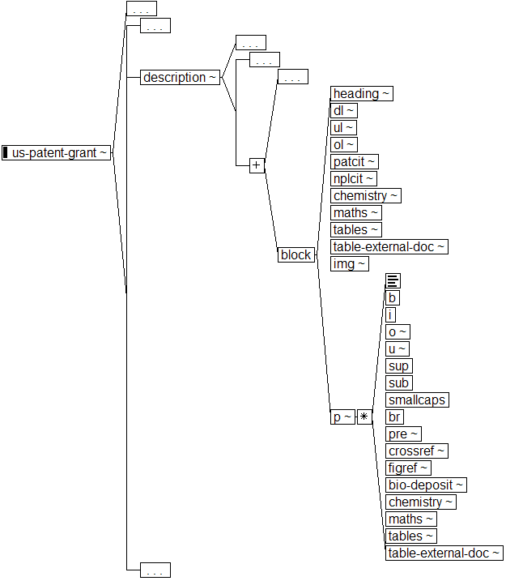
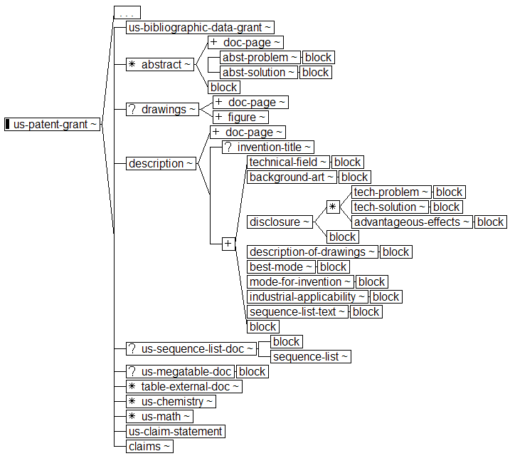

The US interpretation retains the heading element and includes table-external-doc in block and p, as is the table element.

To avoid extensive, inappropriate use of lists to provide markup that correctly renders highly structured text that duplicates claims in the disclosure, the US proposes that both block and p should be recursive (block contains block, p contains p). In claim, claim-text is recursive. Permitting p and block to be recursive makes it possible to duplicate exactly the hierarchical structures that commonly appear in claims.

