
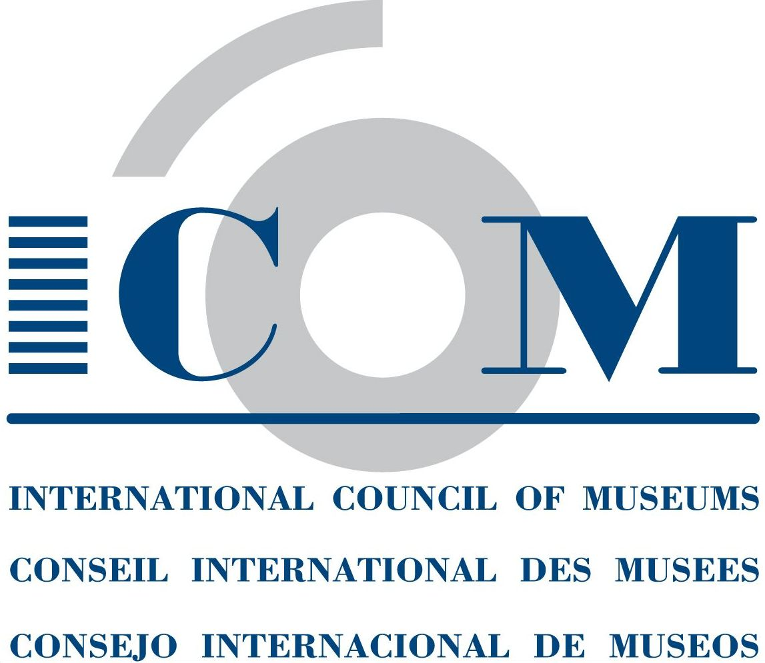

OPTIONAL STANDARD FORM TO FILE A REQUEST FOR MEDIATION

WIPO Arbitration and Mediation Center  Geneva  34, chemin des Colombettes  P.O. Box 18  1211 Geneva 20, Switzerland  T +4122 338 8247  F +4122 740 3700  E arbiter.mail@wipo.int | WIPO Arbitration and Mediation Center  Singapore  Maxwell Chambers  32 Maxwell Road #02-02  Singapore 069115  T +65 6225 2129  F +65 6225 3568  E arbiter.mail@wipo.int

NOTES ON COMPLETING THE FORM

- The present form has been established jointly by ICOM and the WIPO Arbitration and Mediation Center (WIPO Center) as a tool to facilitate the use of ICOM-WIPO Mediation as a means to promote amicable resolution of art and cultural heritage disputes, concerning issues such as the return and restitution, loan and deposit, acquisition, and intellectual property, and involving public or private parties such as States, museums, indigenous communities, and individuals.

- The requesting party may use the form to submit its Request for Mediation to the WIPO Center in accordance with Article 3 of the ICOM-WIPO Mediation Rules.

- The form is optional and should be understood as a guideline to help the parties identify relevant information in submitting a Request for Mediation and any further documentation in the mediation process.

- Please send the completed form to the WIPO Center by email and post to the address indicated above.

0.1 Names and Communication Details of the Parties and their Representatives

Please provide the names and communication details of the relevant parties and their representatives.

0.2 Copy of the Mediation Agreement

Please provide a copy of the Mediation Agreement (contract clause or mediation submission agreement).

0.3 Nature of the Dispute

Please provide a brief statement of the nature of the dispute.

I. DOCUMENTARY DATA ON THE OBJECT

1.1 Description of the Object

Information should be provided, if possible, with respect to:

a) Type of Object: painting, sculpture, manuscript, ceramics, textiles, archaeological finds buildings or monuments, etc.

b) Characteristics: material from which the object is made out of (for instance wood, stone, metal, parchment, etc.), dimensions, weight, form, period, authorship (if applicable), and any special distinctive features.

1.2 Location of the Object

The place where the Object is currently displayed or held should be specified (e.g. a museum, gallery or reserve collection). If the location is unknown, the claimant may wish to state a presumed location, according to the latest information available and provide any evidence in connection with a potential location

1.3 Ownership

It should be specified whether the object was/is the property of a public or private organization or of a private individual and who owns a copyright on the object.

1.4 Date of Acquisition

1.5 Legal Status

Is the object part of national heritage? Is the object part of the collection of a public or private museum? Is the object leased, if it is, is it a short – or long-term lease, or a deposit, etc.?

1.6 State of Conservation

Details concerning the decay of the object’s constituent materials and an assessment of the conservation risks should be provided. Did the object suffer any deterioration(s), or any intentional or accidental mutilation(s)? Was any restoration carried out?

1.7 Conservation Requirements for the Object

Information should be provided as to the environmental conditions required, such as the possible conservation treatment indicated.

1.8 References and Documentation

Bibliographic and/or other references concerning the object should be provided. Other documentation such as labels, catalogue cards, information about the archaeological site from which the object originated, and such should also be included whenever possible. Such material may be attached to the present form.

1.9. Circumstances in which the Object is no Longer in the Country of Origin

Information should be provided, if possible, with respect to the means used to take the object out of its country of origin: trade, illicit appropriation, colonial or foreign occupation, exchange, gift, lease for repair and/or reproduction, temporary export licenses for scientific purposes including, for instance for conservation or exhibition purposes, a copy of any piece of evidence in connection with this issue may be attached to the present form.

1.10 Mode of Acquisition

The mode of acquisition should be specified, e.g. purchase, gift, exchange, lease, archaeological excavation, temporary import for scientific purposes, illicit acquisition, colonial or foreign occupation, etc.

1.11 Particular Significance of Object

The significance may be historical, cultural, religious or scientific, or a combination of several of these. The object may be a “missing link” in a given cultural tradition and/or in the country’s national collection.

1.12 Details on Similar Objects Known to Exist in the Country of Origin or Elsewhere

Information may be provided concerning objects of the same period, provenance or type, or (where applicable) by the same author; objects whose significance is similar to that described under 1.11 above can also be mentioned.

II. CARRIED OUT ACTIONS

2.1 Previous Negotiations

Has any negotiation been carried out so far? If yes, has any result been achieved? Please indicate reasons for lack of progress with respect to these negotiations.

2.2 Expected Orientations

Proposals with respect to further steps necessary or new forms of co-operation or negotiation to be initiated may be outlined here.

2.3 Legal Status the Object would have in the Requesting Party’s Country

Information should be provided as to, whether the object would become part of the national heritage or if it would enter public or private museum collections or another institution.

2.4 Place of Display in the Requesting Country

Information should be provided as to whether the object will be displayed in a State museum or in another institution; in a private museum or institution; in a place of worship, etc.

2.5 Facilities Available

Information should be provided concerning the curatorial, managerial, conservation and security facilities available in the museum or the institution which will receive the object.

2.6 Institutions or Persons Responsible for Negotiations

2.7 Representation

Please provide the name and address of your legal advisor if you are represented or decide to be represented in the mediation process.

III.OTHER OBSERVATIONS

