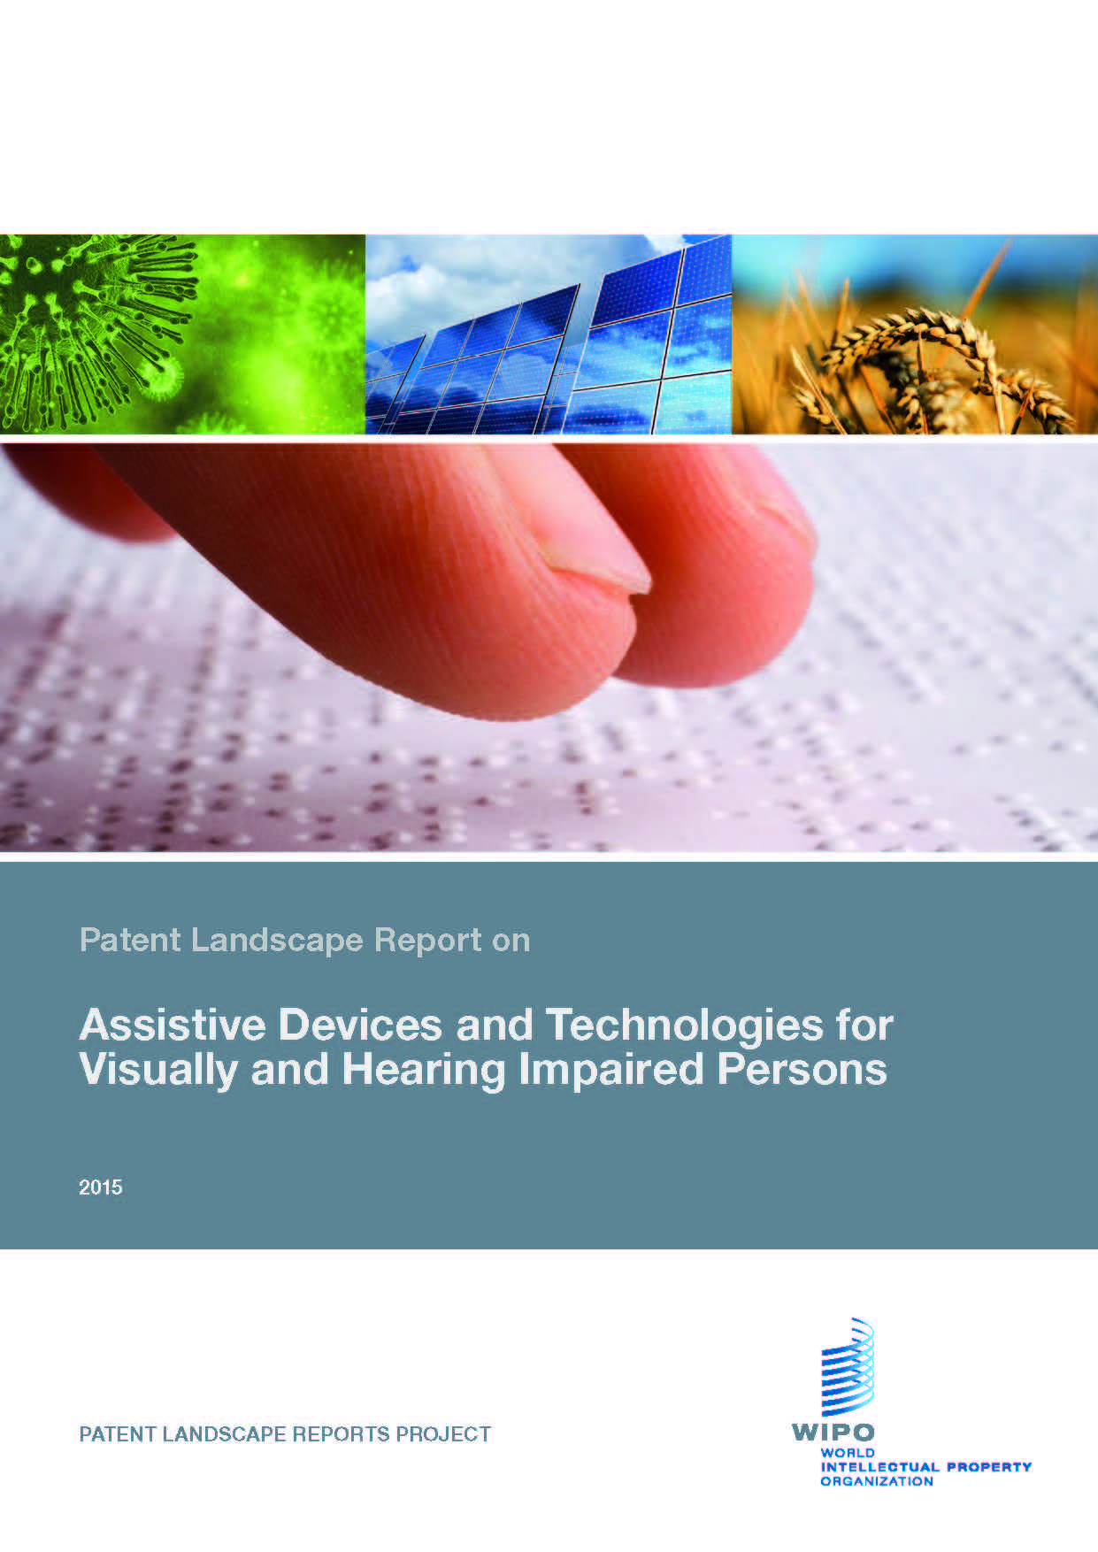
Cover page, document starts on page 2.

PATENT LANDSCAPE REPORT ON ASSISTIVE DEVICES FOR VISUALLY AND HEARING IMPAIRED PERSONS
Prepared for:
World Intellectual Property Organization
By
Thomson Reuters IP Analytics
Nick Solomon and Pardeep Bhandari

This Word document has been enhanced for accessibility by Dave Gunn at Outervations, with contributions from BarrierBreak. These amendments include structural enrichment, color adjustments, enhanced images and the creation of alternate text descriptions to support all of the graphics and tables throughout the document.
To help us improve the accessibility of future reports we welcome your feedback and comments to: patent.information@wipo.int

2015

EXECUTIVE SUMMARY
The present Patent Landscape Report (PLR) forms part of WIPO’s Patent Landscape Reports series. The PLRs started as one of the outputs of WIPO’s Development Agenda project “Developing Tools for Access to Patent Information”, (DA_19_30_31_01) described in document CDIP/4/6, adopted by the Committee on Development and IP in 2009. The project document foresaw the preparation of PLRs in the areas of food and agriculture, public health, environment and energy, and disabilities, on topics of particular interest foremost to developing and least developed countries. This report is the first one prepared in the area of disabilities. It aims to provide patent-based evidence on the available technologies, patenting and innovation trends in the area of assistive devices and technologies for visually and hearing impaired persons.
The present PLR is prepared in collaboration with the World Health Organization (WHO) Medical Devices Program and the Disabilities and Rehabilitation Program and is aimed, among others, at supporting the Global Cooperation on Assistive Technology (GATE) in its efforts to assist “children accessing education and adults to earning a living, overcome poverty, participate in all societal activities, and live with dignity, which are some of the key objectives of the global development goals” It will also be distributed to NGOs working to the benefit of persons with visual and/or hearing impairments. Its part on visual impairment and in particular the one on technologies facilitating access to published works aims to constitute a complement to the recently adopted Marrakesh Treaty to facilitate access to published works for persons who are blind, visually impaired, or otherwise print disabled, and the recent launching of the Accessible Books Consortium (ABC) at WIPO in June 2014, as it provides information on technical solutions described in patent applications which could serve the needs of print disabled persons in the Marrakesh Treaty and ABC context. The ABC supports the goal of the Marrakesh Treaty to increase the number of books worldwide in accessible formats - such as braille, audio and large print - and to make them available to people who are blind, have low vision or are otherwise print disabled (the print disabled). Through its capacity building activities, the ABC is actively engaged in the provision of assistive reading devices to students who are print disabled in developing and least developed countries.
The report covers in detail published patent applications and granted patents within the space of assistive devices and technologies for visually and hearing impaired persons. Additionally, the report uses additional reference information such as news and other business data sources to extend the information into real-world applicability, and also to verify the interest and commercial activity of entities mentioned within the study.
The patent landscaping process applied to the assistive devices and technologies for visually and hearing impaired person’s field has uncovered several interesting facets of this industry.
Innovation associated with this technology has grown substantially over the last half century with only a recent decline in patent activity occurring. This decline was most likely attributed to in some capacity by the increased worldwide competition in the field, especially from entities originating from Asia. These entities appear to have directly affected the filing activity trends of some of the traditionally strong performers in this technology field, typically from the United States and Europe. Additionally, worldwide economic instability around the 2009 period may also have forced some entities to reduce, further scrutinize or even hold off on some innovative practices due to the significantly high financial outlay that is associated with the patent process.
This increased competition and financial awareness have potentially had one positive on many entities covered in this report, namely that these economic conditions have forced more entities to be more technologically savvy and innovative in their research and development associated with assistive devices for visually and hearing impaired persons, a practice that ultimately can only benefit the consumer.
The United States and Japan are the major sources of innovation associated with the technology, however patent activity in both of these countries is in decline. The United States’ major technology strengths lay in the vision restoration technology field such as intraocular devices and in other related technology such as hardware for assistive devices. Japan’s technical strengths lie in hearing assistance technology such as voice or language recognition technology, speech recognition or sound voice conversion to text or video.
China and the Republic of Korea are increasing their patent activity the field. Both countries are becoming more prominent in areas such as voice or language recognition and sound control technology. Many of these patents (China especially) are inherently filed locally, indicating that a large proportion of patents have only been filed in their home location and globally speaking nowhere else. A similar trend can be observed in many Asian countries. China has also witnessed the highest recent growth in patent activity; however, it has one of the lowest percentages of patented innovation filed in multiple or other jurisdictions. It should be noted that Chinese patent activity growth is a trend observed in the modern patent landscape analysis in general. The findings for China in the present report show that these more macro trends extend into the assistive devices arena.
Entities favor filing their patents in the Asian Pacific region over the Americas. This is largely due to a significant proportion of applicants from the Asian Pacific region only filing in their own countries. Asian Pacific entities file the least amount of patents into the Americas (overwhelmingly focused on the United States) or the EMEA regions, which incorporate Europe, the Middle East and Africa. BRICS (Brazil, Russia, India, China and South Africa) countries only make up a small portion of first filed patent activity when all global patent totals are taken into account, indicating that only a small number of applicants originate in these territories. Other economies including Hungry, Czechoslovakia, Poland and developing countries including most African nations, Malaysia and Indonesia contribute very small amounts of patent activity. A large majority originates from developed countries, specifically the United States, Japan, Germany, the Republic of Korea and France.
Over half of all patent families have at least one granted patent associated. This equates to the technology field as a whole being moderately successful and on a par with expected grant-to-application ratios. In terms of patent pendency, Hong Kong, Special Administrative Region of the People’s Republic of China is seen to lead the way with the lowest pendency period whereas the Ukraine has the undesirable distinction of being the slowest.
There are three basic ‘concepts’ into which the general patent landscape has been divided. These include a) restorative, b) assistive and c) enhancement technology. These three general concepts were further divided in to thirty six distinct technical categories covering all aspects of visual and auditory technologies covered by the report.
The highest numbers of patented innovation in relation to hearing technology was associated with voice or language recognition, speech processing or sound-voice conversion to text or video. In the area of vision innovation, general vision assistance technology and intraocular device technology had the highest numbers of patent applications.
The highest growth in patenting activity was observed in the areas of voice control and sound control (related to vision assistance), while general vision enhancement related technology had the largest observed decline in recent patenting activity.
Innovation which alluded to concepts covered in the Marrakesh Treaty, namely technologies facilitating access to published works, and in digital rights management was well represented. Many patents covered were relevant to the methods and processes of a more ‘assistive’ nature covered by the Marrakesh Treaty, including “accessible formats” such as a book being read out. There was understandably less specific mention of copyright-related exemptions associated with literary or artistic works in the patent dataset, as patents (as a registered right) inherently contain content which is new, useful and non-obvious whereas a copyright does not require registration for protection.
In terms of geographical distribution of patenting activity, some general patent technology trends were observed. Entities from the Americas (primarily the United States) generally focused more on the physical aspects of this technology area, including technology directed toward the physical implant or device and also the hardware involved in this technology. The Asia Pacific region (primarily Japan, China and South Korea) had a heightened focus on the more conceptual innovation in this technology field such as voice or language recognition technology, speech processing or sound voice conversion to text video and intellectual property rights, digital management and general technology associated with the goals of the Marrakesh Treaty. EMEA jurisdictions were shown to have the most varied patent portfolio in relation to assistive devices and technologies for visually and hearing impaired persons with no stand out technologies in the patent applications from this region.
On a country specific basis, entities originating from the United States had the highest interest in vision restoration, such as intraocular devices, while related technologies associated to vision and hearing devices, such as hardware, were also prominent. Japan and Australia have the highest perceived interest in hearing restoration technology. Additionally, more than half of Australian patent innovation is associated with aspects of vision restoration technology.
United States, French and Russian entities have a higher proportion of their patent portfolio’s associated with intraocular lens technology, whereas South Korean entities show high interest in voice to speech recognition technology, speech processing and voice to text conversion technology.
China has one of the most varied patent innovation portfolios, however technology related to hearing restoration and hearing enhancement appears to be of least interest there. Russian entities have high interest primarily in vision restoration and enhancement. Europe has strong and varied representation in all major topics associated with this technology. Many of the top countries innovating in the assistive devices and technologies for visually and hearing impaired persons field have moderately high numbers of patents in the additional related technology field which includes innovation alluding to IP rights, digital management, biodegradable or recyclable technology, the design or shape of a device and the hardware or software related to a device.
Vision restoration technology had the highest perceived commercial interest recently by entities due to the patents associated with this technology having high impact in the field, high recent filed patent activity rate and a higher number of patents in this technology being filed very broadly in terms of geography. As in the field of hearing restoration patents have a low impact has and there was the lowest perceived recent commercial interest, there are lower numbers of recently filed patents and number of patents filed in multiple jurisdictions.
Corporate entities comprise the largest part of this patent technology portfolio. 38 large entities having 100 or more patents represent just over a quarter of the total patent inventions in the dataset. Most large entities originate from developed countries with only a small proportion originating from BRICS countries or other economies. Corporate patent activity is highly concentrated in the United States and Japan. A significant amount of smaller corporate entities have originated in the Unites States, highlighting that the United States has good representation among both large and small corporate entities in this technology field.
Corporate entities generally have strong interest in voice or language recognition technology, speech processing technology, technology processes associated or alluding to intellectual property rights and digital management applications and general hearing assistance technology. Corporate patent activity has begun to decrease in recent years and is highly concentrated in the United States and Japan.
Currently, Academic and Government interest only comprises a small part of the patent landscape and is far lower that the patent portfolio of corporate entities. This interest however has begun to increase. Academic and government patent activity has a higher concentration in the China, Russia, Spain, Taiwan – Province of China and South Korea. Academic and government interest appears to be directed toward vision related technology such as vision assistance, intraocular devices and general vision care technology. A large proportion of these academic and government entities are located in Asia – specifically China, South Korea, Japan, Taiwan (Province of China) or India.
Entities that can be described as the most active in this technology field by having the largest number of total inventions associated with this technology field worldwide include Novartis (Switzerland), Panasonic (Japan), Siemens (Germany), Abbott Laboratories (United States) and Cochlear Limited (Australia).
Top patent filers by region (together with their originating country) include Panasonic (Japan), NEC (Japan) and Rion (Japan), Nidek (Japan) and NTT (Japan) for the Asia Pacific region. Novartis (Switzerland), Abbott Laboratories (United States), Valeant (Canada), Advanced Bionics (Switzerland) and Johnson & Johnson (United States) for the Americas region and Siemens (Germany), Carl Zeiss (Germany), Essilor (France), Philips (Netherland) and Oticon (Denmark) for EMEA countries.

CONTENTS
EXECUTIVE SUMMARY 3
CONTENTS 7
PART 1 – INTRODUCTION AND BACKGROUND TO THE PROJECT 9
PART 2 - DESCRIPTION OF THE SEARCH METHODOLOGY 12
2.1 DATA SOURCES 12
2.2 COLLECTION COLLATION METHOD 13
2.3 IDENTIFIED CLASSIFICATIONS OF RELEVANCE 13
2.4 COMMENTS ON NOISE REDUCTION METHODS 15
2.5 SEARCH STRING CREATION AND QUALITY CONTROL 16
2.6 FINAL SEARCH STRATEGY 16
2.7 DATES AND COUNTS 19
2.8 PATENT APPLICANT NAMING VARIATIONS 20
2.9 TECHNICAL TERMINOLOGY 20
PART 3 – INTRODUCTION TO ASSISTIVE DEVICES AND TECHNOLOGIES FOR VISUALLY AND HEARING IMPAIRED PERSONS 21
3.1 PATENT ACTIVITY BY REGION 24
3.2 PATENT ACTIVITY BY PATENT AUTHORITY 30
3.3 LIST OF OFFICES OF FIRST FILING 32
3.4 OFFICES OF SECOND (SUBSEQUENT) FILING 34
3.5 GEOGRAPHIC MAPPING ANALYSIS OF MAJOR SOURCES OF INNOVATION 36
3.6 DIFFERENCES IN IP PROTECTION STRATEGY BY LOCATION 37
3.7 ACTIVITY BY ECONOMY TYPE 39
3.8 SUMMARY METRICS – FILING BREADTH, GRANT SUCCESS, PATENT PENDENCY 40
3.9 PATENT FILING STRATEGIES 45
3.10 ANALYSIS OF MULTI-AUTHORITY FILED PATENT FAMILIES 47
3.11 KEY FINDINGS FROM THE LANDSCAPE OVERVIEW 50
PART 4 - TECHNICAL LANDSCAPE ANALYSIS OF ASSISTIVE DEVICES AND TECHNOLOGIES FOR VISUALLY AND HEARING IMPAIRED PERSONS 52
4.1 TECHNICAL SEGMENTATION OF THE LANDSCAPE 52
4.2 DETAILED BREAKDOWN OF PATENTED TECHNICAL APPROACHES 52
4.4 ASSISTANCE 54
4.5 ENHANCEMENT 55
4.6 ADDITIONAL RELATED TECHNOLOGY 56
4.7 ‘OTHER’ TECHNICAL CATAGORIES 57
4.8 MAJOR TOPICS OF INNOVATION 57
4.9 TECHNOLOGIES FACILITATING ACCESS TO PUBLISHED WORKS 70
4.10 INNOVATION CONCEPT CROSS OVER – ADUNA MAPPING 75
4.11 TECHNOLOGY INNOVATION – ACTIVITY GROWTH OR DECLINE 78
4.12 SPECIALISATION OF INNOVATION BY GEOGRAPHY 82
4.13 TECHNOLOGY RANKING AND COMMERCIALISATION 85
4.14 KEY FINDINGS FROM TECHNOLOGY ANALYSIS 89
PART 5 – COMMERCIAL LANDSCAPE ANALYSIS OF ASSISTIVE DEVICES AND TECHNOLOGIES FOR VISUALLY AND HEARING IMPAIRED PERSONS 91
5.1 DISTRIBUTION OF PATENT ACTIVITY BY PORTFOLIO SIZE 91
5.2 ACADEMIC VERSUS CORPORATE PATENT ACTIVITY 95
5.3 MAJOR PATENT APPLICANTS 98
5.4 MAJOR PATENT APPLICANTS BY PORTFOLIO STRENGTH 107
5.5 MAJOR PATENT APPLICANTS BY REGION 109
5.6 SUMMARY OF MAJOR PORTFOLIO CHARACTERISTICS 111
5.7 SUMMARY OF MAJOR NOT-FOR-PROFIT ENTITIES 116
5.8 MAJOR PATENT INVENTORS 118
5.9 KEY FINDINGS FROM COMMERCIAL ANALYSIS 119
ANNEX A - BUSINESS DATA FOR MAJOR PORTFOLIOSPORTFOLIOS 121
ANNEX B – PATENT LANDSCAPE SEARCH STRATEGYDIX B – PATENT LANDSCAPE SEARCH STRATEGY 182
ANNEX C – GLOSSARY 184
ANNEX D – AUTHOR BIOGRAPHIESTHOR APHIES 187
BACKGROUND ON CONSULTANT – NICK SOLOMON 187
BACKGROUND ON CONSULTANT – PARDEEP SINGH BHANDARI 187
BACKGROUND ON EXTENDED ANALYTICS TEAM 188

PART 1 – INTRODUCTION AND BACKGROUND TO THE PROJECT
A world report prepared by WHO (World Health Organization) and the World Bank indicates that more than a billion people in the world experience disability. A significant proportion of these people (approximately 285 million) are visually impaired, with 39 million being blind and 246 million having low vision. It is estimated that 90% of those affected by visual impairment live in developing countries. Additionally, another 360 million people are affected by hearing impairment. Both visually and hearing impaired persons face many challenges in society including educational, employment related and those related to general wellbeing.
The high importance of assistive technologies for overcoming difficulties and challenges has been addressed in the WHO Disability and Rehabilitation Action Plan 2006 – 2011, and the 2014 – 2021 draft. These documents and also the WHO report “Local Production and Technology Transfer to Increase Access to Medical Devices” highlight the need for improved availability and access for individuals with disabilities to assistive technologies which are both affordable and appropriate for their needs and requirements. It is vitally important for the persons affected by visual or hearing impairment to have access to technologies that aid in assisting, enhancing or restoring hearing or vision and helping individuals tackle and overcome the challenges that such impairment bestows.
In June 2013, the text of the WIPO Marrakesh Treaty was adopted with the aim to facilitate access to published works by visually impaired persons and persons with print disabilities. This agreement focused on copyright exceptions to facilitate the creation of accessible format versions of books and other copyrighted printed materials for visually impaired persons. This treaty acts as a basis for countries ratifying the Treaty to have a domestic copyright exception for the creation of accessible formats of printed materials for the benefit of visually impaired persons, and to allow for the import and export of materials in these formats.
To support the Marrakesh Treaty at a practical level, WIPO also established the Accessible Books Consortium (ABC) in June 2014. ABC is a multi-stakeholder partnership, comprising WIPO, organizations serving persons who are print disabled and organizations representing authors and publishers.
Assistive devices and technologies related to hearing and vision has been defined by the WHO as devices such as prostheses, mobility aides, hearing aids, visual aids, and specialized computer software and hardware increase mobility, hearing, vision and communication capacities. With the aid of these technologies, people with a loss in functioning are better able to live independently and participate in their societies. However, in many low-income and middle-income countries, only 5%-15% of people who require assistive devices and technologies have access to them.
This report investigates and highlights the published patenting activity related to assistive devices and technologies for visual or hearing impairments. Only technology encompassing assistive devices and technologies for visually and hearing impaired persons has been included in this report and has been researched. Other impairment associated technology (e.g. mobility impairment) is not or covered by this report.
Assistive devices and technologies for visually and hearing impaired persons aim to increase vision, hearing and communication capacities among those affected. Technology, including those previously mentioned including vision or hearing aids, prostheses or implants (cochlear implants or bionic eyes), voice recognition and control, touch / tactile / haptic technology, sensor technology, image and data (visual or sound) recognition, technologies serving the same goals as the Marrakesh Treaty, namely facilitating access of print disabled persons to published works, electronic stimulation and specialized software / special accessibility features of technology products are just some of the technologies that have been extensively researched and covered in this report.
In order to better understand the various technologies associated with assistive devices and technologies for visually and hearing impaired persons, the geographical distribution of innovation, the research topics and the primary actors within research and development associated with assistive devices and technologies for visually and hearing impaired persons, this study utilizes a process of assessing the patent activity associated via a methodology known as patent landscaping.
Patent landscaping is a process whereby larger, specifically selected collections of patent documents (whether granted or otherwise) are analyzed to derive important technical, legal and business information.
The collections of patent documents can be selected according to whether they relate to a specific technological subject matter, for example an intraocular device or the collection can be defined at a much wider level such as an industry, such as is the case for the visual or hearing assistive technology report. Similarly, one can also select a group of competitors within an industry, or simply the internal patent portfolio of a single organization.
While published patents are publicly available information, aggregating data from multiple different sources (i.e. the various patent offices around the world), formatting and preparing it for analysis and then the analysis itself is no small task. A single patent document can range anywhere from 10 - 100 pages in length and contains technical details of the invention claimed. This deep information needs to be organized and mined for the approach undertaken or the device invented. Further, the document also contains bibliographic information such as the inventors’ names, their employer, address information, the location of the patent application filing and other useful information that must be formatted, cleaned and prepared prior to in-depth analysis.
Patent information inherently contains commercially relevant information, due to the economic investment that the applicant has performed in researching and developing the invention, the cost involved of filing and successfully prosecuting the application in various jurisdictions the applicant considers as potential markets for commercializing the invention and the intangible asset incorporated into a patent, allowing the patent owner to exploit and excluding third parties from using the invention.
Aggregation of patent information therefore provides technical and commercial conclusions, such as macro-economic or geographic trends in innovation or identifying changes in activity or technology commercialization strategy – whether industry wide or from a single organization perspective. It also provides context of the major actors and players within a space as well as identifying more niche corporations or research institutions with expertise and interest in the field.
The objective of this patent landscape report is to provide a comprehensive overview of available technologies associated with assistive devices and technologies for visually and hearing impaired persons, as far as they are described by published patent applications, to illustrate them with selected patent applications and to identify the trends and patterns of patenting activity in this area.
The report aims at identifying patent families (including utility models) that claim inventions related to the assistive devices and technologies for visually and hearing impaired persons within the scope as defined above. Patent families are defined as the collection of related patent documents (applications and granted / issued patents) that substantially cover the same invention. The landscape report exclusively researches inventions described in patent publications and not any other source of technical information for inventions.
As the study only aims at providing an overview of patent activity in the area of assistive devices and technologies for visually and hearing impaired persons, it does not focus on aspects of validity of protection or freedom-to-operate, i.e. it does not comment on whether a patent that has been granted for a particular patent application has entered into force or is still valid. Claims have only been used as general guidance as to what types of subject matter is claimed as the invention. However, in order to assess coarsely the level of innovation of applications, for each patent family, whether the family comprises at least one publication of a granted patent (based on the publication kind codes of patent family members) has been researched (see column of the patent families database excel sheet).
The report describes patterns or trends of patenting activities in this field by including a standard statistical analysis of the search results, e.g. with breakdown by main applicants, patent activity over time, priority countries (i.e. offices of first filing, OFF), geographical distribution of patent family members (i.e. offices of subsequent filings/second filing, OSF), distribution of patenting activity by type of technology and related components.

PART 2 - DESCRIPTION OF THE SEARCH METHODOLOGY
This section of the report provides a detailed explanation of the process of creating a collection of patent documents related to the field of assistive devices and technologies for visually and hearing impaired persons.
Any patent search methodology, whether for patent landscaping purposes or other patent-related research, requires three primary fundamental steps:
- Selection of data sources and patent coverage
- Understanding and selection of appropriate patent classifications
- Understanding and selection of appropriate terminology related to the subject matter
This section of the report focuses on these three elements and describes the process undertaken for the creation of a collection of patent documents that accurately describe the assistive devices and technologies for visually and hearing impaired persons landscape.

2.1 DATA SOURCES
The study uses the Derwent World Patents Index™, a database of patent applications and granted patents from 50 patent jurisdictions around the world produced by Thomson Reuters.
DWPI is a database that goes back to around 1965 for certain sources, but in essence can be described as an editorially created database of patents. The database is created editorially in the sense that the key content of patent applications and granted patents such as novel feature, applications, benefits are re-abstracted from the original text of the patent document into a standard format.
The database is also re-indexed by Thomson Reuters staff to an in-house patent classification system.
The DWPI database also organizes the raw patent information into families using a definition specific to the DWPI database. As each patent application or granted patent is published, the DWPI system compares the new document to the existing database and identifies any “equivalent” invention, e.g. in terms of claimed technical content. In this manner, the database creates families of patent documents that substantially relate to the same invention.
This process for so-called Thomson DWPI families differs from other definitions of patent families that may be more administrative in their approach, e.g. exclusively compare priorities, and do not account for similar or indeed differing subject matter.
Overall, the usage of the DWPI database provides comprehensive global coverage back far enough in time for accurate descriptions of the landscape. In addition, the architecture of the database provides for good analytical capability, in particular:
- The database includes the following patent classifications for accurate and comprehensive record retrieval:
  - US Patent Classification
  - Cooperative Patent Classification (CPC)
  - International Patent Classification (IPC)
  - Japanese File Index (FI) and F Terms
  - DWPI Classification (editorially applied)
- The structure of the DWPI patent family allows for the usage of patent family and invention as synonyms.

2.2 COLLECTION COLLATION METHOD
The following steps were used to create and then refine the search methodology:
- Creation of search strings including specific terminology with which to interrogate the database for related patent documents to this technology;
- Analysis of the results to identify key classifications (DWPI, IPC, Cooperative Patent Classification and Japanese F-Terms);
- Iteration of the search utilizing relevant classification terms to provide a more comprehensive dataset;
- Analysis of the dataset to identify regions of off-topic subject matter;
- Further iteration of the search to remove off-topic subject matter to the extent possible;
- Finalization of the search string.
The usage of keyword and classification search strings for the creation of discrete technology datasets in patents and literature databases is a standard best practice for information science, informatics and bibliographic data of this type.
Throughout the above process, consultation of the authors of the report took place with WIPO to review, modify and inform regarding many aspects of the search.

2.3 IDENTIFIED CLASSIFICATIONS OF RELEVANCE
The following patent classifications were identified in the course of the search creation procedure. The procedure for the identification of these classifications primarily concerned statistical analysis of returned patent datasets using defined terminology concerning assistive devices and technologies for visually and hearing impaired persons and initial reviews of highly relevant codes.
Not all codes were used alone; in some cases they were used in conjunction with other terminology. Full details of search strategies can be viewed in ANNEX B of this report.

Derwent Manual Codes
A12-V02A | Optical Prosthesis
B14-N03 | Eye Disorder Treatment General
D09-C01A | Prosthesis and Implants – Lenses
S04-B07 | Braille Clock
S05-F01 | Electrical medical Equipment - Prosthesis - Hearing Aids
S05-F05 | Artificial Aids for Eye sight
S05-K | Aids for handicap people e.g. Braille Devices
T01-C08A | Speech Recognition / Synthesis Input / Output
W04-Y | Audio Visual Recording and Systems - Hearing Aids
X22-L | Speech Synthesisers / Speech Recognition Units for Various Applications

International Patent Classifications and CPC Codes
A61F 11/00 | Methods or devices for treatment of the ears, e.g. surgical; Protective devices for the ears, carried on the body or in the hand
A61F 11/04 | Devices or methods enabling ear patients to replace direct auditory perception by another kind of perception
A61F 11/08 | Non Electric Hearing Aids
A61F 11/12 | External mounting means
A61F 11/14 | External, e.g. earcaps or earmuffs
A61F 2/00 | Filters implantable into blood vessels; Prostheses, i.e. artificial substitutes or replacements for parts of the body; Appliances for connecting them with the body; Devices providing patency to, or preventing collapsing of, tubular structures of the body,
A61F 2/02 | Prostheses implantable into the body
A61F 2/14 | Eye parts, e.g. lenses, corneal implants
A61F 2/16 | Intraocular lenses
A61F 2/18 | Internal ear or nose parts e.g. ear drums
A61F 9/ | Methods or devices for treatment of the eyes; Devices for putting in contact-lenses; Devices to correct squinting; Apparatus to guide the blind; Protective devices for the eyes, carried on the body or in the hand
A61N 1/ | Electrotherapy; Circuits therefore
A61N 1/0543 | Electrotherapy; Circuits therefore ; Electrodes for Implantation into the body; Retinal Electrodes
A61N 1/36032 | For stimulation; of the outer, middle or inner ear, e.g. cochlear implants
A61N 1/36046 | Electrotherapy; Circuits therefore ; Electrodes for stimulation of the eye
G01D 7/12 | Indicating measured values ; Audible indication of meter readings, e.g. for the blind
G01L 15/→ | Speech Recognition
G02C 11/00 | Non-optical adjuncts; Attachment thereof
G02C 11/06 | Hearing Aids
G06K 9/→ | Methods or arrangements for reading or recognising printed or written characters or for recognising patterns
G09B 21/→ | Teaching, or communicating with, the blind, deaf or mute
G09B 21/003 | Using tactile presentation of the information, e.g. Braille displays
H04R 25/00 | Deaf-aid sets
H04R 25/02 | Adapted to be supported entirely by ear
H04R 25/04 | Comprising pocket amplifiers

Japanese F-Terms
4C097AA24 | Prosthesis replacing the eye
4C097SA00 | Artificial Eye or Intraocular Lens
5D022 | Hearing Aids
5J100AA05 | Hearing Sense compensation
5K012BA16 | Aiding Hearing

2.4 COMMENTS ON NOISE REDUCTION METHODS
Any large scale and wide ranging search strategy will inevitably return noise, i.e. irrelevant or off topic patent documents.
This is to be expected and can be tolerated, to the extent that this noise does not bias significantly trends observed in the related statistical analysis. In particular, the nature of patent landscaping and the use of advanced analysis techniques mitigate the effect of off topic hits, as any large scale areas of off topic subject matter can be easily identified and removed.
It is however more difficult to lessen the effects of many small, distinct off topic subject areas, each with few documents, that in aggregate may materially affect the results of the landscape study.
Specific off topic areas which arose during the course of the assistive devices and technologies for visually and hearing impaired persons search process creation included:
- Chemicals or chemical processes relating to lenses or construction of a device
- Coating composition for lenses
- Laser corrective surgical applications or methods which aim to improve eyesight
- Manufacturing process of parts or components of a device
- Power or battery sources for hearing or visually impaired devices.
- Purely cosmetic applications for hearing and vision which do not assist, enhance or restore sight or hearing e.g. color lenses
The primary method of concentrating the dataset onto topics of interest used a search-wide restriction of patent documents to the classification areas previously identified.

Each search string (see ANNEX B) used keywords and/or technology classification codes and indexing as appropriate to produce relevant individual technology collections. It is likely that there is some overlap between technology and inclusion of noise in the data; however, to the extent possible this has been minimized.

2.5 SEARCH STRING CREATION AND QUALITY CONTROL
The creation of the search strings was performed iteratively, with the results of each generation of search strings reviewed and evaluated to inform and tailor the search to become more accurate.
As each search string is created, the results are sampled and reviewed for relevancy, and keywords and classifications amended as appropriate. Further, the results of each string are data mined for further key terms of interest, synonyms and alphanumeric technology classification codes of relevance, which are then incorporated in revised search strings. This process is repeated until revisions perform only minor variations in results. At this point, the search string is locked in its configuration (see ANNEX B).

2.6 FINAL SEARCH STRATEGY
The finalized search was constructed using the following elements. These elements are listed in detail in ANNEX B.
- Classification-only search, including DWPI Manual Codes, IPC/CPC Codes and Japanese F-Terms, unrestricted by keywords
- Keyword search restricted by specific classification codes, including DWPI Manual Codes, Japanese F-Terms and IPC/CPC Codes
This section also provided an equivalent search to vision and hearing impaired device key terms via the inclusion of specific DWPI Manual codes for:
- Aids for handicap people e.g. Braille Devices
- Artificial Aids for Eye sight
- Audio Visual Recording and Systems - Hearing Aids
- Braille Clock
- Electrical medical Equipment - Prosthesis - Hearing Aids
- Eye Disorder Treatment General
- Optical Prosthesis
- Prosthesis and Implants – Lenses
- Speech Recognition / Synthesis Input / Output
- Speech Synthesisers / Speech Recognition Units for Various Applications
Restrictions to these searches consisted of the following items:
- All relevant patent classifications, whether IPC, CPC, Japanese F-Terms or Derwent Manual Codes, in places at a higher level of the taxonomy
- Specific removal of off topic subject matter as mentioned above
Multiple patent classifications were utilized in the patent landscape search strategies in order to obtain a far reaching yet relevant set of published patent data. The diagram below highlights the differences and overall advantage in utilizing multiple patent classification sets.
The following search strategy is shown as an example to highlight the differences in patent categorization when using different patent classifications sets. The IPC (International Patent Classification), CPC (Co-operative Patent Classification), ECLA (European Patent Classification) and the DWPI (Derwent World Patent Index) classification has been compared in this example. Totals are based on patent family results returned when only one (or a combination) of patent classifications is utilized. The center result (7239) represents the total when all classification results are combined.
Example search strategy
(IC,ACP,EC=(A61F000200 OR A61F000202 OR A61F000214 OR A61F000216 OR A61F9*) OR MC=(A12-V02A OR D09-C01A OR S05-F05)) AND ALLD=((assist* OR aid* or help* or improve* OR support* OR impair* OR correct* OR repair OR implant* OR emulate* OR prosthesis OR prosthetic OR bionic* OR special need* OR handicap*) AND (cornea* OR retinal OR eyelid* OR iris OR choroid OR sclera OR fovea* OR ophthalmic OR ciliary ADJ muscle OR aqueous ADJ humour OR pupil OR Vision OR eye* OR sight OR see* OR ocular OR intraocular)) NOT ALLD=(retinoid OR urethra OR knee OR femoral OR tibia OR leg OR foot* OR conjunctivitis OR hip OR catheter OR skin ADJ defect OR cardiac OR defibrillator OR femur OR pelvis OR skeletal OR skeleton OR nightvision);
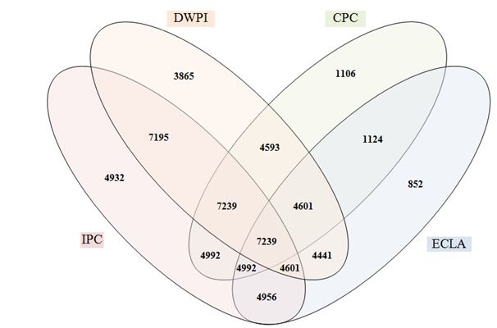
CPC | Cooperative Patent Classification | DWPI | Derwent World Patent Index
ECLA | European Patent Classification | IPC | International Patent Classification
Figure 1 – Patent results by classifications for example search strategy
Raw data for Figure 1: IPC: 4932; DWPI: 3865; CPC: 1106; ECLA: 852; IPC, DWPI: 7195; IPC, DWPI, CPC: 7239; IPC, CPC: 4992; IPC, ECLA: 4956; IPC, DWPI, ECLA: 4601; IPC, CPC, ECLA: 4992; IPC, DWPI, CPC, ECLA: 7239; DWPI, CPC: 4593; DWPI, CPC, ECLA: 4601; DWPI, ECLA: 4441; CPC, ECLA: 1124.
On further examination of these results, we can determine how many patent families per classification, are unique. i.e. a patent result was returned utilizing one patent classification that was not retuned using any other.
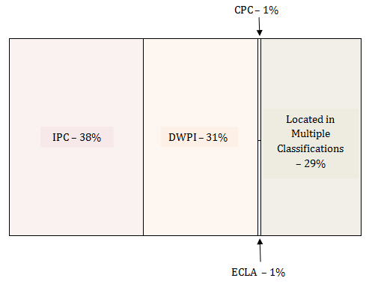
Figure 2 – Percentage (%) of patent data that is unique to each patent classification in example search strategy
The figures above highlight the importance of a varied search strategy utilizing multiple patent classifications. Each patent classification (in this example) returned a unique set of patent results of various sizes which have helped in obtaining a broad and highly relevant patent data set in relation to assistive devices and technologies for visually and hearing impaired persons for this report. All search strategies utilized have incorporated the above patent classifications where possible.
The full search strategies used for the assistive devices and technologies for visually and hearing impaired persons patent landscape project are available in ANNEX B of the report.

2.7 DATES AND COUNTS
All counts of records in the study refer to DWPI patent families or inventions, and not to individual patent documents. For example, the European application, European granted patent and the US granted patent for a single invention family is counted as “1” in all the analyses in this report unless otherwise noted.
This provides a more accurate measure of the level of inventive activity from an entity within the technical space, and a truer picture of the overall level of innovation across the field as a whole.
As each DWPI record contains potentially many individual publication events all with different dates, the report uses the earliest known office of first filing15 date for each patent family. The tables and charts included in the report use this date unless otherwise noted, because it provides the most accurate indication of the time of the inventive activity.
The definition of patent sources, i.e. the location from which patent families are emanating, is based on the Office of First Filing. It should be noted that this definition is not 100% accurate, but provides a useful and fair method of identifying the habitual first filing location of entities, which is typically their home patent office.

2.8 PATENT APPLICANT NAMING VARIATIONS
The name of the organization to which inventors assign their invention (typically, their employer) varies considerably both within a single entity and over time.
For example, IBM can patent both under the acronym and as International Business Machines. Even within these two distinctions, variations in syntax, spelling and formatting can create problems with formal accurate analysis of entity names.
Furthermore, the acquisition of a company, or indeed the divestiture of subsidiaries can create issues with proper identification of patent ownership.
Therefore there is a requirement for normalizing the various name variants that exist within the dataset, as well research into mergers, acquisitions and subsidiaries to provide an accurate reflection of the ownership of patent rights within the landscape.
This process is performed using various methods, including:
- Identifying and correcting minor variations in names, e.g. IBM versus I.B.M.
- Identifying likely candidates for aggregation, such as distinct entities that share inventors; performing research on name variants for definitive identification
- Aggregating known historical mergers and acquisitions
Additionally, these methods provide a good method for minimizing the number of records that are not yet associated with an organization – e.g. unassigned US patent applications.

2.9 TECHNICAL TERMINOLOGY
Terminology used in this report covers technical language that we are aware of, used by experts (WIPO and WHO) who work in the assistive devices and technologies for visually and hearing impaired persons field or who have a common interest in this technology. Terminology generally associated with intellectual property is defined in the glossary located in ANNEX C at the end of this report.

PART 3 – INTRODUCTION TO ASSISTIVE DEVICES AND TECHNOLOGIES FOR VISUALLY AND HEARING IMPAIRED PERSONS
The patent collection created and analyzed during the course of this study consists of patent applications and granted patents within the Derwent World Patents Index concerning assistive devices and technologies for visually and hearing impaired persons.
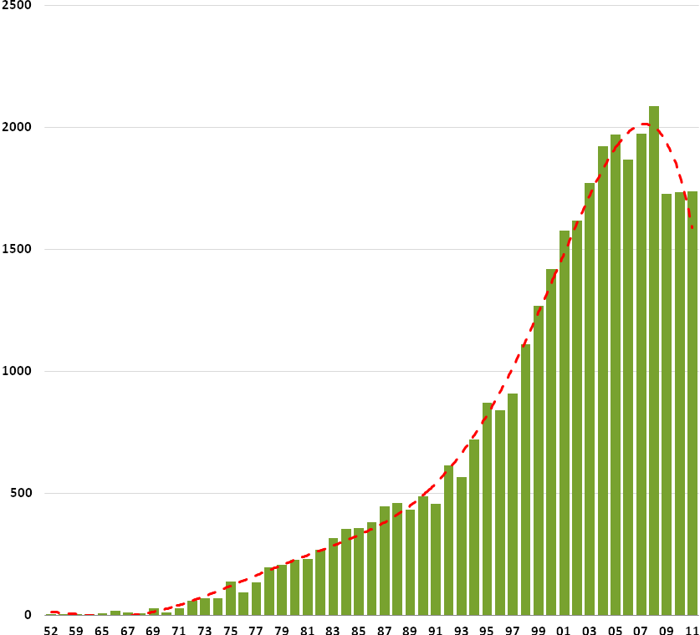
Figure 3 – Number of Patent Families per Year, 1952 to 2011; Earliest First Filing Year; Excludes Incomplete Years16
Figure 3 shows the timeline of activity of the collection of 35,251 inventions or patent families identified to be relevant through search. This timeline shows strong growth in activity since the mid 1970’s, with activity concentrated in the post 2000 time period. For the purposes of the report, patent data from 1980 to – present has been highlighted in all figures and tables.
During this period, there is a distinct peak in patenting activity in 2008, meaning that this is when the first member of a patent family was first filed. Activity subsequently falls away to a lower constant activity level in the years after with 2011 being the last year of complete information for this particular metric.
The earliest first filing year or the earliest priority year associated with each patent family is the most commonly used metric for patent activity performance measurement as this is fixed in time; different patent authorities have different periods of confidentiality and rules concerning publication of applications and grants; furthermore, the date is the most closely tied to the date of “innovation”, where the applicant has decided to register patent rights around the invention.
Measuring the earliest first filing date rather than publication dates has the effect of introducing a measurement “horizon” as patent documents are typically held confidential at patent office’s until their publication, usually for a period of 18-months after initial filing. As data collection for the hearing and vision assistive devices project occurred in mid-Q1 2014, this leaves 2011 as the last complete year of patent information (18 months prior to March 2014 being September 2012).
Figures 4 and 5 show summaries of the subject matter covered by the assistive devices and technologies for visually and hearing impaired persons patent landscape in the form of a thematic concept map. This visualization in figure 4 shows the most commonly occurring concepts and phrases within the project collection, and has been further enhanced by annotation of the major themes.
In general, the collection can be divided into three key concepts:
- Vision / hearing restorative technology
- Vision / hearing assistive technology
- Vision / hearing enhancement technology
The visualization in figure 5 shows the more prominent themes that have occurred within the patent data set. The presentation of these maps is intended to provide the reader with a holistic view of the current state of innovation associated with assistive devices and technologies for visually and hearing impaired persons.
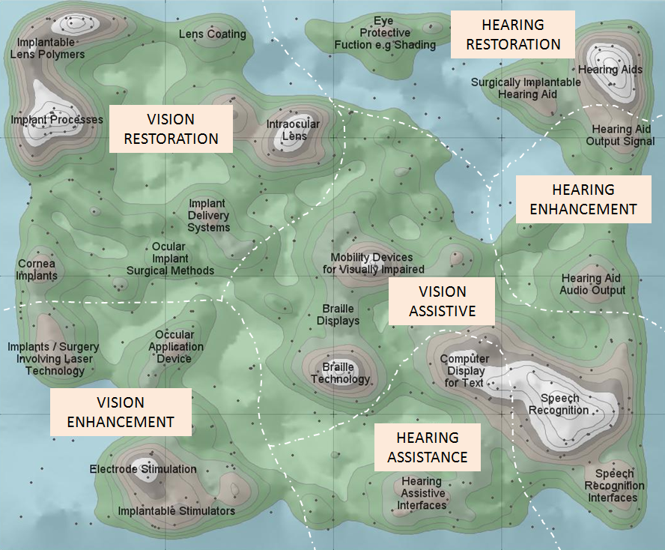
Figure 4 - Thematic Concept Map of Assistive / Enhancement / Restoration Breakdown of Technology for Assistive Devices and Technologies for Visually and Hearing Impaired Persons17
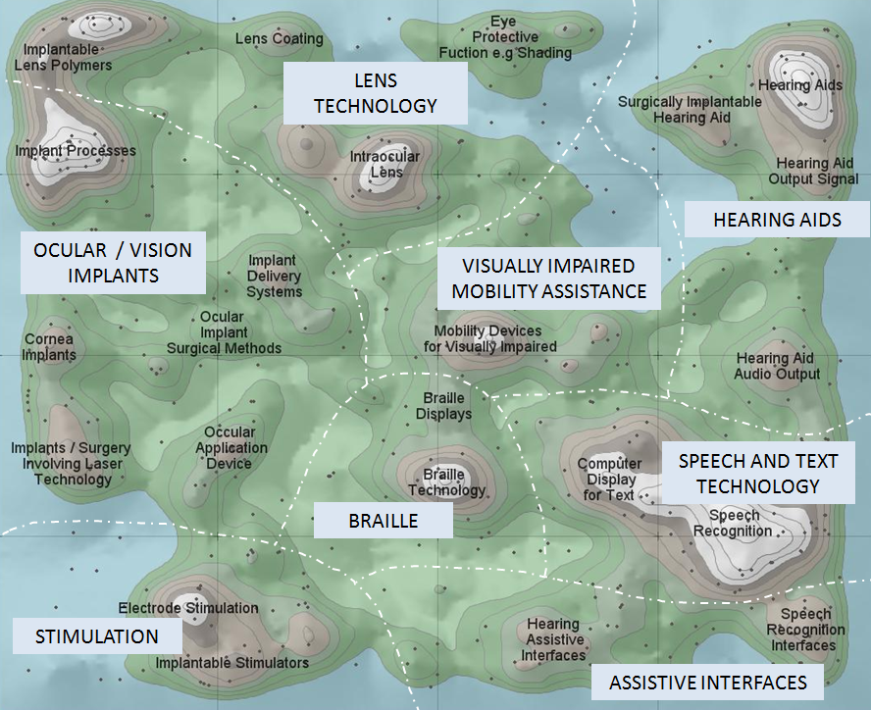
Figure 5 - Thematic Concept Map of Prominent Themes Occurring Within the Device Technology for Assistive Devices and Technologies for Visually and Hearing Impaired Persons

3.1 PATENT ACTIVITY BY REGION
Patent protection is territorial; for example a Swiss granted patent only provides for statutory exclusivity to practice that invention in Switzerland. This being the case, applicants must assess which jurisdictions are best suited to protect their inventions.
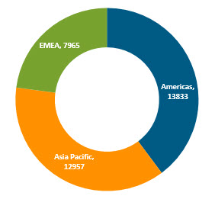
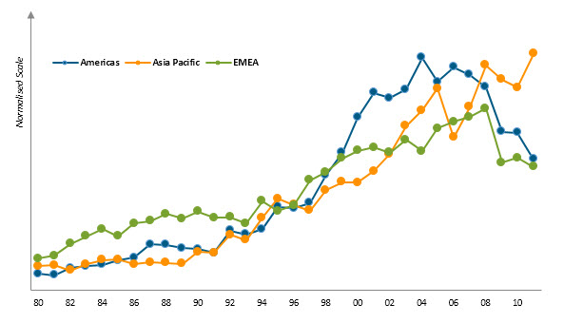
Figure 6 - Source of Patent Activity by Region; Timeline of Activity (normalized scale); Based on Earliest Office of First Filing Location
In many cases, in particular early on in research and development programs, applicants may be unsure of the potential economic returns that the technology could provide, and therefore they must strike a balance between the costs of filing in many different territories versus their estimate of the potential returns the technology could provide.
In practice, most applicants choose to protect their invention in their country of residence at first and then if required extend later – a process for which they generally have a year to decide upon if they wish to benefit of the provisions of the Paris Convention, or typically 30 months if they file a PCT application. The practice of filing locally at first has many advantages – the applicant can use their native language for the application, they can use local (and most likely cheaper) legal counsel for assistance with drafting and filing their application, and they likely have a greater familiarity with the IP laws and culture within their native jurisdiction.
The outcome of this is that the office of first filing event (the priority filing event) for any given invention correlates strongly to the physical geographic location of the applicant, even if in some cases the office of first filing may depend on other factors, such as the location of the legal division of a company.
This correlation can be used an indicator to assess where in the world innovation within a given subject matter is originating from.
Figure 6 summarizes the innovation geography within the device technology for visually and hearing impaired persons at a regional level based on this initial filing location basis.
A fairly even level of activity in device technology for visually and hearing impaired persons is focused in the Americas and in Asia. This is followed by a smaller yet still substantial amount of activity from Europe, the Middle East and Africa (primarily in this case, Europe). The Americas (as would be expected, primarily the United States) make up a relatively large proportion of activity – and likely point to a high level of interest by US entities in device technology for visually and hearing impaired persons.
Figure 7 moves the analysis from beyond the initial filing to all subsequent filing locations. Therefore, the chart visualizes the market of device technology for visually and hearing impaired persons from the aggregate view of all applicants’ reach of exclusivity – where they feel protection is required in order to extract maximum value from their inventions and expand their markets.
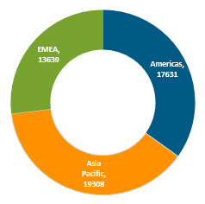

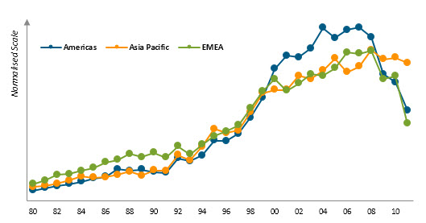
Figure 7 - Filing Locations of Patent Activity by Region; Timeline of Filing Location Activity
In this view, Europe, the Middle East and Africa (EMEA) are represented much better, indicating an outflow of technology from the Americas and Asia Pacific into other territories.
Figure 8 confirms this finding to an extent; it shows the number of patent families that have crossed from one region into another. The Asia Pacific (including China, Japan, South Korea) appears to be the most popular choice of global patent applicants.
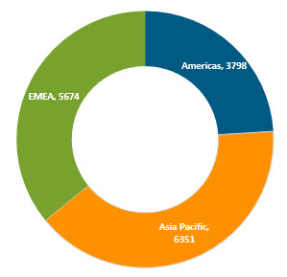

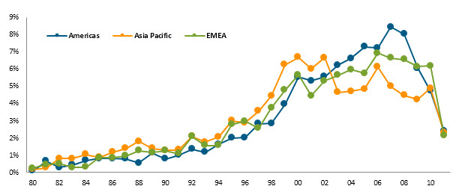
Figure 8 - Cross-Regional Patent Filings; Listed by Source Region also Filing in another Region; Timeline of Cross-Regional Activity by Source Region, by Earliest Priority Year
A final view of this regional analysis is shown in figure 9, and shows the source and destination of cross-regional patent activity. This reveals the Americas filings into the EMEA and Asia as the key transfer of IP rights within the assistive devices and technologies for visually and hearing impaired persons’ patent landscape.
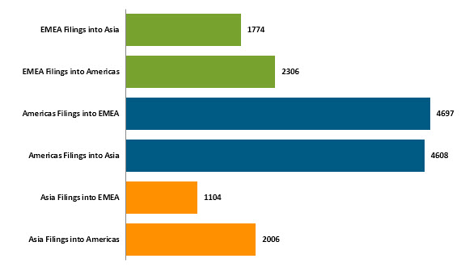
Figure 9 - Source and Destination of Cross-Regional Patent Filing Events; Number of Patent Families
Raw data for Figure 9: EMEA Filings into Asia: 1774, EMEA Filings into Americas: 2306, Americas Filings into EMEA: 4697, Americas Filings into Asia: 4608, Asia Filing into EMEA: 1104, and Asia Filing into Americas: 2006.
The Asia and EMEA regions consist of a wide range of countries contributing to its total number of patent family filings. The Americas region comprises a substantial amount of innovation being produced however innovation occurring in the Americas region appears to be heavily centralized in one country. The Americas is comprised of countries consisting of Argentina, Bolivia, Brazil, Canada, Chile, Colombia, Costa Rica, Cuba, Dominican Republic, Ecuador, El Salvador, Guatemala, Guyana, Haiti, Honduras, Mexico, Nicaragua, Panama, Paraguay, Peru, Puerto Rico Suriname, United States, Uruguay, and Venezuela From the use of this terminology, it appears that the Americas region as a whole is a strong producer of innovation in the assistive devices and technologies for visually and hearing impaired persons. On further analysis, it can be seen that the majority of the innovation is occurring in the United States with Canada appearing as a far distance second in terms of patent family filings. A far lower level of innovative activity has occurred in other South American and Latin American18 countries with only Brazil, Mexico, Argentina and Columbia having innovative patent activity in this technology field.
Table 1 - Segmentation of the Americas Region by patent of first filing
Americas - Offices of First Filing | Number of Patent Families
United States | 13581
Canada | 128
Brazil | 102
Mexico | 12
Argentina | 7
Colombia | 3

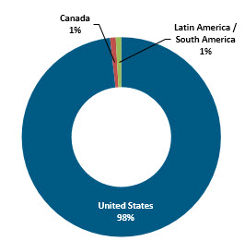
Figure 10 – Segmentation of the Americas Region by %

3.2 PATENT ACTIVITY BY PATENT AUTHORITY
The previous section reviewed for the assistive devices and technologies for visually and hearing impaired persons technology collection at a regional level; this section drills into the activity at a national level.
The analysis rests upon the same correlation between the office of first filing location and the geographic location of patent applicants.
Figure 11 shows the major office of first filing (i.e. the priority filing) locations of applicants in the assistive devices and technologies for visually and hearing impaired persons technology landscape. The United States is the pre-eminent source of activity, making up a significantly large proportion of all activity.
Japan is the secondary source of activity; however, as figure 11 (timeline of activity by major office of first filing location) shows, Japanese and United States activity is on the decline. Chinese activity has grown substantially. From 2004, Chinese patent activity has been continually increasing, eventually overtaking Japan in 2010 as the second highest source of activity. If its current trajectory continues, it will overtake the United States in the near future as the primary source of patent activity in this technology field.
At the same time, Japanese activity has slumped. 2004 reveals a major drop in Japanese patent activity. 2008 shows patent activity for most top countries beginning to decrease at a steady rate apart from China who is increasing strongly.
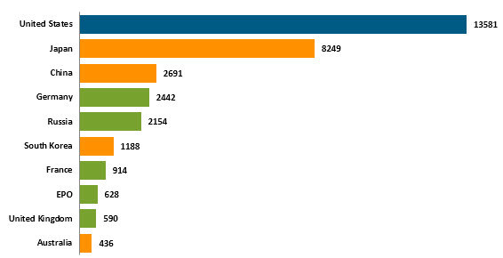
Americas | United States
Asia Pacific | Japan, China, Australia
EMEA | Germany, Russia, France, EPO, United Kingdom
Figure 11 - Major Office of First Filing Locations of the Assistive Devices and Technologies for Visually and Hearing Impaired Persons Patent Activity; Number of Patent Families First Filed in Each Territory

The following trends provide an explanation of the overall landscape timeline of activity (figure 3), with a recent drop in activity occurring across most jurisdictions around 2009. Chinese activity continues to increase at this point however this positive activity from China has not been enough to counteract the overall downward trend caused by other countries.
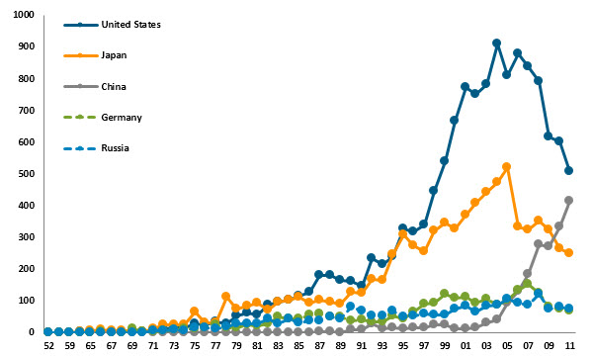
Figure 12 - Timeline of Patent Activity for Top 5 Office of First Filing Locations; Earliest First Filing Year; Excludes Incomplete Years
The timeline in figure 12 is summarized in trend form in figure 13. This shows the compound annual growth or decline in patent activity between 2007 and 2011, and highlights growth for China, South Korea and the United Kingdom, as well as the stagnation and decline of activity from many other jurisdictions including Australia, Germany and the United States.

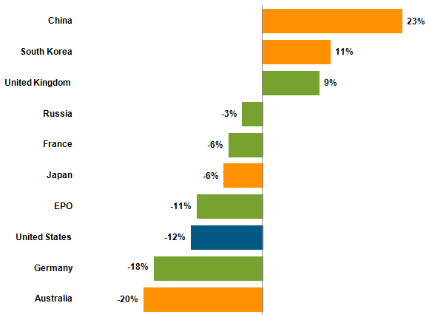
Figure 13 - Recent Changes in Patent Activity; Growth or Decline; Measured as Compound Annual Growth or Decline between 2007 and 2011; Based on Earliest First Filing Year

3.3 LIST OF OFFICES OF FIRST FILING
The table below shows the office of first filing details for the assistive devices and technologies for visually and hearing impaired persons landscape, with the number of patent families shown for each authority. Also shown in the table is the classification of each country into Developed Economies (e.g. Japan, United States), the BRICS (Brazil, Russia, India, China and South Africa) or other economies, such as Malaysia and Mexico.
Table 2 - Number of Patent Families per Office of First Filing for Assistive Devices and Technologies for Visually and Hearing Impaired Persons (2 or more patent families)
Offices of First Filing | Number of Patent Families | Type of Economy
United States | 13581 | Developed Economy
Japan | 8249 | Developed Economy
China | 2691 | BRICS
Germany | 2442 | Developed Economy
Russia | 2154 | BRICS
South Korea | 1188 | Developed Economy
France | 914 | Developed Economy
EPO | 628 | Developed Economy
United Kingdom | 590 | Developed Economy
PCT | 496 | International Filings
Australia | 436 | Developed Economy
Taiwan, Republic of China | 273 | Developed Economy
Sweden | 145 | Developed Economy
Spain | 139 | Developed Economy
Switzerland | 137 | Developed Economy
Netherlands | 136 | Developed Economy
Denmark | 134 | Developed Economy
Italy | 133 | Developed Economy
Canada | 128 | Developed Economy
Brazil | 102 | BRICS
Austria | 101 | Developed Economy
India | 81 | BRICS
Israel | 51 | Developed Economy
Hungary | 40 | Other Economies
Belgium | 37 | Developed Economy
Finland | 28 | Developed Economy
New Zealand | 20 | Developed Economy
South Africa | 19 | BRICS
Czechoslovakia | 18 | Other Economies
Poland | 18 | Other Economies
Romania | 18 | Other Economies
Ireland | 17 | Developed Economy
Czech Republic | 13 | Developed Economy
Portugal | 13 | Developed Economy
Mexico | 12 | Other Economies
Norway | 10 | Developed Economy
Argentina | 7 | Developed Economy
Malaysia | 6 | Other Economies
Greece | 5 | Developed Economy
Colombia | 3 | Other Economies
Singapore | 3 | Developed Economy
Slovenia | 3 | Other Economies
Turkey | 3 | Other Economies
Ukraine | 3 | Other Economies
Bulgaria | 2 | Other Economies
Egypt | 2 | Other Economies
Hong Kong | 2 | Developed Economy
Indonesia | 2 | Other Economies
Kazakhstan | 2 | Other Economies
Luxembourg | 2 | Developed Economy
Philippines | 2 | Other Economies

The table below highlights only the BRICS and other economies including developing countries19 appearing in the data set. BRICS countries dominate here with China and Russia being high patent filers. Hungry is shown to be the largest patent filer among the other economies, however its total patents is still low when compared to most developed countries.
Table 3 - Number of Patent Families per Office of First Filing for Assistive Devices and Technologies for Visually and Hearing Impaired Persons for all BRICS and other economies.
Offices of First Filing | Number of Patent Families | Type of Economy
China | 2691 | BRICS
Russia | 2154 | BRICS
Brazil | 102 | BRICS
India | 81 | BRICS
Hungary | 40 | Other Economies
South Africa | 19 | BRICS
Czechoslovakia | 18 | Other Economies
Poland | 18 | Other Economies
Romania | 18 | Other Economies
Mexico | 12 | Other Economies
Malaysia | 6 | Other Economies
Colombia | 3 | Other Economies
Slovenia | 3 | Other Economies
Turkey | 3 | Other Economies
Ukraine | 3 | Other Economies
Bulgaria | 2 | Other Economies
Egypt | 2 | Other Economies
Indonesia | 2 | Other Economies
Kazakhstan | 2 | Other Economies
Philippines | 2 | Other Economies
African Intellectual Property Organization | 1 | Other Economies
Belarus | 1 | Other Economies
Iran | 1 | Other Economies
Monaco | 1 | Other Economies
Republic of Moldova | 1 | Other Economies
Serbia | 1 | Other Economies
Thailand | 1 | Other Economies
United Arab Emirates | 1 | Other Economies
Vietnam | 1 | Other Economies
Yugoslavia | 1 | Other Economies

3.4 OFFICES OF SECOND (SUBSEQUENT) FILING
This table shows the full list of offices of second (subsequent) filing within the dataset for reference purposes. This list is shorter in length from the office of first filing analysis in Table 2 due to the limitations of patent family coverage within the patent dataset. DWPI (the patent data source for the project) covers 50 distinct patent authorities around the world; however coverage of these patent authorities differs over time. In addition, some patent authorities listed as Offices of First Filing are not covered in the DWPI database.
Moreover, it appears that a large group of specific patent offices are the general locations of subsequent filings. The PCT (Patent Cooperation Treaty) is the top office by far. This is then followed by the EPO (European Patent Office), Japan, Australia and the United States. This indicates that these countries expect an inflow of patent applications from other territories.
Table 4 - Number of Patent Families per Office of Subsequent Filing; Complete Collection
Offices of Subsequent Filing | Number of Patent Families
PCT | 8429
EPO | 7428
Japan | 4450
Australia | 4341
United States | 3493
Canada | 2979
China | 2967
Germany | 2542
South Korea | 1600
Spain | 1139
India | 851
Brazil | 835
Taiwan, Republic of China | 814
Mexico | 801
Singapore | 596
Russia | 335
South Africa | 322
Hong Kong | 284
Norway | 259
New Zealand | 232
Israel | 195
France | 186
United Kingdom | 181
Denmark | 125
Philippines | 92
Italy | 88
Hungary | 81
Finland | 75
Czech Republic | 64
Netherlands | 52
Austria | 38
Belgium | 38
Portugal | 36
Switzerland | 27
Vietnam | 26
Slovakia | 19
Malaysia | 11
Czechoslovakia | 8
Ireland | 8
Romania | 6

3.5 GEOGRAPHIC MAPPING ANALYSIS OF MAJOR SOURCES OF INNOVATION
Figure 14 visualizes graphically the major, medium and small sources of patent applications and granted patents within the assistive devices and technologies for visually and hearing impaired persons landscape.
All of the BRICS countries (Brazil, Russia, India, China and South Africa) are represented. Other developing countries such as Argentina, Indonesia and Malaysia are also represented however in much lower numbers.
Major sources of activity are fairly spread out with activity from United States, Japan, China, Germany, Russian Federation and South Korea the most prominent.
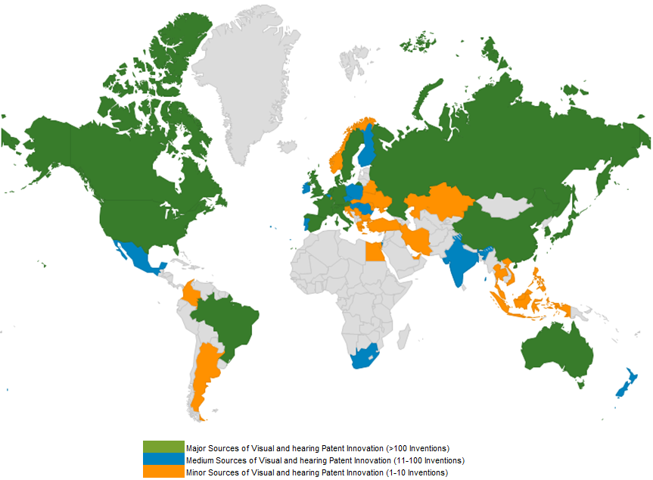
Figure 14 - Geographic Map of Sources of Assistive Devices and Technologies for Visually and Hearing Impaired Persons Patented Innovation; Based on Office of First Filing; Excludes Regional Patent Offices

3.6 DIFFERENCES IN IP PROTECTION STRATEGY BY LOCATION
While the United States, Japanese, Chinese, German, Russian and South Korean patent activity dominates the landscape in terms of overall numbers of patent applications and granted patents, this volume in itself does not tell the entire story of intellectual property (IP) commercialization.
It was mentioned earlier that an applicant chooses where to protect its technology based on markets and where exclusivity is best placed in order to recoup the investment in technology and potentially build commerce around the invention.
Individual inventions that are protected in multiple locations reflect two potential positions of the applicant – a) organizations with existing businesses in multiple territories with a need to protect in multiple locations and, b) individual technologies of a higher intrinsic value or robustness that warrant broader geographic protection.
As the number of different locations into which an individual invention is protected correlates closely to a large increase in the cost of protection, patent families on average filed in more territories to an extent should be considered of a higher intrinsic quality, or at least likely to be used more extensively by their owner.
Figure 15 measures the average level of geographic protection for patents of the major offices of first filing by giving the average size of families originating from the respective jurisdiction. The count of countries used for this calculation excludes filings via the PCT process, as these documents do not themselves produce granted patents; therefore excluding these documents from the metric allows for differentiation of inventions only filed via the PCT route.
The primary finding of this chart is that Chinese and Russian based patent applicants generally appear to only protect their IP locally due to their low metric score (1.1). Therefore, visual and hearing device technology from Chinese and Russian applicants appears to be primarily local in nature. Similar levels of protection are also evident for the other Asian territories. Japan for instance also has a relatively low level of international patent protection. Applicants from the EPO, Australia and France are more likely to adopt a more global IP protection strategy due to their larger metric scores.
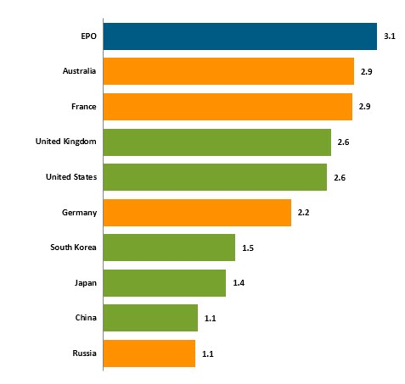
Figure 15 - Average Number of Filings Events (Including First Filing) per Major Office of First Filing Location; Excludes PCT Application Filing Events

3.7 ACTIVITY BY ECONOMY TYPE
A further view of the landscape is shown in figure 16 by the type of economy from which patent activity is deriving.
In this analysis, the offices of first filing locations have been grouped as to whether they are considered developed economies, are members of the BRICS group (Brazil, Russia, India, China or South Africa) or are from emerging or developing economies outside of the BRICS grouping.
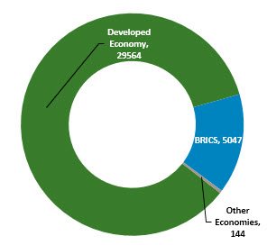
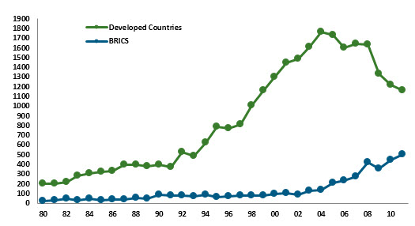
Figure 16 - Breakdown of the assistive devices and technologies for visually and hearing impaired persons Patent Landscape by Economy Descriptor; BRICS equals Brazil, Russia, India, China and South Africa; Timeline of Activity by Economy Category

The analysis serves to further represent the trends within the visual and hearing device landscape as there is a recent decline (last 10 years) in filings occurring from developed economies (primarily the United States, Japan and Germany) and large-scale growth (occurring from around 2003) in activity from the BRICS economies (primarily China and Russia).
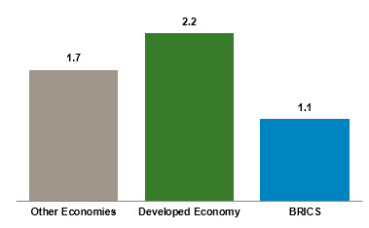
Figure 17 - Average Number of Filings Events per Economy Type across Assistive Devices and Technologies for Visually and Hearing Impaired Persons Patent Landscape
From a forecasting viewpoint, it would be expected that BRICS related patent activity associated with visual and hearing device technology will likely continue to increase strongly from these developing economies and perhaps even reach or exceed the levels of the developed economies within the next 10 years.
Figure 17 summarizes the international or otherwise nature of the patent activity originating from each economic grouping. Activity from the BRICS economies is mostly comprised of Chinese and Russian patents with Brazil, India and South Africa making up a small yet still significant amount. Activity from developed economies is more international in nature. Also evident from this analysis is the activity from the non-BRICS developing economies, which is broader (than BRICS) in its protection regime.

3.8 SUMMARY METRICS – FILING BREADTH, GRANT SUCCESS, PATENT PENDENCY
This section summarizes and reviews several fundamental parameters of the global patent activity in assistive devices and technologies for visually and hearing impaired persons, for later usage in conclusion making and to provide a greater understanding of dynamics in the field.
Figure 18 shows the breadth of geographic protection per patent family arrayed over time, and plotted alongside the overall collection activity time-series analysis (in grey).
There has been a strong dilution in the level of international patent protection due to the increases in activity from BRICS countries including China, Russia and Brazil, a large proportion of which is protected locally in just a single patent jurisdiction.
Normally, this type of analysis would tend to point to a technology field undergoing additional rounds of more fundamental research – with the increasing risks associated for individual innovators reflected in their reticence to invest heavily in the protection of their IP rights.
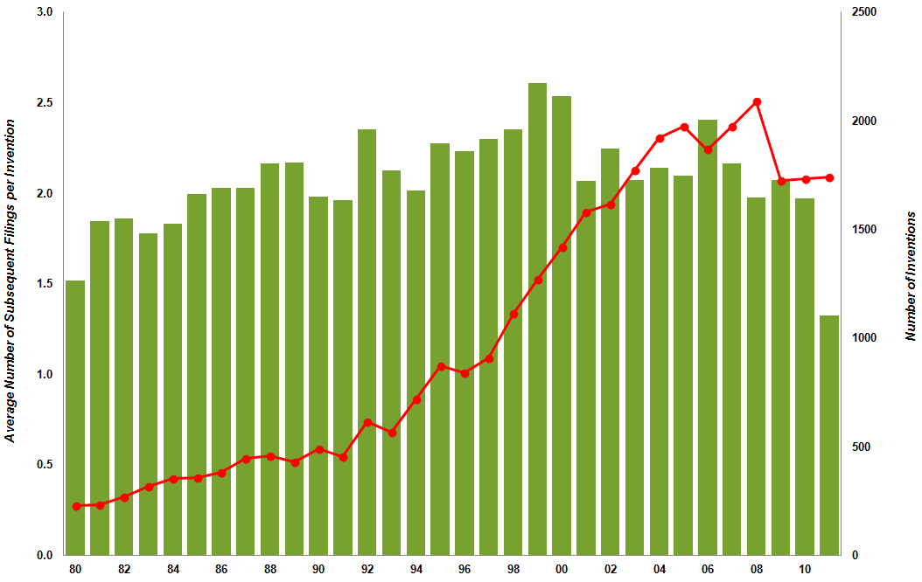
Figure 18 - Average Number of Subsequent Filing Events for Patent Families in the Assistive Devices and Technologies for Visually and Hearing Impaired Persons Landscape for Families Filed Each Year; Co-Plotted with Overall Timeline of patent Activity
However, as it has been shown in this landscape, this is more due to the fact that the assistive devices and technologies for visually and hearing impaired persons technology landscape is undergoing a diversification of geography rather than technology, and it is this localization and specialization in visual and hearing device technology that is driving the movement towards more local protection.

Figure 19 shows the number and proportion of activity within the landscape by the stage of patent prosecution reached – with families either only containing applications, at least one granted patent (and likely a mix of both applications and grant) or finally whether the family only contains Chinese utility models – shorter term, limited examination intellectual property rights.
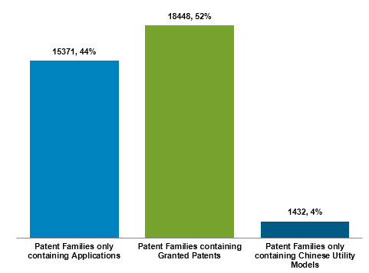
Figure 19 - Analysis of Assistive Devices and Technologies for Visually And Hearing Impaired Persons Technology Landscape Based on Prosecution Stage Reached and Patent Type; Number of Patent Families containing only applications; Number of patent families containing (at least one) granted patent; Number of patent families with only Chinese Utility Models

Figure 20 shows the average length of time between an application being filed and a granted patent being published in the same jurisdiction.
This chart will typically tend to zero as the date approaches the present, as for recent years only unusually fast-granting patent applications will be present in the analysis. The chart does however serve to show that the typical “patent pending” time period for the visual and hearing device technology collection is just less than 4 years from initial filing to grant publication.
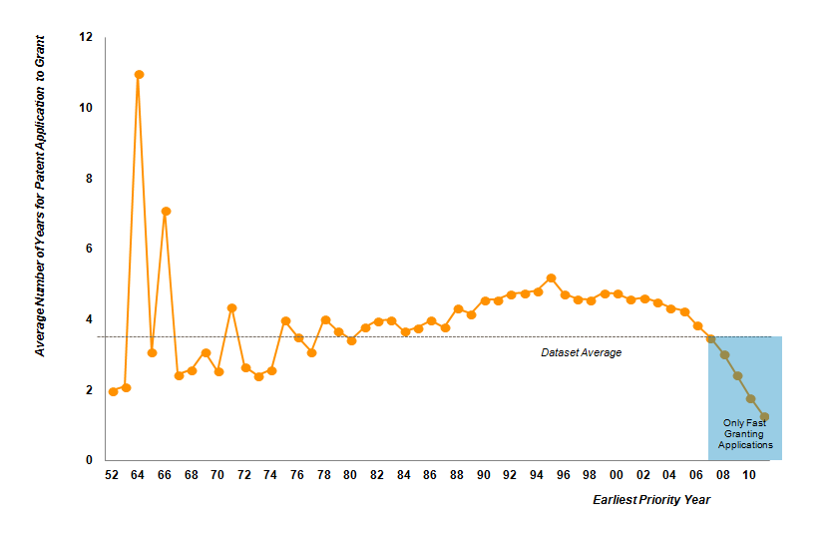
Figure 20 - Average Patent Pending Time Period between Office of First Filing Date and Date of Publication of Granted Patent
The analysis in figure 21 excludes any patent family filed within the last 4 years to avoid a bias towards the fast-granting outlier applications.
Several Asian patent office’s appear to perform best in this view, with patents filed in Hong Kong (Special Administrative Region of the People’s Republic of China), China, Taiwan – Province of China and South Korea taking less than 3 years to achieve granted status. One should bear in mind of course the granting procedure and requirements in each jurisdiction which allows for instance a grant without examining for novelty or inventive step.
The major territories of Japan, the United States and the EPO all appear over 4 years of pendency. Patents filed in the Ukraine show the longest levels of pendency, with granted patents typically taking over 9 years to issue from initial filing.
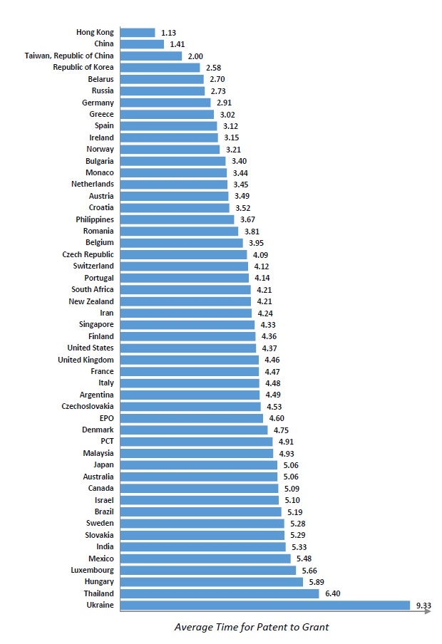
Figure 21 - Average Patent Pendency Time Period; Per Patent Authority; Earliest First Filing to Grant Publication; Excludes patent applications filed since 2008, due to average collection pendency period
Raw data for Figure 21: Hong Kong: 1.13 years, China: 1.41 Years, Taiwan Republic of China: 2.00 years, Republic of Korea: 2.58 years, Republic of Korea: 2.58 years, Belarus: 2.70 years, Russia: 2.73 years, Germany: 2.91 years, Greece: 3.02 years, Spain: 3.12 years, Ireland: 3.15 years, Norway: 3.21 years, Bulgaria: 3.40 years, Monoco: 3.44 years, Netherlands: 3.45 years, Austria: 3.49 years, Phillippines: 3.67 years, Romania: 3.81 years, Belgium: 3.95 years, Czech Republic: 4.09 years, Switzerland: 4.12 years, Portugal: 4.14 years, South Africa: 4.21 years, NewZealand: 4.21 years, Iran: 4.24 years, Singapore: 4.33 years, Finland: 4.36 years, Italy: 4.48 years, Argentina: 4.49years, Czechoslovakia: 4.53 years, EPO: 4.60 years, Denmark: 4.75 years, PCT: 4.91 years, Malaysia: 4.93 years, Japan: 5.06 years, Australia: 5.06 years, Canada: 5.09 years, Israel: 5.10 years, Brazil: 5.19 years, Sweden: 5.28 years, Slovakia: 5.29 years, India: 5.29 years, Mexico: 5.48 years, Luxembourg: 5.66 years, Hungary: 5.89 years, Thailand: 6.40 years and Ukraine: 9.33 years.

3.9 PATENT FILING STRATEGIES
Figure 22 shows the number of patent families that have been filed in 1, 2 or 3 etc. patent jurisdictions, to provide an understanding of the type of IP strategy by applicants in the assistive devices and technologies for visually and hearing impaired persons.
24,108 (68.4%) patent families out of the 35,251 in total in the assistive devices and technologies for visually and hearing impaired persons have been filed in just a single territory, this predominantly being the profile of the Japanese, Russian and Chinese based entities within the dataset.
Only 2825 (8%) of patent families have been filed in 2 locations. Assessing the 4003 patent families that have filed in 5 or more locations (11.4%) these inventions and the applicants behind them, due to the expense of these patent families, naturally become more interesting in terms of qualifying the commercial interest of corporations and other organizations in assistive devices and technologies for visually and hearing impaired persons technology.

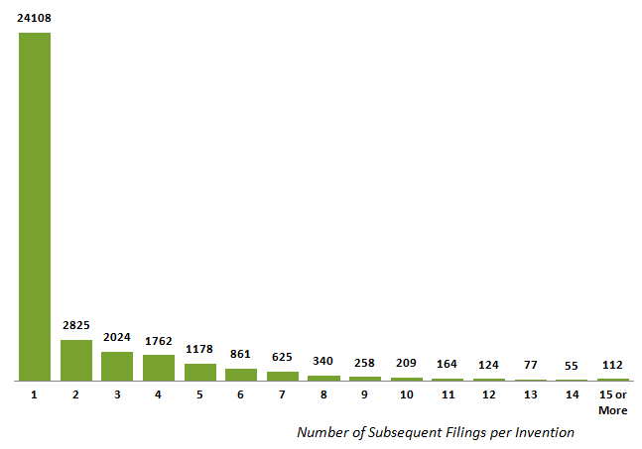
Figure 22 - Assessment of the Patent Protection Strategy of Assistive Devices and Technologies for Visually and Hearing Impaired Persons Patent Applicants; Distribution of Number of Subsequent Filing Events across Landscape

3.10 ANALYSIS OF MULTI-AUTHORITY FILED PATENT FAMILIES
On the previous chart, approximately 10,600 patent families were identified as having been filed in multiple patent jurisdictions (2 or more filings per invention).
These records are now analyzed in further detail in terms of geographic source and the timeline of activity.
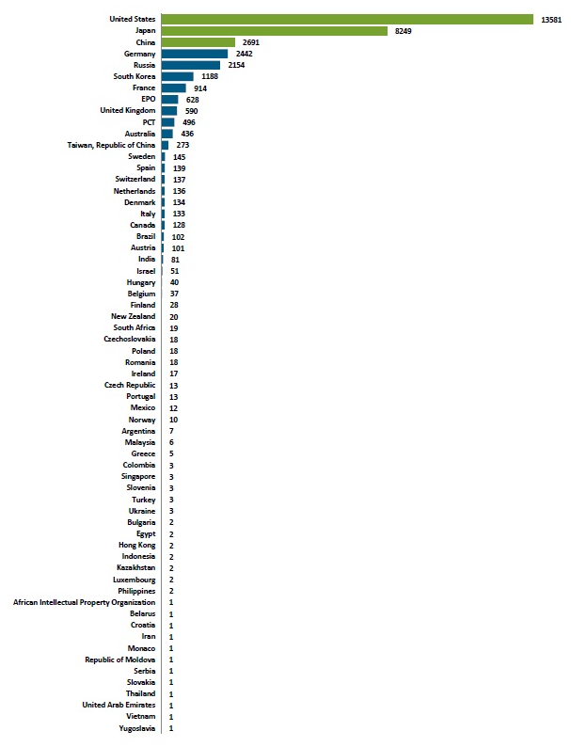
Figure 23 - Office of First Filing for Patent Families with Two or More Subsequent Filings per Family
Raw data for Figure 23: United States: 13581, Japan: 8249, China: 2691, Germany: 2442, Russia: 2154, South Korea: 1188, France: 914, EPO: 625, United Kingdom: 590, PCT: 496, Australia: 436. Taiwan Republic of China: 273, Sweden : 145, Switzerland: 139, Netherlands: 136, Denmark: 134, Italy: 133, Canada: 128, Brazil: 102, Austria: 101, India: 81, Israel: 51, Hungary: 40, Belgium: 37, Finland: 28, New Zealand: 20, South Africa: 19, Czechoslovakia: 18, Poland: 18, Romania: 18, Ireland: 17, Czech Republic: 13, Portugal: 13, Mexico: 12, Norway: 10, Argentina: 7, Malaysia: 6, Greece: 5, Colombia: 3, Singapore: 3, Slovenia: 3, Turkey: 3, Ukraine: 3, Bulgaria: 2, Egypt: 2, Hong Kong: 2, Indonesia: 2, Kazakhstan: 2, Luxembourg: 2, Philippines: 2, African Intellectual Property Organization: 1, Belarus: 1, Croatia: 1, Iran: 1, Monaco: 1, Republic of Moldova: 1, Serbia: 1,Thailand: 1, United Arab Emirates: 1, Vietnam: 1, Yugoslavia: 1.
Figure 23 highlights two countries which are the primary source of multiple jurisdiction inventions, namely the United States and Japan.
China, the third largest overall source of visual and hearing device patenting activity has 2691 records filed in multiple authorities, a figure comparable to other countries, such as Germany and Russia. It should be noted however that of the total number of Chinese patents in the dataset (5658 inventions), less than half (47.5%) have been filed in multiple jurisdictions. This is far lower than the United States (79.5%) and Japan (65%) which appear higher on the multi-authority patent filing table.
Figure 24 shows how the patent activity filed in multiple authorities is distributed over time. The charts show both absolute numbers of patent families per year as well as a normalized scale version to allow activity trends to be discerned. The normalization is performed by assessing the activity filed in any single year as a proportion of the total activity across all years.
The activity trend is showing that patent volumes are increasing up until 2007 where a drop in both complete and multi authority inventions occur. Interestingly, complete inventions plateau, whereas multi authority inventions continue to decelerate and fall. This can be explained by emerging countries such as China increasing their patent activity overall; however given the strong local nature of this patent activity (e.g. China) which is predominantly recent in nature, less multi authority inventions are being filed, causing this fall.
The second item of interest is the acceleration in activity in PCT filings in the normalized scale. This activity has been sporadic over the last 20 years however there was an exceptional jump around 2008. This indicates that less multi authority filings are occurring recently, however entities are increasingly filing via the PCT route. This could potentially lead to an increased number of multi authority inventions in the future. This PCT filing upward trend may be strategic on the part of entities in this technology field in order to reduce the initial costs associated with the patent process. This also provides an entity more time to decide and execute the best worldwide patent filing strategy for their innovation.
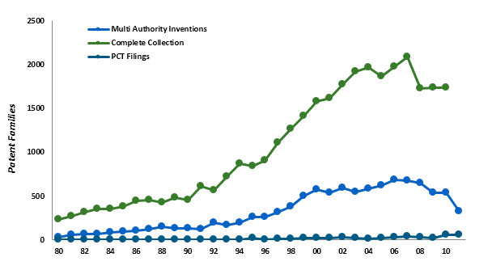
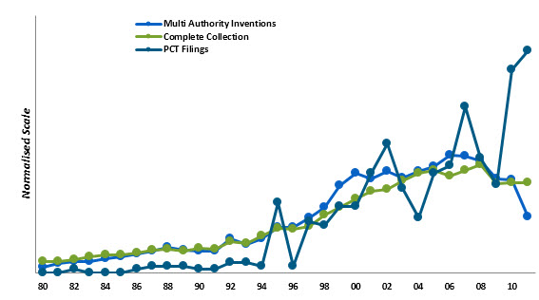
Figure 24 - Number of Patent Families per Year for Multi-Authority Patent Families Versus the Complete Assistive Devices And Technologies For Visually And Hearing Impaired Persons Collection (left); Same Timeline but With Normalized Y-Axis For Comparison of Activity Rates (right)

3.11 KEY FINDINGS FROM THE LANDSCAPE OVERVIEW
- Activity in the visual and hearing device landscape has the highest representation in the Americas followed closely by the Asia Pacific. The United States makes up a significantly large proportion of activity, indicating a potentially high interest in this technology by United States entities.
- Patent innovation related to assistive devices and technologies for visually and hearing impaired persons are highly concentrated in the post 2000 time period. Specifically the 2003 – 2008 periods show the largest proportion of activity for this technology.
- From 2009 onwards, there is a distinct ‘drop’ in overall patent activity followed by a ‘plateau’ in innovative activity.
- The Asia Pacific region continues to increase its patent activity associated with this technology whereas innovation from the Americas and the EMEA has recently (since 2008) begun to decline.
- Entities tend to slightly favor the Asia Pacific region over the Americas in order to file for patent protection. The EMEA is the least favored region to apply for patent protection.
- More entities in the Americas file patents into the Asia Pacific and EMEA regions. Asian Pacific entities file the least amount of patents into the Americas and EMEA regions.
- 98% of the Americas region is comprised of innovation originating from the United States. The remaining 2% comprises innovation from Canada, Brazil, Mexico, Argentina and Colombia.
- China has experienced the highest growth in patent activity (23%) in this technology area recently (2007 – 2011)
- Chinese, Russian and to an extent Japanese patent activity is predominantly local. Only 47.5% of Chinese patents have been filed in multiple jurisdictions. In comparison, the United States has filed 79.5% filed in multiple jurisdictions.
- Developed economies comprise 85% (29564 patent families) of the dataset.
- BRICS countries make up only 14% of first filed patent activity (5047 patent families) i.e. where the patented invention originated. China is the top BRICS country with 2691 patent families.
- Other economies including developing countries comprise a very small amount of the patent families in the dataset (1%). Hungry is the top economy fitting this description with 40 patent families.
- The PCT (8249 patent families) and EPO (7428 patent families) have the highest amount of subsequent patent filings.
- 52% of the patent families in the data set comprise at least 1 granted family member.
- Hong Kong, Special Administrative Region of the People’s Republic of China has the fastest patent pendency period (1.13 years average) whereas the Ukraine has the slowest (9.33 years average)
- From a technical viewpoint, the landscape is divided into three key concepts:
  - Restorative technology which includes such ‘prominent’ themes as hearing aids, ocular / vision implants and lens technology.
  - Assistive technology which includes such ‘prominent’ themes as Braille technology and assistive interfaces.
  - Enhancement technology which includes such ‘prominent’ themes as speech to text technology and stimulation.

PART 4 - TECHNICAL LANDSCAPE ANALYSIS OF ASSISTIVE DEVICES AND TECHNOLOGIES FOR VISUALLY AND HEARING IMPAIRED PERSONS

4.1 TECHNICAL SEGMENTATION OF THE LANDSCAPE
The collection of 35351 patent families related to assistive devices and technologies for visually and hearing impaired persons (including both granted patents and patent applications) was mined in detail for distinct technical approaches, devices and technology to provide a further analytical perspective of the innovation trends and activity within the space.
This technical segmentation process was performed with advice and guidance from WIPO so that items of specific interest were reviewed. Further, the data itself was interrogated to provide information on the major topics of interest to vision and hearing device technology innovators.
Source information for these categories includes patent classifications (International Patent Classification, Cooperative Patent Classification, Derwent Manual Codes and Classes) and mining of the claims, abstract or DWPI abstract terminology.
The segmentation can be summarized broadly into the following key areas:
- Restorative Technology – which includes vision implants (encompassing both intraocular and extraocular devices), permanent and non-permanent restoration technology, internal and external hearing aids, and cochlear implants.
- Assistance Technology – encompassing technology such as voice control / sound control, sensor technology adapted for the vision impaired, touch / tactile / haptic technology e.g. braille, voice or language recognition technology / speech processing or sound / voice conversion to text / video.
- Enhancement Technology – display of information, spatial resolution / vision quality, color / brightness enhancement, image encoding / translation, vision electric / electronic stimulation, sound coding / translation, acoustic transducers / hearing quality, electric / electronic stimulation for hearing.
- Related Technology – This includes technology that is encompassed by restorative, assistance or enhancement technology, however it also has ‘additional’ innovation not specifically covered by these areas. Innovation including IP rights / digital management (covered by the Marrakesh Treaty), disposable / limited use related technology, biodegradable or recyclable technology, design / shape technology and hardware and software related to the vision / hearing device.

4.2 DETAILED BREAKDOWN OF PATENTED TECHNICAL APPROACHES
This section now turns to the detailed and specific categories of technology into which the assistive devices and technologies for visually and hearing impaired persons inventions was segmented.
As stated earlier, these fields are grouped generally into restoration, assistance, enhancement and additional related technology. A field associated to ‘other’ technology applications was also included to help summarize relevant innovation to the technology which was difficult to accurately define into the four general areas mentioned.
Note that individual patent families can be categorized into multiple fields if warranted, and this duplicate categorization is not limited to just one category. For example, an individual patent mentioning an external hearing aid which is also designed or shaped to improve the reduction of background noise for the user would be categorized in multiple categories.
Therefore, this analysis should be reviewed as a summary of the innovation concepts within the vision and hearing impaired device technology field.
Each section is analyzed below for major themes and concepts.

4.3 RESTORATION
There are four primary sectors of innovation in relation to vision or hearing restoration: Vision implants or devices, hearing implants or devices, permanent restoration technology and non-permanent restoration technology. As noted above, individual inventions can occur in multiple categories, and it is likely that many inventions in the dataset will fit this criteria.
Secondary topics covered in restoration technology include:
- Intraocular Devices: comprise technology that is implanted in the eye, for example epiretinal implants
- Extraocular Devices: encompass technology that is implanted in the superficial region outside or around the eye, for example sub-retinal implants
- Vision Implants - Other: this includes such devices as cortical Implants, for example an implant involving direct stimulation of the brain that helps restore vision i.e. not directly attached to the eye.
- Permanent Vision Restoration: technology that permanently restores vision of an impaired individual.
- Non-Permanent Vision Restoration: technology that only restores vision for a limited or short period, for example the restoration of vision while an individual is recovering from surgery or from an accident or under certain environmental conditions.
- Cochlear Implants: cover’s technology which helps to provide hearing in patients who are deaf because of damage to sensory hair cells in their cochlea’s.
- Internal Hearing Aids: encompasses technology similar to auditory brainstem implants, bone anchored implants and bone conducting implants (this category does not include cochlear implants).
- External Hearing Aids: hearing aids that are completely in the ear canal or which are body-worn hearing aids.
- Permanent Hearing Restoration: technology that permanently restores hearing of an impaired individual.
- Non-Permanent Hearing Restoration: technology that only restores hearing for a limited or short period for example the restoration of hearing while an individual is recovering from surgery or from an accident or under certain environmental conditions.

4.4 ASSISTANCE
Assistance technology related to devices and technologies for visually and hearing impaired persons was well defined into four separate topics with an additional two ’other’ topics for both vision and hearing serving further ‘general’ classification of some inventions.
- Voice Control / Sound Control: converting sound or voice into action or control for a device or a technology for a vision impaired person. Some examples include a smart television or radio, dialing a smart phone, finding directions, turning a kitchen device on and off.
- Sensor Technology Adapted for the Vision Impaired: encompasses technology related to proximity identification, event detection, surrounding environment detection or alerting a vision impaired person to an object or condition when it is close.
- Vision Assistance – Other: contains vision assistance technology that does not accurately fit into any other of the assistance technology classifications highlighted.
- Touch / Tactile / Haptic Technology: included technology related to touch, tactile or haptic applications. Example technology includes braille, rumble technology and force conveying technology which includes vibrational motions.
- Voice or Language Recognition Technology, Speech Processing, Sound or Voice Conversion to Text or Video: included is technology that coverts voice or sound and processes it into a useable form for a hearing impaired person. Converting sound or voice into text, video or some other visual type indicator, for example text appearing on a television screen for a program or television show.
- Hearing Assistance – Other: Hearing assistance technology that does not fit accurately into any of the assistance technology classifications previously mentioned.

4.5 ENHANCEMENT
Enhancement technology associated with assistive devices and technologies for visually and hearing impaired persons was grouped into eight separate topics with additional two ’other’ topics for both vision and hearing for further ‘general’ classification of some inventions.
- Display of Information: contains inventions directed to the method or apparatus to display or convey information for a visually impaired individual, for example a display device for a low vision individual.
- Spatial Resolution / Vision Quality: encompasses inventions directed to the clarity or resolution of an image for the vision impaired.
- Color / Brightness Enhancement: relates to technology directed to color or brightness of light associated with a visual implant or prosthesis.
- Image Encoding / Translation: contains technology relating to capturing, sensing or constructing image data and coding, or encoding it into a form understandable and usable by a visually impaired person.
- Electric / Electronic Stimulation – Vision: relates to technology involving electric or electronic stimulation of the eye or functions associated with the eye, for example electric stimulation of muscles around the eye.
- Vision Enhancement – Other: contains vision enhancement technology that cannot be classified accurately using other classifications.
- Sound Coding / Translation: comprises technology that identifies stores and translates sound information for an impaired individual.
- Acoustic Transducers / Hearing Quality: includes technology that converts sound energy signal into another energy signal for better use by an hearing impaired individual.
- Electric / Electronic Stimulation - Hearing : contains technology involving electric or electronic stimulation of the ear.
- Hearing Enhancement - Other: contains hearing enhancement technology that cannot be classified accurately using other classifications.

4.6 ADDITIONAL RELATED TECHNOLOGY
In order to provide a broad and far reaching analysis of the technology related to assistive devices and technologies for visually and hearing impaired persons, the following seven categories were constructed to accurately define the additional innovative elements of inventions which may have been overshadowed if the focus of the categories relied solely on the restorative, assistive and enhancement aspects of this technology.
- Related to both Hearing & Vision: this classification encompasses innovation which affects both hearing and vision of an impaired individual, for example a sensor device with Braille input display.
- Technologies Facilitating Access to Published Works: covers any intellectual property, digital rights management issue, as well as process or method that relates to facilitating access of visually impaired persons to published works, consistent with the goals of the Marrakesh Treaty, covering also related inventions addressed to hearing impaired persons. Examples of such innovation can include a book being read out, or a song being converted into text for a hearing impaired person.
- Disposable or Limited Use Technology: encompasses any visual or hearing restorative, assistive or enhancement related technology which is of a one-time use, limited time use or which has a finite number of uses. An example of such technology would be a disposable external hearing aid for impaired persons travelling on planes so that safety instructions can be communicated.
- Biodegradable or Recyclable Technology: covers any visual or hearing restorative, assistive or enhancement related technology which is biodegradable, recyclable, reusable, environmentally safe or friendly, and non-toxic.
- Design or Shape: this category relates to visual or hearing restorative, assistive or enhancement technology in which the shape or design of the device, implant or prosthesis directly contributes to its function. For example, the special shape of a hearing aid to reduce or eliminate background noise for an individual.
- Hardware: covers computer hardware or the physical elements of a visual or hearing restorative, assistive or enhancement device or technology.
- Software: highlights programs, software and other in-tangible components of visual or hearing restorative, assistive or enhancement devices. For example, this category may include information libraries, language libraries for text or speech recognition, optimal configurations for devices or implants and programming of the speech processors.

4.7 ‘OTHER’ TECHNICAL CATAGORIES
Additionally, three ‘other’ classes were constructed in order to further categorizes vision or hearing innovation encompassed in the broad restoration, assistance and enhancement categories, however not covered accurately in the additional related technology classes. Broadly speaking, these categories are summarized as follows.
- Vision Care-Others: covers broad innovation associated with vision care such as eye drops for use following an ocular implant operation, technology related to lens composition or construction which contribute to vision enhancement.
- Hearing Care-Others: covers broad innovation associated with hearing care such hearing aid magnet systems which align the implant optimally for the user and protective devices that assist a user in prevention of minimization of hearing damage.
- Overall Others: Covers and patent material that does not fit accurately into any of the technology classifications mentioned above.

4.8 MAJOR TOPICS OF INNOVATION
In total, 36 distinct technical categories were created, using a process that interrogated patent classification codes (e.g. DWPI Manual Codes or Classes, International Patent Classification or Cooperative Patent Classification) as well as keywords within major areas of the patent specific (e.g. patent claims, the patent specification abstract or the DWPI abstract – a re-edited and summarized version of the patent specification produced by Thomson Reuters). A summary of all technical categories and the total inventions contained is shown below.

Table 5 – Technical Categorization and Total Invention Count for the Assistive Devices and Technologies for Visually and Hearing Impaired Persons Technology Field.
Technical Category | Type of impairment | Assistive Devices and Technologies | # Total Hits
Restoration | Vision | 1.1.1 Intraocular Devices | 5109
Restoration | Vision | 1.1.2. Extraocular Devices | 287
Restoration | Vision | 1.1.3. Vision Implants - Other | 661
Restoration | Vision | 1.1.4. Permanent Vision Restoration | 551
Restoration | Vision | 1.1.5. Non-Permanent Vision Restoration | 1005
Restoration | Hearing | 1.1.6. Cochlear Implants | 2266
Restoration | Hearing | 1.1.7. Internal Hearing Aid | 983
Restoration | Hearing | 1.2.1. External Hearing Aid | 2393
Restoration | Hearing | 1.2.2. Permanent Hearing Restoration | 23
Restoration | Hearing | 1.2.3. Non-Permanent Hearing Restoration | 160
Assistance | Vision | 2.1.1. Voice Control Sound Control | 586
Assistance | Vision | 2.1.2. Sensor Technology Adapted for the Vision Impaired | 323
Assistance | Vision | 2.1.3. Vision Assistance – Other | 6010
Assistance | Hearing | 2.2.1. Touch Tactile Haptic Technology e.g. Braille | 1597
Assistance | Hearing | 2.2.2. Voice or Language Recognition Technology, Speech Processing or Sound Voice Conversion to Text Video | 3696
Assistance | Hearing | 2.2.3. Hearing Assistance – Other | 3487
Enhancement | Vision | 3.1.1. Display of Information | 2283
Enhancement | Vision | 3.1.2. Spatial Resolution Vision Quality | 2030
Enhancement | Vision | 3.1.3. Color Brightness Enhancement | 449
Enhancement | Vision | 3.1.4. Image Encoding Translation | 2096
Enhancement | Vision | 3.1.5. Electric Electronic Stimulation - Vision | 1664
Enhancement | Vision | 3.1.6. Vision Enhancement - Other | 473
Enhancement | Hearing | 3.2.1. Sound Coding Translation | 1832
Enhancement | Hearing | 3.2.2. Acoustic Transducers Hearing Quality | 322
Enhancement | Hearing | 3.2.3. Electric Electronic Stimulation - Hearing | 1261
Enhancement | Hearing | 3.2.4. Hearing Enhancement - Other | 503
Additional Related Technology | Vision and Hearing | 4.1. Related to both Hearing & Vision | 2208
Additional Related Technology | Vision | 4.2.1. Technologies facilitating access to published works - Vision (relevant to the Marrakesh Treaty) | 1608
Additional Related Technology | Hearing | 4.2.2. Technologies facilitating access to published works - Hearing | 2721
Additional Related Technology | - | 4.3. Disposable or Limited Use Technology | 362
Additional Related Technology | - | 4.4. Biodegradable or Recyclable | 203
Additional Related Technology | - | 4.5. Design or Shape | 1179
Additional Related Technology | - | 4.6. Hardware | 3026
Additional Related Technology | - | 4.7. Software | 840
Others | Vision | 5.1. Vision Care-Others | 4388
Others | Hearing | 5.2. Hearing Care-Others | 866
Others | - | 5.3. Overall Others | 2793

The initial analysis of technical activity in the assistive devices and technologies for visually and hearing impaired persons technology field is shown in table 5 and utilizes all distinct technical categories.

Table 6 – Analysis of Major Subject Matter Activity within the Assistive Devices and Technologies for Visually and Hearing Impaired Persons Patent Landscape
Technical Categories | 80 | 81 | 82 | 83 | 84 | 85 | 86 | 87 | 88 | 89 | 90 | 91 | 92 | 93 | 94 | 95 | 96 | 97 | 98 | 99 | 0 | 1 | 2 | 3 | 4 | 5 | 6 | 7 | 8 | 9 | 10 | 11 | Total Hits
1.1.1 Intraocular Devices | 22 | 34 | 56 | 47 | 59 | 64 | 69 | 106 | 103 | 91 | 112 | 111 | 141 | 99 | 79 | 120 | 105 | 107 | 141 | 170 | 182 | 231 | 259 | 270 | 330 | 295 | 274 | 273 | 237 | 234 | 237 | 206 | 5109
1.1.2. Extraocular Devices | 2 | 1 | 1 | 1 | 2 | 4 | 1 | 2 | 4 | 5 | 5 | 5 | 6 | 5 | 9 | 4 | 8 | 6 | 9 | 7 | 7 | 17 | 12 | 16 | 27 | 19 | 15 | 13 | 16 | 20 | 12 | 15 | 287
1.1.3. Vision Implants - Other |  |  | 1 | 1 | 2 | 1 | 1 | 6 | 3 | 3 | 5 | 1 | 3 | 4 | 5 | 5 | 3 | 10 | 13 | 18 | 40 | 31 | 28 | 39 | 82 | 60 | 69 | 45 | 43 | 36 | 37 | 36 | 661
1.1.4. Permanent Vision Restoration | 1 | 2 | 7 | 3 | 3 | 5 | 7 | 9 | 10 | 6 | 14 | 4 | 10 | 10 | 17 | 11 | 14 | 19 | 16 | 26 | 18 | 21 | 23 | 16 | 34 | 35 | 27 | 33 | 36 | 21 | 34 | 26 | 551
1.1.5. Non Permanent Vision Restoration | 4 | 4 | 5 | 7 | 4 | 12 | 11 | 4 | 13 | 18 | 10 | 9 | 16 | 13 | 24 | 17 | 27 | 26 | 29 | 33 | 35 | 50 | 50 | 47 | 52 | 48 | 69 | 74 | 87 | 57 | 55 | 47 | 1005
1.1.6. Cochlear Implants | 10 | 19 | 19 | 17 | 19 | 24 | 14 | 32 | 26 | 30 | 23 | 14 | 19 | 14 | 26 | 47 | 47 | 58 | 82 | 74 | 90 | 116 | 116 | 112 | 115 | 129 | 115 | 145 | 194 | 136 | 141 | 128 | 2266
1.1.7. Internal Hearing Aid | 6 | 4 | 4 | 13 | 15 | 20 | 16 | 12 | 17 | 18 | 10 | 7 | 9 | 9 | 10 | 16 | 27 | 27 | 43 | 44 | 46 | 44 | 42 | 49 | 39 | 41 | 54 | 80 | 106 | 48 | 41 | 37 | 983
1.2.1. External hearing Aid | 65 | 67 | 61 | 67 | 85 | 54 | 64 | 53 | 58 | 57 | 47 | 31 | 34 | 30 | 18 | 35 | 34 | 43 | 49 | 74 | 83 | 67 | 54 | 59 | 64 | 66 | 82 | 176 | 189 | 86 | 64 | 36 | 2393
1.2.2. Permanent Hearing Restoration |  | 1 |  |  |  |  | 1 |  |  | 1 | 1 |  |  |  | 1 |  | 1 | 1 | 1 | 1 |  | 1 | 4 |  |  |  | 2 | 1 | 1 | 2 |  | 2 | 23
1.2.3. Non Permanent Hearing Restoration |  | 1 |  |  | 2 | 1 | 1 |  |  | 1 | 1 | 1 | 1 |  | 2 | 2 | 4 | 3 | 13 | 4 | 10 | 6 | 5 | 9 | 5 | 11 | 13 | 8 | 16 | 8 | 15 | 9 | 160
2.1.1. Voice Control Sound Control | 6 |  | 3 | 2 | 4 | 1 | 5 | 4 | 3 | 7 | 9 | 7 | 6 | 6 | 13 | 26 | 36 | 23 | 18 | 19 | 19 | 31 | 33 | 32 | 39 | 28 | 31 | 18 | 19 | 29 | 37 | 40 | 586
2.1.2. Sensor Technology adapted for the Vision Impaired | 4 |  | 1 |  | 3 |  | 2 | 2 | 3 | 4 | 5 | 3 | 6 | 6 | 8 | 8 | 15 | 8 | 8 | 11 | 12 | 10 | 18 | 18 | 12 | 24 | 19 | 17 | 21 | 13 | 11 | 25 | 323
2.1.3. Vision Assistance – Other | 25 | 21 | 15 | 20 | 27 | 27 | 34 | 40 | 51 | 44 | 83 | 108 | 133 | 168 | 235 | 277 | 241 | 242 | 262 | 231 | 240 | 327 | 324 | 381 | 361 | 355 | 230 | 183 | 208 | 253 | 275 | 263 | 6010
2.2.1. Touch Tactile Haptic Technology e.g. Braille | 17 | 10 | 5 | 12 | 20 | 12 | 18 | 25 | 25 | 20 | 29 | 20 | 28 | 34 | 42 | 52 | 45 | 56 | 46 | 52 | 53 | 63 | 72 | 62 | 97 | 79 | 80 | 70 | 62 | 115 | 78 | 73 | 1597
2.2.2. Voice or language recognition technology speech processing OR sound voice conversion to text video | 1 |  |  | 1 | 2 |  |  | 5 | 3 | 7 | 13 | 13 | 27 | 30 | 46 | 70 | 65 | 69 | 108 | 164 | 175 | 165 | 173 | 217 | 268 | 329 | 259 | 265 | 287 | 240 | 195 | 247 | 3696
2.2.3. Hearing Assistance – Other | 23 | 36 | 35 | 33 | 45 | 46 | 55 | 71 | 58 | 55 | 44 | 30 | 42 | 45 | 77 | 66 | 87 | 71 | 113 | 138 | 134 | 158 | 163 | 169 | 168 | 171 | 166 | 280 | 261 | 168 | 149 | 140 | 3487
3.1.1. Display of Information | 14 | 15 | 9 | 12 | 16 | 12 | 24 | 24 | 30 | 30 | 34 | 24 | 33 | 30 | 57 | 79 | 77 | 85 | 85 | 87 | 86 | 132 | 108 | 120 | 124 | 113 | 111 | 92 | 104 | 121 | 116 | 118 | 2283
3.1.2. Spatial Resolution Vision Quality | 6 | 2 | 3 | 11 | 9 | 7 | 3 | 17 | 12 | 21 | 21 | 19 | 22 | 28 | 29 | 34 | 44 | 49 | 68 | 75 | 94 | 141 | 111 | 134 | 127 | 96 | 112 | 115 | 116 | 128 | 133 | 140 | 2030
3.1.3. Color Brightness Enhancement | 2 | 2 | 4 | 2 | 1 | 1 | 1 | 2 | 3 | 3 | 7 | 8 | 6 | 6 | 9 | 13 | 17 | 10 | 19 | 19 | 27 | 25 | 19 | 20 | 29 | 13 | 21 | 27 | 25 | 24 | 34 | 20 | 449
3.1.4. Image Encoding Translation | 8 | 3 | 2 | 9 | 10 | 9 | 3 | 10 | 12 | 20 | 18 | 15 | 21 | 27 | 32 | 46 | 54 | 57 | 72 | 77 | 95 | 143 | 108 | 121 | 131 | 94 | 113 | 126 | 119 | 122 | 136 | 156 | 2096
3.1.5. Electric Electronic Stimulation – Vision | 9 | 6 | 7 | 10 | 9 | 7 | 6 | 7 | 10 | 16 | 10 | 10 | 9 | 22 | 17 | 31 | 28 | 34 | 39 | 55 | 53 | 78 | 94 | 101 | 99 | 113 | 126 | 101 | 102 | 101 | 111 | 114 | 1664
3.1.6. Vision Enhancement – Other | 2 | 6 | 6 | 2 | 4 | 7 | 11 | 3 | 8 | 8 | 12 | 7 | 19 | 13 | 15 | 17 | 13 | 16 | 14 | 16 | 21 | 14 | 18 | 18 | 35 | 23 | 44 | 19 | 16 | 13 | 9 | 3 | 473
3.2.1. Sound Coding Translation | 10 | 3 | 8 | 11 | 15 | 17 | 7 | 13 | 23 | 21 | 16 | 12 | 31 | 25 | 36 | 44 | 50 | 54 | 73 | 84 | 83 | 93 | 87 | 101 | 91 | 129 | 111 | 114 | 149 | 87 | 81 | 79 | 1832
3.2.2. Acoustic Transducers Hearing Quality | 1 |  |  |  |  |  |  | 1 | 4 | 3 | 2 | 1 | 15 | 6 | 6 | 5 | 7 | 14 | 16 | 11 | 15 | 23 | 21 | 23 | 25 | 16 | 16 | 13 | 17 | 19 | 22 | 10 | 322
3.2.3. Electric Electronic Stimulation - Hearing | 4 | 7 | 7 | 7 | 11 | 10 | 11 | 9 | 6 | 15 | 8 | 4 | 5 | 6 | 21 | 19 | 17 | 21 | 41 | 38 | 46 | 42 | 52 | 58 | 87 | 79 | 77 | 94 | 111 | 95 | 81 | 81 | 1261
3.2.4. Hearing Enhancement - Other | 3 | 2 | 1 | 5 | 3 | 5 | 4 | 6 | 6 | 1 | 4 | 3 |  | 5 | 8 | 5 | 15 | 15 | 12 | 17 | 26 | 27 | 20 | 16 | 26 | 23 | 29 | 56 | 61 | 22 | 30 | 26 | 503
4.1. Related to both Hearing & Vision | 9 | 8 | 9 | 10 | 10 | 7 | 10 | 22 | 15 | 21 | 15 | 17 | 22 | 17 | 47 | 62 | 58 | 71 | 57 | 107 | 80 | 98 | 98 | 131 | 120 | 138 | 106 | 128 | 158 | 129 | 130 | 148 | 2208
4.2. IP Rights Digital Management Marrakesh Treaty | 28 | 24 | 20 | 42 | 31 | 31 | 32 | 59 | 54 | 47 | 50 | 53 | 76 | 65 | 101 | 129 | 109 | 124 | 162 | 173 | 151 | 214 | 185 | 209 | 213 | 217 | 248 | 267 | 340 | 221 | 221 | 212 | 4382
4.3. Disposable Limited Use Technology | 2 |  |  | 3 | 1 |  | 1 | 5 | 5 | 2 | 1 | 7 | 6 | 1 |  | 11 | 8 | 10 | 6 | 14 | 14 | 16 | 17 | 13 | 21 | 26 | 28 | 19 | 27 | 29 | 24 | 27 | 362
4.4. Biodegradable or Recyclable |  |  |  | 1 |  | 1 |  | 2 | 1 | 2 | 1 | 1 | 7 | 1 | 3 | 6 | 2 | 6 | 5 | 12 | 10 | 12 | 4 | 9 | 14 | 9 | 23 | 14 | 14 | 14 | 13 | 8 | 203
4.5. Design Shape | 1 | 4 | 5 | 4 | 7 | 11 | 14 | 12 | 13 | 10 | 8 | 10 | 12 | 18 | 28 | 28 | 16 | 26 | 27 | 42 | 44 | 70 | 59 | 50 | 62 | 79 | 93 | 88 | 100 | 48 | 67 | 58 | 1179
4.6. Hardware | 1 | 2 | 2 | 2 | 6 | 13 | 8 | 14 | 11 | 18 | 10 | 10 | 13 | 15 | 29 | 48 | 26 | 47 | 69 | 100 | 108 | 168 | 160 | 218 | 237 | 261 | 221 | 208 | 231 | 204 | 181 | 230 | 3026
4.7. Software | 2 |  |  |  | 1 | 1 |  | 1 | 1 | 1 | 1 |  | 3 | 5 | 5 | 6 | 7 | 24 | 23 | 24 | 52 | 68 | 40 | 58 | 68 | 75 | 53 | 79 | 71 | 45 | 40 | 43 | 840
5.1. Vision Care-Others | 24 | 22 | 26 | 28 | 40 | 46 | 45 | 44 | 65 | 45 | 86 | 68 | 82 | 65 | 105 | 107 | 108 | 120 | 145 | 143 | 200 | 181 | 158 | 197 | 173 | 218 | 245 | 241 | 259 | 214 | 247 | 285 | 4388
5.2. Hearing Care-Others | 7 | 7 | 12 | 11 | 11 | 10 | 12 | 14 | 11 | 11 | 8 | 19 | 16 | 16 | 23 | 12 | 20 | 18 | 28 | 34 | 37 | 32 | 41 | 35 | 30 | 42 | 36 | 45 | 41 | 32 | 44 | 46 | 866
5.3. Overall Others | 31 | 26 | 28 | 53 | 55 | 61 | 51 | 62 | 59 | 52 | 41 | 28 | 65 | 56 | 41 | 57 | 56 | 72 | 78 | 89 | 105 | 85 | 146 | 123 | 146 | 139 | 120 | 119 | 103 | 113 | 130 | 126 | 2793

Analysis of the segmentation areas reveals some interesting insight. For restorative technology, intraocular devices (5109 inventions) are the most prominent in relation to vision restorative technology. Innovation directed toward this technology peaked in 2004 before a modest decline in activity begun though to the present. An example of this technology is shown in US8574295B220 which covers technology relating to a system for causing change in shape of compressible, accommodating intra-ocular lens (IOL) of humans for treating cataracts.

Figure 25 – An implantable, compressible, accommodating intra-ocular lens (IOL) highlighted in patent US8574295B2.
Cochlear implants (2266 inventions) and external hearing aids (2393 inventions) are most prominent in terms of hearing restorative technology. The periods encompassing 2007 – 2008 were found to have the highest activity for both these technologies.
Interesting examples of such technology is shown in US6556870B221 which covers technology relating to a signal processing device for a cochlear implant system and US8401657B122 which highlights technology associated with a method for adjusting the spectral profile of incoming audio signal for a cochlear implant patient.
Figure 26 – Cochlear Implant System highlighted in patent US655670B2.
Figure 27 – Method and system for normalizing a spectral profile in relation to an audio signal highlighted in patent US8401657B1.
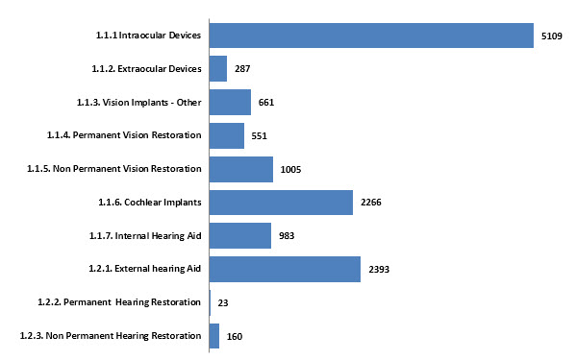
Figure 28 – Analysis of Major Subject Matter within Restorative Technology in the Assistive Devices and Technologies for Visually and Hearing Impaired Persons Technology Landscape
Raw data for figure 28: 1.1.1 Intraocular Devices: 5019, 1.1.2 Extra ocular Devices: 287, 1.1.3 Vision Implants - other: 661, 1.1.4 Permanent Vision Restoration: 551, 1.1.5 Non Permanent Vision Restoration: 1005, 1.1.6 Cochlear Implants: 2266, 1.1.7 Internal Hearing Aid: 983, 1.2.1 External hearing Aid: 2393, 1.2.2 Permanent Hearing Restoration: 23, 1.2.3 Non Permanent Hearing Restoration: 160.
Assistance Technology related to vision proved difficult to accurately classify with many of the innovation contained being general in nature. This vision assistance – other23 classification (6010 inventions) contained such inventions where a user’s vision was relieved of discomfort, therapeutic treatment of eyes to assist vision, and general assistance devices e.g. object tracking for artificial vision, covered in WO2011038465A124.
Figure 29 – Method and system for tracking objects in video data for artificial vision highlighted in patent WO2011038465A1.
Another example of technology in this broad classification (2.1.3) includes Braille printer innovation involving 3D related technology. This type of innovation is shown in JP03775613B225 which covers “Irregular image production method using thermal printer”. It involves the use of a thermal printer’s headr to heat recording sheet with thermal expansion property. This technology can be used for producing printed Braille-points such as those on stamps and has the advantage of reducing irregular image depending on the 3D information provided.
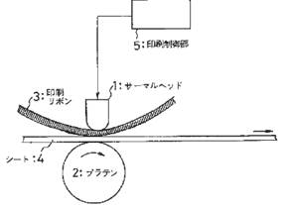
Figure 30 - Irregular image production method using thermal printer involves using thermal head of thermal printer to heat recording sheet having thermal expansion property as highlighted by JP03775613B2
Voice / language recognition technology, speech processing or voice conversion to text technology was the highest represented technology in terms of hearing enhancement (3696 inventions).
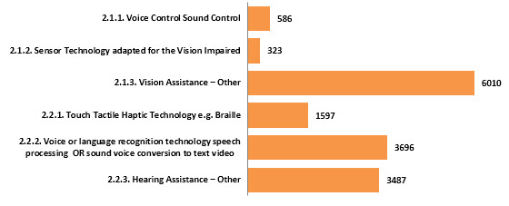
Figure 31 – Analysis of Major Subject Matter within Assistance Technology in the Assistive Devices and Technologies for Visually and Hearing Impaired Persons Technology Landscape
Enhancement technology has a more even spread across the various classifications. Technology in relation to the display of information (2283 inventions) including innovation covered in US6384743B1 ²⁶, highlighting touch screen technology for the vision impaired.
Figure 32 – A touch screen system for the vision-impaired highlighted in patent US6384743B1.
Image encoding and translation technology (2096 inventions), including US2013194402A1 ²⁷, which highlights innovation representing visual images by alternative senses.
Figure 33 – A method of representing visual images by alternate senses highlighted in patent US6384743B1.
Spatial resolution / vision quality (2030), for example EP2677982A128, covering technology such as optical devices for the visually impaired.
Figure 34 – An optical device for a visually-impaired individual highlighted in patent EP2677982A1.
These 3 technology categories were all strongly represented in terms of vision enhancement technology. For hearing, sound coding / translation was the highest represented technology (1832 inventions). US8087936B229 is a good example or representative technology in this category. This patent pertains to innovation directed to systems and methods for verbal communication from a speech impaired individual.
Figure 35 – Flow chart depicting means for a speech impaired individual to communicate with a service provider as highlighted in patent US8087936B2.
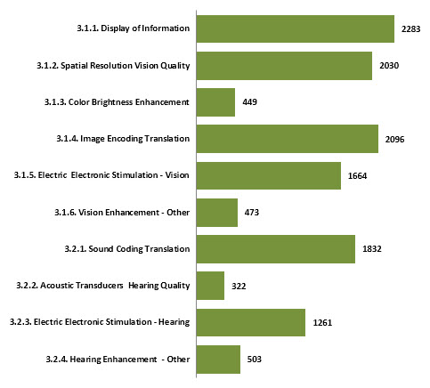
Figure 36 – Analysis of Major Subject Matter within Enhancement Technology in Assistive Devices and Technologies for Visually and Hearing Impaired Persons Technology Landscape
Raw data for Figure 36: 3.1.1 Display of Information: 2283, 3.1.2 Special Resolution Vision Quality: 2030, 3.1.3 Color Brightness Enhancement: 449, 3.1.4 Image Encoding Translation: 2096, 3.1.5 Electric Electronic Stimulation- Vision: 1664, 3.1.6 Vision Enhancement - other: 473, 3.2.1 Sound Coding Translation: 1832, 3.2.2 Acoustic Transducers Hearing Quality: 322, 3.2.3 Electric Electronic Stimulation - Hearing: 1261, and 3.2.4 Hearing Enhancement - other: 503.
The ‘additional’ technology segmentation categories which contain additional innovation not specifically covered by restorative / assistance / enhancement device technology, is shown below. Inventions consistent with the goals of the Marrakesh Treaty, namely associated with technologies facilitating access to published works for print disabled persons, and also such technologies for hearing impaired persons (4382 inventions total) were the highest populated combined categories. This was followed by innovation related to hardware associated with visual and hearing impaired devices (3026 inventions). An example of this type of technology is covered in US 20120268366A1 31, which highlights a method for providing visual compensation using digital camera to capture image of user of i.e. mobile telephone, and involves setting electronic visual display to normal font size if eyeglasses are detected as present in image.
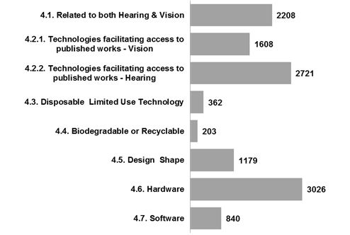
Figure 37 – Analysis of Major Subject Matter within the Additional Related Technology in the Assistive Devices and Technologies for Visually and Hearing Impaired Persons Technology Landscape
Raw data for Figure 37: 4.1 Related to both Hearing and Vision: 2208, 4.2.1 Technologies facilitating access to published works – vision: 1608, 4.2.2 Technologies facilitating access to published works – hearing 2721, 4.3 Disposable Limited Use Technology: 362, 4.4 Biodegradable or Recyclable: 203, 4.5 Design Shape: 1179, 4.6 Hardware: 3026, 4.7 Software: 840.

4.9 TECHNOLOGIES FACILITATING ACCESS TO PUBLISHED WORKS
Innovative technologies which facilitate access to published works are of great importance to those communities who rely on hearing and visually assistive devices and technologies. The Marrakesh Treaty ³², adopted in 2013 in Marrakesh, Morocco and administered by WIPO, is an initiative in which the main goal is to create a set of mandatory limitations and exceptions to increase the number of accessible format works for those who are of blind, visually impaired, or otherwise print disabled persons. This treaty has a clear humanitarian and social development dimension.
Technology associated with innovative technologies which facilitate access to published works, appear in the 4.2.1 (vision) and 4.2.2 (hearing) technical categories of the present Report.
The following figures reveal some of the interesting ‘themes’ or ‘topics’ occurring within these two technology categories, in order to highlight the types of innovation occurring. This information was retrieved by interrogating a patent Themescape map ³² (see also the Themescape below under Figure 39) based only on patent information occurring within the 4.2.1 (vision) and 4.2.2 (hearing) technical categories and via text clustering of the patent data within these categories. Patent documents appearing are not mutually exclusive, meaning that they can appear across different themes (based on keyword) of these categories.
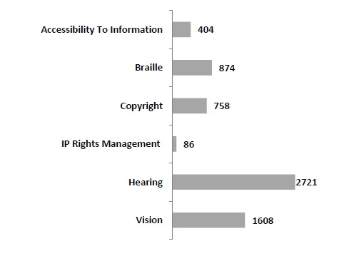
Figure 38 – Interesting Themes / Topics Identified from the Themescape Map (shown below) of Technologies Facilitating Access to Published Works (Technical Categories 4.2.1 and 4.2.2)
Raw data for Figure 38: Accessibility to Information 404, Braille 874, Copyright 758, IP Rights Management 86, Hearing 2721, Vision 1608.

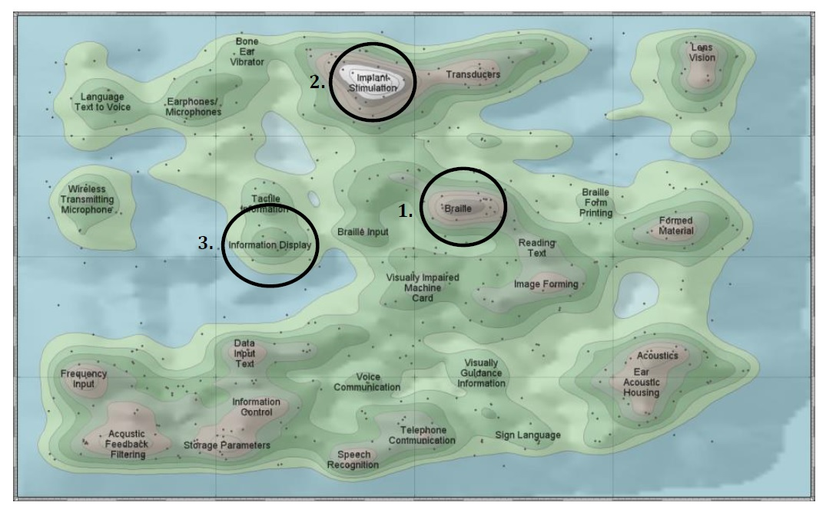
Figure 39 –Themescape Patent Map of Patent Data Located within the Technologies Facilitating Access to Published Works (hearing and vision) Technical Categories (4.2.1 and 4.2.2)
The Themescape map above also highlights innovation from other technology categories appearing concurrently with this category. Many innovative patents appearing in the dataset appear over multiple technology categories. Examples of this include the following, representing the technologies with the highest number of patent applications in the Themescape and the patent dataset of the present report:
- Braille text presenting apparatus for use by e.g. blind person, highlighted in US8382480B2 37, also categorised in 2.2.1 Touch Tactile Haptic Technology. The invention describes a method for converting data into Braille text, and permitting scrolling of a Braille display.

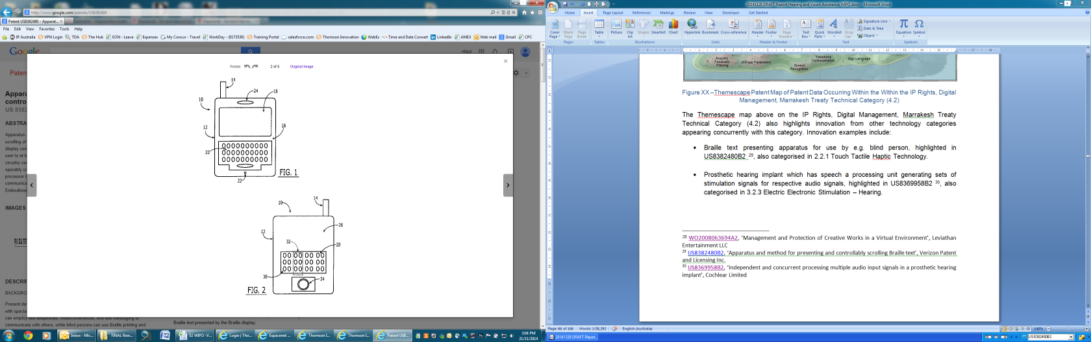
Figure 40 – Apparatus and methods for converting data into Braille text and permitting scrolling of a Braille display, highlighted in patent US8382480 B2.
- Prosthetic hearing implant which has a speech processing unit generating sets of stimulation signals for respective audio signals, highlighted in US8369958B2 38 also categorised in 3.2.3 Electric Electronic Stimulation – Hearing.
Figure 41 – A prosthetic hearing implant capable of independently and concurrently processing multiple audio signals, highlighted in patent document US6230135B1.
- Verbal communications conveying method for providing tactile communication, highlighted in US6230135B1 39, also categorised in 3.1.1 Display of Information. This method and apparatus is based on a so-called “Phonetic Braille Code”, using Braille symbols representing word sounds or phonemes rather than letters in order to accelerate the real-time transmission of the information. It converts electrical signals into Phonetic Braille Code, and uses a two-finger Braille reading approach.

Figure 42 – A tactile communications system which provides a method and apparatus for presenting tactile communications in real time, highlighted in patent US6230135B1.
- Braille display device using electrorheological fluid and manufacturing method thereof, claimed in US8047849B2 40, categorized under 2.2.1 Touch Tactile Haptic Technology and 3.1.1 Display of Information. The device and manufacturing method described in this patent document refers to a refreshable braille display device using an electrorheological fluid and braille pins allowing for a presentation of the information in Braille.
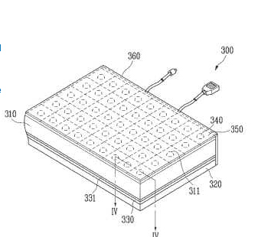
Figure 43 – Braille display device using electrorheological fluid and manufacturing method thereof.
- Optical character recognition (OCR) in combination with Text-to-Voice technology, as for instance the one claimed in IN201200396I4 41. An electronic pen is scanning a text and capturing it as an image, with OCR, extracting the text from the text image, creating a text document and sending it to text-to-speech converter, creating an audio file which can be read out to the print disabled person.
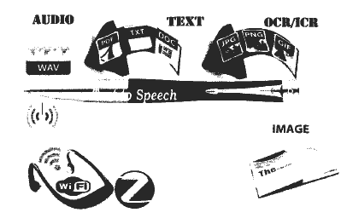
Figure 44 - Penpal - an electronic pen aiding visually impaired in reading, understanding and visualizing textual contents
- Sound/voice conversion to text: US2012329518A1 42 describes an example of this technology. The claimed mobile device has both a speech-to-text and a voice-to-text module, converting information received, such as audio data as radio frequency signals (RF) into text, facilitating access of hearing impaired persons in this type of information.
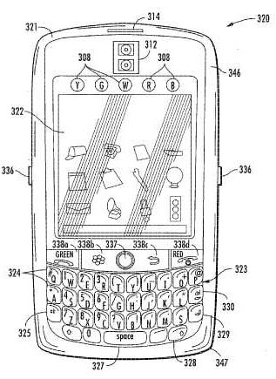
Figure 45 - Mobile wireless communications device for hearing and/or speech impaired user

4.10 INNOVATION CONCEPT CROSS OVER – ADUNA MAPPING
The following Aduna maps highlight the technology ‘cross over’ in terms of innovation in the dataset for both vision and hearing related technologies. These maps show the extent of innovation within the dataset when the three highlighted concepts are taken into account. This reveals visually, the amount of patented innovation which focuses just on one concept area e.g. vision enhancement (top left of Figure 43), compared to the number focused on multiple areas e.g. vision enhancement, assistance and restoration (middle point of Figure 44). The graphical representation of one dot in an Aduna map equates to an order of 100 patent families in the dataset. The actual values of patent families inside the Aduna maps have also been provided (Table 7 & 8).
Table 7: Cross Technology Table for Vision Technology
- | 1.1 Vision Restoration | 2.1 Vision Assistance | 3.1 Vision Enhancement
1.1 Vision Restoration | 9011 | 603 | 1264
2.1 Vision Assistance | - | 6301 | 2808
3.1 Vision Enhancement | - | - | 6101
Raw data for Table 7: Restoration: 9011, Assistance: 6301, Enhancement: 6101, Restoration and Assistance: 603, Restoration and Enhancement: 1264, Assistance and Enhancement: 2808.
The Aduna map below visually highlights the three vision related technology concepts within the data set. It is observed that vision restoration technology (in pink) contains the highest number of patent families associated only with this concept. Patent innovation related to both vision enhancement and assistance (where the blue and green points intersect) has the highest instance of ‘cross over’ in relation to vision technology meaning that there are a large number of patents covering both concepts of this technology. Opportunities on a broad level can be identified by locating low levels of patent ‘cross over’ activity. In terms of vision technology, opportunity lies in ‘cross over’ innovation between vision assistance and restoration technology (where the green and pink points intersect) and with innovation that involves all three concepts related to vision device technology (the middle point of the map).
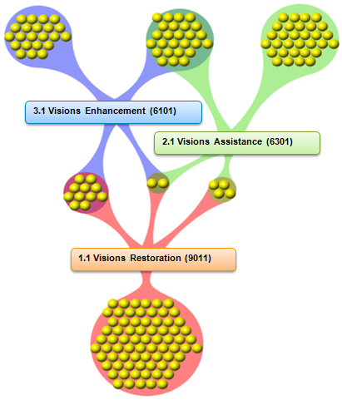
Figure 46 – Vision Technology Aduna Map Highlighting Technology Concept Crossover in Patent Dataset
Table 8: Cross Technology Table for Vision Technology
- | 1.2 Hearing Restoration | 2.2 Hearing Assistance | 3.1 Hearing Enhancement
1.2 Hearing Restoration | 2532 | 591 | 503
2.2 Hearing Assistance | - | 8712 | 1294
3.1 Hearing Enhancement | - | - | 3466
Raw data for Table 8: Restoration: 2532, Assistance: 8712, Enhancement: 3466, Restoration and Assistance: 591, Restoration and Enhancement: 503, Assistance and Enhancement: 1294.
The Aduna map below visually highlights the three hearing related technology concepts within the data set. It is observed that hearing assistance technology (in pink) contains the highest number of patent families associated only with this concept. Patent innovation related to both hearing enhancement and assistance (where the pink and green points intersect) has the highest instance of ‘cross over’ in relation to hearing technology meaning that there are a larger number of patents coving both concepts of this technology. Opportunities on a broad level can be identified by locating low levels of patent ‘cross over’ activity. In terms of hearing technology, opportunity lies in ‘cross over’ innovation between hearing enhancement and restoration technology (where the green and blue points intersect) and with innovation that involves all three concepts related to hearing device technology (the middle point of the map).
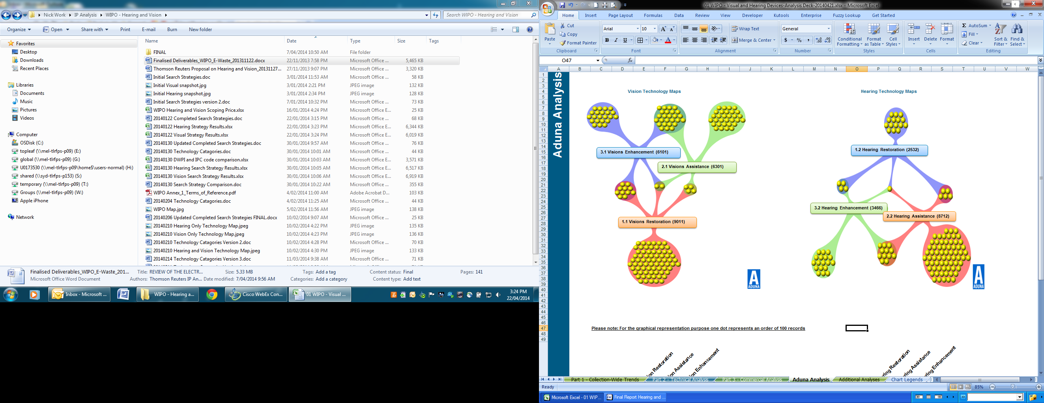
Figure 47 – Hearing Technology Map Highlighting Technology Concept Crossover in Patent Dataset

4.11 TECHNOLOGY INNOVATION – ACTIVITY GROWTH OR DECLINE
Table 9 highlights the compound annual growth rate (CAGR) and recency trends within the patent data set.
Table 9 – Recency and Compound Annual Growth Rate Analysis (CAGR) for technical categories for Technology In the Assistive Devices and Technologies for Visually and Hearing Impaired Persons Landscape
Technical Category | Type of impairment | Assistive Devices and Technologies | CAGR '07-'11 | Recency
Restoration | Vision | 1.1.1 Intraocular Devices | -7% | 16%
Restoration | Vision | 1.1.2. Extraocular Devices | 4% | 18%
Restoration | Vision | 1.1.3. Vision Implants - Other | -5% | 20%
Restoration | Vision | 1.1.4. Permanent Vision Restoration | -6% | 19%
Restoration | Vision | 1.1.5. Non Permanent Vision Restoration | -11% | 20%
Restoration | Hearing | 1.1.6. Cochlear Implants | -3% | 21%
Restoration | Hearing | 1.1.7. Internal Hearing Aid | -18 | 14%
Restoration | Hearing | 1.2.1. External Hearing Aid | -33 | 9%
Restoration | Hearing | 1.2.2. Permanent Hearing Restoration | 19% | 17%
Restoration | Hearing | 1.2.3. Non Permanent Hearing Restoration | 3% | 23%
Assistance | Vision | 2.1.1. Voice Control Sound Control | 22 | 21%
Assistance | Vision | 2.1.2. Sensor Technology Adapted for the Vision Impaired | 10% | 20%
Assistance | Vision | 2.1.3. Vision Assistance – Other | 9% | 17%
Assistance | Hearing | 2.2.1. Touch Tactile Haptic Technology e.g. Braille | 1% | 19%
Assistance | Hearing | 2.2.2. Voice or Language Recognition Technology, Speech Processing or Sound Voice Conversion to Text Video | -2% | 25%
Assistance | Hearing | 2.2.3. Hearing Assistance – Other | -16% | 16%
Enhancement | Vision | 3.1.1. Display of Information | 6% | 19%
Enhancement | Vision | 3.1.2. Spatial Resolution Vision Quality | 5% | 24%
Enhancement | Vision | 3.1.3. Color Brightness Enhancement | -7% | 22%
Enhancement | Vision | 3.1.4. Image Encoding Translation | 5% | 24%
Enhancement | Vision | 3.1.5. Electric Electronic Stimulation - Vision | 3% | 25%
Enhancement | Vision | 3.1.6. Vision Enhancement - Other | -37 | 11%
Enhancement | Hearing | 3.2.1. Sound Coding Translation | -9% | 17%
Enhancement | Hearing | 3.2.2. Acoustic Transducers Hearing Quality | -6% | 19%
Enhancement | Hearing | 3.2.3. Electric Electronic Stimulation - Hearing | -4% | 26%
Enhancement | Hearing | 3.2.4. Hearing Enhancement - Other | -17% | 18%
Additional Related Technology | Vision and Hearing | 4.1. Related to both Hearing & Vision | 4% | 24%
Additional Related Technology | Vision | 4.2.1. Technologies facilitating access to published works - Vision (relevant to Marrakesh Treaty) | 2% | 21%
Additional Related Technology | Hearing | 4.2.2. Technologies facilitating access to published works - Hearing | -9% | 17%
Additional Related Technology | - | 4.3. Disposable or Limited Use Technology | 9% | 26%
Additional Related Technology | - | 4.4. Biodegradable or Recyclable | -13% | 21%
Additional Related Technology | - | 4.5. Design or Shape | -13% | 19%
Additional Related Technology | - | 4.6. Hardware | 6% | 25%
Additional Related Technology | - | 4.7. Software | -14% | 20%
Others | Vision | 5.1. Vision Care-Others | 4% | 23%
Others | Hearing | 5.2. Hearing Care-Others | 1% | 21%
Others | - | 5.3. Overall Others | 1% | 17%

Recency is measured as the percentage of the patent collection per technical category which has been recently filed (over the last 5 years). It can be seen that all technical categories fall below a recency value of 26%. This indicates that none of the technical categories highlighted contain an abundant amount of recent innovation. This does not mean there is no ‘cutting edge’ or ‘break though’ technology being produced, it simply indicates that the bulk of the vision and hearing impaired device technology has been in the public domain for some time and plausibly, a significant number of these inventions may be coming to the end of the 20 year protection period that a patent generally provides43.
Disposable or limited use technology (associated to vision or hearing impairment) and electric electronic stimulation technology (for hearing) are the technical categories that can be defined as having the most recent innovation given 26% of each category has been recently filed. It is reasonable to assume that these technologies may have a higher perceived commercial value given their higher recency values of patented innovation.
Figure 48 details the activity trends within these technical categories, as measured by compound annual growth or decline in patent activity rates per topic between 2007 and 2011.
The compound annual growth/decline metric is a measure of the percentage change in activity when compared between 2011 activity levels and 2007 activity levels. The metric is primarily used in financial investments to assess performance of an investment over a time period. For example, an investment of $10 in 2007 returning $100 in 2011 would be measured as a Compound Annual Growth Rate (CAGR) of 78%. Here it is used to identify the growth or decline in patent activity in the various technology sectors surrounding vision and hearing impaired device technology.
Figure 48 shows a large expansion in patent activity in three technical areas (highlighted in orange). These technical areas include voice and sound control associated with vision assistance (22% CAGR) and technology associated with permanent hearing restoration (19% CAGR). Also growing in activity is sensor technology adapted for Vision impaired persons (10% CAGR).
Interestingly, roughly half of the technical categories show a decrease in compound annual growth rate (highlighted in green). External hearing aids (-33% CAGR) and general technology associated with vision enhancement (-37% CAGR) are revealed to have shown the largest decline in patent activity when compared between 2011 activity levels and 2007 activity levels.
Subject | Growth or Decline
2.1.1 Voice Control Sound Control | 22%
1.2.2 Permanent Hearing Restoration | 19%
2.1.2 Sensor Technology adapted for the Vision Impaired | 10%
2.1.3 Vision Assistance- other | 9%
4.3 Disposable Limited Use Technology | 9%
3.1.1 Display of information | 6%
3.1.4 Image Encoding Translation | 5%
3.1.2 Spatial Resolution Vision Quality | 5%
5.1 Vision Care - others | 4%
4.1 Related to both hearing & Vision | 4%
1.1.2 Extraocular Devices | 4%
3.1.5 Electric Electronic Stimulation -Vision | 3%
1.2.3 Non Permanent Hearing Restoration | 3%
4.6 Hardware | 3%
4.2.1 Technologies facilitating access to published works - Vision | 2%
5.3 Overall others | 1%
2.2.1 Touch Tactile Haptic Technology e.g. Braille | 1%
5.2 Hearing care - others | 1%
2.2.2 Voice or language recognition technology speech processing OR sounds voice conversion to text video | -2%
1.1.6 Cochlear Implants | -3%
3.2.3 Electric Electronic Stimulation - Hearing | -4%
1.1.3 Vision Implants - other | -5%
1.1.4 Permanent Vision Restoration | -6%
3.2.2 Acoustic Transducers Hearing Quality | -6%
1.1.1 Intraocular Devices | -7%
3.1.3 Color Brightness Enhancement | -7%
3.2.1 Sound Coding Translation | -9%
4.2.2 Technologies facilitating access to published works - Hearing | -9%
4.5 Design Shape | -10%
1.1.5 Non Permanent Vision Restoration | -11%
4.4 Biodegradable or Recyclable | -13%
4.7 Software | -14%
2.2.3 Hearing Assistance - other | -16%
3.2.4 Hearing Enhancement - other | -17%
1.1.7 Internal Hearing Aid | -18%
1.2.1 External hearing Aid | -33%
3.1.6 Vision Enhancement - other | -37%
Figure 48 – Analysis of Recent Patent Activity Trends in Assistive Devices and Technologies for Visually and Hearing Impaired Persons Landscape By Major Subject Matter; Compound Annual Growth or Decline between 2007 and 2011; as measured by Earliest First Filing Year

4.12 SPECIALISATION OF INNOVATION BY GEOGRAPHY
Combining the high level topics with the offices of first filing information in the data collection provides an understanding of the focus of applicants in different territories in specific assistive devices and technologies for visually and hearing impaired persons.
Table 10 and 12 shows the proportion of activity from applicants in each of the top territories (based on office of first filing), within both the high level topics and the top 5 major topics in the technical categorization. Table 11 and 13 shows the same information, but provides the absolute number of patent families per office of first filing country and topic.
Table 10 - Analysis of high level topics in the Assistive Devices and Technologies for Visually and Hearing Impaired Persons Technology Landscape by Major Offices of First Filing Location; As % of All Assistive Devices and Technologies for Visually and Hearing Impaired Persons Activity per Office of First Filing Location
High Level Topics | United States | Japan | China | Germany | Russia | South Korea | France | EPO | United Kingdom | Australia
1.1 Vision Restoration | 38% | 12% | 14% | 22% | 25% | 9% | 28% | 24% | 18% | 56%
1.2 Hearing Restoration | 4% | 16% | 1% | 10% | 0% | 3% | 2% | 8% | 3% | 14%
2.1 Vision Assistance | 14% | 21% | 20% | 21% | 6% | 26% | 28% | 14% | 36% | 12%
2.2 Hearing Assistance | 21% | 32% | 20% | 32% | 3% | 35% | 24% | 33% | 34% | 28%
3.1 Vision Enhancement | 18% | 14% | 19% | 17% | 18% | 17% | 22% | 15% | 30% | 11%
3.2 Hearing Enhancement | 12% | 9% | 7% | 9% | 2% | 9% | 6% | 13% | 8% | 33%
4 Additional Related Technology | 33% | 24% | 27% | 26% | 7% | 26% | 26% | 38% | 37% | 36%

Table 11 - Analysis of High Level Topics in the assistive Devices and Technologies for Assistive Devices and Technologies for Visually and Hearing Impaired Persons Landscape by Major Office of First Filing Location; Number of Patent Families
High Level Topics | United States | Japan | China | Germany | Russia | South Korea | France | EPO | United Kingdom | Australia
1.1 Vision Restoration | 5123 | 1029 | 374 | 546 | 549 | 107 | 257 | 149 | 109 | 245
1.2 Hearing Restoration | 583 | 1299 | 37 | 239 | 10 | 38 | 21 | 51 | 17 | 60
2.1 Vision Assistance | 1841 | 1758 | 543 | 513 | 134 | 307 | 257 | 86 | 210 | 52
2.2 Hearing Assistance | 2919 | 2601 | 548 | 786 | 61 | 414 | 217 | 206 | 200 | 121
3.1 Vision Enhancement | 2432 | 1185 | 511 | 410 | 382 | 205 | 202 | 97 | 175 | 49
3.2 Hearing Enhancement | 1594 | 737 | 199 | 221 | 38 | 103 | 55 | 83 | 50 | 145
4 Additional Related Technology | 4504 | 1999 | 714 | 625 | 154 | 311 | 242 | 238 | 221 | 156

Table 12 - Analysis of Major topics in the Assistive Devices and Technologies for Visually and Hearing Impaired Persons Landscape by Major Offices of First Filing Location; As % of All Assistive Devices and Technologies for Visually and Hearing Impaired Persons Activity per Office of First Filing Location
Major Topics | United States | Japan | China | Germany | Russia | South Korea | France | EPO | United Kingdom | Australia
1.1.1 Intraocular Devices | 22% | 9% | 3% | 10% | 18% | 2% | 20% | 15% | 9% | 6%
2.2.2. Voice or language recognition technology speech processing OR sound voice conversion to text video | 10% | 16% | 11% | 5% | 0% | 22% | 3% | 17% | 9% | 3%
2.2.3. Hearing Assistance – Other | 9% | 11% | 7% | 21% | 2% | 8% | 8% | 12% | 9% | 21%
4.2. IP Rights Digital Management Marrakesh Treaty | 11% | 13% | 12% | 15% | 1% | 12% | 18% | 18% | 20% | 16%
4.6. Hardware | 14% | 6% | 5% | 3% | 0% | 8% | 4% | 13% | 10% | 5%

Table 13 - Analysis of Major Topics in Assistive Devices and Technologies for Visually and Hearing Impaired Persons Landscape by Major Office of First Filing Location; Number of Patent Families
Major Topics | United States | Japan | China | Germany | Russia | South Korea | France | EPO | United Kingdom | Australia
1.1.1 Intraocular Devices | 3043 | 703 | 92 | 241 | 383 | 25 | 181 | 93 | 56 | 27
2.2.2. Voice or language recognition technology speech processing OR sound voice conversion to text video | 1339 | 1313 | 300 | 113 | 5 | 264 | 30 | 105 | 56 | 13
2.2.3. Hearing Assistance – Other | 1158 | 894 | 183 | 504 | 39 | 98 | 74 | 77 | 54 | 90
4.2. IP Rights Digital Management Marrakesh Treaty | 1561 | 1112 | 316 | 364 | 32 | 142 | 161 | 116 | 116 | 68
4.6. Hardware | 1893 | 464 | 142 | 84 | 7 | 92 | 39 | 79 | 60 | 20

Major findings from the ‘high level’ topic tables include:
- United States entities have a large focus on vision restoration (38%) and additional related technology (33%) associated to assistive devices and technologies for visually and hearing impaired persons.
- United States entities have low interest in hearing restoration technology (4%). Japan (16%) and Australia (14%) have the highest interest in this technology, however when compared to other high level topics, the interest is still relatively low. Most other territories have low interest in this technology.
- Most of the top countries have a relatively high interest in additional related technology (24% to 38%) apart from Russia (7%) who has a relatively low interest.
- China has a varied innovation portfolio with technology related to hearing restoration (1%) and hearing enhancement (7%) appearing to be of low interest.
- Russia appear to only have interest primarily in vision restoration (25%) and vision enhancement (18%)
- Over half of Australian patent innovation (56%) is associated with vision restoration.

Major findings from the ‘major topic’ tables include:
- Entities from the United States (22%), France (20%) and Russia (18%) have high interest in intraocular lens technology.
- The EPO has strong and varied representation in all major topics presented in the table.
- The Republic of Korea (22%) appears to have high interest in voice, language recognition technology, speech processing and voice to text conversion technology.

4.13 TECHNOLOGY RANKING AND COMMERCIALISATION
Throughout this report, metrics have been applied to dataset that move the analysis of innovation activity beyond simply the number of patents or patent applications within any given sector.
This section moves this further by analyzing the major technical themes within the assistive devices and technologies for visually and hearing impaired persons landscape at the level of commercialization and investment.
It was stated earlier that there is a strong link between the number of different territories in which an individual application is filed and the level of monetary investment required. Put simply, the more countries in which protection is sought, the higher the level of expense, due to the multiplication of the number of legal counsel involved and the potential for expensive processes such as translation.
Metrics related to commercialization covering the high level topics in the dataset are highlighted below.
Table 14 – Commercialization Analysis of Technology Metrics
High Level Topic | Volume | Filing Breadth | Age weighted Citation Impact Value | TR Strength Index | Recency | CAGR '07-'11
1.1 Vision Restoration | 9011 | 2.8 | 1.5 | 5.7 | 18% | -7%
1.2 Hearing Restoration | 2532 | 1.9 | 0.7 | 3.2 | 10% | -29%
2.1 Vision Assistance | 6301 | 1.7 | 0.7 | 3.3 | 17% | 10%
2.2 Hearing Assistance | 8712 | 1.8 | 0.9 | 3.8 | 20% | -7%
3.1 Vision Enhancement | 6101 | 1.9 | 0.9 | 3.9 | 21% | 2%
3.2 Hearing Enhancement | 3466 | 2.0 | 1.2 | 4.8 | 20% | -9%
4 Additional Related Technology | 9868 | 2.0 | 1.1 | 4.3 | 21% | -3%
5 Vision/Hearing Others | 7953 | 2.0 | 0.8 | 3.9 | 21% | 3%

Definitions of each metric are summarized below.
- Volume: The number of inventions that are accurately categorized into each high level topic.
- Filing Breadth: Average Geographic filing breadth for each patent family i.e. average number of patents from different jurisdictions in the patent family.
- Age Weighted Citation Impact Value: This value acts as a measure of impact in the field i.e. the average number of other patents that have cited a patent in each category (older patents have more opportunity to be cited, so this metric is adjusted to correct for patent age)
- TR Strength Score: This is calculated based on aggregated measurements of the volume, filing breadth and age weighted citation values. The TR strength score is a unit less-value that allows entire patent portfolios to be ranked relative to one another.
- Recency: The total amount of patent filings conducted within the last 5 years for each high level topic.
- CAGR 07 – 11: details the activity trends within these high level topics, as measured by compound annual growth or decline in patent activity rates per topic between 2007 and 2011.
Utilizing the above metrics we are able to view the major technology themes in the landscape by this geographic filing breadth (x-axis) as well as by the level of recent growth exhibited by patent activity in each sector (y-axis). The chart below can be considered a form of SWOT analysis (strength, weakness, opportunity, threat) in that categories that are situated further right and higher up the chart are growing and have had heavier investment in. All high level topic sectors in the analysis have been individually labeled according to the table above.
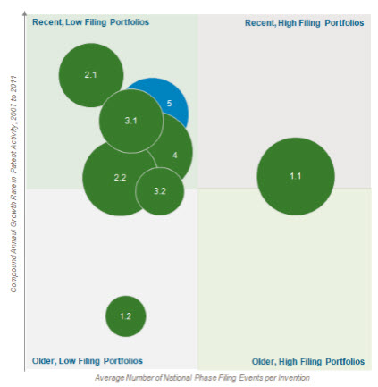
Figure 49 – Model Analysis of Major Subject Matter in Assistive Devices and Technologies for Visually and Hearing Impaired Persons Landscape; Compound Annual Growth versus Average Number of Offices of Subsequent Filing per Invention; Bubble Size reflects Volume of Patent Activity per Subject Area
Most high level topics fall into the top left hand corner of the chart. This shows that in general, vision assistance (2.1), hearing assistance (2.2), vision enhancement (3.1), hearing enhancement (3.2), additional related technology (4) and ‘other’ vision / hearing related technologies (5) have been filed in lower numbers geographically speaking.
There is a bright point however for vision assistance (2.1) and vision enhancement (3.1). Their CAGR values from 2007 - 2011 are positive indicating that there is increased patent activity occurring recently when compared to 5 years earlier. This may indicate that the current state of these technologies appears to be commercially unattractive, however in the coming years, if the increased patent activity trend continues; these technologies may start to ignite interest from commercial entities and become more commercially viable.
Vision restoration (1.1), in its current state, appears to avoid this commercial unattractive trend. It has a higher rate of geographic filing and overall has the highest strength score of all patent portfolios. This indicates that this technology area generally has a higher level of investment when compared to the other technology topics and appears to be more commercially attractive for entities to invest R&D in. It should be noted however that recent patent activity in this topic has decreased slightly as indicated by its CAGR value (-7%). This can potentially indicate that while this technology is presently more popular commercially, it may have peaked and could begin to lose this popularity in future years.
Hearing Restoration (1.2) appears to have the lowest rate of recent geographic filing and also has the largest drop in recent patent activity. This shows that this technology may have once been an attractive proposition commercially; however recently; it is well on the decline in terms of commercialization and its attractiveness to entities in the field.
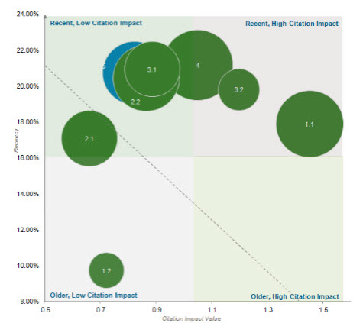
Figure 50 – ‘Three Factor Analysis’ of Major Subject Matter in Assistive Devices and Technologies for Visually and Hearing Impaired Persons Landscape; Recency Vs Citation Impact Value; Bubble Size Reflects Volume of Patent Activity per Subject Area
The figure above highlights the major subject matter in the assistive devices and technologies for visually and hearing impaired person’s landscape based on citation impact value. This value acts as a measure of impact in the field i.e. the average number of other patents that have cited a patent in each category. Technology appearing in the top right hand corner of the chart indicates recently filed patents which have a high impact, or a higher perceived importance based on the number of citations associated with it.
The overall trend (the dotted line) is that generally, more recent innovative patent activity in has less impact in the field than older patent innovation. This technology has been around for over 30 years with the bulk of patent activity not being filed recently (last 5 years), therefore this trend is to be expected as older patents have more opportunity to be cited.
This chart once again highlights that vision restoration (1.1) appears to be the most commercially attractive technology appearing to have both a fairly high recently filed number of patent and a high citation impact value. Hearing enhancement (3.2) technology and additional related technology (4) have also performed well here indicating that although the patent activity in these fields has reduced in the last few years, the fundamental innovation contained within these patents is of a high innovative standard and has high commercial potential.
Hearing restoration (1.2) technology, once again scores poorly. It has the lowest value regarding recent patent activity in the technology field in the assistive devices and technologies for visually and hearing impaired persons landscape. It also has the lowest citation impact value of all technologies. This shows that there appears to be less interest in this technology in general, perhaps because of a lack of recent innovation in the field due to this sub technology (on average) being a lot older than other technologies in this field or because entities have focused their efforts on other sub technology areas with a higher perceived commercial value.

4.14 KEY FINDINGS FROM TECHNOLOGY ANALYSIS
- Voice or language recognition, speech processing or sound voice conversion to text or video had the highest numbers of patented inventions in relation to hearing technology.
- General vision assistance (‘other’ technology) and intraocular devices had the highest numbers of inventions in relation to vision technology.
- Inventions related to the Marrakesh Treaty, namely pertaining to technologies facilitating access of print disabled persons to published works, but also such technologies related to hearing impaired persons were well represented in the data set with 4329 patent families in total (1608 for vision and 2721 for hearing).
- Voice control and sound control (related to vision assistance) has the highest increase in patent activity (CAGR over the 2007 – 2011 period) with 22%. General vision enhancement (‘other’ technology) has the largest decline in patent activity, declining by 37%.
- United States entities have a large focus on vision restoration and additional related technology associated to vision and hearing device technology. United States entities have shown low interest in hearing restoration technology.
- Japan and Australia have shown the highest interest in hearing restoration technology.
- Most top countries have a relatively high interest in additional related technology associated with vision and hearing impaired devices apart from Russia who shows a relatively low interest.
- China has a varied innovation portfolio, however technology related to hearing restoration and hearing enhancement appearing to be of lesser interest.
- Russia appears to only have interest in vision restoration and vision enhancement.
- Over half of Australian patent innovation is associated with vision restoration.
- The EPO has strong and varied representation in all major topics associated with this technology.
- Entities from the United States, France and Russia have high interest in intraocular lens technology
- South Korea is shown to exhibit high interest in voice to language recognition technology, speech processing and voice to text conversion technology.
- Vision restoration technology has the highest perceived recent interest by entities due to patents having a high impact in the field, relatively high recently filed patent activity rate and a higher number of patents being broadly filed geographically.
- Hearing restoration technology has the lowest perceived recent interest by entities due to patents having a low impact in the field; lower recently filed patent activity and lower numbers of patents being broadly filed geographically.

PART 5 – COMMERCIAL LANDSCAPE ANALYSIS OF ASSISTIVE DEVICES AND TECHNOLOGIES FOR VISUALLY AND HEARING IMPAIRED PERSONS
Any analysis of patent activity within a given field should exploit the ownership nature of the IP rights, and thereby derive a focus on the commercial implications of patent activity.
While it is true that patent rights naturally derive from individual inventors, the practicalities of modern commerce mean that these rights most often fall under the ownership and stewardship of organizations which employ inventors.
This section of the study focuses on the nature of patent activity in the vision and hearing impaired device field from these patenting organizations.

5.1 DISTRIBUTION OF PATENT ACTIVITY BY PORTFOLIO SIZE
A primary metric in any landscape analysis is the size of the portfolios from organizations active in the technology, and how the landscape is distributed amongst the various large, medium and small patent portfolios. These portfolios sizes have been transposed into a series of “tiers” which describe large portfolios as those with 100 or more inventions (Tier 1), medium sized portfolios with between 4 and 99 inventions (tier 2), small portfolios of fewer than 3 inventions (tier 3) and finally a 4th tier of inventions not assigned to an organization (individuals).
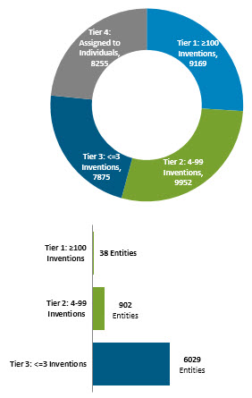
Figure 51 – Distribution of Patent Activity within the Assistive Devices and Technologies for Visually and Hearing Impaired Persons Landscape by Portfolio Size; Number of Entities per Portfolio Tier
The figure above models this distribution in vision and hearing impaired devices, and shows that over a quarter (26%) of the patent families in the collection derive from just 38 patent applicants, all of whom have 100 or more vision and hearing impaired device inventions in the portfolio. There are over 6000 entities which have fewer than 5 inventions, these entities equate to less than a quarter (22%) of all patent families in the collection. This large number of entities show there has been significant interest by a wide range of entities in this technology, however there only appears to be a much smaller amount that has truly focused their efforts toward this technology.
In general, the patent technology landscape is quite top heavy, with a small number of organizations (38 entities) controlling a significantly large proportion of the technology within assistive devices and technologies for visually and hearing impaired person’s technology.
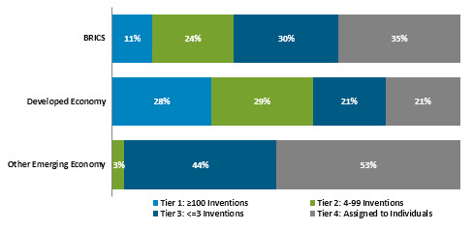
Figure 52 - Distribution of Portfolio Size Tiers Across Economy Types
Raw Data for Figure 52: BRICS: Tier 1: 11%, Tier 2: 24%, Tier 3: 30%, Tier 4: 35%. Developed Economy: Tier 1: 28%, Tier 2: 29%, Tier 3: 21%, Tier 4: 21%. Other Emerging Economy: Tier 1: 0%, Tier 2: 3%, Tier 3: 44%, Tier 4: 53%.
The figure above shows how these portfolios are distributed amongst the economy groupings (developed, BRICS or other emerging economies).
The largest (tier 1) portfolios are heavily based in developed economies, with only a small proportion of them within the BRICS countries. Conversely, BRICS activity is strongly tied to the medium (tier 2) and small portfolios (tier 3), indicating that activity in these countries (primarily China and Russia) is highly diversified and spread across hundreds of different entities.
This finding is shown in more detail in Figure 50, which shows the offices of first filing locations of the smallest patent portfolios (tier 3) in the landscape.
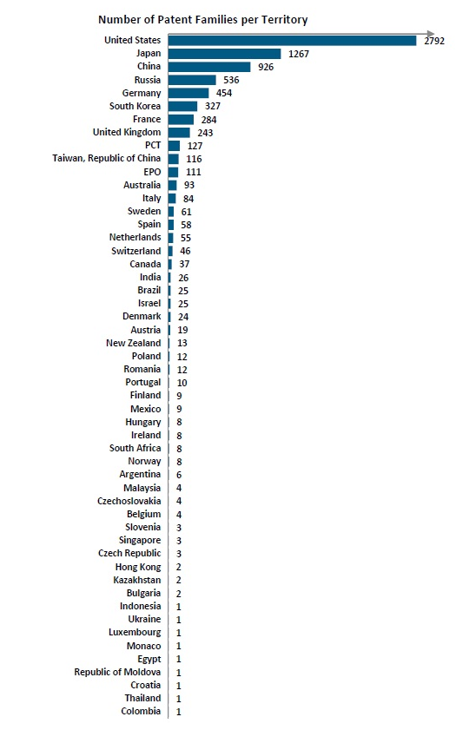
Figure 53 – Office of First Filing Locations of Tier 3 (Small) Portfolios
Raw data for Figure 53: United States: 2792, Japan: 1267, China: 926, Russia: 536, Germany: 454, South Korea: 327, France: 284, United Kingdom: 243, PCT: 127, Taiwan, Republic of china: 116, EPO: 111, Australia: 93, Italy : 84, Sweden: 61, Netherlands: 55, Switzerland: 46, Canada: 37, India: 26, Brazil: 25, Israel: 25, Denmark: 24, Austria: 19, New Zealand : 13, Poland: 12, Finland: 9, Mexico: 9, Hungary 8, Ireland: 8, South Africa: 8, Norway: 8, Argentina: 6, Malaysia 4, Czech Republic: 4,Hong Kong: 2, Indonesia: 1, Ukraine: 1, Luxembourg: 1, Monaco: 1, Egypt: 1, Republic of Moldova: 1, Croatia: 1, Thailand: 1 and Columba: 1.

5.2 ACADEMIC VERSUS CORPORATE PATENT ACTIVITY
A further model of the type of organization active in the landscape is to review the patent applicants and identify whether they are academic or government research institutions or corporations.
The figure below shows that just 8% of the activity in the landscape comes from academic or government entities, with just over 68% of the activity in the landscape originating from for-profit organizations.
The timeline view in Figure 52 shows however that academic patent activity is growing steadily, and on a normalized basis (comparing activity distribution), far more rapidly.
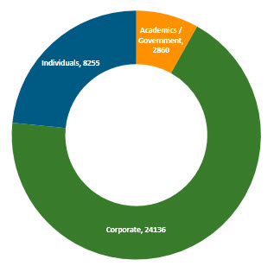
Figure 54 - Assessment of Patent Applicant Type and Distribution across the Assistive Devices and Technologies for Visually and Hearing Impaired Persons Landscape; Academic or Government Applicant Vs Corporate Applicant

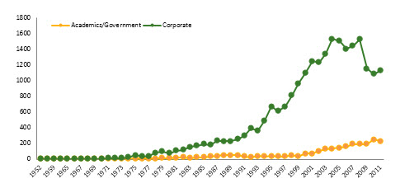
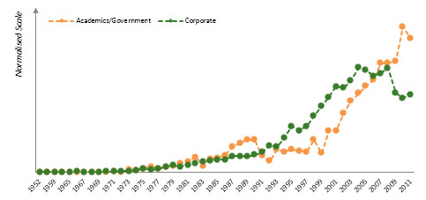
Figure 55 - Timeline of Assistive Devices and Technologies for Visually and Hearing Impaired Persons Landscape Patent Activity by Applicant Type, Academic or Government Applicant versus Corporate Applicant; Charts show both absolute numbers per earliest first filing year and activity trend on a normalized scale (% of total activity filed in any given year)
The growth rate in academic patent activity implies to tie to the high growth rates emanating from some BRICS countries including China and Russia, and this does appear to be the case. Figure 53 show that these jurisdictions have a larger proportion of activity in the academic & government patent landscape. Spain, Taiwan, Province of China and South Korea research institutions also contribute significantly to the academic patent innovation total in this technology field.
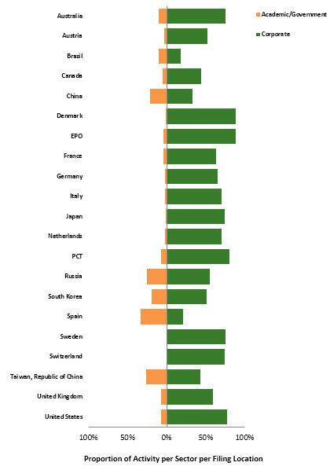
Figure 56 - Breakdown of Academic and Government or Corporate Activity by Office of First Filing Location; As % of Activity per Applicant Sector
Raw data for Figure 56 shown as Academic Government / Corporate: Australia: 10%/70%, Austria: 3%/52%, Brazil: 10%/18%, Canada: 5%/45%, China: 21%/33%, Denmark 1%/88%, EPO: 4%/89%, France: 4%/63%, Germany: 2%/66%, Italy: 2%/71%, Japan: 1%/74%, Netherlands: 2%/70%, PCT: 7%/80%, Russia: 25%/56%, South Korea: 20%/52%, Spain: 33%/21%, Sweden: 0%/76%, Switzerland: 0%/74%, Taiwan Republic of China: 27%/43%, United Kingdom: 7%/59%, United States: 7%/78%.
Figure 57 highlights the spread of academic or government research institutions or corporations by technology classification.
Generally, vision related applications appear to be favored and more heavily focused upon by academic and government entities with vision assistance, intraocular devices and general vision care all strong performers in this technical space. Corporate entities however dominate all aspects of this technology field.
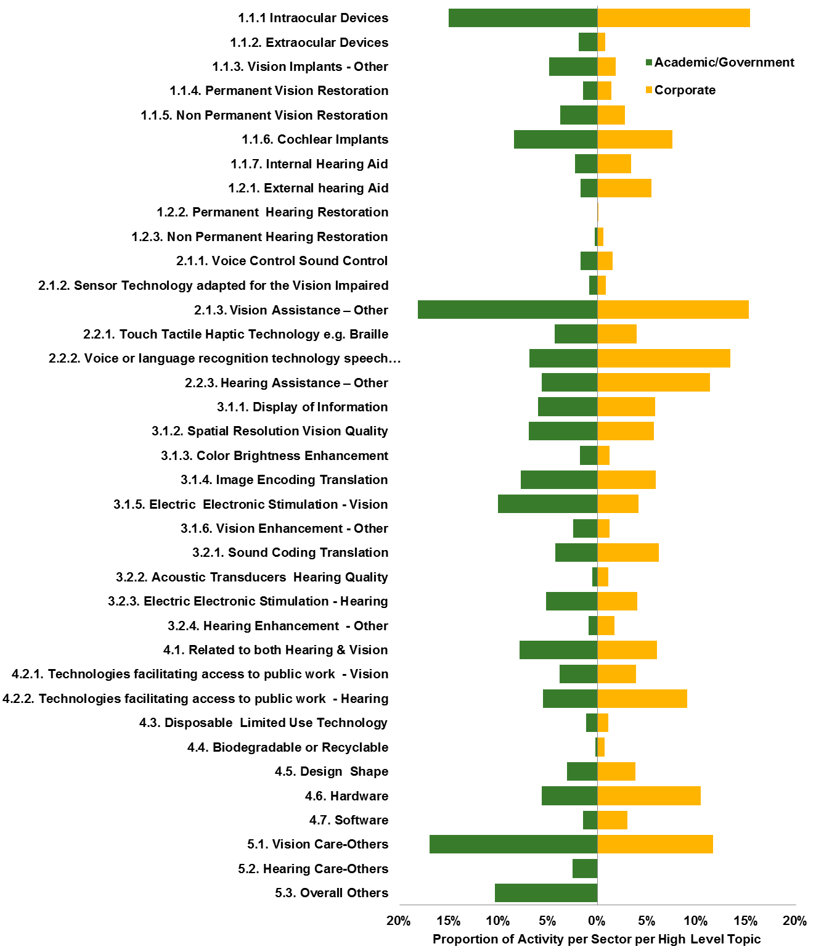
Figure 57 – Analysis of Recent Patent Activity Trends in the Assistive Devices and Technologies for Visually and Hearing Impaired Persons Landscape by Major Subject Matter.

5.3 MAJOR PATENT APPLICANTS
Reviewing the patent families in this subset reveals the following major patent entities. The figure below lists all the corporations with 100 or more patent families (tier 1) sorted by total inventions. Swiss multinational pharmaceutical company Novartis is revealed as the most active applicant at this scale of protection, followed closely followed by the Japanese multinational electronics corporation Panasonic. The next major entities in the list are covered by the German multinational engineering and electronics company Siemens, the American healthcare and products company Abbott Laboratories and finally Cochlear Limited, an Australian biotechnology company which designs, manufactures and supplies various implants
Table 15 – Tier 1 Patent Entities (Entity with 100 or more patent families)
Tier 1 Entity Ranking | Total Inventions
NOVARTIS | 575
PANASONIC | 545
SIEMENS | 540
ABBOTT | 518
COCHLEAR | 434
VALEANT | 419
NUANCE | 345
ADVANCED BIONICS | 341
EYE MICROSURGERY FEDOROV | 289
JHONSON & JOHNSON | 279
NEC | 271
RION | 256
IBM | 249
SONY | 238
NIDEK | 234
MICROSOFT | 231
NTT | 212
CANON | 205
TOSHIBA | 195
AT&T | 193
HITACHI | 191
CARL ZEISS | 182
SECOND SIGHT LLC | 181
PHONAK | 172
FUJITSU | 159
WIDEX A/S | 158
SEIKO EPSON | 151
MED-EL ELECTROMEDIZINISCHE GERAETE GMBH | 147
ALLERGAN | 146
MITSUBISHI | 146
MIKROKHIRURGIYA GLAZA SCI TECH COMPLEX | 145
ESSILOR | 137
MENICON | 125
SAMSUNG | 121
HOYA CORP | 119
TOYOTA | 114
PHILIPS | 106
MOSC EYE DISEASE | 100

The following table provides a timeline of patent activity for all large (tier 1) entities in the dataset.

Table 16 – Patent Activity for all large entities (tier1) in the Assistive Devices and Technologies for Visually and Hearing Impaired Persons Landscape
Tier 1 Entities | 80 | 81 | 82 | 83 | 84 | 85 | 86 | 87 | 88 | 89 | 90 | 91 | 92 | 93 | 94 | 95 | 96 | 97 | 98 | 99 | 0 | 01 | 02 | 03 | 04 | 05 | 06 | 07 | 08 | 09 | 10 | 11 | Total Inventions
NORVARTIS | - | 3 | 2 | - | 5 | 6 | 1 | 3 | 9 | 5 | 12 | 9 | 10 | 7 | 8 | 19 | 15 | 19 | 22 | 22 | 24 | 13 | 35 | 20 | 39 | 21 | 69 | 49 | 22 | 39 | 26 | 26 | 575
PANASONIC | 3 | 3 | - | 7 | 2 | 4 | 4 | 2 | 2 | - | 14 | 11 | 3 | 13 | 14 | 23 | 19 | 11 | 25 | 26 | 17 | 33 | 31 | 31 | 28 | 38 | 11 | 12 | 35 | 29 | 35 | 29 | 545
SIEMENS | 3 | 6 | 7 | 7 | 10 | 8 | 23 | 20 | 9 | 7 | 3 | 2 | 2 | 1 | 5 | 9 | 12 | 11 | 16 | 18 | 18 | 11 | 23 | 19 | 14 | 24 | 46 | 86 | 78 | 21 | 9 | 2 | 540
ABBOTT | - | 3 | 2 | 5 | 7 | 6 | 6 | 29 | 12 | 5 | 4 | 10 | 15 | 14 | 11 | 7 | 8 | 9 | 24 | 20 | 18 | 27 | 47 | 32 | 31 | 18 | 31 | 25 | 34 | 19 | 15 | 11 | 518
COCHLEAR | - | 1 | 1 | 1 | - | - | 2 | 4 | 4 | 3 | 1 | 2 | 3 | 2 | 3 | 11 | 4 | 4 | 10 | 12 | 29 | 24 | 19 | 39 | 23 | 28 | 10 | 39 | 70 | 28 | 18 | 32 | 434
VALEANT | - | - | - | - | 1 | 5 | - | 2 | 1 | 5 | 4 | 4 | 5 | - | 3 | 3 | 7 | 7 | 11 | 21 | 29 | 23 | 29 | 48 | 33 | 38 | 45 | 40 | 25 | 15 | 9 | 2 | 419
NUANCE | - | - | 2 | - | - | - | - | - | - | - | - | - | 1 | 2 | - | 2 | 3 | 4 | 13 | 32 | 13 | 29 | 14 | 29 | 34 | 37 | 31 | 27 | 17 | 10 | 14 | 16 | 345
ADVANCED BIONICS | - | - | - | - | - | - | - | - | - | 1 | - | - | - | - | 1 | 4 | 3 | 3 | 22 | 7 | 17 | 33 | 37 | 20 | 25 | 20 | 17 | 8 | 21 | 22 | 42 | 24 | 341
EYE MICROSURGERY FEDOROV | - | - | - | - | - | - | - | - | 1 | - | - | - | - | - | - | - | - | - | - | - | - | - | - | - | 2 | 41 | 55 | 37 | 58 | 33 | 31 | 31 | 289
J&J | - | - | - | - | - | - | - | - | - | - | 1 | 1 | 9 | 5 | 4 | 12 | 3 | 3 | 14 | 15 | 13 | 10 | 9 | 11 | 17 | 22 | 21 | 20 | 20 | 11 | 20 | 15 | 279
NEC | 1 | - | - | - | 1 | 2 | - | - | - | - | 5 | 7 | 1 | 5 | 11 | 21 | 16 | 12 | 12 | 14 | 13 | 10 | 14 | 12 | 14 | 14 | 16 | 12 | 14 | 9 | 13 | 14 | 271
RION | - | 16 | 2 | 8 | 7 | 12 | - | 6 | 3 | 2 | 5 | 8 | 3 | 10 | 16 | 27 | 6 | 8 | 12 | 10 | 3 | 3 | 5 | 6 | 9 | 9 | 12 | 11 | 13 | 6 | 3 | 6 | 256
IBM | - | - | - | - | 1 | - | - | 1 | 1 | 1 | - | 7 | 7 | 1 | 2 | 5 | 2 | 7 | 10 | 12 | 13 | 34 | 9 | 16 | 15 | 18 | 17 | 12 | 19 | 18 | 2 | 7 | 249
SONY | 2 | 1 | 1 | 1 | - | - | 1 | 5 | - | - | 3 | 5 | 6 | 9 | 12 | 14 | 10 | 10 | 12 | 15 | 13 | 4 | 6 | 16 | 9 | 14 | 3 | 9 | 12 | 9 | 13 | 12 | 238
NIDEK | - | - | - | - | - | - | - | - | - | - | 2 | 2 | 4 | 2 | 6 | 7 | 8 | 5 | 7 | 8 | 8 | 16 | 25 | 15 | 16 | 14 | 11 | 18 | 14 | 14 | 16 | 13 | 234
MICROSOFT | - | - | - | - | - | - | - | - | - | - | - | - | - | - | 1 | 5 | 4 | 3 | 5 | 10 | 8 | 10 | 13 | 18 | 25 | 25 | 19 | 17 | 15 | 15 | 12 | 18 | 231
NTT | - | - | - | - | - | - | - | - | - | - | 2 | 1 | - | 3 | 8 | 12 | 8 | 6 | 6 | 7 | 6 | 7 | 9 | 16 | 18 | 19 | 9 | 17 | 15 | 10 | 11 | 12 | 212
CANON | 1 | 1 | 1 | 1 | 2 | 3 | 4 | 3 | 3 | 2 | 1 | 3 | 1 | 12 | 8 | 1 | 2 | 8 | 5 | 6 | 11 | 12 | 14 | 21 | 19 | 20 | 12 | 9 | 12 | 5 | 2 |  | 205
TOSHIBA | 1 | - | - | - | - | - | 1 | 3 | 1 | - | 1 | 1 | 3 | 5 | 6 | 10 | 11 | 6 | 3 | 10 | 4 | 12 | 9 | 7 | 9 | 8 | 12 | 15 | 18 | 11 | 9 | 11 | 195
AT&T | - | 1 | - | - | - | - | - | - | - | 1 | - | - | 1 | 1 | 1 | 3 | 1 | 3 | 5 | 10 | 12 | 18 | 14 | 11 | 28 | 23 | 11 | 6 | 18 | 11 | 8 | 6 | 193
HITACHI | 2 | 1 | 2 | 1 | 3 | - | - | 1 | 2 | 3 | 1 | 1 | 14 | 14 | 19 | 22 | 13 | 1 | 10 | 9 | 8 | 11 | 7 | 5 | 11 | 7 | 3 | 1 | 7 | 3 | 1 | 4 | 191
CARL ZEISS | - | - | - | 2 | 1 | 1 | - | - | 2 | - | - | 2 | 1 | 2 | 2 | 3 | 3 | 4 | 3 | 11 | 2 | 6 | 4 | 15 | 7 | 12 | 23 | 17 | 15 | 14 | 10 | 15 | 182
SECOND SIGHT LLC | - | - | - | - | - | - | - | - | - | - | - | - | - | - | - | - | - | - | - | 9 | 2 | 14 | 23 | 6 | 16 | 28 | 34 | 25 | 10 | 1 | 9 | 4 | 181
PHONAK | - | - | - | - | 1 | 1 | 2 | - | 1 | 1 | - | 1 | - | - | 1 | - | 5 | 5 | 6 | 18 | 25 | 17 | 5 | 9 | 9 | 6 | 21 | 17 | 6 | 5 | 2 | 1 | 172
FUJITSU | - | - | - | - | 2 | 1 | - | - | - | - | 4 | 2 | 3 | 11 | 7 | 10 | 9 | 8 | 3 | 4 | 3 | 6 | 8 | 6 | 5 | 5 | 11 | 16 | 10 | 11 | 5 | 7 | 159
WIDEX A/S | - | - | - | - | - | - | - | - | 1 | - | - | - | - | - | - | - | 1 | 2 | 4 | 4 | 8 | 10 | 2 | 12 | 7 | 29 | 19 | 18 | 9 | 17 | 13 | 2 | 158
SEIKO EPSON | - | - | - | - | - | - | - | 3 | 4 | 2 |  | 2 | 4 | 1 | - | 3 | 1 | 2 | 4 | 1 | 5 | 4 | 8 | 9 | 30 | 28 | 5 | 3 | 2 | 4 | 5 | 5 | 151
MED-EL ELECTROMEDIZINISCHE GERAETE GMBH | - | 1 | - | 1 | - | 1 | - | - | - | - | - | - | - | - | - | - | 4 | 5 | 3 | 8 | 2 | 2 | 6 | 6 | 6 | 1 | 11 | 16 | 18 | 18 | 17 | 16 | 147
ALLERGAN | - | - | - | 1 | 1 | - | 1 | - | 1 | 1 | - | 3 | 5 | 2 | - | 3 | 1 | 2 |  | 2 | 5 | 2 | 3 | 10 | 54 | 7 | 13 | 4 | 4 | 5 | 5 | 2 | 146
MITSUBISHI | - | - | - | - | 1 | - | - | - | 3 | - | - | 1 | - | 2 | 9 | 3 | 4 | 5 | 2 | 6 | 7 | 11 | 12 | 5 | 5 | 18 | 11 | 6 | 12 | 8 | 4 | 5 | 146
MIKROKHIRURGIYA GLAZA SCI TECH COMPLEX | - | - | - | - | - | - | - | - | 1 | - | 2 | 1 | 1 | - | - | - | 2 | 2 | 11 | 12 | 20 | 38 | 22 | 30 | 2 | - | - | - | - | - | 1 | - | 145
ESSILOR | - | - | 1 | - | - | - | - | 2 | 4 | 5 | 2 | 4 | - | - | - | 3 | 1 | 4 | 4 | 5 | 7 | 5 | 3 | 13 | 12 | 9 | 15 | 9 | 4 | 9 | 6 | 9 | 137
MENICON | - | - | - | - | - | - | 2 | 1 | 5 | 4 | 5 | 3 | 3 | 6 | 4 | 10 | 2 | 6 | 15 | 4 | 6 | 11 | 11 | 3 | 2 | 2 | 3 | 6 | - | 1 | 1 | 3 | 125
SAMSUNG | - | - | - | - |  | - | - | - | - | 1 | - | 1 | - | - | 1 | 2 | 5 | 5 | 1 | 3 | 2 | 2 | 3 | 4 | 16 | 12 | 13 | 14 | 4 | 10 | 4 | 10 | 121
HOYA CORP | - | - | - | - | - | - | 1 | 2 | 1 | 3 | 1 | 2 | 2 | 3 | 2 | 6 | 5 | 3 | 4 | 2 | - | 3 | 2 | 4 | 8 | 6 | 7 | 7 | 8 | 11 | 6 | 11 | 119
TOYOTA | - | - | - | - | - | - | - | - | - | - | - | 1 | - | 1 | 1 | - | 7 | - | 3 | 7 | 3 | 3 | 8 | 7 | 6 | 16 | 12 | 3 | 11 | 6 | 6 | 9 | 114
PHILIPS | 1 | 1 | 1 | - | 1 | - | - | 1 | 3 | 1 | - | 5 | 3 | 1 | 3 | - | - | 4 | 4 | 3 | 5 | 9 | 8 | 10 | 4 | 10 | 6 | 3 | 8 | 4 | 2 | - | 106
MOSC EYE DISEASE | 2 | 1 | 1 | - | 2 | - | 2 | 4 | 1 | 3 | 7 | 11 | 1 | 1 | 4 | 3 | 2 | 4 | 4 | 8 | 7 | 5 | 3 | 6 | 3 | 1 | 1 | - | - | - | 1 | - | 100

The following table provides a breakdown of the high level topics of interest to these listed corporations, as measured as a proportion of their complete vision and hearing impaired device portfolios.
Table 17 - Breakdown of Major Subject Matter of Entities as a number of all Patent Families per Portfolio in the assistive devices and technologies for Assistive Devices and Technologies for Visually and Hearing Impaired Persons Landscape
This table has been divided into two parts.
High Level Topics | NORVARTIS | PANASONIC | SIEMENS | ABBOTT | COCHLEAR | VALEANT | NUANCE | ADVANCED BIONICS | EYE MICROSURGERY FEDOROV | J&J | NEC | RION | IBM | SONY | NIDEK | MICROSOFT | NTT | CANON | TOSHIBA | AT&T
1.1 Vision Restoration | 333 | 41 | 69 | 355 | 408 | 276 | 1 | 309 | 102 | 144 | 4 | 17 | 4 | 14 | 112 | 4 | 7 | 38 | 7
1.2 Hearing Restoration | 1 | 80 | 157 |  | 106 |  | 1 | 71 |  | 1 | 4 | 126 | 1 | 23 |  |  | 3 | 1 | 1
2.1 Vision Assistance | 24 | 107 | 29 | 58 | 1 | 10 | 15 | 3 | 5 | 8 | 96 | 2 | 83 | 31 | 80 | 25 | 39 | 58 | 42 | 9
2.2 Hearing Assistance | 6 | 239 | 359 | 6 | 125 | 6 | 192 | 80 | 5 | 7 | 149 | 134 | 107 | 116 | 1 | 110 | 145 | 81 | 108 | 78
3.1 Vision Enhancement | 58 | 45 | 18 | 99 | 3 | 19 | 30 | 2 | 44 | 49 | 60 |  | 88 | 25 | 94 | 27 | 21 | 45 | 22 | 13
3.2 Hearing Enhancement | 1 | 135 | 114 |  | 254 | 1 | 19 | 238 |  | 4 | 31 | 51 | 15 | 39 | 3 | 22 | 27 | 9 | 17 | 15
4 Additional Related Technology | 64 | 196 | 249 | 53 | 196 | 45 | 227 | 138 | 11 | 31 | 95 | 73 | 161 | 118 | 19 | 165 | 75 | 75 | 63 | 149

High Level Topics | HITACHI | CARL ZEISS | SECOND SIGHT LLC | PHONAK | FUJITSU | WIDEX A/S | SEIKO EPSON | MED-EL ELECTROMEDIZINISCHE GERAETE GMBH | ALLERGAN | MITSUBISHI | MIKROKHIRURGIYA GLAZA SCI TECH COMPLEX | ESSILOR | MENICON | SAMSUNG | HOYA CORP | TOYOTA | PHILIPS | MOSC EYE DISEASE
1.1 Vision Restoration | 8 | 59 | 97 | 44 | 3 | 20 | 8 | 135 | 117 | 1 | 26 | 43 | 89 | 1 | 72 | 1 | 14 | 20
1.2 Hearing Restoration | 10 |  |  | 49 | 2 | 59 | 2 | 25 |  |  |  |  |  | 3 |  |  | 10
2.1 Vision Assistance | 71 | 16 | 8 | 4 | 37 |  | 53 | 1 | 5 | 34 | 1 | 6 | 5 | 23 | 2 | 10 | 20 | 5
2.2 Hearing Assistance | 73 | 1 | 7 | 90 | 96 | 80 | 75 | 34 |  | 93 | 1 | 2 |  | 66 | 2 | 86 | 52 | 1
3.1 Vision Enhancement | 29 | 28 | 162 | 2 | 20 |  | 30 | 5 | 7 | 17 | 30 | 19 | 9 | 15 | 8 | 9 | 20 | 18
3.2 Hearing Enhancement | 25 |  | 31 | 55 | 16 | 62 | 8 | 102 |  | 5 |  |  |  | 10 |  | 8 | 11 | 1
4 Additional Related Technology | 66 | 27 | 75 | 127 | 58 | 91 | 29 | 70 | 10 | 37 | 6 | 13 | 4 | 47 | 5 | 24 | 42 | 4

Table 18 - Breakdown of Major Subject Matter of Entities as a % of all Patent Families per Portfolio in the Assistive Devices and Technologies for Visually and Hearing Impaired Persons landscape
This table has been divided into two parts.
High Level Topics | NORVARTIS | PANASONIC | SIEMENS | ABBOTT | COCHLEAR | VALEANT | NUANCE | ADVANCED BIONICS | EYE MICROSURGERY FEDOROV | J&J | NEC | RION | IBM | SONY | NIDEK | MICROSOFT | NTT | CANON | TOSHIBA
1.1 Vision Restoration | 58% | 8% | 13% | 69% | 94% | 66% | 0% | 91% | 35% | 52% | 1% | 7% | 2% | 6% | 48% | 2% | 3% | 19% | 4%
1.2 Hearing Restoration | 0% | 15% | 29% | 0% | 24% | 0% | 0% | 21% | 0% | 0% | 1% | 49% | 0% | 10% | 0% | 0% | 1% | 0% | 1%
2.1 Vision Assistance | 4% | 20% | 5% | 11% | 0% | 2% | 4% | 1% | 2% | 3% | 35% | 1% | 33% | 13% | 34% | 11% | 18% | 28% | 22%
2.2 Hearing Assistance | 1% | 44% | 66% | 1% | 29% | 1% | 56% | 23% | 2% | 3% | 55% | 52% | 43% | 49% | 0% | 48% | 68% | 40% | 55%
3.1 Vision Enhancement | 10% | 8% | 3% | 19% | 1% | 5% | 9% | 1% | 15% | 18% | 22% | 0% | 35% | 11% | 40% | 12% | 10% | 22% | 11%
3.2 Hearing Enhancement | 0% | 25% | 21% | 0% | 59% | 0% | 6% | 70% | 0% | 1% | 11% | 20% | 6% | 16% | 1% | 10% | 13% | 4% | 9%
4 Additional Related Technology | 11% | 36% | 46% | 10% | 45% | 11% | 66% | 40% | 4% | 11% | 35% | 29% | 65% | 50% | 8% | 71% | 35% | 37% | 32%

High Level Topics | AT&T | HITACHI | CARL ZEISS | SECOND SIGHT LLC | PHONAK | FUJITSU | WIDEX A/S | SEIKO EPSON | MED-EL ELECTROMEDIZINISCHE GERAETE GMBH | ALLERGAN | MITSUBISHI | MIKROKHIRURGIYA GLAZA SCI TECH COMPLEX | ESSILOR | MENICON | SAMSUNG | HOYA CORP | TOYOTA | PHILIPS | MOSC EYE DISEASE
1.1 Vision Restoration | 0% | 4% | 32% | 54% | 26% | 2% | 13% | 5% | 92% | 80% | 1% | 18% | 31% | 71% | 1% | 61% | 1% | 13% | 20%
1.2 Hearing Restoration | 0% | 5% | 0% | 0% | 28% | 1% | 37% | 1% | 17% | 0% | 0% | 0% | 0% | 0% | 2% | 0% | 0% | 9% | 0%
2.1 Vision Assistance | 5% | 37% | 9% | 4% | 2% | 23% | 0% | 35% | 1% | 3% | 23% | 1% | 4% | 4% | 19% | 2% | 9% | 19% | 5%
2.2 Hearing Assistance | 40% | 38% | 1% | 4% | 52% | 60% | 51% | 50% | 23% | 0% | 64% | 1% | 1% | 0% | 55% | 2% | 75% | 49% | 1%
3.1 Vision Enhancement | 7% | 15% | 15% | 90% | 1% | 13% | 0% | 20% | 3% | 5% | 12% | 21% | 14% | 7% | 12% | 7% | 8% | 19% | 18%
3.2 Hearing Enhancement | 8% | 13% | 0% | 17% | 32% | 10% | 39% | 5% | 69% | 0% | 3% | 0% | 0% | 0% | 8% | 0% | 7% | 10% | 1%
4 Additional Related Technology | 77% | 35% | 15% | 41% | 74% | 36% | 58% | 19% | 48% | 7% | 25% | 4% | 9% | 3% | 39% | 4% | 21% | 40% | 4%

In terms of vision, from this analysis we can see that Cochlear (94%), Austrian biotechnology company Med-El Electromedizinische Geraete GmbH (92%) and the American technology device company Advanced Bionics (91%) and have a strong specialization and commercial interest in Vision Restoration, with a high proportion of their portfolio’s directed to this technology. American medical product company Second Sight LLC has as high commercial interest in Vision Enhancement with 90% of its portfolio directed to this technology.
In relation to hearing technology, there are more entities that appear to share this landscape with a much larger amount of tier 1 entities having relatively large amounts of their portfolio’s directed toward hearing related technology. Some stand out companies include, the Japanese medical devices company Rion in the hearing restoration technology field, Japanese telecommunications company NTT (Nippon Telegraph and Telephone) in relation to hearing assistance and Advanced Bionics (70%) in relation to hearing enhancement.
Interestingly, it appears that a great deal of tier 1 (similar trends are observed across the dataset as a whole) entities have a significant number of their patent innovation directed to both vision and hearing device applications as shown by their high patent numbers indicated in both the vision and hearing aspects of this technology.

5.4 MAJOR PATENT APPLICANTS BY PORTFOLIO STRENGTH
Strength analysis is performed in order to determine the quality and influence of IP in terms of a particular patent or patent portfolio of an entity. Quality and influence in patent portfolios are measured based on the following metrics.
- Volume (number of inventions held)
- Remaining life (the remaining patent term)
- Geographic filing breadth as a measure of intent to commercialize (in particular quadlateral filings in the US, EP, CN and JP)
- Grant success
- High technical breadth as an indicator of fundamental innovations
- Citation frequency statistics as a measure of impact in the field (older patents in a portfolio have more opportunity to be cited, so the statistic is adjusted to correct for patent age)
An overall strength score can be calculated based on these aggregated measurements. The strength score is a unit-less value that allows individual inventions or entire patent portfolios to be ranked relative to one another.
Table 19 lists all the above motioned metrics for the top entities in the dataset (tier 1). A strength score for each portfolio has also been ascertained.

Table 19 – Tier 1 Entities Patent Portfolio Strength Score
Tier 1 Entity Ranking | Total Inventions | Average Remaining Life | Quad Filings | Novelty based on Grants | Age Weighted Citation Impact | Thomson Reuters IP Analytics Strength Index
JHONSON & JOHNSON | 279 | 10.3 | 149 | 166 | 2.4 | 8.7
ALLERGAN | 146 | 8.7 | 20 | 89 | 2.6 | 8.2
ABBOTT | 518 | 7.4 | 33 | 403 | 2.3 | 8.2
NOVARTIS | 575 | 9.1 | 153 | 422 | 1.7 | 6.9
VALEANT | 419 | 9.4 | 139 | 257 | 1.5 | 6.1
PHONAK | 172 | 8.3 | 13 | 132 | 1.6 | 5.8
MICROSOFT | 231 | 11.2 | 38 | 160 | 1.8 | 5.8
ESSILOR | 137 | 9.4 | 29 | 99 | 1.3 | 5.7
MED-EL ELECTROMEDIZINISCHE GERAETE GMBH | 147 | 12.0 | 16 | 96 | 1.3 | 5.4
ADVANCED BIONICS | 341 | 11.1 |  | 234 | 1.5 | 5.4
COCHLEAR | 434 | 10.6 | 4 | 262 | 1.5 | 5.4
WIDEX A/S | 158 | 11.4 | 23 | 141 | 1.3 | 5.3
PHILIPS | 106 | 7.4 | 45 | 60 | 1.2 | 5.2
IBM | 249 | 9.3 | 4 | 169 | 1.3 | 4.9
NUANCE | 345 | 10.4 | 18 | 254 | 1.5 | 4.9
CARL ZEISS | 182 | 10.7 | 21 | 108 | 1.2 | 4.6
SIEMENS | 540 | 8.5 | 43 | 377 | 0.9 | 4.3
AT&T | 193 | 10.0 | 3 | 137 | 1.0 | 4.1
HOYA CORP | 119 | 10.0 | 20 | 61 | 0.9 | 3.9
SECOND SIGHT LLC | 181 | 11.0 |  | 122 | 1.0 | 3.8
SONY | 238 | 7.1 | 13 | 100 | 0.8 | 3.4
NIDEK | 234 | 9.7 | 3 | 153 | 0.7 | 3.4
MENICON | 125 | 5.6 | 4 | 67 | 0.7 | 3.2
SAMSUNG | 121 | 11.4 | 4 | 66 | 0.6 | 3.0
CANON | 205 | 7.5 | 11 | 88 | 0.5 | 2.7
EYE MICROSURGERY FEDOROV | 289 | 13.9 |  | 287 | 0.0 | 2.5
MITSUBISHI | 146 | 9.3 | 9 | 61 | 0.4 | 2.5
HITACHI | 191 | 4.8 |  | 53 | 0.5 | 2.5
TOSHIBA | 195 | 9.3 | 2 | 61 | 0.5 | 2.4
PANASONIC | 545 | 8.1 | 42 | 182 | 0.4 | 2.3
NTT | 212 | 9.9 | 6 | 107 | 0.3 | 2.3
NEC | 271 | 8.0 | 3 | 95 | 0.4 | 2.3
TOYOTA | 114 | 10.8 | 3 | 36 | 0.3 | 2.2
FUJITSU | 159 | 8.0 | 2 | 66 | 0.3 | 2.2
SEIKO EPSON | 151 | 8.4 | 8 | 42 | 0.3 | 2.0
RION | 256 | 5.1 | 1 | 119 | 0.3 | 1.9
MIKROKHIRURGIYA GLAZA SCI TECH COMPLEX | 145 | 7.1 |  | 142 | 0.0 | 1.9
MOSC EYE DISEASE | 100 | 3.1 |  | 70 | 0.0 | 1.2

Johnson & Johnson is revealed to have the highest patent portfolio strength score (8.7) among the top entities. Contributing to this strength score is their high rate of quadlateral filings (149) for their large patent portfolio, the high citation frequency (2.4) and their portfolio’s fairly high average remaining patent life (10.3 years).
Johnson & Johnson have a large section of their patent portfolio directed toward vision restoration (specifically intraocular device technology) and vision enhancement technology. It is reasonable to suggest that the level of investment in this technology by Johnson & Johnson is high given their high strength score. It is also reasonable to assume that they are leaders in this technology innovation field, specifically in vision restoration technology.
In contrast, the Moscow Eye Disease Research Institute (Mosc Eye Disease) has ascertained the lowest strength score (1.2) of all the top entities in the dataset. From a relatively large patent portfolio, no quadlateral patent filings have been observed. Russian entities in general have been observed to only file patents locally; Moscow Eye Disease appears to follow this trend. There is no perceived impact in the field represented by a zero value for the citation frequency and the portfolio on the whole has a very low average remaining patent life remaining. Similarly with Johnson & Johnson, the Moscow Eye Disease Research Institute’s patent innovation is directed toward vision restoration technology, specifically intraocular devices, however unlike Johnson & Johnsons innovation in this technology area, the Moscow Eye Disease Research Institute’s innovation has had virtually no impact in this technology field globally.

5.5 MAJOR PATENT APPLICANTS BY REGION
Tables 20, 21 and 22 list the top patenting entities in each geographic region (Asia Pacific, Europe Middle East and Africa, Americas), and list the total number of patent families registered, the location of the organizations headquarters, giving a description of the entity’s primary industry.
These tables are included for reference purposes to aid identification of patent applicants of specific interest to the reader.
Table 20 - Major Patent Applicants filing in Asia Pacific; Based on Office of First Filing Locations
Entity | Total Inventions | HQ | Industry
PANASONIC | 485 | Japan | Electronics, Semiconductors, Home appliances
NEC | 261 | Japan | Information technology, Electronics
RION | 256 | Japan | Hearing instruments
NIDEK | 227 | Japan | Medical Devices
NTT | 211 | Japan | Telecommunications
CANON | 195 | Japan | Electronics
HITACHI | 186 | Japan | Conglomerate
TOSHIBA | 185 | Japan | Conglomerate
SONY | 180 | Japan | Conglomerate
COCHLEAR | 173 | Australia | Biotechnology
FUJITSU | 152 | Japan | Computer hardware, Computer software, IT services, IT consulting
SEIKO EPSON | 149 | Japan | Electronics
MITSUBISHI | 123 | Japan | Electrical equipment, Electronics
MENICON | 117 | Japan | Eye Lens Manufacturers
SAMSUNG | 114 | South Korea | Conglomerate
TOYOTA | 112 | Japan | Automotive
HOYA CORP | 108 | Japan | Optical products
RICOH | 85 | Japan | Digital imaging, Photography, Electronics
YAMAHA | 83 | Japan | Conglomerate
WIDEX A/S | 80 | Denmark | Health care

Table 21 - Major Patent Applicants filing in the Americas; Based on Office of First Filing Location
Entity | Total Inventions | HQ | Industry
NORVARTIS | 517 | Switzerland | Pharmaceuticals
ABBOTT | 491 | United States | Pharmaceuticals
VALEANT | 391 | Canada | Pharmaceuticals
ADVANCED BIONICS | 311 | Switzerland | Medical Devices
J&J | 268 | United States | Medical equipment, Pharmaceutical
NUANCE | 263 | United States | Productivity applications
MICROSOFT | 227 | United States | Computer software, Computer hardware
COCHLEAR | 207 | Australia | Biotechnology
IBM | 204 | United States | Computer hardware, Computer software, IT services, IT consulting
AT&T | 191 | United States | Telecommunications
SECOND SIGHT LLC | 177 | United States | Medical Devices
ALLERGAN | 142 | United States | Pharmaceuticals
MEDTRONIC | 91 | United States | Medical Devices
GOOGLE | 81 | United States | Internet  Computer software  Telecoms equipment
PHONAK | 73 | Switzerland | Hearing instruments
BOSTON SCIENTIFIC CORPORATION. | 72 | United States | Medical Devices
SIEMENS | 68 | Germany | Conglomerate
STARKEY JAPAN CO LTD | 59 | Japan | Hearing instruments
MOTOROLA | 55 | United States | Telecommunications
STAAR SURGICAL CO INC | 55 | United States | Eye Lens Manufacturers

Table 22 - Major Patent Applicants filing in Europe, Middle East and Africa (EMEA); Based on Office of First Filing Locations
Entity | Total Inventions | HQ | Industry
SIEMENS | 461 | Germany | Conglomerate
CARL ZEISS | 149 | Germany | Optical products
ESSILOR | 93 | France | Optical products
PHILIPS | 87 | Netherlands | Electronics
OTICON | 60 | Denmark | Hearing instruments
NUANCE | 55 | United States | Productivity applications
ROBERT BOSCH | 53 | Germany | Automotive components
GN RESOUND A/S | 52 | Denmark | Hearing instruments
PHONAK | 51 | Switzerland | Hearing instruments
NORVARTIS | 42 | Switzerland | Pharmaceuticals
COCHLEAR | 35 | Australia | Biotechnology
WAVELIGHT AG | 31 | Germany | Medical Devices
WIDEX A/S | 29 | Denmark | Health care
ABBOTT | 27 | United States | Pharmaceuticals
FRANCE TELECOM | 24 | France | Telecommunications
IBM | 21 | United States | Computer hardware, Computer software, IT services, IT consulting
VALEANT | 20 | Canada | Pharmaceuticals
GEUDER AG | 20 | Germany | Optical products
CERBOMED GMBH | 20 | Germany | Medical Devices
IOLTECH | 19 | France | Optical products

5.6 SUMMARY OF MAJOR PORTFOLIO CHARACTERISTICS
Table 23 shows the major portfolios from the three major regions into which the landscape has been divided, and details the type of patent filing strategy each applicant has undertaken, as well as providing an indicator of the impact their inventions have had on downstream activity. Applicants for each region have been sorted by total number of inventions
This last metric is provided through the use of patent citation statistic – i.e. the number of occasions a particular patent family has been referenced by downstream patent applications – either through the patent examination procedure or through applicants putting forward relevant prior art. Applicants highlighted in blue indicate that they have a presence in two or more regions.
Table 23 - Assessment of the Vision and Hearing Impaired Device Patent Portfolio Characteristics of Major Asia Pacific, EMEA and Americas Patent Applicants
Region | Entity | Total Inventions | Filing Breadth | Times Cited | Citations per Invention
Asia Pacific | PANASONIC | 485 | 1.4 | 2001 | 4.1
Asia Pacific | NEC | 261 | 1.4 | 1437 | 5.5
Asia Pacific | RION | 256 | 1.2 | 1257 | 4.9
Asia Pacific | NIDEK | 227 | 1.9 | 2034 | 9.0
Asia Pacific | NTT | 211 | 1.2 | 799 | 3.8
Asia Pacific | CANON | 195 | 1.6 | 1247 | 6.4
Asia Pacific | HITACHI | 186 | 1.3 | 1578 | 8.5
Asia Pacific | TOSHIBA | 185 | 1.5 | 989 | 5.3
Asia Pacific | SONY | 180 | 1.7 | 1839 | 10.2
Asia Pacific | COCHLEAR | 173 | 2.2 | 3448 | 19.9
Asia Pacific | FUJITSU | 152 | 1.4 | 663 | 4.4
Asia Pacific | SEIKO EPSON | 149 | 1.6 | 510 | 3.4
Asia Pacific | MITSUBISHI | 123 | 1.5 | 519 | 4.2
Asia Pacific | MENICON | 117 | 1.9 | 1324 | 11.3
Asia Pacific | SAMSUNG | 114 | 2.4 | 654 | 5.7
Asia Pacific | TOYOTA | 112 | 1.3 | 389 | 3.5
Asia Pacific | HOYA CORP | 108 | 2.5 | 1098 | 10.2
Asia Pacific | RICOH | 85 | 1.1 | 343 | 4.0
Asia Pacific | YAMAHA | 83 | 1.4 | 326 | 3.9
Asia Pacific | WIDEX A/S | 80 | 6.5 | 686 | 8.6
Americas | NORVARTIS | 517 | 5.7 | 11722 | 22.7
Americas | ABBOTT | 491 | 3.2 | 18298 | 37.3
Americas | VALEANT | 391 | 4.0 | 8499 | 21.7
Americas | ADVANCED BIONICS | 311 | 1.4 | 7067 | 22.7
Americas | J&J | 268 | 7.7 | 8934 | 33.3
Americas | NUANCE | 263 | 1.5 | 4715 | 17.9
Americas | MICROSOFT | 227 | 2.3 | 4753 | 20.9
Americas | COCHLEAR | 207 | 1.8 | 2766 | 13.4
Americas | IBM | 204 | 1.4 | 3874 | 19.0
Americas | AT&T | 191 | 1.3 | 2446 | 12.8
Americas | SECOND SIGHT LLC | 177 | 1.5 | 1967 | 11.1
Americas | ALLERGAN | 142 | 3.5 | 5407 | 38.1
Americas | MEDTRONIC | 91 | 2.2 | 7975 | 87.6
Americas | GOOGLE | 81 | 1.6 | 971 | 12.0
Americas | PHONAK | 73 | 2.6 | 1312 | 18.0
Americas | BOSTON SCIENTIFIC CORPORATION. | 72 | 1.8 | 3609 | 50.1
Americas | SIEMENS | 68 | 3.0 | 1400 | 20.6
Americas | STARKEY JAPAN CO LTD | 59 | 2.2 | 806 | 13.7
Americas | MOTOROLA | 55 | 2.4 | 1228 | 22.3
Americas | STAAR SURGICAL CO INC | 55 | 4.1 | 3565 | 64.8
EMEA | SIEMENS | 461 | 2.8 | 6134 | 13.3
EMEA | CARL ZEISS | 149 | 3.0 | 1577 | 10.6
EMEA | ESSILOR | 93 | 4.9 | 1509 | 16.2
EMEA | PHILIPS | 87 | 4.2 | 1528 | 17.6
EMEA | OTICON | 60 | 3.1 | 673 | 11.2
EMEA | NUANCE | 55 | 3.4 | 731 | 13.3
EMEA | ROBERT BOSCH | 53 | 1.7 | 452 | 8.5
EMEA | GN RESOUND A/S | 52 | 3.9 | 870 | 16.7
EMEA | PHONAK | 51 | 3.0 | 1602 | 31.4
EMEA | NORVARTIS | 42 | 7.5 | 1964 | 46.8
EMEA | COCHLEAR | 35 | 4.1 | 2026 | 57.9
EMEA | WAVELIGHT AG | 31 | 4.3 | 291 | 9.4
EMEA | WIDEX A/S | 29 | 5.6 | 912 | 31.4
EMEA | ABBOTT | 27 | 7.2 | 1229 | 45.5
EMEA | FRANCE TELECOM | 24 | 2.0 | 60 | 2.5
EMEA | IBM | 21 | 2.4 | 459 | 21.9
EMEA | VALEANT | 20 | 7.1 | 733 | 36.7
EMEA | GEUDER AG | 20 | 1.5 | 56 | 2.8
EMEA | CERBOMED GMBH | 20 | 3.6 | 220 | 11.0
EMEA | IOLTECH | 19 | 4.7 | 206 | 10.8

Patent citation is a common tool for assessing impact, as inventions which gather many such citations are highly likely to be influencing further innovation within the space. In this case, citation statistics are aggregated across the portfolios to provide an overall view of the impact of the inventions associated with each applicant.
Two entities that can be singled out in the table as having high citation impact rates – American medical device company Medtronic and the American Staar Surgical Company Inc. Their high citations impact numbers represent a high impact in this technology field.
From an overall perspective, and reflecting the wider landscape trend previously seen, the United States and European based entities are those that appear to project their IP rights in several different locations, indicating a desire to commercialize their technology in multiple market locations. Conversely, Asian (predominantly Japanese and Chinese) patent applicants tend to file their patents locally within Asia.
Table 24 summarizes the technical approaches of these major patent applicants, and provides reference information for the reader to aid the identification of corporations or organizations of interest.
Interestingly, a large proportion of the top Asia Pacific originating entities appear to have a heightened interest in the more conceptual innovation in this technology such as voice or language recognition technology, speech processing or voice conversion to text, video and IP rights, digital management and general technology associated with the Marrakesh treaty, i.e. technology facilitating access to published works.
Entities originating from the America’s appear to focus more on the actual physical implant or device as well as having high interest in the actual hardware involved. The Europe, Middle East and Africa (EMEA) jurisdictions have a more varied technology portfolio covering aspects from all areas of this technology.
Table 24 - Profile of the Technical Interests of Major Patent Applicants from Asia Pacific, Europe (including Middle East and Africa) and the Americas; Major Subject Matter within Assistive Devices and Technologies for Visually and Hearing Impaired Persons Portfolio
Region | Entity | Total Inventions | Most Prolific Technical Category | Top level technical Category
Asia Pacific | PANASONIC | 485 | 2.2.3. Hearing Assistance - | 2.2 Hearing Assistance
Asia Pacific | NEC | 261 | 2.2.2. Voice or language | 2.2 Hearing Assistance
Asia Pacific | RION | 256 | 2.2.3. Hearing Assistance- | 2.2 Hearing Assistance
Asia Pacific | NIDEK | 227 | 1.1.1 Intraocular Devices | 1.1 Vision Restoration
Asia Pacific | NTT | 211 | 2.2.2. Voice or language | 2.2 Hearing Assistance
Asia Pacific | CANON | 195 | 2.1.3. Vision Assistance - | 2.1 Vision Assistance
Asia Pacific | HITACHI | 186 | 2.1.3. Vision Assistance - | 2.1 Vision Assistance
Asia Pacific | TOSHIBA | 185 | 2.2.2. Voice or language | 2.2 Hearing Assistance
Asia Pacific | SONY | 180 | 2.2.2. Voice or language | 2.2 Hearing Assistance
Asia Pacific | COCHLEAR | 173 | 1.1.6. Cochlear Imptants | 1.1 Vision Restoration
Asia Pacific | FUJITSU | 152 | 2.2.2. Voice or language | 2.2 Hearing Assistance
Asia Pacific | SEIKO EPSON | 149 | 2.1.3. Vision Assistance - | 2.1 Vision Assistance
Asia Pacific | MITSUBISHI | 123 | 2.2.2. Voice or language | 2.2 Hearing Assistance
Asia Pacific | MENICON | 117 | 1.1.1 Intraocular Devices | 1.1 Vision Restoration
Asia Pacific | SAMSUNG | 114 | 2.2.2. Voice or language | 2.2 Hearing Assistance
Asia Pacific | TOYOTA | 112 | 2.2.2. Voice or language | 2.2 Hearing Assistance
Asia Pacific | HOYA CORP | 108 | 1.1.1 Intraocular Devices | 1.1 Vision Restoration
Asia Pacific | RICOH | 85 | 2.1.3. Vision Assistance - | 2.1 Vision Assistance
Asia Pacific | YAMAHA | 83 | 4.2.2 Technologies | 4 Additional Related
Asia Pacific | WIDEX A/S | 80 | 4.2.2. Technologies | 4 Additional Related
Americas | NORVARTIS | 517 | 1.1.1 Intraocular Devices | 1.1 Vision Restoration
Americas | ABBOTT | 491 | 1.1.1 Intraocular Devices | 1.1 Vision Restoration
Americas | VALEANT | 391 | 1.1.1 Intraocular Devices | 1.1 Vision Restoration
Americas | ADVANCED BIONICS | 311 | 1.1.6. Cochlear Implants | 1.1 Vision Restoration
Americas | J&J | 268 | 1.1.1 Intraocular Devices | 1.1 Vision Restoration
Americas | NUANCE | 263 | 4.6. Hardware | 4 Additional Related
Americas | MICROSOFT | 227 | 4.6. Hardware | 4 Additional Related
Americas | COCHLEAR | 207 | 1.1.6. Cochlear Implants | 1.1 Vision Restoration
Americas | IBM | 204 | 4.6. Hardware | 4 Additional Related
Americas | AT&T | 191 | 4.6. Hardware | 4 Additional Related
Americas | SECOND SIGHT LLC | 177 | 3.1.5. Electric Electronic | 3.1 Vision Enhancement
Americas | ALLERGAN | 142 | 1.1.1 Intraocular Devices | 1.1 Vision Restoration
Americas | MEDTRONIC | 91 | 5.3. Overall Others | 5 Vision/Hearing Others
Americas | GOOGLE | 81 | 4.6. Hardware | 4 Additional Related
Americas | PHONAK | 73 | 4.2.2. Technologies | 4 Additional Related
Americas | BOSTON SCIENTIFIC CORPORATION. | 72 | 1.1.6 Cochlear Implants | 1.1 Vision Restoration
Americas | SIEMENS | 68 | 2.2.3. Hearing Assistance - | 2.2 Hearing Assistance
Americas | STARKEY JAPAN CO LTD | 59 | 1.2.1. External hearing Aid | 1.2 Hearing Restoration
Americas | MOTOROLA | 55 | 4.6. Hardware | 4 Additional Related
Americas | STAAR SURGICAL CO INC | 55 | 1.1.1 Intraocular Devices | 1.1 Vision Restoration
EMEA | SIEMENS | 461 | 2.2.3. Hearing Assistance - | 2.2 Hearing Assistance
EMEA | CARL ZEISS | 149 | 5.1. Vision Care-Others | 5 Vision/Hearing Others
EMEA | ESSILOR | 93 | 5.1. Vision Care-Others | 5 Vision/Hearing Others
EMEA | PHILIPS | 87 | 2.2.3. Hearing Assistance - | 2.2 Hearing Assistance
EMEA | OTICON | 60 | 4.2.2. Technologies | 4 Additional Related
EMEA | NUANCE | 55 | 2.2.2. Voice or language | 2.2 Hearing Assistance
EMEA | ROBERT BOSCH | 53 | 2.2.3. Hearing Assistance - | 2.2 Hearing Assistance
EMEA | GN RESOUND A/S | 52 | 4.2.2. Technologies | 4 Additional Related
EMEA | PHONAK | 51 | 2.2.3. Hearing Assistance - | 2.2 Hearing Assistance
EMEA | NORVARTIS | 42 | 1.1.1. Intraocular Devices | 1.1 Vision Restoration
EMEA | COCHLEAR | 35 | 1.1.6. Cochlear Implants | 1.1 Vision Restoration
EMEA | WAVELIGHT AG | 31 | 2.1.3. Vision Assistance - | 2.1 Vision Assistance
EMEA | WIDEX A/S | 29 | 2.2.3 Hearing Assistance - | 2.2 Hearing Assistance
EMEA | ABBOTT | 27 | 1.1.1 Intraocular Devices | 1.1 Vision Restoration
EMEA | FRANCE TELECOM | 24 | 2.1.3. Vision Assistance - | 2.1 Vision Assistance
EMEA | IBM | 21 | 4.6. Hardware | 4 Additional Related
EMEA | VALEANT | 20 | 5.1. Vision Care-Others | 5 Visran/Hearing Others
EMEA | GEUDER AG | 20 | 5.1. Vision Care-Others | 5 Vision/Hearing Others
EMEA | CERBOMED GMBH | 20 | 3.2.3. Electric Electronic | 3.2 Hearing
EMEA | IOLTECH | 19 | 1.1.1 Intraocular Devices | 1.1 Vision Restoration

5.7 SUMMARY OF MAJOR NOT-FOR-PROFIT ENTITIES
The table below shows the top major not-for-profit entities within the vision and hearing impaired device landscape. The table has been sorted so that research institutes and universities that have been more active recently are placed higher up the table.
The first key finding from this table is that all of the entities in this list (i.e. those with more than 7 patent families in the landscape) are based in Asia – specifically China, South Korea, Japan, Taiwan (Province of China) or India.
The first not-for-profit entity in the landscape is ETRI (Electronics and Telecommunications research Institute) in South Korea with 72 patent families. The next highest entity appearing, having less than half the filings of ETRI is the Chinese Academy of Sciences with 31 patent families.

Table 25 - Major Academic and Government Patent Applicants in the Assistive Devices and Technologies for Visually and Hearing Impaired Persons Landscape, Timeline of Activity (sorted for more recent activity) and Total Patent Families; Annotated for Geographic Location
Key to country codes: CH: China, SK: South Korea, JA: Japan, TA: Taiwan Province of China, IN: India.
Entity | 93 | 94 | 95 | 96 | 97 | 98 | 99 | 00 | 01 | 02 | 03 | 04 | 05 | 06 | 07 | 08 | 09 | 10 | 11 | 12 | 13 | Total
ETRI (SK) |  |  |  |  |  |  |  |  | 1 | 4 | 4 | 13 | 6 | 3 | 8 | 8 | 6 | 8 | 6 | 5 |  | 72
CHINESE ACAD SCI (CH) | 1 |  |  |  |  |  |  |  |  |  |  | 2 |  | 3 | 3 | 3 | 2 | 1 | 8 | 5 | 3 | 31
KOREA ADV INST SCI & TECHNOLOGY (SK) |  |  |  |  |  |  |  |  |  | 1 | 2 | 2 | 3 | 3 | 2 | 1 | 4 | 2 | 7 |  |  | 27
UNIV SHANGHAI JIAOTONG (CH) |  |  |  |  |  |  |  |  |  |  |  |  | 2 | 3 | 5 | 3 | 1 |  | 2 | 2 | 2 | 20
INDUSTRIAL TECHNOLOGY RESEARCH INSTITUTE (TA) |  |  |  |  |  | 1 |  |  |  | 1 | 2 | 1 | 1 |  | 3 | 5 |  | 1 | 1 |  |  | 16
UNIV KYUNGPOOK NAT (SK) |  |  |  |  |  |  |  |  |  |  | 2 | 1 | 1 | 1 | 4 | 1 |  | 1 | 4 | 1 |  | 16
UNIV CHENGDU TRADITIONAL CHINESE MEDICIN (CH) |  |  |  |  |  |  |  |  |  |  |  |  |  |  |  |  | 1 |  | 1 | 11 |  | 13
UNIV QINGHUA (CH) |  |  |  |  |  |  |  |  | 1 | 1 |  | 1 | 2 | 1 | 1 |  | 2 | 1 | 1 | 1 | 1 | 13
JAPAN SCI&TECHNOLOGY AGENCY (JA) |  |  |  |  |  |  |  | 1 | 1 | 3 | 3 | 2 |  |  |  | 2 |  |  |  |  |  | 12
UNIV BEIJING UNITED (CH) |  |  |  |  |  |  |  |  |  |  |  |  |  |  |  | 3 | 5 | 2 | 1 |  |  | 11
UNIV ZHEJIANG (CH) |  |  |  |  |  |  |  |  |  |  |  |  |  | 1 | 1 | 4 | 1 | 3 |  | 1 |  | 11
UNIV BEIJING AERONAUTICS&ASTRONAUTICS (CH) |  |  |  |  |  |  |  |  |  |  | 1 |  |  |  |  | 3 |  | 3 | 1 | 2 |  | 10
UNIV PEKING (CH) |  |  |  |  |  |  |  |  |  |  |  |  | 1 |  | 2 | 1 | 1 | 1 | 3 |  | 1 | 10
KOREA INST SCI&TECHNOLOGY (SK) |  |  |  |  |  |  |  |  |  |  |  |  |  |  |  | 1 | 2 | 2 | 4 |  |  | 9
NATIONAL CHIAO TUNG UNIVERSITY (TA) |  |  |  |  |  |  |  |  |  |  |  |  |  |  | 1 | 3 | 3 | 1 |  | 1 |  | 9
UNIV CHANGCHUN (CH) |  |  |  |  |  |  |  |  |  |  |  |  |  |  |  |  |  | 2 | 1 | 6 |  | 9
UNIV SOUTH CHINA TECHNOLOGY (CH) |  |  |  |  |  |  |  |  |  |  |  |  |  |  | 2 |  | 1 |  | 4 | 2 |  | 9
UNIV SOUTHEAST (CH) |  |  |  |  |  |  |  |  |  |  |  |  |  | 1 |  |  | 2 | 2 | 1 | 2 | 1 | 9
COUNCIL SCI & IND RES INDIA (IN) |  |  |  |  |  |  |  |  | 1 | 1 |  | 1 |  | 1 | 1 | 1 |  | 1 |  | 1 |  | 8
KOREA RES INST STANDARDS & SCI (SK) |  |  |  |  |  |  |  |  |  |  |  |  |  |  |  |  | 1 | 5 |  | 2 |  | 8
UNIV THIRD AFFILIATED HOSPITAL THIRD MIL (CH) |  |  |  |  |  |  |  |  |  |  |  |  |  |  |  | 1 |  | 1 | 4 | 1 | 1 | 8
UNIV TIANJIN (CH) |  |  |  |  |  |  |  |  |  |  |  |  | 1 | 1 |  |  |  | 2 | 2 | 2 |  | 8

Interestingly, apart from the Chinese Academy of Sciences, which is the national ‘think tank’ of China which provides research, advisory and appraisal services to the People ’s Republic of China, the remaining Chinese entities are all Universities. Overall, Chinese activity is particularly dominant, as well as being predominantly recent in comparison to other entities in the dataset.

5.8 MAJOR PATENT INVENTORS
Reviewing the inventor information of patent families in dataset, the following top inventor list was revealed. Understandably, inventors originating from the United States dominated this list which reiterates the United States’ dominance in this technology. Interestingly, inventors of Russian origin also appear prominently in this list. Russia was the fifth highest source of innovation in the dataset which indicates that much of their innovation is being produced by a much smaller pool of inventors, with most having multiple inventions published under their names. Innovation originating in other top countries such as Japan, China and Germany appear to be coming from a much broader pool of inventors.
Table 26 - Top Patent Inventors from all Jurisdictions Appearing in the Dataset.
Inventors | # Inventions | Inventor Country
Greenberg Robert J. | 159 | USA
Fedorov Svyatoslav Nikolayevich | 141 | Russia
Takhchidi Khristo Periklovich | 122 | Russia
Peyman Gholam A. | 91 | USA
Litvak Leonid Michael | 76 | USA
Bessarabov Anatolij Nikitich | 65 | Russia
Karavaev Aleksandr Aleksandrovich | 62 | Russia
Salamone Joseph C. | 60 | USA
Humayun Mark. S. | 57 | USA
Kunzler Jay F. | 50 | USA
Blum Ronald David | 48 | USA
Talbot Neil Hamilton | 48 | USA
Gibson Peter | 46 | Australia
Kuzma Janusz A. | 46 | USA
Brady Daniel G. | 45 | USA
Gumming James Stuart | 45 | USA
Zhang Xiaoxiao | 45 | USA

The following table highlights the top inventors appearing across the five broad technical categorizations in this report. Particular technical categories such as Vision enhancement, hearing enhancement and additional related technology all have stand out inventors that dominate these fields. One inventor to note, Robert J Greenberg (United States) is particularly noteworthy as he appears in multiple technical categories in the dataset as well as heading the list of top inventors shown above.
Table 27 - Top Patent Inventors Appearing Across all Broad Technical Categorizations
Technical Category | Top 5 Inventors | Invention
1.1 Vision Restoration | Greenberq Robert J. | 85
1.1 Vision Restoration | Litvak Leonid Michael | 73  73
1.1 Vision Restoration | Fedorov Svyatoslav Nikolayevich | 70  70
1.1 Vision Restoration | Takhchidi Khristo Periklovich | 67
1.1 Vision Restoration | Peyman Gholam A. | 65
1.2 Hearing Restoration | Koo Wee Haw | 15
1.2 Hearing Restoration | Hartley Lee F. | 14
1.2 Hearing Restoration | Segel Philip A. | 12
1.2 Hearing Restoration | Harrison William Vanbrooks | 11
1.2 Hearing Restoration | Watanuki Keisuke  11 | 11
2.1 Vision Assistance | Peyman Gholam A. | 20
2.1 Vision Assistance | Terasawa Yasuo | 19
2.1 Vision Assistance | Donitzky Christof | 18
2.1 Vision Assistance | Engelke Robert M. | 18
2.1 Vision Assistance | Sagawa Hirohiko | 17
2.2 Hearing Assistance | Litvak Leonid Michael | 19
2.2 Hearing Assistance | Gibson Peter | 18
2.2 Hearing Assistance | Kondo Hiroshi | 18
2.2 Hearing Assistance | Kobashigawa Satoru | 18
2.2 Hearing Assistance | Narisawa Yoshiyuki | 17
3.1 Vision Enhancement | Greenberg Robert J. | 148
3.1 Vision Enhancement | Humayun Mark. S. | 48
3.1 Vision Enhancement | Talbot Neil Hamilton | 45
3.1 Vision Enhancement | Little James Singleton | 41
3.1 Vision Enhancement | Roy Arup | 36
3.2 Hearing Enhancement | Litvak Leonid Michael | 71
3.2 Hearing Enhancement | Saoji Aniket | 34
3.2 Hearing Enhancement | Faltys Michael A. | 32
3.2 Hearing Enhancement | Kuzma Janusz A. | 30
3.2 Hearing Enhancement | Greenberg Robert J. | 28
4 Additional Related Technology | Greenberg Robert J. | 61
4 Additional Related Technology | Litvak Leonid Michael | 31  31
4 Additional Related Technology | Leysieffer Hans | 24
4 Additional Related Technology | Talbot Neil Hamilton | 23
4 Additional Related Technology | Ok Jerry | 22
5 Vision/Hearing Others | Fedorov Svyatoslav Nikolayevich | 55  55
5 Vision/Hearing Others | Takhchidi Khristo Periklovich | 45
5 Vision/Hearing Others | Semenov Aleksandr Dmitrievich | 21
5 Vision/Hearing Others | Doga Aleksandr Viktorovich | 21
5 Vision/Hearing Others | Fokin Viktor Petrovich | 20

5.9 KEY FINDINGS FROM COMMERCIAL ANALYSIS
- There are 38 large entities which have 100 or more patents associated with this technology. This comprises 26% of the total inventions in the dataset.
- Most large entities originate from developed countries with a smaller proportion originating from BRICS countries.
- The Unites States comprises just under half of all small entities in this technology field.
- Corporate entities comprise around 68% of the total inventions in this technology field. Academic and government entities comprise about 8%. The rest of the dataset is comprised of individuals not assigned to any known entity.
- Academic and government patent activity is increasing in this technology field where corporate patent activity has begun to recently decrease.
- Academic and government patent activity has a higher concentration in China, Russia Spain, Taiwan, Provence of China and South Korea.
- Corporate patent activity is highly concentrated in the United States and Japan.
- Academic and government entities appear to be favor vision related technology such as vision assistance, intraocular devices and general vision care technology
- Corporate entities have strong interest in voice or language recognition technology, speech processing technology, IP rights and digital management applications and general hearing assistance technology.
- Novartis (Switzerland), Panasonic (Japan), Siemens (Germany), Abbott Laboratories (United States) and Cochlear Limited (Australia) have the largest number of total inventions associated with this technology field (overall).
- In the Asia Pacific region; Panasonic (Japan), NEC (Japan) and Rion (Japan), Nidek (Japan) and NTT (Japan) are the most prominent in terms of total inventions.
- For the Americas; Novartis (Switzerland), Abbott (United States) and Valeant (Canada), Advanced Bionics (Switzerland) and Johnson & Johnson (United States) are the most prominent entities in terms of total inventions.
- For Europe, the Middle East and Africa (EMEA) regions; Siemens (Germany), Carl Zeiss (Germany), Essilor (France), Philips (Netherland) and Oticon (Denmark) are the most prominent entities in terms of total inventions.
- Medtronic (United States) and the American Staar Surgical Company Inc (United States) have the highest citations per invention representing a perceived high impact in this technology field.
- Asia Pacific originating entities appear to have a heightened interest in the more conceptual innovation in this technology such as voice or language recognition technology, speech processing or sound voice conversion to text video and IP rights, digital management and general technology associated with the Marrakesh treaty, i.e. technology facilitating access to published works.
- Entities originating from the Americas appear to focus more on the actual physical implant or device as well as having high interest in the actual hardware involved.
- Europe, the Middle East and Africa (EMEA) jurisdictions have a more varied technology portfolio covering aspects from all areas of this technology.
- A large proportion of not for profit entities (government and universities) are based in Asia – specifically China, South Korea, Japan, Taiwan (Province of China) or India.
- Inventors originating from the United States dominate this technology field, with Russian inventors also having strong representation.

ANNEX A - BUSINESS DATA FOR MAJOR PORTFOLIOSPORTFOLIOS
This appendix contains reference information which captures a business snapshot of the major patent applicants (all tier 1 entities) from the patent landscape assessment.
Included for each company are a summary of the nature and location of the business as well as publicly available information regarding the interests of the firm in vision and hearing impaired device technology.
This information has not been aggregated across the corporations, and is intended as further reference information for the reader is terms of the commercial interests of the entities listed.
Note that information on the research and commercial interests of the firms listed as major patent applicants could not be found for all entities.
Where applicable, links are provided in the footnotes so that primary information can be obtained.

Figure 58 Visual Analysis of Major Entities in the Assistive Devices And Technologies for Assistive Devices and Technologies for Visually and Hearing Impaired Persons Landscape
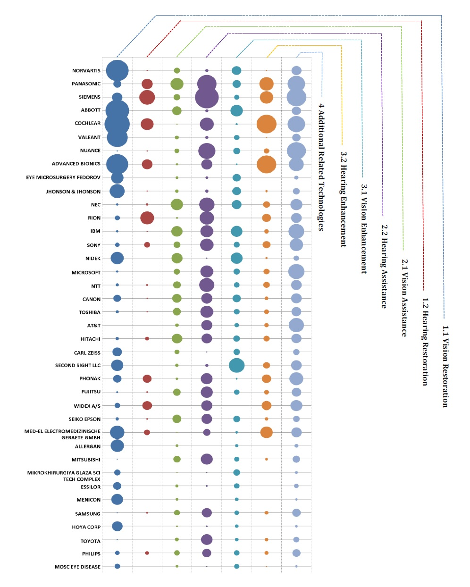

NOVARTIS
Novartis International AG is a Switzerland based multinational pharmaceutical company which was founded in 1996 after a merger between Ciba-Geigy and Sandoz. Novartis has three major businesses associated to vision healthcare including surgical, pharmaceutical and vision care. Novartis has organized its eye care products under the umbrella of Alcon Incorporated, an entity which Novartis fully took over a bought outright in 2010.44
Through this acquisition, Novartis is now one the largest manufacturers of contact lenses and lens care related products. Novartis produces an extensive range of ophthalmic surgical products including technologies and devices for refractive surgery, retinal, cataract, glaucoma and intraocular lenses (AT-IOLs) to treat cataracts including refractive errors, like presbyopia and astigmatism as well as manufacturing and producing many treatment options for eye related problems including bacterial conjunctivitis, inflammation, and pain associated with ocular surgery. An example of vision assistive technology owned by Novartis is below.
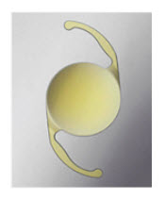
Figure 59: The ‘aspheric toris intraocular lens’, owned by Novartis (US patent 8167940) which can be surgically implanted
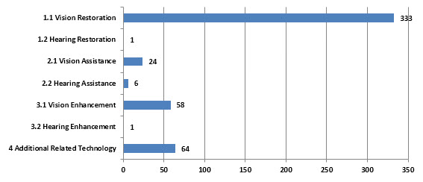
Figure 60: Analysis of Major Topics in Assistive Devices and Technologies for Visually and Hearing Impaired Persons Landscape for Novartis.

PANASONIC
Panasonic Healthcare Co., Ltd. was founded in 1948 and is headquartered in Tokyo, Japan. Panasonic Healthcare Co., Ltd. is a former subsidiary of Panasonic Corporation.45
Panasonic Corporation is a Japan-based electronics manufacturer. The Audio-Visual Computer (AVC) Network segment offers audio and video equipment. The Appliance segment provides household air-conditioning machines. The System Communications segment provides system network and mobile communications-related products and services. The Eco-solutions segment consists of riding, energy system, housing system and others. The Automotive systems segment provides automotive multimedia-related equipment and others. The Device segment provides electronic components, semiconductors and optical devices. The Energy segment provides solar system and lithium-ion batteries. In December 2013, it acquired a Turkey-based company. On April 1, 2014, the Company established a joint venture with Tower Semiconductor Ltd, which took over the Company's semiconductor wafer manufacturing business.46
Panasonic healthcare business segment have Home / Personal Use product lineup for which few examples are provided below.
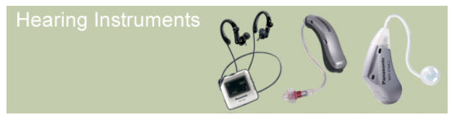
Figure 61: Hearing Instruments (Source: http://panasonic.net/healthcare/hearing/)

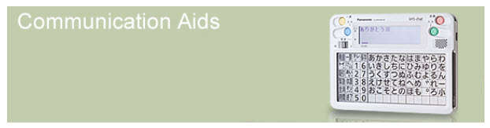
Figure 62: Communication Aids (Source: http://panasonic.net/healthcare/letschat/)

“These communication devices are appropriate for people who have both of speech and upper limb disorders.” ⁴⁷

Relevant News and Articles:
- An article published on September 27, 2013 by Kohlberg Kravis Roberts & Co. L.P (KKR) reveals a signing of a share purchase agreement and a shareholders' agreement between Panasonic and KKR.48
- An article published on November 28, 2011 by Panasonic states that Panasonic announced the development of a new technology for fitting hearing aids. Panasonic's new technology will be based on electroencephalogram pattern analysis enables to accurately and objectively estimate acceptable maximum sound volume of hearing aids for each user, without the need to exposing the user to loud sound in hearing test.49
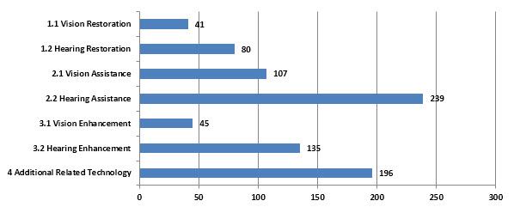

Figure 63: Analysis of Major Topics in Assistive Devices and Technologies for Visually and Hearing Impaired Persons Landscape for Panasonic.

SIEMENS
Siemens Medical Solutions USA, Inc. was founded in 1847 and is based in Malvern, Pennsylvania. It has operations around the world. Siemens Medical Solutions USA, Inc. operates as a subsidiary of Siemens Corporation.50

Siemens AG (Siemens) is a globally operating technology company with core activities in the fields of energy, healthcare, industry and infrastructure. Siemens business activities focus on four sectors, Energy, Healthcare, Industry and Infrastructure & Cities. These sectors form four of Siemens reportable segments. In addition to the four sectors, Siemens has two additional reportable segments: Equity Investments and Siemens Financial Services (SFS). The Energy sector comprises four divisions: Power Generation, Wind Power, Power Transmission and Energy Service. The Healthcare Sector includes four divisions: Imaging & Therapy Systems, Clinical Products, Diagnostics and Customer Solutions; and one sector-led Business Unit, Audiology Solutions. The Industry sector consists of three divisions: Industry Automation, Drive Technologies and Customer Services; and one sector-led Business Unit, Metals Technologies. The Infrastructure & Cities sector consists of five divisions: Rail Systems, Mobility and Logistics, Low and Medium Voltage, Smart Grid, and Building Technologies. In July 2013 Siemens sold its stake in the Nokia Siemens Networks (NSN) joint venture to Nokia and OSRAM Licht AG was spun off from Siemens.

The Healthcare Sector offers customers a comprehensive portfolio of medical solutions across the treatment chain-ranging from medical imaging to in-vitro diagnostics to interventional systems and clinical information technology systems-all from a single source. In addition, the Sector provides technical maintenance, professional and consulting services, and, together with Financial Services (SFS), financing to assist customers in purchasing the Sector’s products. The Healthcare Sector includes four Divisions: Imaging & Therapy Systems, Clinical Products, Diagnostics and Customer Solutions. The Sector also includes one sector-led Business Unit, Audiology Solutions. In addition to its Sector-level financial results, Healthcare also separately breaks out financial results for the Diagnostics Division.51

Hearing instruments by Siemens: innovative and successful
Even Werner von Siemens was concerned to make communication easier for hearing-impaired people. In 1878, he invented a telephone for the hearing-impaired, laying the cornerstone for an ongoing success story that is already more than 130 years old.
Today, hearing systems by Siemens are developed and marketed by the Audiology Solutions Business Unit, part of the Healthcare Sector at Siemens. Siemens Audiology Solutions has a total of more than 4,000 employees.52

Behind-The-Ear hearing instruments
Behind-The-Ear (BTE) hearing aids are used for all types of hearing losses from mild to profound. They come in a variety of styles from Miniature-BTEs to the larger SuperPower instruments. Many BTE hearing aids offer multiple directional microphone systems for improved understanding of speech in noisy situations.53

In-The-Ear hearing instruments
In-The-Ear (ITE) hearing aids are also known as custom hearing aids, as they are individually manufactured to suit a person’s ear. They range from the so-called Micro-CIC instrument, which fits completely in the ear canal to the full-shell hearing instrument, which completely fills the bowl of the ear.54

Pocket hearing instruments
The Pockettio™ from Siemens is a robust, digital hearing system that is simple and convenient to use. The user can choose between three programs depending on the hearing situation. The Pockettio helps you to correct hearing impairments and to better understand your environment. Whether you are with family or friends, listening to your MP3 player or watching television – the Siemens Pockettio will improve your hearing in almost every situation. The Pockettio – top-notch Siemens quality at an outstanding price.55
Siemens owns US patents 8634566 and 8630432 which are related to method for loudness-based adjustment of the amplification of a hearing aid and associated hearing aid and Self-programming hearing apparatus.

Relevant News and Articles:
- An article published on Nov 6. 2014 by Christopher Alessi reveals that German engineering company Siemens AG would sell its hearing aid business to private equity firm EQT Partners and Santo Holding, the investment arm of Germany’s Strungmann family, in a deal valued at €2.15 billion ($2.68 billion).56
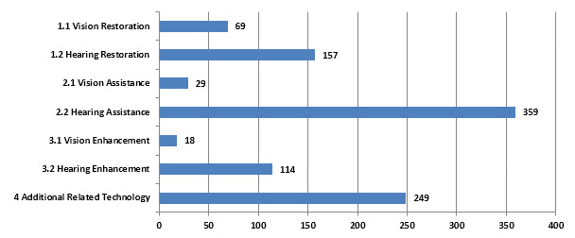
Figure 64: Analysis of Major Topics in Assistive Devices and Technologies for Visually and Hearing Impaired Persons Landscape for Siemens.

ABBOTT
The company was founded in 1888 and is headquartered in Abbott Park, Illinois.57
Abbott Laboratories (Abbott) is engaged in the discovery, development, manufacture, and sale of a portfolio of science-based health care products. Abbott operates in four business segments: diagnostics, medical devices, nutritionals and generic pharmaceuticals. Geographically, 30% of its revenue is generated in the United States; 30% in Western Europe, Canada, Japan and Australia, and 40% in the economies, including India, China, Russia and Brazil. In January 2013, the Company completed the separation of its research-based pharmaceuticals business, which became AbbVie, a new independent biopharmaceutical company. In August 2013, Abbott Laboratories completed its acquisition of OptiMedica Corporation. In August 2013, Abbott Laboratories completed its acquisition of IDEV Technologies.58
Through industry-leading vision technologies, Abbott is advancing vision quality for patients everywhere. To meet the needs of patients who live with vision challenges and look for greater freedom from the limitations of eyeglasses, our products include leading laser vision correction and cataract technologies.59

Abbott Medical Optics Inc.
The innovation began more than three decades ago as the ophthalmic research arm of Heyer-Schulte Medical Optics Center (HSMOC), a division of American Hospital Supply Corporation. The HSMOC would later change its name to American Medical Optics and eventually to Advanced Medical Optics, or AMO, as it is known today.
The company started business in 1976 as a pioneer in the early development of intraocular lenses (IOLs) for cataract patients.
Throughout the 1980s, AMO became known as a technology company, introducing innovative new IOLs, the first U.S.-made YAG laser, and a first-generation phacoemulsification system, for the removal of cataracts. A later generation of this technology, known as the SOVEREIGN® System with WHITESTAR® technology, won the prestigious Medical Design Excellence Silver Award from the Industrial Designers Society of America in 1999 for “excellence in medical product design engineering.”
In 1997, AMO launched the Array® IOL, the first multifocal lens to be approved for commercial distribution by the FDA.
In 2004, AMO introduced the Verisyse phakic IOL for treatment of moderate to severe myopia, the first lens of its kind to receive FDA approval. The company also acquired the TECNIS® and CeeOn® IOLs, the HEALON® line of viscoelastics and the BAERVELDT® glaucoma device, marking the company's entrance into the glaucoma market. The TECNIS® IOL is the first IOL with a modified prolate optic to have a claim for improved functional vision.
On May 27, 2005, AMO completed the acquisition of VISX, Incorporated, creating the world’s leading refractive surgical business, bringing together AMO’s expansive suite of cataract and refractive surgical products with VISX’s state-of-the-art laser vision correction systems.
The growth continued in 2007 with the addition of the industry’s leading wavefront diagnostic system and femotsecond laser through the acquisitions of WaveFront Sciences and IntraLase Corp., respectively.
These additions give AMO the advanced corneal refractive technologies with the ability to offer a full systems approach that is without peer in the industry.
In 2009, Advanced Medical Optics, Inc. was acquired by Abbott Laboratories. Today, AMO is now Abbott Medical Optics Inc. and operated as a separate entity within Abbott’s medical device division.60

Patented products and technology from Abbot in the vision technology are provided below:
Source: http://www.abbott.com/patents/vision-technologies.htm

AMO VITRAX ® OVD
BAERVELDT ® Glaucoma Implant
BLINK-N-CLEAN ® Lubricant Lens Drops
COMPLETE ® BLINK-N-CLEAN ® Lens Drops
COMPLETE ® EASY RUB ® MPS
DIPLOMA X® Fluidics Packs
DIPLOMAX ® II Footpedal
DIPLOMAX ® II System
Ellips ® Handpiece
Ellips ® FX Handpiece
FS60 Laser System
HEALON GV ® OVD
HEALON5 ® OVD
Healon EndoCoat ® OVD
iDESIGN System
iFS ® Laser System
INTRALASE Patient Interface Package
ONE SERIES Ultra Cartridges
OXYSEPT ® Cup
OXYSEPT ® Solution/Neutralizer
PRESTIGE Fluidics Packs
PRESTIGE Footpedal
PRESTIGE System
PROFICIENT Handpiece
PROFINESSE Handpiece
RevitaLens OcuTec ® MPDS COMPLETE RevitaLens
ReZoom IOL
Single-Use Bimanual Kit (test chamber)
SOVEREIGN ® COMPACT Fluidics Packs (OPO61)
SOVEREIGN ® COMPACT Footpedal
SOVEREIGN ® COMPACT System
SOVEREIGN ® Fluidics Packs (OPO 51/52)
SOVEREIGN ® Footpedal
SOVEREIGN ® System
STAR S4 ® and STAR S4 IR ® Systems
TECNIS ® 1-Piece Acrylic Asperic IOL
TECNIS ® Acrylic IOL
TECNIS ® CL Silicone IOL
TECNIS iTec Preloaded Insertion System
TECNIS ® Multifocal 1-Piece IOL
TECNIS ® Multifocal Acrylic IOL
TECNIS ® Multifocal IOL +2.75D
TECNIS ® Multifocal IOL +3.25D
TECNIS ® Multifocal Toric 1-Piece IOL
TECNIS ® Optiblue IOL
TECNIS ® Toric Asperic IOL
TOTALCARE solution
ULTRACARE ® Cup
ULTRACARE ® disinfecting solution/neutralizer
UNFOLDER ® Emerald Series Implantation System
UNFOLDER ® PLATINUM 1 SERIES Cartridges
UNFOLDER ® Silver Series Implantation System
Verisyse IOL
WAVESCAN ® System
WHITESTAR Signature ® Dual Linear Footpedal (Advanced Control Pedal)
WHITESTAR Signature ® Footpedal
WHITESTAR Signature ® System
WHITESTAR Signature ® System FUSION ® Fluidics Pump Pack (OPO70)
WHITESTAR Signature ® System FUSION ® Fluidics Pump Pack (OPO71)
WHITESTAR ® Handpiece

Relevant News and Articles:
- An article published on July 15, 2013 by Abbott states the entry of Abbott into Laser Cataract Surgery market through the acquisition of OptiMedica. OptiMedica's Catalys Precision Laser System is designed to allow surgeons to replace some of the technically demanding manual steps in cataract surgery with a precise, computer-guided, femtosecond laser technology. A femtosecond laser can be used to create anterior capsulotomy, effect phacofragmentation, or make a variety of incisions during ocular surgery. The Catalys laser system has both CE Mark in Europe and clearance from the U.S. Food and Drug Administration. 61
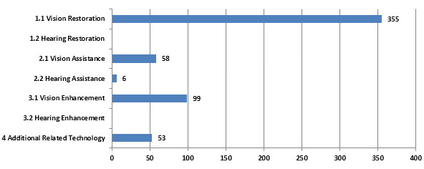
Figure 65: Analysis of Major Topics in Assistive Devices and Technologies for Visually and Hearing Impaired Persons Landscape for Abbott.

COCHLEAR
Cochlear Limited (Cochlear) is an Australia-based company, which operates in the implantable hearing device industry. The Company operates in three geographical segments: Americas, Europe, Middle East and Africa and Asia Pacific. The Company’s product and solution include Cochlear implants, Baha bone conduction implants and Bone anchored prosthetics. The Company has special purpose entities (SPEs) for trading and investment purposes. The Company’s subsidiaries include Acoustic Implants Limited, Cochlear AG, Cochlear Americas, Cochlear Benelux NV, Cochlear Bone Anchored Solutions AB, Cochlear Boulder LLC, Cochlear Canada Inc, Cochlear Deutschland GmbH & Co KG, Cochlear Employee Share Trust, Cochlear Employee Share Trust, Cochlear Finance Pty Limited, Cochlear German Holdings Pty Limited and Cochlear Holdings NV.62

A cochlear implant is an established, effective and long-term solution for people with moderate to profound hearing loss. Cochlear pioneered the implant technology and is still the world’s industry leader. 63

The Cochlear™ Nucleus® 6 Sound Processor works with your cochlear implant to transfer sound to your ear. The Nucleus 6 System is our most advanced hearing solution to date, providing two processors to choose from to help you enjoy simply smarter hearing. 64

Relevant News and Articles:
- A research article which was published on January 24, 2014 states that Cochlear Hit With $131M Verdict In Implant Patent Trial65.A California federal jury served Cochlear Ltd. with a $131.2 million verdict on Thursday, finding that the Australian-based company had infringed two patents related to technology for cochlear implants owned by the Alfred E. Mann Foundation for Scientific Research.
- A research article which was published on September 15, 2014 states that Cochlear Limited got US Food and Drug Administration (FDA) approval for the use of 2.4 GHz wireless connectivity with the Cochlear™ Nucleus® 6 Sound Processor. With a full range of wireless accessories, Cochlear is the first and only company to deliver true wireless freedom without the need for wires or neck-worn loops.66
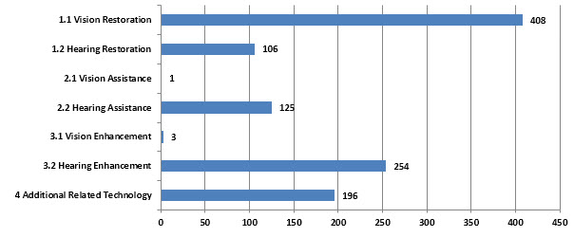
Figure 66: Analysis of Major Topics in Assistive Devices and Technologies for Visually and Hearing Impaired Persons Landscape for Cochlear.

VALEANT
Valeant Pharmaceuticals International, Inc. was founded in 1983 and is headquartered in Laval, Canada.67
Valeant Pharmaceuticals International, Inc., formerly Biovail Corporation, is a multinational, specialty pharmaceutical company that develops, manufactures and markets a range of pharmaceutical products. The Company operates in five business segments: U.S. Neurology and Other, U.S. Dermatology, Canada and Australia, Branded Generics - Europe and Branded Generics -Latin America.
In August 2013, Valeant Pharmaceuticals International Inc completed the acquisition of Bausch + Lomb Holdings Incorporated. In January 2014, the Company's wholly-owned subsidiary Valeant Pharmaceuticals International acquired Solta Medical Inc.68
The acquisition of Bausch + Lomb in 2013 positioned Valeant to capitalize on growing eye health trends driven by an aging patient population, an increased rate of diabetes and demand from emerging markets.
Bausch + Lomb offers a broad portfolio of eye health products, including contact lenses and lens care products, pharmaceuticals, intraocular lenses and surgical equipment. Its contact lens offerings include such well-known brand names as Biotrue® ONEday, PureVision®, SofLens®, Boston®, Optima® and Naturelle™. Lens care products include Biotrue® and the renu® brand of multi-purpose disinfectants for soft contact lenses, as well as the Boston® line of products for cleaning gas-permeable contact lenses.69

Bausch + Lomb
Bausch + Lomb, a division of Valeant Pharmaceuticals International, Inc., has one of the best-known and most respected healthcare brands in the world.
Offering the world’s most comprehensive portfolio of eye health products, the company’s core businesses include contact lenses and lens care products, ophthalmic surgical devices and instruments, and ophthalmic pharmaceuticals.
The company began in 1853 in Rochester, New York, and our history of innovation continues today as we invent new materials, engineer new technologies, and create pioneering ways to help people see better to live better.70

Relevant News and Articles:
- An article which was published on March 13, 2014 states that Bausch & Lomb Launches PeroxiClear™, the Most-Advanced Peroxide-Based Cleaning and Disinfecting Lens Solution in Almost a Decade71.They announced the introduction of PeroxiClear™ 3% hydrogen peroxide cleaning and disinfecting solution, the most advanced* peroxide-based lens care solution to launch in years
- An article published on February 13, 2014 states that Bausch + Lomb Introduces BLIS™ Reusable Injector System for enVista® Intraocular Lenses72 designed exclusively for use with the enVista® glistening-free, hydrophobic acrylic intraocular lens (IOL). BLIS, complete with a reusable hand piece and single-use cartridge, allows surgeons safe, controlled delivery of the enVista IOL through unenlarged phaco incisions as small as 2.2 mm.
- An article published on April 28, 2014 by Business Wire and on 1 May, 2014 by Medical Company Product News states that Bausch & Lomb secured an exclusive license agreement for a three-dimensional surgical navigation technology, the Cirle Surgical Navigation System, from Cirle, Inc., a medical technology incubator based in Miami, Fla. Bausch & Lomb has agreed to license the system from Cirle to pursue commercialization for cataract surgery. This technology system is the result of the cutting-edge research collaboration between Bausch & Lomb and Cirle to develop new technologies that help fill the unmet needs of the eye health community and the patients they serve.73
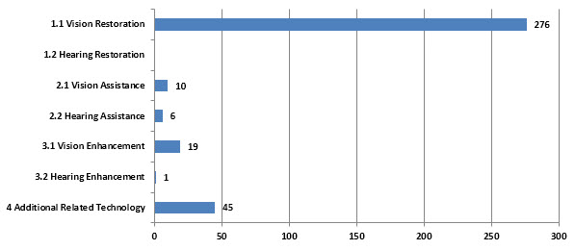
Figure 67: Analysis of Major Topics in Assistive Devices and Technologies for Visually and Hearing Impaired Persons Landscape for Valeant.

NUANCE
Nuance Communications, Inc. was founded in 1992 and is headquartered in Burlington, Massachusetts.74
Nuance Communications, Inc. is a provider of voice and language solutions for businesses and consumers globally. The Company's solutions are used in healthcare, mobile, consumer, enterprise customer service, and imaging markets. The Company offers accuracy, natural language understanding capability, domain knowledge and implementation capabilities. The Company's solutions are based on the Company's voice and language platform and are used by businesses for tasks and services, such as requesting information from a phone-based self-service solution, dictating medical records, searching the mobile Web by voice, entering a destination into a navigation system, or working with portable document format (PDF) documents. The Company offers its solutions to its customers in a range of ways, including through products, hosting, professional services and maintenance and support. The Company's product revenues include embedded original equipment manufacturers (OEM) royalties, traditional enterprise licensing, term-based enterprise licensing and consumer-based sales. The Company's hosting revenues are generated through on-demand service models, consisted of hosted transaction-based pricing arrangements, which have multi-year terms. On June 1, 2012, the Company acquired Vlingo Corporation. On April 26, 2012, the Company acquired Transcend Services, Inc. In October 2012, the Company acquired J.A. Thomas and Associates, Inc. In December 2012, the Company acquired Ditech Networks, Inc. Effective April 1, 2013, Carl Icahn acquired a 9.27% stake in the Company.75

TALKS & ZOOMS Accessibility
Nuance TALKS app for mobile handsets converts text on the screen into highly intelligible speech. Nuance ZOOMS is a sophisticated screen magnifier app. Together they provide blind and low-vision impaired individuals access to the digital world.76

Accessibility Solutions for Business
Nuance offers a wide-range of accessibility and assistive technology solutions for the workforce, helping to provide employees barrier-free access to widely-used information and communication technologies. Our assistive technologies include speech recognition capabilities which allow users to work virtually hands free when creating documents, accessing data or working on the Web, to OCR for the visually impaired, automatic transcription of voice mails for deaf users, and more. Nuance is a leading provider of tailored solutions for users with blindness/low vision, dyslexia, dyspraxia, mobility or dexterity impediments and people with a variety of physical disabilities.77

Relevant News and Articles:
- An article published on September 2, 2012 states that Nuance Releases Dragon Naturally Speaking 1278 which helps People with Disabilities like Mobility Impairments (e.g. RSI, paralysis, broken arm) - speech recognition capabilities allows users to work virtually hands free when creating documents, accessing data or working on the Web. People with Visual Impairments - use Dragon to OCR documents to make content that was previously disabilities (e.g. learning disabilities, dsylexia) - Allows users to express their thoughts in writing with greater speed and ease. Dragon 12 now has a new natural voice unreadable readable. People who have Deaf and hard-of-hearing - Dragon provides automatic transcription of voice mails and web audio content. People with Cognitive for text-to-speech to allow users to listen to text.

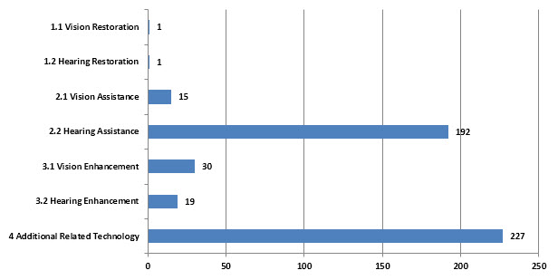
Figure 68: Analysis of Major Topics in Assistive Devices and Technologies for Visually and Hearing Impaired Persons Landscape for Nuance

ADVANCED BIONICS
Advanced Bionics is a global leader in developing the most advanced cochlear implant systems in the world. Acquired by Sonova Holding AG and working with Phonak since 2009, AB develops cutting-edge cochlear implant technology that restores hearing to those with severe-to-profound hearing loss.
With operations in over 50 countries and a track record for developing high-performing, state-of-the-art products, AB’s talented, group of technologists and professionals are driven to succeed, work with integrity, and stay firmly committed to quality while delivering unmatched customer service.79
AB is the only company to offer the patented T-Mic microphone placed at the opening of the ear canal. This strategic placement utilizes the outer ear’s natural sound-gathering capabilities, just like normal-hearing ears. The result is better, more effortless hearing for your child or you in noise.80

Relevant News and Articles:
- An article which was published on February 11, 2014 states that Advanced Bionics Releases Dynamic App for New Naída CI Sound Processor81.Advanced Bionics (AB) and a company of the Sonova Group, announced today the launch of a new app that delivers a fun, dynamic and user-friendly guide for its latest innovation, the Naída CI Q70 (Naída CI) sound processor.The myNaida CI app is an innovative mobile solution for providing product and instructional information to help recipients get the maximum benefit from the exciting features and accessories available for AB’s groundbreaking new processor. Combining AB and Phonak technologies, the innovation leaders in cochlear implants and hearing instruments, Naída CI brings a host of new features to cochlear implant recipients for the first time, including bimodal and bilateral wireless streaming.
- An article which was published on September 26, 2012 states about a possible future sound processor for advanced bionics’ recipients82.Advanced Bionics filed a patent in 2009 for a sound processor that is an all-in-one headpiece.
Figure 69: Advanced Bionics U. S. patent application for an integrated headpiece for a cochlear implant publication no. is US 2010/0046778 A1
- The corporate news which was published on August 28, 2013 by Advanced Bionics states that most advanced Behind-the-Ear sound processor receives Regulatory Approval for commercial release in the United States. The innovation DNA of Advanced Bionics and Phonak have merged together for the introduction of the world’s newest, most advanced behind-the-ear sound processor. Now cochlear implant recipients have access to the combined technologies of the innovation leaders in cochlear implants and hearing instruments.83
- The corporate news which was published on March 25, 2013 in Advanced Bionics website states that Advanced Bionics (AB), the global leader in cochlear implant technology and a company of the Sonova Group, announced today that they have received approval by the Therapeutic Goods Administration (TGA) for Neptune™, the world’s first and only swimmable, waterproof cochlear implant sound processor in Australia. Warranted for use in oceans, lakes and rivers in addition to pools, baths and showers, Neptune is designed to help cochlear implant recipients hear both in and out of the water.84
- An article which was published on November 03, 2014 states that Advanced Bionics (AB), a global leader in cochlear implant technology and a company of the Sonova Group, announced today the launch of a completely redesigned and reimagined online resource, The Listening Room™, developed to help cochlear implant recipients get the maximum benefit from their devices.⁸⁵
- An article which was published on November 03, 2014 states that Advanced Bionics (AB), a global leader in cochlear implant technology and a company of the Sonova Group, announced today that the AquaCase™ container has obtained FDA approval and will be commercially available in the United States starting on November 3, 2014, following its successful launch in Europe and Canada earlier this year. Designed for use with the Naída CI Q70 (Naída CI) sound processor, the AquaCase accessory is the world’s first and only swimmable, waterproof case for cochlear implant recipients.86
- An article which was published on August 14, 2014 states that Advanced Bionics (AB), a global leader in cochlear implant technology and a company of the Sonova Group, announced today the launch of two new iPad® device apps as part of their growing rehAB range of rehabilitative and educational tools for people with hearing loss. The creative, interactive apps have been specially designed for caregivers or therapists to guide the development of listening and language skills in children with hearing loss ages 4 to 10.87
- An article which was published on August 14, 2014 states that Advanced Bionics (AB), a global leader in cochlear implant technology and a company of the Sonova Group, announced today that the HiResolution™ Bionic Ear System, featuring the HiFocus™ Mid-Scala electrode and the Naída CI Q70 (Naída CI) sound processor, is commercially available in Vietnam.88
- An article which was published on July 10, 2014 states that )--Advanced Bionics (AB), the global leader in cochlear implant technology and a company of the Sonova Group, announced today that it received approval by the China State Food and Drug Administration (SFDA) for the Neptune™ sound processor, the world’s first and only swimmable, waterproof cochlear implant sound processor, in China.89

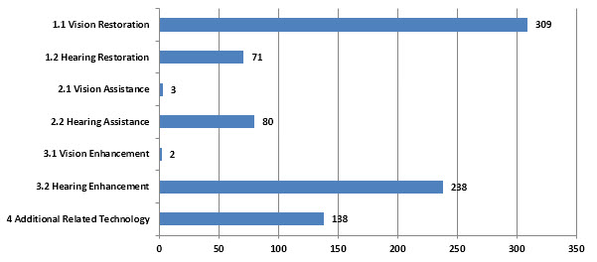
Figure 70: Analysis of Major Topics in Assistive Devices and Technologies for Visually and Hearing Impaired Persons Landscape for Advanced Bionics

EYE MICROSURGERY FEDOROV
The S.N. Fyodorov Federal State Institution “Eye Microsurgery Complex” is a leading clinical and research ophthalmological center in Russia. Besides the Head Organization in Moscow, including the Research Experimental Production Plant, 11 affiliated branches (Clinics in the largest Russian cities) are integrated to it. The Head Organization realizes coordination of their activities. All the Branches of the Complex show the stability of work. The net of medico-diagnostic centers organized in the distant regions on the basis successfully develops bringing the rendering of the highly specialized aid to all the regions of the Russian Federation.
The “Eye Microsurgery Complex” is situated in a picturesque district to the North of Moscow City and consists of several buildings which are: policlinics (the out-patients diagnostic building) for daily examinations of 1200 patients; stationary with 10 clinical departments for the main ocular pathologies treatment; Medical Center No. 2 with specialized department for foreign patients treatment and hospitalization, Experimental Technical Production Plant and others.90

Relevant News and Articles:
- A research article which was published on January 11th 2011 by PubMed states that the MICOF keratoprosthesis is an effective alternative for patients with corneal blindness and a poor prognosis for penetrating keratoplasty. They have evaluated the efficacy and preliminary safety of the Moscow Eye Microsurgery Complex in Russia (MICOF) keratoprosthesis in eyes with complicated corneal opacities unsuitable for keratoplasty. The MICOF keratoprosthesis surgery involves 2 procedures. In stage 1, a supporting titanium frame is inserted into the lamellar pocket; a polymethyl methacrylate (PMMA) optical cylinder is implanted 3 months later (stage 2). Data were collected from the preoperative, intraoperative, and postoperative courses. Statistical analysis was performed to identify factors influencing postoperative complications.91
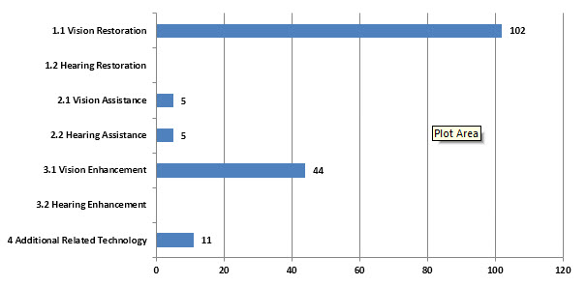
Figure 71: Analysis of Major Topics in Assistive Devices and Technologies for Visually and Hearing Impaired Persons Landscape for Eye Microsurgery Fedorov.

JNJ (JOHNSON & JOHNSON)
Johnson & Johnson was founded in 1885 and is based in New Brunswick, New Jersey.92
Johnson & Johnson is a holding company. The Company is engaged in the research and development, manufacture and sale of a broad range of products in the health care field. The business of Johnson & Johnson is conducted by more than 275 operating companies located in 60 countries, including the United States, which sell products in virtually all countries throughout the world. In March 2013, Johnson & Johnson's Cordis Corporation announced the acquisition of Flexible Stenting Solutions, Inc. In June 2013, Johnson & Johnson announced the opening of the Johnson & Johnson Innovation center in Boston. In August 2013, Johnson & Johnson announced it has completed its acquisition of Aragon Pharmaceuticals, Inc., a pharmaceutical discovery and development company focused on drugs to treat hormonally driven cancers.
The Company’s primary focus has been on products related to human health and well-being. The Company is organized into three business segments: Consumer, Pharmaceutical and Medical Devices and Diagnostics. The Company's subsidiaries operate 146 manufacturing facilities occupying approximately 21.6 million square feet of floor space.93
Johnson & Johnson Vision Care, Inc. is committed to providing high quality products and services to health care professionals and patients and to supporting the communities in which we work and live.
Medical science evolves rapidly with new information becoming available constantly. As part of the health care system, we understand the need to support health care professionals in their pursuit of the most current education to provide the best patient care possible and recognize that our collaboration with physicians can lead to important medical advances. There is further need to support patients, caregivers, and communities to ensure that they have the information and products required to live healthy and productive lives.
We hold ourselves accountable to the highest standards to ensure that our interactions with health care professionals, institutions and non-profit organizations are conducted in an appropriate manner. To that end, we regularly review and improve our practices as part of an ongoing commitment to ensure ethical and transparent interactions with medical professionals.
Our primary focus is making life-changing, long-term differences in human health and disease management for those who may be helped by the products and services we provide. The purpose of our disclosure of payments on this site is to demonstrate our ongoing commitment to this endeavor. It is our hope that this disclosure will help the general public to better understand the nature and volume of programs that we support in the interest of advancing patient care and supporting local communities.94

The millennium and next generation of technology95
“The 90s saw the introduction of many disposable contact lens brands, both in the daily disposable and the frequent disposable modalities. All lenses were made from hydrogel materials. It wasn't until the beginning of the new millennium that we started to see the introduction of silicone hydrogel contact lenses.
Johnson & Johnson Vision Care launched their first silicone hydrogel lens in 2005 with the introduction of ACUVUE® ADVANCE® with HYDRACLEAR®. This was followed 15 months later with ACUVUE® OASYS® with HYDRACLEAR® PLUS.
However, the innovation didn't stop there. Johnson & Johnson Vision Care continued to push the boundaries of contact lens development with the introduction of ACUVUE® ADVANCE® for ASTIGMATISM, 1-DAY ACUVUE® for ASTIGMATISM, 1-DAY ACUVUE® MOIST® and later ACUVUE® OASYS® for ASTIGMATISM – a totally new toric lens design that employed the outstanding stabilisation features of Accelerated Stabilisation Design (ASD) Technology to allow the lens to settle accurately in the eye in 60 seconds.
Their next milestone came in 2008 when Johnson & Johnson delivered another first to the UK market with a world's first launch – 1-DAY ACUVUE® TruEye®. The world's first silicone hydrogel daily disposable lens – the lens that is seen by Eye Care Professionals to be the best innovation in contact lenses in the past ten years.
In 2010, Johnson & Johnson Vision Care launched 1-DAY ACUVUE® MOIST® for ASTIGMATISM, offering a winning combination of two unique technologies: Accelerated Stabilisation Design (ASD) and LACREON®, together with the widest range of any daily disposable toric lens.”96

Relevant News and Articles:
- An article which was published on April 17, 2014 by Ophthalmology Web states that Johnson & Johnson Vision Care Inc. (JJVCI) is now accepting research proposals related to meibography and tear film stability with contact lens wear. Specific areas of interest include the topics like Correlating clinical findings to (i.e. lid wiper epitheliopathy, subjective symptoms, physiology) meibomian gland image analysis and tear film stability and Categorizing magnitude of meibomian gland changes to contact lens type or length of wear.97
- An article which was published on March 14, 2014 by Ophthalmology Web states that Johnson & Johnson Vision Care, Inc. today announced that effective April 15, 2014, ACUVUE® OASYS® Brand Contact Lenses for ASTIGMATISM will be available in more parameters, providing doctors with a range of options to provide coverage for 98 percent of spherical and astigmatic patients.98
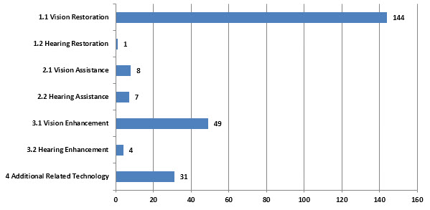
Figure 72: Analysis of Major Topics in Assistive Devices and Technologies for Visually and Hearing Impaired Persons Landscape for Johnson & Johnson.

NEC
NEC Corporation provides social and IT solutions worldwide. The company offers systems integration services, such as systems implementation and consulting services; maintenance and support services; outsourcing/cloud services; and system equipment to government, public, healthcare, finance, media, manufacturing, retail, and services sectors. It also provides network infrastructure, such as backbone network systems comprising optical transmission systems, submarine cable systems, and routers/switches; and access network systems, including wireless broadband access systems, PASOLINK mobile backhaul systems, and FTTx broadband access systems to telecom carriers. In addition, the company offers services and management for telecom operations and management solutions, network operation support systems, business support systems, network control platform systems, and network service delivery platform systems. Further, it provides hardware products, such as servers, mainframes, supercomputers, storage products, business PCs, tablet devices, POS, ATMs, control equipment, wireless LAN routers, displays, and projectors; and software products, including integrated operation management, application servers, security, and database software products. Additionally, the company provides smart energy products, including electrodes/energy storage systems, energy management systems, EV/PHV charging infrastructure, and solutions for utilities; smartphones and mobile phones; BIGLOBE Internet services; and lighting equipment, as well as supplies lithium-ion grid energy storage systems. NEC Corporation has a strategic partnership with Wireless Solutions Limited; and HP for the integration of technology, as well as to deliver networking solutions to enterprise customers. The company was formerly known as Nippon Electric Company, Limited and changed its name to NEC Corporation in April 1983. NEC Corporation was founded in 1899 and is headquartered in Tokyo, Japan. 99

Relevant News and Articles:
- An article which was published on December 13, states that NEC Foundation of America Supports Totally Neat Projects; Gee Whiz Technology Creates Affordable Solutions For People with Disabilities100.The Pulsar Project at Syracuse University develops Totally Neat Gadgets (TNGs) and NeatTools software programs that enable people who are severely disabled to type text, surf the web, send email, and generate speech. Recording for the Blind and Dyslexic's (RFB&D) AudioPlus Testing and Feedback project tests methods for delivering digitally recorded textbooks to students with print disabilities. And the National Center for Accessible Media is dedicated to ensuring that all media, including television, motion pictures, and even the Internet are accessible to people with disabilities.
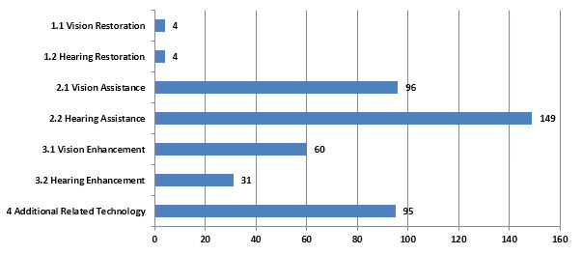
Figure 73: Analysis of Major Topics in Assistive Devices and Technologies for Visually and Hearing Impaired Persons Landscape for NEC.

RION
The company was formerly known as Kobayashi-Riken Seisakusho Ltd. and changed its name to Rion Co., Ltd. in 1960. Rion Co., Ltd. was founded in 1944 and is headquartered in Kokubunji, Japan.101

RION CO., LTD. is engaged in manufacture and sale of medical equipment and environmental equipment. The Company had two business segments. The Medical Equipment manufactures and sells hearing aids and training equipment for hearing impaired people, as well as audiometers and hearing testing equipment. The Environmental Equipment segment provides sound level meters, vibration meters, seismometers and frequency analyzers, as well as air particle counters and liquid particle counters. As of March 31, 2013, the Company had six subsidiaries and one associated company.102

Rion's products are in four main categories: "Hearing Instruments" dealing with hearing aids and equipment for hearing ability training, "Medical Equipment" for the fields of otorhinolaryngology, dermatology, and ophthalmology, "Sound and Vibration Measuring instruments" encompassing sound and vibration level meters, seismometers and related devices, and finally "Particle Counters", mainly equipment for measurement of airborne and liquid-borne particles.103

Relevant News and Articles:
- The company’s recent US patents include 8150082 which is related to the Waterproof Hearing Aid which is capable of being worn without caring about the entry of sweat or water even at the time of sweating or bathing. The waterproof hearing aid has a first waterproof film stretchingly provided at the sound inlet of a microphone and a second waterproof film stretchingly provided at the sound outlet of an earphone and at other locations.
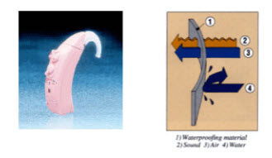
Figure 74: Waterproof hearing aid (Source: http://www.rion.co.jp/english/products-e/communication/hearing04.html) patent owned by Rion US 8150082 B2
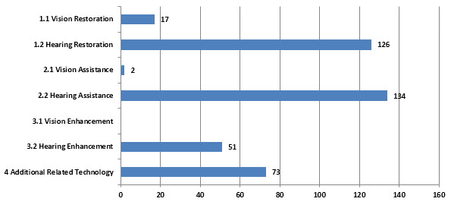
Figure 75: Analysis of Major Topics in Assistive Devices and Technologies for Visually and Hearing Impaired Persons Landscape for Rion.

IBM
The company was formerly known as Computing-Tabulating-Recording Co. and changed its name to International Business Machines Corporation in 1924. International Business Machines Corporation was founded in 1910 and is headquartered in Armonk, New York.104
International Business Machines Corporation (IBM) is an information technology (IT) company. IBM operates in five segments: Global Technology Services (GTS), Global Business Services (GBS), Software, Systems and Technology and Global Financing. GTS primarily provides IT infrastructure services and business process services. GBS provides professional services and application management services. Software consists primarily of middleware and operating systems software. Systems and Technology provides clients with business solutions requiring advanced computing power and storage capabilities. Global Financing invests in financing assets, leverages with debt and manages the associated risks. In March 2014, the Company acquired Cloudant Inc, a privately held database-as-a-service (DBaaS) provider that enables developers to easily and quickly create next generation mobile and web apps.105
The IBM Human Ability and Accessibility Center focuses on exploring new technology solutions to address issues associated with disability, aging and low literacy. An integral part of IBM Research, the Center is a worldwide organization that works with governments, collaborates with partners, and delivers solutions to clients worldwide.106

Relevant News and Articles:
- An article which was published in IBM website states about “The Conversational Internet” - A project that enables people who are blind to 'talk' with web pages.107 The Conversational Internet is an inspiring project developed by a team of Extreme Blue interns throughout the summer at the IBM Hursley Lab in the UK. The Royal London Society for Blind People approached IBM with the aim of creating improvements in the way that people who are blind interact with information on the Internet and the team is working towards a smart solution.
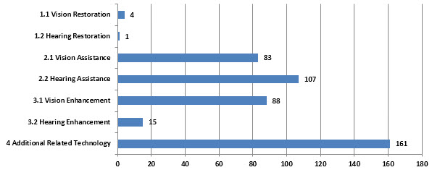
Figure 76: Analysis of Major Topics in Assistive Devices and Technologies for Visually and Hearing Impaired Persons Landscape for IBM.

SONY
The company was formerly known as Tokyo Tsushin Kogyo Kabushiki Kaisha and changed its name to Sony Corporation in 1958. Sony Corporation was founded in 1946 and is headquartered in Tokyo, Japan.108
Sony Corporation (Sony) is engaged in the development, design, manufacture, and sale of various kinds of electronic equipment, instruments, and devices for consumer, professional and industrial markets, as well as game consoles and software. Sony’s primary manufacturing facilities are located in Japan, Europe, and Asia. Sony also utilizes third-party contract manufacturers for certain products. Sony’s products are marketed throughout the world by sales subsidiaries and unaffiliated distributors, as well as direct sales through the Internet. Sony is engaged in the development, production, manufacture, marketing, distribution and broadcasting of image-based software, including motion picture, home entertainment and television products. Sony is also engaged in the development, production, manufacture, and distribution of recorded music. Further, Sony is also engaged in various financial service businesses, including life and non-life insurance operations through its Japanese insurance subsidiaries, banking operations through a Japanese Internet-based banking subsidiary and leasing and credit financing operations through a subsidiary in Japan. In addition, Sony is engaged in a network service business and an advertising agency business in Japan. 109

Relevant News and Articles:
- An article which was published in Sony website which states about “Sony's Entertainment Access Glasses” which can open your doors to a whole new audience.110 This provides a groundbreaking way for people with hearing loss to enjoy movies. Introducing the Sony Entertainment Access Glasses with Audio—new technology that allows a direct line of sight to a movie screen with captioned text right on the lenses for natural and unobstructed viewing. The glasses may be comfortably worn over prescription eyewear and can be used for 3D movies with the option of a detachable polarized filter. The closed-caption viewing uses unique Sony holographic technology, which delivers bright, clear, and easy-to-read subtitles seemingly "in the air." The system transmits closed-caption data from any DCI-compliant media server wirelessly to the glasses' receiver box, and can be programmed to display subtitles in a choice of six languages.
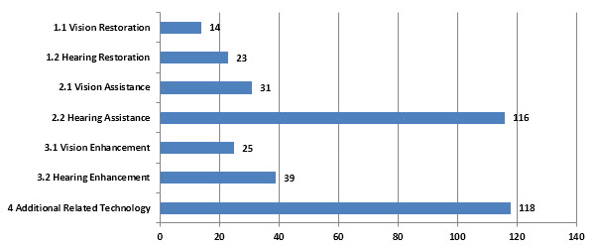
Figure 77: Analysis of Major Topics in Assistive Devices and Technologies for Visually and Hearing Impaired Persons Landscape for Sony

NIDEK
Nidek Medical Products, Inc. manufactures and distributes oxygen concentrators and PSA technologies for use in home care, hospital, and industrial applications. It sells its products worldwide. Nidek Medical Products, Inc. was founded in 1986 and is based in Birmingham, Alabama with warehouses in South America and Europe. It also has distributor locations in Kolkata, India; Bogota, Columbia; Birmingham, Alabama; and Bremen, Germany. 111
Founded in Gamagori, Japan in 1971, NIDEK continues to be a global leader in the design, manufacture and distribution of ophthalmic equipment. The United States subsidiary based in Silicon Valley, California, provides sales and service for ophthalmic lasers, refractive lasers, and many advanced diagnostic devices. Other NIDEK products are distributed by Marco Ophthalmic and Santinelli International. Marco is a “leader in vision diagnostics,” and Santinelli.112
The product range of NIDEK is enlisted below:113
Ophthalmology & Optometric
- RS-3000 Advance
- SSC-370
- AL-Scan

Lens Edging
- LE-700
- Me 900
- AES-2200
Coating
- Geolass

Relevant News and Articles:
- An article which was published on 4th July, 2014 by BioOptics World states that Ophthalmic equipment developer, maker, and distributor - Nidek has received FDA approval for the company's RS-3000 Advance optical coherence tomography (OCT) system, which incorporates a scanning laser ophthalmoscope to evaluate the retina and choroid. The system provides detail of the retinal and choroidal microstructures to assist in clinical diagnosis. The system integrates with most electronic medical record (EMR) systems using the company's NAVIS-EX image filing software, which networks the system and other Nidek imaging devices.114
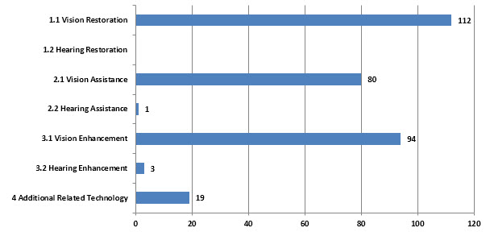
Figure 78: Analysis of Major Topics in Assistive Devices and Technologies for Visually and Hearing Impaired Persons Landscape for Nidek.

MICROSOFT
Microsoft Corporation was founded in 1975 and is headquartered in Redmond, Washington.115 Microsoft Corporation is engaged in developing, licensing and supporting a range of software products and services. The Company also designs and sells hardware, and delivers online advertising to the customers. The Company operates in five segments: Windows & Windows Live Division (Windows Division), Server and Tools, Online Services Division (OSD), Microsoft Business Division (MBD), and Entertainment and Devices Division (EDD). The Company’s products include operating systems for personal computers (PCs), servers, phones, and other intelligent devices; server applications for distributed computing environments; productivity applications; business solution applications; desktop and server management tools; software development tools; video games, and online advertising. It also designs and sells hardware, including the Xbox 360 gaming and entertainment console, Kinect for Xbox 360, Xbox 360 accessories, and Microsoft PC hardware products. In July 2012, the Company purchased Edgewater Fullscope's Process Industries 2 (PI2) software and intellectual property. In July 2012, Comcast Corp. acquired the Company's 50% stake in MSNBC.com. In October 2012, it acquired PhoneFactor Inc. On July 18, 2012, it acquired Yammer, Inc. (Yammer). On March 19, 2013, it acquired Netbreeze GmbH. In September 2013, Ericsson completed the acquisition of Microsoft's Mediaroom business and TV solution. Effective October 23, 2013, Microsoft Corp acquired Apiphany Inc. Effective February 4, 2014, Microsoft Corp acquired an undisclosed stake in Foursquare Labs Inc.116
Microsoft Windows is compatible with a wide variety of assistive technology products such as screen readers, magnifiers, and specialty hardware that meet the needs of computer users with all types of impairments and provide choices at every price point. We strive to ensure that Windows is an outstanding platform for other companies to develop innovative accessible technology products. Interoperability between assistive technology products, the operating system, and software programs is critical for the assistive technology product to function properly.
The following assistive technology companies provide specialty software and hardware products (such as screen keyboards) that provide essential computer access to individuals with significant vision, hearing, dexterity, language or learning needs.117

Relevant News and Articles
- An article which was published on February 13, 2014 by InformationWeek states that Microsoft announces free screen reader software to help Microsoft office users with Vision disabilities. Window-Eyes enables people who are blind, visually impaired, or print disabled to have full access to Windows PCs and makes the computer accessible via speech and/or Braille. This newly introduced offering is reflective of Microsoft’s ongoing commitment to removing barriers to access to technology and enabling people to be productive in both, their work and personal lives.118
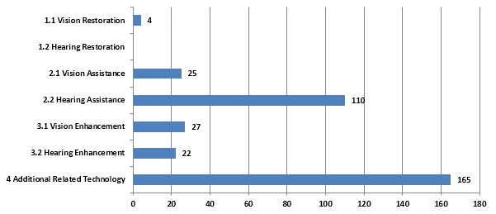
Figure 79: Analysis of Major Topics in Assistive Devices and Technologies for Visually and Hearing Impaired Persons Landscape for Microsoft

NTT
NTT DOCOMO, INC. provides mobile telecommunication services over its long term evolution and W-CDMA networks in Japan. The company offers voice, data, and other services, including docomo Wi-Fi, a public wireless LAN service; international calling and roaming services; Office Link, a service that allows mobile phones to be used as internal lines; Business Mopera Anshin Manager, which enables the unified control of corporate mobile phones; and Mobile groupware, which allows the management of email or documents using smartphones/PCs, and satellite cell phones service. It also offers docomo cloud, which includes dmarket, a market that offers a suite of digital content and physical merchandise on the cloud; Intelligent service, a cloud-based service that provides intelligent solutions through the use of various advanced technologies, such as voice recognition, machine translation, and voice synthesis; and Storage, a service that allows users to store photographs, videos, phone book, and other data on the cloud. In addition, the company focuses on offering services in various business fields, including media/content, finance/payment, commerce, medical/healthcare, machine-to-machine, aggregation/platform, environment/ecology, and safety/security. Further, it purchases and sells various products, including smartphones/tablets and data communications devices; and operates docomo Smart Home, a service for sharing videos, music, shopping, and other content between smartphones and home electronics. The company sells its products through general distributors and its stores, as well as online. As of March 31, 2013, it operated 2,394 docomo shops in Japan. As of June 20, 2013, NTT DOCOMO, INC. served approximately 61 million mobile customers in Japan through advanced wireless networks. The company was founded in 1991 and is headquartered in Tokyo, Japan. NTT DOCOMO, INC. is a subsidiary of Nippon Telegraph and Telephone Corporation.119

Relevant News and Articles:
- The article which was published on January 30, 2012 by “The Verge” , states that NTT Docomo and Nintendo are working on a speech-to-text system for the Nintendo DSi, intended to assist hearing-impaired children with school instruction, NHK reports. As teachers speak, the system converts their words into text, which is then displayed on the DSi's screen on a virtual blackboard. The system is also said to feature a game that allows students to interact with the text, and the text is also stored in the cloud to allow students to access it at a later time. NTT began trials on the technology today in some Japanese schools, but the company aims to use the technology for general speech recognition purposes outside of the classroom as well.120
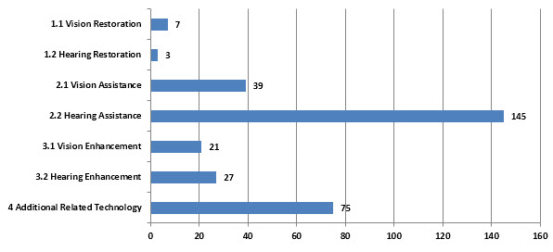
Figure 80: Analysis of Major Topics in Assistive Devices and Technologies for Visually and Hearing Impaired Persons Landscape for NTT.

CANON
Canon Inc. (Canon), incorporated on August 10, 1937, is a manufacturer of network digital multifunction devices (MFDs), plain paper copying machines, laser printers, inkjet printers, cameras and steppers. Canon sells its products principally under the Canon brand name and through sales subsidiaries. Canon has manufacturing subsidiaries in variety of countries, including the United States, Germany, France, Taiwan (Province of China), China, Malaysia, Thailand and Vietnam. Canon operates its business in three segments: the Office Business Unit, the Consumer Business Unit, and the Industry and Others Business Unit. On February 19, 2010, Canon acquired shares of OPTOPOL Technology S.A. On March 9, 2010, Canon acquired shares of Oce N.V. In May 2011, the Company incorporated Canon Information and Imaging Solutions, Inc.121
Canon Medical Systems, Inc. offers a range of digital radiography systems for various general radiographic applications. The company serves hospitals, imaging centers, and clinics. It operates in Canada, the United States, and Latin America. The company was founded in 1997 and is based in Irvine, California. Canon Medical Systems, Inc. operates as a subsidiary of Canon U.S.A., Inc.122
An example of Canon’s innovative contribution to this technology field can be seen in patent US8027835B2 entitled “Speech processing apparatus having a speech synthesis unit that performs speech synthesis while selectively changing recorded-speech-playback and text-to-speech and method”.
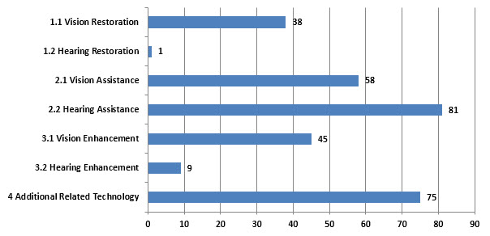
Figure 81: Analysis of Major Topics in Assistive Devices and Technologies for Visually and Hearing Impaired Persons Landscape for Canon.

TOSHIBA
Toshiba Corporation was founded in 1875 and is headquartered in Tokyo, Japan.123
TOSHIBA CORPORATION is a Japan-based manufacturer that operates in five business segments. The Digital Product segment manufactures and sells cellular phones, hard disc devices, optical disc devices, televisions among others. The Electronic Device segment provides general logic integrated circuits (ICs), optical semiconductors, power devices, large-scale integrated (LSI) circuits, among others. The Social Infrastructure segment manufactures and sells various generators, power distribution systems, water and sewer systems, transportation systems and station automation systems, among others. The Home Appliance segment provides refrigerators, drying machines, washing machines, cooking utensils, cleaners and lighting equipment, among others. The Others segment is involved in the provision of logistics services. In January 2014, Toshiba Corp purchased substantially all assets of OCZ Technology Group, and launched new subsidiary, OCZ Storage Solutions.124

Relevant News and Articles:
- This was a case study which was published in Toshiba business website which states a solution for blind to read through a customized a Toshiba e-STUDIO multifunction product (MFP) with Braille on the touch-screen. Software named Re-Rite was installed on SSB’s server, allowing the user to scan a document through the Toshiba MFP, turn it into a readable PDF and send to an email inbox. Readable PDF files can then be translated with reading software, so visually impaired employees can now listen to their mail being read independently.125
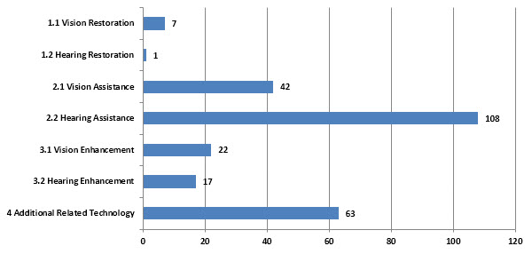
Figure 82: Analysis of Major Topics in Assistive Devices and Technologies for Visually and Hearing Impaired Persons Landscape for Toshiba.

AT&T
AT&T Inc. provides telecommunications services to consumers and businesses in the United States and internationally. Its Wireless segment offers various wireless voice, data, text, and other services, including local wireless communications services, long-distance services, and roaming services. This segment also sells various handsets, wirelessly enabled computers, and personal computer wireless data cards through its owned stores, agents, or third-party retail stores; and accessories comprising carrying cases, hands-free devices, batteries, battery chargers, and other items to consumers, as well as to agents and third-party distributors. As of December 31, 2013, this segment served approximately 110 million wireless subscribers. The company’s Wireline segment provides data services, such as switched and dedicated transport, DSL Internet access, network integration, managed Web-hosting, packet, and enterprise networking services, as well as local, interstate, and international wholesale networking capacity to other service providers. This segment also offers voice services consisting of local and long-distance services; wholesale switched access services to other service providers; and outsourcing services, integration services and customer premises equipment, and government-related services. This segment served approximately 12 million retail consumer access lines, 10 million retail business access lines, and 2 million wholesale access lines. The company has strategic relationship with IBM to provide businesses with a source for network security and threat management. The company was formerly known as SBC Communications Inc. and changed its name to AT&T Inc. in November 2005. AT&T, Inc. was founded in 1983 and is based in Dallas, Texas.126
U-verse remote control allows deaf and blind people to control their TVs from their iPhones and iPads with voice and gesture controls.127
U-verse TV, Closed Captioning through certain content providers. Closed Captioning allows hearing impaired subscribers to see the movie dialog as text on the bottom of the screen.
AT&T U-verse customers can also program their DVR from their PC, allowing visually impaired subscribers to easily schedule recordings. The layout and shape of the buttons on the U-verse TV remote and the programming guide sounds also help the visually impaired navigate the service.128

Relevant News and Articles:
- This was an article which was published on October 4, 2011 in Engadget website which states that AT&T is providing a free android accessibility solution for visually impaired people .Users will find the ability to place calls, send email and text messages, set alarms, browse the web, find their current location and more.129
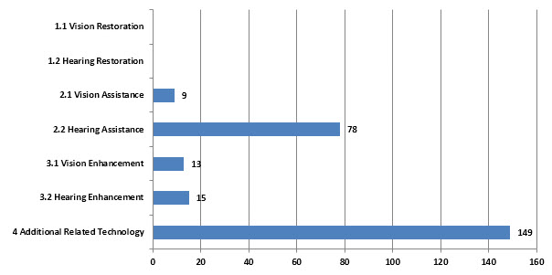
Figure 83: Analysis of Major Topics in Assistive Devices and Technologies for Visually and Hearing Impaired Persons Landscape for AT&T.

HITACHI
Hitachi, Ltd. is a diversified company. Information and Telecommunication System segment offers system integration services and automated teller machines. Electricity System segment offers power generation systems. Social and Industrial System segment offers industrial machinery. Electronic Device and System segment offers liquid crystal displays. Construction segment offers hydraulic shovels and wheel loaders. High Functional Material segment offers electric wires and cables. Automotive System segment offers engine management and in-car information systems. Component and Device segment offers information record media and batteries. Digital Media and Consumer Product segment offers optical disk drives and refrigerators. Financial Service segment offers leasing and loan services. On March 1, 2014, it fully acquired Hitachi Medical Corp. On April 1, 2014, it transferred and integrated its air conditioning systems construction, and elevator and escalator businesses into two subsidiaries.130
Hitachi Medical Corporation develops, manufactures, sells, and installs medical systems, medical information systems, general analysis systems, and medical analysis systems for hospitals and clinics in Japan, North America, Europe, China, rest of Asia, and internationally. The company’s medical systems include diagnostic ultrasound systems, MRI systems, X-ray CT systems, X-ray systems, nuclear medicine systems, and radiotherapy systems; and medical information systems comprise medical image management systems, hospital information systems, medical administration systems, and comprehensive medical checkup systems. Its general analysis systems include radiation measuring instruments and radiation control instruments; and medical analysis systems consist of laboratory test systems and pipettors. The company was founded in 1949 and is headquartered in Tokyo, Japan. Hitachi Medical Corporation is a subsidiary of Hitachi, Ltd.131

Relevant News and Articles:
The Hitachi’s recent US patents include 5185515 and 4760245 which are related to Automated teller machine and method thereof, Method and apparatus for providing a voice output for card-based automatic transaction system respectively.
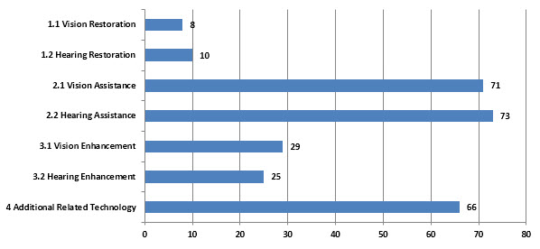
Figure 84: Analysis of Major Topics in Assistive Devices and Technologies for Visually and Hearing Impaired Persons Landscape for Hitachi

CARL ZEISS
The company was founded in 2002 and is headquartered in Jena, Germany. Carl Zeiss Meditec AG is a subsidiary of Carl Zeiss AG.132

Carl Zeiss Meditec AG is a Germany-based medical technology solutions supplier. The Company operates, along with its subsidiaries, in two business areas: Ophthalmology and Microsurgery. The Ophthalmology business area is subdivided into two business units: the Ophthalmology systems unit covers a range of laser and diagnostic systems for ophthalmology, and the Surgical Ophthalmology unit combines the Company’s activities in the field of ophthalmic implants and disposables. The Microsurgery business area offers surgical microscopes and visualization solutions for ear, nose and throat surgery, or neurosurgery. Its microsurgery products are mainly used as supporting equipment for the removal of tumors, as well as the treatment of vascular diseases and functional disorders. In January 2014, it acquired Optronik Optik ve Elektronik Cihazlar Ticaret ve Sanayi AS, a wholesaler of ophthalmology products, as well as a 100% stake in Aaren Scientific Inc, a producer of intraocular lenses.133

The complete spectacle lens and diagnostic instruments portfolio from ZEISS134

- Single Vision Lenses
- Digital Lenses
- Multifocal Lenses
- Sun & Filter lenses
- Coatings
- Dispensing Tools & Instruments

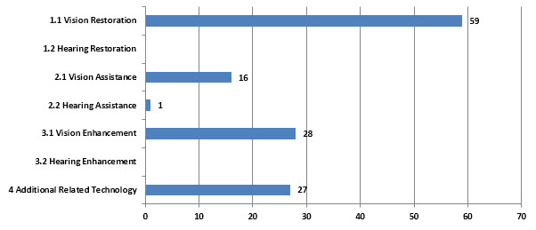
Figure 85: Analysis of Major Topics in Assistive Devices and Technologies for Visually and Hearing Impaired Persons Landscape for Carl Zeiss.

SECOND SIGHT LLC
Second Sight Medical Products, Inc., a medical device company, develops, manufactures, and markets implantable visual prosthetics for blind people. It offers The Argus II Retinal Prosthesis System, a device that restores some functional vision for people suffering from blindness. The company was founded in 1998 and is headquartered in Sylmar, California with an additional office in Lausanne, Switzerland.135

The Argus® II Retinal Prosthesis System
The Argus II Retinal Prosthesis System (“Argus II”) is the world’s first approved device intended to restore some functional vision for people suffering from blindness. Argus II is approved for use in the United States (FDA) and European Economic Area (CE Mark) and is available in some European countries, with several more to be added136
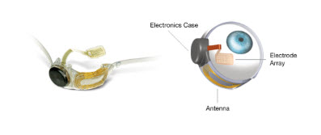
Figure: 86 The Implant (Source: http://2-sight.eu/ee/system-overview)
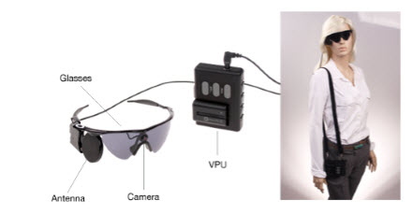
Figure 87: The External Equipment (Source: http://2-sight.eu/ee/system-overview)

Relevant News and Articles:
- This was an article which was published on February 14, 2013 by Business Wire which states that Second Sight Medical Products, Inc., the leading developer of retinal prostheses for the blind, is pleased to announce that its Argus II Retinal Prosthesis System (Argus II) has received U.S. market approval from the Food and Drug Administration to treat individuals with late stage Retinitis Pigmentosa. Argus II is intended to provide electrical stimulation of the retina to induce visual perception in blind individuals with retinitis pigmentosa and has the capacity to offer life-changing visual capabilities to those currently unable to see anything except, at best, extremely bright lights.137
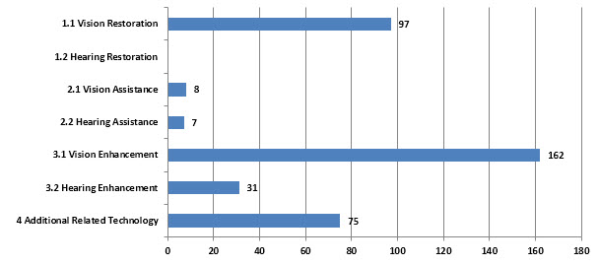
Figure 88: Analysis of Major Topics in Assistive Devices and Technologies for Visually and Hearing Impaired Persons Landscape for Second Sight LLC

PHONAK
Phonak AG develops, produces, and distributes hearing systems and wireless devices for people with hearing loss. It offers various hearing aids, such as tiny hearing aids; water resistant solutions; and three-in-1 accessories that provide wireless access to TVs, MP3 players, and phones. The company also provides various radio systems, including FM transmitters, receivers, CROSLink products, and accessories; pediatric hearing solutions, such as pediatric hearing aids and accessories; and accessories, which include communication products, remote controls, and cleansing and care line products. In addition, it offers communication and protection products, such as hearing protection, studio communication, security communication, and tour guiding systems; earphones, education and business solutions, and amplification upgrade solutions; and hearing aids that enable wearers to hear and understand in various challenging listening situations. The company offers its products through a network of distributors in Switzerland and internationally. Phonak AG was founded in 1947 and is headquartered in Stäfa, Switzerland. It has locations in Australia, Austria, Belgium, Brazil, Canada, China, Denmark, Finland, France, Germany, Hungary, India, Italy, Japan, Korea, Mexico, the Netherlands, New Zealand, Norway, Poland, the Russian Federation, Singapore, Spain, Sweden, Switzerland, Taiwan (province of China), Turkey, the United Kingdom, and the United States. Phonak AG operates as a subsidiary of Sonova Holding AG.138
Phonak’s Binaural VoiceStream Technology™ detects the speech signal and ensures that you can hear it clearly in both ears.139
- Phonak Audéo Q - available in three different discreet models that virtually disappear behind the ear, all offering leading performance.140
- Phonak Bolero Q - available in a range of styles, including a water and dust resistant model for added confidence in active situations.141
- Phonak Baseo Q - offers a perfect balance between performance and affordability. Colors designed to match hair and skin tones.142
- Phonak Virto Q - individually crafted to fit perfectly and comfortably in your ears, ranging in size from small to invisible.143
- Phonak Tao Q - worn discreetly inside the ear. Offers excellent sound quality at a remarkably affordable price.144
- Phonak Naída Q - the power family, designed for people with significant hearing loss, helps you hear and understand in even the toughest listening environments.145
- Phonak Sky Q- built on the latest technology offering one-of-a-kind features that support better hearing and understanding in 4 models and 3 performance levels.146

Relevant News and Articles
- This was an article which was published on March 26, 2014 by Phonak which states that new Phonak Tinnitus Program offers audiologists everything they need to develop their business with tinnitus clients. It contains all the technology and tools required to treat hearing loss and tinnitus simultaneously and effectively – all while giving audiologists the freedom to follow their preferred tinnitus management philosophy. A comprehensive package of support and counseling material allows them to either fine-tune their expertise or add tinnitus management to their skills. In addition, the lead generation component of the program supports audiologist in generating new tinnitus clients.147
- This was an article which was published on August 12, 2014 by PRNewswire which states that a new Roger technology allowed people with hearing loss to surpass the normal hearing in noise. At noise levels of 65dB and higher (similar to noise level in a restaurant setting), people with hearing loss using Roger performed better in the speech recognition test (laboratory test in which user recognizes and repeats words they hear) than those with normal hearing. At a noise level of 75dB, those with hearing loss achieved 69% accurate word recognition compared with only 7% by people with normal hearing.148

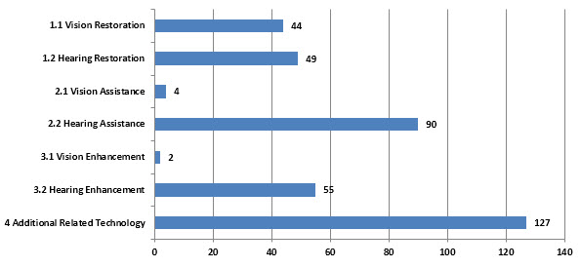
Figure 89: Analysis of Major Topics in Assistive Devices and Technologies for Visually and Hearing Impaired Persons Landscape for Phonak

FUJITSU
The company was formerly known as Fuji Tsushinki Manufacturing Corporation and changed its name to Fujitsu Limited in 1967. Fujitsu Limited was founded in 1935 and is headquartered in Tokyo, Japan.149
Fujitsu Limited is a Japan-based company engaged in the information communication technology (ICT) business. It has three segments. The Technology Solution segment manufactures and sells products including various servers, storage systems, various types of software, network management systems and optical transport systems, as well as the provision of system integrations services, consulting services, front technology services, network services and system support services. The Ubiquitous Solution segment manufactures and sells personal computers, mobile phones, as well as audio navigational devices, mobile communication equipment and automobile electronic devices. The Device Solution segment manufactures and sells large scale integrations (LSIs), semiconductor packages, batteries, relays and connectors, optical transmitter and receiver modules, among others.150

Relevant News and Articles
- This was an article which was published on November 3, 2010 by Media Access Australia which states that Fujitsu Limited is offering a free mobile phone application (app) in Japan that supports children with developmental or learning disabilities. The free mobile phone app addresses key areas of special needs through the following modules: ‘Timer’ to help understand time, ‘Picture card’ to help with communications and scheduling, ‘Handwriting’ to show the correct order in which to write characters in Japanese.
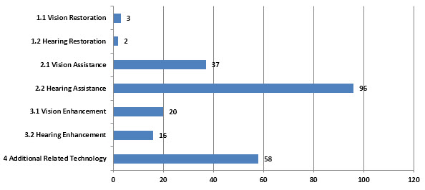
Figure 90: Analysis of Major Topics in Assistive Devices and Technologies for Visually and Hearing Impaired Persons Landscape for Fujitsu

WIDEX A/S
Widex A/S engages in the research, development, and manufacture of digital in-the-ear hearing aids. It provides various types of hearing aids, including behind-the-ear, completely-in-canal, invisible-in-canal, receiver-in-canal, and receiver-in-the-ear. The company also offers other hearing aids and accessories. It serves adults, as well as babies, infants, and older children in Denmark and internationally. The company was founded in 1956 and is based in Lynge, Denmark with production facilities in Vassingeroed and Helsinge, Denmark; Verviers, Belgium; and Tallinn, Estonia. It has subsidiaries in Argentina, Australia, Brazil, Canada, Chile, China, Czech Republic, Denmark, Estonia, Finland, France, Germany, Hong Kong (Special Administrative Region of the People’s Republic of China), Hungary, India, Ireland, Italy, Japan, New Zealand, Poland, Portugal, the Russian Federation, Singapore, Slovakia, Slovenia, South Africa, South Korea, Sweden, Switzerland, Turkey, the United Kingdom, Ukraine, and the United States.151
Widex offers an incredibly wide range of hearing aids to suit all types of hearing loss and styles.152
WIDEX DREAM allows more sound in than any other hearing aid so you can hear more details of the world around you – and in a way that’s as true-to-life as technology allows. Even in noisy environments such as parties, sport events or at the cinema.153
CLEAR hearing aids can communicate wirelessly with each other - just like two ears do. This means that all the functions in your hearing aids are adjusted instantly depending on your listening environment.154
The high-end SUPER440 hearing aid comes with a full range of advanced features that let you localise and focus on the dominant voice in a crowd. SUPER440 also comes with Zen, the revolutionary tone and relaxation program that plays random and harmonic tones in stereo to help you relax or manage tinnitus.155

Relevant News and Articles
- This was an article which was published on November, 2007 by EbscoHost Connection which offers information on the audibility extender, a hearing aid technology developed by Widex. The company's Inteo, is the first hearing aid in the world to employ Integrated Signal Processing (ISP). ISP achieves outstanding precision and accuracy in sound reproduction, helping people hear better in a variety of listening situations.156
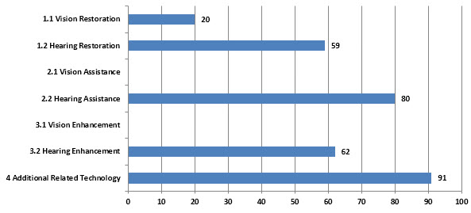
Figure 91: Analysis of Major Topics in Assistive Devices and Technologies for Visually and Hearing Impaired Persons Landscape for Widex A/S

SEIKO EPSON
The company sells its products primarily in Japan, the Americas, Europe, and Asia/Oceania. Seiko Epson Corporation was founded in 1942 and is headquartered in Suwa, Japan.157
Seiko Epson Corporation is primarily involved in the manufacture of various equipments. The Information Equipment segment manufactures and offers printers, such as inkjet printers, page printers and dot matrix printers, among others; visual products, such as liquid-crystal projectors and high temperature poly-silicon thin-film transistor (TFT) liquid crystal panels for liquid-crystal projectors, personal computers (PCs). The Printer segment is engaged in the development, manufacture and sale of products that implement total solutions for color digital data input and output. The Visual Products segment is engaged in the development, manufacture and sale of crystal devices including liquid crystal projectors, high temperature poly-silicon TFT liquid crystal panels of liquid crystal projectors. The other segment is engaged in the sale of PCs.158

An example of Seiko Epson’s innovative contribution to this technology field can be seen in patent US7556444B2 entitled “Embossing control method, program, braille-embossing apparatus, and character-information-processing apparatus”.

Relevant News and Articles
- This is a article which was published in JapanTimes where there is a new technology which was tested on deaf and blind patients , who were two different brands of headset were distributed for attendees to test: Seiko Epson’s Moverio and Olympus’ Meg. They both functioned in more or less the same way. This was a chance for the audience to experience the future of cinema in a barrier-free environment, so that everyone can enjoy going to the movies.159
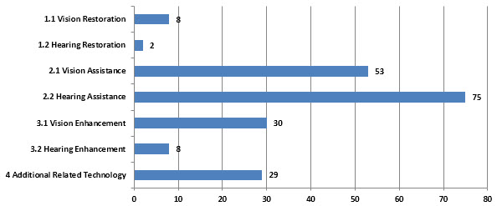
Figure 92: Analysis of Major Topics in Assistive Devices and Technologies for Visually and Hearing Impaired Persons Landscape for Seiko Epson

MED-EL ELECTROMEDIZINISCHE GERAETE GMBH
MED-EL Elektromedizinische Geräte Gesellschaft m.b.H. develops hearing implant solutions for children and adults. It offers cochlear implant and middle ear implant systems. The company was founded in 1977 and is based in Innsbruck, Austria. It has additional offices in Australasia, Austria, China, France, Germany, Hong Kong (Special Administrative Region of the People’s Republic of China), India, Indonesia, Italy, Japan, Korea, Malaysia, the Philippines, Portugal, Singapore, Spain, Thailand, Vietnam, the United Kingdom, and the United States, as well as Latin America and the Middle East.160

MED-EL Hearing Implant Solutions
The MAESTRO Cochlear Implant System- MAESTRO consists of both an internal cochlear implant and an externally worn audio processor.161
Electric Acoustic Stimulation (EAS) is designed to fit the unique needs of individuals with partial deafness. EAS combines the advantages of acoustic amplification and cochlear implant technology in one system. The system consists of both an internal and an external component.162
The Vibrant Soundbridge, a unique middle ear implant system, has opened a world of new hearing possibilities for individuals who have not experienced an improvement with conventional hearing aids or cannot use them for medical reasons. This is often the case with permanent hearing loss after middle ear surgery or when hearing aids cannot be worn due to chronic ear canal inflammation (i.e., otitis externa). The Vibrant Soundbridge can be an effective solution for cases of mild to severe sensorineural hearing loss, as well as for conductive or mixed hearing loss.163
The Bonebridge, the world's first active bone conduction implant system, is intended for individuals with conductive or mixed hearing loss. With conductive or mixed hearing loss, sound cannot take the natural path through the outer and middle ear to the inner ear. With the Bonebridge, the sound waves are transmitted via bone conduction directly to the inner ear, where they are processed as natural sound.164

Relevant News and Articles
- The company has filed an patent AU2012218042 which relates to acoustic signal processing for a hearing implant, and more particularly, to a speech coding methodology and system for a cochlear implant. The patent focusses on enhancing fine time structure transmission for hearing implant system.165
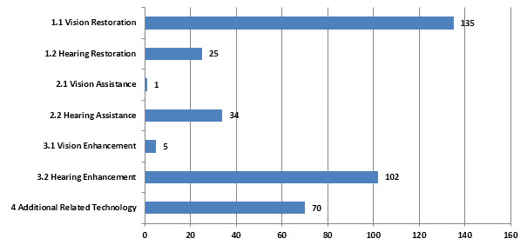
Figure 93: Analysis of Major Topics in Assistive Devices and Technologies for Visually and Hearing Impaired Persons Landscape for Med El Electromedizinische Geraete GmbH.

ALLERGAN
The company has collaboration agreements with Molecular Partners AG; Spectrum Pharmaceuticals, Inc.; and Serenity Pharmaceuticals, LLC. Allergan, Inc. was founded in 1948 and is headquartered in Irvine, California.166
Allergan, Inc. is a multi-specialty health care Company focused on developing and commercializing pharmaceuticals, biologics, medical devices and over-the-counter products. The Company’s segments include specialty pharmaceuticals, which produces a range of pharmaceutical products, including ophthalmic products for dry eye, glaucoma, inflammation, infection, allergy and retinal disease; Botox for certain therapeutic and aesthetic indications; skin care products for acne, psoriasis, eyelash growth and other prescription and over-the-counter skin care products; and urologic products and the medical devices segment, which produces a range of medical devices, including breast implants for augmentation, revision and reconstructive surgery and tissue expanders; obesity intervention products, and facial aesthetics products. In April 2014, TauTona Group’s subsidiary Aline Aesthetics has completed the sale of its Aline hyaluronic acid (HA) thread technology to Allergan, Inc.167
Allergan products to treat a variety of eye conditions including glaucoma, dry eye, and external eye diseases. Today we are a global leader in this specialty area. Leading products in Allergan's eye care product portfolio include RESTASIS® (cyclosporine ophthalmic emulsion) 0.05%, LUMIGAN® 0.01% and 0.03% (bimatoprost ophthalmic solution), and the REFRESH® Brand line of artificial tears.168, 169
An example of Allergan’s innovative contribution to this technology field can be seen in patent US8298570B2 entitled “Sustained release intraocular implants and related methods”.

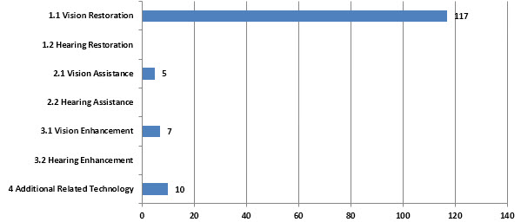
Figure 94: Analysis of Major Topics in Assistive Devices and Technologies for Visually and Hearing Impaired Persons Landscape for Allergan.

MITSUBISHI
Mitsubishi Corporation was founded in 1950 and is based in Tokyo, Japan.170
Mitsubishi Corporation is a Japan-based trading company. The New Industrial Finance segment involves in the asset management, buyout investment, leasing and financing of real estate and others. The Energy segment provides petroleum products, crude oil and others. The Metal segment offers steel products and others. The Machinery segment provides industrial machinery, automobiles and others. The Chemical segment provides petrochemicals, fertilizers, foodstuff, drugs and others. The Living Essentials segment provides distribution services. On August 19, 2013, M2 Communications reported that Mitsubishi Corp announced it had acquired from EDF Energies Nouvelles 50% interest in the companies. On November 15, 2013, the Company transferred 51% interest in a subsidiary, Japan Space Imaging Corporation. On December 18, 2013, Mitsubishi Corp was no longer its parent company. Effective December 16, 2013, Ayala Corp acquired 6.95% interest in Manila Water Co Inc from Mitsubishi Corp.171
An example of Mitsubishi’s innovative contribution to this technology field can be seen in patent US8407051B2 entitled “Speech recognizing apparatus”.
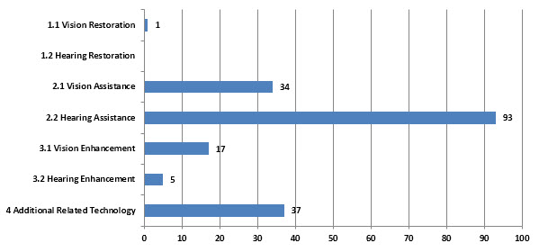
Figure 95: Analysis of Major Topics in Assistive Devices and Technologies for Visually and Hearing Impaired Persons Landscape for Mitsubishi.

MIKROKHIRURGIYA GLAZA SCI TECH COMPLEX
The Mikrokhirurgiya Glaza Interbranch Scientific Technical Complex was a former Soviet Government branch set up in the 1980’s who specialized in eye microsurgery. Now located in Cheboksary, Chuvashia Republic Russia172, Mikrokhirurgiya Glaza Interbranch Scientific Technical Complex is one of the leading centers to provide high-tech opthalmosurgical assistance in a wide variety of eye diseases and conditions173.
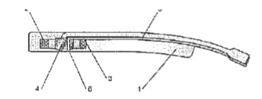
Figure 96: Mikrokhirurgiya Glaza Interbranch Scientific Technical Complex patent, ‘Magnetic laser implant for carrying out surgical photodynamic treatment of subretinal neovascular membrane and intraocular neoplasms’ (RU2240088C)

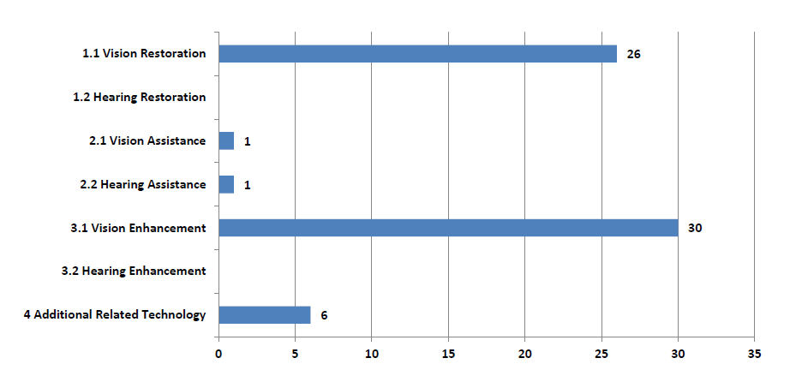
Figure 97: Analysis of Major Topics in Assistive Devices and Technologies for Visually and Hearing Impaired Persons Landscape for Mikrokhirurgiya Glaza Sci Tech Complex

ESSILOR
The company was founded in 1972 and is headquartered in Charenton-le-Pont, France.174
Essilor International SA is a France-based ophthalmic optics company. The Company is engaged in the corrective lenses. Its brands are Varilux, Crizal, Definity, Xperio, Optifog, Kodak and Foster Grant. The Company also develops and sells equipment for prescription laboratories, particularly through its subsidiary Satisloh, as well as instruments and services designed for optical professionals. It also develops and markets equipment, instruments and services for eye-care professionals. In November 2013, it acquired 50% stake in Xiamen Yarui Optical Company Ltd. In January 2014 it acquired majority stakes in in two prescription laboratories, namely R. D. Cherry in Michigan and Plunkett Optical and it Frame Displays, a company that designs, manufactures and distributes display furniture and accessories for optical stores. In February 2014, it acquired all outstanding shares of Costa Inc. In April 2014, it acquired Intercast and 51% of Transitions Optical.175
Essilor is the world’s leader for corrective lenses. The success of Essilor, which is present in more than 100 countries, is the result of a strategy that has been driven by innovation for more than 160 years. From design to manufacture, Essilor develops a wide range of lenses to correct and protect eyesight.176
The group therefore devotes more than 150 million euros a year on research and innovation to offer increasingly efficient products.
Its headline brands are Varilux®, Crizal®, Definity®, Xperio®, Optifog™ and Foster Grant®.
Complementing its portfolio of high performance lenses, Essilor provides a range of non-prescription reading and sunwear glasses through its FGX subsidiary to give people a wide access to quality vision correction solutions.
Essilor also designs, manufactures and distributes a range of instruments used by eye care professionals for testing sight and personalized measurements, edging and mounting lenses, plus specialist diagnostic equipment used by preventive healthcare institutions.
The Group, through its subsidiary Satisloh, is a leading supplier of equipment for ophthalmic and precision optics manufacturing – with surfacing, coating and finishing equipment used by prescription laboratories, optical chains and lens manufacturers and various industries for manufacturing optical components.177

Relevant News and Articles:
- October 17, 2013: Essilor develops its global Low Vision offering with the acquisition of Humanware178
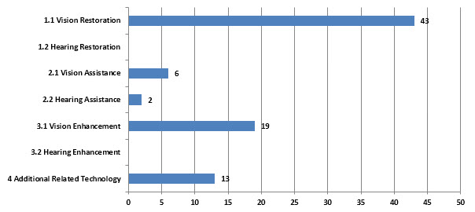
Figure 98: Analysis of Major Topics in Assistive Devices and Technologies for Visually and Hearing Impaired Persons Landscape for Essilor..

MENICON
Menicon Co., Ltd. engages in the manufacture, sale, export, and import of contact lens and care products. It offers medical instruments, medical supplies, and intraocular lenses. The company sells its products through distributors in Japan and internationally. Menicon Co., Ltd. was founded in 1951 and is based in Nagoya, Japan with locations internationally.179
Menicon is dedicated to all areas of the contact lens business including material development, lens design and the manufacture of contact lenses and care solutions. The new facility will expand Menicon's capacity and competitiveness for the supply of daily disposable lenses to global markets. In addition to producing daily disposable contact lenses, the new facility is slated to become a hub for the development of new technologies, complementing research conducted in Japan. Menicon Singapore will utilize technology developed locally in Singapore to produce state-of-the-art disposable contact lenses.180, 181
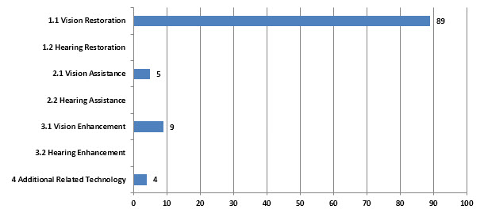
Figure 99: Analysis of Major Topics in Assistive Devices and Technologies for Visually and Hearing Impaired Persons Landscape for Menicon.

SAMSUNG
Samsung Electronics Co. Ltd., together with its subsidiaries, is engaged in consumer electronics, information technology and mobile communications, and device solutions businesses worldwide. The company offers various consumer products, such as mobile phones, tablets, televisions, Blu-rays, DVD players, home theaters, air track, Bluetooth speakers, and mini components; cameras and camcorders; home appliances comprising refrigerators, air conditioners, washing machines, microwave ovens, ovens, and dishwashers; PC/peripherals/printers, including tablet PC, notebooks, chrome devices, monitors, optical disc drive, and laser printer / multifunctions; memory and storage products, such as solid state drives and memory cards; and accessories, as well as computer products. It also provides healthcare products comprising digital X-ray, ultrasound, and in-vitro diagnostics; hospitality displays; large format displays; LSI products that include CMOS image sensors, display driver IC, smart card IC, microcontroller units, and field communication IC, as well as System-on-Chip, foundry services, and application processor for mobile devices; LED lighting solutions that comprise display panels, exterior and dashboard lighting, lighting packages, engines, drivers, and retrofit lighting; and LCD and OLED panels. In addition, the company is involved in cyber game match hosting; technology business venture capital investments; and manufacturing semiconductor components, as well as offers repair service for electronic devices. Further, it is engaged in manufacturing and selling electronic devices; providing general logistics agency services; sponsoring sports team and games; medical equipment; dental CT; credit management; software; marketing and services; consulting services; toll processing of LCD; and manufacturing optical fiber/cable activities. The company was founded in 1938 and is based in Suwon, South Korea.182

Relevant News & Articles:
- An article by Sarah Clark published on 14 March 2014 states about a Samsung unveils NFC voice label for visually impaired smartphone users.183
- An article by Alice Troung and Matt Brian covers a Samsung's Ultrasonic Smartphone Case that helps the visually impaired sense their surroundings184
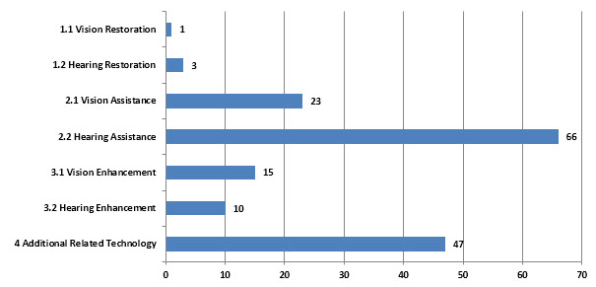
Figure 100: Analysis of Major Topics in Assistive Devices and Technologies for Visually and Hearing Impaired Persons Landscape for Samsung.

HOYA CORP
The company was founded in 1941 and is headquartered in Tokyo, Japan.185
HOYA CORPORATION offers electronics-related products, imaging products, healthcare products and medical products. The Information and Communication business segment has two divisions. The Electronics division offers photomasks and mask blanks. The Image division provides optical lens and optical glass materials, digital camera modules and optical devices, and various laser equipment. The Life Care segment has two divisions. The Healthcare division offers eyeglass lenses and contact lenses. The Medical division provides endoscopes, medical accessories, intraocular lenses, artificial bones and metal orthopedic implants. The Others segment is involved in the building of information systems, and the business contracting services. On October 1, 2013, it transferred its ceramics implant business to a wholly owned subsidiary, Japan Universal Technologies, Inc. On November 1, 2013, it acquired a majority shareholding in Wassenburg Group.186
Hoya single vision lenses are produced with TrueForm Technology:
- Nulux EP: calculated and produced according to the FreeForm principle, which allows each detail of the lens to be precisely determined to create a synergy between correction and natural sight.
- Nulux Active: provides support above and beyond a traditional single vision lens. It guarantees a more focused vision in all directions and variable distances and prevents tiredness, enabling you to work harder for longer.
- Nulux aspheric: Hoya’s aspheric single vision design with flatter, thinner looks and a wider visual field.
- Hilux spheric: Hoya’s standard spherical single vision design. Excellent choice for minor corrections.
- Suntech Intense by Hoya - adapts quickly to changing light conditions.
- Transitions Signature VII - Transitions lenses enhance the everyday visual quality and preserve the health and well being of the wearers’ eyes, so they can see better today and tomorrow
- Transitions XTRActive - the everyday lenses that go extra dark outdoors.
- DriveWear by Hoya - offers protection from glare and provides high contrast vision, resulting in less stress and fatigue while driving. DriveWear® combines Polarisation & Photochromic technologies.187
The company has filed a patent EP0100381A1and US4650843A that covers a soft contact lens has the same optical properties and elasticity as conventional soft contact lenses, and is very superior to the conventional ones in resistance to deposit and in shape stability.
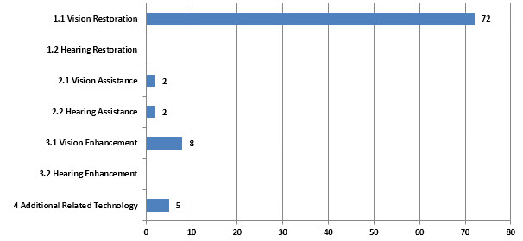
Figure 101: Analysis of Major Topics in Assistive Devices and Technologies for Visually and Hearing Impaired Persons Landscape for Hoya Corp.

TOYOTA
Toyota Motor Corporation was founded in 1933 and is headquartered in Toyota City, Japan.188
Toyota Motor Corporation is a Japan-based company mainly engaged in the automobile business and financial business. The Company operates through three business segments. The Automobile segment is engaged in the design, manufacture and sale of car products including passenger cars, minivans and trucks, as well as the related parts and accessories. The Finance segment is involved in the provision of financial services related to the sale of the Company's products, as well as the leasing of vehicles and equipment.189
An example of Toyota’s innovative contribution to this technology field can be seen in patent JP2012137458A entitled “Speech recognizing device, method and program”.
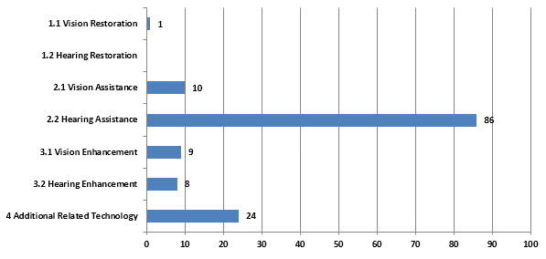
Figure 102: Analysis of Major Topics in Assistive Devices and Technologies for Visually and Hearing Impaired Persons Landscape for Toyota.

PHILIPS
The company was founded in 1896 and is headquartered in Best, the Netherlands. It has additional offices in the United States, Europe, the Asia Pacific, Canada, Africa, Latin America, and the Middle East. Philips Medical Systems International B.V. operates as a subsidiary of Koninklijke Philips N.V.190
Koninklijke Philips Electronics N.V. (Royal Philips Electronics) is the parent company of the Philips Group (Philips). Philips’ activities in the field of health and well-being are organized on a sector basis, which includes Healthcare, Consumer Lifestyle and Lighting. The Group Management & Services sector provides the operating sectors with support through shared service centers. As of December 31, 2010 Philips had 118 production sites in 27 countries, sales and service outlets in approximately 100 countries. In February 2010, the Company completed the acquisition of Somnolyzer 24x7 automated scoring solutions business of the Siesta Group in Vienna. In July 2010, the Company announced the acquisition of the street lighting business of Amplex A/S. In July 2010, it acquired Shanghai Apex Electronics Technology. In August 2010, the Company acquired CDP Medical Ltd. In August 2010, the Company acquired Burton Medical Products Corporation from Glamox ASA. In September 2010, the Company acquired Wheb Sistemas, a Brazil-based supplier of medical information systems. In November 2010, TPV Technology Ltd. acquired Philips TV China, the color television sales and distribution business of the Company. In December 2010, the Company sold certain interest in Assembleon to H2 Equity Partners. In January 2011, the Company bought Optimum Lighting. In June 2011, it acquired AllParts Medical.191
Philips Healthcare’s activities are organized across four businesses: imaging systems; patient care and clinical informatics; home healthcare Solutions, and customer services. Imaging systems include interventional X-ray, diagnostic X-ray, computed tomography (CT), magnetic resonance (MR), nuclear medicine (NM) and ultrasound imaging equipment, as well as women’s health. Patient care and clinical informatics include cardiology informatics, including diagnostic electrocardiography (ECG); enterprise imaging informatics, including radiology information systems (RIS) and picture archiving and communication systems (PACS); patient monitoring and clinical informatics; perinatal care, including fetal monitoring and Philips Children’s Medical Ventures, and therapeutic care, which includes cardiac resuscitation, emergency care solutions, therapeutic temperature management, hospital respiratory systems and ventilation. Home healthcare solutions include sleep management and respiratory care, medical alert services, remote cardiac services and remote patient management. Customer Services include consultancy, site planning and project management, clinical services, ambient experience, education, equipment financing, asset management and equipment maintenance and repair. Products and services are sold to healthcare providers globally, including academic, enterprise and stand-alone institutions, clinics, physicians, home healthcare agencies and consumer retailers.192
An example of Philips’ innovative contribution to this technology field can be seen in patent US7219057B2 entitled “Speech recognition method”.

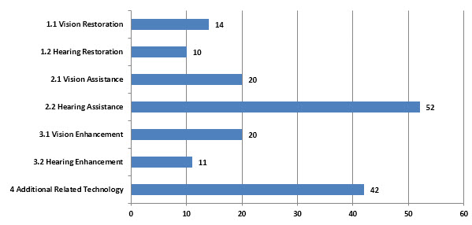
Figure 103: Analysis of Major Topics in Assistive Devices and Technologies for Visually and Hearing Impaired Persons Landscape for Philips.

MOSC EYE DISEASE
Moscow Helmholtz Research Institute of Eye Diseases
The Institute was established in 1900 on the charitable donations of a well-known Moscow philanthropist, Varvara Alexeyeva.
At her request doctor Konstantin Adelheim founded the first municipal Eye Hospital which provided the needy with free specialized medical care.
Opened with 3 in-patient departments (including a pediatric department) with a capacity of 50 beds and an ambulatorium with only about a 100 patient visits a day, the Hospital rapidly expanded and its staff considerably increased.
Soon the hospital was reformed into an institute named after Hermann Ludwig Ferdinand von Helmholtz (August 31, 1821 – September 8, 1894), who was a German physician and physicist who made significant contributions to several widely varied areas of modern science. In physiology and psychology, he is known for his mathematics of the eye, theories of vision, ideas on the visual perception of space, color vision research, and on the sensation of tone, perception of sound, and empiricism. In physics, he is known for his theories on the conservation of energy, work in electrodynamics, chemical thermodynamics, and on a mechanical foundation of thermodynamics. As a philosopher, he is known for his philosophy of science, ideas on the relation between the laws of perception and the laws of nature, the science of aesthetics, and ideas on the civilizing power of science.
Today the Institute is the leading scientific ophthalmological center and the largest specialist eye hospital in the Russian Federation. It is situated in the complex of 8 buildings with 57 departments and has more than 600 employees. Director of the institute professor Vladimir Neroev is the Ophthalmologist-in-Chief at the Ministry of Health of the Russian Federation.193
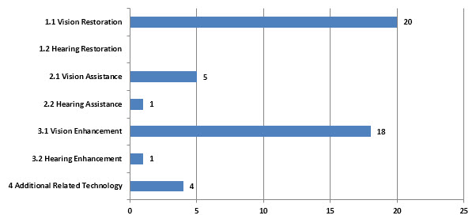
Figure 104: Analysis of Major Topics in Assistive Devices and Technologies for Visually and Hearing Impaired Persons Landscape for Mosc Eye Disease.

OTHER SIGNIFICANT ENTITIES
Below is a list of companies that do not fall within the top tier 1 assignee list but have significant market presence in vision and hearing impaired device related technology.
3M
ADVANCED NEUROMODULATION SYSTEMS INC
ALCATEL LUCENT
ALCON REFRACTIVE HORIZONS INC
ALFRED E. P.MANN FOUNDATION
ALPINE ELECTRONICS INC
APPLE
AS HED EYE DISEASE S RE S INST
AVAYA INC
BAUSCH S LOMB INCORPORATED
BOSTON SCIENTIFIC CORPORATION.
BROTHER IND CO LTD
CALIFORNIA INST OF TECHNOLOGY
CASIOCOMPUTER CO LTD
CHINESE ACAD SCI
CLARION CO LTD
CNRS
COOPER CO INC
CORNEAL
COWEN HEALTHCARE ROYALTY PARTNERS II L. P.
DAINIPPON PRINTING KK
DOHEPJY EYE INSTITUTE
DOKURITSU GYOSEI HOJIN SANGYO GIJUTSU SO
EKATERINBURG EYE MICROSURGERY CENTRE
ENVOY MEDICAL CORP
ETRI
E-VISION INC
EYE DISEAS RES INST
EYE MICROSURGERY RES TECH COMPLEX
FORSIGHT LABS LLC
FRANCE TELECOM
FRAUNHOFER GES FOERDERUNG
FREEDOM SCI INC
FUJI XEROX CO LTD
GE
GENERAL MOTORS CORP
GLAUKOS CORP
GN RESOUND A/S
GOOGLE
HONDA MOTOR CO LTD
HP
INTEL
IVANTIS INC
JOHNS HOPKINS UNIVERSITY
KNOWLES ELECTRONICS INC
KOKUSAI DENKI TSUSHIN KISOGIJUTSU KENKY
KONICA MINOLTA
KOREA ADV INST SCI & TECHNOLOGY
KOWA CO LTD
KYOCERA
LG
MASSACHUSETTS EYE 8, EAR INFIRMARY
MASSACHUSETTS INSITUTE OF TECHNOLOGY
MIKROKHIRURGIYA GLAZA COMPLEX FEDEROV
MINU LLC.
MO SC EYE MICRO SURGERY
MOTOROLA
NATIONAL INSTITUTES OF HEALTH THE
NATIONAL SCIENCE FOUNDATION
NIPPON HOSO KYOKAI
NISSAN MOTOR C O LTD
NOKIA
OKI ELECTRIC IND CO LTD
OLYMPUS CORP
OTICON
PIONEER CORP
PIXIUM VISION SA
POWERVISION INC
QUALCOMM INC
RESEARCH IN MOTION LIMITED
REVISION OPTICS INC
RICOH
ROBERT BOSCH
ROHTO SEIYAKU KK
SHARP KK
STAAR SURGICAL CO INC
STARKEY JAPAN CO LTD
SUMMIT TECHNOLOGY INC
TECHNOLAS PERFECT VISION GMBH
TEXAS IN STR INC
TOPCON CORP
TRANSCEND MEDICAL INC
TRANSITIONS OPITCAL INC
UFA EYE DISEASE RES INST
ULTRATEC INC
UNIV LELAND STANFORD JUNIOR
UNIV SOUTHERN CALIFORNIA
USB AG STAMFORD BRANCH
WAVELIGHT AG
YAMAHA

ANNEX B – PATENT LANDSCAPE SEARCH STRATEGYDIX B – PATENT LANDSCAPE SEARCH STRATEGY
(IC,ACP,EC=(A61F000200 OR A61F000202 OR A61F000214 OR A61F000216 OR A61F9*) OR MC=(A12-V02A OR D09-C01A OR S05-F05)) AND ALLD=((assist* OR aid* or help* or improve* OR support* OR impair* OR correct* OR repair OR implant* OR emulate* OR prosthesis OR prosthetic OR bionic* OR special need* OR handicap*) AND (cornea* OR retinal OR eyelid* OR iris OR choroid OR sclera OR fovea* OR ophthalmic OR ciliary ADJ muscle OR aqueous ADJ humour OR pupil OR Vision OR eye* OR sight OR see* OR ocular OR intraocular)) NOT ALLD=(retinoid OR urethra OR knee OR femoral OR tibia OR leg OR foot* OR conjunctivitis OR hip OR catheter OR skin ADJ defect OR cardiac OR defibrillator OR femur OR pelvis OR skeletal OR skeleton OR nightvision);
OR
IC,ACP,EC=(A61N00010543 OR A61N000136046);
OR
IC,ACP,EC=(G09B0021*) AND (ALLD=(assist* OR aid* or help* or support* OR impair* OR teach* OR emulate* OR tactile* OR Braille) NOT ALLD=(grab ADJ bar OR lift OR bowling));
OR
MC=(S05-F05 OR S05-K) NOT ALLD=(grab ADJ bar OR lift OR bowling OR night ADJ vision OR nightvision OR authenticating OR display ADJ window* OR wheel ADJ chair OR wheelchair OR respiratory OR power ADJ assist OR pulley* OR ergonomic OR digitized ADJ work* OR pruning OR walker or walking OR stool OR urine OR crutch OR oral or airbed OR welding OR cervial OR cervix OR dyslexia OR sidewall);
OR
FTC=(4C097AA24 OR 4C097SA00);
OR
IC,ACP,EC =(G01D000712 OR G06K0009*) AND (ALLD=(blind OR ((visual* OR sight) AND impair*)) NOT ALLD=(radiation OR x-ray OR blindspot OR blind ADJ spot OR athlete* OR watermark* Or financial OR money OR dollar OR magnetic ADJ resonance OR RFID OR camera OR signature OR MRI OR multi-frame OR image frame));

ALLD=(((Hear* OR listen* OR auditory OR sound* OR noise* OR speech OR cochlea* OR ossicular OR ossicle* OR vestibular OR tympanic OR Eustachian OR incus OR malleus OR ear* OR orthology OR Orthological) AND (assist* OR aid* or help* or improve* OR support* OR impair* OR correct* OR repair OR implant* OR emulate* OR prosthesis OR prosthetic OR bionic* OR special need* OR handicap*)) NOT (loudspeaker or loud ADJ speaker or pillow* or sleep or instrument OR vascular ADJ graft or earmuff or headset or garment or clothing or heartburn or stomach or colon or aircraft or pediatric or knee or helmet OR cardiac OR defibrillator OR hydrogel or singer or building or nucleic ADJ acid or tissue ADJ culture or cabinet or woofer or subwoofer or TV or television or hip or sealant Or apnea)) AND IC,ACP,EC =(A61F000200 OR A61F000202 OR A61F000218 OR A61F001100 OR A61F001108 OR A61F001112 OR A61F001114 OR G02C001106 OR H04R002500 OR H04R002502 OR H04R002504) AND MC=(S05-F01 OR W04-Y);
OR
ALLD=((Hear* OR listen* OR auditory OR sound* OR noise* OR speech OR cochlea* OR ossicular OR ossicle* OR vestibular OR tympanic OR Eustachian OR incus OR malleus OR ear* OR orthology OR Orthological) NOT (retinoid OR urethra OR cardiac OR defibrillator OR knee OR femoral OR tibia OR leg OR foot* OR catheter OR skin ADJ defect OR femur OR pelvis OR skeletal OR skeleton OR nightvision OR heart OR sleep* or pancrea* OR bicep*)) AND IC,ACP,EC =(A61N0001*);
OR
ALLD=((Hear* OR listen* OR auditory OR sound* OR noise* OR speech OR cochlea* OR ossicular OR ossicle* OR vestibular OR tympanic OR Eustachian OR incus OR malleus OR ear* OR orthology OR Orthological) AND (assist* OR aid* or help* or improve* OR support* OR impair* OR correct* OR repair OR implant* OR emulate* OR prosthesis OR prosthetic OR bionic* OR special need* OR handicap*)) AND (IC,ACP,EC =(G01L0015*) OR MC=(T01-C08A OR X22-L));
OR
FTC=(5D022 OR 5J100AA05 OR 5K012BA16);

Legend:
Relevant Classifications and Relevant Vision Assistive Devices and Technology Terminology [Search 1]
Relevant Classifications and Relevant Hearing Assistive Devices and Technology Terminology [Search 2]

ANNEX C – GLOSSARY
Glossary of Searched Field Codes:
MC: DWPI Manual Codes
AIOE: Any IPC or European Classification
FTC: Japanese F-Term Classifications
TID: DWPI Title Field
NOV: DWPI Novelty Field
USE: DWPI Use Field
ADV: DWPI Advantage Field
ALLD: Full DWPI Abstract
PRD: Priority Date Field
Glossary of Logic and Proximity Operators:
AND: Both terms must occur in the record
OR: One or the other terms must occur in the record:
NOT: One term but not the other must occur in the record
ADJ, ADJ2, ADJ3: Terms must occur next each, in order shown, within 1, 2 or 3 terms etc.
NEAR, NEAR2, NEAR3: Terms must occur next to each other, in either order, within 1, 2 or 3 terms etc.
Glossary of Other Terms Utilized in this Report:
Term | Definition
Americas | Includes the countries of both North and South America, e.g. Brazil, United States, Canada.
Asia Pacific | Includes the countries of the Far East - e.g. China, Japan, South Korea etc.; South Asian countries such as India and Australia/New Zealand
EMEA | Europe, the Middle East and Africa
Filing Breadth | A measure of the number of patent authorities in which the same invention has been filed. As this largely increases the level of fees the applicant has expended on the invention, it is tied to the level of commercial return the applicant would expect to get.
Granted Patent | Also known as an "Issued Patent", a successful patent application, which is generally re-published containing the finalized specification - the details of which may have changed since the application was first lodged.
National Phase Filing Event | The additional filing that takes place for a patent in further patent jurisdictions. See Office of Subsequent Filing.
Office of First Filing | The first location in which a particular invention has a patent application filed. Also known as the priority filing location.
Office of Subsequent Filing | Additional patent jurisdictions in which the applicant wishes to protect their invention.
Patent | An instrument that provides the holder a statutory right to exclude others (corporations or individuals) from practicing the invention claimed in their patent specification. Practicing the invention varies in different legal jurisdictions, but generally entail selling, marketing, exporting or importing articles which include the patented subject matter. Patents typically provide a exclusivity period of 20 years from the date the patent was first filed. Patent rights are not usually automatically granted; instead applications are filed with the patent office and then examined as to their validity, e.g. whether they are novel, not obvious and have real world usefulness. Patent validity varies considerably from country to country. Also note that lesser "patent-like" IP rights exist, such as Utility Models, that generall have lesser examination procedures as well as shorter exclusivity periods.
Patent Applicant | The organisation or individual applying for a patent.
Patent Application | The specification provided to a patent office by an inventor or their employer that details the invention over which they wish to claim exclusvitiy. Applications are examined as to whether they fulfill various validity requirements; three of which are novely, non-obviousness and usefulness.
Patent Assignee | The organisation to which a patent is assigned ownership; typically the inventor's employer.
Patent Citation | During patent examination/filing procedures, the examiner and/or the applicant will reference relevant patents or patent applications that currently exist in the public domain. Reversing this process allows for the analysis of the number these downstream citations an indivdiaul patent family has obtained over the course of its publication period. Patents with greater numbers of citation events are generally thought to be more impactful in their field, though individual data artifacts (such as citation bias) can occur and need to be accounted for.
Patent Claims | The section of a patent specification that contains the claimed invention by the inventor.
Patent Classification | Typically alpha-numeric codes that define discrete technologies, used both during patent search procedures and for further classification and grouping of sub technologies within a collection. Codes provide a method of retrieving and reviewing patents independent of the language used, overcoming shortfalls in key word searching due to synonyms and foreign languages. Example would be Derwent Manual Codes S02-A01A: Mechanical measurement using rules, micrometers, wheels. Types of classification include the International Patent Classification, European Classification, US Patent Classification, Japanese F-Terms, Cooperative Patent Classification and Derwent Manual Codes.
Patent Family | The collection of related patent documents (applications and granted/issued patents) that substantially cover the same basic invention.
Patent Search | The process of collating a dataset containing patent records of relevance.
Pendency | The period of time during which a patent application is filed at a patent office, but has not yet issued as a granted patent.
Priority Filing | The first location in which a particular invention has a patent application filed. Also known as the office of first filing.
Visual and Hearing Devices IP | This includes patented technologies for assistive devices and technologies for visually and hearing impaired persons

ANNEX D – AUTHOR BIOGRAPHIESTHOR APHIES

BACKGROUND ON CONSULTANT – NICK SOLOMON
Nick Solomon, based in Melbourne (Australia), delivers research, complex analytic projects and services solutions using advanced statistical analysis of scientific, technical, literature and Intellectual property data such as patents and trademarks. These projects and services are designed to provide intelligence on technical or competitive trends to senior client executives and decision makers.
Nick’s responsibilities also include providing expert insight and best practice knowledge on Thomson Reuters’ products, training and services and assessing customer requirements.
In an earlier role, Nick managed information services of an Australian intellectual property law firm for 10 years, where he became familiar with all aspects of the intellectual property field and analytics associated. Prior to this, Nick worked in research at the Commonwealth Scientific Industrial Research Organization (CSIRO) and as an IP officer for a Co-Operative Research center (CRC).
Nick joined Thomson Reuters in 2013 and has a Bachelor of Applied Science (Biochemistry/Chemistry) from Swinburne University and a Diploma in Business / Management.

BACKGROUND ON CONSULTANT – PARDEEP SINGH BHANDARI
Pardeep Singh Bhandari, based in Mumbai (India), has extensive experience in generating competitive landscapes based on patent information in specific technology areas and assessing the patent portfolio for client companies. The competitive landscape studies and assessment of the patent portfolio are designed to provide a comprehensive overview of the patent information on the technologies of interest and also provide insights into how the patent information can be probed to steer the research and technological development to maintain a competitive environment.
In his current role, Pardeep is heading India mechanical engineering team and this involves managing client engagements, process development, recruitment, training, and performance evaluation for the team. The clientele managed by Pardeep includes companies operating in the field of heavy machinery, power tools, gas turbine engine, Heating, air conditioning, & refrigeration (HVACR), home appliances, medical devices, and utility products sector. Apart from this, Pardeep has varied experience in patent application preparation and works in close partnership with in-house attorneys from corporations and in collaboration with outside counsels from law firms.
In his 8 years of overall experience in the intellectual property services sector, Pardeep has also worked on and managed various projects including prior-art/patentability searches, freedom-to-operate searches, patent validity assessment, patent to product mapping for evidence of use studies, and the state-of-art searches in the area of mechanical engineering, and related disciplines. His core technical expertise includes internal combustion engine, HVACR, gas turbine engines, and hydraulics.
Pardeep has been at Thomson Reuters since May 2007. He holds a Bachelor’s of Technology degree in Mechanical Engineering from Indian Institute of Technology (IIT), Delhi, India.

BACKGROUND ON EXTENDED ANALYTICS TEAM
A team of analysts having technology expertise in the field of electronics and biomedical devices is headed by Pardeep Singh Bhandari. The team of analysts included Prateesh Shukla, Kumar Ratish Singh and Shruti.
Prateesh Shukla has extensive experience in developing advanced statistical analysis of scientific, technical, and business data information. These reports are designed to provide intelligence on technical or competitive trends to senior client executives and decision makers.
Prateesh has extensively worked with clients on various landscape analyses in the domain of cellular and wireless communications, network appliances, web-based services and applications, semiconductors, high performance computing, data storage systems, software development and deployment, signal processing, audio, video and image processing, e-commerce and financial systems, electric and hybrid traction, electric power delivery and control, bioMEMS, foods and beverages, home care and personal care products, machine diagnostic/prognostic systems, medical equipment, and fast moving consumer goods (FMCG) sector.
Prateesh has been with Thomson Reuters since May 2012. He has about 3 years of experience in intellectually property and business research and holds a Master’s of Technology degree in Microelectronics from Indian Institute of Information Technology (IIIT), Allahabad, India.
Kumar Ratish Singh has extensive search and analytics experience with particular focus on intellectual property and business research. Ratish has extensively worked with clients on various projects such as searching, landscapes, patent alerts in the field of life sciences, biotechnology, pharmaceuticals, health care, biomedical devices, speciality chemicals, polymers, and fast moving consumer goods (FMCG) sector. He has been a part of Thomson Reuters since June 2012. He has 3 years of experience in the field of Intellectual Property and holds a Master’s of Technology degree in Biotechnology from Dr. D.Y. Patil University, Mumbai, India.
Shruti is involved in delivery of research and analysis projects in the domain of Mobile communication, VLSI Digital electronics, Semiconductor processing and Control systems. She joined Thomson Reuters in January 2014. She has 2 years of experience in the field of intellectual property, particularly patent alert, searching and analytics services. Prior to her stint in IP, she worked as a Software Engineer with Hewlett-Packard Company. She holds a Bachelor’s of Technology degree in Electronic and Communication from Kurukshetra University, Kurukshetra, India.



http://www.wipo.int/patentscope/en/programs/patent_landscapes/
http://www.who.int/medical_devices/en/ and http://www.who.int/disabilities/en/
http://www.who.int/disabilities/technology/gate/en/
http://www.wipo.int/treaties/en/ip/marrakesh/
http://whqlibdoc.who.int/publications/2011/9789240685215_eng.pdf
http://www.who.int/mediacentre/factsheets/fs282/en/
http://www.who.int/mediacentre/factsheets/fs300/en/index.html
http://www.who.int/disabilities/publications/dar_action_plan_2006to2011.pdf and http://www.who.int/disabilities/policies/actionplan/disability_action_plan_en.pdf ; for general information see http://www.who.int/disabilities/actionplan/en/
http://www.who.int/medical_devices/1240EHT_final.pdf
http://www.wipo.int/edocs/mdocs/copyright/en/vip_dc/vip_dc_8_rev.pdf
http://www.who.int/disabilities/technology/en/
For full details of the DWPI coverage and patent families, see DWPI Global Patent Sources
For full details of the DWPI classification system, see DWPI Classification System
A single patent only provides a statutory monopoly for the patented technology within the legal jurisdiction of the authority that granted the patent. This means that inventors must file applications for a patent in each jurisdiction where they foresee a need for protection; for subsequent applications they usually claim the priority of the first filing (territory of patent protection).
15 Office of first filing or Priority refers to the first application for a particular invention which when filed at any patent office becomes the “priority application”, with the date of this event defining the priority date. The patent office location of the first filing is defined as the priority country. The office of first filing event provides the patent applicant with a grace period to file on the same invention in other patent jurisdictions (offices of second filing) without loss of the “novelty” requirement for patentability.
16 Patent families are measured by the earliest known “priority” or first filing event in the inventions history. Patents are typically retained by patent offices for 18 months or more after filing before they are published. This delay means that the last complete year of information available for patent information is 2011.
17 ThemeScape® is a text-mining application that acquires and analyzes free text. The algorithms it uses require no application of thesauri or other outside sources of information, and only the free text itself is used by this text-mining tool. The more text the application acquires, the more likely it will be that the output will provide an accurate summary of the major themes present. After analyzing the text in multiple documents, it pulls together those documents that share related text and pulls apart those with less related text. The outcome is presented as a topographical map. Each document is placed on the map in a unique position that is the vector sum of its relatedness to all the other documents. ThemeScape uses the frequency of occurrence and co-occurrence of words to pick out topics of interest. It aggregates word forms that share a common stem, but it does not directly aggregate synonyms. Instead, synonyms may be gathered under a common theme because of the other words that co-occur with those synonyms. Thus, “battery” and “cell” may be clustered together because of the co-occurrence in the same documents of terms like “electrode, rechargeable, electrolyte” and so on. Conversely, “battery” and “cell” may be separated if the map contains a mixture of documents on electric power and biology, where the two terms have different meanings. In other words, terms are identified as synonyms only by co-clustering based on common context. The topographical maps presented by ThemeScape are mathematical solutions built on a random selection of a first document and sequential calculation of the relationships of all the other documents. The orientation of the map is random, and the directions up, down, left, or right have no significance, because the n-dimensional solution might have been presented from any angle. Only the proximity of points within the map has meaning, and co-localized documents are highly likely to share concepts. ThemeScape maps covering patents, abstracts of scholarly papers, news articles, or types of documents can be made. However two types of documents are not pooled and analyzed together. This is because ThemeScape is context-sensitive, and it would separate patent and literature documents from one another based on the very different formal styles of writing that are reflected in these two types of content. Likewise, if documents in two languages are pooled, it will separate them based on the language, and then each language region will be clustered based on term frequency in that language. ThemeScape can analyze very large numbers of documents. The contour lines on the maps diminish in circumference, encircling regions of higher and higher document concentration. The density is also shown by the map coloration. White snow-capped peaks represent the highest density, while blue expanses (sea level) indicate low density. The labels in black on the map are selected by ThemeScape based on term frequency in that map region, and they may be adjusted by the analyst. The dots on the map represent single documents. Dots are not shown for all the documents, and instead represent a sampling that allows the other features of the map to be discerned. Within the ThemeScape application, the map can be magnified, searched, probed and highlighted to learn more about its contents. ThemeScape is reliant on statistical methods that are not equivalent to reading by human judges, and in compensation, it analyzes millions of documents on a scale of minutes and quickly presents an intuitive, high level summary. It enables and guides further review, and provides a first level overview of very complex datasets.
18 South American and Latin American countries defined as Argentina, Bolivia, Brazil, Chile, Colombia, Costa Rica, Cuba, Dominican Republic, Ecuador, El Salvador, Guatemala, Guyana, Haiti, Honduras, Mexico, Nicaragua, Panama, Paraguay, Peru, Puerto Rico Suriname, Uruguay, and Venezuela.
19 A developing country is defined and measured with statistical indexes such as income per capita (per person) (gross domestic product), life expectancy, the rate of literacy (ignoring reading addiction) etc. The UN has developed the Human Development Index (HDI), a compound indicator of the above statistics, to gauge the level of human development for countries where data is available.
20 US8574295B2 ‘Accommodating Intra-ocular lens system’, Vista Ocular L.L.C
21 US6556870B2 ‘Partially inserted cochlear implant’, Med-El Elektromedizinische Geraete GmbH
22 US8401657B1 ‘Spectral profile adjustment of incoming audio signals for cochlear implant patients’, Advanced Bionics L.L.C.
23 Inventions contained within this classification aren’t exclusive, the technology contained also appears in other technology classes which more accurately describes the invention, however there has been reference to vision assistance in some form within the patent and that’s why it has appeared in a general form in this classification.
24 WO2011038465A1 ‘Object tracking for artificial vision’, National ICT Australia Ltd.
25 JP03775613B2 ‘The production method of an uneven/corrugated image’, ‘Fuji Photo Film CO Ltd’.
26 US6384743B1 ‘Touch screen for the vision-impaired’, Wisconsin Alumni Research Foundation
27 US2013194402A1 ‘Representing visual images by alternative senses’, Yissum Research Development Company of the Hebrew University of Jerusalem
28 EP2677982A1 ‘An Optical device for the visually impaired’, Isis Innovation
29 US8087936B2 ‘Systems and methods for verbal communication from a speech impaired individual’, Jason Knable
31 US2012268366A1 ‘Method and device for visual compensation’, Motorola Mobility LLC
32 http://www.wipo.int/treaties/en/ip/marrakesh/summary_marrakesh.html
32 http://www.intellogist.com/wiki/Report:Thomson_Innovation/Viewing_Results/Analyzing_Results/ThemeScape
37 US8382480B2, ‘Apparatus and method for presenting and controllably scrolling Braille text’, Verizon Patent and Licensing Inc.
38 US8369958B2, ‘Independent and concurrent processing multiple audio input signals in a prosthetic hearing implant’, Cochlear Limited
39 US6230135B1 ‘Tactile Communication Apparatus and Method’, Shannon A Ramsay; Alexander R. Ramsay
40 US8047849B2 “Braille display device using electrorheological fluid and manufacturing method thereof”, Korea Electronics and Telecommunications Research Institute (KETRI)
41 IN201200396I4 “Penpal - an electronic pen aiding visually impaired in reading, understanding and visualizing textual contents, Kumar Joshi; Tehseen Ayesha; Prabhu Madhan
42 US2012329518A1“ Mobile wireless communications device for hearing and/or speech impaired user”, Garg Neeraj; Research in Motion LTD; Blackberry
43 A full 20 year patent protection assumes that a patent has been examined, granted and all maintenance fees associated with the patent have been paid.
44 http://www.scribd.com/doc/24764035/Novartis-exercises-option-and-proposes-merger
45 http://investing.businessweek.com/research/stocks/private/snapshot.asp?privcapId=878091
46 http://www.google.com/finance?q=OTCMKTS%3APCRFY&sq=PANASONIC&sp=1&ei=izVfU6CYLIbRkAXUDw
47 http://panasonic.net/healthcare/letschat/
48 http://files.shareholder.com/downloads/KKR/3148603160x0x693576/645fee7e-3a2f-4a34-a3e5-6dc8925a33f5/KKR_News_2013_9_27_KKR.pdf
49 http://panasonic.co.jp/corp/news/official.data/data.dir/en111128-1/en111128-1.html
50 http://investing.businessweek.com/research/stocks/private/snapshot.asp?privcapId=4196890
51 http://www.reuters.com/finance/stocks/companyProfile?symbol=SI
52 http://hearing.siemens.com/Global/en/about-us/company-information/company-information.html
53 http://hearing.siemens.com/Global/en/products/bte/bte.html
54 http://hearing.siemens.com/Global/en/products/ite/ite.html
55 http://hearing.siemens.com/Global/en/products/pocket/pocket.html
56 http://online.wsj.com/articles/siemens-sells-hearing-aid-unit-for-2-68-billion-1415254996
57 http://investing.businessweek.com/research/stocks/snapshot/snapshot.asp?ticker=ABT
58 http://www.reuters.com/finance/stocks/companyProfile?symbol=ABT.N
59 http://www.abbott.com/global/url/content/en_US/product/product_category/Product_Category_Profile_0006.htm
60 http://www.amo-inc.com/about-amo/history
61 https://www.abbott.com/press-release/abbott-to-enter-laser-cataract-surgery-market-through-acquisition-of-optimedica.htm
62 http://www.reuters.com/finance/stocks/companyProfile?symbol=COH.AX
63 http://www.cochlear.com/wps/wcm/connect/intl/home/discover/cochlear-implants/cochlear-implants-nucleus-system
64 http://www.cochlear.com/wps/wcm/connect/intl/home/discover/cochlear-implants/the-nucleus-6-system-/nucleus-6-for-adults/nucleus-6-sound-processor/nucleus-6-sound-processor
65 http://www.law360.com/articles/503691/cochlear-hit-with-131m-verdict-in-implant-patent-trial
66 http://www.prnewswire.com/news-releases/cochlear-announces-the-fda-approval-of-true-24-ghz-wireless-connectivity-with-the-cochlear-nucleus-6-sound-processor-275137461.html
67 http://investing.businessweek.com/research/stocks/snapshot/snapshot.asp?ticker=VRX:CN
68 http://www.reuters.com/finance/stocks/companyProfile?symbol=VRX.N
69 http://www.valeant.com/operational-expertise/valeant-united-states/eye-health
70 http://www.bausch.com/our-company/
71 http://www.bausch.com/en/our-company/recent-news/2014-archive/peroxiclear-launch/
72 http://www.bausch.com/en/our-company/recent-news/2014-archive/blis-reusable-injector-system/
73 http://www.sys-con.com/node/3074719 ⁷³ http://investing.businessweek.com/research/stocks/snapshot/snapshot.asp?ticker=NUAN ⁷³ http://www.reuters.com/finance/stocks/companyProfile?symbol=NUAN.O
74 http://investing.businessweek.com/research/stocks/snapshot/snapshot.asp?ticker=NUAN
75 http://www.reuters.com/finance/stocks/companyProfile?symbol=NUAN.O
76 http://www.nuance.com/for-individuals/mobile-applications/talks-zooms/index.htm
77 http://www.nuance.com/for-business/by-solution/customer-service-solutions/solutions-services/accessibility/index.htm
78 http://www.interactiveaccessibility.com/blog/nuance-releases-dragon-naturally-speaking-12
79 http://www.advancedbionics.com/com/en/system/footer/about_us.html
80 https://www.advancedbionics.com/com/en/products/accessories/t-mic.html
81 http://www.advancedbionics.com/com/en/system/footer/about_us/corporate_news/2014/myNaida_app.html
82 http://cochlearimplantonline.com/site/possible-future-sound-processor-for-advanced-bionics-recipients/
83 http://www.advancedbionics.com/com/en/system/footer/about_us/corporate_news/2013/naida_us.html
84 https://www.advancedbionics.com/com/en/system/footer/about_us/corporate_news/2013/neptune_australia.html
85 http://www.businesswire.com/news/home/20141103005008/en/Advanced-Bionics-Re-Launches-Listening-Room%E2%84%A2-Website-Unique#.VG24RsljmP0
86 http://www.businesswire.com/news/home/20140916006521/en/Advanced-Bionics-Launches-World%E2%80%99s-Waterproof-Case-Cochlear#.VG24SsljmP0
87 http://www.businesswire.com/news/home/20140814005026/en/Advanced-Bionics-Launches-Educational-Apps-Children-Hearing#.VG24TsljmP0
88 http://www.businesswire.com/news/home/20140414006248/en/Advanced-Bionics-Announces-Arrival-Vietnam#.VG24UMljmP0
89 http://www.businesswire.com/news/home/20140710005041/en/Neptune%E2%84%A2-Waterproof-Cochlear-Implant-Sound-Processor-Advanced#.VG24VcljmP0
90 http://eng.mntk.ru/pages/index.php?id_page=366
91 http://www.ncbi.nlm.nih.gov/pubmed/20813411
92 http://investing.businessweek.com/research/stocks/snapshot/snapshot.asp?ticker=JNJ
93 http://www.reuters.com/finance/stocks/companyProfile?symbol=JNJ.N
94 http://www.acuvueprofessional.com/about-us
95 https://www.jnjvisioncare.co.uk/about-us
96 https://www.jnjvisioncare.co.uk/about-us
97 http://www.ophthalmologyweb.com/1315-News/159838-Johnson-Johnson-Vision-Care-Inc-Now-Accepting-Research-Proposals-Related-To-Meibography-And-Tear-Film-Stability-With-Contact-Lens-Wear/
98 http://www.optometryweb.com/1315-News/157703-Johnson-Johnson-Vision-Care-Announces-Expanded-Parameters-for-ACUVUE-sup-sup-OASYS-sup-sup-Brand-Contact-Lenses-for-ASTIGMATISM/
99 http://investing.businessweek.com/research/stocks/snapshot/snapshot.asp?ticker=6701:JP
100 http://www.prnewswire.com/news-releases/nec-foundation-of-america-supports-totally-neat-projects-gee-whiz-technology-creates-affordable-solutions-for-people-with-disabilities-76180427.html
101 http://investing.businessweek.com/research/stocks/snapshot/snapshot.asp?ticker=6823:JP
102 http://www.reuters.com/finance/stocks/companyProfile?symbol=6823.T
103 http://www.rion.co.jp/english/corp-e/outline.html
104 http://investing.businessweek.com/research/stocks/snapshot/snapshot.asp?ticker=IBM
105 http://www.reuters.com/finance/stocks/companyProfile?symbol=IBM.N
106 http://www-03.ibm.com/able/
107 http://www-03.ibm.com/able/news/conversationalweb.html
108 http://investing.businessweek.com/research/stocks/snapshot/snapshot.asp?ticker=SNE
109 http://www.reuters.com/finance/stocks/companyProfile?symbol=SNE.N
110 http://pro.sony.com/bbsc/ssr/mkt-digitalcinema/resource.latest.bbsccms-assets-mkt-digicinema-latest-EntertainmentAccessGlasses.shtml
111 http://investing.businessweek.com/research/stocks/private/snapshot.asp?privcapid=6921389
112 http://usa.nidek.com/#
113 http://www.nidek-intl.com/products/index.html
114 http://www.bioopticsworld.com/articles/2014/04/nidek-ophthalmic-oct-system-receives-fda-clearance.html
115 http://investing.businessweek.com/research/stocks/snapshot/snapshot.asp?ticker=MSFT
116 http://www.reuters.com/finance/stocks/companyProfile?symbol=MSFT.O
117 http://www.microsoft.com/enable/at/matvplist.aspx
118 http://www.informationweek.in/informationweek/press-releases/287516/microsoft-announces-free-screen-reader-software-help-microsoft-office-users-vision-disabilities
119 http://investing.businessweek.com/research/stocks/snapshot/snapshot.asp?ticker=9437:JP
120 http://www.theverge.com/2012/1/30/2758691/nintendo-ntt-docomo-speech-recognition-education-DS
121 http://www.reuters.com/finance/stocks/companyProfile?symbol=CAJ.N
122 http://investing.businessweek.com/research/stocks/private/snapshot.asp?privcapId=7608786
123 http://investing.businessweek.com/research/stocks/snapshot/snapshot.asp?ticker=6502:JP
124 http://www.reuters.com/finance/stocks/companyProfile?symbol=6502.T
125 http://business.toshiba.com/media/downloads/about/pressroom/Re-Rite_Case_Study.pdf
126 http://investing.businessweek.com/research/stocks/snapshot/snapshot.asp?ticker=T
127 http://www.disabled-world.com/assistivedevices/apps/u-verse-remote.php
128 http://about.att.com/mediakit/disability
129 http://www.engadget.com/2011/10/04/atandt-intros-free-android-accessibility-solution-for-visually-imp/
130 http://www.reuters.com/finance/stocks/companyProfile?symbol=6501.T
131 http://investing.businessweek.com/research/stocks/private/snapshot.asp?privcapId=881604
132 http://investing.businessweek.com/research/stocks/snapshot/snapshot.asp?ticker=AFX:GR
133 http://www.reuters.com/finance/stocks/companyProfile?symbol=AFXG.DE
134 http://www.zeiss.com/vision-care/en_de/home.html
135 http://investing.businessweek.com/research/stocks/private/snapshot.asp?privcapId=7715922
136 http://2-sight.eu/ee/product
137 http://www.businesswire.com/news/home/20130214006081/en/Sight-Medical-Products-Receives-FDA-Approval-Argus#.U2oEyFcTP0V
138 http://investing.businessweek.com/research/stocks/private/snapshot.asp?privcapId=35087146
139 http://www.phonak.com/com/b2c/en/products/hearing_instruments.html
140 http://www.phonak.com/com/b2c/en/products/hearing_instruments/audeo-q.html
141 http://www.phonak.com/com/b2c/en/products/hearing_instruments/bolero-q.html
142 http://www.phonak.com/com/b2c/en/products/hearing_instruments/baseo-q.html
143 http://www.phonak.com/com/b2c/en/products/hearing_instruments/virto-q.html
144 http://www.phonak.com/com/b2c/en/products/hearing_instruments/tao-q.html
145 http://www.phonak.com/com/b2c/en/products/hearing_instruments/naida-q.html
146 http://www.phonak.com/com/b2c/en/products.html
147 http://www.phonak.com/com/b2c/en/system/topnav/about_phonak/media_center/press_releases/2014_mar_26_tinntus.html
148 http://www.prnewswire.com/news-releases/new-phonak-technology-allows-people-with-hearing-loss-to-hear-better-than-normal-hearing-people-270937261.html
149 http://investing.businessweek.com/research/stocks/snapshot/snapshot.asp?ticker=6702:JP
150 http://www.reuters.com/finance/stocks/companyProfile?symbol=6702.T
151 http://investing.businessweek.com/research/stocks/private/snapshot.asp?privcapId=5600371
152 http://www.widex.com/en/products/hearingaids/
153 http://www.widex.com/en/products/hearingaids/dream/
154 www.widex.com/en/products/hearingaids/clear/
155 http://www.widex.com/en/products/hearingaids/super/
156 http://connection.ebscohost.com/c/articles/27520982/new-hearing-aid-technology
157 http://investing.businessweek.com/research/stocks/snapshot/snapshot.asp?ticker=6724:JP
158 http://www.reuters.com/finance/stocks/companyProfile?symbol=6724.T
159 http://www.japantimes.co.jp/news/2014/11/01/national/science-health/new-tech-brings-cinema-deaf-blind/#.VG3NzsljmP0
160 http://investing.businessweek.com/research/stocks/private/snapshot.asp?privcapId=47684079
161 http://www.medel.com/int/cochlear-implants
162 http://www.medel.com/us-eas-the-eas-hearing-implant-system/
163 http://www.medel.com/int/vibrant-soundbridge/
164 http://www.medel.com/int/bonebridge/
165 http://www.ipaustralia.com.au/applicant/med-el-electromedizinische-geraete-gmbh/patents/AU2012218042/
166 http://investing.businessweek.com/research/stocks/snapshot/snapshot.asp?ticker=AGN
167 http://www.reuters.com/finance/stocks/companyProfile?symbol=AGN.N
168 http://www.allergan.com/products/eye_care/index.htm
169 http://www.allergan.com/products/patent_notices.htm
170 http://investing.businessweek.com/research/stocks/snapshot/snapshot.asp?ticker=8058:JP
171 http://www.reuters.com/finance/stocks/companyProfile?symbol=8058.T
172 http://rus.bizdirlib.com/node/138444
173 www.chtts.ru/mntk/
174 http://investing.businessweek.com/research/stocks/snapshot/snapshot.asp?ticker=EI:FP
175 http://www.reuters.com/finance/stocks/companyProfile?symbol=ESSI.PA
176 http://www.essilorindia.com/about-us
177 http://www.essilor.com/EN/GROUP/Pages/Home.aspx
178 http://www.essilor.com/en/Press/News/Documents/2013/CP%20Humanware_A.pdf
179 http://investing.businessweek.com/research/stocks/private/snapshot.asp?privcapId=5544484
180 http://www.davidthomas.com/latest-news/menicon-expand-in-singapore/
181 http://www.menicon.com/consumer/
182 http://investing.businessweek.com/research/stocks/snapshot/snapshot.asp?ticker=005930:KS
183 http://www.nfcworld.com/2014/03/14/328318/samsung-unveils-nfc-voice-label-visually-impaired-smartphone-users/
184 http://www.fastcompany.com/3027742/fast-feed/samsungs-ultrasonic-smartphone-case-helps-the-visually-impaired-sense-their-surrou
185 http://investing.businessweek.com/research/stocks/snapshot/snapshot.asp?ticker=7741:JP
186 http://www.reuters.com/finance/stocks/companyProfile?symbol=7741.T
187 http://www.hoya.co.uk/index.php?SID=535f879f190af054212288&page_id=19319
188 http://investing.businessweek.com/research/stocks/snapshot/snapshot.asp?ticker=7203:JP
189 http://www.reuters.com/finance/stocks/companyProfile?symbol=TM.N
190 http://investing.businessweek.com/research/stocks/private/snapshot.asp?privcapId=842095
191 http://www.reuters.com/finance/stocks/companyProfile?symbol=PHG.N
192 http://www.reuters.com/finance/stocks/companyProfile?symbol=PHG.N
193 http://www.igb.ru/eng/

