|  |  |
| --- | --- |
| **E** | |
|  | WIPO-E |
|  |
|  | |
| **wORKSHOP** | |
| WIPO/IPTK/YFB/19/INF/5 | |
| ORIGINAL:  ENGLISH | |
| DATE:  September 26, 2019 | |

**Practical Workshop on Intellectual Property, Traditional Knowledge and Traditional Cultural Expressions for Countries from the Arctic Region**

organized by

the World Intellectual Property Organization (WIPO)

and

the Government of Canada

in collaboration with

Nunavut Tunngavik Inc.

**Iqaluit, Canada, May 14 to 16, 2019**

Report

*prepared by the International Bureau of WIPO*

**TABLE OF CONTENTS**

[ABBREVIATIONS 3](#_Toc19522147)

[OVERVIEW 4](#_Toc19522148)

[About the Practical Workshop 4](#_Toc19522149)

[Significance 5](#_Toc19522150)

[Participants 5](#_Toc19522151)

[About this Report 5](#_Toc19522152)

[Summary of the Outcomes 7](#_Toc19522153)

[REPORT OF THE INDIGENOUS PEOPLES AND LOCAL COMMUNITIES DAY (IPLCs Day) 9](#_Toc19522154)

[Official Opening and Welcome 9](#_Toc19522155)

[Identifying Issues, Needs and Expectations 11](#_Toc19522156)

[Introduction to Intellectual Property 13](#_Toc19522157)

[Introduction to Traditional Knowledge and Traditional Cultural Expressions 13](#_Toc19522158)

[Observations: IPLCs Day 13](#_Toc19522159)

[REPORT OF THE PRACTICAL WORKSHOP 14](#_Toc19522160)

[Opening Remarks for the Practical Workshop 14](#_Toc19522161)

[Topic 1: Intellectual Property, Traditional Knowledge and Traditional Cultural Expressions 15](#_Toc19522162)

[Topic 2: Available Intellectual Property Tools to Protect Traditional Knowledge and Traditional Cultural Expressions 19](#_Toc19522163)

[Participant Comments on Topic 1 and Topic 2 Presentations 20](#_Toc19522164)

[Overview: Case Studies 21](#_Toc19522165)

[Case Study 1 - Copyright 22](#_Toc19522166)

[Observations: Practical Workshop Day 1 26](#_Toc19522167)

[Case Study 2 - Patents 27](#_Toc19522168)

[Group Work: Case Study 3: Distinctive Signs (Trademarks, Collective and Certification Marks, Geographical Indications) 30](#_Toc19522169)

[Case Study 3 - Distinctive Signs (Trademarks, Collective and Certification Marks, Geographical Indications) 34](#_Toc19522170)

[Presentations on Experiences and Best Practices 36](#_Toc19522171)

[Presentation: The Inuit Art Foundation, Canada 36](#_Toc19522172)

[Presentation: Innovation, Science and Economic Development, Canada 38](#_Toc19522173)

[Presentation: International Trade, Canadian Heritage, Canada 40](#_Toc19522174)

[Presentation: Sweden 44](#_Toc19522175)

[Presentation: Saami Parliament, Finland 47](#_Toc19522176)

[Presentation: Ministry of Education and Culture, Finland 50](#_Toc19522177)

[Closing Comments 52](#_Toc19522178)

# ABBREVIATIONS

|  |  |
| --- | --- |
| GI | Geographical indication |
| GRs | Genetic resources |
| ICH | Intangible cultural heritage |
| IGC | WIPO Intergovernmental Committee on Intellectual Property and Genetic Resources, Traditional Knowledge and Folklore |
| INTA | International Trademark Association |
| IP | Intellectual property |
| IPLCs | Indigenous Peoples and local communities |
| IPRs | Intellectual property rights |
| NTI | Nunavut Tunngavik Inc. |
| Pauktuutit | Pauktuutit Inuit Women of Canada |
| TCEs | Traditional cultural expressions/Expressions of folklore |
| TK | Traditional knowledge |
| UNDRIP | United Nations Declaration on the Rights of Indigenous Peoples |
| WIPO | World Intellectual Property Organization |

# OVERVIEW

## About the Practical Workshop

The *Practical Workshop on Intellectual Property, Traditional Knowledge and Traditional Cultural Expressions for Countries from the Arctic Region* (the Practical Workshop) was held in Iqaluit, Canada, from May 14 to 16, 2019. The Practical Workshop brought together Inuit, Saami and government representatives from three Arctic countries, namely Canada, Finland and Sweden. Together with experts from the World Intellectual Property Organization (WIPO) and a representative from the International Trademark Association (INTA), participants shared concerns, experiences and knowledge on ways to protect traditional knowledge (TK) and traditional cultural expressions (TCEs) with intellectual property (IP). The Practical Workshop was organised by WIPO and the Government of Canada in collaboration with Nunavut Tunngavik Inc. (NTI).

The Practical Workshop had three primary objectives:

* Foster cooperation between government officials and Indigenous Peoples and local communities (IPLCs), within each country and between countries from the Arctic region;
* Impart basic knowledge of the main principles, systems and tools of the IP system and how they relate to IPLCs, emphasizing both the potential value that IP could bring in support of TK and TCEs protection, as well as the challenges;
* Facilitate country-level exchanges on experiences and best practices relevant to the protection of TK and TCEs.

The Practical Workshop was interactive and participatory, and included presentations, case studies, and group work aimed to support and implement these objectives. The Program of the Practical Workshop is attached to this report. The Practical Workshop was not intended to yield any formal outcomes. Instead, it was designed to create an informal space for relationship building, dialogue and exchange.

The Practical Workshop consisted of two component events:

* A one-day preparatory meeting for IPLCs held on May 14. This will be referred to in the report as the IPLCs Day. The purpose of the IPLCs Day was to provide IPLCs with an introduction to basic information on the interface between IP, TK and TCEs. The IPLCs Day created space for the participants to identify and discuss IP-related issues arising in their communities and their organisations.
* A two-day Practical Workshop attended by government officials and IPLCs held on May 15 and 16.

The Practical Workshop was conceptualized and developed by WIPO and the Government of Canada over a two-year period. Invitations were sent to Denmark, Finland, Norway and Sweden. Denmark and Norway were not able to attend. The Practical Workshop was funded by WIPO and the Government of Canada.

## Significance

The Practical Workshop provided a unique platform for representatives and officials from Canada, Finland and Sweden to engage with each other, but also to reflect on these issues and to share experiences and best practices from across the region on the IP protection of TK and TCEs. The Practical Workshop also provided the space to build relationships across the region and imagine collaborative ways forward.

Such Practical Workshops are an important component of WIPO’s capacity-building and awareness-raising activities. This Practical Workshop followed seven previous Practical Workshops on TK, TCEs and GRs. The first two Practical Workshops, held in Geneva in December 2013 and 2014, brought together IPLCs representatives from around the world to Geneva to consider issues relating to IP and the concerns and aspirations of IPLCs. In 2015, a more elaborated model for the Workshops was tested, in which government officials from two or more relevant departments were also invited. In this way, the Workshops became “multi-stakeholder” while retaining their practical orientation. Such Workshops were held in Namibia, Panama, Samoa, Morocco and the Philippines between 2015 and 2017. Documents from these other Workshops are available on WIPO’s TK website.[[1]](#footnote-2)

These Practical Workshops aim to raise awareness of IP, foster engagement with regional and international work, and enhance cooperation between relevant Indigenous, national, regional and international actors. They provide an interactive and participatory forum for sharing information and experiences and dialogue between IPLCs, governments and relevant regional organizations.

## Participants

Representatives from three Arctic countries, Canada, Finland and Sweden, participated in the Practical Workshop. The Indigenous representatives were Inuit and Saami. Participants generally were part of the following categories:

* Representatives of Government Intellectual Property Offices;
* Officials from a range of government agencies, including those covering cultural industries, education and culture, innovation and economic development, and international trade and heritage; and
* IPLCs representatives, from cultural organisations and institutions and Indigenous governance institutions and entities.

Representatives from WIPO, the Government of Canada, the Inuit Circumpolar Council (ICC) of Canada and INTA attended and facilitated the Workshop.

## About this Report

This Report provides an overview of the discussions that occurred at the Practical Workshop. The Practical Workshop was designed to create an informal space for dialogue and exchange between different stakeholders in the Arctic region in respect of the relationship between IP, TK and TCEs. This report outlines the key issues and needs identified by the participants in relation to TK and TCEs protection. It also provides information about the current practices of communities and governments in the Arctic region. The Practical Workshop was not intended to, and did not reach, any formal outcomes.

This Report is a summary of the proceedings of the Practical Workshop. This Report does not constitute legal advice. If participants have specific questions concerning IP in relation to a particular case, please consult a qualified IP expert.

This Report was prepared by Ms. Katerina Lagassé, BCL/LLB, McGill University, Canada. Ms. Lagassé was commissioned by WIPO to be the Rapporteur of the Practical Workshop.

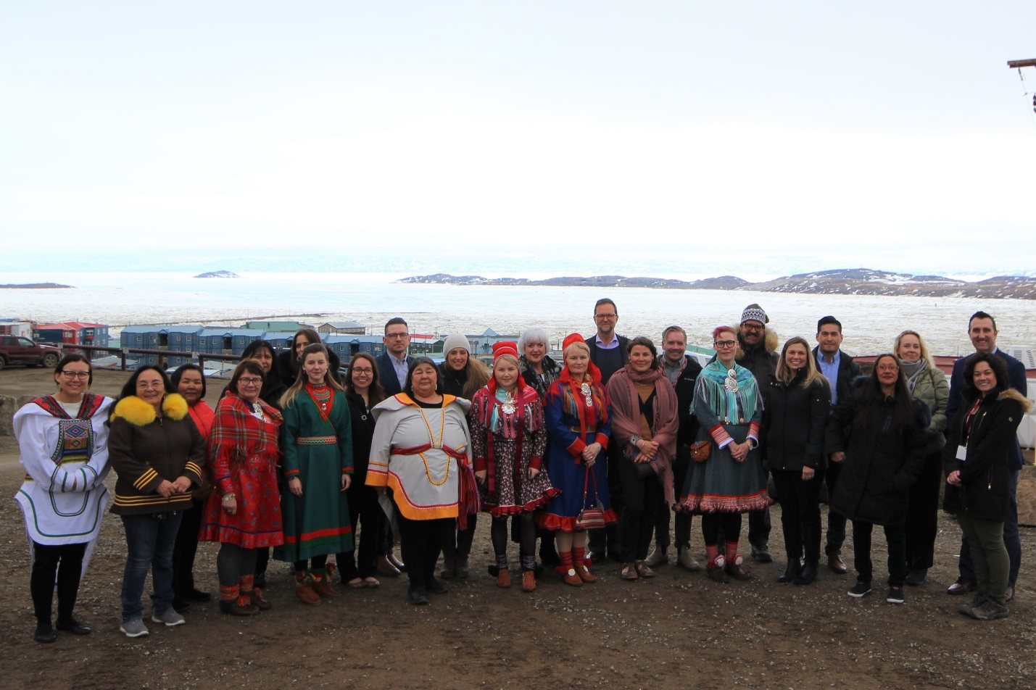

Group photo (photo: © John Maerzluft)

## Summary of the Outcomes

The Practical Workshop was a success as a result of the active and meaningful engagement of the participants. The participants shared their experiences and presented on challenges that have arisen in regards to TK and TCE protection. They also shared best practices and imagined ways forward.

The IPLCs Day provided a unique environment for IPLCs participants to learn about the IP system. This prepared IPLCs participants for the Practical Workshop and provided a unique space for them to build relationships.

Throughout the two-day Practical Workshop, participants learned about the various tools the IP system offers to protect TK and TCEs. They also learned about non-legal tools and methodologies that support the protection and promotion of IPRs, TK and TCEs. The case studies provided the participants with an opportunity to work together to apply the knowledge learned during the presentations on the IP system. The country presentations highlighted specific challenges to and different approaches to TK and TCEs protection.

The diversity of the activities contributed to the success of the Practical Workshop. The relatively small number of participants (around 40), the warm hospitality of the Canadian hosts, the extensive preparations undertaken by WIPO and the Canadian Government, attention to detail in the running of the workshop, and the interactive and participatory nature of the workshop all contributed to its collaborative, collegial and enjoyable atmosphere.

The benefits derived from the group discussions, presentations and case studies by the participants can be summarised as follows:

* An increased awareness of the distinct nature of TK and TCEs;
* An increased awareness and knowledge of the basic principles and objectives of the IP system;
* An increased awareness and knowledge of available IP tools and resources available on a domestic, regional and international level;
* An increased awareness and knowledge of other international instruments that support the protection of TK and TCEs;
* An increased understanding of the benefits and limitations of the IP system;
* An increased awareness of the often harsh realities of misuse of Indigenous TK and TCEs;
* An increased understanding of the non-legal mechanisms (such as guidelines and protocols) that support IP, TK and TCEs protection;
* The identification of common challenges and/or concerns related to the protection and promotion of TK and TCEs;
* The identification of opportunities surrounding cultural heritage and economic development;
* The identification of common goals such as safeguarding cultural identities and preventing the misappropriation of TK and TCEs; and
* Relationship building between IPLCs participants and government officials;

Lessons learned from the Practical Workshop can be summarised as follows:

* TK and TCEs can be considered economic and cultural assets. It is important to understand what protection is available in the conventional IP system to prevent inappropriate use by third parties;
* The identification of knowledge holders in communities in respect of TK and TCEs is beneficial. This form of recognition often occurs through traditional customs and practices;
* There are different methods available to protect TK and TCEs. They include positive and defensive forms of protection;
* Positive protection allows communities to benefit economically from their TK and TCEs. For example, this may be achieved through equitable benefit-sharing agreements, asserting IPRs and granting licenses. Defensive protection prevents third parties from exploiting TK and TCEs. For example, this type of protection may be achieved through trademarking culturally significant words. It may also be achieved by storing TK and TCE information in a database that can be used as evidence of the origin of the knowledge and ensure that it is only accessible by the community;
* The protection of TK and TCEs through IP is one means to achieve broader policy and cultural objectives. There are complementary international legal instruments that promote the ‘protection’, ‘preservation’ and ‘safeguarding’ of cultural heritage. Therefore, it is useful to follow a comprehensive approach and to understand what tools are available on national, regional and international level for different types of objectives;
* The conventional IP system is not designed to replace customary laws and practices that protect and promote TK and TCEs. Instead, the conventional IP system should be viewed as a complementary tool designed to address specific issues. It may be preferable to develop a *sui generis* IP system that is designed to protect TK and TCEs;
* There are many non-IP and non-legal tools that are available that prevent the misuse of TK and TCEs by third-parties. For example, guidelines and protocols may bring awareness on best practices for third-parties when they engage with Indigenous communities and their TK and TCEs. Further, educational campaigns may raise awareness with consumers about the impact of inappropriate use of TK and TCEs on Indigenous Peoples and communities. Education campaigns may also draw attention to issues surrounding the authenticity of Indigenous arts; and
* Continued collaboration is necessary to prevent the continuation of the misuse of Indigenous TK and TCEs.

As noted by all the participants of the Practical Workshop, initiatives such as the Practical Workshops are important in fostering cooperation between different parties on a local, regional and international level. The Workshop allows for productive dialogue and exchange on best practices in relation to the protection of TK and TCEs. The Practical Workshop established the foundation for more initiatives for TK and TCEs protection in the Arctic region. Although there were no formal outcomes, the participants recognised the importance of hosting another workshop for Arctic countries in the future.

# REPORT OF THE INDIGENOUS PEOPLES AND LOCAL COMMUNITIES DAY (IPLCs Day)

May 14, 2019

The first day of the Practical Workshop began with the official opening and welcoming for all of the participants. Following this, IPLCs stayed for the IPLCs Day while Government Officials engaged in informal discussions at a different venue. The government discussions were hosted by the Government of Canada.

Below is the summary of the official opening and welcoming remarks. This is followed by the summary of the IPLCs Day sessions: (1) Identifying Needs and Expectations; (2) Introduction to IP; and (3) Introduction to IP, TK and TCEs. Some of the material presented at the IPLCs Day was also presented to the larger group at the Practical Workshop. In order to avoid repetition, the detailed information about the IP, TK and TCEs presentations are outlined in the “Practical Workshop for All Participants” section of this report.

#### Official Opening and Welcome

The official opening and welcoming was facilitated by Mr. Wend Wendland, Director, Traditional Knowledge Division, Global Issues Sector, WIPO and Mr. Mark Schaan, Director General, Marketplace Framework Policy Branch at the department of Innovation, Science and Economic Development Canada. Opening remarks were delivered by Ms. Kilikvak Karen Kabloona, Chief Executive Officer of NTI, Mr. Wend Wendland and Mr. Mark Schaan. The Honourable Navdeep Singh Bains, Minister of Innovation, Science and Economic Development, also provided opening remarks through a pre-recorded video message. The official welcome began with the Qulliq Lighting Ceremony led by Ms. Sinea Kownirks. A performance by the Inuksuk High School Choir followed.

**Ms. Kilikvak Karen Kabloona**, CEO of NTI, officially opened the IPLCs day. She welcomed the participants on Inuit land and addressed the distinctness of Nunavut and the strength of the Inuit culture. She also drew attention to the impact of colonisation on Inuit and on their TK and TCEs. She spoke about the importance of the Practical Workshop for the protection of IPRs for Arctic Indigenous Peoples. She encouraged the participants to develop networks, share knowledge and learn from each other.

**Mr. Wend Wendland** gave opening remarks. He acknowledged the Inuit land on which the Workshop was taking place and highlighted the significance of the gathering of peoples from distinct countries in the Arctic region to discuss important IP, TK and TCE issues. He drew attention to the history of WIPO’s work on TK and TCEs. This work began in 1998 during WIPO’s fact-finding missions on IP and TK and TCEs. One of those missions had been to Iqaluit. At that time, WIPO met with Pauktuutit in regard to the protection of IPRs associated with the *amauti*.[[2]](#footnote-3) He distinguished between the dual objectives of IPLCs to protect their TK/TCEs *by* IP and *from* IP. He also addressed the various objectives of the Practical Workshop. These included to learn about how IP tools can be used to protect TK and TCEs; to get to know each other; and to share experiences and best practices. He acknowledged the role of women’s knowledge in the Practical Workshop as well as the importance of customary law. He also addressed the nature of the Practical Workshop which focuses on the exchange of information rather than formal outcomes. Finally, he warmly thanked Mr. Schaan and his team for the excellent collaboration in organizing the Workshop. Mr. Wendland also acknowledged INTA’s participation and the presence of Ms. Monica Ell-Kanayuk, President, Inuit Circumpolar Council of Canada, who was going to be the facilitator for this first day of the workshop.

**The Honourable Navdeep Singh Bains**, Minister of Innovation, Science and Economic Development, Canada, gave opening remarks that were delivered through a pre-recorded video message. His remarks addressed the importance of IP within the global economy and the ways in which the Government of Canada is supporting Indigenous initiatives aimed at protecting TK and TCEs. He highlighted the Government’s Indigenous IP Program which is designed to support awareness and build capacity in IP and policy. He also discussed the Government’s commitment to work with Indigenous stakeholders to protect IPRs and promote innovation. He noted the importance of the Practical Workshop as a platform for sharing knowledge across national borders.

**Mr. Mark Schaan** addressed how the Government of Canada is working towards an IP system that is more inclusive of Indigenous Peoples. He stated that this goal is being supported by meetings with Indigenous Peoples across Canada. He framed the Practical Workshop as an event based in dialogue, learning and relationship building.

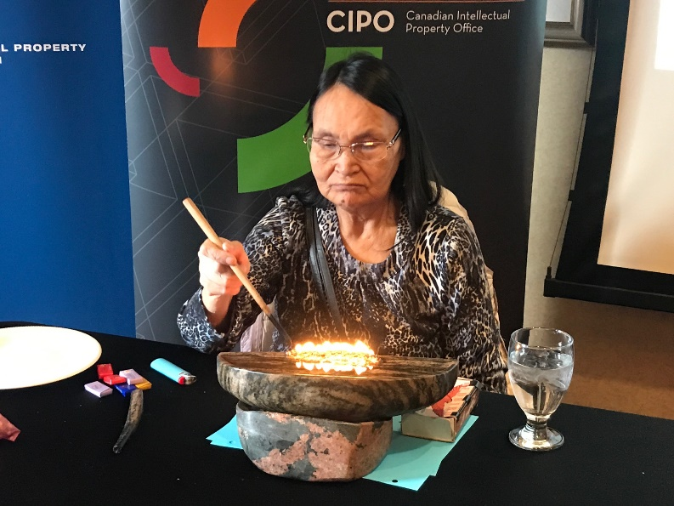

Qulliq Lighting Ceremony led by Ms. Sinea Kownirks (photo: Daphne Zografos Johnsson)

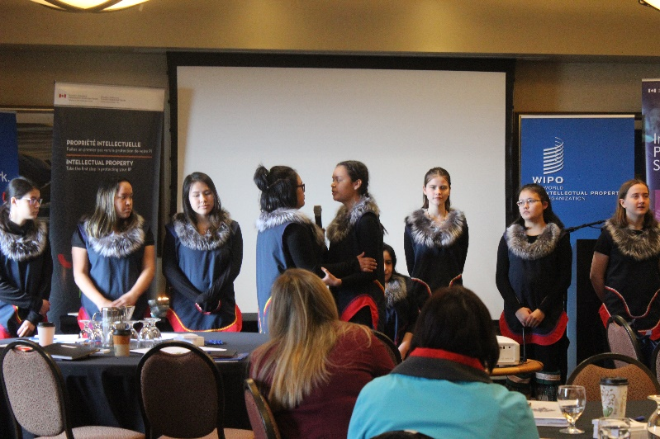

Performance by the Inuksuk High School Choir (photo © Laura Woodward)

#### Identifying Issues, Needs and Expectations

*Facilitator: Ms. Monica Ell-Kanayuk, President, ICC of Canada*

The IPLCs Day began with the participants personal introductions. Participants were asked to identify:

* The challenges their communities were currently facing regarding the protection of TK and TCEs;
* The steps they could take at the community level to promote the protection of, add value to, and maximize the economic opportunities associated with TK and TCEs; and
* Their expectations for the Practical Workshop.

Their responses are outlined below.

**Challenges**

Generally, the challenges raised by the participants centered on two types of issues. The first type of issues related to the protection of TK and TCEs against misuse and appropriation by third parties. The second type of issues related to the mismatch between Indigenous customary laws and collective rights and the nature of the current IP system.

**Community Level**

At a community level, participants believed that certain steps could be taken to promote the protection to TK and TCEs. For example, participants believed that collaboration between organisations and governments in different regions was a necessary step to protect TK and TCEs. Specifically, collaboration was required among countries where the geography and distinct national policies made it difficult to protect Indigenous TK and TCEs, particularly for Indigenous Peoples that resides in several countries, such as Inuit (Canada, Russia, Greenland and the Unites States of America) and Saami (Finland, Sweden, Norway and Russia). Participants also stated that at a community level it was important to identify and document the knowledge keepers.

**Workshop Expectations**

The expectations identified by the participants related to the challenges they identified. The below list of workshop expectations is a compilation of two sessions dedicated to the identification of the TK and TCEs issues, needs and expectations that occurred on the IPLCs Day. These two sessions contributed to the Practical Workshop objective to foster cooperation between IPLCs. The participants’ expectations included:

* To learn about IP law and how it can be used to protect and promote TK and TCEs in different countries and regions;
* To learn about current and past work undertaken by WIPO in respect of TK and TCEs in order to understand best practices;
* To address the types of IP protection available for oral traditions, cultural practices and food;
* To consider and learn about the complementary objectives in different international instruments that may offer different types of protection for TK and TCEs;
* To be provided with practical guidance on how to solve some key issues related to TK and TCE protection;
* To address the mismatch between Indigenous Peoples’ customary laws and ways of knowing and the current IP system;
* To address the territorial and temporal limitations that impact the protection of Indigenous Peoples TK and TCEs;
* To learn more about the protection and promotion of collective rights and cultural heritage in relation to IP;
* To consider the design of an IP system for TK and TCEs that reflects the specific customs and needs of Indigenous Peoples;
* To distill the distinctions between copying, inspiration and appropriation;
* To build relationships and networks to support future collaborations;
* To share the knowledge gained during the Practical Workshop with their communities, governments and / or organisations; and
* To include other Arctic countries in future workshop for this region.

The materials discussed during the two introductory sessions on the IPLCs Day, were also presented to the larger group on the first day of the Practical Workshop. To avoid repetition in this Report, this material and the groups’ discussions are summarised under Topic 1: “Intellectual Property, Traditional Knowledge, and Traditional Cultural Expressions – An Overview of Policy and Legal Issues from an IP Perspective” in the section below.

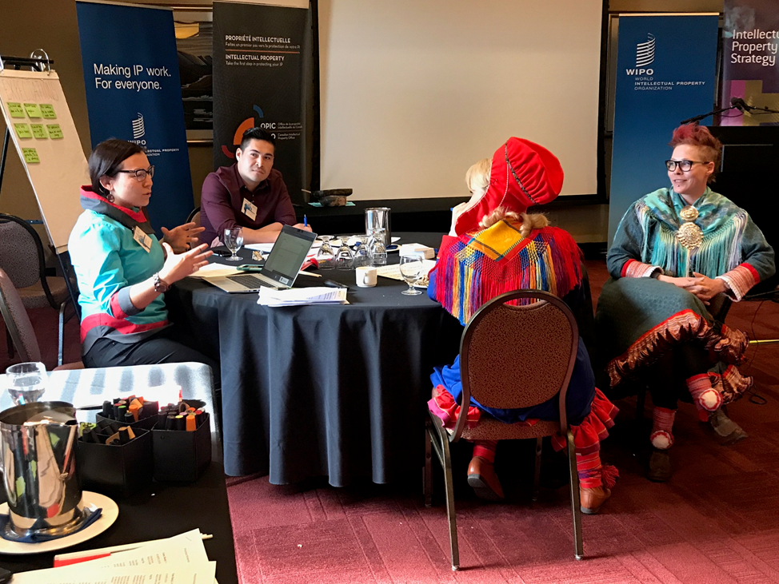

Group work on workshop expectations (photo: Daphne Zografos Johnsson)

#### Introduction to Intellectual Property

*Facilitator: Rebecka Forsgren, Indigenous Fellow, Traditional Knowledge Division, Global Issues Sector, WIPO*

This session introduced IPLCs representatives to the main principles of IP and the types of rights the IP system protects. The session contributed to one of the primary objectives of the Practical Workshop which was to impart basic knowledge about the main principles, systems and tools of the IP system.

#### Introduction to Traditional Knowledge and Traditional Cultural Expressions

*Facilitator: Daphne Zografos Johnsson, Legal Officer, Traditional Knowledge Division, Global Issues Sector, WIPO*

This session introduced the IPLCs representatives to the nature of TK and TCEs their relationship with IP law. It also addressed the opportunities and the limitations of IP law to protect TK and TCEs. Some tools and resources were discussed as was the work undertaken by WIPO in this area. The session contributed to one of the primary objectives of the Practical Workshop which was to impart basic knowledge about the IP system and the forms of protection it provides for TK and TCEs.

#### Observations: IPLCs Day

Throughout the IPLCs Day, the IPLCs representatives asked questions during the introductory sessions. It was noted that many of the issues raised were common concerns expressed by other Indigenous Peoples in relation to TK and TCEs.

# REPORT OF THE PRACTICAL WORKSHOP

May 15 and 16, 2019

Government representatives along with IPLCs representatives participated in the two-day Practical Workshop. The workshop began with opening remarks delivered by Mr. Mark Schaan and Mr. Wend Wendland. This was followed by an introductory exercise for participants to get to know one another. The subsequent sessions on the first day included:

* Topic 1: Intellectual Property, Traditional Knowledge, and Traditional Cultural Expressions – An Overview of Policy and Legal Issues from an IP Perspective;
* Topic 2: Available IP Tools to Protect TK and TCEs;
* A group Q & A period; and
* Case Study 1: Copyright.

The schedule for the first day of the Practical Workshop was amended to create space for discussion. Instead of working through Case Study 2 on patents, time was allocated to a group discussion that addressed the concerns and questions that had been raised during the IPLCs Day and the Practical Workshop presentations (Topic 1 and Topic 2).

#### Opening Remarks for the Practical Workshop

*Facilitators: Mr. Mark Schaan and Mr. Wend Wendland*

The opening remarks provided a background to the conception and realisation of this specific workshop focusing on IP, TK and TCEs for countries from the Arctic region. The Practical Workshop was developed by WIPO and the Government of Canada over the course of nearly two years. The purpose of Practical Workshop was to impart knowledge about IP law and its relationship to Indigenous Peoples’ TK and TCEs through discussions, case studies and country presentations. During the opening remarks, the facilitators revisited the expectations that were shared during the IPLCs Day.

Following the opening remarks, the participants introduced themselves and shared their expectations for the Practical Workshop. These expectations included:

* Addressing the gaps in the current IP system in respect of TK and TCEs protection.
* Considering the creation of an IP system that reflects Indigenous customary laws and values;
* Assessing and understanding the potential for regional cooperation on these issues.
* Learning about IP rights and forms of protection it offers to TK and TCEs that would benefit Indigenous Peoples;
* Learning about good practices undertaken in other countries that protect Indigenous TK and TCEs;
* Identifying practical initiatives that can be implemented on a local / national level;
* Sharing the knowledge imparted during the workshop with local communities and governments to empower them; and
* Identifying ways to move forward collectively.

These expectations should be read alongside the expectations that were raised on the IPLCs Day.

#### Topic 1: Intellectual Property, Traditional Knowledge and Traditional Cultural Expressions

*Presenter: Ms. Daphne Zografos Johnsson*

The presentation provided an overview of the IP system and how it can be used to protect TK and TCEs. The session contributed to one of the primary objectives of the Practical Workshop which was to impart basic knowledge about the IP system and the forms of protection it provides for TK and TCEs. Although GRs were addressed, they were not the primary focus of the session or the discussions that flowed therefrom. The IP concepts discussed during this presentation and session, are outlined below.

**What is intellectual property?**

**Intellectual property** is described as the creation of human minds or the results of human creativity and innovation. Examples of IP include inventions, literary and artistic works, designs, and distinctive signs and symbols. The IP system enables people to gain recognition and financial benefit from their inventions or creations. It encourages inventors and authors to create and innovate by offering different forms of protection against misappropriation.

The different types of IPRs include patents, copyright, trademarks, geographical indications, industrial designs, trade secrets and unfair competition. Generally, these different IPRs share five characteristics. First, IPRs give the holder exclusive rights to use and benefit from their invention or creation. Second, IPRs strive to balance protection and innovation. Third, the recognition of IPRs requires following certain rules or procedures such as registration. Fourth, there are limits to IPRs protection. For example, IPRs generally have time and territorial limitations. Once the time limitation on an IPR expires, the invention or creation enters the public domain. Lastly, IPRs may be transferred or licensed to another.

The IPRs also differ in numerous way. The subject matter that can be protected differs as do the requirements that are necessary for gaining protection. Further, the conditions for protection, the duration of protection, the nature of the granted rights or strength of the protection varies depending on the right. The distinct nature of each of the different IPRs are outlined below.

**Copyright** protects different types of “works” such as literary or artistic works. This type of right only protects the expression of ideas. Copyright does not protect the idea or the knowledge *per se*. It only protects the material expression of the idea which must be original. There are different categories of works that are protected under copyright. These categories of works include: literary, dramatic, musical, artistic, films, sound recordings, broadcasts and published editions.

Copyright assigns exclusive rights to the copyright holder. These include moral rights and economic rights. Moral rights ensure that the creator of the work retains the right to recognition and ensures that the integrity of the work is protected. Whereas the copyright holder’s economic rights include the right to economic benefits in cases of reproduction, distribution, adaptation, translation, public performance/display and public communication of the work in which the right is held. Generally, copyright protection is automatically assigned to the creator if certain conditions are met. The work must be original and expressed or recorded in a material form. The duration of the protection is limited to 50 years after the death of the author (this may vary in different jurisdictions). However, there are exceptions to copyright protection. For example, inspiration can be derived from a work (but not copied) or the work may be used for fair use, including for teaching, research or other non-infringing purposes.

**Patents** protect inventions that are new. For example, patent protection may cover new products derived from a technical solution or new processes. The patentability requirements for an invention include that it is novel, a creation of the human mind (not a naturally occurring process) and that it is useful. Patent rights are assigned by a state to an inventor. This right allows the inventor to exclude others from making, using, or selling or importing the invention in the state where the right was registered without the inventor’s consent. There are certain conditions for a patent right to be enforceable. It must be registered, and the right is generally limited to 20 years. However, in order to get the protection, the inventor must disclose the specifications of the invention.

**Trademarks (TMs)** protect distinctive signs. TMs may consist of logos, drawings, packaging, smells and even sounds. This protection allows consumers to distinguish between different goods and services because TMs may indicate the nature and quality of products. There are several conditions that are necessary for TM registration. The mark must be distinctive, used in trade, and it cannot be generic, descriptive or deceptive. The registration of a TM prevents others from using the same mark in trade. Generally, this type of protection lasts for 10 years and it may be renewed so long as it continues to be in use. Related types of marks that may be of interest to IPLCs include collective marks and certification marks. These types of marks have been used proactively in many instances to protect Indigenous interests.

**Geographical Indications (GIs)** are signsthat indicate that a product is from a specific location and possesses unique qualities or characteristics as a result. GIs prevent others from using a sign that could mislead consumer into believing that a product is from a specific location when it is not. It creates a niche market for the producers from that area. GIs must be registered, and a book of requirements or specifications must be created. This type of protection is also supported through the education of consumers.

**Industrial designs** protect the aesthetic or ornamental aspect of a product. For example, industrial designs protect how a product looks not its functionality. To be afforded this type of protection, the design must be new and differ from other existing designs. Generally, industrial designs must be registered to be protected. This may be done by filing out an application and paying a fee.

**Trade Secrets or Confidential Information** protect secret information that may include manufacturing processes or secret ingredients. Trade secrets prevent others from using information if it is secret. The protection is indefinite. However, trade secrets will not protect the right holder in cases where independent or incidental discoveries have been made. There is no registration required for trade secrets. However, measures should be taken to keep the secret knowledge secret.

**Unfair Competition** prevents the false labelling of products to ensure that a person’s product is not passed off as someone else’s. Unfair competition can supplement the other IP regimes. There is no registration requirement.

**What are TK, TCEs and Genetic Resources (GRs)?**

There are no universally accepted definitions (only working definitions) of TK and TCEs at the international level. Therefore, it makes it difficult to establish norms for protection and enforcement. Notably, TK and TCEs present challenges because there is a conceptual mismatch between TK and TCEs and the IP system. This is because IPRs are vested in individuals while TK and TCEs are generally collective rights. Further, elements of TK and TCEs may be considered public domain. These challenges are addressed in the information below.

TCEs are considered forms in which TK and culture are expressed. They may be intangible, tangible or both. Examples include songs, performances, crafts, names, symbols, art, narratives, designs, architecture and motifs. Some may consider TCEs as part of the common heritage of humanity and therefore, in the public domain. There is a growing awareness that TCEs are susceptible to misuse and misappropriation. Their value stems from their significance as cultural assets which are part of a social and cultural identity. TCEs hold economic potential for communities and industries.

TCEs are considered IP because they are products of creative intellectual activity. They are creative expressions of IPLCs. However, because they are traditional, they cannot be fully protected under the existing IP system due to the limitations of the system. For example, the IP system requires that IP have an identifiable author or inventor, be original or novel and be for commercial use etc. Often, these requirements do not match the characteristics or nature of TCEs.

TKis considered knowledge which results from intellectual activity in a traditional context. It includes the ‘know-how’ to do something, skills, innovations, practices and learning. It is a living body of knowledge that is passed on from generation to generation within a community. It is not limited to a specific technical field.

**Common characteristics of TK and TCEs** include that they are handed down from generation to generation. They reflect a community’s cultural and social identity. Generally, they are made by authors unknown and are considered to belong to the community as per their customary laws. TK and TCEs are constantly evolving, developing and being recreated within a community.

**GRs** are “genetic material of actual or potential value”. Genetic material constitutes “any material of plant, animal, microbial or other origin containing functional units of heredity.”[[3]](#footnote-4) TK may be associated with GRs. Access to genetic resources and benefit sharing is regulated through different international instruments. These include the *Convention on Biological Diversity*; *International Treaty on Plant Genetic Resources for Food and Agriculture*[[4]](#footnote-5); *Bonn Guidelines on Access to Genetic Resources and Fair and Equitable Sharing of the Benefits Arising out of their Utilization[[5]](#footnote-6)*; and the *Nagoya Protocol on Access to Genetic Resources and the Fair and Equitable Sharing of Benefits Arising from their Utilization[[6]](#footnote-7)*.

GRs as encountered in nature are not IP. They are not creations of the human mind and cannot be directly protected as IP. However, IP may protect TK based innovations related to GRs. There are several solutions that may be undertaken to protect TK based innovations related to GRs. These include preventing the grant of erroneous patents by creating a database that includes information about GRs or the TK associated with the GRs, or by adopting additional patent disclosure requirements. TK based innovation related to GRs can be protected through contracts where IP clauses are based on mutually agreed upon terms of use.

**How can intellectual property help?**

There are different approaches to how TK and TCEs can be protected by IP. TK and TCEs may be protected through the conventional IP system, the adaption of the conventional IP system that focuses on TK and TCEs or through a new *sui generis* (specific, special) system(s) specifically designed for TK and TCEs protection. *Sui generis* measures could recognise the distinct characteristics of TK and TCEs.

**Overview: WIPO’S work**

WIPO’s work on TK and TCEs assesses the appropriate role of the IP system in the protection and promotion of TK and TCEs through normative developments and capacity building. In 2000, *the WIPO Intergovernmental Committee on Intellectual Property and Genetic Resources, Traditional Knowledge and Folklore* (IGC) was created. It is a forum where negotiations take place for international legal instruments on TK, TCEs and GRs. The IGC is composed of participants from WIPO Member States, Indigenous Peoples and local communities, business, civil society and other NGOs. Currently, the IGC is negotiating text(s) of an international legal instrument(s), which will ensure the balanced and effective protection of TK, TCEs and GRs. This system would be based on IP principles, values and systems.

WIPO also has a very rich capacity building and technical assistance program that includes assistance with, *inter alia*, strategy, policy and law; protection of indigenous and community marks and symbols; IP clauses in ABS and other contracts; the management of IP in documentation and digitization projects, and the management of IP in arts festivals.

WIPO’s animation film, *The Adventures of the Yakuanoi*, was shared with the Practical Workshop participants.[[7]](#footnote-8) The video provides a fictional example of how a community may find creative solutions to the protection of TK through the existing IP system. Notably, the Inuktitut version of the video was launched during the workshop.

|  |
| --- |
| **Resource Material**  To consult material related to TK and TCEs see WIPO’s various publication, see <https://www.wipo.int/tk/en/resources/publications.html#general>.  To consult the draft provisions / articles the IGC has developed, see <http://www.wipo.int/tk/en/igc/draft_provisions.html>.  To consult the video, *The Adventures of the Yakuanoi*, see **Error! Hyperlink reference not valid.**[www.wipo.int/tk/en/tk/yakuanoi.html](https://www.wipo.int/tk/en/tk/yakuanoi.html).  To consult training opportunities, Cultural Documentation and IP Management Training Program, see  <https://www.wipo.int/tk/en/resources/training.html> |

#### Topic 2: Available Intellectual Property Tools to Protect Traditional Knowledge and Traditional Cultural Expressions

*Presenter: Mr. Jeffrey Orser, Director, Services to Business, Canadian Intellectual Property Office*

This presentation provided an overview of the Canadian Intellectual Property Office (CIPO) and the IP tools that are available for the protection of TK and TCEs in Canada. CIPO is a special operating agency associated with the Department of Innovation, Science and Economic Development Canada. It is responsible for the administration and processing of the majority of IP in Canada. For example, CIPO examines and grants IPRs, provides a quasi-judicial function for TMs and patents, raises awareness about IP tools, shares IP related information and supports innovation. The presentation also provided examples of effective IP strategies.

The session contributed to one of the primary objectives of the Practical Workshop which was to impart basic knowledge about the IP system and the forms of protection it provides for TK and TCEs.

IP and Commercial Opportunities

IP is a business asset. IP can support the preservation and protection of TK and TCEs and also provide commercialisation opportunities. For example, TK can be licensed to others to create new products such as pharmaceutical products or clothing designs.

Approaches to TK and TCEs Protection

There are two main approaches to the protection of TK and TCEs: defensive and offensive protection. Defensive protection centres on preventing others outside the community from acquiring rights over TK and TCEs. Offensive protection grants IPRs that allow the community to promote, control and benefit from the commercial use of TK and TCEs.

Examples of Effective IP Strategies

The examples listed below, are cases where an IP strategy was effectively used to maximize the value of IP to achieve a business objective.

* The Manitobah Mukluks trademark created by Sean McCormick, a Métis entrepreneur for his footwear company.
* The Inuit Art Foundation’s Igloo tag (TM) protects Inuit artists against copycats. It certifies that the artworks are authentic.
* The Maïs sucré de Neuville GI that indicates that the corn is from Neuville where there are special geographical factors that influence the quality of the sweet corn.
* Asham Curling Supplies is an example of a successful use of a patent. Arnold Asham, a Métis entrepreneur, built his namesake company on innovations in the curling industry. He has filed patents to protect innovative curling equipment.
* Inuit filmmaker Zacharias Kunuk and his production company ISUMA’s film *Atanarjuat: The Fast Runner* is protected by copyright.
* The West Baffin Eskimo Cooperative Ltd., has filed many industrial designs.
* Unaaq Fisheries is a company owned by the Inuit in Northern Quebec and Baffin Island. Their technique developments have been protected as trade secrets.

To create an IP strategy, it is important to take inventory of intangible assets and identify potential commercial opportunities, understand the competition and maximize benefits. IPRs need to be monitored and enforced to be effective.

CIPO Programs

CIPO has an IP awareness and education program that supports access to IP resources and learning events. CIPO is working on expanding its presence and partnerships in Indigenous-focused networks and communities. Currently, they are working with two main organizations, the Canadian Council of Aboriginal Business and the National Aboriginal Capital Corporations Association. CIPO has collaborated with the Centre for International Governance Innovation (CIGI) on the development of content that provides an introduction to TK, TCEs and IPRs.

#### Participant Comments on Topic 1 and Topic 2 Presentations

During the sessions, participants made comments that related to the inadequacies of the IP system. These concerns centered on the collective ownership of TK and TCEs and the customary practices that have protected them.

A few participants expressed concerns over the IP system’s focus on the protection of individual IPRs and the economic benefits derived therefrom. It was expressed that this type of protection is not conceptually aligned with the reasons for TK and TCEs protection. This is because, from a community perspective, TK and TCEs protection focuses on the maintenance of the integrity of the knowledge, its respectful use and the acknowledgment of the originating community.

A few participants shared that often unwritten customary laws already protected TK and TCEs. For example, customary laws prevented other people from copying another person’s creations. Instead, people were required to seek permission to use someone else’s designs. A question that derived from this comment, was how unwritten customary law could be included in the IP system.

Before addressing the case studies, the schedule was reorganised to facilitate a discussion and dialogue about the issues and questions that were raised on IPLCs Day and Practical Workshop Topic 1 and Topic 2 presentations.

#### Overview: Case Studies

The case study sessions provided opportunities for group work. The participants were divided into small groups composed of representatives from different countries. Each group was assigned a case study to discuss and then report back to all the participants on their discussions. The case studies were prepared by WIPO and were used to explore and discuss broader issues regarding IP, TK and TCEs.

The case studies were fictional but drew on issues that have arisen with respect to IP, TK, TCEs and GRs. They allowed participants to apply their knowledge of IP law and principles to practical examples. During the case studies session, many IPLCs participants shared examples of factual scenarios that they had observed or experienced that were similar to the case studies. The case study exercise contributed to the three primary objectives of the Practical Workshop: to impart knowledge about the IP system, to foster cooperation and to facilitate country-level exchanges.

This section of the Report documents the issues and considerations raised by all groups and the facilitators.

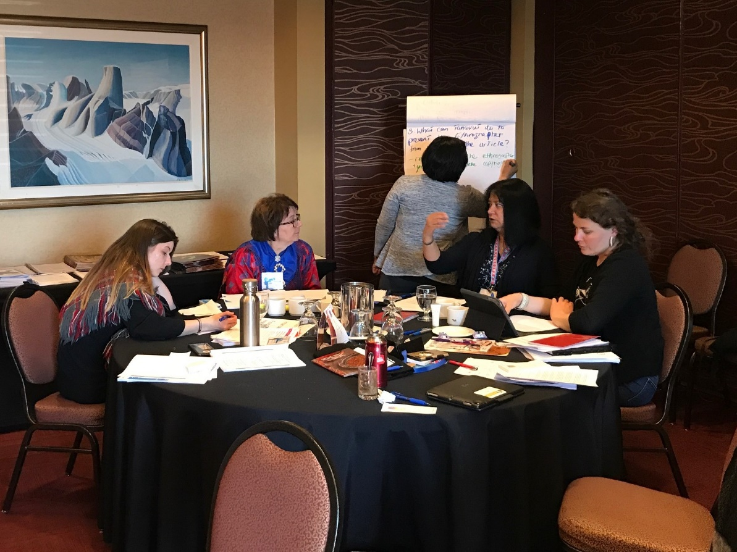

Group work on case studies (photo: Daphne Zografos Johnsson)

|  |
| --- |
| Case Study 1 - Copyright © WIPO 2019  *Disclaimer: The facts in this case study are entirely fictitious. Any resemblance with actual facts is mere coincidence.*  **FACTS**  The National Museum of Ethnography of Arctic country X holds a collection of ethnographic material from communities and groups from the Arctic region, including several indigenous communities.  In recent years, the museum began digitizing its collection to create an online archive in order to reach out to wider audiences. This aims to promote access to knowledge and cultural diversity and the safeguarding of cultural heritage. Researchers, students, artists, industry and the public at large with Internet access can access this online archive for free.  In most cases, the museum has received permission to make digital copies of the material, but in some cases the museum staff was unable to contact the relevant rights holders. In such cases they decided not to make materials available online.   1. In the 1970s, a tapestry had been given by the Tanavut community to an anthropologist employed by the museum. The imagery on the tapestry depicts animal spirits and other traditional symbols. Community members believe that as long as the tapestry is kept in good condition and not displayed in public outside their spring festival, they would keep on having the ability to survive in the North’s harsh conditions.   The community was struggling to keep the tapestry in good condition as it aged, so they agreed that the tapestry should be kept by the museum under the following conditions: (a) that it would be conserved, (b) that authorized members of the community could access it as required during the spring festival, and (c) that it would not be put on public display.  The tapestry was woven on a traditional loom, using traditional techniques, by three women in the community, the last of whom died 80 years ago. The highly stylized designs are unique to the Tanavut, and have been passed down from generation to generation, but each time they are woven into cloth, the weavers create their own interpretation of the design.  A year ago, without properly checking its records or trying to contact the community members, the museum made a reproduction of the tapestry available online. The entry on their digital archive was linked to the digital copies of the anthropologist’s field notes in their library, explaining the significance of the tapestry to the community concerned and the consequences of displaying it outside of the spring festival. The metadata on the digital copy of the tapestry explains under what conditions the Tanavut had given their consent to the conservation of the tapestry within the museum.  The museum’s website encourages viewers to create new artworks based on the open access collection.  A modern artist, known for his deliberatively provocative work, used the online archive to create a large graffiti painting, copying some of the tapestry’s patterns. He called his artwork “Death in the North”.   1. Three paintings displayed in the museum are well-known artworks of a prominent Tanavut artist. The paintings are also reproduced in the open access digital archive or the museum with the artist’s permission. The subject matter of the paintings concerns traditional tales of spiritual and sacred significance to the Tanavut community to which the artists belongs.   An Asian company is producing and selling in Arctic countries carpets that reproduce the artist’s three paintings. The carpets reproduce two of the paintings in identical form and color, while the third painting is substantially reproduced, although in a simplified form. The carpets are made of cheap synthetic fabric. Each carpet is affixed with a swing tag that reads:  *“These unique carpets have been designed by Tanavut artists from the Arctic region. These artists are paid royalties on every carpet sold […] As carpet weaving is not a tradition of the Tanavut people, the carpets are produced in Vietnam where we can combine the artistic skills of the Tanavut people with the weaving traditions of the Vietnamese. […]”*  However, the Asian company has no agreement with the Tanavut artist whose paintings it copied, does not have his authorization to reproduce the artworks, and does not pay him any royalties.  While the authorized display of the paintings in the museum and their reproduction in the digital archive for educational purposes is acceptable to the artist and his community when carried out with appropriate sensitivity, the reproduction of these paintings in circumstances where the traditional tales would be walked on could cause great offence and result in the punishment of the artist from the traditional owners or custodians of the work. Such punishment could include the removal of the right to reproduce paintings of a given traditional tale or being outcast from the community.  QUESTIONS FOR DISCUSSION:   1. Which elements/objects in this scenario are possibly subject to conventional intellectual property rights? In each case, who holds those rights? 2. Did the museum have the legal right to make a digitized copy of the tapestry and paintings available online? 3. Did the modern artist infringe any intellectual property or other rights of other parties? Did he do anything wrong, ethically? 4. What can the Tanavut artist do to prevent the sale of the carpets? Did the Asian company infringe any intellectual property rights? 5. What good practices or principles should third parties follow when they interact with TCEs? |

**Case Study 1: Discussion Questions and Group Answers**

Facilitators: Mr. Mark Schaan and Ms. Daphne Zografos Johnsson

1. **Which elements / objects in this scenario are possibly subject to conventional intellectual property rights? In each case, who holds those rights?**

The groups stated that:

* The tapestry was an object subject to IP. The tapestry was collectively owned by the community because the three women from the community who had created it had passed away. The tapestry was woven on a traditional loom, using traditional techniques that were unique to the community;
* Copyright would not be applicable because the last woman, who had created the tapestry, had passed away 80 years prior. Generally, copyright protection expires 50 years after the death of the creator;
* The tapestry may be protected as a classic under certain national laws. For example, the *Copyright Act* in Nordic countries generally includes a section that covers the protection of classics;
* The community may have remaining moral rights in the tapestry that relate to the paternity and integrity of the tapestry;
* The groups considered whether IP protection would be available if there were women in the community that continued to keep the weaving tradition alive;
* The painting “Death in the North” was another object in the case that was subject to IP. The rights recognised in the painting included the copyright of the artist. The painting itself was considered to be original although it had borrowed elements from the tapestry’s patterns;
* The copyright of the digitized images of the tapestry held in the museum’s database presented another less obvious issue. In many jurisdictions, a new copyright may be created when the photograph was made of the artwork. If so, the photographer holds the copyright in this; and
* The copyright to the anthropologist’s field notes belonged to the museum given that the museum was the anthropologist’s employer.

1. **Did the museum have the legal rights to make a digitized copy of tapestry and paintings available online?**

The groups stated that:

* The terms of the agreement between the community and the museum plays a central factor in determining whether the museum had the legal rights to digitize the image. This would include considering whether the condition against public display in the agreement also precluded the public display of a digitized image of the tapestry;
* Discussion arose around whether an oral agreement between the community and the museum would be enforceable if this agreement had stated that they did not want the museum to make images of the tapestry public;
* In Sweden and in Canada, the assumption is that a museum does not have the right to reproduce the artwork through a photograph unless they have a licence to create a digital copy;
* Concerns were raised about the challenges Indigenous communities are confronted with because they may not have formal agreements with museums in respect of their cultural heritage held in museums; and
* Concerns were also raised in regard to situations where a community lacks internal consensus to grant permission to display certain cultural heritage material.

1. **Did the modern artist infringe any intellectual property or other rights of other parties? Did he do anything wrong, ethically?**

The groups stated that:

* The artist did not infringe any IPRs. It was suggested that he was inspired by the tapestry. The painting was not a copy of it;
* The artist was ethically wrong in painting the tapestry. In addition, the title of the artwork could be read as offensive. The title may allude to the death of the culture that the tapestry design was appropriated from;
* Other types of issues may arise if the modern artist had been a member of the community. For example, certain members of the community may view the painting as an extension of cultural expression (where the ‘weaver’ creates their own interpretation of the design). In contrast, others may view this as contradictory or offensive to the traditional weaving practice; and
* In cases such as this, the descendants of the person who created the artwork would be able to enforce moral rights. These rights generally last longer than economic rights.

1. **What can the Tanavut artist do to prevent the sale of carpets? Did the Asian company infringe any intellectual property rights?**

The groups stated that:

* The company did infringe the copyright of the artist. They did not have an agreement with the artist to reproduce the work;
* In Sweden, this would be considered an infringement of the moral rights of the artist which protects the artist from prejudice;
* The company engaged in false marketing because no royalties were being given to the community;
* The false marketing could be addressed through actions taken outside of the IP system. These include launching a public campaign that raises awareness about the issue(s);
* The false marketing situation may be remedied through legal action;
* In Canada, complaints may also be made through a commissioner of competition. In other jurisdictions, unfair competition complaints may be made through another government agency that is mandated to protect consumers. In EU countries, generally, there are laws that protect consumers from product misrepresentation; and
* This type of case also raises concerns about the use of community names on products.

1. **What good practices or principles should third parties follow when they interact with TCEs?**

The groups stated that:

* Third parties should always maintain respect and receive free, prior and informed consent (from Indigenous Peoples) when they interact with TCEs;
* The Saami Parliament in Finland has guidelines for how third parties can interact with TCEs. These guidelines require that museums assess the impact on Saami cultural heritage. Museums are required to consider how they will repatriate the information they acquire through their research and how they will share the benefits; and
* The Library and Archives Canada has a program that supports the digitization of objects. It gives back the digital work to the community. The community controls how the image is held.

#### Observations: Practical Workshop Day 1

The wrap-up of the day was delivered by Ms. Rebecka Forsgren and Mr. Wend Wendland. It was noted that the participants have shared similar challenges in respect of the misuse of their TK and TCEs and that many important issues are unsolved. There are no simple answers to these issues. IP is a complicated area of the law that does not provide for absolute rights. It is important to understand the limitations and benefits of the system and to manage expectations on what TK and TCE protections are possible. Collaboration and capacity building are important.

As previously stated, Case Study 2: Patents and Case Study: 3 Distinctive Signs (TMs, collective and certification marks, GIs) occurred on the second day of the Practical Workshop.

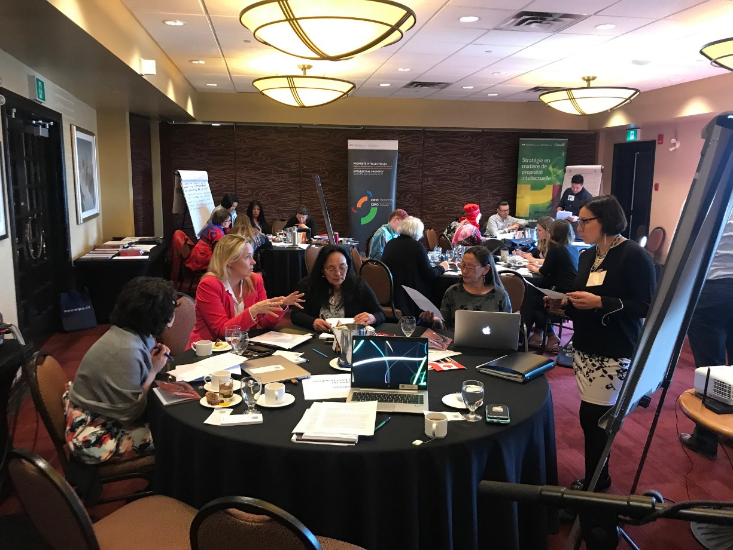

Group work on case studies (photo: Daphne Zografos Johnsson)

|  |
| --- |
| Case Study 2 - Patents © WIPO 2019  *Disclaimer: The facts in this case study are entirely fictitious. Any resemblance with actual facts is mere coincidence.*  **FACTS**  The Tanavut community is located in Arctic country X. The community possesses a unique indigenous medical system based, in part, on their detailed traditional knowledge of the properties and uses of Arctic berries, including a secret medicine. Most of their traditional knowledge is orally transmitted. Arctic country X has not ratified the Nagoya Protocol.  However, some secret formulations based on the use of Arctic berries are available in written form on dried fish skins. The information was encrypted in secret symbols known only to the Tanavut generations ago. The information recorded on the skins is considered highly confidential by the Tanavut. According to their beliefs and customary law, the recipes can only be read by a group of people within the community who hold the authority to produce the secret medicine.   1. One year ago, an ethnographer and expert in symbols from the United Kingdom, came to the community and, accidentally, collected a dried fish skin on which a secret formulation was encrypted in symbols unknown to him. Back in the United Kingdom, he conducted research on the skin and deciphered the formulation.   The ethnographer is planning to publish an academic article explaining the meaning of the information on the skin, describing the method to prepare the traditional medicine, and praising its cultural and scientific value. He contacts the Tanavut to ask for pictures and quotes he could use in his article.   1. The Tanavut realize the potential value of the medicinal uses of Arctic berries. Research and development based on the pharmacological activities of the berries could lead to the development of pharmaceutical products that could benefit humanity and save many lives. They reach out to the University of Arctica in order to jointly undertake research based on the Arctic berries.   In that context, berries are collected and tested in a laboratory to study their pharmacological activities. The research leads to the identification of certain compounds that can be used in the treatment of inflammation.  The university would like to apply for a patent for an invention entitled “anti-inflammatory compounds of Arctic berries”.  **QUESTIONS FOR DISCUSSION**   1. Do the Tanavut hold any rights or interests in the information on the fish skin? If so, what are the rights or interests? If not, why? 2. Did the ethnographer violate any intellectual property rights or interests of the Tanavut? If so, which ones? 3. What can the Tanavut do to prevent the ethnographer from publishing the article? 4. What intellectual property related issues should the Tanavut consider before they approach the University of Arctica? Advise the Tanavut as to their intellectual property strategy. |

**Case Study 2: Discussion Questions and Group Answers**

Facilitators: Mr. Jeffrey Orser and Mr. Wend Wendland

1. **Do the Tanavut hold any rights or interests in the information on the fish skin? If, so what are the rights or interests? If not, why?**

The groups stated that:

* The community held rights in the information as per their customary laws that regulated who had authority to read and produce the secret medicine;
* The information on the fish skins was written in the community’s language and was of important cultural value. It held the potential to be used for the economic benefit of the community;
* Protecting this type of information through trade secrets protects future uses because of the medicinal qualities of the Arctic berries; and
* Although a copyright may exist in the expression of the encrypted information, it does not protect the information itself and is not relevant in this case.

1. **Did the ethnographer violate any intellectual property rights or interests of the Tanavut? If so, which ones?**

The groups stated that:

* The ethnographer violated the community’s customs that regulated who had the authority in the community to hold the TK related to the medicines. This customary law reflects the protection principles found in IP law / trade secrets;
* In certain jurisdictions, there are rules in the IP system that protect encrypted information or other technological measures undertaken to protect information; and
* The publication of the information for an academic article creates issues because it makes the information public. Therefore, the novelty element of the information is eroded. This may have a negative impact on the community and their ability to benefit economically in the future from this TK.

1. **What can the Tanavut do to prevent the ethnographer from publishing the article?**

The groups stated that:

* The community could contact the ethnographer and advise him that the publication of the article would violate their customary laws. It is important to also advise the ethnographer that this may impact the community’s potential to gain economic benefits from the commercialization of this knowledge;
* The community could also reach out to the University and advise them of the situation. This may include approaching the University’s ethics board;
* The community could contact WIPO for information and guidance; and
* The community may decline to provide quotes or pictures.

1. **What intellectual property related issues should the Tanavut consider before they approach the University of Arctica? Advise the Tanavut as to their intellectual property strategy.**

The groups stated that:

* The community should consider the environmental impacts of commercialisation this type of agreement would have on the community’s access to the Arctic berries;
* The community could consider entering into a benefit-sharing agreement with the university;
* A non-disclosure agreement to protect the information from being published by the ethnographer;
* A legally binding agreement that imposes responsibilities on the parties and outlines their rights is one strategy that can be pursued. A key responsibility that could be included in the agreement, may be the maintenance of confidentiality and the protection of the TK for future commercial interests;
* Before entering into an agreement, the parties may want to consider the scope and details that the contract should cover. The contract should provide details on how the parties will work together. It could also include a clause that imposes a fine on a party should they breach their obligations;
* The community may want to consider whether it is preferable to make a joint filing. A joint filing is beneficial in some cases because the filing fees and maintenance fees would be shared; and
* The community may want to consider whether there are other countries in which their IP should to be protected. For example, if the Arctic berries exist in different Arctic countries or there is a market for products derived from the berries in different countries it may be beneficial to consider an IP strategy in those countries. In other words, the community should consider potential value chains of Arctic berry products. From a patent perspective the community should consider where the future products may be manufactured, distributed and sold.

#### Group Work: Case Study 3: Distinctive Signs (Trademarks, Collective and Certification Marks, Geographical Indications)

*Presenter and facilitator: Ms. Marion Heathcote, Representative and Principal, Davies Collison Cave, Sydney, Australia.*

The presentation addressed how daily life is impacted by advertisements and distinctive signs. Advertisements contain distinctive signs that are used to denote a brand and quality of product. Distinctive signs offer different types of protection. The presentation outlined the different uses of distinctive signs through a narrative about an organic farm. This example demonstrated how different signs are used to distinguish products at market. The farm had a trade name, TM, collective mark and a certification mark.[[8]](#footnote-9) As outlined below, the presentation provided an overview of the significance of distinctive signs and their potential use as part of an IP strategy to protect TK and TCEs.

**Overview of distinctive signs**

**Distinctive signs** can be owned and protected if they are distinctive in law. Distinctive signs provide exclusive rights to the right holder. In other words, the right holder is the only one entitled to use the sign. Distinctive signs include TMs, collective marks, certification marks and GIs.

**Trademark** protection is available if the mark is distinctive and if it is used in trade. It cannot be deceptive or descriptive. The effective development of a TM includes the consideration of all the aspects of packaging.

**Certifications Marks** are protected in certain countries. These marks are given if the defined standards are met. Certification marks are not limited to any membership. Anyone that can demonstrate their products meet the established standards may use the certification mark.[[9]](#footnote-10)

**Collective Marks** are protected under the law of many countries. Generally, collective marks are defined as signs that “distinguish the geographical origin, material, mode of manufacture or other common characteristics of goods or services of different enterprises using the collective mark.”[[10]](#footnote-11) The owner of a collective mark may be, for example, a cooperative or a public institution. The owner of the collective mark certifies whether a product satisfies the prescribed rules. Collective marks are often used to identify products with certain qualities and specific producers or regions.

**Geographical Indications** are “signs that are used on products that are from a specific geographic origin and possess qualities or a reputation due to that origin.”[[11]](#footnote-12) Generally, these are used for agricultural products. However, certain countries may extend this type of protection to other types of goods.

|  |
| --- |
| **Question in relation to the organic farm case study**  **Q: What is the additional burden of having a certification mark as opposed to registering a regular TM or a collective mark?**  **A:** For small producers, the certification process requires that they maintain an audit of their processes. It is the responsibility of the producer to follow the rules and satisfy the prescribed criteria. For the certifier, the obligations depend on what is being certified and the quality that the certifier seeks to enforce. There is also an obligation on the certifier to monitor what is being certified and to advertise what the certification means. For example, the Toi Iho is the ‘registered and globally recognised’ TM that certifies that a work is Māori-made.[[12]](#footnote-13) This TM ensures that consumers and retailers are aware of authenticity of the product. At the airport in New Zealand, the information about the Toi Iho TM is advertised. This brings awareness to visitors and non-visitors alike about what signs to look for when they are purchasing Māori artworks. |

**Protection and management of Indigenous knowledge**

There are diverse ways that Indigenous knowledge can be protected and managed. Certain national IP offices are working on addressing the protection and management of Indigenous knowledge. For example, IP Australia recently published a paper by Ms. Terri Janke and Company titled “Indigenous Knowledge: Issues for Protection and Management”.[[13]](#footnote-14) Another publication that provides guidance on managing IPRs is “Minding Culture: Case Studies on Intellectual Property and Traditional Cultural Expressions”. This report was prepared by Terri Janke for WIPO. The report contains case studies and examples of how IP can be used by Indigenous communities to promote their cultural heritage and protect their economic interests.

**Public pressure and other fora** can be effective where there are limitations in law. For example, Philip Morris used the Māori name and image to sell their brand of cigarettes in Israel (the Māori Mix). This was highly offensive to the Māori. As a result of public pressure, Philip Morris issued an apology to the Māori. The Māori Advisory Committees, established by New Zealand’s Intellectual Property Office, determines whether a proposed TM contains elements that are offensive to Māori culture. This type of initiative makes a difference in the national context. However, there are jurisdictional limitations to the influence of the Māori Advisory Committees. It is important to recognise the limitations of IP rules.

**Certification marks** may be effective in certain cases. For example, the Toi Iho certification mark certifies work that is made by Māori artists. As stated, the Toi Iho mark is advertised in New Zealand to raise awareness about the authenticity of artworks. Another example that has been effective is Supply Nation. Supply Nation certifies businesses that demonstrate ongoing Indigenous employment in Australia.[[14]](#footnote-15)

Certification marks may be used in diverse ways to protect cultural material from being copied and deceptively marketed. An example of a successful certification mark initiative is the Indigenous Art Code in Australia. The Code sets ethical standards for art dealers and galleries that engage with Indigenous art and artists. Dealers and galleries that have signed the Code have agreed to comply with the ethical standards it establishes. In return, they may display the Code logo and apply code certificates to Indigenous artworks they sell. The Code is voluntary. It brings awareness to the harm caused when art made by Indigenous artists is copied. [[15]](#footnote-16)

**Education and training programs** may assist businesses in understanding Indigenous cultural and intellectual property. An example is True Tracks: Indigenous Cultural and Intellectual Property for Business. True Tracks is a professional development workshop, created by Terri Janke, that is designed to teach businesses ways “to better professionally engage with Aboriginal and Torres Strait Islander people.”[[16]](#footnote-17) The workshop does this by teaching businesses about cultural protocols. It promotes ethical engagement, benefit sharing and ensures that cultural integrity is maintained.

**Arts Councils may implement protocols** for working with Indigenous artists that are a condition to funding. For example, grants issued by the Australia Arts Council that are used to fund projects with Indigenous Australian artists are required to adhere to the Indigenous cultural protocol guides. These guides are published by the Council.[[17]](#footnote-18)

**Other legislative frameworks**. There are cases where an application for IP protection may result in other types of legal protection. For example, the Māori haka Ka Mate was being misused in advertising campaigns and other nonauthorized commercial purposes. The haka Ka Mate is a valuable part of the Ngati Toa Rangatira’s cultural heritage. Notably, it was composed by the Ngati Toa Rangatira chief Te Rauparaha and had been passed down through generations.[[18]](#footnote-19) The Ngati Toa Rangatira tried to TM the haka Ka Mate to limit its unauthorized use. New Zealand’s IP law provides that moving marks may be registered. Although the TM applications were not a success, the Government of New Zealand enacted the *Haka Ka Mate Attribution Act* in 2014.[[19]](#footnote-20) The Act protects the haka Ka Mate from inappropriate use. It protects the Ngati Toa Rangatira control over and management of how the haka Ka Mate is used and presented.

|  |
| --- |
| **Resource Material**  Australia Arts Council, *Protocols for Working with Indigenous Artists*, at <https://www.australiacouncil.gov.au/about/protocols-for-working-with-indigenous-artists/>.  Australian Government, *Indigenous Knowledge: Issues for Protection and Management*, at <https://www.ipaustralia.gov.au/about-us/news-and-community/news/indigenous-knowledge-issues-protection-and-management>.  *Haka Ka Mate Attribution Act* (2014) NZ, at <http://www.legislation.govt.nz/act/public/2014/0018/latest/DLM5954438.html>.  Indigenous Arts Code, at <https://indigenousartcode.org/>.  Kevin Roberts, *Future Beyond Brands*, at <http://www.saatchikevin.com/lovemarks/future-beyond-brands/>.  Ministry of Business, Innovation and Employment, *Haka Ka Mate Attribution Act Guidelines*, at <https://www.mbie.govt.nz/business-and-employment/business/intellectual-property/haka-ka-mate-attribution-act-guidelines/>.  New Zealand Intellectual Property Office, *Māori Advisory Committees*, at <https://www.iponz.govt.nz/about-ip/maori-ip/maori-advisory-committees/>.  Supply Nation, at <https://supplynation.org.au/about-us/our-mission/>.  Terri Janke, *True* Tracks, at <http://www.terrijanke.com.au/true-tracks>.  —, *True Tracks: Indigenous Cultural and Intellectual Property Protocols*, at <https://www.ala.org.au/wp-content/uploads/2018/05/Terri-Janke-ICIP-Presentation-27March2018.pdf>.  —, *Protocols for working with Indigenous Artists*, at <http://www.terrijanke.com.au/indigenous-art-protocols>.  *The Unreal Campaign*, at <https://www.inta.org/Advocacy/Pages/UnrealCampaign.aspx>.  Toi Iho, *About Toi Iho*, at <http://www.toiiho.co.nz>.  WIPO, *Minding Culture: Case Studies on Intellectual Property and Traditional Cultural Expressions*, <https://www.wipo.int/edocs/pubdocs/en/tk/781/wipo_pub_781.pdf>  WIPO, *Database of codes, guidelines and practices relating to the recording, digitization and dissemination of TCEs*, <https://www.wipo.int/tk/en/databases/creative_heritage/> |

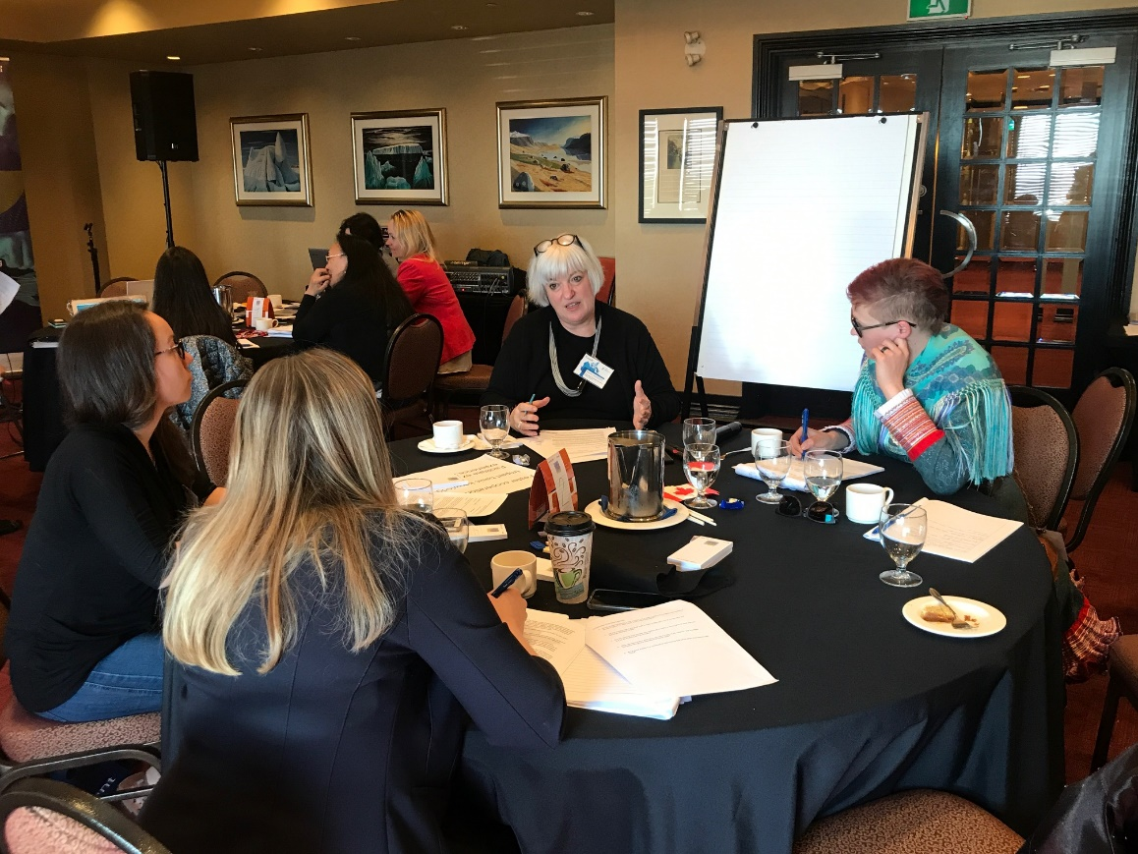

Group work on case studies (photo: Daphne Zografos Johnsson)

|  |
| --- |
| Case Study 3 - Distinctive Signs (Trademarks, Collective and Certification Marks, Geographical Indications) © WIPO 2019  Disclaimer: The facts in this case study are entirely fictitious. Any resemblance with actual facts is mere coincidence.  **FACTS**  1. The Akuitu community is located in an Arctic country. Women from the Akuitu community have traditionally produced clothing adapted to the harsh Arctic environment. The traditional clothing, which is made using local biological resources such as skins, fur, ivory and bone and uses traditional designs and motifs, exemplifies the creative and artistic elements of Akuitu culture. The patterns and symbols used on Akuitu clothing include cultural codes that the community’s members are able to read. These include information on the region in which the person lives and their family history. Within the Akuitu community, there are unwritten norms on the use of clothing, for example, men cannot wear clothing that depict symbols that normally belong on women’s clothing.  2. The Akuitu Handicraft Association (AHA) was founded in 2010 in order to protect and promote the market for traditional Akuitu clothing made by women of the Akuitu community. The AHA has strict rules about how traditional clothing are to be made, both in terms of know-how and resources to be used. AHA would like to build the capacity of its members to understand and leverage IP rights to differentiate and market traditional Akuitu clothing.  3. Extreme North, one of the world’s leaders in extreme weather outerwear started marketing a men’s outerwear line called “Nomad Akuitu Parka”. The Nomad Akuitu Parka is made of modern materials, but features traditional Akuitu motifs and symbols. According to Akuitu culture, some of the symbols used on the parka marketed by Extreme North are only to be reproduced on women’s clothing. The Nomad Akuitu Parka has become extremely popular and is in high demand. Several people have recently contacted AHA asking where they can buy the Nomad Akuitu Parka.  4. It has come to the attention of AHA that Extreme North has applied for a trademark for the works NOMAD AKUITU PARKA in relation to clothing. The Arctic country’s Trade Marks Act does not contain any provision on the protection of traditional knowledge or traditional cultural expressions.  **QUESTIONS FOR DISCUSSION**   1. AHA and its members feel that the use of some Akuitu symbols on the Nomad Akuitu Parka is offensive and that the use of the name Akuitu by Extreme North is deceptive and free rides on the image and reputation of the community. What can AHA do to prevent Extreme North from using the symbols and the word Akuitu? 2. What kind of IP tools could AHA develop and use to distinguish its clothing in the marketplace and build upon the reputation attached to traditional Akuitu clothing? What are the advantages and drawbacks of those options? Could you explain why you would choose one over the other? |

**Case Study 3: Discussion Questions and Group Answers**

1. **AHA and its members feel that the use of some Akuitu symbols on the Nomad Akuitu Parka is offensive and that the use of the name Akuitu by Extreme North is deceptive and free rides on the image and reputation of the community. What can AHA do to prevent Extreme North from using the symbols and the word Akuitu?**

The groups stated that:

* In this type of case, it would be important to pre-emptively protect culturally significant words and symbols;
* In certain countries, when someone has applied for a TM, an opposition can be filed based on bad faith or if it is offensive or deceptive. Therefore, the community or AHA could, in this type of legal context, make an argument that the registration of a TM (in the name of a community) by the company is offensive;
* Had the company approached the community, they may have been able to enter into a benefit sharing agreement;
* AHA or the community could create an awareness campaign that informs the public of the company’s deceptive marketing and use of TCEs. This approach has been effective in similar contexts. For example, in a recent incident a fashion company misappropriated the design of traditional clothing that contained TCEs. As a result of public pressure, the company removed the product from stores; and
* It is important to bring awareness to the fact that misappropriation of TCEs has a direct impact on cultural integrity.

1. **What kind of IP tools could AHA develop and use to distinguish its clothing in the marketplace and build upon the reputation attached to traditional Akuitu clothing? What are the advantages and drawbacks of those options? Could you explain why you would choose one over the other?**

* Collective Marks could be used to distinguish Akuitu clothing;
* It is important to recognise what preventative measures can be taken. In some cases, TMs may want to be proactively registered. For example, Urban Outfitters used the word Navajo (of the Navajo Nation) on a series of products. The Navajo Nation holds TMs on the use of its name. The name had been registered by the Navajo as a TM. It brought a case against Urban Outfitters. The case was settled; and
* It is important that when a party seeks to TM a name, they assess whether it would be offensive. Even in cases where parties engage with good intention, issues may arise. Sometimes there is disagreement between members of the community. For example, during the Gold Coast Commonwealth Games the Borobi was the name selected for the mascot. The word Borobi originates from the Yugambeh Aboriginal language. Generally, IP Australia examines TMs to ensure that the mark would not be considered offensive or scandalous. The Commonwealth Games had consulted with members of the community. Despite consultation, the application was opposed on the grounds that consent was required to use the word.

#### Presentations on Experiences and Best Practices

*Facilitators:* *Mr. Wend Wendland and Ms. Daphne Zografos Johnsson*

Each country and IPLCs representatives therefrom, were asked to prepare a presentation of their best practices related to IP, TK and TCEs. The summaries below are directly drawn from the presentations. The presentations contributed to the three objectives of the Practical Workshop which were to impart knowledge, foster cooperation and facilitate country-level exchanges.

##### Presentation: The Inuit Art Foundation, Canada

*Presenter: Ms. Blandina Attaarjaw Makkik, Igloo Tag Coordinator for the Inuit Art Foundation.*

The presentation provided an overview of the history of the Igloo Tag TM (Igloo Tag). It also addressed the benefits of the Igloo Tag and some of the current challenges it is facing.

Overview

The Igloo Tag was introduced by the Government of Canada in 1958 in order to identify artworks made by Inuit. The purpose of the Igloo Tag was to ensure that there was a sign that would distinguish Inuit-produced sculptures circulating on the market from fraudulent mass-produced works.

In March 2017, Indigenous and Northern Affairs Canada (INAC) transferred the ownership of the Igloo Tag to the Inuit Art Foundation. Currently, the foundation manages and administers the Igloo Tag. The Igloo Tag is only applied to Inuit art and is applicable to different art forms including sculptures, textile art, crafts, ceramics, jewellery, and fashion goods. There are three licence categories. These include artist associations and non-profit organizations, Inuit art retailers and Inuit art distributers. In other words, artists do not get the tags. These are issued by the licensees.

Significance

The Igloo Tag is important because it establishes provenance for artworks. It allows collectors, curators and art dealers to connect an Inuit artist with their work. The Igloo Tag also adds value to the artwork. In 2017, the Inuit Arts Economy Study concluded that consumers were willing to pay an additional $117 on average for artwork sold in association with the Igloo Tag. The study was commissioned by Indigenous and Northern Affairs. Many collectors will only purchase Inuit artwork if it comes with the Igloo Tag.

Current Issues and Solutions

Some of the current issues or questions that have arisen in respect of the Igloo Tag include:

* whether contemporary Inuit art should be marked with the Igloo Tag;
* whether the Igloo Tag should only be applied to artwork whose subject matter is specifically “Inuit”;
* whether the Igloo Tag can be applied to music and if so whether there would need to be a “distinct Inuit” element; and
* whether the Igloo Tag can be used when an artwork is the result of a collaboration between Inuit and non-Inuit.

In order to address some of the aforementioned questions, the Inuit Art Foundation has undertaken comprehensive stakeholder engagement. The focus of the consultations is also to determine whether the Igloo Tag can be expanded to include and license individual Inuit artists across the country.

Notably, there is discussion about the creation of a Nunatsiavut specific TM. There are diverse types of arts and crafts that are being produced in Nunatsiavut today. These include stone and antler carvings, textile art and sealskin garments to name a few. Potential licence holders in Nunatsiavut have been identified. These include the Nunatsiavut Government, Inuit Community Governments and Illusuak. [[20]](#footnote-21)

A concern that was raised was the challenge in regard to enforcement on an international level. For example, the Igloo Tag only provides protection in Canada. This is an issue because there have been instances where a gallery in another country uses a version of the Igloo Tag to benefit from the Igloo Tag’s reputation.

|  |
| --- |
| **Resource Material**  Inuit Art Foundation, *Igloo Tag*, at <https://iglootag.inuitartfoundation.org>. |

##### Presentation: Innovation, Science and Economic Development, Canada

*Presenter: Mr. Mark Schaan*

The presentation was titled, “Toward a More Inclusive IP Regime for Canada”. It provided an overview of the actions the Government of Canada is taking to move toward a more inclusive IP regime. It highlighted the initiatives that are targeted towards supporting Indigenous Peoples.

Overview of Canadian IP system

IP in Canada is mostly protected by specific statutes. For example, the *Patent Act[[21]](#footnote-22)*, the *Copyright Act[[22]](#footnote-23)* and the *Trade-marks Act[[23]](#footnote-24)*. The Department of Innovation, Science and Economic Development governs the overalls responsibility of the IP regime. However, the responsibilities for copyright are shared with the Department of Canadian Heritage. While CIPO is responsible for most of the administration and processing of the IP regime, Global Affairs Canada also plays a role in the IP regime because they manage the negotiation of international treaties which may include IP related provisions. Generally, trade secrets are primarily a matter of common law regulated in each province or territory (with the exception of Québec). Generally, IPRs are private rights. Therefore, they are enforceable through civil actions. Criminal remedies are available in certain cases.

On a domestic level, there are several recent developments in Canada in regard to the IP regime worth highlighting. The *Copyright Act* has been reviewed and Canada’s IP strategy includes a commitment to fund Indigenous initiatives. On an international level, the Government of Canada continues to pursue a progressive international trade agenda. It also continues to be present at WIPO and on other multilateral forums.

2018 IP Strategy and Indigenous Initiatives

The IP Strategy announced in 2018 is aligned with the Government’s commitment to reconciliation and inclusive economic growth. The IP strategy aims to create awareness about IP, promote strategic IP tools for growth and implement changes to IP legislation. The comprehensive focus of the IP strategy is on inclusiveness.

Under the IP Strategy, the Government committed funds for five years to Indigenous initiatives. The objective of this commitment was to contribute to a more inclusive IP system and the implementation of the United Nations Declaration on the Rights of Indigenous Peoples (UNDRIP). This includes supporting Indigenous IP awareness and capacity building. The Government’s strategy aims to enable Indigenous participation in the development and implementation of IP law, policy and programs as they relate to the protection of TK and TCEs on a domestic and international level.

Data Collection and Education and Awareness

Part of the strategy includes data collection on the use of IP protections, services and resources by Indigenous businesses and entrepreneurs. Further, CIPO is partnering with Indigenous organizations, business and academia to develop educational materials and programs about IP.

Grant Program

The IP strategy also includes a grant program that enables capacity building. This supports the participation of Indigenous representatives in policy and program development on the domestic and international level. The objectives of the grant program include: to increase the dialogue on reconciliation between Indigenous Peoples and the IP system; to support the advancement of Indigenous IP issues in international fora; and to increase the use of the IP system by Indigenous Peoples.

Moving Forward

Moving forward, Canada aims to work more closely with Indigenous Peoples on the development of domestic IP. This will take the form of multi-stakeholder workshops in 2019‑2020. Canada also aims to work closely with Indigenous Peoples in the international IP fora, including the IGC.

There are other initiatives that are also relevant. These include the Government of Canada’s work on Indigenous languages; investments that support Canada’s Research Coordinating Committee to develop partnerships with First Nations, Métis and Inuit communities to develop research training models; Polar Knowledge Canada Initiatives and Crown-Indigenous Relations and Northern Affairs Canada programs. Further, the Environmental Assessments Bills (C-68 and C-69) require transparency on how Indigenous knowledge is used in different types of assessments. These provide strong protection for the confidentiality of Indigenous knowledge.

The presentation highlighted the fact that reconciling the current IP system with the protection of TK and TCEs is a complex and controversial area of the law both domestically and internationally. IP offers opportunities and creates challenges for the protection of TK and TCEs. The Government and Indigenous Peoples in Canada need to work together to consider how to address the opportunities and challenges, starting with the initiatives under the IP Strategy.

|  |
| --- |
| **Resource Material**  Government of Canada, *Indigenous Peoples and Intellectual* Property, at <http://www.ic.gc.ca/eic/site/108.nsf/eng/00004.html>.  —. *Patent Act*, at <https://laws-lois.justice.gc.ca/eng/acts/p-4/index.html>.  —. *Copyright Act*, at <https://laws.justice.gc.ca/eng/acts/C-42/rpdc.html>.  —. *Trade-marks Act*, at <https://laws.justice.gc.ca/eng/acts/T-13/>. |

##### Presentation: International Trade, Canadian Heritage, Canada

*Presenter: Julie Boyer, Director General, International Trade, Canadian Heritage.*

The presentation entitled “Promoting and Protecting Indigenous Arts and Cultural Expressions: Experiences and Best Practices in Canada”provided examples of misappropriation and misuse of Indigenous arts and cultural expressions, an overview of the Canadian policy context, and examples of emerging tools and best practices supporting the promotion and protection of Indigenous arts and cultural expressions.

Examples of Misappropriation and Misuse

In Canada, Indigenous artists and stakeholders continue to raise concerns over the misappropriation and misuse of Indigenous arts and cultural expressions, citing the negative economic, social, and cultural implications. The issues are often crosscutting and complex, touching many forms of Indigenous arts and cultural expression (e.g., dance, theatre, fashion, visual arts, literature, film, music, languages, etc.) and intertwining copyright and intellectual property concerns, contractual and marketplace issues, and moral and cultural questions.

The presentation provided examples of misappropriation and misuse of Indigenous arts and cultural expressions in Canada, including:

* unauthorized copying and use;
* mass production and sale of offensive goods;
* production and sale of inauthentic arts and crafts; and
* online marketplace challenges.

Policy context

Indigenous arts and cultural expressions are powerful tools for Indigenous Peoples to share and present their stories. The presentation outlined some of the key policy pieces that form the policy context for supporting Indigenous arts and cultural expressions in Canada, including: the United Nations Declaration on the Rights on Indigenous Peoples (UNDRIP); the Truth and Reconciliation Commission’s Calls to Action (2015); the parliamentary review of the *Copyright Act;* and the establishment of the *Indigenous Languages Act* (2019).

In June 2015, the Truth and Reconciliation Commission released its final, six-volume report, including 94 Calls to Action for all levels of government and the Canadian public. These Calls to Action included actions pertaining to culture, language, and media, as well as a call for the implementation of the UNDRIP. In 2016, the Government of Canada announced full support of the UNDRIP.

As part of the parliamentary review of the *Copyright Act*, parliamentarians were asked to pay special attention to the needs and interests of Indigenous Peoples as part of Canada's cross‑cutting efforts to achieve reconciliation. In the spring of 2019, the committees tabled their respective reports, which included recommendations pertaining to Indigenous-specific issues.

Between 2017 and 2019, the Government of Canada, along with Indigenous partners, developed the foundational elements of Bill C-91, the *Indigenous Languages Act*, which supports the reclamation, revitalization, maintaining and strengthening of Indigenous languages in Canada. The Act received royal assent on June 21, 2019, and implementation is ongoing.

Examples of Tools and Best Practices

The presentation provided examples of tools and best practices aimed at supporting and protecting Indigenous arts and cultural expressions, including: protocols, guidelines, licensing and labeling tools, authentication tools, legislation, promotion and investment, public awareness campaigns, and progressive contracting practices.

Protocols and Guidelines

Protocols can help cultural industry stakeholders better understand how to appropriately and respectfully work with Indigenous peoples and communities, including working with Indigenous stories, concepts, arts, and symbols. An example of a protocol that has been developed in Canada was the “On-Screen Protocols & Pathways: A Media Production Guide to Working with First Nations, Métis, and Inuit Communities, Cultures, Concepts & Stories”.[[24]](#footnote-25) This was developed for imagineNATIVE, the Indigenous film and media arts festival, and made possible through the support of Canada Media fund, the National Film Board of Canada, Ontario Creates, Telefilm Canada, Creative BC and the Inspirit Foundation.

The development of guidelines is another tool that can target a specific issue. Guidelines can promote professional and public awareness and support normative practices in a specific area. For example, the guidelines entitled “Think Before You Appropriate: A Guide for Creators and Designers” were developed to provide guidance for designers and marketers engaging with Indigenous artists and communities.[[25]](#footnote-26)

Licensing and labeling tools

The development of licensing and labeling tools can allow Indigenous communities to indicate the presence of TK and TCEs in arts and cultural expressions. These tools can be used to articulate protocols for accessing and using cultural content. An example of an initiative related to licensing and labeling is *Local Contexts*.[[26]](#footnote-27) This initiative supports “Indigenous communities in the management of their IP and cultural heritage in a digital environment.”[[27]](#footnote-28)

Authentication tools

Authentication tools can be used to identify and verify that a work was created by an Indigenous artist. A key example from Canada is the Igloo Tag.[[28]](#footnote-29). First developed in 1958, this tag was used to protect Inuit artists from copyright infringement by certifying items as being authentic. In 2017, the management of the Igloo Tag was transferred from the Government of Canada to the Inuit Art Foundation.

Progressive agreements

There are examples of new and progressive practices that demonstrate fair and respectful consultations and progressive terms and conditions in contracts and agreements. For instance, when acquiring the art instillation The Witness Blanket, the Canadian Museum for Human Rights’ and First Nations artist Carey Newman co-developed an agreement that vested legal rights with the artwork itself.[[29]](#footnote-30) This contract gives equal weight to the oral and written agreement.[[30]](#footnote-31) Another progressive example was the collaboration between Métis artist Christi Belcourt and the fashion house Valentino.[[31]](#footnote-32) Belcourt worked with Valentino on a fashion line based on the designs in her paintings.

Promotion and investment

Among the emerging tools and best practices, there is a recognition that promotion and investment can be an effective approach to protecting Indigenous arts and cultural expressions. New programs can be created, or existing programs augmented to increase investment in and promotion of Indigenous arts and culture at both domestically and internationally. Examples presented include, the Canada Council for the Arts “Creating, Knowing and Sharing: The Arts and Cultures of First Nations, Inuit and Métis Peoples” program.[[32]](#footnote-33) This program supports Indigenous artists and arts/cultural organizations. Another example is Library and Archives Canada’s digitization for Indigenous language and culture recordings initiative titled “Listen, Hear Our Voices”.

Public awareness and education

Public awareness campaigns can be an efficient and effective way of deterring misuse and misappropriation by raising awareness of the issues and educating creators on their rights. An example of this type of initiative includes the Government of Canada’s IP Strategy, which includes an Indigenous Intellectual Property Program and an Education and awareness raising initiative to develop materials and programs in partnership with Indigenous organizations, business, academia and regional offices.[[33]](#footnote-34)

Legislation

Legislative solutions can be developed at a national and provincial/territorial level either through new legislation or amendment of existing legislation. A recent example in Canada is the *Indigenous Languages Act.* [[34]](#footnote-35) Between 2017 and 2019, the Government of Canada, along with Indigenous partners, developed the foundational elements of Bill C-91, the Indigenous Languages Act, which supports the reclamation, revitalization, maintaining and strengthening of Indigenous languages in Canada. The Act received royal assent on June 21, 2019, and implementation is ongoing.

The presentation concluded by recognising that issues pertaining to the protection and promotion of Indigenous arts and cultural expressions are often raised in the context of IP. However, these concerns intersect with marketplace issues and other moral and cultural questions. The creation of effective solutions requires understanding the challenges that communities, creators and artists face. These solutions also require drawing from a range of tools and best practices developed in local, national and international contexts. The challenges and opportunities extend beyond Canadian borders and intersect with other international considerations such as trade relations and other international obligations.

Canadian Heritage is looking to develop a toolkit focused on analyzing and documenting the economic, social, and cultural impacts related to the misuse and misappropriation of Indigenous arts and cultural expressions, along with examples of emerging best practices and tools.

|  |
| --- |
| **Comment following the presentation**  The Government of Nunavut has created a working group on IP. The purpose of this group is to bring together different governmental departments that work with IP. This includes intergovernmental affairs, cultural heritage and justice. The working group seeks to gather information on the types of legislative frameworks that exist in order to see what gaps need to be addressed. |

|  |
| --- |
| **Resource Material**  *An Act Respecting Indigenous Languages*, at <https://www.parl.ca/DocumentViewer/en/42-1/bill/C-91/first-reading>.  *An Act Respecting a National Strategy for the Repatriation of Aboriginal Cultural Property*, at <https://www.ourcommons.ca/Committees/en/CHPC/StudyActivity?studyActivityId=10237626>.  Authentic Indigenous, at <http://www.authenticindigenous.com/authenticity-tags.php>.  Canadian Museum for Human Rights, *Indigenous artist and Museum make history with unique agreement,* at<https://humanrights.ca/news/indigenous-artist-and-museum-make-history-with-unique-agreement-for-artwork-of-national>.  Canada Council for the Arts, *Creating, Knowing and Sharing: The Arts and Cultures of First Nations*, Inuit and Métis Peoples, at <https://canadacouncil.ca/funding/grants/creating-knowing-sharing>.  Christie Belcourt, at <http://christibelcourt.com/the-globe-and-mail-metis-artist-christi-belcourt-inspires-valentino-fashion-line/>.  Government of Canada, *Indigenous Peoples and Intellectual* Property, at <http://www.ic.gc.ca/eic/site/108.nsf/eng/00004.html>.  imagineNATIVE, *On-Screen Protocols & Pathways: A Media Production Guide to Working with First Nations, Métis, and Inuit Communities, Cultures, Concepts & Stories*, at <https://www.in-institute.com/publications>.  Intellectual Property Issues in Cultural Heritage Project, 2015. Think Before You Appropriate. Things to know and questions to ask in order to avoid misappropriating Indigenous cultural heritage. Simon Fraser University: Vancouver, at <https://www.sfu.ca/ipinch/sites/default/files/resources/teaching_resources/think_before_you_appropriate_jan_2016.pdf>.  Local Contexts, at <http://localcontexts.org>.  Royal BC Museum and the Haida Gwaii Museum at Ḵay Llnagaay, *Indigenous Repatriation Handbook*, at <https://royalbcmuseum.bc.ca/sites/default/files/indigenous_repatriation_handbook_rbcm_2019.pdf>.  Truth and Reconciliation Commission of Canada, *Truth and Reconciliation Commission of Canada’s Calls to Action*, at <http://nctr.ca/assets/reports/Calls_to_Action_English2.pdf>. |

##### Presentation: Sweden

*Presenters: Mr. Martin Berger, Legal Advisor, Swedish Patent and Registration Office and Ms. Ellacarin Blind, Officer of Cultural Affairs at Sámiid Riikkasearvi (National Association of the Saami people of Sweden)*

The presentation was given by both Mr. Martin Berger and Ms. Ellacarin Blind. Mr. Martin Berger provided an overview of the current IP system in Sweden. He brought attention to potential issues and drew from numerous examples of TMs that misuse elements of Saami culture. Ms. Ellacarin Blind drew attention to good practices relating to different types of signs that are used for Saami food products. The presentation noted that IP law in relation to Indigenous Peoples is unexplored in Sweden.

Overview Swedish Patent and Registration Office

The Swedish Patent and Registration Office (PRV) works under the Ministry of Enterprise and Innovation. There are two office locations: Söderhamn and Stockholm. The Office in Söderhamn focuses on TMs, designs, periodicals and copyright. The PRV in Stockholm focuses solely on patents. The PRV serves the entire country. It also promotes growth and strengthens the country's innovation capacity and competitiveness by increasing their knowledge of, and understanding of, the value of intangible assets.

Overview of the National Association of the Saami People in Sweden

The National Association of the Saami People in Sweden (SSR) reports to the Saami Parliament in Sweden. The Saami Parliament is a governmental body with its own elections and Saami political parties. They act as an advisory to the Swedish Government. Currently, there is no official established contact between the PRV and the Saami Parliament in Sweden.

Overview of Legislative Context

The Swedish *Trade Marks Act* provides that TMs must have a distinctive character. During an ex officio examination, a TM will lack the distinctive character if it:

* only indicates the place where goods are manufactured, or the services provided;
* only has a technical function; and
* only shows the shape of the nature of the goods, or gives substantial value to the goods.

Certain geographical names can be protected through IP. However, if a TM only indicates the place of production of a good, it may be difficult to register a TM because certain geographical names can be protected through GIs. Whereas, if a place is unknown for the production of certain goods or services, it may be registered as a TM. A recent case that exemplifies this concerned the registration of a mark called GAMVIK. GAMVIK is the name of a small fisherman’s community in the north of Norway. The PRV did in the first place not find that GAMVIK had enough of a connection with the fishing industry to deny its registration. The case was appealed and the Patent- and Market Court overruled the decision, since they found that no exclusive right could be given to the name Gamvik alone.

TMs may not be registered in cases where the TM is contrary to law or it is contrary to public policy or morality. The scope of this is not very clear. However, as per preparatory works and case law, marks that are offensive may be considered contrary to public policy and morality. For example, if a mark consists of a religious symbol, racist symbols or old communist symbols it may be considered offensive. Sweden is a secular and liberal country and what is considered offensive changes over time and the IP system itself is dynamic.

There are numerous examples of TMs that may be considered offensive as a result of their appropriation of elements of Saami cultural heritage or use of offensive words. However, no opposition or revocation requests have been made in regard to TMs that contain Saami symbols, words or traditional patterns. If an opposition request was submitted, this could lead to a decision from the Patent and Market Courts. No formal register exists that contains Saami symbols, words or traditional patterns etc.

There are notable examples of TMs that appropriate elements of Saami culture. For example, Lapland Nubben. This is a TM for an alcoholic beverage. The depiction on the TM is of artist Nils Nilsson Skum. He was a famous Saami artist that presented at the World Expo in Paris in 1937. He died over 68 years ago. According to the Swedish *Trade Mark Act*, a mark that consists of a surname or a picture of someone else that has not been deceased for a long time cannot be protected. As per case law, the name and portrait of a person is protected for 70 years after their death. There is a time limitation. Further, Lapland is a geographical area in Sweden and Finland where many Saami people live. The word ‘Lapp’ is no longer used because it is considered offensive. Another example includes the TM for Lapland Rom and Lapland Vodka. This is a rum company. The TM for this company uses Saami colours and depicts an icon from traditional Saami art.

There are also examples where products are registered with the word Saami or words related to Saami TCEs. This raises questions as to whether it is an issue for a non-Saami to register a mark with the word Saami or a word related to Saami TCEs. The Jokkmokk Sami Cheese is currently registered. Another example is TM Jojk which is registered for an alcoholic beverages company. Jojk is the traditional Saami way of singing and is also a Saami ritual. There are other TMs such as Bieggolmai Holding AB that may present issues. Bieggolmai is the wind god in Saami mythology.

Good Practices

There are examples of good practices in respect of Saami registered TMs. This includes Renlycka which is a TM registered for meat, poultry and fish by the National Association of the Saami People in Sweden. Another example is the Saami Duodji collective mark. The proprietor of the Saami Duodji is the Swedish Saami Handicraft Society. It is also used in Norway, Finland and Russia to authenticate Saami handicraft.

Geographical Indications

GIs are another distinctive sign that may be used for protection. Within the EU context, there is a three-level system for GIs. These include the protected designation of origin, the protected geographical indication and the traditional specialities guaranteed. The traditional specialities guaranteed can be said to protects traditional recipes used in the whole country.

There are some issues between the TM system and GIs. A TM gives an exclusive right which can be licensed to other companies. In a liberal country, private property is highly respected and in the marketing economy an entrepreneur must be able to make his or her own choices as regards to the place of production etc. GIs can be understood as a means to force the producers to stay in one region and to share the exclusivity with other producers in the area. Questions arise as to whether GIs are a quality stamp or a means to protect goodwill and reputation. There is potential for non-agriculture related GIs to provide protection for TK.

Potential IP Protection

There are potential opportunities for the Saami to use IP protections in relation to Saami food. There are important food related movements such as Slow Food Sápmi. Slow Food Sápmi is an organization committed to the Slow Food movement. It includes the Saami regions of Sweden, Finland, Norway and Russia. [[35]](#footnote-36) The Saami are also working on the protection of fish products.

Recently, a question was raised as to whether a GI for Saami food products would be possible and/or beneficial for the Saami. GIs may be a way to promote Saami products and gain higher prices at market. This would be useful for export. Traditional Saami foods include suovas or gurpi. The National Food Agency does provide guidance and assistance with application in regard to GIs in Sweden.

Some of the obstacles to GI protection is that they are expensive and more complicated to register. GIs are collective rights. Their proprietors are associations / societies that are connected to specific areas. However, the administrative borders of the GIs do not follow the Saami territory. GIs are also more expensive and more complicated than collective marks. Potential solutions to this could be through bilateral agreements. Another issue is that Norway and Russia are not members of the European Union which may limit the scope of a potential GI related to Saami food products.

Ways Forward

The improvements that can be made include establishing a contact between the PRV, Department of Justice, Department of innovation and Energy and the Saami national organisations and communities. Further, improvements can be made in terms of awareness in IP for small and medium enterprises (SMEs) in Sápmi. This may include courses, the attendance in business fairs/expos and seminars.

Innovation is important for the economy in Sweden. The PRV’s mission includes to raise awareness and inform people about the value of IP registration to protect IPRs. The PRV’s focus over the last few years has been on SMEs. This mandate is also important for the many Saami people who are entrepreneurs in handicraft, reindeer herding and tourism etc.

The PRV also creates awareness campaigns that promote the respect of IPRs. This includes campaigns that address counterfeit or fake goods and illegal streaming. The awareness campaign projects have been made in cooperation with the European Intellectual Property Office, EUIPO. Further, the European cooperation between the national offices is explicitly mentioned in the European Trademarks Directive.

Other ways forward that were discussed included addressing instances of offensive TMs such as the use of Nils Nilsson Skum’s portrait by Lapland Nubben.

|  |
| --- |
| **Resources**  PRV, at <https://www.prv.se/en/>.  Slow Food Sapmi, at <http://en.slowfoodsapmi.com>. |

##### 

##### Presentation: Saami Parliament, Finland

*Presenters: Ms. Anni-Helena Ruotsala, Environmental Secretary of the Saami Parliament and Ms. Sarita Kämäräinen, Secretary for Saami Livelihoods of the Sami Parliament*

The presentation was titled “Promoting Rights for Self-determination in the Context of Traditional Knowledge and Cultural Heritage”. The presentation addressed the challenges, best practices and the approach that the Saami have taken in Finland in respect of TK and TCEs protection. Ms. Anni-Helena Ruotsala presented on the challenges, current legal and policy context and the ways forward. Ms. Sarita Kämäräinen presented on specific TK and TCE issues that have arisen in relation to the tourism industry in Finland.

Challenges

There are several challenges that the Saami face in regard to the protection of TK and TCEs. For example, the distinct geography of the Sápmi territory spreads across four different countries which makes it difficult to coordinate policies. In Finland, the focus on the protection of Saami TK and cultural heritage has been holistic and not purely based on IP. The goal is to protect the future existence of the Saami. This holistic approach seeks to utilise the different instruments that support the protection and preservation of Saami TK and cultural heritage.

Current Legal and Policy Context

Currently, there are instruments and guidelines in place that support the protection of Saami TK and cultural heritage in Finland. These include the *Convention on Biodiversity* (Convention) and the Akwé: Kon Guidelines (Guidelines). Notably, Article 8(j) of the Convention addresses TK.

The Guidelines also support the involvement of Indigenous Peoples and local communities in land use and planning. It provides guidance on how land development can take into account TK, innovations and practices and the concerns and interests of Indigenous Peoples. The Guidelines require the inclusion of the Saami in impact assessments for land planning and use. The Guidelines have facilitated an increase in dialogue and trust between the Saami and state agencies. It has also supported capacity building in Saami communities. Based on these developments, knowledge groups have been formed in communities that act as rights holders. These groups learn about the areas they are in charge of and about the different instruments that they can use to protect their interests.

Challenges and Ways Forward

There are gaps and issues in respect of the implementation of the Guidelines. For example, Saami are not able to efficiently participate in the decision making and their interests are not sufficiently taken into account in decision making processes. Another issue is that there are insufficient procedures to monitor the implementation of plans and to assess the true impact of plans.

As a way forward, the Saami have created an updated model to ensure that land use plans benefit the Saami and that benefit sharing agreements are entered into on the basis of free, prior and informed consent. The model provides that at all stages of the land planning and use Saami customary law and rights are respected. It also requires that the other party disclose their decision-making processes and any conflicting interests they may have. The model also outlines the approval required to use Saami TK. The model provides that the land plan that demonstrate that they will have the least negative impact on the Saami should be selected. Currently, the Government has not provided feedback on the updated model.

As stated before, consent is an important issue for land plans and use. This is why the Saami advocate for free, prior and informed consent in regard to any land plans and use. Any project that may affect the Saami requires consent of the Saami community and Saami Parliament. There are many examples where researchers seek permission for projects once the project is completed and not at the beginning of the project. The Guidelines have helped because people generally want to be morally accountable. However, the Saami maintain the right to decline research projects and these decisions need to be respected. The procedure for seeking consent can be summarized as follows:

* Free prior and informed consent be obtained by the affected Saami community and Saami Parliament;
* Consent does not mean that rights to ownership are given away;
* Consent must be sought in a timely manner;
* Full disclosure of the relevant information about the project, its impacts, ethical challenges, benefit sharing plans etc. are necessary;
* Saami community and Saami Parliament are offered the opportunity to participate and this participation is resourced; and
* Saami may decline any project.

Lastly, it is important to recognise that cultural heritage sites and sacred sites are not public domain. TK needs to be protected. However, according to Finish law the information collected about these sites is public if it is collected by the Government. Saami Parliament seeks to engage in a productive dialogue with the Government to raise awareness, to develop principles and to find ways forward.

Tourism Issues related to TK and TCEs

Tourism has presented issues in respect of TK and TCEs for the Saami. Tourism has grown in the Finnish Lapland and in the Saami home region in Finland. This has created challenges to cultural sustainability. Elements of Saami culture are commercialised through the tourism industry. Further tourism operators outside of Saami communities exploit elements linked to Saami culture without any connection to the communities.

Culturally Responsible Saami Tourism Project

The Culturally Responsible Saami Tourism Project is a response to the aforementioned issues. Saami Parliament has received funding from the Ministry of Education and Culture to develop this project. One of the primary tasks of this project was to develop ethical guidelines for sustainable Saami tourism product development and presentation in Finland. This ensures that the Saami determine who, what and how the elements of their culture are used and portrayed in tourism. In 2018, the guidelines were accepted by the Saami Parliament. Currently, the guidelines are being distributed and marketed. There are seven guiding principles for ethically sustainable Saami tourism. These include:

* Recognising and respecting the value and richness of Saami cultural heritage;
* Protecting and maintaining the vitality of Saami cultural heritage for future generations;
* Mutually beneficial understanding and co-operation;
* Issues featured in Saami tourism – their recognition and correction;
* Positive impacts of Saami tourism on Saami people, their culture and environment;
* Responsible and ethically sustainable marketing and communications of Saami tourism; and
* High quality visitor experiences – quality assurance.

The Saami have been reactive and not proactive. The goal is to work in a more proactive manner and with Saami peoples across the different borders. This is reflected in the draft Saami Convention.

|  |
| --- |
| **Resources**  Saami Parliament, *Procedure for seeking consent for research projects dealing with Saami cultural heritage and traditional knowledge*, at  <https://www.samediggi.fi/procedure-for-seeking-consent-for-research-projects/?lang=en>  Saami Parliament, *Guidelines for Sustainable Tourism*, at [www.samediggi.fi](http://www.samediggi.fi/) |

##### Presentation: Ministry of Education and Culture, Finland

*Presenter: Ms. Anna Elisa Carita Vuopala, Government Counsellor, Ministry of Education and Culture*

The presentation addressed the current initiatives undertaken by the Government of Finland in respect of TK and TCEs. It addressed the applicability of IP legal frameworks (national and international) and the issues that have arisen in terms of efficiency, access and usability. The presentation also recognised that a synergistic approach to the protection of TK and TCEs was necessary in Finland. This mean understanding the benefits and gaps in the existing legal frameworks and available tools (both legal and non-legal) that support the protection, preservation and promotion of TK and TCEs.

Overview of legal and policy context

In Finland, the Government’s main focus in regard to TK has been through the *Convention on Biodiversity*. The Government has also relied on guidance from WIPO. The general approach in Finland is to achieve the objectives of existing international instruments in a comprehensive and synergistic way.[[36]](#footnote-37) The needs of Indigenous Peoples to protect their tradition and TCEs is central to approaching these issues. However, challenges arise in regard to the descriptions of the different objects of protection and the scope of their protection in different instruments.

Section 6 of the *Genetic Resources Act* (Act) provides for a Saami database that stores information for research development. This database stores Saami TK related to GRs. Section 7 of the Act provides that the right to access the database requires a permit from the competent authority. The competent authority is required to notify the Saami Parliament of permit applications. The competent authority determines whether or not to approve the terms of agreement between the permit seeker and Saami Parliament. This model is not in practice yet. It has been developed from the State’s perspective and not from the Saami’s perspective.

The *Nordic Saami Convention* was ratified in 2016 by Finland, Sweden and Norway. This legislation is significant because it promotes cooperation between the different countries in respect of the protection and preservation of Saami cultural heritage. Relevant articles include: article 11 (symbols), article 20 (right to language and culture), article 22 (Saami cultural heritage, TCEs and TK), article 26 (cross-border cooperation), article 34 (Saami livelihood), article 38 (Duodji). The three Saami Parliaments have not yet decided whether they will accept it.

WIKI of intangible cultural heritage

The Government has also created the WIKI of Intangible Cultural Heritage. This initiative was intended to safeguard Saami intangible cultural heritage. The purpose was to allow communities to define the value and significance of their cultural heritage. However, the public nature and openness of the WIKI portal is an issue. The Saami are making their own assessment and ethical guidelines to address the issues and concerns about the circulation of their cultural heritage in the public domain.

Study on IP and Saami TK and TCEs

The study by Tuamos Mattila titled, “Needs of the Saami People for Intellectual Property Protection from the Viewpoint of Copyright and Trademarks” was commissioned by the Ministry of Education and Culture.[[37]](#footnote-38) The study identified relevant questions and issues required to protect TCEs and to determine the gaps in their legal protection. The study addressed the Duodji mark, copyright and TMs. Some of the findings included that:

* Weight needs to be given to the Saami’s determination on the scope of protection;
* Appropriation threatens to dilute the cultural significance of TCEs;
* Appropriation of TCEs infringes Saami self-determination; and
* Appropriation harms viable economic sectors such as traditional crafts.

The use of the IP system to protect TCEs and TK needs to be determined by the Saami. This includes who manages the IPRs, what is to be protected and the scope of the protection.

Copyright Act

The *Copyright Act* provides for the protection of classics. This is form of protection is found in the legislation in all Nordic countries. It applies to works so long as they have never been protected by copyright. The scope of this provision is considered to be narrow. However, it would be worth addressing it through a Nordic case study to determine whether the protection it offers can be extended to TCEs.

|  |
| --- |
| **Resources**  Ministry of Education and Culture (Finland), *Needs of the Saami People for Intellectual Property Protection from the Viewpoint of Copyright and Trademarks*, at <https://www.samediggi.fi/2018/12/12/ministry-of-education-and-culture-publications-needs-of-the-sami-people-for-intellectual-property-protection-from-the-viewpoint-of-copyright-and-trademarks/?lang=en>.  *Nagoya Protocol on Access to Genetic Resources and the Fair and Equitable Sharing of Benefits Arising from their Utilization to the Convention on Biological Diversity,* at <https://wipolex.wipo.int/en/treaties/details/311>.  UNESCO, *Convention on the Protection and Promotion of the Diversity of Cultural* Expressions, at <https://en.unesco.org/creativity/convention>.  *—. Convention for the Safeguarding of the Intangible Cultural Heritage*, at <https://ich.unesco.org/en/convention>.  *United Nations Declaration on the Rights of Indigenous Peoples*, at <https://www.un.org/development/desa/indigenouspeoples/declaration-on-the-rights-of-indigenous-peoples.html>. |

#### Closing Comments

The closing comments for the Practical Workshop were provided by Ms. Aluki Kotierk, President of NTI, Mr. Mark Schaan and Mr. Wend Wendland.

**Mr. Wend Wendland** spoke about how the Practical Workshop was the beginning to future initiatives. He observed that over the course of the Practical Workshop all the participants have learned from each other about the different approaches that are being undertaken in each country. He also noted how participants recognised that guidelines themselves do not provide enough protection for TK and TCEs and that enforceability is an important aspect of TK and TCEs protection. He encouraged the IPLCs representatives to participate in the workshops and programs offered by WIPO, such as WIPO’s Distance Learning Course and an upcoming training and mentoring program for Indigenous Women Entrepreneurs. Mr. Wendland announced the award of two scholarships to Indigenous persons from the Arctic to participate in WIPO’s Summer School on IP in Geneva in 2020. Finally, he thanked all involved for having ensured the success of the Workshop, including his colleagues present and back in Geneva.

**Ms. Aluki Kotierk, President of NTI**, spoke about how the Practical Workshop is the beginning of the discussion in regard to TK and TCEs. She recognised that these issues will continue to need to be addressed. She stated that although there are IP tools that exist and can address TK and TCEs, the question arises as to how to include Indigenous ways of being and knowledge in these IP tools. The individual nature of IPRs is an issue, it fails to recognise the benefits for the collective. This tension will continue to be a longstanding discussion. Other concerns raised include the misuses of different cultural expressions by people not from that culture. This dilutes culture. Cultural expressions and practices are important forms of empowerment that allow the reclamation of identities and practices that were taken away. The arts have maintained cultural continuity for Indigenous Peoples. Cultural traditions need to be maintained to assert the identity of Indigenous Peoples. The issues and concerns raised during the Practical Workshop are important and require ongoing consideration. The Saami and Inuit need to work together as Arctic peoples, to continue to share best practices. The Practical Workshop has been encouraging. It has brought Arctic peoples together to work on important issues.

**Mr. Mark Schaan** spoke about how IP is complex, a technical area, emotional and personal in many ways. He spoke about how the Practical Workshop engaged in issues that are challenging but provided the space for relationship building which is necessary for the IP system to become more inclusive. He also stated that IPRs are individual rights but the participants in the Practical Workshop have proven that the process through which the IP system is examined, analysed and critiqued can be collective and that this collective process creates (and has created) momentum for change.

|  |  |  |  |
| --- | --- | --- | --- |
| **E** | | | |
|  |  |  | WIPO-E |
| C:\Users\zografos\AppData\Local\Microsoft\Windows\INetCache\Content.Outlook\E6TIBN2Q\goc_fip_e_2c_55.jpg | | |
|  | | | |
| **WORKSHOP** | | | |
| WIPO/IPTK/YFB/19/INF/4 | | | |
| ORIGINAL: ENGLISH | | | |
| DATE: March 27, 2019 | | | |

**Practical Workshop on Intellectual Property, Traditional Knowledge and Traditional Cultural Expressions for Countries from the Arctic Region**

organized by   
the World Intellectual Property Organization (WIPO)

and

the Government of Canada

in collaboration with

Nunavut Tunngavik Inc.

**Iqaluit, Canada, May 14 to 16, 2019**

PROGRAM

*prepared by the International Bureau of WIPO*

|  |  |
| --- | --- |
| **Objectives:** | The objectives of the Workshop would be to:   * Foster cooperation between government officials from different departments and indigenous peoples and local communities (IPLCs), within each country and between countries from the Arctic region; * Impart basic knowledge of the main principles, systems and tools of the IP system and how they relate to IPLCs, emphasizing both the potential value that intellectual property (IP) could bring in support of traditional knowledge (TK) and traditional cultural expressions (TCEs) protection, as well as the challenges; * Facilitate country-level exchanges and exchanges on experiences and best practices relevant to the protection of TK and TCEs. |
| **Participants:** | Government officials and IPLC representatives from Canada, Finland and Sweden. |

Tuesday, May 14, 2019

***Note: For all Participants***

9.00 – 9.30 Registration

9.30 – 10.00 **Welcome**

**Qulliq Lighting Ceremony**

Welcome Addresses by:

Mr. Mark Schaan, Director General, Marketplace Framework Policy Branch, Innovation, Science and Economic Development Canada

Mr. Wend Wendland, Director, Traditional Knowledge Division, Global Issues Sector, World Intellectual Property Organization (WIPO), Geneva

Ms. Kilikvak Karen Kabloona, CEO, Nunavut Tunngavik Inc.

10.00 – 10.30 **Overview of Program and Practical Arrangements**

Ms. Daphne Zografos Johnsson, Legal Officer, Traditional Knowledge Division, Global Issues Sector, WIPO, Geneva

Ms. Laura Woodward, Policy Analyst, Copyright and Trademark Policy Directorate, Innovation, Science and Economic Development Canada

10.30 – 11.00 Coffee Break

***Note: For IPLCs only from now on.***

***Informal Discussions between Government Officials of Participating Countries on IP, TK and TCEs will be hosted in parallel by the Government of Canada***

11.00 – 11.45 **Getting to Know One Another**

Facilitator: Ms. Monica Ell-Kanayuk, President, Inuit Circumpolar Council of Canada

11.45 – 12.30 **Introduction to IP**

Presentation: Ms. Rebecka Forsgren, WIPO Indigenous Fellow, Traditional Knowledge Division, Global Issues Sector, Geneva

Discussion

12.30 – 13.30 Lunch Break

13.30 – 14.15 **Introduction to** **IP, TK and TCEs**

Presentation: Ms. Daphne Zografos Johnsson

Discussion

14.15 – 15.15 **Group Work: Identifying Issues, Needs and Expectations**

Facilitator: Ms. Monica Ell-Kanayuk

* What challenges is your community currently facing regarding the protection of TK and TCEs?
* Which steps could be taken at the community level to promote the protection of, add value to, and maximize the economic opportunities associated with TK and TCEs?
* What are your expectations of this Workshop?

15.15 – 15.30 Working Coffee Break

15.30 – 16.30 **Group Work: Identifying Issues Needs and Expectations (continued)**

Reports from the Groups

Discussion

16.30 – 17.00 **Wrap-up of the Day**

Facilitators: Ms. Monica Ell-Kanayuk

Ms. Rebecka Forsgren

17.00 End of Session

Wednesday, May 15, 2019

***Note: For all Participants from now on***

9.00 – 9.30 **Getting to Know One Another – Introductions and Expectations**

Facilitators: Mr. Mark Schaan

Mr. Wend Wendland

9.30 – 10.30 **Topic 1: IP, TK and TCEs - An Overview of Policy and Legal Issues from an IP Perspective**

Presentation: Ms. Daphne Zografos Johnsson

Discussion

10.30 – 10.45 Coffee Break

10.45 – 12.00 **Topic 2: Available IP Tools to Protect TK and TCEs**

Presentation: Mr. Jeffrey Orser, Director, Services to Business, Canadian Intellectual Property Office

Discussion

12.00 – 13.30 Lunch Break

13.30 – 15.15 **Group Work: Case Study 1: Copyright**

Facilitators: Mr. Mark Schaan

Ms. Daphne Zografos Johnsson

Reports from the Groups

General Discussion

15.15 – 15.30 Coffee Break

15.30 – 16.45 **Group Work: Case Study 2: Patents**

Facilitators: Mr. Jeffrey Orser

Mr. Wend Wendland

Reports from the Groups

General Discussion

16.45 – 17.00 **Wrap-up of the Day**

Facilitators: Mr. Wend Wendland

Ms. Rebecka Forsgren

17.00 End of Session

17.00 – 18.00 **Country-level Exchanges [venue tbd]**

18.00 onward **Cultural Event hosted by the Government of Canada**

Thursday, May 16, 2019

9.00 – 9.30 Re-cap of Wednesday

Facilitator: Ms. Daphne Zografos Johnsson

9.30 – 10.45 **Group Work: Case Study 3: Distinctive Signs (Trademarks, Collective and Certification Marks, Geographical Indications)**

Facilitator: Ms. Marion Heathcote, Representative, International Trademark Association (INTA), Principal, Davies Collison Cave Pty, Sydney, Australia

10.45 – 11.00 Coffee Break

11.00 – 12.00 **Group Work: Case Study 3 (continued)**

Reports from the Groups

General Discussion

12.00 – 13.30 Lunch Break

13.30 – 13.40 Group Photo

13.40 – 15.00 **Presentations on Experiences and Best Practices Related to IP, TK and TCEs**

Facilitators: Mr. Wend Wendland

Ms. Daphne Zografos Johnsson

Presentations: Canada

Discussion

15.00 – 15.15 Coffee Break

15.15 – 16.45 **Presentations on Experiences and Best Practices Related to IP, TK and TCEs**

Presentations: Finland

Sweden

Discussion

16.45 – 17.15 **Wrap-up of the Workshop and Closing Remarks**

Ms. Aluki Kotierk, President, Nunavut Tunngavik Inc.

Mr. Wend Wendland

Mr. Mark Schaan

17.15 Closing of Sessions

[End of document]

|  |  |
| --- | --- |
| **E** | |
|  | WIPO-E |
|  |
|  | |
| **Workshop** | |
| WIPO/IPTK/YFB/19/inf1 | |
| ORIGINAL: English | |
| DATE: May 9, 2019 | |

**Practical Workshop on Intellectual Property, Traditional Knowledge and Traditional Cultural Expressions for Countries from the Arctic Region**

organized by

the World Intellectual Property Organization (WIPO)

and

the Government of Canada

in collaboration with

Nunavut Tunngavik Inc.

**Iqaluit, Canada, May 14 to 16, 2019**

LIST OF PARTICIPANTS

*prepared by the International Bureau of WIPO*

1. INVITED PARTICIPANTS

(in the alphabetical order of the names of the States and of the persons)

CANADA

Marie BELLEAU (Ms.), Lawyer, Nunavut Tunngavik Inc.

Julie BOYER (Ms.), Director General, International Trade, Canadian Heritage

Tina DECOUTO (Ms.), Director, Nunavut Tunngavik Inc.

Monica ELL-KANAYUK (Ms.), President, Inuit Circumpolar Council of Canada

Koovian FLANAGAN (Ms.), Senior Advisor, Inuit Community Relations, Canadian Northern Economic Development Agency

Anne-Cécile GRUNENWALD (Ms.), Cultural Industries, Government of Nunavut

Brenda JARARUSE (Ms.), Director (Culture), Nunatsiavut Government

Rhoda KOKIAPIK (Ms.), Executive Director, Avataq Cultural Institute

Aluki KOTIERK (Ms.), President, Nunavut Tunngavik Inc.

Natasha LATREILLE (Ms.), Project Coordinator, Inuit Circumpolar Council of Canada

Blandina MAKKIK (Ms.), Igloo Tag Coordinator, Inuit Art Foundation

Jeffrey ORSER (Mr.), Director, Services to Business, Canadian Intellectual Property Office

Éric SAVARD (Mr.), Administrative Assistant, Copyright and Trademark Policy Directorate, Innovation, Science and Economic Development Canada

Mark SCHAAN (Mr.), Director General, Marketplace Framework Policy Branch, Innovation, Science and Economic Development Canada

Christian SPENCE (Mr.), Project Coordinator, Inuit Tapiriit Kanatami

Theresie TUNGILIK (Ms.), Traditional Economy Acting Manager, Government of Nunavut

Laura WOODWARD (Ms.), Policy Analyst, Copyright and Trademark Policy Directorate, Innovation, Science and Economic Development Canada

FINLAND

Sarita Annika Katariina KAMARAINEN (Ms.), Saami People

Riitta Anneli ORTI-BERG (Ms.), Saami People

Anni-Helena RUOTSALA (Ms.), Saami People

Anna Elisa Carita VUOPALA (Ms.), Government Counsellor, Ministry of Education and Culture

SWEDEN

Martin BERGER (Mr.), Legal Advisor, Swedish Patent and Registration Office

Ellacarin BLIND (Ms.), Saami People

1. INTERNATIONAL NON-GOVERNMENTAL ORGANIZATIONS

International Trademark Association (INTA)

Marion HEATHCOTE (Ms.), Representative and Principal, Davies Collison Cave, Sydney, Australia

1. INTERNATIONAL BUREAU OF THE WORLD INTELLECTUAL PROPERTY ORGANIZATION (WIPO)

Hanna Rebecka FORSGREN (Ms.), Indigenous Fellow, Traditional Knowledge Division, Global Issues Sector

Katerina LAGASSE (Ms.), Rapporteur

Wend WENDLAND (Mr.), Director, Traditional Knowledge Division, Global Issues Sector

Daphné ZOGRAFOS JOHNSSON (Ms.), Legal Officer, Traditional Knowledge Division, Global Issues Sector

[End of document]

1. https://www.wipo.int/meetings/en/topic.jsp?group\_id=309 [↑](#footnote-ref-2)
2. Pauktuutit Inuit Women’s Association, *supra* note 1. [↑](#footnote-ref-3)
3. *Convention on Biological Diversity*, 1992, at <https://wipolex.wipo.int/en/treaties/details/254>. [↑](#footnote-ref-4)
4. *International Treaty on Plant Genetic Resources for Food and Agriculture*, 2001, at <http://www.fao.org/plant-treaty/overview/texts-treaty/en/>. [↑](#footnote-ref-5)
5. *Bonn Guidelines on Access to Genetic Resources and Fair and Equitable Sharing of the Benefits Arising out of their Utilization*, 2002, at https://www.cbd.int/doc/publications/cbd-bonn-gdls-en.pdf. [↑](#footnote-ref-6)
6. *Nagoya Protocol on Access to Genetic Resources and the Fair and Equitable Sharing of Benefits Arising from their Utilization to the Convention on Biological Diversity,* 2014,at <https://wipolex.wipo.int/en/treaties/details/311>. [↑](#footnote-ref-7)
7. WIPO, *The Adventures of the Yakuanoi*, at http:///[www.wipo.int/tk/en/tk/yakuanoi.html](https://www.wipo.int/tk/en/tk/yakuanoi.html). [↑](#footnote-ref-8)
8. The details of the organic farm example are not included in the report. [↑](#footnote-ref-9)
9. See WIPO, *Certification Marks*, at <https://www.wipo.int/sme/en/ip_business/collective_marks/certification_marks.htm>. [↑](#footnote-ref-10)
10. See WIPO, *Collective Marks*, at <https://www.wipo.int/sme/en/ip_business/collective_marks/collective_marks.htm>. [↑](#footnote-ref-11)
11. See WIPO, *Geographic Indications*, at <https://www.wipo.int/geo_indications/en/>. [↑](#footnote-ref-12)
12. See Toi Iho, *About Toi Iho*, at <http://www.toiiho.co.nz>. [↑](#footnote-ref-13)
13. See Australian Government, *Indigenous Knowledge: Issues for Protection and Management*, at <https://www.ipaustralia.gov.au/about-us/news-and-community/news/indigenous-knowledge-issues-protection-and-management>. [↑](#footnote-ref-14)
14. See Supply Nation, at <https://supplynation.org.au/about-us/our-mission/>. [↑](#footnote-ref-15)
15. See Indigenous Arts Code, at <https://indigenousartcode.org/>. [↑](#footnote-ref-16)
16. See Terri Janke, *True* Tracks, at <http://www.terrijanke.com.au/true-tracks>. See also Terri Janke, *True Tracks: Indigenous Cultural and Intellectual Property Protocols*, at <https://www.ala.org.au/wp-content/uploads/2018/05/Terri-Janke-ICIP-Presentation-27March2018.pdf>. [↑](#footnote-ref-17)
17. See Australia Arts Council, *Protocols for Working with Indigenous Artists*, at <https://www.australiacouncil.gov.au/about/protocols-for-working-with-indigenous-artists/>. [↑](#footnote-ref-18)
18. See *Haka Ka Mate Attribution Act* (2014) NZ, at <http://www.legislation.govt.nz/act/public/2014/0018/latest/DLM5954438.html>. [↑](#footnote-ref-19)
19. Id. [↑](#footnote-ref-20)
20. See Inuit Art Foundation, *Igloo Tag*, at <https://iglootag.inuitartfoundation.org>. [↑](#footnote-ref-21)
21. See Government of Canada, *Patent Act*, at <https://laws-lois.justice.gc.ca/eng/acts/p-4/index.html>. [↑](#footnote-ref-22)
22. See Government of Canada, *Copyright Act*, at <https://laws.justice.gc.ca/eng/acts/C-42/rpdc.html>. [↑](#footnote-ref-23)
23. See Government of Canada, *Trade-marks Act*, at <https://laws.justice.gc.ca/eng/acts/T-13/>. [↑](#footnote-ref-24)
24. imagineNATIVE, *On-Screen Protocols & Pathways: A Media Production Guide to Working with First Nations, Métis, and Inuit Communities, Cultures, Concepts & Stories*, at <https://www.in-institute.com/publications>. [↑](#footnote-ref-25)
25. Intellectual Property Issues in Cultural Heritage Project, 2015. Think Before You Appropriate. Things to know and questions to ask in order to avoid misappropriating Indigenous cultural heritage. Simon Fraser University: Vancouver, at https://www.sfu.ca/ipinch/sites/default/files/resources/teaching\_resources/think\_before\_you\_appropriate\_jan\_2016.pdf [↑](#footnote-ref-26)
26. See Local Contexts, at <http://localcontexts.org>. [↑](#footnote-ref-27)
27. Id. [↑](#footnote-ref-28)
28. See Inuit Art Foundation, *Igloo Tag*, at <https://iglootag.inuitartfoundation.org>. [↑](#footnote-ref-29)
29. See Canadian Museum for Human Rights, *Indigenous artist and Museum make history with unique agreement,* at<https://humanrights.ca/news/indigenous-artist-and-museum-make-history-with-unique-agreement-for-artwork-of-national>. [↑](#footnote-ref-30)
30. Id. [↑](#footnote-ref-31)
31. See Christie Belcourt, at <http://christibelcourt.com/the-globe-and-mail-metis-artist-christi-belcourt-inspires-valentino-fashion-line/>. [↑](#footnote-ref-32)
32. See Canada Council for the Arts, *Creating, Knowing and Sharing: The Arts and Cultures of First Nations*, Inuit and Métis Peoples, at <https://canadacouncil.ca/funding/grants/creating-knowing-sharing>. [↑](#footnote-ref-33)
33. See Government of Canada, *Indigenous Peoples and Intellectual* Property, at <http://www.ic.gc.ca/eic/site/108.nsf/eng/00004.html>. [↑](#footnote-ref-34)
34. See *An Act Respecting Indigenous Languages*, at <https://www.parl.ca/DocumentViewer/en/42-1/bill/C-91/first-reading>. [↑](#footnote-ref-35)
35. See Slow Food Sapmi, at <http://en.slowfoodsapmi.com>. [↑](#footnote-ref-36)
36. See UNESCO, *Convention on the Protection and Promotion of the Diversity of Cultural* Expressions, at <https://en.unesco.org/creativity/convention>. See UNESCO, *Convention for the Safeguarding of the Intangible Cultural Heritage*, at <https://ich.unesco.org/en/convention>. See *United Nations Declaration on the Rights of Indigenous Peoples*, at <https://www.un.org/development/desa/indigenouspeoples/declaration-on-the-rights-of-indigenous-peoples.html>. See *Nagoya Protocol on Access to Genetic Resources and the Fair and Equitable Sharing of Benefits Arising from their Utilization to the Convention on Biological Diversity,* at <https://wipolex.wipo.int/en/treaties/details/311>. [↑](#footnote-ref-37)
37. See Ministry of Education and Culture (Finland), *Needs of the Saami People for Intellectual Property Protection from the Viewpoint of Copyright and Trademarks*, at <https://www.samediggi.fi/2018/12/12/ministry-of-education-and-culture-publications-needs-of-the-sami-people-for-intellectual-property-protection-from-the-viewpoint-of-copyright-and-trademarks/?lang=en>. [↑](#footnote-ref-38)