E
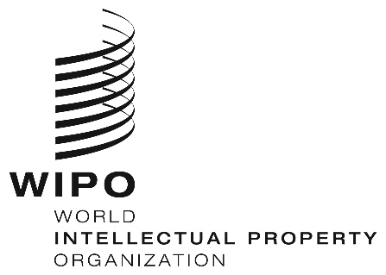
Workshop
WIPO/IPTK/YFB/19/inf1
ORIGINAL: English
DATE: May 9, 2019

Practical Workshop on Intellectual Property, Traditional Knowledge and Traditional Cultural Expressions for Countries from the Arctic Region

organized by
the World Intellectual Property Organization (WIPO)

and
the Government of Canada

in collaboration with
Nunavut Tunngavik Inc.

Iqaluit, Canada, May 14 to 16, 2019

LIST OF PARTICIPANTS

prepared by the International Bureau of WIPO

- INVITED PARTICIPANTS

(in the alphabetical order of the names of the States and of the persons)

CANADA

Marie BELLEAU (Ms.), Lawyer, Nunavut Tunngavik Inc.

Julie BOYER (Ms.), Director General, International Trade, Canadian Heritage

Tina DECOUTO (Ms.), Director, Nunavut Tunngavik Inc.

Monica ELL-KANAYUK (Ms.), President, Inuit Circumpolar Council of Canada

Koovian FLANAGAN (Ms.), Senior Advisor, Inuit Community Relations, Canadian Northern Economic Development Agency

Anne-Cécile GRUNENWALD (Ms.), Cultural Industries, Government of Nunavut

Brenda JARARUSE (Ms.), Director (Culture), Nunatsiavut Government

Rhoda KOKIAPIK (Ms.), Executive Director, Avataq Cultural Institute

Aluki KOTIERK (Ms.), President, Nunavut Tunngavik Inc.

Natasha LATREILLE (Ms.), Project Coordinator, Inuit Circumpolar Council of Canada

Blandina MAKKIK (Ms.), Igloo Tag Coordinator, Inuit Art Foundation

Jeffrey ORSER (Mr.), Director, Services to Business, Canadian Intellectual Property Office

Éric SAVARD (Mr.), Administrative Assistant, Copyright and Trademark Policy Directorate, Innovation, Science and Economic Development Canada

Mark SCHAAN (Mr.), Director General, Marketplace Framework Policy Branch, Innovation, Science and Economic Development Canada

Christian SPENCE (Mr.), Project Coordinator, Inuit Tapiriit Kanatami

Theresie TUNGILIK (Ms.), Traditional Economy Acting Manager, Government of Nunavut

Laura WOODWARD (Ms.), Policy Analyst, Copyright and Trademark Policy Directorate, Innovation, Science and Economic Development Canada

FINLAND

Sarita Annika Katariina KAMARAINEN (Ms.), Saami People

Riitta Anneli ORTI-BERG (Ms.), Saami People

Anni-Helena RUOTSALA (Ms.), Saami People

Anna Elisa Carita VUOPALA (Ms.), Government Counsellor, Ministry of Education and Culture

SWEDEN

Martin BERGER (Mr.), Legal Advisor, Swedish Patent and Registration Office

Ella-Karin BLIND (Ms.), Saami People

- INTERNATIONAL NON-GOVERNMENTAL ORGANIZATIONS

International Trademark Association (INTA)

Marion HEATHCOTE (Ms.), Representative and Principal, Davies Collison Cave, Sydney, Australia

- INTERNATIONAL BUREAU OF THE WORLD INTELLECTUAL PROPERTY ORGANIZATION (WIPO)

Hanna Rebecka FORSGREN (Ms.), Indigenous Fellow, Traditional Knowledge Division, Global Issues Sector

Katerina LAGASSE (Ms.), Rapporteur

Wend WENDLAND (Mr.), Director, Traditional Knowledge Division, Global Issues Sector

Daphné ZOGRAFOS JOHNSSON (Ms.), Legal Officer, Traditional Knowledge Division, Global Issues Sector

[End of document]

