E
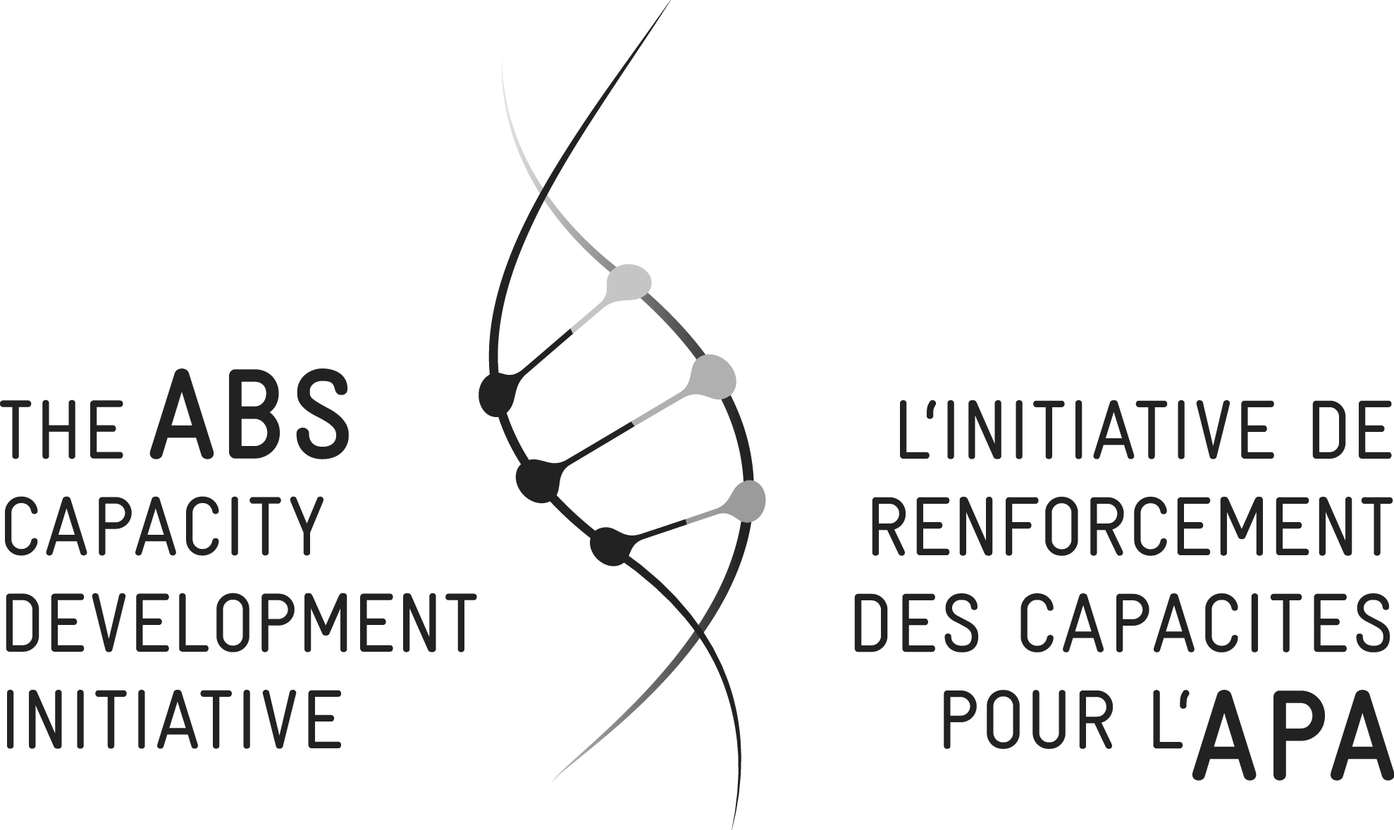
WORKSHOP

WIPO/IPTK/WDH/15 Prov.2
ORIGINAL: English
DATE: AUGUST 12, 2015

Practical Workshop on Intellectual Property and Genetic Resources, Traditional Knowledge and Traditional Cultural Expressions/Folklore

organized by
the World Intellectual Property Organization (WIPO)

and

the Access and Benefit-Sharing Capacity Development Initiative (ABS Initiative)

Windhoek, Namibia, August 17 to 20, 2015

PROGRAM
prepared by the International Bureau of WIPO and the ABS Initiative's Secretariat

Monday, August 17, 2015 [Note: Day for Indigenous Peoples and Local Communities (IPLCs) only]

Opening

9.00 am – 9.30 am Registration

9.30 am – 10.00 am Indigenous Opening

10.00 am – 10.30 am Welcome addresses by:

Ms. Lena Fey, Programme Manager IPLCs, ABS Initiative and
Ms. Hai-Yuean Tualima, Indigenous Fellow, Traditional Knowledge Division, WIPO

10.30 am – 11.00 am Overview of WIPO
Presentation: Mr. Wend Wendland, Director, Traditional Knowledge Division, WIPO

Overview of ABSi
Presentation: Mr. Suhel al-Janabi, Co-Manager, ABS Initiative

Facilitator: Ms. Lucy Mulenkei, Executive Director, Indigenous Information Network (IIN)

11.00 am – 11.30 am Coffee break

11.30 am – 12.30 pm Getting to Know One Another

Facilitator: Ms. Lucy Mulenkei

12.30 pm – 2.00 pm Lunch break

2.00 pm – 3.00 pm Identifying Issues – Group work

- What challenges is your community currently facing regarding Traditional Knowledge (TK) and Traditional Cultural Expressions (TCEs)?
- Which steps could be taken by IPLCs at the community level to promote the protection, add value and maximize the economic opportunities associated with TK and TCEs?

Facilitator: Ms. Lucy Mulenkei

3.00 pm – 3.30 pm Coffee break

3.30 pm – 4.00 pm Reports of group work

4.00 pm – 5.30 pm Plenary discussion to strategize on what could be done at a national level

Facilitator: Ms. Lucy Mulenkei

5.30 pm – 6.00 pm Wrap-up

6.00 pm End of program for the day

Tuesday, August 18, 2015 [Note: All participants from now on]

Facilitators for the day: Mr. Suhel al-Janabi and Ms. Lena Fey

9.00 am – 9.30 am Welcome remarks by:

Mr. Teofilus Nghitila, Environmental Commissioner, Ministry of Environment and Tourism, Namibia
Mr. Suhel al-Janabi
Mr. Wend Wendland

9.30 am – 10.30 am Objectives and agenda

Getting to know each other

10.30 am – 11.00 am Coffee break

11.00 am – 12.00 pm Setting the scene: “People, Plants and Profits”

Led by: Ms. Lena Fey and Mr. Olivier Rukundo, Consultant,
ABS Initiative

Discussion

12.00 pm – 1.00 pm Topic 1: Introduction to Intellectual Property

Presentation: Ms. Hai-Yuean Tualima

Discussion

1.00 pm – 2.30 pm Lunch

2.30 pm – 4.30 pm Case Studies (Parallel Groups)
Patents
Trade Marks
Copyright

Led by: Mr. Wend Wendland and Ms. Hai-Yuean Tualima

4.30 pm – 5.00 pm Coffee break

5.00 pm – 5.45 pm Topic 2: Intellectual Property (IP), Traditional Knowledge (TK) and Traditional Cultural Expressions (TCEs)

Presentation: Mr. Wend Wendland

Discussion

5.45 pm – 6.00 pm Wrap-up

6.00 pm End of program for the day

6.30 pm Namibian (Bio-) Cultural Evening

Statements by:

Mr. Lazarus Kairabeb, Indigenous Peoples and Local Communities’ representative
Mr. Christian Grün, Head of Cooperation, Embassy of the Federal Republic of Germany
His Excellency Mr. Pohamba Shifeta, Minister, Ministry of Environment and Tourism (MET)

Wednesday, August 19, 2015

Facilitators for the day: Mr. Wend Wendland and
Ms. Hai-Yuean Tualima

9.00 am – 9.30 am Re-cap of Tuesday

Facilitators: Mr. Wend Wendland and Ms. Hai-Yuean Tualima

9.30 am – 11.00 am Topic 3: Intellectual Property and Genetic Resources

Presentation: Mr. Suhel al-Janabi and Mr. Pierre du Plessis, Advisor to the African Union Commission

Discussion

10.30 am – 11.00 am Coffee break

11.00 am – 12.45 pm Case Study: ABS and IP

Presentation: Mr. Olivier Rukundo and Ms. Lena Fey

12.30 pm – 2.00 pm Lunch

2.00 pm – 3.00 pm Overview of relevant Regional and International Processes

Moderator: Mr. Pierre du Plessis

3.00 pm – 3.30 pm Coffee break

3.30 pm – 6.00 pm National level meetings:

- National experiences and ongoing projects related to TK, TCEs and GRs in your country
- How could IP be used to protect, add value and maximize economic and development opportunities associated with TK, TCEs and GRs?

6.00 pm End of program for the day

Thursday, August 20, 2015

Facilitators for the day: Mr. Suhel al-Janabi and Ms. Lena Fey

9.00 am – 9.30 am Re-cap of Wednesday

Facilitators: Mr. Suhel al-Janabi and Ms. Lena Fey

9.30 am – 12.30 pm National level meetings

Suggested topics for discussion:

- What specific steps could be taken using IP to protect, add value and maximize the economic opportunities associates with TK, TCEs and GRs?
- Pending agenda regarding traditional knowledge, traditional cultural expressions and genetic resources in your country

12.30 pm – 2.00 pm Lunch

2.00 pm – 3.30 pm Report of national groups: Cameroon
Ethiopia
Kenya
Namibia

3.30 pm – 4.00 pm Coffee break

4.00 pm – 5.00 pm Report of national groups: South Africa
Uganda

5.00 pm – 5.45 pm Wrap-up – Plenary discussion

Facilitator: Mr. Pierre du Plessis

5.45 pm – 6.00 pm Closing remarks:

Ms. Kauna B Schroder, Principal Project Coordinator and Advisor to the Environmental Commissioners Office, Ministry of Environment and Tourism
Ms. Lena Fey
Mr. Wend Wendland

6.00 pm End of program

[End of document]

