E
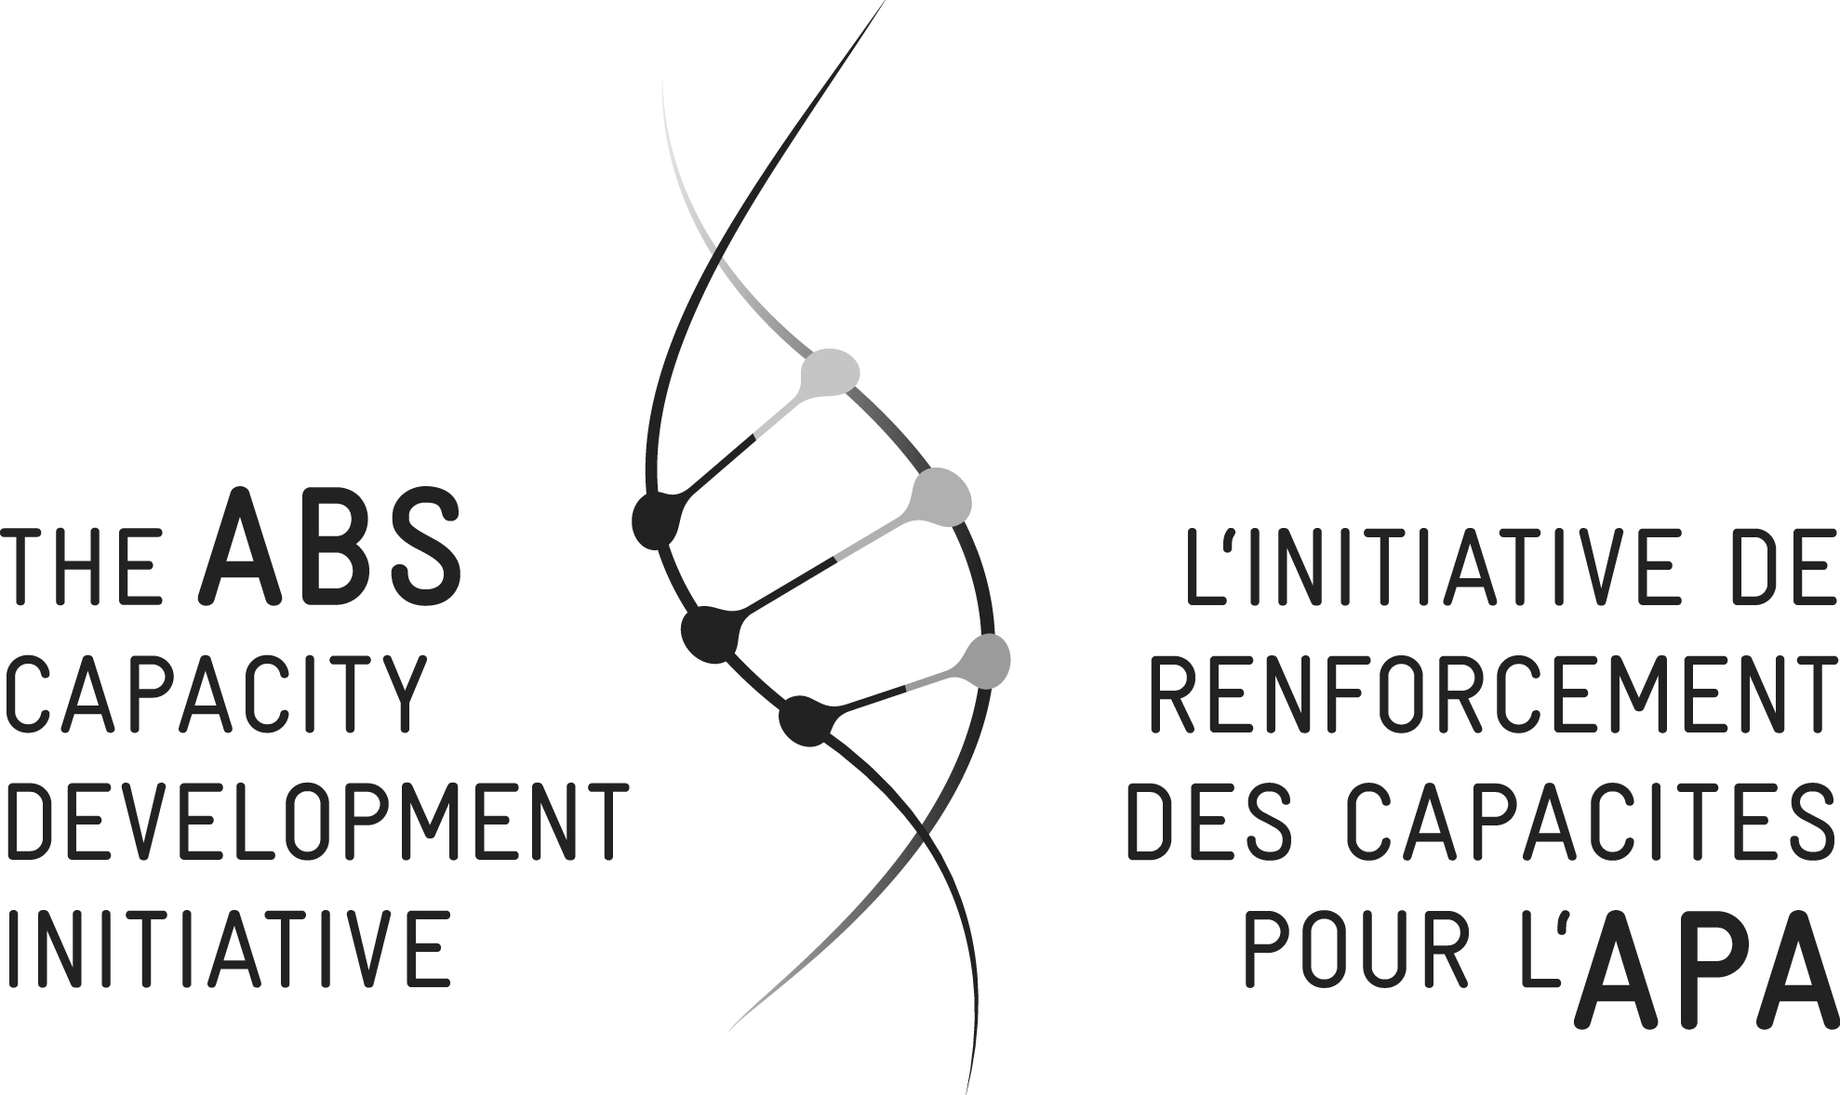
WIPO/IPTK/WDH/15/INF/1
ORIGINAL: English
DATE: August 31, 2015

Practical Workshop on Intellectual Property and Genetic Resources, Traditional Knowledge and Traditional Cultural Expressions/Folklore

organized by
the World Intellectual Property Organization (WIPO)

and

the Access and Benefit-Sharing Capacity Development Initiative (ABS Initiative)

Windhoek, Namibia, August 17 to 20, 2015

LIST OF PARTICIPANTS
prepared by the International Bureau of WIPO and the ABS Initiative

I. INVITED PARTICIPANTS

(in the alphabetical order of the names of the States and of the persons)

CAMEROON
Aii Shatu ALI (Ms.), Executive Member, Indigenous Peoples of Africa Co-ordinating Committee (IPACC), Bamenda
Ethel Bei CHAM EPSE NKUO (Ms.), Senior Staff, Ministry of Mines, Industry and Technological Development, Yaoundé
Albun William Banye LEMNYUY, Sub-director, Waste, Toxic and Hazardous Chemicals Management, Ministry of Environment, Protection of Nature and Sustainable Development, Yaoundé
Bruno MVONDO, Coordinator, National Council of Traditional Chiefs of Cameroon, Yaoundé

ETHIOPIA
Aliye Dallu AMAJI, Trainer, Shade: Local Communities, Biodiversity and Livelihood Improvement, Addis Ababa
Tadesse Worku ENGDASWE, Team Leader, Ethiopian Intellectual Property Office,
Addis Ababa
Ashenafi Ayenew HAILU, Director, Ethiopian Biodiversity Institute (EBI), Addis Ababa
Mersha YILMA (Ms.), Legal Advisor, Movement for Ecological Learning and Community Action (MELCA), Addis Ababa

KENYA
Catherine BUNYASSI-KAHURIA (Ms.), Senior Legal Counsel, Kenya Copyright Board (KECOBO), Nairobi
Ole Kaunga JOHNSON M.N., Honorary Technical Project Advisor, Laikipia Maasai, Nairobi
Lucy MULENKEI (Ms.), Executive Director, Indigenous Information Network (IIN), Nairobi
Mweu Ali MWANZEI, Enforcement Specialist, National Environment Management Authority (NEMA), Nairobi

NAMIBIA
Sonner GERIA, Chairperson, Khwe Custodian Committee, Windhoek
Lazarus KAIRABEB, Chief Administrator and Executive Officer, Nama Traditional Leaders Association, Windhoek
Martha Kadafi KANGANDJO (Ms.), Manager, Eudafano Women’s Cooperative (EWC), Windhoek
Stephanus Pieter MASILISO, Local Community Coordinator, Khwe Custodian Committee, Windhoek
Kauna SCHRODER (Ms.), Project Manager, Ministry of Environment and Tourism, Windhoek

SOUTH AFRICA
Lesley JANSEN (Ms.), Lawyer, Lawyers for Communities and the Environment, Natural Justice, Pretoria
Collin LOUW, General-Secretary, South African San Institute (SASI), Kimberley
Patience MAIMELA (Ms.), Executive Manager, Innovation and Creativity, Companies and Intellectual Property Commission (CIPC), Pretoria
Yonah SELETI, Director, National Indigenous Knowledge Systems Office, Department of Science and Technology, Pretoria
Helena Maria Wilhelmina STEENKAMP (Ms.), Office Manager, South African San Institute (SASI), Kimberley
Lactitia TSHITWAMULOMONI (Ms.), National Focal Point, Ministry of Environment, Department of Environmental Affairs, Pretoria

UGANDA
Gilbert AGABA, Senior Registrar, Intellectual Property Rights, Ministry of Justice and Constitutional Affairs, Uganda Registration Services Bureau, Kampala
Christine AKELLO, Senior Legal Counsel, National Environment Management Authority (NEMA), Kampala
Margaret LOMONYANG (Ms.), Coordinator, Karamoja Women Cultural Organization, Kampala
Penninah ZANINKA (Ms.), Technical Support and Communications, United Organization for Batwa Development in Uganda, Kisoro

ZIMBABWE
John KABARE, Senior Patent Examiner, African Regional Intellectual Property Organization (ARIPO), Harare

II. INTERNATIONAL BUREAU OF THE WORLD INTELLECTUAL PROPERTY ORGANIZATION (WIPO)

Hai-Yuean TUALIMA (Ms.), WIPO Indigenous Fellow, Traditional Knowledge Division
Wend WENDLAND, Director, Traditional Knowledge Division

III. THE ABS CAPACITY DEVELOPMENT INITIATIVE (ABSi)

Suhel AL-JANABI, Co-Manager, ABS Capacity Development Initiative, Windhoek
Lena FEY (Ms.), Program Manager IPLCs, ABS Capacity Development Initiative, Germany

Nadine PAULY (Ms.), Head, Event Management Department, ABS Capacity Development Initiative, Germany
Pierre du PLESSIS, Advisor, African Union Commission, ABS Capacity Development Initiative, Windhoek
Olivier RUKUNDO, Consultant, ABS Capacity Development Initiative, Germany
Sabine ZAJDERMAN (Ms.), Rapporteur, ABS Capacity Development Initiative, Germany

[End of document]

