E
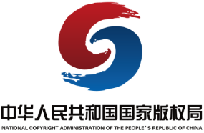 | 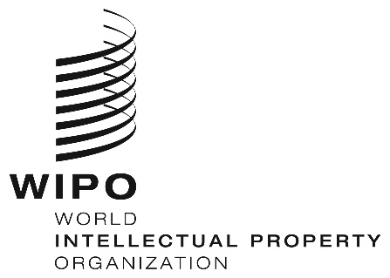
Program
WIPO/IPTK/JJN/25/1
DATE: November 19, 2025

International Symposium on Intellectual Property and Traditional Cultural Expressions

Co-organized by
National Copyright Administration of China (NCAC)
and
World Intellectual Property Organization (WIPO)

In Cooperation with
Fujian Provincial Copyright Administration
and
Quanzhou Municipal People’s Government

Quanzhou, China
November 25 to 27, 2025

Program

November 25, 2025

8:00 – 17:00 Study Visits to Dehua Ceramics Museum; Luzerne (Fujian) Group Co., Ltd; Dehua Hongqifang Cultural Park; and World of Shunmei Ceramics

November 26, 2025

8:30 – 17:00 Study Visits to Quanzhou Kaiyuan Temple; Quanzhou Intangible Cultural Heritage Museum; Quanzhou Qingyuan Mountain; Yuanhe 1916 Arts District; and Xunpu Village

November 27, 2025

8.30 am – 9.00 am Registration

9.00 am – 9.30 am Opening Session

Mr. Wang Zhicheng, Director General, Copyright Department, National Copyright Administration of China (NCAC), China

Mr. Chen Tiangui, Head, Fujian Provincial Copyright Administration, China

Mr. Liu Linshuang, Standing Committee Member, Head of Publicity Department & Head of United Front Work Department, the CPC Quanzhou Municipal Committee, China

Mr. Edward Kwakwa, Assistant Director General, Global Challenges and Partnership Sector, World Intellectual Property Organization (WIPO)

9.30 am – 10.40 am Regional, National and Community Policies and Legislations Regarding the Intellectual Property Protection of Traditional Cultural Expressions

Speakers: Mr. Hu Kaizhong, Deputy Director, International Copyright Research Base of NCAC; Professor, KoGuan School of Law, Shanghai Jiao Tong University, China

Ms. Patricia Adjei, Director, Office of the Arts, Australia

Ms. Nurilya Barakanova, Manager, Kyrgyz Republic’s Union of Designers, Kyrgyzstan

Mr. Chewe Chilufya, Deputy Registrar-Intellectual Property, Patents and Companies Registration Agency, Zambia

Mr. Cristian Florescu, Head, International Relations Department, Romanian Copyright Office, Romania

10.40 am – 11.00 am Coffee/tea Break

11.00 am – 12.00 pm Regional, National and Community Experiences Regarding the Use of Intellectual Property as a Tool to Protect Traditional Cultural Expressions

Speakers: Ms. Guo Danhong, Deputy Head, Publicity Department of the CPC Quanzhou Municipal Committee, China

Mr. Alejandro Rangel Bang, Intellectual Property Law Professor, Ibero-American University / Senior Associate, Basham, Ringe and Correa Law Firm, Mexico

Mr. Jamyang Norbu, Assistant Intellectual Property Officer, Department of Media, Creative Industry and Intellectual Property (DoMCIIP), Ministry of Industry, Commerce and Employment, Bhutan

12.00 pm – 2.00 pm Lunch Break

2.00 pm – 3.00 pm International Intellectual Property Protection of Traditional Cultural Expressions

Speakers: Ms. Jiao Fei, Senior Program Officer, Traditional Knowledge Division, Global Challenges and Partnership Sector, WIPO

Ms. He Yingxin, Director, Copyright Division, Anhui Provincial Copyright Administration, China

Mr. Kildren Pantoja Rodrigues, Professor and Researcher, Federal Institute of Education, Science and Technology of Goiás (IF Goiano) / University of Brasília (UnB), Brazil

Mr. Otto Gani, Deputy Director for International Organisations, Directorate for Socio-Cultural Affairs and Strategic Partnerships, Directorate General for Multilateral Affairs, Ministry of Foreign Affairs of the Republic of Indonesia, Indonesia

Mr. Marco D’Alessandro, Senior Policy Advisor, Swiss Federal Institute of Intellectual Property,
Switzerland

3.00 pm – 3.20 pm Coffee Break

3.20 pm – 4.40 pm Roundtable Discussion on International Intellectual Property Protection of Traditional Cultural Expressions

Moderator: Ms. Jiao Fei

Panelists: Mr. Pan Lusheng, Vice President, China Federation of Literary and Art Circles (CFLAC); President, China Folk Literature and Arts Association (CFLAA), China

Mr. Otto Gani

Mr. Marco D’Alessandro

Mr. Chikumbutso Namelo, Registrar General, Registrar General’s Office, Ministry of Justice and Constitutional Affairs, Malawi

Mr. Kildren Pantoja Rodrigues

Ms. Alice Guérinot, Intellectual Property Policy Advisor, Economic Diplomacy Directorate, French Ministry for Europe and Foreign Affairs, France

4.40 pm – 5.00 pm Closing Session

Mr. Edward Kwakwa

Mr. Wang Zhicheng

[End of document]

