WIPO |  | E  WIPO/GRTKF/IC/6/INF/4  ORIGINAL: English  DATE: March 18, 2004
WORLD INTELLECTUAL PROPERTY ORGANIZATION
GENEVA

intergovernmental committee on
intellectual property and genetic resources,
traditional knowledge and folklore
Sixth Session
Geneva, March 15 to 19, 2004
Patents as a Source of Technological Information in the Technology Transfer Process
Document submitted by the Delegation of Spain

1 On March 18, 2004, the Spanish Patent and Trademark Office submitted a document entitled “Patents as a Source of Technological Information in the Technology Transfer Processes”. The cover letter submitting the document noted that the document had previously been submitted to the seventh meeting of the Conference of the Parties (COP) to the Convention on Biological Diversity (CBD) as document UNEP/CBD/COP/7/INF/32.

2 The document is reproduced in the form received and published in the Annex to this document.

[Annex follows]

 |  |  | CBD
 |  | CONVENTION ON  BIOLOGICAL DIVERSITY |  |  | Distr.  GENERAL  UNEP/CBD/COP/7/INF/32  20 January 2004  ENGLISH AND SPANISH ONLY
CONFERENCE OF THE PARTIES TO THE CONVENTION ON BIOLOGICAL DIVERSITY
Seventh meeting
Kuala Lumpur, 9-20 and 27 February 2004
Item 25 of the provisional agenda*
TRANSFER OF TECHNOLOGY AND TECHNOLOGY COOPERATION (ARTICLES 16 AND 18)
Patents as a source of technological information in the technology transfer process

Submission by the Government of Spain

1. At the request of the Government of Spain, the Executive Secretary is circulating herewith, for the information of participants in the seventh meeting of the Conference of the Parties to the Convention on Biological Diversity, a document on patents as a source of technological information in the technology transfer process, prepared by the Spanish Patent and Trademark Office.

2. The document is being circulated in the form and languages in which it was received by the Secretariat of the Convention on Biological Diversity.
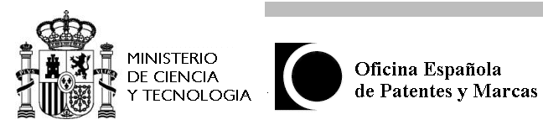

patents as a source of technological information

in the technology transfer process

Madrid. January 2004

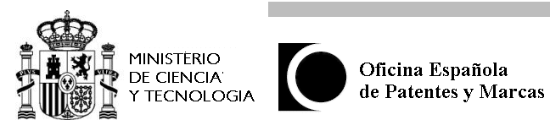

patents as a source of technological information in the

technology transfer process

1. Introduction

2. Technological Information
Sources of Technological Information .-

3. Patents as a Source of Technological Information
3.1 The Double objetive of the patent system
Protecting Inventors .-
Publishing Inventions .-

3.2 Patent Documents
The International Patent Classification .-

3.3 Advantages of patent documents

3.4 Limitations of Patent Protection
Time Limitation .-

Geographical Limitation .-

3.5 Protection of inventions in other countries
Priority Right .-
Patent Family .-

3.6 Patents in force and patents in the public domain

4. The role of Patents in Technology Transfer

Technology Transfer.-

5. Recommendations

6. Bibliography

7. Annexes

Patents as a source of Technological Information

in the Technology Transfer Process

1. Introduction

Since the 19th century, industrialised countries have developed a multitude of technologies. Those which involved innovation can be protected by patents.

Many of these innovative technologies are never published in books or magazines. However, they are described, both theoretically and practically, with examples and drawings, in a universal system for the publication of inventions: Patent Documents.

The U.S. patent file spans over 200 years. From plough to DNA. It tells the story of world science and technology since 1970. The knowledge disclosed through the patent literature is a significant contributor to the base of science and technology upon which the Nations’ economy is built. Patents frequently contain information which cannot be obtained any other way. (Mukund J. Shah (USPTO)).

Source: WIPO

The important role which patents play in technology transfer has been repeatedly highlighted by international organizations such as UNCTAD (United Nations Conference on Trade and Development) and WIPO (World Intellectual Property Organization).

In 1964, UNCTAD had already issued a publication on:

“ROLE OF PATENTS IN THE TRANSFER OF TECHNOLOGY TO DEVELOPING COUNTRIES” (A/RES/1935(XVIII).

In New York in 1975, UNCTAD published a book in Spanish entitled:
“La función del sistema de patentes en la transmisión de tecnología a los países en desarrollo”.

Though these publications can be difficult to find and may now even be obsolete, the fact is that UNCTAD has been holding expert meetings on technology transfer for several decades. Nowadays, these meetings take into account technologies that are relevant for the Convention on Biological Diversity (CBD).

2. Technological Information

Technological Information is a necessary condition for success in any process of research, industrial planning, development, manufacturing, commercialization or management.

There is a strong correlation between a country’s level of technological development and its capacity to access information and use it freely.

The growing importance of the role of information in the development of the economy is one of the characteristic features of the scientific and technological change which is occurring daily. An effective exchange of information between the representatives of different fields of science and technology, and between scientists, engineers, managers and consumers of the results of reseach and development, has become a necessary condition of accelerated economic , scientific and technological progress.

Information today is a significant constituent element of research and development. The fact is that the conversion of science into a direct productive force has led to the intensification of the flow of information among the different spheres of science, technology, production and consumption.

Source: R. Andary. WIPO

Sources of Technological Information .-

* Direct contacts.
* Exhibitions. Congresses. Lectures.
* Professional and scientific literature.
* Patent literature (published patent documents).

An important consideration is the selection of suitable sources of information. Since it is generally not possible to evaluate the entire scientific and technical literature, even if the greatest efforts are made, the proper selection of sources of information is highly significant. In this regard, patent literature plays an important part since it is an important integral part of the scientific and technological information available in the world today.
Source: R. Andary, WIPO

3. Patents as a source of Technological Information *

3.1 The double objetive of the patent system

In order to understand the role of patents as a source of technological information, we should remember the double objective of the patent system:

* Protecting inventors
(benefits individuals who innovate)
* To increase society’s scientific, technological and cultural patrimony
(society benefits as a whole, inventions are not kept secret and the inventor only receives proctection for his invention if it is described in a clear and complete manner).

Patents are well known as Monopolies (legal protection) but very little as sources of technological information. However, this second objective is the most important as patent applications are published and disclosed before it is known whether the patent will be granted or not. Nowadays, Patent Offices give great importance to patents as a source of information.

Patents have two basic functions:

* protecting inventions
* providing technical information.
Giving the correct level of importance to this second function is the aim of the patent information policy implemented by the European Patent Office, WIPO and many national patent offices (Jean-Michel Zilliox, EPO).
Source : WIPO

Protecting inventors.-
Inventors or applicants apply for their inventions to get a twenty-year exclusive exploitation Monopoly.

However, in order for this monopoly to be granted, the applicant must undertake to describe his invention sufficiently for an expert in the field to be able to carry it out. The object of the invention is defined by the technical features of the claims (reivindicaciones in Spanish).

_________________________________________________________________

* This section is based on the publication “Las Patentes como fuente de Información Tecnológica” by the Spanish Patent & Trademark Office (OEPM) (see bibliography).

Publishing Inventions .-

Descriptions of inventions are disclosed. The Official Authority (usually, the Patent Office) PUBLISHES these descriptions, thus increasing the society’s technolgical patrimony.

Publication of patent applications (A).-
Most patent offices publish patent applications 18 months after filing (usually, they are known as “A” publications).

Any person can ask for copies of the published applications or even get them on the Internet.

Publication of Granted Patents (B).-
The application procedure then continues with the novelty and inventive step examination.
After that, the application is either GRANTED or REJECTED (usually, this process takes 3 to 4 years).
- If the application is granted, it is published as Patent Specification (“B” publications). From then onwards, legal protection applies for exclusive exploitation in those countries where protection as been requested.
- If the application is rejected, this second publication never appears.

As such, the technology is published before it is known whether it will be legally protected or not.

3.2 Patent Documents

These publications, either of patent applications or patent specifications, are known as PATENT DOCUMENTS.

The structure of patent documents .-

Patent documents have a uniform structure worldwide, with :

* First Page (details of the inventor, applicant, address, title, abstracts)
* Full description (technical problem, solutions, advantages, uses, etc.)
* Claims (defining the object or process for which protection is sought)
* Drawings

Patents as a source of information provide:

* Technical information : they describe technology in a clear and complete manner.
* Commercial information : they include data on the company, inventors, etc.
* Legal information : what is included in the scope of protection, when it entered into force, etc.

Nowadays, there are more than thirty million patent documents available on the Internet through Espacenet (www.epo.org) (www.oepm.es). Patents contain more than 80% of all technical information worldwide and are a trigger for new ideas and new solutions to known technical problems. They are considered to be one of the most complete, accesible, practical and up to date sources of information on innovative developments in all areas of technology.

……………….…………………………………………………………………………………………..

Reasons why better use should be made of patent information:

* Size of the Resource
Number of documents covering all areas of technology. Over the years, more than 32 million patents have been published worlwide.

* 80% Not Published Elsewhere
80% of the disclosures in patents are never published in any other form.

* First Publicacion
Most patents are published after 18 months form filing and usually are the first published disclosure of the invention (Michael Blackman, Patent Office, London, UK)
Source : WIPO
………………………………………………………………………………………............................….

The International Patent Classification

The international patent classification system subdivides technology into more than 70,000 groups.
Patent documents are classified according an international classification system.
This classification allows technologies described in the field we are interested in to be retreived quickly and easily.

Patent documents bear “classification symbols“. For the purposes of maintaining search files and performing searches for the state of the art, industrial property offices using the International Patent Classification (IPC) classify patent documents according to the field or fields of technology to which their contents relate...

This classification allows the retrieval of the information contained in patent documents belonging to any given branch of technology.
Source: WIPO

3.3 advantages of patent documents

* Contain the most up to date information.
* Uniform format worldwide.
* Usually contain information not disclosed elsewhere.
* Source of information on new and also known technology (prior art)
* Describe technology in a manner sufficiently clear for it to be carried out by a person skilled in the art.
* Availability of information electronically.

Advantages of Patent Literature

A worldwide collection of patent documents contains information on the technical solutions created during the last 150 years in all the different fields of human creative technological activity. Such a unique colletion of information is rightfully one of the most important elements of the world’s scientific and technological potential.

Patent information has a number of specific features, which make it esential not only for current industrial activities and research and development but also for forescasting further technological progress (R. Andary, WIPO)
Source: WIPO

Scientsts and technicians are not always aware of the richness of patent information. There is a widely held misconception that using this information can give rise to legal action from the patent owner.

Obstacles to the use of patents are: the great number of existing documents, the language in which they are written, the effort involved in locating them and the cost of obtaining copies.
However, nowadays, many of these obstacles are resolved:
Documents may be retrieved using the classification combined with keywords. There are versions of the same invention in different languages which allow us to read them.

3.4 Limitations of Patent Protection

Generally speaking, patents do not extend beyond the boundaries of the country which granted the patent. (Source: WIPO).

Limitations to the exclusive right:
- Time limitation .- Patents have a validity of 20 years since their filing date, after which they pass into the public domain.

- Geographical limitation - The right only applies to the national territory of the country where protection is applied for (national patent), to various countries (regional patent), or to many countries (PCT system).

- Actions which are not considered patent infringements:
* Using the invention in the private sphere with no commercial aims (private use).
* Scientific experiments (experimental use).
* Producing medicines in a pharmacy to make up prescriptions.

3.5 Protection of inventions in others countries

Priority Right.- In order to protect an invention in other countries under the Paris Union Convention and the World Trade Organization, the applicant may use the priority right. Under this right, the applicant has 12 months from the filing date of the first application to apply for protection in other member countries, keeping the same initial filing date for all subsequent applications.

Patent Family.- From the above paragraph it can be concluded that an applicant applying to protect an invention in other countries generates a patent family (different applications based on the same priority). In this case, each office makes its own publication. So, if we find a document in a language we do not know, we can find another from the same family in a known language.

To avoid multiple applications, regional and international patents have been created, whereby a single application is presented for various countries.

* National Patent
A patent can be applied for in a single country such as Spain (ES), France (FR), Great Britain (GB), the United States (US), etc., giving rise to a national patent, each country having its own legislation. Using this application protection may be also applied for in other countries (priority right).

* Regional Patent
An applicant can file an application in a set of countries, as is the case for the European patent (27 European countries whether members of the European Union or otherwise). This patent was established by the European Patent Convention in Munich,1973.
The applicant designates the states where protection is sought . The European patent application (EP) is processed by the European Patent Office, which has its headquarters in Munich and The Hague.

* International Patent
The PCT system allows protection to be requested for an invention in each of the Member States of the International Treaty (currently 123 countries) through a single application called an international application. It is not a grant procedure nor does it substitute nationally granted patents.
The Patent Cooperation Treaty (PCT) is a multilateral Treaty, administrated by the World Intellectual Property Organization (WIPO or OMPI).

3.6 Patents in force and patents in the public domain

To maintain a patent monopoly in force, the applicant has to pay an annual renewal fee, which increases annually. If the annual fee is not paid then the patent monopoly is lost and it passes into the public domain.

Expired Patents: Free Use

The fourth feature is that much of the information contained in patent specifications is freely available for public use, either because the owner has not paid renewal fees or because the maximum term, usually 20 years, has expired. For instance, of the nearly 2 million United Kingdon patents published so far, barely one-tenth are still in force (Michael Blackman, The Patent Office, UK.)
Source: WIPO

Therefore, many of the technologies described are in the public domain even though a patent as been applied for.

In effect, patent documents are available to be read and freely consulted by all. For patents which are in force, commercial exploitation is not allowed in the countries where protection has been granted. Nevertheless, in countries where protection has not been requested, they may be used freely.

It is common practice to protect inventions in industrialised countries, and not to protect them in developing countries. As applicants have to pay fees in every country applied for, they only usually chose to pay in certain industrialised countries (USA, Japan, European countries), meaning that the technology is not legally protected in the majority of developing countries, but is disclosed, accesible and can be used freely.

This is a key point and should be taken into account in order to understand the availability of described and published technologies.

4. The role of Patents in Technology Transfer

It is considered that the search for technological information is the first step in Technology Transfer. Only through consulting and studying many technologies is it possible to make decisions as to which technologies are applicable for a particular country.

Technology Transfer .-

Many studies have demonstrated the important role that patents play in technology transfer.

Patents are documents with complete technological information, as it is a legal requirement that they describe the invention in a sufficiently complete manner so that others are able to reproduce it.

Morever, they give a description of the prior art, providing the reader with a broader view of the technology.

By identifying the inventor and the applicant, they facilitate direct negotiations, without third party involvement.

In conclusion, patents are a good instrument for technology transfer, and most of them are available in the public domain.

……………………………………………………………………………………………………………….

Technology Transfer

For some years now, international organisations like the United Nations and its agencies, including WIPO, have been investigating means of transferring technology from industrially developed countries to those not so industrially developed. Numerous studies and proposals have been made on the use of patents in the transfer of technology to developing countries. These studies suggest that patents have an important role to play in technology transfer for the following reasons:

  - patents are by the nature technologically self-contained in that they are require by law to furnish such information as is required to allow for their implementation;

  - patents are in a convenient document form; this makes patents more suitable for exchange purposes than know-how locked up in the brains of individual technologists;

  - by indicating the state of the art patents can serve as a basis for new developments or advances in technology;

  - patents cover a wide range of technologies and therefore permit a planned program of development in the areas of technology most suitable to the transferee;

  - patents present the reader with both a historic development in an area of technology as well as up-to-date knowledge. This may be useful in imparting understanding of know-how to the transferee rather than restricting the transferee to mere imitation;

  - patents allow the transferee actually to see what his is buying.

  - by indicating the holder and the creators of the technology the patent document may facilitate direct negotiations, dispensing with intermediaries;

  - the licensing system developed in relation to patents is well developed and provides a ready-made and expedient means of ensuring participation by indigenous institutions.

The use of patent technology transfer has to be augmented by other factors such as capital investment, education of indigenous technologists and the development of entrepreneurial skills in those in managerial positions, but patents may nevertheless have a vital role to play as the actual mechanism for the transfer of knowledge.

Source : R. Andary, WIPO

...........................................................……………………………………………………………………..

5. Recommendations

We recommend that the Secretariat of the Convention on Biological Diversity, the Contracting Parties and all those interested in the field of Technology Transfer, considering the role that patents can play in this field, plan or organise capacity building activities that include training in finding and retrieving technologies described in patent documents and which may be of interest for reaching the objectives of the Convention on Biological Diversity.

Asha Sukhwani
Dto. de Patentes e Información Tecnológica
Spanish Patent and Trademark Office (SPTO)

6. Bibliography

- “Las Patentes como fuente de Información Tecnológica”, 1999. Oficina Española de Patentes y Marcas (Spanish Patent and Trademark Office).

- The WIPO text quoted in boxes is from the publication “WIPO Asian Regional Seminar on the Use of Patent Information by Industry”. New Delhi, India, March 16 to 18, 1994. World Intellectual Property Organization.

A selection of UNCTAD documents on this subject:

* TD/B/C.6/24/ADD.1 (1977)
“Report of the Group of Governmental Experts on the Role of the Industrial Property System in the Transfer of Technology on its session held at the Palais de Nations”.

* TD/B/C.6/AC.5/3 (1981)
“Review of recent trends in Patents in developing countries: Report“.

* TD/B/COM.2 /EM.9/2 (2001)
“Institutional arrangements for Transfer of Technology: best practices for access to and measures to encourage transfer of technology with a view to capacity building in developing countries , especially in least developed countries“.

* TD/B/COM.2 /L.6 (2002)
“International policy issues: international arrangements for transfer of technology: best practices for access to and measures to encourage Transfer of Technology with a view to capacity building in developing countries, especially in least developed countries“.

7. Annexes

The Annexes include, as examples, the FIRST PAGES of patent documents with bibliographic data (applicant, inventor, title, abstract, classification, etc.). In some cases, part of the descripction is also included.

Annex I

Examples of technologies related with the conservation and cataloging of biodiversity (Annex I)

- Bioremediation. [ 1 ]
- Method for controlling soil erosion [ 2 ]
- Monitoring wildlife biodiversity [ 3 ]
- Reforestation procedure [ 4 ]
- Bypass channel for aquatic life [ 5 ]
- Characterization of genetic diversity [ 6 ] , [ 8 ]
- Assessment of ecosystem health [ 7 ]

Annex II

Examples of technologies related with biodiversity uses (Annex II):

- Cosmetic uses, dermatological, UV filters, etc [ 9 ], [10 ]
- Uses as food supplements. Nutritional supplements [ 9 ], [ 12 ]
- Therapeutic uses (hepatitis, cancer, aids, etc. [ 10 ], [ 12 ], [ 13 ], [ 14 ], [ 15 ]
- Uses for controlling plant parasites [ 11 ].
- Method of extracting active principles. Preparation of tablets [ 16 ], [ 17 ]

Annex III

This annex summarises how to retrieve the patent documents included in annex I and II using Esp@cenet (Europe’s Network of Patent Databases). This contains bibliographic data of patents published in the last two years in any member state of the European Patent Organization, all patents of the European Patent Office (EPO) and all patent applications of the World Intellectual Property Organization (WIPO - OMPI).

Note on Annexes.-
Considering that the interest of this document for the CBD Parties is to show the potencial of patents as a source of technological information, it is important to take into account that the reproductions of patent documents included as annexes are only intended to serve as examples of technological information associated to biodiversity. In no case, does the use of these technologies necessarily imply the sustainable use of biological diversity, with particular reference to the examples contained in Annex II.

Annex I
[ 1 ]
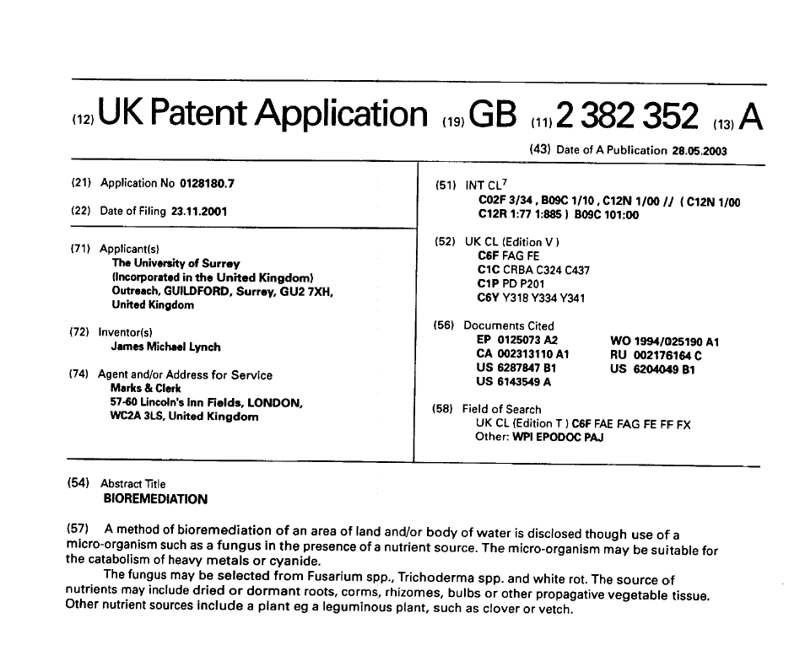

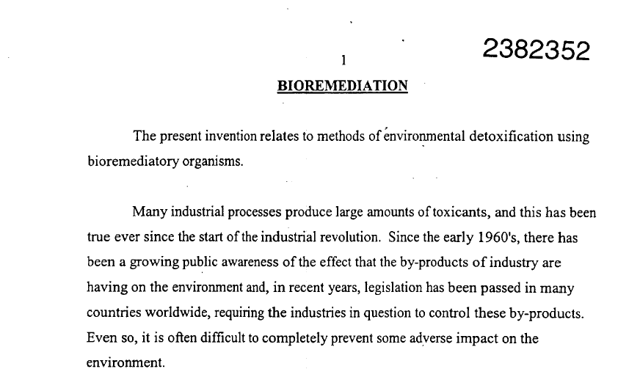

[ 2 ]
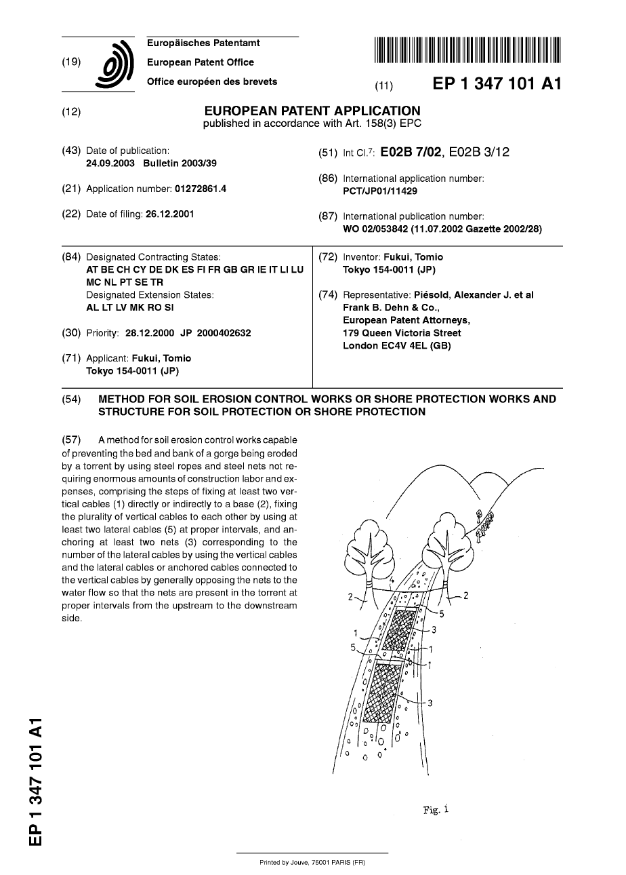

[ 3 ]
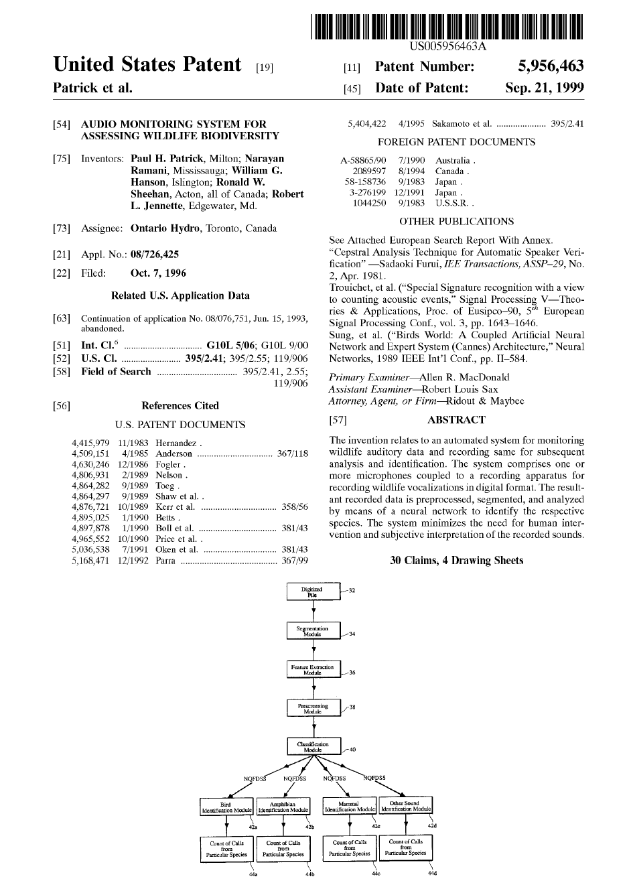

[ 4 ]
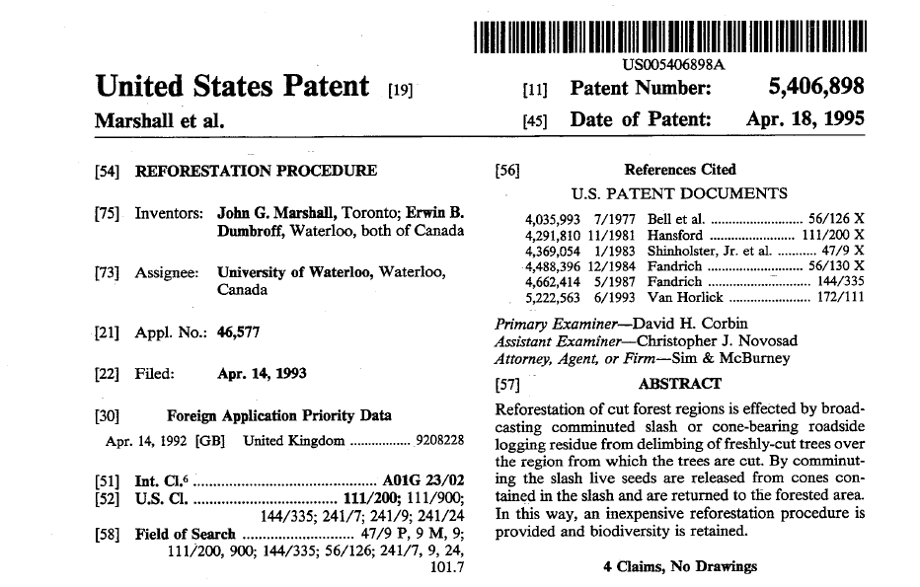

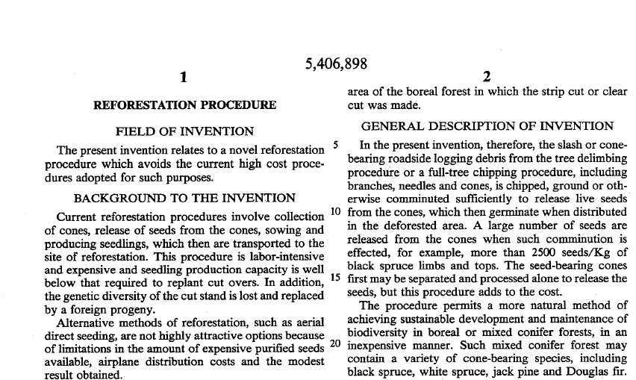

[ 5 ]
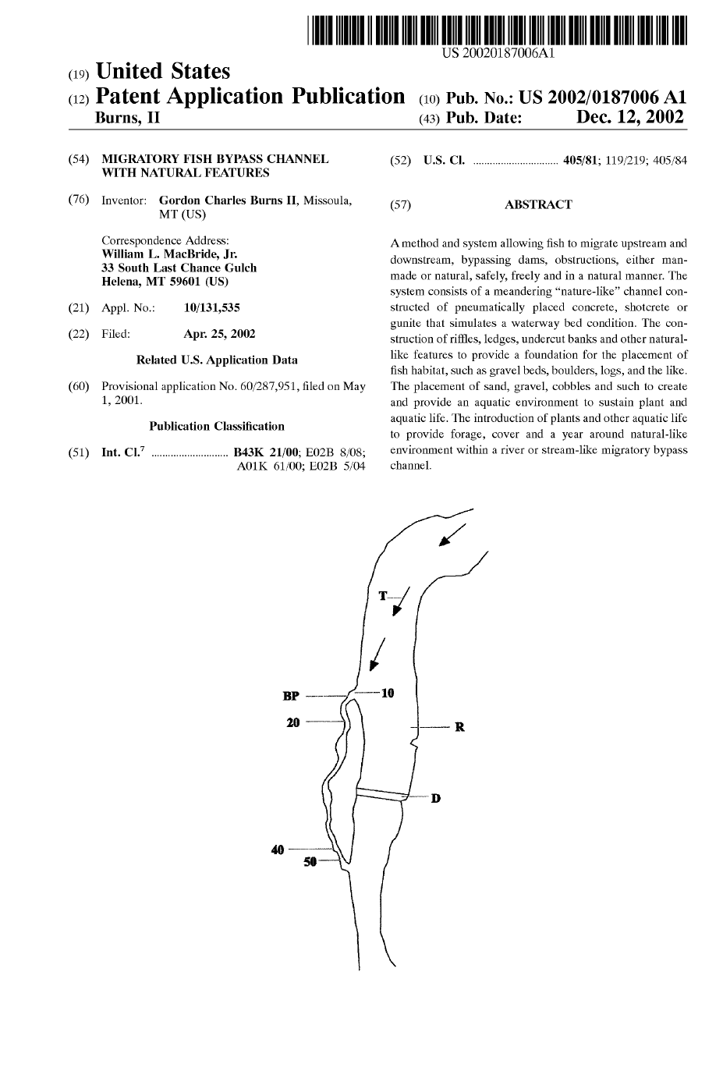

[ 6 ]
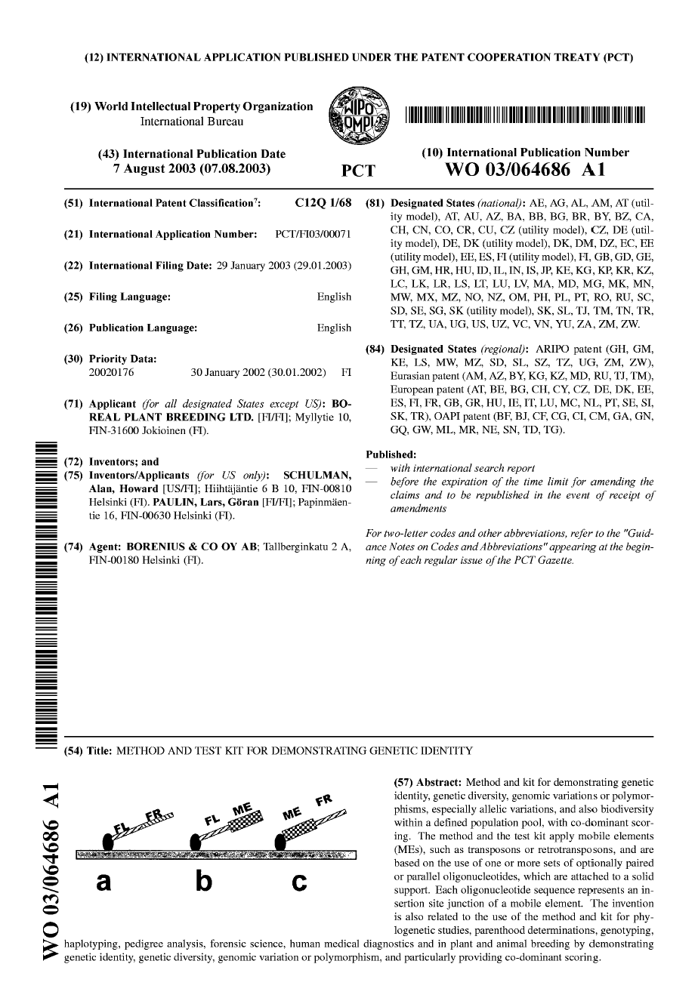
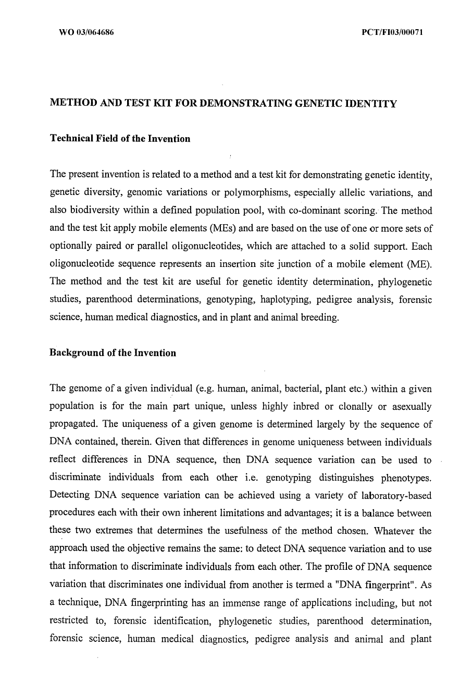

[ 7 ]
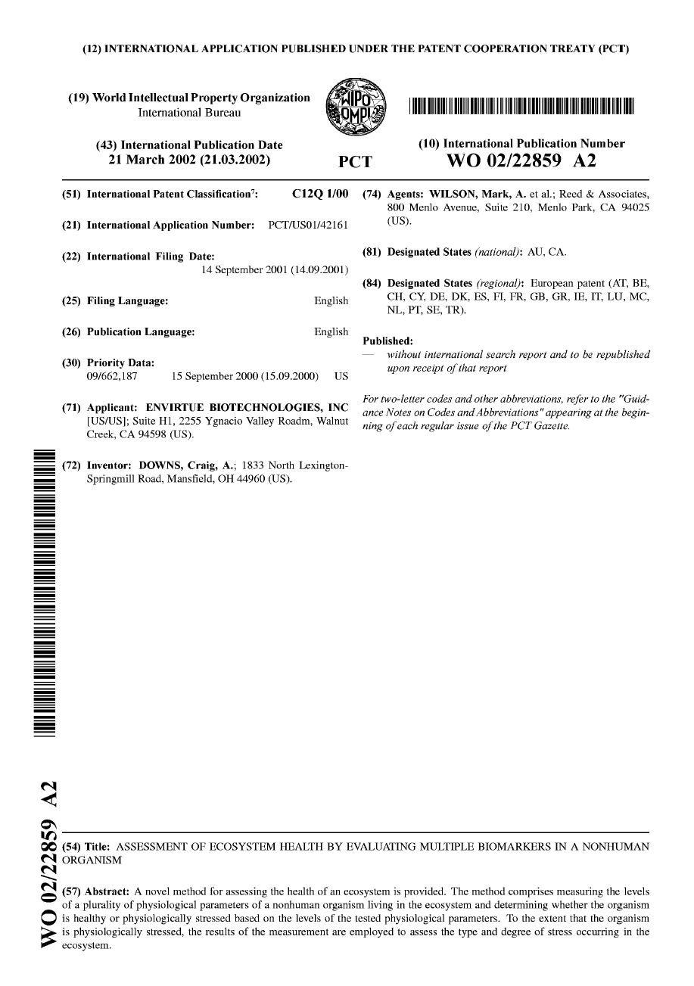
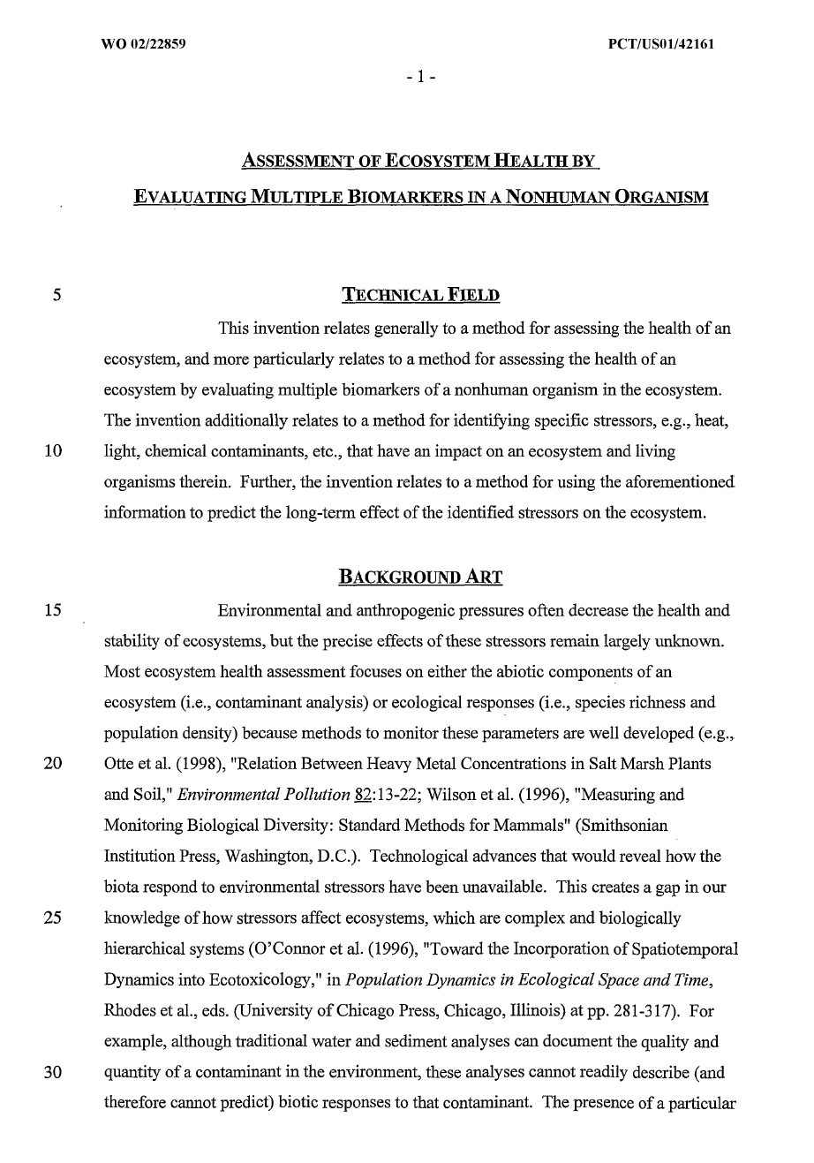
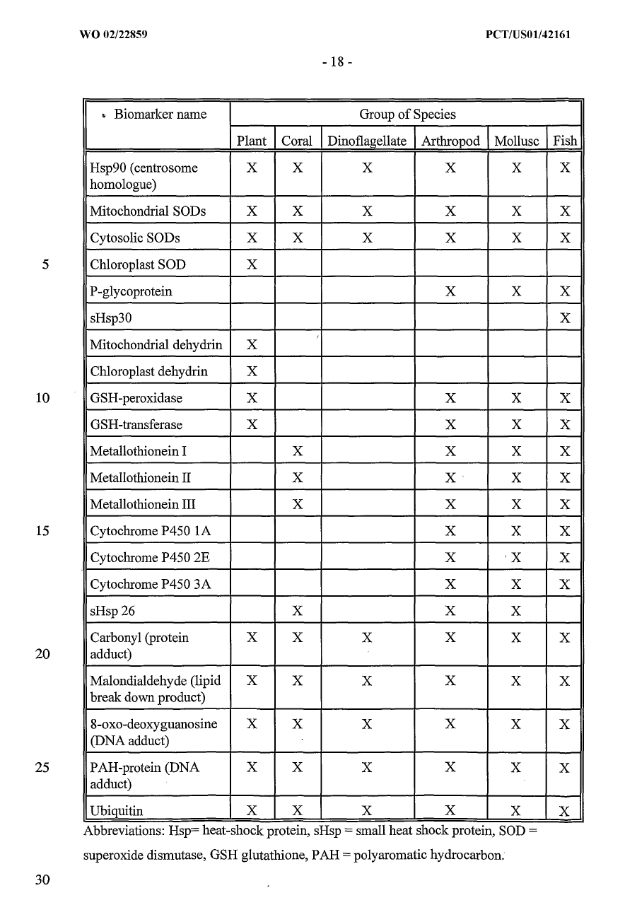
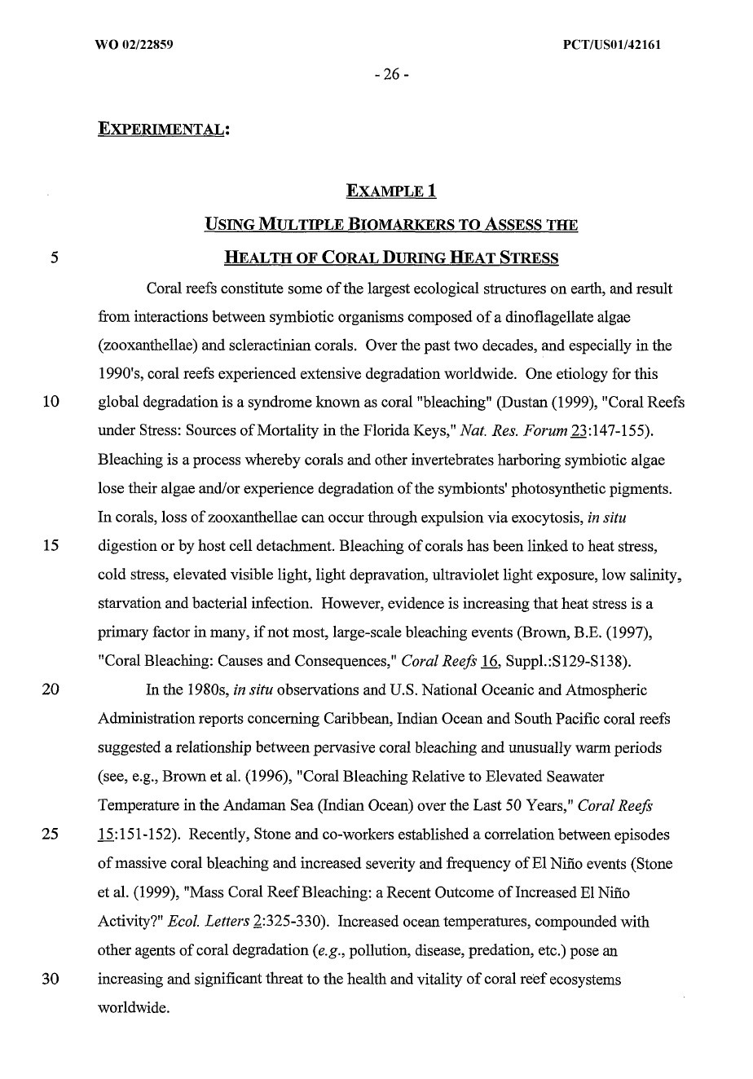

[ 8 ]
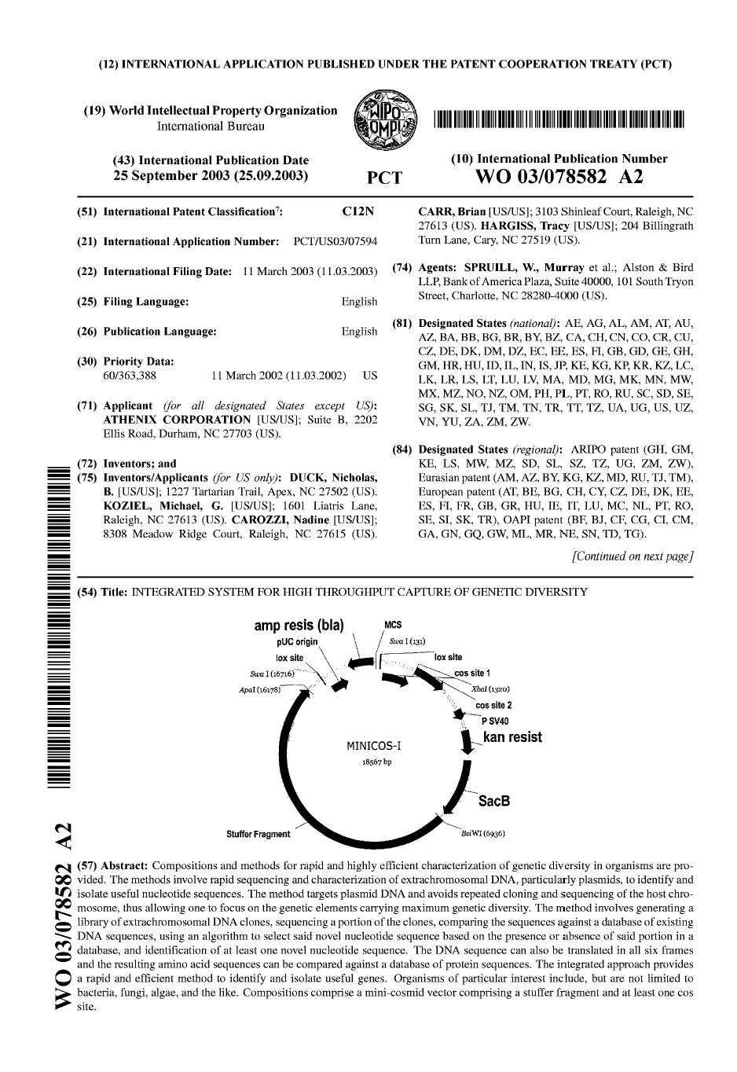
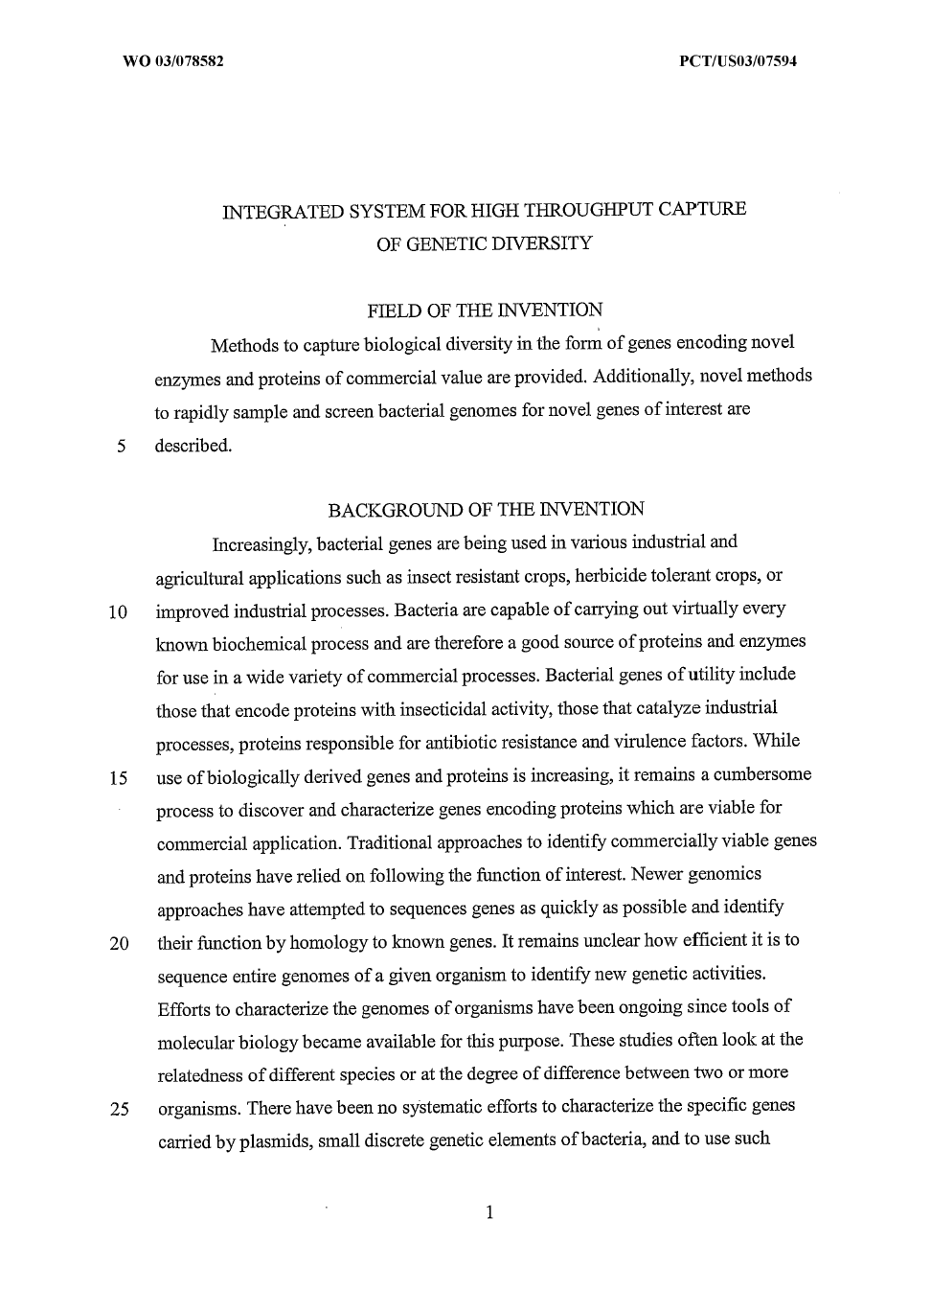

Annex II

[ 9 ]
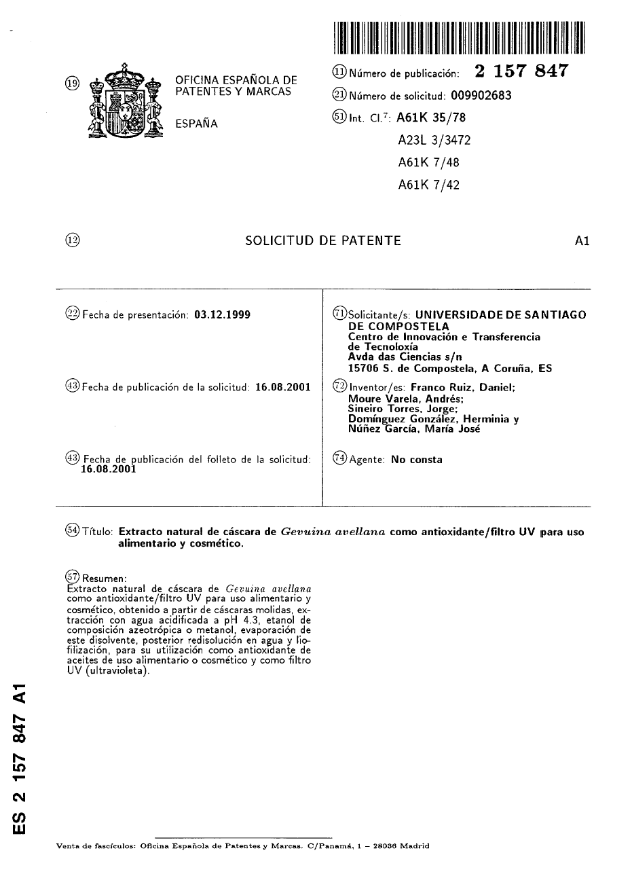

[ 10 ]
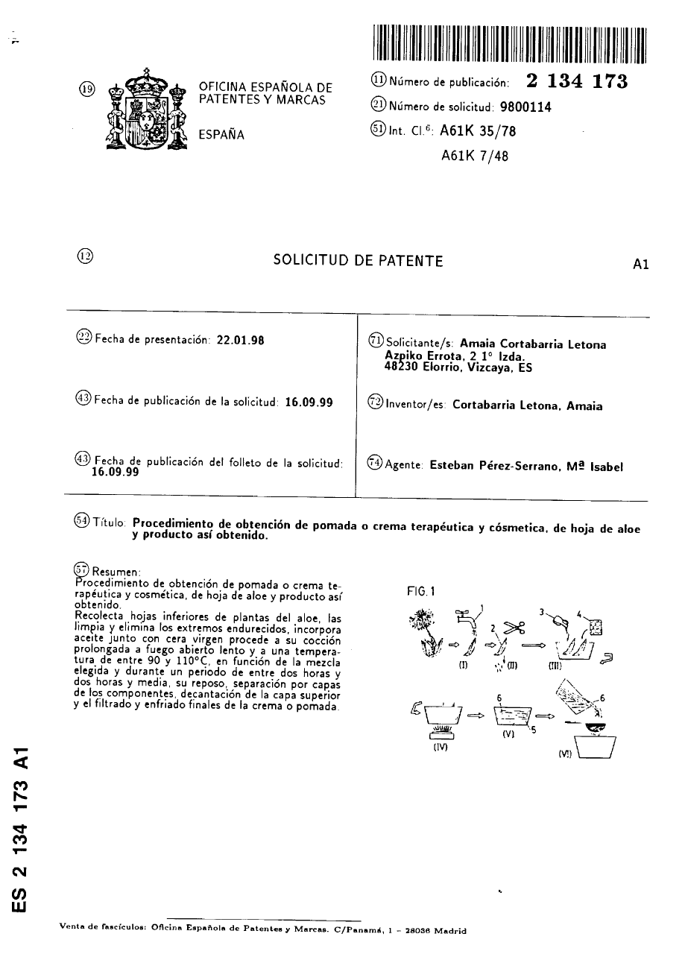

[ 11 ]
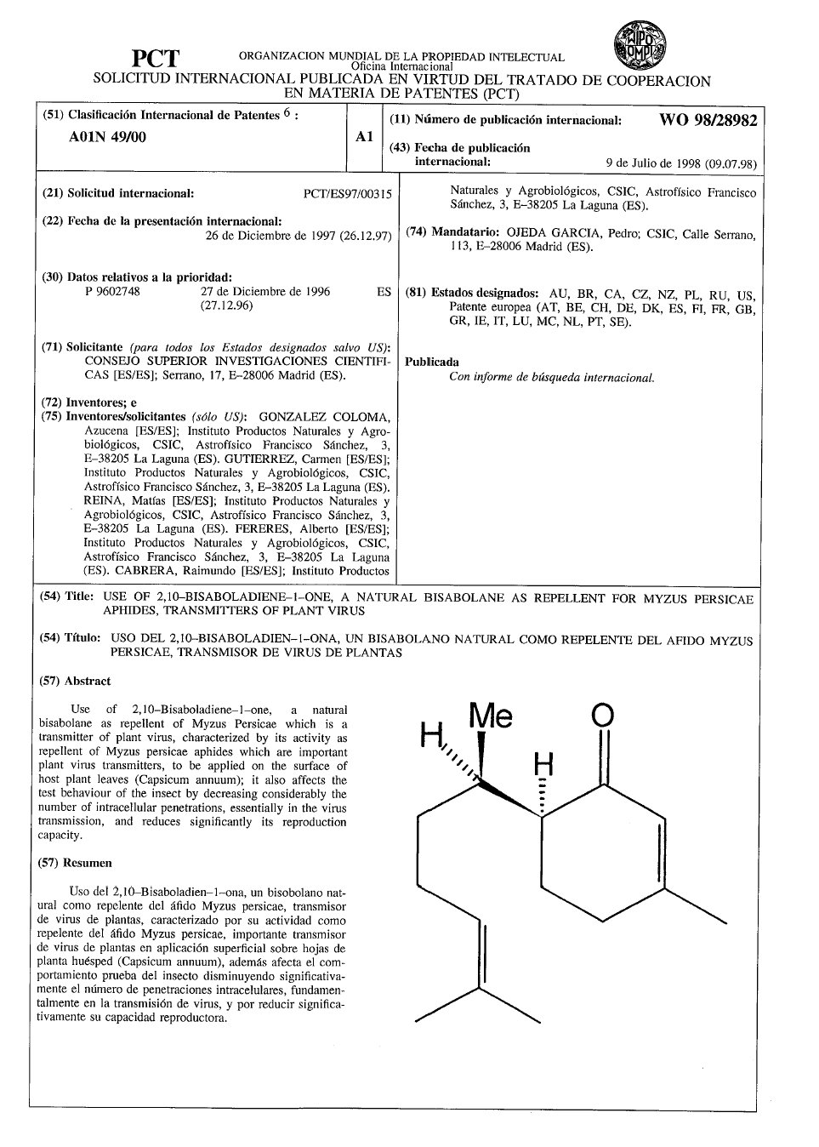

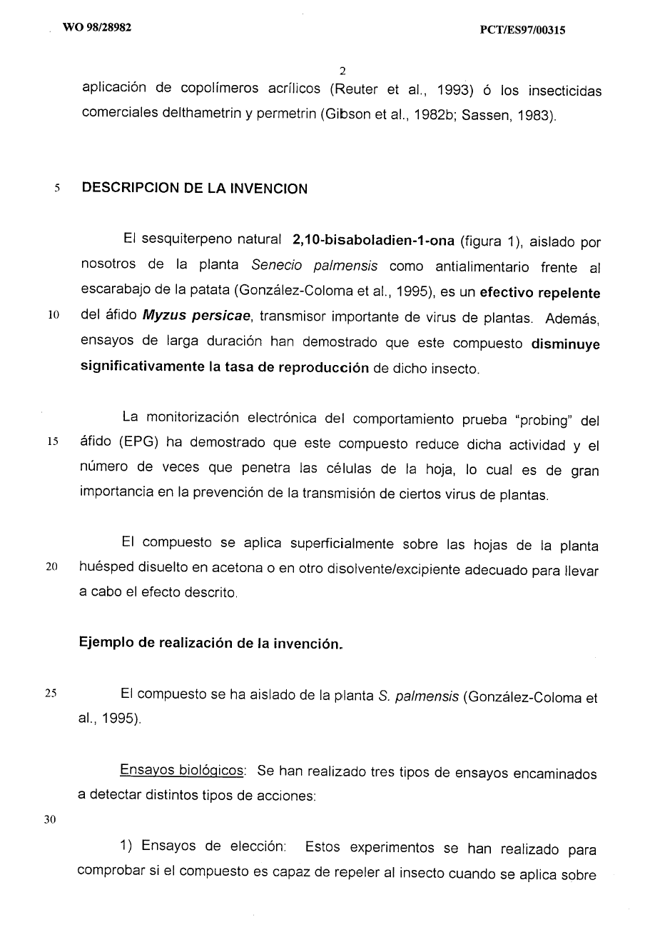

[ 12 ]
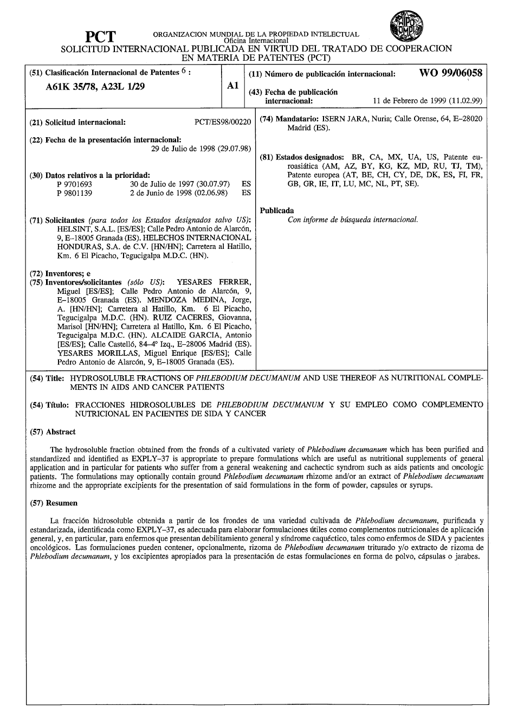

[ 13 ]
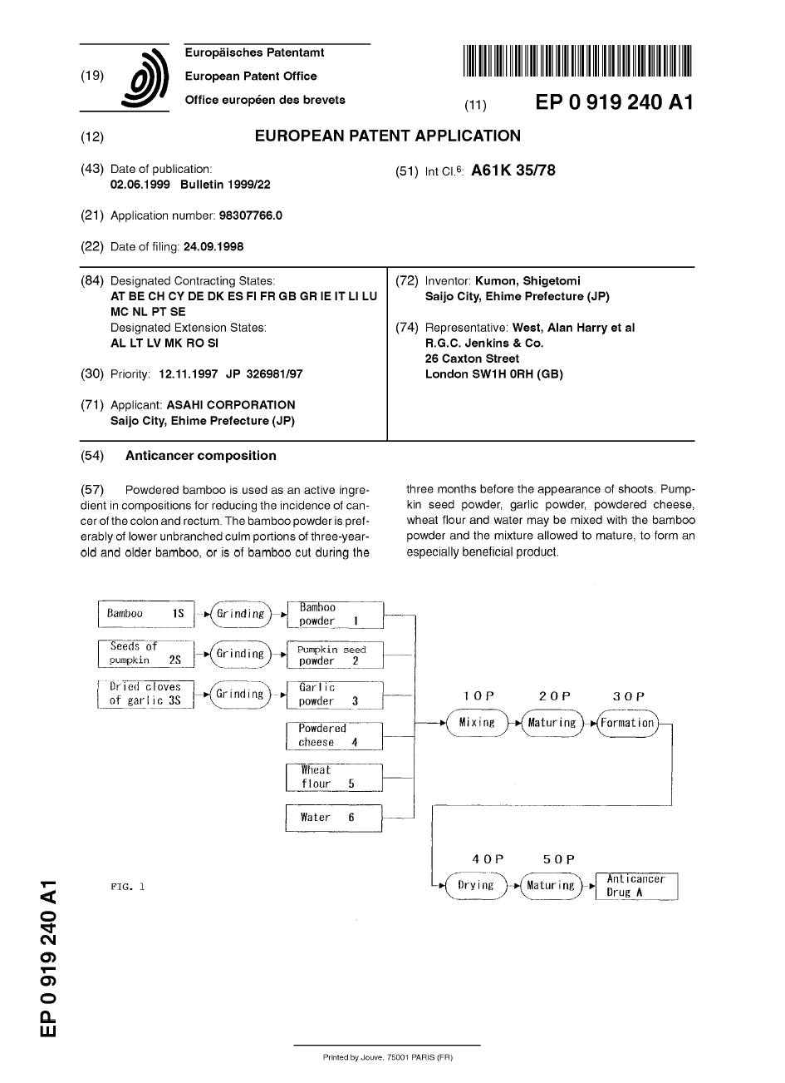

[ 14 ]
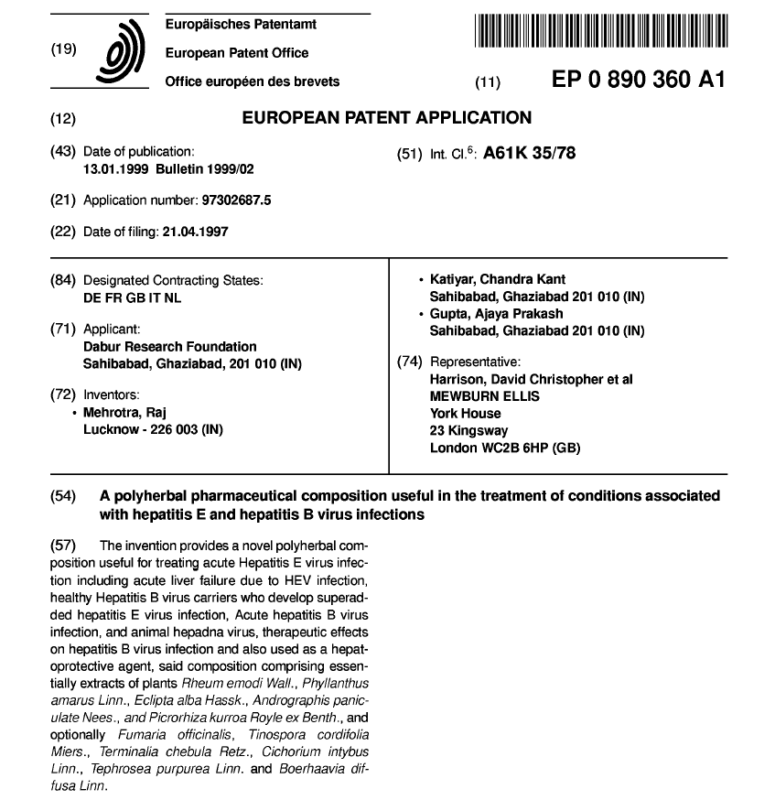
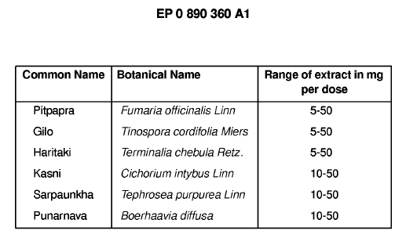

[ 15 ]
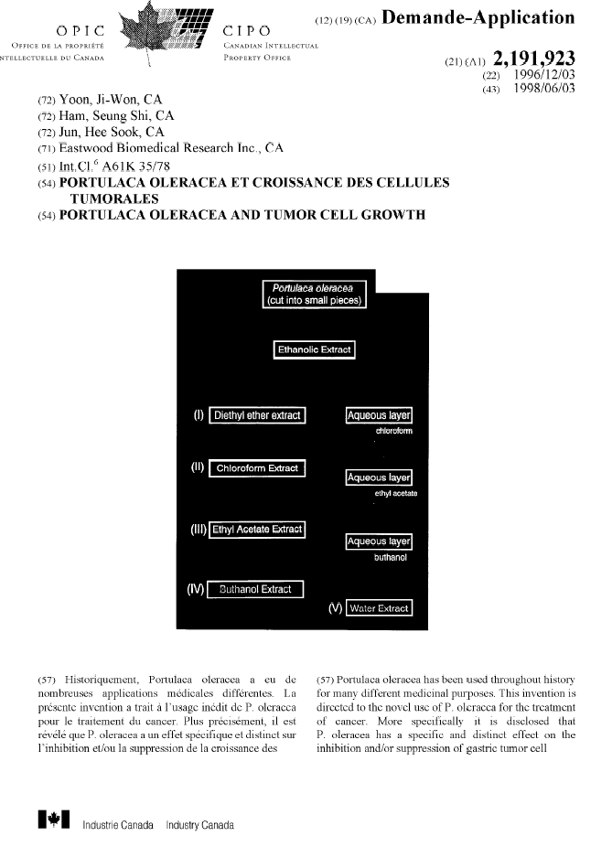

[ 16 ]
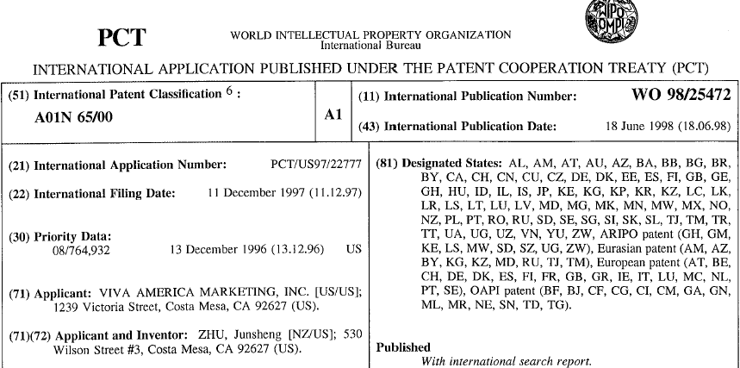

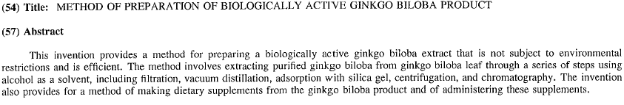

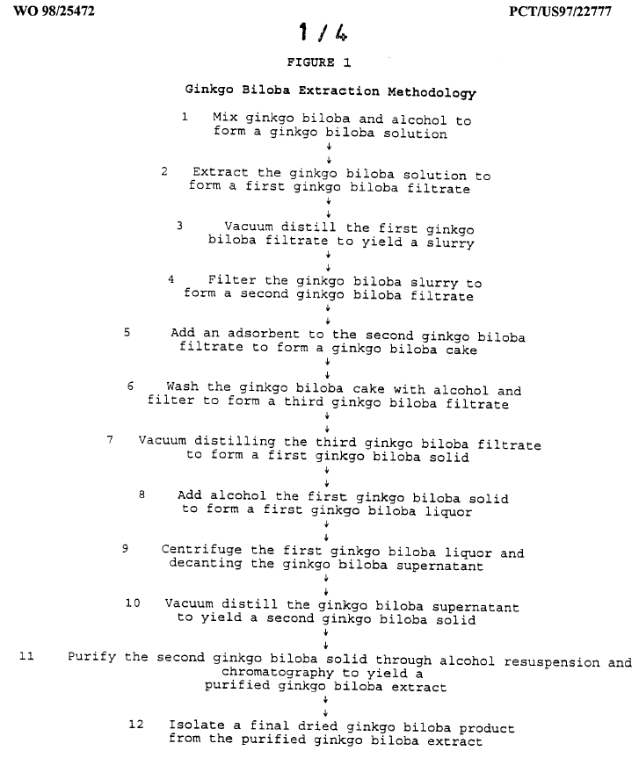

[ 17 ]
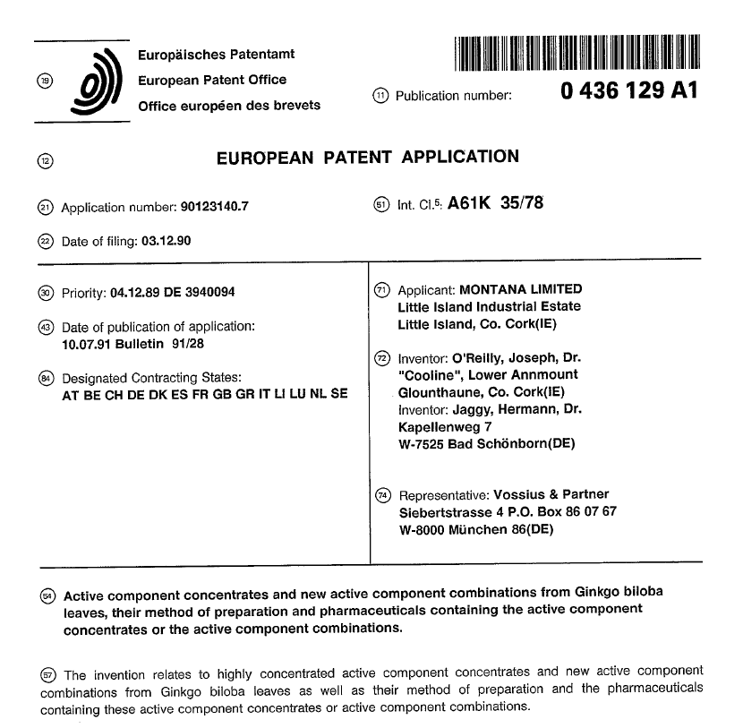

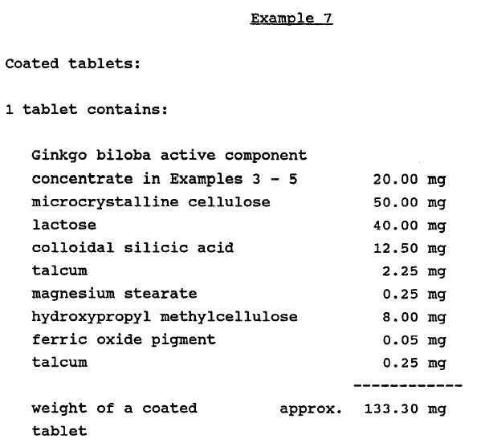

Annex III

All the aforementioned examples can be found on the Internet through Esp@cenet, at the following websites:

* http://www.epo.org (website in English). European Patent Office (EPO).
http://www.espacenet.com . Direct access through the European Patent Office.

* http://www.oepm.es (website in Spanish). Oficina Española de Patentes y Marcas (OEPM) (Spanish Patent and Trademark Office)

This tool allows us to search for patents, by their publication number or by their application number, the applicant, the classification or with keywords.

Patent documents numbers are always two digits of the country code followed by the number assigned by the Patent Office publishing the document. Thus, for example, GB2382352, EP1347101, US5956463, WO03064686.
* Spain ES, United Kingdom GB, United States US, France FR, Japan JP, China CN, etc.
* EP – European Patent - published by the European Patent Office.
* WO - international application published under the Patent Cooperation Treaty (PCT) by WIPO.

The International Patent Classification (IPC, in Spanish CIP) that appears in reference (51) of the First Page of the document allows us to retrieve other patent documents with the same classification and which belong, therefore, to the same technical field.

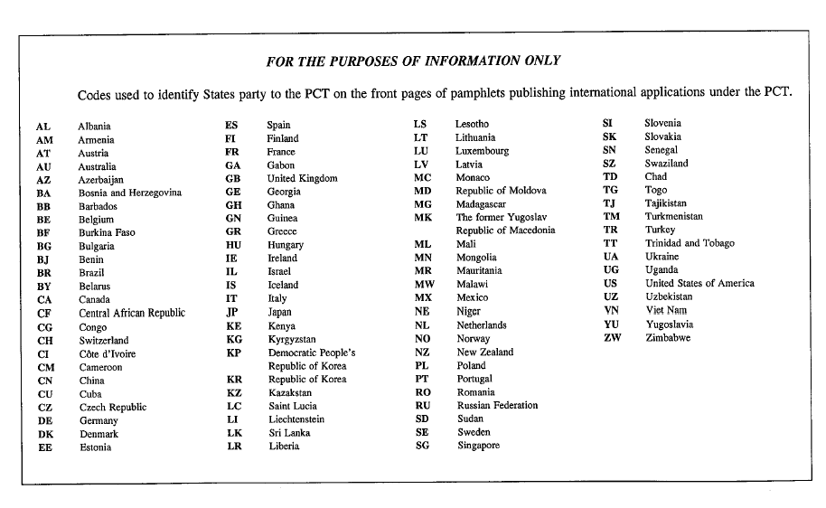

The option “Worldwide - 30 million documents” is the one which contains the largest number of documents. All the pages of most of these documents can be viewed.

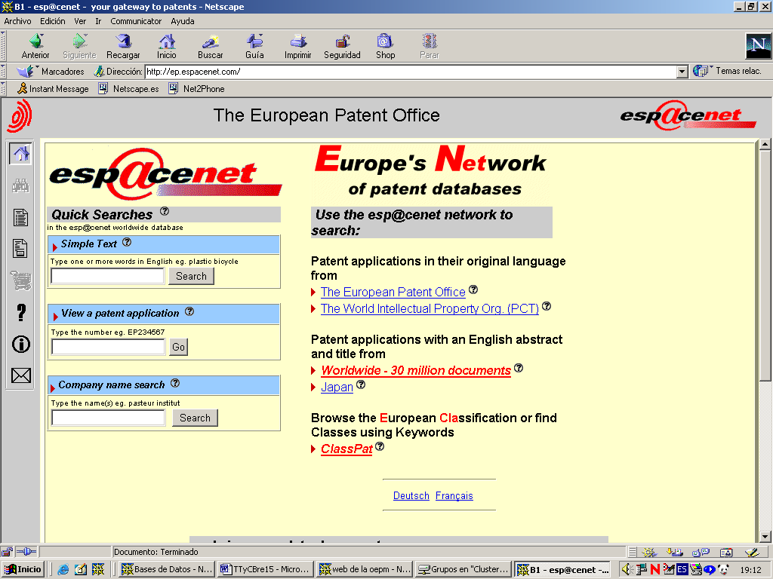

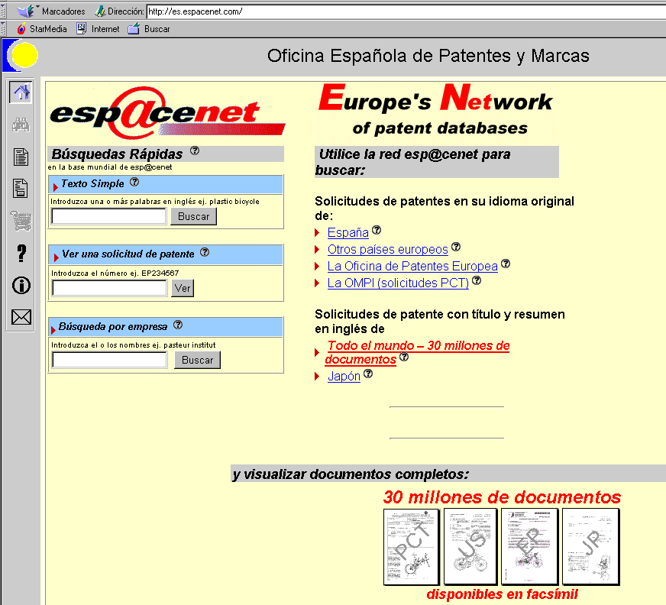

[End of Annex and of Document]

* UNEP/CBD/COP/7/1 and Corr.1.

