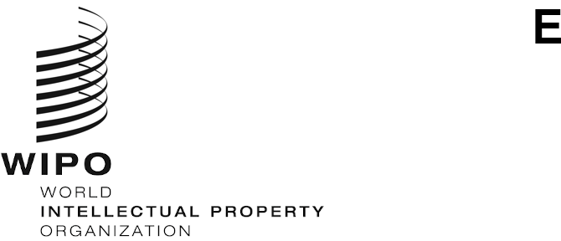
WIPO/GRTKF/IC/52/INF/5
ORIGINAL: English
DATE: JANUARY 26, 2026

Intergovernmental Committee on Intellectual Property and Genetic Resources, Traditional Knowledge and Folklore

Fifty-Second Session

Geneva, March 4 to 13, 2026

Information Note for the Panel of Indigenous and Local Communities
Document prepared by the Secretariat
- At its Seventh Session, the Intergovernmental Committee on Intellectual Property and Genetic Resources, Traditional Knowledge and Folklore (“the Committee”) agreed “that, immediately before the commencement of the sessions of the Committee, half-day panel presentations should be organized, chaired by a representative from a local or Indigenous community”. These panels have since been organized for each Committee session convened from 2005.

- The theme of the panel at the present session will be: “Together or Apart?: The Relationship Between Traditional Knowledge and Traditional Cultural Expressions”.

- The Annex contains the provisional program of the panel for the Fifty-Second Session.

[Annex follows]

PROVISIONAL PROGRAM OF THE PANEL

Wednesday, March 4, 2026 (Geneva Time)

15.00 | Opening  Chair – (to be identified by the WIPO Indigenous Consultative Forum)
15.00 – 15.20 | Mr. Vital Bambanze, who is an Indigenous Mutwa from Burundi, and serves as the Director of Unissons nous pour la Promotion des Batwa (UNIPROBA) in Burundi.
15.20 – 15.40 | Ms. Hai-Yuean Tualima, who is a Samoan from Sataua, Puapua, Iva, Faleula, Lepea and Salelologa in Samoa, and is a Senior Law Lecturer at the Victoria University of Wellington.
15.40 – 16.00 | Mr. Aaron Jones, who is a member of the Tulalip Tribes of Washington, and serves as the Director of the Natural and Cultural Resources Department for The Tulalip Tribes of Washington in the United States of America.
16.00 – 16.20 | Ms. Evelin Carolina Acosta Gutiérrez, who is Indigenous Wayuu del clan Ipuana, and works with the Indigenous Women’s Network on Biodiversity of Latin America and the Caribbean (RMIB-LAC) in Colombia.
16.20 – 18.00 | Floor discussion and closing of the panel.

[End of Annex and document]

