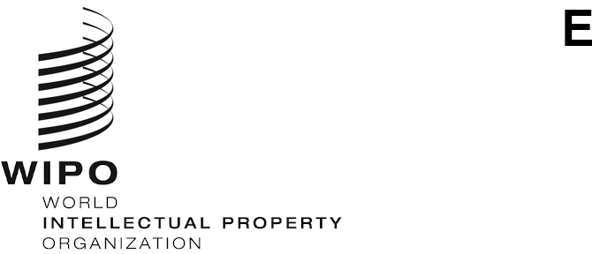
WIPO/GRTKF/IC/52/2
ORIGINAL: English
DATE: JANUARY 21, 2026

Intergovernmental Committee on Intellectual Property and Genetic Resources, Traditional Knowledge and Folklore

Fifty-Second Session

Geneva, March 4 to 13, 2026

ACCREDITATION OF CERTAIN ORGANIZATIONS
Document prepared by the Secretariat
The Intergovernmental Committee on Intellectual Property and Genetic Resources, Traditional Knowledge and Folklore (“the Committee”), at its first session, held in Geneva, from April 30 to May 3, 2001, approved certain organizational and procedural matters, including according ad hoc observer status to a number of organizations that had expressed their wish to have a role in the work of the Committee (see the Report adopted by the Committee, WIPO/GRKTF/IC/1/13, paragraph 18).
Since then, an additional number of organizations have expressed to the Secretariat their wish to obtain the same status for the subsequent sessions of the Committee. The applications containing the names and other biographical details of the organizations which, before January 2, 2026, requested accreditation at the Fifty-Second Session of the Committee are annexed to this document, as received from each organization.
The Committee is invited to consider and decide upon the accreditation request as ad hoc observers submitted by the organizations referred to in the Annex to this document.
[Annex follows]

ORGANIZATIONS WHICH HAVE REQUESTED ACCREDITATION AS OBSERVERS IN SESSIONS OF THE INTERGOVERNMENTAL COMMITTEE

Cree Native Arts and Crafts Association (CNACA)

Métis Legal Research & Education Foundation, Inc.

Native American Church – State of New Mexico (NAC - SNM)

Cree Native Arts and Crafts Association (CNACA)

To: Traditional Knowledge Division
World Intellectual Property Organization (WIPO) 34, chemin des Colombettes
1211 Geneva 20
Switzerland

Fax.: +41 (0) 22 338 81 20
Email: grtkf@wipo.int

Dear Traditional Knowledge Division,

Re: Request for accreditation as an observer in future sessions of the WIPO Intergovernmental Committee

I am writing to express the wish of my organization to participate in the sessions of the WIPO Intergovernmental Committee on Intellectual Property and Genetic Resources, Traditional Knowledge and Folklore as an ad hoc observer. Please find our application attached for the Committee’s consideration.

Please do not hesitate to contact us if you require any further information.

Yours sincerely,

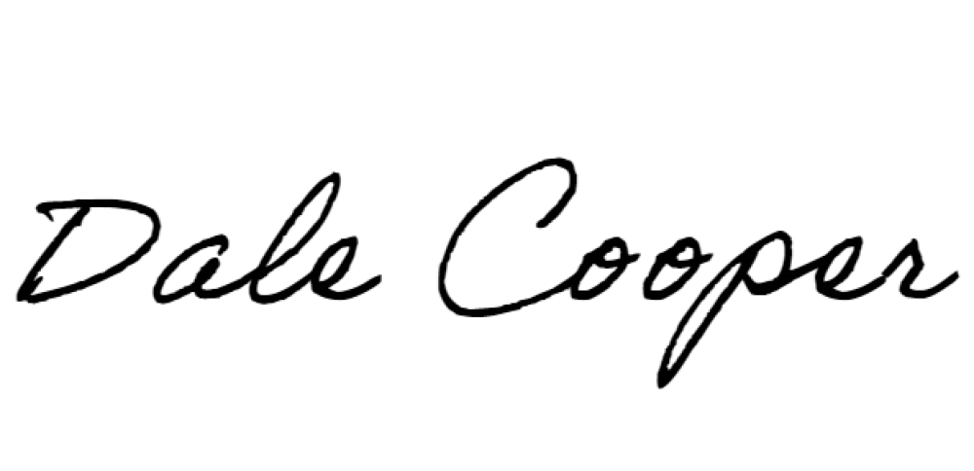
____________________
Dale Cooper
Executive Director
Cree Native Arts & Crafts Association

Application Form for Accreditation as Ad Hoc Observer
to the WIPO Intergovernmental Committee on Intellectual Property and Genetic Resources, Traditional Knowledge and Folklore

BIOGRAPHICAL DETAILS OF THE APPLICANT ORGANIZATION

Full name of the Organization:

Cree Native Arts and Crafts Association (CNACA)

Description of the Organization: (maximum 150 words)

The Cree Native Arts and Crafts Association (CNACA) is a non-for-profit organization established in 2004 under the James Bay and Northern Quebec Agreement (JBNQA) signed in 1975. Our mandate is to assume a leadership role on behalf of the Cree for the development of the arts and crafts and the cultural industries of Eeyou Istchee. CNACA is a resource hub that links arts and crafts entrepreneurs with the resources to assist them to succeed and thrive in their business. We develop and encourage educational and funding programs to assist the membership to maximize their potential, as well as foster and encourage networking within the arts and craft industry.

Main aims and objectives of the Organization:

- Our vision and work are guided by four pillars:
  - Our artists and craftspeople are living bearers of our culture and heritage.
  - Our arts and crafts are the expression of our past, our present and our aspirations for the future.
  - Our artists and artisans must be able to sustain themselves economically through their talents.
  - As long as Cree arts and crafts are maintained, and our traditions preserved; our Cree people will remain strong.
- Our objectives:
  - Develop and be responsible for programs that contribute to the development of the Cree arts and crafts industry in Eeyou Istchee.
  - Assist individuals or Cree communities in marketing and related services for arts and crafts products throughout the world.
  - Facilitate access to material resources for the creation, preservation and promotion of Cree arts and crafts.
  - Coordinate our efforts with other Cree entities when needed for the support and promotion of Cree arts and crafts.

Main activities of the Organization:

- Membership Support
  - Provides access to sponsorship programs, training, and trade show opportunities.
- Bursary Program
  - Awards $500 bursaries to graduating Cree high school students excelling in arts and crafts.
- Cultural Events
- Participates in and organizes events like:
    - Achievement Awards
    - Annual Members Assembly
    - Cree Knowledge Festival
    - Other community-driven cultural events
- Training & Professional Development
- Offers skill-building workshops and training in:
    - Traditional and contemporary arts
    - Business and entrepreneurship
- Networking & Resource Hub
  - Acts as a central hub for:
    - Connecting artists to funding and promotional resources
    - Encouraging collaboration and peer support
- Advocacy for Intellectual Property
- Promotes and protects:
    - Traditional knowledge
    - Intellectual property rights of Cree artists
- Wachiya Store
  - An online and physical store that showcases Cree artists and Indigenous groups. (wachiya.com)

Relationship of the Organization with intellectual property matters, including a full explanation of why you are interested in the issues under discussion by the Committee (Maximum 150 words)

CNACA (Cree Native Arts and Crafts Association) is deeply engaged in issues surrounding intellectual property (IP) as they relate to traditional knowledge and cultural expressions. As a not-for-profit organization representing Cree artists and artisans, we work to protect the integrity of Indigenous cultural heritage and ensure creators are empowered through both education and advocacy. Many of our members rely on orally transmitted, collectively held knowledge that falls outside conventional IP protections. CNACA is interested in WIPO’s work because international guidance and reform are essential to address gaps in existing frameworks, particularly in protecting Traditional Knowledge (TK) and Traditional Cultural Expressions (TCEs). We support efforts that integrate UNDRIP principles, promote respect for Indigenous laws, and ensure fair benefit sharing. Our goal is to safeguard Cree culture from misappropriation while creating sustainable opportunities for our artists. CNACA aims to contribute a Cree perspective to WIPO’s global discussions.

Country in which the Organization is primarily active:

Canada

Additional Information: Please provide any additional information which you feel may be relevant (maximum 150 words)

CNACA represents over 900+ Cree artists and artisans across Eeyou Istchee. We regularly collaborate with legal experts, Elders, and cultural practitioners to ensure that IP education and advocacy reflect traditional values and community protocols. In 2024, we launched a public education initiative on IP and Traditional Knowledge to build awareness and support grassroots protection. CNACA is also working toward developing culturally relevant IP policies that center Cree law and community governance. Participation in the WIPO IGC will strengthen our capacity to advocate for international standards that recognize Indigenous worldviews and enable communities to retain control over their cultural expressions.

Full contact details of the Organization:

Cree Native Arts & Crafts Association
205 Opemiska Meskino, P.O. Box 1234
Ouje-Bougoumou, QC, Canada
G0W 3C0

Telephone number: (+418)-745-2444 ext. 3000
Fax number: n/a
Email address: administration@cnaca.ca
Web site: www.cnaca.ca

Name of Organization Representative and Title:

Dale Cooper – Executive Director

Métis Legal Research & Education Foundation, Inc.

To: Traditional Knowledge Division
World Intellectual Property Organization (WIPO)
34, chemin des Colombettes
1211 Geneva 20
Switzerland

Fax.: +41 (0) 22 338 81 20
Email: grtkf@wipo.int

Dear Traditional Knowledge Division,

Re: Request for accreditation as an observer in future sessions of the WIPO Intergovernmental Committee

I am writing to express the wish of my organization to participate in the sessions of the WIPO Intergovernmental Committee on Intellectual Property and Genetic Resources, Traditional Knowledge and Folklore as an ad hoc observer. Please find our application attached for the Committee’s consideration.

Please do not hesitate to contact us if you require any further information.

Yours sincerely,

Kathy L Hodgson-Smith, KC
Board Member
Metis Legal Research and Education Foundation Inc
____________________
(Name and Signature of Representative)

Application Form for Accreditation as Ad Hoc Observer
to the WIPO Intergovernmental Committee on Intellectual Property and Genetic Resources, Traditional Knowledge and Folklore

BIOGRAPHICAL DETAILS OF THE APPLICANT ORGANIZATION

Full name of the Organization:

Métis Legal Research & Education Foundation, Inc.

Description of the Organization: (maximum 150 words)

The Foundation is a not-for-profit organization which was formed in 2001 to carry on the work of advancing the recognition of Métis Nation Aboriginal rights, as protected by the S35 Canadian Constitution Act, 1982. The Foundation’s mandate is to conduct research, public education, publishing, lectures, workshops, advocacy, human rights research and advocacy and appear before government hearings, commissions, tribunals and courts of law for the betterment and advancement of the rights and well-being of the Métis people. The Foundation is governed by a Board of Directors which consists of Aboriginal representatives from across the province within Canada. The Foundation operates primarily by the pro bono legal services of various lawyers and where possible through paid contracts to professional services contractors.

Main aims and objectives of the Organization: (Please use a bulletted list)

- to conduct human rights and legal research
- to undertake public education through workshops and lectures on pressing legal matters facing Indigenous Peoples
- to publish materials online and in print for the dissemination of Foundation products to promote community capacity development
- to advocate on behalf of Indigenous communities or citizens to advance their human or Indigenous rights with governments, industry, private corporations or public corporations and in courts or tribunals.

Main activities of the Organization: (Please use a bulleted list)

- appear in courts and before tribunals to defend and advance Indigenous rights
- develop online materials to increase public knowledge of the contributions of Indigenous Peoples, specifically the Métis people
- attend relevant conferences and provide information and updates to relevant organizations and agencies.
- prepare research and information publications to advance and advocate for those perspectives which advance informed decision making on matters affecting Métis peoples, inclusive of all genders and ages and socio-economic situation

Relationship of the Organization with intellectual property matters, including a full
explanation of why you are interested in the issues under discussion by the Committee
(Maximum 150 words)

The Foundation, through its board members, often attending in other capacities, has been involved with WIPO since IGC 5 where representation of our board participated in the dialogues in WIPO being funded under the Voluntary Fund. We have been following WIPO all the way to the finalization of the treaty in 2024. We have focused significant attention to Indigenous knowledge systems, advancing Métis traditional knowledge, cultural knowledge and systems in numerous courts and arenas. The protection of Métis traditional knowledge is an ongoing struggle as industry and government advance economic priorities and interfere with the ongoing relationship of Métis and other Indigenous peoples’ access to their traditional resources, genetic resources and associated TK. Patent systems do not have adequate access to TK to include TK in their assessments. Work must be done to create meaningful partnerships to promote, disclose and protect TK in patents generally.

Country in which the Organization is primarily active:

Canada

Additional Information:
Please provide any additional information which you feel may be relevant (maximum 150 words)

The Foundation is committed to provision of education and information to various agencies including Indigenous communities and non-Indigenous communities to better appreciate the subject matter (TK, TKAGR, TCE) under the WIPO Treaty and to assist in the exploration and dialogue on solutions to advance access to TK and to support Indigenous peoples to store, protect and inure benefit from the sharing of their knowledge with others. The Foundation is also committed to the exploration of possible mechanisms and tools in information sharing systems that would protect the knowledge while allowing communities to share appropriate knowledge with patent offices. Our board members have undertaken significant number of TK studies on land use of Indigenous peoples and presented at international CBD programs and on panels, including at the World Summit on Sustainable Development, and give advice within Commission for Environmental Cooperation on TK Engagement in Canada/US/Mexico.

Full contact details of the Organization:

Postal address: 311 21st Street East Saskatoon, SK S7K 0C1

Telephone number: (306)955-0588
Fax number: (306)955-0590
Email address: kathy@mlref.ca
Web site: www.mlref.ca

Name of Organization Representative and Title:

Clément Chartier, President and/or Kathy Hodgson-Smith, Board Member

Native American Church-State of New Mexico (USA) (NAC-SNM)

To: Traditional Knowledge Division
World Intellectual Property Organization (WIPO)
34, chemin des Colombettes
1211 Geneva 20
Switzerland

Fax.: +41 (0) 22 338 81 20
Email: grtkf@wipo.int

Dear Traditional Knowledge Division,

Re: Request for accreditation as an observer in future sessions of the WIPO Intergovernmental Committee

I am writing to express the wish of my organization to participate in the sessions of the WIPO Intergovernmental Committee on Intellectual Property and Genetic Resources, Traditional Knowledge and Folklore as an ad hoc observer. Please find our application attached for the Committee’s consideration.

Please do not hesitate to contact us if you require any further information.

Yours sincerely,
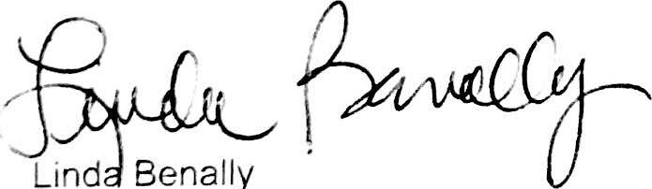
(Name and Signature of Representative)

Application Form for Accreditation as Ad Hoc Observer
to the
WIPO Intergovernmental Committee on Intellectual Property and Genetic Resources, Traditional Knowledge and Folklore

BIOGRAPHICAL DETAILS OF THE APPLICANT ORGANIZATION

Full name of the Organization:

Native American Church-State of New Mexico (USA) (NAC-SNM)

Description of the Organization: (maximum 150 words)

The NAC-SNM has been incorporated in the USA under the laws of the state of New Mexico since 1981. Its mission is to support the protection of American Indian religious, ceremonial, spiritual and traditional practices held sacred since time immemorial. This includes education about this way of life with the goal of protecting and preserving medicinal plants and associated traditional knowledge and traditional expressions for future generations.

The NAC in the United States is comprised of U.S. citizens and tribally enrolled citizens, such as citizens of the Navajo Nation from Shiprock, New Mexico.

Main aims and objectives of the Organization: (Please use a bulleted list)

- Develop the next generation of leaders.
- Offer educational endeavors and programming for the protection and preservation of Medicinal Plants and its natural ecosystems, Traditional Knowledge and Cultural Expressions
- Collaborate with partners at all levels that align with Educational Programming described above
- Community engagement (military veterans, holiday drives, youth opportunities)

Main activities of the Organization: (Please use a bulleted list)

- Capacity Building — Develop and offer programs, experiences, and opportunities for the next generation of leaders.
- Educational Programming — Develop and provide educational endeavors and programming for the protection and preservation of Medicinal Plants and its natural ecosystems, Traditional Knowledge and Cultural Expressions
- Synergy Initiative — Collaborate with partners at all levels that align with Educational Programming described above
- Community Service — hands on community involvement (veterans, holiday, youth)

Relationship of the Organization with intellectual property matters, including a full explanation
of why you are interested in the issues under discussion by the Committee (Maximum
150 words)

Native American Church — State of New Mexico is interested in issues concerning the intellectual property rights of genetic resources, traditional knowledge, cultural expressions, and folklore because these Intellectual Property (IP) rights allow our members to maintain the skills and practices that are integral to their cultural identities. Preserving such IP rights helps maintain our members' heritage and tradition while simultaneously ensuring that our members can safeguard against unauthorized use of their cultural expressions. Moreover, traditional knowledge oftentimes includes practices related to biodiversity and/or environmental management so preserving this knowledge helps support and protect natural resources important to the organization's members.

Country in which the Organization is primarily active:

United States of America

Additional Information:
Please provide any additional information which you feel may be relevant (maximum 150 words)

The knowledge systems of Indigenous Peoples have existed since time immemorial and are inherently connected to traditional cultural expressions, genetic resources and associated traditional knowledge. Indigenous Peoples have been historically and systemically impacted and harmed by the lack of protections for their traditional knowledge and traditional cultural expressions and resulting in appropriation and misuse.

Full contact details of the Organization:

Postal address
25556 N. 105th Drive
Peoria, Arizona 85383
Telephone number: 623-308-2329
Fax number: none
Email address: Ijdbenally@gmail.com
Web site: nacnewmexico.org
Name of Organization Representative and Title:

Linda Benally, Secretary of the Board of Directors, Advisor

[End of Annex and document]

