 |  | E
WIPO/GRTKF/IC/30/INF/8
ORIGINAL: ENGLISH
DATE: May 4, 2016

Intergovernmental Committee on Intellectual Property and Genetic Resources, Traditional Knowledge and Folklore

Thirtieth Session
Geneva, May 30 to June 3, 2016

RESOURCES AVAILABLE ON THE wipo tRADITIONAL KNOWLEDGE, TRADITIONAL CULTURAL EXPRESSIONS AND GENETIC RESOURCES wEBSITE

Document prepared by the Secretariat

1. At its Twentieth Session, held from February 14 to 22, 2012, the Intergovernmental Committee on Intellectual Property and Genetic Resources, Traditional Knowledge and Folklore (“the IGC”) invited the Secretariat to produce an information document briefly describing the resources available on the WIPO Traditional Knowledge, Traditional Cultural Expressions and Genetic Resources website (“the WIPO TK website”).

2. Pursuant to that decision, a detailed description of the resources available on the WIPO TK website (http://www.wipo.int/tk/en/) has been prepared for all subsequent IGC sessions. The latest version of such description was included in document WIPO/GRTKF/IC/29/INF/9.

- The Annex of the current document provides a concise list of main entries of the WIPO TK website and an update on the resources available on the website.

- At its Twenty-Ninth Session, the IGC requested the Secretariat to establish “a new webpage consolidating all existing resources on regional, national, local and communities experiences (such as studies, collections of laws, submissions, databases, voluntary codes and protocols, and presentations) prepared by the WIPO Secretariat or submitted by Member States and observers for purposes of the Committee to date”. Pursuant to this decision, a new webpage has been established. The link and description of this webpage are included in the Annex.

- In the future, this information document will only be issued once a year or when there are significant amendments to the website.

6. The IGC is invited to take note of this document and the Annex to it.

[Annex follows]

RESOURCES AVAILABLE ON THE wipo tRADITIONAL KNOWLEDGE, TRADITIONAL CULTURAL EXPRESSIONS AND GENETIC RESOURCES wEBSITE

1 The present Annex provides a list of the main entries of the WIPO TK website (http://www.wipo.int/tk/en/) and an update on the new resources since February 2016.

2 There are five main entries of the WIPO TK website:

- IGC: http://www.wipo.int/tk/en/igc/index.html. This webpage constitutes the most important gateway to detailed information for IGC participants.

- Indigenous Portal: http://www.wipo.int/tk/en/indigenous/. This is part of the WIPO Secretariat’s effort to improve access to available information for and relating specifically to indigenous peoples and local communities. It offers links to the practical workshops, relevant WIPO resources, information on accreditation to, and participation in, the IGC process and provides access to external links of interest to indigenous peoples and local communities.

- Traditional Knowledge: http://www.wipo.int/tk/en/tk/. This webpage includes a concise description of the issues involved and the links to the relevant resources.

- Traditional Cultural Expressions: http://www.wipo.int/tk/en/folklore/. This webpage includes a concise description of the issues involved and the links to the relevant resources.

- Genetic Resources: http://www.wipo.int/tk/en/genetic/. This webpage includes a concise description of the issues involved and the links to the relevant resources.

3 More resources, including databases and publications, are available at: http://www.wipo.int/tk/en/#resources.

4 Below are the main updates since February 2016.

The IGC

5 A special page containing an “IGC Preparation Kit” for the Thirtieth Session of the IGC is available in order to help participants in the IGC to prepare for the session with various shortcuts: (http://www.wipo.int/tk/en/igc/preparation/).

6 The complete list of available documents related to the Thirtieth Session of the IGC is available at: http://www.wipo.int/meetings/en/details.jsp?meeting_id=39724.

The Seminar on Intellectual Property and Genetic Resources

7 The renewed mandate of the IGC for the 2016/2017 biennium requested the WIPO Secretariat to organize seminars to “build regional and cross regional knowledge and consensus on issues related to intellectual property and genetic resources, traditional knowledge and traditional cultural expressions with a focus on unresolved issues”. A Seminar on Intellectual Property and Genetic Resources will be organized on May 26 and 27, 2016, prior to the Thirtieth Session of the IGC. Information on the Seminar is available at: http://www.wipo.int/meetings/en/details.jsp?meeting_id=39823.

New Resources

8 A new Background brief on intellectual property and genetic resources is available at: http://www.wipo.int/edocs/pubdocs/en/wipo_pub_tk_10.pdf.

9 The disclosure requirements table was updated in April 2016: http://www.wipo.int/export/sites/www/tk/en/documents/pdf/genetic_resources_disclosure.pdf

10 At its Twenty-Ninth Session, the IGC requested the Secretariat to establish “a new webpage consolidating all existing resources on regional, national, local and communities experiences (such as studies, collections of laws, submissions, databases, voluntary codes and protocols, and presentations) prepared by the WIPO Secretariat or submitted by Member States and observers for purposes of the Committee to date”. A webpage including resources available on WIPO’s website on regional, national, local and community experiences regarding IP and GRs/TK/TCEs has been established: http://www.wipo.int/tk/en/resources/tk_experiences.html. A snapshot of this webpage is reproduced below:

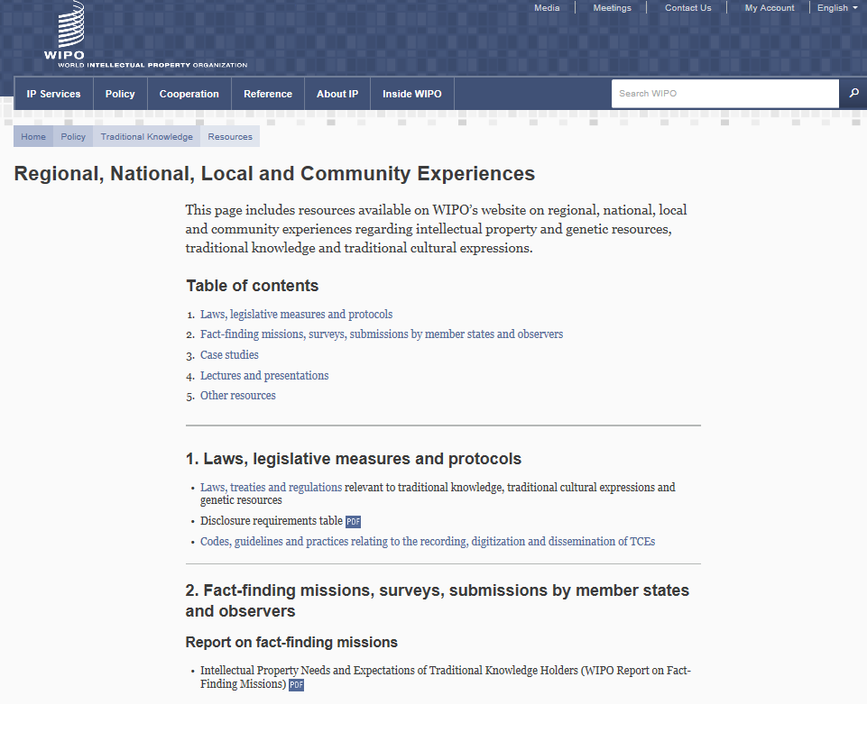
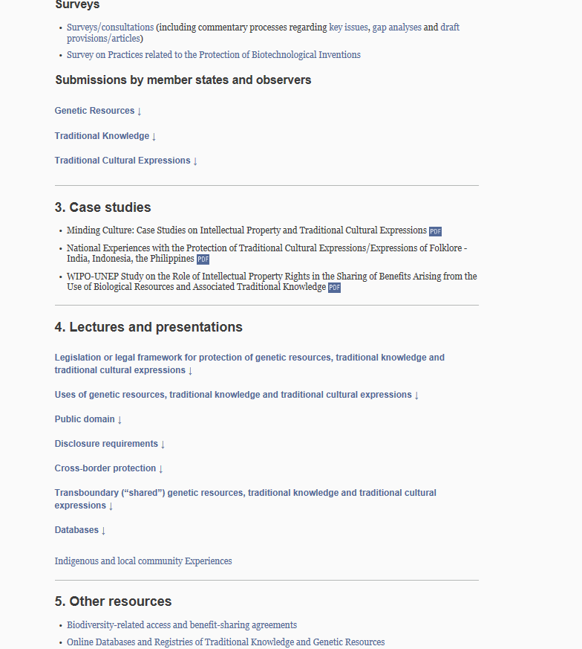

[End of Annex and of document]

See report of the Twentieth Session (WIPO/GRTKF/IC/20/10), paragraph 801 (f).

