 |  | E
WIPO/GRTKF/IC/20/INF/11
ORIGINAL: English
DATE: October 17, 2011

Intergovernmental Committee on Intellectual Property and Genetic Resources, Traditional Knowledge and Folklore

Twentieth Session
Geneva, February 14 to 22, 2012

Additional Explanation from Japan regarding the Document WIPO/GRTKF/IC/9/13 on the Patent System and Genetic Resources

Document prepared by the Secretariat

1. The Annex to this document comprises document WIPO/GRTKF/IC/11/11 (“Additional Explanation from Japan regarding the Document WIPO/GRTKF/IC/9/13 on the Patent System and Genetic Resources”).

2. The Committee is invited to take note of this document and the Annex to it.

[Annex follows]
WIPO |  | E  WIPO/GRTKF/IC/11/11  ORIGINAL: English  DATE: June 25, 2007
WORLD INTELLECTUAL PROPERTY ORGANIZATION
GENEVA

intergovernmental committee on
intellectual property and genetic resources,
traditional knowledge and folklore
Eleventh Session
Geneva, July 3 to 12, 2007
Additional Explanation from Japan regarding the Document WIPO/GRTKF/IC/9/13 on the Patent System and Genetic Resources
Document submitted by Japan
1. A communication from the Permanent Mission of Japan to the International Organizations in Geneva dated June 22, 2007, conveyed a document entitled “Additional Explanation from Japan regarding the document WIPO/GRTKR/IC/9/13
on the Patent System and Genetic Resources”.

2. The text of the document as received is published in the Annex to this document.

3. The Intergovernmental Committee is invited to take note of the contents of the Annex during its consideration of item 9 on genetic resources.

[Annex follows]

ADDITIONAL EXPLANATION FROM JAPAN REGARDING THE DOCUMENT WIPO/GRTKR/IC/9/13 ON THE PATENT SYSTEM AND GENETIC RESOURCES

- INTRODUCTION

- The relationship between the TRIPS Agreement and the CBD encompasses two issues: (i) the erroneous granting of patents and (ii) CBD compliance (in other words, prior informed consent (PIC) and benefit sharing, as set out in the CBD). When discussing the relationship between the TRIPS Agreement and the CBD at the IGC, it is important to distinguish the two issues.

- Firstly, with regards the issue of erroneous granting of patents, this can be effectively addressed by improving databases for storing genetic resources and related traditional knowledge that are used for prior art searches, as well as through utilizing certain existing institutional systems, such as information provision systems and the invalidation trial system more efficiently.

- In the document WIPO/GRTKF/IC/9/13, Japan proposed a one-click database search system that will help examiners conduct searches more efficiently for prior art concerned with genetic resources and related traditional knowledge. We have prepared this paper to encourage further discussion on this proposal. This paper explains the structure of the proposed one-click database search system as well as how the system prevents inappropriate access to its contents by third parties. It should be noted that budgetary implications of this proposed system would also need to be considered where appropriate.

- STRUCTURE OF THE ONE-CLICK DATABASE SEARCH SYSTEM

- As described in Figure 1 below, searchable databases under the proposed system should be in the possession of, and maintained by, each participating WIPO member states. The database will be composed of a WIPO portal site as well as databases of WIPO member state, which are linked to this portal site.

- Each participating WIPO member state will first assume the role of collecting information on genetic resources and related traditional knowledge within its territory and store this information in its database/databases (either adapted from an existing database or newly created). Assigning the responsibility of the development of databases to each member state will allow each member state adequately take into account various sensitive issues, such as considerations for customary law, the identification of interested parties concerned and their willingness and condition for providing information, and coordination amongst multiple interested parties who claim entitlement to common genetic resources. With regards to the format of a database, at least some kind of a basic format for registering data to the database should be developed by WIPO. For example, entries to the database would have to include the name and a brief description of the genetic resource, as well as a code number to identify the said genetic resource. For genetic resources that have been referenced in a publication, such as a book or journal, the bibliographic data of the said publication should also be included in the database.

- A simple text search function should be provided in the databases of each participating WIPO member state. For countries that are not able to develop such search programs,
technical assistance can be provided. For example, technical assistance in the form of a common program for conducting searches can be provided by WIPO.

- The WIPO portal site will be equipped with two basic functions: (i) a function which enables an examiner to directly access the databases of the participating WIPO member states and (ii) a function which enables an examiner to retrieve data from the accessed databases. “Surf-IP” developed by the Intellectual Property Office of Singapore is a well-known portal site with functions similar to those described above.

- Simply by accessing the WIPO portal site and entering a search formula, an examiner can instantaneously obtain search results derived from the databases of all participating WIPO member states. (see Figure 2) This search result can be used as prior art or reference material for a patent application, enabling an examiner to determine more easily whether the subject matter of a patent application lacks novelty. As an examiner need only point to the necessary information in the database when rejecting an application under examination, the danger of information leakages would be minimal.

- While the languages used in databases differ, there are some possible solutions to the language barrier problem. For instance, the name and a brief description of each genetic resource in a database could (and should) be translated into English and registered in the database as keywords. The development of a multi-language glossary of technical terms is another possible solution. With a multi-language glossary of technical terms, an examiner is able to have a search keyword entered in certain language translated automatically into multiple languages and, then, using the translated keywords, can conduct a one-click multilingual search of the databases of the participating WIPO member states.

III. PREVENTION OF THIRD PARTY ACCESS

- To prevent third party access, the WIPO portal site will be made accessible only from registered IP (Internet Protocol) addresses.

- Specifically, an IP (Internet Protocol) Address Authentication System (IPAAS) will be incorporated into the WIPO portal site. Then, access will be provided only to registered IP (Internet Protocol) addresses. (See Figure 1.)

- IP Offices that conduct examinations have a specific IP (Internet Protocol) addresses. Therefore, by restricting access to the WIPO portal site to specific IP (Internet Protocol) addresses, we can limit users of the site to those IP Offices that have registered their unique IP (Internet Protocol) addresses with WIPO. For example, the Advanced Industrial Property Network (AIPN) is a database search system developed by the Japan Patent Office (JPO) and equipped with an IP (Internet Protocol) address authentication system. The IP (Internet Protocol) address authentication system only allows IP Offices with an IP (Internet Protocol) address registered with the JPO to access file wrapper information.

IV. REGISTRATION OF CITED/REFERENCE INFORMATION

- When an examiner accesses the WIPO portal site, he might come across a relevant piece of information on genetic resources that would serve as prior art or reference information for a patent application under examination. In such a case, it would be valuable for the WIPO portal site to have a function enabling an examiner to add any data concerned with such an application (e.g. the application number ) under the code number of a relevant genetic resource. In this way, a code number attached to a genetic resource and a relevant patent application number can be linked. Such data on patent applications linked with genetic resources could be used by interested parties to explore where patent applications related to the genetic resources are filed with specific IP Offices. The interested parties, (e.g., indigenous people) who provided information on the genetic resources concerned might be allowed through the examining authority or other competent authority to have access to such data on the relevant patent applications.

- It should be noted, however, that the data in a certain patent application being
cross-referenced with certain genetic resources in a database has no relevance to whether the invention in the application was made in compliance with CBD or not.

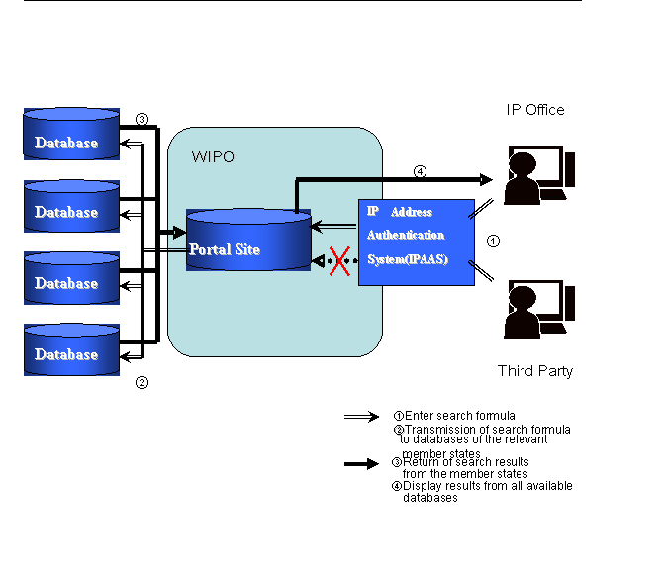
Figure 1: Overview of One-Click Database Search System for individual Databases of WIPO Member States

Figure 2: Image of a retrieval screen

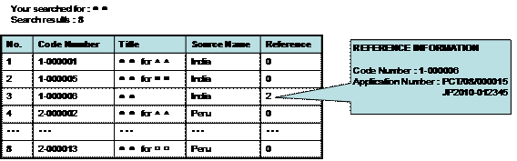

[End of Annex and of document]

Reference material includes information not available to the public which can be used only by an examiner as references for determining patentability.

