E
WIPO/SMEs/MPT/06/INF/1
ORIGINAL: English
DATE: July 27, 2006
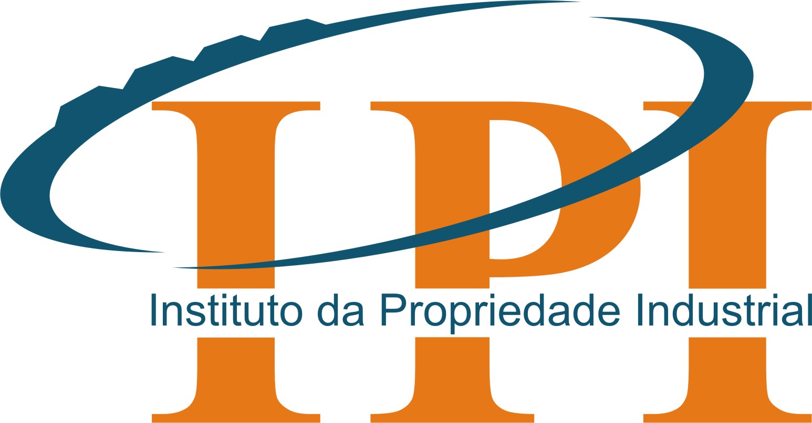

THE INDUSTRIAL PROPERTY INSTITUTE (IPI)  MOZAMBIQUE | WORLD INTELLECTUAL  PROPERTY ORGANIZATION
WIPO – IPI SEMINAR ON
INTELLECTUAL PROPERTY
FOR THE COMPETITIVENESS OF
Small and medium sized enterprises
in Mozambique

organized by
the World Intellectual Property Organization (WIPO)
in cooperation with
The Industrial Property Institute (IPI), Mozambique

Maputo, August 21 and 22, 2006
PROVISIONAL pROGRAM
prepared by the Secretariat of WIPO

August 21, 2006

09.00 – 09.30 Registration

09.30 – 10.00 Opening Ceremony

Welcome Address by:

Mr. Dos Santos, Director General, Industrial Property Institute (IPI), Ministry of Industry and Trade, Mozambique

Mr. Marco Dinis, Head, IP Promotion Department, Industrial Property Institute of Portugal (INPI), Portugal
Mr. Guriqbal Singh Jaiya, Director, Small and Medium-Sized Enterprises Division, WIPO

10.00 – 10.30 Coffee Break

10.30 – 11.00 Topic 1
Leveraging Intellectual Property Assets for Business Success; Introduction to Intellectual Property Rights

Speaker: Mrs. Caroline Schwab, Program Officer, SMEs Division, WIPO

11.15 – 11.45 Topic 2
Use of the Intellectual Property System for the Promotion of the Innovation through GAPI Network for SMEs

Speaker: Mr. Marco Dinis, INPI, Portugal

11.45 – 12.30 Topic 3
The Intellectual Property System in Mozambique

Speaker: Mr.Dos Santos

12.30 – 14.00 Lunch Break

14.00 – 14.45 Topic 4
Using the Tools of IP for Business Success: The Experience of two
Mozambican SMEs

Speakers: - Mr. Abdul Karim Abdulla, Director General,
“Gringo” Company

- Mr Paulo Ferrão from Companhia Industrial da Matola

Debate

14.45 – 15.15 Topic 5
An Introduction to WIPO and its Services: the SMEs and the LDC’s Programs

Speakers: Mrs. Tamara Nanayakkara, Senior Program Officer,
Least-Developed Countries Division (LDC’s), WIPO

Mrs. Caroline Schwab

15.15 – 15.45 Topic 6
Keeping Confidence: Trade Secrets in Business Strategy and Starting Your Business

Speaker: Mrs. Tamara Nanayakkara

15.45 – 16.15 Topic 7
Getting Noticed: The Role of Trademarks, Industrial Designs and Geographical Designs

Speaker: Mrs. Caroline Schwab

16.15 – 16.45 Coffee break

16.45 – 17.15 Topic 8
The IP National System and SMEs in Mozambique

Speaker: Mr. Élio Teixeira, Mozlegal, Limitada (Law firm in
Maputo)

Tuesday, August 22, 2006

09.00 – 10.00 Topic 9
Enhancing Enterprise Competitiveness Through Patents and Patent Information

Speaker: Mr. Guriqbal Singh Jaiya

10.00 – 10.30 Coffee break

11.30 – 12.30 Topic 10
Leveraging Intellectual Property Assets; Licensing and Franchising

Speaker: Mrs. Tamara Nanayakkara

12.30 – 14.00 Lunch Break

14.00 – 14.45 Topic 11
IP Services of INPI to SMEs in Portugal
Case Studies on Effective Use of IP by SMEs in Portugal

Speaker: Mr. M. Dinis, Industrial Property Institute of Portugal (INPI)

14.45 – 15.15 Discussion/Debate

15.15 – 16.35 Coffee Break

16.35 – 17.00 Closing Ceremony

[End of document]

