WIPO |  | E  SCT/19/4  ORIGINAL: English  DATE: May 27, 2008
WORLD INTELLECTUAL PROPERTY ORGANIZATION
GENEVA

STANDING COMMITTEE ON THE LAW OF TRADEMARKS,
INDUSTRIAL DESIGNS AND GEOGRAPHICAL INDICATIONS
Nineteenth Session
Geneva, July 21 to 25, 2008
MARKS AND INTERNATIONAL NONPROPRIETARY NAMES FOR PHARMACEUTICAL SUBSTANCES (INNs)

Document prepared by the Secretariat

I. INTRODUCTION

1 At the eighteenth session of the Standing Committee on the Law of Trademarks, Industrial Designs and Geographical Indications (SCT), held in Geneva from November 12 to 16, 2007, the SCT requested the Secretariat to invite the World Health Organization (WHO) Secretariat to make a presentation to the SCT at its next session concerning the application of the relevant WHO resolutions relating to the non-appropriation of proposed and recommended International Nonproprietary Names for pharmaceutical substances (INNs) (see document SCT/18/10 Prov., paragraph 269).

2 The request followed a discussion among SCT members, in which it became apparent that it could be beneficial for industrial property offices to discuss and compare existing approaches to the examination of trademark applications against prior INNs. The Chair of the eighteenth session of the SCT noted that SCT members interpreted INNs circulated by WHO in a divergent manner. In particular, the question arises as to whether offices should refuse registration as trademarks to those signs that are identical or similar to prior INNs, or should refuse registration only to those signs which are identical to prior INNs.

3 In response to the invitation of the SCT Secretariat, the WHO Secretariat has prepared a presentation, which is reproduced in Annex I.

4 The present document provides additional background information on the work that has been carried out so far by the SCT regarding marks and INNs, and includes a proposal for a modified procedure for the communication of new lists of proposed and recommended INNs by the International Bureau of WIPO to the national and regional industrial property offices of WIPO Member States.

II. BACKGROUND

5 The question of marks and INNs was added to the list of issues for consideration by the SCT at its first session, which took place in Geneva from July 13 to 17, 1998. Prior to that session, WHO had approached WIPO to explore possible ways of cooperation between the two Organizations in order to ensure that INNs were not misused or appropriated through registration as trademarks.

6 At that first session, the SCT requested the Secretariat to conduct a survey among its Member States, in the form of a questionnaire, concerning the practice of trademark offices as regards to the examination, with respect to conflicts with proposed or recommended INNs, of applications for trademark registration.

7 The survey was conducted among all States party to the Paris Convention and/or members of WIPO. The following States replied to the questionnaire: Albania, Argentina, Armenia, Australia, Austria, Belarus, Belgium, Bhutan, Bosnia and Herzegovina, Brazil, Brunei Darussalam, Bulgaria, Cambodia, Canada, China, Colombia, Croatia, Cyprus, Czech Republic, Denmark, Dominica, El Salvador, Estonia, Finland, France, Georgia, Germany, Ghana, Greece, Guatemala, Guinea, Hungary, Iceland, India, Ireland, Israel, Jamaica, Japan, Kazakhstan, Kyrgyzstan, Latvia, Lebanon, Liechtenstein, Lithuania, Mali, Malta, Mauritius, New Zealand, Nicaragua, Norway, Panama, Philippines, Poland, Portugal, Republic of Korea, Republic of Moldova, Romania, Russian Federation, Singapore, Slovakia, Slovenia, Spain, Sri Lanka, Sweden, Switzerland, Tajikistan, The former Yugoslav Republic of Macedonia, Tunisia, Turkmenistan, Ukraine, United Kingdom, United States of America, Uruguay, Viet Nam (74). The Benelux Trademark Office also replied to the questionnaire, which is reproduced in Annex II, along with the number of replies provided to each question.

8 The survey enabled the SCT to obtain information on, inter alia, the number of offices which examine applications for the registration of trademarks as to conflicts with INNs (the results showed that 72% of the surveyed offices conduct such examination), as well as on the number of offices which would refuse the registration of a trademark because of a conflict with an INN. However, the survey did not enquire about the conditions under which a “conflict with an INN” was deemed to occur. In other words, the survey did not address the question as to whether an office would refuse the registration of a sign, only if it is identical with an INN, or also in the case of similarity.

9 The survey further revealed an interest on the part of industrial property offices in receiving the lists of INNs in electronic format and, in general, in enhancing the communication of those lists. As a result, the SCT focused, during the subsequent sessions, on the question of improving the circulation of information on INNs to the industrial property offices of WIPO Member States.

COMMUNICATION OF THE LISTS OF INNs BY THE INTERNATIONAL BUREAU OF WIPO

10 At its sixteenth session, held in Geneva from November 13 to 17, 2006, the SCT approved several measures to improve the accessibility of the lists of proposed and recommended INNs by the national and regional industrial property offices of WIPO Member States.

11 The measures include the following:

(i) the sending of a circular letter by the International Bureau of WIPO to the national and regional industrial property offices of WIPO Member States, inviting them to publish on their websites a link to the online INN database of the WHO;

(ii) the distribution to all national and regional industrial property offices of WIPO Member States, by the International Bureau of WIPO, of a CD-ROM made available by the WHO, containing updated lists of proposed and recommended INNs;

(iii) the sending of a circular letter by the International Bureau of WIPO to the national and regional industrial property offices of WIPO Member States, informing them of the publication of each new list of proposed and recommended INNs on the website of the WHO.

12 Following their adoption by the SCT, the International Bureau of WIPO began to apply the aforementioned measures in August, 2007.
13 As regards item (iii) above, it is recalled that the new lists of proposed and recommended INNs are published on the website of the WHO twice a year. The date of publication of the list of proposed INNs constitutes the starting point of a four-month time limit for any interested person to file a formal objection against a name contained therein. In this respect, rapid accessibility to that list by the interested circles appears to be crucial.

14 Having received the relevant information from the WHO Secretariat, the International Bureau of WIPO informs the industrial property offices concerned of the publication of a new list of proposed and recommended INNs by means of a circular letter, as already noted.

15 With a view to ensuring prompt relay of that information to industrial property offices, it is suggested that the transmittal, by circular letter, of information concerning the new lists of proposed and recommended INNs be replaced by an e-mail alert to all offices that have subscribed to the SCT electronic forum.

16 The SCT is invited to consider the contents of the document and to indicate whether it wishes

    - to approve the proposal for a modified form of transmittal of the information on the publication of the new lists of proposed and recommended INNs, as outlined in paragraph 15;
    - to continue work in the area of INNs and to identify possible areas of convergence in the interpretation of INNs as regards possible conflicts with trademarks; and

    - to make any further recommendation on trademarks and INNs.

[Annexes follow]

 | INN Working Doc. 08.228  Distr.: RESTRICTED  ENGLISH ONLY

INN System and Protection of INN

for the

WIPO Standing Committee on the Law of Trademarks, Industrial Designs

and Geographical Indications (SCT) - Nineteenth Session

Geneva, 21-25 July 2008

Program on International Nonproprietary Names (INN)
Quality Assurance and Safety: Medicines (QSM)
Medicines Policy and Standards (PSM)
World Health Organization, Geneva

© World Health Organization 2008
All rights reserved.
This health information product is intended for a restricted audience only. It may not be reviewed, abstracted, quoted, reproduced, transmitted, distributed, translated or adapted, in part or in whole, in any form or by any means.
The designations employed and the presentation of the material in this health information product do not imply the expression of any opinion whatsoever on the part of the World Health Organization concerning the legal status of any country, territory, city or area or of its authorities, or concerning the delimitation of its frontiers or boundaries. Dotted lines on maps represent approximate border lines for which there may not yet be full agreement.
The mention of specific companies or of certain manufacturers’ products does not imply that they are endorsed or recommended by the World Health Organization in preference to others of a similar nature that are not mentioned. Errors and omissions excepted, the names of proprietary products are distinguished by initial capital letters.
The World Health Organization does not warrant that the information contained in this health information product is complete and correct and shall not be liable for any damages incurred as a result of its use.

SUMMARY

The existence of the World Health Organization (WHO) international nomenclature for pharmaceutical substances, in the form of INNs, has proved since 1953 to be important for the safe prescription and dispensing of medicines to patients, and for communication and exchange of information among health professionals worldwide. INNs identify pharmaceutical substances by unique names that are globally recognized and are public property. T hey are also known as generic names.

Common stems are developed for the selection of INNs to communicate to the health professionals the type of pharmaceutical product in question. National and international nomenclature commissions collaborate closely to select a single name of worldwide acceptability for each active substance that is to be marketed as a pharmaceutical.

To avoid confusion, which could jeopardize the safety of patients, nonproprietary names and their common stems should not be used in trademarks. The selection of further names within a series should not be hindered by the use of a common stem in a brand-name.

“Some activities undertaken by WHO are largely invisible, quietly protecting the health of every person on this planet, every day. By assigning a single international name to drugs, WHO helps ensure that a prescription filled abroad is what the doctor ordered back home.”

Dr Margaret Chan, Director-General
Working for Health: an introduction to the World Health Organization - 2007 ¹

I. BACKGROUND TO THE INN SYSTEM

A. Aims
International Nonproprietary Names (INN) identify pharmaceutical substances or active pharmaceutical ingredients. Each INN is a unique name that is globally recognized and is public property. A nonproprietary name is also known as a generic name.
Nonproprietary names are intended for use in pharmacopoeias, labeling, product information, advertising and other promotional material, drug regulation and scientific literature, and as a basis for product names, e.g. for generic (multisource) medicines. Their use is normally required by national or, as in the case of the European Union, by the Community legislation. As a result of ongoing collaboration, national names such as British Approved Names (BAN), Dénominations communes françaises (DCF), Japanese Adopted Names (JAN) and United States Adopted Names (USAN) are nowadays, with rare exceptions, identical to the INN.
Some countries have defined the minimum size of characters in which the generic nonproprietary name must be printed under the trade-mark labeling and advertising. In several countries the nonproprietary name must appear prominently in type at least half the size of that used for the proprietary or brand-name. In some countries it has to appear larger than the trade-mark name. Certain countries have even gone so far as to abolish trade-marks within the public sector.
To avoid confusion, which could jeopardize the safety of patients, trade-marks cannot be derived from INN and, in particular, must not include their common stems. As already mentioned the selection of further names within a series will be seriously hindered by the use of a common stem in a brand-name ².

B. History

During the twentieth century, the rapid development of new active drug substances brought with it the need to identify large numbers of active drug substances by unique, universally available and accepted names. The systematic chemical name, codified by international bodies, including the International Union for Pure and Applied Chemistry (IUPAC) and International Union of Biochemistry (IUB) has the advantage of unambiguously defining a specific chemical substance, but it is often very long, difficult to memorize and practically incomprehensible for the non-chemist. Moreover, it gives no indication as to the therapeutic action of the substance.

In order to avoid citation of difficult chemical names, nonproprietary generic names came into being. However, in the beginning different names were independently assigned to the same substance in different countries. For example, not everybody would know that acetaminophen, N-(4-hydroxyphe-nyl)acetamide, 40-hydroxyacetanilide, p-acetamidophenol, N-acetyl-p-aminophenol, acetomenophen and paracetamol are the same substance (see Fig. 1).

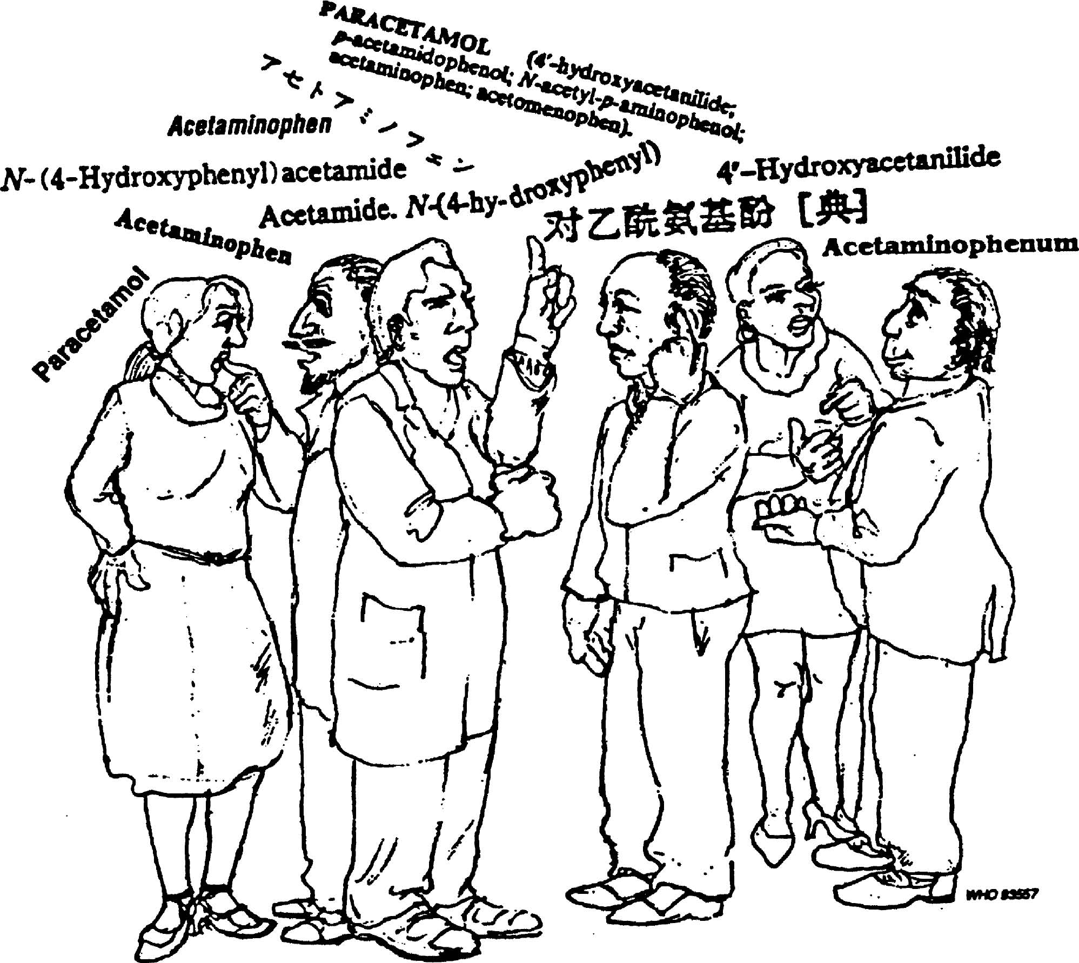
Fig. 1 Various common names for one substance, example paracetamol.
When WHO started the INN Program, the experts had to coordinate the activities of existing national nomenclature Programs, which were especially active in France, the Nordic countries, the UK, Japan and the USA. As a result of these national activities, many substances already had different well-established national names. Members of the newly established International Nonproprietary Nomenclature Program were faced with the difficulty of choosing a single name in these instances - paracetamol is an example of finding a common name (see Fig. 2).

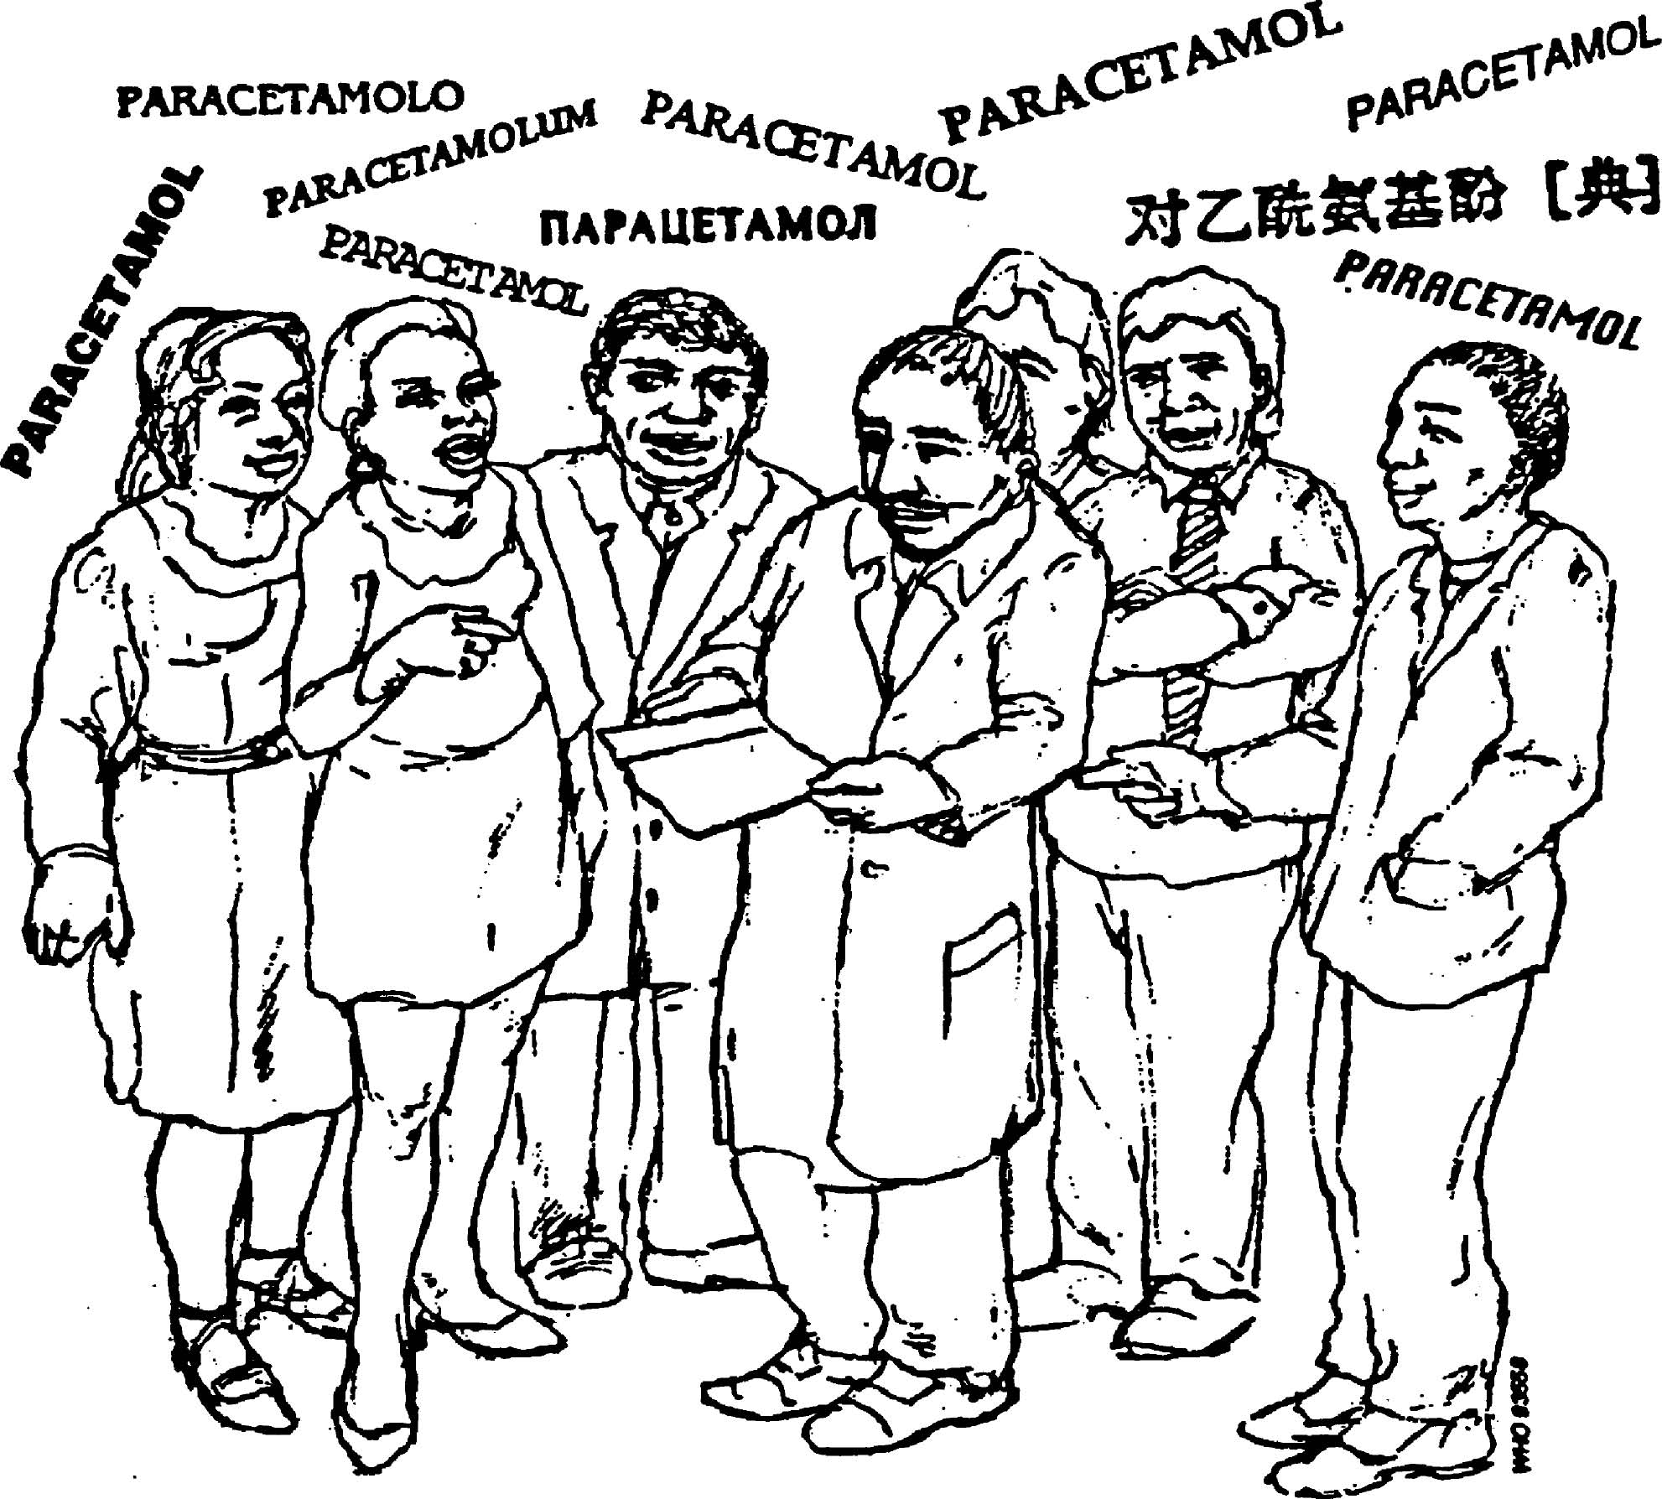
Fig. 2 One international name for one substance, example paracetamol.
Since then, the activities of national nomenclature commissions have been coordinated in order to achieve international standardization in nomenclature under the auspices of WHO according to article 2 (a) and 2 (u) of its constitution³:

“In order to achieve its objective, the functions of the World Health Organization shall be: (a) to act as the directing and co-ordinating authority on international health work;… (u) to develop, establish and promote international standards with respect to food, biological, pharmaceutical and similar products …”

WHO has therefore a constitutional mandate to ‘develop, establish and promote international standards with respect to biological, pharmaceutical and similar products’. One way in which this mandate is discharged is through the Program for International Nonproprietary Names (INNs) for pharmaceutical substances.

The INN system as it exists today was initiated in 1950 by the World Health Assembly resolution WHA3.11 and began operating in 1953, when the first list of International Nonproprietary Names for pharmaceutical substances was published. The cumulative list of INN now stands at some 8000 names designated since that time, and this number is growing every year by some 120-150 new INNs.
Since its inception, the aim of the INN system has been to provide health professionals with a unique and universally available designated name to identify each pharmaceutical substance. The existence of an international nomenclature for pharmaceutical substances, in the form of INNs, is important for the clear identification, safe prescription and dispensing of medicines to patients, and for communication and exchange of information among health professionals and scientists worldwide ⁴.

II. GENERAL INFORMATION ON INNs

A. Structure of an INN, in particular the use of common stems
As unique names, INNs have to be distinctive in sound and spelling, and should not be liable to confusion with other names in common use. To make INNs universally available they are formally placed by WHO in the public domain, hence their designation as “nonproprietary”. They can be used without any restriction whatsoever to identify pharmaceutical substances.
The extent of INN utilization is expanding with the increase in the number of names. Its wide application and global recognition are also due to close collaboration in the process of INN selection with numerous national drug nomenclature bodies. The increasing coverage of the drug-name area by INNs has led to the situation whereby the majority of pharmaceutical substances used today in medical practice are designated by an INN. The use of INN is already common in scientific publications, research and clinical documentation, while their importance is growing further due to expanding use of generic names for pharmaceutical products. In some countries, prescribing by using INNs is encouraged.
An important feature of the INN system is that the names of pharmacologically-related substances demonstrate their relationship by using a common “stem”. A stem is usually a suffix, but can also be a prefix or a combination of an infix and a suffix. Official stems are published in an official WHO publication (The use of stems in the selection of International Nonproprietary Names (INN) for pharmaceutical substances) every two years and regular addenda are also published after each INN Consultation. By the use of common stems, medical practitioners, pharmacists, scientists or anyone dealing with pharmaceutical products can recognize that the substance belongs to a group of substances having similar pharmacological activity.
As INNs should show relationship to other substances of similar pharmacological action, common stems have been created. A large number of such common stems are in use, and new stems are created when necessary⁵. Some examples are given in Table 1.

Examples of INNs ending -entan, a stem selected for designating endothelin receptor antagonists, are: ambrisentan, atrasentan, avosentan, bosentan, clazosentan, darusentan, edonentan, enrasentan, fandosentan, feloprentan, nebentan, sitaxentan, tezosentan and zibotentan .
Table 1 Some common stems used in the selection of INNs

Stem | Pharmacotherapeutic group
-ac | Anti-inflammatory agents, ibufenac derivatives
-adol/-adol- | Analgesics
-ast | Antiasthmatic, antiallergic substances not acting
 | primarily as antihistaminics
-astine | Antihistaminics
-azepam | Diazepam derivatives
bol | Steroids, anabolic
-cain- | Class I antiarrhythmics, procainamide and
 | lidocaine derivatives
-caine | Local anaesthetics
cef- | Antibiotics, cefalosporanic acid derivatives
-cillin | Antibiotics, derivatives of 6-aminopenicillanic acid
-conazole | Systemic antifungal agents, miconazole derivatives
cort | Corticosteroids, except prednisolone derivatives
-coxib | Selective cyclo-oxygenase inhibitors
-entan | Endothelin receptor antagonists
gab | Gabamimetic agents
gado- | Diagnostic agents, gadolinium derivatives
-gatran | Thrombin inhibitors, antithrombotic agents
gest | Steroids, progestogens
gli- | Antihyperglycaemics
io | Iodine-containing contrast media
-metacin | Anti-inflammatory substances, indometacin
 | derivatives
-mycin | Antibiotics, produced by Streptomyces strains
-nidazole | Antiprotozoal substances, metronidazole
 | derivatives
-olol | Beta-adrenoreceptor antagonists
-oxacin | Antibacterial agents, nalidixic acid derivatives
-platin | Antineoplastic agents, platinum derivatives
-poetin | Erythropoietin type blood factors
pril(at) | Angiotensin-converting-enzyme inhibitors
-profen | Anti-inflammatory substances,
 | ibuprofen derivatives
prost | Prostaglandins
-relin | Pituitary hormone release-stimulating peptides
-sartan | Angiotensin II receptor antagonists,
 | antihypertensive (non-peptidic)
-vaptan | Vasopressin receptor antagonists
vin-/-vin- | Vinca-type alkaloids

When requesting selection of an INN, the manufacturer has often not yet finalized research to identify the precise indications for the therapeutic use of the compound. A name is usually requested during the development phase of a new compound, which means that the request is submitted to WHO during the relatively early phase of (clinical) development. A name is, however, needed as soon as an application for registration of a product is forwarded to the national authorities.
This means that the naming process is close to all new scientific developments in the pharmaceutical field. External expertise is often needed for specific questions concerning new molecular structures, mechanisms of actions and potential new therapeutic applications.

During the last few years the selection process has become more complex. New pharmacological actions involving new molecular targets are discovered more and more frequently. This means in many cases that new stems have to be created. However, there is sometimes a structural relationship to existing molecules and experts have to decide whether an existing stem may be used or whether a new one must be established. Fibrinogen receptor antagonists are an example. These substances act as platelet aggregation inhibitors for which the stem-grel existed for several years. The nomenclature experts have to decide whether the same stem should be used for the fibrinogen receptor antagonists or whether the group of new molecules is so important that a new stem needs to be established. On the other hand, a new mode of action is sometimes discovered for an existing substance. If further substances are developed with a similar mode of action, the question arises whether a new stem is needed, which would mean modifying the ‘old’ name for the first compound in the series. For example albifylline and pentoxifylline are N-methylxanthine derivatives and the stem-fylline was therefore chosen for their names. These substances have been found to also suppress tumour necrosis factor-α⁶. The experts decided to retain the stem-fylline in this case, since the ‘new’ action was nevertheless based on the typical xanthine-mediated inhibition of phosphodiesterase ⁶.

New approaches to naming pharmaceutical substances may be needed in the near future because of the increasing research using molecular design. ‘Simple’ derivatives of known compounds are becoming more and more rare. Chemistry based on receptor structure and molecular design focuses more on synthesizing compounds to fit receptor binding sites. This means that nomenclature will have to move in the same direction. Chemical relationship will need to be looked at from a different standpoint, and the pharmacological activity might have to be considered in almost all cases as a basis for assigning a given substance to a group. Moreover the complexity of the new biological pharmaceutical substances is increasing even more the complexity of selecting INN names^{7,8}.

B. Procedure for selecting INNs
The names which are given the status of an INN are selected by the World Health Organization on the advice of experts from the WHO Expert Advisory Panel on the International Pharmacopoeia and Pharmaceutical Preparations. The process of INN selection follows three main steps:
- a request/application is made by the manufacturer or inventor⁹;
- after a review of the request a proposed INN is selected and published for comments
- after a time-period for objections has lapsed, the name will obtain the status of a recommended INN and will be published as such if no objection has been raised.
INN are selected in principle only for single, well-defined substances that can be unequivocally characterized by a chemical name (or formula). It is the policy of the INN Program not to select names for mixtures of substances, while substances that are not fully characterized are included in the INN system in exceptional cases only. INN are not selected for herbal substances (vegetable drugs) or for homoeopathic products. It is also the policy of the INN Program not to select names for those substances that have a long history of use for medical purposes under well-established names such as those of alkaloids (e.g. morphine, codeine), or trivial chemical names (e.g. acetic acid).
An INN is usually designated for the active part of the molecule only, to avoid the multiplication of entries in cases where several salts, esters, etc. are actually used. In such cases, the user of the INN has to create a modified INN (INNM) himself; mepyramine maleate (a salt of mepyramine with maleic acid) is an example of an INNM. When the creation of an INNM would require the use of a long or inconvenient name for the radical part of the INNM, the INN Program will select a short name for such a radical (for example, mesilate for methanesulfonate)¹⁰.
In the process of INN selection, the rights of existing trade-mark owners are fully protected. If in the period of four months following the publication of a proposed INN, a formal objection is filed by an interested person who considers that the proposed INN is in conflict with an existing trade-mark, WHO will actively pursue an arrangement to obtain a withdrawal of such an objection or will reconsider the proposed name. As long as the objection exists, WHO will not publish it as a recommended INN.
The selection of a new INN relies on a strict procedure. Upon receipt of an INN request form, the WHO Secretariat examines the suggested names for conformity with the general rules, for similarities with published INN and potential conflicts with existing names, including published INN and trade-marks. A note summarizing the result of these checks is added and the request is subsequently forwarded to the INN experts for comments. Once all experts agree upon one name both by correspondence first and during the formal INN Consultation voting then, the applicant is informed of the selected name.
Newly selected, proposed INN are then published in WHO Drug Information, which indicates a deadline for a 4-month objection period¹¹. This period is allowed for comments and/or objections to the published names to be raised. The reasons for any objection must be stated clearly and these will be evaluated by the experts for further action. Users are invited to refrain from using the proposed name until it becomes a recommended INN, in order to avoid confusion should the name be modified. Two lists of proposed INN are published yearly.
The final stage of the selection process is the recommended INN¹². Once a name has been published as a recommended INN it will not normally be modified further and is ready for use in labeling, publications, on drug information. It will serve to identify the active pharmaceutical substance during its life-time worldwide. Since the name is available in the public domain it may be used freely. However, it should not be registered as a trade-mark since this would prevent its use by other parties.
Recommended INNs are published in the WHO Drug Information as a consequence of the objection procedure applied to proposed INNs. As from 1997, two lists of proposed INNs are published yearly and as from list 37 of recommended INNs, graphic formulae are also included for better identification of the substances.
More than 8000 INNs have been published so far and they are listed in the Cumulative list, which is also available in a searchable manner and periodically updated. INN data can also be freely accessed through the INN Extranet, Mednet¹³.
General rules were established at the beginning of the INN Program in order to allow health professionals to understand the rationale for a number of new names for pharmaceutical substances. The following principles should in general be applied when selecting an INN. The name should: (1) be distinctive in sound and spelling; (2) not be too long; and (3) show relationship to substances with the same pharmacological action. In addition the new name should not conflict with any existing common names or trademarks, and patients should not be confronted with nonproprietary names that are likely to have anatomical, physiological or pathological connotations: e.g. a name starting cancer would not be acceptable (see Fig. 3)

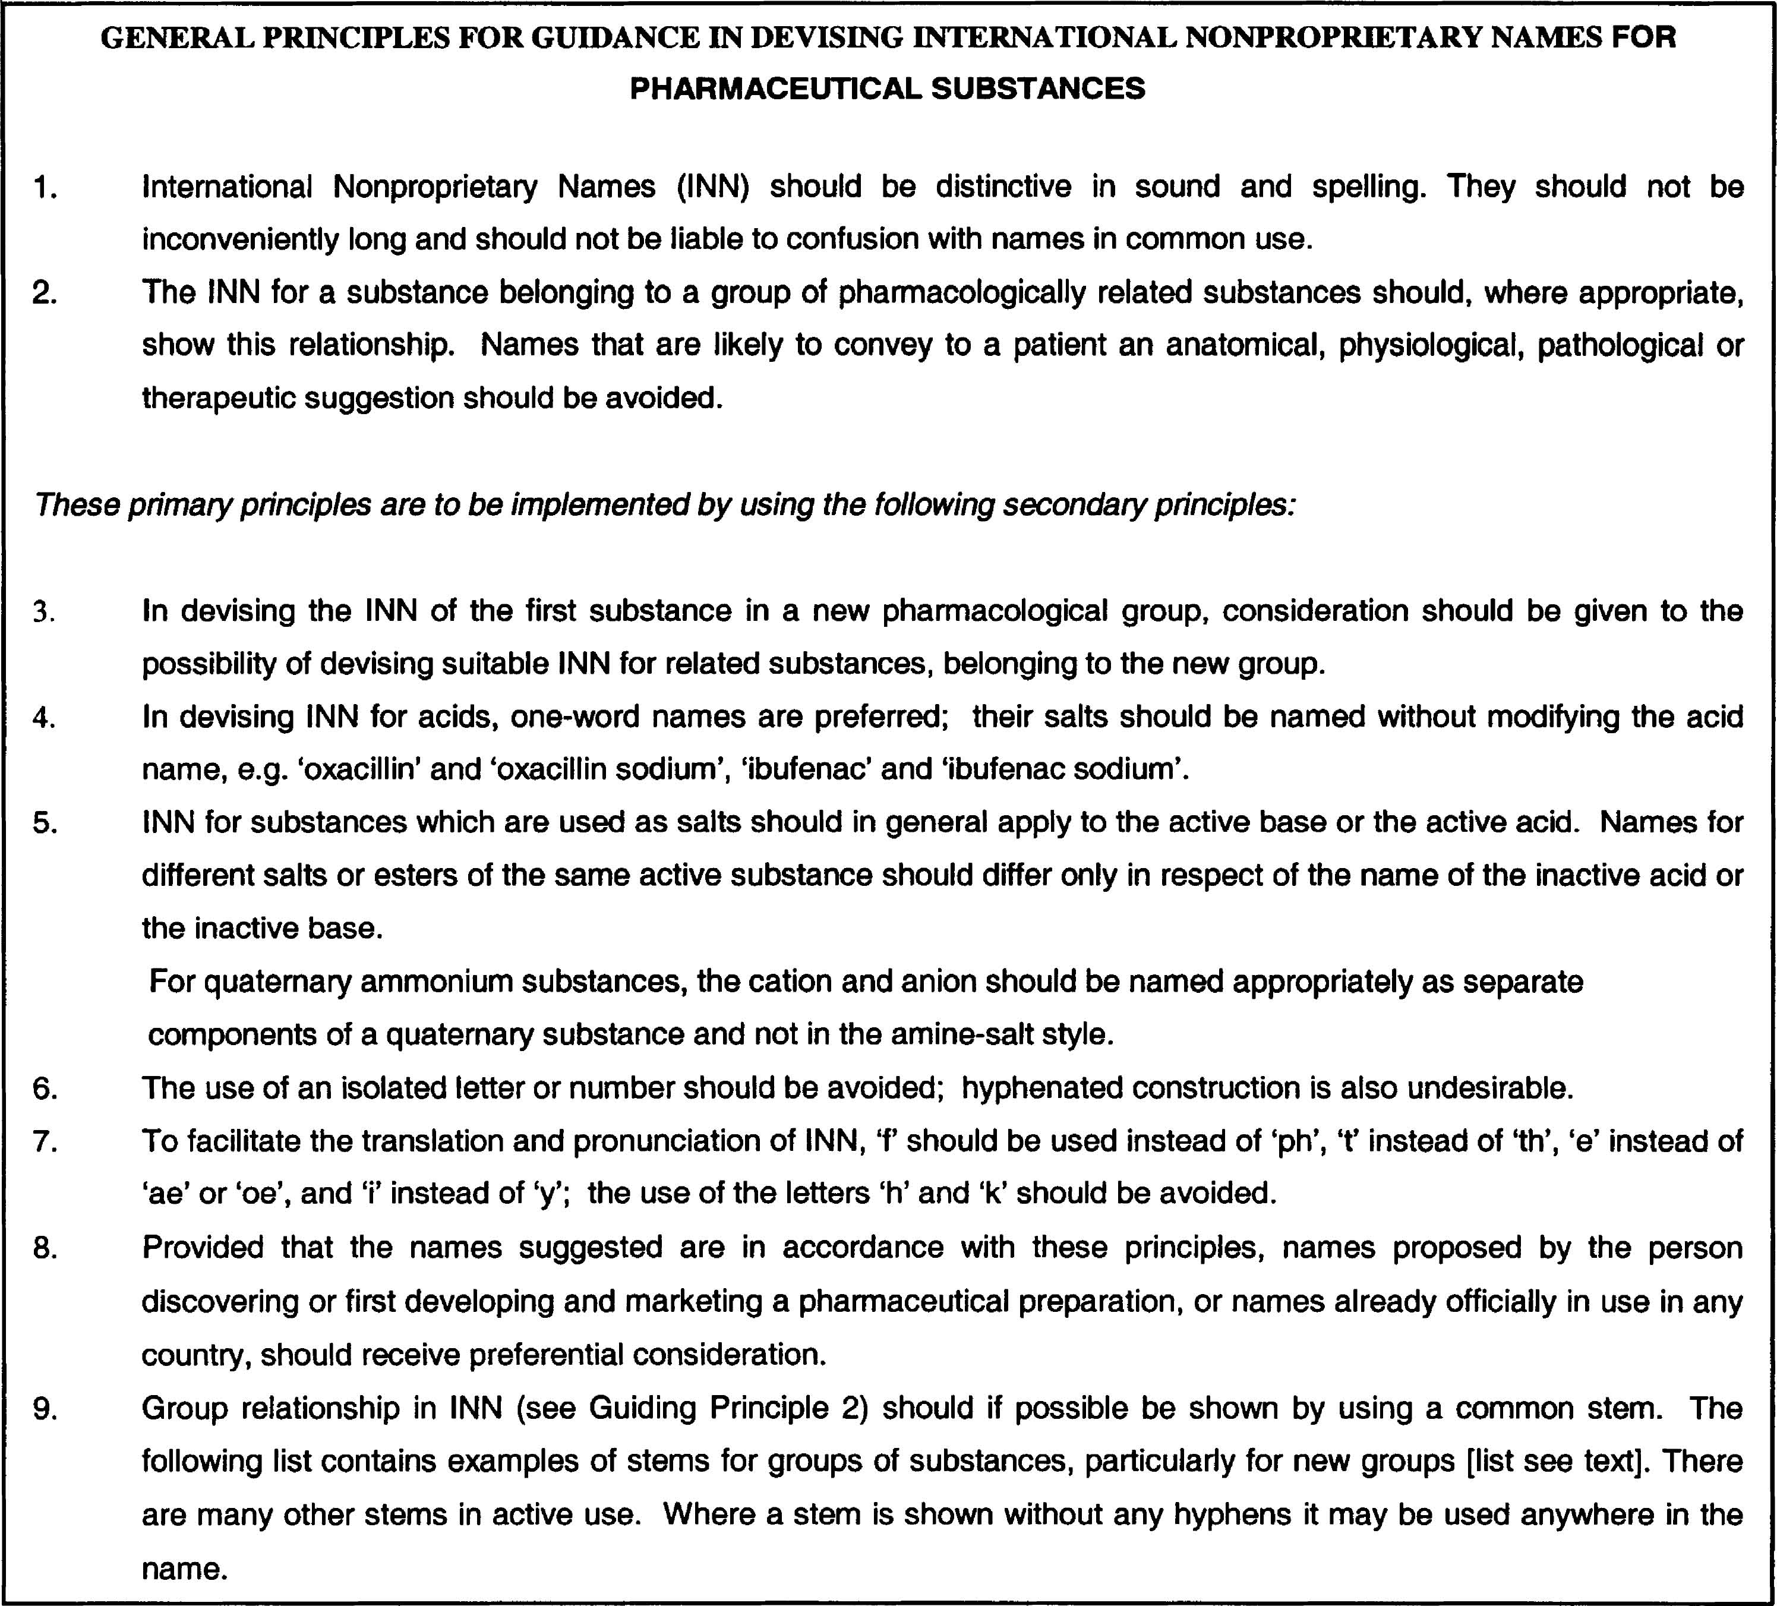

Fig. 3 General Principles for guidance in devising International Nonproprietary Names for Pharmaceutical Substances
To facilitate the transliteration and pronunciation of International Nonproprietary Names for pharmaceutical substances certain letters, such as ‘h’ and ‘k’, should be avoided. Preference is given to ‘f’ instead of ‘ph’, ‘t’ instead of ‘th’, ‘e’ instead of ‘ae’ or ‘oe’ and ‘i’ instead of ‘y’. The INN for amphetamine is, therefore spelt amfetamine. When devising an INN it is important to be aware of possible language problems. Since the name is used worldwide, not only should certain letters be avoided, but experts need to be aware of unsuitable connotations in the major languages spoken in the world. A name may appear excellent for an English speaker, but unacceptable in another language. For example the name ‘inglicretin’ could remind a French speaker of the term ‘crétin anglais’ (stupid Englishman) and might therefore not be the best choice for naming a pharmaceutical substance.

III. PROTECTION OF INNs

A. Recommended scope of protection

Lists of both proposed and recommended INNs are sent by WHO, together with a note verbale, to the Organization’s Member States (at present 193), to national pharmacopoeia commissions, trade-mark offices and to other bodies designated by Member States. In his note verbale, the Director-General of the World Health Organization requests that Member States should take such steps necessary to prevent the acquisition of proprietary rights on the name, including prohibiting registration of the name as a trade name.
Over the years, the need to maintain the integrity of the INN system has become urgent. This is reflected in the following extract from the Fifth Report of the WHO Expert Committee on the Use of Essential Drugs which met in November 1991:
“The procedure for selecting INNs allows manufacturers to contest names that are either identical or similar to their licensed trade-marks. In contrast, trade-mark applications are disallowed, in accordance with the present procedure, only when they are identical to an INN. A case for increased protection of INNs is now apparent as a result of competitive promotion of products no longer protected by patents. Rather than marketing these products under generic name, many companies apply for a trade-mark derived from an INN and, in particular, including the INN common stem. This practice endangers the principle that INNs are public property; it can frustrate the rational selection of further INNs for related substances, and it will ultimately compromise the safety of patients by promoting confusion in drug nomenclature¹⁵”.
These concerns were debated during the sixth International Conference of Drug Regulatory Authorities (ICDRA), in Ottawa, in October 1991. Based on recommendations made by the WHO Expert Committee on the use of Essential Drugs, the resolution WHA46.19 on Nonproprietary names for pharmaceutical substances was adopted by the Forty-sixth World Health Assembly in 1993, requesting Member States to:
“enact rules or regulations, as necessary, to ensure that international nonproprietary names … are always displayed prominently; to encourage manufacturers to rely on their corporate name and the international nonproprietary names, rather than on trademarks, to promote and market multisource products introduced after patent expiration; to develop policy guidelines on the use and protection of international nonproprietary names, and to discourage the use of names derived from INNs, and particularly names including INN stems in trademarks¹⁶”.
In the note verbale, attention is drawn to this resolution concerning the use and protection of INN.
As a matter of principle, it may thus be recommended that trade-marks should not be derived from INN. In particular, the intentional incorporation of meaningful INN stems in trade-marks should be avoided.
Similarly, inclusion of elements from biochemical nomenclature (like -feron from interferon, or -leukin from interleukin) in trade marks in anticipation is discouraged since these elements are likely to be utilized as stems within the INN nomenclature. Their inclusion in trade-marks could pre-empt the logical development of the INN nomenclature.
In accordance with resolution WHA46.19, registration of an INN together with a firm’s name is perfectly acceptable, as long as it does not prevent another manufacturer from using the same approach.

B. Rationale behind

Pharmaceutical preparations produced by the pharmaceutical industry are generally given invented names, and these are usually registered by individual companies as trade-marks (T/Ms). The existence of both the INN system names and invented (T/M) names sometimes leads to conflict, especially when new names are being created. This may occur when new INNs are established, but also when T/M departments are considering introducing invented names for new pharmaceutical products. Proper information on the formal position of INNs as given below may be of help in avoiding such situations¹⁷.

Selecting new INNs includes use of appropriate safeguards to avoid infringement of existing intellectual property rights in the form of established trade-marks of pharmaceutical manufacturers. When selecting new INNs, the WHO INN Program rejects any proposal that could result in a conflict between existing INNs and trademarks used to designate pharmaceutical products. Selected names are then published in a WHO periodical “WHO Drug Information” as Proposed INNs. Interested parties are given a period of 4 months in which to raise any objection to the Proposed INN. An objection may be based, for example, on similarity of the proposed INN to a trade-mark over which the interested party has proprietary rights. In such instance, if the objection is not withdrawn, the name will not be published as a Recommended INN.

Infringement of the INN system by pharmaceutical manufacturers sometimes occurs. Infringements can include attempts to obtain proprietary rights in names (T/Ms) identical, or very similar, to established INNs, taking steps to obtain proprietary rights over the invented names that are inherently similar to INNs and applications to register as trade-marks a name that contains stems used in the INN system. T/M departments should familiarize themselves with the INN system so that they could initiate a process whereby inappropriate new T/Ms for pharmaceutical products are not proposed¹⁸. Currently INNs are placed by WHO in the public domain to facilitate and encourage their free and unrestricted global use. WHO actively promotes not only the use of INNs to describe the composition of pharmaceutical preparations, but also their use as product names and is encouraging manufacturers of multisource (generic) products to use their corporate name in conjunction with INNs to designate such products¹⁹.

To safeguard the use of INNs, WHO has requested national institutions (i.e. drug regulatory authorities, trademark and patent authorities) to prevent the granting of exclusive proprietary rights to any INN and circulates through a note verbale every newly published list of proposed or recommended INNs to all its Member States. In cases where WHO is notified of a T/M registration identical or very similar to an existing INN, the WHO Secretariat requests the relevant national authorities to reject the application or to revoke any registration, if it has already been granted. WHO also objects to registration as trade-marks of any invented names that are intrinsically similar to existing INNs, as this would lessen the inherent rights that INNs hold in the public domain. T/M departments should be guided by the similarity/dissimilarity criteria applied by the national trade-mark office in a given country, in respect of other proposed trade-marks.

Indeed, once a recommended INN has been selected, it is important that it has to be freely available to all interested parties (drug regulatory authorities, pharmaceutical industry, medical professions, scientists, etc.) as only in this way it can serve properly as a communication tool. This issue has been recognized since the inception of the INN Program, and recommended INNs are therefore placed in a public domain by a formal communication of the WHO Director-General addressed to all WHO Member States. In this communication, Member States are requested to prevent the acquisition of proprietary rights in the name, including prohibiting the registration of the name as a trade-mark or trade-name.

The need for protection also applies to INN stems, which are syllables used to designate pharmacologically-related substances as far as possible in a manner showing their relationship. Such syllables are usually placed as suffixes, sometimes as infixes or prefixes. WHO also objects to the use of invented names that include established INN stems, and especially registration of such names as trade-marks. The rationale is that this may complicate, or even exclude future use of those stems to select INNs for new substances belonging to the group. In fact, the consequence of introducing INN common stems into trade-marks, which seems to be increasingly popular, hampers the selection of new nonproprietary names within the established system. Given that all new INNs should be distinctive from existing INNs, and without similarity to trade-marks, this practice causes confusion to the health professional, may be the source of serious errors in prescribing and dispensing and hinders the selection of future names for compounds in the same group of substances²⁰.

IV. CONCLUSION

In our experience, the prohibition to register recommended INNs as trade-marks or trade-names is working reasonably well, as pharmaceutical industry is generally respecting this restriction, and if such attempt is made, T/M offices are rejecting applications. In quite rare cases when WHO is informed that an application in any country for registration of a recommended INN is being processed, the INN Secretariat is requesting the appropriate national authority to oppose formally the granting of such registration or, if the registration as a trade-mark has already occurred, to reverse such a decision. In the vast majority of cases such requests are successful.

There are two main reasons for the INN Program to oppose actively that INNs are appropriated as trademarks. First of all, this may put at risk the free availability of the name, especially as concerns its free use in labeling of pharmaceutical products. There is also another risk, this time for the INN Program itself. INNs are coined in a systematic way, and are forming families of names to indicate a specific type of activity of a group of substances. Formal T/M owner of a T/M identical to an INN would be in a position to restrict future application of INN systematic approaches.

The strict prohibition to register recommended INNs as trade-marks pertains formally to their original versions, including linguistic variants mentioned above. However, the increasing popularity of INNs has prompted many pharmaceutical manufacturers to apply for registration as trade-marks of invented names resembling INNs more or less closely, or containing word elements that are included in INNs to indicate that the substance belongs to a group having similar pharmacological activity. Such word elements are called “stems” in the INN system.

Wide use of INN stems in registered trade-marks would be detrimental for a systematic creation of INNs for new substances that are constantly being developed and introduced into therapy. One of the possible threats is that a formal T/M owner of such a trade-mark would be in a position to restrict future application of INN systematic approach. There is also an additional hazard, of improper use of such a stem, leading to confusion among medical prescribers as to the exact meaning of a stem. To better safeguard the INN system against such difficulties, the World Health Assembly has adopted in 1993 a resolution requesting Member States to discourage the use as trade-marks of names including established INN stems.

The INN Program recognizes well that the implementation of the prohibition of registering INNs as trade-marks and, in even greater degree, the prevention of registering trade-marks which are including INN stems, depends in the first place on the decisions taken by T/M offices in individual countries. We are aware that the question of the extent of similarity (or dissimilarity) of a new application for a trade-mark with existing INNs or with INN stems is similar to the usual process of deciding on similarity (or lack of similarity) with existing trade-marks, and these are procedures with which T/M offices are quite familiar. WHO and the INN Program therefore highly appreciate the present opportunity of describing to the World Intellectual Property Organization (WIPO) our activities and concerns. We hope that this explanation will be of assistance to trade-mark assessors when ruling on individual applications related to the INN Program, and that also the safety aspects associated to drug prescribing and drug delivery issues related to INNs will be taken into account.

REFERENCES:

- Dr Margaret Chan, WHO Director-General (2007). Working for Health: an introduction to the World Health Organization, ISBN 92 4 156313 5.
- WHO, INN Program (1997). Guidelines on the Use of International Nonproprietary Names (INNs) for Pharmaceutical Substances, in: WHO/PHARM S/NOM 1570 (Distribution General).
- WHO (1950). World Health Assembly Resolution WHA3.11, World Health Organization, Geneva.
- WHO (1992). Basic Documents, thirty-ninth edition, World Health Organization, Geneva.
- WHO, INN Program (2006): The use of stems in the selection of INN for pharmaceutical substances, 2006. World Health Organization, Geneva.
- Semmler, J., Gebert, U., Eisenhut, T., et al. (1993) Xanthine derivatives: Comparison between suppression of tumor necrosis factor-a production and inhibition of cAMP phosphodiesterase activity in: Immunology 78: 520–525.
- WHO, INN Program: International Nonproprietary Names (INN) for Biological and Biotechnological Substances (a review), INN Working Document 05.179 (Distribution General), Update November 2007
- WHO, INN Program: 44th INN Consultation - Executive Summary on International Nonproprietary Names (INNs) for Pharmaceutical Substances, INN Working Document 07.214, 2007 (Distribution General)
- WHO, INN Program: INN Application Form (2007) to be sent to: World Health Organization, INN Program, 20 avenue Appia, 1211 Geneva 27, Switzerland - http://www.who.int/medicines/services/inn/en/.
- WHO, INN Program (2007). International Nonproprietary Names Modified , INN Working Document 05.167.3 (Distribution General).
- WHO, INN Program: Example of published Proposed INN lists: List 98 of proposed INNs in: WHO Drug Information, Vol 21 No 4, 2007. World Health Organization, Geneva.
- WHO, INN Program: Example of published Recommended INN lists: List 58 of recommended INNs in: WHO Drug Information, Vol 22 No 1, 2008. World Health Organization, Geneva.
- WHO, INN Program (2007). Cumulative List No. 12 of International Nonproprietary Names (INN) for Pharmaceutical Substances, World Health Organization, Geneva, Switzerland.
- WHO, INN Program: Procedure for the Selection of Recommended International Nonproprietary Names for Pharmaceutical Substances, WHO Executive Board in its resolution EB15.R7, amended in 2005 by resolution EB115.R4.
- WHO (1991). Fifth Report of the WHO Expert Committee on the Use of Essential Drugs, 1991.
- WHO (1993): Forty-sixth World Health Assembly Resolution on Nonproprietary Names for Pharmaceutical Substances (WHA46.19). (1993) World Health Organization, Geneva.
- Wehrli, A. (1986) Pharmaceuticals: Trademarks versus generic names in: Trademark World Journal, 31–35.
- WHO (1987). Trademarks versus generic names for pharmaceuticals - a conflict that requires resolution. In: WHO Drug Information 1: 39–40.
- Balocco Mattavelli, R.G,. Dong J.C, Lasseur, S., Kopp, S. (2008) Drug Nomenclature. In: The Practice of Medicinal Chemistry- 3rd Edition , Elsevier (in press)
- WHO, INN Program: (2004) International Nonproprietary Names - Information Leaflet for Trademark Departments

[Annex II follows]
Questionnaire Concerning Trademarks and International Nonproprietary Names for Pharmaceutical Substances (INNs)

1. Does your Office examine applications for the registration of trademarks as to conflicts with INNs and/or equivalent nonproprietary names adopted by a national or regional authority?

Yes No

54 21

2. If your Office does not carry out such an examination, is it possible to invalidate or cancel registered trademarks which conflict with such names?

Yes No

35 7

3. If your Office carries out such an examination, from what source does it obtain the lists on the basis of which applications for trademark registrations are examined?

World Health Organization Other (Please specify)

36 14
Problems with updating (2)

National Health Administration

17

4. If your Office carries out such an examination, does your Office carry out a manual or an automated search in order to determine possible conflicts between applications for trademark registrations and INNs?

Manual Search Automated Search

40 14

5. Would you be interested in receiving the lists with proposed or recommended INNs in an electronic format? If yes, what format(s) would you prefer?

Yes (Please specify format) No

68 4

Excel (5)
Word (10)
PDF (6)
Oracle (1)
TXT (4)
HTM (3)
ASCII (3)
Access (2)

Magnetic Tape (1)
CD-ROM (25)

6. Would your Office refuse the registration of a trademark because of a conflict with an INN? If yes, under what condition?

Yes (Please specify condition) No

641 8

[End of Annex II and of document]

1 Replies containing an affirmative response to that question generally indicated that a registration of a trademark would be refused because of a conflict with an INN, since such a trademark would be regarded to be either descriptive (if the trademark was constituted by or contained the INN proposed or adopted for the substance for which the trademark is used), or deceptive (if the trademark was constituted by or contained an INN proposed or adopted for a substance other than the one for which the trademark is used).

