
DLT/DC/10
ORIGINAL: english
DATE: November 11, 2024
Diplomatic Conference to Conclude and Adopt a Design Law Treaty (DLT)
Riyadh, November 11 to 22, 2024
RESOLUTION SUPPLEMENTARY TO THE TREATY PROPOSED FOR ADOPTION BY THE DIPLOMATIC CONFERENCE
Proposal by the Delegation of Japan
The Delegation of Japan transmitted to the Secretariat of the Diplomatic Conference the proposal contained in the Annex to the present document.
[Annex follows]
Resolution on ARTICLE 14
Proposal by the Delegation of Japan
ONLY FOR CONTRACTING PARTIES WHICH REQUIRES PRIORITY DOCUMENTS
It is stressed that the following proposal for resolution could, once adopted, provide supplementary elements of clarification in interpreting Article 14 of the DLT only for Contracting Parties which require applicants to submit priority documents when these applicants claim priority based on their earlier applications. This clarification would not affect Contracting Parties which do not require priority documents to be submitted to their Offices.
OPPORTUNITY FOR SUBMITTING PRIORITY DOCUMENTS AS A RESULT OF A REQUEST FOR THE CORRECTION OR ADDITION OF A PRIORITY CLAIM
The following Resolution by the Diplomatic Conference Supplementary to the Design Law Treaty (DLT) is proposed.
“When adopting Article 14, the Diplomatic Conference confirmed that it was desirable that where the correction or addition of a priority claim is made pursuant to Article 14(1), a Contracting Party that requires evidence pursuant to Article 3(1)(vii) allows the evidence to be submitted at least within the time limit for filing the request referred to in Rule 12(2).”
BACKGROUND
Recalling Japan’s arguments made at the past several sessions of the SCT, a concern in relation to Article14(1) and Rule 12(2) is explained again with the image below.
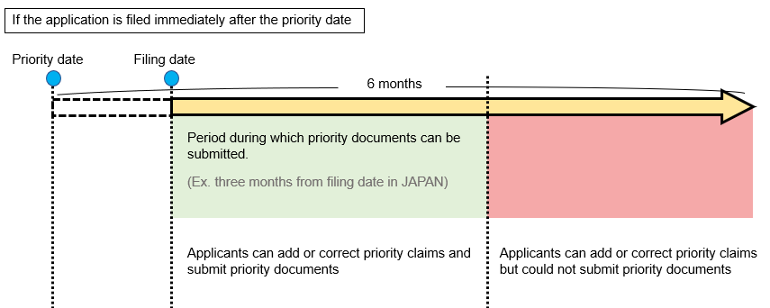
Article 14(1) of the basic proposal for the DLT provides that a Contracting Party shall provide for the correction or addition of a priority claim with respect to an application. However, it does not prescribe any time limit for submitting priority documents in contrast to the Patent Law Treaty (PLT).
Accordingly, it is uncertain whether an applicant can submit a priority document during the entire time period when the correction or addition of a priority claim is allowed, e.g., in the period colored in red in the image above. If an applicant is unable to submit a priority document to the Office of the Contracting Party that requires such a document, the applicant could not enjoy the priority of the earlier application.
Therefore, it is desirable that where the correction or addition of a priority claim is made pursuant to Article 14(1), a Contracting Party that requires evidence pursuant to Article 3(1)(vii) allows the evidence to be submitted within the time limit for filing the request referred to in Rule 12(2).
[End of Annex and of document]

¹ Rule 4 of the Regulations under the Patent Law Treaty prescribes a time limit for filing priority documents, which covers the time limit for the correction or addition of the priority claim (see Rules 4 and 14). Patent Law Treaty Article 6 Application […] (5) [Priority Document] Where the priority of an earlier application is claimed, a Contracting Party may require that a copy of the earlier application, and a translation where the earlier application is not in a language accepted by the Office, be filed in accordance with the requirements prescribed in the Regulations. […] Article 13 Correction or Addition of Priority Claim; Restoration of Priority Right (1) [Correction or Addition of Priority Claim] Except where otherwise prescribed in the Regulations, a Contracting Party shall provide for the correction or addition of a priority claim with respect to an application (“the subsequent application”), if: […] (ii) the request is filed within the time limit prescribed in the Regulations; and […] Regulations Under the Patent Law Treaty Rule 4 Availability of Earlier Application Under Article 6(5) and Rule 2(4) or of Previously Filed Application Under Rule 2(5)(b) (1) [Copy of Earlier Application Under Article 6(5)] Subject to paragraph (3), a Contracting Party may require that a copy of the earlier application referred to in Article 6(5) be filed with the Office within a time limit which shall be not less than 16 months from the filing date of that earlier application or, where there is more than one such earlier application, from the earliest filing date of those earlier applications. […] Rule 14 Details Concerning Correction or Addition of Priority Claim and Restoration of Priority Right Under Article 13 […] (3) [Time Limit Under Article 13(1)(ii)] The time limit referred to in Article 13(1)(ii) shall be not less than the time limit applicable under the Patent Cooperation Treaty to an international application for the submission of a priority claim after the filing of an international application. […] Regulations under the PCT Rule 26 bis 26bis.1 Correction or Addition of Priority Claim (a) The applicant may correct a priority claim or add a priority claim to the request by a notice submitted to the receiving Office or the International Bureau within a time limit of 16 months from the priority date or, where the correction or addition would cause a change in the priority date, 16 months from the priority date as so changed, whichever 16-month period expires first, provided that such a notice may be submitted until the expiration of four months from the international filing date. The correction of a priority claim may include the addition of any indication referred to in Rule 4.10. […]

