WIPO |  | E  SCIT/SDWG/4/7  ORIGINAL: English  DATE: November 25, 2003
WORLD INTELLECTUAL PROPERTY ORGANIZATION
GENEVA

standing committee on information technologies
standards and documentation working group
Fourth Session
Geneva, January 26 to 30, 2004
RECOMMENDED MINIMUM CONTENTS FOR INTELLECTUAL
PROPERTY OFFICES’ WEBSITES
Document prepared by the Secretariat
1 In its letter of August 11, 2003, the Patent Documentation Group (PDG) informed the International Bureau (IB) on the main results of its investigations regarding the implementation of the “Recommended Minimum Contents for Intellectual Property Offices’ Websites” (Part 8.5 of the WIPO Handbook on Industrial Property Information and Documentation) that was adopted by the Standing Committee on Information Technologies (SCIT) at its fourth Plenary session in December 1999. These investigations by a group of patent information specialists covered Websites of “big” and “small” industrial property offices, including the European Patent Office itself.

2 The letter of the PDG and Part 8.5 of the WIPO Handbook are reproduced as Annexes I and II to this document.

3 The Standards and Documentation Working Group is invited to take note of the information provided in the above-mentioned letter of the PDG and its attachment, which are reproduced in the two Annexes to this document.

[Annexes follow]

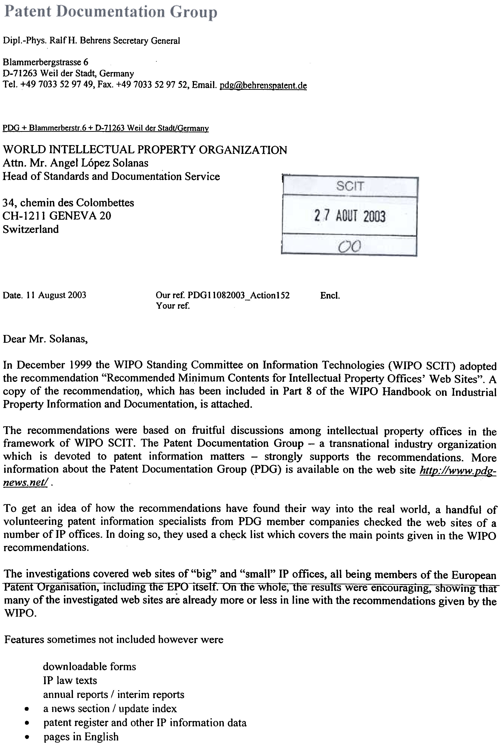

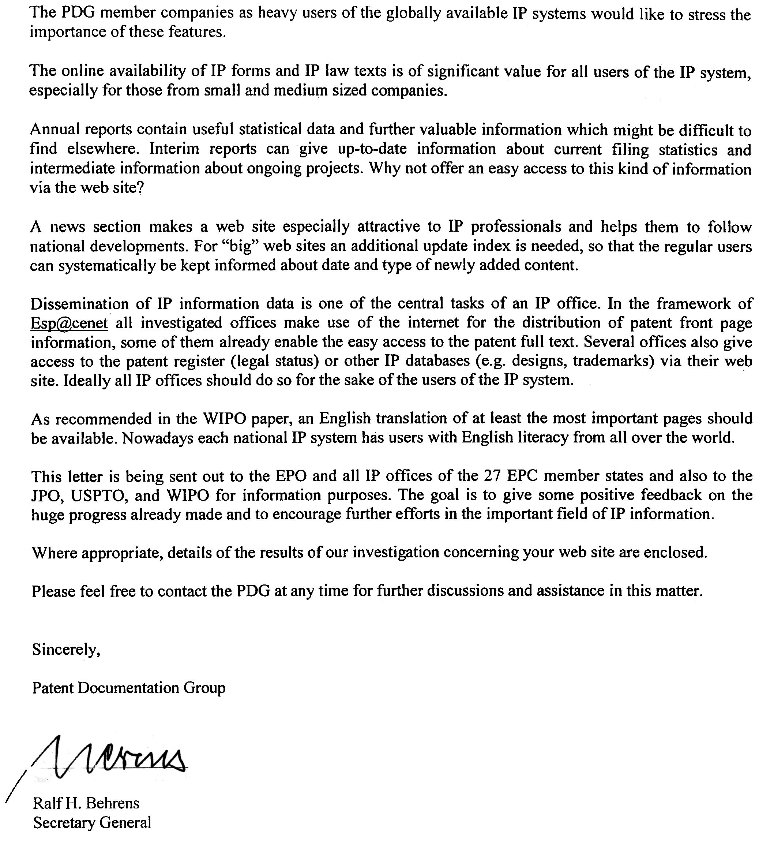

[Annex II follows]

INTELLECTUAL PROPERTY OFFICES’ WEB SITES
RECOMMENDED MINIMUM CONTENTS
FOR INTELLECTUAL PROPERTY OFFICES’ WEB SITES

adopted by the Standing Committee on Information Technologies
at its fourth Plenary session on December 10, 1999

Introduction
1. This document intends to provide guidance to Intellectual Property Offices (IPOs) regarding the presentation and contents of their Web sites made available through the Internet. The recommendations are not limited to patents for inventions but cover all the intellectual property rights dealt with by the respective IPO. If an IPO creates a new Web site or changes the contents/layout thereof, the Office is invited to inform the International Bureau of WIPO of that fact in order for the International Bureau to establish a hyperlink to the individual URL of the IPO. The links are listed under “Site Addresses of IPOs” on the WIPO Web site, http://www.wipo.int.
RECOMMENDED CONTENT
RECOMMENDED CONTENT FOR INTELLECTUAL PROPERTY WEB SITES
2. The content of Intellectual Property Web sites should be presented in the language(s) of the national office. At least the homepage and the most important pages (e.g., information on how to apply for intellectual property protection) should also be presented in English.
3. Intellectual Property Web sites should provide information about the procedures of the national office and other information to assist users of the national system. For example, Intellectual Property Web sites should contain:
- basic information about national IP rights,
- technical documents (e.g., guidelines, classification information),
- legal documents (e.g., treaties, laws),
- downloadable forms,
- fee schedules,
- annual reports (statistics) of the national office,
- links to other Intellectual Property Web sites,
- Intellectual Property information data,
- notices about changes in national intellectual property laws or administration,
- a News Section, or an Update Index, covering at least a six-month time period.
4 Intellectual Property Web sites should contain information that is helpful to users, especially those who are new to the intellectual property field. For example, Intellectual Property Web sites should contain:
- information about the procedures of the national office in the form of basic facts and frequently asked questions (FAQs);
- descriptions of products and services provided by the national office, including how to obtain them, their cost, and the media in which they are available; and
- references to sources for assistance or information, such as libraries and legal representatives or chambers.
5 Intellectual Property Web sites should contain navigational aids to assist users in locating information on the site. For example, Intellectual Property Web sites should contain a site search capability and/or a site index. Nevertheless the homepage should contain an overview on the whole Web site as well as an indication on services free of charge and services available only with costs. Furthermore, an indication on the date of the last update should be given on the homepage, or preferably on each page of the Web site.
6 Intellectual Property Web sites may contain information to allow users to contact designated employees of the national office. For example, the site could contain the e-mail address, mailing address, phone and fax number for the office per se, points of contacts to receive and respond to external inquiries, and an e-mail address for Web-related help consistent with standard web support practices.
7 To the extent possible, Intellectual Property Web sites should provide searchable databases or a link to databases relating to intellectual property documents of the IPO (such as legal status information). Links to other searchable databases should be included where appropriate.
DESIGN PRINCIPLES
RECOMMENDED DESIGN PRINCIPLES FOR INTELLECTUAL PROPERTY WEB SITES
8 Intellectual Property Web sites should preferably post contents in HTML 3.2 (HTML 4.0 when the standard stabilizes), and standard browser image file types (e.g., gif, jpg). The second preferred format for posting administrative or informational text-only documents is ASCII text. Large downloadable files may also be made available via FTP.
9 Web pages should use international standard character sets to encode their content. All web pages shall carry a distinct identifier for the particular international character used for the purpose of assisting users with browsers that may not be configured to display the character set.
10 Documents used internally, e.g., documents in image formats, should be made available in the format used internally if it is practical to view that format with a browser. If a browser plug-in is required to view such documents (e.g. Adobe PDF or TIFF), the plug-in or a link to the plug-in should be provided.
11 Web pages should degrade gracefully (i.e., pages containing JavaScript, Java or images should be legible on browsers that cannot deal with JavaScript, Java or images).
12 Intellectual Property Web sites should be kept simple in order to reduce loading times. The use of images should be minimized.
13 Intellectual Property Web sites should take extra care if there is a desire to use frames. When frames are used care should be taken not to exclude users with browsers that don’t handle frames. The design of sites with frames needs to take into account limitations introduced by viewing the page on a small screen, and testing should be done to ensure the frames do not create navigation difficulties.
14 Html pages, especially the Home Page, should include the html tags relied upon by WWW search engines for indexing sites (i.e., <TITLE>, <META>, <H1>) whenever possible.
15 Documents presented as ASCII text should be enclosed within minimal html tags (<HTML>, <HEAD>, <BODY>) and <PRE>…</PRE> tags whenever possible. A <TITLE> tag is also highly desirable.
16 Intellectual Property Web site servers should use the default HTTP port 80.
17 Intellectual Property Web sites should have a high degree of accessibility in order to provide information to the widest possible audience and enable usability for individuals with disabilities. For example, Intellectual Property Web sites could provide:
- alternative text (<ALT>) for all images,
- alternative text for imagemap hot spots,
- captioned audio,
- text to describe video, and
- alternative access to frames or scripts.
Advanced Services
ADVANCED SERVICES FOR INTELLECTUAL PROPERTY WEB SITES
18 It is recognized that in order to support applications, such as e-commerce, image display, electronic filing, and encryption, the system requirements of the user’s web browser may be higher. As an example, many Intellectual Property Web sites already offer full-text searching of their databases with retrieval of images stored in the TIFF format. Newer or more feature-full browsers support the use of plug-ins (TIFF is not a browser standard) that would enable the IPO to offer their content without modification. Intellectual Property Web sites should clearly indicate to the user the minimum system/browser requirements, including links to any plug-ins.
19 Intellectual Property Web sites should be tested by the publishing office for compatibility with such browsers as may be used in their national environment and in the international community.

[End of Annex II and of document]

