APPENDIX

IMPORTANT SCREENS FOR ELECTRONIC INVENTORY APPLICATION

Screen 3.1. - Login and registration
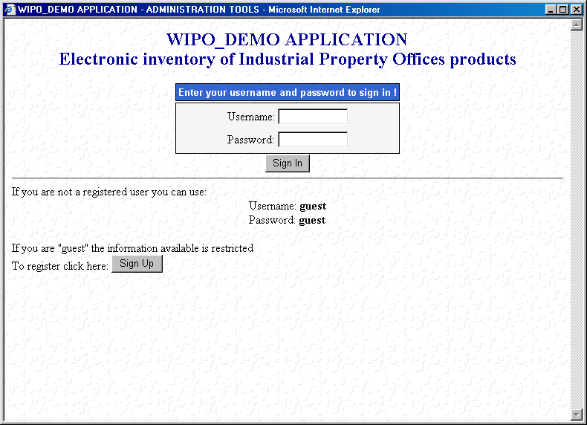

Screen 3.2. - Search with labels in English language
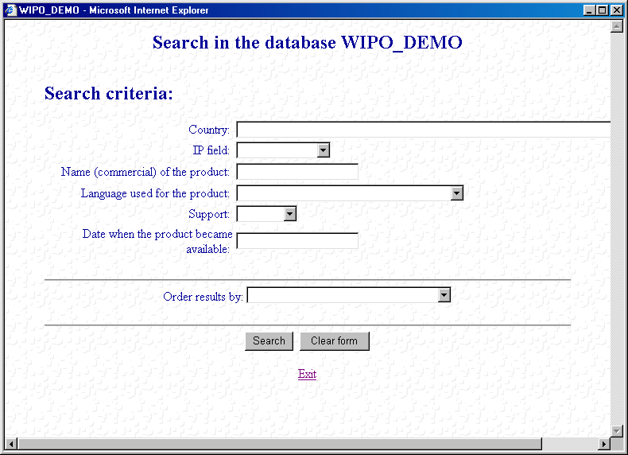

Screen 3.2. - Search with labels in Romanian language
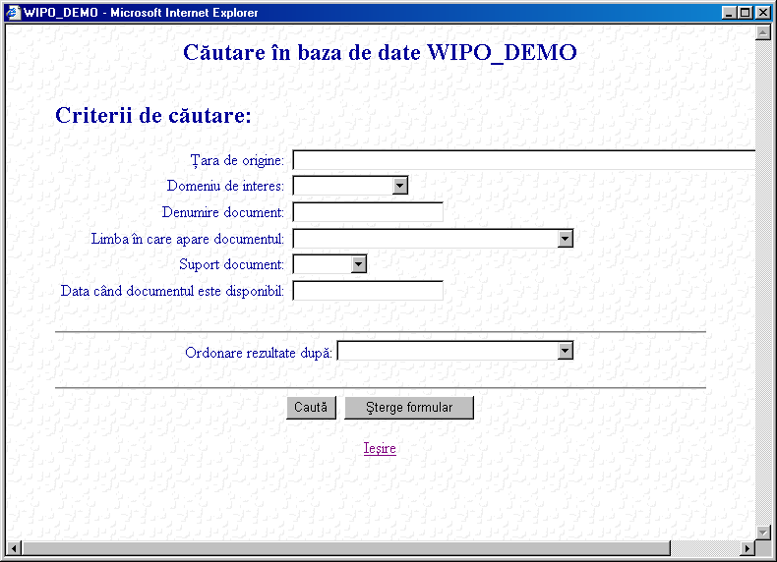

Screen 3.2.1. - Short display in English language
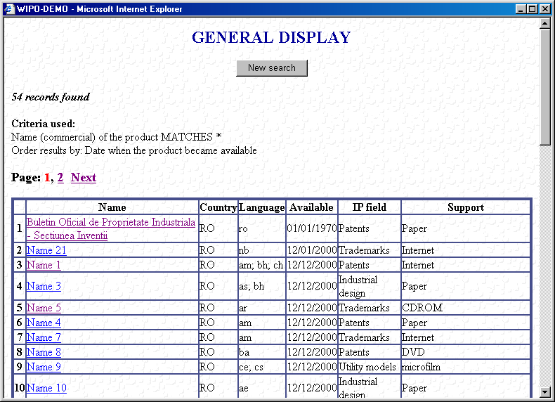

Screen 3.2.1. - Short display in Romanian language
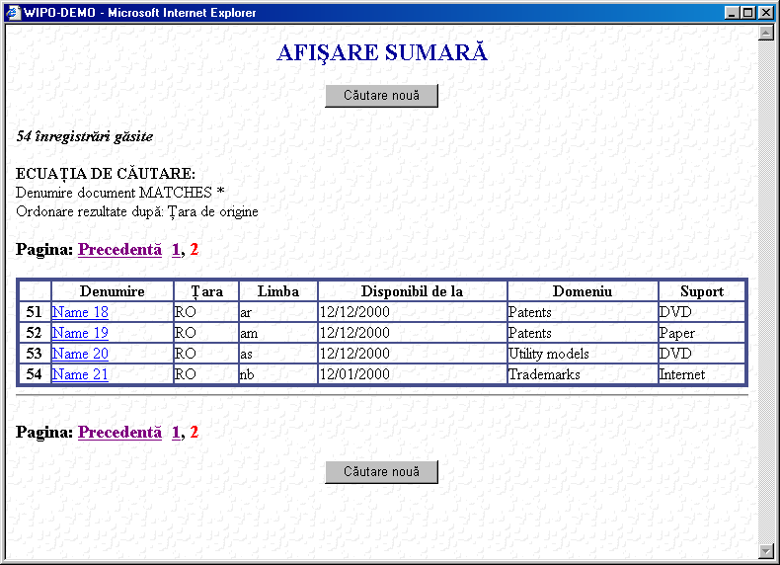

Screen 3.3. - Country Selection
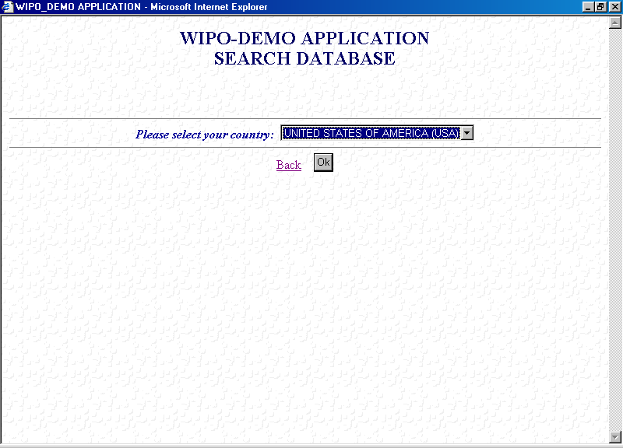

Screen 3.4. - Administration tools
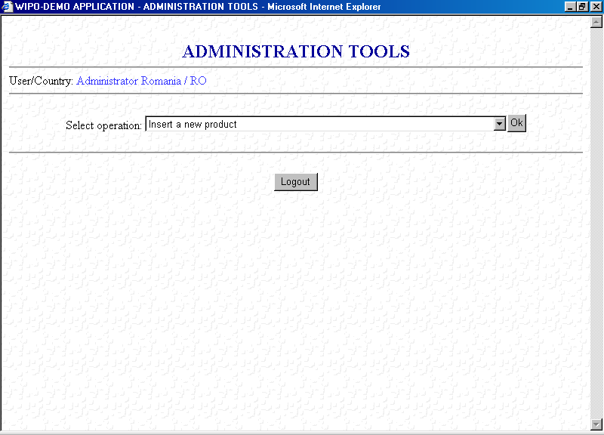

Screen 3.4. -Options
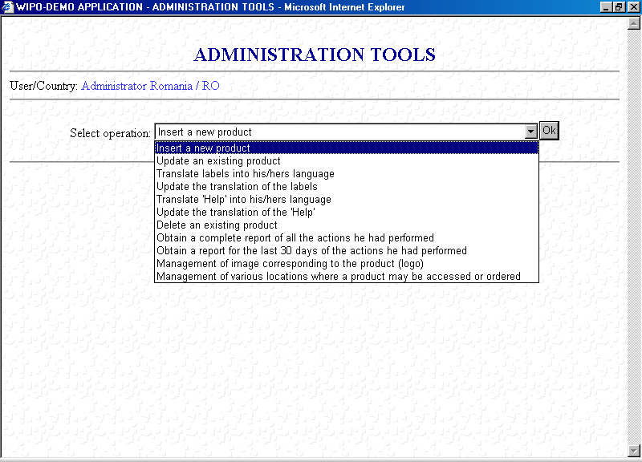

Screen 3.4.1. - Insert
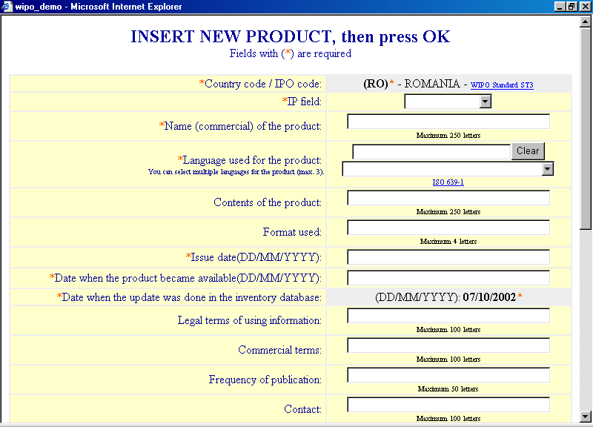

Screen 3.4.1. - Selection for update
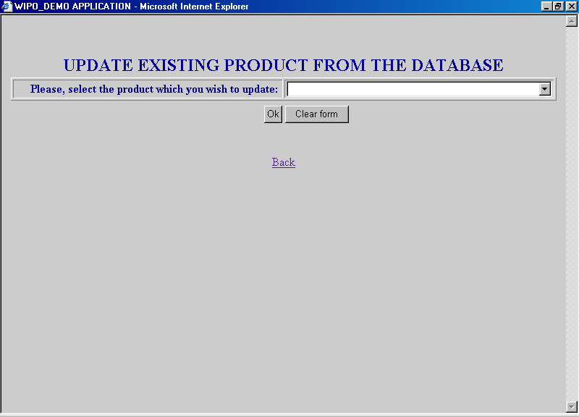
Screen 3.4.1. - Update
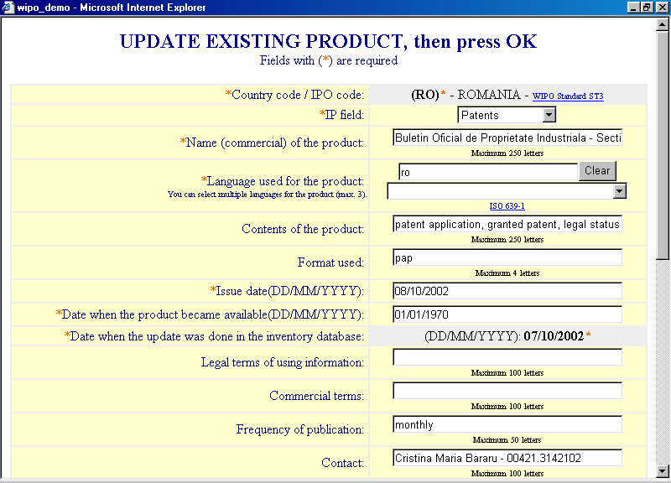

Screen 3.4.1. - Management of images (logo) - Update of existing logo
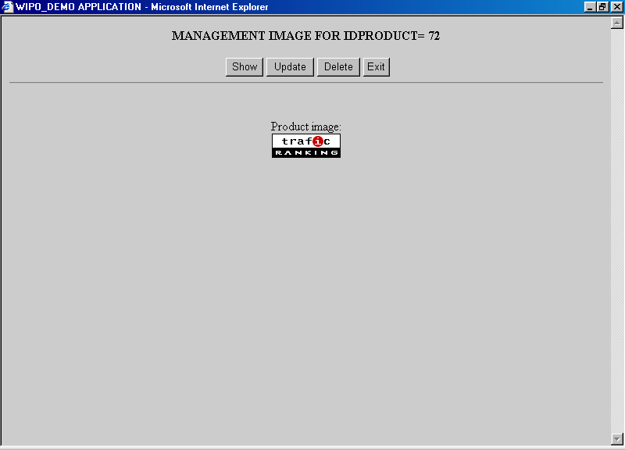

Screen 3.4.1. - Management of images (logo) - Insert a logo
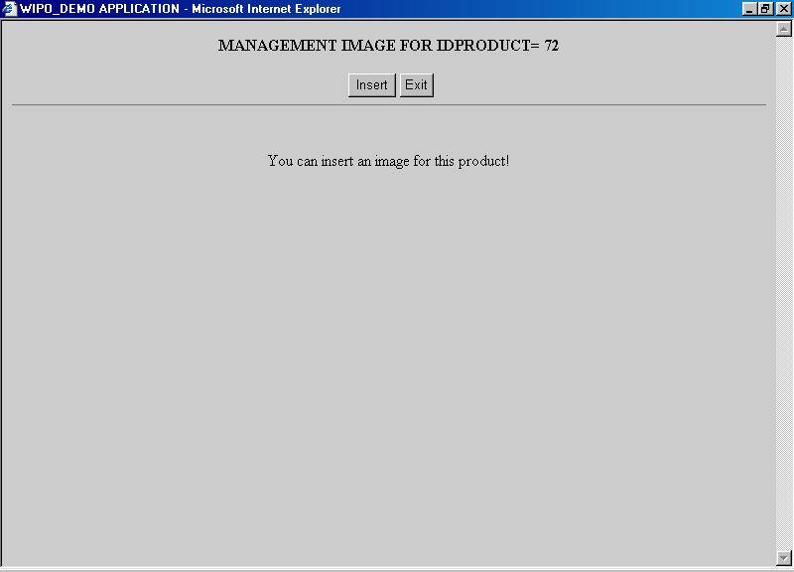

Screen 3.4.1. - Management of images (logo) - Upload of a logo
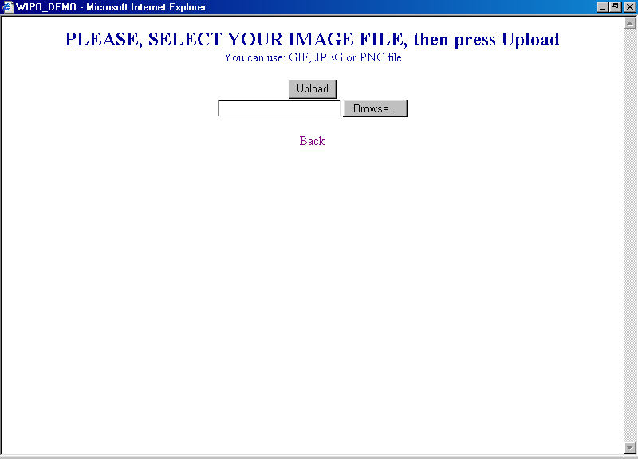
Screen 3.4.1. - Management of location - List of locations
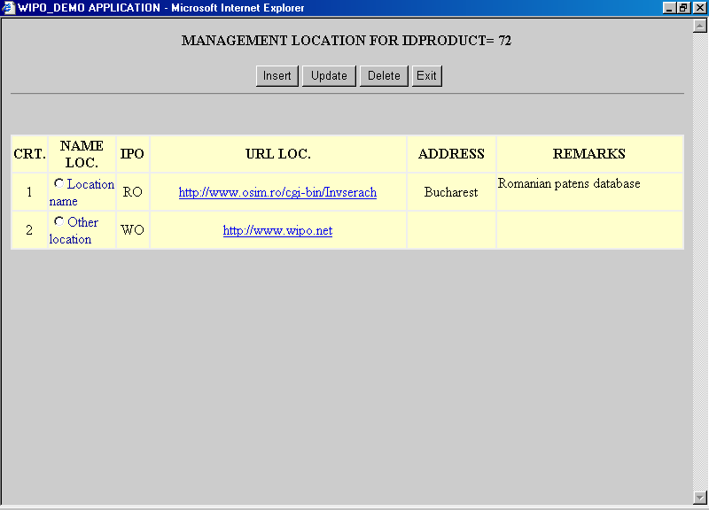

Screen 3.4.1. - Management of location - Insert
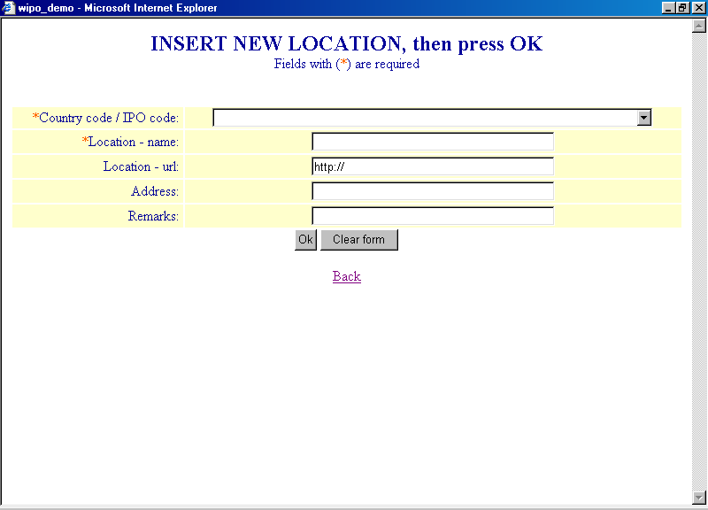

Screen 3.4.1. - Management of location - Update
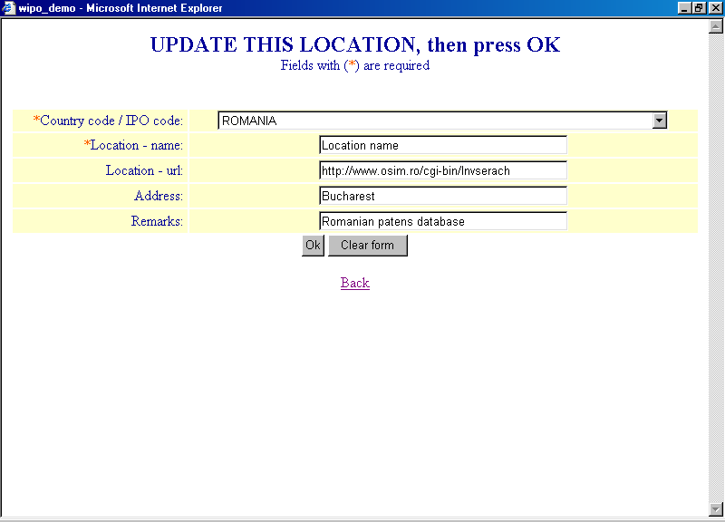

Screen 3.4.1. - Report for the last 30 days for local DBA:
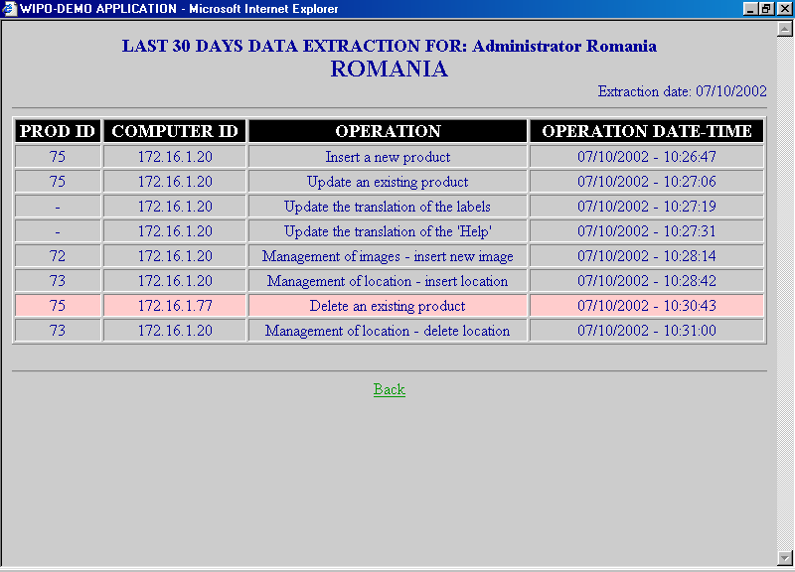

Screen 3.4.1. - Complete report of local DBA
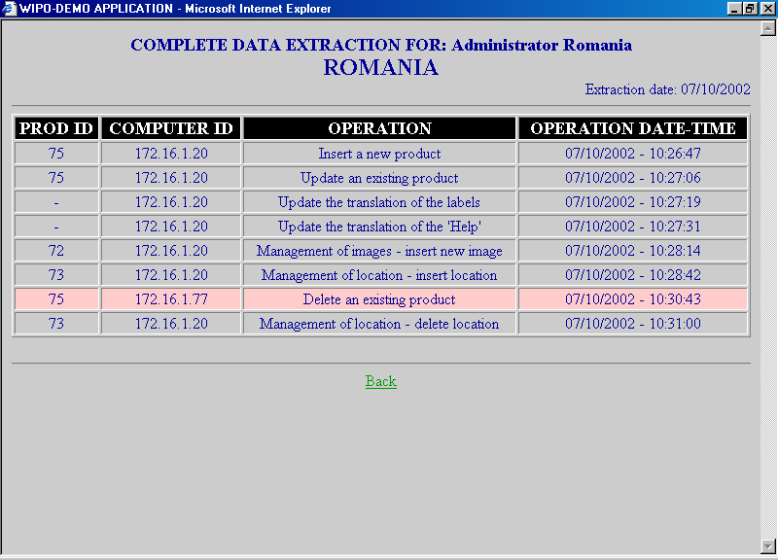

Screen 3.4.2. - Labels translation
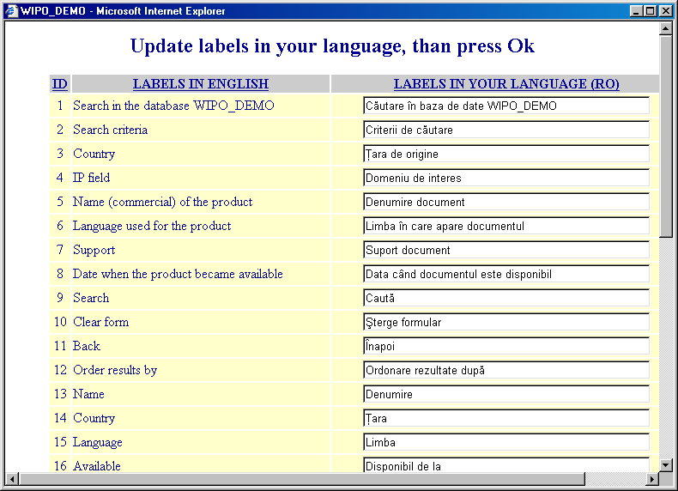
Screen 3.4.4. - Selection for deletion
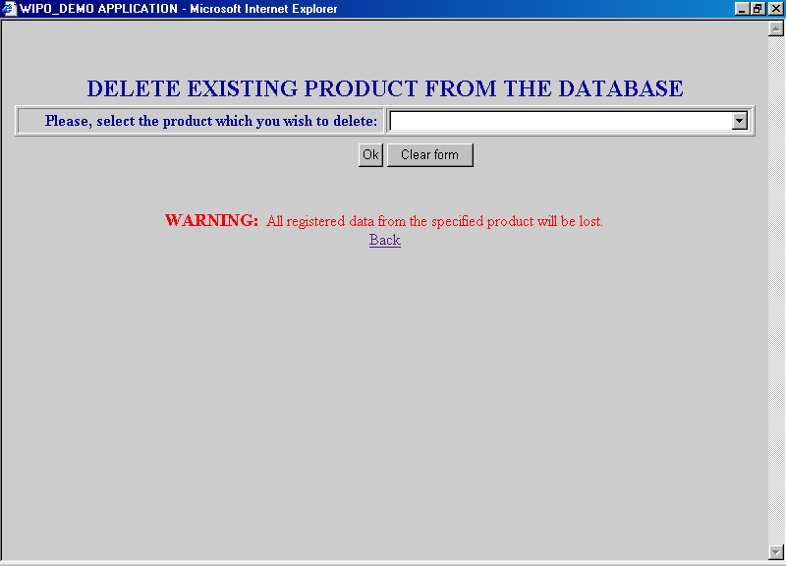

Screen 3.4.4. - Confirmation for deletion
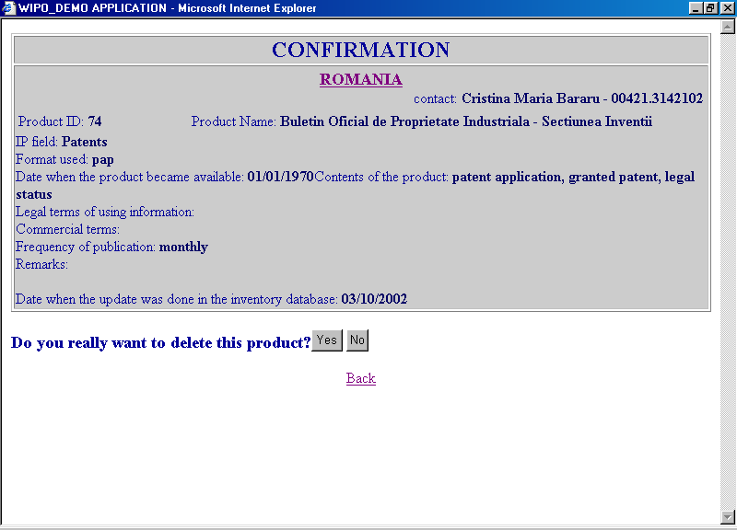

Screen 4 - Registration form
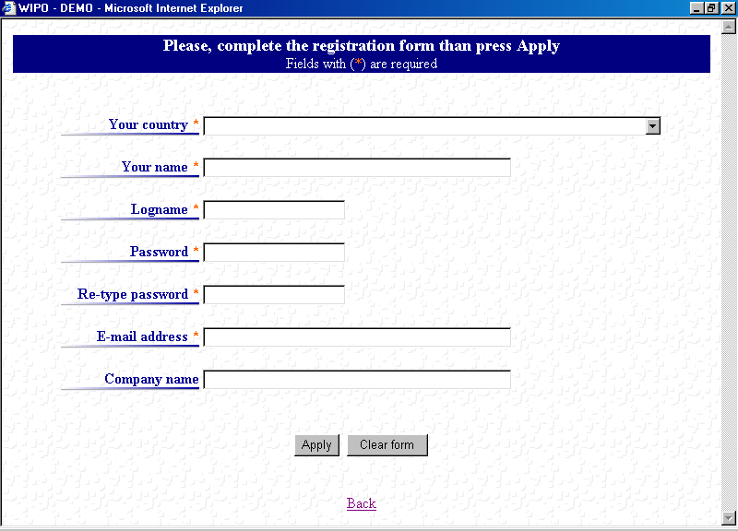

Warning message - sample:
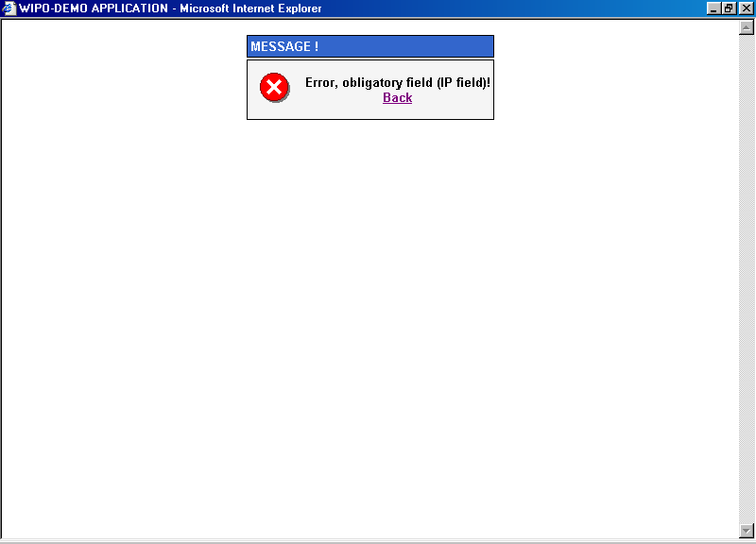

Error message - sample:
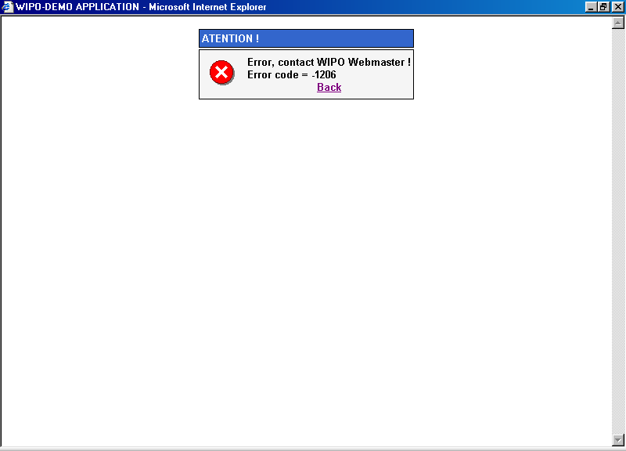

[End of Appendix and of document]

