STANDARD ST.22

RECOMMENDATION FOR THE AUTHORING OF PATENT APPLICATIONS FOR THE PURPOSE
OF FACILITATING OPTICAL CHARACTER RECOGNITION (OCR)
Proposal prepared by the ST.22 Task Force

INTRODUCTION
1. This Recommendation applies to patent applications submitted on paper or submitted electronically (e-filed) but having the text body of the application submitted in image form (e.g., PDF or TIFF images).
2. This Recommendation has been established so as to assist in the preparation of a patent application in a typewritten form suitable for the subsequent production of an electronic digitized record of the contents of the patent application by the use of Optical Character Recognition (OCR) equipment.
3. This Recommendation has been established based upon the experiences of various offices in the use of OCR equipment. It has been drawn up with the objective of achieving the lowest possible error rate in the step of automatic reading of the text of patent applications whilst, at the same time, still permitting efficient personal reading of the document. Note that this document does not provide detailed recommendations for the Japanese and Korean languages; the percentage of the number of full text electronic filings to the total number of filings by year is indeed above 90% in these countries, meaning that this Standard is not applicable for the Japanese and Korean languages in practice.
4. The primary aim of producing a digitized record of a patent application is to permit the easy publication of that application in a composed format using computer typesetting techniques and to thus enhance the presentation and value of patent documents to the advantage of all users. A further aim is to create a machine-readable database of the full text of a published document so that advantage can be taken at a later date of the possibilities offered by full text computer search.

DEFINITIONS
5. For the purposes of this Recommendation, the expression "patent application" means applications for patents for invention, inventor's certificates, utility certificates, utility models, patents or certificates of addition, inventor's certificates of addition and utility certificates of addition.
6. A mathematical or chemical formula is said to be “complex” if it cannot be displayed as a linear sequence of characters, each character having an optional subscript or superscript attribute. A formula is notably complex if it contains nested subscripts/superscripts or if it contains the sum, integral or product mathematical symbols.
7. A bounding box of a character/set of characters is the smallest axis-aligned rectangle which includes all parts of the character/set of characters.
8. The term "cursive" refers to a stylized form of handwriting whereby the letters in words are connected, making a word one single complex stroke. Fonts are said to be cursive if they are designed to resemble handwriting.

CREATION OF THE ORIGINAL
9. A patent application will often be prepared using word processing equipment. Experience has shown that the most efficient format that is to be used which would enable OCR equipment to be reliably used is that defined in the International Standard Organization (ISO) Standard 1073/II, the so-called OCR-B format.

PAPER SUPPORT IF FILED ON PAPER
10. To facilitate scanning, the paper support of the typed application should have the following characteristics:
(a) The paper should be strong, white and clean.
(b) The paper weight should be between 70 and 120 g/m².
(c) The paper size should preferably be A4, viz. 210 mm x 297 mm or 8 1/2 by 11 inches (which is the de-facto North-American standard).
(d) Sheets should be free of creases, holes and should not be rolled.
(e) The paper should not be absorbent in order to avoid smearing of the ink (for example when using an ink jet printer).

PAGE LAYOUT RECOMMENDATIONS
11. Double-sided printing should be avoided. If this is not possible, sufficiently opaque paper should be used to ensure clean recto/verso scanning.
12. The characters should be solid black on a white background.
13. A minimum margin of 2 centimeters should be present at the top, bottom and sides of each sheet, and a minimum margin of 2.5 centimeters on the left side of each sheet. Any applicant's or representative’s references should appear in the margin at the top. Please refer to Appendix 1.
14. Line numbering should be avoided. If required, line numbers should be typed using Arabic characters in the left hand margin, at least 1 cm outside of the box as shown in Appendix 1. The font size of the line numbers should be at least 12 points.
15. Page numbering should be indicated with Arabic characters without other delimiting characters. Page numbers should preferably be centered at the top or bottom of the sheet in the margin, as shown in Appendix 1.
16. The description, the claims and the abstract should be typed starting each on a new page. Moreover, the first word printed on the first page of each of the three previously mentioned parts of the application should specify the corresponding part (in the language of the application); the claims paragraph should be numbered sequentially. The format of the claims numbering should allow for a clean separation between the claim number and the claim text for each claim. Recommended formats are either to use Arabic numerals followed by a point or to use the word "Claim" –or the equivalent in the language of the patent application-, followed by a space and the claim Arabic number, the following text of the claim being right-indented with respect to the claim number of at least 1 cm in both cases.
17. Pages should be constituted of single column paragraphs (text paragraphs or paragraphs containing an embedded image).
18. Pages containing paragraphs should have a portrait orientation.
19. Landscape orientation should be avoided. It is acceptable only for pages containing embedded drawings or tables that would not fit in a portrait orientation.
20. Any page should contain only one direction of text.
21. Landscape pages should be turned 90 degrees counterclockwise for integration within the set of portrait pages.
22. It is recommended to avoid the use of footnotes, margin texts and headers, except as indicated in paragraph 14 (line numbering), paragraph 15 (page numbering) and for the inclusion of an applicant's file reference in the top left-hand corner of the margin.

PARAGRAPH LAYOUT RECOMMENDATIONS
23. It is recommended that tables, complex chemical formulae, complex mathematical formulae, images and drawings be separated from text paragraphs. It is advised that such items be surrounded by top and bottom blank margins of at least 1 cm that encompass the width of the page.
24. Images and drawings should at maximum be included in the "Drawings" section and referred to in the "Description" and "Claims" sections of the patent application.
25. Images and drawings should be in black and white (grayscale images should be avoided as information is lost when scanning them or converting them to black and white). Figures should contain clear lines that are thick enough to be well represented at a 300 dpi resolution.
26. Handwritten text paragraphs or annotations should be avoided. If required, they would be considered as embedded drawings and should follow the recommendation given in paragraph 23.
27. Typing should be done at one and a half line spacing.
28. Paragraphs should be separated by spacing that is at least twice as big as the intra-paragraph line spacing.
29. All characters within a paragraph line should have their baselines carefully aligned, except for subscript and superscript characters as indicated in paragraph 35.
30. Justified text paragraphs should be avoided. If applied, the spacing between words should be at least as wide as with unjustified text. Justified text may prevent the OCR systems to correctly identify the word boundaries in a paragraph.
31. When possible, word splitting by the use of hyphens should be avoided (for example, at the end of lines or table cells). This does not apply for languages that use compound nouns (for example the German language).

TABLE RECOMMENDATIONS
32. Only white background should be used.
33. Tables must have borders. The borders should be thicker than 1.5 points and be only solid lines.

FONT RECOMMENDATIONS
34. The minimal recommended font size is 12 points, 14 points being preferred. As a general recommendation, all characters of a paragraph should have the same font size.
35. Text paragraphs containing subscripts and superscripts should use a font size of at least 12 points (14 points is recommended – the bigger, the better). Ensure that the bounding box of the subscript or superscript characters sufficiently intersects the bounding box of the normal characters on the same line (This prevents the OCR procedures to put the subscripts/superscripts on different lines.)
36. The recommended fonts are the following in order:
(a) Monospaced family: OCR-B, Courier New, Free Mono.
(b) Serif family: ITC Officina Serif, Times New Roman, Free Times.
(c) Sans Serif family: Verdana, ITC Officina Sans , Arial, Helvetica, DejaVu Sans.
However, the Arial, Helvetica, DejaVu Sans, Free Times and Times New Roman fonts are not recommended for applications containing chemical and/or mathematical formulae, as well as acronyms mixing letters and digits. For Chinese characters, the Song font is recommended.
37. The characters of the fonts should be well shaped, with no shadows. The spaces between characters should be wide enough (narrow spacing should be avoided).
38. Narrow and cursive fonts should not be used.
39. Bold and italic styles should be avoided as much as possible.
40. Unusual (non-standard /non-typical/ irregular) characters should be avoided as much as possible. If necessary, they should be of the standard Greek alphabet and to the symbol font (by order of preference). Characters that cannot be found in the UNICODE range must not be used: those characters are recognized as embedded images by OCR engines and therefore make the recognized text difficult to read. Each office shall define and publish its requirements for the character set which can be used for the preparation of the patent applications.
41. Text should not be underlined. If required, it should be assured that the underline does not intersect the underlined characters’ bounding boxes.

RECOMMENDATIONS FOR NON-LATIN LANGUAGES
42. Within sections/pages of Patent Applications, the mixing of Asian (i.e., ideogram based) and European (i.e., Latin and Cyrillic alphabets) languages is problematic for the OCR procedures and should be avoided.

SCANNING RECOMMENDATIONS
43. Patent applications should be scanned either in black and white or grayscale.
44. The preferred resolution for the scanning is 300 dpi. Scanning at resolutions lower than 300 dpi, even in grayscale, can result in poor quality documents published by offices, since exchange of documents between offices and the publication processes often involve conversions to 300 dpi black and white TIFF group IV pages.
45. Scanned documents should be converted either into PDF or TIFF formats.

CORRECTIONS
46. Corrections of the text of an application should be done by reprinting the whole page. Proof correction marks -as for example specified in the International Standard ISO 5776- are not accepted. Making corrections by means of white correcting fluid, self adhesive strips of paper, erasure or strikethrough are not accepted. Replacement pages shall not be sent by fax to the office using the standard fax resolution: pages should either be sent physically or by fax using a resolution higher than or equal to 300 dpi or by any network transfer means supported by the office, on condition that each page has been scanned at a resolution higher than or equal to 300 dpi .

RECOMMENDATIONS FOR OFFICES
47. Patent offices should avoid altering the received pages before submitting them for scanning and OCR operations. For example, some current practices include stamping operations that may superimpose characters on pages, making text submitted by the applicant unreadable by OCR procedures. If stamps/changes have to be applied on the original pages, the office shall take measures to ensure that the changes only occur in the margins of the documents, as defined in Appendix 1.
48. In the future, patent offices should avoid designing paper forms to handle the communication between the applicants and the office. According to past experience, designing and putting in place secured on-line forms systems is preferable to building systems to recognize paper forms. Nevertheless, the following recommendations are made for the design of paper forms in the view of facilitating their recognition:
- Lines of small dots should not be used in forms to indicate to the user where text should be entered.
- Drop-out colors should be used for the character boxes (light gray).
- Drop-out colors should not be used for areas deemed to receive grayscale or colored contents like a scanned signature or a drawing.

IMPLEMENTATION
49. It is recommended that Offices intending to start accepting or requesting the filing of patent applications typed in OCR format publish full guidance in their Official Gazettes at regular intervals and in their websites, defining therein the exact character type(s) permitted, and specifying the exact paper size allowable.

Examples
50. Examples of good and bad practices regarding OCR are reproduced in Appendix 2 to this Recommendation. The examples show what should and should not be done, along with a short explanation.

[Appendices follow]

APPENDIX 1

Original Size = A4

APPENDIX 2

Examples of good and bad practices

You will find in this Appendix good examples and bad examples of patent document pages with respect to the accuracy obtained when performing OCR operations on them.

Examples of good practices

Example 1: a good description page
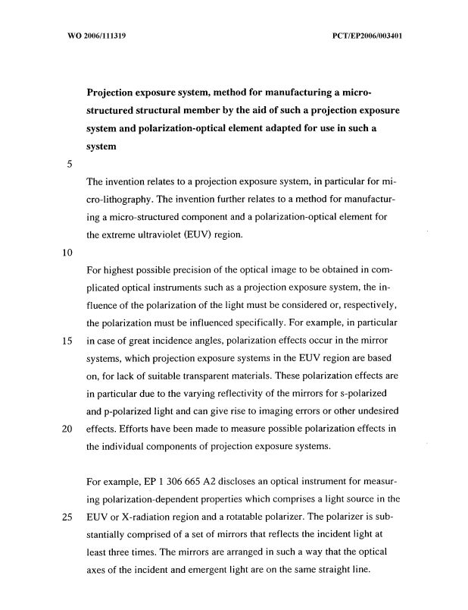

Example 2: a good claims page
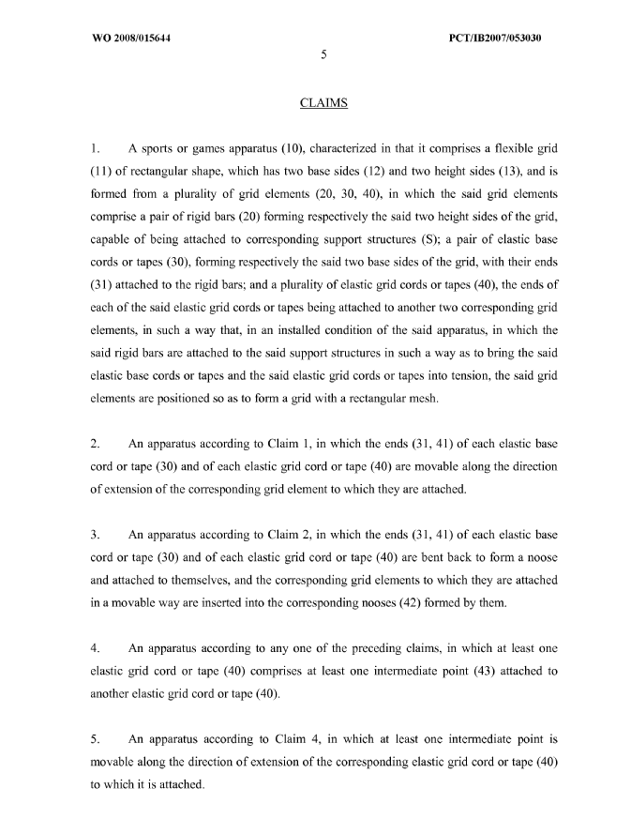

All recommendations are met: margins, a standard font (Times New Roman), a good font size, no line numbers, limited use of bold, no italics, no underlined text, claims numbering adequate and well separated from the claims texts.

Example 3: a good complex description page
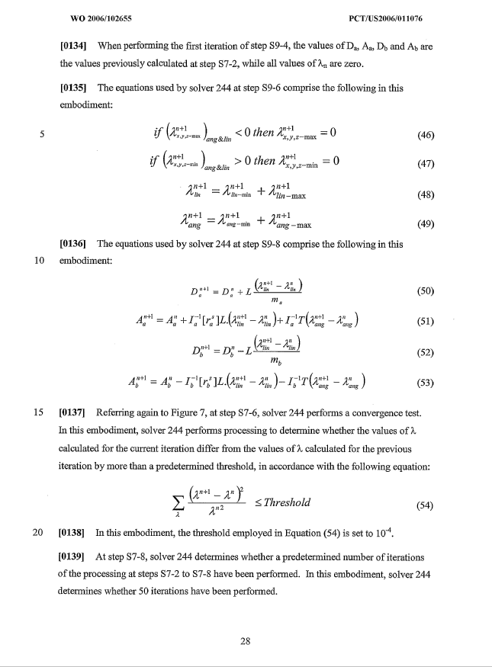

The text paragraphs do not contain unusual mathematical characters. The mathematical formulae are correctly embedded allowing for an easy segmentation of the embedded images by the OCR engines. A possible result of the segmentation is shown in blue.

Examples of bad practices

Example 1: a poor quality page with many deficiencies
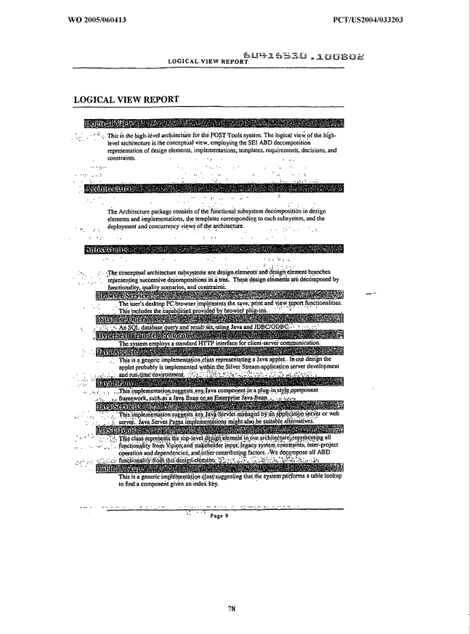

This example does not conform to paragraph 10 (the page was probably submitted by fax at 200 dpi to the office – see the noise – and some text appears on heavy gray backgrounds). Nor does the example comply with paragraphs 13 and 47: a reference number (604115530.100802) is stamped on the body of the page (it should be in the margins). The page numbering is incorrect (should be “9”, not “page 9”, see paragraph 34). Finally, the font size is too small (paragraph 15). Such pages should ideally not be accepted by offices and replacement pages should be requested (this page is impossible to OCR correctly).

Example 2: a page with a non-white background
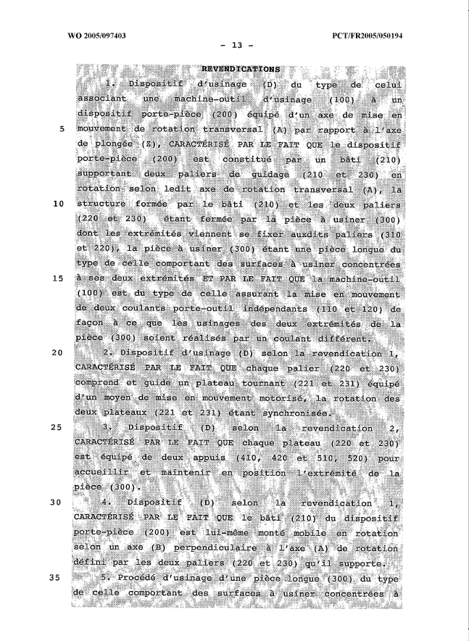

This example does not conform to paragraph 12. The page needs to be filtered to attempt to remove the noisy background before submitting it for an OCR operation. If OCRed as is, the obtained text is unreadable.

Example 3: a page with faint characters
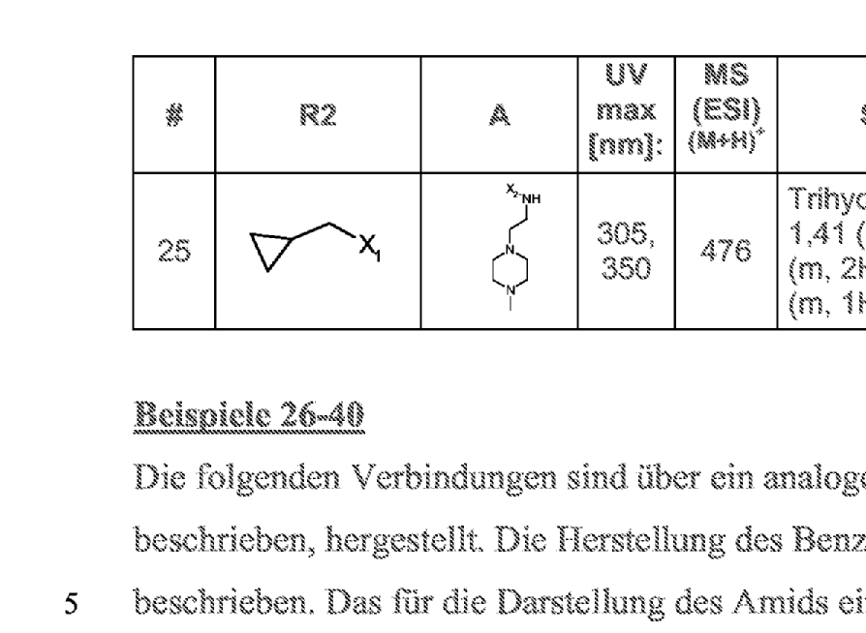

A small area of the page is zoomed to show the characters: the color of the original text is probably gray, resulting after the scanning in 300 dpi black and white in characters which are not solid. As a result, the accuracy of the OCRed text is poor (this example does not conform to paragraph 12).

Example 4: a page with handwritten text
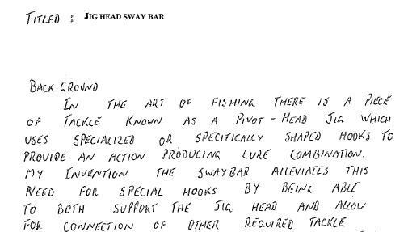

As to be expected, the text obtained by OCRing this page is unreadable. Offices should request typewritten text to ensure minimum publication quality.

Example 5: a page with a non-recommended layout and other deficiencies
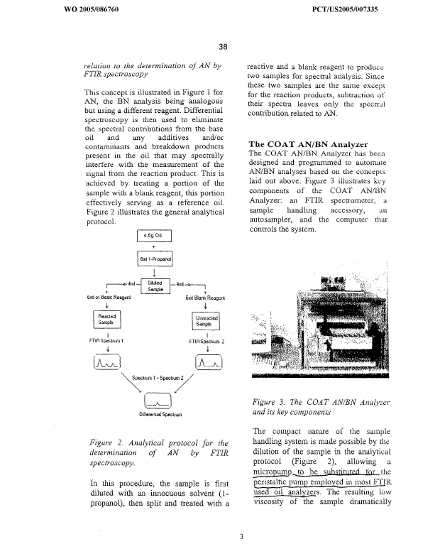

This page does not conform to the following recommendations: paragraph 17 (single column formatting), paragraph 39 (uses italic and bold fonts), paragraph 46 (has manual corrections performed after printing). The left-right justification of the paragraph is also not recommended (paragraph 30), although in this case, this would not have negative effects on the OCR since the words are still sufficiently separated by white spaces. Nor, finally, does the example comply with paragraph 27 (one and a half line spacing).

Example 6: a page with line numbers that are too small
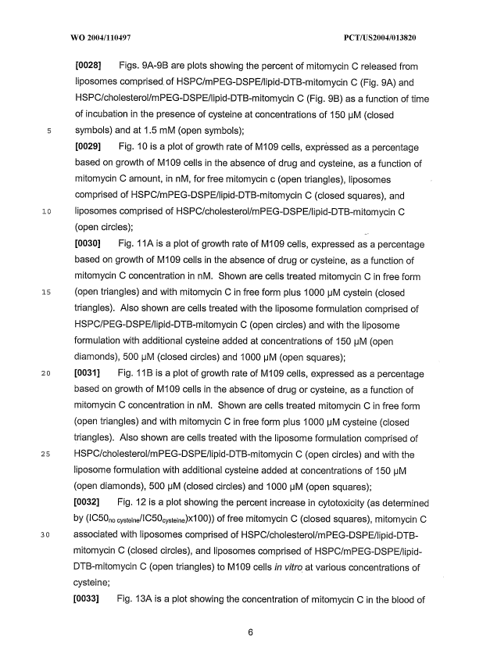

Line numbers cause problems for the OCR engines for several reasons (paragraph 14):
- they may not be aligned with the lines they correspond to, leading to baseline detection defaults;
- they could be too small, resulting in recognition errors that would prevent the XML extraction procedures to remove them correctly from the text body of the page;
- they could be misplaced within the body text area of the page, or in the margins but too close to the body text area, and as a result will appear inside the text stream exported by the OCR operations.

In this example, they are too small.
Subscript characters are also too small in this example (paragraph 35).

Example 7: a page containing several directions of text
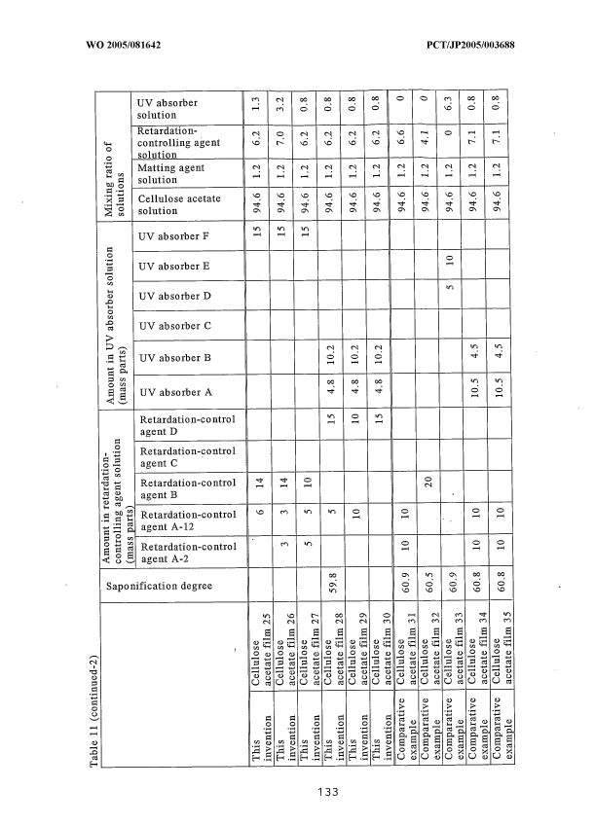

This example does not conform to paragraph 20.
One of the limitations of the best OCR engines available today is that they can read only one direction of text on one page (a preprocess of the page is to detect the main text orientation of the page). As a result, all of the words that are not in the main text direction are ignored. It is of course acceptable to have in a page a landscape table or even a main landscape text with portrait annotations in the margins (page number, application number, etc.).

Example 8: a page with mixed embedded mathematical formulae and text
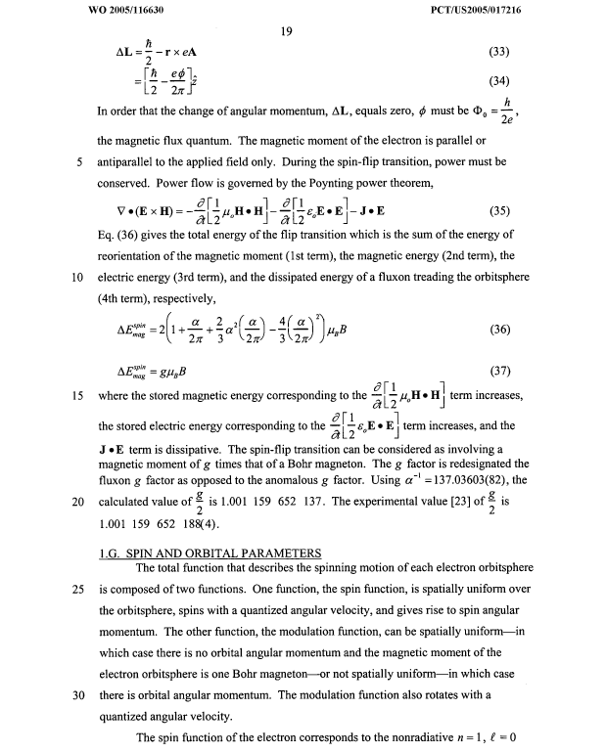

This example does not conform to paragraph 23. The OCR engine is not able to separate correctly the text and the formulae (see the result of a manual segmentation of the formulae in red: the embedded formulae even intersect).
As a general comment, in this example, the text and the formulae are too dense for good recognition; neither does the example comply with paragraphs 27 and 28.
This example also uses unusual characters: Greek symbols can be used even if they increase the recognition difficulty of the page (see paragraph 40). However, it is highly recommended not to combine italics, bold or underlined fonts with unusual characters (paragraph 39).

Example 9: a page with mixed embedded chemical formulae and text
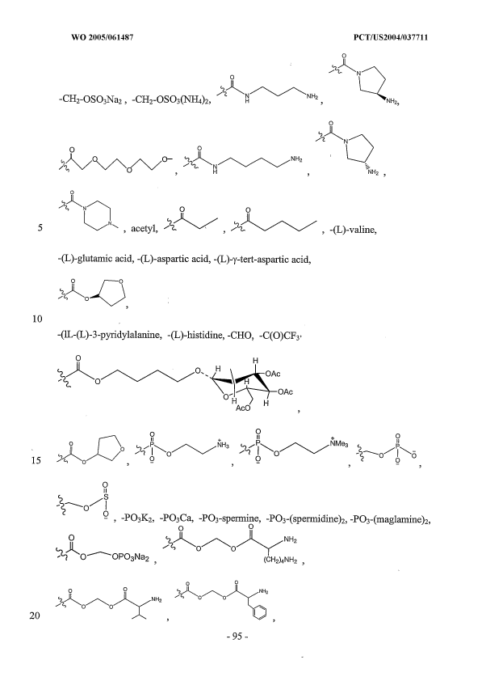

This example does not conform to paragraph 23. You can find in red one expected result of the drawings segmentation (done manually). This segmentation cannot be performed correctly by an OCR engine since the formulae are too close to the surrounding text.

Example 10: a page with subscript characters that are too small
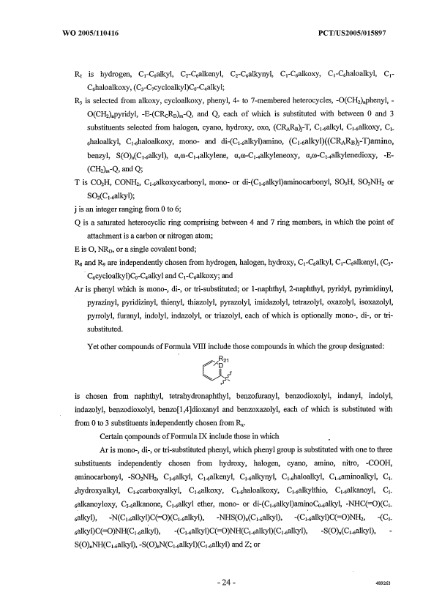

This is a typical example where the subscript characters are too small to allow for accurate recognition. This phenomenon is frequently encountered for patents in the chemistry field.

Example 11: a page with badly formatted tables
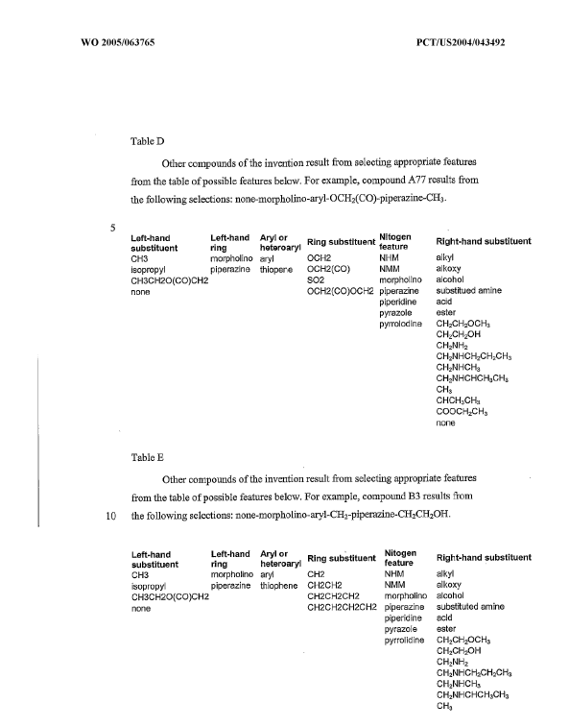

In this example, the table boundaries are missing (does not conform to paragraph 33). As a result, the OCR engine will try to recognize contents of the tables as paragraph text. This leads to several other problems:
The font size of the characters in the tables is too small (paragraphs 34 and 35)
The baselines of the column headings are mixed (paragraph 29). As a result, the engine will detect wrongly subscripts or superscripts.
The text stream obtained will not take into account the columns:
Left-hand Left-Hand Aryl or Nitogen
Substituent ring heteroaryl ^{Ring substituent} feature ^{Right-hand substituent}
CH3…

Example 12: a justified page
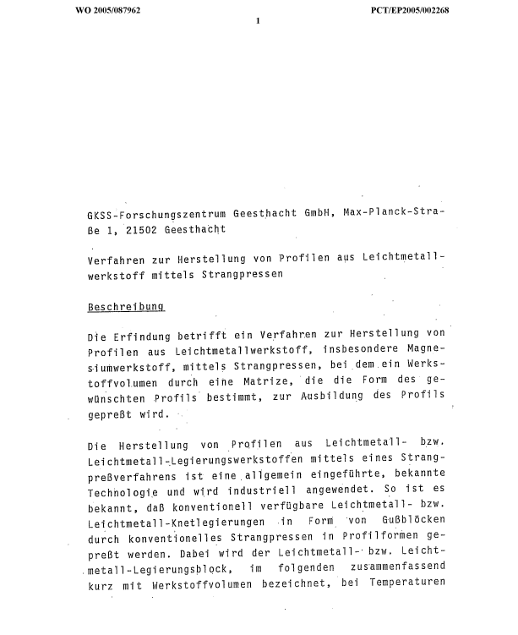

In this example, left and right justifications are applied to the paragraphs. If this makes the text more aesthetic looking, it sometimes makes OCR operations difficult when the separations between the words become too small (paragraph 30). Neither does this example conform to paragraph 31, which states that word splitting at the end of the lines should be avoided as much as possible (the OCR engine sometimes has difficulties distinguishing hard and soft hyphens, resulting in words containing undesired hyphens in the output).

Example 13: a table with bad boundaries
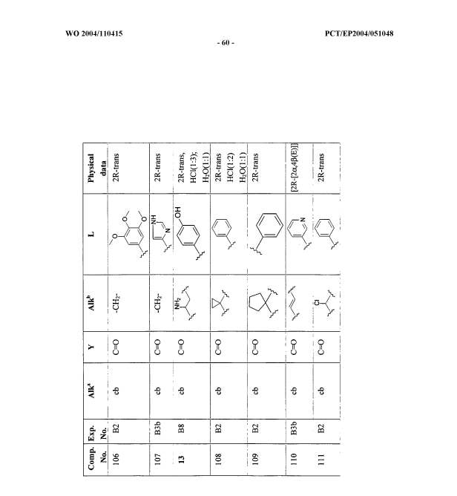

In this example, the boundaries of the table in the original received before scanning are of bad quality. After scanning, the OCR procedure is unable to detect correctly the table, and a manual operation is required to segment the page. If such a page is not checked by an operator for quality, the text output will contain undesired "junk" characters that will make the indexation of the document by search engines less effective.

Example 14: bad subscript and superscript characters
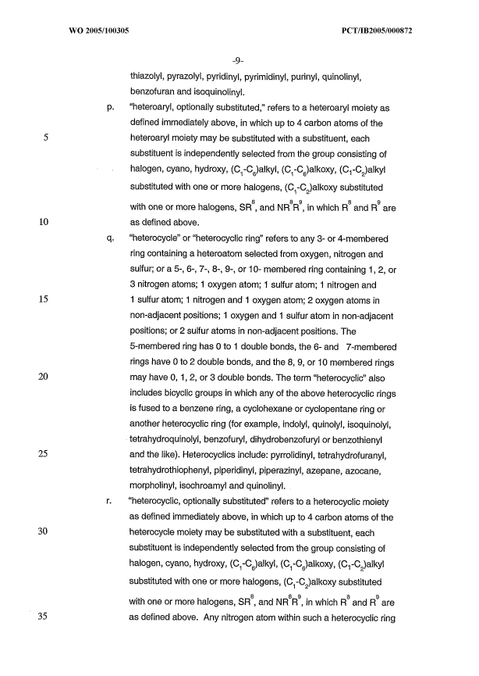

The following problems exist in this example (paragraph 35):
- Subscript and superscript characters too small
- Subscript characters located too low with respect to the baseline
- Superscript characters located too high with respect to the baseline

As a result, lines 34 and 35 of the text are recognized as follows by the OCR procedure:

"Substituted with one or more halogens, (C -C )alkoxy substituted
1 2
8 8 9 8 9
with one or more halogens, SR , and NR R , in which R and R are"

Example 15: an example with unusual characters
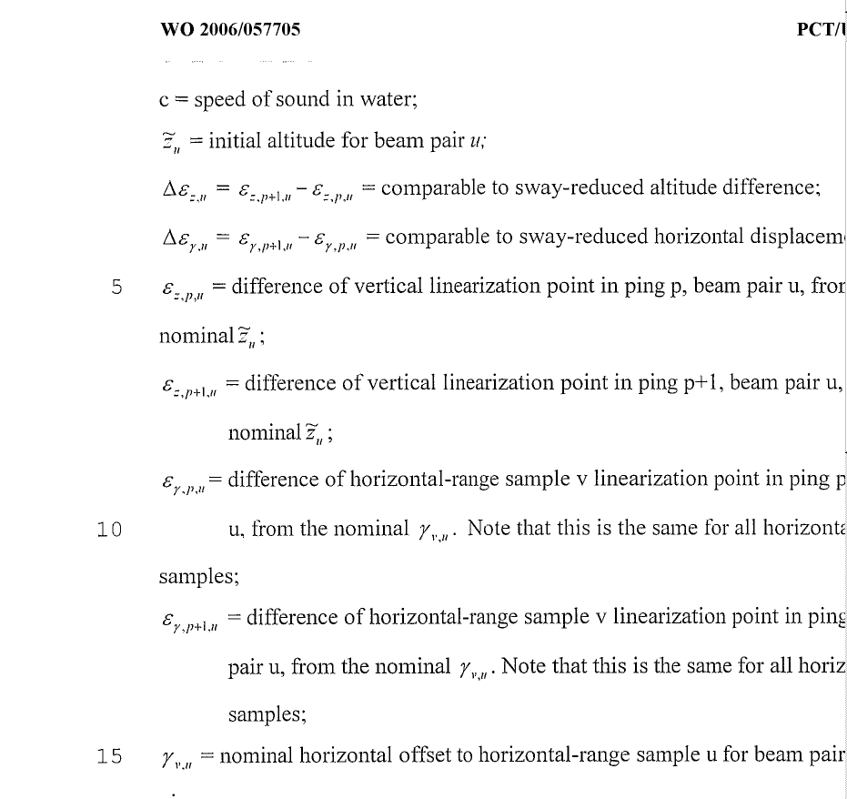

The following problems exist in this example:
- Unusual characters: italic Greek, and even characters with a tilde.
- The subscripts here again are too small

With most OCR engines, all unusual characters will not be recognized correctly.

Example 16: an example with narrow fonts and narrow spacing
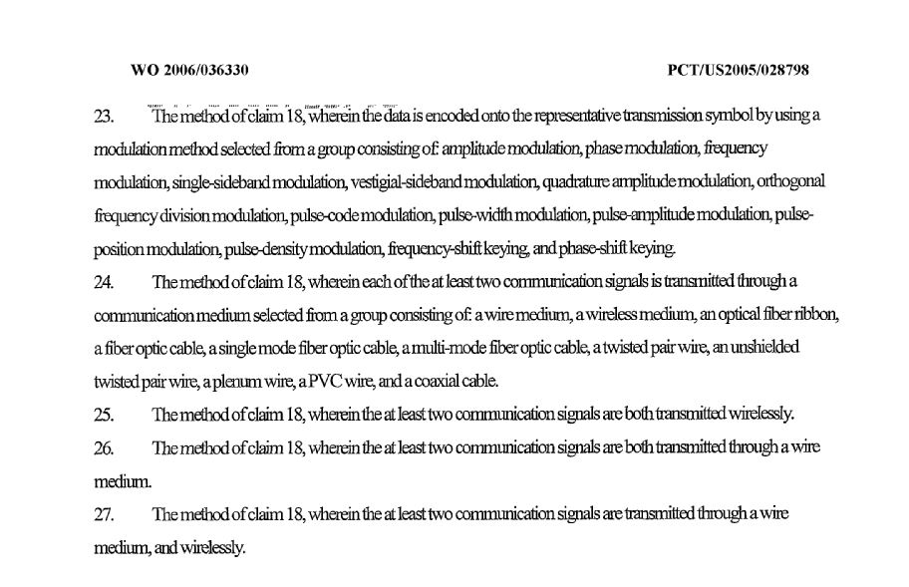

This example does not conform to paragraphs 37 and 38. As a result, the OCR engine cannot correctly distinguish word boundaries, and the result is that the OCR is totally unusable.

Example 17: bad stamp by receiving office before scanning
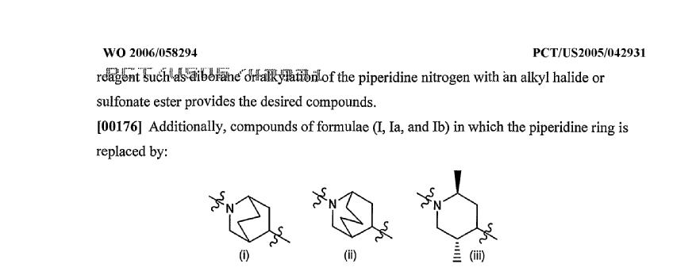

This example does not conform to paragraph 47. As a result, the first six words of the text of the page cannot be read by the OCR procedure. Moreover, the stamp introduces extra invalid characters that will pollute the indexation engines if the page is not quality-checked by an operator.

Example 18: another page with mathematical formulae badly laid out
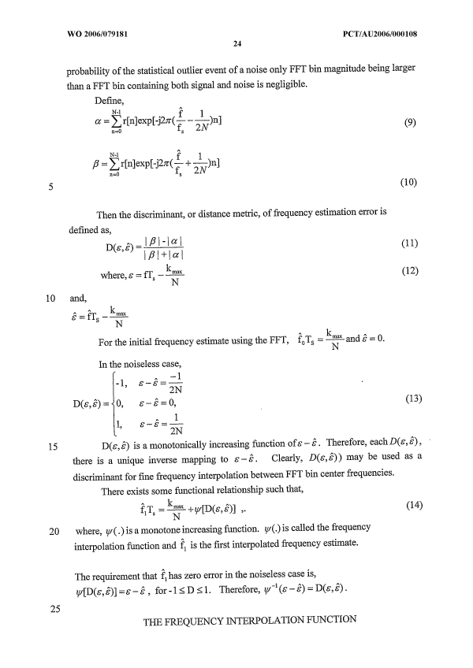

As this page does not conform to many recommendations, the result of the OCR is not usable:
- embedded mathematical formulae not separated from text paragraphs (paragraph 23);
- unusual characters in text paragraphs (paragraph 40);
- italic style combined with Greek characters (paragraph 39).

The recommended way to lay out this page is to use extra spaces to separate embedded formulae from the paragraphs. Greek letters should not be italicized in formulae and paragraphs. Circumflexes (^) shall be avoided to denote variables in text paragraphs when possible: superscripts may be used instead: "epsilon circumflex" could be represented ε^ or ε^{circumflex}.

Example 19: a page with italic and underlined characters
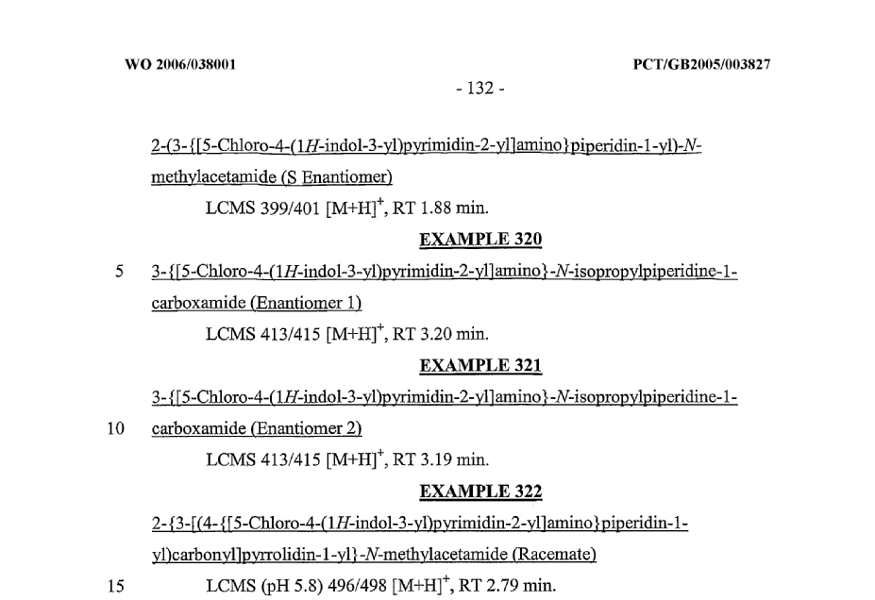

This is a frequent OCR problem encountered in the PCT publication. This page does not conform to the following recommendations:
- Paragraph 41: text should not be underlined. Underlining is especially not recommended for chemical formulae (dictionaries cannot help in these cases). Notably, this causes problems with all characters that intersect with the underline: ] ) y p … are not recognized correctly.
- Paragraph 39: italic style is not recommended. It is highly recommended not to change the font style within a word (OCR engines assume often that all characters of a word have the same style). As a result, all the "1H" and "-N-" are badly recognized.

Example 20: a page completely unreadable
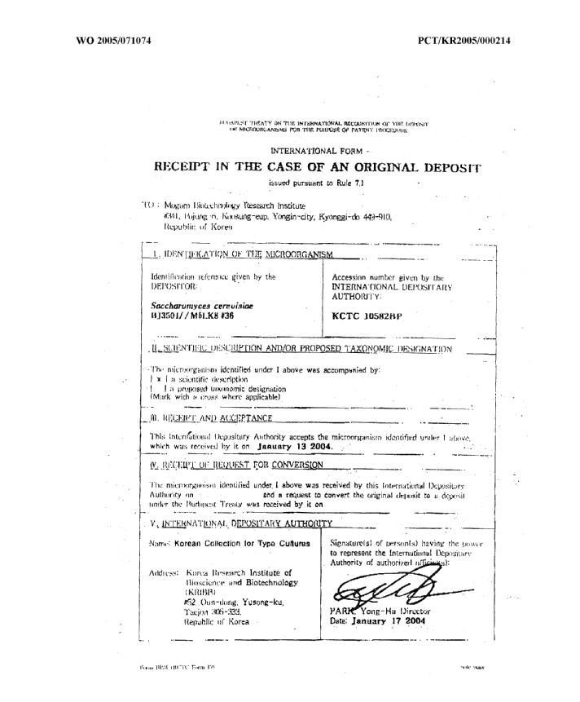

This page should not be accepted by offices: it has been sent by fax at 100 dpi and is not even readable by the human eye. In order to deal with these cases, operators declare the whole content of the page as an image as no text is extractable.
[End of Appendix 2 and of Standard]
[End of Appendix 2 and of document]

