 |  | E
PCT/WG/9/16
ORIGINAL: English
DATE: April 11, 2016

Patent Cooperation Treaty (PCT)
Working Group

Ninth Session
Geneva, May 17 to 20, 2016

Number of Words in Abstracts and Front Page Drawings

Document prepared by the International Bureau

Summary
- A large proportion of international applications are published with abstracts which fall well outside the recommended range of lengths and with significant quantities of text in the drawing chosen for the front page of the published international application. This results in increased translation and processing costs and suggests that the abstract and drawing published on the front page may often not be optimal for the purpose of effective searching.
- Ideally, applicants should prepare abstracts and drawings in better compliance with PCT Rules 8 and 11. Member States may need to consider the extent to which abstracts and the drawing chosen to accompany the abstract at present are suited to the purposes indicated in the Rules. Initial views are sought on how useful the current products are and what steps might be considered to maximize useful results and minimize costs.

Background
- The International Bureau has noted that a large number of international applications contain abstracts significantly longer than 150 words when translated into English (contrary to the recommendation set out in Rule 8.1(b)) and drawings with large volumes of text (contrary to Rule 11.11) which, if contained in the drawing chosen to accompany the abstract on the front page of the published international application, also need to be translated by the International Bureau. This causes significant expense for the International Bureau and difficulties with the contracts for outsourced translation of abstracts, which were negotiated based on the expectation of abstracts with a length between 50 to 150 words when translated into English.
- While investigating this issue, it was observed firstly that the extent of the difference from expectations varied significantly not only by field of technology but also by language of publication. Secondly, a significant number of very short abstracts had been published.
- Where drawings contain text, the following translations are prepared by the International Bureau and made available:
  - International applications filed in English: the abstract and the text contained in the drawing accompanying the abstract appear on the front page of the published international application in English only. French translations of both the abstract and the text contained in the drawing are prepared by the International Bureau and published in the Gazette (PATENTSCOPE French language pages). The text of the abstract is available and searchable in full text format. The text contained in the drawing appears only as an image within the drawing accompanying the abstract.
  - International applications filed in French: the abstract and the text contained in the drawing accompanying the abstract appear on the front page of the published international application in English and French. The text of the abstract is available and searchable in the Gazette (PATENTSCOPE) in full text format in both languages. The text contained in the drawing appears only as an image within the drawing accompanying the abstract.
  - International applications filed in other languages: the abstract and the text contained in the drawing accompanying the abstract appear on the front page of the published international application in English and the language of publication. French translations of both the abstract and the text contained in the drawing are prepared by the International Bureau and published in the Gazette (PATENTSCOPE French language pages). The text of the abstract is available and searchable in English, French and the language of publication. The text contained in the drawing is included in image format only within the drawing accompanying the abstract, in English and the language of publication on the front page of the published international application and in French and the language of publication in the Gazette.
- The extraction of text contained in the drawing accompanying the abstract and the “creation” of a “new” drawing containing the translated text is a time-consuming process for the International Bureau, which may not always produce results useful for search purposes. Where the drawing contains only one or two words, the English or French translated text may sometimes be placed directly alongside the original language words if there is sufficient space to do so. Where large quantities of text are contained in the drawing, typically reference letters are added to supplement reference numerals within the text. The translations are shown in a list below or to the side of the original drawing, against the relevant reference. Where large numbers of words are used, the words may be difficult to read at the size printed on the front page of the published international application. Furthermore, flow-charts (which account for most figures with very large numbers of words) may be difficult to read when the translated text is not in the appropriate position within the chart.
- The Annex to this document contains examples of abstracts and drawings accompanying the abstract on the front page of the published international application in a range of languages of publication and with various quantities of text, extracted from the front pages of published international applications within the sample and presented at approximately their original size.

Distribution of Abstract Lengths
- The length of abstracts in English or as translated into English was analyzed for international applications published in the first six months of 2015. This was chosen as a large, relatively recent sample, for which there should be no outstanding search reports which might result in republication with a revised abstract or front page drawing.
- The chart below shows a cumulative total of abstract lengths, split by language and in total (the line for Arabic language publications is not visible because only one point falls within the region shown). That is, the Y-value shows the proportion of international applications in the sample which have the number of words indicated on the X-axis or less. Nearly a third of abstracts overall fall outside the recommended range of lengths, some by a large margin. The X-axis is cut off at 300 words, but it should be noticed that not all of the lines have reached 1. There is a small but significant number (over 600 in the six month sample) of abstracts longer than 300 words, with a few reaching over 500.
Figure 1: Cumulative total of abstract lengths when translated into English
Table 1: Distribution of abstract lengths when translated into English
 | Proportion of abstracts outside recommended lengths |  |  | Numbers of words in sample
Language | Total | <50 words | >150 words | mean | minimum | maximum | median
Russian | 64.3% | 2.0% | 62.3% | 170 | 22 | 584 | 172
Chinese | 55.7% | 1.6% | 54.1% | 154 | 14 | 441 | 156
Arabic | 50.0% | 0.0% | 50.0% | 225 | 111 | 338 | 225
German | 45.2% | 6.1% | 39.1% | 139 | 11 | 669 | 132
Japanese | 41.1% | 2.0% | 39.1% | 138 | 14 | 461 | 137
Korean | 36.3% | 5.8% | 30.4% | 130 | 12 | 720 | 118
Portuguese | 34.5% | 6.1% | 28.4% | 129 | 25 | 501 | 118
French | 32.8% | 4.4% | 28.3% | 127 | 7 | 452 | 126
Spanish | 23.3% | 5.8% | 17.5% | 117 | 16 | 379 | 118
English | 22.5% | 10.9% | 11.6% | 107 | 5 | 636 | 105
All languages | 32.7% | 7.2% | 25.5% | 123 | 5 | 720 | 120

Distribution of Text in Drawings Accompanying the Abstract
- In the same sample of publications, the number of words in the drawing accompanying the abstract was counted, as translated into English (for English language publications, the number of words in the French translation were used instead because the English language original text is not recorded in the relevant system).
- The numbers slightly underestimate the proportion of international applications where the figure contains text (in addition to “Fig.” which, in accordance with Rule 49.5, does not require translating), because the International Bureau usually only transcribes text for translation where it appears useful – text items such as “Section A-B” and short acronyms are typically not recorded. Among those applications where text in the drawing accompanying the abstract is recorded, the number of words is slightly overestimated from what is contained in the original drawing because the count includes reference letters which frequently need to be added to associate the text with the relevant part of the page. Nevertheless, the numbers provide a good general indicator of the quantity of text which needs to be translated from figures accompanying the abstract.
- A chart of cumulative total of number of words in the drawing accompanying the abstract is shown below, equivalent to that for the length of abstract. As can be seen, nearly 40 per cent of all drawings chosen to accompany an abstract include words which need to be translated. In most of these cases, the number of words is significant. Nearly 14,000 drawings in the six month sample contained more than 50 words and over 4,000 drawings contained more than 100 words; in over 3,000 cases, the number of words in the (unsearchable) figure exceeded the number of words in the (searchable) abstract.
Figure 2: Cumulative total of number of words in figure accompanying abstract when translated into English (or French)
Table 2: Distribution of number of words in figure accompanying abstract when translated into English (or French)
Language | Proportion of publications with text in figure | Proportion of publications with >100 words in figure | Mean number of words | Maximum number of words
Chinese | 51.2% | 12.6% | 36.6 | 564
Korean | 49.0% | 1.5% | 15.6 | 288
Japanese | 41.9% | 1.4% | 14.1 | 301
English | 40.5% | 3.9% | 18.2 | 574
Portuguese | 16.6% | 0.7% | 5.0 | 303
Spanish | 12.0% | 0.1% | 2.8 | 140
French | 11.8% | 0.4% | 3.0 | 609
Russian | 10.4% | 0.9% | 3.1 | 142
German | 7.2% | 0.1% | 1.5 | 193
Arabic | 0.0% | 0.0% | 0.0 | 0
All Languages | 38.3% | 3.7% | 17.1 | 564

Requirements of Abstracts and Drawings
- PCT Rule 8 sets out the following concerning the content, length and purpose of the abstract and the drawing accompanying the abstract:
Rule 8
The Abstract

8.1 Contents and Form of the Abstract
(a) The abstract shall consist of the following:
(i) a summary of the disclosure as contained in the description, the claims, and any drawings; the summary shall indicate the technical field to which the invention pertains and shall be drafted in a way which allows the clear understanding of the technical problem, the gist of the solution of that problem through the invention, and the principal use or uses of the invention;
(ii) where applicable, the chemical formula which, among all the formulae contained in the international application, best characterizes the invention.
(b) The abstract shall be as concise as the disclosure permits (preferably 50 to 150 words if it is in English or when translated into English).
(c) The abstract shall not contain statements on the alleged merits or value of the claimed invention or on its speculative application.
(d) Each main technical feature mentioned in the abstract and illustrated by a drawing in the international application shall be followed by a reference sign, placed between parentheses.

8.2 Figure
(a) If the applicant fails to make the indication referred to in Rule 3.3(a)(iii), or if the International Searching Authority finds that a figure or figures other than that figure or those figures suggested by the applicant would, among all the figures of all the drawings, better characterize the invention, it shall, subject to paragraph (b), indicate the figure or figures which should accompany the abstract when the latter is published by the International Bureau. In such case, the abstract shall be accompanied by the figure or figures so indicated by the International Searching Authority. Otherwise, the abstract shall, subject to paragraph (b), be accompanied by the figure or figures suggested by the applicant.
(b) If the International Searching Authority finds that none of the figures of the drawings is useful for the understanding of the abstract, it shall notify the International Bureau accordingly. In such case, the abstract, when published by the International Bureau, shall not be accompanied by any figure of the drawings even where the applicant has made a suggestion under Rule 3.3(a)(iii).

8.3 Guiding Principles in Drafting
The abstract shall be so drafted that it can efficiently serve as a scanning tool for purposes of searching in the particular art, especially by assisting the scientist, engineer or researcher in formulating an opinion on whether there is a need for consulting the international application itself.

- Moreover, PCT Rule 11.11 provides the following:

11.11 Words in Drawings
(a) The drawings shall not contain text matter, except a single word or words, when absolutely indispensable, such as “water,” “steam,” “open,” “closed,” “section on AB,” and, in the case of electric circuits and block schematic or flow sheet diagrams, a few short catchwords indispensable for understanding.
(b) Any words used shall be so placed that, if translated, they may be pasted over without interfering with any lines of the drawings.

ISSUES
- The translation of lengthy abstracts and large number of words in the drawing accompanying the abstract result in significant costs for the International Bureau, going beyond what was expected in setting up the translation arrangements. That expense should be absorbed as part of the international filing fee only if the translations are indeed useful and add value. If that is not the case, then steps should be taken to control the costs or to ensure that the intended benefits of preparing the translations are indeed achieved.
- A certain additional volume of translation also occurs due to rework required in cases where a translation of the original abstract and accompanying drawing is made before the international search report is received in order to meet the deadlines for publication, but the International Searching Authority modifies the abstract or changes the accompanying drawing. This needs to be seen as a further reason why it is important to establish the international search report on time.
- The length of abstract indicated in Rule 8.1(b) is only a recommendation, covering the expectations of a “typical” case. Furthermore, it is recognized that Rule 11.11 was drafted to deal with certain inventions, such as mechanical devices and electronic circuits, and that sometimes inventions are best explained by means such as flowcharts. However, the fact that the volumes of text are so frequently well outside the expected parameters suggests that the abstract (and accompanying drawings) may often fail to meet the purpose set out in Rule 8.3, above, namely, “that it can efficiently serve as a scanning tool for purposes of searching …”.
- In relation to the abstracts themselves, too short a disclosure may mean that the reader or searcher is unable to determine the nature of the invention. Too long a disclosure may hide the important information and make it inefficient as a scanning tool.
- Although Rule 11.11 states that “any words used [in the drawings] shall be so placed that, if translated, they may be pasted over without interfering with any lines of the drawings”, in practice, such a method of translating the words is now rarely used in the PCT. Rather, reference letters or numerals are provided against the original words and translated texts placed alongside. While a drawing with much text may “characterize the invention”, it is unlikely to “be useful for the understanding of the abstract” since, reduced to a size to fit on the front page and accompanied by text at the side, without formatting, the value of a flowchart or other drawing with words as an efficient means of disclosure is significantly reduced.
- A more general issue, going beyond simply the drawing which may accompany the abstract, is that there appears to be an increasing number of applications where the only drawings which can be said to characterize the invention contain significant quantities of text. If applicants feel the need to draft such applications, despite the risk that they may be required in some States to correct this formal defect (which may be extremely difficult without adding subject matter), it must be asked whether Rule 11.11 remains appropriate to the range of inventions which are the subject of patent applications today. Where flowcharts including text are essential to effective disclosure, these should ideally be presented in a manner which allows the full text to be published and searched, rather than having text in images which are essentially unsearchable and often hard to read.
- Ideally, applicants would file international applications with good quality abstracts and drawings which are compliant with Rule 11.11. However, there does not appear to be an effective means of enforcing this in the international phase, since:
  - withdrawal of the international application appears an excessive penalty;
  - it is not practical for receiving Offices to judge the quality of an abstract and the provisions in Rule 38 for allowing the applicant to modify the abstract are not easy to use, unless the problem is detected very quickly; and
  - it is not practical to require correction of Rule 11.11 defects as part of the review by the receiving Office, since attempts to do so will generally involve a difficult judgement of whether subject matter has been added.

POSSIBLE ACTION
- The International Bureau intends to bring this matter up at the next Meeting of International Authorities, since the International Searching Authorities are both responsible for ensuring the content and quality of abstracts published with international applications and among the main users of the abstracts when performing searches in relation to later applications.
- To assist the process, the International Bureau would welcome initial comments and suggestions from Offices (including in their roles as receiving Offices and designated Offices) and from user groups on relevant issues, including:
  - Is the quality of abstracts typically sufficient to meet the objective set out in Rule 8.3?
  - Is the length of an abstract a useful guide to how useful it is likely to be and, if so, would it be valuable to set up systems to refer back cases falling outside the guidelines for confirmation or adjustment?
  - Is a drawing with large quantities of text useful as an item accompanying the abstract for the purpose set out in Rule 8.3 if, as is done at present, the translated text is set out at the side with reference letters and numerals to associate it with the relevant text in the original language drawing?
  - Are abstracts still used in the same way for searching and browsing as when the PCT Rules were written?
  - Are the French versions of front page drawings significantly used in relation to international applications published in other languages?
  - What might be done to encourage applicants to file better quality abstracts and drawings with an absolute minimum of text?
  - What further analysis might be needed to understand and address the problem properly?
- Depending on the answers to these questions, it may be desirable to consider action in one or more areas, such as amending the PCT Regulations, encouraging International Searching Authorities to amend abstracts and select figures according to improved standards, or modifying the manner of publication of the front page images.
- It is unsurprising that English language publications have the largest proportion of abstracts which fall within the recommended length (though also the largest proportion with less than the minimum recommended number of words). It is difficult for either an applicant or an examiner to reliably estimate the number of words which will result from a translation of an abstract into English, particularly from Asian languages which are significantly different in structure. One possible early action may be to develop guidelines providing recommendations which are more directly relevant to drafting abstracts in other languages of publication.
- The Working Group is invited to comment on the issues set out in paragraphs 23 to 25, above.

[Annex follows]
ANNEX

EXAMPLES OF ABSTRACTS AND DRAWINGS
FROM FRONT PAGES OF INTERNATIONAL APPLICATIONS
WHERE THE DRAWING CONTAINS VARIOUS QUANTITIES OF TEXT

Example 1: Abstract Text Within Recommended Range; Single Translated Word in Accompanying Figure

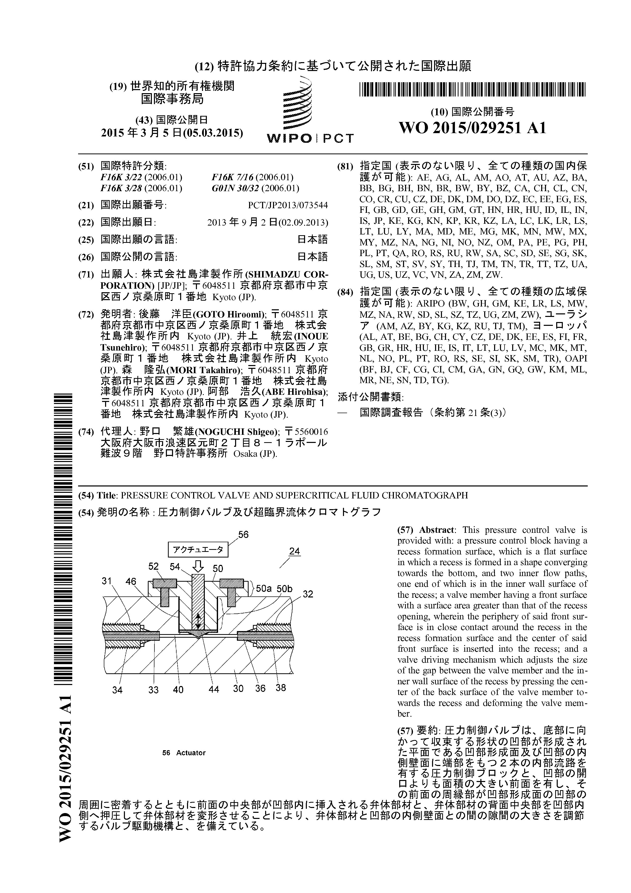

Example 2: Abstract Text Over 400 Words
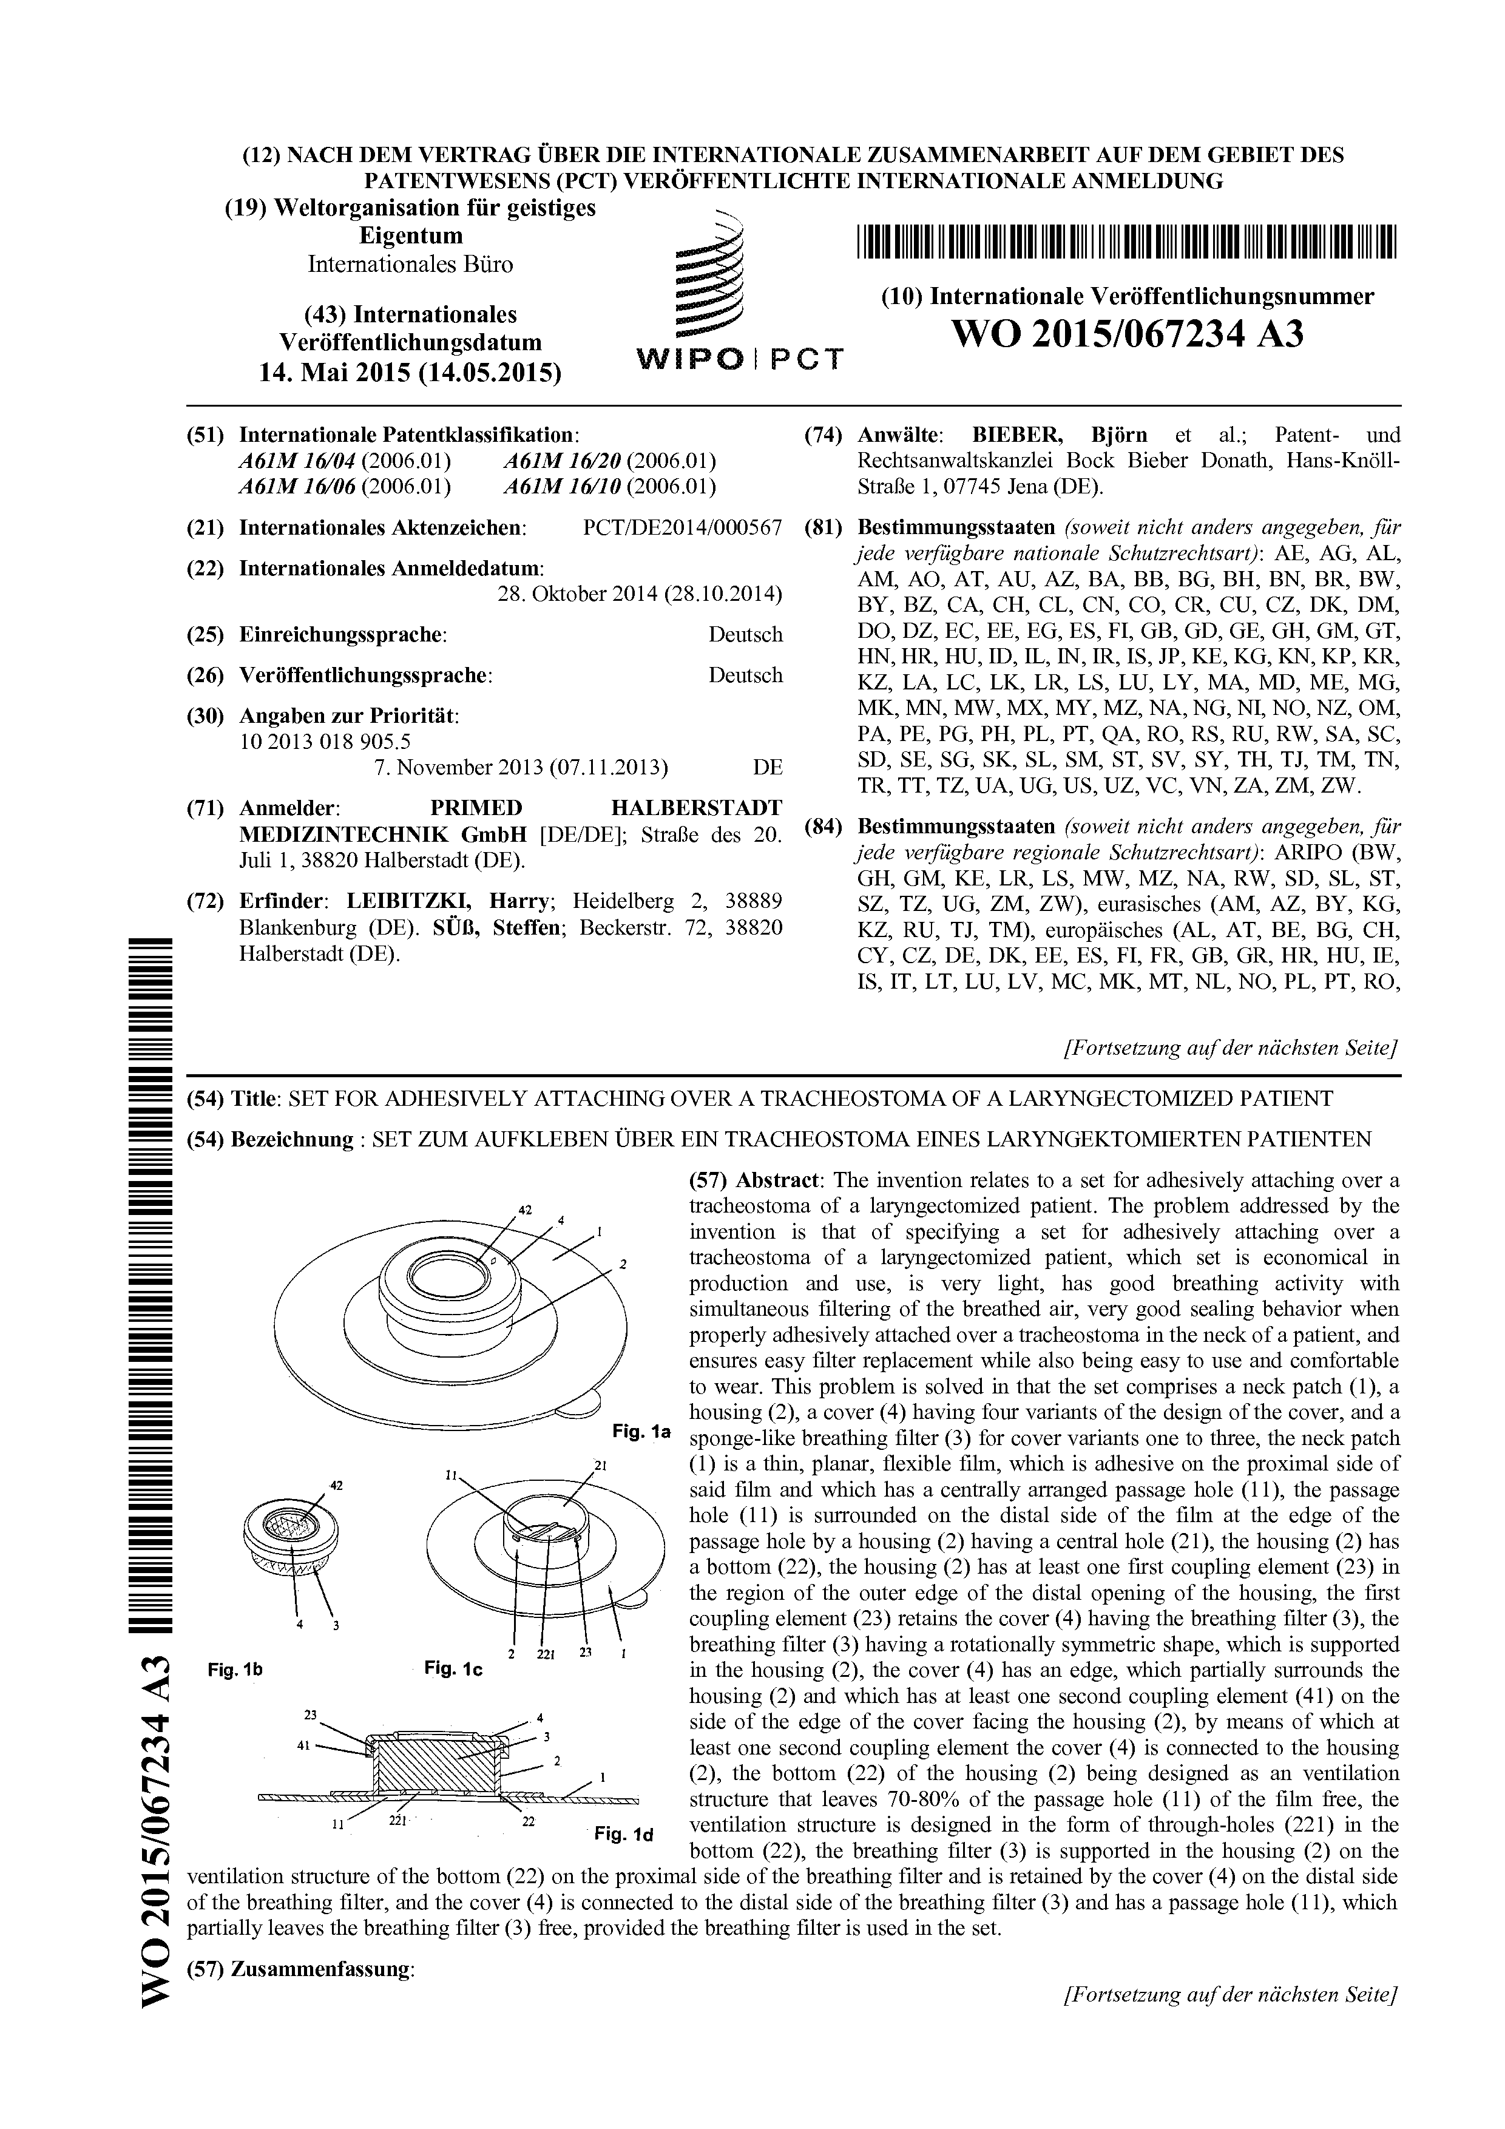

Example 3: Very Short Abstract, More text in Accompanying Drawing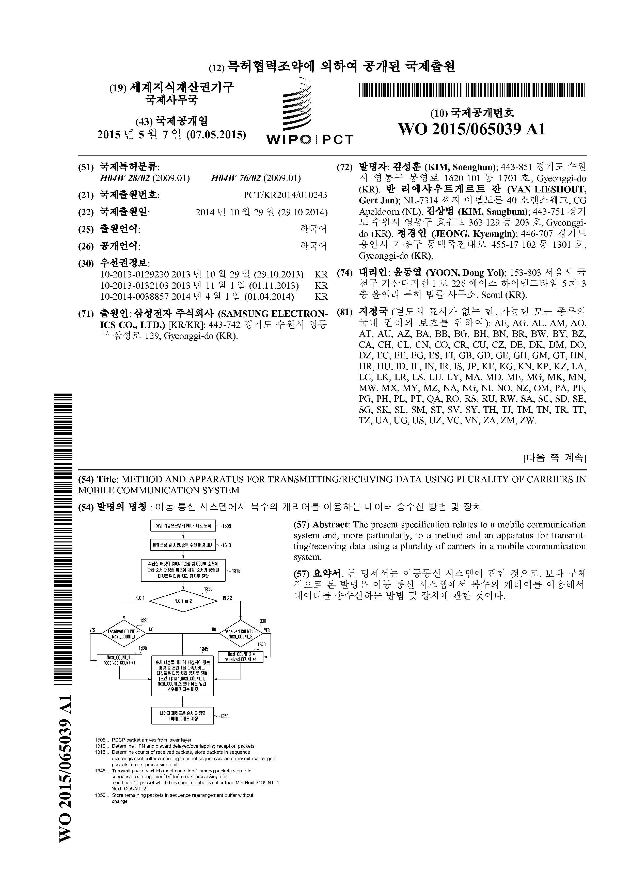

Example 4: Very Large Quantities of Text in Accompanying Drawing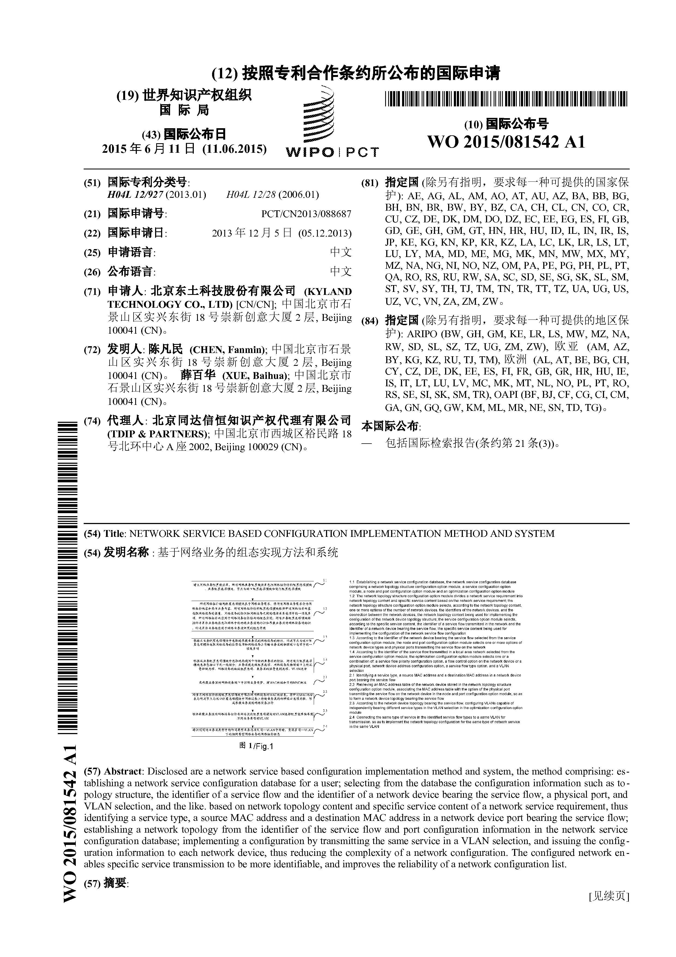

[End of Annex and of document]

