E
PCT/WG/7/12
ORIGINAL: English
DATE: April 22, 2014

Patent Cooperation Treaty (PCT)
Working Group

Seventh Session
Geneva, June 10 to 13, 2014

National Phase Entry Using ePCT

Document prepared by the International Bureau

Summary
- A concept is outlined for using ePCT to trigger national phase entry. Most of the documents and bibliographic data which designated Offices need to commence national phase processing are held on file by the International Bureau. Applicants could add any outstanding documents and information before requesting national phase entry. On confirming that a national phase entry request should be generated, a package would be created for the designated Office containing all the required bibliographic data and documents.
- This service would be convenient for applicants, but would also be extremely beneficial to designated Offices since it offers bibliographic data in electronic form with a great reduction in the risk of errors being introduced by the transcription of bibliographic data.
- Payment would, at the outset, still need to be made directly to the relevant designated Office, but the option of centralized payment services could be added at a later date if equivalent services, intended to be offered soon to receiving Offices, prove successful and designated Offices wished to take advantage of such an arrangement.

Background
- National phase entry typically requires considerable cooperation between agents in the applicant’s home country and in each country where national phase entry is to occur. ePCT offers an opportunity for this to occur in a secure, shared environment, where the different agents can review the draft documents and data before it is submitted and where most of the bibliographic data and original language documents can be provided from the international phase records, eliminating the time and risk of errors involved in transcribing the information to local forms.
- There should be few, if any, legal barriers to beginning to use such an arrangement:
  - Each international application involved is already a national application in each designated State.
  - Already today, the designated Offices are acting on the application body, bibliographic data, priority documents and other documents submitted to them by the International Bureau.
  - The Treaty explicitly precludes national Offices from having any requirements to be met in order to enter the national phase, save for (i) payment of a fee and (ii) where relevant, furnishing of a translation (and also a copy of the international application and certain details about inventors in circumstances which are not relevant to this issue). In particular, Offices are not permitted to require the use of a specific national form for national phase entry, even though optional forms are in fact provided and used in most cases.
  - The service would be optional for any designated Office wishing to participate.

Outline of the Proposal
- Participating designated Offices would confirm a number of details of their requirements for national phase entry, such as:
  - the latest date for national phase entry (typically 30 to 33 months from the priority date);
  - what languages are permitted for national phase processing;
  - whether applicant names and addresses can be accepted in the latin character set or are required to be translated or transliterated into the character set of the relevant national language if not already available (for the international phase, the International Bureau holds names and addresses in the character set of the language of international publication and, where different, the latin character set);
  - whether a translation into a national language is required at the time of national phase entry (if the international application has not already been filed or published in such a language) or, if not, within what additional period it needs to be provided;
  - whether a local agent or address for service is required;
  - the level of any fee for national phase entry and the time by which it needs to be paid.
- The applicant would be allowed to select one or more participating designated Offices for which national phase entries were to be prepared. The main applicant or agent could give ePCT access to the international application to agents in the countries where national phase entry was being considered. The system would allow any person with eEditor or eOwner rights to add or modify the additional data and documents and those with eViewer rights to review, but not to change.
- Figure 1, below, shows an illustrative mockup of an ePCT national phase information page, showing details of national phase entries which had been confirmed by designated Offices (including ones where the national phase entry had been requested in the conventional way), national phase entry requests which had been submitted via ePCT and draft national phase entry requests which were in the process of preparation. Links to national private or public online file inspection systems might be provided where appropriate.
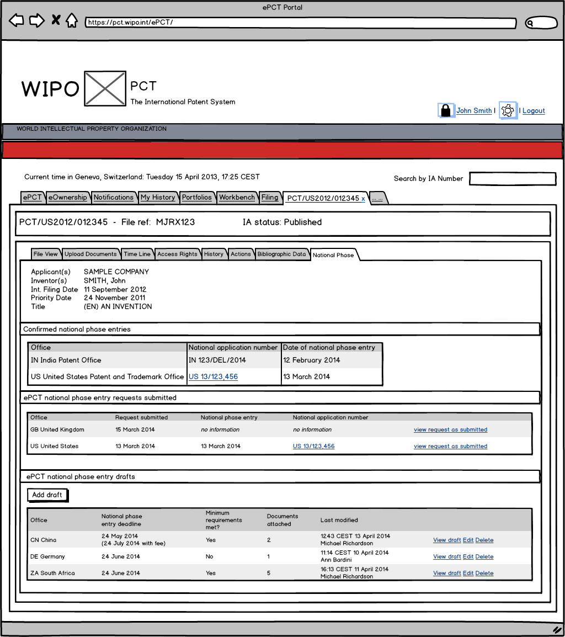Figure 1: Illustrative mockup of national phase entry information page
- Typically, a user (who could be the international phase agent, the proposed national phase agent or joint) would be required to enter or upload (where relevant):
  - a local address for service (for the local national phase entry, this could involve simply indicating that the international phase address for service would also be used for the national phase);
  - an indication of the language to be used for the national phase (where the designated Office offers a choice);
  - translations or transliterations of applicant names (and potentially addresses);
  - an indication of whether the national phase entry was to be on the basis of the international application as filed, as amended under Article 19, as amended under Article 34, or in a form amended specifically for the purpose of the individual national phase;
  - a translation of the title of the invention into a national language;
  - a translation of the application body into a national language; and
  - an indication of whether national phase processing was to start immediately on receipt of the request for national phase entry or only on expiry of the applicable time limit under Article 22.
- The user would also be permitted to enter or upload additional documents, such as powers of attorney or declarations of the type envisaged in Rule 51bis.
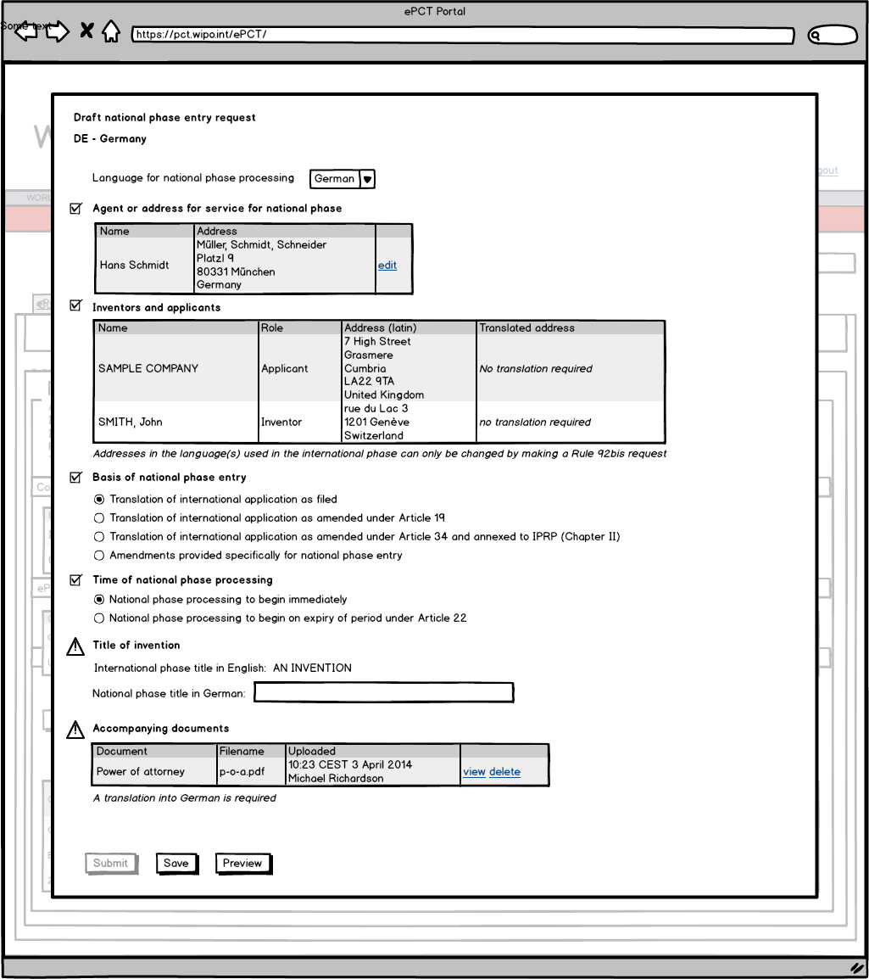Figure 2: Illustrative mockup of data entry for a national phase entry request
- Figure 2 shows an illustrative mockup of a data entry page for preparing a national phase entry request for Germany – an address for service has been entered and the basis of national phase entry indicated, but the “submit” button is not enabled because the German title of the invention has not been entered and a German language translation needs to be uploaded.
- Once all of the required data was entered, a “submit” button would become available. This would cause a national phase entry request to be created for the relevant designated Office, consisting of a package including:
  - a national phase entry request form in XML and image formats – the image version would be rendered in the language of national phase entry, at least where this was one of the PCT languages of publication; the XML would allow the data to be uploaded easily into national IT systems;
  - if so requested by the designated Office in configuration of the service, key documents from the international phase file, such as the international application, any amendments and priority documents;
  - copies of all the documents specifically uploaded.
- The package would be transmitted to the relevant designated Office by PCT-EDI (an existing batch delivery service for documents and data which typically runs daily) or potentially a web services automation (which would allow the applicant to receive an immediate confirmation of receipt in most cases).
- The rendered version of the form delivered to the designated Office would be in the language selected by the applicant for national phase processing if that were a PCT language of publication, or in a language of publication selected by the designated Office otherwise.
- The applicant would initially need to pay any fees required on national phase entry directly to the designated Office. The option of centralized payment services could be added at a later date if equivalent services, intended to be offered soon to receiving Offices, prove successful and designated Offices wished to take advantage of such an arrangement.
- Ideally, designated Offices would confirm receipt of the requests for national phase entry as soon as possible and provide information on national application numbers as soon as they had been assigned. This information would be made available to the applicant through ePCT and to the public via PATENTSCOPE.
- If demand existed, an IPAS module which is presently being tested, designed to assist Offices with the collection of documents and data required for national phase entry, could be modified to permit receipt and import of the relevant information so that designated Offices using that system could benefit from this approach.

Benefits of the Proposed System
- The system could reduce costs for applicants and designated Offices by allowing a cheap, secure and effective means of collaboration between applicants (or the main agents used for the international phase) and national phase applicants, resulting in receipt of data with reduced risk of errors having been introduced compared to filling in a traditional national phase entry form.
- The system could also bring advantages to third parties in that it offers directly an increased visibility of national phase entry information and also provides an incentive to improve the delivery of national phase entry information more generally. This may lead to improved patent information services, better able to answer the question of where patent protection has not been sought for a particular invention.

Further Work
- As indicated, the mockups above are provided merely for illustrative purposes. Some illustrative package samples are also available from the WIPO website.
- A final system would likely look considerably different and might require some additional information. Notably, careful consideration needs to be given to the approach to entering names and addresses in different languages or character sets to provide a simple interface where the information need only be entered once in each version.
- The International Bureau would work with interested designated Offices to identify what information is essential to assist effective national phase entry and to ensure that it was presented in a manner which could be used by any participating designated Office in a consistent format.
- The Working Group is invited to consider the proposal set out in this document.

[End of document]

IPAS: the Industrial Property Automation System offered by WIPO. See http://www.wipo.int/global_ip/en/activities/technicalassistance/
See http://www.wipo.int/efiling_standard/en/pre-pfc/

