 |  | E
PCT/WG/5/17
ORIGINAL: English
DATE: april 3, 2012

Patent Cooperation Treaty (PCT)
Working Group

Fifth Session
Geneva, May 29 to June 1, 2012

Revision of WIPO Standard ST.14

Document prepared by the International Bureau

1 The Meeting of International Authorities, at its 19th session, which took place in Canberra from February 8 to 10, 2012, discussed a proposal by the International Bureau (document PCT/MIA/19/11) to create a task force under the Committee on WIPO Standards (CWS) to consider the revision of WIPO Standard ST.14. The aim of such revision would be to create new document category codes to replace category “X” in WIPO Standard ST.14, distinguishing between documents which are relevant to novelty and those which are relevant to inventive step when the corresponding document is taken alone. It was further proposed that the mandate of the task force should extend to all matters within the scope of ST.14, including the definition of citation categories and the recommended presentation of non-patent literature.

2 While some International Authorities expressed certain reservations, the Meeting of International Authorities recommended that the International Bureau should propose the creation of such a task force to the CWS (see the report of the session, document PCT/MIA/19/14,reproduced in the Annex to document PCT/WG/5/2). A proposal to that effect has consequently been submitted to the CWS, for consideration at its upcoming second session, scheduled to take place in Geneva from April 30 to May 4, 2012.

3 Document CWS/2/6, setting out the proposal submitted to the CWS to create a task force to consider the revision of WIPO Standard ST.14, as well as further background on the aim of such a revision, is reproduced in the Annex to this document.

4 The International Bureau will report orally to the Working Group on the outcome of the discussions by the CWS.

5 The Meeting is invited to note the contents of the present document.

[Annex follows]
PROPOSAL FOR THE REVISION OF WIPO STANDARD ST.14

(reproduced from document CWS/2/6)

INTRODUCTION
1. Following the invitation by the International Bureau, the Meeting of International Authorities under the Patent Cooperation Treaty (PCT/MIA), at its nineteenth session, held from February 8 to 10, 2012, discussed whether it was desirable for the International Bureau to propose a revision of WIPO Standard ST.14. The purpose of that task should be to review the recommendations provided in paragraph 14 of the Standard with regard to some category codes to be placed next to any document (reference) cited in search reports, as well as to consider the convenience of bringing WIPO Standard ST.14 in line with the recent version of International Standard ISO 690: 2010 (Information and documentation – Guidelines for bibliographic references and citations to information resources). (WIPO Standard ST.14 is available at: http://www.wipo.int/export/sites/www/standards/en/pdf/03-14-01.pdf)

2. While some International Authorities expressed certain reservations, the PCT/MIA recommended that the International Bureau should propose the creation of a task force under the Committee on WIPO Standards (CWS) to consider revision of WIPO Standard ST.14. The PCT/MIA also recommended that the draft mandate of such a task force should extend to all matters within the scope of WIPO Standard ST.14, including the definition of citation categories and the recommended presentation of non-patent literature. (See document PCT/MIA/19/11, and paragraph 40 of PCT/MIA/19/13.)

WIPO STANDARD ST.14 CATEGORY CODES
3. The current version of WIPO Standard ST.14 recommends that documents (references) of particular relevance cited in the search report should be categorized by the following letters:

- Category “X”: the claimed invention cannot be considered novel or cannot be considered to involve an inventive step when the document is taken alone; and

- Category “Y”: the claimed invention cannot be considered to involve an inventive step when the document is combined with one or more other such documents, such combination being obvious to a person skilled in the art.

4. With regard to documents (references) of particular relevance to inventive step, the European Patent Office (EPO) made the following announcement in EPO Newsletter 23/2011:

“ ‘I’ citations available in the Register”

“For some time, the EPO has been using – internally, not in the search reports themselves – the "I" citation category to indicate documents which, taken alone, cast doubt on inventive step. Since August, we have now made this new category available to the public in the European Patent Register.”
Sample extract from European Patent Register, showing “I” category documents, which appear as “X” on the European Search Report.
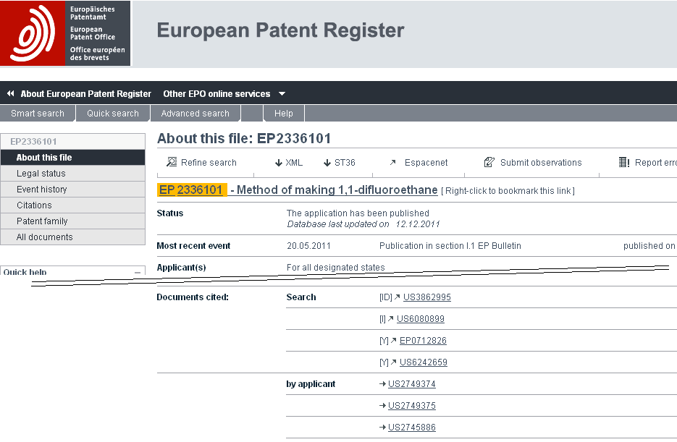

5. Therefore, according to the current EPO practice, documents which are relevant, taken alone, to inventive step continue to be cited in search reports as category “X” in accordance with WIPO Standard ST.14, but more detailed information may be available online through the European Patent Register as shown above, or other systems such as the Trilateral Common Citation Document.

6. The International Bureau believes that it would now be useful to introduce a distinction in search reports between documents cited for novelty and documents cited for their relevance to inventive step when taken alone, as this distinction would help to clarify the specific relevance of cited documents. Such a change has become particularly appropriate because of the increasing desire to obtain and consider national, regional and international search reports on related patent applications in other Offices. Further consideration regarding this change to WIPO Standard ST.14 may be found in paragraphs 4, 8 and 9 of document PCT/MIA/19/11.

7. Therefore, the International Bureau proposes to create a task force with a mandate to review WIPO Standard ST.14 based on a first draft proposal for new category codes relating to novelty and inventive step as follows:

Category “N”: The claimed invention cannot be considered novel when the document is taken alone.

Category “I”: The claimed invention cannot be considered to involve an inventive step when the document is taken alone.

Category “Y”: The claimed invention cannot be considered to involve an inventive step when the document is combined with one or more other such documents, such combination being obvious to a person skilled in the art.
Category “X”: This category was previously recommended to indicate that the claimed invention cannot be considered novel or cannot be considered to involve an inventive step when the document is taken alone. New search reports should no longer use this category. The more specific categories “N” or “I” should be used instead.

8. Among other categories indicating cited documents (references) of other relevant prior art, paragraph 14 of WIPO Standard ST.14 defines categories “E”, “O” and “P” as follows:

Category “E”: Earlier patent document as defined in Rule 33.1(c) of the Regulations under the PCT, but published on or after the international filing date;

Category “O”: Document referring to an oral disclosure, use, exhibition or other means;

Category “P”: Document published prior to the filing date (in the case of the PCT, the international filing date) but later than the priority date claimed in the application. Code “P” should always be accompanied by one of the categories “X”, “Y” or “A”;

9. As indicated in document PCT/MIA/19/11, some consideration might also be given to the above-mentioned definitions of categories “E”, “O” and “P” for their improvement. Paragraphs 10 to 15, below, reproduce the comments stated in the PCT/MIA document with regard to the said category codes.

10. The purpose of category P is essentially to indicate that the examiner will need to give careful consideration to the validity of the priority date of the application against which the document is cited. If the citation is published on the priority date of the application being searched, it has no effect if the priority is valid and discloses the relevant subject matter, but can be cited for novelty and inventive step if the priority is invalid. As such, a document published on the priority date falls into the same category as documents which are published after the priority date but before the filing date. Consequently, a better definition of the category might be:

“Category ‘P’: Document published prior to the filing date (in the case of the PCT, the international filing date) but on the priority date or on a date later than the priority date claimed in the application. Code ‘P’ should always be accompanied by one of the categories ‘X’, ‘Y’ or ‘A’.”

11. Secondly, category P “should always be accompanied by one of the categories ‘X’, ‘Y’ or ‘A’” (or new categories “I” or “N”, if agreed), whereas this is not stated to be the case for categories “O” and “E”.

12. On the face of it, such information should always be provided at least in the case of category “O”, since under most national laws, oral disclosures and exhibition count as prior art potentially relevant to both novelty and inventive step provided that their content can be proven. While this is not strictly prior art under the definitions in the PCT, such disclosures are nevertheless required to be included in the international search report and it would appear appropriate to indicate the nature of the potential relevance against the oral disclosure itself, rather than against any later document which is not citable in its own right but provides evidence of the earlier disclosure.

13. It may also be desirable to require categories “X”, “Y” or “A” (or “I” or “N”, if agreed) to be indicated next to category “E”. For most national laws, this is not necessary for purely domestic use since category “E” citations can only possibly be relevant for purposes equivalent to novelty so that “X” (or “N”, if agreed) can be implied. However, in a few States, earlier patent applications can also be cited for inventive step purposes, including in combination with other
documents. Consequently, for effective sharing of search reports, it would seem desirable to make explicit the potential relevance of an “E” category citation, if only so that category “E, Y” or “E, I” documents could be more quickly dismissed as irrelevant in States where they cannot be cited.

14. Finally, there is an agreed practice in the PCT International Search and Examination Guidelines (paragraph 16.67) whereby International Authorities should cite patent documents sharing the same date as the international application being searched and apply category E even though this is outside the definition of category E. This is a sensible procedure in practice to help Offices apply their anti-double-patenting laws, but has no basis in either the PCT Administrative Instructions or in WIPO Standard ST.14 for the category to mark the documents with. It may be desirable either to extend the definition of category E or to create a new category specifically for the purpose.

15. The Committee is invited to provide guidance whether the definitions of the said categories codes “E”, “O” and “P” should also be amended within the framework of the proposed revision of WIPO Standard ST.14.

INTERNATIONAL STANDARD ISO 690:2010
16. International Standards ISO 690:1987 (Documentation – Bibliographic references – Content, form and structure) and ISO 690-2:1997 (Information and documentation – Bibliographic references – Part 2: Electronic documents or parts thereof) are of relevance to current version of WIPO Standard ST.14, which was revised by the former Standards and Documentation Working Group (SDWG) for the last time in February 2008. The said two International Standards ISO 690 have been withdrawn and revised by the most recent International Standard ISO 690:2010 (Information and documentation – Guidelines for bibliographic references and citations to information resources).

17. International Standard ISO 690:2010 offers a more consistent approach to the citation of non-patent literature than in previous versions, on which the multiple categories of non-patent literature citations in WIPO Standard ST.14 is based. While the standards which it includes for citation of patent documents are clearly less useful for patent search reports than the existing ones, it may be desirable to assess whether the recommendations in relation to non-patent literature should be adopted or be taken in part to improve the recommendations in WIPO Standard ST.14.

PROPOSAL
18. It is expected that a proposal for revision of the categories of citations could be presented for adoption by the CWS in 2013, provided that the CWS approves the creation of the task and the establishment of the task force. If it is decided to include a review of the recommended format of non-patent literature citations based on ISO 690:2010, the work of the task force might easily take more than one year. In this case, it should be open to the task force to present proposals on the subject of citation categories to the CWS for adoption in 2013, as a first round, and to present proposals on format of non-patent literature citations to a later session.

19. In accordance with the above, the International Bureau proposes the following for consideration and approval by the CWS:

(a) the creation of a new task whose description would read as follows:

“Revision of WIPO Standard ST.14:

(i) Prepare a proposal for the revision of category codes provided in paragraph 14 of WIPO Standard ST.14 taking into account comments and draft proposals stated in paragraphs 7 and 10 to 14 of document CWS/2/6.

(ii) Study the convenience of revising the recommendations for the identification of non-patent literature citations in order to bring WIPO Standard ST.14 in line with the International Standard ISO 690:2010 (Information and documentation – Guidelines for bibliographic references and citations to information resources). If the revision is considered convenient, prepare the corresponding proposal.”

(b) the establishment of a new task force to handle the new task;

(c) the priority of the task force as follows: to first focus on finalizing the revision of WIPO Standard ST.10/C in regard to the recommendations concerning category codes; then this proposal should be presented for consideration and approval by the CWS at its session to be held in 2013. The task force should present the results of the study, along with any eventual proposal, regarding the identification of cited non-patent-literature and ISO 690:2010 at a later session of the CWS on the basis of the progress made and the agreements reached by the task force; and

(d) the designation of task force leaders after considering the convenience of having a different Leader for each one of the two parts of the task.

20. The International Bureau would be willing to act as a task force leader, if so requested, for a revision process which was limited to issues of citation category. However, it considers that issues related to format of non-patent literature citations would be better led by a representative of an Office which has greater practical experience in using the citations presented in search reports.

21. The CWS is invited to:

(a) note the invitation by the International Bureau to consider the revision of WIPO Standard ST.14 and the information provided in this document;

(b) consider the scope of the proposed task, i.e., whether the recommended format of non-patent literature citations should be revised in line with the recommendations of ISO 690:2010, as indicated in paragraph 17 above, or the revision should be limited to categories of citation only as introduced in paragraphs 7 and 10 to 14, above;

(c) consider and approve the proposal concerning the creation of a task for revision of WIPO Standard ST.14 as referred to in paragraph 19(a), above;

(d) consider and approve the establishment of a new task force to handle the new task as referred to in paragraph 19(b), above;

(e) consider and approve time frame for the new task as referred to in paragraph 19(c), above; and

(f) designate a task force leader(s) as referred to in paragraphs 19(d) and 20, above.

[End of Annex and of document]

