 |  | E
PCT/WG/5/13
ORIGINAL: English
DATE: April 5, 2012

Patent Cooperation Treaty (PCT)
Working Group

Fifth Session
Geneva, May 29 to June 1, 2012

Restoration of the right of priority

Document prepared by the International Bureau

summary
At the fourth session of the Working Group, held in June 2011, the International Bureau was requested to review the practices of Offices relating to the restoration of the right of priority under Rule 26bis.3 (receiving Offices) and Rules 49ter.1 and 2 (designated Offices), which entered into force on 1 July 2007. This document sets out a summary of the findings of the review carried out by the International Bureau and suggests areas of further work to address certain issues in relation to the operation of the above mentioned Rules.

Introduction
The PCT Union Assembly, at its September/October 2005 session, adopted amendments to the PCT Regulations providing for the restoration of the right of priority. New Rules 26bis.3 and 49ter were introduced with the aim of aligning the PCT with the provisions governing the restoration of the right of priority under the Patent Law Treaty (PLT). These amendments entered into force on April 1, 2007. New Rule 26bis.3 was further amended by the PCT Assembly at its September/October 2007 session, with effect from July 1, 2008.

At the Working Group’s fourth session, held in June 2011, the International Bureau was requested to review the practices of Offices relating to the restoration of the right of priority. The discussions in the Working Group are set out in paragraphs 284 and 285 of the report of the session (document PCT/WG/4/17), reproduced below:

“284. The Representative of the European Patent Office stated that, in 2012, the provisions on the restoration of the right of priority would have been in force for five years The European Patent Office therefore believed that it would be interesting at that point for an evaluation to be carried out by the International Bureau concerning potential statistics and practices of Offices that apply those provisions in their functions as a receiving Office during the international phase or as a designated Office on entry into the national or regional phase. This evaluation could also provide useful information to Offices acting as a designated Office applying the criterion for restoration of due care who are required, if necessary on the basis of Rule 49ter.1(d), to re-examine decisions of the receiving Office. This would thus clarify if, and to what extent, the standards for applying the criterion of “due care” varied between receiving Offices having this requirement in order to facilitate the work of designated Offices. Moreover, the information collected during the evaluation could also be useful to make any possible adjustments to these provisions deemed necessary, to exchange information and to inform Offices that have made “reservations” relating to these provisions who could then envisage lifting these reservations.

“285. In response to this suggestion, the International Bureau agreed to assess the practice under the Rules dealing with the restoration of the right of priority and to report back to the fifth session of the Working Group in 2012.”

This document contains the review of the restoration practices of various Offices in their capacities as receiving Offices and designated Offices under the PCT.

RESTORATION OF THE RIGHT OF PRIORITY under the Pct
The PCT deals with the issue of the restoration of the right of priority under two different aspects: (i) requests for the restoration of the right of priority by the receiving Office during the international phase (Rule 26bis.3) and the effect of any decision by the receiving Office on designated Offices during the national phase (Rule 49ter.1); and (ii) requests for restoration of the right of priority by designated Offices during the national phase (Rule 49ter.2).

Restoration of the Right of Priority by Receiving Offices
In general, each receiving Office is to apply the PCT provisions on restoration of the right of priority. Rule 26bis.3(a) provides that each receiving Office must, on request of the applicant, restore the right of priority if the Office finds that the criterion applied by it is satisfied, namely, that the failure to file the international application within the priority period occurred in spite of due care required by the circumstances having been taken “(due care criterion”) or was unintentional (“unintentional criterion”). Each receiving Office must apply at least one of those criteria and may apply both of them.

The only exception to the general rule that each receiving Office is to apply the PCT provisions on restoration of the right of priority is set out in Rule 26bis.3(j), which provides an “opt out” for those receiving Offices which, by April 5, 2006, had notified the International Bureau that the PCT provisions dealing with the restoration of the right of priority by receiving Offices were, on October 5, 2005, not compatible with the national law applied by the receiving Office concerned. Originally, 21 receiving Offices made use of that option and notified the International Bureau accordingly. Of those 21 Offices, five have since withdrawn their notice of incompatibility. Thus, today, the PCT provisions dealing with the restoration of the right of priority by receiving Offices are to be applied by all receiving Offices except for those whose notice of incompatibility is still in force. Those are the Offices of the following 16 PCT Contracting States: Algeria, Belgium, Brazil, Colombia, Cuba, Czech Republic, Germany, Greece, India, Indonesia, Italy, Japan, Republic of Korea, Norway, Philippines and Spain.

Criteria Applied by Receiving Offices
Of all Offices of PCT Contracting States, 85 Offices have informed the International Bureau of the criteria for the restoration of the right of priority applied by them either in their capacity as a receiving Office and/or a designated Office. This information has been made available on WIPO’s website (http://www.wipo.int/pct/en/texts/restoration.html) and is reproduced in Annex I to this document. For the remainder of Offices, the International Bureau has not received any information on the criteria applied.

Of the receiving Offices which apply the PCT provisions dealing with the restoration of the right of priority and which have informed the International Bureau of the criteria applied by them (a total of 51 receiving Offices), 50% apply the “due care” criterion, 15% apply the “unintentional” criterion and 35% apply both criteria.

Fees
Some receiving Offices do not charge any fee for the processing of requests for restoration. Most receiving Offices which informed the International Bureau about their practices in relation to requests for restoration charge a fixed processing fee. One receiving Office differentiates between online and paper filings of requests for restoration. Another Office charges three different levels of fees, one for individuals and research institutes, one for companies with less than 10 employees and one for companies with more than 10 employees.

Decisions Taken by Receiving Offices
An analysis of requests for restoration of the right of priority filed by applicants shows that, by the end of August 2011, a total of more than 1000 requests for restoration had been filed with receiving Offices bound by Rule 26bis.3. The by far largest number of requests for restoration has been filed with the International Bureau acting as a receiving Office (see below).

In order to analyze decisions taken by receiving Offices on requests for restoration, the International Bureau looked into the decisions by those receiving Offices which applied either the “due care” criterion or both the “due care” and the “unintentional” criteria, and which had received in total more than four requests for restoration. Decisions taken by receiving Offices which apply the “unintentional” criterion only were not analyzed since those decisions usually do not contain any explanations by the Office as to the reasons for its decision. The review thus focused on the practices of 13 receiving Offices.

Annex II contains an overview of the main findings of the review, which may be summarized as follows:

(a) The interpretation of the “due care” criterion differs slightly among the various receiving Offices. Some receiving Offices require that the error which led to the late filing of the international application was an isolated mistake within a normally satisfactory system. Other receiving Offices require that the applicant has done everything that reasonably could be expected of him to ensure that the application was filed in time. A few receiving Offices require that the failure to file the international application within the priority period was not in the control of the applicant. One Office requires that the failure to file the international application within the priority period occurred due to an unforeseeable impediment. Another receiving Office requires that the failure to file the international application within the priority period occurred due to an involuntary mistake by the applicant.
(b) A detailed analysis of the differing interpretations of the “due care” criterion by the various receiving Offices appears difficult in view of the fact that most of the situations which led to the failure to file the PCT application within the priority period appear unique. For example, in a number of cases, the failure to file the international application within the priority period was due to a medical condition. However, the medical conditions in the individual cases which prevented the applicants from filing the international application within the priority period differ, and so do the decisions by the receiving Offices.

(c) More generally, some Offices interpret the “due care” criterion rather strictly, while others would appear to take a more lenient approach. For example, some receiving Offices granted requests for the restoration of the right of priority based on the “due care” criterion where a docketing error in data entry by a paralegal led to the failure to file the international application within the priority period; others denied such requests on the basis of the “due care” criterion and only granted such requests on the “unintentional” criterion. On the other hand, in other cases Offices appear to have taken a very similar approach. For example, errors by a delivery service were considered by all Offices to qualify as an error which occurred despite “due care” exercised by the applicant.

(d) Due to the lack of sufficient information from receiving Offices it was not possible for the International Bureau to carry out a detailed analysis as to the question what kind of evidence is required by receiving Offices in support of the “statement of reasons”.

In addition, the following was noted as a result of the review:

(a) In some cases, receiving Offices do not submit to the International Bureau the “statement of reasons” provided by the applicant, which thus cannot be made available by the International Bureau to designated Offices (nor the public); consequently, it becomes very difficult if not impossible for designated Offices to perform the (limited) review of the decision by the receiving Office provided for in Rule 49ter.1(d).

(b) In some cases, receiving Offices do not give any reasons for their decisions, neither where restoration was granted or refused based on the “due care” criterion, nor where restoration was granted or refused based on the “unintentional” criterion. In such cases, only copies of Form PCT/RO/158 and/or Form PCT/RO/159, informing the applicant of the decision made, were submitted to the International Bureau, again making it very difficult if not impossible for designated Offices to perform the (limited) review of the decision by the receiving Office provided for in Rule 49ter.1(d).

(c) In some cases, applicants requested restoration based on both criteria, but the receiving Offices restored the right of priority based on the “unintentional” criterion without furnishing any explanation as to why the right of priority was not restored based on the “due care” criterion (the criterion which, if found to have been complied with, is more favorable for applicants in view of the fact that any decision to restore based on that criterion is effective in each designated State (see Rule 49ter.1(a)).

(d) In some cases, receiving Offices apparently do not give applicants first an opportunity to make observations on the intended refusal of a request for restoration (Form PCT/RO/158) before making a final decision (Form PCT/RO/159), as required by Rule 26bis.3(g).

The International Bureau as Receiving Office
At the end of March 2012, the International Bureau as a receiving Office had received and processed over 320 requests for restoration since April 2007. This includes requests for restoration in respect of international applications which were initially filed with a different receiving Office but later transferred to the International Bureau as a receiving Office under Rule 19.4 because the national receiving Office has notified the International Bureau of the incompatibility of the PCT provisions dealing with the restoration of the right of priority (see above) or only applied the “unintentional” criterion but the applicant requested to have the right of priority restored based on the “due care” criterion.

The International Bureau as a receiving Office applies both the “due care” and the “unintentional” criteria. Where an applicant has requested restoration on the basis of both criteria, or where the applicant did not specifically request restoration on the basis of only one of the criteria, the International Bureau first applies the stricter “due care” criterion and only if the applicant has failed to meet that criterion then considers the “unintentional” criterion. The International Bureau does not charge a fee for the processing of requests for restoration.

12% of applicants who filed a request for restoration of the right of priority with the International Bureau as a receiving Office did so based on the “unintentional” criterion only. The request was granted in all but two cases; one request was filed outside the two-month time limit under Rule 26bis.3, and one international application was withdrawn by the applicant before a decision on the request for restoration was made.

88% of applicants who filed a request for restoration of the right of priority with the International Bureau as receiving Office did so on the basis of both the “due care” and the “unintentional” criteria. Of the requests processed to date, the International Bureau as receiving Office granted the restoration based on the “due care” criterion in 22% of cases. In almost 65% of cases in which the applicant requested restoration based on both criteria, the International Bureau as receiving Office decided to restore the right of priority based on the “unintentional” criterion only. In 2.5% of the cases, the International Bureau refused the request for restoration because the applicant met neither the “due care” nor the “unintentional” criterion. In 2% of cases, the applicant withdrew the international application before a decision was made. In 4% of cases, the request was received outside the two-month time limit under PCT Rule 26bis.3. In 1.5% of cases, the applicant did not state the reasons for the failure to file the international application within the priority period, as required under PCT Rule 26bis.3(b)(ii).

A detailed analysis of the practice of the International Bureau as a receiving Office is attached as Annex III to this document.

Effect of Restoration of Right of Priority by Receiving Offices on Designated Offices
In general, where the receiving Office has restored the right of priority based on a finding by it that the failure to file the international application within the priority period occurred in spite of “due care” required by the circumstances having been taken, that restoration is (subject to certain limited exceptions provided for under Rule 49ter.1(c)), effective in each designated State. If, on the other hand, the receiving Office has restored the right of priority based on a finding by it that the failure to file the international application within the priority period was unintentional, that restoration is (subject to certain limited exceptions provided for under Rule 49ter.1(c)) effective in any designated State whose applicable national law provides for restoration of the right of priority based on that criterion or on a criterion which, from the viewpoint of applicants, is more favorable than that criterion.

The only exception to the general rule set out in paragraph , above, is set out in Rule 49ter.1(g), which provides an “opt out” for those designated Offices which, by April 5, 2006, had notified the International Bureau that the PCT provisions dealing with the effect of decisions by receiving Offices in designated States as set out in Rule 49ter.1 were, on October 5, 2005, not compatible with the national law applied by the designated Office concerned.

Originally, 24 designated Offices made use of that option and notified the International Bureau accordingly. Of those 24 Offices, five have since withdrawn their notice of incompatibility. Thus, today, the PCT provisions dealing with the effects of decisions by receiving Offices in designated States, as set out in Rule 49ter.1, are to be applied by all designated Offices except for those whose notice of incompatibility is still in force. Those are the Offices of the following 19 PCT Contracting States: Algeria, Brazil, Canada, China, Colombia, Cuba, Czech Republic, Germany, India, Indonesia, Japan, Republic of Korea, Latvia, Mexico, Norway, Philippines, Spain, Turkey and the United States of America.

In February 2012, the International Bureau sent a Questionnaire to the “top 20” designated Offices with the most national phase entries and which are required to apply the provisions of Rule 49ter.1 with regard to the effects of decisions on the restoration of the right of priority by receiving Offices (13 designated Offices in total). The purpose of the Questionnaire was to gather further information and feedback on the practice of the Offices with regard to international applications which had entered the national phase before the Office in respect of which the receiving Office had made a decision on the restoration of the right of priority under Rule 49ter.1.

Unfortunately, responses to the Questionnaire were received from only four Offices. Due to the limited number of responses, it was not possible for the International Bureau to carry out a meaningful analysis or to draw any meaningful conclusions as to the operation of Rule 49ter.1

Restoration of the right of priority by designated Offices
In addition to the provisions dealing with requests for restoration of the right of priority by the receiving Office during the international phase (Rule 26bis.3) and the effect of any decision by the receiving Office on designated Offices during the national phase (Rule 49ter.1), the PCT also provides for requests for restoration of the right of priority by designated Offices during the national phase (Rule 49ter.2).

In general, each designated Office is required, on request of the applicant, to restore the right of priority if the Office finds that the criterion applied by it is satisfied, namely, that the failure to file the international application within the priority period occurred in spite of due care required by the circumstances having been taken “(due care criterion”) or was unintentional (“unintentional criterion”); each designated Office must apply at least one of those criteria and may apply both of them (Rule 49ter.2(a)).

The only exception to the general rule that each designated Office is to apply the PCT provisions on restoration of the right of priority is set out in Rule 49ter.2(h), which provides an “opt out” for those designated Offices who, by April 5, 2006, had notified the International Bureau that the PCT provisions dealing with the restoration of the right of priority by designated Offices were, on October 5, 2005, not compatible with the national law applied by the designated Office concerned. Originally, 24 designated Offices made use of that option and notified the International Bureau accordingly. Of those 24 Offices, five have since withdrawn their notice of incompatibility. Thus, today, the PCT provisions dealing with the restoration of the right of priority by designated Offices are to be applied by all designated Offices except for those whose notice of incompatibility is still in force. Those are the Offices of the following 19 PCT Contracting States: Algeria, Brazil, Canada, China, Colombia, Cuba, Czech Republic, Germany, India, Indonesia, Japan, Republic of Korea, Latvia, Mexico, Norway, Philippines, Spain, Turkey and the United States of America.

The Questionnaire referred to in paragraph 23 above, sent to the “top 20” designated Offices with the most national phase entries, also sought further information and feedback on the practice of the designated Offices with regard to international applications which had entered the national phase before the Office concerned and in respect of which the applicant had specifically requested the designated Office to restore the right of priority. Unfortunately, due to the limited number of responses received by Offices, it was again not possible for the International Bureau to carry out a meaningful analysis or to draw any meaningful conclusions as to the operation of Rule 49ter.2.

Further work
The findings of the review carried out by the International Bureau outlined above suggest that there is “room for improvement” with regard to the way in which the PCT provisions for the restoration of the right of priority are being interpreted and applied by both receiving Offices and designated Offices. So as to move towards more consistent practices by Offices, it is proposed that the Working Group:

(a) invites receiving Offices and designated Offices to inform the International Bureau of the criteria applied by them for the restoration of the right of priority in their capacity as receiving Offices and designated Offices;

(b) invites receiving Offices to review their current practices to ensure that they are in accordance with the PCT Regulations and the guidance given to Offices in the PCT Receiving Office Guidelines, notably with regard to the safeguards built into the system, such as Rule 26bis.3(g), giving applicants the opportunity to make observations on an intended refusal of a request for restoration of the right of priority, are being applied;

(c) invites for receiving Offices to review their current practices to ensure that decisions to grant or to deny restoration of the right of priority contain all the necessary information to enable designated Offices to perform the (limited) review of the decision by the receiving Office provided for under Rule 49ter.1(d); in this context, the Working Group may wish to consider amending Rule 26bis.3 so as to require receiving Offices to submit to the International Bureau the “statement of reasons” provided by the applicant under Rule 26bis.3(b)(ii), any declaration or other evidence submitted by the applicant under Rule 26bis.3(b)(iii), and the reasons for the decision by the receiving Office so as to enable the International Bureau to publish that information in accordance with Rule 48.2(xi) and to make that information available to designated Offices; and

(d) invites the International Bureau to consult with Offices on possible modifications to the PCT Receiving Office Guidelines, with a view to providing further guidance to Offices on the application of the provisions dealing with the restoration of the right of priority, along the lines of the practice guidelines issued by the International Bureau for the staff of its receiving Office (RO/IB) (see Annex III to this document).

In addition, noting the considerable number of notices of incompatibility still in force, it is proposed that the Working Group invites those Offices which have submitted notices of incompatibility to the International Bureau under Rule 26bis.3(j) (receiving Offices) and Rules 49ter.1(g) and 49ter.2(h) (designated Offices) to consider reviewing their national laws with a view to being in a position to withdraw the notice of incompatibility in the not too distant future.

Finally, as noted above, due to the insufficient number of responses received by designated Offices in reply to the International Bureau’s Questionnaire, it was not possible for the International Bureau to carry out a meaningful analysis or to draw any meaningful conclusions as to the operation of Rules 49ter.1 and 49ter.2. It is thus proposed that the International Bureau again invites all designated Offices, by way of a Circular, to report on their experiences with regard to the operation of both Rules and to present its findings to the next session of the Working Group, provided that it receives sufficient feedback from Offices.

The Working Group is invited to comment on the issues raised in this document, including on the proposed further work set out in paragraphs 29 to 31, above

[Annexes follow]

table of Restoration of the right of priority by receiving Offices and designated Offices under PCT Rules 26BIS.3 and 49TER.2

(reproduced from WIPO’s website)
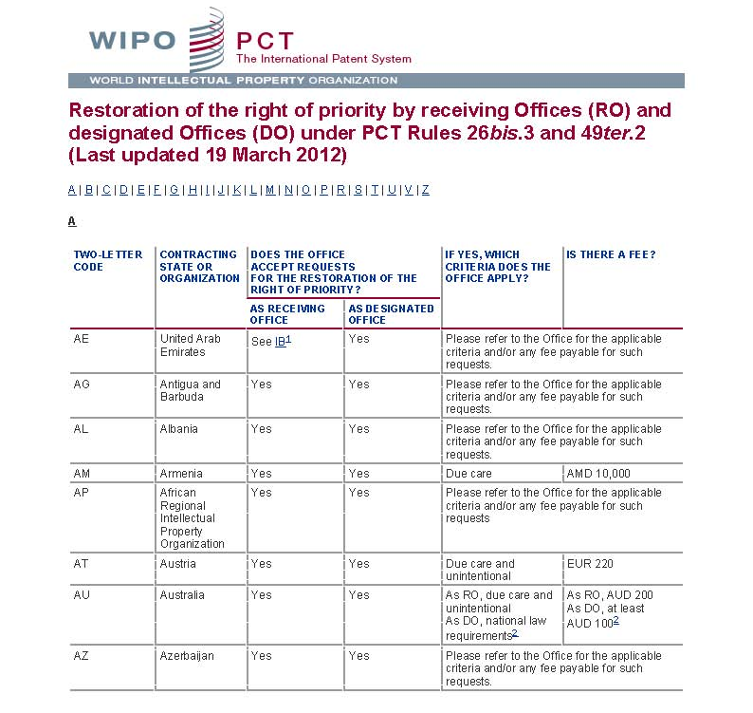
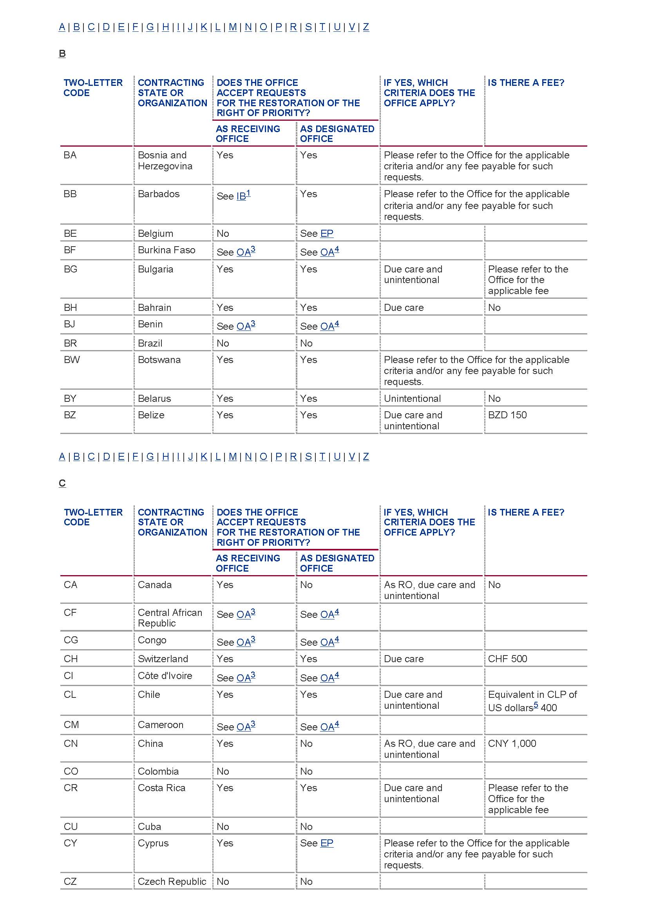
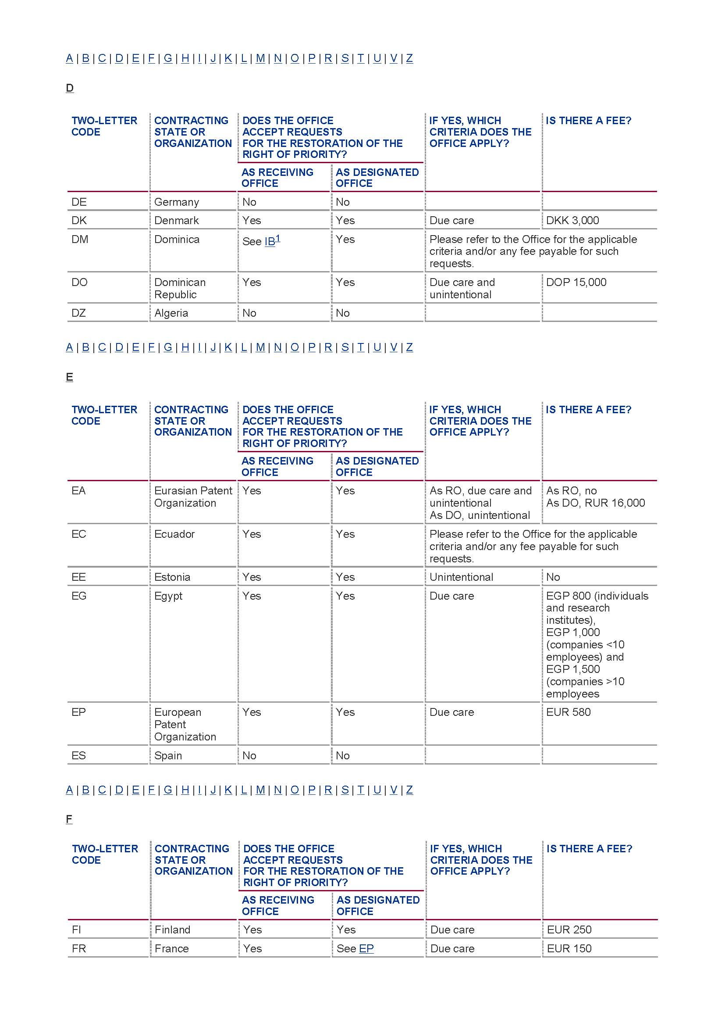
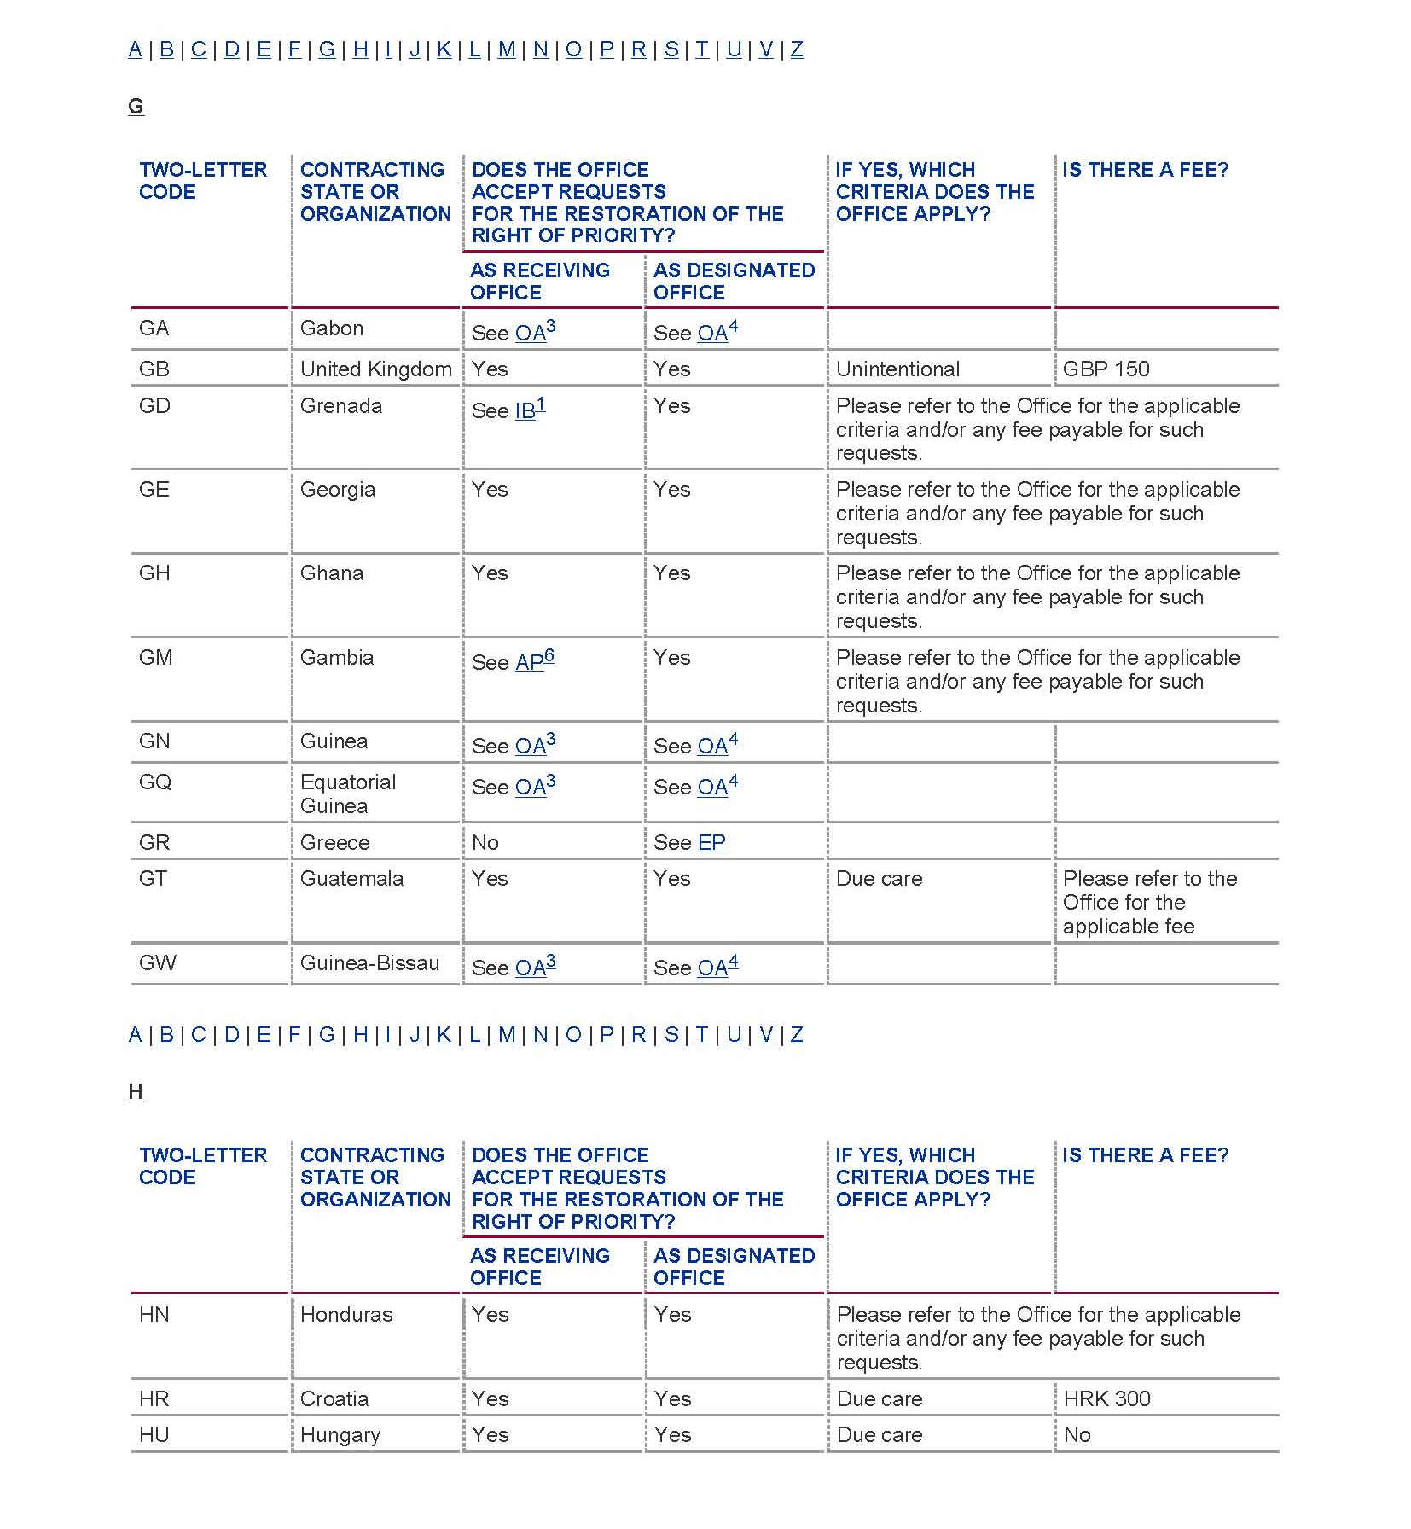
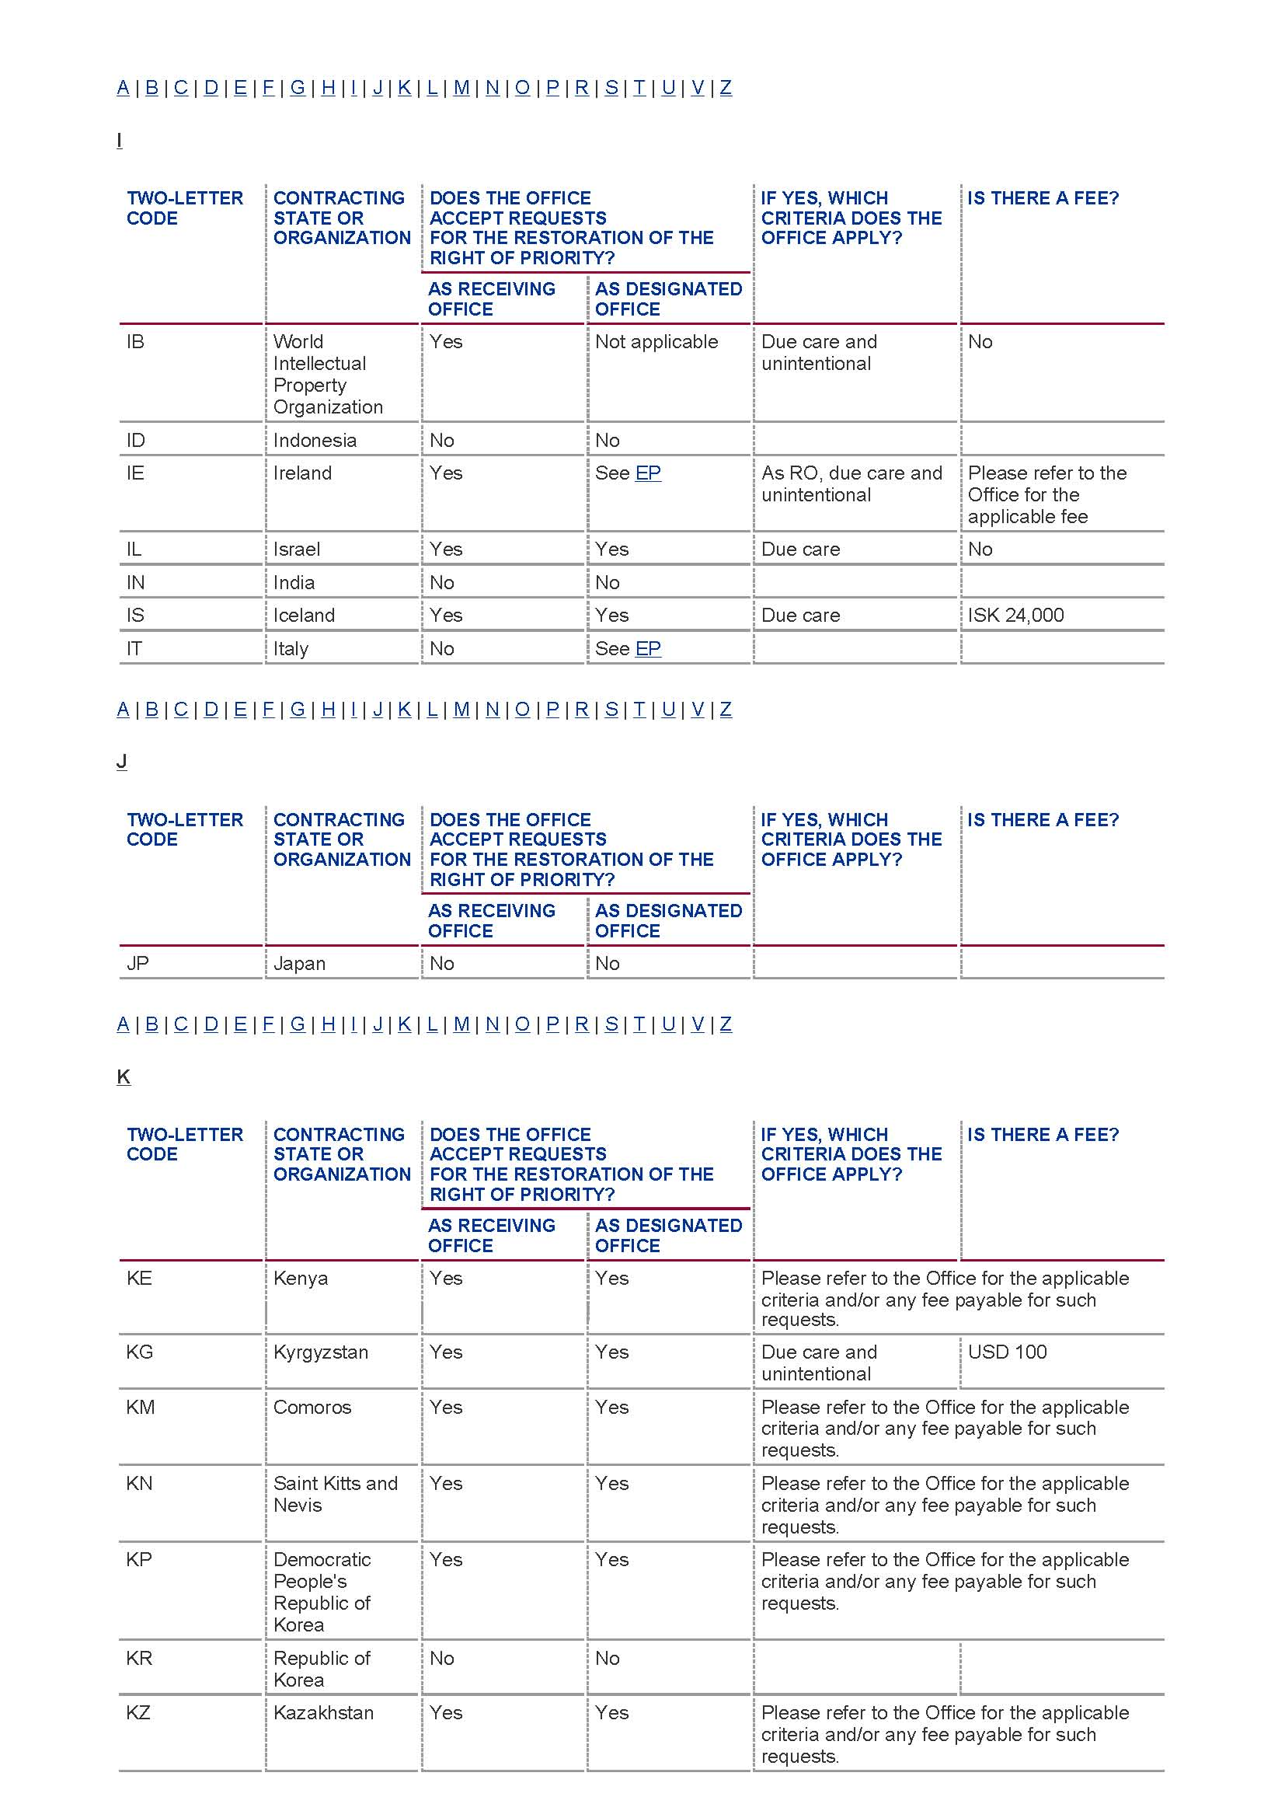
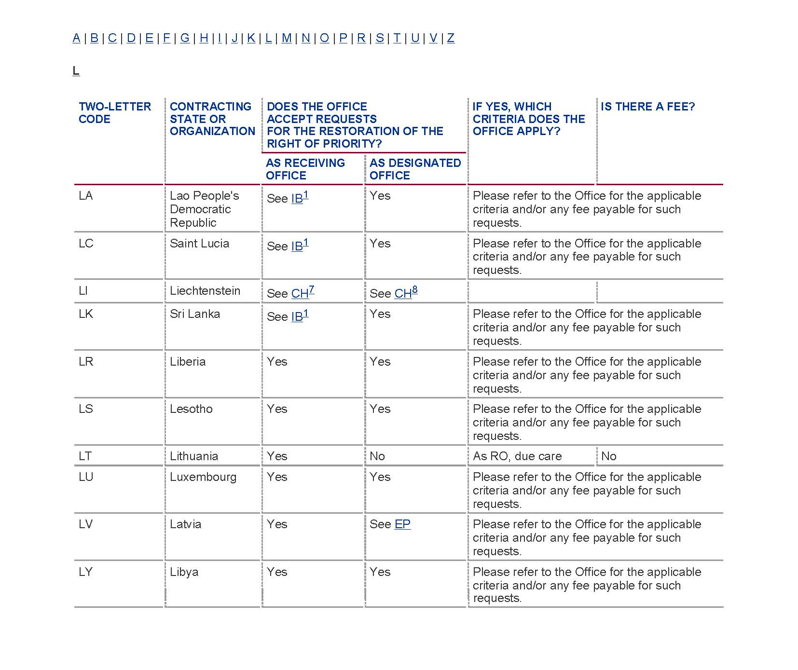
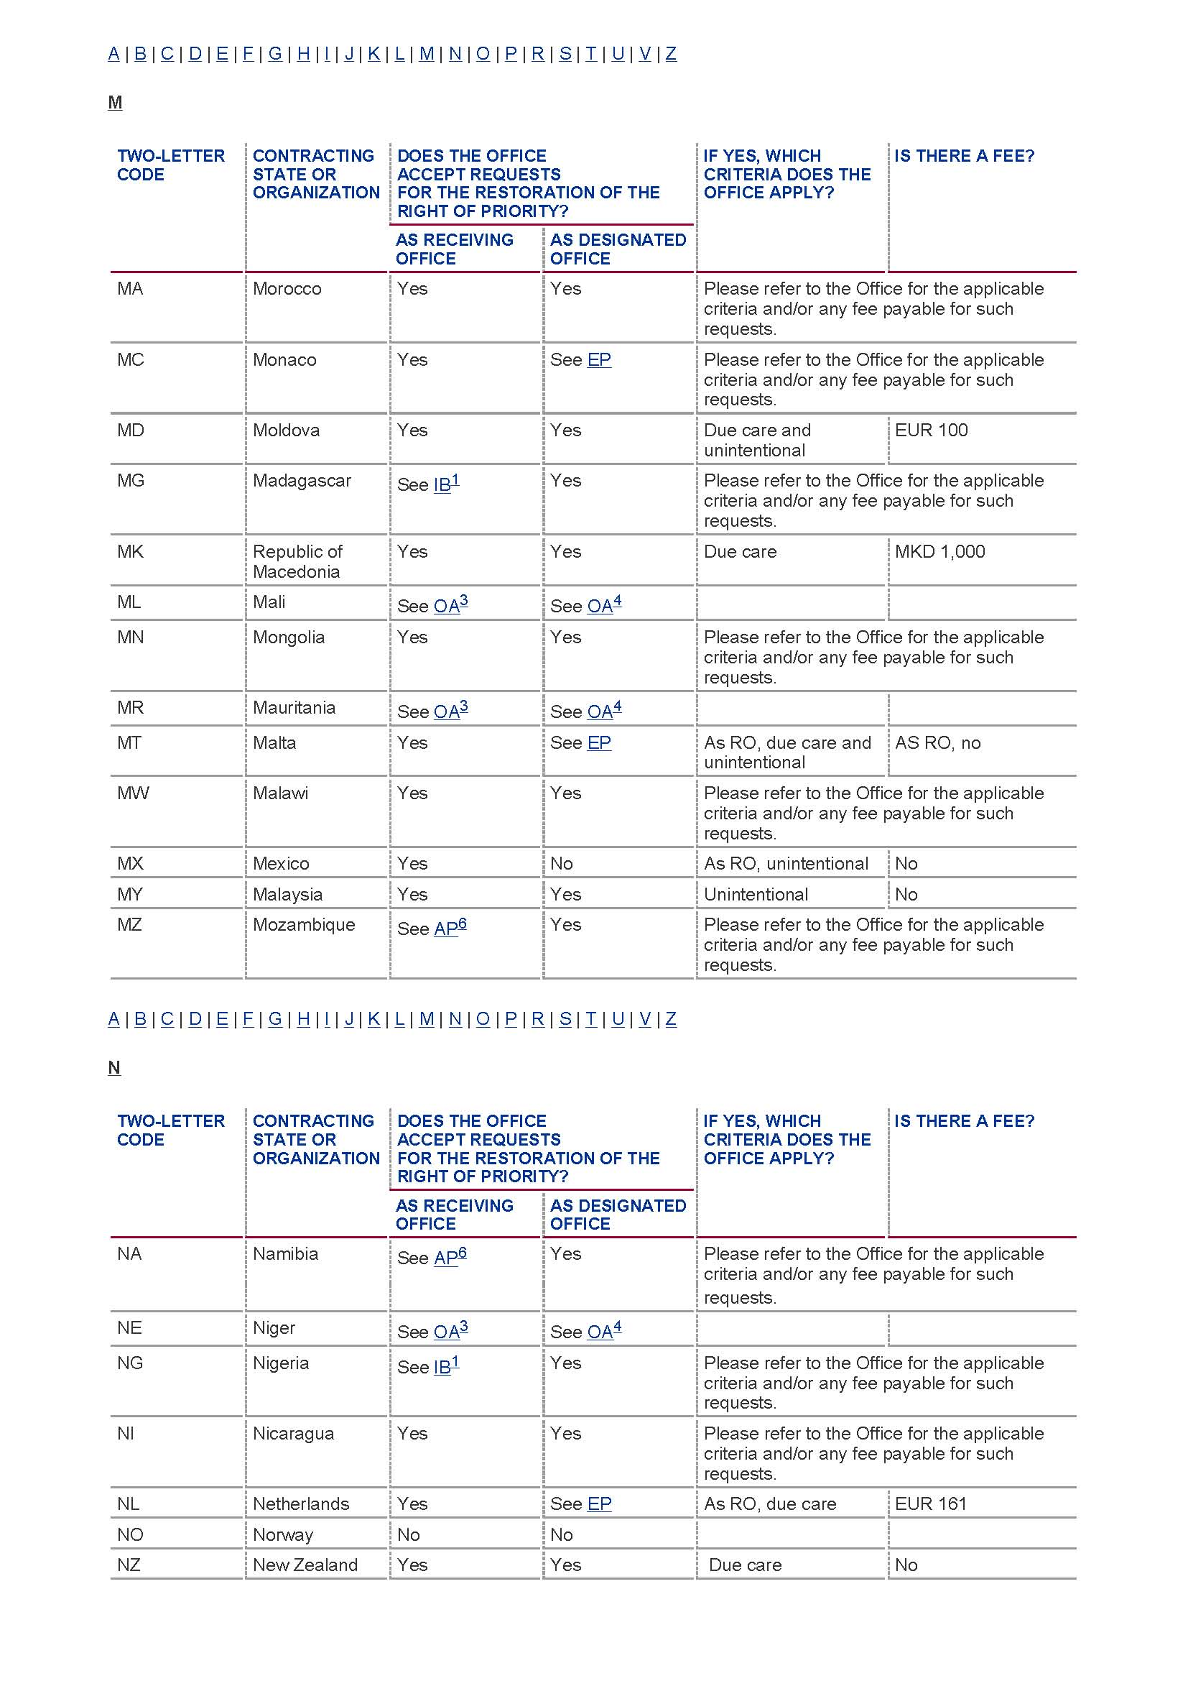
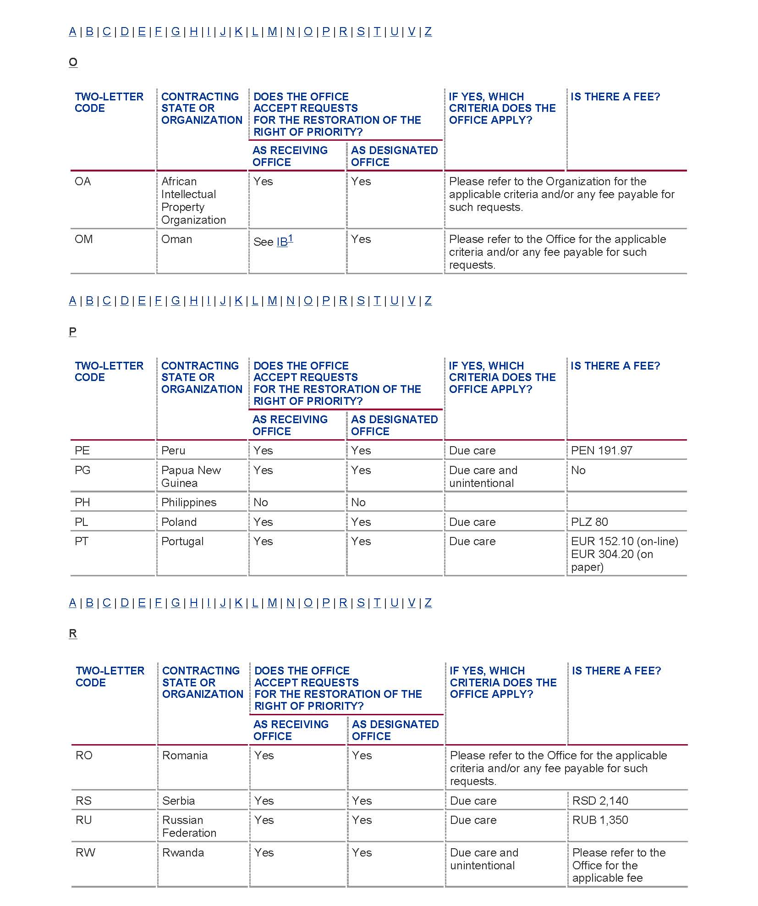
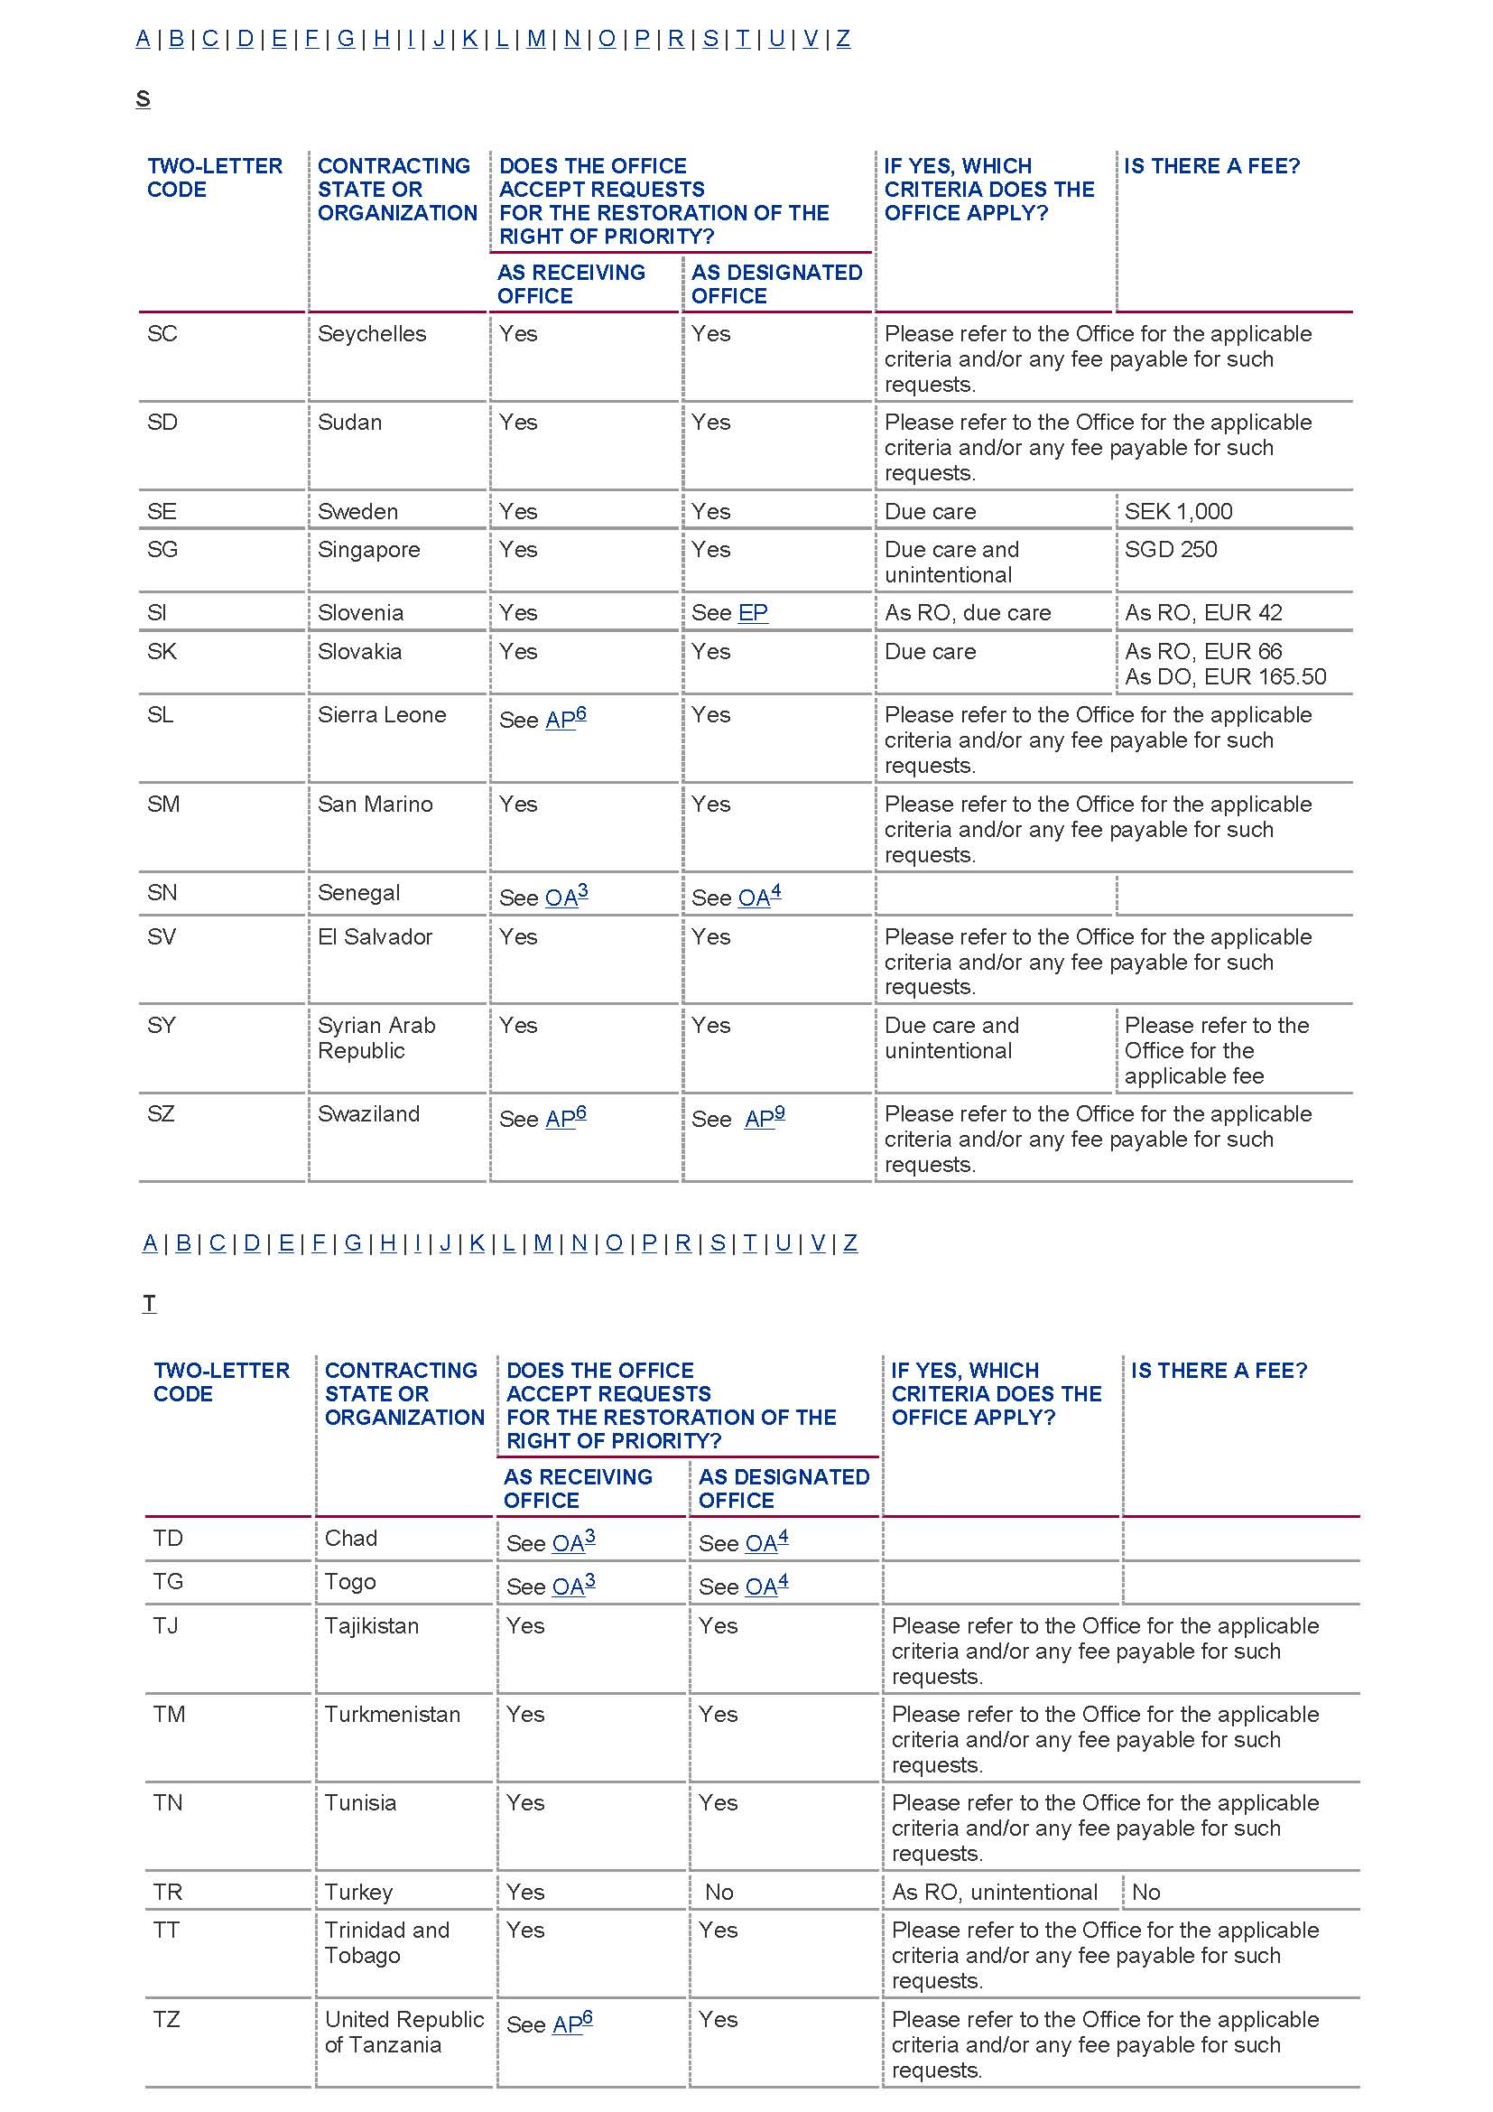
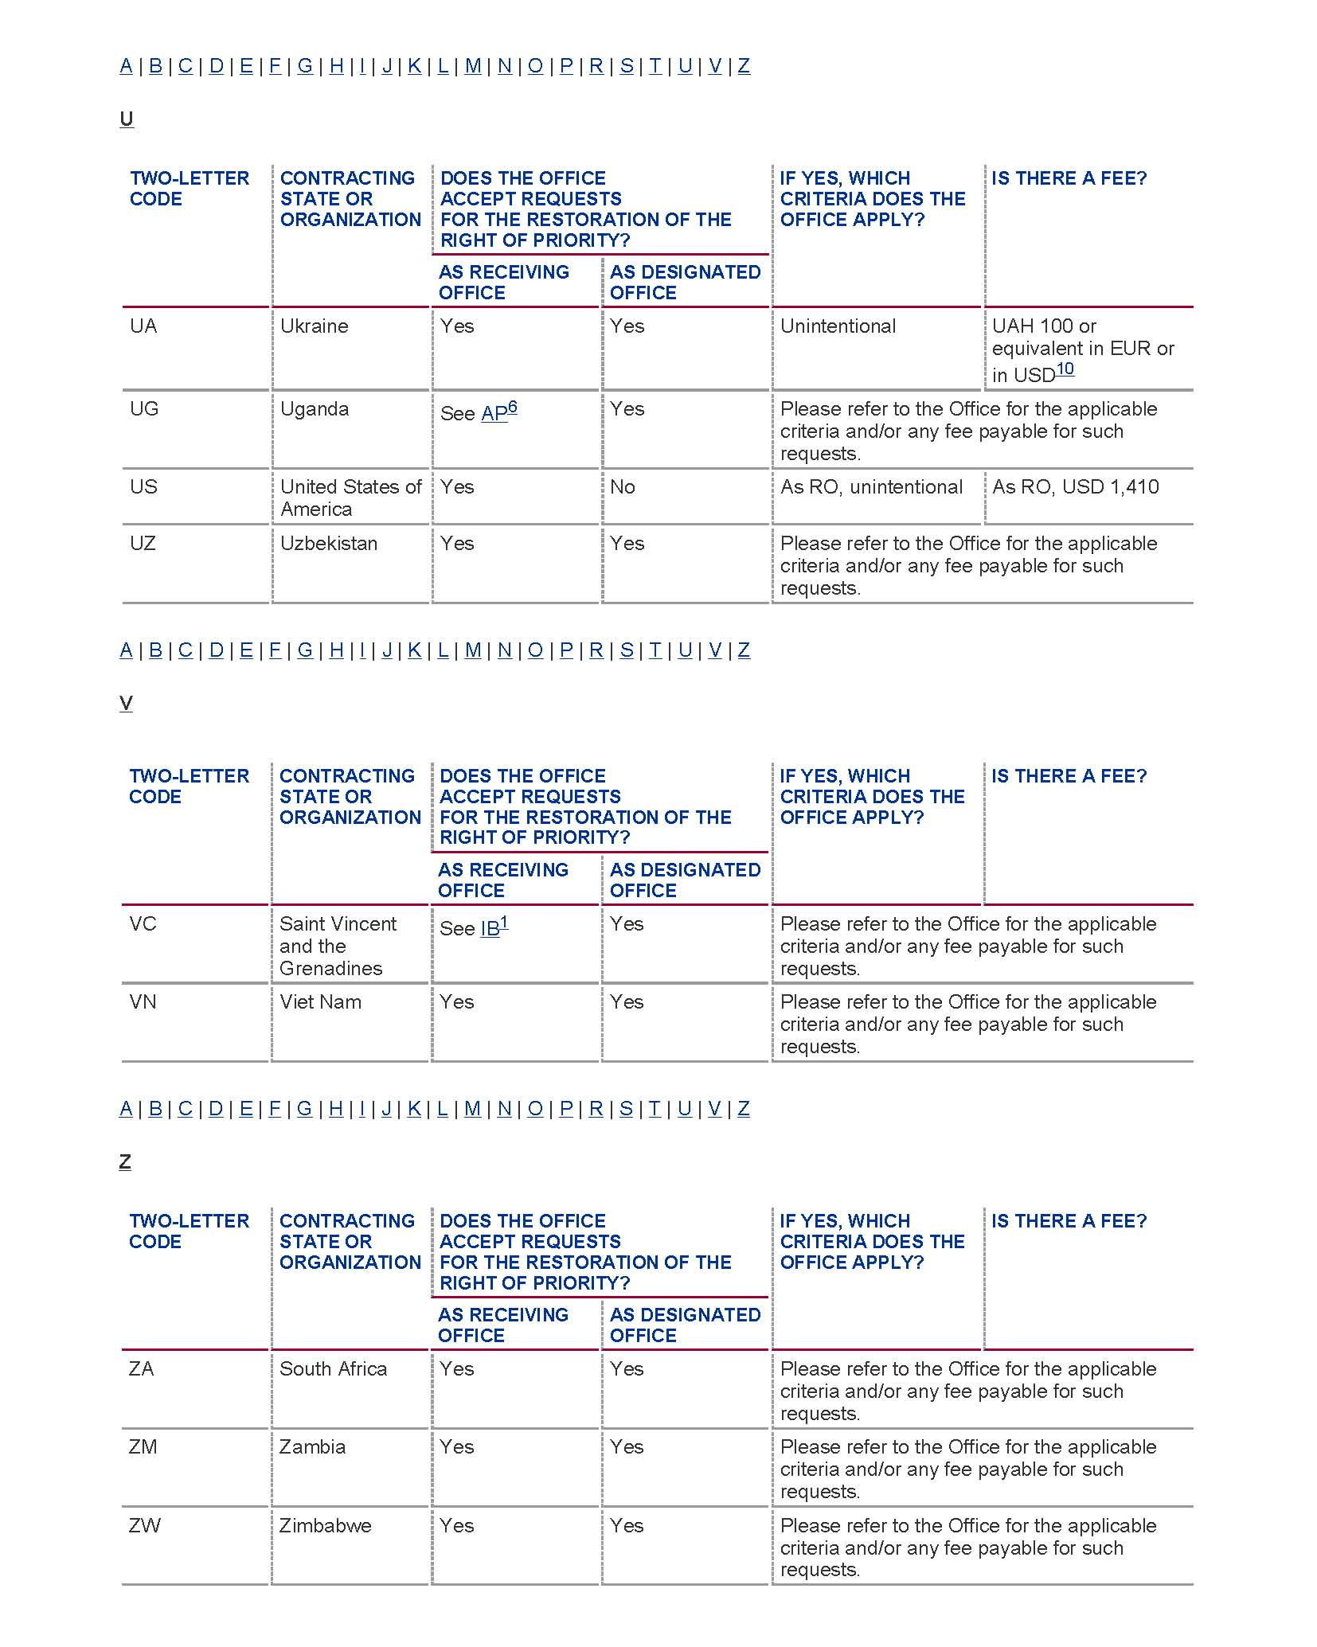
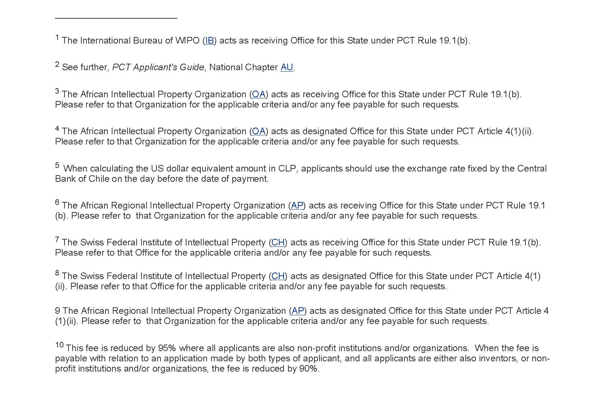
[Annex II follows]

RO | RO  Criteria | # | #  “due care” | #  “due care” granted | #  “due care” denied | Essence of “Due Care”  Criterion Applied | Exemplary “Due Care” Cases
AT | Due care and unintentional | 4 | 2 | 1 | 1 | The criteria of due care is only considered to be fulfilled if the applicant has done everything that reasonably could be expected of him to ensure that the deadline is not missed, and the deadline still could not be met | Case No. 1 Facts: When printing out a list of applications that were to be filed in foreign countries, a printing error caused this application to not appear on the list of applications that should subsequently have been filed under the PCT. The error was not discovered by the agent responsible until after the expiration of the priority period. Decision: Restoration granted under due care, no further explanation provided in the annex of the issued Form PCT/RO/159.  Case No. 2 Facts: The PCT application deadline was confused with a national patent deadline. Decision: Restoration denied under due care, the confusion of the national priority deadline with the international application deadline would not have occurred if the applicant had exhibited due diligence when dealing with the applications. Two reminders were submitted to the responsible party (to file the international application within the priority period) and these reminders were not heeded.
AU | Due care and non-intentional | 44 | 20 | 11 | 9 | Due care is considered to have been taken if the non-compliance with the time limit results from an isolated mistake that a reasonably prudent applicant could not have avoided | Case No. 1 Facts: Docketing data entry, confusion in the priority date between US format (mm/dd/yy) and AU format (dd/mm/yy). Decision: Restoration granted under due care and unintentional, no further explanation provided in the annex of the issued PCT/RO/159.  Case No. 2 Facts: Filing reminder sent by the agent to the applicant who did not timely reach the applicant since a virus had corrupted the operating system. Decision: Restoration granted under due care and unintentional, no further explanation provided in the annex of the issued PCT/RO/159.  Case No. 3 Facts: Filing clerk erroneously filed a national AU application rather than a PCT one contrary to the applicant’s clear instructions in the matter. Decision: Restoration granted under Non-intentional only  Case No. 4 Facts: Paralegal erroneously populated the docketing system with the information that a PCT application had been filed where this had not been the case. Decision: Restoration granted under due care and unintentional, no further explanation provided in the annex of the issued PCT/RO/159.  Case No. 5 Facts: Interruption in the fax transmission but based on the evidence provided—receipt of the fax service provider—this Office considered that the applicant had no reason not to believe her fax did not fully get through. Decision: Restoration granted under due care and unintentional, no further explanation provided in the annex of the issued PCT/RO/159.
CA | Due care and non-intentional | 20 | 13 | 3 | 10  (10 granted based on non-intentional) | In applying the due care criterion the office takes into consideration whether the applicant did everything that would have reasonably been expected to ensure that the relevant act was done and despite that, the relevant act was not done in time. The standard applied to the due care requirement is the customary diligence which a prudent party to the procedure would have exercised in the individual case. | Case No. 1 Facts: Docketing error in data entry in relation to the date of the priority claim. Decision: Restoration granted under non-intentional only. In form PCT/RO/158, the Canadian Patent Office stated that, in its views, the fact pattern did not sufficiently show that due care was exercised. However, the office agreed that the alleged error demonstrated that the failure was not intentional.  Case No. 2 Facts: Filing clerk erroneously filed a national CA application rather than a PCT one contrary to the applicant’s clear instructions in the matter. Decision: Restoration granted under Non-intentional only. The Office held that even though the missing of the priority period was clearly not intentional, it did not establish that due care had been exercised.  Case No. 3 Facts: Applicant claimed he sent his application pursuant to the required means, “Registered letter” but it turned out that the Postal Clerk sent it by “regular parcel” despite the applicant requesting his communication be sent by Registered Mail. Decision: Restoration granted under due care without any further explanations in form PCT/RO/159.  Case No. 4 Facts: Despite the use of FedEx® Priority Overnight delivery service, the day before the expiration of the priority period, the delivery of this application to the receiving Office was delayed for one day due to mechanical problems. Decision: Restoration granted under due care without any further explanations in form PCT/RO/159.
CN | Due care and unintentional | 144 | 125 | 30 | 95 | Due care standard is considered to have been met if the applicant can show that the reason for which the international application was not filed within the priority period was not something he was able to control. A medical emergency of the staff concerned, for example, are therefore considered as meeting the due care standard. However, insufficiently explained cases of illnesses do not generally meet this standard. Technical errors and planned absences of the staff concerned do not generally meet the due care standard. Errors made by the applicant’s assistant are generally measured against the same standard of due care as the one applied to the applicant himself | Case No. 1 Facts: The responsible staff member of a small corporate applicant had to be hospitalized due to a medical emergency and no other staff member was aware of the time limit about to expire. The missing of the priority period was only noticed after the responsible staff member returned to work and immediate action was taken. Decision: Restoration granted under due care, no further explanation provided in Form PCT/RO/159.  Case No. 2 Facts: The applicant explained that the data management function of the applicant’s computer system was corrupted and resulted in the loss of part of the data, thus causing the expiration of the priority period not being noticed. Decision: Restoration granted under unintentional, no further explanation provided in Form PCT/RO/159.  Case No. 3 Facts: The applicant explained that the responsible staff for this case was on a business trip which led to the failure to file the application within the priority period. Decision: Restoration granted under unintentional, no further explanation provided in Form PCT/RO/159.  Case No. 4 Facts: The applicant explained that the applicant’s representative was on a business trip and, in addition, that the person whose task it was to file the application had to be hospitalized due to an accident during the relevant period. Decision: Restoration granted under due care, no further explanation provided in Form PCT/RO/159.  Case No. 5 Facts: The applicant explained that he has timely instructed an assistant to file the international application and warned him of the deadline. The assistant faxed the application to the Office and thought it was successful, whereas the submission was not received as a result of fax machine fault. Decision: Restoration granted under unintentional, no further explanation provided in Form PCT/RO/159.
EG | Due care | 7 | 7 | 7 | 0 | Applicant acts with all due care required if unforeseeable impediments such as health care problems prevent him from filing within the priority period | Case No. 1 Facts: Applicant could not file the international application in time due to unforeseen health problems presented a medical certificate stipulating that he had unforeseen health problems that caused him to miss the priority deadline. Decision: Based on the medical certificate supplied, RO accepted that the time limit to file the international application was missed as a result of unforeseeable health problems
EPO | Due care | 69 | 69 | 26 | 27  (4 refused because of unpaid fees or untimely filing of the request for restoration) | Due care is considered to have been taken if non-compliance with the time limit results either from exceptional circumstances or from an isolated mistake within a normally satisfactory monitoring system. Also, where the agent is responsible and the assistant made a mistake in carrying out routine tasks, attention is given as to whether the assistant is a suitable person for the work, was properly instructed in the tasks to be performed and was reasonably supervised | Case No. 1 Facts: Error by the agent in filing the international application in due time. Decision: Restoration granted: The non-compliance with the time limit resulted from the sudden illness of the agent which was such that it could be regarded as an exceptional circumstance. Consideration was given, even more in the present case where the agent stayed on duty in order to proceed with the filing of the application still within the time limit. The online transmission was received at the receiving Office only four minutes passed midnight, a very short delay that may be excused in view of the circumstances of the case. Therefore, it could be established that the necessary due care was exercised.  Case No. 2 Facts: Error by the agent’s assistant in filing the international application in due time. Decision: Restoration granted: The non-compliance with the time limit resulted from an unexplainable mistake made by the agent’s assistant. Where an assistant has been entrusted with carrying out routine tasks such as typing, posting letters and noting time limits, the agent has to show that he carefully selected a qualified assistant, made the assistant familiar with the duties required and that the execution of the assistant’s work was supervised to a reasonable extent. In the present case, it was determined that the agent has acted with due care in dealing with his assistant. Therefore, the failure to timely file the international application within the priority period could be regarded as an isolated mistake in an otherwise well-functioning system.  Case No. 3 Facts: Error by the delivery service chosen from the applicant. Decision: Restoration granted: The non-compliance with the time limit resulted from an exceptional incident from the part of the delivery service. The applicant has proven to the satisfaction of the EPO as receiving Office that he selected a reliable delivery service recognized by the EPO and has given the necessary and proper instructions to the carrier, in particular the address of delivery and the day of delivery as indicated in the shipment receipt. The applicant could have taken a better product with the delivery service or could have made use of alternative or parallel means of filing such as fax or online filing to ensure the timely filing of the application. On the other hand, it seems reasonable to expect from a reliable delivery service that it fulfils its commitment as guaranteed in its service guide. The EPO as receiving Office was of the opinion that the facts and arguments offered by the applicant were sufficient to show due care.  Case No. 4: Facts: Error by the applicant’s employee in filing the international application in due time due to a data entry mistake. Decision: Restoration denied: The non-compliance with the time limit resulted from the loss of a written notice instructing the data processing department of the applicant to change the status of the application concerned. The system did not allow direct control over this change, so that it could not be qualified as routine task but rather as exceptional in nature. It may thus reasonably be expected from the responsible person to take due care that the instructions are properly implemented. The eventuality of a paper file being lost and thereby a time limit being missed was reasonably foreseeable. Therefore, it could not be established that the applicant exercised the due care required by the circumstances.  Case No. 5 Facts: The cause for the failure seems to be an inherent weakness in the system for postal administration of the applicant as well as deficiencies in the control of the correct application of the system in place. Decision: Restoration denied: The non-compliance with the time limit resulted from an error made by the IP department of the applicant and from the lack of a satisfactory monitoring system. Instead of three, only two registered letters had been dispatched to the EPO and this error went unnoticed by the IP department. It remained unclear to which extends the system in place allowed any efficient internal checks. The failure to file the application in due time could therefore not be regarded as an isolated mistake within a satisfactory system for monitoring time limits.
FR | Due care | 12 | 12 | 11 | 1 (untimely filing of the request for restoration) | Restoration under due care is generally granted where the failure to timely file is caused by a lawful and accidental incident and is not attributable to the will of the applicant, or his fault or negligence. The facts have to be proven by relevant documentary evidence. | Case No. 1 Facts: Error of the paralegal responsible for monitoring the filing calendar of PCT applications. Decision: Restoration granted under due care, no further explanation provided in the annex of the issued PCT/RO/159.  Case No. 2 Facts: Medical conditions which prevented the applicant from filing his PCT application in time, documented with medical certificate. Decision: Restoration granted under due care, no further explanation provided in the annex of the issued PCT/RO/159.  Case No. 3 Facts: Docketing error and technical problems affecting the docketing automated system. Decision: Restoration granted under due care, no further explanation provided in the annex of the issued PCT/RO/159.  Case No. 4 Facts: Agent filed an EP application rather than a PCT application despite the clear instructions in the matter from the applicant. Decision: Restoration granted under due care, no further explanation provided in the annex of the issued PCT/RO/159.  Case No. 5 Facts: Disruption of services caused by the closure of the law firm for refurbishing works, as well as heavy workload issues. Decision: Restoration granted under due care, no further explanation provided in the annex of the issued PCT/RO/159.
IL | Due care | 24 | 24 | 24 | 0 | The applicable criterion is that of “due care”, which is explained as “whether the applicant has taken reasonable measures in order to file the application on time.” Restoration can normally only be accepted when it is well documented that a fully reliable office routines has been put in place, that these routines are being handled by qualified staff and that the applicant has a normally well-functioning system aiming at avoiding mistakes and missing time limits. Due care is considered to have been taken if the applicant demonstrates that he had intention to file the international application and has made all arrangements in good time within the prescribed time limit. It is required that the applicant or his representative has a system for monitoring time limits. | Case No. 1 Facts: Affidavit shows that the applicant has taken reasonable measures for filing the application by giving timely instructions to their agent to prepare and file the PCT application. The agent also took reasonable measures by docketing the priority filing date in his internal well-functioning docketing system. The fact that the date was missed was a result of erroneous entry of the priority filing due date, a mistake that may occur even when observing utmost due care. The patent attorney erroneously entered the wrong due date into the excel table. Decision: Restoration granted under due care, no further explanation provided in the annex of the issued PCT/RO/159.  Case No. 2 Facts: Affidavit and documents demonstrate that the delay in filing of the above mentioned application occurred in spite of the applicant’s exercise due care. The fact that the date was missed was a result of a changing of the agent. The applicant properly instructed the agent to transfer all his files to another agent. During transfer period the former agent did not send reminders to the applicant. The applicant asked the agent to transfer all files to him. During the transfer period, the agent did not send reminders to the applicant. Decision: Restoration granted under due care, no further explanation provided in the annex of the issued PCT/RO/159.  Case No. 3 Facts: A clerical error was committed upon receiving a letter from the applicant indicating that a PCT application should be filed. The error resulted in an incorrect priority date being entered into the reminder system. Decision: Restoration granted under due care, because it resulted clearly from the submitted evidence that the clerical error was an isolated mistake within a normally satisfactory system at the firm of the patent attorneys. Such isolated mistakes were unavoidable and excusable and the requested restoration of the right of priority could therefore be granted.
MX | Due care and unintentional | 9 | 6 | 6 | 0 | Reasons beyond applicant’s control or involuntary mistake are generally accepted under the due care standard. This can include lack of knowledge of, or misunderstandings about, the patent procedures. | Case No. 1 Facts: Applicant explains that he could not timely file the application because his mother was seriously sick and he was therefore too busy and could not afford to file the application in time. Decision: Restoration granted under due care, no further explanation provided in Form PCT/RO/159.  Case No. 2 Facts: Applicant explains that the Mexican Patent Office sent him a notification (when filing the priority application) in which they asked him to resend the application in duplicate with signatures, according to Art. 180 of the Mexican Industrial Property Law, and he, after also reading Art. 38 of the law, erroneously thought that the priority date would be the date on which the requirement would be fulfilled. Decision: Restoration granted under due care, no further explanation provided in Form PCT/RO/159.  Case No. 3 Facts: Applicant explains that he had the intention to file a PCT application but due to his lack of knowledge about the 1 year period he unintentionally missed to file the application before the expiration of the priority period. Decision: Restoration granted under due care, no further explanation provided in Form PCT/RO/159.
NL | Due care | 4 | 4 | 4 | 0 | No information available | Case No. 1 Facts: The applicant filed the wrong description, claims and abstract but the correct figures in the application, due to an error by a reliable employee. Filed request for restoration with the correct claims, description and abstract. Decision: Restoration granted under due care, no further explanation provided in the annex of the issued PCT/RO/159.  Case No. 2 Facts: The applicant was submitting the application electronically when his wife called to say that their daughter was ill and needed to go to the doctor. The applicant went to the doctor without waiting for the filing receipt. When he returned to the office the next day he found out that the submission had been unsuccessful (on the last day of the priority period). Decision: Restoration granted under due care, no further explanation provided in the annex of the issued PCT/RO/159.
RU | Due care and unintentional | 65 | 42 | 42 | 0 | No information available | Case No. 1 Facts: Agent was on sick leave in Ukraine during the month of November, and therefore the application was not submitted before the expiration of the priority period. Decision: Restoration granted under due care, no further explanation provided in Form PCT/RO/159.  Case No. 2 Facts: The applicant was on a long business trip and lost communication with his agent, and therefore failed to instruct his agent to file the PCT application within the priority period. Decision: Restoration granted under due care, no further explanation provided in Form PCT/RO/159.  Case No. 3 Facts: The applicant cited the need to conduct further laboratory experiments and to revise the claims of the application as the reason for missing the priority period. Decision: Restoration granted under due care, no further explanation provided in Form PCT/RO/159.
SE | Due care | 14 | 14 | 8 | 6 | In order for the Office to restore priority the applicant must show that they have taken “all due care” and the loss of priority was the result of an isolated procedural mistake within a normally satisfactory system. An effective system for monitoring time limits should generally also include a cross-check mechanism | Case No. 1 Facts: Applicant became seriously ill right before the expiration of the priority period and had to abstain completely from all work until after the expiration of the relevant time limit. Decision: Restoration granted under due care.  Case No. 2 Facts: The applicant confused two letters from the agent, one which concerned a Swedish Patent Applicant and the other concerning the priority period deadline for this applicant. The applicant failed to instruct the agent to proceed with the PCT application in a timely manner. Decision: Restoration was denied under due care. The applicant’s confusion over the two letters from the agent and the mistake thereafter to instruct the Agent not to take any further actions regarding the International Patent Application must be regarded as a “normal” error and not unavoidable “in spite of all due care”. Therefore the Swedish Patent Office can not establish that the “all-due-care requirement” has been met.  Case No. 3 Facts: Corporate applicant relied on a generally well functioning docketing system. However, a data entry error occurred which led to a situation that the warnings of the docketing system that the priority period was about to expire were sent to the wrong recipient. Decision: Restoration was denied under due care. Even though an isolated mistake in a normally satisfactory functioning docketing system is excusable, the statement submitted by the applicant did not plausibly show that a effective system for monitoring time limits work had been established, in particular since the system used did apparently not provide for any cross-checking.
SG | Due care and unintentional | 11 | 8 | 3 | 5 | Agent acted with due care if he can show that the missing of the priority period only occurred due to an isolated human error by a well-trained paralegal and despite the existence of a well-functioning docketing system | Case No. 1 Facts: Applicant had instructed agent to ensure that a PCT application was filed. Although the agent had a well functioning docketing system which accurately generated several reminders, the well-trained paralegal with many years of experience did not, contrary to clear and specific instructions and for no apparent reason, submit the application for filing within the priority period. Decision: Restoration granted under due care.  Case No. 2 Facts: The agent was away from work for 20 days for medical reasons and during the period the priority period for the application expired. Decision: Restoration denied under due care, no explanation provided.  Case No. 3 Facts: There was a breakdown in communication at in the applicant’s in house legal department. The instructions to file the PCT application were not forwarded to the responsible party, who lacked patent experience and therefore did no know of the priority period deadline himself. Decision: Restoration denied under due care, no explanation provided.

[Annex III follows]

RESTORATION OF THE RIGHT OF PRIORITY UNDER RULE 26BIS.3
BY THE INTERNATIONAL BUREAU AS RECEIVING OFFICE (RO/IB)

I. PURPOSE
1. This document contains a detailed overview of the approach to and the precedent developed by the RO/IB and the PCT Legal Division since 2007 in deciding on requests by applicants for the restoration of the right of priority in individual PCT applications under PCT Rule 26bis.3. The purpose of this document is to serve as guidelines for the staff of the International Bureau as a receiving Office on how to interpret and apply the criteria of “due care” and “unintentional”.

2. The document may also serve to assist and give guidance to staff of other receiving Offices on how to interpret and apply those criteria.

II. PRODEDURE FOLLOWED AT RO/IB
3. Incoming requests for the restoration of the priority right are identified by staff of the RO/IB. Where the required statement of reasons (PCT Rule 26bis.3(b)(ii)) is not furnished by the applicant, the RO/IB immediately contacts the applicant by way of Form PCT/RO/132 to request the missing statement. Once a statement has been received, the case is forwarded to the PCT Legal Division (PCTLD) to look into the substance of the request and to apply the “due care” and “unintentional” criteria. The RO/IB has decided, by the end of March 2012, more than 320 restoration of the right of priority cases since April 2007.

III. Evidentiary Requirements
4. Another issue commonly faced by the PCTLD when dealing with restoration of the right of priority cases is a lack of sufficient evidentiary material to substantiate the facts presented by the applicant or agent for failing to file the international application within the priority period. It is imperative that the receiving Office have all of the facts before issuing a ruling on whether the failure to file the international application within the priority period occurred in spite of due care required by the circumstances having been taken. If the applicant is asking for the right of priority to be restored under the “unintentional” criterion, typically a simple statement that the failure to file the international application within the priority period was not intentional is generally considered sufficient (see paragraph 166F of the PCT Receiving Office Guidelines).

5. After reading the submitted statement of reasons (either in the request or in a separate document), PCTLD often requests (generally by way of Form PCT/RO/132) that the applicant or agent submit a more comprehensive statement of reasons and/or, according to Rule 26bis.3(f), provide a declaration or affirmation from the responsible parties confirming their role in the events that led to the late filing of the international application. From the standards enunciated above, one can see which questions are usually included in Form PCT/RO/132. Depending on the facts already provided, the PCTLD will usually cater the questions to one of the common fact pattern categories laid out above. For example, if a problem with the docketing system caused the failure to file the international application within the priority period, the PCTLD is likely to ask:

- Who was responsible for monitoring the docketing system? Please provide a declaration from that party describing the conditions and events that led to the failure to file the international application within the priority period.

- What training and supervision did the individual receive? How much experience did this individual have with the filing of patent applications?

- What are the standard guidelines and procedures for docketing a patent application?

- Was there a back-up docketing system? If so, please describe this system.

6. By issuing Form PCT/RO/132 and allowing the applicant or agent to further explain the circumstances, PCTLD allows the applicant or agent to present all the facts of the case and then can rule on whether the applicant or agent met the “due care” criterion. If the applicant or agent fails to reply to Form PCT/RO/132 and has delivered an insufficient statement of reasons to PCTLD, the applicant or agent will not have met the burden of demonstrating that his or her actions exhibited “due care”.

IV. CRITERIA APPLIED BY RO/IB
7. RO/IB applies both the “due care” and the “unintentional” criteria. Where an applicant has requested for both criteria to be applied, and where the applicant did not specifically ask for the application of only one of the criteria, RO/IB first applies the stricter “due care” criterion and only considers the “unintentional” criterion if the applicant has failed to meet the “due care” criterion. This approach is advantageous for the applicant.

A. Due Care – PCT Rule 26bis.3(a)(i)
8. The standard stated in PCT Rule 26bis.3(a)(i) for “due care” is “that the failure to file the international application within the priority period occurred in spite of due care required by the circumstances having been taken […].”.

9. Under the Rule, applicants are required to present the facts of the case in a “statement of reasons” (PCT Rule 26bis.3(b)(ii)), explaining why the international application was not filed within the priority period. If the facts as set out in the submitted statement of reasons are not sufficient in the view of the PCTLD so that a determination can be made as to whether the standard of “due care” was met, the PCTLD would invite the applicant to submit further explanation and/or proof in the form of declarations or affirmations from responsible parties (PCT Rule 26bis.3(f) and (g)). The factual circumstances set out in the statement of reasons and any declarations are analyzed by the PCTLD to determine whether “due care” was exhibited.

10. Since April 2007, the following interpretation of the “due care” standard has been and continues to be developed by the PCTLD and is applied by RO/IB:

Reasonably Prudent Applicant Standard
11. The overarching standard as applied by the RO/IB in rulings on “due care”, is stated in the following form paragraph:

Generally, in the view of this receiving Office, the standard of having exercised “due care” within the meaning of Rule 26bis.3(a) can only be met if the applicant has taken all measures that a reasonably prudent applicant would have taken. The criterion cannot be met if the failure to file the international application within the priority period was due to an omission or fault that a reasonably prudent applicant would not have made.

12. The reasonably prudent applicant standard has been applied by the PCTLD in “due care” cases. It is clear that this reasonably prudent applicant standard is less than an “act of God” or “force majeure” standard. The reasonably prudent applicant standard allows for some human error, as long as it is an error that even a reasonably prudent applicant could conceivably commit under the specific circumstances of the case.

Relevant point in time
13. Under the reasonably prudent applicant standard the PCTLD evaluates the responsible party’s actions up until the priority deadline. Actions by the responsible party (applicant or agent) after the expiration of the priority period should not be used when determining whether the responsible party did or did not exhibit “due care”.

Case specific interpretation
14. Furthermore, evidence that the responsible party acts or has acted in the past with “due care” in general while filing international or national patent applications is not sufficient to show that the responsible party acted in a reasonably prudent manner in relation to the specific international application in question. As stated in a PCTLD opinion,

In the view of this receiving Office, it is therefore not sufficient that an agent or applicant is able to demonstrate that, in general, he has taken all precautions to ensure that the time limit for filing international applications is not missed but the applicant or agent has to also show that for the very application itself, all “due care” has been exercised.

Selection of an Agent
15. In most cases, the reasonably prudent applicant standard must be applied in the context of the applicant-agent relationship. In most PCT applications, applicants rely heavily on agents to prepare and file the international applications and thus to meet crucial priority deadlines. The appointment of an agent by the applicant extends the responsibility to act in a reasonably prudent manner to the agent, but the applicant must still demonstrate prudent action:

An applicant is under an obligation to use “due care” in the selection of the third party concerned. A prudent applicant would be aware that the filing of patent applications is a matter which requires considerable expertise and, given the potentially significant financial and legal implications, must be placed in trusted hands.

For an applicant, the appointment of a qualified representative, under normal circumstances, should be sufficient to satisfy the criterion of “due care”. However, the applicant must, in each and every case, take “due care” in the instructions and arrangements for filing and not only in the appointment of a well trained and qualified representative.

16. An applicant may argue that he/she was misled by the agent into thinking the agent was qualified to file international applications, but the applicant must be able to show convincingly that he/she had no reason to doubt the agent’s capabilities:

Where an applicant can show that he was misled by a third party into thinking that the third party was a well-trained patent professional when in fact this was not the case, and a prudent applicant would not have had any doubts in hiring such a third party as a patent professional, an applicant might be able to show that he acted with all due care required by the circumstances and thus that the acts of the hired patent professional were not attributable to him.

17. It should be noted that appointment of an agent is not required:

Appointing an agent is not obligatory in meeting the standard of “due care”. In circumstances where an international application is filed by the applicant himself, he needs to show that he had acted with all “due care” a prudent applicant would have taken in filing an international application in person under the same situation.

18. From the over 250 cases where the PCTLD has applied the reasonably prudent applicant standard, commonly recurring fact patterns have resulted in more specific guidelines on the application of restoration criteria. While keeping in mind that decisions on the restoration of the right of priority under the “due care” criterion must be made on a case by case basis, an examination of the common fact patterns and how the PCTLD has decided those cases demonstrates the precedent established by PCTLD for “due care” cases.

19. After analyzing the fact patterns relating to requests for restoration of the right of priority decided by the RO/IB, nine general fact patterns emerged: 1) applicant/agent error; 2) applicant/agent ignorance; 3) applicant-agent miscommunication; 4) applicant/agent illness or vacation; 5) force majeure; 6) applicant/agent staff error; 7) computer docketing error; 8) fax or PCT-SAFE/PCT-EASY submission failure; and 9) postal service difficulties.

Applicant/Agent Error
20. Occasionally, an applicant or agent has cited a human error made by the responsible party during the preparation and filing of the international application as the cause for the failure to file the international application within the priority period. In many such cases, this type of error does not demonstrate “due care”. A reasonably prudent applicant (or agent acting on the applicant’s behalf) would recognize the importance of meeting crucial priority deadlines and would ensure that aspects of the preparation and filing of the international application under his or her control are carried out with the diligence and meticulousness needed to successfully submit the application on time. The following excerpts properly exemplify the lack of “due care” shown in these types of fact patterns and how the PCTLD has applied the reasonably prudent applicant standard:

- Increased Agent Workload: The fact that there was an unusual increase of work-load at the law firm has not typically been accepted as an excuse for missing such important time limits. A prudent agent must be expected to still conduct his business in an orderly fashion even if the work-load increases abruptly.

- Lost Work Files: The applicant explained that the failure to timely file this international application occurred because all the documents relating to the previous national application got lost while he moved apartments, which is why he could not file the international application in time. A prudent applicant would have had at least a copy of such important documents, for example an electronic copy on his computer.

- Incomplete International Application Originally Filed: A prudent applicant would make sure that his filing results in a complete application that can obtain an international filing date.

- Filing of PCT in conjunction with Non-Provisional National Applications: A prudent agent filing the US non-provisional application (claiming priority of a prior filed provisional application) very late on the last day of the priority period would have realized that the PCT application would have to be filed on the very same day.

- Last day/last hour filings: Applicants and agents seem prepared to take a considerable risk by filing patent applications late in the priority period. It is not uncommon for applicants or agents to wait in fact until the last day of the priority year to file an international application. Even though a prudent applicant or agent would try to avoid as much as possible such last minute filings, the fact that an application is submitted on the last day of the priority period does not in itself negate “due care”. However, it would be reasonable to expect from an applicant or agent who relies on such last minute submissions to act with particular care to avoid any errors.

Applicant/Agent Ignorance
21. Applicants have pleaded ignorance of the PCT and its procedures in explaining their failure to timely file their international application but, as applied by RO/IB, this would normally not be a sufficient reason under the reasonably prudent applicant standard. The applicant’s ignorance, in priority restoration fact patterns, is usually related to the existence of the PCT system or the Paris Convention 12 month priority deadline. The PCTLD has therefore held that:

A prudent applicant would have acquired all necessary knowledge of the PCT to properly deal with all matters arising when filing for patent protection, or if he could not, he would have chosen to use the professional services of a patent agent to properly deal with those matters on his behalf. For an individual applicant or an applicant representing a small business that has limited financial resources and could not afford to hire a patent agent, the applicant is obliged to shoulder the burden to acquaint himself with the matters of patent filing. By failing to acquire all the necessary knowledge himself, the applicant risks the loss of rights.

Applicant-Agent Miscommunication
22. Failure to clearly communicate or to communicate at all regarding international applications has caused agents and applicants to miss the priority deadline. The applicant must take “due care” in giving the instructions for filing and the agent must take “due care” in receiving, reading, interpreting, and taking action on those instructions. It is much easier for the applicant and agent to show “due care” when a technical (usually email) problem caused the communication breakdown between the two parties. The following are common miscommunication issues that have arisen and how the PCTLD has ruled in regards to the reasonably prudent applicant standard:

- Applicant Instructions: The applicant failed to provide a timely response to the agent’s request for clarification, which directly resulted in the lack of follow-up action to file the application within the priority period. Even though an agent has already been appointed, a prudent applicant would still always provide clear and timely instructions to the agent when it is required.

- Applicant’s Diligence and Timing in Providing Instructions to Agent: A prudent applicant would have endeavored to give a timely instruction to his agent with respect to such an important decision as the filing of an international application. In particular, when the applicant tried to contact the agent shortly before the expiration of the priority period, he should have tried as well to contact the colleagues of the agent in case the agent himself was not available, noting that the instruction to file an international application had not yet been conveyed.

- Agent’s Responsibility to Counsel Applicant: An agent is expected to be able to advise his client of all the important issues such as the due date for claiming a priority right in terms of filing a PCT application. The advice and communications should be clear enough for the applicant to understand the options and the related consequences and to avoid any misunderstandings.

- Agent Interpretation of Applicant Instructions: The agent misinterpreted a notification indicating that he should file a PCT application and believed that it was only necessary to file in Argentina and Colombia via direct national applications. The notification would have been correctly interpreted by the agent if it had been printed out. A prudent agent would have carefully read all instructions received from his client and, in case of doubt, would have double-checked if the instructions had been correctly understood. To not print out and read the entirety of the instructions received is the kind of mistake or omission a prudent agent would not have made.

- Email Delivery Failure: The email sent by the applicant more than 2 weeks prior to the expiration of the priority period, asking the agent to file the PCT application before the end of the priority period, was actually never received by the agent, due to an apparent overload of memory on the company servers. Given that the computer system had been operational for several years and that it has apparently worked reliably, even a prudent applicant would not have necessarily immediately called his agent to inquire whether the instructions had been received. Furthermore, knowing that the other recipients copied on the email had in fact received it, the applicant could not have realized that the agent had not (“due care” met).

Applicant/Agent Illness or Vacation
23. Applicants and agents sometimes state that the absence (expected and unexpected) of an individual, which they perceived as essential to properly file the international application, has caused the priority period to be missed. In the experience of the PCTLD and based on its application of the reasonably prudent applicant standard, only in extreme examples will this absence result in a situation where the failure to file the application occurred in spite of “due care”. Only in cases where the applicant is filing himself and becomes unexpectedly ill in a debilitating manner will “due care” have been demonstrated. In the majority of cases, however, other parties can ensure that the priority deadlines are met or that preventative measures are taken to protect the rights of the absent party. The following are exemplary cases that deal with applicant and agent illness or vacation:

- Agent’s Responsibility during Applicant Illness: As a preventive measure and to protect the rights of his client, a prudent agent would have filed a simple copy of the earlier application even if the applicant eventually would have decided not to pursue the matter abroad. In the latter case, the PCT application could have simply been withdrawn at a later stage without causing harm. Nevertheless, in the views of PCTLD a prudent agent cannot always be expected to file a PCT application as a preventive measure unless the circumstances of the particular case are such that the intentions of the applicant to file a PCT application had been rather apparent to the agent.

- Nature of the Applicant’s Illness: In the view of this receiving Office, before going to the first hospital, or after having been to hospital and before consulting another medical practitioner, or at the latest after having been advised to keep himself confined and restricted, a reasonably prudent applicant would have instructed his agent at least by telephone, e-mail or through an intermediary of some sort to file the international application. Psoriasis does not appear to be a disease which requires such urgent treatment that an applicant is not able to take some preparatory measures before going to hospital or in-between hospital
stays, such as checking whether important deadlines expire during the hospitalization which require action on the applicant’s side, and authorizing or instructing an agent to take care of important matters during his absence. A reasonably prudent applicant would have planned ahead.

- Timing of the Applicant’s Illness: The applicant states that his failure to file the international application within the priority period was also due to the fact that he experienced a state of extreme distress during the period of November 2010 until January 2011 due to an uncertainty about his state of health. However, he also states that at the same time, he was working hard in two different jobs and that he undertook a business trip to Spain from 18 to 21 January 2011 which leads to the assumption that his state of health was not the predominant reason for not filing the international application within the priority period.

- Proof of Illness: Applicant stated that he was unable to timely file the PCT application because he was hospitalized abroad, and in a state of coma following a snake bite, during a period which started two weeks before the expiration of the priority period and from which he only recovered once the priority period had expired. Therefore, the applicant was unable to instruct the agent to file the IA. The applicant’s hospitalization was proven by a signed certificate by a health professional stating that the applicant was unable to communicate with anyone during the relevant period. In such an extreme case, “due care” was granted.

Force Majeure
24. When an “act of God” or “Nature” causes the filing of the international application to become impossible or so difficult that a reasonably prudent applicant/agent would be unable to file the international application within the priority period, the failure to file will have occurred in spite of “due care”. So far, the PCTLD has ruled on situations involving hurricanes (Ivan) and volcanic eruptions and found in those instances that the events constituted a force majeure and thus restored priority under the “due care” criterion. When dealing with force majeure, the crucial analysis is whether the circumstances justify the invocation of force majeure protection:

An event of force majeure generally means externality, unforeseeability and/or unavoidability circumstances beyond the control of the applicant or his agent, the consequences of which could not have been avoided even if all “due care” had been exercised. An applicant should be allowed to invoke a force majeure model in the case of externally-caused events. Disasters, such as hurricane, earthquake, international conflicts and war are considered as such events. Even though the concept of force majeure is not limited to absolute impossibility, it nevertheless implies that the failure to file international application on time is due to abnormal and unforeseeable circumstances beyond the control of the applicants and/or his agent. The impossibility has to be so important that even if the event was foreseeable, the applicant will be excused if this prediction would not have attenuated the consequences of the event.

Agent/Applicant Staff Error
25. The most common type of error seen in this context is when the agent or applicant’s administrative staff makes an error in the preparation and filing of the international application. Most agents and large applicants with in-house patent counsel have paralegals or administrative assistants who monitor crucial deadlines and assist in the filing of applications. These staff members are not held to as high a standard when evaluating their actions, but the agent or applicant must show that they have been careful in choosing, training and monitoring the work of an experienced and reliable assistant:

An agent can be expected to entrust staff (non-attorneys such as administrative assistants or paralegals) to assist in the performance of administrative tasks. The same strict standard of “due care”, as applied to applicants and agents, is not expected of the assistant. An error by an assistant while carrying out routine tasks is not imputed to the agent if the agent can show that “due care” was exercised in dealing with the assistant. A reasonably prudent agent would: 1. carefully choose a suitable person for the work to be carried out by the assistant; 2. provide proper instruction to the assistant regarding the tasks to be performed; 3. exercise reasonable and regular supervision over the work performed by the assistant.

26. A successful request under the “due care” criterion when there has been an error by the staff usually states that the staff was experienced, well trained, and properly supervised to carry out tasks which are required to file patent applications. The request will also usually highlight the number of years the assistant has been working on patent applications and that no prior errors had been committed by the assistant.

27. While most staff error cases occur in conjunction with docketing system errors, which will be discussed in the next section, the following fact pattern and decision highlights how a staff error has been evaluated by RO/IB:

The international application was completed by the agent and a paralegal, designating the US receiving office, and then was placed in a mail outbox. Before the trained clerical person could pick up the mail, files were laid on top of the mail obscuring it and resulting in the clerical person not noticing the envelope in question, which was eventually not picked up for delivery to the postal service. In regards to routine clerical tasks, an agent acts with the “due care” of a reasonably prudent person by carefully choosing a suitable person for the clerical work to be carried out, properly instructing that person in the tasks to be performed and exercising reasonable and regular supervision over the clerical work performed by that person. Here, no error with the mail outbox system of this nature had been made before and the clerical person was sufficiently trained, experienced, and instructed. Therefore, the restoration of priority is granted, since missing of the priority period was an exceptional human error in an otherwise satisfactory system.

File Docketing Error
28. By far the most common reason given by applicants and agents for failing to file the international application within the priority period is an error with the computerized docketing system. These docketing systems vary from Outlook calendars to Excel files to software specifically designed for attorneys to monitor deadlines. The errors can be divided between technical errors (improperly functioning software or server crashes) and human errors (failure to properly insert the date in the system, failure to properly classify the application, and failure to set sufficient reminders within the system). Technical errors are possibly more likely to lead to a successful restoration request than human errors but human errors, which are commonly made by staff, will not bar the application from being restored under “due care”. The standard applied by PCTLD for evaluating docketing system errors is whether “the failure to timely file this PCT filing can be construed as an isolated event in a generally satisfactory docketing system.” In determining what constitutes an “isolated event” PCTLD would consider the following issues:

- Docketing System Guidelines: Are there guidelines (standard procedures) for use of the docketing system or an established “chain of command” for prosecuting patent filings?

  - Established Docketing System: A reasonably prudent applicant would have set up a reliable reminder system which observes important deadlines, and which would have reminded him to file the international application within the priority period.

  - Competence in Dealing with Docketing System: A prudent applicant would have taken every step to make sure that the docketing system function properly. This includes, inter alia, acquiring all necessary knowledge on how to operate the system and correctly inputting all important data into the system.

  - Properly Functioning Docketing System: A prudent applicant would not have a docketing system that automatically deletes all foreign filing reminders when a prior application is abandoned for the distinct case (as is at hand) where the applicant desires to still file a PCT application claiming priority from the previously abandoned prior application.

- Docketing System Back-Up/Review: Is there a back-up system (electronic if primary system is non-electronic and non-electronic if primary system is electronic). Is the work of the assistants double-checked by other assistants or agents (some type of quality control/ review process)?

  - Law Firms and Companies: A prudent applicant would also have put in place some kind of a review process, ideally by a second person that would independently check that all relevant dates have been entered correctly.

  - Small and Medium Enterprises: It might be reasonably expected from any company to set up some supervision and back-up systems, at the same time it cannot be reasonably expected that small and medium enterprises set up different levels of prosecution and supervision which cannot be reasonably implemented in small companies. The applicant should have a filing and prosecuting system set up that is efficient and reliable in relation to the standards reasonably expected from a small company.

- Staff Training and Supervision: Does the agent properly train the assistants on how to use the docketing system and later properly supervise the assistant’s use of the docketing system? A reasonably prudent agent would: 1. carefully choose a suitable person for the work to be carried out by the assistant; 2. provide proper instruction to the assistant regarding the tasks to be performed; 3. exercise reasonable and regular supervision over the work performed by the assistant.

- Absences: Is there an established procedure for when assistants in charge of the docketing system are absent, with a designated person to take over the absent assistant’s responsibilities? A satisfactory docketing system will have a designated party who takes over the duties of an agent or staff member responsible for monitoring deadlines through the docketing system.

29. With all of the considerations listed above, PCTLD would have to evaluate what would be sufficient to demonstrate “due care” while considering the size of the entity. The PCTLD has consistently held that the applicant’s resources (whether a large corporation, small company, or individual inventor) should be taken into account when determining whether “due care” has been exhibited. PCTLD has been more lenient for individual inventors, recognizing that they may not have the monetary resources to hire an agent to prepare the international application or instruct them on the availability of the PCT system and the importance the 12 month Paris Convention deadlines (“priority period” deadlines).

Fax or PCT-SAFE/PCT-EASY Submission Failure
30. Some applicants still submit international applications to the RO/IB via facsimile machines, while most applicants now commonly use the available electronic submission systems to file their international applications. Errors when using these different submission systems have been the reason behind missed priority deadlines. Most of the time, the PCTLD has viewed facsimile transmission errors and errors with PCT-SAFE and PCT-EASY as mistakes that are easily avoided by a reasonably prudent applicant, thus errors that would not be made if “due care” was exhibited (for fax submissions, see also PCT Rule 92.4 which puts the burden on the applicant). The standard applied by PCTLD when dealing with these “technical errors” is:

In order to meet the “due care” standard in relation to technical problems, it has to be shown that the technical problems are external problems that are beyond the control of and not attributable to the applicant.

31. Fax errors and electronic submission errors commonly occur on the last day and in the waning hours of the priority period. As previously noted, an agent or applicant is expected to show particular care and vigilance in ensuring that no errors occur when filing in the last possible hour.

In the view of this receiving Office, a prudent applicant would have prepared himself with the necessary facilities to file a PCT application before he started the filing process reasonably in advance of the expiration of the priority period. These necessary facilities include, if he chooses to file electronically, a well-functioning computer system connected to the Internet with the right version PCT-SAFE software installed and digital certificate obtained, and where he chooses to file via facsimile, a well-functioning fax machine connectable to the receiving Office, and where he chooses to use the so-called “web fax”, the service permissions that can accommodate fax transmissions in a capacity similar to traditional fax.

32. Other common errors with facsimile submission include errors while transmitting the application via fax (illegible copies received or incomplete copies received) and unexpected delays while transmitting which cause the priority period deadline to be missed. Other PCT-SAFE and PCT-EASY errors revolve around applicants or agents lacking the requisite knowledge to properly submit the international application through the electronic submission system. A prudent applicant would acquire all necessary knowledge in a timely manner to make sure the application can be filed within the priority period. The PCTLD has expected a
reasonably prudent applicant to utilize time zone differences and different submission vehicles to avoid missing the priority period, to the extent that this would not place an unreasonable burden on the applicant:

- Late Fax: When submitting the international application to the International Bureau as receiving Office and realizing that the filing of the international application was only successful 48 minutes after the expiration of the priority period Geneva time, a reasonably prudent agent based in the US would have submitted the international application to the USPTO before midnight local US time. The USPTO would then have transmitted the international application to the International Bureau as receiving Office and the international application would have been considered to have been received by the International Bureau as receiving Office under Rule 19.1(a)(iii) on the date of receipt of the international application by that national Office (Rule 19.4(b)). In that case, the international application would have been received by the International Bureau within the priority period.

- Other Available Submission Options: A prudent applicant unable to file via PCT-SAFE or PCT-EASY for whatever reason would take reasonable remedial actions by choosing, for example, to use fax to ensure the timely receipt of the application by the receiving Office.

It is worth noting that an element to guard against when dealing with fax and PCT-SAFE/PCT-EASY submission errors is hindsight bias. The focus is on whether there were any external problems that were beyond the control of the applicant or agent. Later successful submission through PCT-SAFE, PCT-EASY, or fax is neither positive nor negative evidence of applicant or agent “due care”. All that matters is whether “due care” was demonstrated by the applicant or agent up until the expiration of the priority period.

Postal Service Difficulties
Some applicants still submit applications through the various national postal services. While evaluating whether or not the applicant or agent has exhibited “due care”, the PCTLD relied also on the standard contained in Rule 82.1:

According to Rule 82.1 of the Regulations under the PCT, a delay in mail may be excused if the mailing was done five days prior to the expiration of a time limit if surface mail normally arrives within two days of mailing. Although Rule 82.1 of the Regulations under the PCT does not apply to the failure to file an international application within the priority period as the priority period is not one of the time limits referred to in Art. 48(1) of the PCT, the underlying idea of this provision could be used to identify what can be expected from a reasonably prudent agent when using regular mail. In the present case, where the mailing of the international application was done seven days prior to expiration of the priority period, and where surface mail could be expected to arrive in 2 or less days, the agent’s actions seem to generally correspond with what can be expected from a reasonably prudent agent.

B. Unintentional – Rule 26bis.3(a)(ii)
Under the “unintentional” criterion, the standard applied by the PCTLD has been that the applicant did not miss the priority period deadline on purpose (i.e. the applicant did not deliberately permit the priority period to expire) as long as the applicant had a “continuing underlying intention” to file the PCT application within the priority period, the applicant’s action is deemed by PCT to satisfy the “unintentional” criterion.

It should be stressed that, in deciding whether the applicant had the intent to file an international application, the crucial point in time to be looked at is the time when the priority period expired. Whether the applicant’s intent might have changed before this time frame or whether it changed afterwards does not affect the assessment of the “unintentional” criterion under Rule 26bis.3(a)(ii). Thus far, the RO/IB has denied very few cases under the “unintentional” criterion, and only in cases where it appeared that the applicant had deliberately refrained from filing the international application before the expiration of the priority period due to either financial considerations, the desire to conduct further testing before filing or in order to secure a biological sample before filing.

[End of Annex III and of document]

References in this document to “Articles” and “Rules” are to those of the Patent Cooperation Treaty (PCT) and the Regulations under the PCT (“the Regulations”).

