
E
pct/wg/4/7
OriGINAL: English
DATE: April 29, 2011
Patent Cooperation Treaty (PCT)
Working Group
Fourth Session
June 6 to 10, 2011, Geneva
Third Party Observation System; Quality Feedback System
Document prepared by the International Bureau

summary
The International Bureau has begun work on the implementation of a third party observation system, broadly in line with the proposals set out in the Annex to Circular C. PCT 1288 (reproduced as the Annex to this document) and taking into account the comments received in response to that Circular. Further Circulars will make detailed proposals for the required changes to the PCT Administrative Instructions and PCT International Search and Preliminary Examination Guidelines, as well as indicating the start date for the service (expected to be in early 2012).
The proposed system for allowing quality feedback from designated Offices to International Searching Authorities will not be implemented as part of the above system. Instead, designated Offices will be able to send a document to the International Bureau to be forwarded to the quality department of the relevant Authority. Preferably, this will be done by simply uploading the document through PCT-EDI with the appropriate document type code, but a paper Form will also be made available.

Third Party Observation System
Circular C. PCT 1288 set out proposals for the main features of a third party observation system under the PCT. The Circular was also placed on the agenda of the 18th session of the Meeting of International Authorities under the PCT as document PCT/MIA/18/5 (see the report of the session, document PCT/MIA/18/16, paragraphs 38 to 51, reproduced in the Annex to document PCT/WG/4/2). The responses to this Circular were all very positive with regard to the broad principles which were proposed.
Some of the detailed comments are set out below, where the comments will either result in changes to the system as it will be first implemented, or else highlight the need to implement the system with certain flexibility so as to be able to make changes at a later stage, depending on how the system will be used in practice.
Work has begun on implementing the system. Further Circulars will be issued making detailed proposals for the required changes to the PCT Administrative Instructions and the PCT International Search and Preliminary Examination Guidelines, as well as indicating the start date for the service (expected to be in early 2012). There may also be further consultations if issues encountered during development and testing of the system suggest that major changes to the design may be necessary.

Use of the System by the Applicant
One Office noted that applicants are themselves the ones most likely to be aware of prior art and that the system should allow them to submit details of such prior art for consideration by the International Searching and Preliminary Examining Authorities. The International Bureau agrees and notes that, to be effective, such details would need to be filed before the international search is begun, rather than only after international publication. The International Bureau therefore proposes, as a short term measure, to introduce a specific document type code such as “applicant-submitted prior art” for document transmission purposes and to allow applicants to upload PDF documents containing details of prior art for consideration by the International Authorities, using the existing online document upload system (see https://webaccess.wipo.int/pctservice/en/), which will then automatically be transmitted to any International Authority which has not yet completed its report.
In the longer term, the International Bureau will consider adding functionality substantially the same as that in the Third Party Observation system to the ePCT secure system, which is currently in pilot testing (document PCT/WG/4/12), to allow citations to be uploaded by the applicant prior to the international publication in a directly machine-processable format.

Harassment of Applicants; Irrelevant Comments
Several Offices expressed concern that the system could be used to harass applicants, for example, by orchestrated campaigns arranging for large numbers of third parties to submit similar sets of observations, thereby bypassing the technical limitation on the number of citations which can be made by any one person. In response to the specific proposals made to address this issue, the International Bureau intends to proceed as follows:
The International Bureau will adjust the field on the “Identify yourself” section of Figure 3 of the Annex to Circular C.PCT 1288 (reproduced on page 7 of the Annex to this document) to make clear that the third party making the observations should identify any “principal” on whose behalf the third party is making the observations even if the third party does not specifically represent that person; a similar field will be added in the case where the person making the observations logs in using a WIPO account.
The International Bureau will monitor cases where multiple observations are made on the same international application and take any necessary action to avoid abuse; this might include closing off observations on a specific international application or introducing new technical measures more generally to identify patterns of filing of observations and either limit total numbers of observations or otherwise deter the use of the system to flood a particular international application with comments of no additional value to the process. However, the International Bureau does not, at this
stage, wish to introduce any further specific limitations on the number of observations which can be made so as to not shut out potentially valuable new observations based on an arbitrary piece of automation which cannot be used to assess patterns of observations.
The proposals state that the International Bureau will, at least initially, moderate submissions. One Office stressed the importance of this, noting that irrelevant comments would be a burden on both applicants and designated Offices. The International Bureau will monitor the occurrence of apparently irrelevant comments and, should any significant problems be found, make further proposals necessary to address those problems.

Specifying the Relevant International Application
One Office considered that it was unnecessary to request the third party to enter the international filing date in addition to the international application number about which the observations were to be made. This was intended as a check to reduce the risk of observations being made on the wrong international application in the event that the third party used the system by typing the number directly (the date would be automatically pre-filled when the system was invoked from a view of the relevant international application in Patentscope®). However, the applicant and title of the selected international application are indicated on the screen where the observations are entered and this may be sufficient check. The International Bureau will initially omit the requirement to specify the international filing date and only introduce it if it is subsequently found that a significant number of observations are made on the wrong international application.

Anonymous Comments
One Office requested that it be sent details of who submitted the observations even when the checkbox to keep the identity from the public record has been selected. However, given that most Offices would then place those details on their own public file, this would negate the purpose of requesting the identity to be suppressed and would almost certainly result either in the system not being used or else false details or “straw men” being given. Moreover, the identity of the person making the observations does not change their merit. Consequently, the International Bureau proposes that this information should not be provided. Rather, the system will be set up such that it would be easy to “switch off” the option to allow the identity of the person making the observation to be hidden if, at a later stage, it is found that the system is being abused in practice.
In response to a query from one Office, the International Bureau would accept observations from a third party who wrote “Anonymous” or a clearly fake name as long as the observations were not clearly unacceptable for any other reason. However, it is hoped that the confidence that anonymity will be respected means that real contact details will be given so that it is possible to contact a person who made observations if necessary, for example, because there are apparently inadvertent problems with the observations which mean that the International Bureau, on checking the contents of the submission, considers that it is inappropriate to make the observations publicly available.
The International Bureau will monitor the use of the request for anonymity and of obviously fake names.

Bringing Observations to the Attention of Applicants
One Office, while agreeing with the proposal that no more than two physical mailings should be sent to the applicant even if many observations are received, considered that it was important that applicants who had not initially provided an e-mail address should be able to receive notifications by e-mail. The International Bureau will already act on a request to add or change an e-mail address to be used for the agent or common representative at any time during the international phase, as well as to change whether this address is to be used as a replacement for, or an addition to, normal mailings. Moreover, a more comprehensive solution to the issue should be available by the time of launch of the Third Party Observation system, or at least shortly afterwards, as part of the ePCT system (document PCT/WG/4/12).

Copies of Documents
Several Offices noted the difficulties which can occur in obtaining copies of non-patent literature and even some patent documents and consequently agreed that it would usually be desirable to receive copies of at least the non-patent literature documents referred to by the third party. One Office suggested that it should be mandatory for third parties to upload copies of any cited document, including patent documents.
The International Bureau proposes that there should be a stronger recommendation for third parties to upload copies of non-patent literature documents. However, in view of potential copyright issues, it does not consider it appropriate to make this compulsory. Furthermore, while many countries’ patent collections are still not available in electronic form, a large majority of patent documents by volume are so available. For patent documents which are readily available, the International Bureau considers that it would be positively undesirable for a third party to upload a copy unless it was in order to highlight the relevant text or drawings. This would be extra work for the third party in order to provide a version of a document which is likely to be of lower quality than a document which can be automatically retrieved for the examiner on the basis of information which has been provided. It is proposed to permit, but not to actively promote, the upload of patent documents.

Length of Comments
The proposal suggested 2000 characters as a limitation for a “brief explanation” of the relevance of citations in English, but with a typical page layout this amounts to most of a page of text and is not really brief. The limit for English comments will initially be set at 500 characters and reviewed following experience. The limit for other languages of comments will be set based on the results of translating examples of English texts of around 500 characters into those various languages.
One Office suggested that a brief explanation of the citations should be mandatory. The International Bureau will implement a minimum number of characters for this box, but points out that it will be almost impossible otherwise to automatically enforce this requirement in a meaningful way. Furthermore, the minimum number of characters will need to be very small since in some cases “See figure 1” could be all the explanation which is required or even desirable.

Language of Observations
The International Bureau intends to offer a system whereby observations can be made in any of the 10 languages of publication. One Office suggested that there should be a recommendation in the Administrative Instructions to use the actual language of publication of the specific international application. The International Bureau proposes rather to offer guidance to third parties who are capable of posting in different languages on what might be the most effective language, taking into account the language of the applicant and the language of any International Preliminary Examining Authority, but also of any designated Offices where they may have a particular interest in the outcome of the national examination.
The International Bureau confirms that it hopes eventually to offer automatic machine translation of observations into any of the languages of publication (and potentially others, depending on the capabilities of any system used). However, this is unlikely to be included in the initial system. The highest linguistic priority will be to ensure that the interface is available in all of the languages of publication as soon as possible after the basic design of the system has been sufficiently tested.

Time Period for Comments
Some Offices and interested user groups suggested reducing the period slightly within which observations can be made in order to allow applicants more time to review the comments and make responses before national phase entry. Some suggested reducing the period significantly so that it would normally be possible to take any observations into account during international preliminary examination (where demanded) and introduce any appropriate amendments .
Other Offices suggested increasing the period, allowing observations to be made also after the national phase has begun, noting that their Office may find the observations useful even if they are only actively pushed to them if they are made during the international phase.
If applicants wished to make amendments in the international phase to overcome relevant citations submitted as a third party observation, they would need to demand international preliminary examination. The time limit for this is usually 22 months from the priority date. Consequently, if it were desired to always allow the applicant the option of making an amendment in response to third party observation it would be necessary either to extend the time limit for filing a demand (and possibly extend the national phase) or else to limit the period for filing observations to around 21 months from the priority date. The International Bureau would not wish to consider such a major change as the former option purely in the context of third party observation.
Bearing the above points in mind the International Bureau proposes to maintain the time limits agreed by the third session of the Working Group. However, the technical implementation of these time limits will allow them to be changed easily if feedback on use of the system suggests that this is appropriate. Furthermore, guidelines for use of the system will encourage third parties to submit observations as early as possible so as to maximize the chance that they will be taken into account by the International Preliminary Examining Authority or any designated Office where the applicant enters the national phase early.

Transmittal of Comments to Offices
A number of Offices requested further details of the methods by which they could automatically receive copies of the observations and any associated citations which had been uploaded by a third party. The International Bureau intends that at least the observations themselves should be made available through all of the systems currently used to deliver bulk data to Offices. The details of the best methods of transferring the associated citations are still under consideration. A circular will be sent to Offices once a complete proposal on this point has been prepared.

Alternative Routes for Providing Observations
One Office noted that the early draft modifications to the Administrative Instructions sent with Circular C. PCT 1288 did not restrict observations specifically to being filed using the proposed system and wondered whether observations sent by e-mail would also be accepted. If correspondence is received by the International Bureau in any form relating to an individual international application, it will be put on file and will be visible to anyone inspecting the file through Patentscope®. However, the International Bureau would not take any further action on such documents and they would not automatically be notified to applicants, International Authorities or designated Offices. Third parties should be aware that observations made in any way other than by using the Third Party Observation system will be ineffective since they are unlikely to be noticed by anybody.

Making the System Known
The International Bureau will advertise the availability of the system through its website, the PCT Newsletter and seminars. It would welcome the assistance of national Offices in bringing the system to the attention of their nationals.

Trial and Review
The use of the system will be open-ended rather than there being a specifically limited trial period. However, the use of the system will be reviewed at various stages to determine whether it has proved useful or whether changes are required. The International Bureau will continually monitor use of the system through the early stages and may close the system down if significant problems arise in operation. The International Bureau will report to the PCT Working Group on the use of the system whenever appropriate and in any case at the first session following the system having been operational for a year. The International Bureau will welcome feedback from any Office, State or interest group on the use of the system at any time once it is available.

Quality Feedback System
Circular C. PCT 1288 also proposed that the third party observation system should include an extension allowing designated Offices to use it to provide feedback to International Searching Authorities.
Following discussions in the Meeting of International Authorities (see paragraphs 52 to 55 of document PCT/MIA/18/16, reproduced in the Annex to document PCT/WG/4/2), it was reaffirmed that designated Offices should be able to offer feedback to International Searching Authorities, but it was concluded that an alternative approach would be easier, more appropriate and more likely to be used.
The International Bureau will set up a system where designated Offices can send documents to the International Bureau which are related to individual international applications but will not be included in the public file. Instead, they will be immediately forwarded to the International Searching Authority for the attention of quality departments.
Preferably, such documents should be uploaded to the International Bureau’s systems using the PCT-EDI electronic document exchange system, using a specific document type code. The International Bureau will create a new form allowing such feedback to be reliably identified by International Bureau staff so that it is not published if it is sent in on paper or without the proper type identification, but if the feedback is sent using PCT-EDI with the document type code, it will not be required to use that form.
The International Bureau will send a circular shortly with further details of this proposal.
The Working Group is invited to note this status report.

[Annex follows]
ANNEX
DEVELOPMENT OF A PCT THIRD PARTY OBSERVATION SYSTEM
(reproduced from Circular C.PCT 1288)

Madam,
Sir,
Development of a PCT Third Party Observation System
1. This Circular is addressed to your Office in its capacity as a receiving Office, International Searching Authority, International Preliminary Examining Authority and/or designated/elected Office under the Patent Cooperation Treaty (PCT). It is also being sent to Geneva-based missions and foreign ministries of PCT Contracting States and of States that are invited to attend meetings of the PCT Working Group as observers, as well as to certain organizations that are invited to attend meetings of the PCT Working Group as observers.
2. At its third session, held in Geneva from June 14 to 18, 2010, the PCT Working Group endorsed a series of recommendations to improve the functioning of the PCT system, based on a study prepared by the International Bureau (document PCT/WG/3/2) and related submissions from certain Member States (documents PCT/WG/3/5 and PCT/WG/3/13). The Working Group’s discussions are outlined in the report of the session (document PCT/WG/3/14 Rev., paragraphs 14 to 137). The recommendations endorsed by the Working Group cover a variety of actions which should be undertaken by the International Bureau, applicants, Contracting States and national Offices (acting in both their national and international capacities) to make the PCT system more effective both for processing patent applications and for supporting technology transfer and technical assistance for developing countries.
3. The purpose of the present Circular is to follow up on the recommendation endorsed by the Working Group that the International Bureau should begin the development of a PCT Third Party Observation System (see document PCT/WG/3/14 Rev., paragraphs 87, 91 and
138 to 151).
4. Annex I to this Circular contains proposals as to the details of how the International Bureau intends to implement a Third Party Observation System under the PCT, including sample screens of web-forms to be filled-in by the third party making the observation. The proposals take into account the comments made by delegations during the third session of the PCT Working Group, as set out in document PCT/WG/3/14 Rev., paragraphs 138 to 151.
./.
5. As explained by the International Bureau during the discussions in the third session of the Working Group (see document PCT/WG/3/14 Rev., paragraph 151), the approach which the International Bureau intends to take in implementing the Third Party Observations System is that the system as proposed in Annex I should be seen as a pilot project whose details are subject to review as experience is gained. Work will begin with the cases where the Working Group agreed that that the system should apply, and which should provide the easiest and fastest solution to implement. However, the system will be developed in a way which will make it easy to change any of the features should such change, in light of the experience gained, be desirable. This might include changes to the specific timing, the details of the contents or the way the system can be integrated with other IT systems in order to make use of the system more attractive or the results more effective. This might also include further integration of systems provided by the International Bureau, by national Offices or other projects, such as the various national “Peer to Patent” schemes. Any such changes would, of course, be subject to appropriate further consultations and agreement by Member States.
6. Annex II to this Circular contains a preliminary draft of proposed modifications to the PCT Administrative Instructions intended to provide the legal framework for the proposed system. Please note that those proposed preliminary draft modifications are sent for information only; a formal consultation procedure on those proposed modifications will follow once the final form of the system has been decided.
./.
7. Comments on the proposals set out in the Annexes to this Circular are invited by all recipients of this Circular. The International Bureau would appreciate receiving any comments by 31. March 2011, sent to Mr. Claus Matthes, Director, PCT Business Development Division (e-mail: claus.matthes@wipo.int; fax: +41-22-338 7150).
8. Any comments received within the above time limit will be taken into account in the further development of the system. The proposals will also be discussed during the upcoming meeting of the PCT International Authorities, scheduled to take place in March 2011. The International Bureau will report on the status of the development work at the next session of the PCT Working Group, tentatively scheduled to take place from June 6 to 10, 2011.
Yours sincerely,

Francis Gurry
Director General

Enclosures: Annex I – Proposed main features of a PCT Third Party Observation System
Annex II (Preliminary draft proposed modifications of the PCT Administrative Instructions) is not reproduced in this document

ANNEX I [to Circular C. PCT 1288]
PROPOSED MAIN FEATURES OF A
THIRD PARTY OBSERVATIONS SYSTEM UNDER THE PCT
General Principles
In accordance with the approach agreed in the PCT Working Group, the proposed system will:
(i) be a mainly web-based system by which the third party would enter the observations using web-forms; in addition, third parties would continue to have the option of submitting observations by way of a simple submission on paper (letter or filled-in standardized form);
(ii) at least initially be limited to the indication of prior art which the third party considers to be relevant in respect of novelty and inventive step of the claimed invention;
(iii) be eventually available in all 10 PCT publication languages, assuming the usage of the system by third parties evolves as expected (however, the prototype will be available in English only);
(iv) be free of charge to the third party submitting the observations;
(v) if the third party so wishes, allow for the submission of observations without disclosing the third party’s identity to the applicant or the public;
(vi) accept submissions of observations as from the date of publication of the international application concerned until the expiration of 28 months from the priority date;
(vii) be supported by specific provisions set out in the PCT Administrative Instructions as well as the PCT International Search and Examination Guidelines, specifying details, such as the time limits within which observations may be submitted and the status of any observations submitted.
Access to the Web-based Third Party Observations System
A third party will have the option to submit observations on any published international application to the International Bureau via a new web-tool integrated into Patentscope® which will allow any third party to submit observations, using web-forms, on any published international application. The new web-tool to submit observations may be accessed either via the “PCT Service Center” on Patentscope® or via the “Search International and National Patent Collections” database search tool on Patentscope®, as further explained In the following paragraphs.
Where a third party wishes to access the Third Party Observations System’s webpage via the PCT Service Center on Patentscope® , the third party will have to click on a new link entitled “Submit observations on an international application” which will be integrated into the PCT Service Center webpage, as shown in figure 1, below.

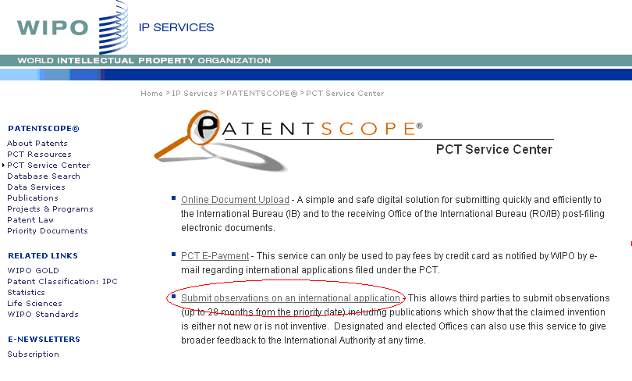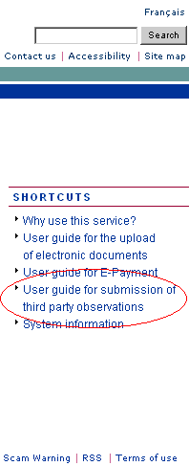
Figure 1: Access to the “Submit Observations” web-page via the PCT Service Center on Patentscope®

Alternatively, where a third party has accessed the international application in respect of which observations are to be submitted via the “Search International and National Patent Collections” database on Patentscope®, the third party can submit observations on that international application by simply clicking on a new ‘Submit Observation’ tab (see figure 2, below).
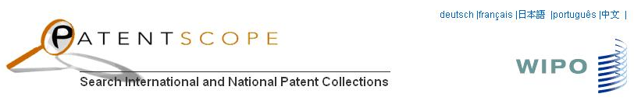

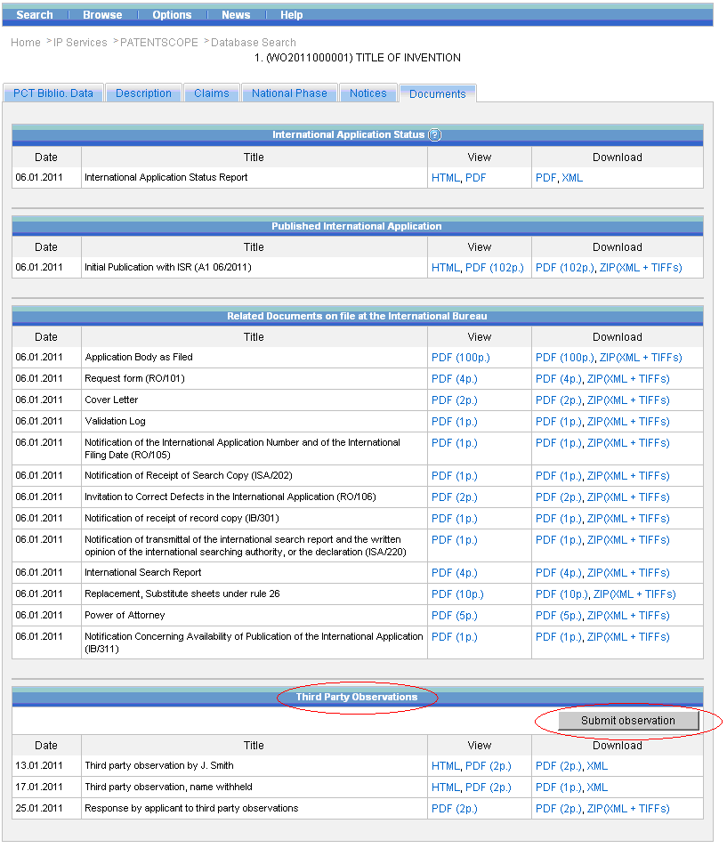
Figure 2: Access to the Third Party Observations System via the “Search International and National Patent Collections” Database Search Tool on Patentscope®

Log-in Into the Third Party Observations System
After clicking on the ‘submit observations’ button on either the “PCT Service Center” webpage or the “Search International and National Patent Collections” database search tool on Patentscope®, the third party will be taken to a new “Log-in” webpage, shown in figure 3, below. Where a third party accesses the Third Party Observations System via the Patentscope® view of a particular international application, the system will automatically fill-in the international application number and the international filing date on the log-in webpage. Where a third party chooses to access the PCT Third Party Observations System via the “PCT Service Center” on Patentscope® (and not via the individual application published on Patentscope®), the third party will be required to indicate at least the international application number or international publication number and the international filing date of the international application concerned (see figure 3, below).
The system will require third parties to identify themselves in order to submit observations by providing some basic bibliographic data, such as name, the company or person he or she represents (if any), country of residence and e-mail address. A third party can do so either by logging in as a registered user (in which case the system would fill in the required bibliographic data) or by entering the bibliographic data whenever a new observation is to be submitted. In the latter case, the system will also require the third party to complete the “captcha test” so as to ensure that the web-form is not filled-in by a computer (see figure 3, below).
As indicated above, third party observations may be submitted without disclosing the third party’s identity to the applicant or the public (see the summary of the discussions during the third session of the Working Group set out in document PCT/WG/3/14 Rev., paragraph 144). Consequently, the bibliographic data given by the third party as set out in paragraph 6, above, will not be disclosed to the applicant or the public, if the third party so requests (by way of ticking a box, see figures 3, 4 and 5 below).

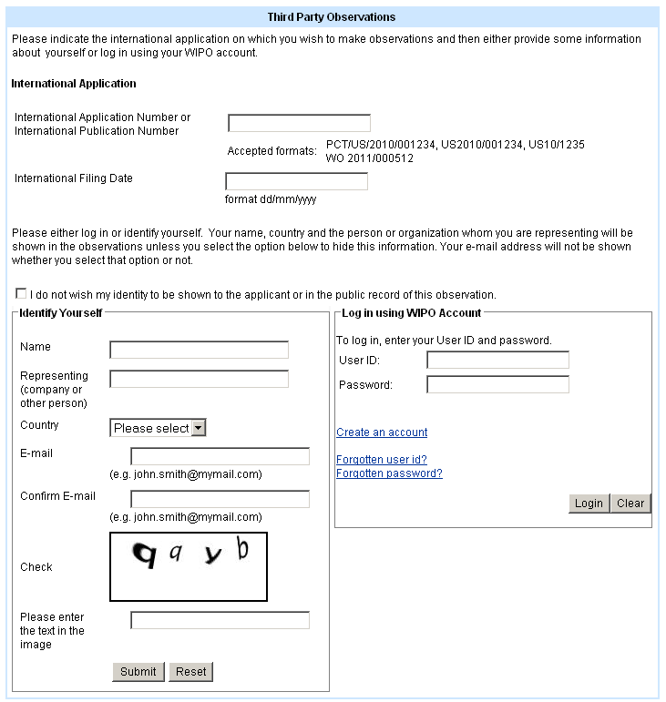
Figure 3: Log-in Screen for third parties

Time Limit for Making Observations
As indicated above, it is proposed that the web-based Third Party Observation System should accept submissions of observations as from the date of publication of the international application concerned until the expiration of 28 months from the priority date (see the summary of the discussions during the third session of the Working Group set out in document PCT/WG/3/14 Rev., paragraphs 142, 149 and 150). The User Guide of the system will include a recommendation encouraging third parties to submit observations as early as possible in the process since they would be less likely to be taken into account at a later stage, notably by the International Preliminary Examining Authority where Chapter II examination is demanded, but also by designated or elected Offices where the applicant had entered the national phase early. Where a third party attempts to submit observations after the expiration of 28 months from the priority date, the system will automatically generate a message that the time limit for submitting observations to the International Bureau has passed (either on the screen in figure 2 or in response to the indication of an international application number/international publication number with a too early priority date in the relevant box in figure 3), but that third parties may nevertheless submit
observations directly to the designated or elected Offices before which the international application has entered the national phase, provided the submission of such observations is permitted under the applicable national law of the designated/elected Office concerned.
Language of System’s Interface and of Submissions
As indicated above, it is proposed that the interface of the web-based Third Party Observation System be eventually available in all 10 PCT publication languages
(however, the prototype will be available in English only). It will be possible to submit observations in any of those 10 PCT publication languages. Documentary evidence, in particular publications submitted in support of any observation, may be filed in any language. However, no translation will be required and no human translation service will be provided by the International Bureau. The system will be developed so as to include the provision of machine translations in a limited range of languages for the free text area.
Content of Observations
Taking into account the discussions during the third session of the Working Group
(see document PCT/WG/3/14 Rev., paragraphs 143 and 150), it is proposed that, at least initially, until experience has been gained with the system, observations should be limited to citations and explanations of prior art considered to be relevant to novelty and inventive step of the claimed invention. In this context, and noting the limited moderation of submissions by the International Bureau (see paragraph 18, below), it should be noted that the system will allow for the submission of observations and citations of documents which are not considered prior art for the purposes of PCT Article 15(2) but which provide evidence of earlier use or oral disclosures which might be relevant in some Contracting States, similar to the mentioning of such documents in international search reports under PCT Rule 33.1(b).
Notwithstanding the initial limitations set out in the previous paragraph, the system will be developed so as to permit the addition of observations on other issues such as “clarity” or “sufficiency of disclosure” at a later stage, should Member States decide that this is appropriate.
The system will give third parties the option to indicate whether the observations submitted relate to the international application as originally filed or as amended under Article 19
(see figures 4 and 5 below). While, in some cases, the application may also have been amended under Article 34, this fact would not be generally known to the public
(or, in most cases, the International Bureau) until after the end of the period for filing observations, and consequently, this will not need to be taken into account.
Submission of Observations
Based on the earlier identification of the international application in respect of which observations are to be submitted (see paragraph 5, above), the system will automatically fill-in basic bibliographic data relating to the international application concerned, such as the international publication number, the international application number, the publication date, the international filing date, the name of the applicant and the title of the invention.
The system will accept the submission of observations through the use of web-forms, which will encourage the submitter to present the relevant information in a structured manner and will allow the system to transform the information provided into different types of output, for the benefit of different users of the information (see paragraph 19, below). The web-forms will include templates for the different types of citations (patent and non-patent literature) and the input of related bibliographic information (based on WIPO Standard ST.14 and the related XML definitions in WIPO Standard ST.36). Where a cited patent document is available to the system from a database, the system will allow the third party, based on basic bibliographic information indicated by the third party (such as a country code and a publication number), to look up further related bibliographic information and to automatically populate the web-form with that further information. Where a cited non-patent document is available from an online source, a direct web-link to that document can be provided. In addition, the system will provide for separate “free text” areas so as to allow the third party to identify the relevant passages within the citation, to indicate the claims to which those citations are relevant and to include a brief explanation as to the relevance of the citation to the claimed invention.

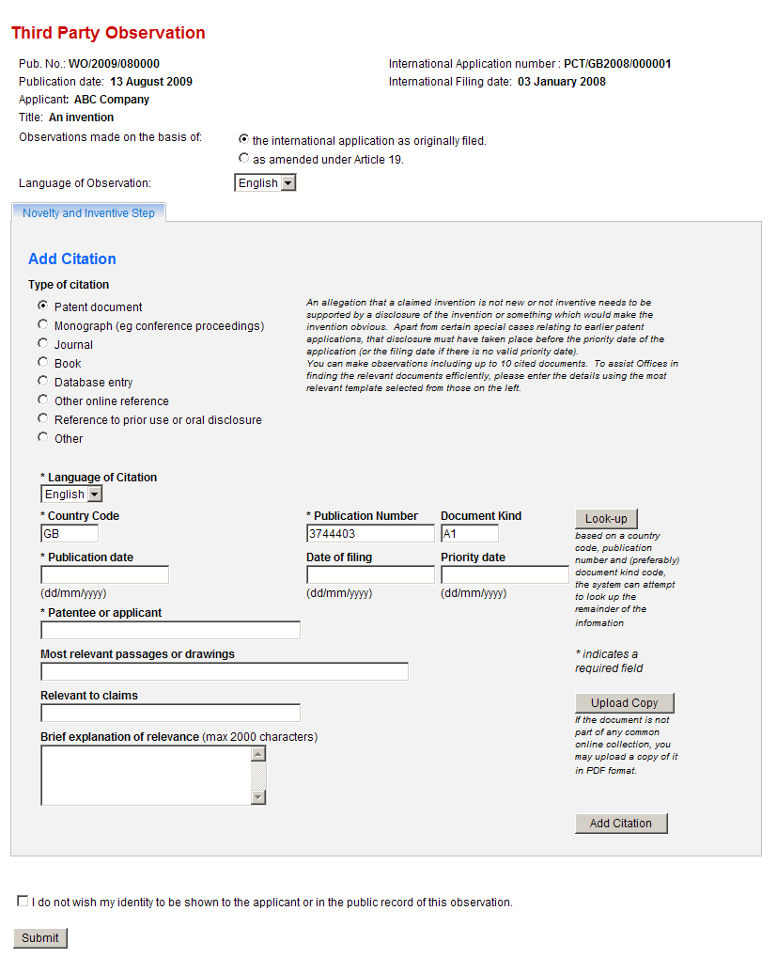
Figure 4: Example of a third party observation citing a patent document

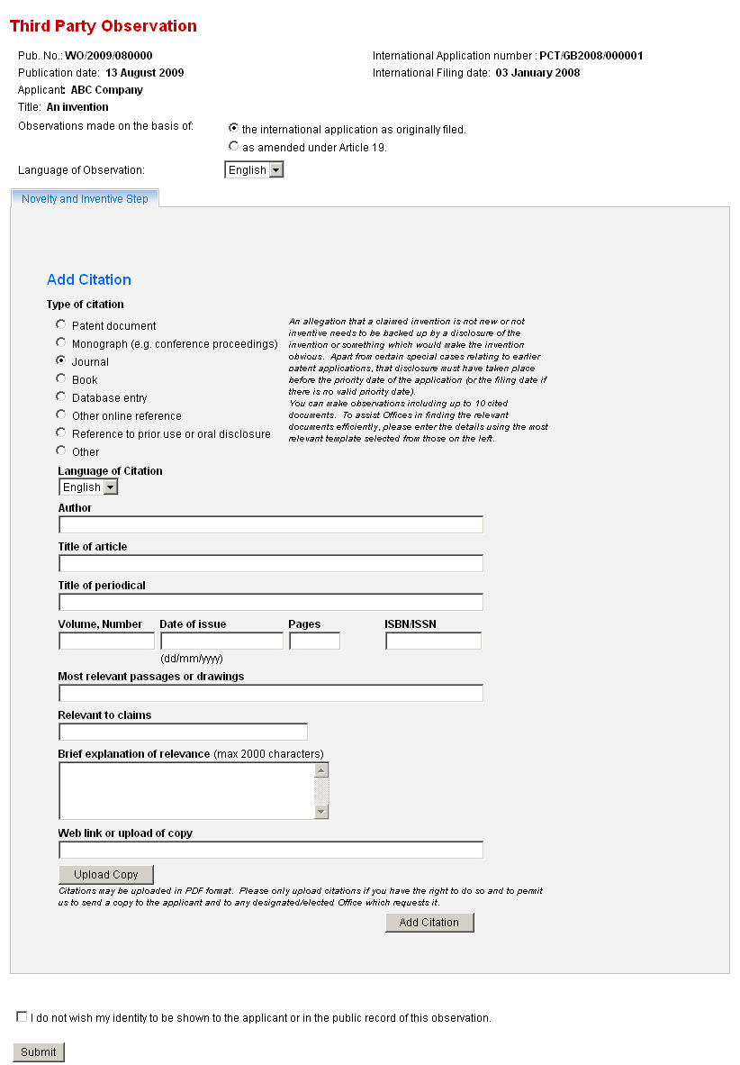
Figure 5: Example of a third party observation citing a non-patent document

The system will allow third parties to upload referenced documents via the service in PDF format. It should be noted that, in order to avoid the risk of copyright infringement, notably in respect of non-patent literature, such documents uploaded by third parties will not be made available to the public via Patentscope®. Uploaded documents will only be made available to the applicant concerned and to the International Authorities and designated/elected Offices. When a third party uploads a document, the third party will be asked to only upload documents if he or she is authorized to do so and to allow the International Bureau to transmit a copy of it to the applicant, International Authorities and designated and elected Offices.
Technical Measures to Prevent Abuse of the System
The International Bureau will put in place technical measures designed to reduce the risk of abuse of the system. The number of citations in a single observation by a third party will be limited to 10 and the free text area will permit a maximum of characters per cited document, such as 2000 characters for submissions using the Latin alphabet (different values could be assigned dependent on the language used to allow approximately the same amount of information to be included in each case). In addition, multiple or automated observations by the same person will be reduced by technical measures, only allowing one observation to be submitted per international application for each account or e-mail address, as well as the use of “captcha” images before the submission form is shown (to reduce automated attacks on the system), measures against multiple submissions in quick succession from the same IP address, and other typical bulletin-board arrangements used to identify submission of “spam” messages.
Submission of Observations on Paper
Third parties will also have the option to submit any observations on paper. The International Bureau will develop a paper form with content along the lines of the web-forms outlined above so as to encourage the information to be provided in the desired structure. The International Bureau will scan such observations and feed them into the system. However, in the event of mass campaigns, the International Bureau will reserve the right not to scan all submissions but only a representative sample. Documents attached by third parties will not be made available to the public via Patentscope® but will be made available to the applicant, International Authorities and designated/elected Offices which require them (see also paragraph 15, above).
Moderation of Third Party Observations by the International Bureau
The International Bureau will moderate all observations submitted by third parties before making them publicly available or communicating them to the applicant, International Authorities and designated/elected Offices to ensure that they are not spam and that their content is not disparaging, offensive or obviously irrelevant or unnecessary under the circumstances (equivalent to PCT Rule 9.1). The degree of scrutiny will be reviewed over time, depending on the degree to which problems occur in real use of the system.
Making Third Party Observations Publicly Available on Patentscope®
All observations submitted by third parties in respect of a published international application will be made publicly available on Patentscope®, and will thus be easily available to the applicant, International Authorities and designated/elected Offices as well as the general public. Patentscope® will allow access to all observations submitted and
will provide direct links to cited documents (but not to any documents uploaded by the third party, see paragraph 15, above). It will be possible to download any observations in several different formats, including:
– a PDF or similar pure text view of all the collected observations for easy reading;
– an HTML view, including hypertext links to the relevant documents to the extent that these can be automatically generated by Patentscope® (likely initially to be limited to those patent documents included in at least one of the major free patent databases);
– an XML version of the complete observations, marked up as far as possible using the same elements as are used in the international standards for XML search reports and written opinions, to allow easy integration of the citation data into lists of citations made by Offices;
– a list of only the cited documents, for use in Offices whose third party observation systems do not permit commentary on the relevance of the documents.
Acknowledgement of Receipt of Submission for Third Party
A third party who has submitted any observations, be it using the web-based system or on paper, will not be sent an acknowledgment of receipt, except that there will be a confirmation screen as part of the online system. Neither International Authorities nor national Offices are obliged to inform third parties whether their comments were taken into account.
Notification of Receipt of Observations to the Applicant; Response by the Applicant
The International Bureau will notify the applicant at least twice of any observations submitted. There will be one notification shortly after receipt of the first observation and another one after the expiration of 28 months from the priority date. In addition, where further observations were received, applicants who provided an email address will be informed by means of an automatically generated e-mail that these observations are available on Patentscope®. Where no e-mail address was provided, the International Bureau will inform the applicant with the first notification, that, if further observations are made, these observations will be made publicly available on Patentscope® and that it is the applicant’s responsibility to monitor his or her international application in that respect.
Applicants will have the right to respond to any observations made but will not be obliged to do so. Any response may be submitted by sending a letter to the International Bureau or by uploading such a letter through the PCT Service Center. Any response submitted by the applicant will be made publicly available on Patentscope® under the newly integrated heading “Third Party Observations” (see figure 2, above). Applicants will be strongly encouraged to submit any response as early as possible in the procedure to ensure that it will be taken into account by the International Preliminary Examining Authority during Chapter II procedures and by designated and elected Offices during national phase procedures. Where a response is submitted after the expiration of 30 months from the priority date, the applicant will be informed that the time limit to submit has passed and that the response should be send directly to the designated or elected Offices where the application has or will enter the national phase, where this is permitted by the relevant national law.
Notification of Receipt of Observations and Reponses by the Applicant to International Authorities and designated/elected Offices
The International Bureau will notify International Authorities and designated/elected Offices by means of an automatically generated form or data feed of any observations made by third parties and of any responses sent by applicants, drawing their attention to the fact that such observations as well as applicants’ responses are available on Patentscope®
(see figure 2, above). The system will also permit automated retrieval of the observations and the responses by the International Authorities and designated/elected Offices. Documents uploaded by third parties will not be made available to the public via Patentscope® but will be made available to the applicant, International Authorities and designated/elected Offices which require them (see paragraph 15, above).
Proposed Legal Framework of the System
As indicated above, it is proposed that the new PCT Third Party Observation System be supported by specific provisions set out in the PCT Administrative Instructions as well as the PCT International Search and Examination Guidelines, setting out specifying details, notably, the time limits within which observations may be submitted and the status of any observations submitted. In particular, the provisions will clarify that neither the International Searching and Preliminary Examining Authorities nor designated or elected Offices will be under any obligation to take into account any observations submitted by third parties, and that it will be up to each International Authority and each designated or elected Office to decide whether to review any observations submitted by a third party, and whether and if so, to which extent to take them into account, in accordance with individual national laws, practices and policies of the Authority or Office concerned. Annex II to this Circular sets out a preliminary draft of possible provisions to be included in the Administrative Instructions and the International Search and Examination Guidelines. Note that a formal consultation procedure on those proposed modifications will follow in due course.
SIMILARITIES WITH THE QUALITY FEEDBACK SYSTEM
At its third session, the PCT Working Group also recommended that the International Bureau develop a quality feedback system which allows effective quality feedback from designated/elected Offices to International Authorities (see document PCT/WG/3/14 Rev., paragraphs 152 to 157).
The Working Group’s discussions with regard to the similarities of both systems are set out in document PCT/WG/3/14 Rev., paragraph 153, as reproduced in the following paragraph:
“153. In introducing the document, the Secretariat recalled the close links which were seen with the third party observation system which had just been discussed and other projects for sharing search and examination information between Offices. The Secretariat emphasized the importance of all such systems working together effectively and indicated that it believed that the cost of developing this system should be minimal since most of the services could be shared with those being developed for the third party observation system.”
The International Bureau proposes that designated/elected Offices should be able to use the above arrangements to give feedback to the International Authorities at any time (without the 28 month limit which applies to third parties). The details of how this aspect of the system should be presented will be further discussed with the International Authorities, but it is envisaged that if a user is logged in as an account holder which is authorized to act as a representative of a designated/elected Office (or the system otherwise confirms that the response is from a designated/elected Office rather than a member of the public), the system will allow the above screens to be used at any time and comments on new citations will be made available to the public in exactly the same way as a third party observation, save that the origin of the comment will be noted as being the relevant designated/elected Office. In addition, further screens would be available, permitting feedback of a more general nature to be included. Any new cited documents entered in this way would be made available in the same form as for a normal third party observation, but the additional information would probably be actively notified only to the quality department of the relevant International Authority, but not to the applicant or other Offices.

[Annex II to Circular C. PCT 1288 (Preliminary draft proposed modifications of the PCT Administrative Instructions) is not reproduced in this document]

[End of Annex and of document]

