
E

PCT/WG/3/12
OriGINAL: English
DATE: JUne 14, 2010
Patent Cooperation Treaty (PCT) Working Group
Third Session
Geneva, June 14 to 18, 2010
proposal on numbering figures
Document submitted by the Republic of Korea

SUMMARY
According to PCT Rule 11.13(k), the figures shall be numbered consecutively in Arabic numerals and independently of the numbering of the sheets. Under this rule, therefore, it is not allowed to number figures alphanumerically.
However, the national regulation of some Offices including KIPO permits applicants to alphanumerically number figures, for examples figure numbers, such as 4a and 4b are allowed.
Some PCT users should renumber the figures in the PCT application to meet the PCT rule 11.13(k) when they use the description and drawings of an earlier application in which figures have been alphanumerically numbered.
Also, we have found that some PCT applications, especially those with earlier national applications contained figures that are alphanumerically numbered, and were published by WIPO without correction as you can see in the next page.
As a result, some PCT users are calling for the revision of the provision to eliminate their unnecessary work.
To meet this request, we should consider revising the PCT Rule 11.13(k) to allow for the alphanumeric numbering of figures.
According to our technical experts, there is no problem to reflect the revision in the PCT application system.
The Working Group is invited to consider the proposed amendment of Rule 11.13(k).

[Annex follows]
ANNEX

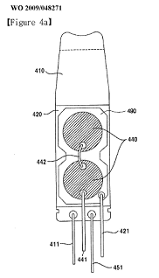
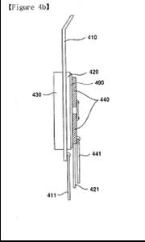

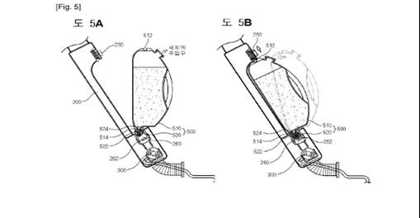

[End of Annex and of document]

