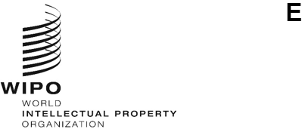
PCT/WG/18/13
ORIGINAL: English
DATE: January 17, 2025
Patent Cooperation Treaty (PCT) Working Group
Eighteenth Session
Geneva, February 18 to 20, 2025
International Publication Related Processes
Document prepared by the International Bureau

Summary
- The International Bureau proposes to move international publication towards a text-based process, allowing the components of the publication to be used more efficiently and flexibly. To do this, the traditional “pamphlet” would change to contain only the front page (including the abstract), description, claims (including claims amended under Article 19) and drawings. The international search report or declaration that no international search report will be established would be published as separate documents, as would translations of search reports and potentially statements concerning claims amended under Article 19. This would mirror the arrangement that has been in place for some years for declarations referred to in Rule 4.17, indications in relation to deposited biological material and various other items.
- This would simplify publication processes, reduce delays, deliver products that are easier to present in different languages and formats according to need, and ease the way toward publication of color drawings and further improvements in information display and use. All the same information that is published at present would continue to be published, with the aim of it all being available on the international publication date, provided that the relevant documents are received by the International Bureau in good time from the receiving Office and International Searching Authority.

Background
- The international publication is an important document of information and record, but the way it is used has changed. The content of the international publication is defined by Rule 48. The original version of this Rule was created at a time when there was no electronic file inspection and consequently, it was important for all the most important information concerning the international application to be combined into a single “pamphlet”, which was published distributed on paper to all Contracting States and information providers.
- Rule 48.1 was updated from April 1, 2006, to eliminate the term “pamphlet” and to leave the form and means of publication to the Administrative Instructions (Section 406). This led to PATENTSCOPE becoming the official means of publication and to certain parts of the international publication being referred to on the front page, but left as separate documents, which are grouped on PATENTSCOPE within the “published international application” part of the documents tab when viewing the application.
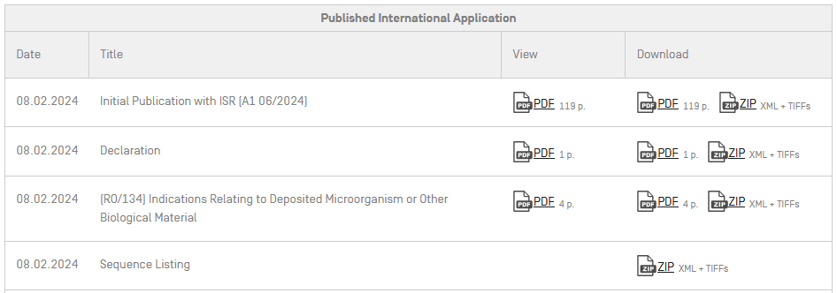
Example of the “Published International Application” section on PATENTSCOPE

- This simplified the publication process, made the “pamphlet” part of the international publication more manageable to navigate and simplified identification by designated Offices of the various sections of the international publication that need to be processed in different ways on national phase entry. However, each individual part of the publication remains – at least in its official form – a set of page-based images very similar to what was traditionally published on paper.
- In some cases, structured or text-based information is available for some or all components of the international publication, but it is presented separately, not part of the official publication. It is now desired to move towards greater use of structured data as part of the official publication.

Content of the International Publication
- PCT Article 21 requires that the International Bureau should publish international applications (paragraph (1)), as well as international search reports or declarations that no international search report shall be established (paragraph (3)). However, there is no fundamental requirement that these publications should be presented as a single document.
- The content of the international publication is defined by Rule 48.2 as follows:

48.2 Contents
(a) The publication of the international application shall contain:
(i) a standardized front page;
(ii) the description;
(iii) the claims;
(iv) the drawings, if any;
(v) subject to paragraph (g), the international search report or the declaration under Article 17(2)(a);
(vi) any statement filed under Article 19(1), unless the International Bureau finds that the statement does not comply with the provisions of Rule 46.4;
(vii) where the request for publication under Rule 91.3(d) was received by the International Bureau before the completion of the technical preparations for international publication, any request for rectification of an obvious mistake, any reasons and any comments referred to in Rule 91.3(d);
(viii) the indications in relation to deposited biological material furnished under Rule 13bis separately from the description, together with an indication of the date on which the International Bureau received such indications;
(ix) any information concerning a priority claim referred to in Rule 26bis.2(d);
(x) any declaration referred to in Rule 4.17, and any correction thereof under Rule 26ter.1, which was received by the International Bureau before the expiration of the time limit under Rule 26ter.1;
(xi) any information concerning a request under Rule 26bis.3 for restoration of the right of priority and the decision of the receiving Office upon such request, including information as to the criterion for restoration upon which the decision was based.
- In practice, for some years the items listed in Rule 48.2(a) items (vii) to (xi) have been published as separate documents, grouped on PATENTSCOPE (the official publication tool) in a section titled “Published international application”, with notices on the front page to draw attention to the availability of the relevant content.
- The international search report, its translation where applicable, and statements under Article 19(1) concerning amended claims continue to be merged into the document forming the main part of the international application. However, the entire document continues to be based on a series of page-based images, even where the original content of the application body or international search report was prepared in XML format.
- Merging the international search report and (where relevant) its translation into the international publication adds complexity that no longer appears to serve a useful business purpose. Rather, it may cause delays in publications and republications of the report. In the case where an international search report is received after the completion of preparations for international publication but before the publication date, the international application will be published as an A2 document even though the international search report will be visible on the file of the international application on the publication date; a formal publication of the international search report as an A3 document is only able to occur some time later (typically three to six weeks, at present).

Preparation and Publication of the Application Body
- At present, the official publication of the description, claims and drawings is as page-based images. The official publication contains an XML file, which includes data equivalent to that on the front page of the international publication, but the body of the application is included only by reference to a series of black and white TIFF images, even if the international application had been filed and processed in XML format.
- Over half of international applications are now received by the International Bureau with the application body in XML format. This includes applications originally submitted in XML format, including those uploaded to ePCT in DOCX format and automatically converted to WIPO Standard ST.36 XML prior to submission. It also includes applications originally filed in PDF format at the receiving Office of the China National Intellectual Property Administration (RO/CN) and converted to XML format by RO/CN prior to transmission of the record copy to the International Bureau.

Markup of Changes
- As part of a pilot project (see Circular C. PCT 1656) expected soon to be formalized, these applications are then processed by the International Bureau in XML format in preparation for publication, including marking up corrected or rectified paragraphs and figures such that markings equivalent to the stamps for substitute sheets required by Section 325 of the Administrative Instructions are shown in the margins.
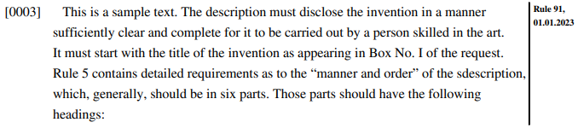
Extract from a page-based rendering of a sample rectified paragraph of an XML application body in English

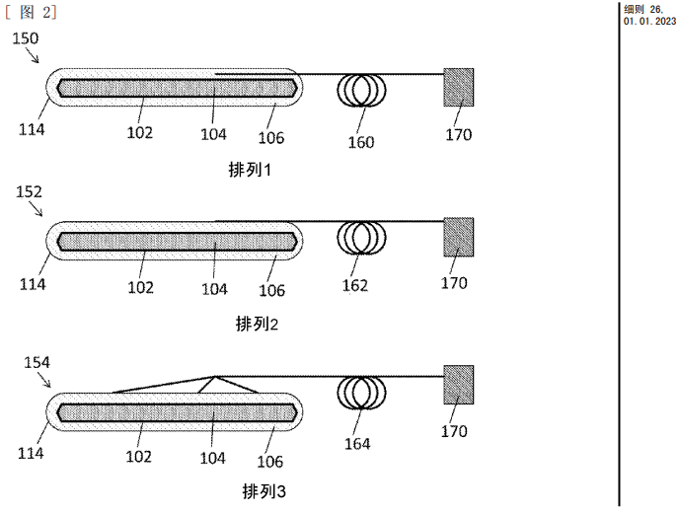
Extract from a page-based rendering of a sample corrected figure in an XML application body in Chinese

- The markup for this is not ideal since it involves inserting text such as “[Corrected under Rule 26, 31.01.2023]” at the start of the relevant paragraphs or within the figure-labels attribute of drawings in the XML data. The International Bureau hopes to move to a new XML format where the main part of the XML shows a “clean” text of the application body as corrected, rectified or amended, with the marginal information being generated from a modifications section, indicating which parts of the application body have changed since filing and, potentially, the previous content that it replaces, allowing the possibility of easy comparison of original and replaced content.

Full Text and Color Drawings
- XML-based applications are already processed in XML format, with references to the individual figures as received in the record copy. As part of the preparations for publication, a text-based PDF is created, which also includes drawings in color if these were part of the record copy and have not been replaced as part of a correction or rectification. The text-based PDF is then “flattened” to a series of black and white TIFF images, which are referenced in the wo-published-application.xml file (which, as noted above, contains the bibliographic data from the front page in structured format, as well as a reference to an image of the front page).
- The International Bureau would like eventually to present text-based XML as part of the official international publication, at least in cases where the record copy is received with the application body in XML format.
- While an official page-based rendering would continue to be offered, having the official text-based publication of the application body would simplify import of the full text into national phase processing and patent information databases. It would also make it easier to present the application body in different formats, according to user needs, such as showing the description and claims flowing within a resizable window, with the drawings displayed and linked alongside for easier reference, potentially also showing cited documents alongside based on links from an XML search report in a separate document.
- As an interim step, where the international application is processed in XML format, it is intended shortly to provide the full text PDF (including drawings in color where relevant) as an unofficial part of the package supplied for publication of the relevant applications in the format previously used for OCR copies of documents. The supply of OCR as part of the publication package was withdrawn because the quality of OCR was not considered good enough to be associated with the official publication, but for XML applications, the text content would be guaranteed to be equivalent to the images since it is the source from which the images are created.

Separation of International Search Report and Article 19 Statements
- At present, declarations referred to in Rule 4.17, indications in relation to deposited biological material and the various other items referred to in Rule 48.2(a) items (vii) to (xi) are part of the international publication but are published as files distinct from the main A1 or A2 publication, with references on the front page.
- On the other hand, the international search report and statements filed under Article 19(1) continue to be incorporated into the “pamphlet” part of the international publication. While it is important that these documents be available to both designated Offices and patent information users, most interested parties use the application body, the international search report and Article 19 statements in different ways, such that they are more likely to be useful if viewed side-by-side than inline as part of a single, image-format document.
- Furthermore, it is desired to provide new, value-added services based on the use of available XML, including rendering documents into alternative languages and providing links to cited documents. An example of this type of service can be seen in the “ISR/WOSA/A17(2)(a)” tab in PATENTSCOPE, which provides HTML views of the international search report and written opinion from the original language XML, official translations into English where available, or machine translation into any of the other 10 languages of publication, as shown below. The view also includes links to patent documents and some non-patent literature.
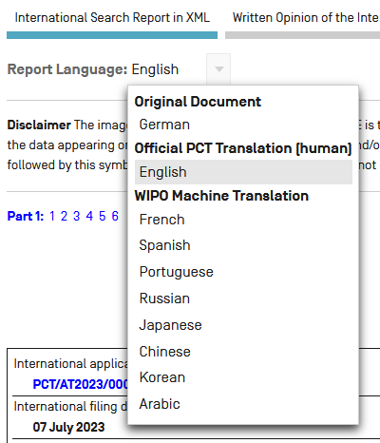
Selection of the preferred language to view a full text version of the international search report in PATENTSCOPE
- The XML formats for the various document components such as application body, international search report and declarations are designed to be included in separate XML files. While it would in principle be possible to create a single XML document or package containing all of the components of the international publication in order for it to be rendered in a single PDF document equivalent to the “pamphlet”, this would greatly increase the complexity of the systems behind international publication. Such an arrangement would need to deal with the fact that not all components of the publication are received in XML format, the variations in the XML delivered from different Offices and the different versions of XML that come into use at different times during the application process. Keeping the component parts of the international publication as separate original documents will allow improvements to the processing of each part to be delivered without risk of unforeseen consequences for other parts of the publication process.
- Consequently, separating the international search report (or declaration under Article 17(2)(a)) and potentially the statements filed under Article 19(1) into separate documents will simplify the publication process, and facilitate use of the information by different users.

Timing and Availability of Content
- These proposals are not intended to have any substantive effect on the content or timing of the various parts of the international publication. Specifically, it will remain a goal of the system to deliver both the international search report and any required translation into English in time to be available on the international publication date or, where that is not possible, for them to be published as soon as reasonably possible afterwards. The content of the translated search reports will continue to include the same material as at present, that is at least Boxes No. II and III of Form PCT/ISA/210 (where these are used), showing the observations where some claims were found unsearchable and observations where unity of invention is lacking, in addition to the “second sheet” including details of the field of search, documents considered to be relevant and patent family members.

Official Republications
- Noting that Article 21(3) specifically requires the publication of the international search report, it is envisaged that the first international publication would continue to be listed as either A1 or A2, depending on whether the international search report (or Article 17(2)(a) declaration) and any required translation were available in time for publication. In the case of an A2 publication, an A3 publication would be made once the report and translation were ready. However, the main republished document would consist only of a front page, making note of the existence of the report and, where necessary, updating the title, abstract and classifications to reflect any changes from the international search report. As at present, the international search report and any translation would be made available on the international publication date or as soon as possible afterwards, even though an A3 document recording their official publication might only be issued some weeks later.
- Other republications would similarly occur as at present for various cases such as receipt of Article 19 amendments and corrections of errors. However, the main document would consist solely of a new front page and its associated data except in the case where the republication is due to a change to the application body (including Article 19 amendments).
- It is hoped that the simplification in processes will allow more search reports and translations thereof to be recognized in the first publication, as well as a shorter timetable for republications so that the original documents can be made available more quickly than at present following the relevant events, while ensuring that key events continue to be properly recorded in the PCT Gazette and can easily be seen by interested parties.

Implementation of the Changes
- The proposed changes do not require any amendments to the PCT Regulations. The fact that the international search report would only be published under Rule 48.2(a)(v) as a separate document, rather than being integrated into a “pamphlet” together with the application body is exactly equivalent to the process that has been used since 2006 for the parts of the international publication referred to in Rule 48.2(a) items (vii) to (xi). However, the International Bureau will inform interested parties, including by PCT Circular, when it is ready to make the relevant changes and is ready to offer information and assistance to Offices concerning any necessary changes to ensure that all necessary document types can be automatically identified and downloaded for national phase processing.
- The Working Group is invited to comment on the proposed approach to publication of international search reports and Article 19 statements as documents separate from the front page and application body.
[End of document]

Note that the statement under Article 19(1) and Rule 46.4 is distinct from the letter accompanying an amendment under Rule 46.5 – see paragraphs 9.006 and 9.007 of the PCT Applicant’s Guide. The statement is part of the international publication, but the letter is published simply as a normal part of the international application’s file.

