PCT/WG/15/13
ORIGINAL: English
DATE: September 7, 2022

Patent Cooperation Treaty (PCT) Working Group

Fifteenth Session

Geneva, October 3 to 7, 2022

Filing Medium of International Applications and Related Documents
Document submitted by Brazil

Summary
- The present document proposes an amendment of the Regulations under the Patent Cooperation Treaty, aiming to allow Offices to require the filing of international applications and the submission of subsequently-filed documents to be performed only in electronic form and not on paper. The document also proposes to invite the International Bureau to study the issues concerning electronic-only entry into the national phase.

Background
- The thirty-second series of meetings of the Assembly of Member States of WIPO, held from March 25 to 27, 1998, approved the proposal for automation of PCT operations (document A/32/5). The project of electronic filing of international application originated as part of the Information Management Project for the PCT. The PCT-EASY (Electronic Application SYstem) software was launched in January 1999, allowing creation of an electronic request form, submitted on physical media with paper application bodies. PCT-SAFE (Secure Applications Filed Electronically) entered service as a pilot in February 2003, allowing fully-electronic filings to be made. This was soon formalized and adopted by additional Offices. Together with compatible software from national Offices operating to the same protocols, this quickly became the dominant mode of filing at receiving Offices offering the service.
- In June 2011, at the fourth session of the PCT Working Group, the International Bureau reported that a new IT system was being developed to improve the services provided under the PCT, the ePCT system (document PCT/WG/4/13). Since then, the ePCT system has been expanding the range of online services for applicants and patent Offices as receiving Office (RO), International Searching Authority (ISA) and International Preliminary Examining Authority (IPEA). In 2013, the electronic filing “ePCT-Filing” was initially offered for filings at the receiving Office of the International Bureau, and was extended in 2014 for filings to any Office wishing to use the service.
- In recent years, the number of international applications filed on paper has decreased considerably. According to WIPO data, in 2018, only 2.99 per cent of the total international applications were filed on paper; in 2019, they were 2.33 per cent; in 2020, they were 1.6 per cent; and in 2021, they were 1.3 per cent. In 2021, international applications on paper in some receiving Offices represented less than 1 per cent of filings, such as China, Israel, Japan, Republic of Korea, Singapore and Sweden.
- Figure 1, taken from the PCT Yearly Review 2022, shows the variation that has occurred in the last 10 years in relation to the filing medium of international applications.
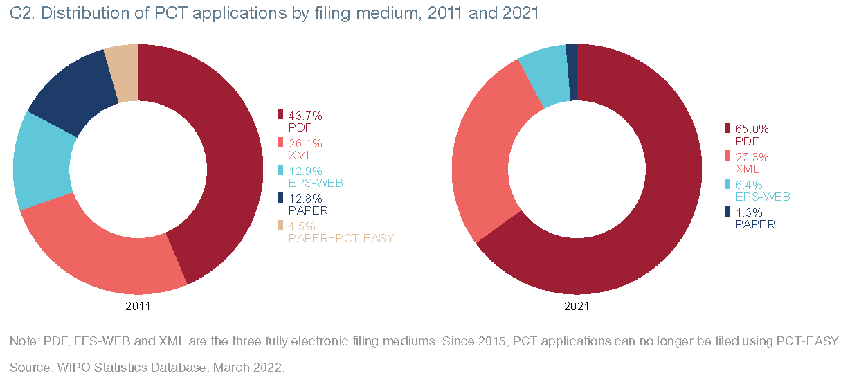
Figure 1: Distribution of PCT Applications by Filing Medium, 2011 and 2022
Source: WIPO Statistics Database, March 2022
- This decrease in paper filing is due to the fact that a large number of receiving Offices and their applicants have adopted the ePCT electronic filing system, encouraged by the reduction in cost and processing time, and applicants have in turn found electronic filing highly beneficial. In addition, some patent Offices that have their own electronic filing systems, such as the European Patent Office (EPO) and the United States Patent and Trademark Office (USPTO) also use the ePCT system for the electronic filing of the PCT international application. It is worth remembering that a special discount applies to the international filing fee for international applications filed in electronic means or by electronic means and some national Offices also offer electronic filing discounts on other fees, such as the transmittal fee.
- Currently, ePCT-Filing is used by 83 receiving Offices and national electronic filing systems are available for filing to a number of other receiving Offices.
- The International Bureau has spared no effort to improve the ePCT system in order to facilitate not only the filing of international applications but also to expedite the transmission of copies of international applications, documentation and reports issued by International Authorities. The eSearchCopy system is being used by all receiving Offices that transmit search copies to other Offices as International Searching Authorities.

Current Situation
- The national and regional Offices also seek to improve the services provided, both for national and foreign applicants (Paris Convention and PCT), using IT systems to develop electronic services that speed up the processing of the application, reduce costs and guarantee security data and information contained in the patent application.
- In the case of PCT international applications, the electronic processing takes place not only between the receiving Office, the International Bureau and the International Searching Authority, but also within the Office itself, for example, upon receiving the application, formalities examination and issuance of forms.
- Nowadays, many patent Offices have electronic processing in all sectors responsible for the activities involved in granting a patent: reception of national applications and documents, registration, formalities examination, publication, payment of fees, petitions, substantive examination and patent granting.
- Thus, receiving an application on paper, whether filings in the international or national phase of the PCT, represents extra work for the Office, whether acting as a receiving Office, International Authority or as an elected or designated Office, as it will have to prepare it to process electronically through their systems.
- A PCT international application filed on paper takes longer to process, as it needs to be scanned, registered and uploaded to the ePCT system, considering the International Bureau and International Authorities only work with documents in electronic format. In addition, the work is twofold with regard to the forms issued, as the applicant will receive all paper documentation, while the International Bureau and the International Searching Authorities will receive it in electronic format. There is also a significant risk of Offices introducing errors in the transcription of information from the request form and uploading and categorization of scanned documents. It should be noted that many of these issues also apply to electronic filing systems where items such as the request form are received in image format, rather than automatically processable XML.
- All the International Bureau's initiatives are aimed at encouraging and reinforcing electronic services in all phases of the PCT, which makes the Offices also increasingly prepare to act in this format. Thus, the receipt of all documentation of international applications in electronic format is an important point for the participation and contribution of the Offices in the priority initiatives of the PCT.

Proposal
- Annex I sets out a proposed amendment of Rule 89bis.1 to allow receiving Offices to define the filing medium of the international application, and in particular to require that international applications must be filed only in electronic format and not on paper. Rule 89bis.2 acts to extend the same principle to documents submitted after the filing of the international application, whether to the receiving Office or to an Office acting in another capacity such as the International Searching or Preliminary Examining Authority.
- Any Office wishing to introduce such measures would notify the International Bureau, which would publish the information in the PCT Gazette and make it available in other places, including the PCT Applicant’s Guide and PCT Newsletter. The proposal would not require receiving Offices to make any changes to the filing formats that they currently accept.
- It is recognized that occasionally there may be situations where it is difficult or impossible for an applicant to submit documents electronically. This might be a general problem, such as an extended outage of the electronic filing systems or circumstances specific to an individual applicant. Consequently, it is proposed to include a provision in the PCT Administrative Instructions to clarify that an Office could accept a paper filing (or a subsequently-filed document) if this is considered appropriate, even if it had made a notification indicating that paper filings were no longer allowed. Annex II sets out a draft new Section 703(e-bis) for this purpose, based on existing Section 703(e), which allows Offices to accept non-standard electronic submissions on a case-by-case basis. Alternatively, applicants from a country whose Office had made such a notification would remain free to file paper applications at the receiving Office of the International Bureau.
- The Brazilian National Institute of Industrial Property also wishes to make national phase entry electronic only. However, a number of issues remain to be clarified in the context of PCT Article 22 and Rule 49. It also has a more significant effect on the interests of applicants from all PCT Contracting States, not only that where the application was filed. Consequently, Brazil invites comments from the Working Group on the issues concerned and proposes to invite the International Bureau to make an analysis and proposal at the next session of the Working Group.
- The Working Group is invited to:
    - consider the proposals set out in the Annexes to document PCT/WG/15/13; and
    - request the International Bureau to study the issues concerning electronic-only entry into the national phase and make proposals to the next session of the Working Group.

[Annex I follows]
PROPOSED AMENDMENTS TO THE PCT REGULATIONS

TABLE OF CONTENTS

Rule 89bis Filing, Processing and Communication of International Applications and Other Documents in Electronic Form or by Electronic Means 2
89bis.1 International Applications 2
89bis.2 Other Documents 3
89bis.3 Communication between Offices 3

Rule 89bis
Filing, Processing and Communication
of International Applications and Other Documents
in Electronic Form or by Electronic Means

89bis.1 International Applications
(a) International applications may, subject to paragraphs (b) to (e), be filed and processed in electronic form or by electronic means, in accordance with the Administrative Instructions, provided that any receiving Office shall permit the filing of international applications on paper.
(b) [No change] These Regulations shall apply mutatis mutandis to international applications filed in electronic form or by electronic means, subject to any special provisions of the Administrative Instructions.
(c) [No change] The Administrative Instructions shall set out the provisions and requirements in relation to the filing and processing of international applications filed, in whole or in part, in electronic form or by electronic means, including but not limited to, provisions and requirements in relation to acknowledgment of receipt, procedures relating to the according of an international filing date, physical requirements and the consequences of non-compliance with those requirements, signature of documents, means of authentication of documents and of the identity of parties communicating with Offices and authorities, and the operation of Article 12 in relation to the home copy, the record copy and the search copy, and may contain different provisions and requirements in relation to international applications filed in different languages.
(d) [No change] No national Office or intergovernmental organization shall be obliged to receive or process international applications filed in electronic form or by electronic means unless it has notified the International Bureau that it is prepared to do so in compliance with the applicable provisions of the Administrative Instructions. The International Bureau shall publish the information so notified in the Gazette.
(d-bis) An Office that has made a notification under paragraph (d) may notify the International Bureau that it will only receive international applications if they are filed in electronic form or by electronic means. The International Bureau shall publish a notification made under this paragraph in the Gazette.
(e) [No change] No receiving Office which has given the International Bureau a notification under paragraph (d) may refuse to process an international application filed in electronic form or by electronic means which complies with the applicable requirements under the Administrative Instructions.

89bis.2 Other Documents
[No change] Rule 89bis.1 shall apply mutatis mutandis to other documents and correspondence relating to international applications.
[NOTE: This paragraph would act on the amended Rule 89bis.1 to extend the possibility of excluding paper to subsequently-filed documents. It would be possible to go step-by-step and notify the International Bureau that paper was no longer accepted for filing and for subsequently-filed documents from different dates, provided that the relevant IT systems used by the Office allowed for this.]

89bis.3 Communication between Offices
[No change] Where the Treaty, these Regulations or the Administrative Instructions provide for the communication, notification or transmittal (“communication”) of an international application, notification, communication, correspondence or other document by one national Office or intergovernmental organization to another, such communication may, where so agreed by both the sender and the receiver, be effected in electronic form or by electronic means.

[Annex II follows]
PROPOSED MODIFICATIONS TO THE ADMINISTRATIVE INSTRUCTIONS
UNDER THE PCT

Section 703
Filing Requirements; Basic Common Standard
(a) to (d) [No change]
(e) [No change] Any receiving Office may refuse to receive an international application submitted to it in electronic form if the application does not comply with paragraph (b), or may decide to receive the application.
(e-bis) Any receiving Office that has made a notification in accordance with Rule 89bis.1(d-bis) may refuse to receive an international application submitted to it on paper, or may decide to receive the application.
(f) [No change]

[End of Annex II and of document]

