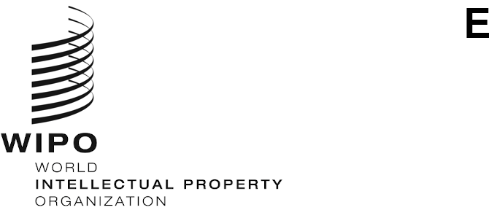
PCT/WG/13/14
ORIGINAL: English
DATE: October 8, 2020

Patent Cooperation Treaty (PCT) Working Group

Thirteenth Session
Geneva, October 5 to 8, 2020

Summary by the Chair

Agenda Item 1: Opening of the session
- Mr. Daren Tang, Director General of WIPO, opened the session, together with the thirty-first session of the Committee for Technical Cooperation, and welcomed the participants. Mr. Michael Richardson (WIPO) acted as Secretary to both meetings.

Agenda Item 2: Election of a Chair and two Vice Chairs
- The Working Group unanimously elected Ms. Dong Cheng (China) as Chair and Ms. Rekha Vijayam (India) and Mr. Charles Pearson (United States of America) as Vice-Chairs for both meetings.

Agenda Item 3: Adoption of the agenda
- The Working Group adopted the revised draft agenda as set out in document PCT/WG/13/1 Prov. 3.

Agenda Item 4: Implementation of WIPO Standard ST.26 in the PCT
- Discussions were based on document PCT/WG/13/8.
- The Working Group approved the proposed amendments to Rules 5, 12, 13ter, 19 and 49 of the Regulations, as set out in the Annex to document PCT/WG/13/8, with a view to their submission to the Assembly for consideration at its next session in the first half of 2021.

Agenda Item 5: Strengthening PCT Safeguards in Case of General Disruption
- Discussions were based on document PCT/WG/13/10.
- All delegations supported the principle that the PCT legal framework should provide adequate mechanisms to safeguard against loss of rights of an application from failure of an applicant to meet a time limit fixed in the PCT Regulations due to the COVID-19 pandemic and similar situations such as those listed in Rule 82quater.1(a).
- Some delegations supported the proposed Rule changes in the document, or after addressing minor drafting points. Some other delegations expressed concerns with specific details of the proposal that they believed would require further consideration at the next session of the Working Group.
- One delegation requested that the International Bureau should assess the experiences of Offices in the implementation of the Interpretative statement and Recommended Patent Cooperation Treaty (PCT) Practice Changes in light of the COVID-19 Pandemic that it issued on April 9, 2020.
- The Working Group expressed support for the principle of providing for better safeguards for applicants and Offices in cases of general disruption outside their control and:
  - invited the European Patent Office, France, Switzerland and the United Kingdom to submit a revised proposal to the next session of the Working Group, taking into account the comments made by delegations; and
  - requested the International Bureau, in cooperation with the Member States, to assess the experiences of Offices in the implementation of the Interpretative statement and Recommended Patent Cooperation Treaty (PCT) Practice Changes in light of the COVID-19 Pandemic that it issued on April 9, 2020 and to submit a report to the next session of the Working Group.

Agenda Item 6: Review of the Supplementary International Search System
- Discussions were based on document PCT/WG/13/4 Rev.
- Some delegations stated that the costs of maintaining the supplementary international search (SIS) system were not justified by the level of use and favored discontinuing the service. Some other delegations considered that the system was of benefit to certain applicants and should be maintained pending further developments, such as the outcome of the collaborative search and examination pilot or the making available of further options within the SIS system.
- The Chair noted that, in the absence of consensus, it was unlikely that agreement could be reached on amendments to the PCT Regulations and suggested to adopt the proposal in paragraph 21 of the document, noting that doing so maintained the possibility for any Contracting State to request a further review when it deemed that there was consensus for change.
- The Working Group agreed to recommend to the Assembly to adopt the following decision:
“The PCT Assembly, having reviewed the supplementary international search system in 2012, 2015 and 2021, decided:
“(a) to invite the International Bureau to continue to monitor the system and report to the Meeting of International Authorities and the Working Group on significant developments; and
“(b) to review the system again at a time to be recommended by the International Bureau, or on request by a Contracting State, but no later than 2027.”

Agenda Item 7: PCT Minimum Documentation: Status Report
- Discussions were based on document PCT/WG/13/12.
- The Working Group noted the contents of document PCT/WG/13/12.

Agenda Item 8: Coordination of Patent Examiner Training
- Discussions were based on document PCT/WG/13/6 Rev.
- The Working Group noted the contents of document PCT/WG/13/6 Rev.

Agenda Item 9: Coordination of Technical Assistance Under the PCT
- Discussions were based on document PCT/WG/13/7 Rev.
- The Working Group noted the contents of document PCT/WG/13/7 Rev.

Agenda Item 10: Other matters
- The International Bureau indicated that the fourteenth session of the Working Group was tentatively scheduled to take place in May/June 2021.

Agenda Item 11: Summary by the Chair
- The Working Group noted that the present document was a summary established under the responsibility of the Chair and that the official record would be contained in the report of the session.

Agenda Item 12: Closing of the session
- The Chair closed the session on October 8, 2020.

[End of document]

