WIPO |  | PCT/MIA/VI/7  ORIGINAL: English  DATE: January 21, 1997
WORLD INTELLECTUAL PROPERTY ORGANIZATION
GENEVA
International patent cooperation union
(PCT union)
Meeting of international authorities
under the PCT
Sixth Session
Canberra, February 17 to 21, 1997
use of the internet During international search and international preliminary examination
Document prepared by the International Bureau

1 Several International Authorities appear to have gained significant experience related to the use of the Internet as a resource in the work of search and examination. For example, the European Patent Office, the Japanese Patent Office and the United States Patent and Trademark Office, in the course of their trilateral cooperation, have been studying the use of the Internet in connection with Trilateral Project 14.6 (Common Search Tools).

2 Because that experience may be of interest to the other Authorities, it is proposed that the Meeting discuss the use of the Internet during international search and international preliminary examination, and particularly, whether, and along what lines, modifications should be made to the PCT Search Guidelines and PCT Preliminary Examination Guidelines in relation to the use of the Internet.

3 The Annex to this document contains a copy of a paper, prepared by the United States Patent and Trademark Office, entitled “Use of the Internet in the USPTO for the Patent Examination Process,” which is included as background for the purposes of discussion.

4 The Meeting is invited to discuss the matter outlined above and to consider, in particular, whether and along what lines any modifications should be made to the PCT Search Guidelines and the PCT Preliminary Examination Guidelines.

[Annex follows]
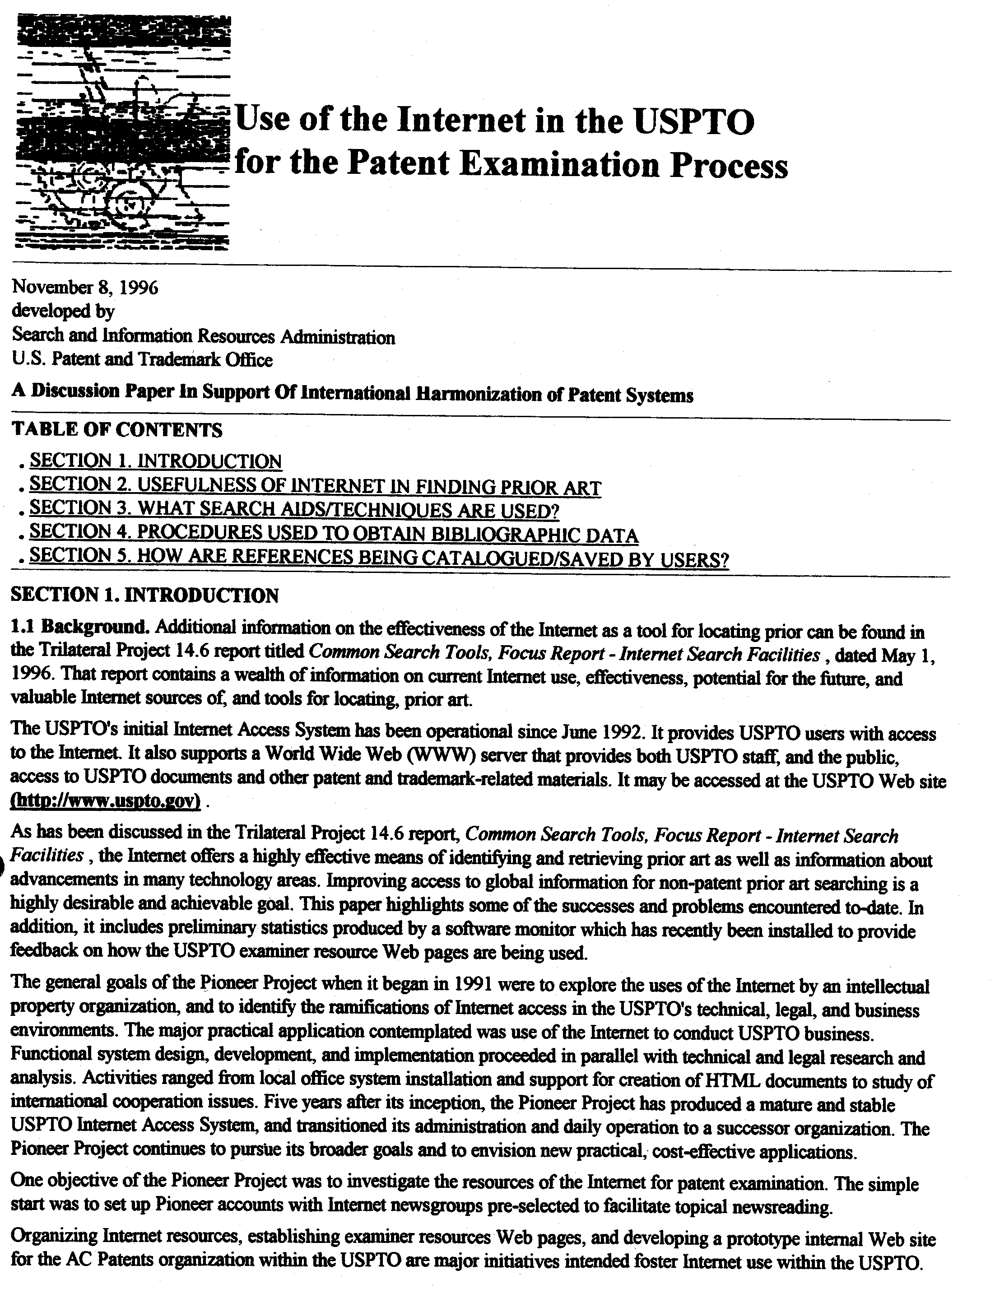

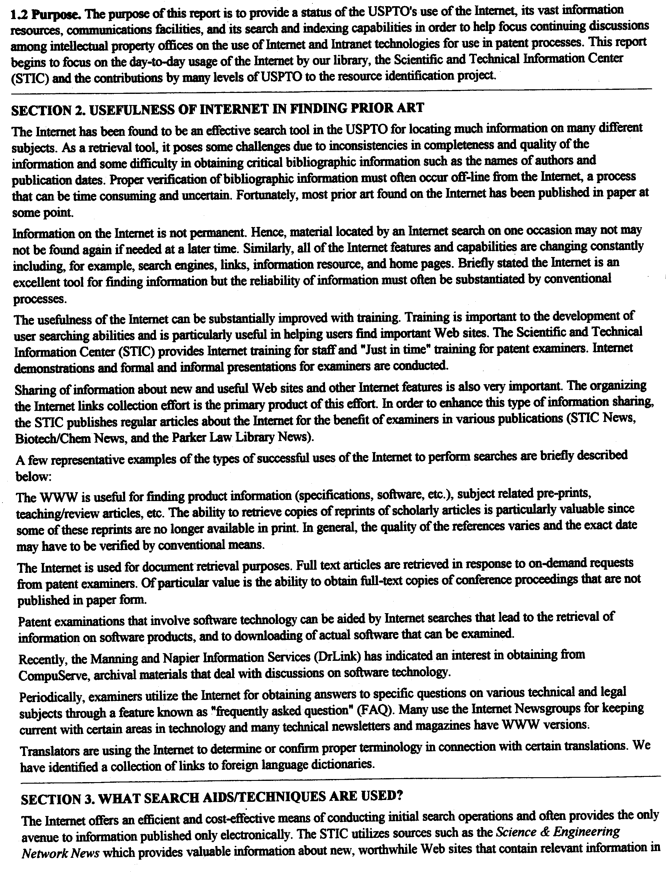

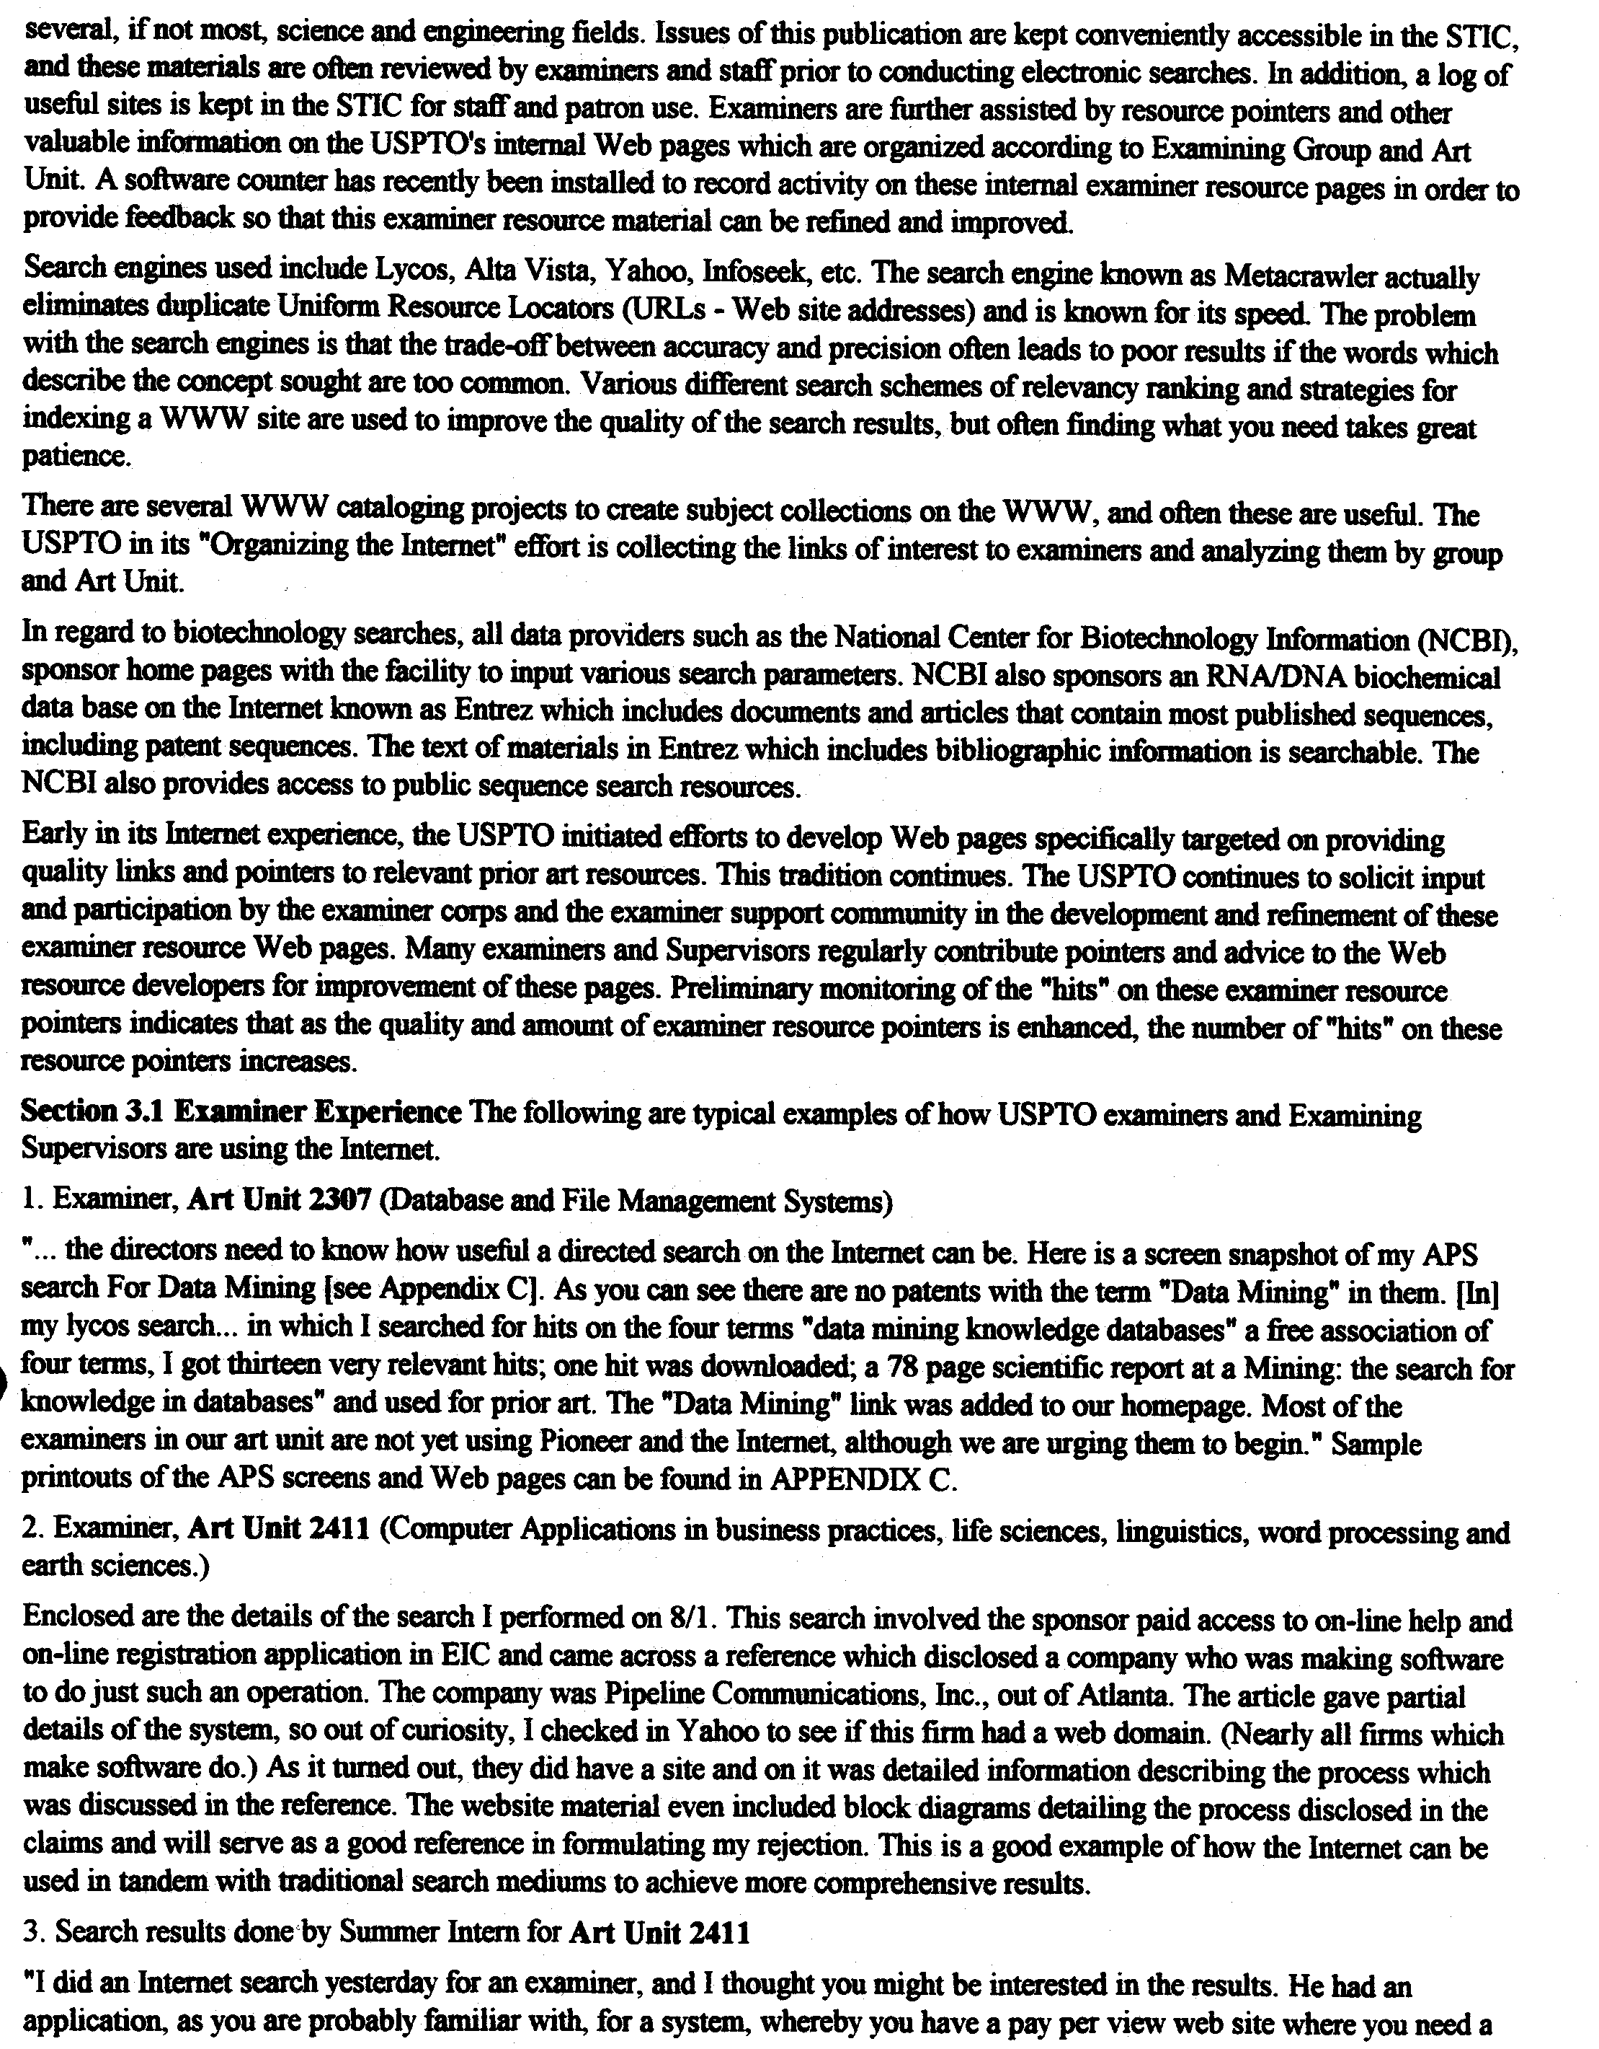
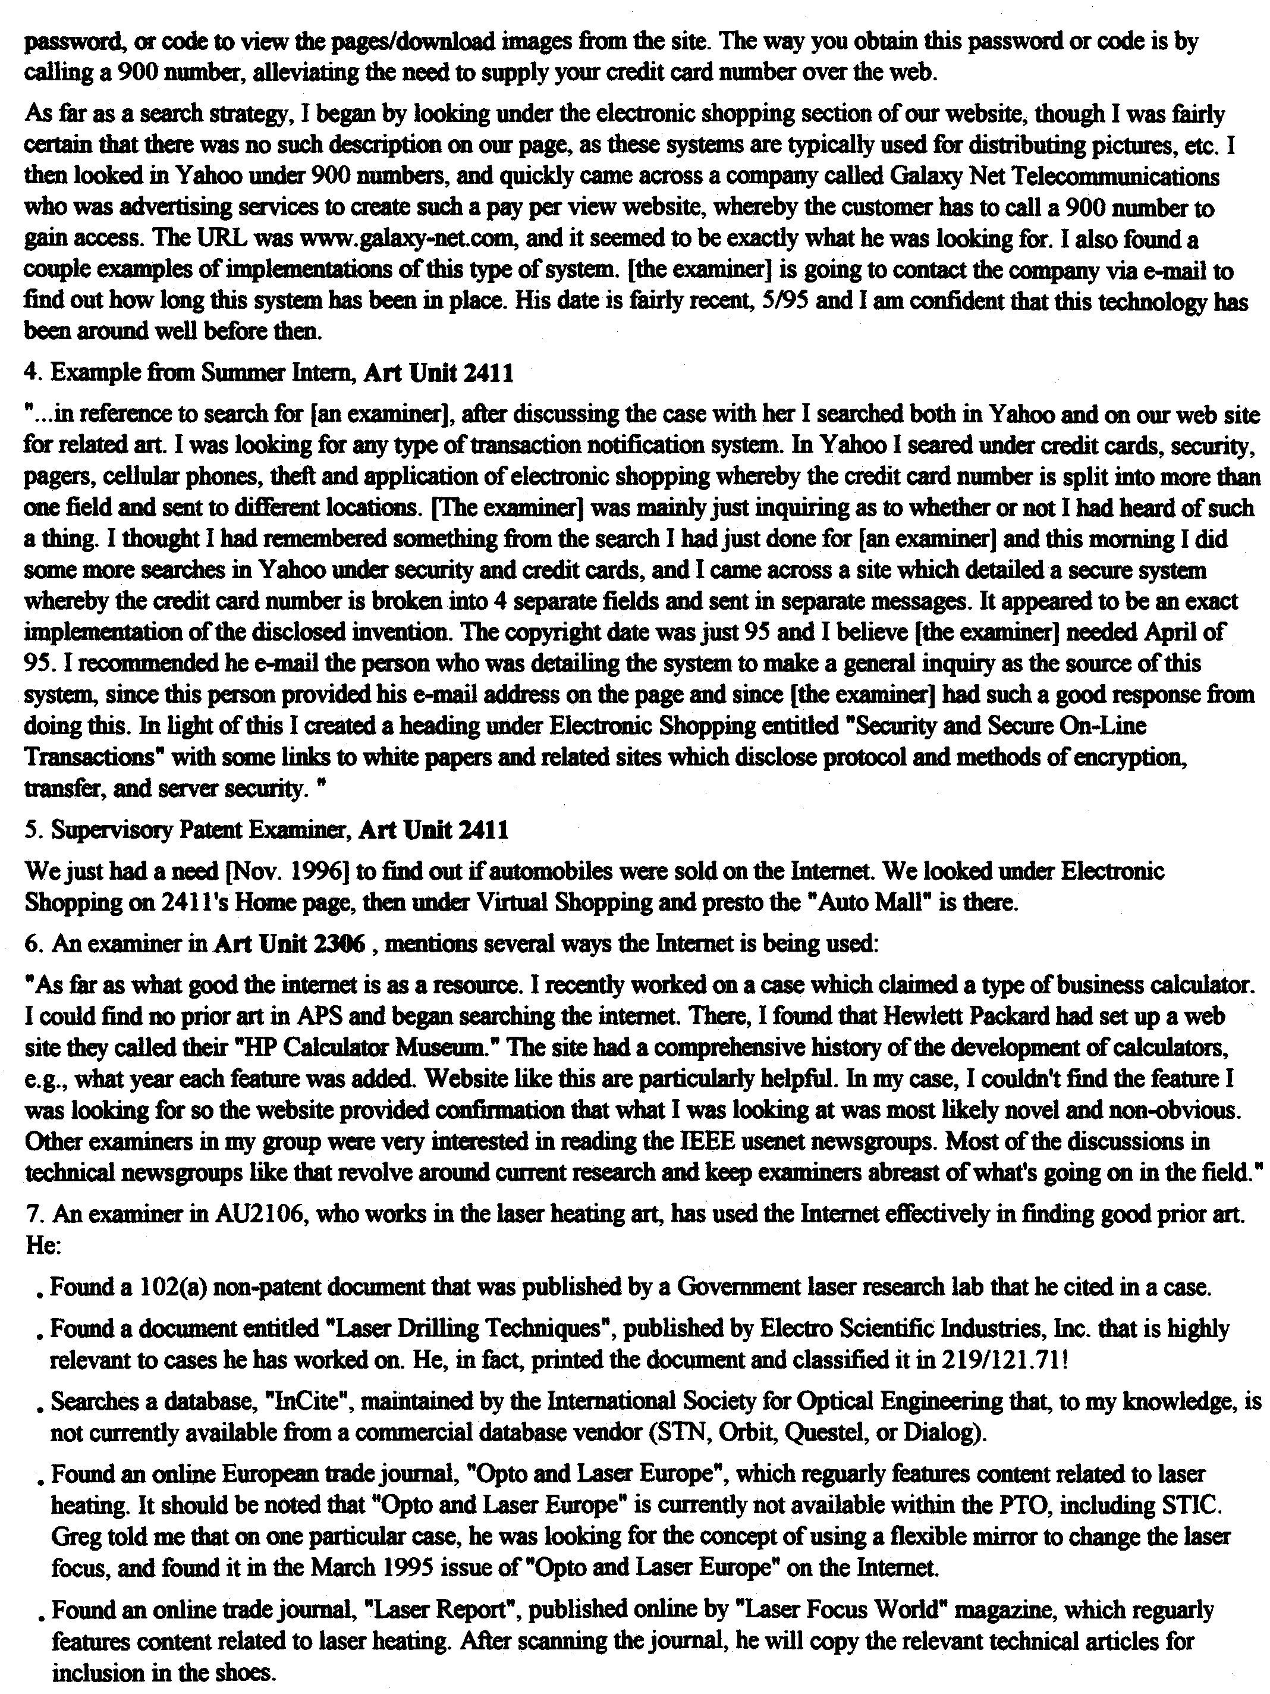
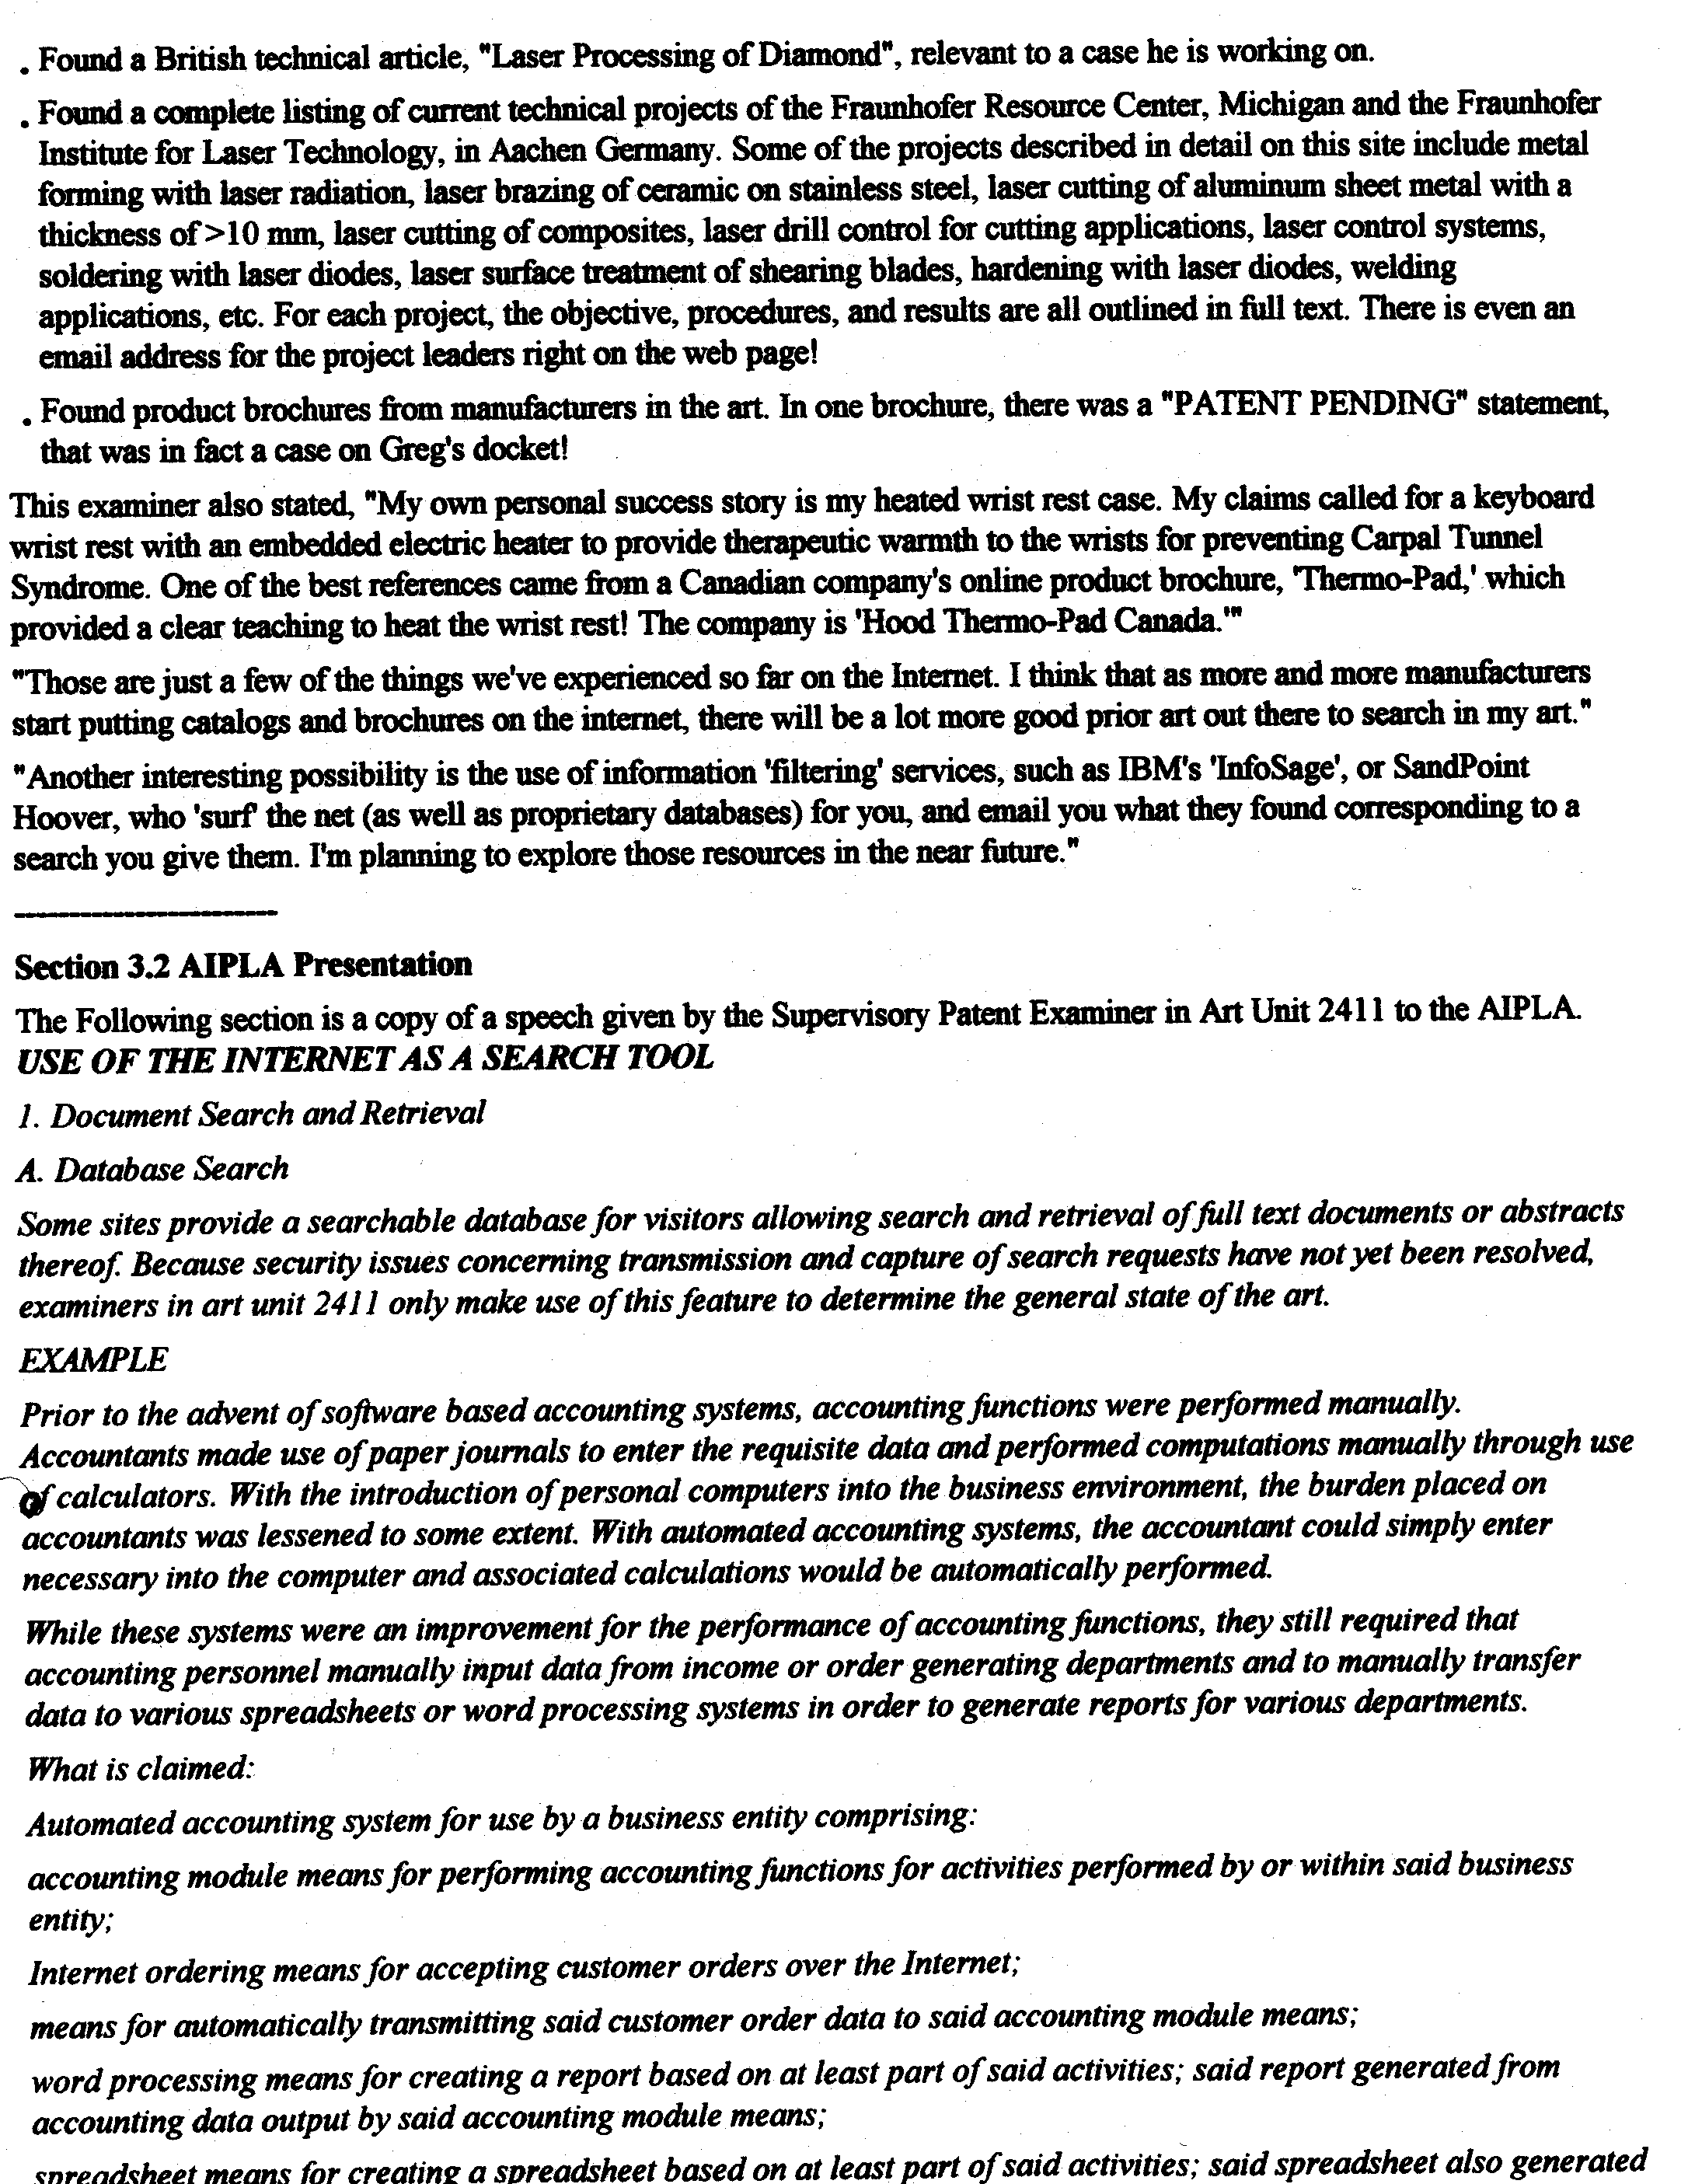

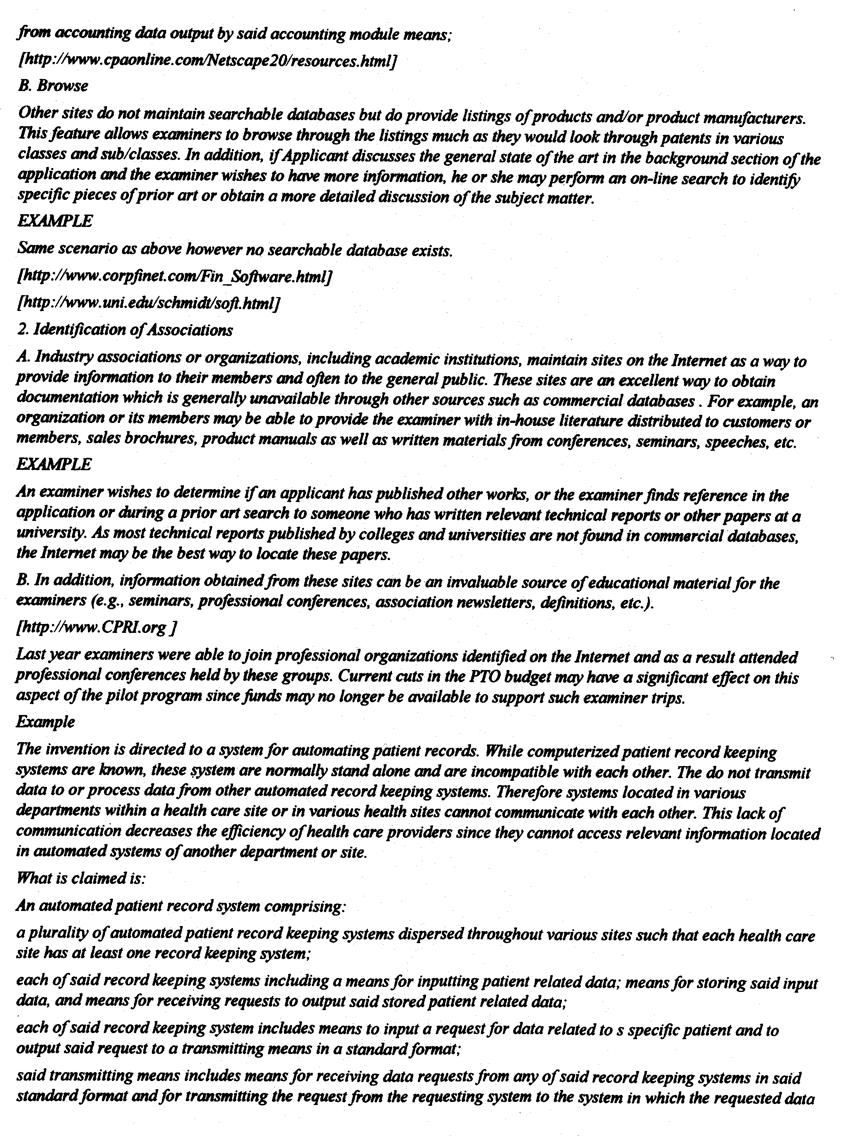

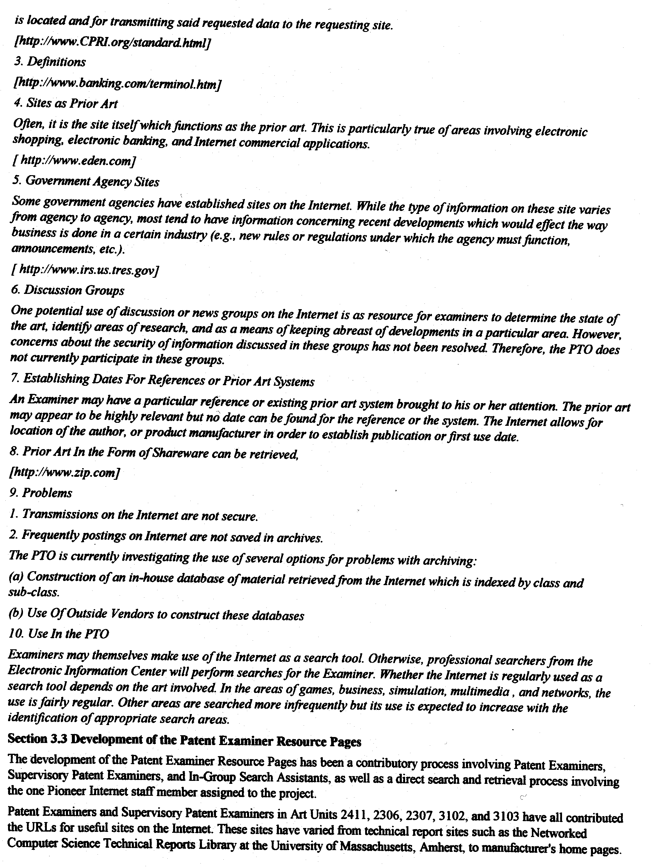

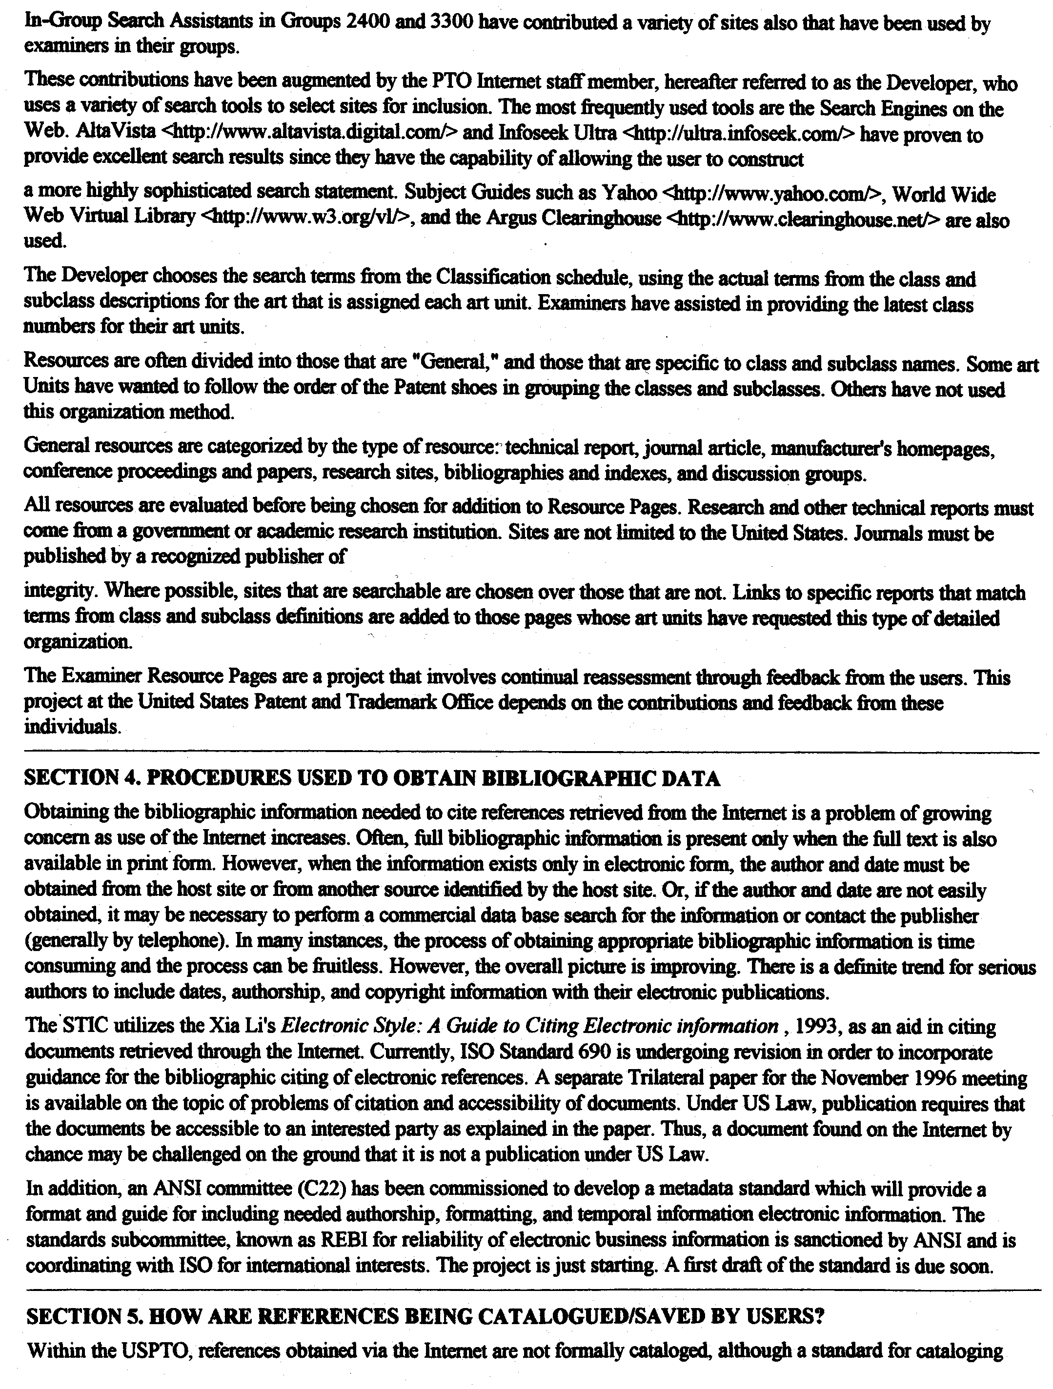

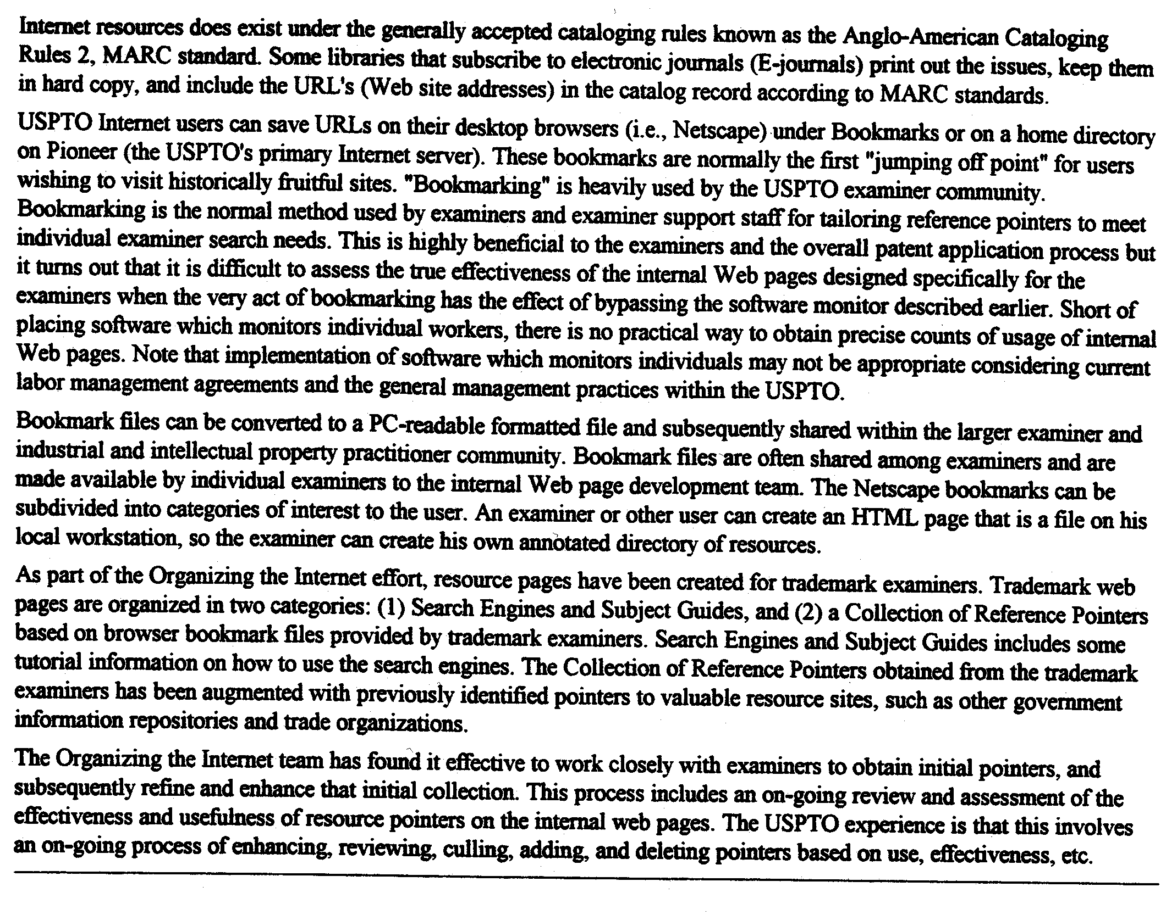

[End of Annex and of document]

