WIPO |  | PCT/MIA/VI/2  ORIGINAL: English  DATE: December 20, 1996
WORLD INTELLECTUAL PROPERTY ORGANIZATION
GENEVA
International patent cooperation union
(PCT union)
Meeting of international authorities
under the PCT
Sixth Session
Canberra, February 17 to 21, 1997
Possible modifications of the PCT Search Guidelines
Proposal by the European Patent Office, the Japanese Patent Office
and the United States Patent and Trademark Office

1. The European Patent Office, the Japanese Patent Office and the United States Patent and Trademark Office (the “Trilateral Offices”), in the course of their trilateral cooperation, have agreed on Common Ground Rules for International Search relating to the determination of the subject of search (claim interpretation for the purpose of searching), the determination of the field of search and the evaluation of documents.

2. The present text of the PCT Search Guidelines is that contained in document PCT/GL/2, dated November 18, 1992, and published as a Special Issue of the PCT Gazette, No. 30/1992, on December 10, 1992, as affected by modifications with effect from January 1, 1994, notified by Circular PCT 526, dated December 1, 1993, and published in PCT Gazette No. 29/1993 on December 9, 1993.

3. The Annex to this document contains a proposal by the Trilateral Offices for the incorporation of those Common Ground Rules into the PCT Search Guidelines.

4. The Meeting is invited to consider the proposal of the Trilateral Offices contained in the Annex to this document.

[Annex follows]

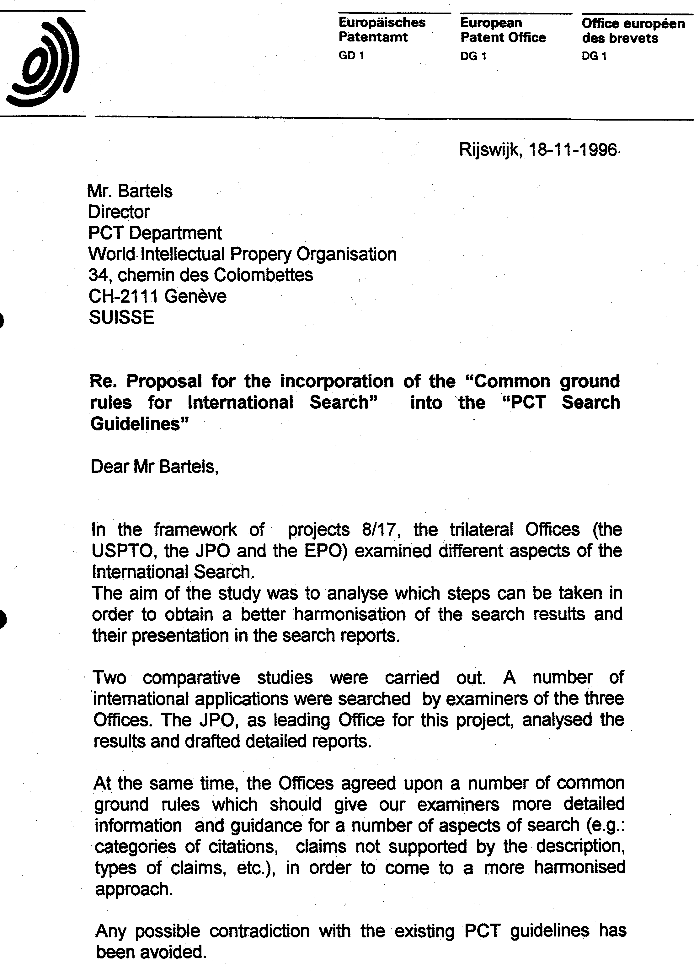

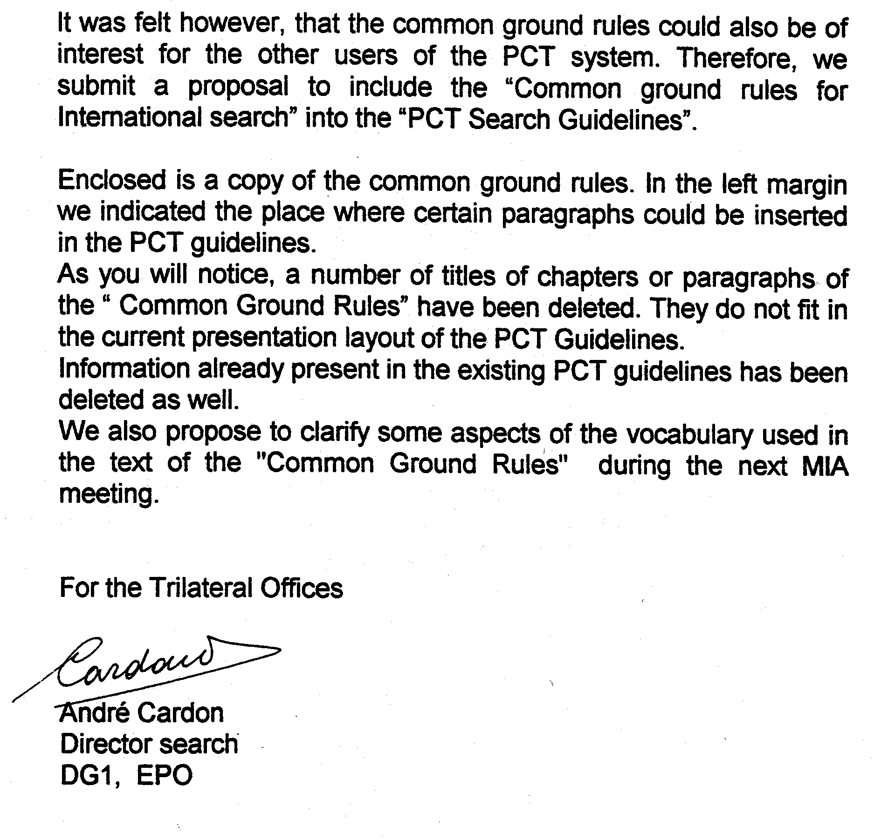

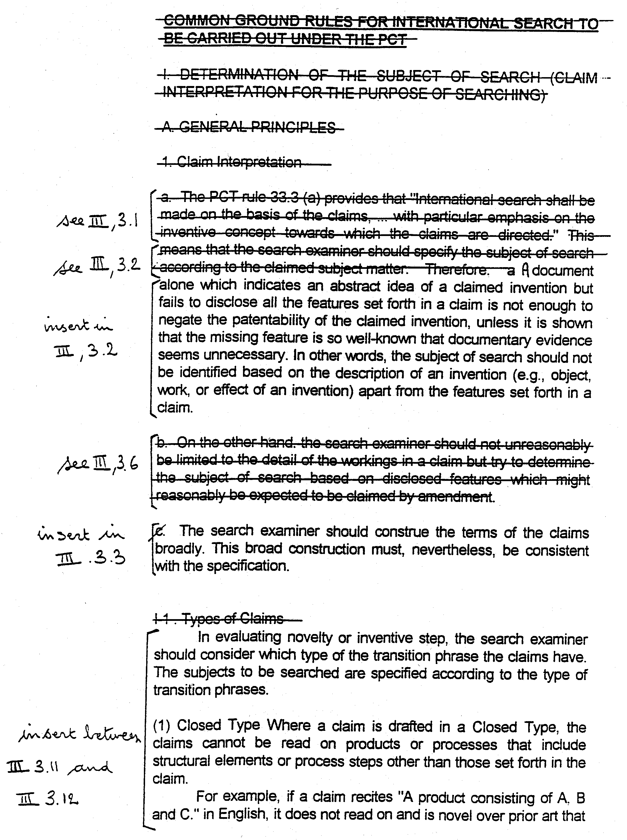
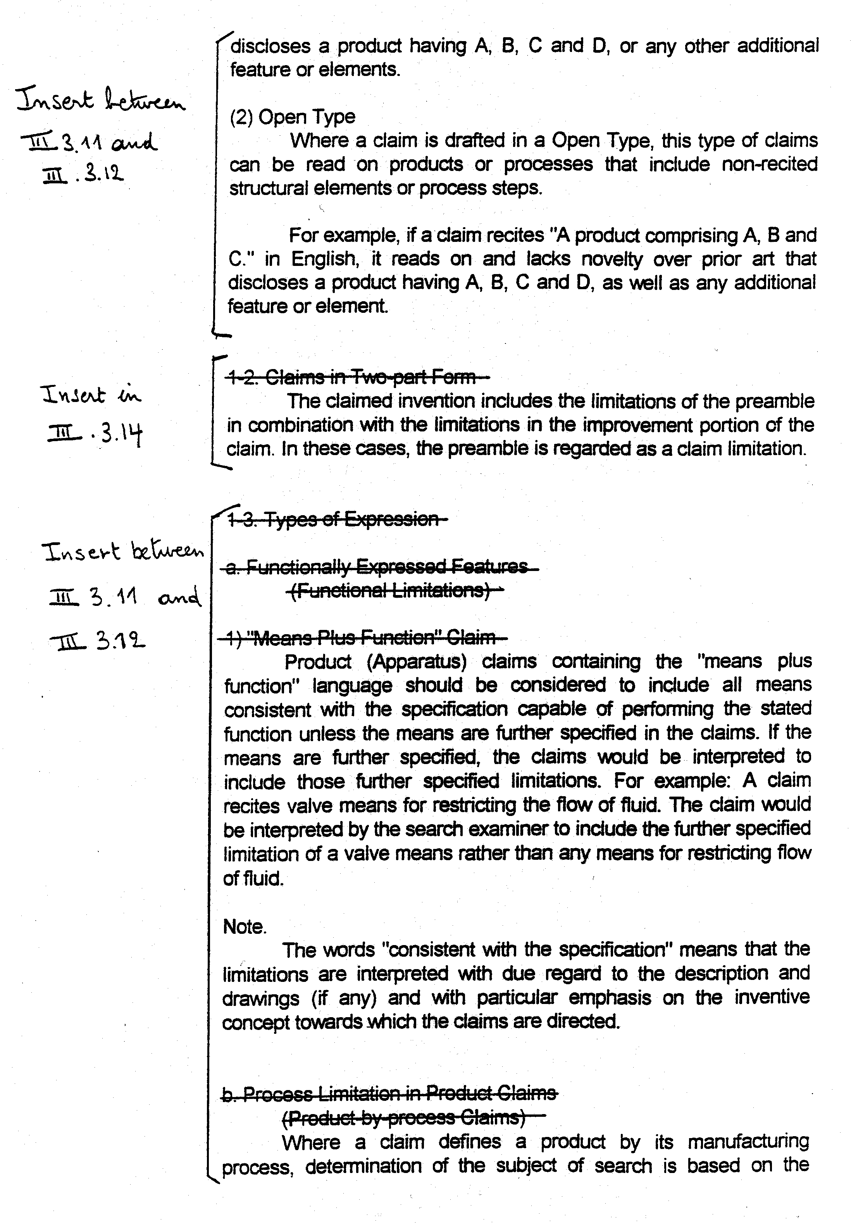

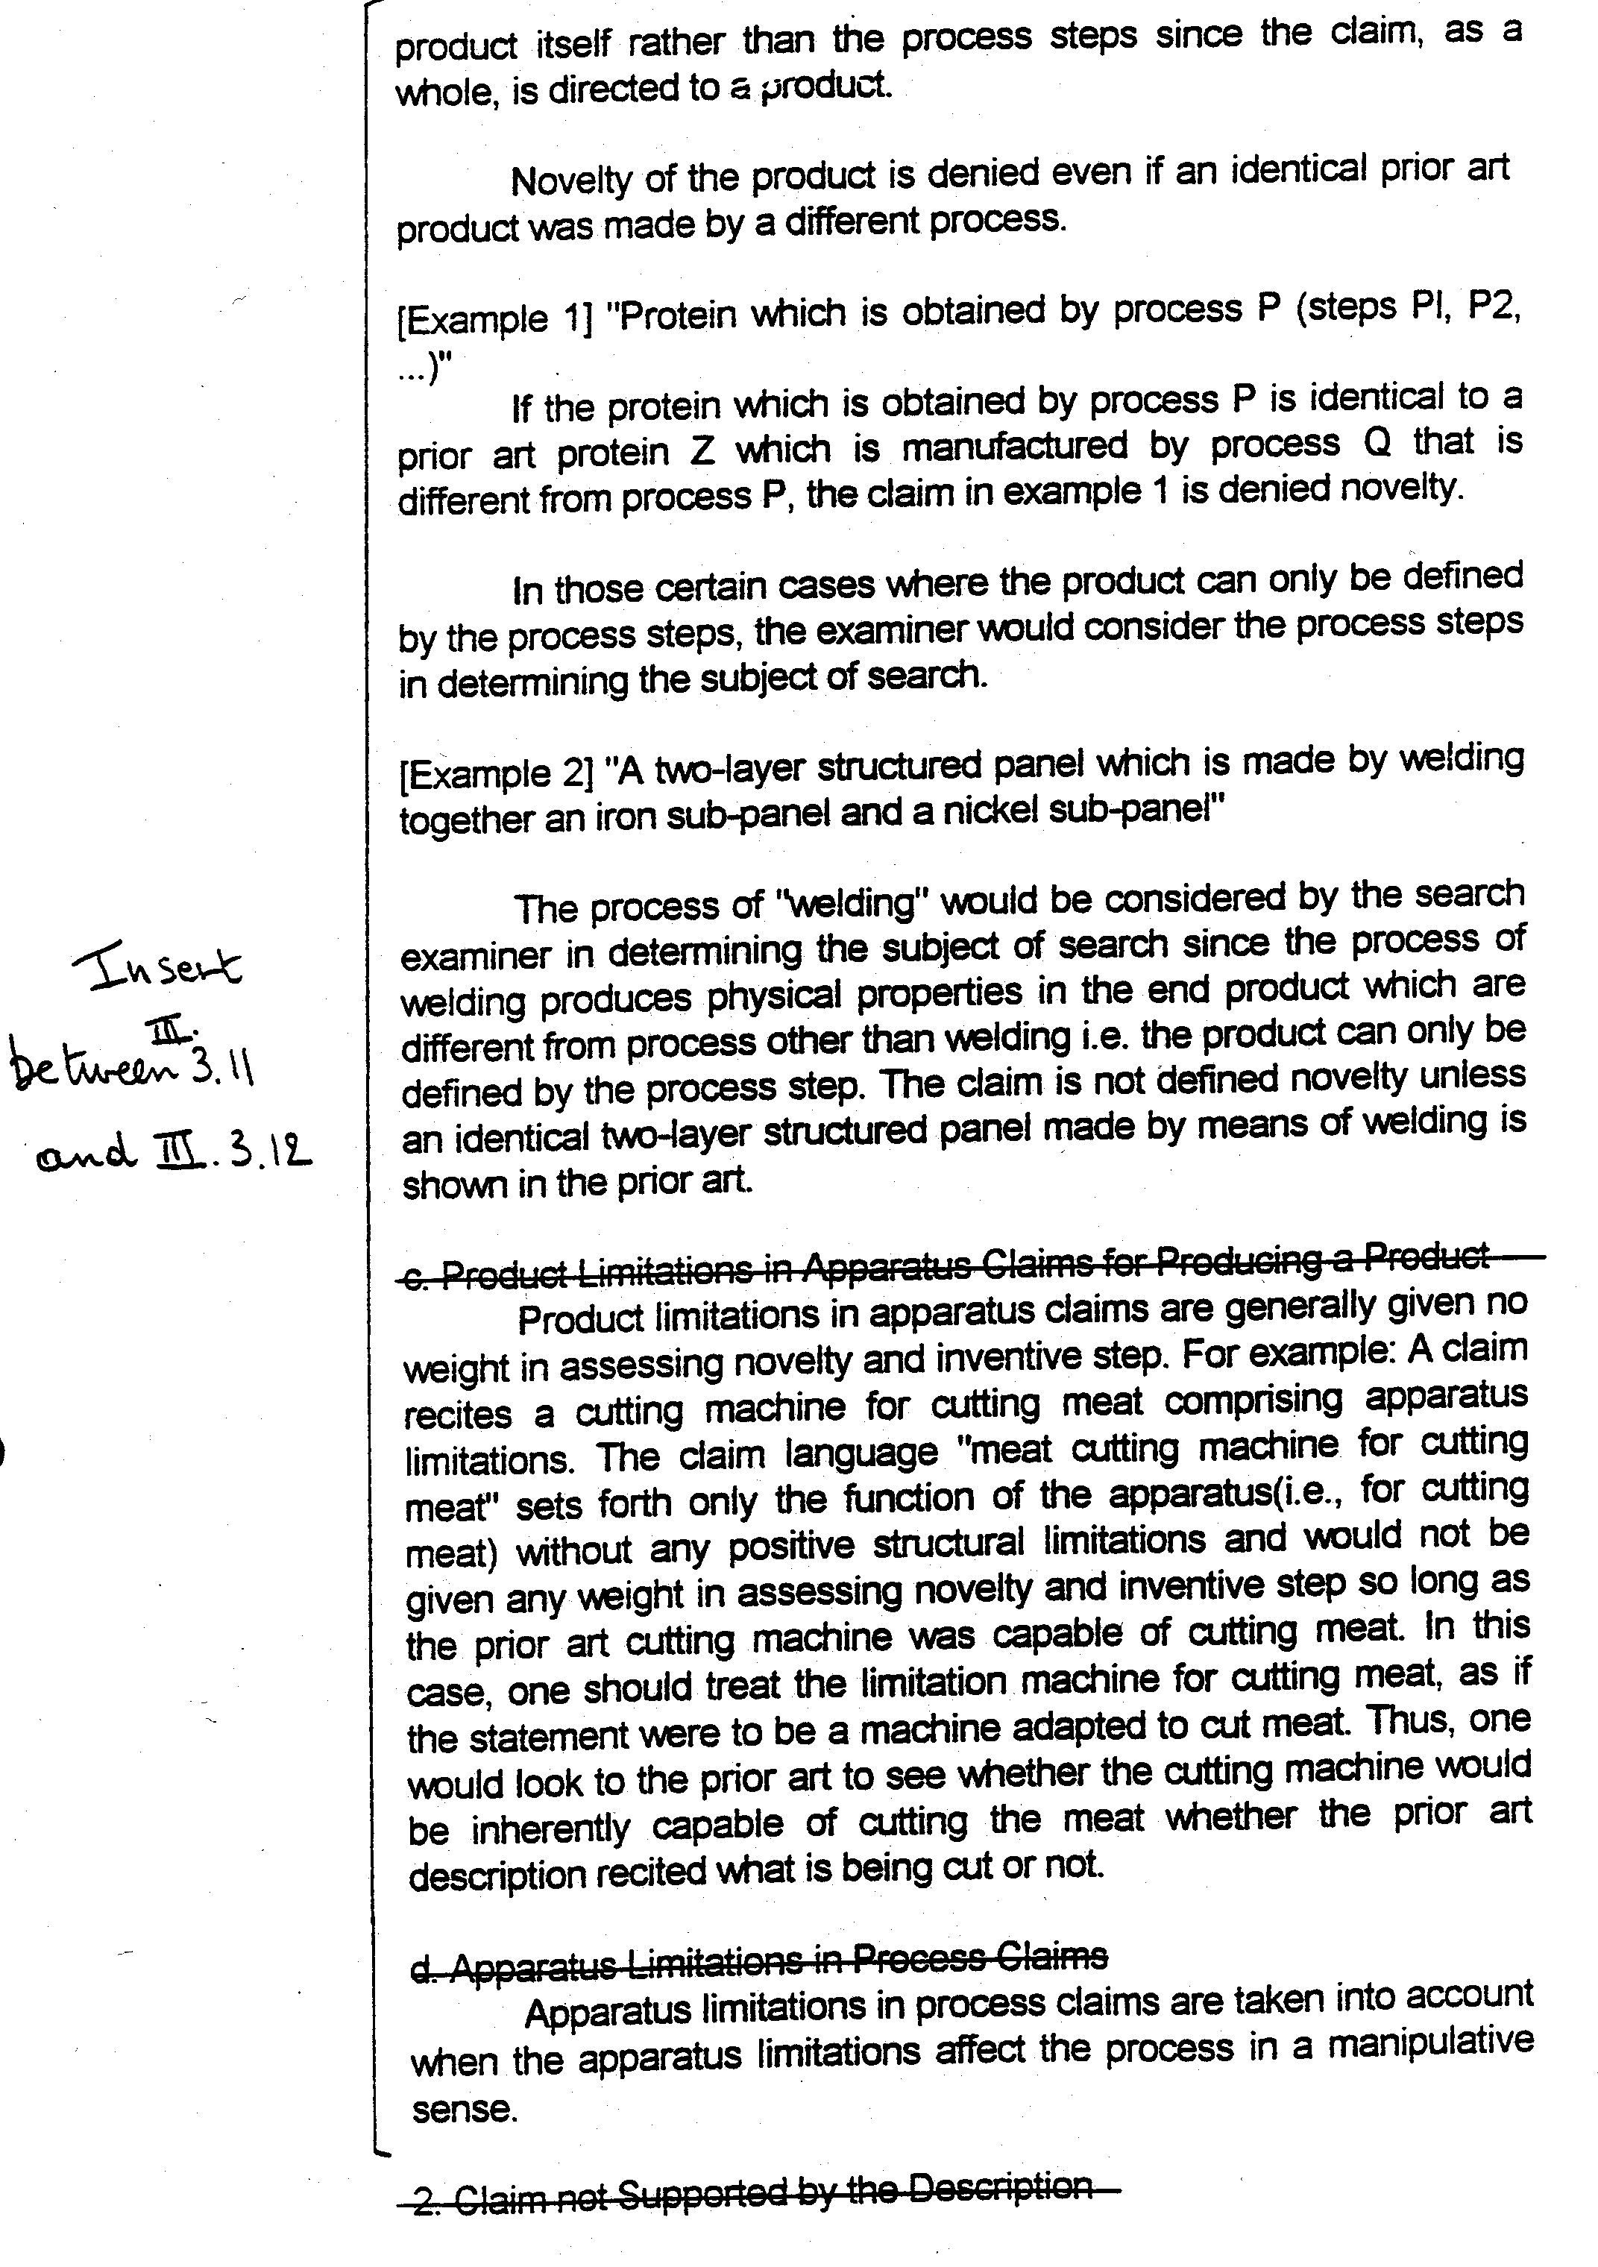

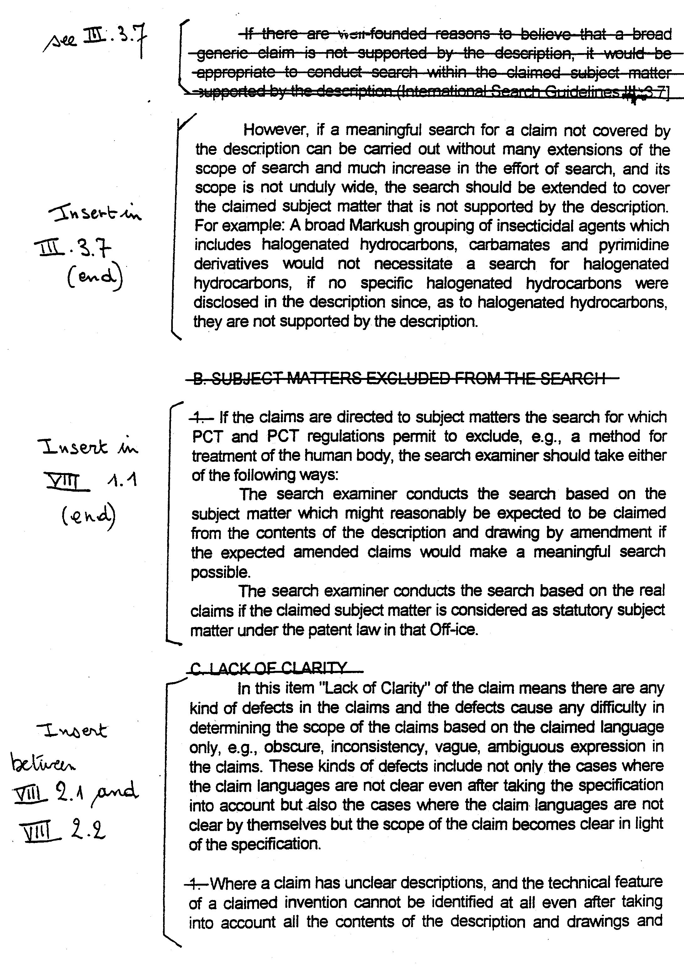

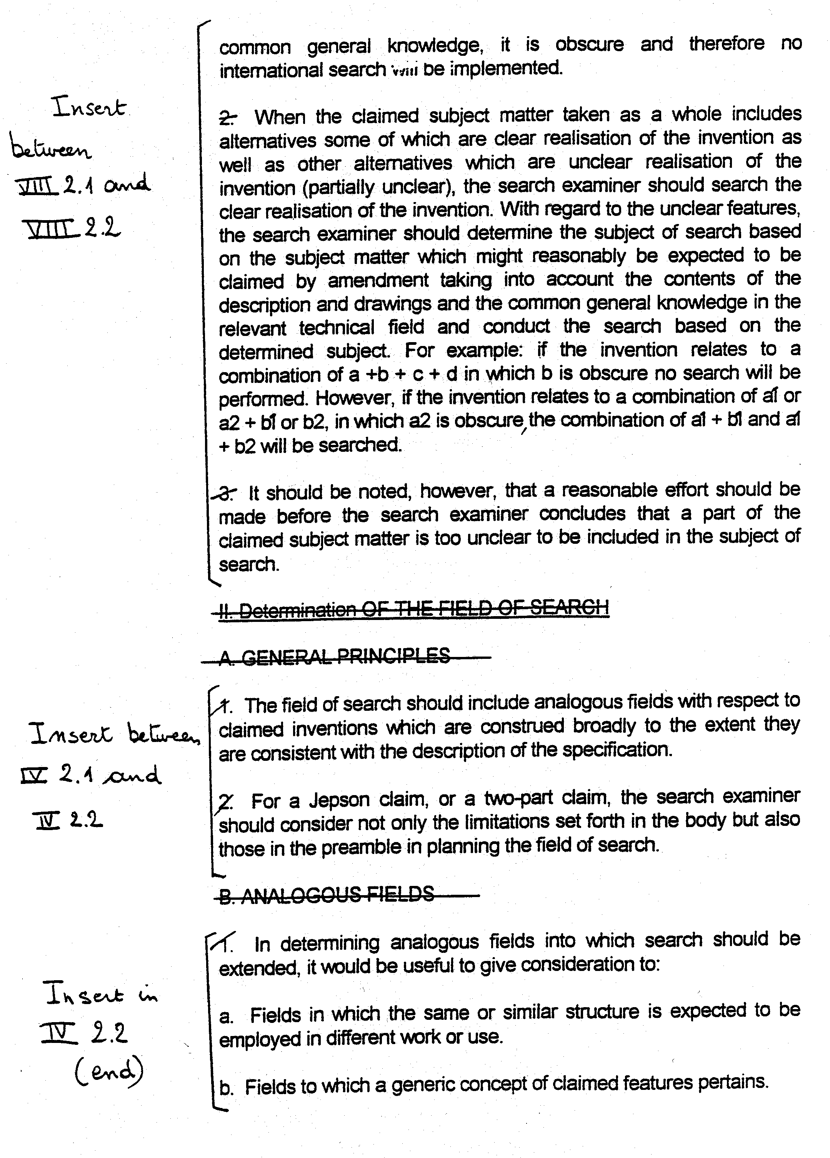

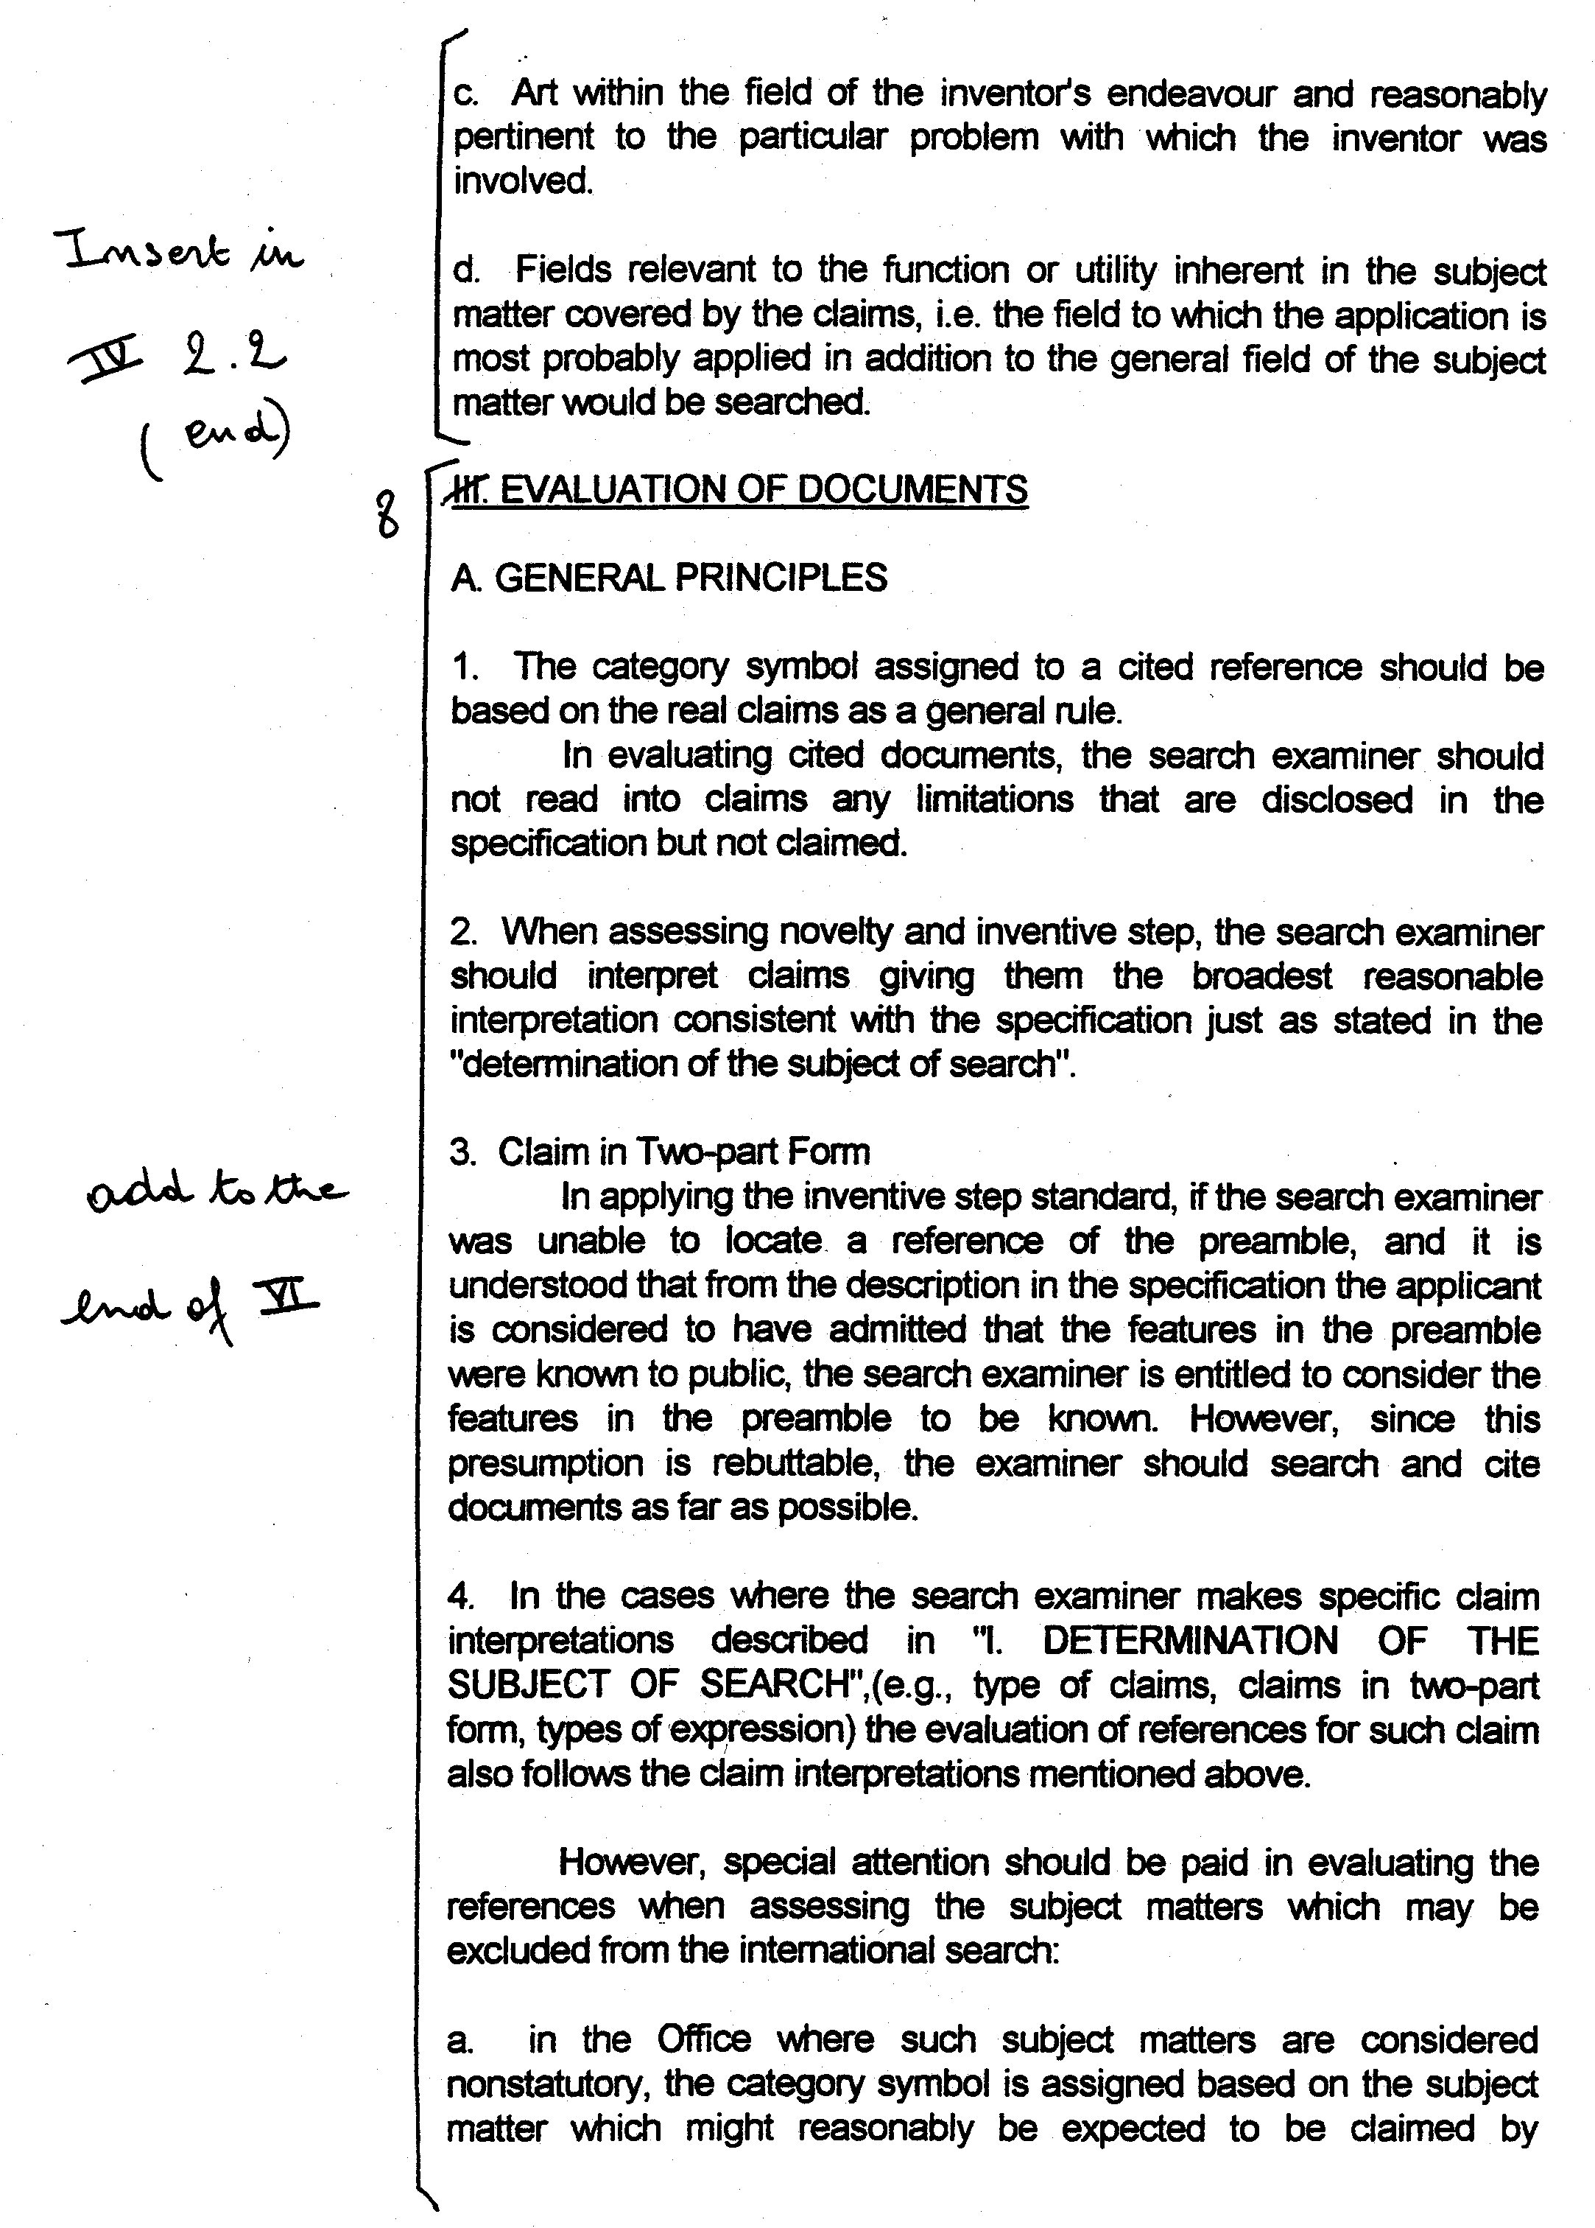

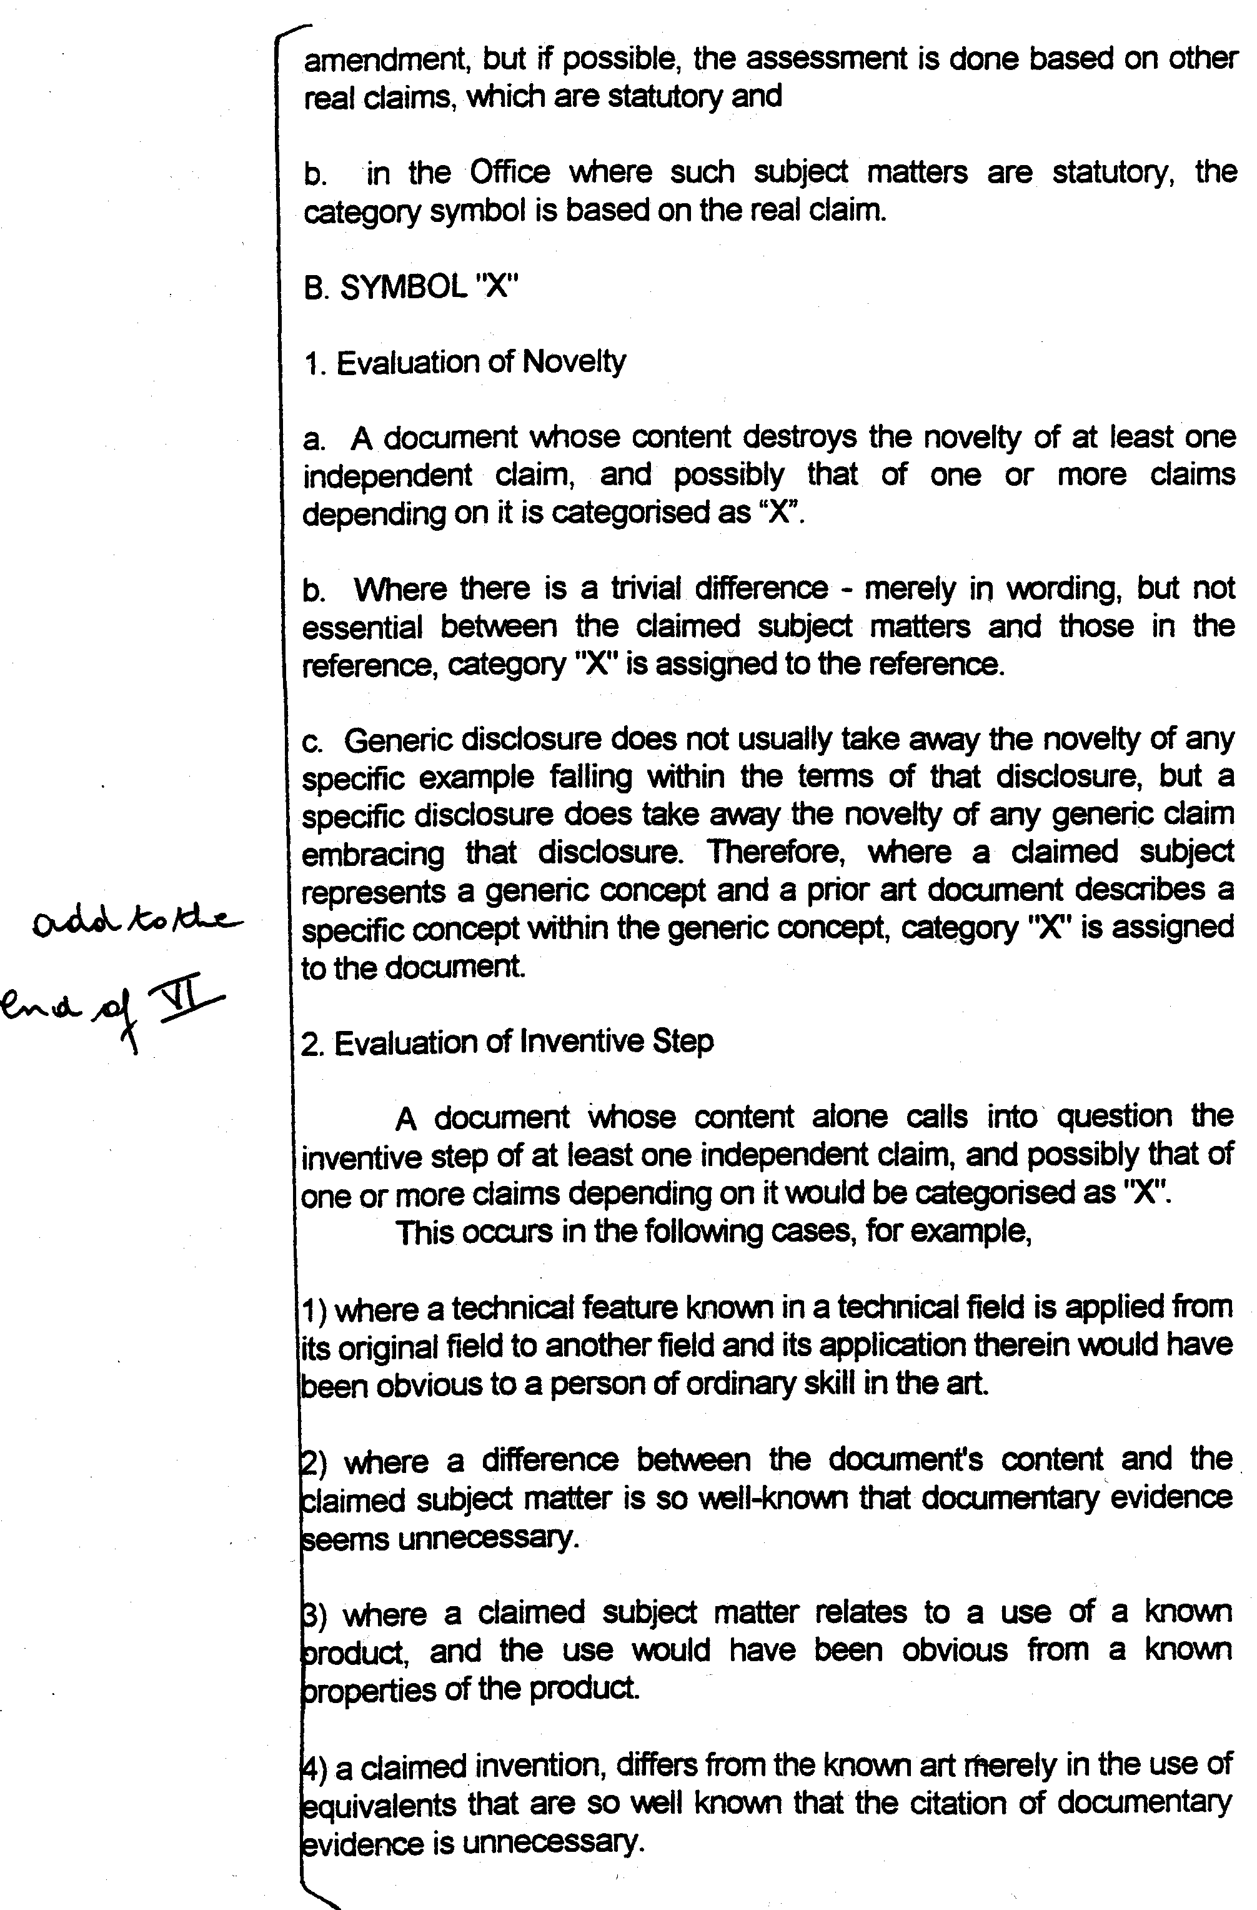

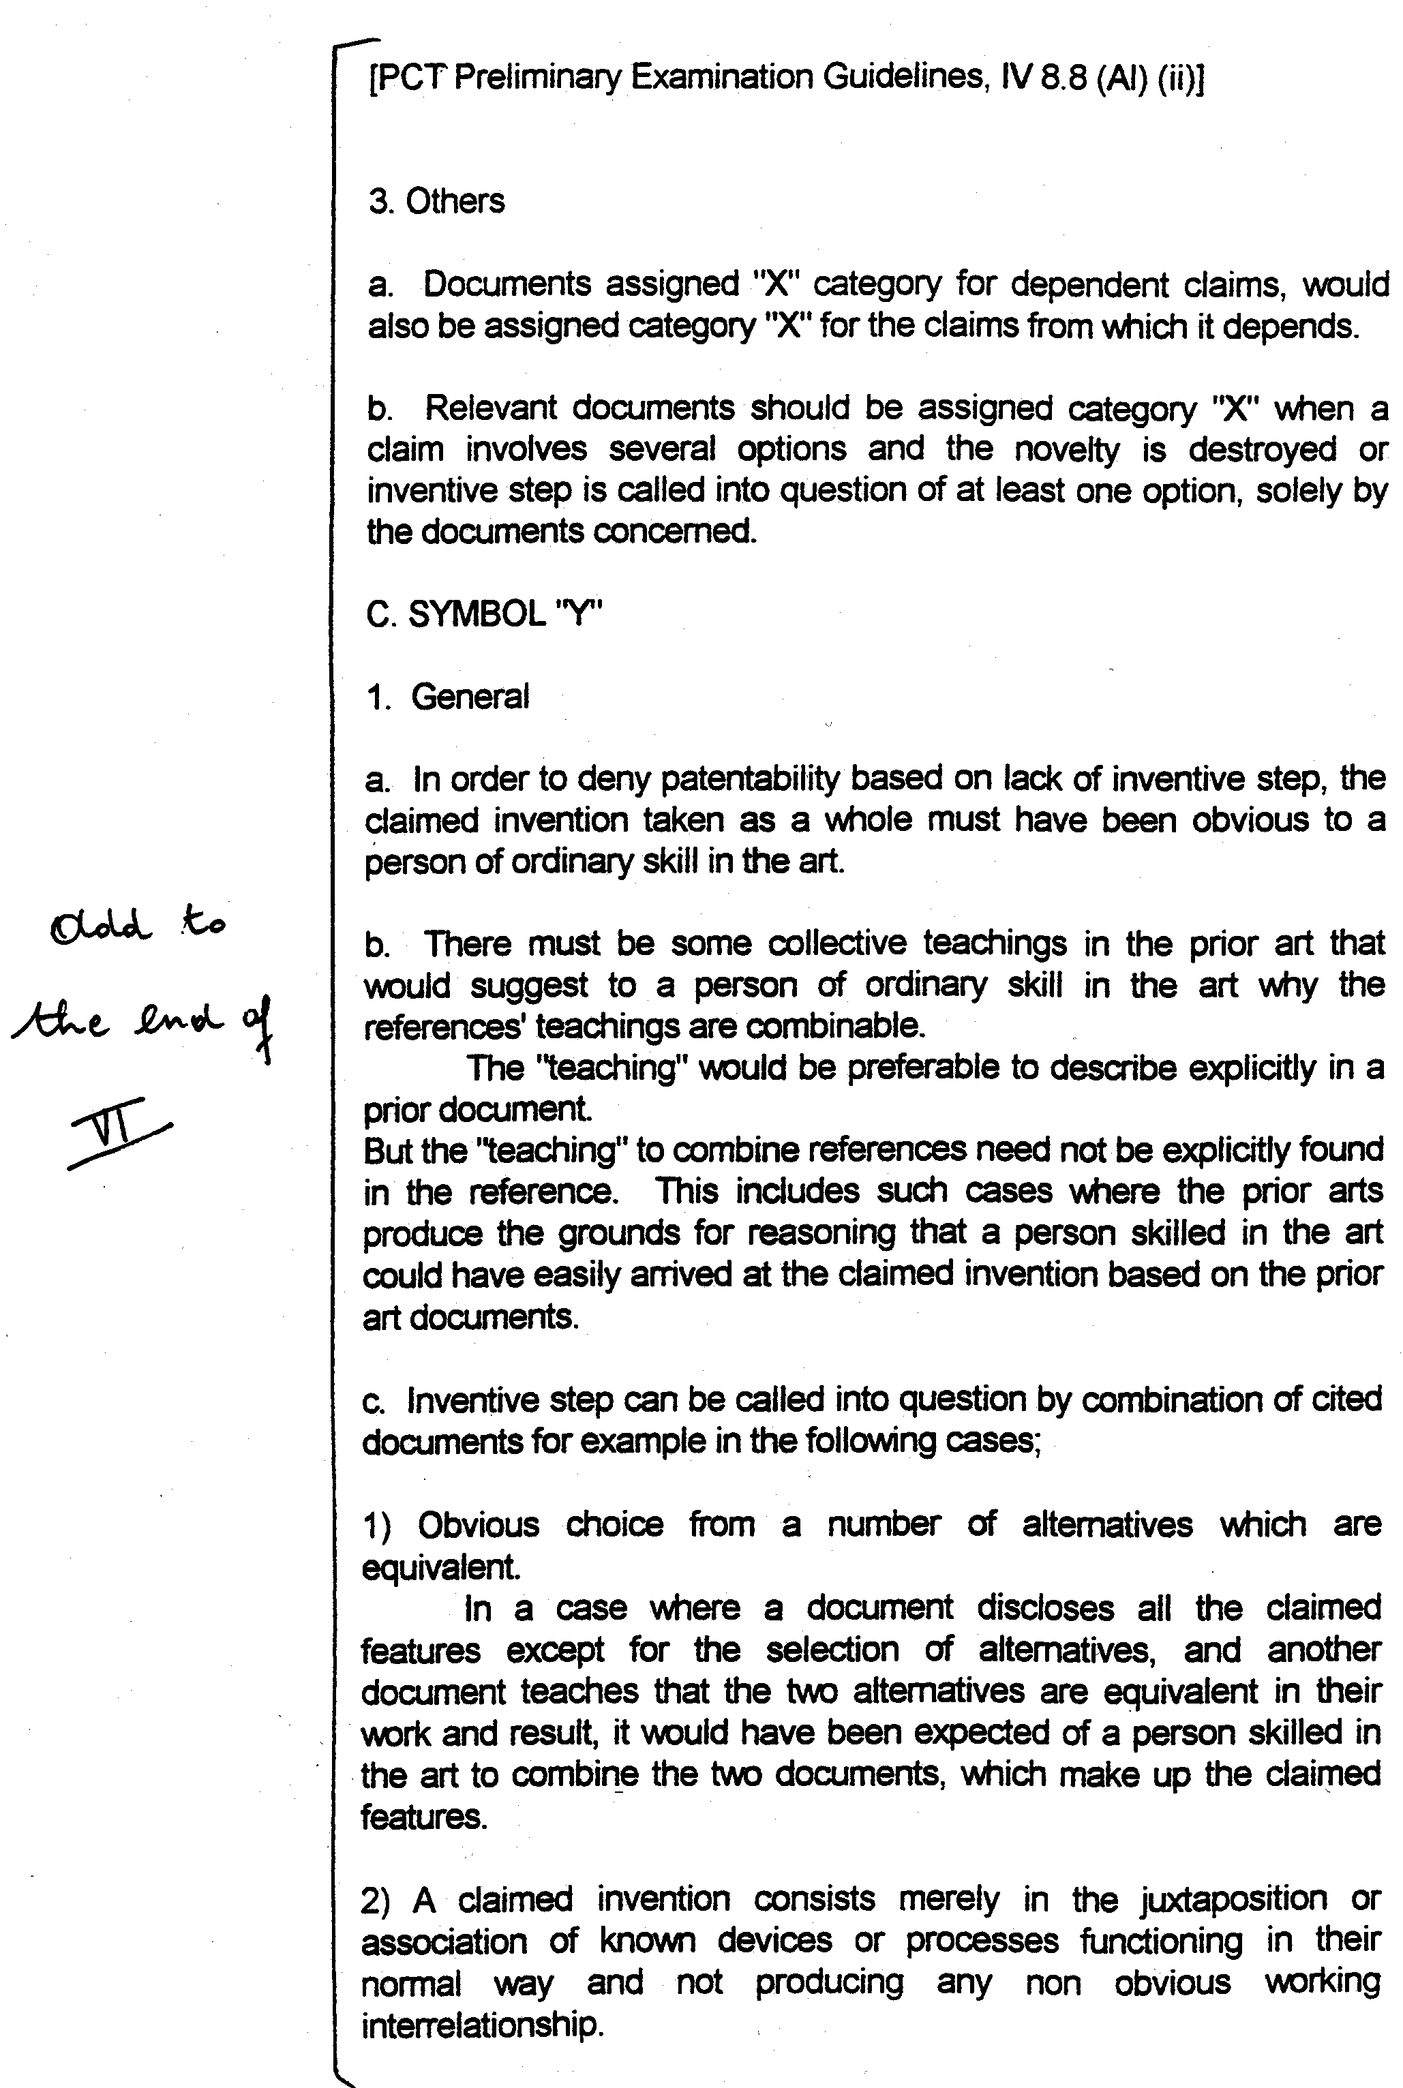

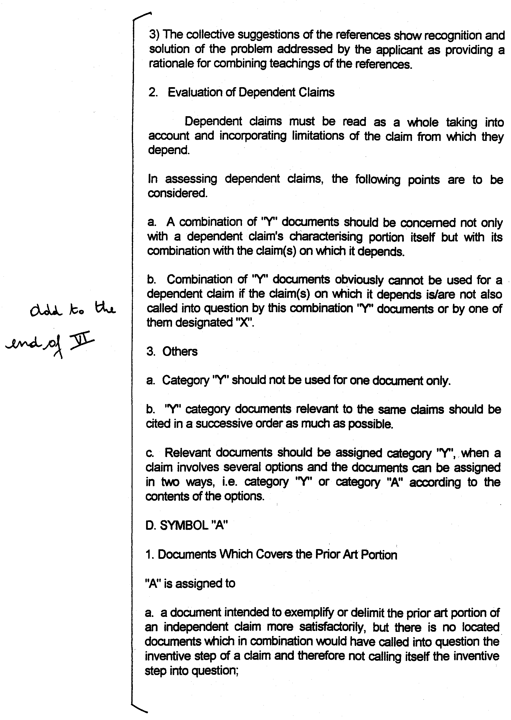

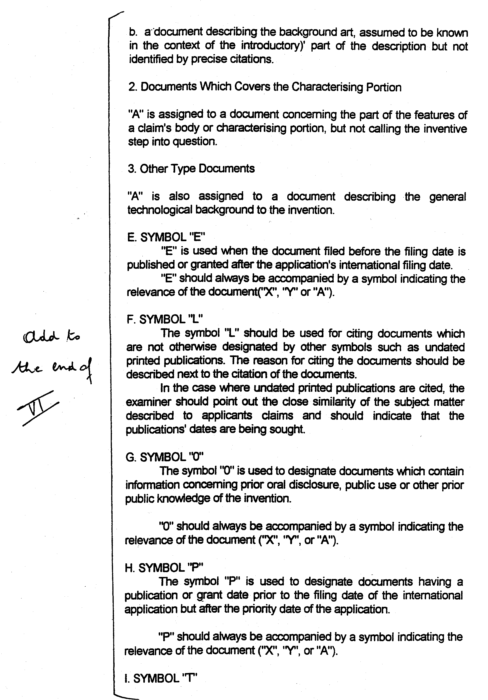

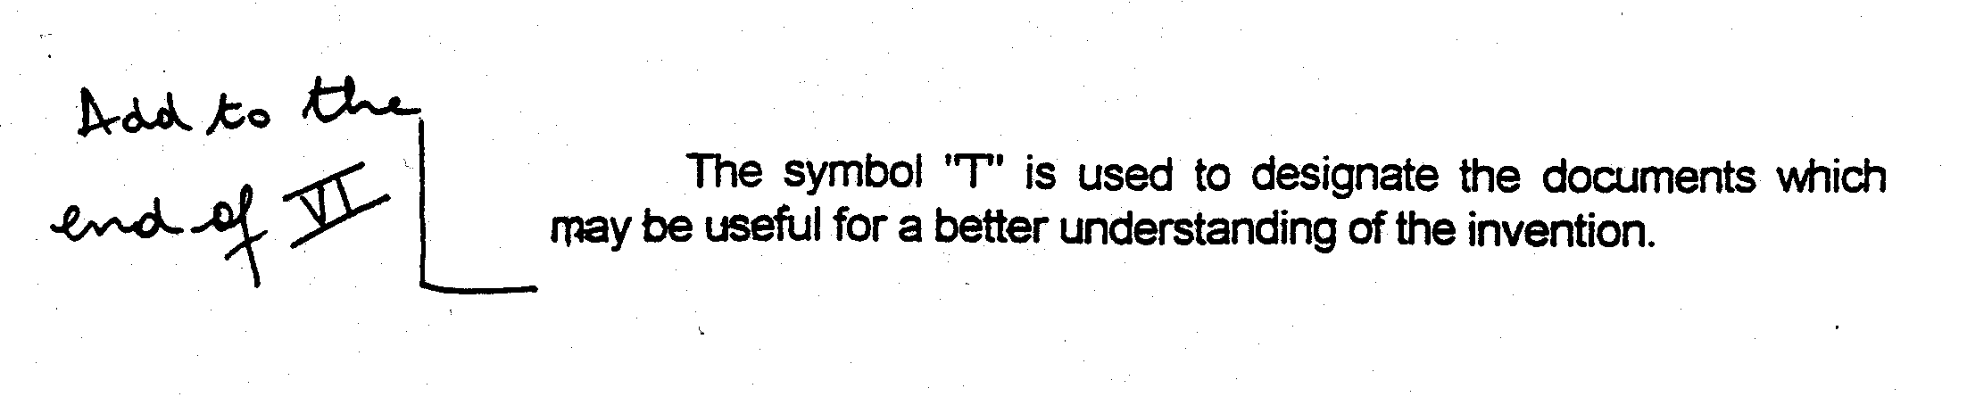

[End of Annex and of document]

