WIPO |  | PCT/MIA/VI/12  ORIGINAL: English  DATE: February 7, 1997
WORLD INTELLECTUAL PROPERTY ORGANIZATION
GENEVA
International patent cooperation union
(PCT union)
Meeting of international authorities
under the PCT
Sixth Session
Canberra, February 17 to 21, 1997
PROPOSED AMENDMENTS of THE PCT REGULATIONS relating to International Preliminary ExaminATION: lATE FILING OF DEMAND;
FILING OF DEMAND WITH NON-COMPETENT AUTHORITY;
LATE PAYMENT FEE
Proposal by the European Patent Office

1. In the context of matters relating to international preliminary examination, and following the proposals by the International Bureau outlined in document PCT/MIA/VI/5 relating to late filing of the demand and filing of the demand with a non-competent International Preliminary Examining Authority, the European Patent Office has made further proposals relating to proposed new PCT Rules 53bis and 59.3.

2. In addition, the European Patent Office has made a proposal for amendment of PCT Rules 57 and 58 relating to a late payment fee in case of late payment of the handling fee and the preliminary examination fee.

3. The Annex to this document contains the proposals by the European Patent Office.

[Annex follows]

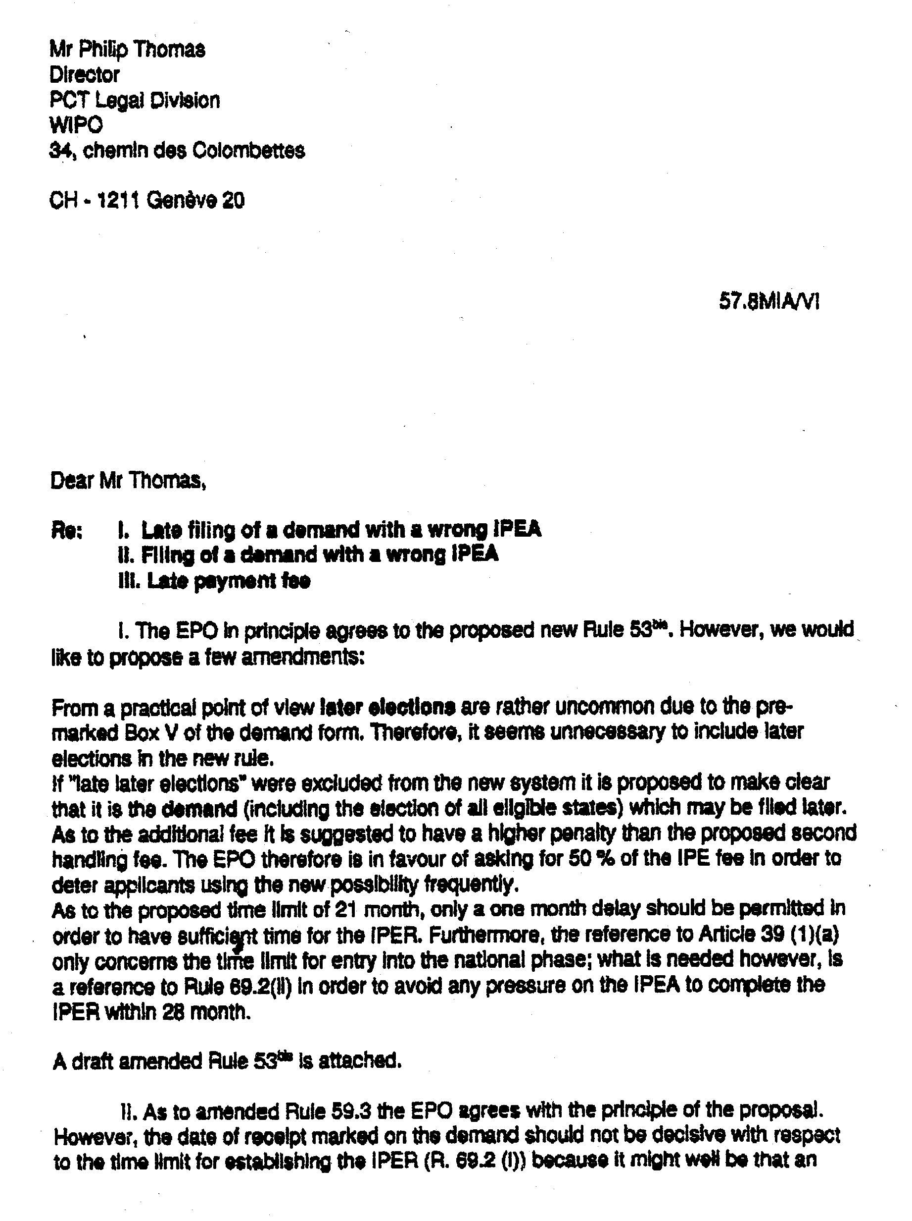

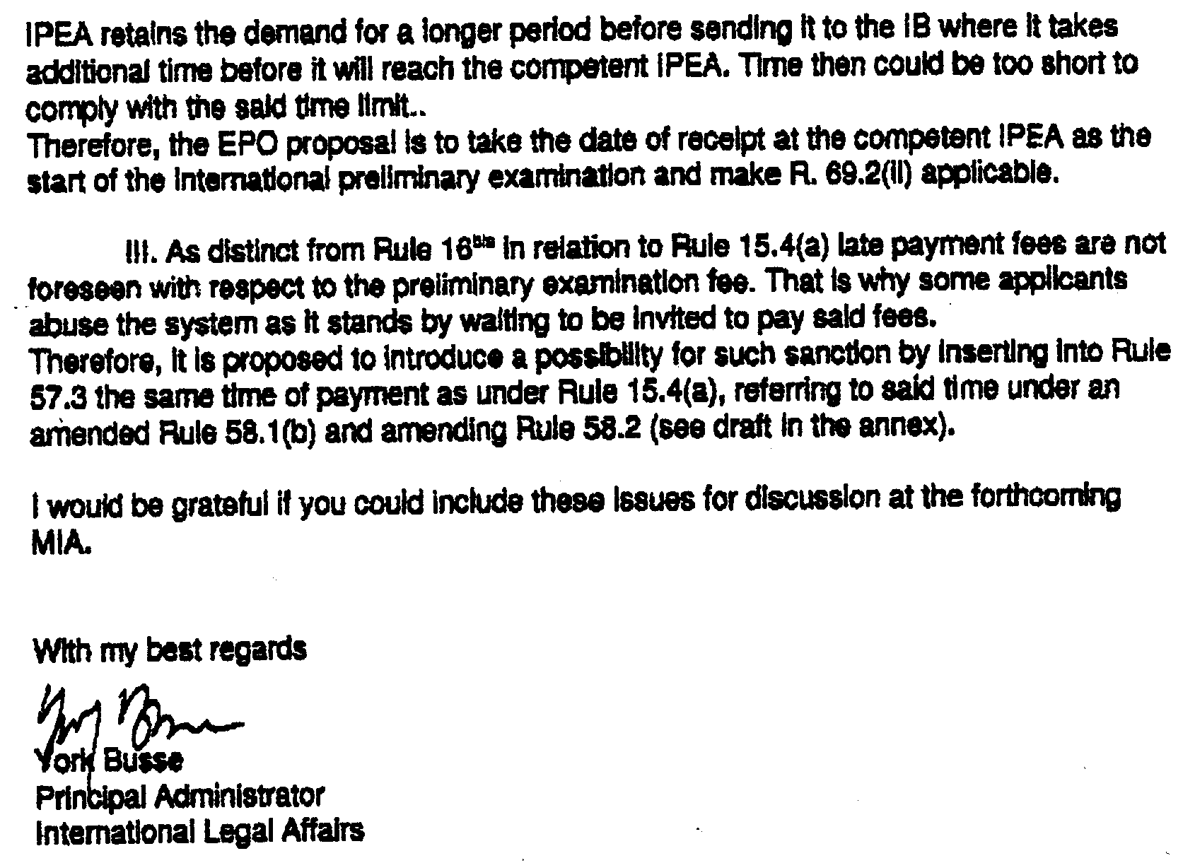

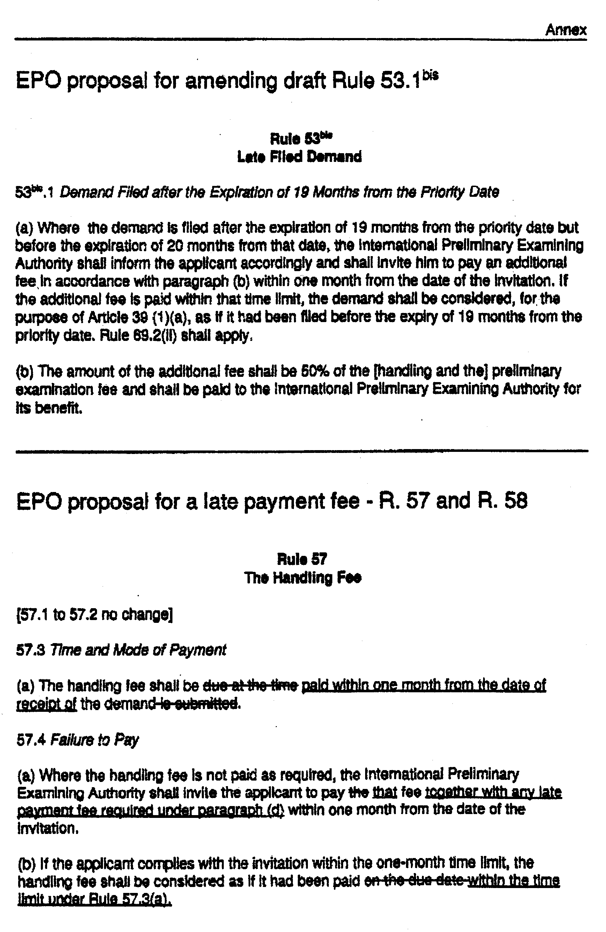

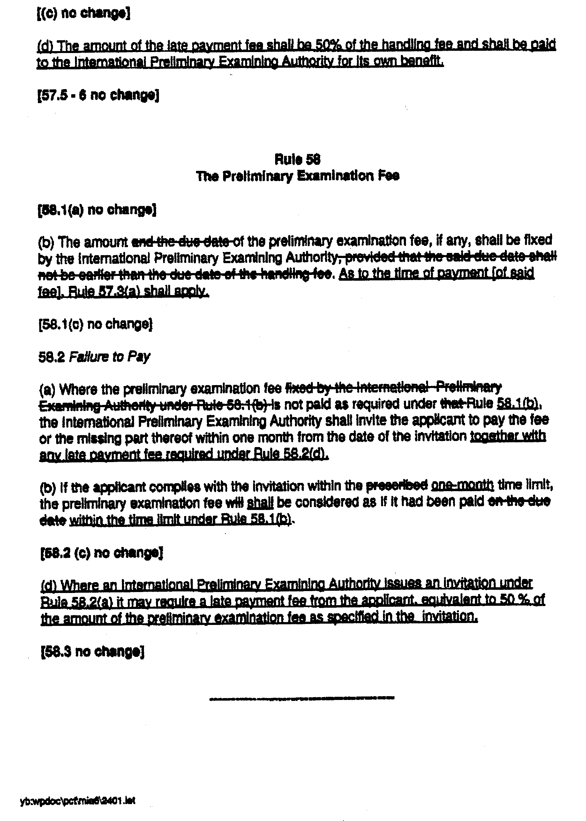

[End of Annex and of document]

