WIPO |  | PCT/MIA/II/7  ORIGINAL: English  DATE: February 17, 1992
WORLD INTELLECTUAL PROPERTY ORGANIZATION
GENEVA
International patent cooperation union
(PCT union)
Meeting of international authorities
under the PCT
Second Session
Geneva, March 9 to 13, 1992
draft of proposed modified forms for use by
the international preliminary examining authorities
prepared by the International Bureau
1. The annex to this document contains:

(i) the draft of the modified Written Opinion Form (PCT/IPEA/408) and

(ii) the draft of the modified International Preliminary Examination Report Form (PCT/IPEA/409)
for use by the International Preliminary Examining Authorities.

2. The modifications take into account the amendments to the PCT Regulations, as well as suggestions received from the United Kingdom Patent Office and the European Patent Office, as agreed at the first Meeting of International Authorities (see paragraph 19 of document PCT/MIA/I/8).
4. The drafts of Forms PCT/IPEA/408 and 409 now contain substantially the same indications or types of indications, and the order of appearance of the various portions is the same. This should help the examiners in establishing the written opinion or the international preliminary examination report, as the case may be, and will permit using those parts of a written opinion which are still valid for a subsequent written opinion or for the report. Their similar structure would help the applicants not only to more readily understand them but also, later, to compare the report with the opinion(s).

5. Each portion could preferably start on a separate sheet and it could be envisaged that only portions actually used need to be part of the opinion or report, as the case may be. In this regard, both Forms are now proposed to contain on the front page a table of contents.

6. The proposed modifications would also facilitate producing the Forms by computer as well as filling them in or producing the filled-in Forms by computer.

7. The drafts of the proposed modified Forms are submitted to the International Preliminary Examining Authorities for their observations and for the purpose of the consultations required under Rule 89.2(b).

[Annex follows]

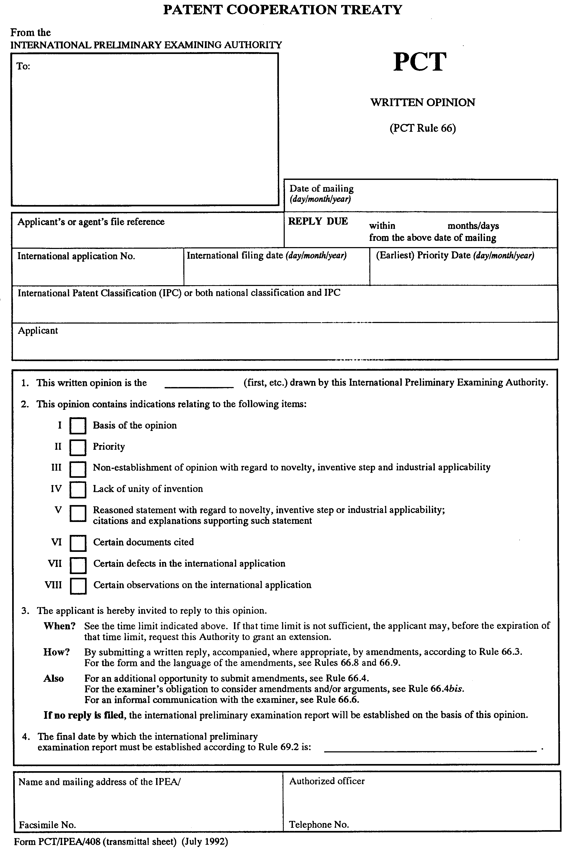

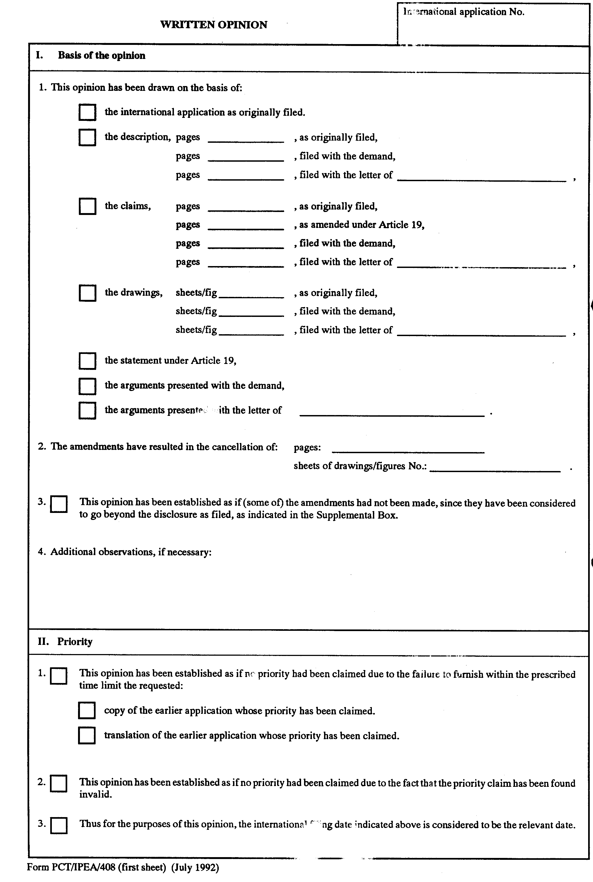

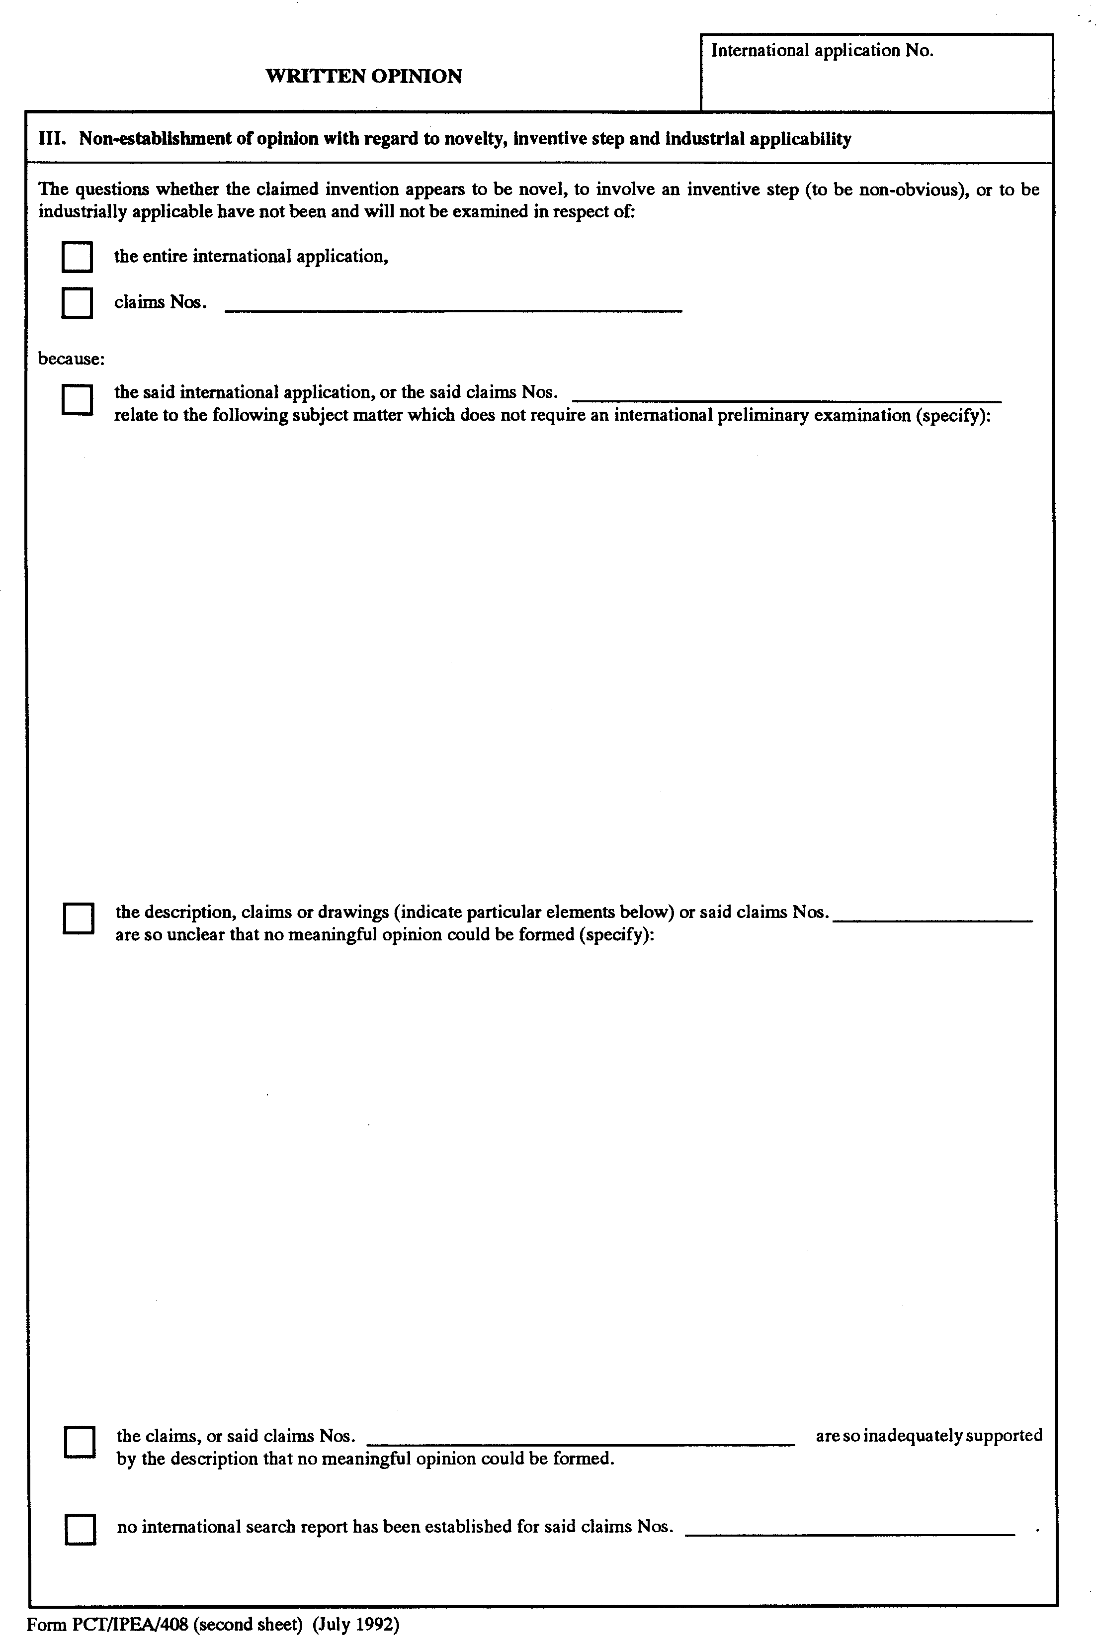

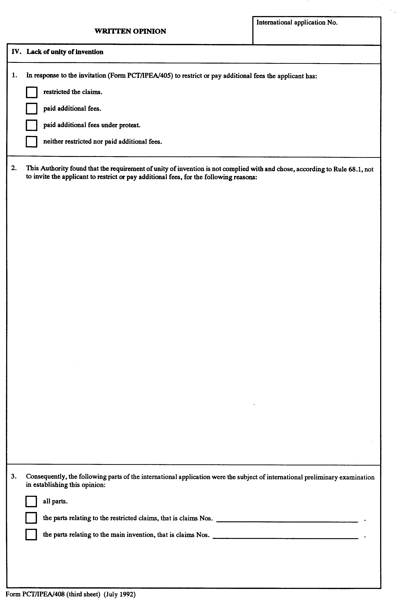

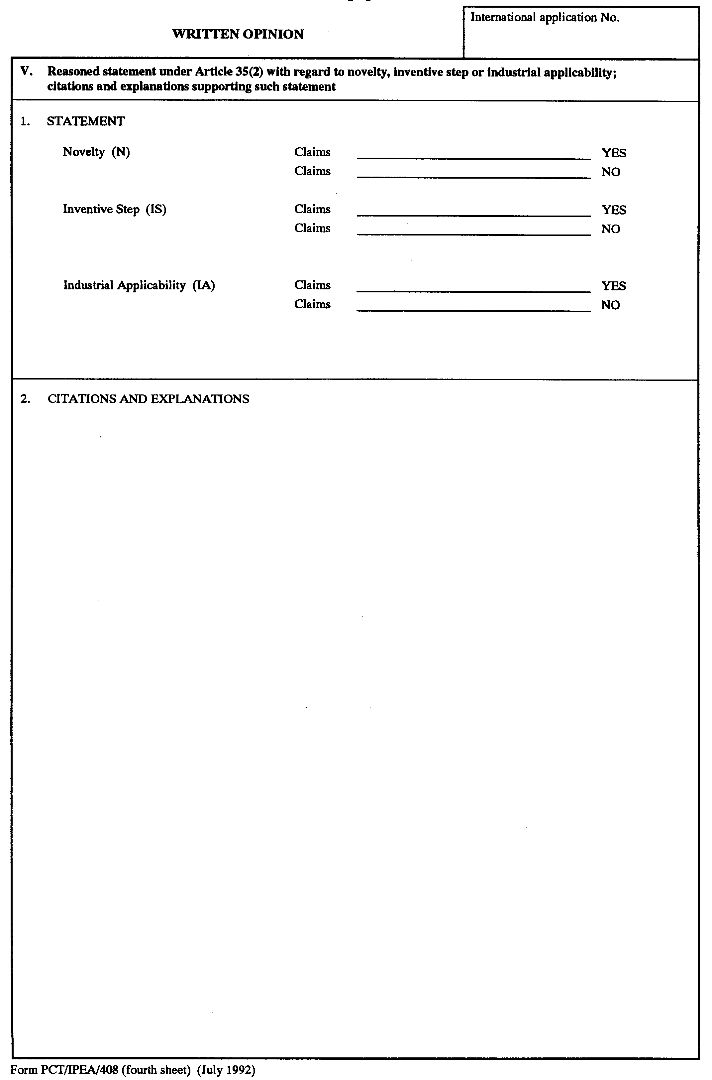

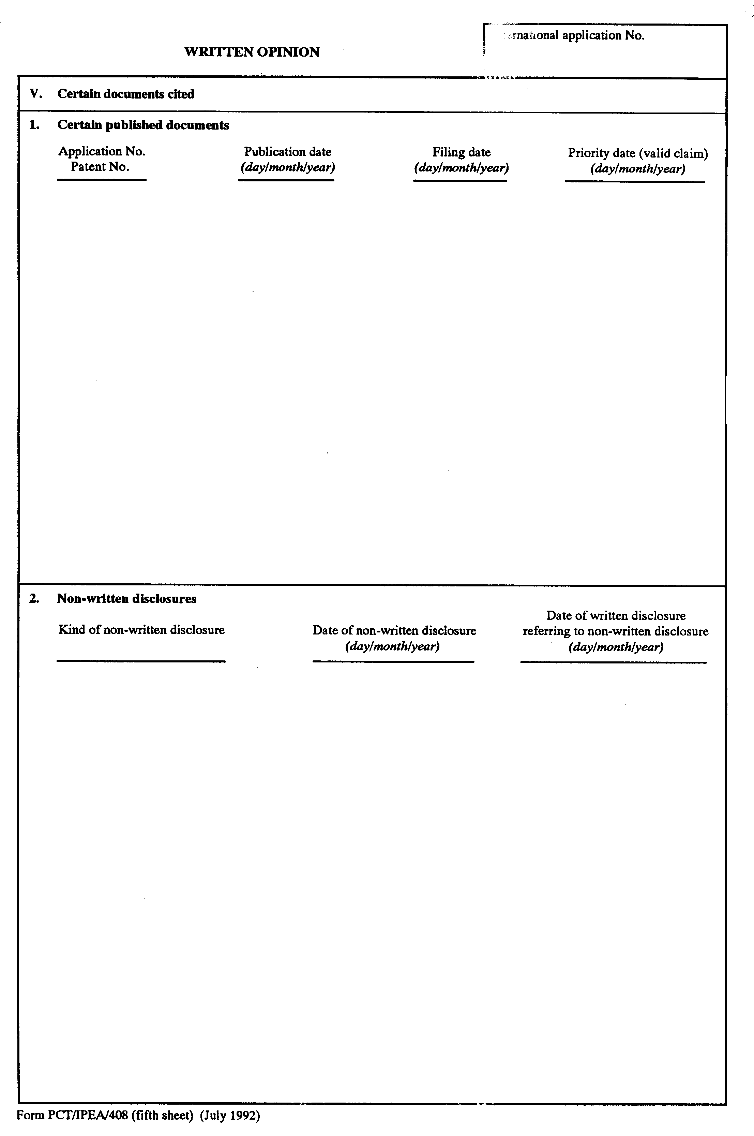

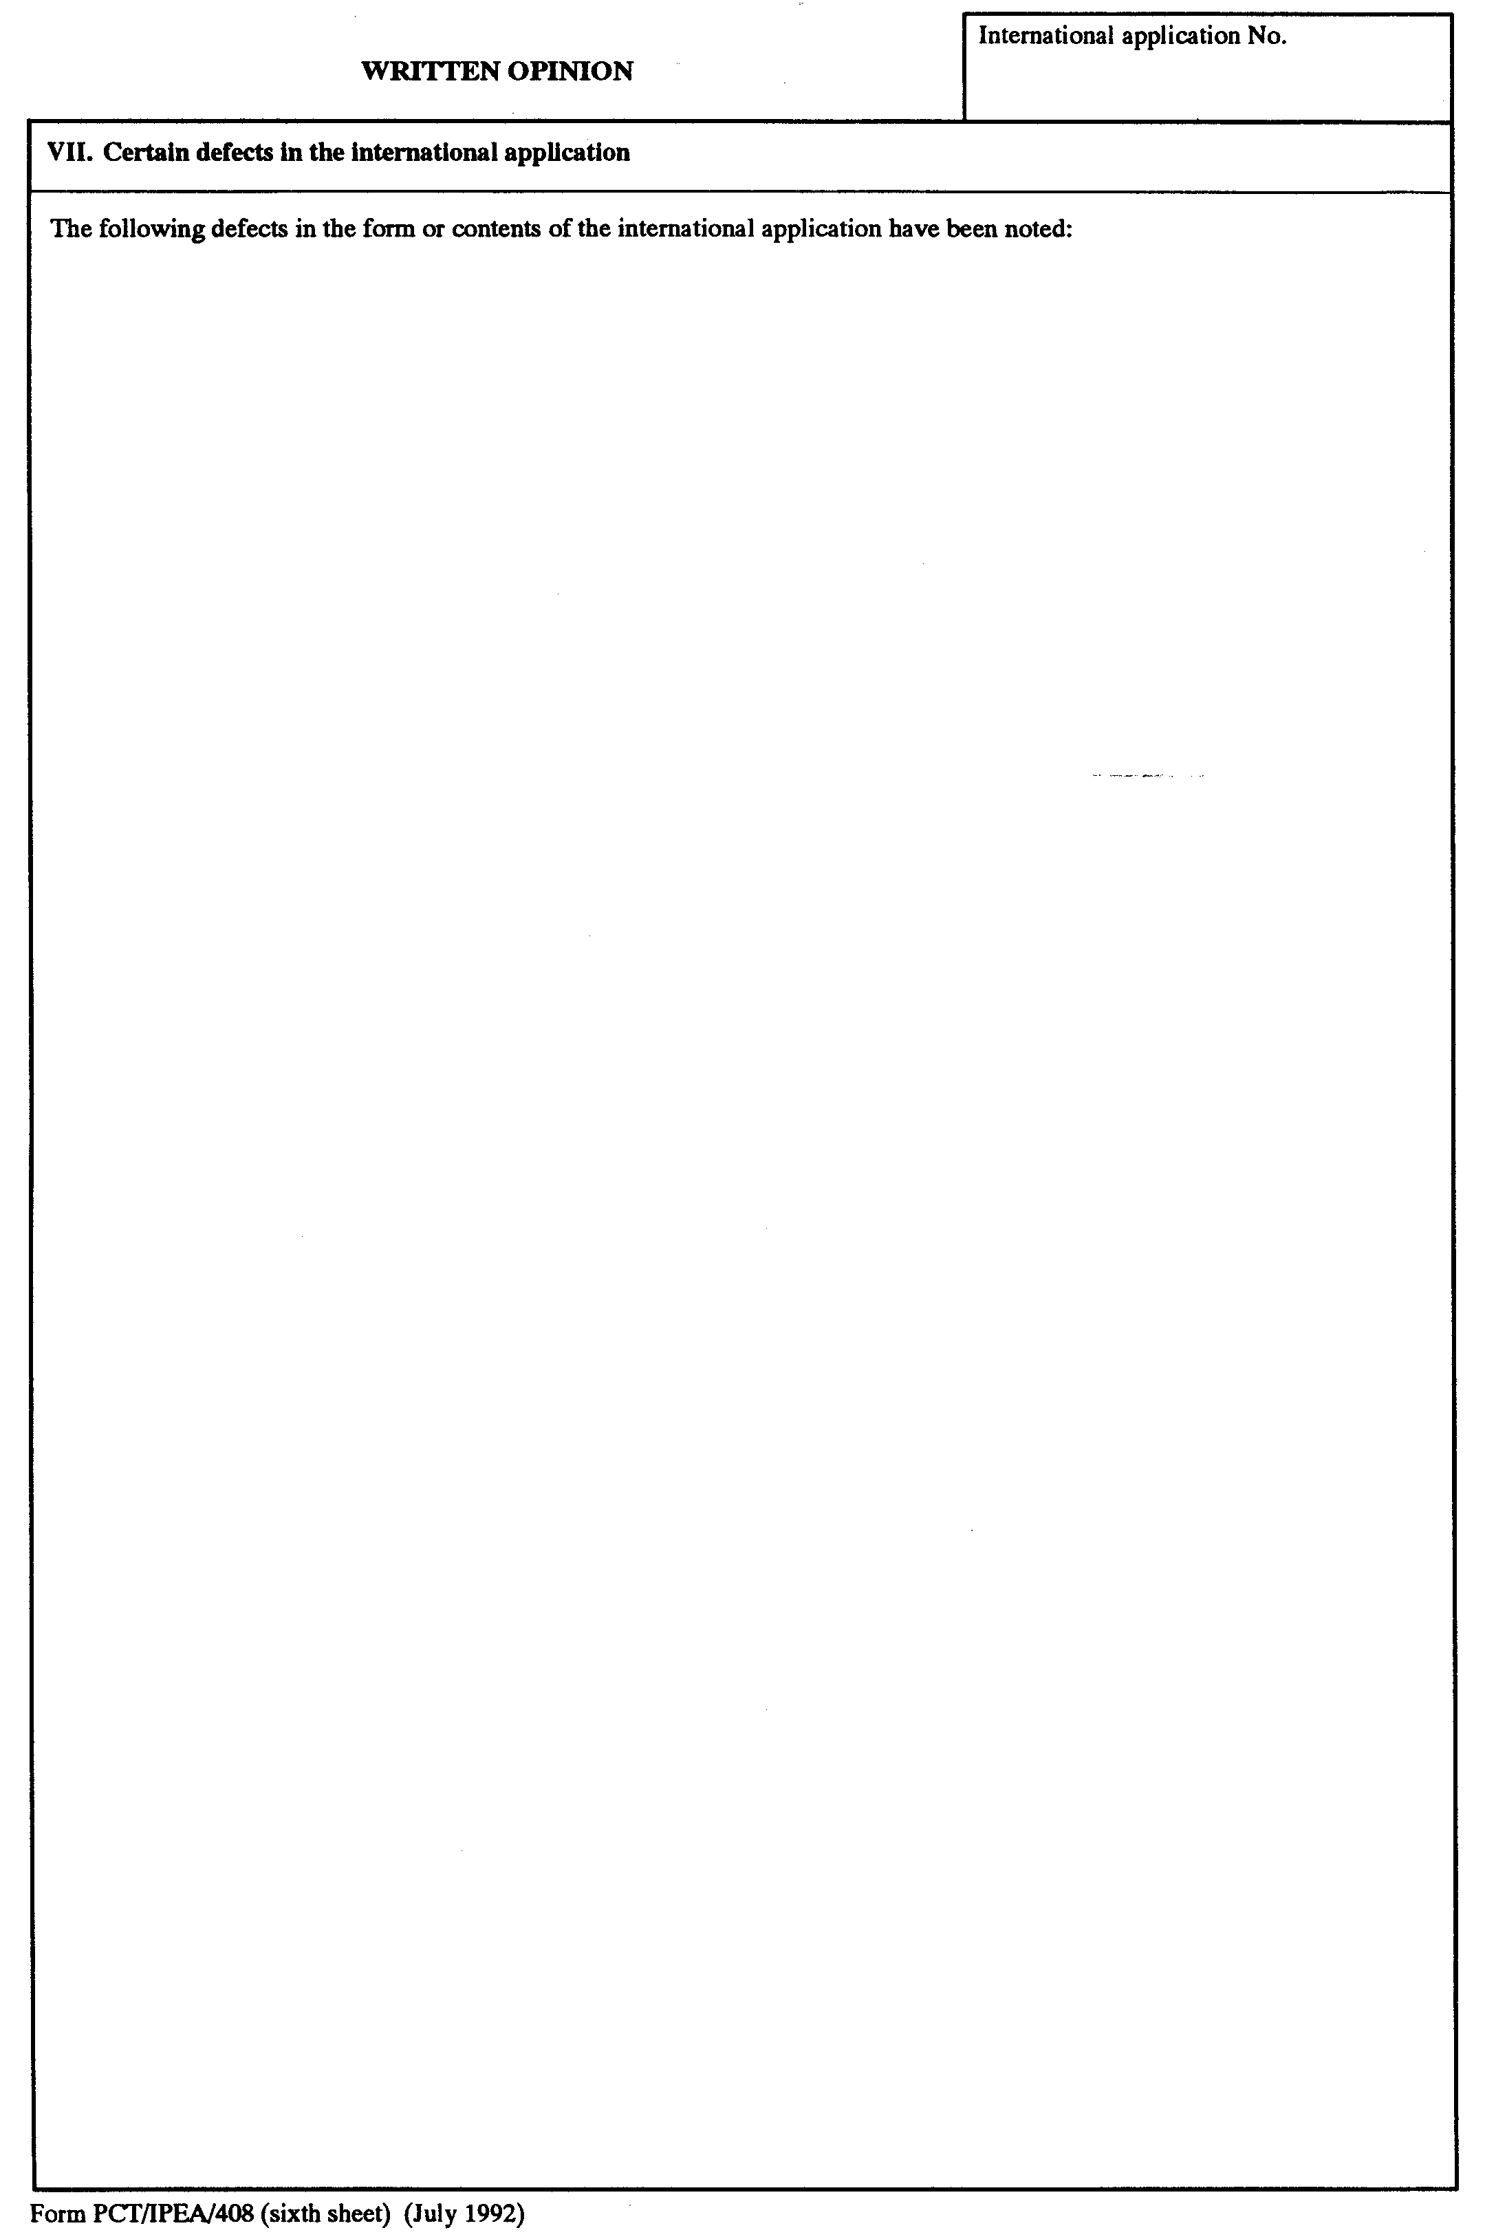

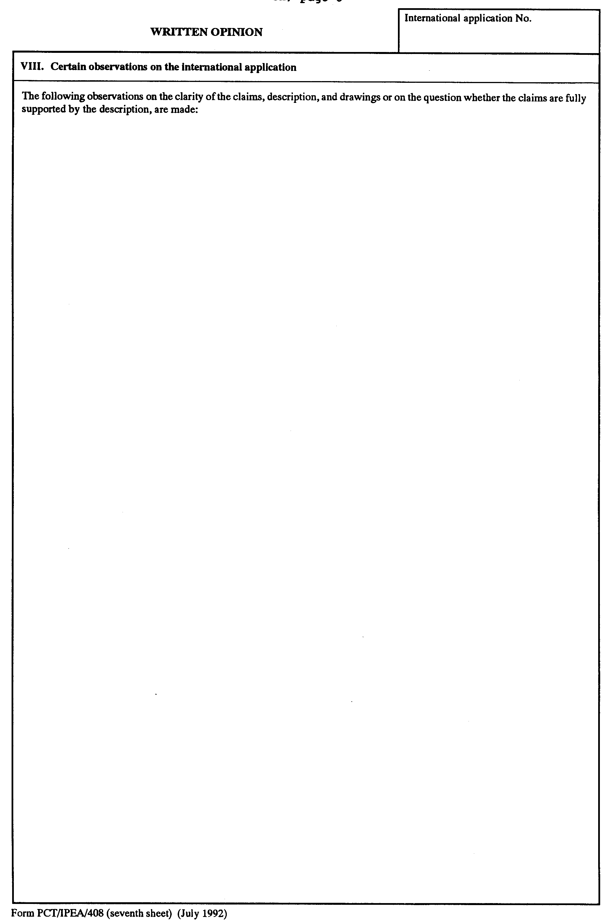

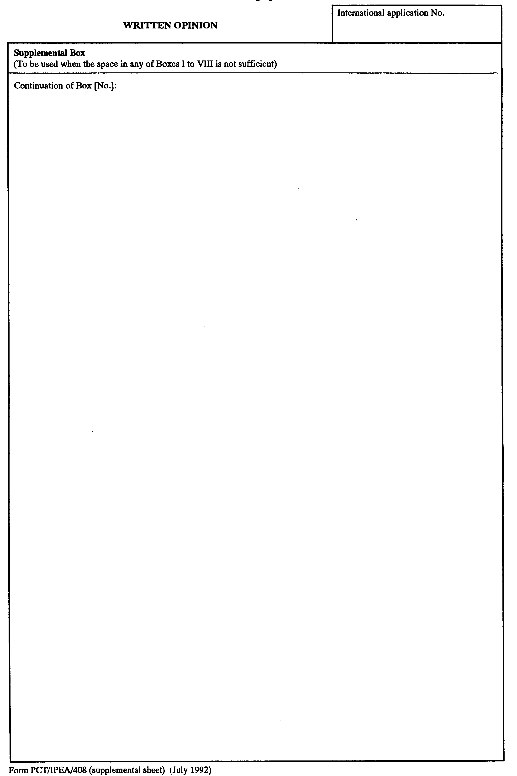

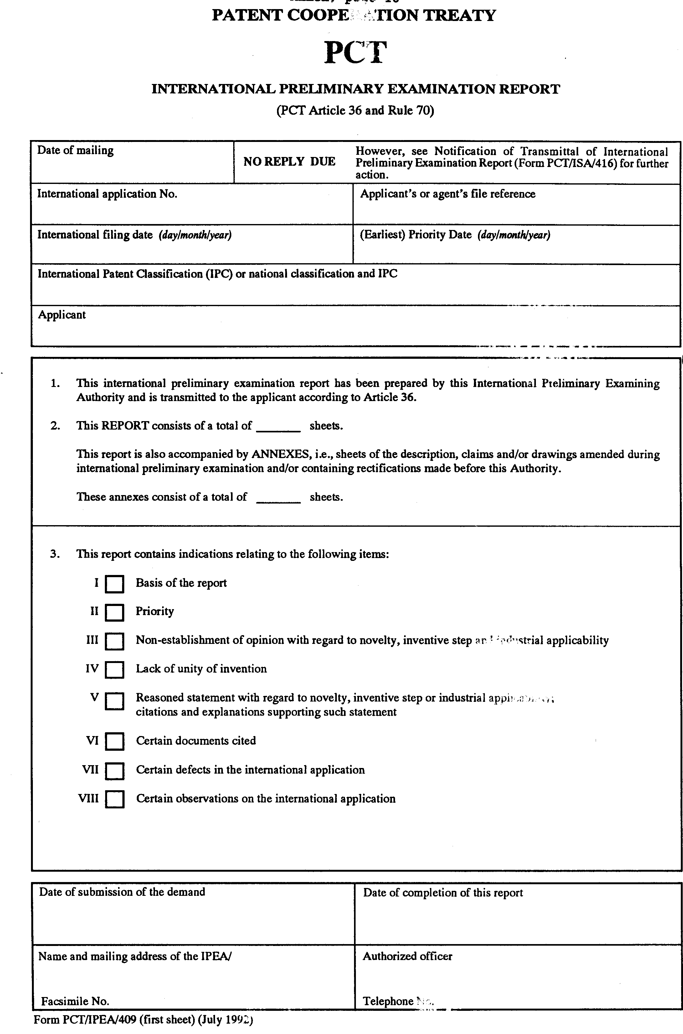

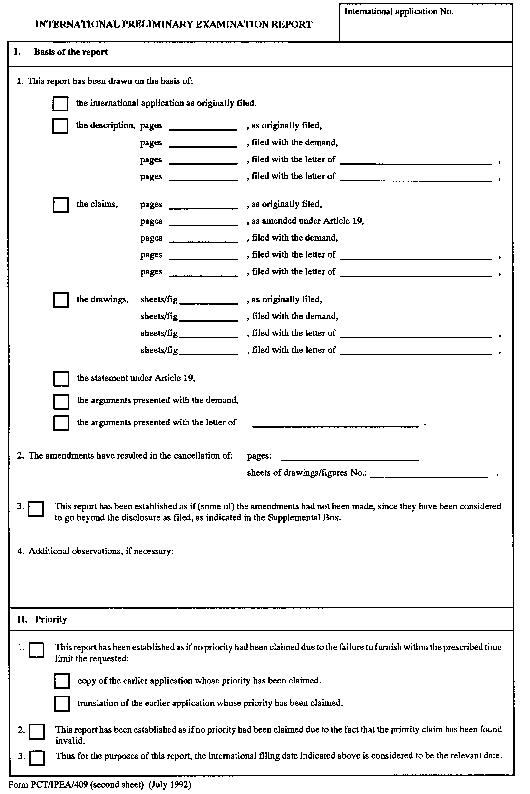

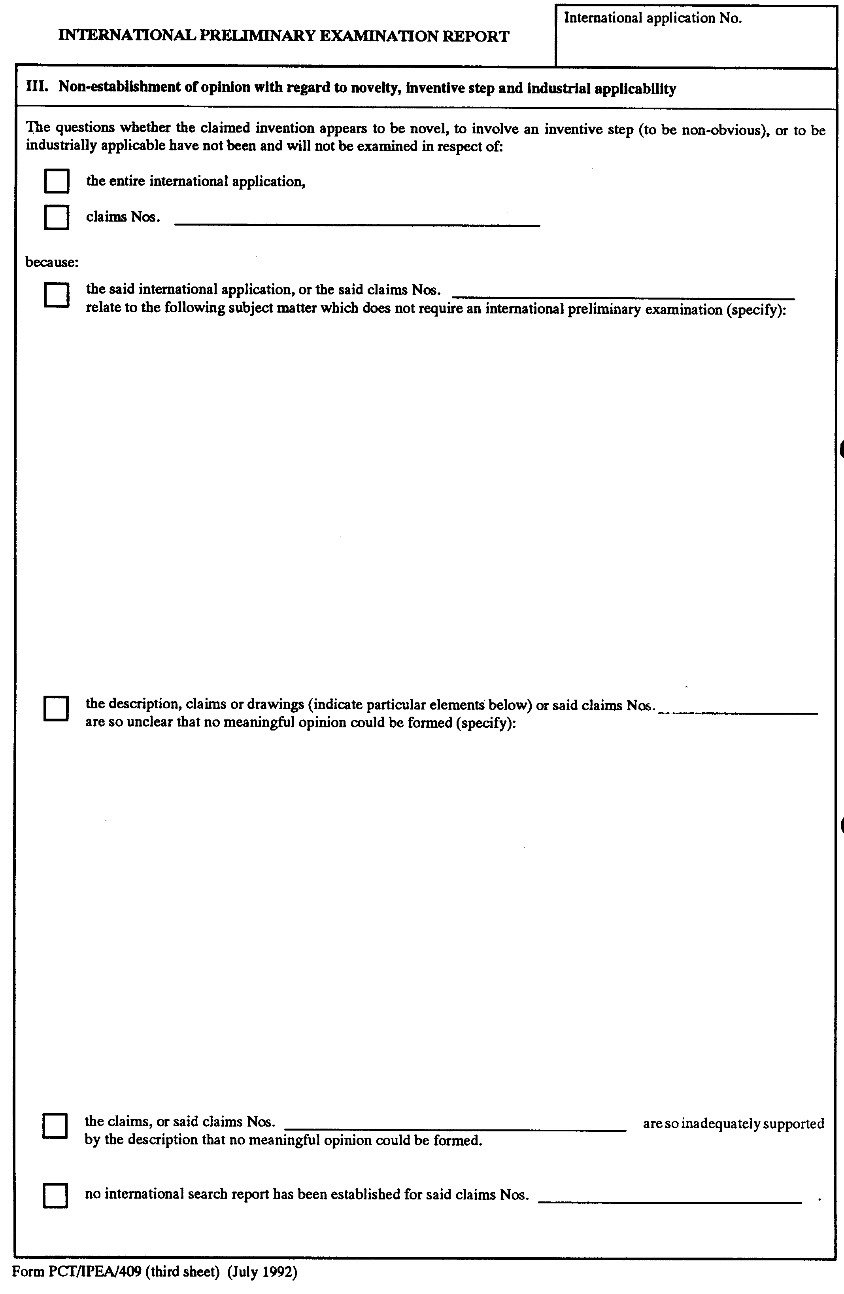

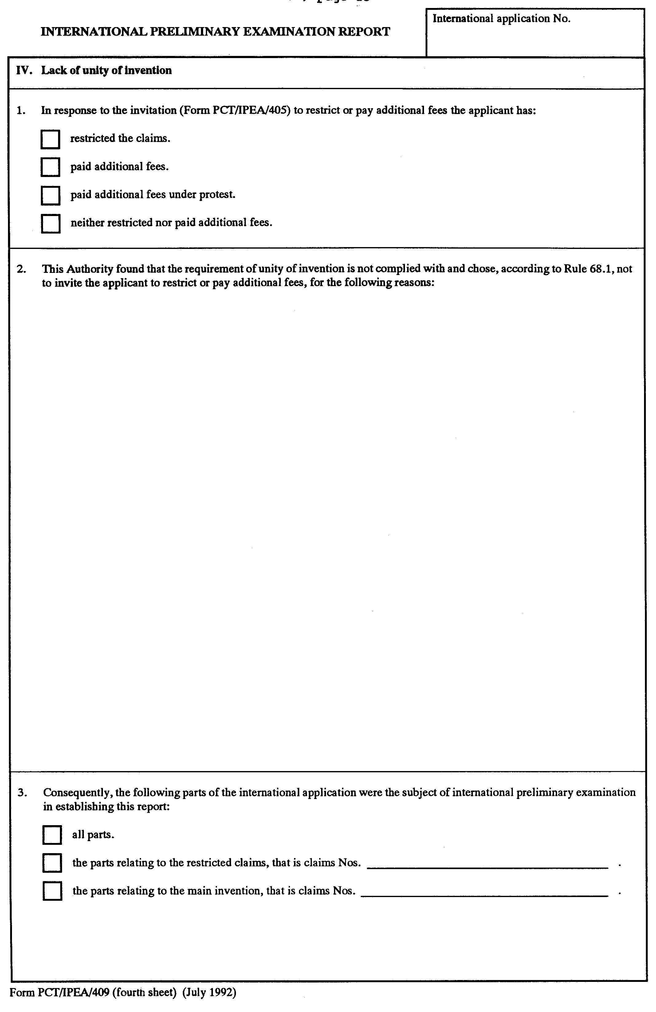

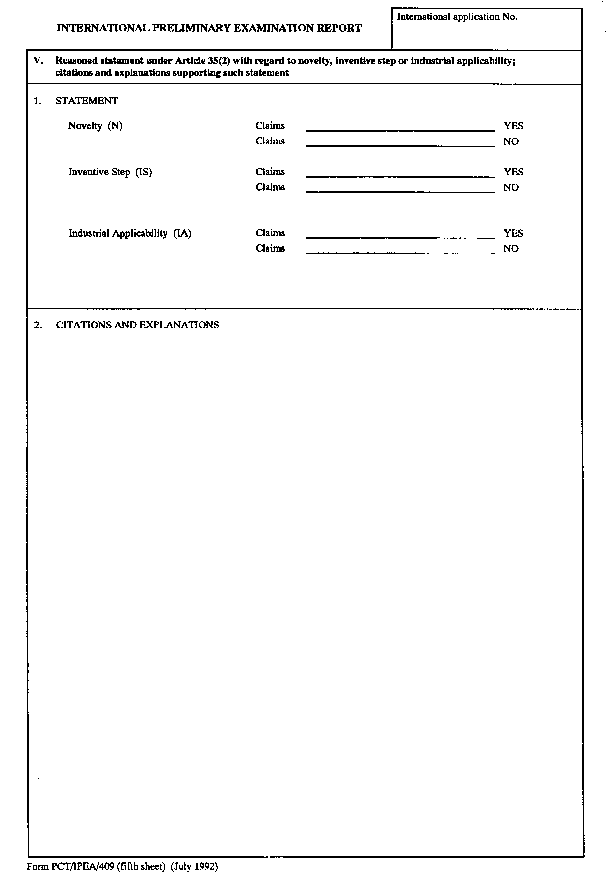

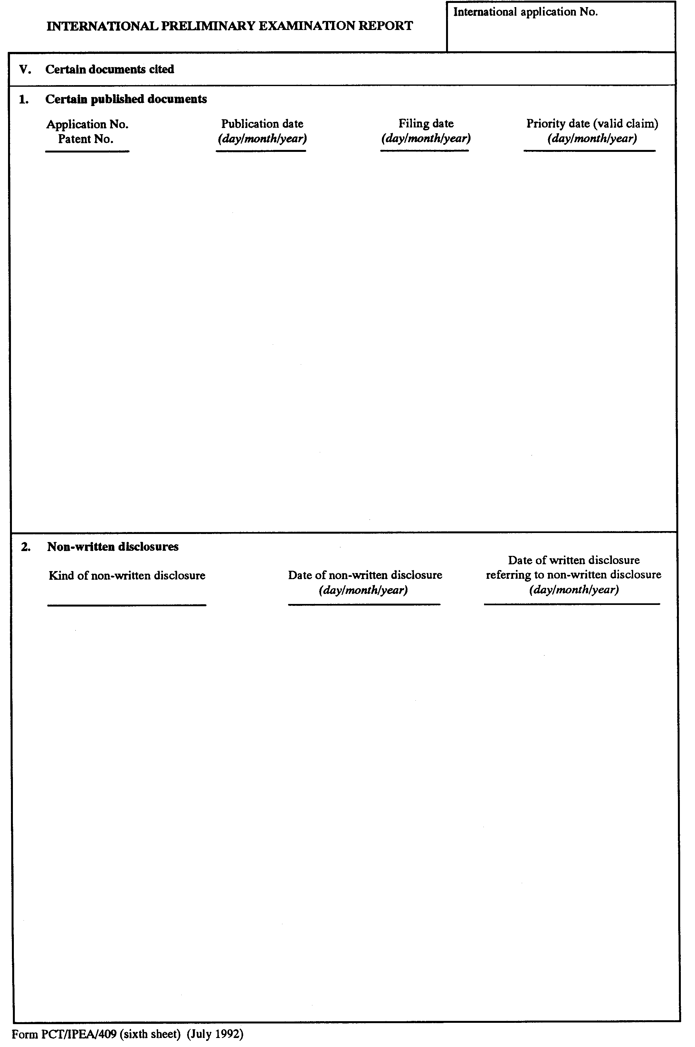

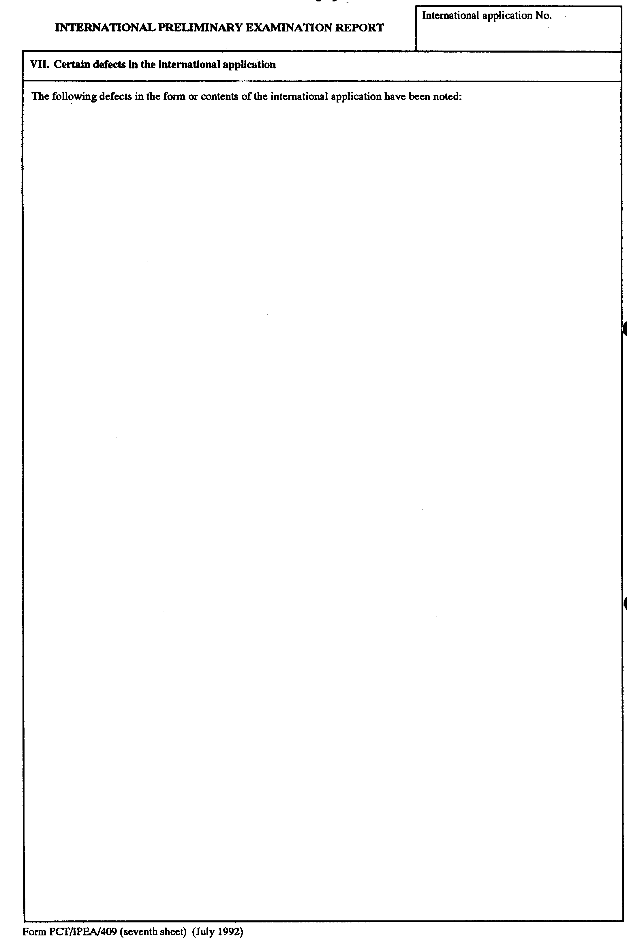

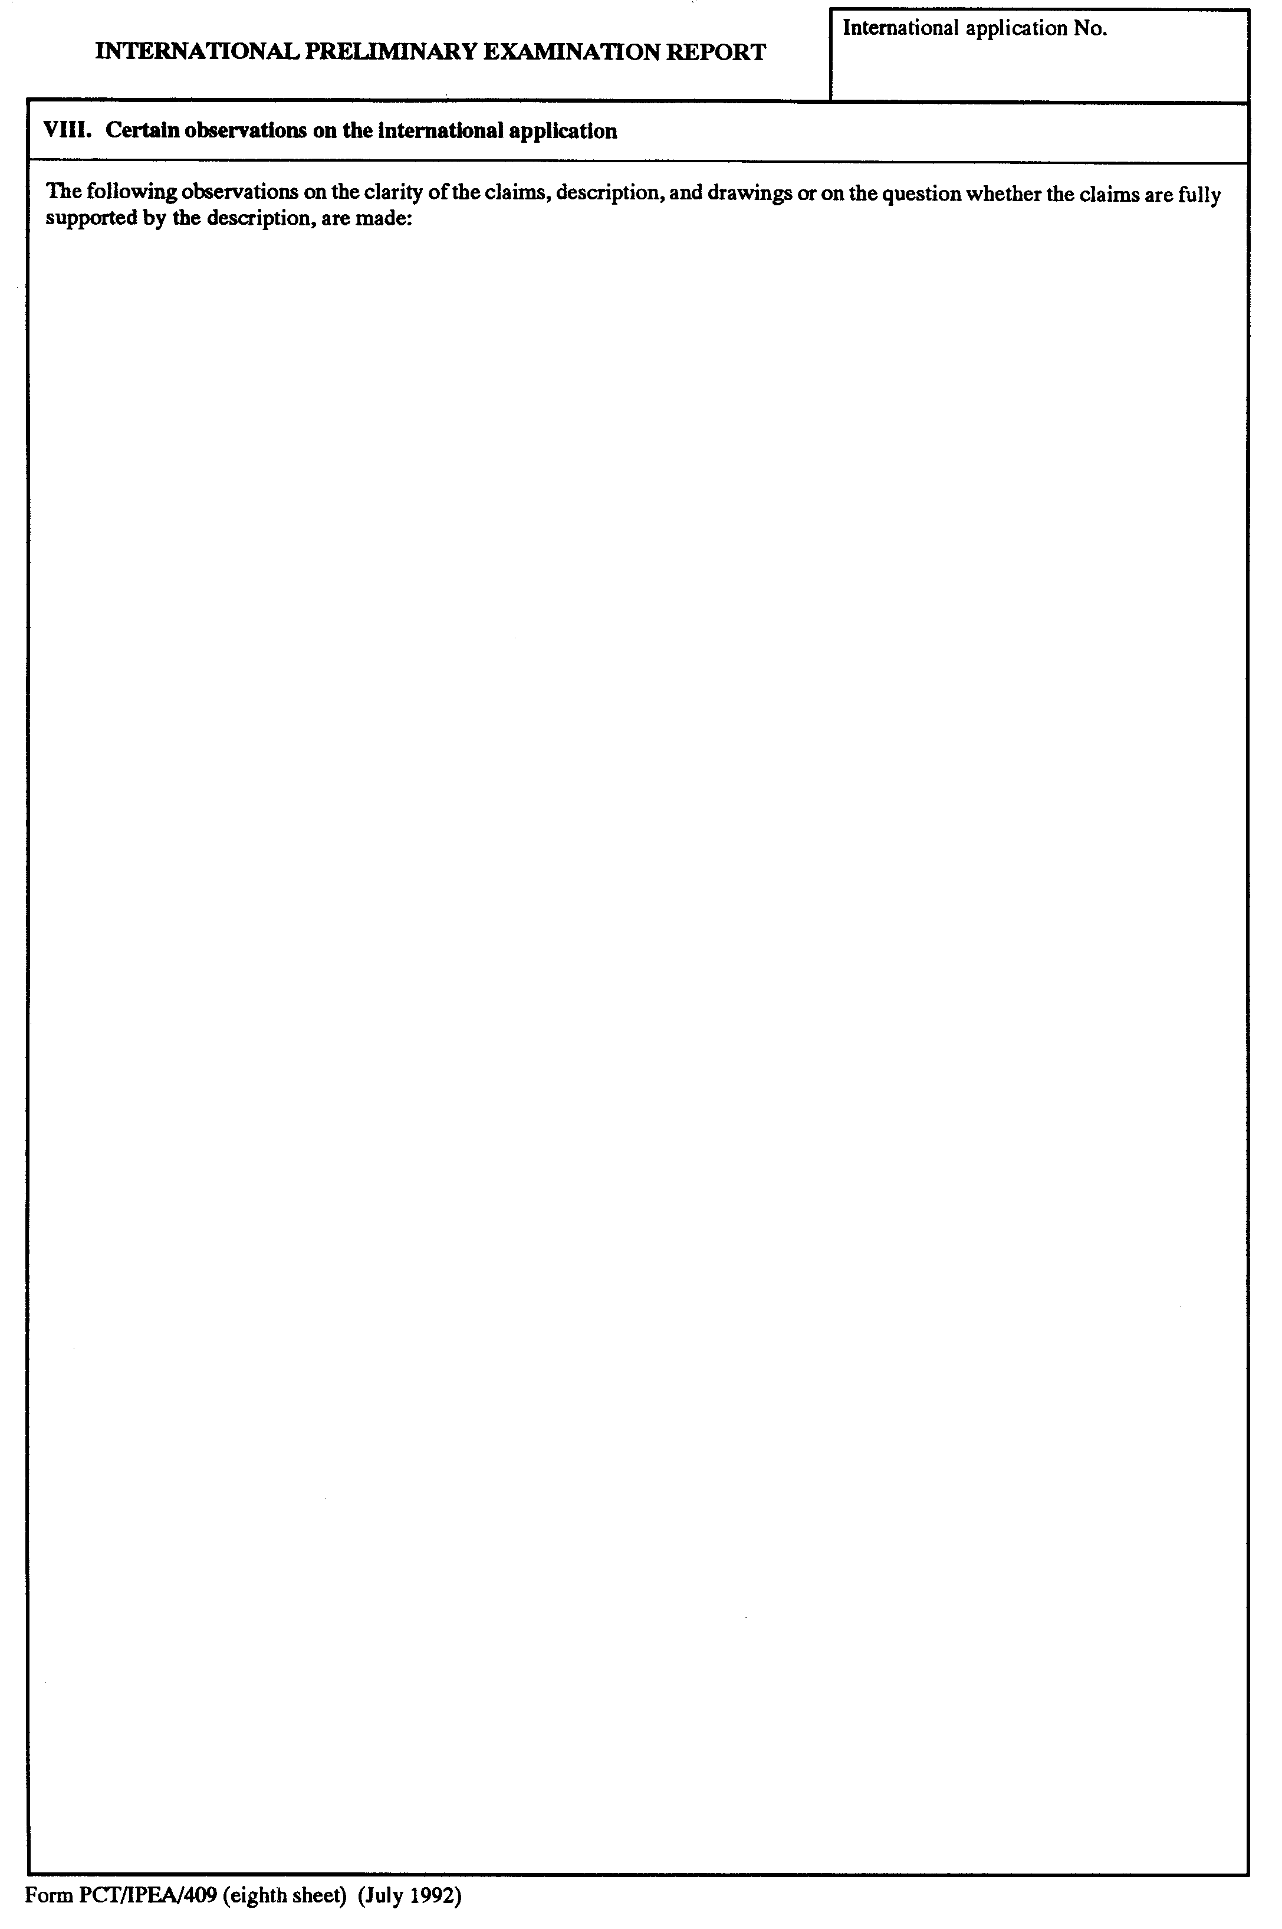

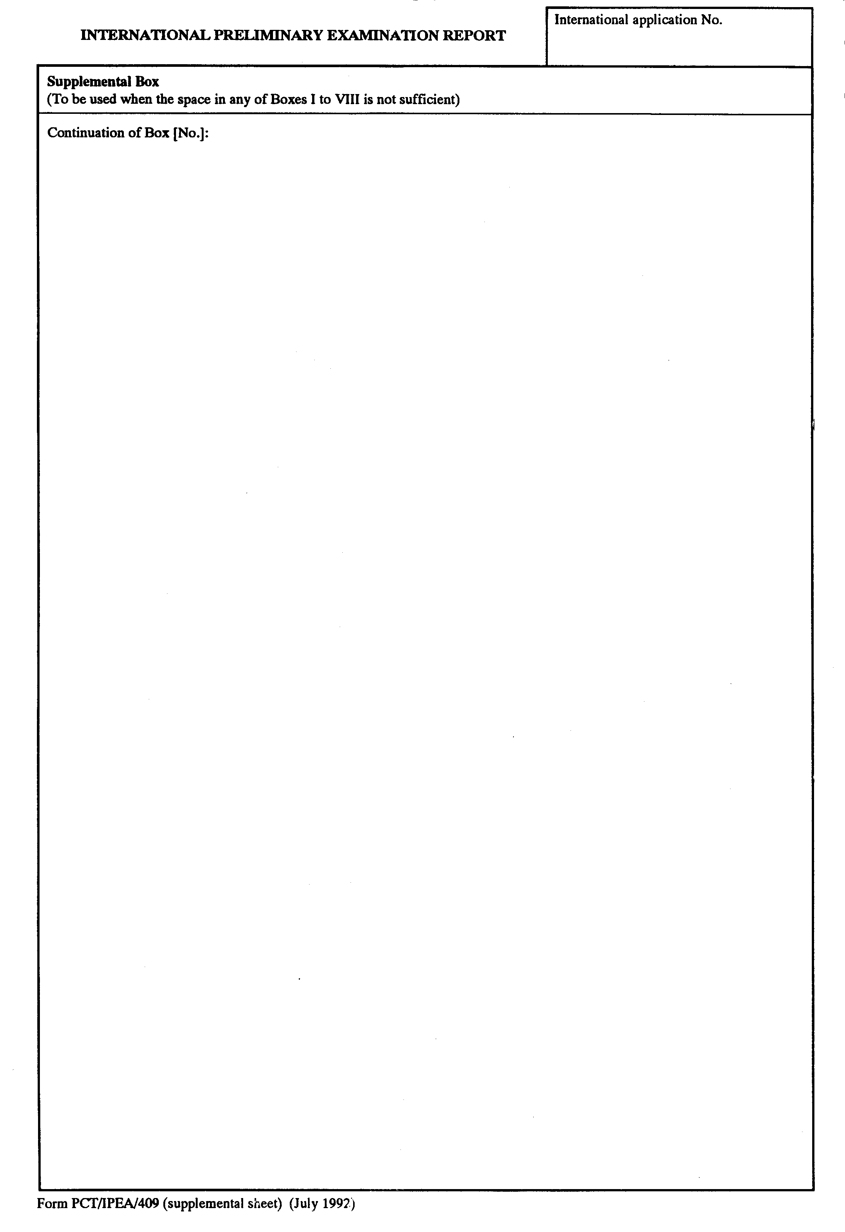
[End of Annex and of document]

