WIPO |  | PCT/MIA/II/5  ORIGINAL: English  DATE: January 27, 1992
WORLD INTELLECTUAL PROPERTY ORGANIZATION
GENEVA
International patent cooperation union
(PCT union)
Meeting of international authorities
under the PCT
Second Session
Geneva, March 9 to 13, 1992
DRAFT of proposed modified demand form
prepared by the International Bureau
The annex to this document contains:

(i) a modified Demand Form (PCT/IPEA/401);
(ii) modified Notes to the Demand Form;
(iii) a modified Fee Calculation Sheet—Annex to the Demand; and
(iv) modified Notes to the Fee Calculation Sheet.

The modifications take into account the amendments to the PCT Regulations and are submitted to the International Preliminary Examining Authorities for their observations.

[Annex follows]

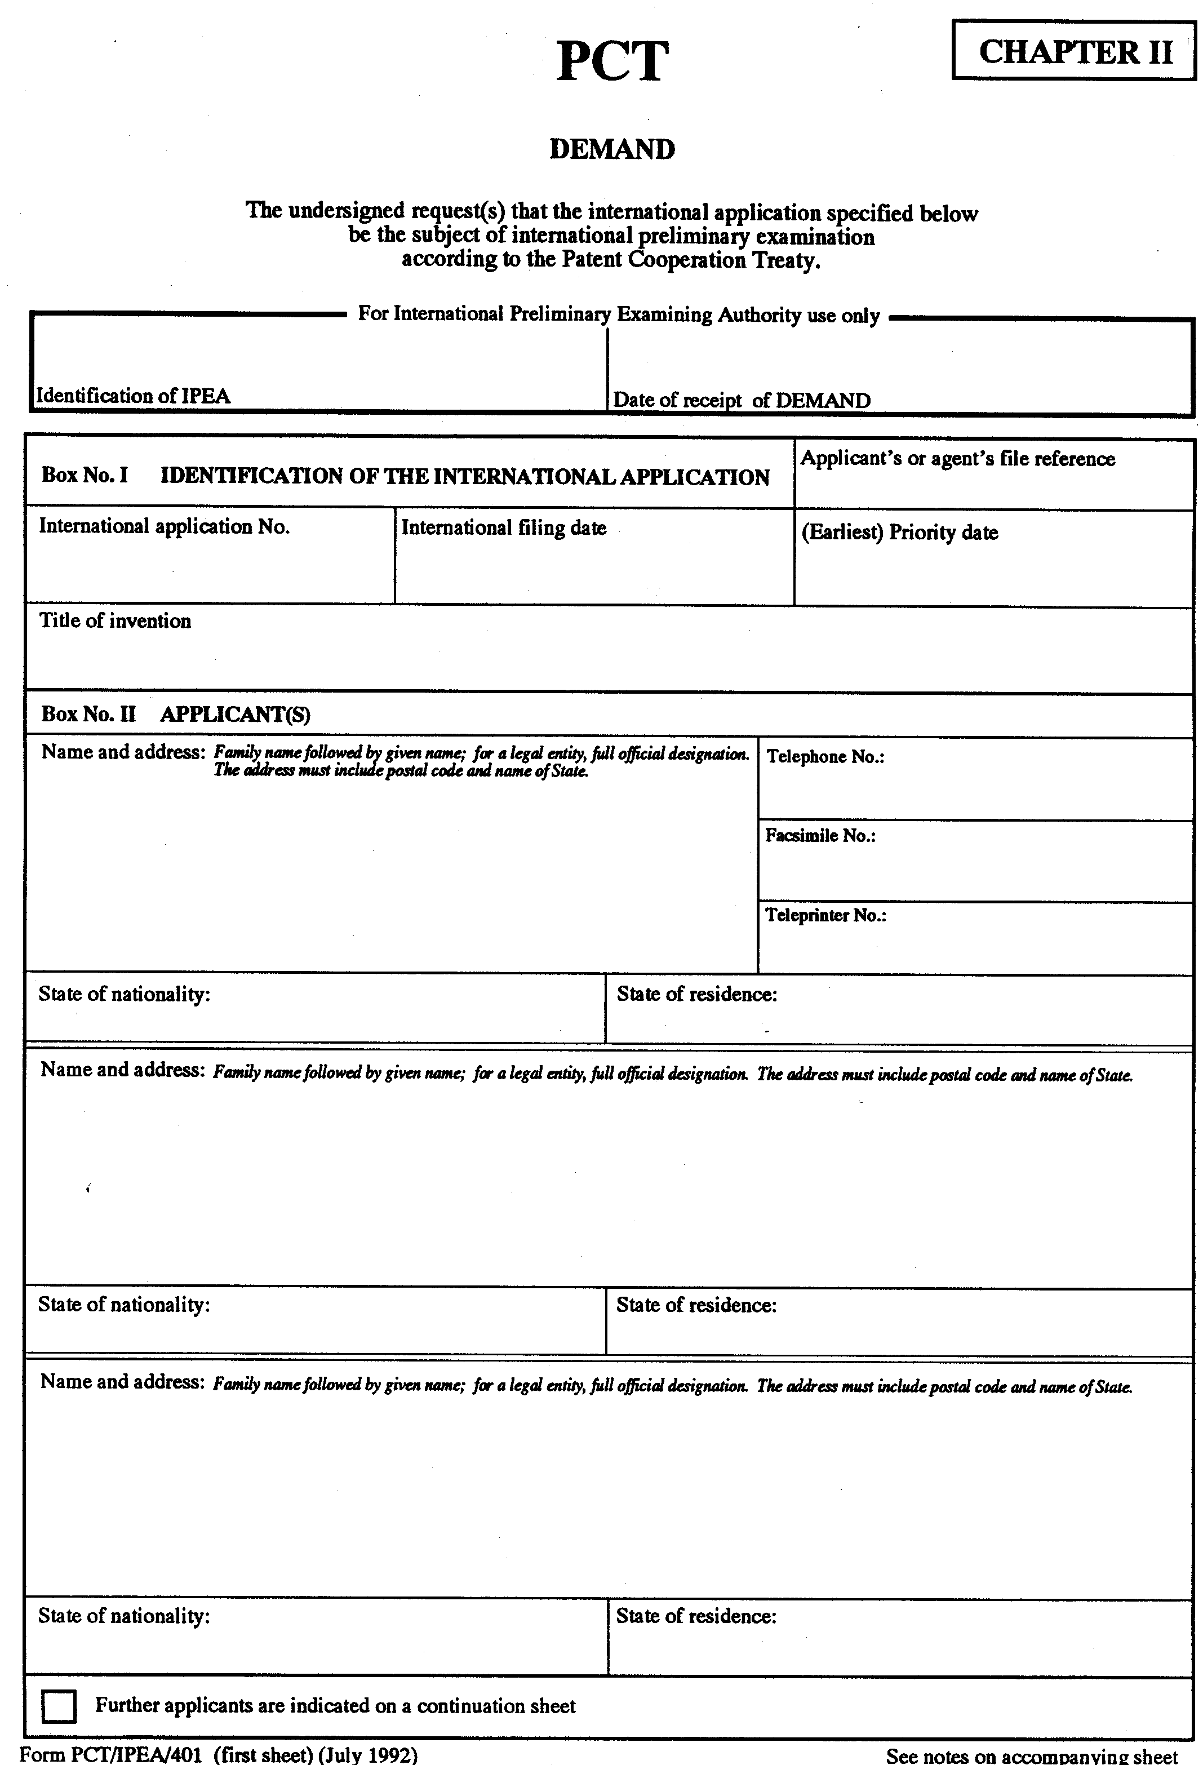

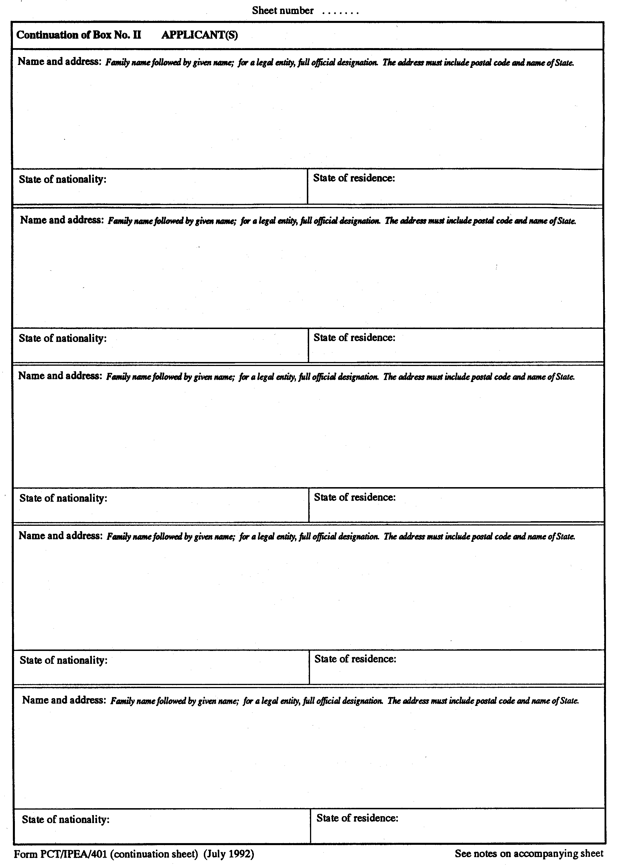

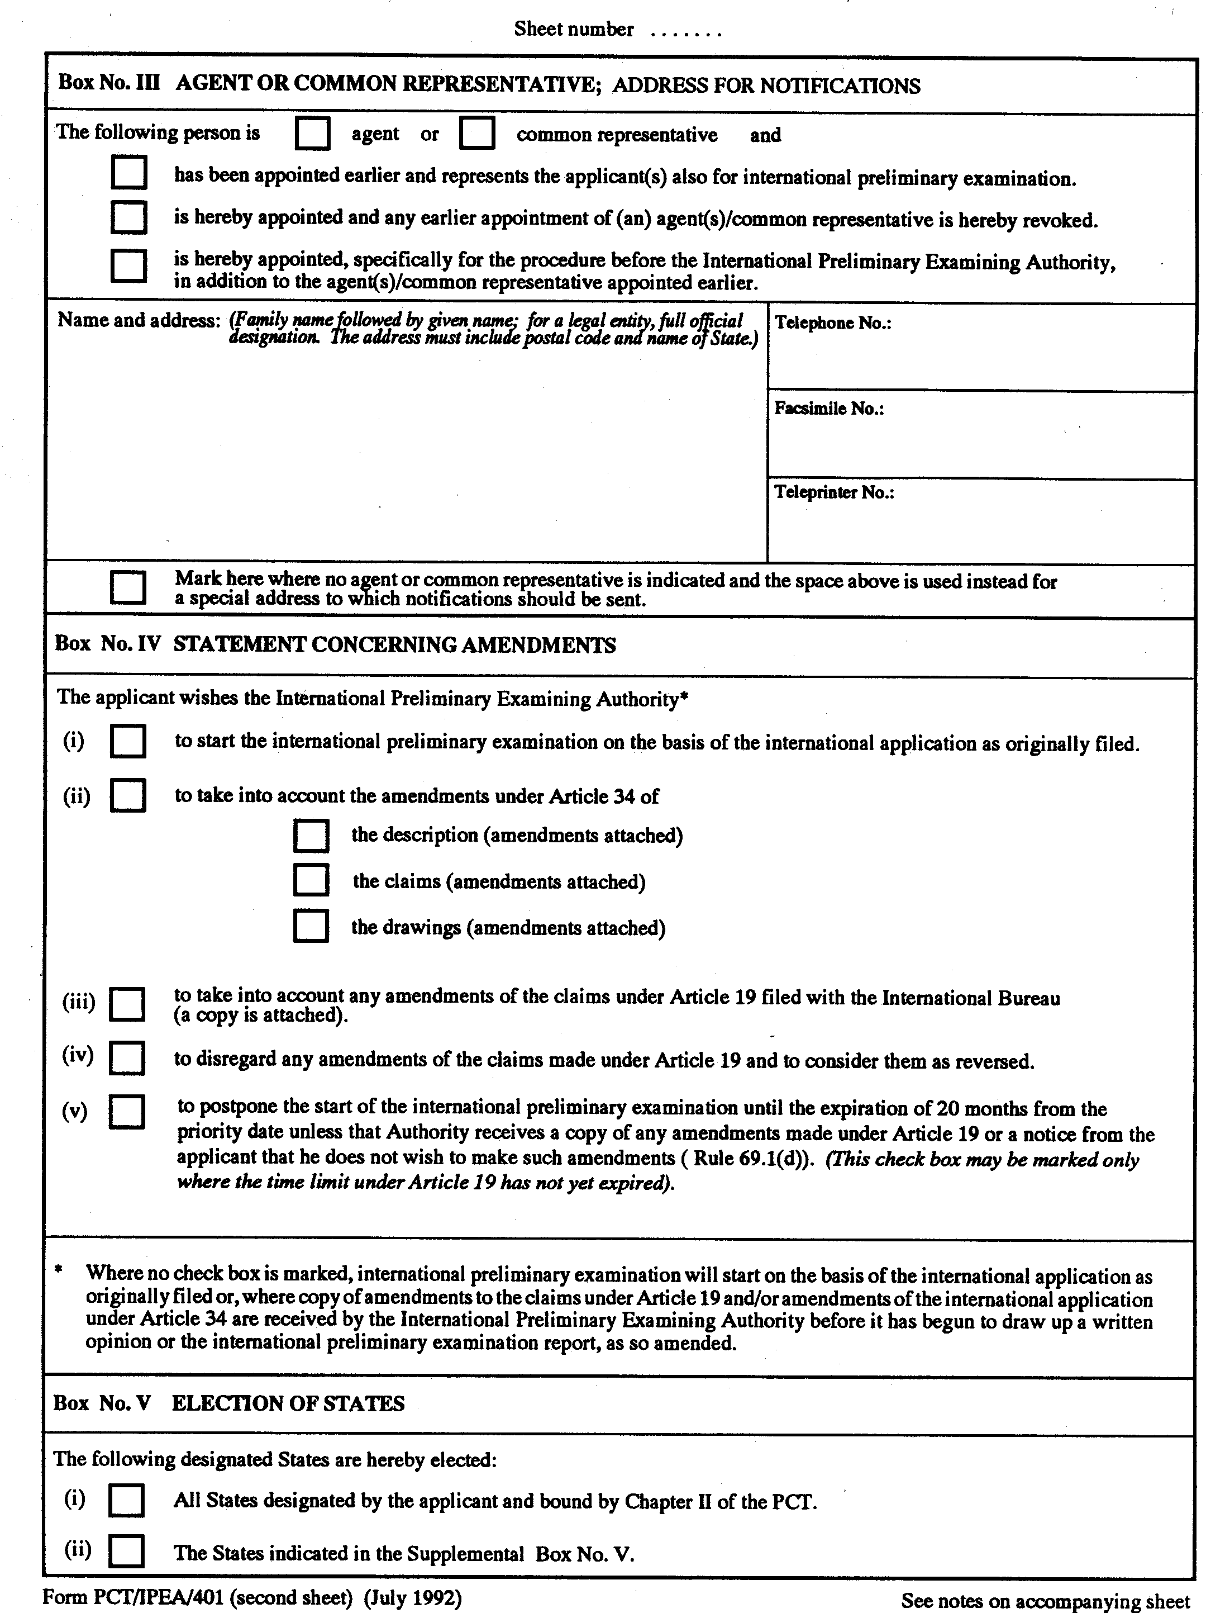

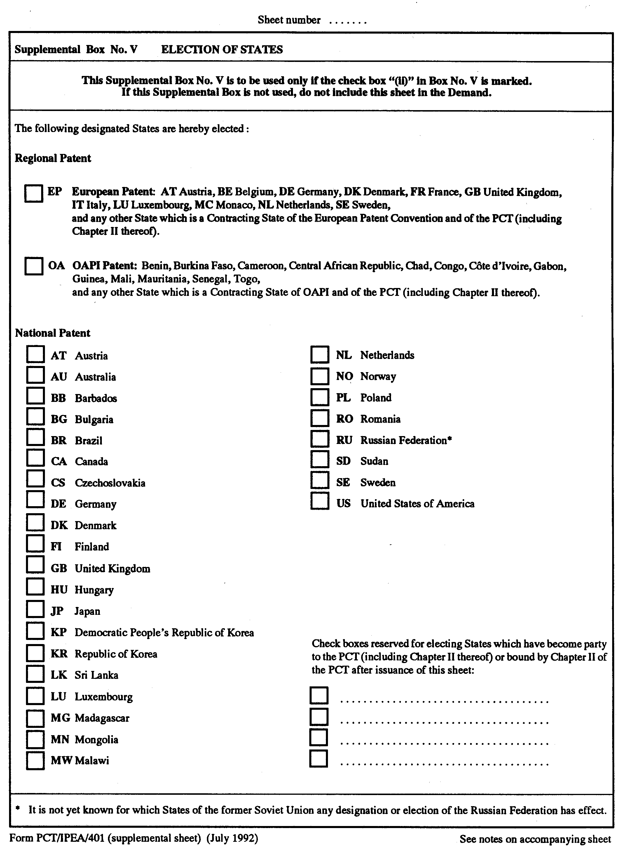

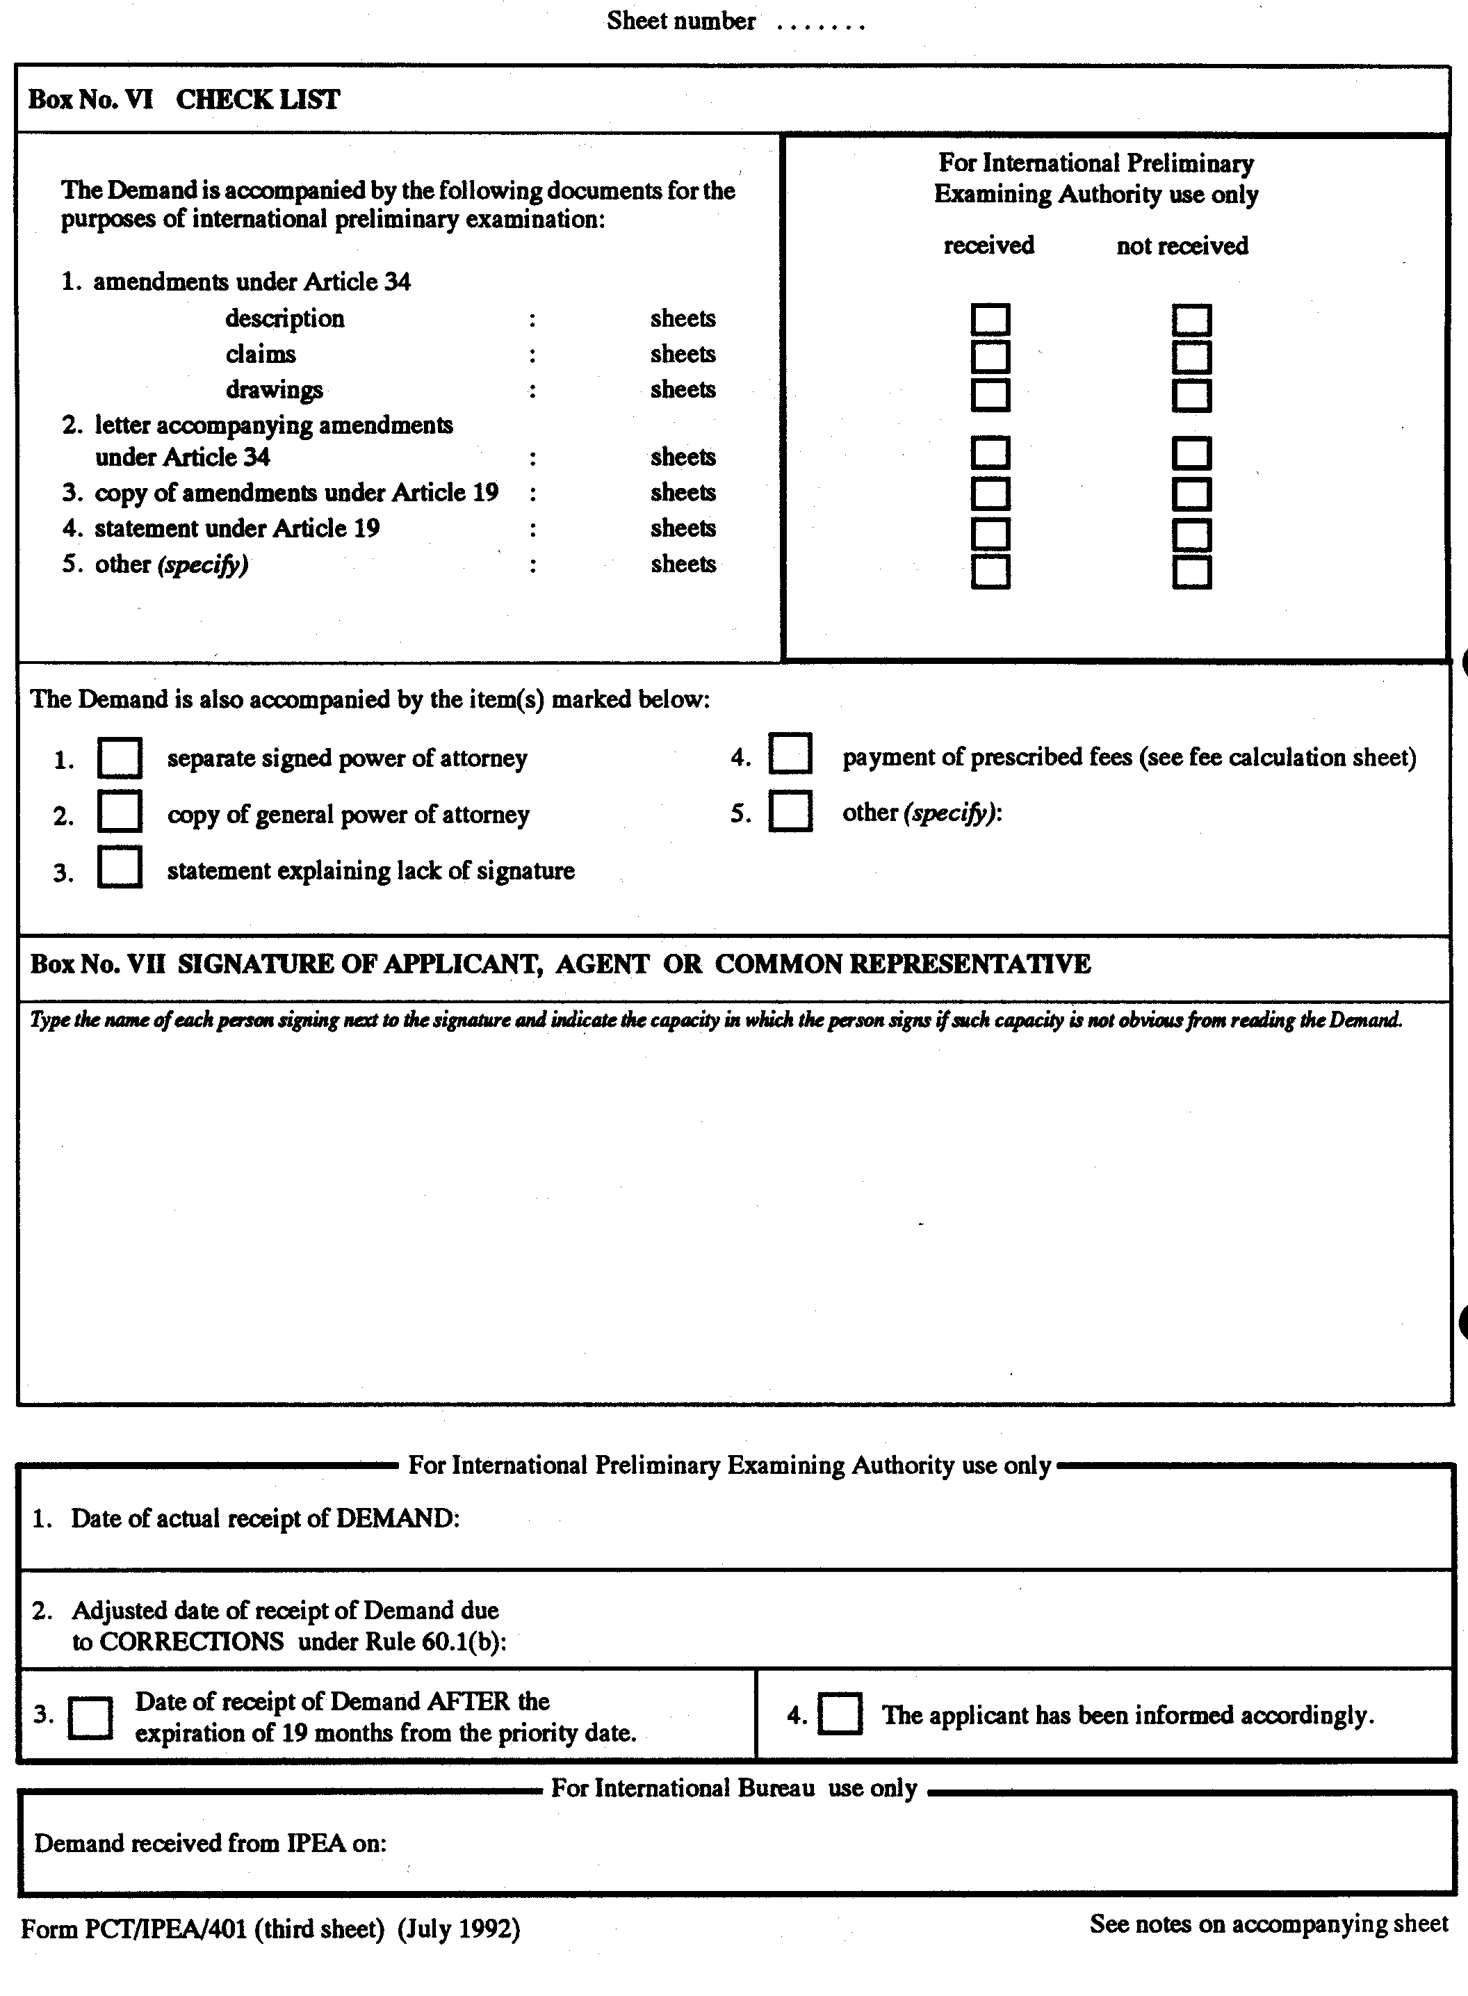

NOTES TO THE DEMAND FORM (PCT/IPEA/401)

These Notes are intended to give some information concerning international preliminary examination under Chapter II of the PCT and to facilitate the filling in of the present form. For authentic information, see the text of the Patent Cooperation Treaty and the texts of the Regulations and the Administrative Instructions under that Treaty. In case of discrepancy between these Notes and the said texts, the latter are applicable. For more detailed information, see also the PCT Applicant’s Guide, a publication of WIPO.

“Article” refers to Articles of the Treaty, “Rule” refers to Rules of the Regulations and “Section” refers to Sections of the Administrative Instructions.

IMPORTANT GENERAL INFORMATION

Who May File a Demand (Article 31(2)(a) and Rule 54)? A demand (for international preliminary examination) may only be filed by an applicant who is a national or resident of a PCT Contracting State which is bound by Chapter II of the PCT; furthermore, the international application must have been filed with a receiving Office of, or acting for, a State bound by Chapter II. Where there are different applicants for different elected States, at least one of them must qualify.

Where Must the Demand be Filed (Article 31(6)(a))? The demand must be filed with the International Preliminary Examining Authority (IPEA). The receiving Office with which the international application was filed will, upon request, give information about the competent IPEA (or see Annex C of the PCT Applicant’s Guide, Volume I). If several IPEAs are competent, the applicant has the choice and the demand must be filed with (and the fees must be paid to) the IPEA chosen by the applicant.

When Must the Demand be Filed (Article 39(1))? The demand must be filed before the expiration of 19 months from the priority date in order to extend the time limit for entering the national phase of the PCT procedure from 20 to 30 months from the priority date. Warning: if the demand is filed later, the national phase will not be delayed in respect of the elected States and the applicant must enter the national phase before the expiration of the time limit applicable under Article 22 (which is usually 20 months from the priority date).

In Which Language Must the Demand be Filed (Rule 55.1)? The demand must be filed in the language of the international application if that language is English, French, German, Japanese or Russian; otherwise, the demand must be filed in English.

What is the Language of Correspondence (Rules 66.9 and 92.2, Section 104)? Any letter from the applicant to the IPEA must be in the same language as the international application to which it relates. However, the IPEA may authorize the use of another language for letters which do not contain or relate to amendments of the international application, whereas amendments and letters relating thereto must be in the language of publication. Any letter from the applicant to the International Bureau must be in the same language as the international application if that language is English or French; otherwise, it must be in English or French, at the choice of the applicant.

Which Fees Must be Paid and When (Rules 57 and 58)? At the time the demand is submitted, the applicant must pay the preliminary examination fee and the handling fee. For details concerning the payment of those fees, see the Fee Calculation Sheet.

NOTES TO BOX No. I

Identification of the International Application (Rule 53.6): The international application number must be indicated in Box No. I. Where the demand is filed at a time when the international application number has not yet been notified by the receiving Office, the name of that Office must be indicated instead of the international application number.

International Filing Date and Priority Date (Section 110): They must be indicated by the Arabic number of the day, the name of the month and the Arabic number of the year; after, below or above such indication, the date should be repeated in parenthesis by indicating it by two-digit Arabic numerals each for the number of the day, for the number of the month and for the last two numbers of the year, e.g., “10 June 1986 (10.06.86)”. Where the international application claims the priority of several earlier applications, the filing date of the earliest application whose priority is claimed must be indicated as the priority date.

Title of the Invention: If a new title has been established by the International Searching Authority, that title must be indicated in Box No. I.

NOTES TO BOX No. II

Applicant(s) (Rule 53.4): Make here the relevant indications as appearing in Boxes Nos. II and III of the REQUEST (Form PCT/RO/101). The Notes to the REQUEST apply mutatis mutandis. If there are two or more applicants for the States elected in the demand, give the relevant indications for each of them; if there are more than three applicants, make the required indications on the “Continuation Sheet”.

If different applicants for different designated States are indicated in the REQUEST part of the international application, indicate only the applicants for the States elected in Box No. V (no indication of the States for which a person is applicant need be made, because those indications have been made in the REQUEST).
NOTES TO BOX No. III

Agent or Common Representative (Rules 53.5 and 90.1): Mark the applicable check-boxes to indicate
– first whether the person named in Box No. III is agent or common representative ,
– then whether that person
- has been appointed earlier (i.e., during the procedure under Chapter I), or
- is appointed for the procedure before the IPEA and any earlier appointment to another person is revoked, or
- is appointed only for the procedure before the IPEA without revocation of any earlier appointment.

In the latter case all notifications issued by the IPEA will be addressed only to that additional person. A separate power of attorney must be filed with the IPEA, the International Bureau of WIPO or the receiving Office, if the person appointed at the time the demand is filed (i.e., was not appointed earlier) signs the demand on behalf of the applicant (Rule 90.4).

Address for Notifications (Rule 4.4(d)): If no agent or common representative is/has been appointed, a special address for the sending of notifications to the applicant may be indicated in Box No. III instead of the name and address of an agent. That address must be different from the address given in Box No. II and the special check-box must be marked. If an agent or common representative has been appointed, notifications will be sent to him only, at the address indicated in Box No. III.

NOTES ON BOX No. IV

Statement Concerning Amendments (Rules 53.2(a)(v), 53.9, 62, 66.1 and 69.1): The international preliminary examination will start on the basis of the international application as filed or, if amendments have been filed, as amended. Mark the appropriate check-box(es) to enable the IPEA to determine whether it can start international preliminary examination and on what basis.

Mark check-box (i) where the international preliminary examination should start on the basis of the international application as filed.

Mark check-boxes (ii) and/or (iii) where amendments are to be taken into account and submit with the demand a copy of amendments of the claims under Article 19 (Rule 53.9(a)(i)) and/or the amendments to the international application under Article 34 (Rule 53.9(c)), as the case may be. If a check-box is marked and the demand is not accompanied by the documents referred to, the start of international preliminary examination will be delayed until the IPEA receives them.

Mark check-box (iv) if amendments to the claims under Article 19 have been filed with the International Bureau during the Chapter I procedure, but the applicant does not want that these amendments be taken into account for the purpose of international preliminary examination when the latter starts (Rule 53.9(a)(ii)).

Mark check-box (v) where the time limit for filing amendments to the claims under Article 19 has not expired at the time the demand is filed and the applicant wants to keep the option for the filing of such amendments open; the IPEA is thus requested to postpone the start of international preliminary examination (Rules 53.9(b) and 69.1(d)). It should be noted that the examination will start in any event after the expiration of 20 months from the priority date even where no amendments have been received by the IPEA.

If no check-box is marked, refer to the footnote at the bottom of Box No. IV.

NOTES TO BOX No. V

Election of States (Rule 53.7): Only States which are bound by Chapter II of the PCT and which have been designated in the international application (i.e., designations made under Rule 4.9(a) or confirmed under Rule 4.9(c)) can be elected. They are the “eligible States”.

If all eligible States are to be elected, mark check-box “(i)”. Do not fill in the Supplemental Box No. V and discard the supplemental sheet.

If only some of the eligible States are to be elected, mark check-box “(ii)” and fill in the Supplemental Box No. V (see below).

NOTES TO SUPPLEMENTAL BOX V

This Supplemental Box is to be filled in only where check-box “(ii)” is marked in Box No. V.

The kind of protection or treatment desired follows the indication made in the REQUEST part of the international application. If a European patent is desired and only some of the Contracting States of the European Patent Convention have been designated for a European patent in the international application, the names of the other such States must be struck out. Greece, Spain, Switzerland and Liechtenstein are not listed in this Box because they are not bound by Chapter II and cannot be elected; however, if they have been designated in the international application for a European patent together with at least one other Contracting State of the European Patent Convention, the time limit under Article 39(1) applies also with respect to those four States if the other State has been elected before the expiration of 19 months from the priority date.

NOTES TO BOX No. VI

Check List: It is recommended that this Box be filled in carefully in order for the IPEA to determine as soon as possible whether it is in possession of the amendment(s) or letter (s) on the basis of which the applicant wishes international preliminary examination to start.
NOTES TO BOX No. VII

Signature (Rule 53.8): The demand must be signed by the applicant or by his agent. If the demand is not signed by (all) the persons who are applicants for the elected States (i.e., a person who is applicant only for a State which is not elected need not sign the demand) , a power of attorney signed by (all) the applicant(s) must be filed with the International Bureau of WIPO, with the receiving Office or with the IPEA, unless the agent has previously been appointed.

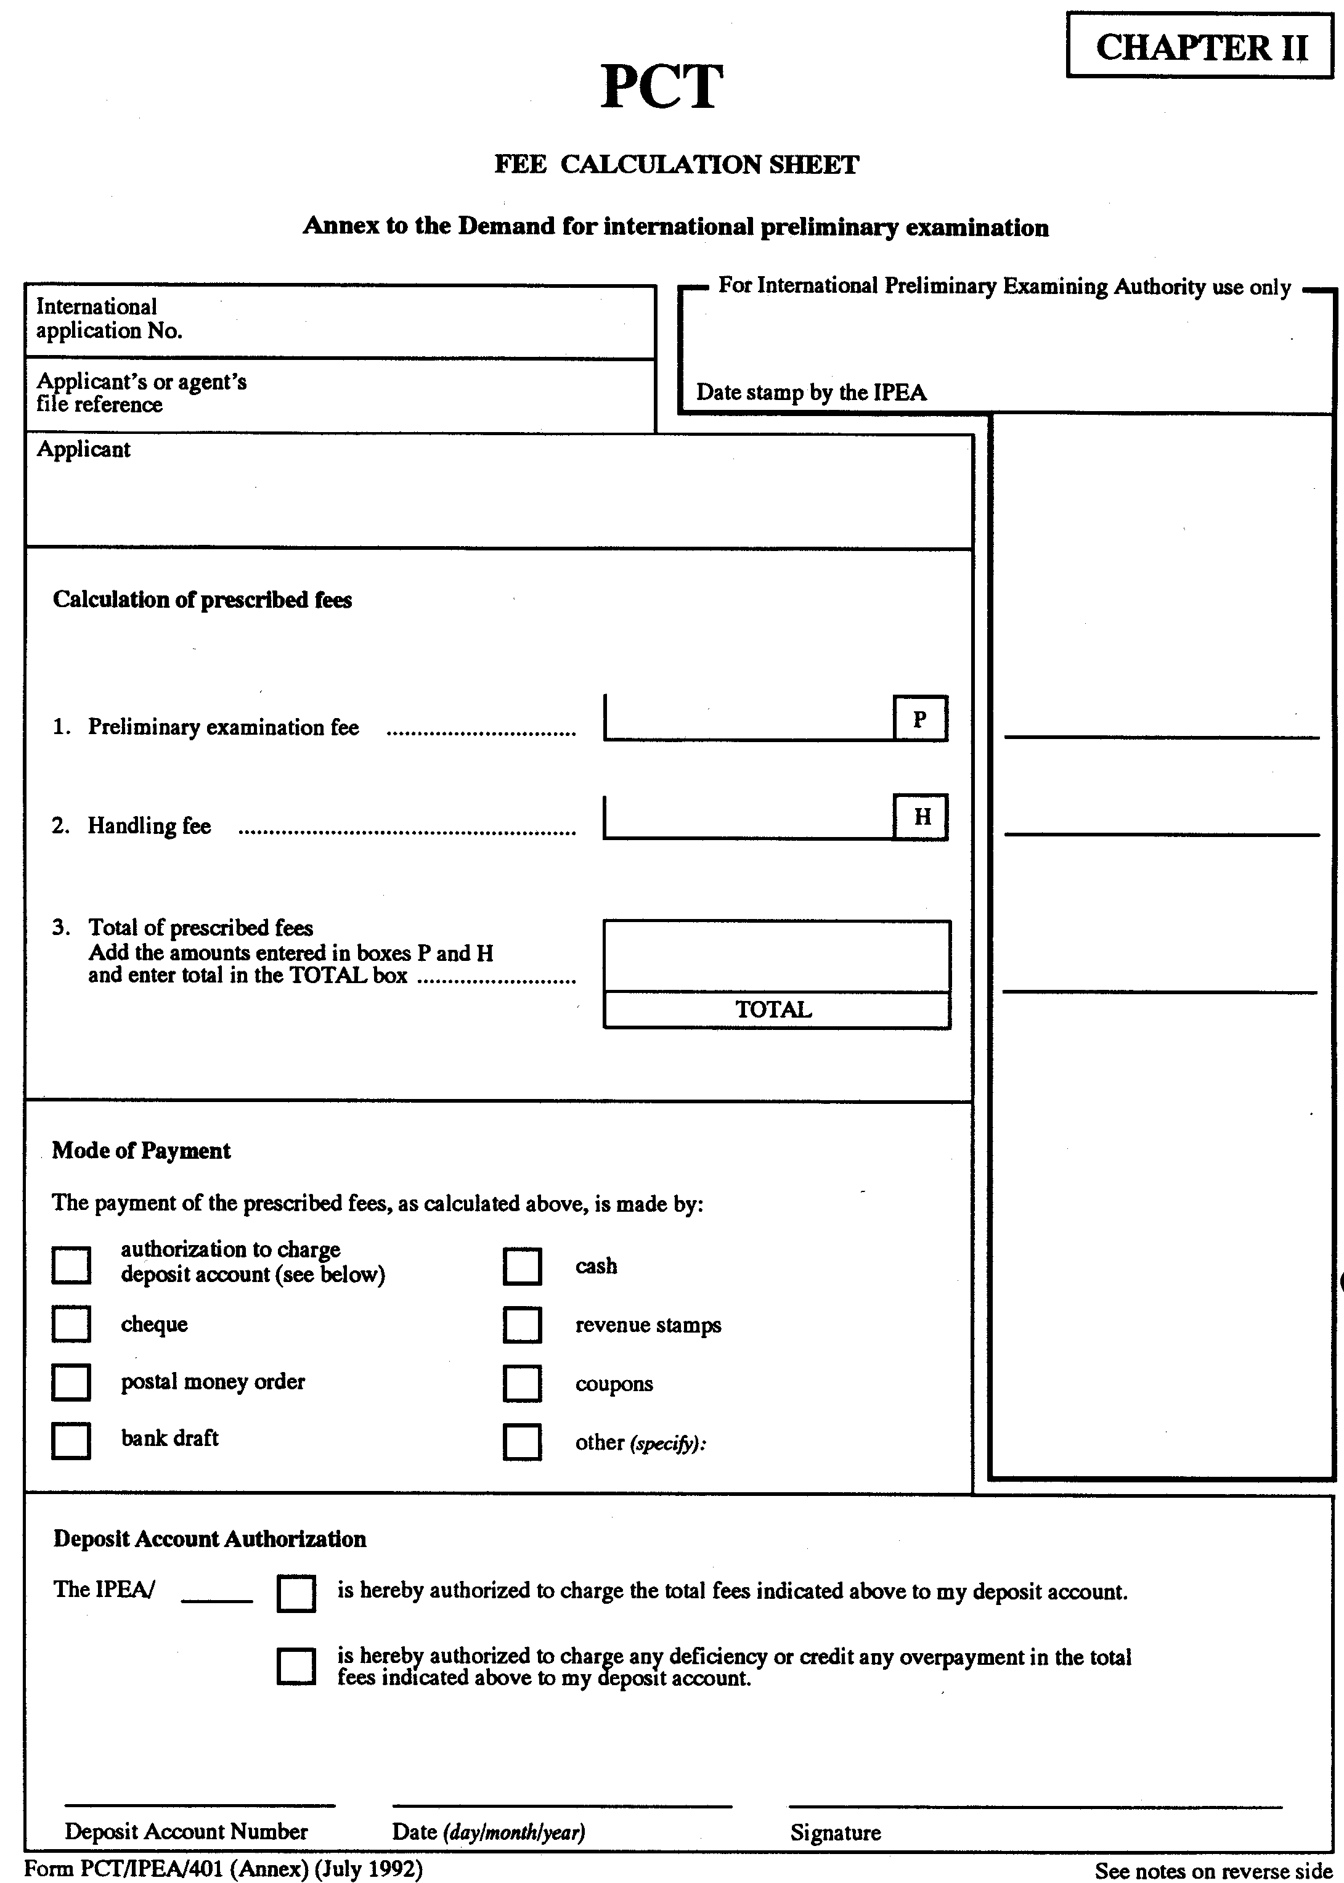
NOTES TO THE FEE CALCULATION SHEET
(ANNEX TO FORM PCT/IPEA/401)

The purpose of the fee calculation sheet is to aid the applicant to identify the prescribed fees and to calculate the amounts to be paid. It is strongly recommended that the applicant complete, by entering the appropriate amounts in the boxes provided, and submit the fee calculation sheet at the time of filing of the demand. This will help the International Preliminary Examining Authority to verify the calculations and to identify any error in them.

CALCULATION OF PRESCRIBED FEES

Two fees must be paid for international preliminary examination:

(i) the preliminary examination fee for the benefit of the International Preliminary Examining Authority (Rule 58.1);

(ii) the handling fee for the benefit of the International Bureau (Rule 57).

Both fees must be paid to the International Preliminary Examining Authority upon filing the demand in a currency acceptable to that Authority.

Information about the amount of those fees or about equivalent amounts in other currencies can be obtained from the International Preliminary Examining Authority or the receiving Office. This information is also published in Annex E of Volume I of the PCT Applicant’s Guide and from time to time in Section IV of the PCT Gazette.

Box P: For the calculation of the total amount payable, the amount of the preliminary examination fee must be entered in Box P.

Box H: The amount of the handling fee must be entered in Box H.

Total Box: The total of the amounts inserted in Boxes P and H is the amount which must be paid to the International Preliminary Examining Authority.

MODE OF PAYMENT

In order to help the International Preliminary Examining Authority identify the mode of payment of the prescribed fees, it is recommended to mark the applicable check-box(es).

AUTHORIZATION TO CHARGE DEPOSIT ACCOUNT

The International Preliminary Examining Authority will not charge fees to deposit accounts unless the deposit account authorization is signed and indicates the deposit account number.

[End of Annex and of document]

