
PCT/MIA/33/2
ORIGINAL: English
DATE: August 27, 2026

Meeting of International Authorities
under the Patent Cooperation Treaty (PCT)
Thirty-Third Session
Geneva, October 28 and 29, 2026
Third Party Observations
Document prepared by the International Bureau

Summary
- This document provides a review of the use of the PCT third party observation system over the 14 years from its start in July 2012 to June 2026. Like in most national systems where third party observations are permitted, it is used in relation to only a small percentage of applications. Based on the limited proportion where they are reviewed in the international phase, it would appear that many of the citations raised are considered by examiners to be no more relevant than the citations found in the international search report. However, in a few cases, the observations have been found to be highly relevant. No assessment has been attempted on the effect of observations in the national phase.

About the System
- Since July 2012, it has been permitted for third parties to submit observations on the novelty and inventive step of inventions claimed in international applications. The main principles and effects of the system are set out in Part 8 of the PCT Administrative Instructions.
- While opportunities for third party observations or other forms of involvement are commonplace in national and regional systems, this was previously unknown in the international phase of the PCT. As such, it was agreed to begin with a conservative approach in order to avoid the risk of placing inappropriate burdens on either applicants or designated Offices. In particular, several restrictions were put in place, the main ones being as follows:
  - a maximum of ten observations would be permitted on any one international application;
  - a maximum of ten documents could be cited in any one observation;
  - observations would be limited to matters of novelty and inventive step, not matters such as support, sufficiency or inventorship; and
  - the observations should be limited in length, having only a “brief explanation” of the relevance of the cited documents.
- On the other hand, to encourage the use of the system, it was explicitly indicated that anonymous observations should be permitted.
- Initially, a limit of 500 characters was imposed in the system in the “brief explanation” part for each citation. Following user feedback, the sixth session of the PCT Working Group (2013) agreed to increase this limit. Since December 2014, the system has permitted up to 5,000 characters to be entered directly against each cited document. Prior to the change, some third parties had been creative in overcoming the limit, citing the same document several times and adding more explanation in each one. From the same time, it has been permitted to add a short PDF document containing additional comments. The PDF document was intended to permit more effective description of how disclosures in different documents might be combined for inventive step purposes, or else to allow tables and formulae to be used in the explanation, though it is frequently also used to present the arguments in the formats typically used in national or regional third party observations.
- In addition to the brief explanation of relevance, a person making observations may also upload copies of cited documents. The system permits up to three PDF documents to be attached per cited document. This was intended to allow for the possibility of attaching the document itself, an abstract and a translation of particularly relevant portions in separate files, though the system does not strictly check the different types of uploaded document.
- Once accepted, the observations are notified to the applicant. The main observation and any document containing additional comments are made available to the public on PATENTSCOPE. To give suitable prominence to the observation, these documents are grouped together with the international search report and international preliminary report on patentability in the “Search and Examination-Related Documents” section of the file list.
- Any uploaded copies of the cited documents are not made available to the public, but copies of any non-patent literature documents are usually transmitted to the applicant and all of the uploaded documents appear in the file lists in ePCT for the applicant, International Searching and Preliminary Examining Authorities, and designated and elected Offices.
- If the international search report has not been transmitted to the International Bureau before the observation is accepted, a copy of the observation is transmitted to the International Searching Authority. Similarly, if international preliminary examination has been demanded but the final report has not yet been transmitted to the International Bureau, a copy of the observation is sent to the International Preliminary Examining Authority.
- After 30 months from the priority date, copies of the observations, together with copies of any uploaded documents, are actively transmitted to designated Offices that have requested this service (11 in total). Other designated Offices should download them as needed using ePCT, PATENTSCOPE, or automatically using ePCT or PATENTSCOPE web services. The United States Patent and Trademark Office as designated Office has indicated that it does not routinely retrieve these observations but expects the applicant to indicate relevant documents from the observations in the Information Disclosure Statement which is required on national phase entry.
- The applicant is permitted to provide comments on the observations until 30 months from the priority date but not required to do so. Any applicant comments which are received are transmitted to International Authorities and designated Offices according to the same conditions as apply to the observations.

Related Issues
- In document PCT/MIA/32/2, the National Institute of Industrial Property of Brazil made proposals to allow a request for analysis of a document submitted under the third party observation system. The Institute has indicated that it is analyzing the comments that it received in relation to this proposal and is likely to make further proposals at a future date to advance the goals underlying that document.
- The system was set up requiring the person making the observation to fill in a form that generates XML in a format closely based on the PCT search report XML standard. This has allowed the analysis in this document to be performed, but the original intention was to allow the results to be combined with the content of the international search reports in order to deliver better information to designated Offices and third parties. Most international search reports are now delivered in XML format and such arrangements may be taken forward in due course.

Use of the System
- In the 14 years from the start of the system to the end of June 2026, 5,246 observations have been submitted on 4,991 international applications. As expected, most are submitted anonymously.
Year of observation | Observations in year | % anonymous
2012 | 58 | 86.2
2013 | 235 | 79.6
2014 | 298 | 78.9
2015 | 316 | 78.2
2016 | 338 | 71.3
2017 | 331 | 87.3
2018 | 341 | 80.6
2019 | 408 | 92.2
2020 | 387 | 90.2
2021 | 520 | 88.7
2022 | 479 | 79.3
2023 | 501 | 69.3
2024 | 429 | 78.8
2025 | 398 | 87.9
2026 | 207 | 92.8

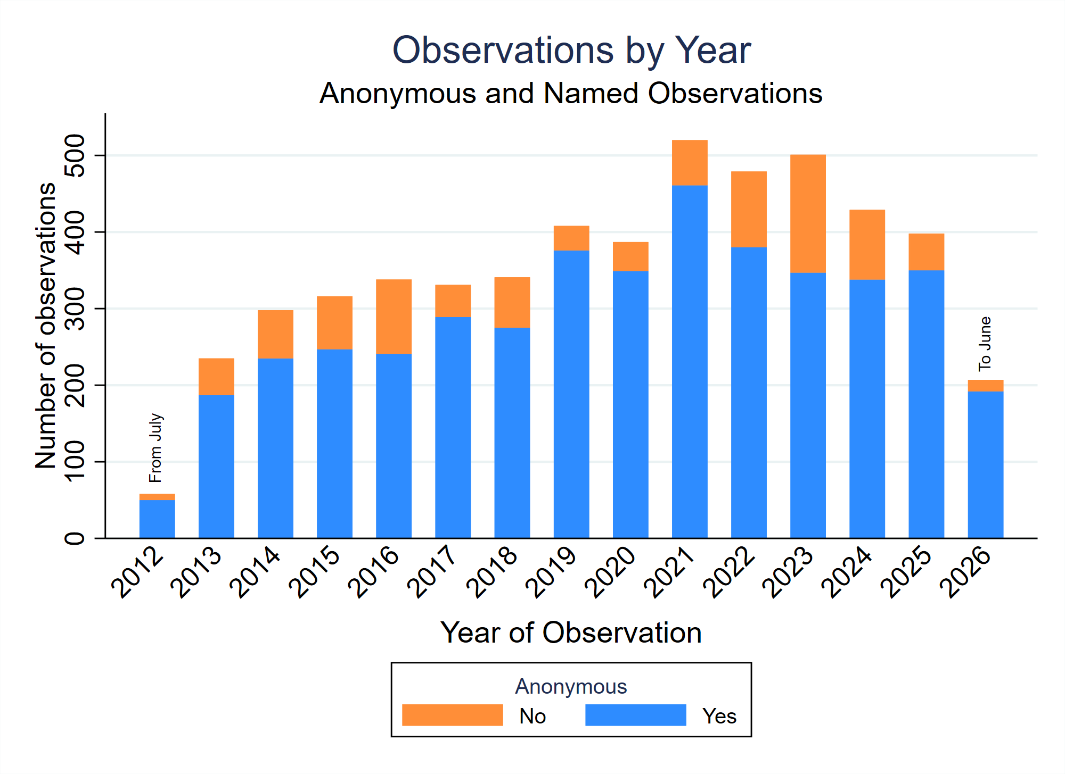

Numbers of observations and citations
- Concerns of campaigns overwhelming the system have not materialized. A large majority of international applications with observations receive only a single observation.
Number of observations | Number of applications
1 | 4,772
2 | 194
3 | 19
4 | 3
5 | 1
6 | 2

- Within each observation, the most common number of cited documents is one, gradually decreasing down to nine citations, and then a significant number using the maximum 10 cited documents.
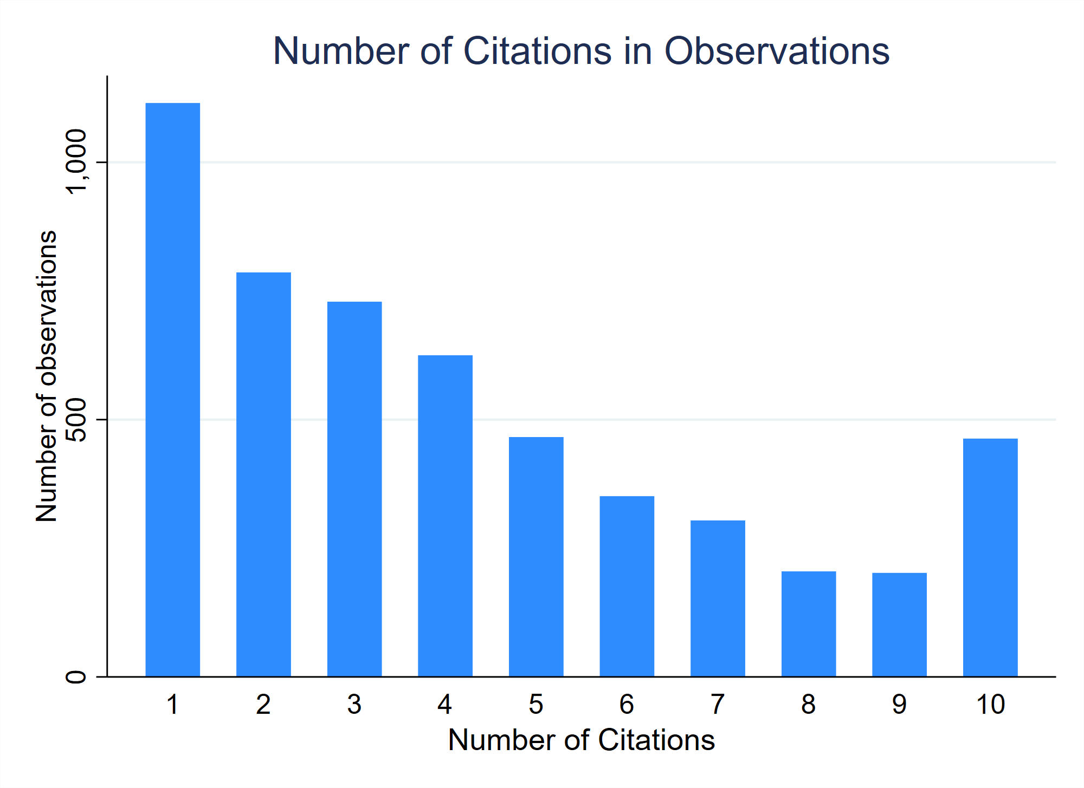
- The lengths of the brief indications of relevance for each cited document have typically seen significant numbers with very short explanations, or else closely approaching the maximum length, with a lower but relatively even distribution in between.
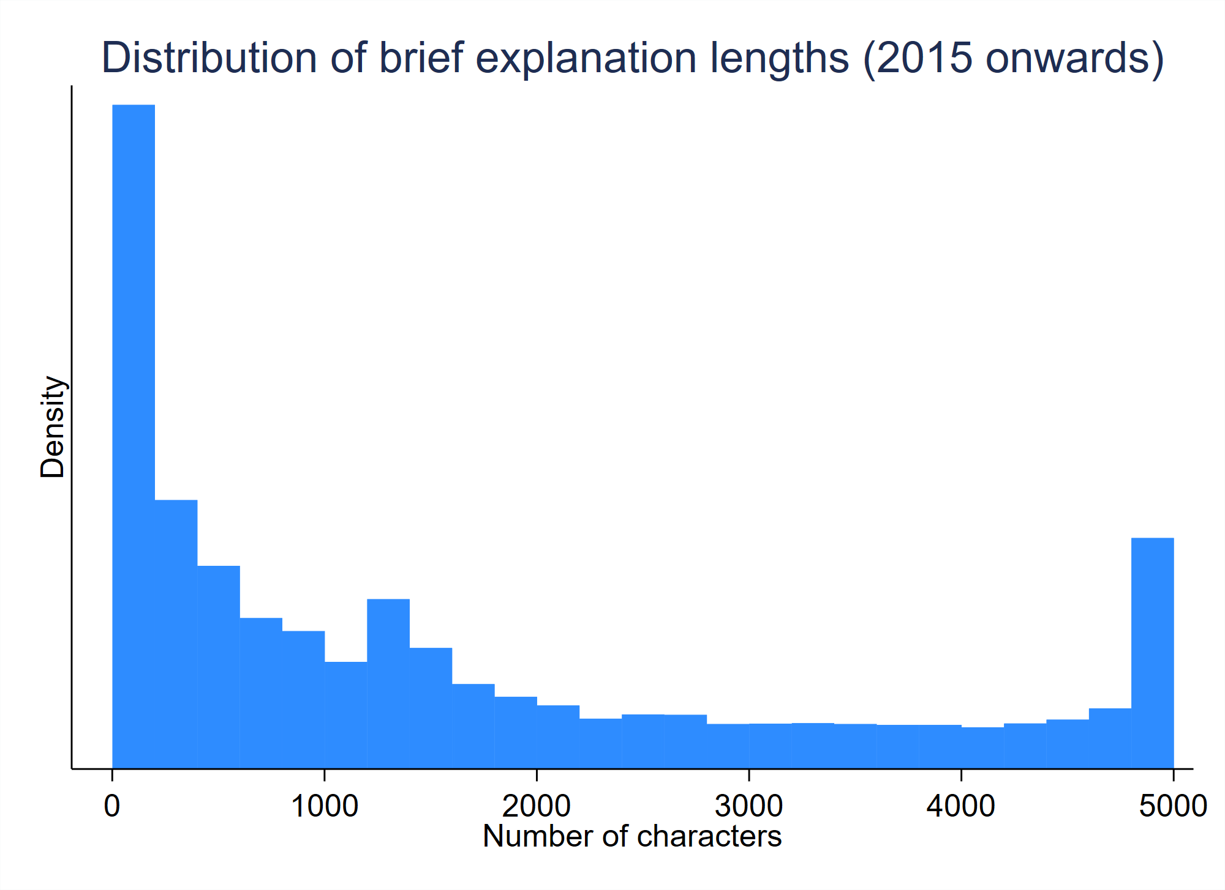
- Since they were first permitted in December 2014, an increasing proportion of observations are submitted with a PDF document containing additional comments. In recent years, approximately half of observations include such documents. These are frequently presented in formats typical of national or regional observations made to the local Office of the person submitting the observation.
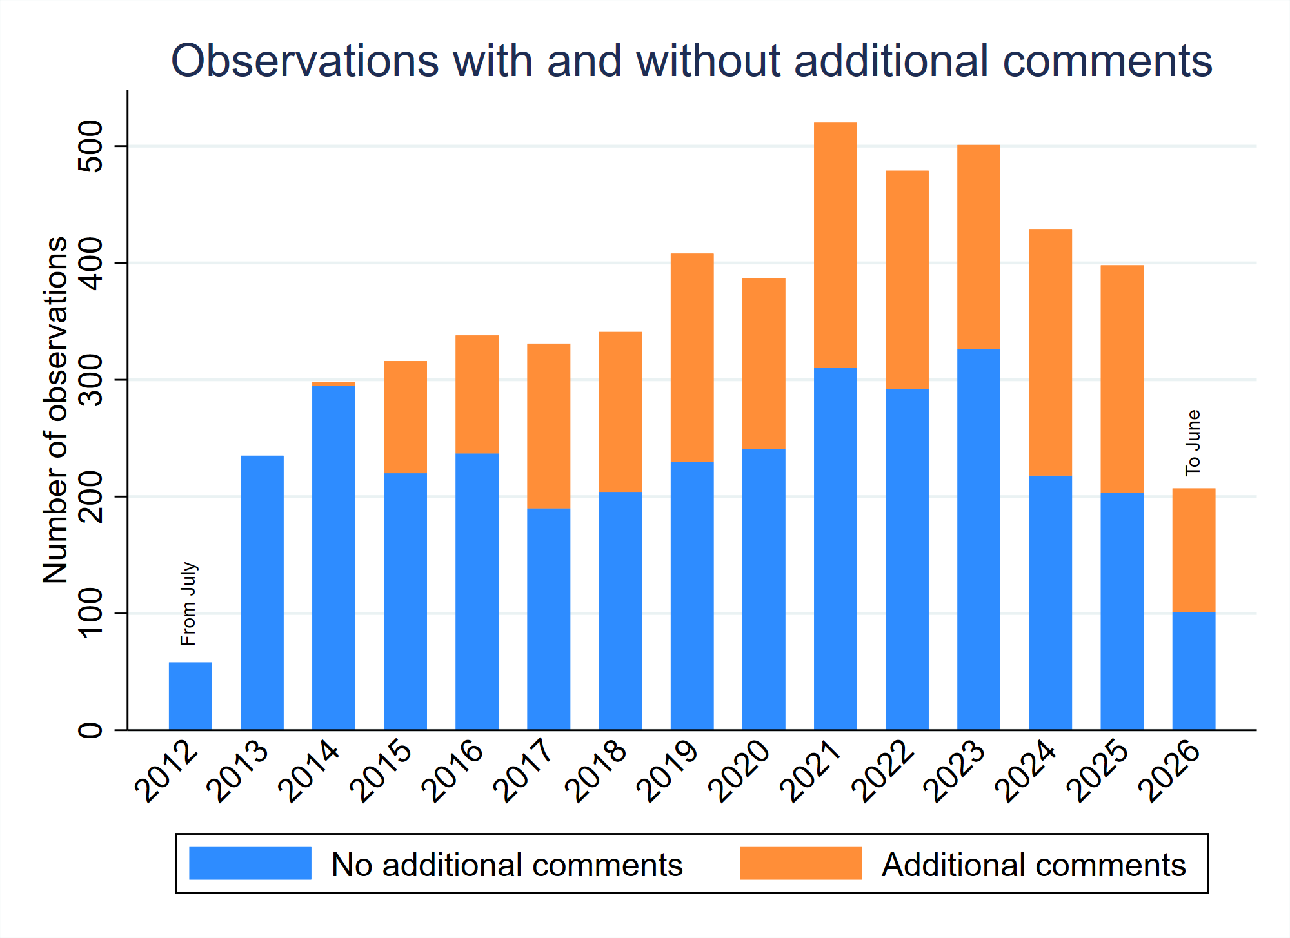
- Most observations include copies of cited documents, which are made available to the applicant and designated Offices. This is particularly important for non-patent literature citations. 93.5% of non-patent literature citations included an uploaded copy of the document, abstract and/or translation.

Distribution of observations
- Observations have been made on around 0.15% of international applications published over the relevant period. However, this is not distributed evenly across areas of technology. A significantly higher proportion of observations are made on applications in the chemical sector. Among the 35 technology fields, applications in the field of food chemistry attracted the most observations at around 0.81% of publications, followed by macromolecular chemistry and polymers at around 0.63%.
Technical field | % with observations
Food chemistry | 0.81
Macromolecular chemistry, polymers | 0.63
Organic fine chemistry | 0.48
Pharmaceuticals | 0.44
Other special machines | 0.43
Materials, metallurgy | 0.39
Basic materials chemistry | 0.31
Handling | 0.25
Textile and paper machines | 0.25
Biotechnology | 0.24
Surface technology, coating | 0.22
Chemical engineering | 0.22
Machine tools | 0.20
Environmental technology | 0.15
Thermal processes and apparatus | 0.15
Civil engineering | 0.14
Other consumer goods | 0.14
Mechanical elements | 0.11
Electrical machinery, apparatus, energy | 0.10
Medical technology | 0.10
Measurement | 0.09
Transport | 0.08
Analysis of biological materials | 0.08
Optics | 0.08
Furniture, games | 0.08
Control | 0.07
Engines, pumps, turbines | 0.06
Semiconductors | 0.04
IT methods for management | 0.04
Micro-structural and nano-technology | 0.03
Computer technology | 0.03
Audio-visual technology | 0.02
Telecommunications | 0.01
Digital communication | 0.01
Basic communication processes | 0.00

- Among international applications filed at the top 15 receiving Offices, applications filed at RO/IN attracted the highest proportion of observations; international applications filed at RO/CN attracted the lowest proportion.
Receiving Office | % applications with observations
IN | 0.53
IB | 0.29
FR | 0.26
GB | 0.25
TR | 0.24
AU | 0.24
EP | 0.22
IL | 0.22
CA | 0.20
Other | 0.18
US | 0.16
JP | 0.15
KR | 0.13
SE | 0.10
DE | 0.09
CN | 0.02

Origin of observations
- The origin of observations is not recorded. However, the languages in which observations are made (see above), the distribution of languages of cited documents compared to the receiving Offices of the international applications concerned and the times of day at which observations are submitted are suggestive that observations are made more frequently by European third parties than others in general, and that observations on particular applications are most likely to be made by third parties from the same region as the applicant.
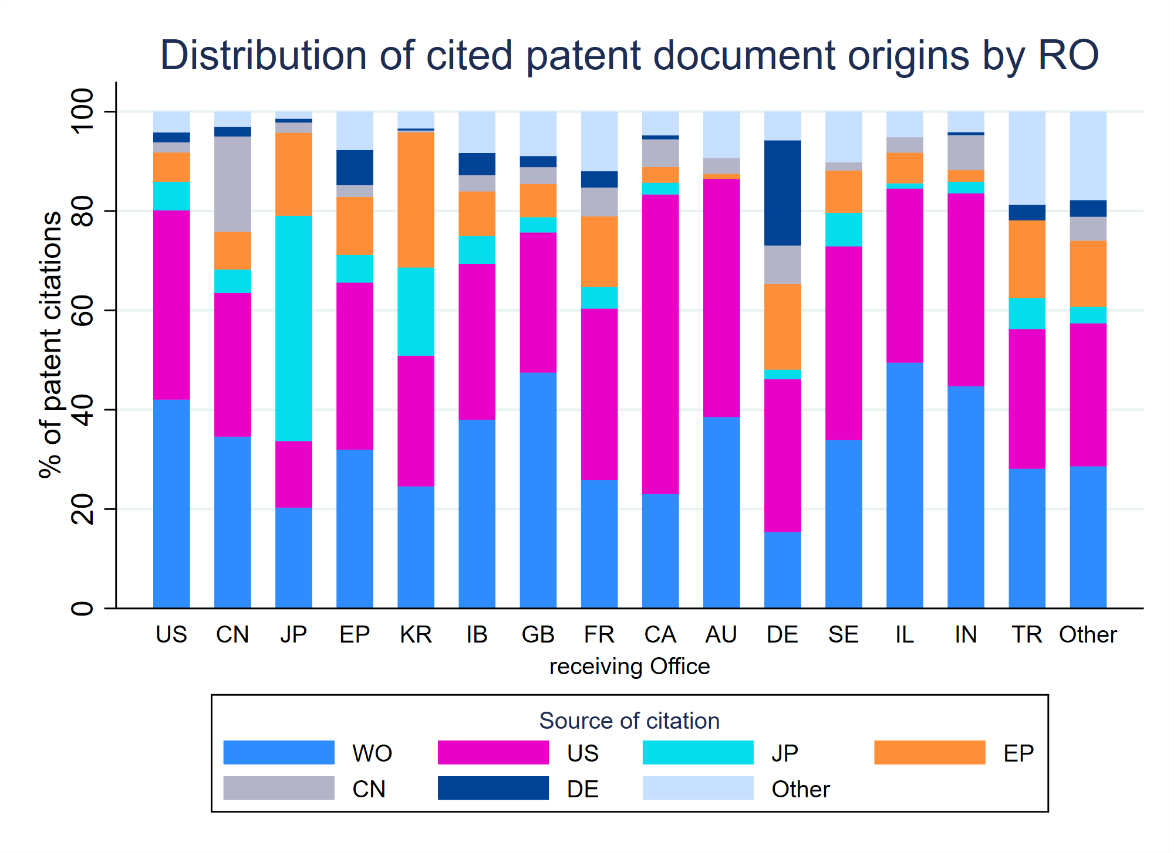
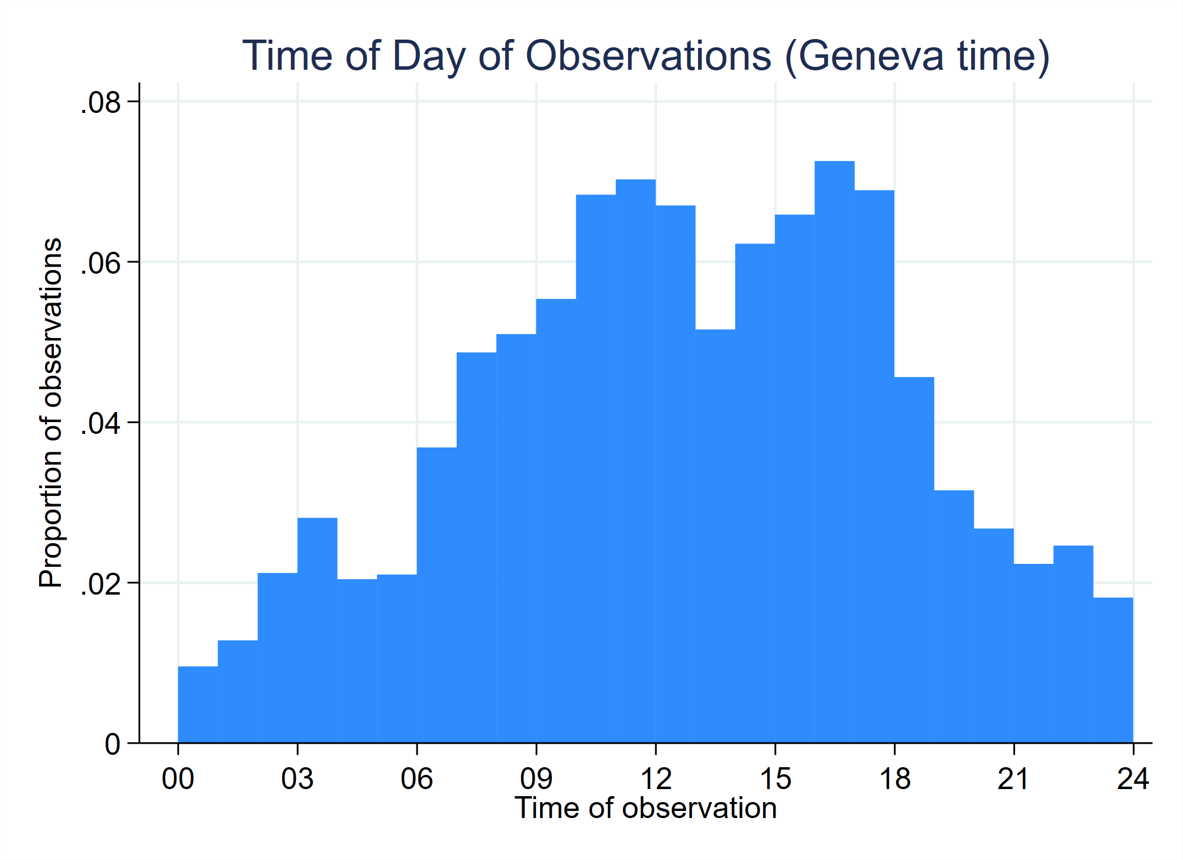
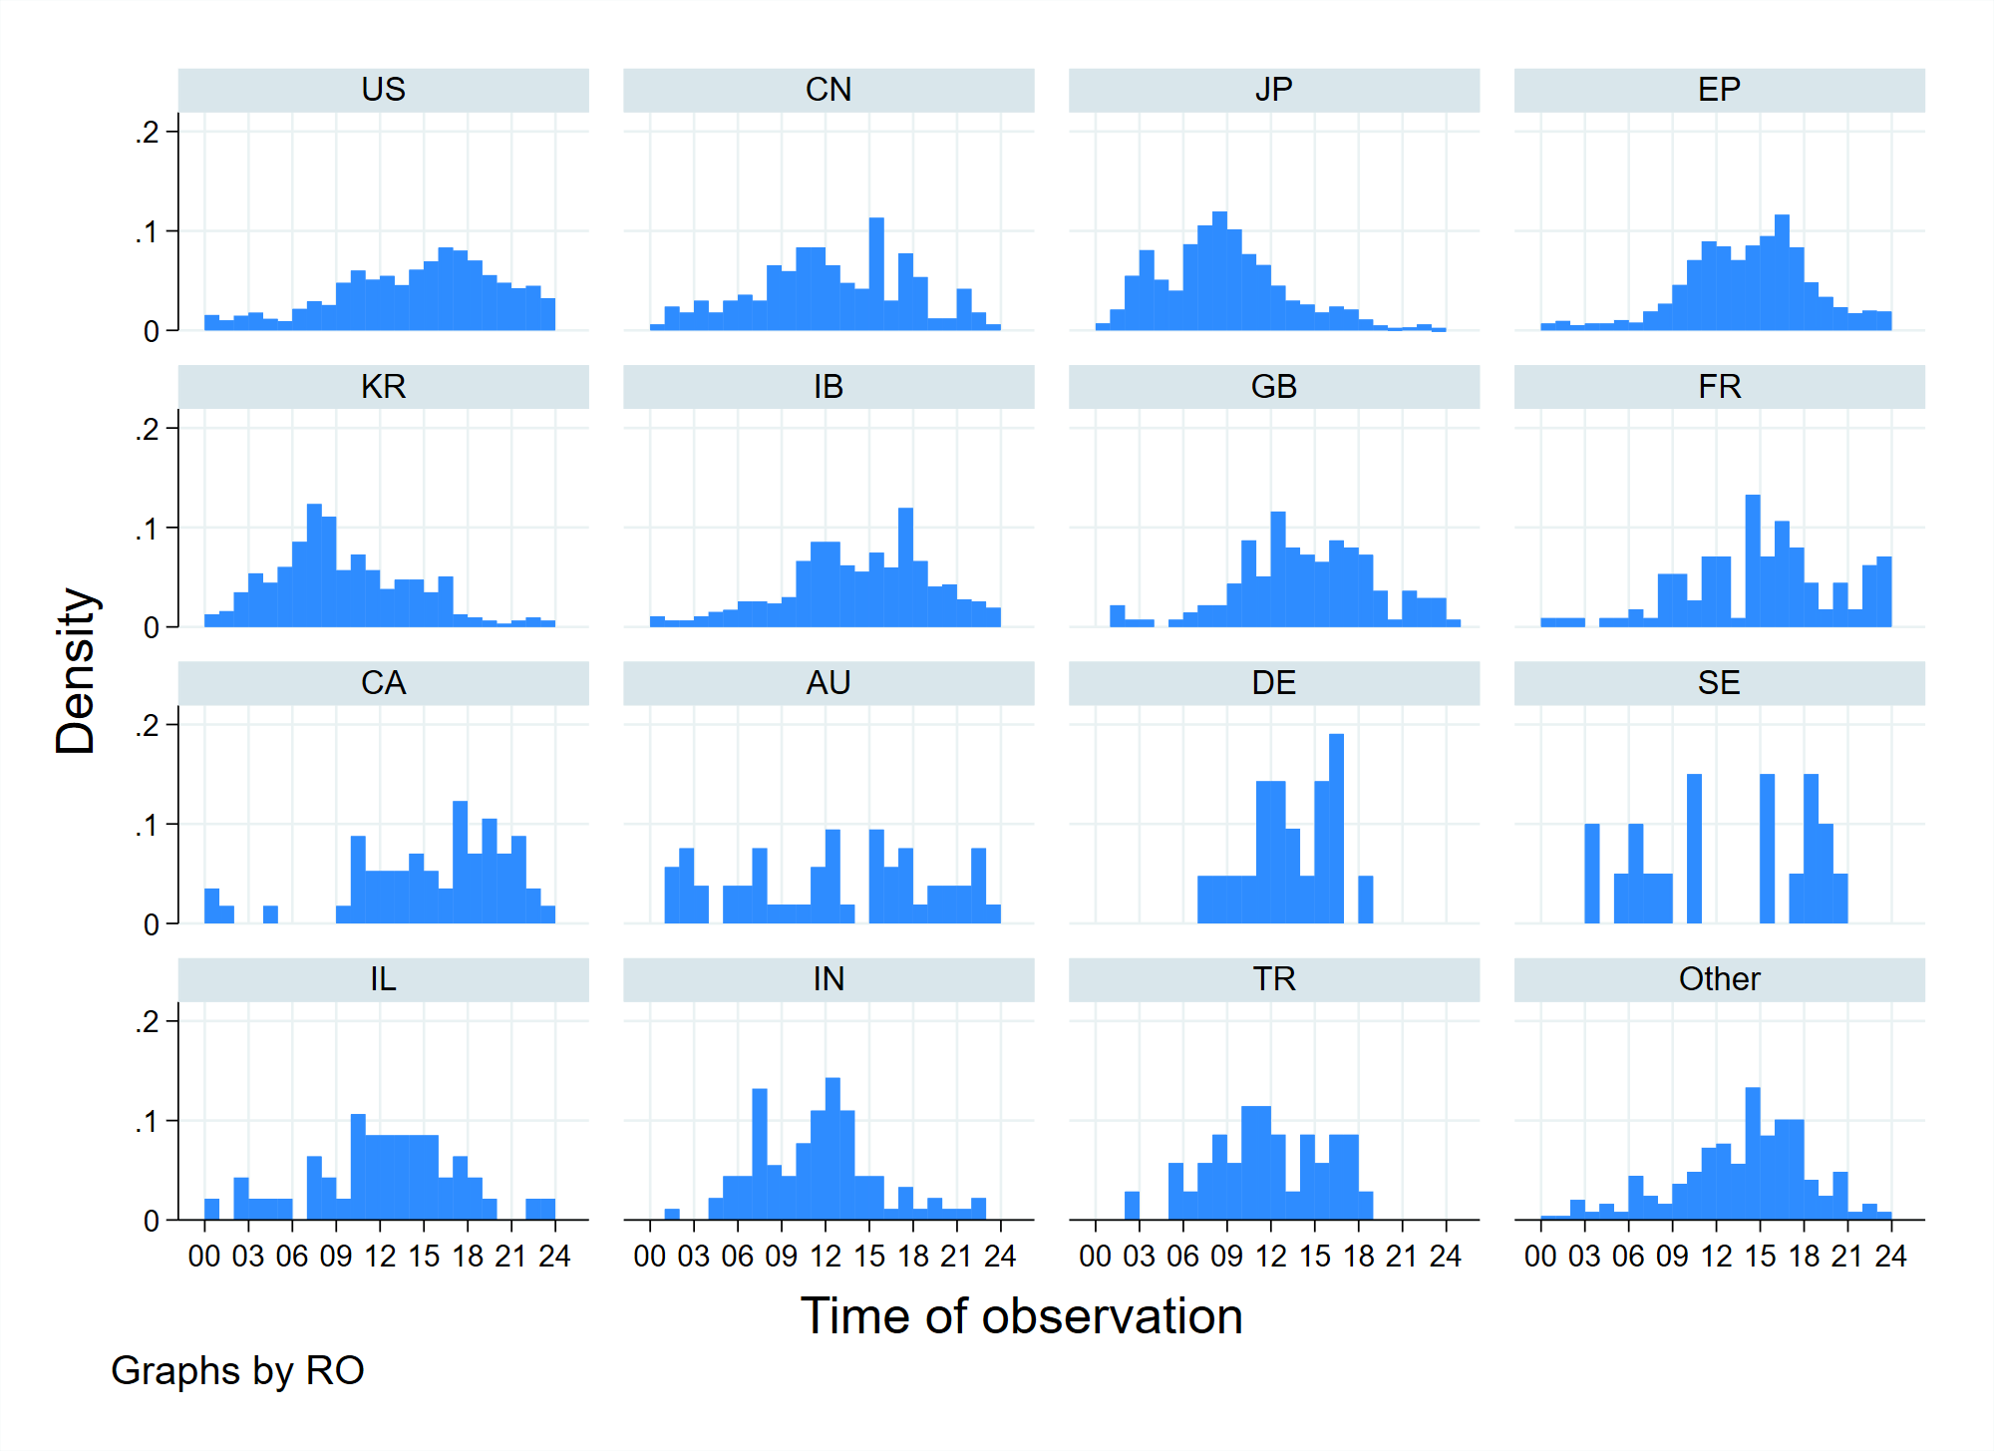

Language of observations
- Observations can be made in any of the languages of publication, but the vast majority are made in English. The main exception is that some languages show a significant proportion of observations being made in the language in which the international application was published.
Language of observation | Observations in language
ar | 11
de | 129
en | 4,714
es | 20
fr | 68
ja | 253
ko | 9
pt | 6
ru | 2
zh | 34

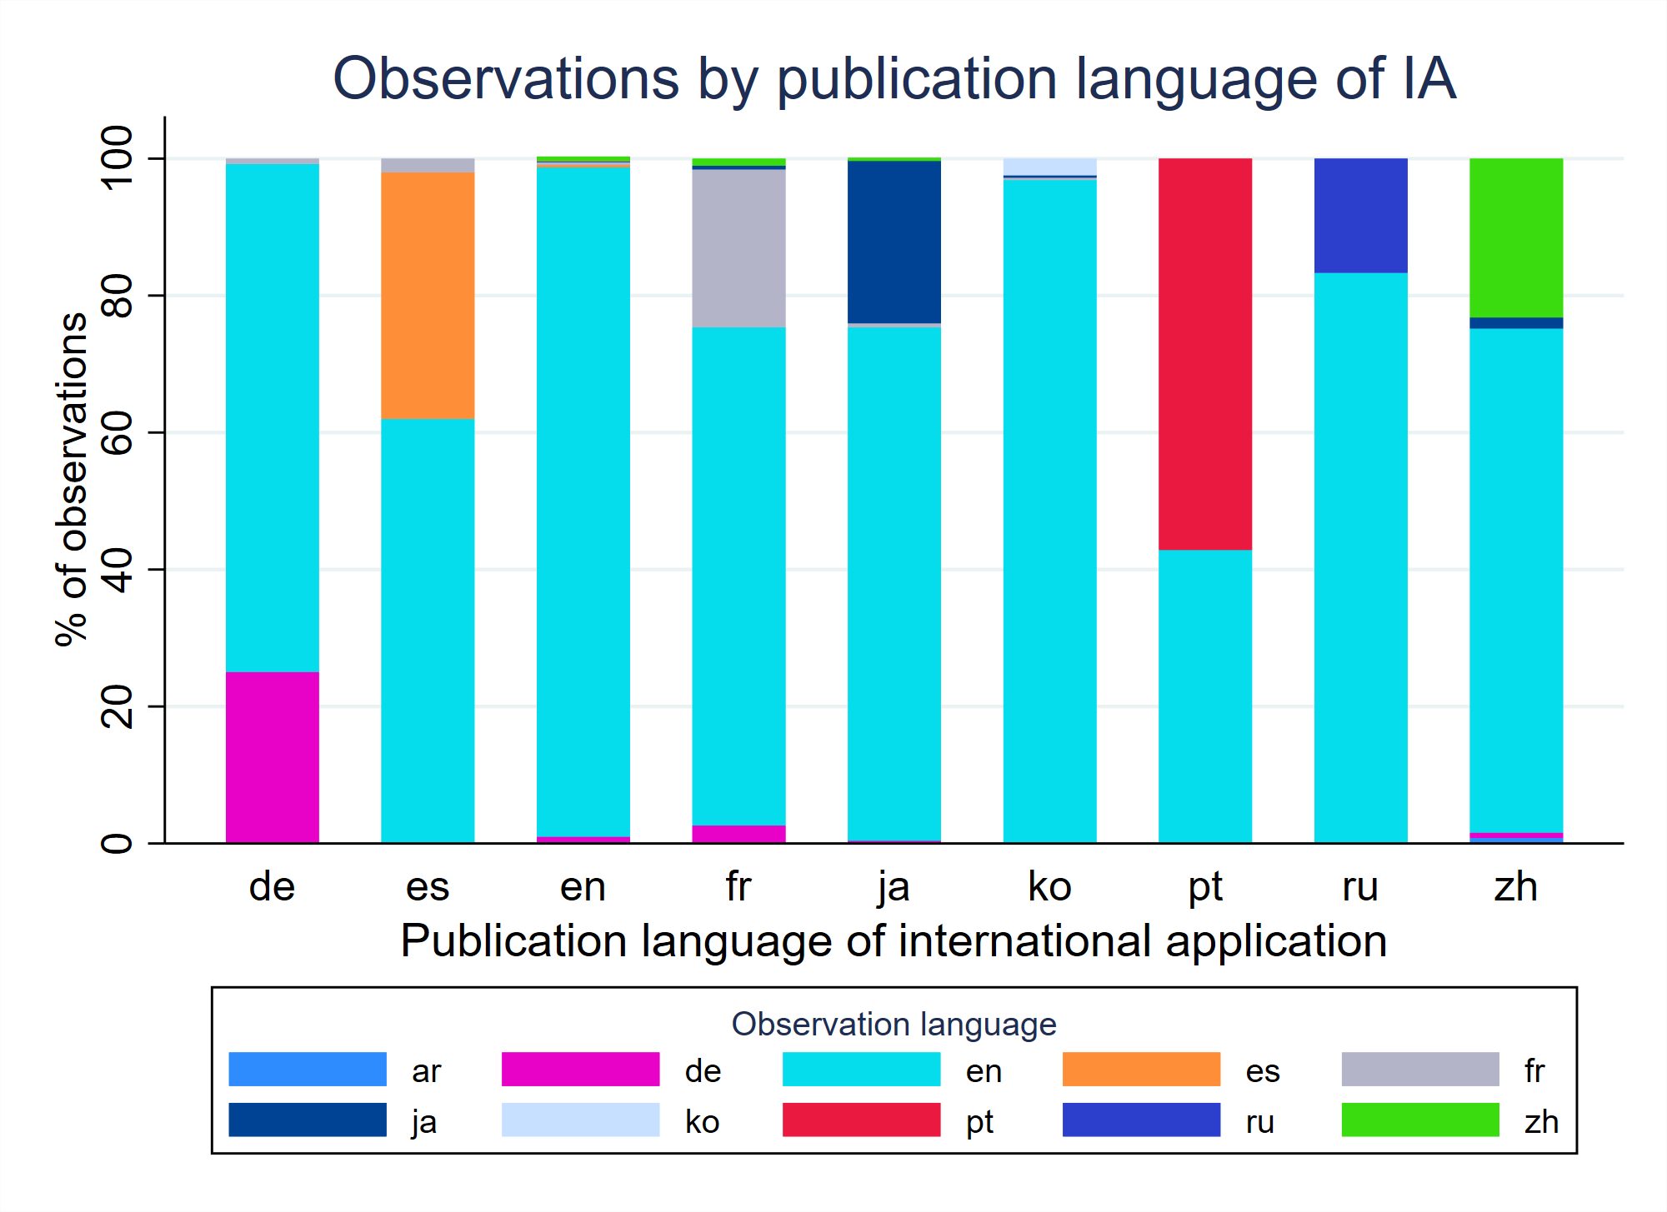

Timing of observations
- The first 60% of observations are submitted at a fairly steady rate between publication of the application and approximately 10 days before the deadline; the remaining 40% of observations are submitted in the final 10 days. Only around 20% of observations are submitted prior to 22 months from the priority date, the most common time limit for submission of a demand for international preliminary examination under Rule 54bis.1(a)(ii).
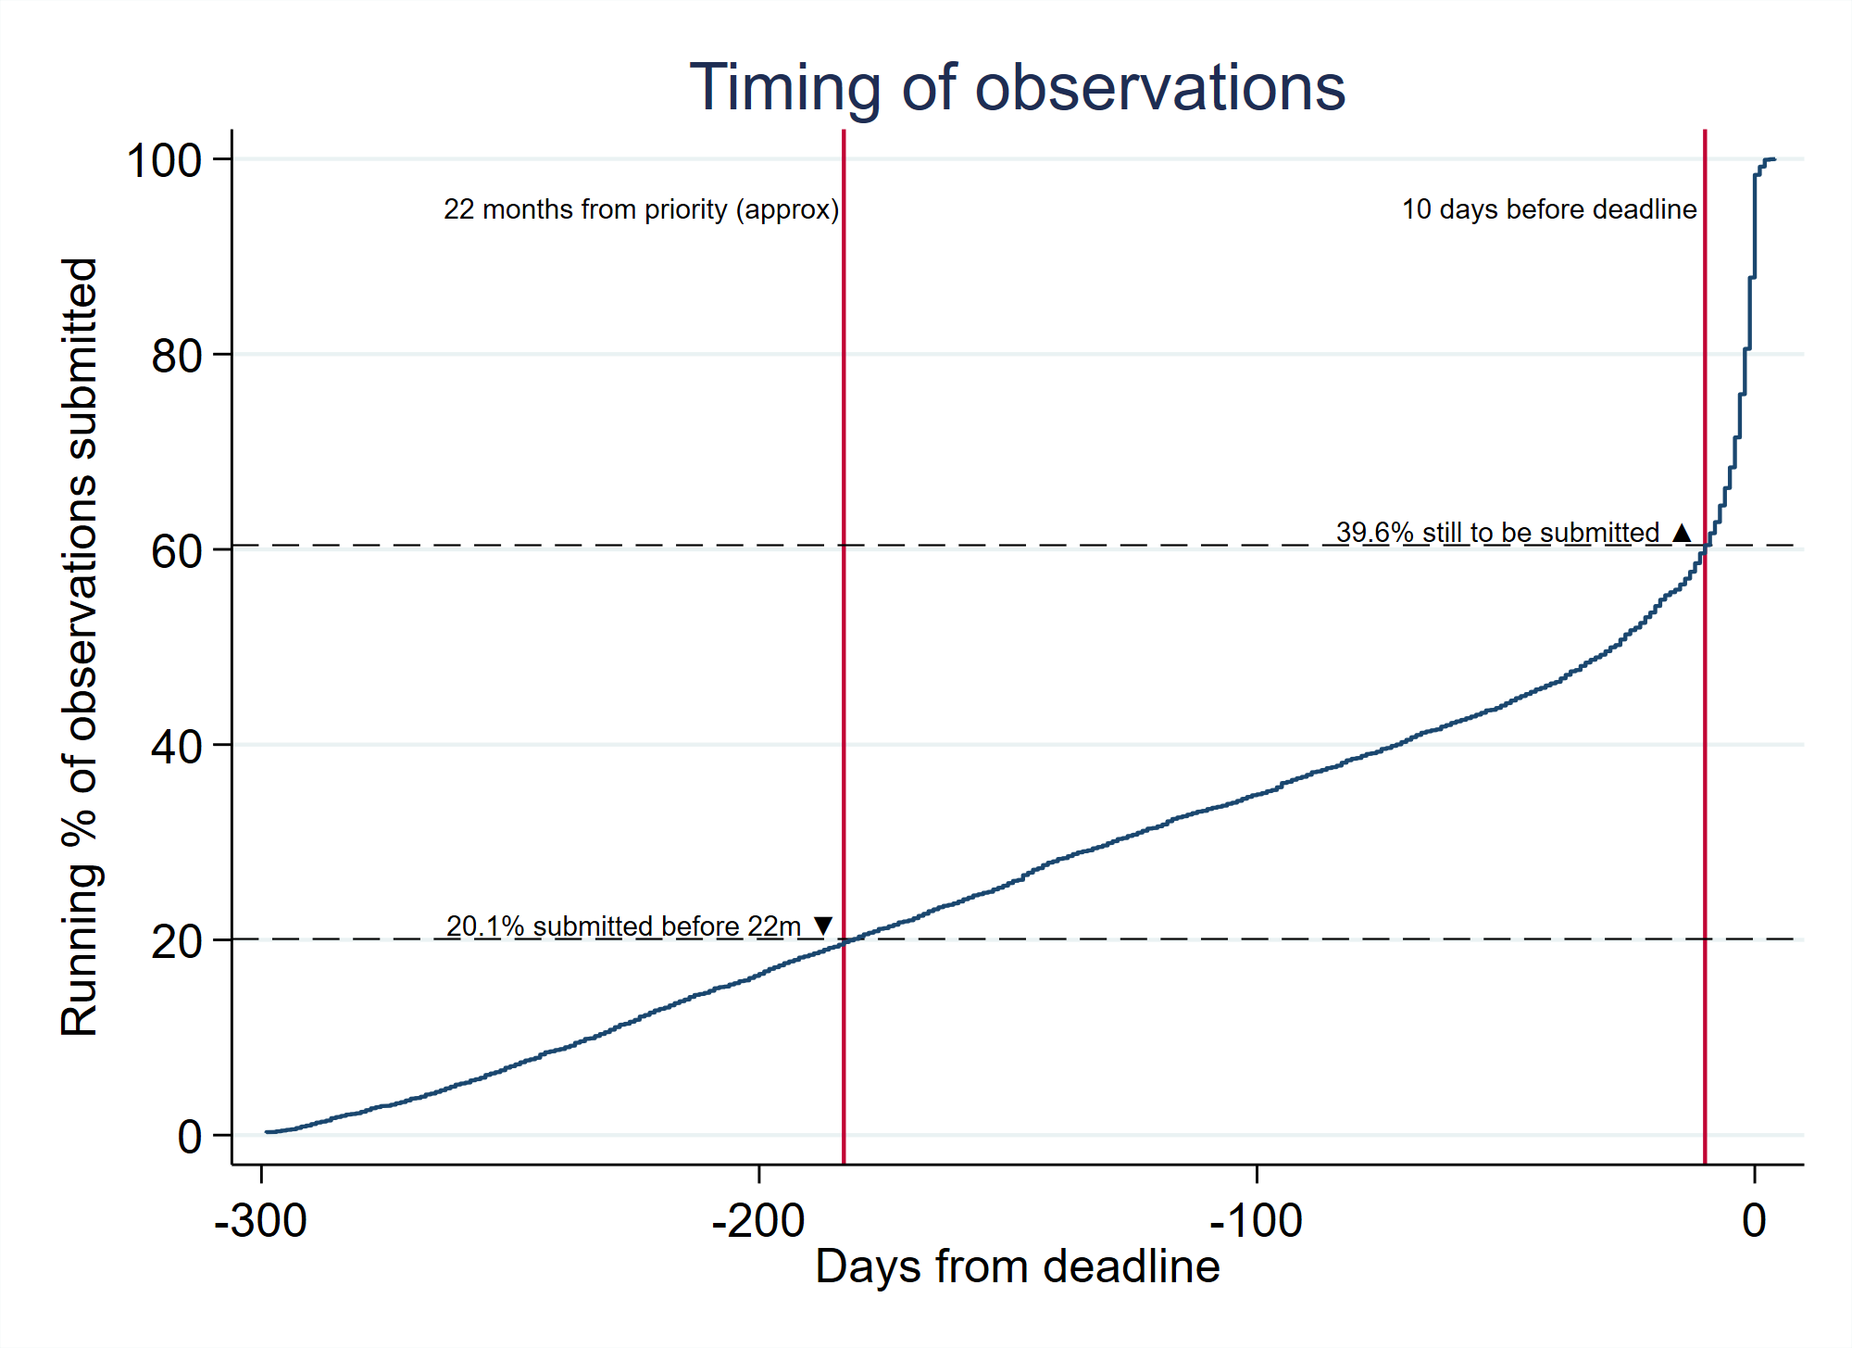
- The large proportion being made within days of the deadline is expected. The steady state before then is more surprising – a more significant number occurring within around a month from international publication followed by more of a “lull” might have been expected.

Responses to observations
- Very few applicants respond to observations in the international phase. Of the 4,991 international applications with third party observations, only 133 (2.7%) received an applicant response (excluding any responses that may have been considered during processing during international preliminary examination under Chapter II).

Types of citation
- It was hoped that the third party observation system would be particularly effective at bringing to light non-patent literature documents, which are more difficult for patent Offices to search effectively. Perhaps unsurprisingly, a majority of cited documents, around 68%, are nevertheless patent documents. However, 32% of citations being non-patent literature is considerably higher than the average for international search reports.
- The distribution of reported document types is shown below. This is slightly arbitrary since the document types are as indicated by the person making the observation without verification by the International Bureau. Some "other" category documents may belong to one of the more specific types of citation in the table, and a few "registered IP right" citations are in fact patent documents. It is nevertheless a good indicative representation of the types of prior art referred to in third party observations.
Type of citation | Number of citations | % of all citations
Patent document | 15,049 | 68.4
Periodical article | 2,659 | 12.1
Other | 1,536 | 7.0
Online database | 986 | 4.5
Web page | 823 | 3.7
Book | 561 | 2.5
Conference proceedings | 324 | 1.5
Registered IP right | 63 | 0.3

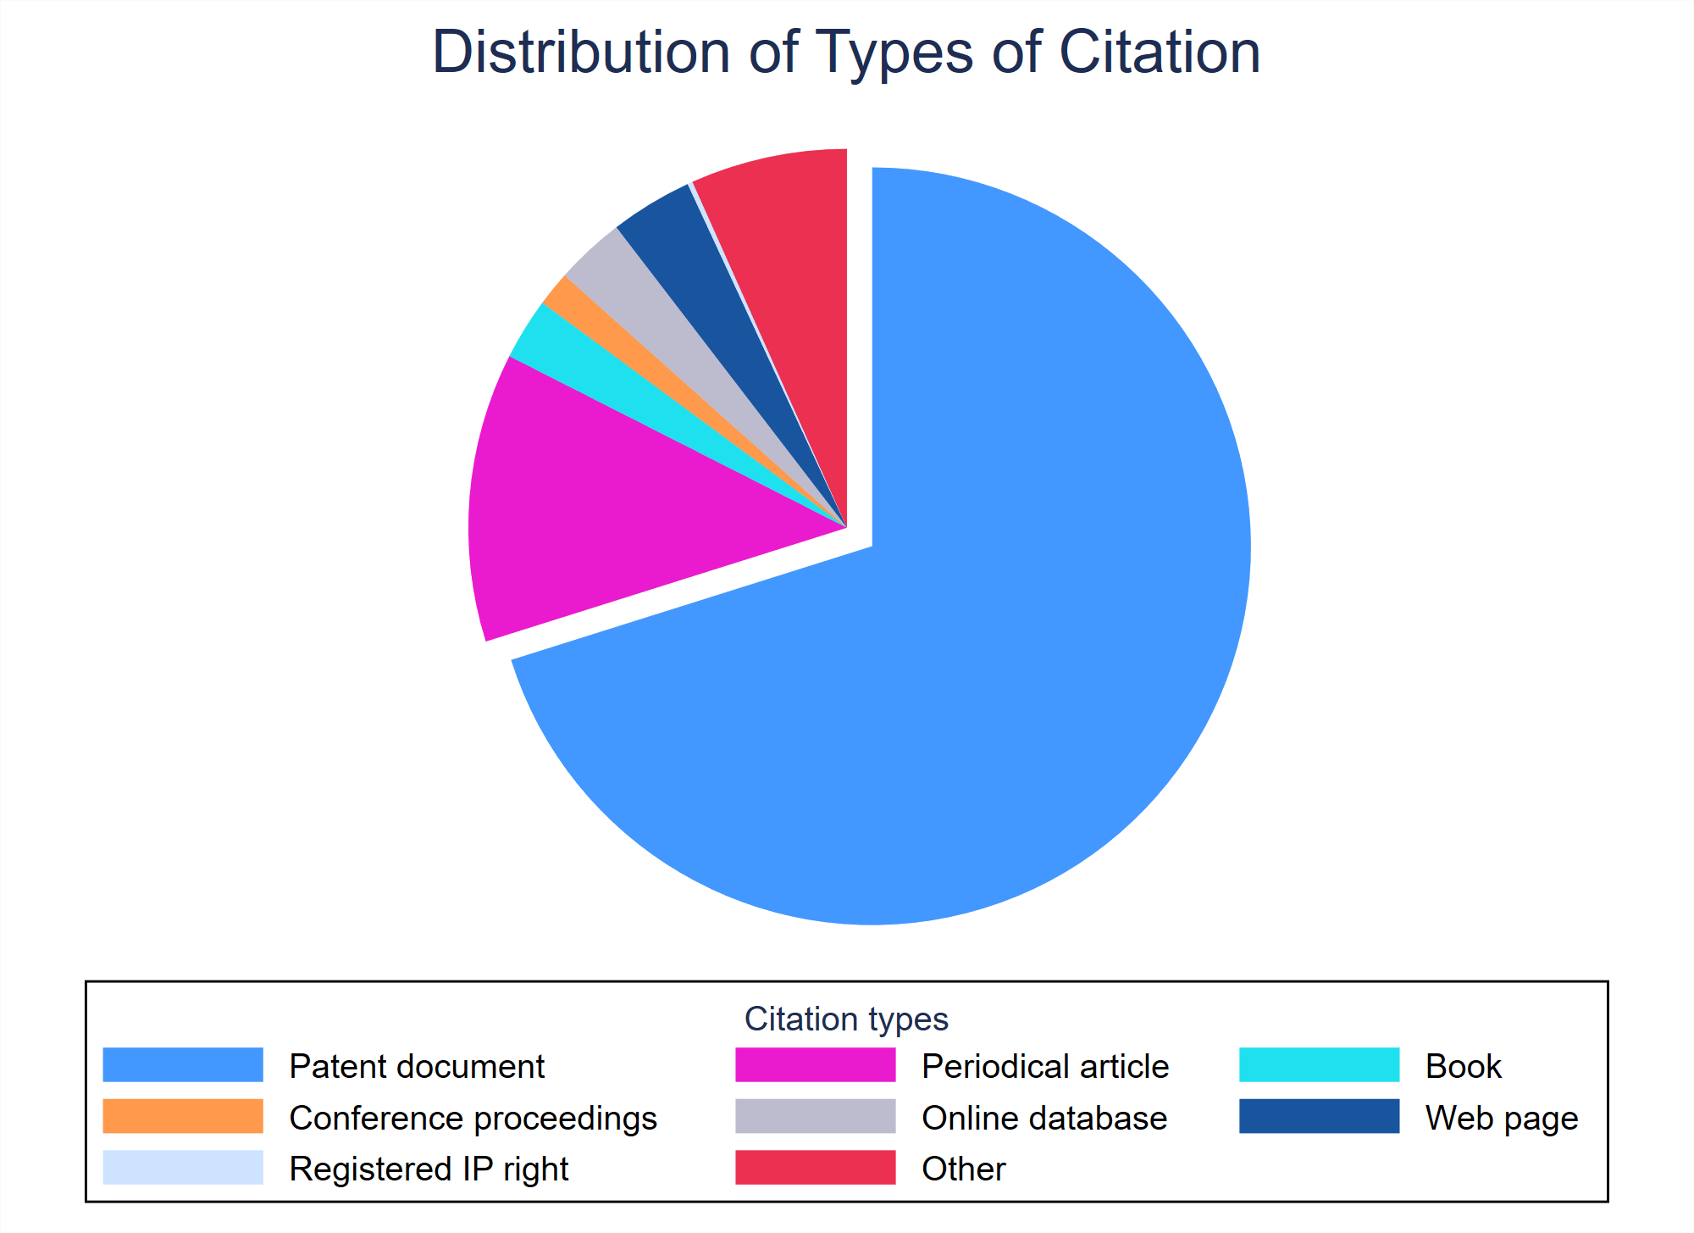
- Around half of the cited documents for which publication dates are given are new, being published no earlier than five years before the filing date of the international application. However, the range is very large, with some patent and non-patent literature citations from the nineteenth century having been used to make third party observations.
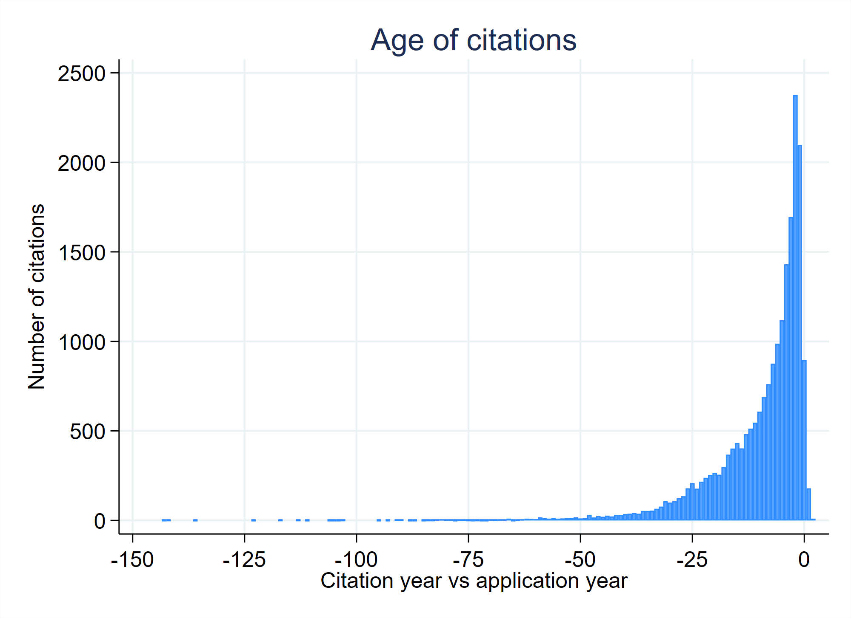

Relationship between observations and international search and preliminary examination
- Given that observations are permitted only after international publication, it is unsurprising that only 0.7% of observations are submitted before an international search report is established. Consequently, it will be extremely rare for an International Searching Authority to be able to consider a third party observation.
- Approximately 7.2% of international applications on which observations were submitted (358 out of 4,991) were the subject of a demand for international preliminary examination under Chapter II of the Treaty, compared to around 4.5% of international applications in general across the period. However, this does not appear to be a causal relationship. Only 43 were submitted before the applicant demanded international preliminary examination. Even if all of these observations were the cause of the applicant seeking international preliminary examination, this would only explain around a quarter of the difference. Furthermore, the limited information available to the public concerning the fact of Chapter II processing prior to the establishment of the international preliminary examination report means that the start of the Chapter II process is unlikely to be the direct cause of many third party observations. It seems likely, rather, that there is some form of correlation – that observations are more likely to be submitted on applications of types where the applicant is already more inclined to demand international preliminary examination. However, the nature of such a correlation is not clear.
- 186 applications had third party observations submitted before an international preliminary examination report was established – around half of the applications with observations for which a demand for international preliminary examination was submitted. The International Bureau transmits such observations to the International Preliminary Examining Authority. The distribution of timing of observations relative to the date on which an international preliminary examination report was transmitted to the International Bureau is shown below.
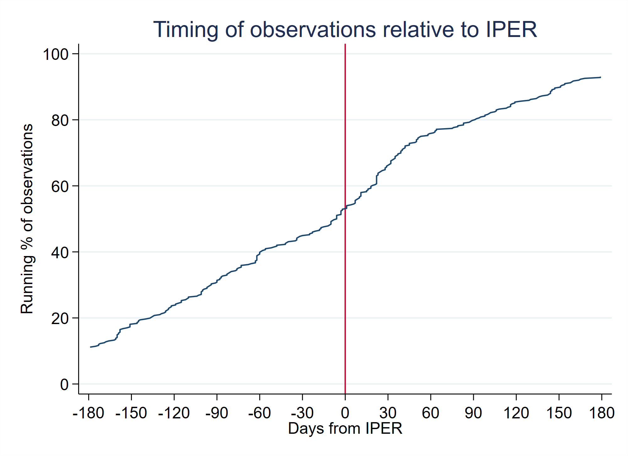
- Within this sample, at least 9.2% of patent documents cited in observations were repeats of patent documents cited in the international search report (some matches are likely to have been overlooked due to the simplistic matching of patent numbers against ISR citation data from PATSTAT). These observations generally either indicate a belief that a document is in its own right more relevant than was indicated by the international search report, or else are used to suggest inventive step objections in combination with new indicated prior art.
- Based on a rough analysis (using pattern matching on OCR of international preliminary reports on patentability, together with quick visual scans), approximately 23.3% of the citations from third party observations on the relevant applications were listed in the final reports. About 36.0% of the relevant reports included at least one citation from a third party observation.
- However, this information only tells part of the story. Citations from third party observations may be missing from the reports because (i) the examiner never saw the observation; (ii) the examiner saw the observation and did not consider the citation relevant; or (iii) the examiner cited the observation in a written opinion and the applicant amended the application so that it was no longer relevant when the final report was established (the International Bureau does not have access to all written opinions of the International Preliminary Examining Authority and did not include those that it has in the analysis). On the other hand, in some cases the examiner explicitly listed the citations from the third party observation and stated that they were not considered relevant, in which case they are nevertheless included in the above percentages.
- Some qualitative remarks from the visual inspection of the reports include the following. The European Patent Office clearly has a fairly effective mechanism for ensuring that third party observations are seen by examiners if they are submitted before the examiner has completed the international preliminary examination, as well as guidelines for mentioning their existence even if they are not considered relevant (this is in line with statements previously made by the Office when developing and reviewing the system). This is less apparent for other Authorities, though the sample size is relatively small and there are certainly examples of examiners referencing documents from observations both as citations and in stating that they are either not considered relevant or else are no more relevant than other documents previously cited in the international search report. It is clear that examiners consider most citations from third party observations to be less relevant than documents cited in the search report. However, there are examples where a citation from an observation is the document considered most relevant to novelty and inventive step, and occasionally the only document considered relevant. Consequently, while the relevance of observations is not always high, they do appear to add to the quality of the search and examination process, as long as the information is conveyed to examiners efficiently.

National Phase
- The small review sample provided by the observations referred to during international preliminary examination suggests that most observations do not significantly add to the quality of information available to the examiner from the international search report, but that enough do to make the system worthwhile. However, the key issue is how the observations affect applicants’ actions on entering the national phase (whether or not they choose to do so and the extent to which claims may be restricted), and how useful the observations are in ensuring a high quality of examination. Any information on this, whether qualitative or quantitative, would be useful in assessing the true effect of the system.
- The Meeting is invited to comment on the functioning of the PCT third party observation system in the international and national phases.
[End of document]

The WIPO technology concordance table, available on the WIPO website at https://www.wipo.int/en/web/ip-statistics, links the International Patent Classification (IPC) symbols with the 35 fields of technology.

