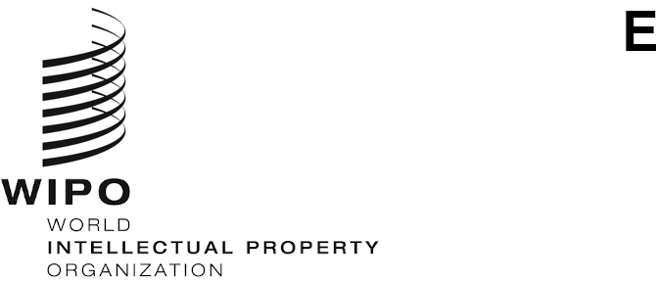
PCT/MIA/32/1 Prov.
ORIGINAL: English Only
DATE: July 15, 2025

Meeting of International Authorities
under the Patent Cooperation Treaty (PCT)

Thirty-Second Session

Geneva, October 29 to 31, 2025

Draft Agenda
prepared by the Secretariat
- Opening of the session
- Election of a Chair
- Adoption of the agenda
- PCT Statistics
- Matters arising from the Quality Subgroup
- Extension of Appointment of International Searching and Preliminary Examining Authorities
  - Procedure and Timing
  - Draft Model Agreement Between an Office or Organization and the International Bureau in Relation to its Functioning as an International Searching and Preliminary Examining Authority and Proposed Amendments to the PCT Regulations
- PCT Minimum Documentation
- Sequence Listings
  - Processing Sequence Listings
  - Sequence Listings Task Force: Status Report
- Further work
- Summary by the Chair
- Closing of the session
[End of document]

