|  |  |  |
| --- | --- | --- |
|  |  | **E** |
| pct/mia/21/20 | | |
| ORIGINAL: English only | | |
| DATE: February 4, 2014 | | |

**Meeting of International Authorities   
under the Patent Cooperation Treaty (PCT)**

**Twenty-First Session**

**Tel Aviv, February 11 to 13, 2014**

Translation of Abstracts and Reports of International Applications

*Document prepared by the International Bureau*

# Summary

1. This document discusses the translation of abstracts, international search reports and international preliminary reports on patentability concerning international applications. The translations are important for designated Offices, third parties and patent information purposes and need to be provided in a timely but cost‑effective way.
2. The International Bureau (IB) seeks to raise awareness of the factors which affect the quality, timeliness and ease of providing these translations. While such matters should not directly drive the development of the system, the costs involved are large and need to be taken into account in efforts to improve the efficiency and utility of the system. International Authorities are invited to consider whether action can be taken that would contribute to the reduction of the cost of translation at the IB while improving, or at least not reducing, the quality of service provided to the end users of the translations.

# Background

1. The IB is required to translate all abstracts, including any text matter appearing in the reference drawing, and titles of international applications so they are made available in both English and French. The IB is also required to translate all international search reports and international preliminary reports on patentability (IPRP) (whether established under Chapter I or II) into English if this is not the original language of the report.
2. The titles, abstracts and international search reports are supposed to be included in the international publication. The international application will need to be republished if the translation is not available in time, or if an abstract is modified too late for the revised version to be included in the original international publication. The international preliminary reports on patentability and the translations thereof are intended to be available at 30 months from the priority date, with the possibility of designated or elected Offices requesting early translations (where relevant, of the written opinion of the International Searching Authority rather than the IPRP) in cases where the applicant enters the national phase early.
3. The rise in the number of international applications filed and the larger share of applications in the Asian languages have resulted in an increasing workload on the IB to produce these translations. In order to meet the growing demands with timely delivery of abstracts and reports and flexibility to accommodate possibly changing future needs, the IB outsources the translation of a growing proportion of abstracts and reports.



*Figure 1: Volume of Translations (source: PCT Yearly Review, 2013)*

1. Figure 1 shows the total number of abstracts (including titles and drawings) and international search and preliminary examination reports (“reports”) translated since 2007, along with the share of outsourced translations. The numbers are increasing both as absolute figures and as a proportion of international applications. Significant increases occurred during this period as a result of the addition of Portuguese and, especially, Korean as languages of publication in 2009. In addition, international applications have increased significantly in Japanese and Chinese. The number of documents translated in 2012 increased significantly compared to 2011. In 2012, 264,975 abstracts and 78,455 reports were translated, an annual growth of 13.4 per cent and 25.3 per cent, respectively. External agencies and translators produce 87.1 per cent of translations of abstracts and 97.3 per cent of translations of reports. Many of these translations have to be produced over a tight timescale in order to be available for international publication at 18 months from the priority date of the application or to designated Offices at 30 months from the priority date.
2. A small but significant and increasing proportion of international preliminary reports on patentability need to be translated early as a result of early national phase entry. The time constraints involved put a strain on internal resources and the unpredictable nature of early national phase entry requests makes planning difficult.
3. To deal with the rising demand for translations, the IB has made efforts to improve the efficiency of operations and the quality of both internally and externally‑produced translations. In terms of quality, the PCT Translation Service applies a comprehensive quality control procedure to translations produced by all suppliers and provides regular feedback to suppliers, as well as to Offices when recurrent errors occur in the original files. In terms of operational efficiency, the Translation Service is increasingly applying document-streaming techniques that allow applications of a similar nature to be identified and translated in the most cost-effective manner. In 2012, the IB introduced a modernized translation environment for its internal translators to enable the reuse of past translations and more effective utilization of terminology. In addition, a further Translation Management System principally for handling translations carried out by external agencies was introduced at the end of 2013 and will be extended to additional agencies and translators throughout 2014. This will ensure secure and flexible workflow automation and improve translation quality. Structural improvements have also been made to the tendering process for translation suppliers to enhance and diversify the supplier network with agencies capable of providing cost-effective quality translation. Furthermore, the IB has also continued to develop its multilingual terminology database to improve the consistency and the quality of translations, with priority being placed on adding terms in languages underrepresented in the database
4. The actions of receiving Offices (ROs), International Searching and Preliminary Examination Authorities (ISA/IPEAs) and applicants also influence the delivery of translations by the IB. Offices and applicants can therefore contribute towards timely production of translations of abstracts and reports. This document discusses this issue in detail, especially with regard to ISA/IPEAs.

# Abstracts

## Time of Transmitting International Search Reports

1. Because translations may be needed into both French and English, the majority of abstracts undergo a relay translation process whereby translation into English is then followed by translation into French. For this reason, the initial translation into English needs to be sent out no later than 10 weeks before the due date for publication. The IB therefore relies on receiving the final version of the abstract (modified by the ISA under Rule 38.2 if necessary) with the international search report before this date. If a modified version of the abstract arrives after this time, the abstract will require additional in‑house work to modify the translation of the original abstract or, in some cases, a full re‑translation, resulting in additional or double the cost to the IB. Similarly, the IB cannot be sure of the figure of the drawings to accompany the abstract until it receives the international search report.

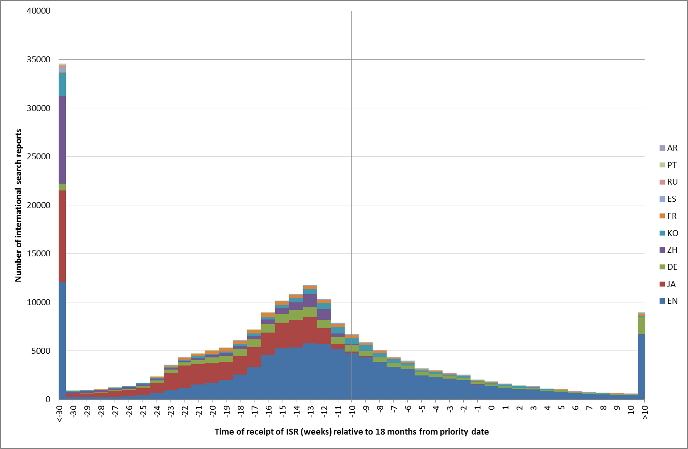

*Figure 2: Time of receipt of ISR or Article 17(2)(a) declaration compared to normal publication date (ISRs and declarations received by IB in 2013); axis at -10 weeks shows time by which ISRs are needed for most efficient translation processing*

1. As can be seen, a large proportion of international search reports are received in good time to allow efficient translation processes for the international search report and abstracts. However, a large number – and in some languages, a large proportion – are not, even though the ISA may have delivered the ISR within the time limit specified in Rule 42.
2. Rule 42 requires the ISA to establish the report within three months from the receipt of the search copy, or nine months from the priority date, whichever time limit expires later. For most applications, the former time limit will apply. This target is already ambitious for most ISAs, particularly in cases such as where a lack of unity of invention is found, requiring a month or more to be consumed in communications with the applicant. Consequently, the most practical ways of bringing forward the delivery of international search reports seem to be to improve the timeliness of transmission of search copies from the RO and to encourage electronic communication with applicants to minimize delays in those cases where correspondence is necessary. Document PCT/MIA/21/2 considers ways in which ePCT and related online systems could help in this area.
3. Overall, for the international applications for which the IB has data concerning the receipt of the search copy, the average times from the filing date to the date of receipt of the search copy is 20.1 days for cases where the ISA is the same Office as the RO and 33.9 days for cases where the Offices are different. However, hidden within these averages are many variations in distribution of times between RO-ISA pairs.
4. There is insufficient data available to the International Bureau to determine reliably the extent to which the longer delays in transmission are a result of slow processing by the receiving Office, long transmission delays due to posting paper search copies or, alternatively, factors such as late payment of the search fee by the applicant. It would be desirable if receiving Offices could review their own performance and procedures in terms of delivering search copies and identify actions which could be taken to improve performance and encourage applicants to minimize delays attributable to the need for payment of fees or other forms of applicant action after filing.

## Text in Figure accompanying the abstract

1. Rule 11.11 states that “the drawings shall not contain text matter, except a single word or words, when absolutely indispensable”. In the case of drawings containing electric circuits, or block schematic or flow sheet diagrams, “a few short catchwords indispensable for understanding” may be included. There is also a requirement to place any words used so that, if translated, they may be pasted over without interfering with any lines of the drawings.
2. Drawings in applications often do not meet this requirement, particularly block or flow sheet diagrams. This creates additional translation work when there is excessive text on the figure selected to accompany the abstract. In certain languages, the text on this figure, after translation into English, regularly exceeds 250 words, even extending to over 1000 words in extreme cases. Since this text is generally not a repetition of text in the abstract, but instead comes from the explanation of the selected figure in the description, the total text requiring translation is more than double the desirable maximum of 150 words for the abstract.
3. Under Rule 26.3, the RO is required to check an international application for compliance with the physical requirements in Rule 11 only to the extent that compliance is necessary for reasonably uniform international publication or satisfactory reproduction. ROs therefore have neither the power nor the technical expertise to verify whether the text matter included in the drawings is indispensable for understanding. Moreover, once a non‑compliant figure has been filed, it will be difficult for the problem to be corrected without modifying the description as well as the drawings in a manner such that it would not be reasonable to ask a formalities examiner to judge whether the correction truly reflected the international application as filed and did not add subject matter.
4. By contrast, action from ISAs could contribute towards reducing the problem of excessive text in the drawings that require translation. For example, where this problem exists in the figure(s) selected by the applicant to accompany the abstract, under Rule 8.2(a), the ISA could select an alternative figure to accompany the abstract that complies with Rule 11.11. The ISA can also decide under Rule 8.2(b) that the abstract should be published without an accompanying figure if none of the drawings in the application is useful for understanding the abstract. A drawing should not be included with the abstract merely because it has been suggested by the applicant.
5. Nevertheless, in many cases, a figure with large amounts of text will in fact be the one which best represents the invention. Given the difficulty in enforcing Rule 11.11, it is not clear how this problem can be overcome. It does not appear practical to charge an additional fee, noting that the figure to be used is not known until the ISA has confirmed it and the number of words when translated into English or French (which is the usual basis for costs based on volume) is only known after translation.

# International Preliminary Reports on Patentablity

1. Along with the rise in the number of reports translated (see paragraph 6, above) their average length has also increased in recent years. This adds to translation costs and affects timely delivery of high quality translations.

|  |  |  |  |  |  |  |  |  |
| --- | --- | --- | --- | --- | --- | --- | --- | --- |
|  | German | Spanish | French | Portuguese | Russian | Japanese | Korean | Chinese |
| 2011* | 606 | n/a | 578 | n/a | n/a | 400 | 521 | 900 |
| 2012 | 621 | 630 | 665 | 675 | 476 | 428 | 550 | 1185 |
| 2013 | 632 | 648 | 663 | 628 | 452 | 428 | 628 | 1232 |

*Figure 3: Length in words of the IPRPs after translation into English, by original language.  
(*) figures for some languages are not available for 2011 due to the way in which invoices were submitted by suppliers at that time.*

1. Since 2011, the International Bureau has been monitoring the average word count per language combination of international preliminary reports on patentability after translation into English. As shown in Figure 3, above, this average has risen since 2011 for reports established in most languages, and there are significant variations between Authorities.
2. Reports that are clear and concise are not only more straightforward to translate, but are also easier to understand by the applicant and third parties. The IB intends to discuss the preparation of reports with Authorities whose reports are longer than average and have recently increased significantly in length. International Authorities are also invited to provide views on what further guidance could be provided for drawing up written opinions and international preliminary reports on patentability to facilitate translation into English. This could include recommendations on writing style such as short sentences, avoiding unnecessary repetition, and consistent use by an International Authority of general expressions in reports. The discussions on use of standardized clauses could contribute to this process.

# Format of Documents

1. Most international search reports, written opinions and international preliminary examination reports are still received by the IB in image‑based format or on paper. The efficiency of translation would be significantly increased if the translators had access to a text‑based version of the documents. This could be Annex F‑compliant XML, as some International Authorities are currently preparing systems to produce. It could alternatively be any major word processor format.
2. International search reports in particular are highly structured documents with many parts which do not require translation at all, or which are representations of simple data in ways which involve mere replacement of one standard text with another. If the international search reports were received in text formats (preferably, but not necessarily XML) which allowed the different parts to be reliably identified by machine, some international search reports might not require human translation and, for the others, costs could be reduced by reliably identifying those small number of words which required human translation.
3. Where reports are received on paper, the International Bureau will frequently attempt to perform optical character recognition (OCR) to retrieve the text. However, not only is this a source of additional work which could apparently be avoided in most cases, but it is also in some cases impossible because OCR is extremely unreliable with the very small fonts used in reports by some International Authorities.

# Possible Action

1. Translation is an important service in ensuring that the PCT system is effective for designated Offices, third parties and patent information purposes. Although it is an ancillary service which should not drive overall policy, it is a major cost of running the system, which needs to be managed well and needs to be taken into account in the operation of the system, along with many other factors.
2. As such, the International Bureau is not presently suggesting any review of the time limits or principles of processing, but seeks the assistance of ROs, ISAs and applicants in ways such as:
   1. reducing RO processing times and ISA backlogs where reasonably possible;
   2. timely payment and processing of fees;
   3. supporting services, such as ePCT, which reduce transmission delays (both applicant to Office and Office to Office) and provide higher quality information to assist processing by other Offices;
   4. reviewing standard clauses and guidelines on drafting written opinions to reduce their length, to the extent that this does not adversely affect the quality of the opinions;
   5. seeking stricter compliance with Rule 11.11 (Words in Drawings) at least for the drawings accompanying abstracts;
   6. prioritizing work towards providing machine‑readable versions of international search reports, written opinions, international preliminary reports on patentability and associated matter such as revised abstracts.
3. The International Bureau continues to study this area and hopes to find ways in which translations can be delivered effectively for the needs of their target audiences in more efficient and cost‑effective ways.
4. *The Meeting is invited to comment on the issues set out in this document.*

[End of document]