 |  | E
pct/mia/19/11
ORIGINAL: English
DATE: December 20, 2012

Meeting of International Authorities
under the Patent Cooperation Treaty (PCT)

Nineteenth Session
Canberra, February 8 to 10, 2012

Revision of WIPO Standard ST.14

Document prepared by the International Bureau

Summary
1 The International Bureau believes that it may be useful to create new document category codes to replace category “X” in WIPO Standard ST.14, distinguishing between documents which are relevant to novelty and those which are relevant to inventive step when the corresponding document is taken alone. International Authorities are invited to comment on whether they would consider it useful to begin a revision to ST.14 for this purpose.

2 If a proposal is made to the Committee on WIPO Standards (CWS) to create a task force on revision of WIPO Standard ST.14 for this matter, it would be appropriate also to consider whether further issues should be considered in the mandate, namely, issues relating to minor clarifications of the definition of category “P” and recent changes to related International Standard ISO 690 on bibliographic references and citations.

Citing Documents Relevant to Inventive Step

Background
3 At present, WIPO Standard ST.14 recommends (and for the PCT, Section 505 of the Administrative Instructions requires) that documents relevant to inventive step should be indicated in search reports using either category X (if the document is relevant when taken alone) or Y (if the document is relevant in combination with one or more other documents cited with that category). However, category X has a second meaning: it is also used for documents relevant to novelty when the documents are taken alone. WIPO Standard ST.14 is available at:

http://www.wipo.int/standards/en/pdf/03-14-01.pdf

4 One of the comments made in response to Circular C. PCT 1295, relating to the quality of search and examination of international applications, was that a distinction should be made in international search reports between “X for novelty” and “X for inventive step”.

5 Separately, the European Patent Office (EPO) made the following announcement in EPO Newsletter 23/2011:

" ‘I’ citations available in the Register

“For some time, the EPO has been using – internally, not in the search reports themselves – the "I" citation category to indicate documents which, taken alone, cast doubt on inventive step. Since August, we have now made this new category available to the public in the European Patent Register.”

Sample extract from European Patent Register, showing “I” category documents, which appear as “X” on the European Search Report.
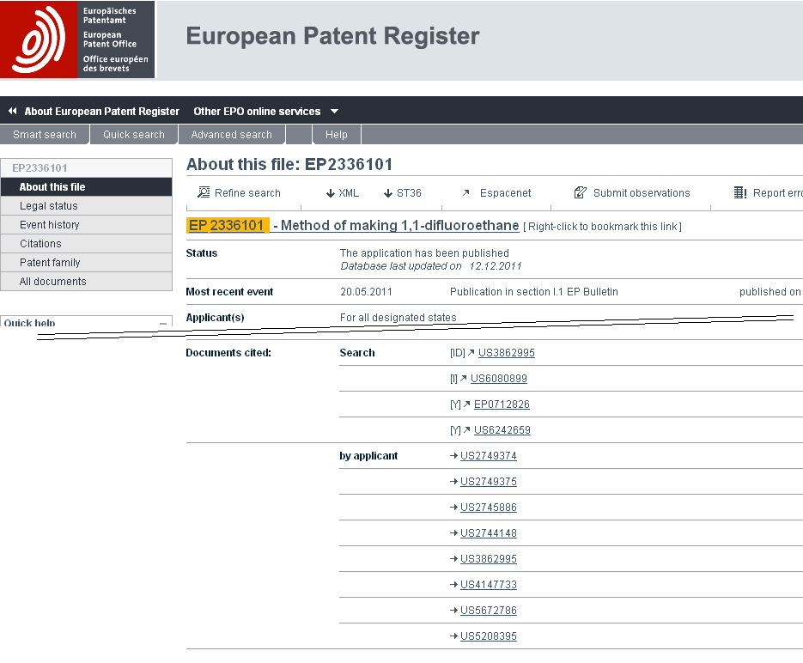

6 Therefore, according to the current EPO practice, documents which are relevant, taken alone, to inventive step continue to be cited in search reports as category “X” in accordance with WIPO Standard ST.14, but more detailed information may be available online through the European Patent Register as shown above, or other systems such as the Common Citation Document (see paragraph 9, below).

7 The International Bureau believes that it would now be useful to introduce a distinction in search reports between documents cited for novelty and documents cited for their relevance to inventive step when taken alone. Such a change has become particularly appropriate because of the recent increased desire to obtain and consider national search reports on related patent applications in other Offices as well as international search reports.

Considerations
8 When considering search reports from several other Offices, it is important to obtain as much information as possible as quickly as possible. Most national search reports will not be accompanied by a written opinion when received by another Office. In the case of international applications, the written opinion of the International Searching Authority is not usually made available until 30 months from the priority date. Even when it becomes available, it does so as a separate document rather than being attached to the published international application. Consequently, it will not necessarily be easily available for clarifying the international search report.

9 Using a separate code for documents related to inventive step would help clarify the relevance of documents as seen by the search examiner, while requiring little or no additional effort on the part of that examiner. It would be particularly useful in the context of projects to bring the contents of multiple search reports together into a single view, such as the “Common Citation Document” recently launched by the EPO on behalf of the Trilateral Offices (EPO, Japan Patent Office and United States Patent and Trademark Office). It may also help to automate the generation of consistent search reports and written opinions by Offices.

10 However, category X has been used to cover two meanings for many years and is likely to retain its twin meaning in search reports from some Offices for some time to come even if a change is made to the recommendations in WIPO Standard ST.14. Consequently, it would be undesirable for an Office which begins to use a new category such as “I” to continue to use category “X” with a more limited definition than applies in other reports. Offices which use category “I” in search reports should also use a new code (such as “N”) to represent citations relevant to novelty so that there is no doubt about the meaning of category “X” in different contexts.

Sample Common Citation Document view, showing citations from two Offices and family information from others
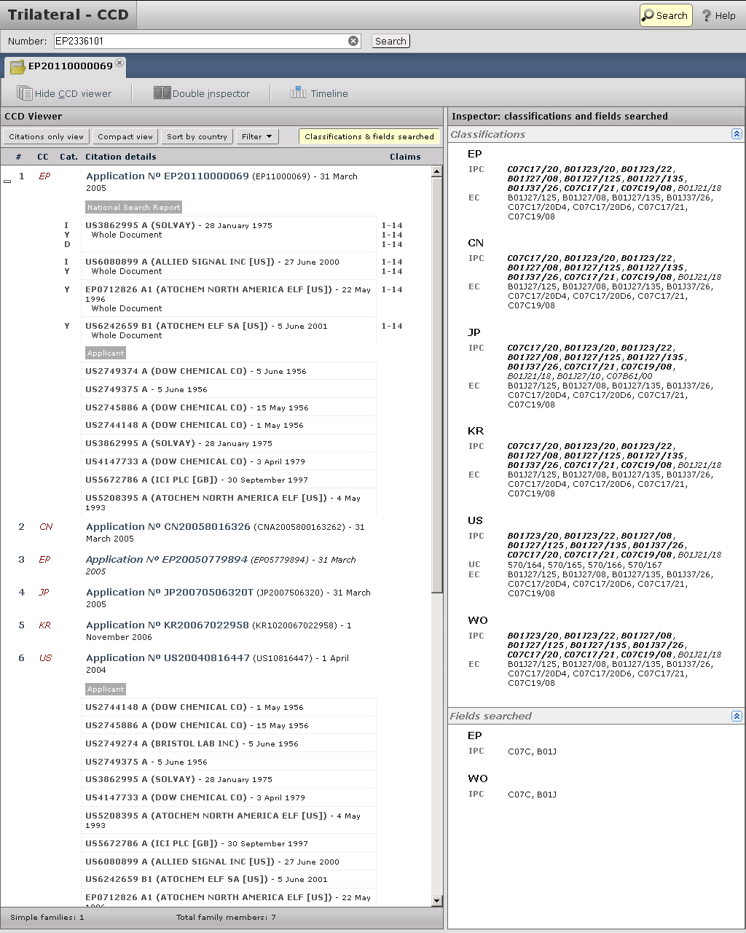

Draft Proposal
11 Consequently, the International Bureau is considering proposing at the April 2012 session of the Committee on WIPO Standards to create a task force with a mandate to review WIPO Standard ST.14 based on a first draft proposal for new category codes relating to novelty and inventive step as follows:

Category “N”: The claimed invention cannot be considered novel when the document is taken alone.

Category “I”: The claimed invention cannot be considered to involve an inventive step when the document is taken alone.

Category “Y”: The claimed invention cannot be considered to involve an inventive step when the document is combined with one or more other such documents, such combination being obvious to a person skilled in the art.

Category “X”: This category was previously recommended to indicate that the claimed invention cannot be considered novel or cannot be considered to involve an inventive step when the document is taken alone. New search reports should no longer use this category. The more specific categories “N” or “I” should be used instead.

Other Issues
12 If a task force is created to review WIPO Standard ST.14, it will be necessary to consider whether its mandate should be strictly limited to the above matter or might also include other matters. The following subjects have been identified which Member States might wish to include.

Recent Revision of Standard ISO 690
13 Since WIPO Standard ST.14 was last updated in February 2008, a new version of the corresponding ISO Standard has been issued (ISO 690:2010, Information and documentation -- Guidelines for bibliographic references and citations to information resources). This offers a more consistent approach to the citation of non-patent literature than in previous versions, on which the multiple categories of non-patent literature citations in ST.14 is based. While the standards which it includes for citation of patent documents are clearly less useful for patent search reports than the existing ones, it may be desirable to assess whether the recommendations in relation to non-patent literature should be adopted or be taken in part to improve the recommendations in WIPO Standard ST.14.

Definition of Categories “E”, “O” and “P”
14 Some consideration might also be given to the definitions of categories P, E and O. These are currently defined as follows:

Category “E”: Earlier patent document as defined in Rule 33.1(c) of the Regulations under the PCT, but published on or after the international filing date;

Category “O”: Document referring to an oral disclosure, use, exhibition or other means;

Category “P”: Document published prior to the filing date (in the case of the PCT, the international filing date) but later than the priority date claimed in the application. Code “P” should always be accompanied by one of the categories “X”, “Y” or “A”.

15 The purpose of category P is essentially to indicate that the examiner will need to give careful consideration to the validity of the priority date of the application against which the document is cited. If the citation is published on the priority date of the application being searched, it has no effect if the priority is valid and discloses the relevant subject matter, but can be cited for novelty and inventive step if the priority is invalid. As such, a document published on the priority date falls into the same category as documents which are published after the priority date but before the filing date. Consequently, a better definition of the category might be:

“Category ‘P’: Document published prior to the filing date (in the case of the PCT, the international filing date) but on the priority date or on a date later than the priority date claimed in the application. Code ‘P’ should always be accompanied by one of the categories ‘X’, ‘Y’ or ‘A’.”

16 Secondly, category P “should always be accompanied by one of the categories ‘X’, ‘Y’ or ‘A’” (or new categories “I” or “N”, if agreed), whereas this is not stated to be the case for categories “O” and “E”.

17 On the face of it, such information should always be provided at least in the case of category “O”, since under most national laws, oral disclosures and exhibition count as prior art potentially relevant to both novelty and inventive step provided that their content can be proven. While this is not strictly prior art under the definitions in the PCT, such disclosures are nevertheless required to be included in the international search report and it would appear appropriate to indicate the nature of the potential relevance against the oral disclosure itself, rather than against any later document which is not citable in its own right but provides evidence of the earlier disclosure.

18 It may also be desirable to require categories “X”, “Y” or “A” (or “I” or “N”, if agreed) to be indicated next to category “E”. For most national laws, this is not necessary for purely domestic use since category “E” citations can only possibly be relevant for purposes equivalent to novelty so that “X” (or “N”, if agreed) can be implied. However, in a few States, earlier patent applications can also be cited for inventive step purposes, including in combination with other documents. Consequently, for effective sharing of search reports, it would seem desirable to make explicit the potential relevance of an “E” category citation, if only so that category “E,Y” or “E,I” documents could be more quickly dismissed as irrelevant in States where they cannot be cited.

19 Finally, there is an agreed practice in the PCT International Search and Examination Guidelines (paragraph 16.67) whereby International Authorities should cite patent documents sharing the same date as the international application being searched and apply category E even though this is outside the definition of category E. This is a sensible procedure in practice to help Offices apply their anti-double-patenting laws, but has no basis in either the PCT Administrative Instructions or in ST.14 for the category to mark the documents with. It may be desirable either to extend the definition of category E or to create a new category specifically for the purpose.

Process
20 If the International Bureau makes a proposal to revise WIPO Standard ST.14, the April/May 2012 session of the CWS would be invited to create a task force to consider the issues. The expectation would be that a final proposal for revision of the categories of citations would be presented to a 2013 session of the CWS for adoption. If adopted, modifications to the PCT Administrative Instructions would be proposed shortly afterwards, to become effective for international search reports established from a date to be decided towards the end of 2013 or at the beginning of 2014.

21 If it is decided to include a review of the recommended format of non-patent literature citations based on ISO 690:2010, the work of the task force might easily take more than one year. In this case, it should be open to the task force to present proposals on the subject of citation categories to the 2013 session of the CWS for adoption as a first round and to present proposals on format of non-patent literature citations to a later session.

22 The International Bureau would be willing to act as a task force leader, if so requested, for a revision process which was limited to issues of citation category. However, it considers that issues related to format of non-patent literature citations would be better led by a representative of an Office which has greater practical experience of using the citations presented in search reports.

23 The Meeting is invited to comment on:

(i) whether it is desirable for the International Bureau to propose a revision of WIPO Standard ST.14 to provide new category codes specific to novelty and inventive step;

(ii) whether any such revision process should also extend to other issues related to the standard; and

(iii) whether any of the International Authorities might be prepared to offer a candidate to act as task force leader for such a revision process.

[End of document]

