 |  | E
pct/mia/19/10
ORIGINAL: English
DATE: January 11, 2012

Meeting of International Authorities
under the Patent Cooperation Treaty (PCT)

Nineteenth Session
Canberra, February 8 to 10, 2012

ePCT Update

Document prepared by the International Bureau

Summary
1 The ePCT applicant portal is now available for use by any applicant, irrespective of the receiving Office with which the international application was filed and the format in which it was submitted. ePCT provides secure access to the electronic files of international applications held by the International Bureau (pre- and post-publication), including the opportunity to upload most types of post-filing documents for the attention of the International Bureau or the receiving Office of the International Bureau. It also provides various practical and useful features, such as a timeline graphic displaying key dates and time limits tailored to each international application and optional e-mail notifications of the approach of certain deadlines.

2 Additional new features which the International Bureau intends to add in the next few months which do not rely on participation by other Offices include web-based online filing with the receiving Office of the International Bureau and online “actions” which will allow applicants to take certain actions themselves. Applicants will be able to indicate changes relating to the international application directly in the International Bureau’s systems, thus eliminating to the extent possible the need to draft correspondence describing requested actions to be taken on their international applications and the time and risk of error involved in transcribing data. Such actions will initially include withdrawal of the international application, correction of priority claims and changes to persons, names and addresses under Rule 92bis, with further actions becoming available in subsequent releases of the ePCT system.

3 The International Bureau also intends to add further services both for the benefit of national Offices in their PCT capacities and to improve the overall service to applicants by providing a common portal to the records and services which are the responsibility of national Offices in their various PCT capacities. For this aspect of the ePCT system to be successful, the buy-in and cooperation from Offices that wish to participate and benefit from such services is essential.

General
4 The term “ePCT” is used to cover a range of PCT electronic services provided by the International Bureau to assist applicants and Offices in processing international applications. It is based on direct, secure interaction with the International Bureau’s electronic systems, covering both published and unpublished international applications and associated documents. At present, the main existing services are directed towards applicants, but the intention is to also provide properly integrated tools for Offices in their various PCT capacities, including both systems hosted directly by the International Bureau and improved interfaces for Offices which prefer to use their own systems to interact with those of the International Bureau.

5 Services for third parties will, with the exception of third party observations, continue to be provided through PATENTSCOPE (which also offers useful information services for applicants and Offices) as a separate service which runs on a copy of the published and publicly available parts of the International Bureau’s files, updated each day. Although entirely separate in function, future developments are being coordinated to provide synergies and a degree of linking between both ePCT and PATENTSCOPE services.

6 The ePCT services are divided into two categories: “public” and “private” ePCT services.

(a) ePCT public services require little or no authentication because they do not offer any access to confidential information and can be accessed by creating a standard WIPO online user account authenticated with only a username and password. These public ePCT services are conducted using secure transmission so that the integrity of the transaction is assured, but do not seek to verify the source of the transaction any more than with a letter received by post, which is assessed on the basis of its contents. The online public ePCT services that are currently available are simply replicas of services which are available in the existing PCT Service Center (http://www.wipo.int/pct/en/service_center), namely, online document upload and PCT e-Payment (online payment by credit card of certain fees payable to the International Bureau). The forthcoming third party observations functionality is currently targeted to be deployed as part of ePCT public services as of July 1, 2012. It is intended to decommission the PCT Service Center on that date in favor of ePCT public services.

(b) ePCT private services on the other hand require strong authentication because they offer access to the entire file of an international application, including various types of confidential information, as further set out in the following paragraphs. Other than the information set out in paragraph 6(a), above, this document is concerned only with ePCT private services, which are the current main focus of development.

Current ePCT Private Services
7 During 2011, a small pilot group of applicants conducted live tests of ePCT private services using real international applications, for the most part limited to international applications filed at the receiving Office of the International Bureau using WIPO digital certificates. In December 2011 the system was opened up so that it is now possible for any applicant to use the system in relation to any international application filed since January 1, 2009. However, the system is considered still to be in a pilot phase and has, to date, not been significantly advertised, largely because the International Bureau is still in the process of working with its service providers to guarantee the availability of the system at all times, save for limited and pre-notified maintenance periods.

8 ePCT private services provide real time, two way interaction with the live file of an international application. Users can see the entire content of a file, including documents, bibliographic data and status information, plus a timeline of key time limits and outstanding actions to be taken. If documents are uploaded, they are immediately visible in the “file view”.

View of Live Bibliographic Data and File Contents
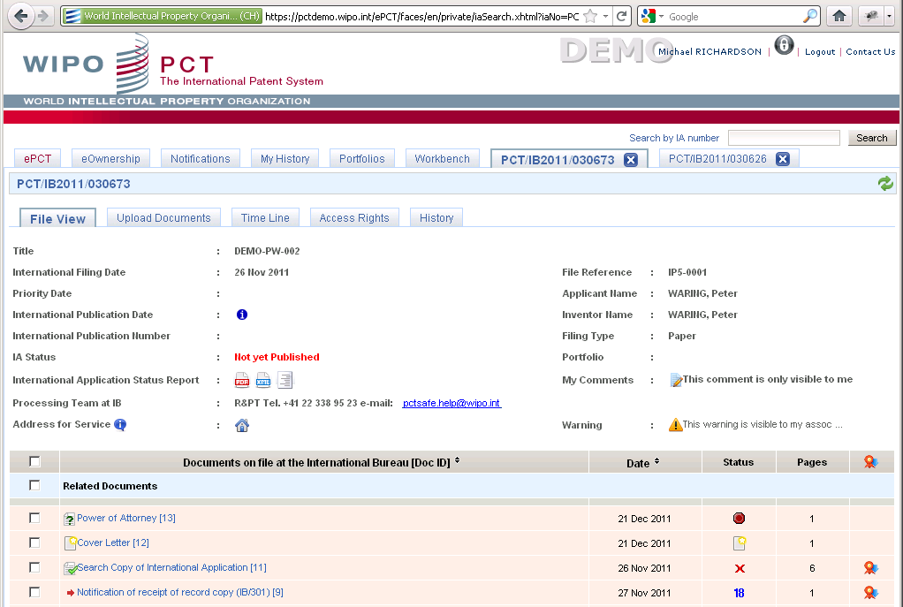

Timeline of Expected, Required and Permitted Actions
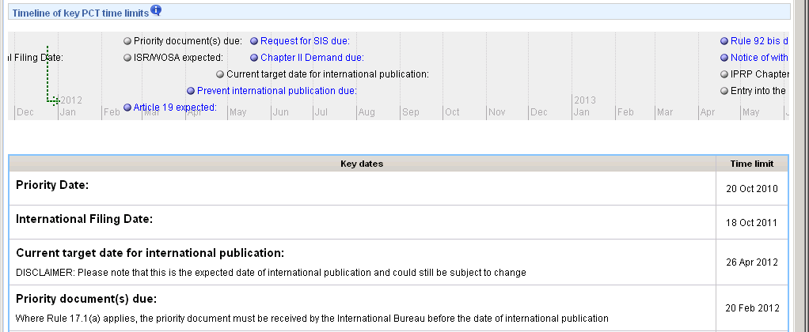

9 Some of the significant features currently available include the following:

(a) Secure login, using a digital certificate in addition to user ID and password – the system supports both WIPO digital certificates and those issued by Member States, provided they are compatible technology and the International Bureau has access to the necessary information, such as revocation files.

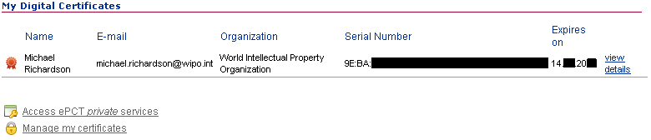

(b) Secure transmission of data, with reliable verification of WIPO’s ownership of the website to avoid risks from fake sites.

(c) Securely claim access rights to international applications – fully automated system to gain immediate access to most international applications filed using a WIPO or compatible digital certificate (provided that, at the time of claiming access, the international application is not published and no changes have been requested under Rule 92bis); secure manually scrutinized process for confirming access rights for other international applications filed on paper or using non-supported certificates.

(d) Ability to delegate access rights – each international application initially has a single “eOwner” who is able to delegate access rights to other account holders either as additional eOwners (who are able to subsequently delegate rights) or as “eEditors” (who are only able to view data, upload documents and take other actions, but are not permitted to delegate access rights).

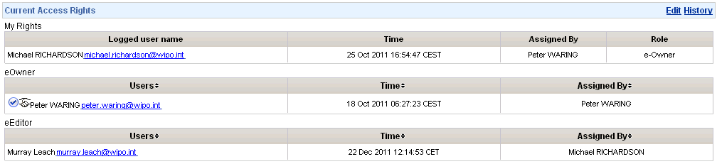

(e) eOwners are expected to be responsible for ensuring that only appropriate persons are given access to an international application, but the International Bureau can perform access management functions and will, for example, automatically temporarily suspend all access to an international application whenever a change request under Rule 92bis is received (pending a check that the change does not affect which user accounts should have electronic access) and can, if required, manually suspend an entire user account or suspend access to an international application either at the level of all users or individual users only.

(f) Find accessible applications by typing in the application number or by selecting from a list; organize applications into portfolios to suit different ways of working; keep multiple international applications open and switch between tabs.

(g) Upload documents to the International Bureau and immediately view them in the file.

(h) Generate a signed covering letter automatically for uploaded documents to meet the requirements of Rule 92.1.

(i) See an indication of the processing status of documents, such as:

“not yet processed by the IB” (in which case the indexing of the document type is not yet confirmed and the International Bureau has not yet completed the processing);

“processed by IB” (the document type has been confirmed and the International Bureau has taken any necessary actions);

“business error” (the document type has been confirmed, but there is a problem preventing the associated action from being completed);

“outgoing IB form” (a form sent by the International Bureau);

“outgoing RO form” (a form sent by the receiving Office of the International Bureau).

(j) See an indication of when the relevant document will become publicly available via PATENTSCOPE (at international publication, 30 months from the priority date or never).

(k) Download individual documents, a package of selected documents or (for documents which have been processed by the International Bureau and are available in PDF format) certified copies of documents.

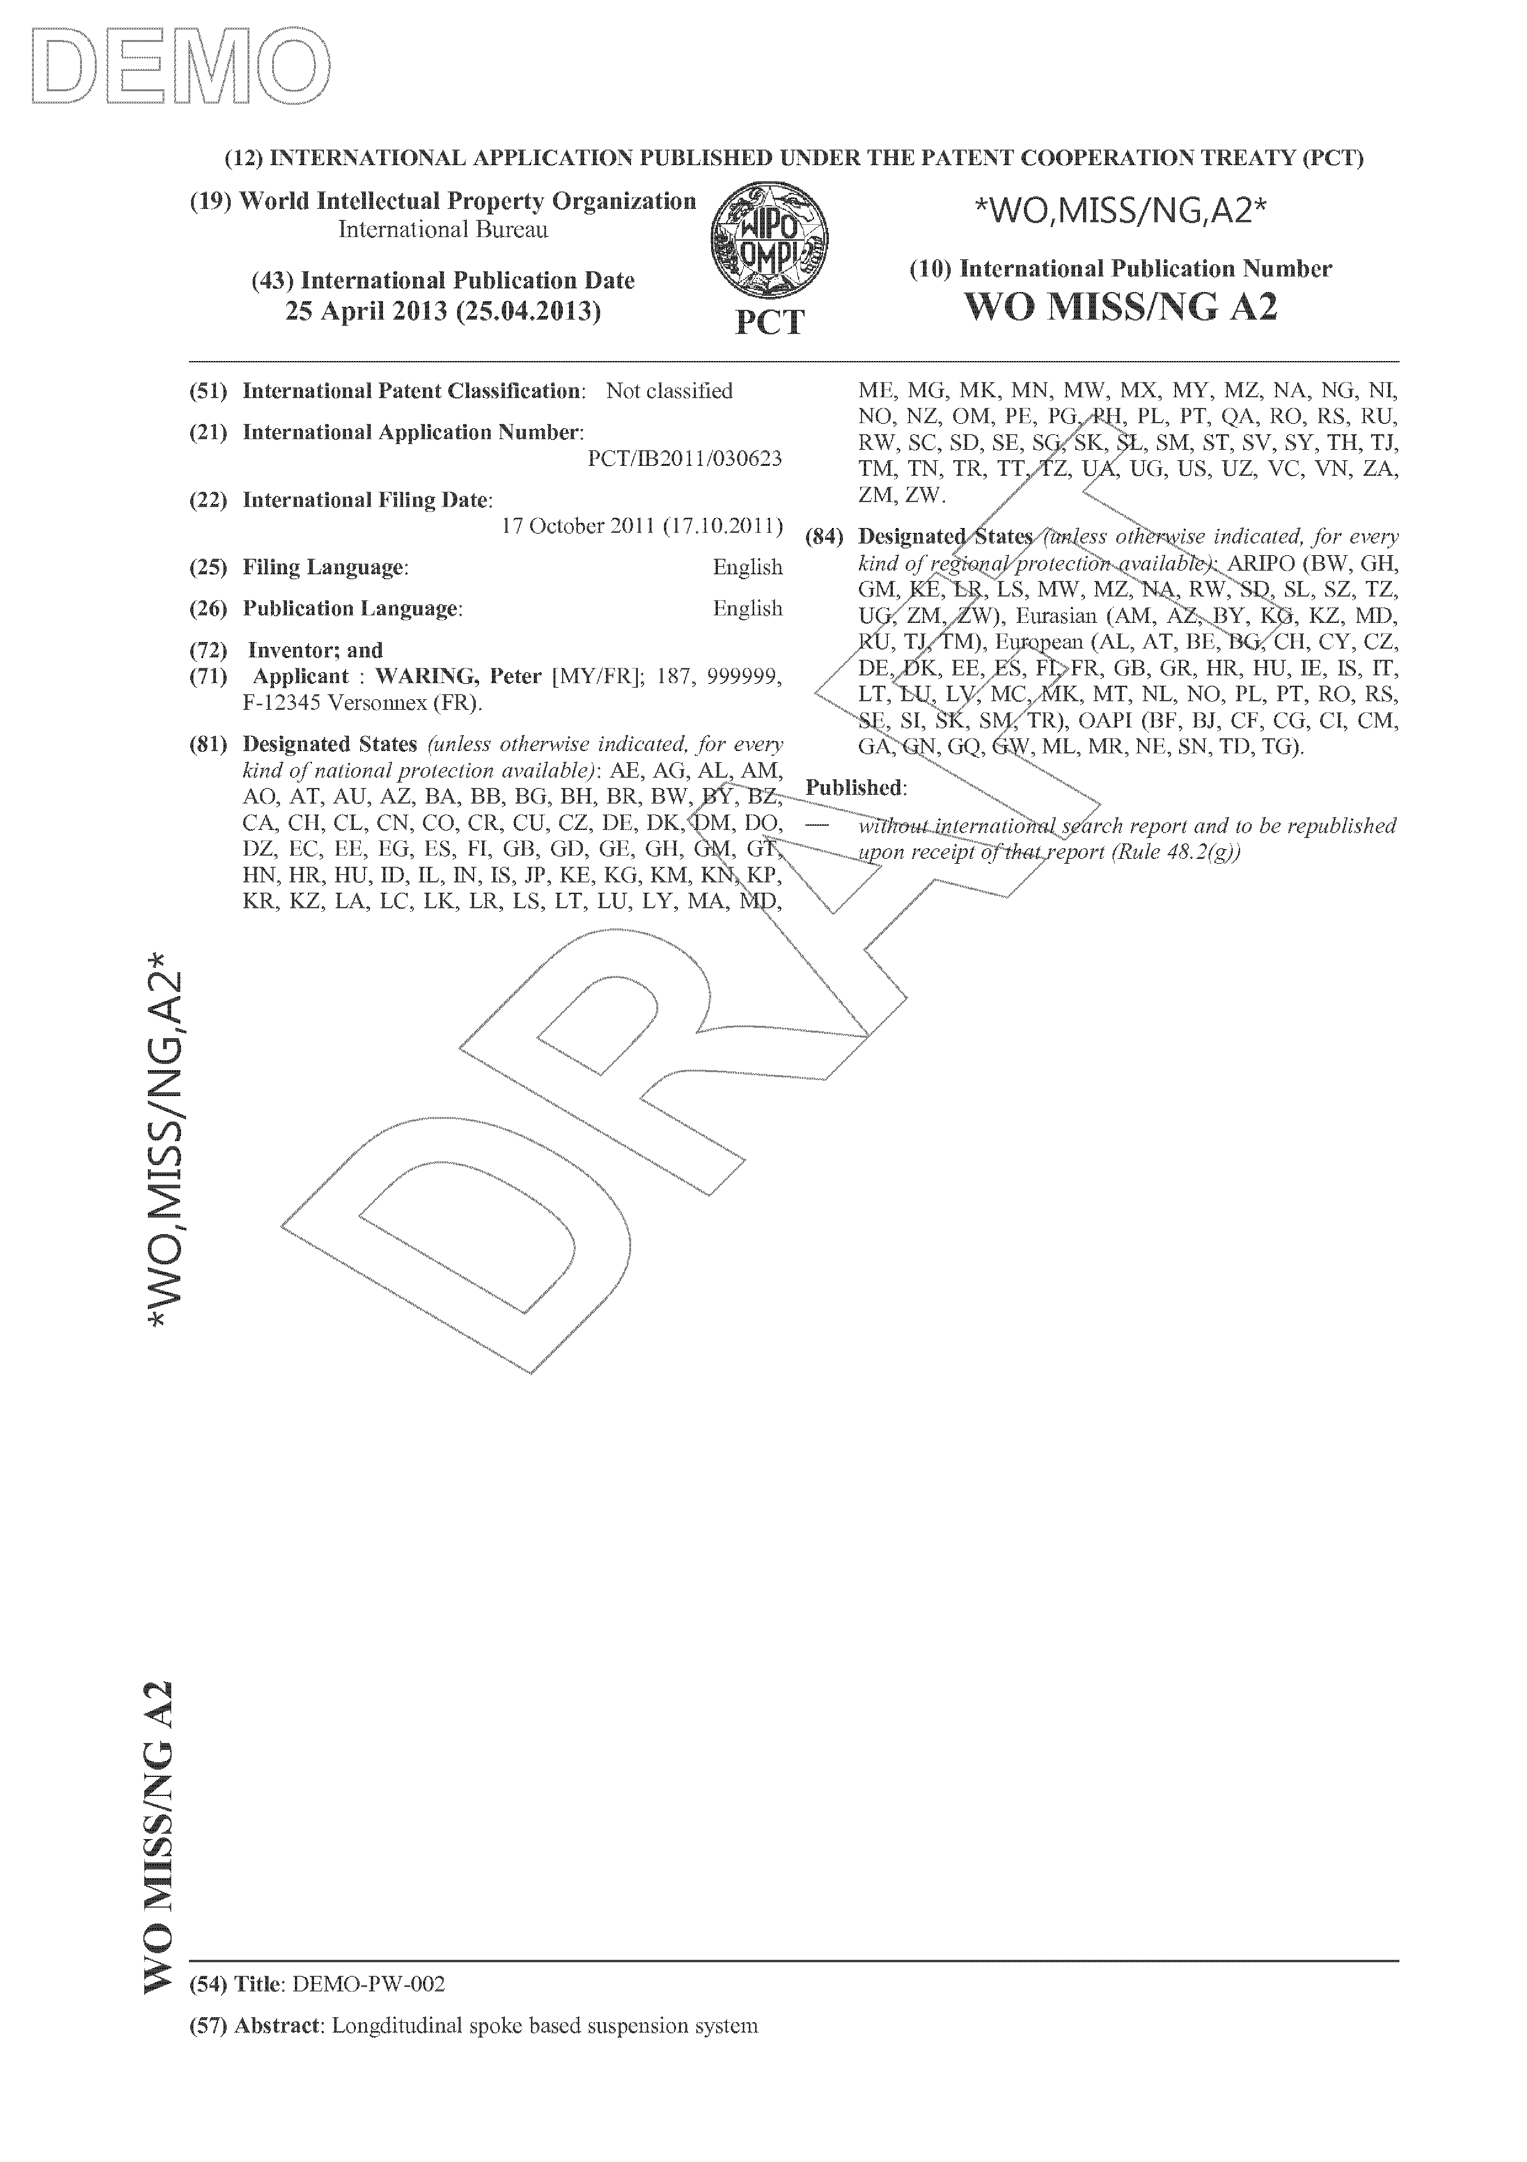
(l) See the latest bibliographic information in various forms – key items on the main web screens, full reports in HTML or PDF format, or as a preview (see right) of the front page of the international application in draft form, produced in real time by the same system which is used to generate the real publication front pages.

(m) See a timeline of events and deadlines based on the latest information available to the International Bureau concerning the international filing date, priority date and date of transmittal of the international search report.

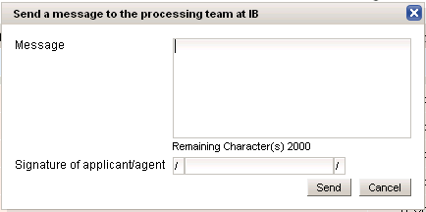
(n) See additional information concerning the processing of the international application, including estimated publication dates and the contact details of the Processing Team at the International Bureau responsible for the particular international application. A built-in secure messaging function enables informal messages to be sent directly to the relevant Processing Team.

(o) Receive notifications based on customizable criteria, both to flag new documents that are added to the file and for certain other events; users can decide whether the notifications should be sent by e-mail, appear in the user’s ePCT “notifications” tab or both.

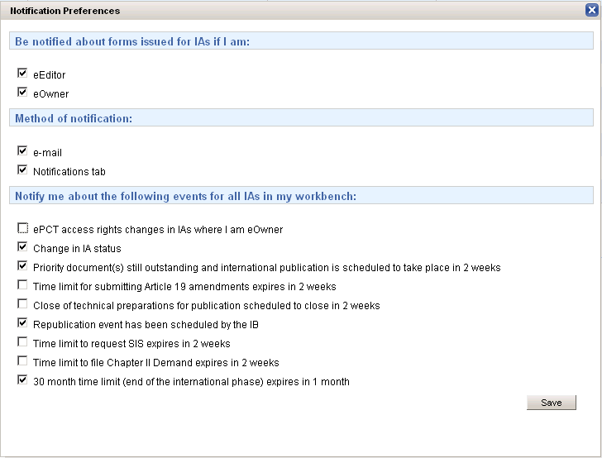

(p) Insert private comments which are not visible to the International Bureau and do not appear on the application file – comments may be either purely personal (only visible to the account holder who writes the comment) or may be entered as a warning message, in which case it is then shared between all users who have access rights to the international application.

(q) Personal history information for actions taken within ePCT (such as changes of access rights or uploading of documents) by the logged-in user in relation to any international application.

(r) History information for actions taken within ePCT by any other person in relation to a particular international application.

Scheduled Improvements to Applicant Services
10 The following improvements to the ePCT applicant services are expected to be introduced in the coming months:

(a) Applicant “actions” which will allow applicants to take certain actions themselves and will eliminate to the extent possible the need to draft correspondence describing requested actions to be taken on their international applications – instead users can indicate the changes directly in the International Bureau’s systems. This should make processing at the International Bureau quicker, more efficient and more accurate since there will be much less scope for misinterpretation of instructions and less need for transcribing information. Instead, in most such cases, the International Bureau will simply need to check that a request is valid and approve it. The first of such actions to be made available will initially include withdrawal of the international application, correction of priority claims and changes to persons, names and addresses under Rule 92bis, with further actions becoming available in subsequent releases of the ePCT system.

(b) “Filters” for long lists of international applications in the workbenches of applicants and agents who handle large numbers of international applications, such as to show all international applications filed by an applicant with a particular name (for example, “Smith”), international applications with priority documents outstanding, or international applications filed between specified dates.

(c) The ability, at the time of initial filing using PCT-SAFE, to specify a WIPO user account so that the account holder will automatically become the “eOwner” in ePCT and will be able to view the file of the international application online as soon as the International Bureau receives and starts to process it (almost immediately after filing in the case of international applications filed at the receiving Office of the International Bureau; as soon as the record copy is received in the case of international applications filed at other receiving Offices).

11 The International Bureau is also developing a web-based online filing component, which will be fully integrated with the system described above, so that access to a draft international application can be shared between several WIPO account holders in the same way as the access rights described above. When the international application is e-filed via this web-based online filing system, any pre-set access rights would remain and at the time of submission the international application would be attributed an international application number and simply move from the drafts section to become a filed application in the user’s main workbench.

12 Initially, this arrangement will be limited to international applications filed at the receiving Office of the International Bureau, but proof of concept work shows that the arrangement can subsequently be extended to other receiving Offices in at least two different ways (subject to the relevant Offices wishing to do so and the arrangements meeting national security requirements in the States concerned):

(a) The International Bureau can operate a separate section of a server on behalf of a receiving Office. The Office could either access this server through a web interface (see paragraphs 15 and 16, below) or potentially by automated means should there be sufficient demand for a suitable machine interface to be developed. The receiving Office’s “as-received” copy of the international application on this server would be visible to the applicant as a single common file shared also as the ePCT “file view” of the International Bureau as shown above but could, if so required by the receiving Office, initially be restricted only to viewing by the receiving Office and the applicant but not by the International Bureau, until the action equivalent to transmitting the record copy to the International Bureau is taken by the receiving Office.
(b) The International Bureau could send the newly filed application on behalf of the applicant to an existing e-filing server hosted directly by a receiving Office. This arrangement would be indistinguishable to the receiving Office from an international application filed using PCT-SAFE. In this case, subject to any additional work to share files between the receiving Office and the International Bureau, the applicant’s view of the file through ePCT would normally be limited to the documents which had been filed and the filing receipt which had been returned by the receiving Office’s server until the International Bureau received the record copy from the receiving Office. Moreover, the information available to the International Bureau’s systems would be sufficient to match up the record copy with the user account which made the electronic filing and the eOwnership and eEditor rights which had been given to the draft application would similarly be retained in relation to the file of the international application in ePCT.

Broader Developments: “The Big Picture”
13 The ultimate goal, bearing in mind the variety of different Offices involved and the paramount importance of security of confidential information and integrity of processing is to provide, to the extent possible:

(a) a consistent service and electronic interface for all applicants across the entire PCT system, irrespective of which Office happens to carry out a particular function;

(b) an efficient process for national Offices of all types and in all their different PCT roles; and

(c) a greater and more consistent supply of information in directly usable form to all interested parties (including applicants, Offices and, to the extent that the international applications have been published, third parties).

14 Applicants should be able to:

(a) log into ePCT securely;

(b) view the complete international application file, including documents at the receiving Office, International Bureau and all competent International Authorities;

(c) see the current processing status at each relevant Office, including requirements which remain outstanding and, ideally, estimates of when search reports and written opinions can be expected;

(d) communicate with any of those Offices through the same ePCT interface;

(e) make as many types of requests as possible directly in the system (in terms of bibliographic information, processing arrangements and changes to the application body alike), by providing information which can be used directly instead of having to write letters which need to be interpreted and the relevant information transcribed; and

(f) as far as possible, work and view information and documents in their own language.

15 Offices should:

(a) have immediate access to all documents and information that they need in formats which are useful to them (as far as possible, processable directly by machines as well as understandable by humans and for the information to be available in their own languages); and
(b) be able to communicate documents and information efficiently between one another so that the fact that the processing is physically distributed around the world does not result in unnecessary delays for the applicant or difficulties for Offices responsible for later stages of processing in meeting the expectations of the applicant.

16 To meet these requirements, it is desirable for the International Bureau’s systems to have access to as much information as possible about the current state of processing in receiving Offices and International Authorities so as to be able to make this information available to the applicant and to other Offices that have a role in processing the international application, as required. Ideally, this would mean secure, real-time access to the files and information held by each Office, together with information being pushed whenever a significant change of processing status occurs within an Office. More realistically for the short to medium term, two main approaches are envisaged, which will also involve a number of sub-options to take into account the reality of the different needs and capacities of the various Offices involved:

(a) For Offices which have their own dedicated systems for their work as receiving Offices or International Authorities, the Offices should be encouraged to copy all significant documents to the International Bureau’s files to allow the applicant to view it in ePCT. The International Bureau should provide any necessary improvements to the machine interfaces to its systems to ensure that these Offices are sent all useful information in a timely and usable fashion and are able to access the International Bureau’s files on demand in relation to applications for which they are a competent receiving Office or International Authority.

(b) For Offices which do not currently have dedicated systems, the International Bureau intends initially to offer secure web-based access to its files and a document upload service, similar to the services currently available for applicants. As a next phase, it will offer to provide receiving Office functionality under a “SaaS” (Software as a Service) model. This service, in combination with the web-filing system referred to in paragraph 11, above, would allow any Office (subject to the arrangements meeting national security requirements in the State concerned) to allow its residents and nationals the option of electronic filing without the need to use the receiving Office of the International Bureau instead of the national receiving Office. Initially, the service available to receiving Offices would probably be largely limited to ensuring the receipt of international applications and according of filing dates; other functions would be gradually added until all functions of a receiving Office would be offered (noting that it would not be obligatory to use all of the functions – in particular, many Offices would need to use a separate financial system and in the International Bureau’s system merely flag whether the relevant fees had been paid).

Outline of Systems Involved

17 Ideally, transmission of messages between different Offices would be carried out via the International Bureau’s ePCT system. This would allow an Office to use a single channel of communication for all purposes (potentially including to applicants, to the extent that they agree to receive communications through ePCT and not on paper). It would also allow certain processing steps to be eliminated, such as notifications to the International Bureau that a search copy had been received by the International Searching Authority.

18 The benefits sought by the International Bureau from these improved communications are not limited to eliminating mailing delays and allowing the applicant to gain a complete file view from a single source. It is also desired to improve the quality of the data being passed. In particular, in developing the receiving Office functions referred to in paragraph 16(b), above, the International Bureau aims to provide a system which does not simply produce forms equivalent to those currently used for recording an action or pointing out a defect (though such forms may well be produced as a file record and a convenient way of expressing the information), but rather a system which records the meaning of an action in a way which allows the system to show more detailed processing information and pass it on to Offices and applicants in a way which can be understood by other systems and, potentially, can also allow the information to be displayed in any language of publication chosen by the reader. Similarly, Offices with their own automated systems are encouraged to supply documents and data in directly machine-readable formats.

19 The International Bureau does not currently have plans to provide hosted services for International Authorities since these Offices will generally have their own systems which may be closely integrated with their search systems, though simple file views and document upload services should be made available at the same time as those for receiving Offices. Analysis in this area is mainly focused on improving machine interfaces and data formats for communication between the systems of the International Bureau and the International Authorities. The most important areas are considered to be the transmission of international search reports, written opinions and international preliminary reports on patentability in a consistent XML format, and allowing full text versions of international applications and any required translations thereof to be effectively filed, corrected, rectified and amended, bearing in mind the need for effective coordination and consistent standards since changes of various types could be made in each of the receiving Office, the International Searching Authority, the International Bureau and the International Preliminary Examining Authority, the timeframes for actions before each Office overlapping with one another.

Demonstration of Existing System
20 A fully functional demonstration version of the existing system for applicants is available from https://pctdemo.wipo.int/epct/. To try it out, you will need to obtain a WIPO digital certificate and associate it with a WIPO online user account, according to the instructions in the ePCT User Guide, which is also available from that link. PCT-SAFE works with this system. If you make a demo mode filing to RO/IB and provide an e-mail address for the purpose of receiving electronic notifications, you will receive an e-mail with a mock-up of Form PCT/IB/301 as if the International Bureau had received a record copy. Using the code at the bottom of that Form, you should then be able to confirm “e-ownership” of the demo filing and access online the contents of the application as filed.

21 The Meeting is invited to comment on the ePCT system and outline of plans set out above.

[End of document]

