
E
PCT/mia/18/8
OriGINAL: English only
DATE: February 24, 2011
Meeting of International Authorities under the Patent Cooperation Treaty (PCT) Working Group
Eighteenth Session
March 15 to 17, 2011, Moscow
Standardized Clauses in PCT International Search and Preliminary
Examination Reports
Proposal by the Canadian Intellectual Property Office

Summary
Currently, the fields in the Patent Cooperation Treaty (PCT) search and examination forms encompass many free text areas. International Authorities provide explanations in these areas using their own style and text format, such that there is little consistency among the reports from different International Authorities. It is proposed that a standardization of the style and format of the text used in these areas be adopted, to improve the clarity, consistency and value of these reports to all users.

background
At both the third session of the PCT Working Group (WG) and the 17th Meeting of the International Authorities (MIA), much consideration was given to improving the PCT system, including the quality and usefulness of reports generated by the International Authorities. It is generally accepted that improvements should be sought which can be implemented without changing the PCT legal framework.
The PCT User Survey done by the International Bureau between October 1, 2009 and January 31, 2010 identified the need for an improved quality of search and examination reports. It was acknowledged at the 17th MIA that an improvement in the quality of international phase work would encourage its use in the national phase. Additionally, high quality reports were identified as essential to not only offices and applicants, but also for setting up effective work sharing mechanisms based on PCT work products, such as PCT-PPH projects. It was noted that any change to the existing system must be made as efficiently as possible, so as to not impose any additional burden on International Authorities.
Specific areas identified for improving the usefulness of reports included giving better explanations of objections (notably concerning inventive step), more consistently observing the requirements of the Treaty in preparing the reports, and the simplification of the presentation of reports.
These suggestions were accepted and reinforced at the third PCT WG in the discussion on the need for improving the functioning of the PCT system, notably that good explanations should be given on the relevance of cited documents.

Contents of the Proposal
Currently, the PCT search and examination reports encompass many free text areas, which leads to variability in the style and content of the information presented. A list of the specific free text areas where standardized paragraphs would be most useful in forms PCT/ISA/210 (International Search Report), PCT/ISA/237 (Written Opinion of the International Searching Authority), PCT/IPEA/408 (Written Opinion of the International Preliminary Examining Authority), and PCT/IPEA/409 (International Preliminary Report on Patentability) is provided in Annex I.
It is proposed that all International Authorities use standardized paragraphs in completing the international search and preliminary examination reports, specifically of the areas indicated in Annex I. (Of note, if the initiative is successful it could be expanded to cover other PCT forms as well.)
Examples of standardized clauses for search and preliminary examination reports are provided in Annex II. The standardized clauses could also be used in a consistent order, to facilitate ease of following the reports.
Examiners will be prompted to enter the required information when making an objection. An example of how this process can be implemented in provided in Annex III.

Benefits of the use of Standardized Paragraphs:
The introduction of standardized paragraphs for use in the free text areas of PCT search and examination reports would help achieve an increase in the quality and usefulness of these reports and could be implemented without any change to the PCT Regulations.
Standardizing the language and formatting of the free text areas of the PCT forms will enable all end users of the forms, both examining and non-examining, to quickly and easily obtain the required information from the written text. If the report is not in a language understood by the reader, such a standardized format would help with knowing what portions need to be translated and, with experience, what general information is in the field in the absence of translation. Both of these factors will assist in increasing the clarity of the PCT reports.
Further, the use of uniform clauses will result in all International Authorities including the same set of information in each report and will encourage a common level of explanation given for each comment. This will result in the assurance that the PCT reports are comprehensive, will facilitate the consistent production of high quality reports, and will enable all users to have a thorough report available to them.
Each International Authority would still be able to provide as much explanation as they deem necessary in explaining the objections, and there is still some flexibility in the overall text written. Of note, such standardization of clauses for the free text areas of the PCT search and preliminary examination reports does not change the non-binding nature of the opinions expressed therein.

Next Steps
If it is agreed that standardized paragraphs are to be used in completing international search and preliminary examination reports, International Authorities would need to provide input on the language of the standardized paragraphs, as well as on a common format to be followed in ordering objections in reports.
The resulting initial set of paragraphs would be used by all International Authorities in their reports, and these could be modified and additional paragraphs included on a regular basis.
The Meeting is invited to comment on the proposal by the Canadian Intellectual Property Office.

[Annexes follow]
ANNEX I
FREE TEXT AREAS IN ISA AND IPEA FORMS

PCT/ISA/210 (International Search Report)

Box II – Observations where certain claims were found unsearchable
Box III – Observations where unity of invention is lacking

PCT/ISA/237 (Written Opinion of the International Searching Authority)

Box III – Non-establishment of opinion with regard to novelty, inventive step and industrial applicability
Box IV – Lack of unity of invention
Box V – Reasoned statement under Rule 43bis.1(a)(i) with regard to novelty, inventive step and industrial applicability; citations and explanations supporting such statement
Box VII – Certain defects in the international application
Box VIII – Certain observations on the international application

PCT/IPEA/408 (Written Opinion of the International Preliminary Examining Authority)

Box III – Non-establishment of opinion with regard to novelty, inventive step and industrial applicability
Box IV – Lack of unity of invention
Box V – Reasoned statement under Rule 66.2(a)(ii) with regard to novelty, inventive step and industrial applicability; citations and explanations supporting such statement
Box VII – Certain defects in the international application
Box VIII – Certain observations on the international application

PCT/IPEA/409 (International Preliminary Report on Patentability)

Box III – Non-establishment of opinion with regard to novelty, inventive step and industrial applicability
Box IV – Lack of unity of invention
Box V – Reasoned statement under Article 35(2) with regard to novelty, inventive step and industrial applicability; citations and explanations supporting such statement
Box VII – Certain defects in the international application
Box VIII – Certain observations on the international application

[Annex II follows]
ANNEX II
EXAMPLES OF STANDARDIZED CLAUSES

In Box II of form PCT/ISA/210 (International Search Report):

Claim(s) (XXX) (is/are) considered to be a mere scientific principle or mathematical (theory/theories/theorem/theorems), which the International Search Authority is not required to search under Rule 39.1(i) of the PCT.

In Box V, 2. (Citations and explanations) of forms PCT/ISA/237 (Written Opinion of the ISA), PCT/IPEA/408 (Written Opinion of the IPEA) and PCT/IPEA/409 (International Preliminary Report on Patentability):

Reference is made to the following documents:

D1: (Insert bibliographic information…).
D2: (Insert bibliographic information…).
Etc.

D1 discloses (insert brief description of the document…)
D2 discloses (insert brief description of the document…)
Etc.

The alleged invention of the instant application is (insert brief description of the claimed subject matter of the instant application…)

Novelty (Article 33(2) of the PCT):

Claim XX appears novel and in compliance with Article 33(2) of the PCT. Document DX is considered the closest prior art and discloses (insert explanation...).
The subject matter of claim XX differs from the prior art by (insert explanation…).

Inventive Step (Article 33(3) of the PCT):

Claim XX does not comply with Article 33(3) of the PCT. The subject matter (claimed in this application) OR (of this claim) is not considered to involve an inventive step, having regard to / in view of (insert explanation…).

Industrial Applicability (Article 33(4) of the PCT):

The subject matter of claim XX is considered to be industrially applicable and in compliance with the requirements of Article 33(4) of the PCT.

In Box VIII of forms PCT/ISA/237 (Written Opinion of the ISA), PCT/IPEA/408 (Written Opinion of the IPEA) and PCT/IPEA/409 (International Preliminary Report on Patentability):

Claim XX does not comply with Article 6 of the PCT because the claimed characteristic (Describe claimed characteristic...) lacks proper support in the present description.

The description does not clearly, correctly and fully describe the alleged invention and its operation or use to enable any person skilled in the art to practice the alleged invention. Therefore, the description does not comply with Article 5 of the PCT and Rule 5.1(a)(vi) of the PCT. (Compulsory explanation).

Claim XX does not comply with Article 6 of the PCT. The claim shall be clear and concise. (Compulsory explanation).

[Annex III follows]
ANNEX III
EXAMPLE OF A MACRO-BASED SYSTEM FOR ENTERING
STANDARDIZED PARAGRAPHS INTO FORMS

Top Menu:

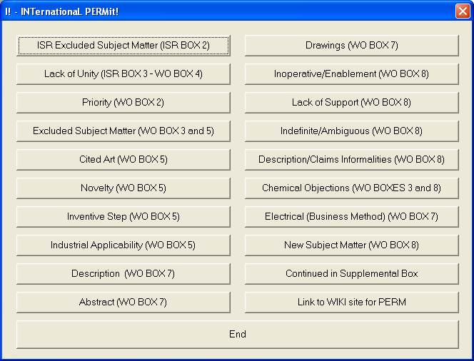

Sub-menu “ISR Excluded Subject Matter (ISR Box 2)”

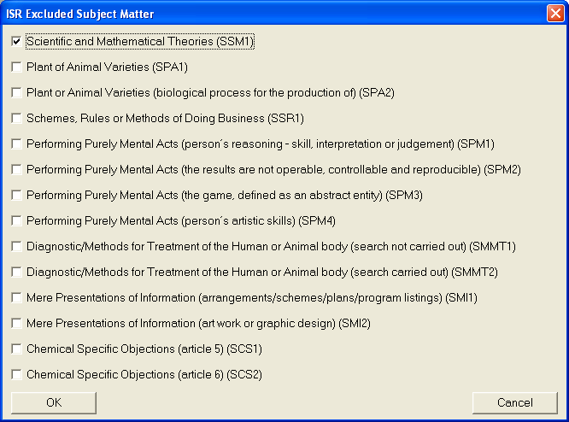

Sub-menu “Scientific and Mathematical Theories (SSM1)”:

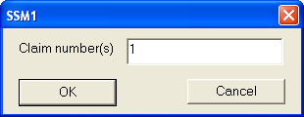
After pressing “OK”, the following text is inserted into the form:
“Claim 1 is considered to be a scientific and mathematical theory, which the International Search Authority is not required to search.”
Sub-menu “Novelty (WO Box 5)”:

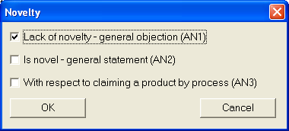

Sub-menu “Lack of novelty – general objection (AN1)”:

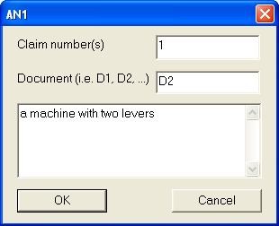
After pressing “OK”, the following text is inserted into the form:
“Claim 1 is not novel and does not comply with Article 33(2) of the PCT. Document D2 discloses a machine with two levers. Given the above objection, claim 1 is also considered to lack an inventive step in light of the described prior art and thus fails to comply with Article 33(3) of the PCT.

Sub-menu “Lack of Support (WO Box 8)”:

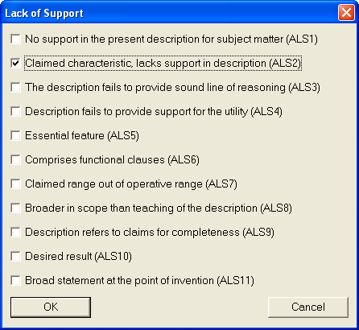

Sub-menu “Claimed characteristic, lacks support in description (ALS2)”:

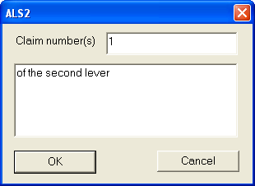
After pressing “OK”, the following text is inserted into the form:
“Claim 1 does not comply with Article 6 of the PCT because the claimed characteristic of the second lever lacks proper support in the present description.”

[End of Annex III and of document]

Document PCT/MIA/17/12, paragraph 45
Document PCT/MIA/17/7, Annex II, paragraph 73
Document PCT/MIA/17/12, paragraph 14(m)
Document PCT/MIA/17/12, paragraph 47
Document PCT/MIA/17/12, paragraph 49(c)
Document PCT/WG/3/2, paragraph 170(d)

