WIPO |  | E  PCT/MIA/17/9  ORIGINAL: English only  DATE: February 2, 2010
WORLD INTELLECTUAL PROPERTY ORGANIZATION
GENEVA
INTERNATIONAL PATENT COOPERATION UNION
(PCT UNION)
MEETING OF INTERNATIONAL AUTHORITIES
UNDER THE PATENT COOPERATION TREATY (PCT)
Seventeenth Session
Rio de Janeiro, February 9 to 11, 2010
Paragraph Amendment of PCT Applications
Document prepared by the International Bureau

Summary

There is an increasing desire amongst highly automated Offices to introduce “end to end” electronic processing of international applications (meaning from the point of first digitization by the receiving Office or the International Bureau in cases where international applications are filed on paper) and, in particular, to use text formats for the application body rather than merely electronic images of pages. Such an arrangement must not only benefit those Offices, but at least maintain the current level of service (and preferably improve it) for those Offices and applicants who will need to continue to use a page-based system for a long period to come.

International Authorities are invited to comment on the requirements of a system allowing for processing of international applications in text format, taking into account their role in handling amendments, their need to interact with many receiving Offices and applicants from a wide variety of Contracting States, and the need for the end result to be useful to all designated Offices and third parties.

Background

From the beginning of PCT electronic filing, it has been recognized that “character coded” forms of international application provided the greatest potential for making processing of the application more efficient, for increasing the quality of international searches, and for providing improved services to applicants, Offices and third parties wishing to use the technical information in the international application alike. To encourage filings in character coded format, Annex F of the Administrative Instructions under the PCT included XML as part of the “basic common standard” which was to be accepted by all receiving Offices, and the Schedule of Fees offered a larger reduction in the international filing fee for use of that format.

However, up to now, while the character coded bibliographic information in the electronic request form has been used directly to greatly improve the efficiency and accuracy of formalities processing within the International Bureau, relatively little use has been made of the character coded (XML) version of the application body. Indeed, there remain some cases where an application may be filed in XML format only for the rendered page-based view of the text to be printed by the receiving Office and posted to the International Searching Authority, where it is scanned in again. This is not only inefficient and losing the advantages of the text-based format, but risks losing important information, especially in the drawings. This, in turn, may result in a more difficult or less effective international search.

One of the barriers to the development and more widespread implementation of Office systems for processing XML applications directly, as well as to the use of XML by applicants, is that there is no common method defined under the PCT for allowing these applications to be amended directly in their XML format. For example, if a rectification of an obvious mistake needs to be made, the applicant has to furnish a replacement sheet containing the rectified text. This is then incorporated into a page-based rendering of the international application, essentially as an image of the page. At least for international applications filed in Japanese or Korean languages, a text-based version of the amended application is usually also prepared by the International Bureau, but this is not the basis for further official processing.

Some national systems permit amendment of applications using XML. However, under the PCT it is essential to ensure that the amendments are done in a consistent manner which produces an end product suitable for all designated Offices. Noting that the actual process of amendments could in principle be carried out by up to four different Offices in the international phase, one aspect of this is ensuring that designated Offices have sufficient, reliable and effective information about the international application as initially filed and the differences which are introduced by the amendments.

Discussion of processes for paragraph based amendment has been stalled for several years, mainly over the issue of how to number paragraphs in the event that paragraphs were inserted or deleted by an amendment. Proposals by the International Bureau in 2002 for “branch numbering” (where successive insertions between paragraphs might be numbered “[0004.1]” or “[0004.1.1]” as required to avoid renumbering the surrounding paragraphs) and for complete renumbering of international applications with each change were both opposed by various Offices.

It should also be recalled that any system for paragraph-based amendments under the PCT must:

be practical to implement for the International Bureau and Offices who need to process the amendments;

be easy for applicants of all types to use; and

deliver end results which meet the needs of Offices in all Contracting States.

These considerations need to take into account, inter alia:

the differing levels of automation in different Offices;

any legal concerns of Contracting States

the systems which applicants use (or would be prepared to use) for preparing their patent applications; and

the fact that applications will certainly continue to be filed in a variety of different formats (including PDF and paper as well as XML) for a significant period to come.

Paragraph Numbering

WIPO Standard ST.36 contains a standard for processing of patent information using XML. The Standards and Documentation Working Group’s ST.36 Task Force has recently been considering a proposal for revision of this standard (PFR ST.36 2009/007, “Corrections and Changes in Patent Documents”) to develop a common system for recording changes which have been made to an application body. In discussions relating to that proposal, the arrangement shown in the diagram below was proposed in respect of paragraph numbering.

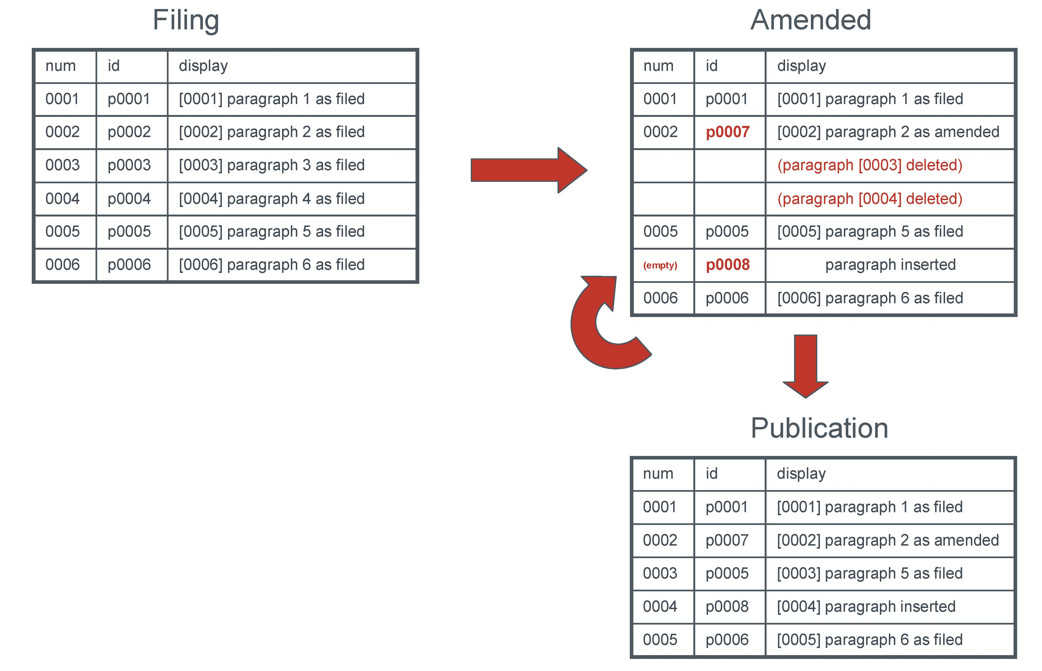

It should be explained that in the XML standard for application bodies, every paragraph (similarly with figures and many other components) has two “attributes” which are associated with the paragraph, but not part of its text:

A unique identifier (“id”) which is intended to be assigned when the application is created in order to identify that paragraph uniquely and never changed throughout the life of the application (though the text of the paragraph might be amended). This is intended to assist machine processing and is never displayed in the normal “human readable” version of the text.

A number (“num”) which is displayed in square brackets in front of the paragraph. According to the standard, this is required, but is permitted to be blank. This number can be automatically changed very easily – many XML editors renumber paragraphs consecutively as users add or delete paragraphs.

Subject to any further comment by Contracting States, this arrangement looks acceptable for use in the PCT system, though the box titles shown may be misleading in the context of the processes likely to be used in the international phase:

The international publication and any versions of the international application amended under Article 34 which were transmitted to elected Offices would be prepared in accordance with the box titled “Amended” so that they could be treated as if they were part of the early stages of national processing.

The arrangement in the box titled “Publication” would represent the fact that designated and elected Offices would be at liberty to renumber the paragraphs for their national publications, or indeed at any stage of national phase processing where it seemed appropriate to them.
Numbering amended applications in that way appears to meet the basic needs of all designated Offices:

For Offices which require “branch numbering” for their national processes, it would simply be an issue of inserting the relevant numbers into those paragraphs which lacked a number in the PCT document; in principle (according to the remainder of the proposal for change), the XML file should contain sufficient information on the amendments which have been made for this to be automated accurately.

For those which cannot accept branch numbering, it would not appear in the PCT document and renumbering of all the paragraphs, should that be required, is technically extremely simple.

While there is a theoretical problem in reliably referring to paragraphs which have been inserted and have no number, it will rarely be the case that there are a large number of these. This will be a much smaller issue than the fact that most applications filed on paper have no paragraph numbering at all.

Incorporation and Presentation of Revisions

The proposed arrangement in PFR ST.36-2009-007 for dealing with paragraph-based amendment of applications essentially says that an XML application body file should contain:

a main part with the latest version of the application; and

a separate “document amendments” section at the end, containing (in cases where there is a need for version information) details of all the changes which have been made,

so that it is, in principle, possible to reconstruct the original (or any intervening) form of the international application and show the differences between that and the current text.

The International Bureau is evaluating whether this arrangement could meet the needs of the PCT. Some of the issues are mainly internal matters for the International Bureau and others will require careful consultation with Contracting States. Some of the questions so far identified include:

Can the International Bureau create files in this format easily and accurately?

Can receiving Offices and International Authorities ensure that new application body files are created in this format easily and accurately for amendments which are their responsibility?

Will the International Bureau need to offer software kits or complete software packages for Offices wishing to deal with paragraph-based amendments?

Will there need to be new arrangements for the International Bureau to incorporate amendments on behalf of receiving Offices and International Authorities who cannot or do not wish to handle paragraph-based amendments directly?

Will XML files in this format meet the needs of Offices who wish to process their applications in XML? Here, it should be noted that the main body of the XML will show no indication of whether individual paragraphs are original ones or subsequent amendments. Given that the correspondence relating to the amendments will be in the files of several different Offices, not all in the International Bureau’s files, it may be more important than for purely national processing that the information in the document-amendments section is both sufficient and usable by designated Offices.

Can the International Bureau easily and reliably render page-based views of the XML files containing sufficient information for designated Offices and third parties using traditional views of the application to see where changes have been made since the international filing date and compare the original and latest texts?

Will the system be able to deal with cases where amendments occur “out of order”? For example, the applicant might request the International Searching Authority to rectify an obvious mistake in an originally filed paragraph, but by the time this has been agreed and the information transmitted to the International Bureau, an amendment under Article 34 could already have been made to the same paragraph before the International Preliminary Examining Authority.

Will applicants need special software to file paragraph-based amendments in a way which can be easily handled by Offices?

Will the process of filing paragraph-based amendments (whether requiring special software or not) be sufficiently simple for applicants to want to use this approach?

Will the approach be used solely for international applications initially filed in XML format or will there be either a possibility or requirement to make amendments that way for international applications filed in paper, PDF or other page-based formats? The answer to this question may also open further questions about the status, quality and other standards relating to OCR of international applications.

The Meeting is invited to comment on:

whether the system of paragraph numbering referred to in paragraphs to would meet the needs of International Authorities and would be likely to meet the needs of designated Offices;

whether the list of questions in paragraph covers all the main points which need to be analyzed before making a proposal on paragraph-based amendments of international applications; and

any other issues which should be addressed related to introducing a system allowing paragraph-based amendments.

[End of document]

In this document, the term “amendment” is used to cover generically the processes of correction, rectification, amendment and confirmation of incorporation by reference.

