WIPO |  | E  PCT/MIA/11/9  ORIGINAL: English only  DATE: February 1, 2005
WORLD INTELLECTUAL PROPERTY ORGANIZATION
GENEVA
INTERNATIONAL PATENT COOPERATION UNION
(PCT UNION)
MEETING OF INTERNATIONAL AUTHORITIES
UNDER THE PATENT COOPERATION TREATY (PCT)
Eleventh Session
Geneva, February 21 to 25, 2005
PCT Minimum Documentation:
Korean Patent Documents
Document prepared by the International Bureau

Summary

The Meeting is invited to make recommendations on a proposal of the Korean Intellectual Property Office to add Korean patent documents to the PCT minimum documentation.

Background

In a letter from the Commissioner dated January 25, 2005, reproduced in the Annex, the Korean Intellectual Property Office proposes that the Meeting should discuss the addition of Korean patent documents to the PCT minimum documentation. The extent of the relevant documentation, together with the benefits of including this material in the PCT minimum documentation are set out in the letter.

Legal Basis

The national patent documents which form a part of the PCT minimum documentation are defined by Rule 34.1(c) to (f) as follows:

“(c) Subject to paragraphs (d) and (e), the ‘national patent documents’ shall be the following:

“(i) the patents issued in and after 1920 by France, the former Reichspatentamt of Germany, Japan, the former Soviet Union, Switzerland (in the French and German languages only), the United Kingdom, and the United States of America,

“(ii) the patents issued by the Federal Republic of Germany and the Russian Federation,

“(iii) the patent applications, if any, published in and after 1920 in the countries referred to in items (i) and (ii),

“(iv) the inventors’ certificates issued by the former Soviet Union,

“(v) the utility certificates issued by, and the published applications for utility certificates of, France,

“(vi) such patents issued by, and such patent applications published in, any other country after 1920 as are in the English, French, German or Spanish language and in which no priority is claimed, provided that the national Office of the interested country sorts out these documents and places them at the disposal of each International Searching Authority.

“(d) Where an application is republished once (for example, an Offenlegungsschrift as an Auslegeschrift) or more than once, no International Searching Authority shall be obliged to keep all versions in its documentation; consequently, each such Authority shall be entitled not to keep more than one version. Furthermore, where an application is granted and is issued in the form of a patent or a utility certificate (France), no International Searching Authority shall be obliged to keep both the application and the patent or utility certificate (France) in its documentation; consequently, each such Authority shall be entitled to keep either the application only or the patent or utility certificate (France) only.

“(e) Any International Searching Authority whose official language, or one of whose official languages, is not Japanese, Russian or Spanish is entitled not to include in its documentation those patent documents of Japan, the Russian Federation and the former Soviet Union as well as those patent documents in the Spanish language, respectively, for which no abstracts in the English language are generally available. English abstracts becoming generally available after the date of entry into force of these Regulations shall require the inclusion of the patent documents to which the abstracts refer no later than six months after such abstracts become generally available. In case of the interruption of abstracting services in English in technical fields in which English abstracts were formerly generally available, the Assembly shall take appropriate measures to provide for the prompt restoration of such services in the said fields.

“(f) For the purposes of this Rule, applications which have only been laid open for public inspection are not considered published applications.”

For Korean patent documents to be added to the PCT minimum documentation, a decision of the PCT Assembly would be required to amend Rule 34. Any such decision would need to take into account the relevant range of document dates and types which should be included and the date from which it would be practical to bring such a rule change into force.

The Meeting is invited to make recommendations on the proposal of the Korean Intellectual Property Office in the Annex and on the issues which would need to be taken into account by any decision of the PCT Assembly on the proposal.

[Annex follows]
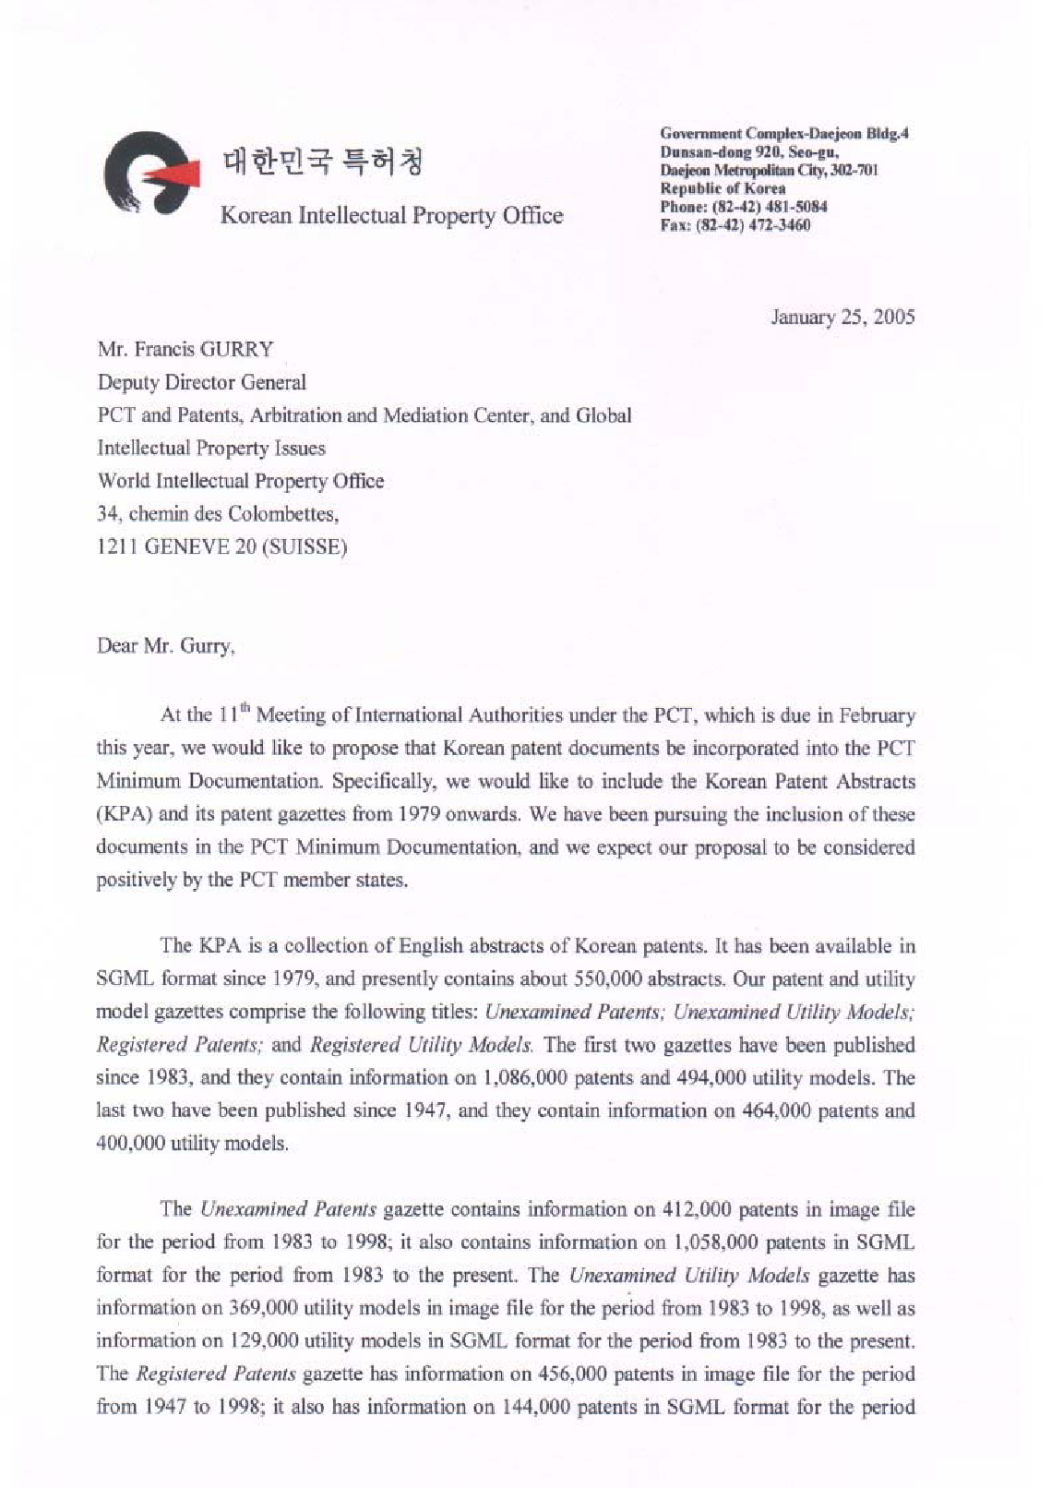
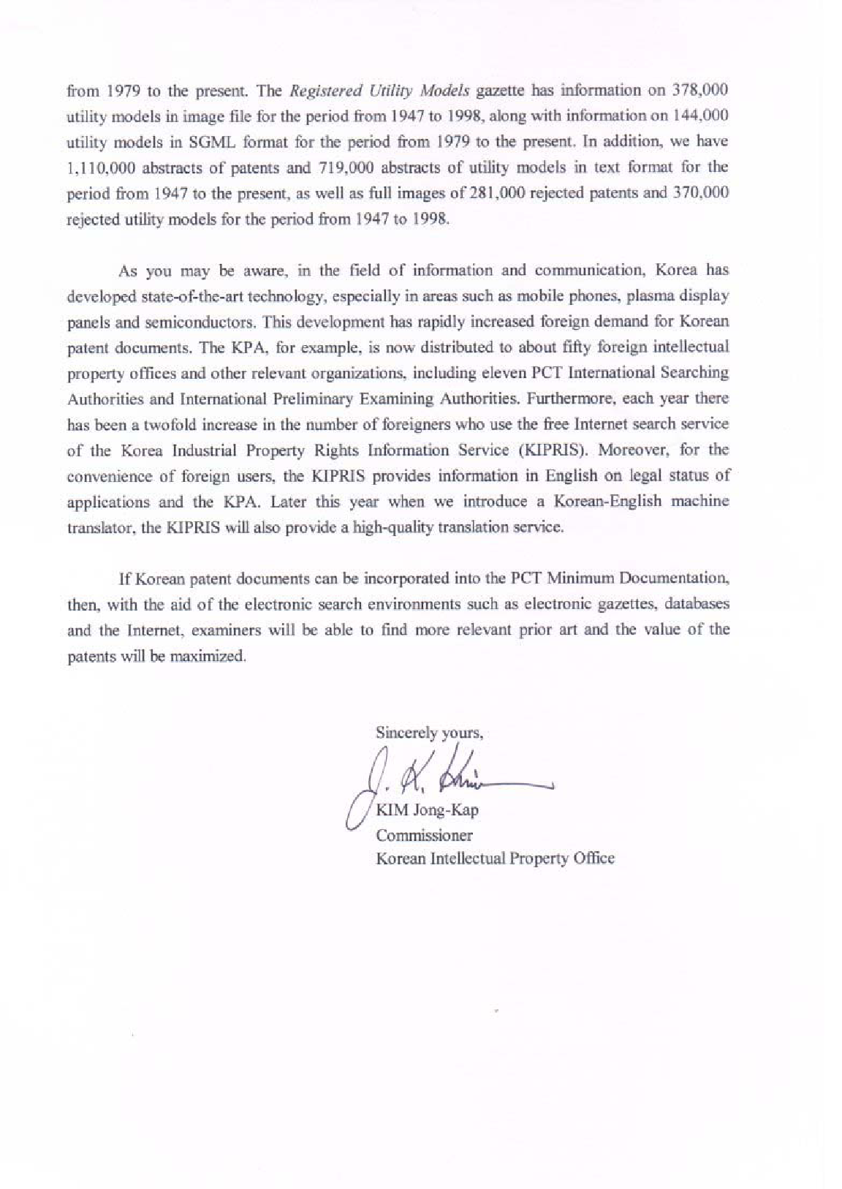
[End of Annex and of document]

