WIPO |  | E  PCT/MIA/11/12  ORIGINAL: English only  DATE: February 16, 2005
WORLD INTELLECTUAL PROPERTY ORGANIZATION
GENEVA
INTERNATIONAL PATENT COOPERATION UNION
(PCT UNION)
MEETING OF INTERNATIONAL AUTHORITIES
UNDER THE PATENT COOPERATION TREATY (PCT)
Eleventh Session
Geneva, February 21 to 25, 2005
Detailed Proposal for Modification of PCT Forms
Document prepared by the United States Patent and Trademark Office

Summary

1. Proposals for modification of PCT Forms PCT/ISA/210, PCT/ISA/237, PCT/IPEA/408, and PCT/IPEA/409 as they pertain to sequence listings and tables related thereto are set forth in Annexes I to IV of this document. Annexes V to VIII contain the relevant portions of those forms as presented by the International Bureau in Circular C. PCT 1012, which contained draft modified forms, proposed to be introduced with effect from April 1, 2005.

Background

2. The United States Patent and Trademark Office (USPTO) raised concerns regarding various PCT forms relating to sequence listings and tables related thereto, and Box No. I of Form PCT/ISA/237 at the tenth session of the Meeting of International Authorities held in Geneva, September 13 to 15, 2004. The Meeting accepted the offer of the USPTO to present a detailed proposal for modification of some of the forms (see document PCT/MIA/10/11, paragraphs 17 to 19) as outlined in the following paragraphs:

“17. One Authority pointed out that the portions of the new versions of Forms PCT/ISA/210, PCT/ISA/237, PCT/IPEA/408 and PCT/IPEA/409 which related to sequence listings were confusing and, in certain circumstances, misleading. An international application might contain either a sequence listing only, or else a sequence listing and tables, and the required indications regarding the listing and any tables might be different. Also, the term ‘written format’ was ambiguous in view of the redefinition in Part 8 of the Administrative Instructions of the term ‘computer readable form’. Finally, the question of time of filing should not apply to tables, since Rule 13ter did not permit the furnishing of a table relating to sequence listings after the international filing date for the purpose of the international search, but only provided for the furnishing of the sequence listing itself. The Meeting was pleased to accept the offer of the United States Patent and Trademark Office to present detailed proposals for modification of the sequence listing parts of these Forms.

“18. The Meeting agreed with the suggestion by one Authority that Box No. I (‘Basis of This Opinion’) of Form PCT/ISA/237 was confusing for both applicants and examiners since, in most cases, no boxes at all would be checked because the international search was carried out on the basis of the international application in the language in which it was filed and there was no sequence listing. It was suggested that the indications regarding the language version which had been searched might be moved to the cover sheet. Alternatively, item 1 of Box No. I should contain two boxes, one indicating that the international search was carried out on the basis of the international application in the language in which it was filed and an alternative indicating that the international search was carried out on the basis of a translation.

“19. The Meeting was pleased to accept the offer of the United States Patent and Trademark Office to present a detailed proposal for modification of the cover sheet and Box No. I of Form PCT/ISA/237.”

Revision of the Forms

3. The proposed revisions to the relevant portions of PCT Forms PCT/ISA/210, PCT/ISA/237, PCT/IPEA/408, and PCT/IPEA/409 (attached in Annexes I to IV) are to correct misunderstandings concerning sequence listings and tables related thereto. In addition to the discussion in paragraphs 17 to 19 of the report from the last (tenth) session of the Meeting of International Authorities, the necessity for the suggested revisions will be further outlined in the below discussion of the differences in location, use, and processing of sequence listings and tables related to sequence listings.

4. Where nucleotide and/or amino acid sequences are disclosed in an international application, Rule 5.2(a) requires that the application contain a sequence listing part of the description in compliance with the standard provided for in the Administrative Instructions, Annex C. The sequence listing part of the description is physically located after the drawings and is (preferably) independently numbered (Section 207(iv) of the Administrative Instructions). The applicant may also be required by the ISA to file an electronic form of the sequence listing to be used as a search tool. This search tool is not part of the international application. The size of the sequence listings in certain biotech applications can be extremely large, e.g., tens of thousands of pages. Part 8 of the Administrative Instructions allows the applicant to file the sequence listing part of the description in electronic form rather than on paper, in addition to the electronic form required for search purposes. When the applicant discloses sequences in an international application but does not supply a sequence listing part of the description and/or an electronic form for search purposes, or if one or the other does not comply with Annex C, the ISA may invite the applicant to provide a compliant copy (Rule 13ter.1) for search purposes (i.e., for searching the sequence against a database of known sequences and possibly for review by the examiner). Any sequence listing part of the description provided subsequent to the international filing date does not, subject to Article 34, form part of the international application (Rule 13ter.1(e)).

5. An international application that discloses sequences may also contain tables with information related to those sequences. However, the Regulations do not specify that the tables form a distinct part of the description (Rule 11.10(c)), unlike the sequence listings themselves. Therefore, in the description, sheets containing such tables may also include text matter and thus it may not be easy to count the tables related to sequence listings separately from the remainder of the description. Like sequence listings, tables related thereto can be extremely large and Part 8 also allows the applicant to file tables related to sequence listing in electronic form rather than on paper. While the tables contain information related to the sequences and may be “text-searched”, they are not used as a search tool in the same way as the electronic form of the sequence listing. The term “table” is not defined, and consequently, tables are not required to be presented in a specified, uniform manner amenable to search. For this reason, the International Searching Authority (ISA) would not invite the applicant to provide an electronic form of the tables for search purposes in addition to any tables already provided as part of the description, either where it was not provided, or where it did not comply with Annex C-bis. Rule 13ter.1 authorizes the ISA to invite the applicant to submit sequence listings for use as a search tool only and not as a part of the international application. Since the ISA would not use an electronic form of the table part of the description as a search tool, there is no need for a provision allowing the ISA to invite the applicant to provide one. If the ISA did invite the applicant to provide an electronic form of the table, that table would not constitute a part of the application (Rule 13ter.1(e)) and therefore it would not correct any defects in the international application as such. Thus, Section 802(b-quater), which indicates that Rule 13ter.1 applies mutatis mutandis to any tables not complying with Annex C-bis, is not necessary, and results in complication rather than simplification.

Further Work

6. As set forth in Article 14(1)(a)(v), the receiving Office is required to check whether an international application complies with the prescribed physical requirements provided in the Regulations. If any part of the international application is provided in electronic form, as per Rule 89bis.1(c), the physical requirements provided for in the Administrative Instructions for the filing of an international application in electronic form must be checked. Therefore, any receiving Office prepared to accept the filings of sequence listings and/or tables related thereto in electronic form under Part 8 should review the electronic submission for compliance with these requirements. While Section 801(d) specifies that the receiving Office verify that the electronic submission has been provided on a medium specified by that Office, it does not specify that the receiving Office should also review the electronic submission for the above-mentioned physical requirements. Therefore, the Receiving Office Guidelines and Administrative Instructions, particularly Part 8, need to be carefully reviewed and modified to address the above concerns as an overall review of procedures for handling sequence listings and tables relating thereto.

7. Further, in the course of reviewing the present forms for revision, it was discovered that more extensive revisions of numerous other forms are needed with respect to sequence listings and related tables. Suggestions for such additional changes have been presented to the International Bureau in the context of the USPTO response to Circular C. PCT 1012.

8. The Authorities are invited to consider the proposed modifications to PCT Forms contained in Annexes I to IV.

[Annex I follows]
Basis Of The Report, Item 1.a.

1. Basis of the report
a. With regard to the language, the international search was carried out on the basis of:
□ the application in the language in which it was filed.
□ a translation of the application from the original language into the following language , which is the language for the purposes of international search (under Rules 12.3 and 23.1(b)).

[COMMENT: The suggested change to item 1.a., Basis of the report, is for consistency with the suggested change to Form PCT/ISA/237 as per paragraph 18 of document PCT/MIA/10/1.]

Box No. I, Nucleotide And/Or Amino Acid Sequence(s)

Box No. I Nucleotide and/or amino acid sequence(s) (Continuation of item 1.b of the first sheet)
1. □ With regard to any nucleotide and/or amino acid sequence disclosed in the international application and necessary to the claimed invention, the international search was carried out on the basis of:

□ the sequence listing part of the description filed as of the international filing date and complying with the standard provided for in the Administrative Instructions
□ in paper form
□ in electronic form

□ the sequence listing in electronic form filed together with the international application for search purposes only

□ the sequence listing subsequently filed for search purposes only
□ in paper form
□ in electronic form

2. □ The required statement that the sequence listing in electronic form is identical to the sequence listing on paper, or that multiple copies of the sequence listing in electronic form are identical to each other, has been furnished.

3. □ For any subsequently filed sequence listing, the required statement that the sequence listing does not go beyond the disclosure of the application as filed, has been furnished.

4. Additional comments:

[COMMENT: The suggested change to Box No. I is as per paragraph 17 of document PCT/MIA/10/11. Specifically, item 1 no longer references table(s) related to sequence listings and has been reformatted accordingly. Item 2 has been rewritten as items 2 and 3 to address the different required statements individually.]

[Annex II follows]
Box No. I, Basis Of The Opinion

Box No. I Basis of this opinion
1. With regard to the language, this opinion has been established on the basis of:
□ the international application in the language in which it was filed.
□ a translation of the international application from the original language into the following language , which is the language of a translation furnished for the purposes of international search (under Rule 12.3 and 23.1(b)).

2. With regard to any nucleotide and/or amino acid sequence disclosed in the international application and necessary to the claimed invention, the international search was carried out on the basis of:

□ the sequence listing part of the description filed as of the international filing date and complying with the standard provided for in the Administrative Instructions
□ in paper form
□ in electronic form

□ the sequence listing in electronic form filed together with the international application for search purposes only

□ the sequence listing subsequently filed for search purposes only
□ in paper form
□ in electronic form

3. □ The required statement that the sequence listing in electronic form is identical to the sequence listing on paper, or that multiple copies of the sequence listing in electronic form are identical to each other, has been furnished.

4. □ For any subsequently filed sequence listing, the required statement that the sequence listing does not go beyond the application as filed has been furnished.

5. Additional comments:

[COMMENT: The suggested changes to Box No. I, Basis of this opinion, are made as per paragraphs 17 and 18 of document PCT/MIA/10/11. Specifically, the items in Box No. I have been modified as follows: Item 1 has been modified to provide a separate checkbox to indicate that the opinion is based on the international application in the language in which it was filed; Item 2 no longer references table(s) related to sequence listings and has been reformatted accordingly. Item 3 has been rewritten as items 3 and 4 to address the different required statements individually.]

Box No. III, Non-Establishment With Regard To Novelty,
Inventive Step, And Industrial Applicability

Box No. III Non-establishment with regard to novelty, inventive step, and industrial applicability
The questions whether the claimed invention appears to be novel, to involve an inventive step (to be non obvious), or to be industrially applicable have not been examined in respect of:

□ the entire international application
□ claim Nos. .

because:
□ the said international application, or the said claim Nos. relate to the following subject matter which does not require an international search (specify):

□ the description, claims or drawings (indicate particular elements below) or said claim Nos. are so unclear that no meaningful opinion could be formed (specify):

□ the tables related to the nucleotide and/or amino acid sequence listing, if in electronic form only, do not comply with the technical requirements provided for in Annex C-bis of the Administrative Instructions.

□ the claims, or said claim Nos. are so inadequately supported by the description that no meaningful opinion could be formed.

□ no international search report has been established for claim Nos.

□ a meaningful opinion could not be formed without a sequence listing complying with the standard provided for in Annex C of the Administrative Instructions; applicant did not, within the prescribed time limit:
□ furnish the sequence listing
□ in paper form
□ in electronic form
□ pay the required late furnishing fee for the furnishing of a sequence listing in response to an invitation under Rule 13ter.1(a) or (b).

□ See Supplemental Box for further details.

[COMMENT: The suggested changes to Box No. III, Non-establishment with regard to novelty, inventive step and industrial applicability, are made as per paragraph 17 of document PCT/MIA/10/11. Specifically, the third check-box from the bottom, relating to tables, was removed as per the discussion in paragraph 5 of this document. Unlike the sequence listing part of the description, which is to be placed after the drawings, any tables related to the nucleotide and/or amino acid sequence listing are part of the description. Thus, where the tables, if in electronic form only, do not comply with the technical requirements provided for in Annex C-bis of the Administrative Instructions, the box informing applicant of this defect (the penultimate box) was moved on the form to follow “the description, claims or drawings are so unclear that no meaningful opinion could be formed.” Finally, reference to “an international preliminary examination” has been changed to “an international search” in the third check-box.]

[Annex III follows]
Box No. I, Basis Of The Opinion

Box No. I Basis of the opinion
1. With regard to the language, this opinion has been established on the basis of:
□ the international application in the language in which it was filed.
□ a translation of the international application from the original language into the following language , which is the language of a translation furnished for the purposes of:
□ international search (under Rules 12.3 and 23.1(b))
□ publication of the international application (under Rule 12.4)
□ international preliminary examination (under Rules 55.2 and/or 55.3)

2. With regard to the elements of the international application, this opinion has been established on the basis of (replacement sheets which have been furnished to the receiving Office in response to an invitation under Article 14 are referred to in this opinion as “originally filed.”).
□ the international application as originally filed/furnished

□ the description (excluding the sequence listing part of the description but including tables related thereto in paper form.)
pages as originally filed/furnished
pages received by this Authority on
pages received by this Authority on
□ tables related to sequence listings in electronic form (Section 801)
□ as originally filed/furnished
□ received by this Authority on
□ received by this Authority on

□ the claims:
pages as originally filed/furnished
pages as amended (together with any statement) under Article 19
pages received by this Authority on
pages received by this Authority on

□ the drawings:
pages as originally filed/furnished
pages received by this Authority on
pages received by this Authority on

□ a sequence listing part of the description in paper form
pages as originally filed/furnished
pages received by this Authority on
pages received by this Authority on

□ a sequence listing part of the description in electronic form (Section 801)
□ as originally filed/furnished
□ received by this Authority on
□ received by this Authority on

3. □ The amendments have resulted in the cancellation of:
□ the description (excluding sequence listing part), pages
□ tables related to sequence listing part in electronic form (specify):
□ the claims, Nos.
□ the drawings, sheets/figs
□ the sequence listing part of the description (specify):

4. □ This opinion has been established as if (some of) the amendments had not been made, since they have been considered to go beyond the disclosure as filed, as indicated in the Supplement Box (Rule 70.2(c)).
□ the description (excluding sequence listing part), pages
□ tables related to sequence listing part in electronic form (specify):
□ the claims, Nos.
□ the drawings, sheets/figs
□ the sequence listing part of the description (specify):

5. With regard to any nucleotide and/or amino acid sequence disclosed in the international application and necessary to the claimed invention, this opinion was established on the basis of:

□ the sequence listing in electronic form filed together with the international application for search purposes only

□ the sequence listing subsequently filed for search and/or examination purposes only
□ in paper form
□ in electronic form

□ the sequence listing in electronic form received by this Authority as an amendment on

6. □ The required statement that the sequence listing in electronic form is identical to the sequence listing on paper, or that multiple copies of the sequence listing in electronic form are identical to each other, has been furnished.

7. □ For any subsequently filed sequence listing, the required statement that the sequence listing does not go beyond the application as filed has been furnished.

8. Additional comments:

[COMMENT: The suggested changes to Box No. I, Basis of this opinion, are made as per paragraphs 17 and 18 of document PCT/MIA/10/11. Specifically, the items in Box No. I have been modified as follows: Item 1 has been modified to provide a separate checkbox to indicate that the opinion is based on the international application in the language in which it was filed; The description section of item 2 has been modified to clearly indicate that the sequence listing part of the description is excluded from this section and to provide checkboxes relating to table(s) related to sequence listings. The last checkbox under item 2 has been modified to remove reference to related table(s) and has been expanded to sufficiently address sequence listings. Items 3 and 4 have been modified to move the checkbox relating to table(s) to a position where it is shown to be a sub-section of the description. Finally, the subject matter from the Supplemental Box Relating to Sequence Listing has been added as items 5 to 8 and reformatted in a manner similar to the comment to Box No. I in Annex II of this document. This last modification thus obviates the need for the Supplemental Box, and therefore it should be deleted from the form.]

Box No. III, Non-Establishment With Regard To Novelty,
Inventive Step And Industrial Applicability

Box No. III Non-establishment with regard to novelty, inventive step, and industrial applicability
The questions whether the claimed invention appears to be novel, to involve an inventive step (to be non obvious), or to be industrially applicable have not been examined in respect of:

□ the entire international application
□ claim Nos.

because:
□ the said international application, or the said claim Nos. relate to the following subject matter which does not require an international preliminary examination (specify):

□ the description, claims or drawings (indicate particular elements below) or said claim Nos. are so unclear that no meaningful opinion could be formed (specify):

□ the tables related to the nucleotide and/or amino acid sequence listing, if in electronic form only, do not comply with the technical requirements provided for in Annex C-bis of the Administrative Instructions.

□ the claims, or said claim Nos. are so inadequately supported by the description that no meaningful opinion could be formed.

□ no international search report has been established for claim Nos.

□ a meaningful opinion could not be formed without a sequence listing complying with the standard provided for in Annex C of the Administrative Instructions; applicant did not, within the prescribed time limit:
□ furnish the sequence listing
□ in paper form
□ in electronic form
□ pay the required late furnishing fee for the furnishing of a sequence listing in response to an invitation under Rule 13ter.1(a) or (b).

□ See Supplemental Box for further details.

[COMMENT: The suggested changes are made as per paragraph 17 of document PCT/MIA/10/11. Specifically, the third check-box from the bottom, relating to tables, was removed as per the discussion in paragraph 5 of this document. Unlike the sequence listing part of the description, which is to be placed after the drawings, any tables related to the nucleotide and/or amino acid sequence listing are part of the description. Thus, where the tables, if in electronic form only, do not comply with the technical requirements provided for in Annex C-bis of the Administrative Instructions, the box informing applicant of this defect (the penultimate box) was moved on the form to follow “the description, claims or drawings are so unclear that no meaningful opinion could be formed.”]

[Annex IV follows]
Cover Sheet, Item 3.b.

3.b. □ (sent to the International Bureau only) a total of (indicate type and number of electronic carrier(s)) , containing a sequence listing and/or tables related thereto, in electronic form only.

[COMMENT: The suggested change to item 3.b. made as per paragraph 18 of PCT/MIA/10/11. Specifically, the reference to the Supplemental Box Relating to Sequence Listing has been deleted as a result of the proposed changes to Box No. I, below.]

Box No. I, Basis Of The Report

Box No. I Basis of the Report
1. With regard to the language, this report has been established on the basis of:
□ the international application in the language in which it was filed.
□ a translation of the international application from the original language into the following language , which is the language of a translation furnished for the purposes of:
□ international search (under Rules 12.3 and 23.1(b))
□ publication of the international application (under Rule 12.4)
□ international preliminary examination (under Rules 55.2 and/or 55.3)

2. With regard to the elements of the international application, this report has been established on the basis of (replacement sheets which have been furnished to the receiving Office in response to an invitation under Article 14 are referred to in this opinion as “originally filed.”).
□ the international application as originally filed/furnished

□ the description (excluding the sequence listing part of the description. Tables related thereto in paper form are included.)
pages as originally filed/furnished
pages received by this Authority on
pages received by this Authority on
□ tables related to sequence listings in electronic form (Section 801)
□ as originally filed/furnished
□ received by this Authority on
□ received by this Authority on

□ the claims:
pages as originally filed/furnished
pages as amended (together with any statement) under Article 19
pages received by this Authority on
pages received by this Authority on

□ the drawings:
pages as originally filed/furnished
pages received by this Authority on
pages received by this Authority on

□ a sequence listing part of the description in paper form
pages as originally filed/furnished
pages received by this Authority on
pages received by this Authority on

□ a sequence listing part of the description in electronic form (Section 801)
□ as originally filed/furnished
□ received by this Authority on
□ received by this Authority on

3. □ The amendments have resulted in the cancellation of:
□ the description (excluding sequence listing part), pages
□ tables related to sequence listing part in electronic form (specify):
□ the claims, Nos.
□ the drawings, sheets/figs
□ the sequence listing part of the description (specify):

4. □ This opinion has been established as if (some of) the amendments had not been made, since they have been considered to go beyond the disclosure as filed, as indicated in the Supplement Box (Rule 70.2(c)).
□ the description (excluding sequence listing part), pages
□ tables related to sequence listing part in electronic form (specify):
□ the claims, Nos.
□ the drawings, sheets/figs
□ the sequence listing part of the description (specify):

5. With regard to any nucleotide and/or amino acid sequence disclosed in the international application and necessary to the claimed invention, this report was established on the basis of:

□ the sequence listing in electronic form filed together with the international application for search purposes only

□ the sequence listing subsequently filed for search and/or examination purposes only
□ in paper form
□ in electronic form

□ the sequence listing in electronic form received by this Authority as an amendment on

6. □ The required statement that the sequence listing in electronic form is identical to the sequence listing on paper, or that multiple copies of the sequence listing in electronic form are identical to each other, has been furnished.

7. □ For any subsequently filed sequence listing, the required statement that the sequence listing does not go beyond the application as filed has been furnished.

8. Additional comments:

[COMMENT: The suggested changes to Box No. I, Basis of this opinion, are made as per paragraphs 17 and 18 of PCT/MIA/10/11. Specifically, the items in Box No. I have been modified as follows: Item 1 has been modified to provide a separate checkbox to indicate that the opinion is based on the international application in the language in which it was filed; The description section of item 2 has been modified to clearly indicate that the sequence listing part of the description is excluded from this section and to provide checkboxes relating to table(s) related to sequence listings. The last checkbox under item 2 has been modified to remove reference to related table(s) and has been expanded to sufficiently address sequence listings. Items 3 and 4 have been modified to move the checkbox relating to table(s) to a position where it is shown to be a sub-section of the description. Finally, the subject matter from the Supplemental Box Relating to Sequence Listing has been added as items 5 to 8 and reformatted in a manner similar to the comment to Box No. I in Annex II of this document. This last modification thus obviates the need for the Supplemental Box, and therefore it should be deleted from the form.]

Box No. III Non-Establishment With Regard To Novelty,
Inventive Step And Industrial Applicability

Box No. III Non-establishment with regard to novelty, inventive step, and industrial applicability
The questions whether the claimed invention appears to be novel, to involve an inventive step (to be non obvious), or to be industrially applicable have not been examined in respect of:

□ the entire international application
□ claim Nos.

because:
□ the said international application, or the said claim Nos. relate to the following subject matter which does not require an international preliminary examination (specify):

□ description, claims or drawings (indicate particular elements below) or said claim Nos. are so unclear that no meaningful opinion could be formed (specify):

□ the tables related to the nucleotide and/or amino acid sequence listing, if in electronic form only, do not comply with the technical requirements provided for in Annex C-bis of the Administrative Instructions.

□ the claims, or said claim Nos. are so inadequately supported by the description that no meaningful opinion could be formed.

□ no international search report has been established for claim Nos.

□ a meaningful opinion could not be formed without a sequence listing complying with the standard provided for in Annex C of the Administrative Instructions; applicant did not, within the prescribed time limit:
□ furnish the sequence listing
□ in paper form
□ in electronic form
□ pay the required late furnishing fee for the furnishing of a sequence listing in response to an invitation under Rule 13ter.1(a) or (b).

□ See Supplemental Box for further details.

[COMMENT: The suggested changes are made as per paragraph 17 of PCT/MIA/10/11. Specifically, the third check-box from the bottom, relating to tables, was removed as per the discussion in paragraph 5 of this document. Unlike the sequence listing part of the description, which is to be placed after the drawings, any tables related to the nucleotide and/or amino acid sequence listing are part of the description. Thus, where the tables, if in electronic form only, do not comply with the technical requirements provided for in Annex C-bis of the Administrative Instructions, the box informing applicant of this defect (the penultimate box) was moved on the form to follow “the description, claims or drawings are so unclear that no meaningful opinion could be formed.”]

[Annex V follows]
Basis Of The Report, Item 1.a.

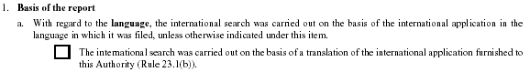

Box No I, Nucleotide And/Or Amino Acid Sequence(s)

Box No. I Nucleotide and/or amino acid sequence(s) (Continuation of item 1.b of the first sheet)
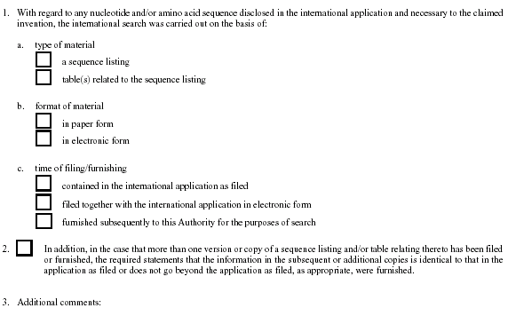

[Annex VI follows]
Box No. I, Basis Of The Opinion

Box No. I Basis of this opinion
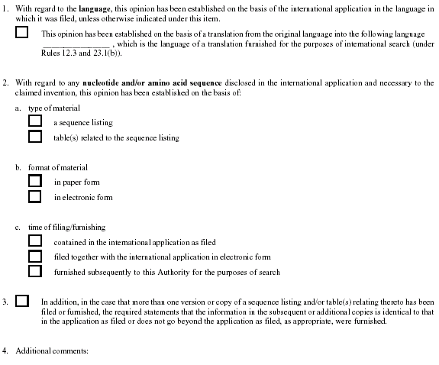

Box No. III, Non-Establishment With Regard To Novelty,
Inventive Step, And Industrial Applicability

Box No. III Non-establishment with regard to novelty, inventive step, and industrial applicability
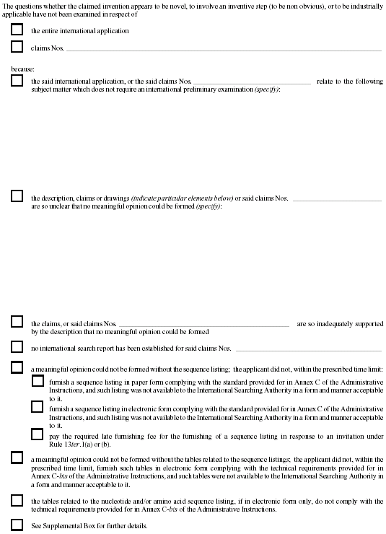

[Annex VII follows]
Box No. I, Basis Of The Opinion

Box No. I Basis of the opinion
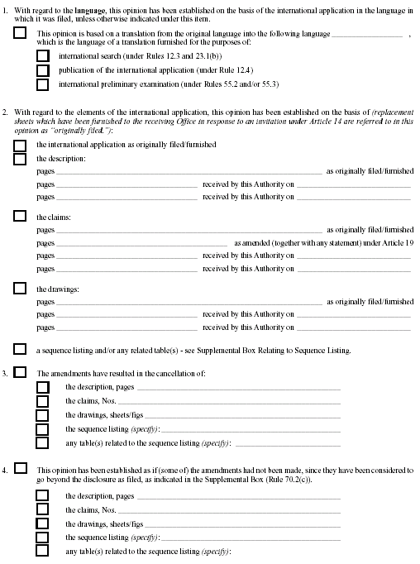
Box No. III, Non-Establishment With Regard To Novelty,
Inventive Step And Industrial Applicability

Box No. III Non-establishment with regard to novelty, inventive step, and industrial applicability
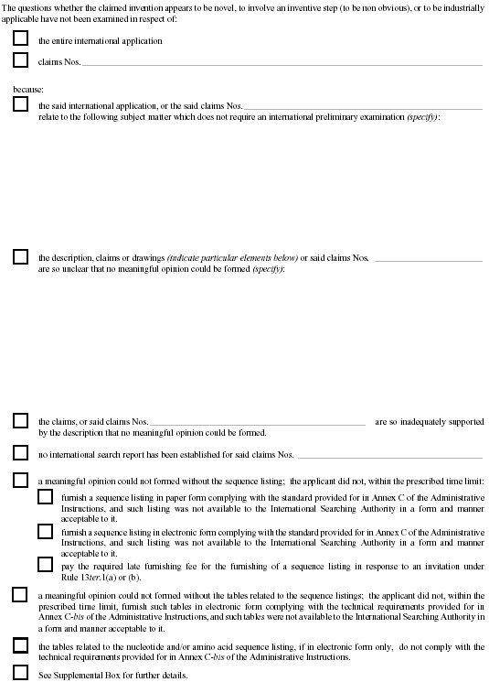
Supplemental Box Relating to Sequence Listing

Supplemental Box Relating to Sequence Listing
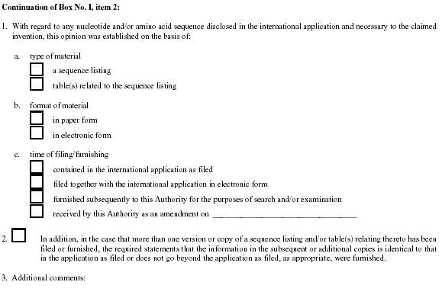

[Annex VIII follows]
Cover Sheet, Item 3b.

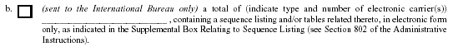

Box No. I, Basis Of The Report

Box No. I Basis of the Report
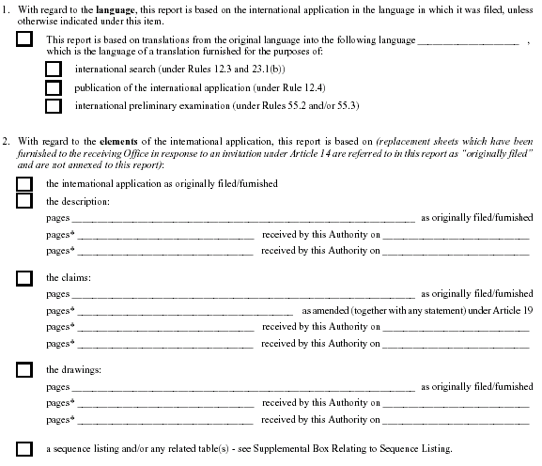
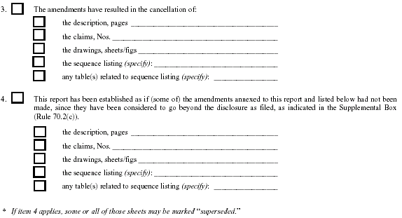

Box No. III Non-Establishment With Regard To Novelty,
Inventive Step And Industrial Applicability

Box No. III Non-establishment with regard to novelty, inventive step, and industrial applicability
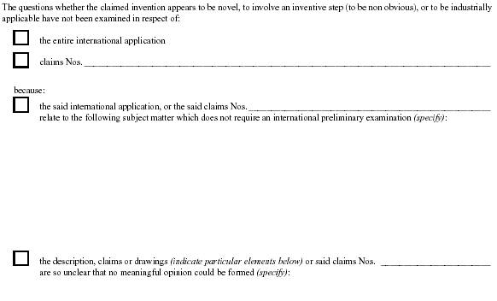

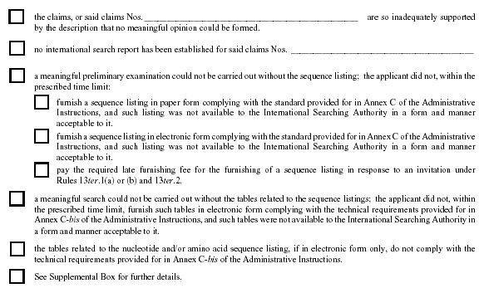

Supplemental Box Relating to Sequence Listing

Supplemental Box Relating to Sequence Listing
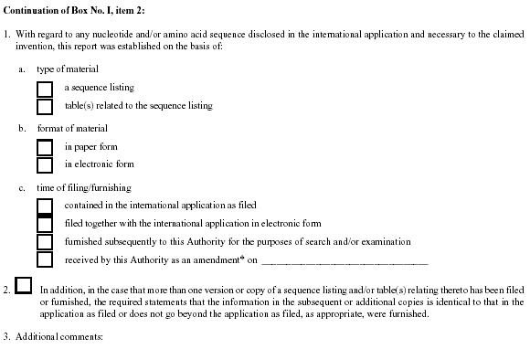

[End of Annex VIII and of document]

